North Eastern Karnataka Road Transport Corporation
CIVIL ENGINEERING DIVISION KALBURGI

No/NEKT/EEG/GLB/DB(T)/ 691 /2015-16, Date: 29 /09/2015

TENDER NOTIFICATION No: 19/2014-15 (Call-4)

(Through GOK e-procurement platform https://eproc.karnataka.gov.in)

Item rate tender in Single Cover System through GOK e-procurement for the following work as per Karnataka Transparency Act in Public procurement ordinance of 2000 is invited from the Civil Class-I Contractor registered in Karnataka CPWD/MES and KPWD. The intending contractors can obtain the Tender details through website https://eproc.karnataka.gov.in and upload the duly completed tenders / Relevant documents within the stipulated date and time mentioned in website only.
The Tender shall be submitted through e-procurement portal (https://www.eproc.karnataka.gov.in) only. Bidders/contractors need to register in the e-procurement portal to submit their bids through online.

Sl  no | Name of work | Amt put to tender (Rs. In lakh) | Earnest money deposit (in Rs.) | Time limit for completion of work Excluding Monsoon | Class of contractor
1 | Construction of new bus station with its sub works at Kalakeri. Dist:Vijaypur | 49.50 | 99000=00 | 06 Months | Class-I

The Tenderers shall pay the tender processing fee and Earnest Money deposit (EMD) through any of the following e-payment modes. The details are available at the end of this document.

- Credit Card
- Debit Card
- National Electronic Fund Transfer (NEFT)
- Over the Counter (OTC) (Axis Bank)

SINGLE COVER SYSTEM

The tender shall follow Single Cover System consisting Technical as well as Financial bid.

1. Calender of Tendering:-

- Last Date & time for clarifications, queries & Pre-bid meeting
19-10-2015 upto 17.00 Hrs.
- Last Date & time for uploading tender documents 30-10-2015 upto 17.00 Hrs

- Date & time for opening of Tender (If Possible) 02-11-2015 at 11.00 Hrs

2. Eligibility Criteria:-
Sl.No. | Requirements | Documents should be uploaded by scanning all the certificates
1 | Should be a valid Class-I Civil Contractor registered in Karnataka CPWD/MES/KPWD. | Registration Certificate for the block period 2015-20.
2 | EMD | EMD shall be paid in the form of e-payment through e-procurement on or before 30-10-2015 upto 17:00 Hrs.
3 | Should have successfully completed at least one work of similar nature of Building work, costing not less than Rs. 24.75 lakhs (Rs. Twenty four Lakhs seventy four thousand) i.e., from 01/04/2010 onwards for any of the Govt./ Public Sector Corporate undertakings. The work done certificate showing the following minimum quantities of works executed in a single / individual work from 01-04-2010 onwards.  Earth work excavation 173.00 Cum  Plain Cement Concrete 31.00 Cum  Reinforced Cement Concrete 60.00 Cum  Brick masonry 54.00 Cum  Reinforcement Steel 6016.00 Kg  Plastering Work 1040.00 Sqm  Flooring work 209.00 Sqm  Structural Steel 2012.00 Kg  Galvolume sheet Roofing 85.00 Sqm | Certificate of completion issued by an officer not below the rank of Executive Engineer, in case of Govt., / Public Sectors under takings.
4 | Should have achieved a Annual Financial Turnover of Rs. 49.50 Lakhs (Rs. Fourty nine Lakhs fifty thousand) pertaining to civil works for any of 2 (two) financial years from last preceding Five years i.e  ( 2010-11, 2011-12, 2012-13, 2013-14,2014-15). | Submit a copy of audited balance sheet and profit & loss accounts statement certified by a Chartered Accountant.
5 | Provident Fund Details | Upload a copy of P.F Registration Certificate issued by the provident fund Departments
6 | Sales tax Details. | Upload a copy of VAT Composition/clearance certificate for 2014-15 or Current year.
7 | Income tax details | Upload a copy of Income Tax returns for 2014-15 or Current year.

CONDITIONS
- Rate shall be quoted in figures and words.
- For EMD and FSD no Bank Guarantee will be accepted.
- Quoted rates shall be inclusive of cost of all materials, all lead and lift and transportation up to work spot for all places mentioned in the notification.
- The quoted rates shall be inclusive of all taxes, surcharges, service taxes, income taxes and sales taxes etc.
- Conditional Tenders will be rejected. The competent authority reserves right to reject all or any of the tender without assigning any reasons.
- The Department will not be responsible for any technical defects committed by the firms/agencies while down loading and up loading the documents/tender.
- Tender documents submitted through e-governance without the requisite Certificates as mentioned in the above Qualification information will be summarily rejected.
- If authority desires, physical verification will be done both for previous work done and Annual Turnover details submitted by the tenderer.
- Even though the tenderer meet the above criteria, they are subject to be disqualified if they have
- A) Made misleading or false representations in the forms, statements and attachments submitted in proof of the qualification requirement: and or
- B) Record of poor performance such as abandoning the works, not properly completing any contract, inordinate delays in completion, litigation history, or financial failures etc.
- The contractor shall abide by the Tender Conditions mentioned in the NEKRTC Schedule of Contract Book.
- In each running bill 5.50% FSD will be deducted apart from EMD. The same will be refunded after completion of maintenance period of One year from date of completion of work.
- Any defects observed during maintenance period, should be attended by the contractor / firm at his own cost failing which EMD & FSD amount will be forfeited.
- In case of the death of a contractor after executing the agreement/ commencement of the work, his legal heir, if an eligible registered contractor and willing, can execute and complete the work at the accepted tender rates irrespective of the cost of the work.
- The contractor shall go through terms and conditions clearly before quoting his rates and have no right for any claims subsequently thereafter.
- If the bidder quotes his rates less than the Sanctioned Estimated Rates (SER), then the difference amount shall be paid by the bidder before entering into the agreement. And it will be refunded after completion of those items without interest.
- For all RCC items of works, design mix is to be tested & approved using minimum quantity of cement as mentioned in the prescribed items. Test certificate is tobe produced before execution.
- The employer may terminate the contract if the other party causes fundamental breech of contract
- Statutory recoveries as and when imposed by the Central and State Government such as Taxes and Cess shall be recovered in the bills payable to the Contractor.
- The bid is to be submitted in the GOK e-procurement platform www.eproc.karnataka.gov.in system only.
- Tenderers, who have not registered in the GOK e-procurement portal should be registered through website www.eproc.karnataka.gov.in
- The tenderer should obtain tender documents through e-procurement website www.e-proc.karnataka.gov.in additional conditions and information’s also can be obtained through the above mentioned website.
- Bidders / contractors should submit the bid on the website itself (for help on e-procurement /e-payment, please contact helpdesk No. 8025501216 and 802501227 from Monday to Saturday during 9.00 Am to 9.00 Pm
- The tender documents may be downloaded from gov. of Karnataka e-procurement website http://eproc.karnataka.gov.in.

EXECUTIVE ENGINEER,

TERMS AND CONDITIONS

1 | The selected firm /Contractor should submit the PERT CHART/MILE STONE to show execution plan of work
2 | The firm /Contractor should submit the quality test reports by reputed Govt. colleges/Quality control labs for the materials /concrete steel/mortar used at his own cost and submit to site Engineer
3 | The firm/Contractor should make their own arrangement for water supply, electricity, sanitary during the execution of work. If contractor uses departmental water 1% of amount of water consumable items shall be deducted in the Bills.
4 | The firm/Contractor should make all safety measures as per safety manual
5 | The firm/Contractor should make all necessary barricading works for the execution of work at his own cost
6 | The firm/Contractor should store the explosives/building materials as per prevailing rules
7 | The firm/Contractor has to establish a site office in the NEKRTC site premises and necessary arrangements should be made for inspecting officers.
8 | The firm/Contractor should adhere to the rules and regulations of the labour department and should have been registered with Labour Department
9 | The firm/ Contractor should have minimum infrastructure facilities for the deployed workers (i.e., Drinking water facility, housing facility, sanitary and first aid medical facility etc.,) at the project site in hygienic condition
10 | If the firm/Contractor delays the project, milestones penalties will be levied to the maximum of 7.50% of the estimated cost.
11 | The proportionate progress on the work to be achieved every month as per SBD.
12 | The firm/Contractor should abide by the terms and conditions mentioned in the contract frame work and SBD Schedule of contract agreement and amendments there off
13 | If the tenderer fails to quote his rates for any items, it will be construed as to be covered by the rates quoted in other items and shall execute that item without assigning any reasons. The rate shall be considered as Zero
14 | The firm/Contractor will have to deploy the technical staff for the execution of work as per norms.
15 | The tenderer shall submit a list of litigations pending as on 31/03/2010 and faced during last 5 years. (01/04/2010 to 31/03/2015) with all relevant details i.e., Name of litigant party, nature of Litigation, facts of litigation, name of court and final outcome of the litigation. Any false information will be viewed seriously and may even lead to termination of the contract.
16 | In case of the firms registered under the Indian Partnership Act and companies registered under Companies Act, the person signing the tender shall state the authority under which he is Signing /Acting on behalf of partnership firm/ company and enclose the certified copy of the partnership deed/Memorandum of Articles of Association issued by the Authorities.
17 | The tenderer shall see the specifications, detailed drawings carefully and visit the work spot, Quarries, before quoting his tender rates. Any requests or claims for Escalation of rates in Quoted tender rates for any reasons will not be entertained. Quoted rates are binding on Contractor.
18 | No joint venture participation in the tender will be accepted.
19 | Conditional tenders and incomplete tenders will be rejected.
20 | The tenderer shall procure and use only materials confirming to BIS specification such as Steel, Cement, Water supply materials for the work. Any one of the following brand cement shall be used: ACC, Coramandal, Birla Super and Rajashree or as per direction of Engineer in charge of work. Any of the following steel shall be used: S.A.I.L. TATA/VIZAK Steel or as per direction of engineer in charge.
21 | The estimate rates are derived from the PWD SR of Belgaum circle, along with lead charges based on PWD lead chart. The rates quoted shall be inclusive of cost of all materials. Labour charges all lead & lift transportation and finishes. Any escalation in quoted rates for nay reasons will not be entertained.
22 | Any information regarding work, plan and estimate may be obtained from the office of the Executive Engineer during office hours on working days.
23 | No mobilization advance payable will be made.
24 | All the recoveries will be made in each bill as per prevailing Govt. rules and the regulations and any modifications there of.
25 | Royalty will be recovered as per the prevailing rates from the Mines and Geology Dept
26 | The other stipulated terms and conditions prescribed in transparency Act-2000 and SBD schedule of contract form shall be applicable
27 | The contractor shall cast 3 sets of 3 Nos each of test sample of concrete cubes of each day of concrete pavement, RCC works these cubes shall be tested for 28 days compressive strength of concrete at his own cost he shall submit the test reports to Asst. Executive Engineer.
28 | The tenderer/firms shall get the material tested in any PWD quality control lab/Govt./ Private Engineering colleges for construction materials used for the work viz.. Jelly, sand, cement and steel at his own cost and submit to the site engineer for each consignment of materials.
29 | The tenderer /firms shall make all arrangements to ensure safety for its employees/ labourers and to public causing any untoward incidents that may occur while execution which may cause injuries /fatal accidents. The tender /firms is solely responsibly for these incidents. NEKRTC is not responsible for this.
30 | The NEKRTC will not be responsible for any failure that may occur while uploading & downloading the documents through Tendering.
31 | If any chance, the above mentioned tender dates happens to be holiday or declared as a holiday due to any valid reason the dates will be postponed to next working day with specified timings.
32 | The Competent Authority shall at any time even after execution of agreement or execution of work shall terminate the contract, if it is found the information like work done certificate, registration, TOC and any other information to be false & non authentic, after verifications from concerned department.
33 | The tenderer should not sublet the contract work
34 | Dispute resolution shall be only through courts and not through process of Arbitration The jurisdiction of courts will be at Kalburgi only.
35 | Quoting lowest rates shall not confer legitimate right for award of contract to the tenderer/firm. The decision of the Competent Authority in this regard is final and binding on all the quoted firms / contractors.
36 | All subsequent notifications, changes and amendments with regard to the bidding process will be posted on the aforesaid websites.
37 | The Contractor/Firm should not engage the child labour on the work site.
38 | The contractor shall have no right to claim any compensation due to delay in supply of drawings / deviations the applicable tender time limit will be extended for department delay.

Executive Engineer

Tender Transaction fee and Earnest Money Deposit.

The supplier/contractor can pay the Earnest Money Deposit (EMD) in the e-Procurement portal using any of the following payment modes:

- Credit Card
- Direct Debit
- National Electronic Fund Transfer (NEFT)
- Over the Counter (OTC)

- CREDIT CARD PAYMENT METHOD:

To pay the registration fee through your credit card, click on the “Credit Card (Online Payment)” option. If you choose to pay the fees later click on “Close” button. Click Pay after verifying details on the screen that appears.
Click on “Pay” button to proceed with payment process. Click “Back” if you wish to
Choose a different payment method. Click on “OK” button on the payment method
Confirmation window that is displayed. You will choose your card type (VISA, master Card).
You enter your credit card details.

Card Details completely filled.

The screen will look like it is shown above when you have completely filled the card details. Click on “PAY NOW” button to effect the payment. Your card details are verified by the payment gateway service and you will receive confirmation of payment debited to your card account if the card is valid. If the card is not valid you will receive alert about it and system will wait for you to correct any errors in the card details provided by you. A successful transaction message is displayed.

- DIRECT DEBIT METHOD:

Click on “Direct Debit Using Internet Banking (Online Payment) option to pay from your bank account through Internet Banking facility.
Click on “Pay” to proceed or “Back” to change the payment method on the Payment details screen.
Click on “OK” on the confirmation window to effect the payment. Click on “Cancel” and then on “Back” to change the payment method.
You will information on your screen about successful completion of payment process.

- OTC PAYMENT PROCEDURE:

If a contractor/supplier chooses to make payment of EMD/tender processing fees Over The Counter (OTC) in any of the designated Axis Bank branches listed in the e-Procurement web-site (www.eproc.karnataka.gov.in), the contractor/supplier will need to log into e-Procurement system, access the tender for which bid is being created and then select the OTC option under the payment section and print the Challan shown in that section. The printed challan will have the unique bid reference number and the amount to be remitted. Along with the challan, contractor can choose to make the payment either in the form of cash or in the form of Demand Draft. Cheque payments will not be accepted. The contractor is requested to specifically inform the bank officer to input the unique bid reference number printed in the challan in the banking software. Upon successful receipt of the payment, the bank will provide a 16-digit reference number acknowledging the receipt of payment. This 16-digit reference number has to be inputted by contractor in the payment section of its bid as payment confirmation before the bid is submitted (i.e.) as a pre-requisite for bid submission.

4. NEFT (National Electronic Fund Transfer) PAYMENT PROCEDURE:
If a contractor/supplier chooses to make payment of EMD/tender processing fees using Reserve Bank of India's (RBI) National Electronic Fund Transfer (NEFT) system, the contractor/supplier will need to log into e-procurement system, access the tender for which bid is being created and then select the neft option under the payment section and print the challan shown in that section. the printed challan will have the unique bid reference number, account details of Government of Karnataka and the amount to be remitted. The contractor has to submit the printed challan to its bank-branch (NEFT-enabled) and request for an account-to-account transfer, wherein the money will get transferred from the contractors' bank account to GoK's bank account. The contractor should ensure that NEFT transfer instructions are executed and the funds are wired to the Government of Karnataka's principal account before the last date for bid submission and preferably 24 hours before the last date for bid submission. If the contractor's bank transfers/wires the money after the last date for bid submission, the contractor's bid will be liable for rejection. Upon executing the transfer, the contractor's bank will provide a reference number generated by NEFT software as confirmation of transfer, which has to be inputted by contractor in the payment section of its bid as payment confirmation before the bid is submitted (i.e.) as a pre-requisite for bid submission. Also, the account number from which the funds were transferred has to be inputted in the e-Procurement system as part of its bid.

The supplier/contractor’s bid will be evaluated only on confirmation of receipt of the payment (EMD) in the Government of Karnataka central pooling a/c held at Axis Bank.

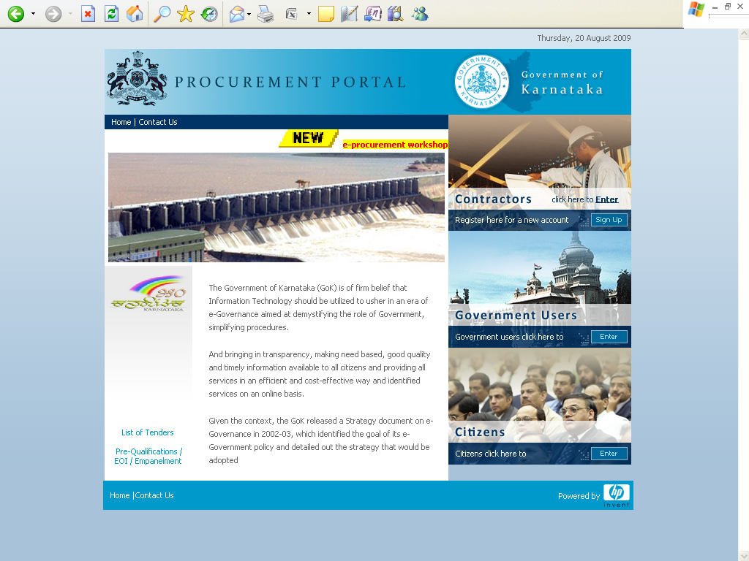
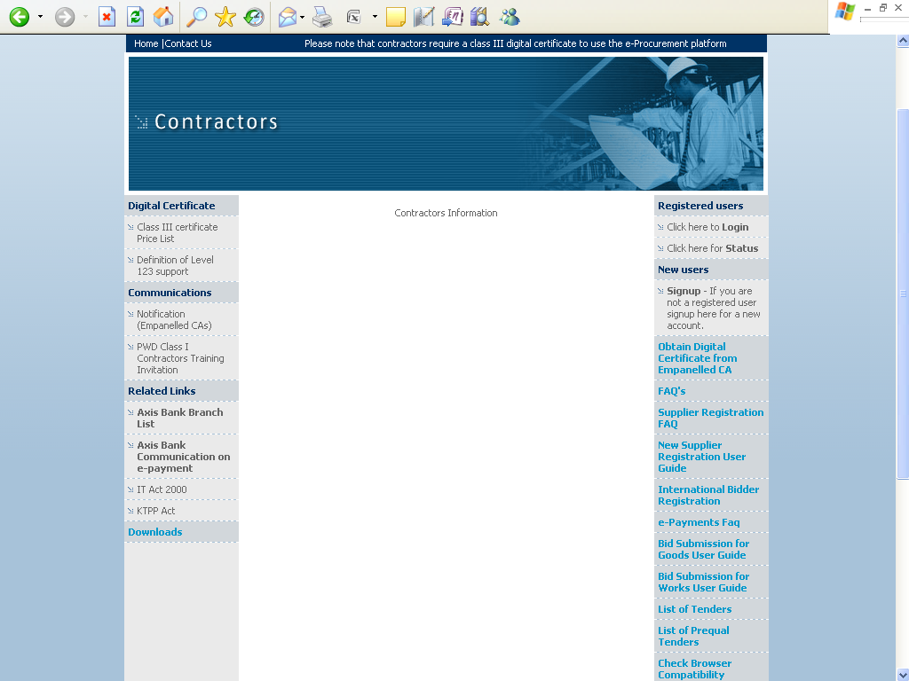
For details on e-Payment services refer to e-procurement portal for more details on the process.

Note: In e-Procurement Portal Contractor has the option of withdrawing the Bid by digitally signing to withdraw/cancel bid before the bid submission time /Date.
e-mail: hphelpdesk.blr@rteservices.com

SUPPORTS timings : (9.00 am to 9.00 pm)

Help desk : 080-22485867/22485927
or
e-mail: hphelpdesk.blr@rteservices.com

Sd/-
Executive Engineer

Copy submitted to:

The Deputy Commissioner (Dist. Tender Bulletin Officer) Government of Karnataka, Vijaypur District for kind information and for kind publication in the district tender bulletin.
The P.S to The Chairman NEKRTC Central Office, Gulbarga for information & to place the same for kind perusal of the Competent Authority.
The P.S to The Managing Director NEKRTC Central Office, Kalburgi for information & to place the same for kind perusal of the Competent Authority.
The Chief Account Officer Cum-F.A, The Chief Civil Engineer/The Chief Mechanical Engineer/The Chief Law Officer / Chief Security & Vigilance officer/ Chief Labour Welfare Officer / System Manager/ Controller of Stores & Purchases / Chief Statistical & Planning Officer NEKRTC, Central Offices, Kalburgi for kind information.

Copy FWC’S to:

The Chief Civil Engineer, KSRTC / NWKRTC / BMTC for information.
The Chief Civil Engineer, ( Projects ) BMTC for information.

The Executive Engineer, NEKRTC CE Division Bellary / NWKRTC, C.E Division Hubli / Belgaum / BMTC, Bangalore / KSRTC, C.E Division Mysore, Bangalore, Executive Engineer ( Projects)/ KSRTC/BMTC/ Bangalore, for information and with a request to display the same in their office notice board.

The Divisional Controller, NEKRTC, Kalburgi /Bidar /Yadgir /Vijaypur/ Bellary / Raichur / Koppal /Hospet Division for information.

The Executive Engineer, P.W.D / Zilla Panchayath, Kalburgi / Bidar / yadgir District for information, with request to display the notification in their office notice board.
The Assistant Executive Engineer, P.W.D / Zilla Panchayath Sub-division Kalburgi, for information and necessary action.

Copy to:

- The Assistant Executive Engineer, NEKRTC, Kalburgi / Bidar / Yadgir /Vijaypur/ C.E Sub-Division, for information and necessary action.
- The Accts. Supdt. /Cashier / Junior Assistant / Junior Engineer for information.
- Notice Board and corresponding files.

EXECUTIVE ENGINEER

