14.07.2013
CRIME BRANCH
PRESS RELEASE
➢ TWO INTER STATE CHEATS-CUM-THIEVES, WITH UNIQUE MODUS OPERANDI, ARRESTED.

➢ THREE TATA-407 VEHICLES AND ONE WAGON-R CAR RECOVERED.

With the arrest of two persons namely Vikas Dandhi s/o Sukhbir Singh r/o 387/1, Ward No.12, Vishnu Nagar, Lahana, Sonepat (Haryana) and Naseeb Singh s/o Satya Prakash r/o village Singhpura, PS Dadar, Distt. Rohtak, the staff of Special Investigation Team, Crime Branch has recovered three TATA-407 vehicles and one Wagon-R Car from their possession which were stolen from Delhi/Haryana.

INFORMATION AND TEAM:-

On 23.5.2013, an information was received that a Tempo TATA-407, hired from Bawana Industrial Area, was taken to Panipat and subsequently the same was stolen by the means of cheating. ACP KPS Malhotra of Special Investigation Team of Crime Branch, deputed Inspr Rajbir, HC Ajeet and Const Ravinder to collect relevant information to work out the case. On 10.07.2013, the deputed team after a hard work of 45 days received an information that some thieves will be coming to dispose off the stolen vehicles at Kela Godown, Azadpur Sabzi Mandi. Accordingly, a team under close supervision of ACP KPS Malhotra, comprising Inspr Rajbir, ASI Ramesh, HCs Ajeet, Subash, Pardeep, Surender, Jasbir, Rishikesh, Anil and Consts Ravinder, Anil Hooda, Rambir and Devender was constituted.

RAID AND INTERROGATION:-

The team conducted a raid at the place of information, and two persons later on identified, as Vikas Dandhi s/o Sukhbir Singh r/o 387/1, Ward No.12, Vishnu Nagar, Lahana, Sonepat (Haryana) and Naseeb Singh s/o Satya Prakash r/o village Singhpura, PS Sadar Rohtak, Distt. Rohtak were apprehended with two stolen TATA-407 vehicles . On interrogation, one more TATA 407 and one Wagon-R car were recovered from their possession. It was revealed that both these TATA-407 Tempos were stolen from Haryana in case FIR No.343/13 u/s 379 IPC, PS Jhajjar, Haryana, 376/13 u/s 379 IPC, PS Chandni Bagh, Panipat Haryana and FIR No.352/13 u/s 379 IPC, PS Panipat City, Panipat, Haryana and one stolen Wagon-R car No. DL-9CY-5469 was also recovered was stolen using the same modus operandi in case FIR No.255/13 u/s 406/420 IPC, PS Chandni Bagh, Panipat.

MODUS OPERANDI:

During the investigation, it was revealed that the accused persons used unique modus operandi to steal the vehicles. Accused Vikas Dandi used to approach the drivers of these vehicles at vehicle stands in Delhi and hired the vehicle to ferry goods from Delhi to Haryana. He took the vehicle to various places in Haryana on the pretext of bringing wheat/pulse etc. On the way, he became friendly with the drivers, and took the keys on some pretext while halting midway. After distracting the attention of the driver, he used to get the keys of the vehicle and the same were handed over to the co-accused Naseeb Singh, who used to flee away from the spot with the vehicle.

CASES WORKED OUT:

1. FIR No.343/13 u/s 379 IPC, PS Jhajjar, Haryana
2. FIR No.376/13 u/s 379 IPC , PS Chandni Bagh, Panipat, Haryana
3. FIR No.352/13 u/s 379 IPC, PS Panipat City, Panipat, Haryana
4. FIR No.255/13 u/s 406/420 IPC, PS Chandni Bagh, Panipat, Haryana
5. FIR No.217/13 u/s 406/420 IPC, PS Sampla, Rohtak, Haryana

PROFILE OF ACCUSED PERSONS:

1. Vikas Dandhi s/o Sukhbir Singh aged 25 years. He has a fruit shop at Gohana, Sonepat, Haryana.

2. Naseeb Singh s/o Satya Prakash, aged 34 years, is engaged in supply of milk.

RECOVERIES:

1. TATA-407 Tempo No. DL-1LR-7076
2. TATA-407 Tempo No. DL-1LR-7361
3. TATA-407 Tempo No. HR-74-5525
4. Wagon-R car No.DL-9CY-5469

(RAVINDRA YADAV)IPS
ADDL. COMMISSIONER OF POLICE:
CRIME BRANCH, DELHI.

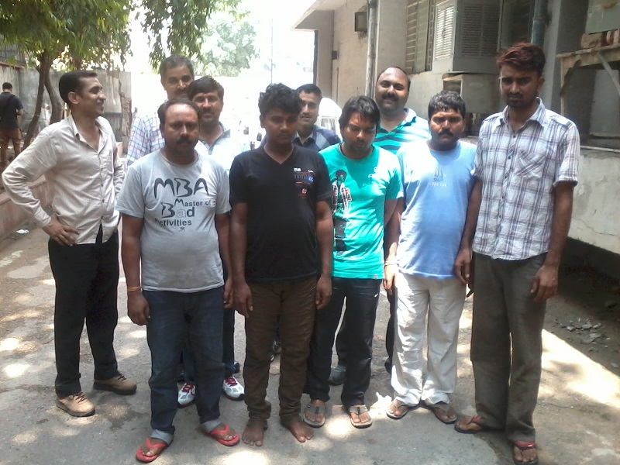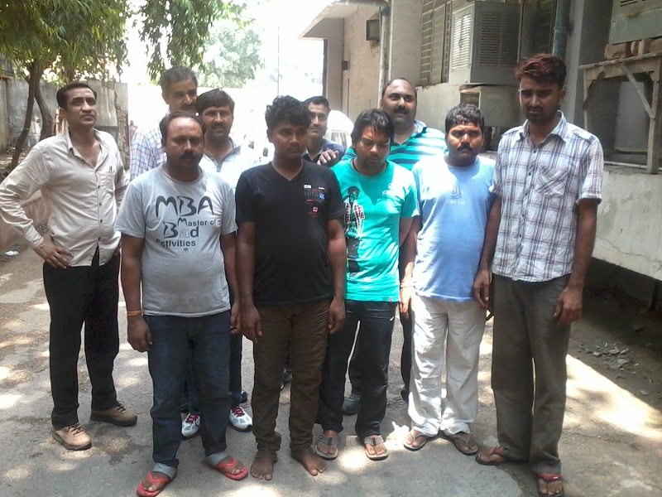

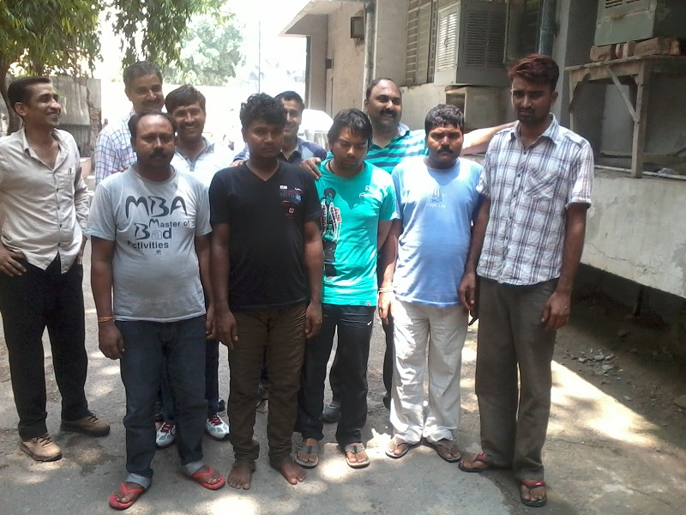

PRESS RELEASE

2 MORE ARRESTED IN RPF PAPER LEAK.

An organised gang involved in the paper leak of exam held for the post of Constable, conducted by Railway Protection Force (RPF), Gorakhpur, was busted by Crime Branch on 30.06.13 vide case FIR No. 113/13 dt. 30.06.2013 u/s 406, 420, 120-B IPC and 66-A IT Act, P.S. Crime Branch. Six candidates including accused Robin and Sunny were arrested in the case.

Investigation regarding the source of question paper to the accused Robin led to one Jai Karan r/o Meerut and raids were conducted at his hideouts in Meerut. He was arrested on 06.07.2013, and mobile phone which was used in commission of crime, was recovered from his possession.

Interrogation of Jai Karan revealed that he had indulged in providing the answer keys of various competitive examinations held for govt. posts through his associate namely Vikas r/o Muzzafar Nagar. Accused Robin was appearing in the examination of Multi Tasking Staff (MTS) exam conducted by SSC and he had approached the accused Jai Karan. Jai Karan had taken Rs. 70,000/- from him for arranging the answer keys of MTS exam. However, accused Jai Karan could not arrange the answer keys. He assured Robin that he will arrange answer keys of the RPF exam in lieu of the amount paid earlier. On 30.06.2013, accused Jai Karan had arranged answer keys for Robin for exam.

Investigation regarding the source of question paper to another accused Sunny revealed that he had received the answer keys from three mobile phone numbers through SMSs. Through one such mobile number, one Mohit was identified who happens to be a Constable in Delhi Police and posted at P.S. Defence Colony (South district).

During interrogation, Mohit confessed his involvement in this case. Accordingly, he was arrested and the mobile phone used in commission of the crime was recovered from his possession.

Further interrogation of accused Mohit Kumar revealed that one Pawan R/o Vill. Sinoli, UP is known for running recruitment rackets in Western UP. Pawan had contacted Mohit and offered to provide answer keys of recruitment test for Constable in RPF conducted on 30.06.2013. He had struck a deal with Pawan for Rs. 3 Lac for providing the answer keys through SMS. He had paid Rs. 50,000/- as advance to Pawan.

Mohit had proceeded on casual leave from 27.06.2013 onwards to organise this cheating. Pawan provided him answer keys of RPF exam on 30.06.2013, which was forwarded by him to his brother. The answer keys were forwarded by him to some other phone numbers also, provided by Pawan, and accused Sunny is one of them.

RECOVERY

Two mobile phones used in the commission of crime.

ACCUSED ARRESTED

1. Jai Karan Singh s/o Dhan Pal r/o Village Kankarkhera, Meerut, UP. He works as a property dealer in Meerut.

2. Mohit Kumar s/o Kushal Pal r/o Village Chaproli, Distt. Baghpat, UP.

Further investigation of the case is in progress to identify/trace many other culprits, since it is very large scale organised cheating involving several people.

(RAVINDRA YADAV), IPS
ADDL. COMMISSIONER OF POLICE,
CRIME, DELHI.

Dated 14/07/2013

CRIME BRANCH

PRESS RELEASE

➢ COSMETICS PRODUCTS OF FAMOUS COMPANY STOLEN FROM BURARI WORTH Rs.25 LACS RECOVERED.
➢ ORGANIZED GANG OF BURGLARS BUSTED.
➢ 5-DESPERATE BURGLARS ARRESTED.
➢ 500 KG ELECTRIC STRIP STOLEN FROM PS SWAROOP NAGAR AREA RECOVERED.
The Crime Branch of Delhi Police has busted a gang of desperate burglars operating in the area of Delhi and indulged in various highlighted burglary cases. Cosmetics products worth Rs.25 Lacs & 500 Kg Electric Strips have been recovered at their instance from their hideouts.
The arrested persons are:
1. Manoj Kumar S/o Kundan Singh R/o Gali No. 12, A-Block, Burari Delhi, Age–30 Yrs,
2. Sunil Sahni S/o Rajeshwar Sahni R/o Village-Harsidhi Dhar Khariya PS Harsidi, Distt- Motihari, Bihar, Age-28 Yrs,
3. Neeraj Kumar S/o Nawal Kishore R/o Gali No.9, Jharoda (nearby Police Chowki), Burari Delhi, Age-27 Yrs, Permanent Address Village Sheetalpur, PS Chatia, Distt Motihari, Bihar,
4. Amit Chaudhary S/o Mahabir Chaudhary R/o Village Uda Bathua, PS Musri Gharari, Distt Samastipur, Bihar, Age-35 Yrs,
5. Hasmukh @ Rajkumar S/o Ram Chandra R/o C-44, Badi More Sarai, Near Kodiya Pul, Delhi, Age-30 Yrs., Permanent Address:-Village-Lehni, Post-Urva, Distt- Allahabad UP.
INFORMATION AND TEAM:-
The Crime Branch was working on undetected burglaries and thefts in North and North-West Delhi and deputed a team in search of the culprits. The team of HC Parmod and Const Yogender Kumar of Special Operation Squad of Crime Branch developed the information through informers over some of the suspects. The technical surveillance and the information being received was also regularly analysed. The consistent efforts and analysis brought a public person in the net, who was in constant touch of the gang. He was taken into confidence and the information was further developed and scrutinized minutely. The team got a specific information on 13.07.2013, through informers and technical surveillance that the gang of burglars had burgled a godown of cosmetics and had stolen articles worth millions of rupees from the Burari area and concealed the stolen property in hideouts.
Immediately, a team headed by Inspr Satyabir Singh consisting of SI Chander Parkash, HCs Narender Godara, Devender Kumar, Parmod Kumar, Dinesh Singh and Consts Bijender, Lal Bahadur, Yashbir, Rajeev, Yogender, Lalit & Sunil was formed under the close supervision of ACP/SOS Suresh Kaushik and overall supervision of Addl DCP Kumar Gyanesh.
OPERATION:
The team conducted raids at various hideouts in the area of village Jharoda and Burari and apprehended Manoj, Sunil Sahni, Neeraj Kumar and Amit Chaudhary. The stolen cosmetics were recovered from their hideouts. The quantity of the stolen articles was so huge that they had to store the same on different places and the gang was making efforts to dispose it off. The recovered items are expensive perfumes, deodorants, hair colours, lipsticks, shampoos and face creams of Revlon.
INTERROGATION:
Interrogation revealed that accused Manoj Kumar a resident of Burari, Delhi is the kingpin and operating the gang. He has a small counter of video CD in Lajpat Rai Market. He searched a godown which was situated in a lonely place and took it on rent. He was in contact with some active criminals. He keeps watching over such godowns where he could keep the burgled articles safely and also used to give tip of the godown or shop where the burglary is to be committed, as he was very well acquainted with the area.
Sunil Sahni is master in breaking the locks. He alongwith his associates reach the godown with a pressure cutter and other devices as required, break open the lock in early hours of night, put his own lock on the door and in the early hours when there is minimum vigil, hire tempo from the road side, open the lock with key and take away the stuff impersonating himself as the staff of the company and working in the godown. They shift the articles in different vehicles and take it to hide outs in batches. Then Manoj again takes charge of disposing off the stolen articles.
Similary, in this case in the night intervening 9/10 July, on the tip of Manoj, the gang members committed burglary in a godown of Burari and stored the property in various places and used to dispose it off. The informer tried to struck the deal leading to the arrest of all accused persons. Earlier in a case, they were not able to dispose off the stolen property in Delhi, then Sunil took the articles to his native Distt in Bihar through a transport company and sold it there as he is known there as a trader doing trading in Delhi.
PROFILE OF ACCUSED PERSONS:-
1. Accused Manoj Kumar is a permanent resident of Burari Delhi alongwith his family. He studied upto 5 th class. His father is working as an electrician. He left his study and was dealing in trading of spare parts. Later he started a counter of sale of CD in Lajpat Rai Market. During this, he lured to earn more money and lift his livelihood was involved in crime.
He is involved in the following cases:-
I. FIR No. 112/2012 u/s 328/379/34 IPC PS Crime Branch
II. FIR No. 100/2009 u/s 63/38 CR Act PS Kotwali
2. Accused Sunil Sahani is resident of Distt Motihari, Bihar. He is illiterate and belongs to poor family. He came to Delhi in 2012 with one Akhilesh resident of Motihari Bihar, who was residing in Swarup Nagar Delhi and came into the world of crime with Akhilesh. In a very short span he became master of breaking locks & shutters. During this, he met with Manoj and started working with him.
He is involved in the following cases:-
Involvement:- FIR No.73/12 u/s 457/380/411/34 IPC PS Swaroop Nagar
3. Accused Amit Chaudhary is the resident of Distt-Smastipur, Bihar. In 2007, he came in contact of one Balkishan who took him the world is commit crime in Delhi and now a days he is in jail. During this he came in contact with Sunil Sahni and involved in his gang and committed burglary. Earlier he is involved in case FIR No. 197/10 u/s 454/380/411/34 IPC PS Mahendra Park, Delhi.
4. Accused Neeraj Kumar is resident of Distt. Motihari Bihar. He studied upto 11th class. He came to Delhi in 2002, and started his career as a helper in a export company but was not satisfied with the job. He came in contact of some criminals and indulged in the world of crime. He is known to Amit Chaudhary from Bihar and he became an active member of the gang.
He is involved in the following cases:-
1. FIR No. 550/2003 u/s 392/34 IPC PS Moti Nagar Delhi
2. FIR No. 498/2003 u/s 379/411 IPC PS Mehrauli
3. FIR No. 607/2003 u/s 25/54/59 A.Acr PS Mehrauli
4. FIR No. 773/2003 u/s 379/34 IPC PS Lajpat Nagar
5. FIR No. 235/2003 u/s 379 IPC PS Malviya Nagar
6. FIR No. 789/2005 u/s 379 IPC PS Badarpur
7. FIR No. 651/2005 u/s 457/380 IPC PS Badarpur
5. Accused Hasmukh @ Rajkumar resident of C-44, Bari More Sarai Kodiya Pul Delhi. He worked as a salesman in Lajpat Rai Market and during the period he came in contact with Manoj and became active criminal. He is mastermind in the burglary committed in the area of PS Swaroop Nagar in which they stole 85 packing steel strips machines weighing about 5 quintals which have been also recovered from their possession.
RECOVERY
1. Cosmetics products like (hair colour, perfumes, deo’s, body lotion, lipsticks and shampoos ) of Revlon company worth Rs. 25 Lacs
2. 500 kg electric strips.
CASE WORK OUT
1. FIR NO. 283/13 U/S 457/380 IPC PS BURARI, DELHI
2. FIR NO. 161/13 U/S 457/380 IPC PS SWAROOP NAGAR, DELHI

The accused persons are further being interrogated and more incidents of burglary are likely to be solved.

(RAVINDRA YADAV), IPS
ADDL. COMMISSIONER OF POLICE:
CRIME BRANCH, DELHI.

13/7/2013
➢ ICICI Credit Card Fraud unearthed.
➢ A cheat arrested namely Raju Tevar arrested from Mumbai by New Delhi District.
➢ Employee of ICICI Bank, Credit Card Division, Mumbai is disclosed to have been involved in the theft of Credit Card Data of 30000 card holders
➢ Suspected to have used the data for internet transaction worth Rs. 1-2 Crores.
➢ Search of the co-accused is on.
With the arrest of one Raju TevarS/o Lt. Sh. Shanmugam Tevar R/o Jhuggi near Sanjay Kirana Store, Gaon Devi Mandir, old Balaji Nagar, Ambar Nath West, Thane, Maharashtra, the police of PS Connaught Place havesolved a case of cheating involving the theft of the credit card data from ICICI Bank from Mumbai and then fraudulently obtaining the security internet transaction number from the credit card holder on mobile phone as the stolen data also contained the details of the mobile numbers etc.
Facts of the case:
A complaint was received from Ms. Abhya Srivastva, AFP, Janpath, New Delhi stating that a call from mobile no. 879623056 saying that an online transaction has been made by using her ICICI Bank Credit Card details. The caller asked her to give all the information regarding her credit card so that he can block the card and refund the amount. The caller told himself to be calling from ICICI Bank. After giving her details to the caller she started getting messages that up to Rs. 44,911/- have been spent from her card. Hence a case FIR No. 45/13 dt 3.4.13 was registered and investigation were taken up.
Ateam led by SHO/ Connaught Place, Inspr. Sunil Kumar consisting of SI Love Atrey, SI Surendra Sharma, SI Kuldeep Kumar and SI Badri Prashad was constituted under the supervision of ACP/Connaught Place to apprehend the accused. In the month of April’2013, a team headed by IO/SI Love Atrey went to Mumbai for the field investigations as the transactions from this credit card were made to make the payment of electricity bills to Maharashtra District ElectricityBoard company and to PayTM mobile company. The transactions for these were being done by internet through Reliance Mobile. The field investigations revealed that one Raju use to come to collect the telephone bills representing himself as agent of the company to the shopkeeper of the Ambarnath area who used to collect the bills of the local residents for small service charges. Raju Tevar had offered 5% to 10% as a discount to be given to the shop keeper. The accused Raju Tevar had not disclosed his place of stay and was coming in a white Accent car. The number of the car could not be found during this visit. However the investigators were puzzled as the location of the Reliance number was from Surat, Gujrat. No success resulted in this visit.
Then the team collected the data about the location of the accused using the same Reliance number and the other such transactions from ICICI Bank. The analysis of the data revealed that Reliance Sim Card number is being used only for the internet transactions. A detailed study of the pattern and the similar kind of transactions made on ICICI Bank Credit Cards were collected and studied which confirmed that only one person is involved in all such transactions.
After two months, the team got new location of this number in Palghar, Thane, Maharashtra and the team of the police station was immediately dispatched to Thane. On reaching the new location, the team encountered a problem of the identity of the accused as the accused had stopped coming to Ambarnath as he had sensed that police is on his trail. The IO made local enquiries in Palghar but no clue was found. The witnesses who could identify the accused had already gone to Kerala for his domestic reasons. The IO discussed this problem with the SHO/PS Connaught Place on phone and briefed that the search of the accused is like the search of a needle in the hay stack. The Palgahr was a densely populated Jhuggi cluster near Thane and the presence of the team in the area could have alerted the accused since they did not know his address as well his photograph. On the instructions of the SHO/Connaught Place, the witness was contacted to reach Mumbai immediately. IO/SI Love Atrey made a search of the accused on the internet and they succeeded in finding his photograph on Face Book Account with the name of Raju Naik on the identification of one of the witnesses in the case. The SHO directed to get 10 copies of the photographs prepared and the same to be distributed among the team of the PS Connaught Place and local intelligence for making the enquiries. IO developed local intelligence and found that he is using a white Huyandi Accent car for commuting and usually changes his residence within 2/3 months. This time the cell location of the Reliance SIM card was found at Palghar, Thane. The IO and his team made the enquiries in the area of Palghar, Thane and ultimately succeeded in locating his place of stay and the Hyundai car was also identified stationed near his accommodation. A raid was conducted and the accused was apprehended. The accused was brought to Delhi on transit remand and now he was remanded to police custody for 8 days.
The team went to Mumbai to arrest the co-accused who had managed to steal the data from ICICI Bank, Mumbai.The sustained and scientific interrogation of the accused led to have disclosed that he can lead the police team to show the place of stay of the co-accused persons as well as can get the computers and other accessories used in making phone calls and internet transactions.

Recoveries made:
Several raids were conducted at the known places of stay of the co-accused. The team went to Vill. Savroli, on Palghar-Boisar Road, PS Boisar and at the pointing out of the accused the following articles used for committing this cheating were recovered:-
1. OneLaptop Sony Vio, Tria Note Book
2. One ASUS Laptop
3. One Samsung Laptop, N-148
4. One Router Beetel
5. One Mobile Samsung
6. One Mobile Nokia
7. Three Stamp of Agent Maha Discom, BEST, PayTM
8. 7 Paid Bills that were used in making the payment through the credit card.
Profile:
Raju Tevar was born in Ambarnath in 1981 and has one brother and three sisters. His three sisters have died leaving behind their one son each on his shoulder. He is married and has one son two daughters. He is taking care of all of them alone. He is involved is four cases of hurt and threat and one murder in case FIR No. 137/03 dt 11.6.03 u/s 302/34-IPC PS Ambarnath. His involvement are as under: -
He was born in Chaya Hospital in Ambernath in year 1982. His mother ‘Kali Amma’ is a house wife. His father had worked in Ambernath Ordinance Factory. He studied up to 7th class in M.M.S. High School in Ambernath. After that he started working in ordinance factory on daily wages. He had worked there for 1½ years. After that he fell in the bad company and started hawing quarrels in public. Four cases of hurt were registered against him in P.S. Ambernath (W). In 2002, he had murdered a bodyguard of Sh. Naresh Gaikwad, Nagar Sewak namely Jagdish Bhagwan Gaikwad over a petty issue as the deceased had abused his mother. He had spent 14 months in Adharwadi Jail in Kalyan. He came out on bail and now had been acquitted in all those cases. After that several cases u/s 324 IPC & 326 IPC were also registered against him. He was married to Anuradha in year 2004. He shifted to Pune (Deoroad). After his marriage, he started undertaking minor repairs work/ whitewash work in Pune. Then he pulled the Rikshaw as well. Then he started selling pirated CDs in Deoroad. He did this for more than two years. He was then raided by police and CD writers were seized. Then he started selling country made illicit liquor for almost 2 years. Then he against came back to Ambernath at home and started outsourcing the man power at Dadar and Byculla for 6 months. Then he had some quarrel with his local rivals and a case u/s 326 IPC was registered against him and he went to Shingasi (Madurai), Tamilnadu with his family and started working in a metal box company. He worked there for almost one year. Then he met Abhijit (Co-accused in murder) who took him to Zakir. Thereafter, he shifted to Badlapur with his family for 6 months then he surrendered and was released on bail after 20-22 days. Then Zakir met him and took him to Moral Goan at his home and started doing his household work. One day suddenly he shifted to Serur with Zakir. He learnt to use Laptop with Zakir also learnt its operation. He learnt all the in & out of what Zakir was doing and one day he got an opportunity and copied the data on a pen drive from the computer. He then fled away and started working alone. He has used around the data of 4500 credit card holders for the last 1½ years. He used to collect the money in cash for depositing the money for the last one & half years and give 10% discount on the bill paid. This way he used to collect Rs. 5-6 lacs/months. He usually buys new furniture & house hold goods and frequently changes his hide outs to avoid his arrest after 2/3 months. He has thus collected amount of Rs.1.5 Crores during this period. He was an extravagant and usually visits night bars and spends Rs1-2 lacs per night. He had no bank account in his name.
Father expired – 1 ½ yrs. Back due to old age
Brother Merraiya Swami
Sisters: 1. Surya Kala, 2. Jamuna 3. Mahalaxmi
1. Kushi 8 yrs
2. Rohit 5 yrs.
3. Shruti 3 yrs
Involvements: -
Involvements of Accused Raju S. Tewar s/o Late Sh. Shanmugam Tewar r/o Jhuggi near Sanjay Kirana Store, Old Balaji Nagar, Ambernath (West), Thane, Maharastra.
S. No. | FIR No. | Date | U/S | Police Station
1. | 253/01 | 04.12.01 | 326/325/34 IPC | PS Ambernath (W)
2. | 137/03 | 11.06.03 | 302/34 IPC | PS Ambernath (W)
3. | 247/08 | 24.09.08 | 326/325/324/  323/504/34 IPC | PS Ambernath (W)
4. | 155/09 | 16.10.09 | 324/504/34 IPC | PS Ambernath (W)
5. | 185/09 | 15.12.09 | 324/323/504/34 IPC | PS Ambernath (W)

Notice has been given to ICICI Bank to ascertain actual amount that has been cheated by this accused as well as the co-accused. There is a strong possibility of the involvement of employees of the ICICI Bank in this Credit Card fraud. The accused had disclosed that he has been making the internet transactions for the last one year.
The verification of the ASUS Laptop computer on recovery confirmed that it contained the data of Credit Card Data of 30000 card holders. The data is being analyzed for further investigation. The actual loss to the ICICI Bank can be ascertained from the complaints received in the bank from the card holders.

(S.B.S. TYAGI) IPS
DY. COMMISSIONER OF POLICE,
NEW DELHI DISTRICT: NEW DELH

