THE CHURCH OF THE
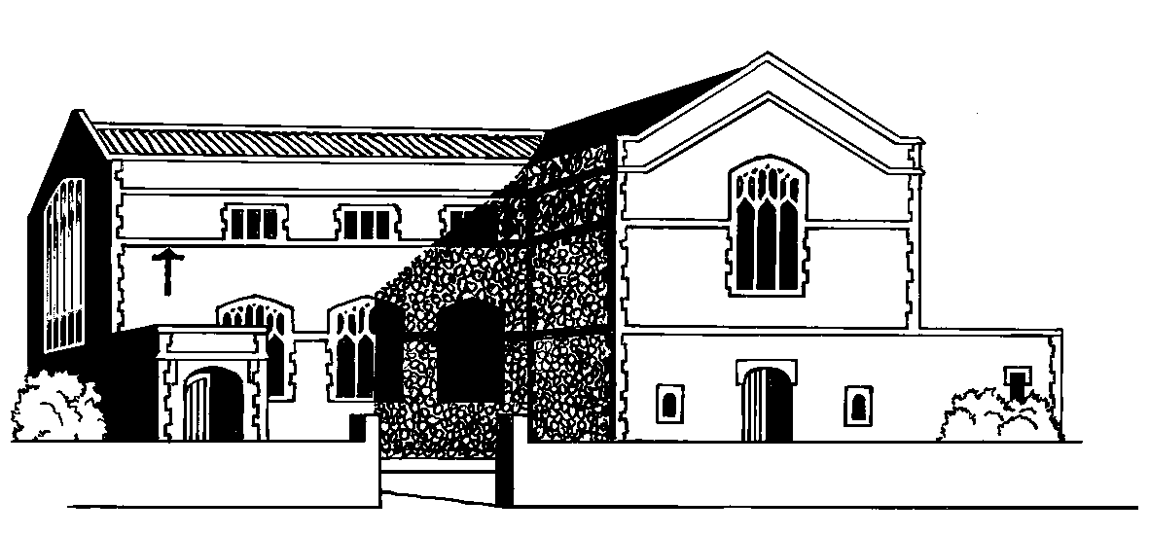

SACRED HEART OF JESUS

& SAINT JOSEPH, WARE

e.mail: ware@rcdow.org.uk Parish Priest: Fr. John Gray
website: www.sacredheartware.com Parish Deacon: Rev. Adrian Cullen
telephone: 01920 462140 Pastoral Assistant: Mary Hallett
Parish Secretary: Tracy Moloney



23rd November 2014
CHRIST THE KING

TIMES OF SERVICES THIS WEEK

MONDAY  24th  St Andrew Dung-Lac | 9.45 a.m.  10.00 a.m.  8.00 p.m. | Morning Prayer  MASS  Prayer Group in the Hall
TUESDAY  25th  St Catherine of Alexandria | 8.00 a.m.  9.30 a.m.-11.00 a.m.  8.00 p.m. | MASS at Carmel  Toddler Group in the Hall  RCIA in the Hall – Salvation History
WEDNESDAY  26th | 8.00 a.m.  10.30 a.m. | MASS at Carmel  Faith Sharing Group in the Hall
THURSDAY  27th | 9.45 a.m.  10.00 a.m.  8.00 p.m. | Morning Prayer  MASS  Faith Sharing Group at 1 Ware Park Cottages
FRIDAY  28th | 10.00 a.m.  12.00 noon | Requiem Mass for Jean Clifford R.I.P. followed by burial at Ware Cemetery  Nuptial Mass: Terry Burke & Donna Malone
SATURDAY  29th | 10.00 a.m.  6.30 p.m. | Reconciliation Service for First Holy Communion children  FIRST MASS OF SUNDAY
SUNDAY  30th  1st Sunday of Advent | 8.30 a.m.  10.30 a.m. | MASS  MASS

Mass Book Page 158
Response to today’s Psalm
“The Lord is my shepherd; there is nothing I shall want.”

READINGS NEXT WEEK
Isaiah 2:1-5, Psalm 121,
Romans 13:11-14, Gospel Matthew 24:37-44
MONEY COUNTING TEAM NO 4 THIS WEEK

CHURCH CLEANING

This week Diana Alderman & Frances Pinkerton, thank you.

DICKENSIAN EVENING

Ware Dickensian Evening is on Friday 5th December and our parish will be having a Bottle Tombola Stall which raises funds for our church/hall. There will be boxes placed in the porch for you to donate any ‘bottles’ for the stall - unopened and in date please! Helpers are needed to run the stall; people only need to offer an hour of their time to hel, please sign up on the sheet at the back of the Church. Your continuing generosity to this Parish Fund Raiser is always appreciated and it's a great way to be part of this community event.

____________________________________________________________

MASS FOR STEVENAGE PRO-LIFE

Bishop John Sherrington, will offer Mass for Stevenage Pro-Life work on Saturday 6th December at 9.30 a.m., at St Hilda’s, Hydean Way, Stevenage, SG2 9SQ. Refreshments provided afterwards. All are very welcome.

_________________________________________________________________

A VISITOR FROM BETHLEHEM

Please come along to hear about one of the projects that our parish is supporting.
When? 8.00 p.m. - 9.00 p.m. Monday 1st December.
Where? Sacred Heart Church Hall
Who? Fr. Mamdouh AbuSada, Director of the School of Joy (for disabled children and young people in Bethlehem)
Why? We need to support “the Living Stones” of the Christian Faith in the Holy Land
What? You will hear about the work of the school, the services it provides and its development programme
How? A vocational programme which emphasises life skills development by making carved Olive Wood articles such as Crosses, Nativity Sets, wooden Christmas tree hangers and embroidery bags and bookmarks. Profit from selling these items is used as an income source for the school. Items costing from £1-15 will be on sale on the evening and make wonderful gifts. For more information see
http://www.schoolofjoy.org/index.shtml
_________________________________________________________________
Walk with Me –Daily Reflections for Advent and Christmas
‘Walk with Me’ a daily spiritual companion for Advent & Christmastide 2014, edited by Cardinal Vincent Nichols, are available at the back of the Church, price 50p, which should be put in the box marked ‘Books’ on the wall at the rear of the Church. Also, there are Advent Calendars for children – these are free. ________________________________________________________________

CALLING ALL “FACEBOOK” USERS

When visiting “Facebook”, please add “My Hospital Prayer and Activities Book” as a “like”, to aid its publicity. This unique and original Catholic publication aims to help children pray if they are patients in a hospital. All proceeds from the book go to “Seasons for Growth England & Wales”, an education bereavement charity for children.
_________________________________________________________________

VERY IMPORTANT ITEM REGARDING HOSPITAL CHAPLAINS

QEII &The Lister: At the present time the Catholic chaplaincy is being run by volunteers during normal working hours. The telephone number to ring in normal working hours is 07884 187463. In an emergency in the evenings or during the night; if there is a need for a Catholic priest, please call the main switchboard number 01438 314333 and ask them to page the on call Catholic priest.
Princess Alexandra: There is a new Catholic chaplain at this hospital as
Fr. Slavek has now left & the new Catholic priest is Fr. Leszek who can be contacted on the same number i.e. 01279 426017.

‘SCHOOL OF JOY’ Gift Sale

After Masses on Sunday 30th November
The School of Joy (for disabled children and young people in Bethlehem) runs a vocational programme which emphasises life skills development by making carved Olive Wood articles such as Crosses, Nativity Sets, wooden Christmas tree hangers and embroidered bags and bookmarks. Profit from selling these items is used as an income source for the school.
Please come along and support these young people. Items cost from £1-15 and make wonderful gifts.
_________________________________________________________________

VOCATION DISCERNMENT GROUP

Vocation Discernment Group for adults (18-30’s) meets on Friday 28thNovember, 7.00 p.m.-9.00 p.m. in the Hinsley Room next to Westminster Cathedral.
Fr Gianni Notarianni OSA on “St Augustine for today”. For more info contact
Fr Richard at richardnesbitt@rcdow.org.uk
_________________________________________________________________
THE GIVING MACHINE

We recently received a credit for £27.67p from ‘The Giving Machine’ in respect of commission because parishioners have bought goods ‘on line’. Thank you to all who do this & put our parish as your nominated charity. Thanks also to Joanne Griffin for her efforts with this fundraiser. On the run up to Christmas if you are shopping online, did you know you can raise money for our Church at no extra cost to yourself by accessing your favourite retailer’s websites via The Giving Machine website http://www.thegivingmachine.co.uk Please be reassured, you do not need to put any credit card details into the Giving Machine website, these are only entered in the normal way on the retailer’s site for the purpose of making your actual purchase
_________________________________________________________________

‘WARE CHRISTMAS TOGETHER’ – For people on their own
Organised and run by members of local churches and others. This initiative has been greatly appreciated, particularly by people who would otherwise spend Christmas on their own. Come and join with others at the Riverside Hall (Age Concern), Priory Street, Ware for a delicious Turkey Dinner on Christmas Day from 12 noon – 3.00 p.m. or have a dinner taken to your home. Helpers are needed on Christmas Eve & Christmas Day for transport and delivery and with cooking and serving the meal. The ‘Guest Invitation or Home Delivery’ forms (white) and the ‘Helper Registration’ forms (pale blue) are available on the table at the back of the Church. ____________________________________________________________
ST AUGUSTINES’S PARISH MISSION

St Patrick’s Community Mission team will lead St Augustine’s in a parish mission in Advent from Monday 8th to Friday 12th December. The team will include the famous speaker John Pridmore, author of “From Gangland to Promised Land.” You are warmly invited to join them. For more information please take a flyer from the table at the back of the Church.
_________________________________________________________________

I BELIEVE IN JESUS CHRIST, THE ONLY BEGOTTEN SON OF GOD

94. Q. Did Jesus know that he would die when he entered Jerusalem?

- Yes. Three times Jesus had predicted his suffering and death before consciously and voluntarily (LK 9:51) going to the place of his Passion and his resurrection.

