Modbus Plus Modules
Communication Adapters

Installation Guide for Modbus Plus models
CA3-MBPALL-41,
QPJMBPXA1, and
QPIMBPXA1
Revision Description Date
A Installation Guide Released 11/03
B Corrected titles above Figures 3 & 5 4/04
Part Number 143201(B)
Trademark Information
Brand or product names are registered trademarks of their respective owners.
Windows is a registered trademark of Microsoft Corporation in the United States and other countries.
Copyright Information
This document is copyrighted by Xycom Automation Incorporated (Xycom) and shall not be reproduced or copied without expressed written authorization from Xycom.
The information contained within this document is subject to change without notice. Xycom does not guarantee the accuracy of the information and makes no commitment toward keeping it up to date.
United States FCC Part 15, Subpart B, Class A EMI Compliance Statement:
This equipment has been tested and found to comply with the limits for a Class A digital device, pursuant to part 15 of the FCC Rules. These limits are designed to provide reasonable protection against harmful interference when the equipment is operated in a commercial environment. This equipment generates, uses, and can radiate radio frequency energy and, if not installed and used in accordance with the instruction manual, may cause harmful interference to radio communications. Operation of this equipment in a residential area is likely to cause harmful interference, in which case the user will be required to correct the interference at the user’s expense.
For European Users – WARNING:
This is a Class A product. In a domestic environment this product may cause radio interference in which case the user may be required to take adequate measures.
INSTALLATION: Electromagnetic Compatibility WARNING
The connection of non-shielded equipment interface cables to this equipment will invalidate FCC EMI and European Union EMC compliance and may result in electromagnetic interference and/or susceptibility levels which are in violation of regulations which apply to the legal operation of this device. It is the responsibility of the system integrator and/or user to apply the following directions that relate to installation and configuration:
All interface cables must include shielded cables. Braid/foil type shields are recommended. Communication cable connectors must be metal, ideally zinc die-cast backshell types, and provide 360-degree protection about the interface wires. The cable shield braid must be terminated directly to the metal connector shell; ground drain wires alone are not adequate.
Protective measures for power and interface cables as described within this manual must be applied. Do not leave cables connected to unused interfaces or disconnected at one end. Changes or modifications to this device not expressly approved by the manufacturer could void the user’s authority to operate the equipment.
EMC compliance is, in part, a function of PCB design. Third party add-on AT/XT peripheral PCB assemblies installed within this apparatus may void EMC compliance. FCC/CE compliant PCB assemblies should always be used where possible. XYCOM can accept no responsibility for the EMC performance of this apparatus after system integrator/user installation of PCB assemblies not manufactured and/or expressly tested and approved for compliance by XYCOM. It is the responsibility of the system integrator/user to ensure that installation and operation of such devices does not void EMC compliance.

Table of Contents
Modbus Plus Modules 1
Table of Contents ii
Module Identification 1
Installation Considerations 2
Hazardous Location Installations 2
Definitions 3
Class I Locations 4
Class II Locations 4
Division 1 Locations 4
Division 2 Locations 5
Group Ratings 5
Enclosures 5
Installing Modbus Plus Modules 7
CA3-MBPALL-41 Modbus Plus Module 7
QPJMBPXA1 Modbus Plus Module 9
QPIMBPXA1 Modbus Plus Module 11
Module Configuration 13
Diagnostic LED 13
Station Address Switches 13
Configuring CA3-MBPALL-41 for GP/GLC2xxx Screen Size 14

Module Identification
This installation guide will assist you in installing a Modbus Plus module on your Pro-face GP or PanelStation operator interface. This guide is divided into three main sections; each section discusses the installation of one of the Xycom Modbus Plus modules listed below:
CA3-MBPALL-41 Modbus Plus module for GP2000, GLC2000, QPxC, and QPxS series units
QPJMBPXA1 Modbus Plus module for other GP & PanelStation units with 5” or 6” displays
QPIMBPXA1 Modbus Plus module for other GP & PanelStation units with displays larger than 6”
Use the following table to find which section includes module installation instructions for your unit:
Table 1. Module Identification
CA3-MBPALL-41 | QPJMBPXA1 | QPIMBPXA1
QPL-CTAE-0000 | GP270-LG31-24VP | GP477R-EG11
QPL-CTDE-0000 | GP270-LG21-24VP | GP477R-EG41-24VP
QPI-CTAE-0000 | GP270-SC31-24V | GP577Q-TC41-24VP
QPI-CTDE-0000 | GP377R-TC41-24VP | GP577Q-SC41-24VP
QPG-CTDE-0000 | GP377-SC41-24V | QPL-21200-C2P
QPK-STDN-0000 | GP377-LG41-24V | QPI-2D100-L2P
QPK-CTDE-0000 | QPM-2D100-L2P | QPI-31200-S2P
GP2601-TC11 | QPM-3D200-B2P | QPI-3D200-S2P
GP2600-TC11 | QPK-3D200-L2P | QPI-31200-C2P
GP2600-TC41-24V | QPK-3D200-S2P | QPI-3D200-C2P
GP2501-LG41-24V | QPK-3D200-C2P | QPI-31200-E2P
GP2500-LG41-24V | QPJ-2D100-L2P | QPI-3D200-E2P
GP2501-SC11 | QPJ-2D101-L2P
GP2500-SC41-24V | QPJ-2D100-S2P
GP2501-TC11 | QPJ-2D101-S2P
GP2500-TC11
GP2500-TC41-24V
GP2401-TC41-24V
GP2400-TC41-24V
GP2301-LG41-24V
GP2300-LG41-24V
GP2301-SC41-24V
GP2301-TC41-24V
GP2300-TC41-24V
GLC2300-LG41-24V
GLC2300-TC41-24V
GLC2400-TC41-24V
GLC2600-TC41-24V

Installation Considerations
When installing the module, follow these considerations:
- To protect the unit, to provide accessibility in operation, and to improve ventilation, please ensure that there is adequate space around the unit. The recommended clearance is 4” from other structures.
- Ensure that this unit is located as far away as possible from electromagnetic circuits, circuit breakers, and other equipment that causes arcing.
- The operating temperature range for these modules is 0° to 50° Celsius. If necessary, the enclosure should be heated or cooled to maintain an ambient temperature in this range.
- Route all signal lines in a separate duct, away from power circuits. Use shielded cable and tie the shield to the Frame Ground contact point.
- Please ensure that heat from other equipment does not add heat to this unit.
- Power, Input and Output (I/O) wiring must be in accordance with Class I, Division 2 wiring methods Article 501 4(b) of the National Electrical Code, NFPA 70 and in accordance with the authority having jurisdiction.

Hazardous Location Installations
Xycom Automation designed the Modbus Plus modules to meet Class I, Division 2 Hazardous Location application requirements. Division 2 locations are locations that are normally non-hazardous, but could potentially become hazardous should accidents expose the area to flammable vapors, gases, or combustible dusts.
These modules have been designed as non-incendiary devices. They are not intrinsically safe and should never be operated within a Division 1 (normally hazardous) location when installed as described here. Nor should any peripheral interface device attached to the systems be located within Division 1 locations unless approved and/or certified diode barriers are placed in series with each individual signal and DC power line. Any such installations are beyond the bounds of Xycom Automation design intent. Xycom Automation accepts no responsibility for installations of this equipment or any devices attached to the equipment in Division 1 locations.
It is the customer’s responsibility to ensure that the product is properly rated for the location. If the intended location does not presently have a Class, Division, and Group rating, then users should consult the appropriate authorities having jurisdiction to determine the correct rating for that hazardous location.
In accordance with federal, state/provincial, and local regulations, all hazardous location installations should be inspected by the authority having jurisdiction, prior to use. Only technically qualified personnel should install, service, and inspect these systems.
Warning
Suitable for use in Class I, Division 2, Groups A, B, C, and D hazardous locations or non-hazardous locations only.
Warning - Explosion Hazard
Substitution of components may impair suitability for Class I, Division 2.
Advertissement Risque D’Explosion
La substitution de composants peut rendre ce materiel inacceptable pour les emplamements de classe I, Division 2.
Warning - Explosion Hazard
Do not disconnect equipment unless the power has been disconnected or the area is known to be non-hazardous.
Advertissement Risque D’ Explosion
Avant de deconnecter l’equipment, coupler le courant ou s’assurer que l’emplacement est designe non dangereux.
Advertissement Risque D’ Explosion
Dans les situations hasardees, couper la courant avant de remplacer ou de cabler les modules.
Warning - Explosion Hazard
When operating in hazardous locations, disconnect power before replacing or wiring modules.

Definitions
The following Class and Division explanations are derived from Article 500 (Sections 5 and 6) of the United States National Fire Protection Agency National Electric Code (NFPA 70, 1990). They are not complete and are included here as a general description for those not familiar with generic hazardous location requirements.
People responsible for installing this equipment in hazardous locations are responsible for ensuring that all relevant codes and regulations related to location rating, enclosure, and wiring are met.

Class I Locations
Class I locations are those in which flammable gases or vapors are or may be present in the air in quantities sufficient to produce explosive or ignitable mixtures.

Class II Locations
Class II locations are those that are, or may become, hazardous because of the presence of combustible dust.

Division 1 Locations
Division 1 locations are those in which flammable or ignitable gases, vapors, or combustible dusts and particles can exist due to the following conditions:
- Normal operating conditions.
- Because of repair, maintenance conditions, leakage, or where mechanical failure or abnormal operation of machinery or equipment might release or cause explosive or ignitable mixtures to be released or produced.
- Combustible dusts of an electrically conductive nature may be present in hazardous quantities.
Note
Xycom Automation systems are not suitable for installation within Division 1 locations.
Note
Electrical equipment cannot be installed in Division 1 locations unless it is intrinsically safe, installed inside approved explosion-proof enclosures, or installed inside approved purged and pressurized enclosures.
Division 2 Locations
Division 2 locations are listed below:
- Class I volatile flammable liquids or flammable gasses are handled, processed, or used, but confined within closed containers or closed systems from which they can escape only in cases of accidental rupture or breakdown of such enclosures or systems, or in case of abnormal operation of equipment.
- Ignitable concentrations of Class I vapors or gasses are normally prevented by positive mechanical ventilation, but which may become hazardous due to mechanical failure of those ventilation systems.
- Location is adjacent to a Division 1 location.
- Class II combustible dust is not normally in the air in quantities sufficient to produce explosive or ignitable mixtures. Dust accumulations are normally insufficient to interfere with normal operation of electrical equipment or other apparatus. Combustible dust may be in suspension in the air as a result of the following: infrequent malfunctioning of handling or processing equipment; combustible dust accumulations on, or in the vicinity of electrical equipment; may be ignitable by abnormal operation or failure of electrical equipment.

Group Ratings
All electrical equipment that is approved for use in hazardous locations must include a group rating. Various flammable and combustible substances are divided into these groups as a function of their individual maximum experimental safe gap (MESG), explosion pressure, and ignition temperature.
Component temperatures and the potential for spark based upon voltage, current, and circuit characteristics, within electrical equipment, will determine what the equipment group rating will be. A device approved for installation within Class I, Group A locations may also be used in Groups B, C, or D.
Note
Approved Class I equipment may not be suitable for Class II installations. Class I includes Groups A, B, C, and D. Class II includes Groups F and G.

Enclosures
The systems are designed to be installed within clean and dry enclosures for both ordinary and hazardous locations. The front panel meets the requirements of UL and CSA Type 4, 4X, and 12 enclosures. The enclosure used for Class I hazardous locations should have a minimum rating of Type 12 (NEMA 12, IP 5X). However, Type 4 (IP 6X) enclosures are strongly recommended.
Panel flatness and rigidity are important to maintain a proper panel seal. If you are going to use non-metal type enclosures, such as plastic or fiberglass, install a rigid metal stiffener behind the front panel. Failure to do so may result in an inadequate panel seal due to flexure of the front panel material between the stud mounts. Requirements for enclosure fittings, conduit, and wiring vary according to the specific rating of the location and the type of flammable or combustible material involved. Those requirements are beyond the scope of this document. It is the customer’s responsibility to ensure that the installation is compliant with codes and regulations that apply to the specific location. Reference NFPA 70, Article 500 for specific regulations in the United States.

Installing Modbus Plus Modules
The following sections describe installation instructions of the CA3-MBPALL-41, QPIMBPXA1, and QPJMBPXA1 Modbus Plus modules. Please refer to the installation section that is specifically for your unit’s Modbus Plus module.

CA3-MBPALL-41 Modbus Plus Module

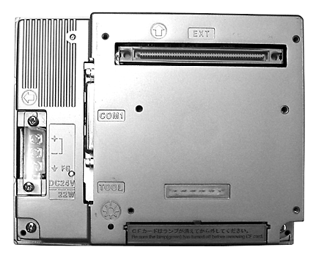
Figure 1. Rear View of GP/GLC2000, QPxC, or QPxS Unit with Connector Cover Removed

Follow the instructions to install the module:
- Disconnect all power connections.
- To avoid ESD damage to the modules, make sure that you are grounded.
- Remove the protective cover from the unit’s connector port. Note: Figure 1 shows the unit with the protective cover already removed.
- Remove the module from the anti-static bag.
- If necessary, change the setting on the DIP switch to correctly specify the host unit (see the section titled Configuring CA3-MBPALL-41 for GP/GLC2xxx Screen Size on page 15).
- Carefully seat the module on the connector of the operator interface (see Figure 2).
- Secure the module to the operator interface by tightening the four screws.

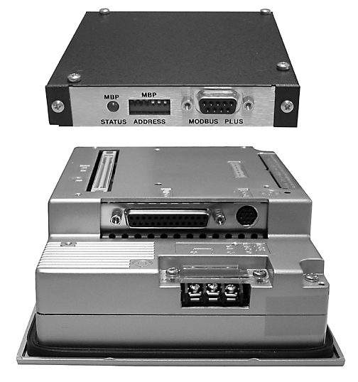
Figure 2. GP/GLC2000, QPxC, or QPxS Unit with CA3-MBPALL-41 Module in Position

QPJMBPXA1 Modbus Plus Module

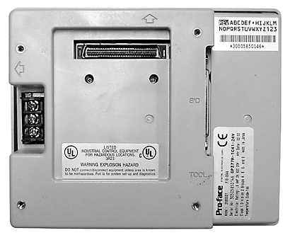
Figure 3. Rear View of a 5” or 6” Unit with Connector Cover Removed

Follow the instructions to install the module:
- Disconnect all power connections.
- To avoid ESD damage to the modules, make sure that you are grounded.
- Remove the protective cover from the unit’s connector port. Note: Figure 3 shows the unit with the protective cover already removed.
- Remove the module from the anti-static bag.
- Carefully seat the module on the connector of the operator interface (see Figure 4).
- Secure the module to the operator interface by tightening the three screws.

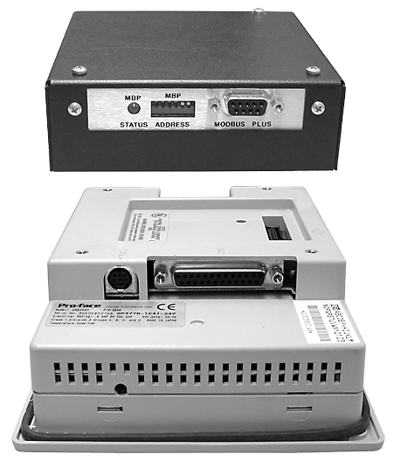
Figure 4. View of a 5” or 6” Unit with QPJMBPXA1 Module in Position

QPIMBPXA1 Modbus Plus Module

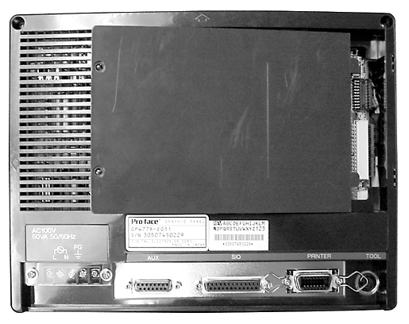
Figure 5. Removing Back Cover from a Typical Larger Screen Unit

Follow the instructions to install the module:
- Disconnect all power connections.
- To avoid ESD damage to the modules, make sure that you are grounded.
- Loosen the two screws and remove the back cover from the rear of the GP/PanelStation (see Figure 5).
- Remove the module from the anti-static bag.
- Angle and insert the module so the tabs are in the correct position as shown in Figure 6. Carefully seat the module on the connector of the operator interface.
- Secure the module to the operator interface by tightening the two screws.

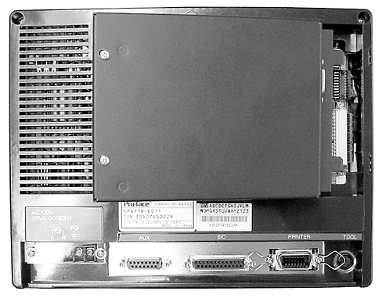
Figure 6. Installing QPIMBPXA1 Module into a Typical Larger Screen Unit

Module Configuration

Diagnostic LED
The LED is controlled by the on-board processor and displays node status by flashing repetitive patterns.
Table 2. Diagnostic LED Patterns
Flash Pattern | Diagnosis
6 flashes per second | This node is working normally by receiving and passing the token. All nodes should be flashing this pattern.
1 flash each second | Monitor Link Operation. This node is in the MONITOR_OFFLINE state, where it must monitor the link for 5 seconds, and it is not allowed to transmit any packets out onto the link.
2 flashes every 2 seconds | Never Getting Token. This node is permanently in the MAC_IDLE state. This node hears other nodes on the link pass the token to themselves, but the token is never passed to this node. This node may have a bad transmitter.
3 flashes every 1.7 seconds | Sole Station. This node is not hearing any other nodes, so it is periodically claiming and winning the token, and then finds there is no other node to pass it to. This node may have a bad receiver.
4 flashes every 1.4 seconds | Duplicate Station. This node has heard a valid packet that was duplicate-node-address sent from another node on the link that is using the same link address as this node. This node is now in the DUPLICATE_OFFLINE state where it will remain passively monitoring the link, until the duplicate node is not heard from for 5 seconds.

Station Address Switches
Each module on a Modbus Plus network must have a unique address in the range from 1 to 64. Use the 6-position switch bank on the side of the module to set the address for your node (Figure 7). Refer to Table 3 and the examples in Table 4 to set the addresses for your module. To set an address, turn on the combination of switches whose values add up to 1 less than the desired address.
Table 3. Station Address Switch Values
Switch Number | 1 | 2 | 3 | 4 | 5 | 6
Switch Value | 1 | 2 | 4 | 8 | 16 | 32

Examples (note that the address is equal to the value set on the switches plus 1):
Table 4. Module Address Examples
Switch Settings | Module Address
1 2 3 4 5 6
1 0 0 1 1 0 | 26 ( = 1 + 8 + 16 plus 1)
0 1 0 1 1 1 | 59 ( = 2 + 8 + 16 + 32 plus 1)
1 0 1 0 0 0 | 6 ( = 1 + 4 plus 1)
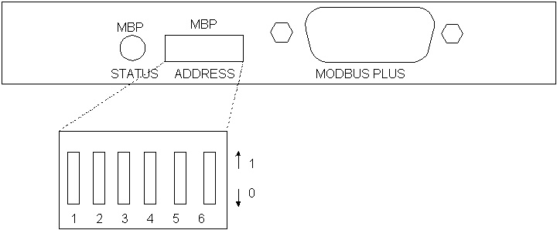
Figure 7. Side View of Module

Configuring CA3-MBPALL-41 for GP/GLC2xxx Screen Size
The CA3-MBPALL-41 will work with all GP/GLC2000 series units, but must be configured to the screen size of the host unit. To configure the module for the screen size of the unit to which it will be attached, adjust the switch (SW2) on the underside of the board according to the settings in Table 4.
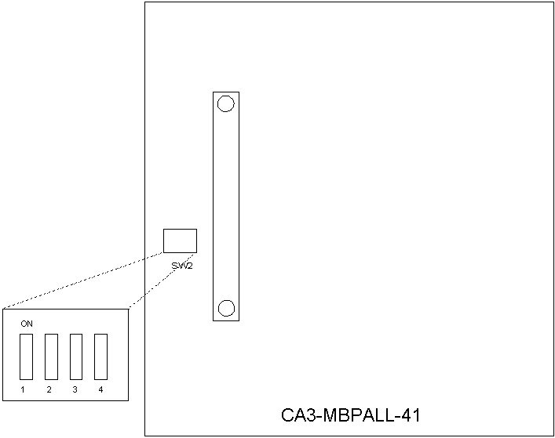
Figure 8. View of Underside of CA3-MBPALL-41 Module, Showing SW2

Table 4. Configuring Screen Size
Switch (Jumpers) | Position/Setting  1 2 3 4 | Module | Possible Unit Types
SW2 (1–4) | Off Off Off Off | CA3-MBPALL-41 | GP/GCL2400, GP2500, GP/GLC2600 (large screen)
SW2 (1–4) | Off On Off Off | CA3-MBPALL-41 | GP2300, GLC2300

Xycom™ Automation, Inc.
734-429-4971
Fax: 734-429-1010
http://www.Xycom.com
Canada Sales: 905-607-3400
Northern Europe Sales: +44-1604-790-767
Southern Europe Sales: +39-011-770-53-11
143201(B)

