Table of Contents
5. ARTEMIS JOINT UNDERTAKING 3
5.1. Introduction to the Artemis JU 3
5.1.1. Budget 3
5.1.2. Governing structure 3
5.2. Overall progress since the establishment of the ARTEMIS JTI/JU 4
5.3. Outline of the main activities and achievements in 2012 8
5.3.1. Running of the JU 8
5.3.2. Second Interim Evaluation 9
5.3.3. Calls implementation in 2012 11
5.3.4. Governance - Major decisions taken by the Governing Board and other JU bodies 14
5.3.5. Main communication activities 15
5.3.6. Success Stories 17
5.4. Call(s) implemented in 2012 18
5.4.1. Call ARTEMIS-2012-1 18
5.5. Project Portfolio 20
5.5.1. Grant agreements signed or under negotiation - GAs signed in 2012 (commitments amount) 20
5.5.2. Grant agreements for which activities have ended and/or final results are available 21
6. ENIAC JOINT UNDERTAKING 31
6.1. Introduction to the ENIAC JU 31
6.1.1. Budget 32
6.1.2. Governing structure 32
6.2. Overall progress since the establishment of the ENIAC JTI JU 33
6.2.1. Funding ratio between European Commission and Member States 36
6.3. Outline of the main activities and achievements in 2012 37
6.3.1. Running of the JU 37
6.3.2. Progress in the implementation of the Strategic Research Agenda 38
6.3.3. Implementation of calls for proposals (CFP) overall 39
6.3.4. Governance - Major decisions taken by the Governing Board and other JU bodies 41
6.3.5. Main communication activities 42
6.3.6. Success story 43
6.4. Calls implemented in 2012 43
6.4.1. ENIAC-2012-1 43
6.4.2. ENIAC-2012-2 46
6.5. Project Portfolio 49
6.5.1. Grant agreements signed (commitment amounts) 50
6.5.2. Grant agreements for which activities have ended and/or final results are available 51
7. FUEL CELL AND HYDROGEN (FCH) JOINT UNDERTAKING 52
7.1. Introduction to the FCH JU 52
7.1.1. Budget 53
7.1.2. Governing structure 53
7.2. Overall progress since the establishment of the FCH JTI/JU 55
7.2.1. A strong and strategic partnership at the forefront of FCH technologies 55
7.2.2. Progress towards the Multi-Annual Implementation Plan (MAIP) objectives 57
7.2.3. Leveraging effect 59
7.2.4. Industry and SME participation to date 59
7.3. Outline of the main activities and achievements in 2012 59
7.3.1. Running of the FCH JU 59
7.3.2. Progress in the implementation of the Multi-Annual Implementation Plan 61
7.3.3. Implementation of calls for proposals (CFP) 61
7.3.4. Evaluation process 63
7.3.5. Governance - Major decisions taken by the Governing Board and other JU bodies 63
7.3.6. Second Interim Evaluation 65
7.3.7. Main communication activities 65
7.3.8. Success stories 67
7.4. Call(s) for proposals implementation in 2012 68
7.4.1. Call for proposals FCH-JU-2012-1 68
7.5. Project Portfolio 72
7.5.1. Grant agreements signed (commitment amounts – during the year 2012) 72
7.5.2. Grant agreements for which activities have ended and/or final results are available 88
GLOSSARY AND ABBREVIATIONS 90

5. ARTEMIS JOINT UNDERTAKING

5.1. Introduction to the Artemis JU
Growing out of the ARTEMIS European Technology Platform (ETP), the ARTEMIS Joint Undertaking (hereinafter referred to as "ARTEMIS JU") was established by Council Regulation (EC) 74/2008 of 20 December 2007 as a public-private partnership between the European Commission, the participating Member and Associated States (by now 23 countries), and ARTEMIS-IA, a non-profit industrial association of R&D actors in the field of embedded computer systems.
The ARTEMIS JU has been set up for a period up to 31 December 2017 with the main objective to tackle the research and structural challenges in embedded systems faced by the industrial sector. The goal is to define and implement a Research Agenda for Embedded Computing Systems. ARTEMIS JU aims to help European industry consolidate and reinforce its world leadership in embedded computing technologies.

5.1.1. Budget
The maximum EU contribution to the ARTEMIS Joint Undertaking is set to € 420 million paid from the appropriations in the general budget of the European Union allocated to the theme "Information and Communication Technologies" of the Specific Programme "Cooperation" under the FP7. The research activities of the entity are supported also through financial contributions from the ARTEMIS member States amounting to at least 1.8 times the EU contribution (€ 756 million) and through in-kind contributions by research and development organisations participating in projects, which at least match the contribution of the public authorities.

5.1.2. Governing structure
The ARTEMIS Joint Undertaking governance structure comprises:
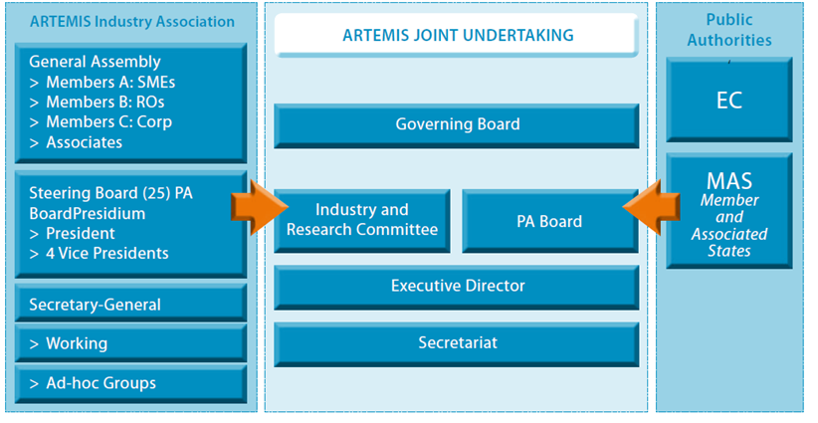
- The Governing Board (GB) has overall responsibility for the operations of the ARTEMIS Joint Undertaking. Its role is to oversee the implementation of the JU. It consists of representatives from industry (ARTEMIS-IA) and public authorities including the Commission and member States. Voting rights are split equally: 50% for industry and 50% for public authorities.
- The Industry and Research Committee (IRC) represents the interests of industry and the research community through ARTEMIS-IA, the Artemis Industrial Association. It consists of members appointed by ARTEMIS-IA. Its role is to draft the Multi-Annual Strategic Plan based on the Research Agenda. In addition, it drafts an Annual Work Programme for the activities of the JU including calls for research proposals.
- The Public Authorities Board (PAB) consists of representatives of the ARTEMIS member States and the European Commission. It discusses and approves the Annual Work Programme. It is also responsible for the decisions on the scope and budget of the calls for proposals, launch of the calls, selection of proposals and allocation of public funds for selected proposals. A third of the voting rights are assigned to the Commission and the remaining two thirds are allocated to Member States.
- The Executive Director is the chief executive of the Joint Undertaking whose role is to ensure its day-to-day management. He is appointed by the Governing Board, for a period of three years and is supported by a secretariat - the ARTEMIS-JU Office - which handles the operational aspects of the JU.

5.2. Overall progress since the establishment of the ARTEMIS JTI/JU
ARTEMIS JU has since 2008 been able to become a reference both in terms of piloting a new model for public-private partnerships in research and in enabling R&D projects co-financed by both Union and national funds. The ARTEMIS JU has launched and managed 44 projects from its first four Calls, started negotiations on 8 projects from its fifth Call and initiated preparations for its sixth and final Call.
The following achievements of the initiative on the embedded systems industry have been realised:
- An effective collaboration between the public and private sectors within the public-private partnership represented by the JU. The 44 running projects represent a total R&D&I investment of 708M€, comprising 228M€ national contributions, 116M€ contribution by the EU and 363M€ from industry. The ratio of national to EU funding – a figure of merit of the leverage effect of the EU contribution – is 1.96. The project 'footprint'/average countries per project is about 7, reducing fragmentation in Europe.
- Combining Union and national efforts in order to support the best European collaborative R&D to contribute to achieving the technology and industrial objectives of the ARTEMIS JTI. The distribution of the investment allocation of projects to the ARTEMIS Sub-Programme (ASPs) of the ARTEMIS Research Agenda is as follows:

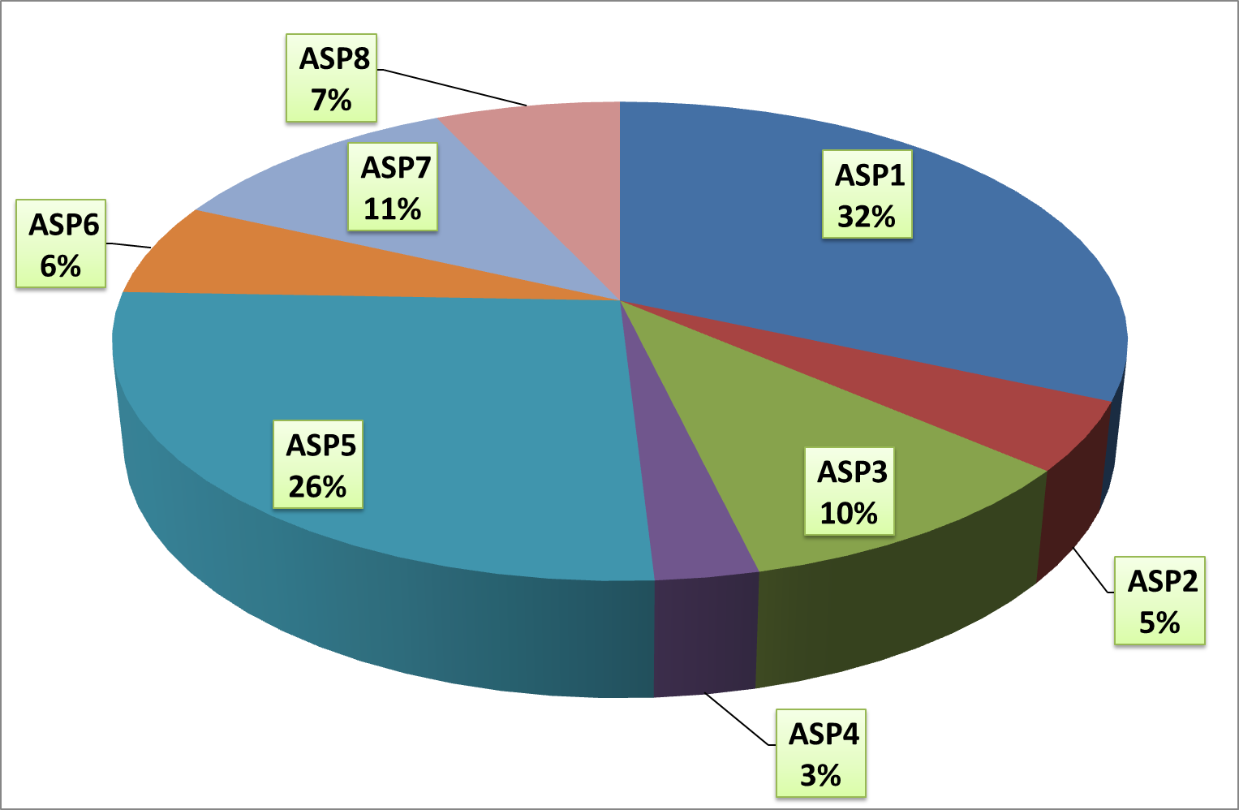
The distribution of investment over the 8 ASPs is mainly in ASP1 (Safety-critical systems, with 32%) and ASP5 (Architectures, with 26%). ASP1 is of high importance to the Transport and Medical industries. It attracts larger projects with directly industrially relevant outcomes. ASP5 addresses the high technical complexity of low-power multi-core platforms. It is made up of generally smaller-scale projects and higher academic content.
- Increasing overall R&D investments in the field of Embedded Computing Systems: the first 4 years of ARTEMIS JU, showed a negative trend in the volume of the commitments of the ARTEMIS member States. The introduction of the concept of AIPPs (ARTEMIS Innovation Pilot Projects) for Call 2012 reversed this trend. The concept of very large projects, that are closer to the market, was positively welcomed by many ARTEMIS member States, resulting in the highest ever commitment for an ARTEMIS call.
- Promoting the involvement of SMEs in the JU activities. Of the 586 unique entities participating in ARTEMIS projects (with many organization participating in multiple projects), 207 (35%) are large enterprises, 210 (36%) are SMEs and 169 (29%) are public research organisations. The 70% industrial participation indicates the industrial focus of the programme. The high SME participation results from the national contribution that favour SME participation, and from the establishment of local ARTEMIS networks.
In order to monitor the progress of the ARTEMIS-JU programme, a specific working group “Success Criteria and Metrics” was set up in 2010. Its goal was to convert the generic targets described in the ARTEMIS SRA into measurable quantities. This was done by conducting a bottom-up study using a targeted questionnaire to the participants in ARTEMIS-JU projects. The results of the first returns were published in 2011. A second questionnaire was launched during 2012. The preliminary analysis of the results shows that:
- Networks have been established and are fully operational. New partnerships and the involvement of SME’s has grown.
- The industry-driven approach and the combination of scientific & industrial views are key strengths and motivators within the ARTEMIS community.
- There is growing awareness of and interaction with the ARTEMIS “Centres of Innovation Excellence” (CoIE).
- Business impact has been mostly observed in reduced development costs, reduced time to market and higher re-usability.
- The ARTEMIS Annual Work Programme targets that are revised for each Call is a very useful living instrument for the ARTEMIS stakeholders.
- The societal challenges are addressed properly, with ‘’security and safety’’ being first number 1.
- There is growing interest in building prototypes and demonstrators, including public trials and/or field tests.
- There has been increasing attention to communication, including on press releases and press coverage, bringing ARTEMIS into the public domain.
Table 1: General overview on ARTEMIS progress - from the establishment up to 2012
Call Reference | Publication date | Evaluation date | Nr of topics | Nr of GA signed | Indicative budget [max funding] (M€) | Outcome of the call (M€)
ARTEMIS-2012-1 | 19/04/2012 | 8-12/10/2012 | 8 ASP + 6 AIPP | 8 under negotiation | 140,28 | 102,04
ARTEMIS-2011-1 | 1/03/2011 | 3-7/10/2010 | 8 ASP | 9 | 72,42 | 68,88
ARTEMIS-2010-1 | 26/02/2010 | 4-8/10/2010 | 8 ASP | 10 | 93,34 | 81,73
ARTEMIS-2009-1 | 5/03/2009 | 28/9-2/10/2009 | 8 ASP | 13 | 104,51 | 101,29
ARTEMIS-2008-1 | 8/05/2008 | 29/9-2/10/2008 | 8 ASP | 12 | 98,9 | 92,45
Total |  |  |  |  | 509,45 | 446,39
The ARTEMIS Calls' submission and evaluation procedure has been completed in one or two stages (i.e. with or without PO phase). The following Calls have had a two phase submission/evaluation process: 2009, 2010 and 2011; and Calls 2008 and 2012 had a one phase submission process (without PO phase).
Table 2: Total number of participant and success rate from the establishment up to 2012
Type of participant | Nr of participants in the Full Project Proposals | Nr of participants in the funded Projects | Participants success rate
Uni/Inst/NP | 920 | 311 | 33,80%
Large Industry | 880 | 366 | 41,59%
SMEs | 840 | 263 | 31,31%
Others | - | -
Total | 2640 | 940 | 35,61%
The data in table 2 counts the participation of a partner in projects as one i.e. multiple participations of an individual partner are not accounted for. Table 3 shows that 50% of Full Project Proposals (FPP) are evaluated to be above threshold and roughly 50% of these above-threshold proposals are funded, giving a “proposal success ratio” of 1 in 4. This ratio is considered to be good as on the one hand it assures good quality in the projects and on the other hand does not discourage participation (especially from SMEs).
Table 3: Overall proposal success ratio
CALL | FPPs submitted | FPPs above threshold | Funded Projects
2008 | 27 | 17 | 12
2009 | 44 | 24 | 13
2010 | 73 | 28 | 10
2011 | 27 | 16 | 9
2012 | 24 | 13 | 8
TOTAL | 195 | 98 | 52
% of total FPPs submitted |  | 50% | 27%
Overall, the 44 on-going projects in ARTEMIS present additional features, as by number of partners and countries involved in consortia and by budget allocated. Statistics are represented in table 4 below.
Table 4: Statistics on running projects – projects dimension and average duration
Projects typology | Min | Max | Average
Number of partners | 8 | 56 | 21
Number of Countries | 4 | 11 | 7
Total Budget | 2.5 M€ | 59 M€ | 16 M€
Duration | > 90% of projects are 3 years, < 10% are 2 years
The geographic distribution on successful participations is summarised in figure 1.
24 Countries have been involved in ARTEMIS projects since its launch. The countries participated most are Italy (with 148 successful organisations involved), Spain (128) and Germany (100). Participation from the EU-13 is as follows: Czech Republic (32), followed by Hungary and Latvia (with respectively 7 and 6 organisations involved).
Figure 1: Overall geographic distribution of successful organisations (by coordinator and participant)
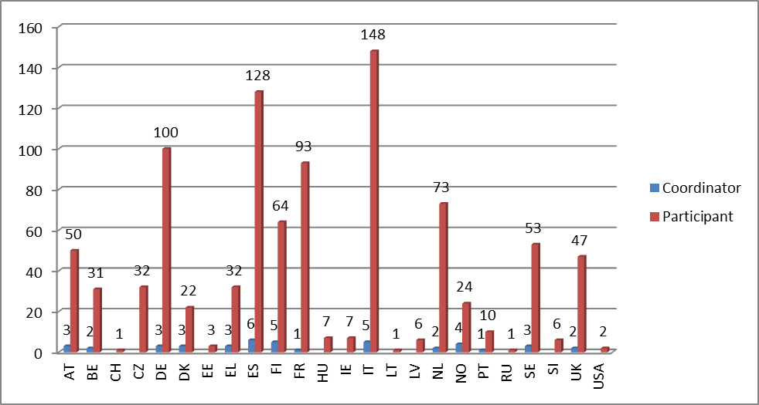

5.3. Outline of the main activities and achievements in 2012

5.3.1. Running of the JU

5.3.1.1. HR issues
ARTEMIS currently hires 13 staff members in total. Staff ensures the execution of the needed financial transactions (payment of salaries, payments to project participants…) according to the Financial Regulation.
In 2012 two positions were filled: one Administrative Assistant to the Programme Officers’ team in October to replace a staff member who resigned; one secretary was recruited in 2012 and will be in the post on January 2013. To cover the gap between September and January, an interim secretary was contracted.

5.3.1.2. Internal Control
In September 2012, notice was given of the discharge given by the Budgetary Authority to the ARTEMIS JU Executive Director for the financial year 2010.
In 2012, the Court of Auditors delivered a qualified opinion on the annual accounts of the JTI for 2011, mainly about the insufficient assurance regarding the transactions at national level upon which the JU payments are based. The Commission is closely monitoring the qualifications made by the Court of Auditors and the follow-up given to these by the Executive Director.
Since the inception of the JTI, the Executive Director has been investing significant efforts to simplify the procedures, ensure sound financial management, implement the Internal Control Standards and work closely together with the member States. Action plans have been established to respond to the Court of Auditors' concerns, including a close follow-up on the ex-post controls done by the member States. The increasing attractiveness of the JTI to member States and industrial investment shows that these efforts are paying off.

5.3.1.3. Administrative expenditure
For the year 2012, it was agreed between the Commission and ARTEMIS-IA that all administrative expenditure (running costs) would be paid according to the following repartition: ARTEMIS-IA 1.2 MEUR and the European Commission 1 MEUR. At the end of the year the needs of ARTEMIS JU for administrative expenditures reached 2M and a consequence the contribution from the European Commission was 0.8M EUR.

5.3.1.4. Agreements signed
In March 2012 ARTEMIS revised the General Financing Agreement (GFA) signed with the European Commission on 17 October 2009 in order to correct the date by which the specific report (i.e. the provisional accounts) should be delivered by the Joint Undertaking. This GFA determines the modalities and conditions applicable to the Union contribution to be provided to the Joint Undertaking and other items defining mutual rights and obligations as considered appropriate by the parties.
An Administrative Agreement was signed with Poland in January 2012.
A host agreement was signed with the Belgian authorities in February 2012.
The following Service level Agreements and/or Memorandum of Understanding have been signed by ARTEMIS in 2012:
Service/DG | Content | Date
REA | Supply of FP7 support services for evaluations and reviews | 09.01.2012
CDT | Translation services | 10.01.2012
DG HR | Centralised services from DG HR | 28.02.2012
DG BUDG | Implementation and usage of ABAC | 17.10.2012

5.3.2. Second Interim Evaluation
The Council decision establishing the ARTEMIS Joint Undertakings foresaw that two interim evaluations (IE) should be carried out by December 31st 2010 and December 31st 2013 respectively. The 2nd Interim Evaluation ran from September 2012 to February 2013 and focused on the assessment of the following four criteria: Relevance; Effectiveness; Efficiency and Research Quality. A panel of 6 independent experts coordinated by a panel chairman and supported by a recorder conducted a systematic and rigorous evaluation, using multiple data sources. The ARTEMIS JU facilitated the interim evaluation by providing relevant documentation and by contributing to panel interviews. The 2nd IE report was published in early June 2013.

5.3.2.1. Progress in the implementation of the Strategic Research Agenda
A Multi-Annual Strategic Plans (MASP), with connected Research Agenda, was approved in December 2011, based on the revised Strategic Research Agenda (SRA). It was further updated and adopted in 2012 to include the findings of the ARTEMIS-ITEA Sherpa group.
The ARTEMIS SRA is articulated in terms of both vertical application areas and horizontal technology thrusts as shown in the figure below:
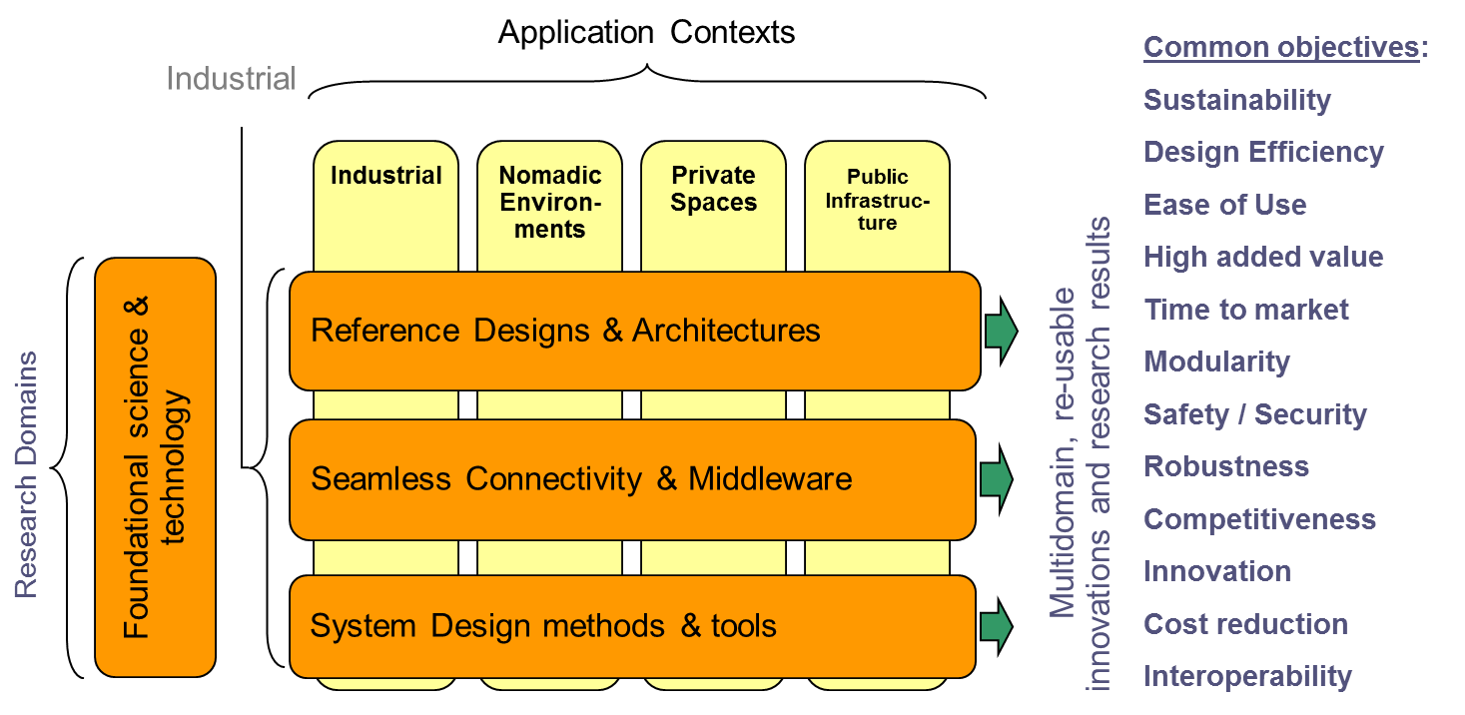
All the relevant industrial communities interested in embedded computing systems, such as downstream system companies and upstream component companies (such as semiconductor, pure software and sub-system suppliers) are involved in ARTEMIS.
Eight ARTEMIS ASPs are defined to facilitate appropriate coverage of the area and involvement of stakeholders:
- ASP1: Methods and processes for safety-relevant Embedded Systems
- ASP2: Embedded Systems for Healthcare and Wellbeing
- ASP3: Embedded Systems in Smart Environments
- ASP4: Embedded Systems for manufacturing and process automation
- ASP5: Computing Platforms for Embedded Systems
- ASP6: Embedded Systems for Security and Critical Infrastructures Protection
- ASP7: Embedded Technology for supporting Sustainable Urban Life
- ASP8: Human-centred design of Embedded Systems
The present situation on the 44 projects selected in the first 5 years is illustrated by the following chart (ASP coverage by averaged count of projects - projects may cover more than one ASP):
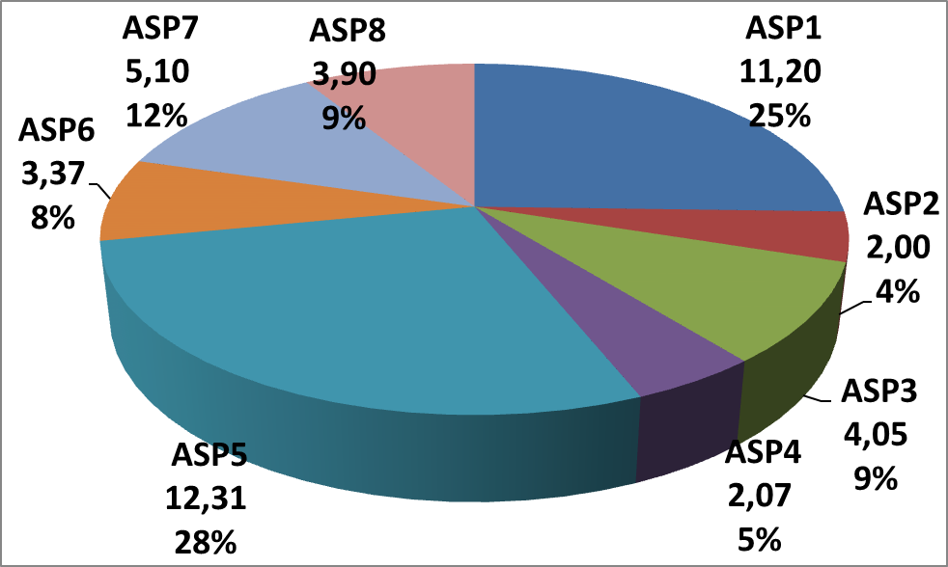
The ASP graph by investment distribution shows a similar distribution.
In 2012 ARTEMIS introduced the AIPPs to cover the full innovation chain from a proof of concept and prototyping stage right through to a solid industrial platform. The implementation will build on the results of the research of ARTEMIS-JU projects clustered around societal challenges. AIPPs aim to achieve long-lasting and self-sustaining “eco-systems” of actors. One of the major characteristics of the new research approach promoted by the ARTEMIS JU is the promotion of cross-fertilization and reuse of technology results in different application domains. The AIPPs are addressing the areas of:
- Critical Systems Engineering Factories.
- Innovative Integrated Care Cycles.
- Seamless Communication & interoperability- smart environment (the neural system of society).
- Production and Energy System Automation.
- Computing platforms for embedded systems.
- “Intelligent-Built” environment and urban infrastructure for sustainable and “friendly” cities.

5.3.3. Calls implementation in 2012
The ARTEMIS JU supports R&D activities through open and competitive yearly call for proposals. The programme is open to organisations in the EU Member States and Associated Countries.
Call 2012 was published on 19 April 2012 with a one-step procedure and a deadline for submission of Full Project Proposals (FPP) on 6th September 2012. The Call text specified the contribution from the Joint Undertaking, the contributions from ARTEMIS member States, the national eligibility criteria, the Guide for Applicants and other information related to the Call.
The total indicative budget of the Call was 140.280.166 €, which includes an ARTEMIS Joint Undertaking contribution of 49.776.833 €, and an ARTEMIS member States contribution of 90.503.333 €. The in-kind effort from industry would be roughly the same amount, yielding a total investment to the projects of roughly 280 M€.
Following the evaluation, the ARTEMIS PAB decides on the selection of proposals and the allocation of funding. The ARTEMIS JU is then mandated by the PAB to negotiate with selected proposals taking into account the maximum public funding allocated and the recommendations for changes, if any.
After the successful conclusion of the negotiations the grant agreements are signed with ARTEMIS JU and participants. Participants that receive national financial contribution from ARTEMIS member States also conclude national grant agreements with the national funding authorities.

5.3.3.1. Evaluation procedure and criteria
The evaluation criteria for full project proposals are set out in the document ARTEMISPAB-4-08: "ARTEMIS Joint Undertaking selection and evaluation procedures related to Calls for proposals". The 5 evaluation criteria are listed in the following table along with the weight and thresholds.
 | Criteria | AWP 2012 part A (ASP) |  | AWP 2012 part B (AIPP)
 | Criteria | Maximum score / weighting | Threshold | Maximum score / weighting | Threshold
1 | Relevance and contributions to the objectives of the call | 10 / 1 | 6 | 5 / 1 | 3
2 | R&D innovation and technical excellence | 10 / 1 | 6 | 10 / 1 | 6
3 | S&T approach and work plan | 10 / 1 | 6 | 10 / 1 | 6
Proposals submitted to ARTEMIS JU calls are evaluated with the assistance of independent experts. This process ensures the principles of equal treatment, excellence and competition.
Funding for ARTEMIS projects follows a unique tripartite model. About 50% of the costs is covered by the partners, the ARTEMIS Joint Undertaking provides 16.7% funding and the member States and/or regions fund the rest. This funding model has been working well in the first years of the Joint Undertaking, but with certain limitations – mainly due to the reduced level of commitments from the member States in the context of the economic and financial crisis.

5.3.3.2. Proposal submission, assessment and evaluation
The proposals were submitted electronically to the ARTEMIS JU via the Electronic Proposal Submission System (EPSS). 25 FPPs (22 ASP’s and 3 AIPP’s) were submitted, all of which except one AIPP satisfied the eligibility criteria for full project proposals. The evaluation was conducted according to the rules set out in document ARTEMIS PAB-4/08: "ARTEMIS Joint Undertaking selection and evaluation procedures related to Calls for proposals".
The total costs and requested funding for the submitted proposals is as follows:
Total Costs Requested | JU Funding Requested | National Funding Requested
485.608.783,00 € | 81.096.666,76 € | 162.475.572,87 €
In addition to the two AIPP proposals, both for more than 80 M€ total cost, there are 4 proposals of more than 20 M€ and 8 proposals of more than 10 M€ and another 5 of very close to 10 M€.
Analysing the participation of the different participant types shows that Call 2012 has again attracted a balanced mix of industry and academia appropriate for its market-facing programme, and again a healthy participation by SMEs. The details of this breakdown are given in the following tables:
Participation by Total Costs
LE | PRO | SME | Grand Total
221.012.801,00 | 143.254.998,00 | 121.340.984,00 | 485.608.783,00
46% | 30% | 25%
Total participations
LE | PRO | SME | Grand Total
184 | 222 | 225 | 631
29% | 35% | 36%
Unique participants
LE | PRO | SME | Grand Total
128 | 133 | 188 | 449
28,5% | 29,6% | 41,9%
The 24 eligible FPPs were submitted to a group of 51 independent experts. AIPP’s and ASP’s each had their own set of evaluation criteria and scoring in order to address their specific needs, as described in the AWP2012. The resulting individual evaluation reports were consolidated into Evaluation Summary Reports (ESR) and an ordered list was established through a panel meeting, held in Brussels from the 8th to the 12th October 2012. 25 of the independent experts attended the panel session, which was also attended by an independent observer. The report of the observer confirmed that procedures and quality controls as set out in the evaluation manual were correctly implemented.
The ESRs were each reviewed by the Executive Director. This ensured consistency of the quality of the ESR and more generally acted as a fine-grained filter quality control. The consistency of the results so achieved gives a very high level of confidence in the quality of the technical selection process.
13 proposals (2 AIPP’s and 11 ASP’s) were evaluated above threshold (40 points minimum on a maximum of 60, with individual threshold on certain criteria).

5.3.3.3. Proposal ranking, selection and allocation of funding
The selection decision was taken by the Public Authorities Board at its meeting on 7th November 2012. The selection took into account the eligibility checks performed by the national authorities. To aid the PAB in making its funding decision, two tools were used. Firstly, a presentation containing the key parameters and abstract of each proposal was made, to serve as a reference base. Secondly, a new adaptation of the funding allocation Excel spread sheet used in previous Calls was made, which allowed for dynamic re-ordering of the proposals giving instant visibility of the impact of suggested ordering changes that takes place during the funding allocation discussions.
The final decision of the PAB was to grant a mandate to the Executive Director for negotiation of 8 proposals, to put 3 proposals in the reserve list and to reject two proposals because of lack of funding. This yields the following table of allocated funding (summary only – full details can be found in the PAB decision ARTEMIS-PAB-2012-D.19).

5.3.3.4. Negotiation and start of R&D projects
As from end of November 2012, the consortia were invited to enter into negotiations for establishing a grant agreement. The negotiation framework allows consortia to provide the relevant documentation in the first 6 weeks of 2013. For the negotiations of project proposals submitted under Call 2012, the Commission’s IT tools will be used, namely NEF (contract negotiation module) and CPM (contract management module).

5.3.4. Governance - Major decisions taken by the Governing Board and other JU bodies
The GB held 3 meetings in 2012, while the PAB met 4 times. The Industry and Research Committee (IRC) had 2 official meetings. The main decisions taken by the GB during the year were related to Annual Implementation Plan 2012 and Annual Budget Plan 2012. All decisions were taken unanimously.
Important decisions of the PAB included the launch of 2012 call and the work programme of 2013.
The ARTEMIS GB took the following decisions:
- ARTEMIS-GB-2012-D.38 Multiannual Staff Policy Plan 2013-2015
- ARTEMIS-GB-2012-D.39 Strategic audit plan for 2012-2014
- ARTEMIS-GB-2012-D.41 Amendment to budget 2012
- ARTEMIS-GB-2012-D.42 AIP 2012
- ARTEMIS-GB-2012-D.43 Extension of the contract of employment of the Executive Director
- ARTEMIS-GB-2012-D.44 Appointment of independent experts to monitor evaluations
- ARTEMIS-GB-2012-D.45 Annual accounts 2011 (decision)
- ARTEMIS-GB-2012-D.46 MASP
- ARTEMIS-GB-2012-D.47 Annual Implementation Plan for 2013
- ARTEMIS-GB-2012-D.48 Budget for 2013
- ARTEMIS-GB-2012-D.50 Call 2012 evaluations: report from observer
- ARTEMIS-GB-2012-D.51 Amendment of budget 2012
- ARTEMIS-GB-2012-D.52 Amendment to AIP 2012
The ARTEMIS PAB took the following decisions:
- ARTEMIS-PAB-2012-D.15 Amendment to selection of proposals retained for negotiation (Call 2011)
- ARTEMIS-PAB-2012-D.16 Amendment to AWP 2012
- ARTEMIS-PAB-2012-D.17 Decision instructing the Executive Director to launch the Call 2012
- ARTEMIS-PAB-2012-D.18 Amendment to rules for evaluation and selection for calls for proposals
- ARTEMIS-PAB-2012-D.19 Selection of project proposals retained for negotiations following Call 2012 and allocation of public funding
- ARTEMIS-PAB-2012-D.20 AWP 2013

5.3.5. Main communication activities
In 2012 ARTEMIS has continued to promote its activities and enhanced the visibility of results achieved so far. In particular, a number of communication activities have been performed and a set of different tools have been used to best reach the target audience.

5.3.5.1. Website
As the web site represents the principal tool to communicate on ARTEMIS to the wider public, the site has been upgraded, both in its content and in the “back-office” Content Management System (CMS). The content of specific pages of common interest, such as “Events”, has been linked between the JU and –IA sites, assuring proper synchronisation and harmonisation of the content presented on those pages. The site has also prepared for full digitalisation of the documents made available (unified data format), and also for compatibility with the growing number of small-format display devices (smart-phones and tablet computers).

5.3.5.2. Publications
- ARTEMIS Magazines 12 and 13. The ARTEMIS magazine is distributed to:
- Cabinet of Commissioner Neelie Kroes
- DG CONNECT unit embedded systems
- ARTEMIS Public Authorities
- ARTEMIS National Contact Points
- Strategic institutes (such as PROMETEO, EICOSE)
- Members of ARTEMIS Industry Association
- ARTEMIS project partners
- ITRE Committee,
- Magazines are also shipped to ARTEMIS events around Europe.
- ARTEMIS Call 2012 Brochure
- Revised ARTEMIS general brochure
- Advertisement. The ARTEMIS Joint Undertaking published an advertisement in the European Parliamentary Yearbook that is disseminated into the European Parliament. Also, a digital announcement on the yearbook website was arranged, including a profile.
- ARTEMIS Newsletter, sent to the ARTEMIS Community a week before the Co-summit.
- ARTEMIS Book of Projects Volume 2 as a follow-up of ARTEMIS Book of Projects Volume 1.
- ARTEMIS Project Folder Call 2010 & 2011, as a follow-up of ARTEMIS Project Folder of Call 2008 & Call 2009. This is a summary of all projects mentioned in ARTEMIS Book of Projects Volume 2.
- ARTEMIS Project Call leaflets & posters for projects from Call 2008/2009/2010/2011. (For call 2011 new posters & leaflets have been produced. For the calls 2009 & 2010 the posters & leaflets have been updated. All Call 2008 projects are finished and all got a poster in the ARTEMIS Walk of Fame, including a ‘finished’ star).

5.3.5.3. Press
Interaction with the press occurred mainly via press releases and interviews. The main press interactions are listed here:
- The pre-announcement for the ARTEMIS Proposers Day was wired to the press database;
- A press release of ARTEMIS project CESAR was distributed;
- An email interview was arranged with the Chair of the JU Governing Board, for the Embedded World Conference and Exhibition newspaper
- Press release for the Call 2012 launch, distributed via the ARTEMIS-IA press database and published on the website.
- ARTEMIS MBAT project press release, distributed to the press and published on the website.
- Research Media (UK) published an interview with ARTEMIS Industry Association chairman Klaus Grimm, focusing on international innovation.
- Pre Co-summit 2012, press release
- Post Co-summit 2012, press release

5.3.5.4. Events
- International Brokerage Event 2012 in Prague, organised by the ARTEMIS Industry Association (17.01.2012 and 18.01.2012).
- ARTEMIS Pre-brokerage event, held in Reading UK on 11.01.2012.
- ARTEMIS Workshop in Finland, organised by TEKES the Electronics Knowledge Centre (1.02.2012)
- ARTEMIS Spring Event 2012 in Nuremberg, coupled with the Embedded World Conference and Exhibition (28 and 29.02.2012).
- ESI symposium 2012, stand on the “information market” in Eindhoven (22.03.2012)
- Call 2012 workshops:
- In Madrid, co-organized with the Ministerio de Industria, Energia y Turismo, The Ministerio de Ciencia e Innovation, CDTI and Prometeo (13.04.2012).
- In Paris, co-organized with Ubifrance and the National Contact Point (20.04.2012)
- In Gdansk, organized in co-operation with ETI and the National Contact Point (11.05.2012).
- Extra AIPP Brokerage Event to further disseminate Call 2012 information for the AIPPs (03.07.2012).
- ARTEMIS-ITEA Co-summit 2012, 30 and 31 October 2012 CNIT - Paris, France.
- Pre-Brokerage Event for Call 2013, in Brussels, Belgium on 13 December 2012.
- In Munich, Germany, the EUROPEAN NANOELECTRONICS FORUM organised by ENIAC & Catrene took place from 20-21 November 2012 in Munich, Germany and was attended by ARTEMIS-JU projects POLLUX and IoE.
- In Reading, United Kingdom, the ARTEMIS Information Workshop took place on 17 December 2012, to disseminate preliminary Call 2013 information.
- Presentations by the Executive Director
- During 2012, the Executive Director actively took part in many ARTEMIS promotion activities, including presentations in 25 events.

5.3.6. Success Stories
The CESAR (Cost-efficient methods and processes for safety relevant embedded systems) project ended on 30.06.2012 and the final review took place on the 2 -4.07.2012. The project cost was more than 58 M€ and 56 partners were involved. CESAR was credited with a very high importance and visibility right from the beginning and its results have a significant impact on the European embedded systems industry, mainly in the area of safety relevant applications, such as automotive, aerospace, rail and industry.
The state of the art in safety-critical embedded systems has considerably been advanced in several areas, both related to processes and products. Many scientific (academic) and technical (industrial) achievements have been published and many of the important results of CESAR have been made available on the CESAR website to the Embedded System community. A significant number of breakthroughs and innovations are part of the CESAR results particularly on cross-sectoriality and /or to overcome barriers and obstacles that hampered reusability of design approaches, reference architectures for ES, technology platforms and tools in the Embedded System Community at large. A large number of deliverables and demonstrators (pilot applications) were developed and shown.
CESAR has shown the value of a large project. CESAR had the critical mass, as well as the right mix of partners, to present a uniform set of processes, tools, guidelines and examples for the development of safety-critical embedded systems.
The Objective of POLLUX - which stands for Process Oriented Electronic Control Units for Electric Vehicles developed on a multisystem real-time embedded platform - is to develop a distributed real time embedded systems platform for next generation electric vehicles, by using a component and programming-based design methodology. Reference designs and embedded systems architectures for high efficiency innovative mechatronics systems will be addressed with regard to requirements on composability, networking, security, robustness, diagnosis, maintenance, integrated resource management, evolvability and self-organization. This approach is extremely promising in predicting the drive behaviour of the electric car, which underpins the successful market appreciation of such a vehicle. So far the Project has achieved most of its objectives and technical goals. Software in the loop (SIL) simulation of vehicle dynamics was given that is received as a major positive outcome in the project.
Investigations are on-going on the usability of ethernet approach for in car communications (including safety-critical ones). The physical demonstrators – 2 electric vehicles – are being developed to validate the POLLUX approach. Hereto the work is not completed, but it is progressing according to plan.
eSONIA stands for Embedded Service-Oriented Monitoring, Diagnostics and Control: Towards the Asset-Aware and Self-Recovery Factory. Its objectives are to realise the asset-aware and self-recovery plant through pervasive heterogeneous IPv6-based embedded devices, bringing on-board specialised services, glued through a middleware capitalising the service orientated approach. This will be applied in industry for the first time, in order to support continuous monitoring, diagnostics, prognostics and control of assets, regardless of their physical location. The project will contribute to reduced costs of maintenance and increased up-time in manufacturing in the specified use cases but also in other industries as the technology is generic and the solutions are designed in a way that can be applied to current production systems. The project thus contributes to current state of art and addresses important interoperability issues.

5.4. Call(s) implemented in 2012

5.4.1. Call ARTEMIS-2012-1

5.4.1.1. Summary information
Call Identifier | ARTEMIS-2012-1
Publication date | 19/04/2012
Deadline | 06/09/2012
Indicative Total budget (in €) | 140,28 M€
EU contribution after evaluation | 37,95 M€
MS contributions after evaluation | 64,05 M€
In-kind contribution after evaluation | 125,42 M€
Reference to call topics | All 8 ASP and 6 AIPP topics are relevant

5.4.1.2. Analysis of proposals submitted
- Number of proposals submitted and, if appropriate, by topic:
- Total: 25
- Eligible for evaluation: 24
- Number of participants in the submitted proposals:
- Total: 631

5.4.1.3. Evaluation results
- Number of proposals submitted and, if appropriate, by topic: 24
- Passing the thresholds, failing the thresholds: 13 above threshold /11 below threshold
- Proposed for funding, and reserve list: 8 for funding /3 in reserve list
- Success rate: 33.3%
- Number of participants in the proposals selected for funding:
Total: 326
SMES: 106 – Budget allocated to SMEs equal to € 9.6 M.
Table 5: Evaluation results
Call Reference | Submitted Full Project Proposals |  |  | Evaluation results |  |  | Reserve list, if any % of retained
Call Reference | Submitted Full Project Proposals | Eligible FPPs | % of retained | Above threshold | Selected for funding | Success rate% | Reserve list, if any % of retained
ARTEMIS-2012-1 | 25 | 24 | 0,96 | 13 | 8 | 32% | 3 proposals, 23% of above  threshold
Table 6: Participation by type and success rate
Type participant | Nr of participants in the Full Project Proposals | Nr of participants in the funded Projects | Participants success rate
Uni/Inst/NP | 222 | 108 | 48,65%
Large Industry | 184 | 112 | 60,87%
SMEs | 225 | 106 | 47,11%
Others | - | 0
Total | 631 | 326 | 51,66%
In 2012, 18 Countries participated in the 8 selected for funding projects. Spain with 45 participations, Italy (44) and France (38) followed by Germany, resulted as the most represented countries. The Czech Republic and Poland registered the highest participation from EU-13 Countries. Turkey was the only associated country that took part successfully to calls in 2012.
Figure 2: Participation by country – selected for funding projects

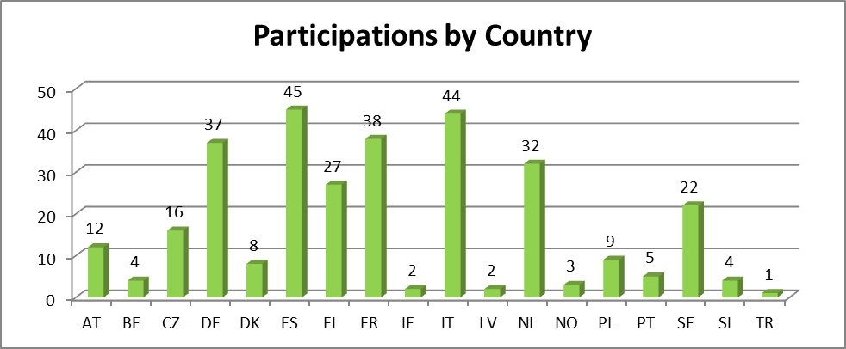

5.5. Project Portfolio

5.5.1. Grant agreements signed or under negotiation - GAs signed in 2012 (commitments amount)
The following table provides the list of projects for which grant agreements have been signed by Call identifier:
№ | GA № | Project acronym | Call Identifier | A | B | C | D | E
 |  |  |  | JU contribution | In-kind contribution | Own resources | National funding | Total contribution
 |  |  |  |  |  | (Other than B) | National funding | A+B+C+D
1 | 295378 | e-GOTHAM | ARTEMIS-2011-1 | 1.142.417,11 | 3.163.265,89 | - | 2.535.138,00 | 6.840.821,00
2 | 295311 | VeTeSS | ARTEMIS-2011-1 | 3.212.373,42 | 9.768.418,20 | - | 6.254.977,38 | 19.235.769,00
3 | 295371 | CRAFTERS | ARTEMIS-2011-1 | 2.937.789,52 | 8.490.854,03 | - | 6.162.910,45 | 17.591.554,00
4 | 295372 | DEMANES | ARTEMIS-2011-1 | 3.430.086,48 | 10.387.644,71 | - | 6.721.708,81 | 20.539.440,00
5 | 295373 | nSafeCer | ARTEMIS-2011-1 | 2.722.812,59 | 8.960.670,66 | - | 4.620.783,75 | 16.304.267,00
6 | 295364 | DESERVE | ARTEMIS-2011-1 | 4.328.019,73 | 14.075.250,03 | - | 7.513.016,06 | 25.916.285,82
7 | 295354 | SESAMO | ARTEMIS-2011-1 | 1.968.114,44 | 6.824.278,14 | - | 3.220.723,82 | 12.013.116,40
8 | 295397 | VARIES | ARTEMIS-2011-1 | 2.200.959,23 | 5.827.033,91 | - | 5.151.403,42 | 13.179.396,56
9 | 295440 | PaPP | ARTEMIS-2011-1 | 1.732.709,34 | 5.766.132,27 | - | 3.030.663,00 | 10.529.504,60
TOTALS |  |  |  | 23.675.281,85 | 73.263.547,84 | - | 45.211.324,69 | 142.150.154,38

5.5.2. Grant agreements for which activities have ended and/or final results are available
The following table indicates the projects which have had their final review in 2012. Due to administrative processing, including in the Member States administrations, the final payments were still pending at the end of 2012. Therefore the amounts indicated in the table are the committed amounts as agreed in the PAB decisions of the first and second calls of ARTEMIS.
 | GA № | Project Start Date | Date GA ended | Project acronym | Project features | A | B | C | D | E
 |  |  |  |  |  | JU contribution | In-kind contribution | Own resources | National funding | Total contribution
 |  |  |  |  |  |  |  | (Other than B) | National funding | A+B+C+D
1 | 100039 | avr-09 |  | CHARTER | CHARTER will develop concepts, methods, and tools for embedded system design and deployment that master complexity and substantially improve the development, verification and certification of critical systems. | 850868,841 | 2577346,159 | 0 | 1666808 | 5095023
2 | 100012 | févr-09 |  | eDIANA | To enable sustainable urban life, eDIANA targets rationalization of the use of resources while increasing comfort by means of embedded systems technologies in residential and commercial buildings. To achieve greater efficiency in use of resources, it aims at prioritizing energy use, more flexibility in the provision of resources and better situation awareness for the citizen and for service and infrastructure owners. | 2894188,167 | 9775161,973 | 0 | 4661117,86 | 17330468
3 | 100035 | janv-09 |  | SYSMODEL | SYSMODEL will develop supportive modelling tools for the design and implementation of time and power critical heterogeneous systems. The focus is on reuse of existing models and their integration in a heterogeneous system. The vision is to allow SMEs to build cost-efficient ambient intelligence systems with optimal performance, high confidence, reduced time to market and faster deployment. | 897457,1718 | 2084531,358 | 0 | 2392126,87 | 5374115,4
4 | 100026 | mars-09 |  | iLAND | iLAND will develop enabling technologies for modular, component-based middleware for networked systems that demand deterministic, dynamic functional composition and reconfiguration. Its results embrace a lightweight middleware architecture offering deterministic services and QoS-based resource management, and an approach for modelling deterministic, dynamic reconfiguration and composition of applications, with validation through three application demonstrators. | 653471,531 | 1711898,809 | 0 | 1547632,76 | 3913003,1
5 | 100021 | avr-09 |  | INDEXYS | INDEXYS will develop a cross-domain instantiation of the GENESYS embedded system architecture, for Industrial-grade exploitation on real-world platforms in Railway, Aerospace, Automotive and Industrial Control domains. | 1226367,005 | 3397705,995 | 0 | 2719442 | 7343515
6 | 100022 | févr-09 |  | CHESS | CHESS aims to build modelling languages for extra-functional properties, and develop tools for evaluation of these properties of component contracts. It will adapt component infrastructures for the integration of real-time and dependable patterns, and validate the approach through multi-domain case studies. | 1990537,461 | 5838163,879 | 0 | 4090685,24 | 11919386,58
7 | 100032 | mars-09 | avr-13 | SMART | SMART will create an innovative WSN infrastructure based on both off-the shelf reconfigurable devices (FPGAs) and specially designed Reconfigurable Application Specific Instruction Set Processors (RASIPs). This infrastructure will support video and data compression as well as high-levels of security with lower power consumption than existing solutions. | 594177,344 | 1784706,056 | 0 | 2071860,6 | 4450744
8 | 100016 | mars-09 |  | CESAR | CESAR targets significant reduction of overall development time and effort, between 30% and 50%, using a Reference Technology Platform (RTP). The aim is, within 5 years, to double the number of European technology providers and SMEs joining the CESAR ecosystem and reduce by 50% the cost of integration, configuration, deployment, and maintenance of tool-chains. | 9500583,177 | 30215637,1 | 0 | 18816899,34 | 58533119,62
9 | 100036 | mars-09 |  | EMMON | EMMON will perform technological research of new, efficient, and low-power consumption communication protocols, embedded middleware with better overall energy-efficiency, fault-tolerance and reliability for large scale monitoring, remote command & control operational systems for end-users and development of network planning and deployment tools to facilitate and assist those same deployments. The quantified goal of the project is to create an integrated framework of technologies for large scale and dense wireless sensor networks that allow effective monitoring for more than 10,000 devices. This would advance WSN deployment size by one order of magnitude. The EMMON project is preparing the final demonstrator to show the real world example of the EMMON technology. Due to external factors this will be shown to the ARTEMIS Project Officer and invited experts at the end of May 2012 | 406691,424 | 970736,076 | 0 | 1185850,5 | 2563278
10 | 100017 | janv-09 |  | SOFIA | SOFIA will create an Open Innovation Platform (OIP) providing the interoperability that allows interaction between multi-vendor devices. For this, it will create interaction models and embedded devices that support a variety of “smart spaces” and a variety of users, and develop methods, techno-economic structures and toolkits for the deployment of smart environments and for the development of services and applications based on them. It will also define scenarios to demonstrate the capabilities of the OIP in personal spaces, indoor spaces and cities. | 6093013,203 | 21238458,8 | 0 | 9153637 | 36485109
11 | 100224 | juin-10 |  | pSHIELD | SHIELD aims at addressing Security, Privacy and Dependability (SPD) in the context of Embedded Systems (ESs) as “built in” rather than as “add-on” functionalities, proposing and perceiving the first step toward SPD certification for future ES. | 900599,2817 | 2987141,828 | 0 | 1505068,97 | 5392810,08
TOTALS |  |  |  |  |  | 26007954,61 | 82581488,03 | 0 | 49811129,14 | 158400571,8

6. ENIAC JOINT UNDERTAKING

6.1. Introduction to the ENIAC JU
The ENIAC Joint Undertaking (hereinafter referred to as "ENIAC JU") was established by Council Regulation (EC) 72/2008 of 20 December 2007 as a public-private partnership between the European Commission, the participating Member and Associated States (by now 22 countries) and AENEAS, a non-profit industrial association of R&D actors in the field of semiconductors.
The ENIAC JU has been set up for a period up to 31 December 2017 with the main objective to tackle the research and innovation in nanoelectronics technologies and their integration in smart systems. The goal is to define and implement a Strategic Research Agenda (SRA) on Nanoelectronics-Based Systems in Europe. ENIAC JU aims to help European industry consolidate and reinforce its position in nanoelectronics technologies and systems.
The nanoelectronics industry is the provider of all integrated circuits found in all devices and equipment requiring either standalone computational capacity or interaction with human beings or their environment. Progress of the past decades in work efficiency was largely driven by such smart components. It is evident that personal computers, cell phones and related personal devices improved the life quality of people overall.
The strategic importance of nanoelectronics was recognized and triggered the establishment of ENIAC JU as a way to improve European competitiveness in these enabling fields. First of all, they allow for a concerted effort at the European level through the funding of R&D projects where the industry is a major actor. This is done through Strategic Research Agendas established by the related ETPs, i.e. AENEAS in the case of ENIAC. The vision was to reduce unnecessary duplication and improve the cooperation between the R&D public and private actors in Europe. Furthermore this helped to cope with the fast increasing R&D costs in nanoelectronics due to extreme miniaturization. Funding down to innovation is increasingly necessary to address the innovation gap and bridge R&D to deployment. This will help to keep innovation capability in Europe instead of producing high class research that is industrialized elsewhere in the world.
In 2011, the recommendations of the High-Level Group on Key Enabling Technologies (KET) led to a positive influx on the activities of the ENIAC JU. Increased support by Member States allowed the ENIAC JU to successfully execute 2 calls in 2012. As a result the downwards trend in funding has been reversed. The provision for a KET-related call in the Annual Work Programme 2012 was approved at the end of 2011. This approval facilitated the funding of projects at higher levels of Technological Readiness (TRL).
ENIAC coordinates research activities through competitive calls for proposals to enhance the further integration and miniaturization of devices, and increase their functionalities while delivering new materials, equipment and processes, new architectures, innovative manufacturing processes, disruptive design methodologies, new packaging and ‘systemising’ methods. It drives and is driven by innovative high-tech applications in communication and computing, transport, health care and wellness, energy and environmental management, security and safety, and entertainment.

6.1.1. Budget
The maximum EU contribution to the ENIAC JU covering running costs and R&D activities is set to € 450 million paid from the appropriations in the general budget of the European Union allocated to the theme "Information and Communication Technologies" of the Specific Programme "Cooperation" under the FP7. The research activities of the entity are supported also through financial contributions from the ENIAC member States amounting to at least 1.8 times the EU contribution (i.e. € 810 million for a total EU contribution of € 440 million) and through in-kind contributions by research and development organisations participating in projects, which at least match the contribution of the public authorities.

6.1.2. Governing structure
The ENIAC JU is managed by an Executive Director. Its governance structure comprises a Governing Board (GB), a Public Authorities Board (PAB) and an Industry and Research Committee (IRC).
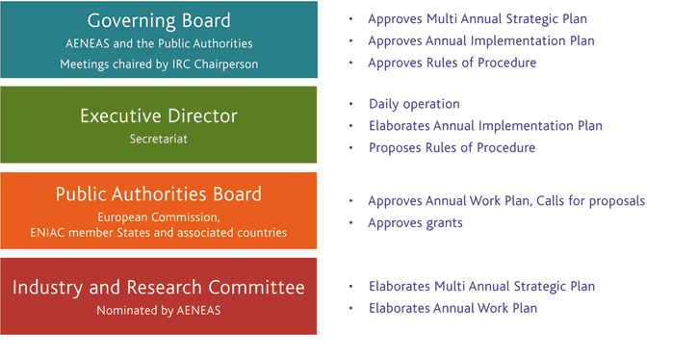
The Governing Board consists of representatives of the members of the ENIAC Joint Undertaking and the chairperson of the industry and research committee. It has the overall responsibility for the operations of the ENIAC Joint Undertaking and oversees the implementation of its activities.
The Executive Director is the chief executive responsible for the day-to-day management of the ENIAC Joint Undertaking in accordance with the decisions of the governing board and its legal representative.
The Public Authorities Board consists of the public authorities of the ENIAC Joint Undertaking. It is responsible for, among others, ensuring that the principles of fairness and transparency are properly applied in the allocation of public funding to participants in projects; discussing and approving the annual work programme upon proposals from the industry and research committee, including the budgets available for calls for proposals; approving the rules of procedure for calls for proposals, for the evaluation and selection of proposals and for monitoring of projects; upon proposal of the representative of the Community, deciding on the ENIAC Joint Undertaking financial contribution to the budget of the calls for proposals; approving the scope and the launch of calls for proposals; approving the selection of project proposals to receive public funding following calls for proposals; upon proposal of the representative of the Community, deciding on the percentage of the ENIAC Joint Undertaking's financial contribution to participants in projects arising from calls for proposals in any given year.
Members of the Industry and Research Committee are appointed by the AENEAS Association. This Committe consists of no more than 25 members. It is responsible for, among others, elaborating the draft multiannual strategic plan and submit it to the governing board for approval; preparing the draft annual work programme; elaborating proposals regarding the technological, research and innovation strategy of the ENIAC Joint Undertaking; elaborating proposals for activities regarding the creation of open innovation environments, promoting the participation of SMEs, developing standards transparently and with openness to participation, international cooperation, dissemination and public relations; advising the other bodies on any issue related to planning and operating research and development programmes, fostering partnerships and leveraging resources in Europe in order to achieve the objectives of the ENIAC Joint Undertaking; appointing working groups where necessary under the overall coordination of one or more members of the industry and research committee in order to achieve the above tasks.

6.2. Overall progress since the establishment of the ENIAC JTI JU
The impact of the initiative on the semiconductor industry is observed in the following achievements:
- It defined and implemented a Research Agenda strengthening the relevant areas in which Europe improved its competitiveness by directing funding to the priority subjects, in the first line to “Energy Efficiency” (24%), “Equipment, Materials and Manufacturing” (28%) and "Semiconductor Process and Integration" (25%).
- The first projects approaching completion demonstrated significant advances of the state of the art in their respective fields, strengthening the global competitive position of the European industry.
- It leveraged the public investments, increasing the amounts contributed by the ENIAC member States by a factor of 2.5 (from €62 million in 2008 to €150 million in 2012) and the EU contributions by a factor of 3.5 (from €35 million in 2008 to €125 million in 2012). The private sector increased its contributions by a factor of 5 (from about €110 million in 2008 to an estimate amount exceeding €550 million in 2012).
- It engaged the whole ecosystem, allowing the countries with smaller national programmes in nanoelectronics to contribute to a combined level equivalent to the three leading nations.
- It created opportunities to contribute for the SMEs that represent 24% of the participating organizations, inducing collaboration of the large industry (41% of the participating organizations) and the academic and technological research (35%).
- The project proposal, submission and evaluation mechanisms allow to execute the whole cycle within 7-9 months.
- It is the only mechanism that already engaged in implementing the KET policies to the extent to which they are compatible with the existing regulations, rules and procedures, playing the role of a catalyser federating all contributors towards re-engaging the European semiconductor industry on a path of profitable growth.
- It induced a new quality of collaboration between the stakeholders that resulted in remarkable progress in the past and provides a solid basis for the future strategic perspectives.
Table1: General overview on ENIAC progress - from the establishment up to 2012
Call Reference | Publication date | Evaluation date | Nr of topics | Nr of GA signed | Indicative budget [max funding] (M€) | Outcome of the call (M€)
ENIAC-2008-1 | 8/05/2008 | 28/10/2008 | 5 | 7 | 89,8 | 95,6
ENIAC-2009-1 | 19/03/2009 | 13/11/2009 | 8 | 11 | 104,4 | 106,2
ENIAC-2010-1 | 26/02/2010 | 2/11/2010 | 7 | 10 | 86,0 | 87,5
ENIAC-2011-1 | 23/02/2011 | 27/07/2011 | 18 | 6 | 70,8 | 53,1
ENIAC-2011-2 | 24/06/2011 | 11/11/2011 | 18 | 5 | 99,4 | 62,7
ENIAC-2012-1 | 23/02/2012 | 29/10/2012 | 25 | 6 | 73,3 | 55,2
ENIAC-2012-2 | 4/05/2012 | 29/10/2012 | 25 | 5 | 193,2 | 218,9
Total |  |  | 106 | 50 | 630,9 | 679,2
NB: this table takes into account the 2 cancelled projects as compared to PAB decisions and as reported in the 2012 ENIAC AAR
Table 2: Aggregated information on the number of participant and success rate by participant from the establishment up to 2012
Type participant | Nr of participants in the Project Outlines | Nr of participants in the Full Project Proposals | FPPs participants success rate | Nr of participants in the Funded Projects | Participants success rate
Public Bodies | 1 | 1 | 100,0% | 0 | 0,0%
Research organisations | 274 | 312 | 113,9% | 191 | 69,7%
Higher or secondary education | 363 | 359 | 98,9% | 190 | 52,3%
Private for profit (excl. education) | 640 | 737 | 115,2% | 435 | 68,0%
SMEs | 370 | 443 | 119,7% | 253 | 68,4%
Others | 15 | 5 | 33,3% | 0 | 0,0%
Total | 1663 | 1857 | 111,7% | 1069 | 64,3%
NB: not all calls were subject to PO phase, this explains the higher than 100% success rate at FPP level. Due to the two-stage evaluation and to the recommendations provided by evaluators after the first step evaluation, it occurred that a number of consortia in the submitted Project Outlines decided to add specific capabilities and/or equipment following the feedback given by the independent experts. This resulted in a higher number of participants at the level of FPP, as shown in the table above.
Figure 1: Overall geographic distribution of successful organisations (by coordinator and participant)
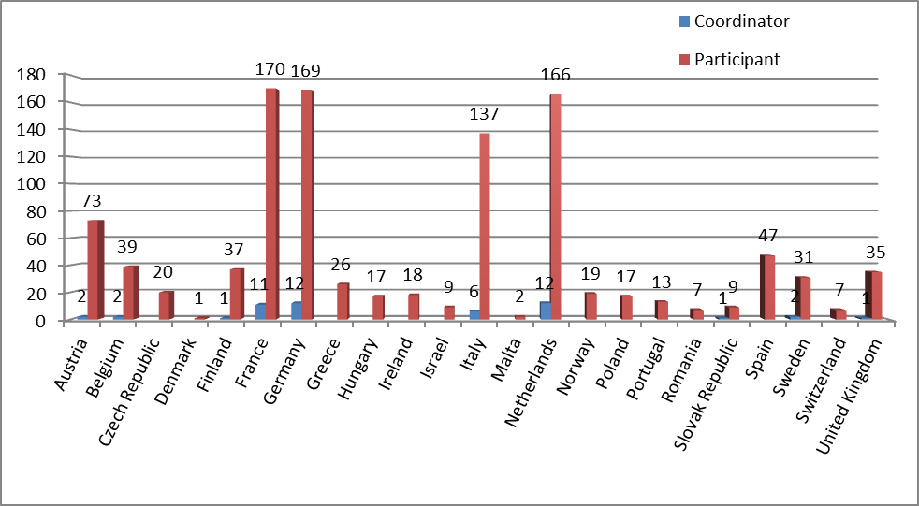
The situation on the 50 projects selected over the first 5 years is illustrated by the following chart where numbers refer to eligible costs of the funded projects.

This graph reflects an overall balance between the applications and technology topics as identified in the SRA. On the applications side, almost 1/4 of the total implementation is related to energy efficiency – a very important topic in which nanoelectronics can provide significant improvements and innovation. Automotive, communications and health are balanced and take the largest portion of the rest of the applications. The increase of the technology share in the total funding reflects the weight of the pilot lines, focus of the second call of 2012.

6.2.1. Funding ratio between European Commission and Member States
The Statutes of the ENIAC Joint Undertaking state in Art. 11.6(b) that "financial contributions from ENIAC Member States shall amount in total to at least 1.8 times the Community's financial contribution".
This requirement has to be met at the end of the implementation of the ENIAC JU, i.e. essentially at the end of 2013 when the total commitment contributions to projects from the Union and the ENIAC Member States will be known.
In the previous years and especially in Call 2 ('KET' call) in 2012, the target of 1.8 was not reached for ENIAC JU. The main reason for the deviation of the ratio is that the focus of the calls influences the funding regime applied by the ENIAC member States. ENIAC member States overall lower their contribution to pilot lines as these are considered as 'experimental development' rather than 'applied research'. Typically the total public funding (EU and ENIAC member States) is set at 25% for large organizations with the JU funding rate at 15%. A differentiated analysis of the period 2008-2012 shows this effect:
Here it appears that the ratio 1.8 is almost adhered to for 'standard' calls (1.72) while it deviates significantly for the 'KET' calls (0.96).
Furthermore the EU contribution calculated as a fixed percentage (55%) of the national commitments was consumed in each call, also in case the national commitments were not fully allocated and EU commitments were granted to support participants in projects when there was no national funding available. Indeed the Regulation imposes that all beneficiaries receive the same JU funding rate whether or not partners receive national funding. In these instances, de facto the partners in the projects contribute more of their own resources, which explain the large volume of activities, shows their commitment and the high leverage effect of JU funding.
Developments such as the KET initiative induced a changed landscape which could not be foreseen at the launch of the ENIAC JU. This had an impact on the financing model which stipulated 2/3 Member States and 1/3 EU funding. The funding ratio target value at 1.8 for the 'standard' projects is fully in line with the Council Regulation whilst a lower funding ratio for 'KET' pilot projects results. Note in this context that the leverage effect of the EU contribution is fully in line with the Council Regulation, i.e. a leverage effect of a factor of 6.

6.3. Outline of the main activities and achievements in 2012

6.3.1. Running of the JU
Within a small structure, the basic functions remained unchanged in 2012: one operational unit, one administration and finance unit, and one secretariat. The ENIAC JU will reach its Staff ceiling in January 2013, when a Seconded National Expert is expected to join.
The increase in personnel made necessary a number of changes, which have been executed in January 2012, in particular the financial circuits have been updated to include the additional resources and ensure a back-up for every function.
The Data Protection Officer (DPO) was nominated on 27 September 2011 and in 2012, the European Data Protection Supervisor (EDPS) performed a survey and issued its report on the “Status of Data Protection Officers” confirming that the ENAC JU is compliant.
The ENIAC JU also nominated its Local IT Security Officer (LISO).

6.3.1.1. Internal Control
In 2012, the Court of Auditors delivered a qualified opinion on the annual accounts of the JTI for 2011, mainly related to the insufficient assurance regarding the transactions at national level upon which the JU payments are based. The Commission is closely monitoring the qualifications made by the Court of Auditors and the follow-up given to these by the Executive Director.
Since the inception of the JTI, the Executive Director has been investing significant efforts to simplify the procedures, ensure sound financial management, implement the Internal Control Standards and work closely together with the Member States. Action plans have been established to respond to the Court of Auditors' concerns, including a close follow-up on the ex-post controls done by Member States. The increasing attractiveness of the JTI to Member States and industrial investment shows that these efforts are paying off.
The IAS issued on 12 June 2012 the “Annual Internal Audit Report for 2011 (Article 72 (4) of the Framework Financial Regulation) for the ENIAC Joint Undertaking”. The ENIAC JU management defined an action plan to address the weaknesses that were identified.
In 2012 the ENIAC JU continued collaborating with ARTEMIS JU in collecting the national audit policies. The report of the IAS chartered to assess the national procedures indicated to the ENIAC JU that the available data is not conclusive. Consequently, the ENIAC JU changed its strategy and mandated the IAC to propose and then execute an audit.
In essence, the audit involved a sample of 161 transactions randomly pulled from all transactions executed since the programme inception, in compliance with the statistical model defined by the Commission, using the Monetary Unit Sampling.

6.3.1.2. Second Interim evaluation
The Council Regulation foresees for the ENIAC JU two interim evaluations (IE) tod be carried out by December 31st 2010 and December 31st 2013 respectively. The 2nd Interim Evaluation ran from September 2012 to February 2013 and assessed the following: Relevance; Effectiveness; Efficiency and Research Quality. A panel of 6 independent experts coordinated by a panel chairman and supported a Recorder conducted a systematic and rigorous evaluation, using multiple data sources. The ENIAC JU facilitated the process by providing relevant documentation and by contributing to the panel interviews. The 2nd IE report will be published in early June 2013.

6.3.2. Progress in the implementation of the Strategic Research Agenda
The Annual Work Programme 2012 (AWP2012) is based on the "Vision, Mission and Strategy for European Micro- and Nanoelectronics" jointly set out with CATRENE. The topics are shown in the table below.
APPLICATIONS |  | TECHNOLOGY
1. Automotive and Transport | Intelligent Electric Vehicle | 6. Design Technology | Managing Complexity
1. Automotive and Transport | Safety in Traffic | 6. Design Technology | Managing Diversity
1. Automotive and Transport | Co-operative Traffic Management | 6. Design Technology | Designing for Reliability and Yield
2. Communication and Digital Lifestyle | Internet Multimedia Services | 7. Semiconductor Process and Integration | Know-how on Advanced and Emerging Semiconductor Processes
2. Communication and Digital Lifestyle | Evolution to a Digital Lifestyle | 7. Semiconductor Process and Integration | Competitiveness through Semicond. Process Differentiation
2. Communication and Digital Lifestyle | Self-organizing Networks | 7. Semiconductor Process and Integration | Opportunities in System in Package
2. Communication and Digital Lifestyle | Short-range Convergence | 8. Equipment, Materials and Manufacturing | Advanced CMOS - 1Xnm & 450mm
3. Energy Efficiency | Sustainable and Efficient Energy Generation | 8. Equipment, Materials and Manufacturing | More than Moore
3. Energy Efficiency | Energy Distribution and Management - Smart Grid | 8. Equipment, Materials and Manufacturing | Manufacturing
3. Energy Efficiency | Reduction of energy consumption
4. Health Care and Aging Society | Home Healthcare
4. Health Care and Aging Society | Hospital Healthcare
4. Health Care and Aging Society | Heuristic Healthcare
5. Safety and Security | Consumer and Citizen Security
5. Safety and Security | Securing the European Challenging Applications
5. Safety and Security | Enabling Technologies for Trust, Security and Safety

6.3.3. Implementation of calls for proposals (CFP) overall
The ENIAC JU supports R&D activities through open and competitive calls for proposals published on a yearly basis. The programme is open to organisations in the EU Member States and Associated Countries. Selected projects are co-financed by the ENIAC JU and the countries that have joined ENIAC. The ENIAC JU implements significant parts of the above referred Strategic Research Agenda.
Funding decisions under the ENIAC JU Annual Work Programme are made on the basis of proposals submitted upon a call. Proposals describe the planned research activities, give information on the applicants and costs. The eligible proposals are evaluated by independent experts using of pre-established evaluation criteria.
Following the evaluation, the PAB decides on the selection of proposals and the allocation of funding (ENIAC JU and national funding). The ENIAC JU then negotiates with selected proposals taking into account the maximum public funding allocated and the recommendations for changes, if any.
If negotiations are successfully concluded grant agreements are signed with ENIAC JU. Participants from ENIAC member States also conclude national grant agreements with their own national funding authorities.
According to the AWP2012, the ENIAC JU launched two calls (sixth and seventh calls):
- A first call open to regular project proposals centred on the Technology Readiness Levels (TRL) 1-5, with a budget of € 73.3 million; and
- A second call addressing projects satisfying the specific criteria defined for KET Pilot Line proposals and addressing TRL 4-8, with a budget of € 193.2 million.
These calls were both on a 2 steps procedure with a project outline submission phase. The first call of 2012 was in line with previous calls. The second call followed a call for expression of interest that was launched at the end of 2011.
Each full project proposal (FPP) was initially evaluated by four individual external experts. On each FPP a consensus meeting between these experts was subsequently organised. Following all consensus meetings a panel meeting of external experts under the chairmanship of the Executive Director was held. The panel produced the final evaluation result for each proposal and the ranking of the proposals.
Table 3: Aggregated information on calls launched and managed in 2012
Call Reference | Publication date | Evaluation date | Nr of topics | Nr of GAs signed | Indicative budget [max funding]  (M€) | Outcome of the call (M€) | Funding
 |  |  |  |  |  |  | EU contribution | In-kind | MS contribution
ENIAC-2012-1 | 23/02/2012 | 29/10/2012 | 25 | 6 | 73,3 | 55,2 | 17,6 | 62,8 | 37,6
ENIAC-2012-2 | 4/05/2012 | 29/10/2012 | 25 | 5 | 193,2 | 218,9 | 107,8 | 508,6 | 111,1
Total |  |  | 50 | 11 | 266,5 | 274,1 | 125,4 | 571,4 | 148,7
Table 4: Aggregated information on results from evaluation in 2012
Call Reference | Submitted Project Outlines |  |  | Evaluation results
Call Reference | Submitted Project Outlines | Eligible POs | % of retained | Full Project Proposals | Selected for funding | Success rate%
ENIAC-2012-1 | 16 | 16 | 100,0% | 11 | 6 | 37.5%
ENIAC-2012-2 | 11 | 11 | 100,0% | 6 | 5 | 45.5%
Total | 27 | 27 | 100,0% | 17 | 11 | 40,7%
The geographic distribution of countries involved in Full Project Proposals selected for funding is presented in the table below.
Overall, 21 countries were represented. France, Netherlands, Germany and Italy altogether had 155 participations out of 247 (about 63% of total).
From EU-13, Czech republic had 4 participations followed by Poland with 3, Hugary, Malta, Slovak Republic and Romania with 2. From the associated countries Israel had 4 participations, Norway had 3 and Switzerland had 2.
Figure 2: Participation by Country in Full Project Proposals selected for funding
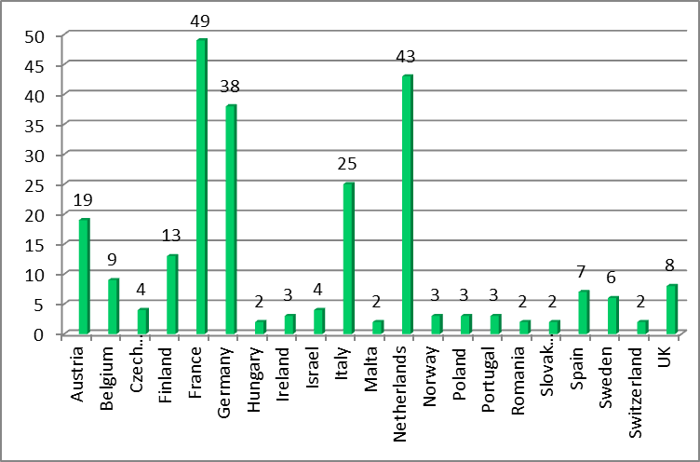
The 5 evaluation criteria listed in the following table along with their weight and thresholds:
Criteria | Maximum score / weighting | Threshold
Relevance and contributions to the objectives of the call | 10 / 1 | 6
R&D innovation and technical excellence | 10 / 1 | 6
S&T approach and work plan | 10 / 1 | 6
Market innovation and market impact | 10 / 2 | 6
Quality of consortium and management | 10 / 1 | -
Total | 60 | 40
One project (DeNeCor) of the sixth call involved clinical tests to validate demonstrators. It was subject to an ethical evaluation. 2 experts were selected from the relevant database of the 7th Framework Programme. The recommendations of the ethical evaluation were implemented in the negotiation phase and the project was accepted for funding.

6.3.4. Governance - Major decisions taken by the Governing Board and other JU bodies
The GB held 3 meetings (14 March, 28 June and 20 November 2012) and approved decisions by six written procedures, while the PAB met 4 times. The main decisions taken by the GB during the year were related to Annual Implementation Plan 2012 and Annual Budget Plan 2012.
Important decisions of the PAB included the launch of 2 calls and the related selection of projects, and the adoption of the Annual Work Programme for 2013.
The ENIAC GB took the decisions listed below:
- Adoption of the Multi-annual Staff Policy Plan (MSPP) for years 2013-2015
- Approval of the preliminary draft Annual Budget Plan (ABP) 2013
- Draft Annual Implementation Plan (AIP) 2013
- Adoption of the Annual Activity Report 2011 and its analysis and assessment
- Amendment to the AIP 2012 and ABP 2012
- Adoption of the 2011 Annual Accounts
- Adoption of the AIP 2013 and ABP 2013
The ENIAC PAB took the decisions listed below:
- Adoption of the decision to launch the sixth and seventh Calls for proposals
- Mandate to the Executive Director to enter negotiations for Call 2012-1
- Mandate to the Executive Director to enter negotiations for Call 2012-2
- Adoption of the Annual Work Programme 2013
- Projects Selection and Funding

6.3.5. Main communication activities
The ENIAC JU prolonged in 2012 the Service Level Agreement with AENEAS on communication and public relations support. The ENIAC JU defined and executed in 2012 a Communication Plan. The following activities were carried out:
- Organized together with The Parliament Magazine the “Securing the Future” round table event at the European Parliament on 6 November 2012 hosted by MEP Lambert van Nistelrooij with participation from Galileo, the European Defence Agency, the European Commission and industry representatives.
- Executed a communication day for the Project Coordinators.
- Had numerous exchanges with project coordinators, visited or hosted representatives from the industry including CEA/Leti, IMEC, Silicon Saxony, SEMI Europe, ESIA, Infineon, SOITEC, Intel, ASML and NXP.
- At the European Nanoelectronics Forum 2012 the ENIAC JU announced that the “ENIAC JU Innovation Award” went to two projects, “IMPROVE” and “LENS”.
- Issued 2 press releases exceeding 10,000 and 8,000 viewers respectively.
- Printed and distributed:
- in collaboration with the magazine “Zillion”, a feature on the ENIAC Innovation Award 2011
- in collaboration with the International Research magazine the Executive Summary of the Annual Activity report 2011 (brochure), an interview with the Executive Director “Stimulating growth in nanoelectronics”, projects results from the Call 2008-1 and ENIAC 2012 Innovation Awards (brochure)
- in collaboration with The Parliament magazine, the “Smart support?” feature covering the “Securing the future” event
- Updated the web site, including video content.
- Co-organized the European Nanoelectronic Forum with the EUREKA cluster CATRENE, and the European Commission.
- Participated in several events in Germany, Austria, Italy, and sponsored events in Belgium, France, the Netherlands and Germany.

6.3.6. Success story
The IMPROVE project partners developed computational models for equipment behaviour and history enabling virtual metrology, predictive maintenance and adaptive control plans to improve throughput, stability and reproducibility, and the overall wafer fab efficiency. According to the project coordinator: “In IMPROVE, six manufacturers with operations in Europe collaborated with 14 research laboratories, institutional and academic, and 10 industrial solution providers to considerably advance the state of the art in manufacturing sciences and get ready to compete based on efficiency and innovation”. More than 90 publications resulted from the findings of IMPROVE project which are further cited, showing their value. Exchange with other ENIAC projects allows for further development and implementation of the obtained results.
Lithography is the essential technology for scaling semiconductor devices. The sophistication and cost of the equipment increases at fast pace as the patterned feature size steadily decreases. To extend as much as possible the incumbent immersion lithography technology down to the 22 nm technology node, the 12 partners of LENS project considerably advanced the multiple facets of the technology using double exposure. LENS thus successfully demonstrated the applicability of the incumbent immersion lithography technology for at least two more technology nodes using dual exposure or pitch doubling techniques, “thereby allowing the timely and economically efficient development of the next generations of semiconductor devices”.

6.4. Calls implemented in 2012

6.4.1. ENIAC-2012-1

6.4.1.1. Summary information
Call Identifier | ENIAC-2012-1
Publication date | 23/02/2012
Deadline | PO: 12/04/2012
Deadline | FPP: 14/06/2012
Indicative Total budget (in €) | 73,3 M€
EU contribution after evaluation | 17.6 M€
MS contributions after evaluation | 37.6 M€
In-kind contribution after evaluation | 62.8 M€
Reference to call topics | All grand challenges were selected

6.4.1.2. Analysis of proposals submitted
- Number of proposals submitted and, if appropriate, by topic:
- Total: (PO) 16
- Eligible for evaluation: (PO) 16
- Number of participants in the submitted proposals:
- Total: 207
- Success rate by type (see table 6),.
- By country:
16 Countries submitted Project Outlines, the most significant participation in terms of number of organisations involved was from Germany with 39 participations followed by Netherlands with 34 and Italy and France with 31 each. From EU-13, only Czech Republic was represented with 7 participations. As Associated Countries, Turkey, Israel and Switzerland accounted together for 4 participations.
Figure 3: Participations by Country (submitted FPPs)
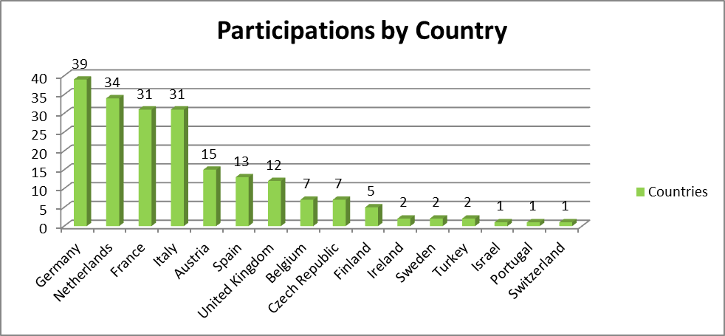

6.4.1.3. Evaluation results
Number of proposals submitted and, if appropriate, by topic:
- FPP passing the thresholds, failing the thresholds: 11 above threshold
- FPP proposed for funding, and reserve list: 6 for funding and 0 on the reserve list
- Success rate: 37.5%
Table 5: Evaluation results
Call Reference | Submitted Project Outlines |  |  | Evaluation results |  |  | Reserve list, if any
Call Reference | Submitted Project Outlines | Eligible POs | % of retained | Full Project Proposals | Selected for funding | Success rate% | Reserve list, if any
ENIAC-2012-1 | 16 | 16 | 100,0% | 11 | 6 | 37,5%

Table 6: Participation by type and success rate
Type participant | Nr of participants in the Project Outlines | Nr of participants in the Full Project Proposals | FPPs % of retained | Nr of participants in the funded Projects | Participants success rate
Public Bodies | 0 | 1 | 0,0% | 0 | 0,0%
Research organisations | 27 | 27 | 100,0% | 15 | 55,6%
Higher or secondary education | 56 | 55 | 98,2% | 29 | 51,8%
Private for profit (excl. education) | 76 | 73 | 96,1% | 44 | 57,9%
SMEs | 43 | 42 | 97,7% | 31 | 72,1%
Others | 5 | 4 | 80,0% | 0 | 0,0%
Total | 207 | 202 | 97,6% | 119 | 57,5%

Number of participants in the proposals selected for funding:
- Total: 119
- Of which SMEs: 31
- Success of SMEs: 72,1%, the budget allocated to SMEs is 10.6 M€
- By country:
16 Countries were represented in the selected for funding FPPs. After selection, 23 participants are from Netherlands, 19 from Germany and 19 from France and 18 from Italy. Slovak Republic had 2 participations and Norway 1.

Figure 4: Participations by Country (funded FPPs)
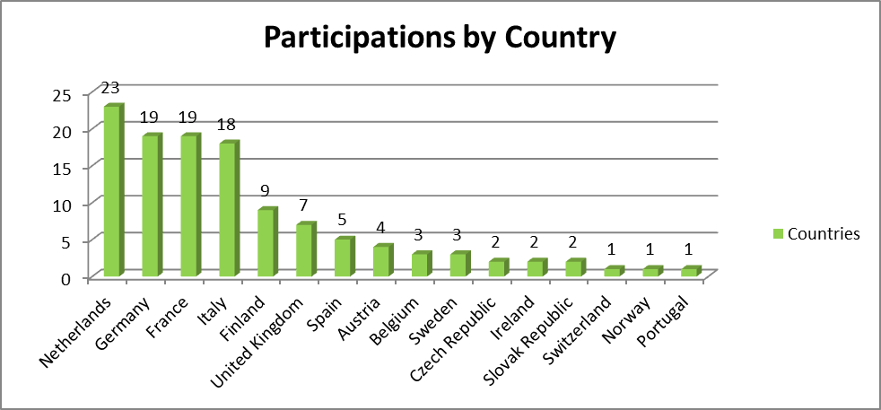

6.4.2. ENIAC-2012-2

6.4.2.1. Summary information
Call Identifier | ENIAC-2012-2
Publication date | 04/05/2012
Deadline | PO: 14/06/2012
Deadline | FPP: 13/09/2012
Indicative Total budget (in €) | 193,2 M€
EU contribution after evaluation | 107.8 M€
MS contributions after evaluation | 111.1 M€
In-kind contribution after evaluation | 508.6 M€
Reference to call topics | focus on projects targeting Pilot Line activities

6.4.2.2. Analysis of proposals submitted
Number of proposals submitted:
- Total: 11 (PO)
- Eligible for evaluation: 11 (PO)
Number of participants in the submitted proposals:
- Total: 158
- Success rate by type, of which SMEs: see table 8
- By country:
20 Countries overall took part to the ENIAC second call for a total of 158 participations. The most represented Countries were France, Germany, Netherlands and Austria. From EU-13, Poland had 3 participations. Czech Republic, Hungary, Malta and Romania each had one participant. Israel, Norway and Switzerland represented the Associated Countries with a total of 8 participations.

Figure 5: Participations by Country (submitted FPPs)
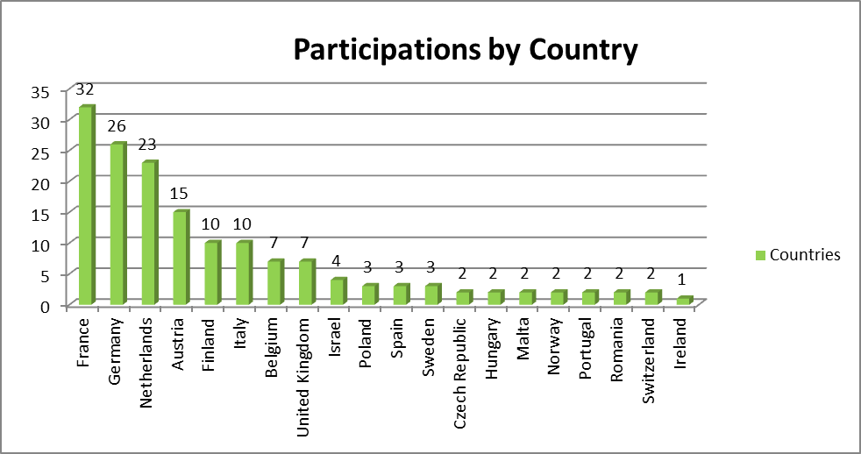

6.4.2.3. Evaluation results
Number of proposals submitted (FPP): 6
- FPP proposed for funding: 5
- Success rate: 45,5 %
Table 7: Evaluation results
Call Reference | Submitted Project Outlines |  |  | Evaluation results |  |  | Reserve list, if any
Call Reference | Submitted Project Outlines | Eligible POs | % of retained | Full Project Proposals | Selected for funding | Success rate% | Reserve list, if any
ENIAC-2012-2 | 11 | 11 | 100,0% | 6 | 5 | 45,5%
Table 8: Participation by type and success rate
Type participant | Nr of participants in the Project Outlines | Nr of participants in the Full Project Proposals | FPPs % of retained | Nr of participants in the funded Projects | Participants success rate
Public Bodies | 1 | 0 | 0,0% | 0 | 0,0%
Research organisations | 27 | 27 | 100,0% | 24 | 88,9%
Higher or secondary education | 19 | 22 | 115,8% | 13 | 68,4%
Private for profit (excl. education) | 59 | 81 | 137,3% | 64 | 108,5%
SMEs | 17 | 28 | 164,7% | 27 | 158,8%
Others | 5 | 0 | 0,0% | 0 | 0,0%
Total | 128 | 158 | 123,4% | 128 | 100,0%
Number of participants in the proposals selected for funding:
- Total: 128
- Of which SMEs: 27 SMEs were involved in selected for funding FPPs with a budget allocated equal to 14.1 M€
- Success rate of SMEs:. Over 100% success rate is due to the inclusion of new partners from PO to FPP as recommended in the PO evaluation report.
- By country
20 Countries were represented in the selected for funding FPPs. After selection, the situation is as follows France (30 participations), Netherlands (20), Germany (19) and Austria (15). From EU-13, Poland had 3 participations. Czech Republic, Hungary, Malta and Romania each had 2 participations. Israel (4 participations), Norway (2) and Switzerland (1) represented the Associated Countries with a total of 7 participations.
Figure 6: Participations by Country (funded FPPs)
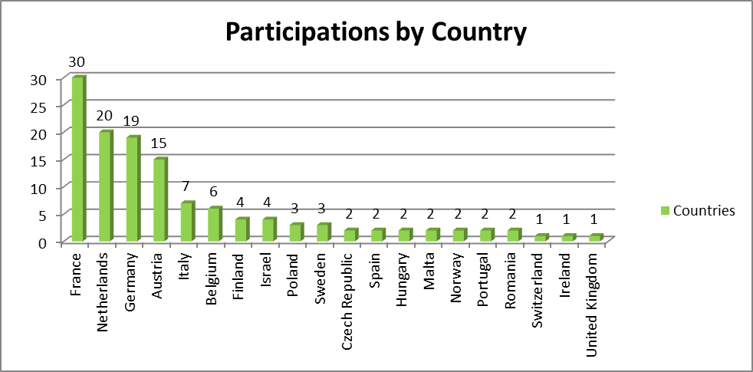

6.5. Project Portfolio
This section provides an overview on signed grant agreements and their implementation.
The following table provides the list of eligible and funded projects. The projects are funded according to their ranking and the available funding (European Commission and Member States).

Call | Eligible projects | Funded projects
ENIAC-2012-1 | HIT-Light  APPOLLO  DeNeCor  E2COGaN  ESEE  INTEGRATE  OPERA  PROMINENT  CityCar  AAH  AUTARK  DIVA  BEST MAP | DeNeCor  E2COGaN  ESEE  INTEGRATE  OPERA  PROMINENT
ENIAC-2012-2 | AGATE  E450EDL  EPPL  Lab4MEMS  PLACES2BE  PULMAN | AGATE  E450EDL  EPPL  Lab4MEMS  PLACES2BE

6.5.1. Grant agreements signed (commitment amounts)

6.5.2. Grant agreements for which activities have ended and/or final results are available
The following table indicates the projects which have had their final review in 2012. Due to administrative processing, including in the Member States administrations, the final payments were still pending at the end of 2012. Therefore the amounts indicated in the table are the committed amounts as agreed in the PAB decisions of the first and second calls of ENIAC.

7. FUEL CELL AND HYDROGEN (FCH) JOINT UNDERTAKING

7.1. Introduction to the FCH JU
The Fuel Cells and Hydrogen Joint Undertaking (hereinafter referred to as "FCH JU") has been established by Council Regulation (EC) N° 521/2008 of 30 May 2008 as an industry-led public-private partnership supporting research, technological development and demonstration (RTD) activities in fuel cell and hydrogen technologies in Europe. The FCH JU members are the New Energy World Industry Grouping (NEW-IG), representing the fuel cell and hydrogen industries, the N.ERGHY Research Grouping, representing the research community, and the European Union, represented by the European Commission.
The FCH JU has been set up for a period up to 31 December 2017 with the main objective to significantly accelerate the market introduction of fuel cell and hydrogen technologies, realising their potential as an instrument in achieving a carbon-clean energy system. The broader use of fuel cells, as an efficient power conversion technology, and hydrogen, as an environment-friendly energy carrier, can contribute to reduce greenhouse gas emissions, and lower the dependence on hydrocarbons, and to stimulate the economic growth. The aim of the FCH JU is to bring these benefits to Europeans through a concentrated effort from all sectors pooling together public and private resources.
The FCH JU programme of activities comprises long-term and breakthrough-oriented research, research and technological development, and demonstration and support actions. Project support is mainly granted following open and competitive calls for proposals, peer review evaluation and the conclusion of Grant Agreements. A small number of activities are implemented through calls for tender (i.e. public procurement). The strategic research and demonstration priorities of the FCH JU are set out in the Multi-Annual Implementation Plan (MAIP). This document is critical since it outlines the activities to be supported by the FCH JU and serves as the basis to draft the Annual Implementation Plans (AIP) which contains inter alia the topics for the annual calls for proposals. The MAIP 2008-2013 outlines four main application areas (AA):
- Transport & Refuelling Infrastructure - It has as a main objective the development and testing of competitive hydrogen-fuelled road vehicles and corresponding hydrogen refuelling infrastructure, and the full range of supporting elements for market deployment and increased industrial capacity. Approximately 32-36% of the overall budget is earmarked for this application area
- Hydrogen Production and Storage - It aims to develop and, where possible, fully implement a portfolio of cost-competitive, energy efficient and sustainable hydrogen production, storage and distribution processes enabling supply of the anticipated hydrogen energy demand while demonstrating the role that hydrogen can play as an energy carrier in reaching Europe’s key long term and mid-term energy objectives. Approximately 10-12% of the overall budget is earmarked for this application area
- Stationary Power Production & Combined Heat and Power - overall objective is to improve the technology for fuel cell stack and balance of plant components to the level required by the stationary power generation and CHP (Combined Heat & Power) markets by bridging the gap between laboratory prototypes and pre-commercial systems. Approximately 34-37 % of the overall budget is earmarked for this application area.
- Early Markets - The aim is to develop and deploy a range of fuel cell-based products capable of entering the market in the near term and to turn into commercial success stories. Early markets are considered strategically important to build up and sustain an early manufacturing and supply base for fuel cells products and systems. Approximately 12-14 % of the overall budget is earmarked for this application area.
- Cross-cutting activities - have been established as a fifth area to provide programme level coordination. These activities include drafting of regulations and formulation of codes and standards, pre-normative and socio-economic research, technology and life cycle assessments, market support (particularly for SMEs), public awareness and education. Approximately 6- 8% of the overall budget will be dedicated to these cross-cutting activities.

7.1.1. Budget
The maximum EU contribution to the FCH JU is € 470 million, covering running costs (€ 20 million) and operational costs (€ 450 million). The EU contribution is paid from the appropriations in the general budget of the European Union allocated to themes "Energy", "Nanosciences, Nanotechnologies, Materials and New Production Technologies", "Environment" and "Transport" of the Specific Programme "Cooperation" under the FP7. For operational costs, the EU contribution shall at least be matched by the contributions of all the legal entities participating in the FCH JU activities.

7.1.2. Governing structure
For coordinating the inputs of all the members and managing its activities, the Joint Undertaking's governance structure comprises of two executive bodies – the Governing Board and the Executive Director assisted by the Programme Office, and three advisory bodies – the Scientific Committee, the States Representatives Group (SRG) and the Stakeholders' General Assembly.
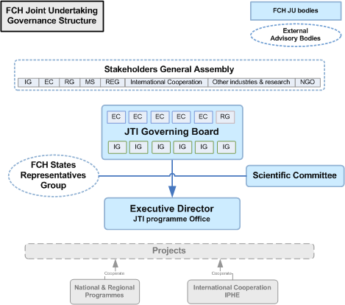
The Governing Board is the main decision-making body of the FCH JU. All three members of the FCH JU are represented on the Governing Board: the NEW Industry Grouping has six seats, the European Commission has five seats and the N.ERGHY Research Grouping has one seat. At least one of the representatives appointed by the Industry Grouping represents SMEs. The vote of the European Commission is indivisible. The decisions are taken by consensus, or, if failing to reach one, by a three quarters majority. The Governing Board has overall responsibility for the operations of the Joint Undertaking: implementation of activities, approval of the annual implementation plan, budget, accounts and the balance-sheet; approval of the list of selected project proposals, etc.
The Executive Director and the Programme Office are in charge of the day-to-day management of the Fuel Cells and Hydrogen Joint Undertaking. The Executive Director is the legal representative of the FCH JU. He is the chief executive responsible for the implementation of the Joint Undertaking, in accordance with the decisions of the Governing Board.
The Scientific Committee is an independent advisory body to the Governing Board. Its priorities are to:
- Advice on the R&D agenda set out in the Multi-Annual and Annual Implementation Plans;
- Advice on the scientific achievements described in the annual activity report.
The Scientific Committee has nine members, appointed by the Governing Board on the basis of their scientific competencies and expertise to give their strategic science-based recommendations on the priorities and the progress of the FCH JU. The members reflect a balanced representation of world class expertise from academia, industry and regulatory bodies. They represent different fields of expertise within fuel cell and hydrogen technologies.
The States Representatives Group consists of one representative of each Member State and of each country associated with the 7th Framework Programme and has an advisory role to the FCH Joint Undertaking and the representatives act as an interface between the FCH JU and the relevant stakeholders within their respective countries. The States Representatives Group reviews information and provides opinions on programme progress in the FCH JU, compliance and respect of targets, coordination with national programmes and more. It meets at least twice a year. The Chairperson of the States Representatives Group has the right to attend the meetings of the Governing Board as an observer.
The Stakeholders' General Assembly is an annual event aimed at informing all interested parties about the activities of the FCH JU and acquiring feedback for future planning of the programme. It is also a key platform for European and global stakeholders across sectors to come together to examine and assess the current position of this emerging industry, exchange ideas on next steps and make contacts. The Stakeholders' General Assembly has a formal advisory role to the FCH Joint Undertaking and it is an important communication channel to ensure transparency and openness of the FCH JU's activities with its stakeholders.

7.2. Overall progress since the establishment of the FCH JTI/JU

7.2.1. A strong and strategic partnership at the forefront of FCH technologies
The FCH JU has structured the R&D landscape in the FCH sector through the establishment of an industry led public-private partnership with a long-term perspective, combining the capacities of companies and research organisations to design a joint strategic research agenda and multi-annual plans and pooling long-term public and private commitments for funding.
The FCH JU has also enabled the development of a strategic programme of activities as defined in the Multi Annual Implementation Plan (MAIP), comprising long-term, breakthrough-orientated research, applied research and technological development, demonstration and supporting actions, including strategic studies, pre-normative actions and technology assessment. More than 380 M€ in grants has already been allocated to about 130 projects (completed, on-going and under negotiation) and several of them can be considered as important success stories. The tables and figure below describe some features of the participation in the FCH JU projects:
Table 1: General overview on FCH progress from the establishment in 2008 up to 2012
Call Reference | Publication date | Evaluation date | Nr of topics | Nr of GA signed | Indicative budget [max funding] (M€) | Outcome of the call (M€)
FCH-JU–2008-1 | 15/10/2008 | February 2009 | 15 | 16 | 28,1 | 68,5**
FCH-JU–2009-1 | 2/07/2009 | November 2009 | 29 | 28 | 71,3 | 122,3**
FCH-JU-2010-1 | 18/06/2010 | November 2010 | 25 | 26 | 89,1 | 230,5**
FCH-JU-2011-1 | 3/05/2011 | September 2011 | 36 | 33 | 109 | 282,4**
FCH-JU-2012-1 | 17/01/2012 | June 2012 | 31 | 0* | 77,5 | 292,5**
Totals |  |  | 136 | 103 | 375 | 996,2

Note: * The 2012 call for proposals is still under negotiations and ** Sum of the
amounts requested in all eligible proposals
Table 2: Total number of participants by type and success rate
from the establishment in 2008 up to 2012
Type participant | Nr of participants in the Proposals | Nr of participants in the Funded Projects | Participants success rate | Budget allocation
Public Bodies | 52 | 18 | 34,6% | 4,2%
Research organisations | 621 | 315 | 50,7% | 21,0%
Higher or secondary education | 511 | 175 | 34,2% | 10,0%
Private for profit (excl. education) | 584 | 316 | 54,1% | 37,0%
SMEs | 602 | 256 | 42,5% | 27,0%
Others | 78 | 27 | 34,6% | 0,8%
Total | 2448 | 1107 | 45,2% | 100,0%
Overall, SMEs have success rate equal to 42,5 % and take 27% of the funding compared to 18% in FP7-Energy. And the average size of a project is 8 partners with a FCH JU contribution of €2.95 million.

Figure 1: Overall geographic distribution of successful organisations
(by coordinator and participant)
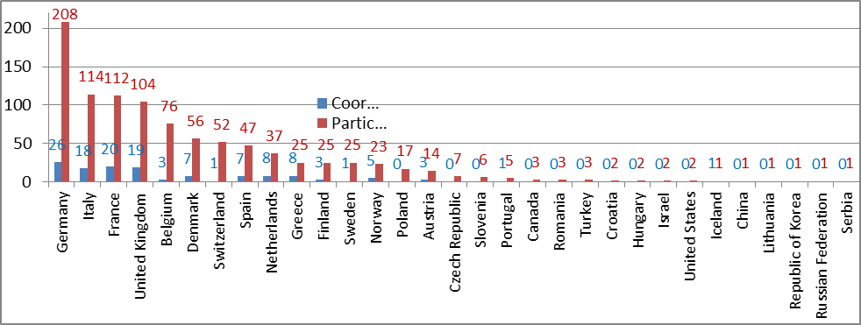

7.2.2. Progress towards the Multi-Annual Implementation Plan (MAIP) objectives
The main objective of the existing FCH JU is to accelerate the market introduction of FCH technologies, and place Europe at the forefront of FCH technologies worldwide. The 2012 Programme review held on 28 and 29 November 2012 has confirmed that overall the FCH JU is making progress against its principal objectives as set out in the MAIP. Market introduction has already been achieved for some early applications such as forklifts and small back-up power units. For both energy and transport applications progress has been achieved notably in the materials performance, durability, and costs reduction for both components and systems of transport and stationary power applications. As an illustration, between 2008 and 2012:
- The cost of PEM fuel cells has dropped on average by half (from 1,000 €/kW to 500€/kW) and their lifetime increased by 25% (from 2,000 to 2,500 hours);
- The cost of fuel cells for forklifts has dropped from 7,000 €/kW to 4,000 €/kW;
- The cost of storing gaseous hydrogen has been reduced from 1.0 to 0.5 M€/ton;
- The cost of hydrogen refuelling stations has dropped by 30% (today 0.7 to 2 M€ for Capex depending on the quantity of hydrogen available).
In the area of transportation and refuelling infrastructure, dominated so far by large demonstration projects, more than 40 fuel cell electric vehicles (FCEV) and more than 40 buses are being tested in real condition (approx. 10% of worldwide fleet), with more vehicles expected to be rolled-out. Work has also continued on standardisation in order to ensure that the challenges of fuel metering and fuel quality are addressed appropriately. Good progress has been made both in terms of extending the performance and improving durability of the vehicles and in the reducing the cost of Hydrogen Refuelling Stations (HRS) for which the target of 1-2 M€ for 50-200 kg/day capacity has been achieved. For buses, the purchasing prices are coming closer to the 1M€ range target. Volume-building towards mass commercialisation remains, however, a challenging target of the MAIP that goes beyond the remit of the programme's scope and budget.
The hydrogen production and distribution portfolio mainly focuses on research and development especially on the production of green hydrogen, with a mix of mature and novel technologies, such as water electrolysis, biomass gasification, fermentation and solar technology. Strengthened efforts on underground storage, improvement of solid stage hydrogen storage and on distribution of hydrogen are complementary to the research on production pathways. The potential to use hydrogen for large scale storage of energy from intermittent renewable energy sources is at the top of the energy agendas and will be investigated in a project which will demonstrate the system level technology readiness of the production of hydrogen using renewable electricity as well as its compression, storage and end use in transport applications or for grid balancing. The project might be a showcase for end customers.
In the Stationary Power Generation and Combined Heat and Power application area the research projects related to materials degradation and components' control and diagnostics have been complemented by a number of demonstrations that are providing valuable experience and learning. With the portfolio of projects supported so far, it can be said that progress is being made towards the most important targets on volume and costs for the medium term, 2015 set up by the MAIP document: demonstration of more than 1000 units 1-2 kW systems (project ene.field) from 9 manufacturers supported by 24 utilities in 12 Member States,1MW commercial system H2-based in Hungary for more than 20000 hours operation, electrical efficiency of 48% and a cost of system 2.5 mill €/MW (equivalent of 2500 €/kW). Electrical efficiencies of more than 60% are expected to be achieved in the near future.
The projects of the early markets portfolio fall into one of three main categories: (i) material handling vehicles, primarily fork lift trucks; (ii) portable and micro-fuel cells for personal power solutions; and (iii) back-up power systems. The portfolio continues to be well aligned with strategic objectives: three flagship projects focus on forklifts, postal delivery vehicles as well as trucks for airport usage. Back-up power systems are addressed with two large projects, focused on telecommunication applications. These projects are paving the way for deployment with some of the manufacturers optimizing their production lines for larger commercialisation. Innovative personal power solutions and unmanned flying vehicles are also explored as part of the portable and micro-fuel cells category. Taken as a whole, this portfolio covers the objectives of the MAIP, although some demonstrations had experienced difficulties attracting end users and OEMs in the consortia.
Last but not least, cross-cutting projects are playing an important strategic role in the realisation of the FCH JU’s overarching commercialisation objective. In this respect, the on-going projects provide the minimum coverage of the key elements of the MAIP, covering three distinct topics: (i) training and education, (ii) socio-economic aspects (including a project aiming at developing a new tool for technology assessment and progress monitoring) and (iii) pre-normative research and Life Cycle Analysis (PNR & LCA) projects. More effort is needed to ensure that the progress made is maintained and enhanced through additional projects. In particular, further work is needed to address market obstacles arising from variability of regulations, standards and permit procedures and to keep training materials up to date.

7.2.3. Leveraging effect
The establishment of the FCH JU was expected to trigger from the industry an additional investment of 600M€ in RTD on top of their in-kind contribution to the FCH JU. The close to 80 private companies that have participated to the survey undertaken in the framework of the impact assessment for the continuation of the FCH JU under Horizon 2020 have together reported an annual € 1,5 billion of expenditures in R&D and market introduction in 2011 or 2012, 36% seeing an increase of more than 10% annually since 2007. About 50% of the FCH JU Industry Grouping members state they have increased their R&D expenditures thanks to the existence of the JU, even during a period of severe economic and financial crisis, suggesting that the industry has taken their commitment very seriously. This illustrates that a public-private partnership with a mechanism such as a JU does improve the investment environment and can indeed trigger additional investments.
The leveraging effect is also apparent from the funding rates of the JU, which have been lower than for FP7 due to the obligation of the legal entities participating in the projects to match the EU contribution. As a consequence, the JU budget has allowed supporting a larger number of projects.

7.2.4. Industry and SME participation to date
The weight of the private sector in the applicant consortia has increased, indicating that the JU calls for proposals are more attractive to industry, particularly SMEs, than FP7. Industry (including SMEs) takes 66% of the funding compared to 47% in FP7. SME participation is significantly higher than in FP7: SMEs take 25% of the funding compared to 18% in FP7. These figures refer to the Energy Theme of FP7 in the period 2008-2012.

7.3. Outline of the main activities and achievements in 2012

7.3.1. Running of the FCH JU

7.3.1.1. HR issues
Two selection procedures were completed (replacement of the staff upon their resignation):
- Financial Assistant AST4 (took up the duties on 16 October 2012)
- Project Manager FG IV for a temporary filling of an AD 8 project manager position (to take up the duties on 01 January 2013)
In this context the Governing Board approved a change in the organisation chart aiming at reinforcing the finance team given the increased workload stemming in particular from the increased number of cost claims submitted and from the coordination and monitoring of ex-post audits.
At end of 2012 the FCH JU Program Office was staffed with 17 Temporary Agents and 3 Contract Agents. The FCH JU also offered 6 months traineeship to young graduates.
The following implementing rules were adopted by the Governing Board of the Joint Undertaking in March 2012:
- Decision on the policy on protecting the dignity of the person and preventing psychological harassment and sexual harassment
- Decision for setting up the FCH JU Staff Committee
- Decision on staff appraisal
Finally, two team building events were organized as well as training activities and a survey on the satisfaction of the staff was conducted for the first time in 2012.

7.3.1.2. Legal and Financial Framework
In 2012, the main activities carried out by the Program Office in this field included the following:
- Revision of the model grant agreement:
The model grant agreement was revised to include two simplifications:
The possibility for SMEs owners and other persons who work for a FCH JU project but do not receive a salary to declare their personnel cost through a flat rate system.
The possibility for beneficiaries to declare average personal costs without having to obtain a certification of their methodology in advance.
- Communication campaign on how to avoid financial errors:
In order to facilitate the financial implementation of projects and to avoid errors in the costs reporting by beneficiaries, the FCH JU organised three sessions of a one-day-training for its beneficiaries. The training included a detailed explanation of the financial provisions of the grant agreement, an explanation of the control system applicable to the FCH JU funding as well as an analysis of the most frequent errors in the costs reporting of beneficiaries. A guide was also drafted for the beneficiaries.

7.3.1.3. IT Infrastructure
The priority objectives for IT are to ensure a stable and secure IT system, provide IT support to staff and to cooperate with the other JUs to ensure synergy and the efficient use of resources. The main achievements in 2012 for IT include the following: (i) the IT infrastructure was stabilised and enhanced throughout the year, (ii) the business continuity plan including elements of disaster recovery plan was adopted and an agreement was signed with DG RTD which provides for support in case of crisis, (iii) the mail registration tool was improved which offers some features available in the Ares tool of the Commission, and (iv) the IT governance structure for the JUs has been put in place and coordinated by the IT Officers, Heads of Finance and Administration and Executive Directors.
The 2012 risk assessment identified a number of problems still experienced with the IT tools during the year which increased the risk level for the internal processes for the calls for proposals. Particular attention was given to those issues as they have a direct impact on the workload and planning activities of the staff. Aside from this, access to the CORDA database has improved the speed and quality of data analysis.
The stabilisation of the IT tool configuration and servers, timely reporting and monitoring of IT issues and a root-cause analysis of the problems and a close following the Service Level Agreements have all worked to significantly reduce other IT risks in the organization in 2012.

7.3.2. Progress in the implementation of the Multi-Annual Implementation Plan
In 2012, 33 grant agreements were concluded for an amount of € 117.5 M corresponding to the call for proposals 2011, the largest call for proposals launched by the JU. In parallel the evaluation of 2012 call for proposals was carried out and the Governing Board approved on the 11 October 2012 the start of negotiations of 28 proposals for an indicative budget of € 79.8 M.
24 interim and 5 final reports concerning 209 beneficiaries were validated leading to interim/final payments for an amount of € 5.2 M and to clearing of € 12 M. In this frame, following the recommendations of the internal audit capability the ex-ante control process was enhanced in particular through a clarification of the control strategy, a strengthening of the monitoring tools and a review of the procedures/checklists. In addition, the implementation of the ex-post audit strategy launched in 2011 was pursued with 19 audits finalized out of 33 selected. Furthermore, a communication campaign aiming at avoiding financial errors in cost claims of the FCH JU beneficiaries was organised, including 3 training sessions covering 54% of the projects. With a similar aim, the FCH JU Guide on Financial Issues was published providing detailed explanations of the financial provisions of the grant agreement.
A study on the commercialisation of Fuel Cell buses was carried out involving a coalition of 40 companies and government organisations. It concludes that Fuel Cells and Hydrogen technology allows for a promising, necessary and environment-friendly alternative powertrain for urban buses contributing to the decarbonisation of road transport.
The RTD priorities and topics to be included in the AIP for the 2013 call for proposals were initially drafted by the Application Area Working Groups led by representatives of the member companies of the Industry and Research Groupings. The AIP 2013 was completed after consultations with the relevant services of the Commission, the Scientific Committee and the FCH JU States Representatives Group. Based on the AIP 2013 the 2013 call for proposals comprises 27 topics with an estimated FCH JU financial contribution of € 68.5 million, as well as 5 public procurements for € 4,65 million, summing up to the committed € 450 million EU contribution for the period 2008-2013.

7.3.3. Implementation of calls for proposals (CFP)
The FCH JU launches open and competitive calls for proposals annually on the basis of which funding is granted for research, technological development and demonstration projects. The topics stem from the FCH JU Annual Implementation Plan (AIP) and are consistent with the five Application Areas described above and the RTD priorities and key objectives for the respective year.
Two types of funding schemes are used to implement projects in the FCH JU: 1) collaborative projects, and 2) coordination and support actions. The schemes to be used in the different calls for proposals are announced in the call for proposals fiche. FCH JU's projects are selected through calls for proposals following a single stage submission and evaluation process. The whole call for proposals process is managed by the Programme Office of the FCH JU according to the principles of excellence, transparency, fairness and impartiality, confidentiality, efficiency, speed and ethical and security considerations and following the FCH JU Rules for submission of proposals and the related evaluation, selection and award procedures.
As a first step, the FCH JU performs an eligibility check to see whether the applicants meet the announced eligibility criteria. Then FCH JU appoints independent experts with the same principles as for the Framework Programme, to assist with the evaluation of proposals and identification of those of best quality for possible funding. All eligible proposals are evaluated with respect to the evaluation criteria and the associated weight and thresholds set for the call for proposals. Evaluations are done in three steps: remotely, through on-site consensus meetings and panel reviews. During the remote evaluation, proposals are assessed individually by a minimum of three experts and the results are included in an individual evaluation report. Once the experts complete their individual assessments, the evaluation proceeds to a consensus assessment, the objective of which is to exchange common views on the evaluated proposals. The results of the consensus meetings are included in consensus evaluation reports. The final step in the evaluation process is the panel review. The outcome of this review are the evaluation summary reports for each proposal, including a list of ranked proposals above thresholds for each application area, a list of proposals failing one or more thresholds and a list of ineligible proposals, if any. The presence of independent observers during the different evaluation stages verifies and guarantees that the above-mentioned rules and principles are followed.
After completing the evaluation and establishing ranked lists with proposals for funding for each application area and a reserve list, these lists are presented to the FCH JU Governing Board. Once the latter approves the list of proposals to be funded the Joint Undertaking enters into negotiations with the coordinators. If a negotiation is successfully concluded, the project is selected and a grant agreement providing for a FCH JU financial contribution is signed.

7.3.4. Evaluation process
Figure 2: FCH JU calls for proposals. Submission and evaluation process
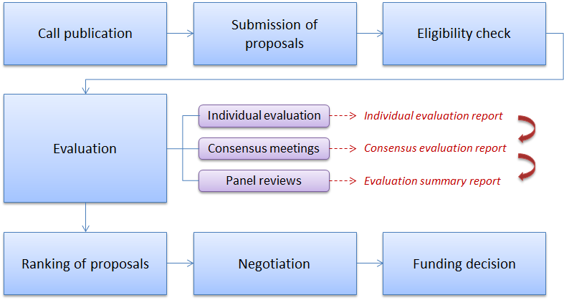
33 Grant Agreements resulting of the evaluation of the 2011 call for proposals were signed.
During 2012 the FCH JU launched and evaluated one call for proposals (FCH-JU-2012-1). The evaluation was carried out by 31 independent experts, 1 chairperson and 1 vice-chair person who oversaw the whole consensus phase. In addition, 1 independent observer monitored that the evaluation procedure was carried out in a fair, impartial and confidential manner. The individual remote evaluations took place from 8th to 20th June 2012 and the consensus meetings from 25th to 27th June, which were followed by the final Panel meeting on 28th and 28th June. The details of the evaluation are provided in section 4.1 below.

7.3.5. Governance - Major decisions taken by the Governing Board and other JU bodies
The FCH Governing Board held four meetings in 2012:
- The 11th Governing Board meeting was held on 7 March 2012. The main decision taken was the adoption of the 3rd batch of implementing rules.
- The 12th Governing Board meeting was held on 29 June 2012. The main decision taken was the approval of the Final Accounts 2011, the appointment of 2 new members of the Scientific Committee, the adoption of the first amendment to the FCH JU budget 2012, and the adoption of the Annual Assessment of the in-kind contribution for the year 2011.
- The 13th Governing Board meeting was held on 11 October 2012. The main decisions taken were the adoption of the correction factor for the funding of the call for proposals 2012 (0.8), the adoption of the list of proposals to start negotiations and the second amendment to the FCH JU budget 2012.
- The 14th Governing Board meeting was held on 29 November 2012. The main decision taken was the appointment of two other new members of the Scientific Committee.
The following documents were adopted and/or approved by the FCH JU Governing Board via written procedure:
- FCH JU Multi Annual Staff Policy Plan 2013-2015;
- Provisional accounts for the financial year of 2011;
- FCH JU Annual Activity Report 2011;
- FCH JU Annual Implementation Plan and budget for 2013.
- FCH JU Communication Strategy;
- Methodology for asessing in-kind contribution;
- Contract for the study on Bus commercialisation;
- Contract for the Study on the trends in terms of investments, jobs and turnover in the Fuel cells and Hydrogen Sector;
- Contract on “Development of a European Fuel Cells and Hydrogen Vehicles Roll out: Written report about a rollout strategy for Hydrogen transport in the UK”;
- Amendment of the FCH JU Model Grant Agreement;
- Change in the organisational structure of the FCH JU Programme Office;
- Decisions for concluding a grant agreement for the seven batches of projects from the call for proposals FCH-JU-2011-1.

7.3.5.1. FCH JU Consultative Bodies
The Scientific Committee met three times during the year (January, March and October). The meetings focused on three main topics: discussions and recommendations for the preparation of the AIP 2013, organisation of the 2012 Programme Review and discussions and recommendations for the future role and mandate of the Scientific Committee in the possible FCH JU in Horizon 2020. 4 new members (out of 9) have joined the Scientific Committee during 2012, and the chair has also changed during the period.
The States Representatives Group (SRG) held three meetings in 2012 (March, June, November). Information on the FCH JU operations was provided to the SRG by the Programme Office and by the Commission and the Industry Grouping on future perspectives for Horizon 2020. During the meeting there were open discussions on the future role of the SRG and on ways to improve the coordination between MS and FCH JU Programmes. The SRG was also consulted on the AIP 2013. The "mapping exercise" launched in 2011 for SETIS, the Strategic Energy Technology Information System of the Joint Research Centre (JRC), did unfortunately not materialise due to a lack of sufficient data transmitted by the MS representatives.
The Stakeholders General Assembly which had as a theme "Realising sustainable growth through fuel cells and hydrogen", was held at "Maison de la Chimie" in Paris on 12th October 2012. The number of participants (255) was lower than in previous editions. The breakdown by sectors was: industry (40%), "research organisation – academia" (26%), national and regional institutions (13%) and EU institutions 8%. By countries: France (25%), Belgium (15%) and Germany (12%). The panel discussions, with Q&A sessions with the public, focused on the following topics: (i) perspective for the FCH sector and the possible future Joint Undertaking for the 2014-2020 period, (ii) the increasing profile of hydrogen as a storage medium for renewable energy and grid balancing, (iii) national and regional initiatives for deployment of fuel cells technology and hydrogen infrastructure and (iv) the financing of innovation and early deployment of FCH technologies.

7.3.6. Second Interim Evaluation
The Council Regulation of Hydrogen and Fuel Cells JTI Joint Undertaking stipulates that the Commission shall conduct a second interim evaluation by the 31 December 2013 with the assistance of a panel of independent experts, on the basis of the terms of reference established after consultation of the JU. During 2012 the FCH JTI JU has cooperated with the services of the Commission and the Clean Sky and IMI JTIs JUs to start the preparatory work. This concerned in particular the provision of data, statistic and information on the operations of the programme and inputs provided for the definition of the terms of reference.

7.3.7. Main communication activities
In 2012, activities initiated in 2011 have been further developed. In addition, new activities have been initiated, with a view to strengthen awareness-raising towards EU and national policy makers, multipliers’ networks as well as towards opinion leaders and stakeholders of the FCH sector and related communities. The messages focused on the overall potential and market readiness of FCH technologies, the progress of the program so far and the dissemination of projects' results.
The FCH JU further strengthened its relationships with policy makers at European and national levels, creating opportunities for presenting the partnership, its achievements and its perspectives for delivering the objectives. Presentations were made to Commission officials, MEPs (in particular the ITRE working group of the S&D Group and two dinner debates in Brussels and Strasbourg), representatives from Member States (in particular the Councillors and Scientific attachés of the National Permanent Representations at the occasion of an official Research & Energy Council Working Party meeting in June) and the Social and Economic Committee (April). A special effort was made towards Central and Eastern European policy makers through meetings with permanent representation advisors from EU 12. Additionally, individual meetings with some 50 key relevant policy makers were also organised.

7.3.7.1. Events
The FCH JU organised the following events:
- The 5th Stakeholders’ General Assembly, organized on the 12 October in Paris with a view to raise awareness on FCH technologies and programs among stakeholders and decision makers in France. A reception was hosted by Senator Jean-Marc Pastor, on 11 October.
- The second Program Review Days, organised on 28 and 29 November, enabling a public assessment on the progress of the program towards its objectives.
- A public information session for the 2012 call for proposals and support to the brokerage event organised by Industry and Research groupings in Brussels (9 February).
The FCH JU participated in the following events (booth, presentations of the FCH JU activities, participation in panels etc.):
- The Hannover Messe from 23 to 27 April 2012, as part of the Group Exhibit Hydrogen + Fuel Cells. The FCH JU joined force with the German partners NOW, CEP and Linde. The EU Commissioner for Climate Action, Connie Hedegaard, and the EU Commissioner for Energy, Günther Oettinger, showed great interest in the exhibits.
- The World Hydrogen Energy Conference, from 3 to 7 June in Toronto.
- The EU Open day, through an exhibition in the Berlaymont Building and a display of a Fuel Cell and Hydrogen car. Commissioner Oettinger had the opportunity to test drive the Fuel Cells and Hydrogen car.
- The EU Sustainable Energy Week (EUSEW), from 22 to 28 June, the FCH JU offered a joint exhibition with one of its flagship demonstration projects, H2 Moves Scandinavia, in the European Parliament.
- The Paris Motor show, from 27 to 29 September, in collaboration with Air Liquide and the project H2 Moves Scandinavia.
- The Festival of sustainable development, from 9 to 11 November, organised by a Brussels local authority, offered an opportunity to show the technology to a general public.
- National information sessions for the 2012 call for proposals (UK, Spain, Italy)
FCH JU staff and/or the Executive Director participated in more than 30 external events and conferences in 2012 in 10 different Member States and 3 key non-European countries (US, Switzerland, Canada) to present the program and FCH JU activities and developments.
The FCH JU contributed to the organisation and/or supported the organisation of two workshops, one on materials on 26-27 March in Grenoble and one on electrolysers on 10 May in Copenhagen.

7.3.7.2. Publications
Publications include (i) the 'fact-based study on power trains for vehicles', (ii) the report from the FCH sector on 'the financial and technological outlook for the period 2014-2020', (iii) the 2011 Program Review Days final report, (iv) a policy analysis, commissioned by the FCH JU to the Bruegel Institute labelled 'The great transformation: decarbonising Europe's energy and transport systems', and (v) a wide sectorial survey addressing the whole FCH community on R& D investments and activities, job creation, and on the general growth of the sector.
The FCH JU maintained regular press relations at many activity launches, such as the launch of the 2012 call for proposals, the publication of the Bruegel study on the decarbonisation of the energy and transport system, the events organised during the EUSEW, the Motor Show and the Stakeholders’ General Assembly. Four press releases were issued in 2012 and numerous inputs were also provided to journalists upon request. Articles on FCH JU were directly contributed and published in Research Media (issue Spring 2012) and European Energy Innovation magazine (issue winter 2012).
Several publications have been developed: a general leaflet on FCH JU, a listing & mapping of demonstration activities and a report on the program review with fact-sheets per projects. The FCH JU web site, operational since March 2011, developed new pages: the Stakeholders’ General Assembly and its surrounding activities, program reviews and projects which were presented by application area and year.

7.3.8. Success stories
In the field of back-up power of the early market, FITUP is a demonstration project in which a total of 19 market-ready fuel cell systems from two different suppliers are installed as backup power sources by final users in Italy, Switzerland and Turkey. Real-world customers from the telecommunications industry are using these fuel cell-based systems, with power levels in the 3-12kW range, in their sites. These units are under test to demonstrate a level of technical performance that qualifies them for market entry, thereby accelerating their worldwide commercialisation, in particular (i) reliability of greater than 95%, (ii) durability of more than 1500 hours and more than 1000 cycles. The project involves the benchmarking and certification of units from both fuel cell suppliers according to a test protocol developed by the consortium in order to conduct extensive tests in field trials in sites selected by the final users. About 50% of planned tests are already performed (about 1300 total hours) and the analysis of the data collected so far indicates that the progress achieved will allow meeting the project targets and showing that the systems developed are competitive with incumbent technologies such as batteries and/or diesel generators. The project has a 3-year duration and a total cost of €5.4 million with a FCH JU contribution of €2,5 million. The consortium consists of large and small entities including fuel cell system manufacturers, end users, certification companies and R&D centres.
The project SOFT-PACT ('stationary applications' portfolio), led by E.ON, intends to deploy 100 micro-CHP units (Gennex SOFC based provided by Ceramic Fuel Cell Limited company) in Germany, UK, Italy and Benelux and to demonstrate an electrical efficiency of at least 60%. The project also addresses the most important commercial challenges by developing the whole supply chain, mass manufacturing aspects and European housing stock availability, ultimately addressing the certification schemes in the different Member States, Standard Assessment procedures and Grid connection standards. Up to date more than 30 units have been successfully installed in UK and Germany in two different configurations and electrical efficiencies of 62% were reported for some of them. Some installation issues not related to the technology itself but to the different requirements in the Member States will be addressed in the final phase of the project.
With support of the FCH JU, the Danish based SME H2Logic A/S has developed and facilitated the commercialisation of its two innovative products: H2Station® - Hydrogen refuelling stations for automotive, bus and materials handling applications, and H2Drive® - Fuel cell systems for materials handling vehicles such as forklift trucks and airport tow tractors. The company´s first move was supported by Danish national programmes and the Nordic Energy Research; the further optimisation of a cost effective fuel cell system was carried out in the FCH JU- supported HyLift-DEMO-project. In 2011, H2Logic A/S installed four 70MPa H2Stations in less than 12 months; one of them operates on the premises of SINTEF as part of the FCH JU H2moves Project - the large scale demonstration of fuel cell vehicles and refuelling infrastructure in Oslo.

7.4. Call(s) for proposals implementation in 2012

7.4.1. Call for proposals FCH-JU-2012-1

7.4.1.1. Summary information
Call Identifier | FCH-JU-2012-1
Publication date | 17 January 2012
Deadline | 24th May 2012
Indicative Total budget (in €) | €77.5 million
EU contribution after evaluation | €80,1 million
In-kind contribution after evaluation | €63,9 million
Reference to call topics | Annex 1
Table 3: Evaluation results
Call Reference | Publication date | Evaluation date | Nr of topics | Nr of GAs signed | Indicative budget [max funding] (M€ ) | Outcome of the call (M€) | Funding
 |  |  |  |  |  |  | EU contribution | In-kind
FCH-JU-2012-1 | 17/01/2012 | June 2012 | 31 | 0 | 77,5 | 292,5 | 80,1 | 63,9

7.4.1.2. Analysis of proposals submitted
Number of proposals submitted:
- Total: 72
- Eligible for evaluation: 68
Area | Submitted | Eligible
Transportation & Refuelling Infrastructure | 15 | 15
Hydrogen Production & Distribution | 20 | 18
Stationary Power Generation & CHP | 22 | 21
Early Markets | 8 | 8
Cross-cutting Issues | 7 | 6
Total: | 72 | 68

Number of participants in the submitted proposals:
- Total: 573
- SMEs: 160, which corresponds to 28% of total participants.
The average size of a project is 8 partners with a FCH JU contribution of €3.05 million.
Figure 3: Requested contribution by Country
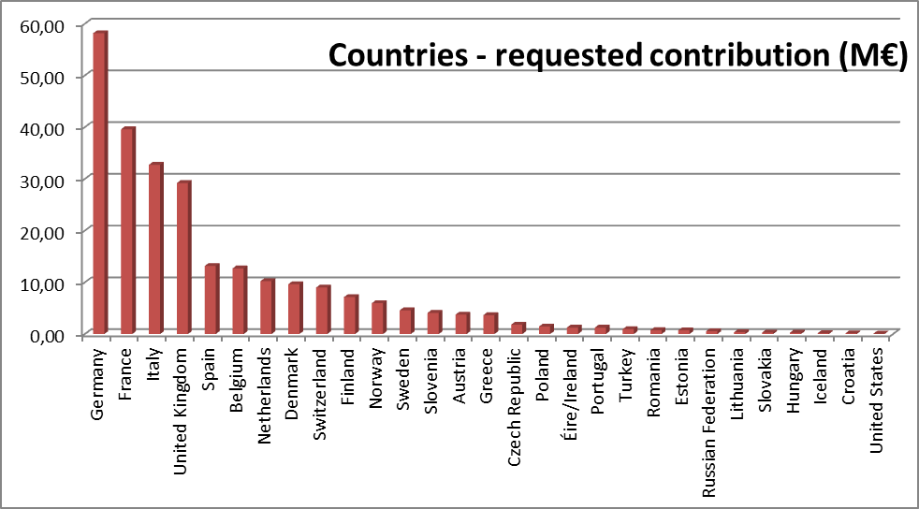
Table 4: Success rate by type of participant
Type participant | Nr of participants in the Proposals | Nr of participants in the funded Projects | Participants success rate | Budget allocation
Public Bodies | 19 | 3 | 16% | 0,2%
Research organisations | 136 | 59 | 43% | 24,0%
Higher or secondary education | 112 | 31 | 28% | 11,0%
Private for profit (excl. education) | 126 | 68 | 54% | 38,0%
SMEs | 160 | 55 | 34% | 26,0%
Others | 20 | 6 | 30% | 0,8%
Total | 573 | 222 | 39% | 100,0%
Participation by countries is presented in the table below. Overall, 30 Countries took part to FCH Call, best players were Germany (with 102 participations), Italy (72), France (61) and the UK (59). Form the EU-13, Slovenia, Czech Republic, Poland, Romania, Estonia, Lithuania, Slovakia, Hungary and Croatia submitted applications for a total of 3 participations, the best player being Poland with 7 participations. To be noted that non-EU or Associate Countries showed interest to FCH calls: the United States and Russian Federations got respectively 3 and 2 participations.
Figure 4: Number of Countries in evaluated proposals
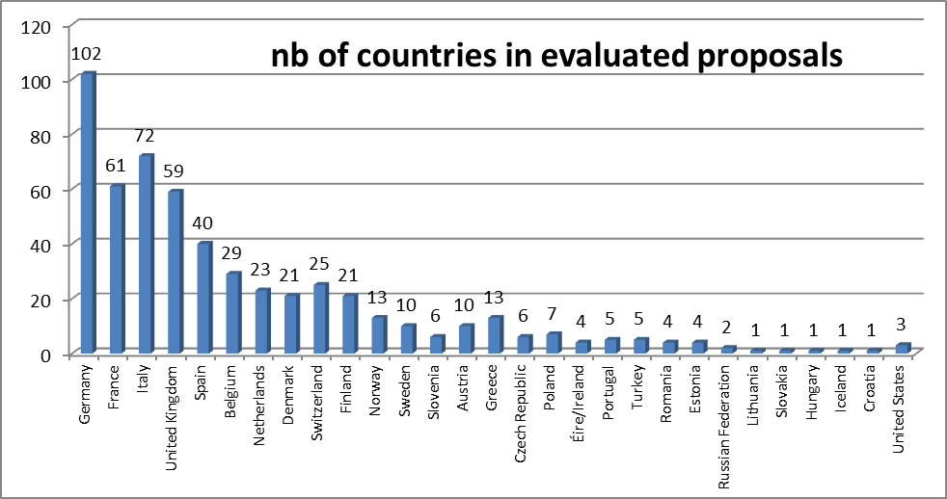

7.4.1.3. Evaluation results
Number of proposals submitted:
- Passing the thresholds: 43
- Failing the thresholds: 29
- Proposed for funding: 28
- Reserve list: 15
- Success rate: 39%
Table 5: Evaluation results
Call Reference | Submitted Proposals |  |  | Evaluation results |  |  | Reserve list, if any % of retained
Call Reference | Submitted Proposals | Eligible Proposals | % of retained | Above threshold | Submitted for funding | Success rate% | Reserve list, if any % of retained
FCH-JU-2012-1 | 72 | 68 | 94% | 43 | 28 | 39% | 35%
Number of participants in the proposals selected for funding (see table 5):
- Total: 224
- Success rate by type, of which SMEs: 55 participants with a 34 % success rate
- By country:
Germany, France, the UK and Italy performed best as number of participations in the selected for funding projects, all together registered 136 participations out of 224 – over 60% of the total participations.
Figure 5: Participations by Country selected for funding
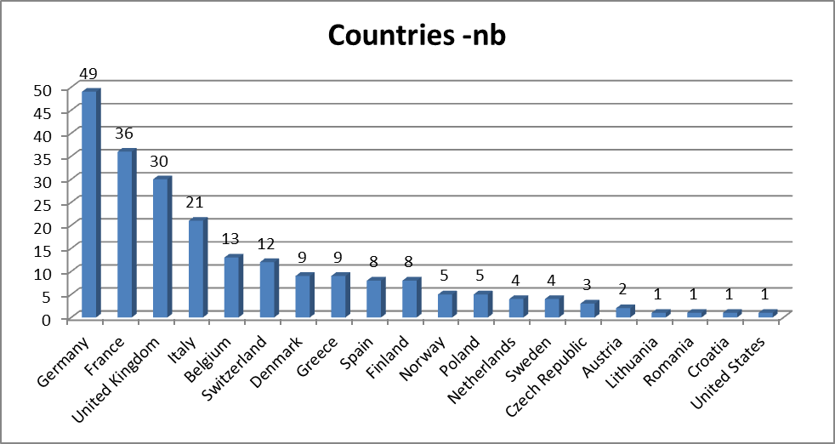

7.5. Project Portfolio
This section will provide information on the general picture on signed grant agreements (GA) and on their implementation together with a comprehensive picture of the JU's business.

7.5.1. Grant agreements signed (commitment amounts – during the year 2012)
№ | GA № | Project acronym |  | Call Identifier | A | B | C
№ | GA № | Project acronym | Project title | Call Identifier | JU contribution | In-kind contribution | Total contribution
№ | GA № | Project acronym |  | Call Identifier | JU contribution | In-kind contribution | A+B
1 | 298300 | T-CELL | Innovative SOFC Architecture based on Triode Operation | FCH-JU-2011-1 | 1.796.267,00 | 1.627.900,80 | 3.424.167,80
2 | 299732 | UNIFHY | UNIQUE gasifier for hydrogen Production | FCH-JU-2011-1 | 2.203.599,00 | 1.352.053,00 | 3.555.652,00
3 | 300081 | ELECTROHYPEM | Enhanced performance and cost-effective materials for long-term operation of PEM water electrolysers coupled to renewable power sources | FCH-JU-2011-1 | 1.352.771,00 | 1.489.541,00 | 2.842.312,00
4 | 301782 | FLUMABACK | Fluid Management component improvement for Back up fuel cell systems | FCH-JU-2011-1 | 2.773.700,00 | 1.666.764,00 | 4.440.464,00
5 | 303024 | EURECA | Efficient use of resources in energy converting applications | FCH-JU-2011-1 | 3.557.293,00 | 2.757.212,00 | 6.314.505,00
6 | 303411 | DON QUICHOTE | Demonstration Of New Qualitative Innovative Concept of Hydrogen Out of windTurbine Electricity | FCH-JU-2011-1 | 2.954.846,00 | 1.991.288,00 | 4.946.134,00
7 | 303415 | SAPIENS | SOFC Auxiliary Power In Emissions/Noise Solutions | FCH-JU-2011-1 | 1.591.590,00 | 777.917,20 | 2.369.507,20
8 | 303417 | HYUNDER | Assessment of the potential, the actors and relevant business cases for large scale and seasonal storage of renewable electricity by hydrogen underground storage in Europe | FCH-JU-2011-1 | 1.193.273,00 | 573.243,00 | 1.766.516,00
9 | 303418 | PHAEDRUS | High Pressure Hydrogen All Electrochemical Decentralized RefUeling Station | FCH-JU-2011-1 | 3.566.343,00 | 2.743.489,00 | 6.309.832,00
10 | 303419 | PUMA MIND | Physical bottom Up Multiscale Modelling for Automotive PEMFC Innovative performance and Durability optimization | FCH-JU-2011-1 | 2.294.106,00 | 1.798.523,69 | 4.092.629,69
11 | 303422 | MATHRYCE | Material Testing and Recommendations for Hydrogen Components under fatigue | FCH-JU-2011-1 | 1.296.249,00 | 1.196.688,00 | 2.492.937,00
12 | 303428 | BOR4STORE | Fast, reliable and cost effective boron hydride based high capacity solid state hydrogen storage materials | FCH-JU-2011-1 | 2.273.682,00 | 1.797.029,30 | 4.070.711,30
13 | 303429 | EVOLVE | Evolved materials and innovative design for high-performance, durable and reliable SOFC cell and stack | FCH-JU-2011-1 | 3.105.093,00 | 2.700.280,80 | 5.805.373,80
14 | 303435 | ARTIPHYCTION | Fully artificial photo-electrochemical device for low temperature hydrogen production | FCH-JU-2011-1 | 2.187.040,00 | 1.454.802,00 | 3.641.842,00
15 | 303445 | STACKTEST | Development of PEM Fuel Cell Stack Reference Test Procedures for Industry | FCH-JU-2011-1 | 2.909.898,00 | 2.727.882,20 | 5.637.780,20
16 | 303446 | IMPALA | IMprove PEMFC with Advanced water management and gas diffusion Layers for Automotive application | FCH-JU-2011-1 | 2.640.535,00 | 2.441.051,80 | 5.081.586,80
17 | 303447 | HYPER | Integrated hydrogen power packs for portable and other autonomous applications | FCH-JU-2011-1 | 2.221.798,00 | 1.694.711,00 | 3.916.509,00
18 | 303449 | STAMPEM | STAble and low cost Manufactured bipolar plates for PEM Fuel Cells | FCH-JU-2011-1 | 2.576.505,00 | 2.647.302,60 | 5.223.807,60
19 | 303451 | HYLIFT-EUROPE | HyLIFT-EUROPE - Large scale demonstration of fuel cell powered material handling vehicles | FCH-JU-2011-1 | 9.263.194,00 | 11.068.789,20 | 20.331.983,20
20 | 303452 | IMPACT | Improved Lifetime of Automotive Application Fuel Cells with ultra-low Pt-loading | FCH-JU-2011-1 | 3.902.403,00 | 4.934.891,00 | 8.837.294,00
21 | 303454 | TRISOFC | Durable Solid Oxide Fuel Cell Tri-generation System for Low Carbon Buildings | FCH-JU-2011-1 | 1.481.391,00 | 1.254.169,00 | 2.735.560,00
22 | 303457 | PURE | Development of Auxiliary Power Unit for Recreational yachts | FCH-JU-2011-1 | 1.665.796,00 | 1.280.763,20 | 2.946.559,20
23 | 303458 | CLEARGEN DEMO | The Integration and demonstration of Large Stationary Fuel Cell Systems for Distributed Generation | FCH-JU-2011-1 | 4.600.000,00 | 5.549.904,00 | 10.149.904,00
24 | 303461 | LIQUIDPOWER | Fuel cell systems and Hydrogen supply for Early markets | FCH-JU-2011-1 | 1.999.872,00 | 1.688.454,00 | 3.688.326,00
25 | 303462 | ENE.FIELD | European-wide field trials for residential fuel cell micro-CHP | FCH-JU-2011-1 | 25.971.605,00 | 26.979.538,60 | 52.951.143,60
26 | 303466 | IMMEDIATE | Innovative autoMotive MEa Development – implementation of Iphe-genie Achievements Targeted at Excellence | FCH-JU-2011-1 | 2.087.390,00 | 1.598.163,00 | 3.685.553,00
27 | 303467 | HYTRANSIT | European Hydrogen Transit Buses in Scotland | FCH-JU-2011-1 | 6.999.999,00 | 9.321.166,57 | 16.321.165,57
28 | 303472 | EDEN | High energy density Mg-Based metal hydrides storage system | FCH-JU-2011-1 | 1.524.900,00 | 1.128.674,00 | 2.653.574,00
29 | 303476 | BEINGENERGY | Integrated low temperature methanol steam reforming and high temperature polymer electrolyte membrane fuel cell | FCH-JU-2011-1 | 2.245.244,00 | 1.969.179,40 | 4.214.423,40
30 | 303482 | ARTEMIS | Automotive pemfc Range extender with high TEMperature Improved meas and Stacks | FCH-JU-2011-1 | 1.747.884,00 | 1.200.318,10 | 2.948.202,10
31 | 303484 | NOVEL | Novel materials and system designs for low cost, efficient and durable PEM electrolysers | FCH-JU-2011-1 | 2.663.357,00 | 3.080.088,00 | 5.743.445,00
32 | 303485 | SWARM | Demonstration of Small 4-Wheel fuel cell passenger vehicle Applications in Regional and Municipal transport | FCH-JU-2011-1 | 6.978.277,00 | 10.439.665,00 | 17.417.942,00
33 | 303492 | CATHCAT | Novel catalyst materials for the cathode side of MEAs suitable for transportation applications | FCH-JU-2011-1 | 1.895.862,00 | 1.082.680,80 | 2.978.542,80
TOTALS |  |  |  |  | 117.521.762,00 | 116.014.123,26 | 233.535.885,26

7.5.2. Grant agreements for which activities have ended and/or final results are available
№ | GA № |  |  | Project acronym |  | Initial requested funding/ Total costs |  | A | B | C
№ | GA № | Date GA signed | Date GA ended | Project acronym | Project title |  |  | JU contribution | In-kind contribution* | Total contribution
№ | GA № |  |  | Project acronym |  |  |  | JU contribution | In-kind contribution* | A+B+C
1 | 245133 | 18/12/2009 | 31/12/2010 | NEXTHYLIGHTS | Supporting action to prepare large-scale hydrogen vehicle demonstration in Europe | 499.303 | 1.142.114 | 481.769 | 518.264 | 1.000.033
2 | 245142 | 18/12/2009 | 30/09/2011 | AUTO-STACK | Automotive Fuel Cell Stack Cluster Initiative for Europe | 1.193.015 | 2.576.629 | 885.839 | 1.184.594 | 2.070.433
3 | 245332 | 21/12/2009 | 30/06/2011 | PREPAR-H2 | Preparing socio and economic evaluations of future H2 lighthouse projects | 257.075 | 559.154 | 256.153 | 341.655 | 597.808
4 | 256328 | 15/12/2010 | 30/09/2011 | HYGUIDE | HyGuide | 366.318 | 374.359 | 366.318 | 209.530 | 575.848
5 | 256850 | 21/12/2010 | 30/09/2011 | H2FC-LCA | Development of Guidance Manual for LCA application to Fuel cells and Hydrogen technologies | 311.957 | 400.016 | 311.957 | 98.019 | 409.976
TOTALS |  |  |  |  |  | 2.627.668 | 5.052.272 | 2.302.036 | 2.352.063 | 4.654.099
* including contributions of JRC of €63,929 and €8,696.05 for AUTO-STACK and HYGUIDE respectively.

GLOSSARY AND ABBREVIATIONS

GENERAL
AAR – Annual Activity Report
ABAC – Accrual Based ACcounting is a transversal, transactional information system allowing for the execution and monitoring of all budgetary and accounting operations by the Commission, an Agency or EU Institution
ABP – Annual Budget Plan
AIP – Annual Implementation Plan
APR - Annual Progress Report
AWP – Annual Work Program
CDT – Translation Centre for the Bodies of the European Union
CFP - Calls For Proposal
CORDA - COmmon Research DAta warehouse application (IT Tool) is a module used to create statistics and report tables for FP6/7 project
CPM – Contract and Project Management (IT Tool)
CSWD – Commission Staff Working Document
DG BUDG – European Commission Directorate-General for Budget
DG CNECT – European Commission Directorate General for Communications Networks, Content and Technology
DG HR – European Commission Directorate-General Human Resources and Security
DG RTD - European Commission Directorate-General for Research and Innovation
ECA - European Court of Auditors
EPSS - Electronic Proposal Submission System (IT Tool)
ESS – Evaluation Service Support (IT Tool)
EC – European Commission
ED – Executive Director
ERA – European Research Area
ESR – Evaluation Summary Reports
EU – European Union
FP7 - Seventh Framework Programme of the European Community for research, technological development and demonstration activities (2007-2013)
FPP - Full Project Proposal
GA – Grant Agreements
GB – Governing Board
Horizon 2020 - Horizon 2020 is the financial instrument implementing, in the period from 2014 to 2020, the Innovation Union, a Europe 2020 flagship initiative aimed at securing Europe's global competitiveness.
HR – Human Resources
IE – Interim Evaluation
IT – Information Technology
JTIs - Joint Technology Initiative are European Union instruments for addressing technological challenges that are of key importance for the future competitiveness of the EU industry involved, challenges that industry and markets would fail to address without a sizeable public intervention extended over a multi-annual timescale
JU - Joint Undertaking refers to the administrative structure of the JT
MASP - Multi-Annual Strategic Plans
MSPP - Multi-Annual Staff Policy
NEF – Negotiation Module, Back Office (IT Tool) used to manage data entry for Negotiations, Amendments, and Periodic Reports
PDM – Participant Data Management (IT Tool)
PO – Project Outline
REA - Research Executive Agency (REA)
R&D – Research and Development
SEP – Submission and Evaluation of Proposals (IT Tool)
SESAR (JU) - Single European Sky ATM Research programme is the technological and operational dimension of the Single European Sky (SES) initiative
SME – Small and Medium Enterprises
SRA - Strategic Research Agenda
SRIA - Strategic Research & Innovation Agenda

ARTEMIS
AIPP – ARTEMIS Innovation Pilot Project
ARTEMIS-IA – ARTEMIS Industrial Association
ITEA– the Information Technology for European Advancement is a strategic pan-European programme currently is its second phase (ITEA 2)
ASP – ARTEMIS Sub-programme
CMS – Content Management System
GFA - General Financing Agreement
IRC - Industry and Research Committee
MBAT - Combined Model-based Analysis and Testing of Embedded Systems (on-going project launched in 2011)
PAB - Public Authorities Board

ENIAC
AENEAS – Association for European Nanoelectronics Activities is a non-profit industrial association established under French law
CATRENE - is a four-year programme, which started in 2008 and extendable to eight years. This programme aims at delivering nano-/microelectronics solutions that enable lighthouse projects and responding to the needs of society at large
DPO – Data Protection Officer
EDPS – European Data Protection Supervisor
ETP – European Technology Platform
EUREKA – intergovernmental network launched in 1985, to support market-oriented R&D and innovation projects by industry, research centres and universities across all technological sectors
IAS – Internal Audit Service
IRC – Industry and Research Committee
KET – Key Enabling Technologies
LISO – Local IT Security Officer
PAB – Public Authorities Board

FCH
AA – Application Areas
CHP - Combined Heat & Power
FCEV - Fuel Cell Electric Vehicles
HRS - Hydrogen Refuelling Stations
MAIP – Multi Annual Implementation Plan
N.ERGHY - Association that groups the European research community
NEW-IG - New Energy World Industry Grouping
PNR & LCA - Pre-normative Research and Life Cycle Analysis
SRG - States Representatives Group

Austria, Belgium, Cyprus, Czech Republic, Germany, Denmark, Estonia, Spain, Finland, France, Greece, Hungary, Ireland, Italy, Latvia, Netherlands, Norway, Poland, Portugal, Romania, Sweden, Slovenia and the United Kingdom.
The ARTEMIS Industrial Association (ARTEMIS-IA) was established in January 2007 in the Netherlands by five companies: Philips, ST Microelectronics, Thales, Nokia and DaimlerChrysler. It represents the interests of the industry and the research community within the ARTEMIS Joint Undertaking.
A CoIE is a group of multi-country, multi-organisation, interconnected R&D actors and businesses that by efficient planning, acting and cooperation, achieve a significant advantage in innovation success in a specific market. The ARTEMIS Label by the ARTEMIS Industry Association recognises the achievements of the COIE in the field of innovation in embedded systems. To date three CoIE are established: EICOSE (European Institute for Complex Safety Critical Systems Engineering); ProcessIT.EU focusing on automation solutions for the Process industry in a number of segments; ES4IB (Embedded Systems for Intelligent Buildings).
Austria, Belgium, Czech Republic, Estonia, Finland, France, Germany, Greece, Hungary, Ireland, Italy, Latvia, Malta, Netherlands, Norway, Poland, Portugal, Romania, Slovak Republic, Spain, Sweden and the United Kingdom.
The Association for European Nanoelectronics Activities (AENEAS) is a non-profit industrial association established on 30 November 2006 to represent the R&D performers in the ENIAC Joint Undertaking.
The New Energy World Industry Grouping "Fuel Cell and Hydrogen for Sustainability" (NEW-IG) is a non-profit association open to industrial companies dealing with fuel cell and hydrogen R&D activities in Europe, including the EU Member States, the countries in the European Economic Area and the EU associate and candidate countries. By the end of 2012, the Industry Grouping had over 60 members. They varied from micro companies to large enterprises from across the fuel cells and hydrogen value chain.
The N.ERGHY Research Grouping is a non-profit association representing the research community in Europe. The objective of N.ERGHY is to promote, support and accelerate the research and deployment process of fuel cell and hydrogen technology in Europe from the point of view of the research community. By the end of 2012, the Research Grouping had over 60 research institutes and universities as members.
The European Strategic Energy Technology (SET) Plan has identified fuel cells and hydrogen among the technologies needed for Europe to achieve the 2020 Energy and Climate Change goals: 20% reduction in greenhouse gas emissions, 20% share of renewable energy sources in the energy mix and 20% reduction in primary energy use, as well as to achieve the long-term vision for 2050 towards decarbonisation [Communication from the Commission of 22 November 2007, COM (2007) 723 final].
Capex (capital expenditure) comes for any funds used by an entity to acquire or upgrade physical assets such as property, industrial buildings or equipment
Study on jobs and investment in the fuel cells and hydrogen sector, 2012, http://www.fch-ju.eu/sites/default/files/Investment%20jobs%20%26%20turnover%20in%20FCH%20Sector.pdf
http://www.fch-ju.eu/content/how-participate-fch-ju-projects
The presentation and report prepared by McKinsey are available at the following link: http://www.fch-ju.eu/news/fch-ju-launches-its-study-urban-buses-alternatives-power-trains-europe
http://www.fch-ju.eu/page/documents
Available under http://www.fch-ju.eu/page/publications
(increased by the EFTA contributions and reactivation of amounts from previous years, as approved by the Governing Board to € 79.8 M €)

