USDA Foreign Agricultural Service
GAIN Report

Global Agriculture Information Network
Template Version 2.09

Required Report - public distribution
Date: 11/13/2008
GAIN Report Number: MO8019
MO8017
Morocco
Retail Food Sector
Report
2008

Approved by:
Hassan F. Ahmed
U.S. Embassy, Rabat
Prepared by:
Aziz Abdelali

Report Highlights:
Retail food distribution channels in Morocco continue to develop. In the past ten years, large modern supermarkets have played an important role in transforming Morocco's food distribution system and buying habits. The number of modern supermarkets is still expected to grow in the medium term but local importers will continue to play the major role in introducing, distributing, and promoting food products in Morocco.

Includes PSD Changes: No
Includes Trade Matrix: No
Annual Report
Rabat [MO1]
[MO]
Table of Contents

SECTION I. MARKET SUMMARY 3
Major Categories of supermarkets 3
Trend in distribution channels 4
Trend in services offered by retailers 4
SECTION II. ROAD MAP FOR MARKET ENTRY 6
A1. Large Retail and Wholesale Supermarkets 6
A2. Small Retail Supermarkets, Convenience Stores, Large Grocery Stores 9
Gas Marts 12
C. Traditional Markets - "Mom & Pop" Small Independent Grocery Stores 13
SECTION III. COMPETITION 14
SECTION IV. BEST PRODUCTS PROSPECTS 17
SECTION V. POST CONTACT AND FURTHER INFORMATION 20

SECTION I. MARKET SUMMARY

The Moroccan retail food sector continues to develop, though at modest rate, as additional modern large supermarkets are projected to open. The advent of these food distribution outlets has been instrumental in changing the purchasing habits of a wide base of urban consumers throughout Morocco. That said, traditional small grocery stores, because of their proximity and convenience, will continue to play a major role in most parts of large cities, and particularly in rural areas and small cities where 45 percent of Moroccans live.

The early advent of large supermarkets to Casablanca, Rabat, and Marrakech reflects the concentration of high-income population in these cities. An estimated 60 percent of the total number of the modern supermarkets are concentrated between Casablanca and Rabat. Currently, large supermarkets have opened in virtually all-major cities (including Agadir, Tangiers, Fes, Meknes, Mohamedia) and more are being opened in even smaller cities (such as Beni Mellal and Tetouan) and in lower income sections of major cities thus providing alternatives to traditional buying habits of relatively low income groups.

Casablanca, with an estimated population of 4 million, is the largest city and is considered the economic capital Morocco and the largest concentration of high-income consumers. Rabat, about 1 hour north of Casablanca, has about 1 million people with a large number of government employees, foreign missions, and international organizations that can be targeted with modern distribution chains. Marrakech is, by far, the leading destination for tourists. It has been growing remarkably fast because many high-income Moroccans and Europeans consider it as the choice destination for holidays and, more recently, for retirement.

European multinationals (mostly French, but also Dutch wholesale distributions) invested heavily in the Moroccan modern distribution chain. They brought know-how in supermarket management that Moroccan investors lacked. Most of the existing chains have had, or had, at least some European (French) participation in their capital. Some are increasingly consolidating purchases (food and non-food) in centralized purchasing departments in Europe while others are exporting their products to Morocco under their private label which prevent them from benefiting from the preferences secured under the United States-Morocco Free Trade Agreement that requires the products to be of U.S. origin.

In the medium term, importers based in Morocco will continue to play a major role in distributing and promoting imported products in Morocco. Typically, they have their own sales agents and distribution fleet and are in direct contact with large supermarkets, wholesalers, and in many cases with large grocery stores as well. Some importers are involved in imports of a wide range of products with no particular loyalty to a specific product, brand or origin. Others are working exclusively to develop markets for specific labels or even for their own private label. As these importers tend to promote their products more heavily, they work more regularly with the supermarket chains and may require more involvement from the exporter in terms of pushing the product in the market.

Major Categories of supermarkets

As far as imported food products are concerned, the Moroccan food distribution sector can be divided into three major categories:
- • Large modern retail and wholesale supermarkets chains.
- • Small supermarkets, convenience supermarkets, large self-service grocery stores.
- • Mom & Pop stores.

Imported high value food products typically don’t reach the open-air markets that exist mostly in rural areas where the lower income segment of the population lives.

Trend in distribution channels

Marketing experts and food distributors estimate that the modern food distribution channels accounts for nearly 15 percent of total retail food sales in Morocco. Although small mom & pop shops will continue to play a major role in the food distribution in the medium term, the number of supermarkets is likely to continue to grow in the cities because of:
- A growing large base of western-minded consumers, especially in urban areas.
- A growing middle class where both parents are working and less time is available for shopping for food so that food purchases tend to be more grouped.
- The aggressive promotions, the appealing prices and discounts, and the wide range of products offered by large supermarkets are likely to enlarge the consumer base by attracting even lower-income consumers.
- The increasing acceptance by the Moroccan consumer of processed and packaged products. Many products traditionally sold in bulk are now readily available in various packages.
- The increasing perception among the Moroccan consumers that food sold in the modern supermarkets chains are safer and that imported products offer a wider range of products generally of higher quality.

Trend in services offered by retailers

Large supermarkets in Morocco tend to be located in small malls that include a large number of European and U.S. franchises for fast food, textiles, shoes, quick car repairs, banks, and car services. The number of adjacent shops varies from 10 to 25 and is meant primarily to attract a large number of visitors. Large supermarkets that started a couple of years ago to allocate some space for ready-to-eat food, which is rather unusual in Moroccan supermarkets but do reflect the increasing habit of eating outside for a certain segment of the Moroccan consumers. In many cities, the lack of adequate entertainment and amusement sites draws many Moroccan families to visit supermarkets to roam around where they often end-up buying or at least are exposed to new products.

In an effort to attract the lower income segment of the population, large supermarket chain developed their own generic brand that supposedly is the most economic to the consumer. The generic brands are being used for food and non food products and some imported products are also being offered under the label “Most economic”.

In spite of the dramatic increase in use of Internet by the Moroccan communities, Internet sales of food products are virtually non-existent in Morocco. Currently, there are virtually no offers made on a regular basis by food companies and payment procedures via Internet are not yet developed. Today, there are an estimated 4 million Internet users in Morocco of which only some 300,000 are subscribed to an Internet provider. The remaining users have access to internet typically in Cyber Cafés.

Number and Type of Retail Outlets in Morocco

Type of Store | Estimated  Number* | Identified Supermarket  Locations
Large Supermarkets  (Including Independent)  12-32 registers, over 500 parking spots, Over 40,000 ft² | 30 | Casablanca-6, Rabat/Sale-4, Marrakech-5, Agadir-3, Fes-2, Tanger-2, Meknes 2, Mohamedia 1, Kenitra-2, Tetouan-1, Temara 1, Safi 1
Small Supermarket & Convenience Stores:  1. Small Supermarket & Convenience Stores (> 3 registers, >12,000 ft²)  2. Small Self-Service Grocery Stores (2 registers, > 1000 ft²) | 60  180 | Casablanca-18, Rabat-7, Marrakech 5  Agadir-4, etc.  Casablanca-70, Marrakech-15, Rabat-10, Agadir-7, Meknes-6,  etc.
Hanouty small Convenience Stores Chain / franchise  (1 register, 220-1300 ft² ) | 130 | Concentrated in Casablanca and Rabat. Plans to cover other regions as well. Mostly franchisee’ privately owned shops
Mom & Pop Stores  1. 1000 ft²  2. 226 – 1000 ft²  3. Less than 226 ft²  4. Small convenience Gas-Marts | 500  4,500  40,000  30 | Estimated 15,000 in Casablanca  Marrakech, Casablanca,  Agadir, Rabat.
Source: Importers, Agricultural Affaires Office, Rabat
* The total number of small supermarket and small stores has to be taken with care as reliable statistics are not available.

Advantages and Challenges of the Moroccan Market

Advantages | Challenges
33 million Moroccans  10-15 percent can repeatedly afford to buy imported products. | 45 percent in rural areas.  Limited purchasing power in small cities and rural areas.
Morocco and the U.S. signed a free trade agreement that provides preferential access to many U.S. food products, especially on the medium and long term. | Currently, high duties on imported products.
Western-minded youth. Developing middle class. More women working outside the home. | Promotional activities very difficult in traditional outlets.
Most importers are in Casablanca. | Relatively small volume involved even in large supermarkets.
There are very progressive and marketing oriented importers. | Modern independent supermarkets require an entry fee for each new product.
Fast growth of modern distribution channels. More supermarkets are expected to open in the near future. | Proximity of Europe to Morocco:  - Imports of small quantities are economically feasible.  - EU is a traditional supplier.  - EU suppliers are more aggressive in this market.
Growing perception that supermarkets offer safer and cheaper products. Increased acceptance of packaged products. | Multinational chains procure some food products through their home office and in many cases under a private label.

SECTION II. ROAD MAP FOR MARKET ENTRY

A1. Large Retail and Wholesale Supermarkets

Included in this category are stores of a minimum of 40,000 ft2 (up to 75,000 ft2), having between 12 and 34 registers, and over 250 employees. The supermarket ground usually has many private shops including pharmacists, fast-food chains, amusement centers, and in most cases gas stations. These stores have large parking lots that can fit up to 1,000 cars. Typically, these supermarkets are at not in walking distance, which is likely to restrain the consumer base to medium-high class consumers. These supermarkets offer both food and non-food items. The number of different food items is often over 12,000 and is believed to generally account for 40-50 percent of the total sales.

Entry Strategy

The best way to introduce new products to these supermarkets is to go through local importers because:
- Many have long experience and direct relations with supermarkets. Thus, they are in much better position to negotiate space and promotional events.
- They have their own distribution fleet and are able to deliver in relatively small volumes.
- They carry out promotional activities regularly in these stores.
- They supply smaller supermarkets as well.
- Supermarkets might only work with well-established importers. Some supermarket chains do import directly, but usually through buying boards in Europe (METRO), or under a European private label (Leader Price label for Label Vie Chain).

Market Structure

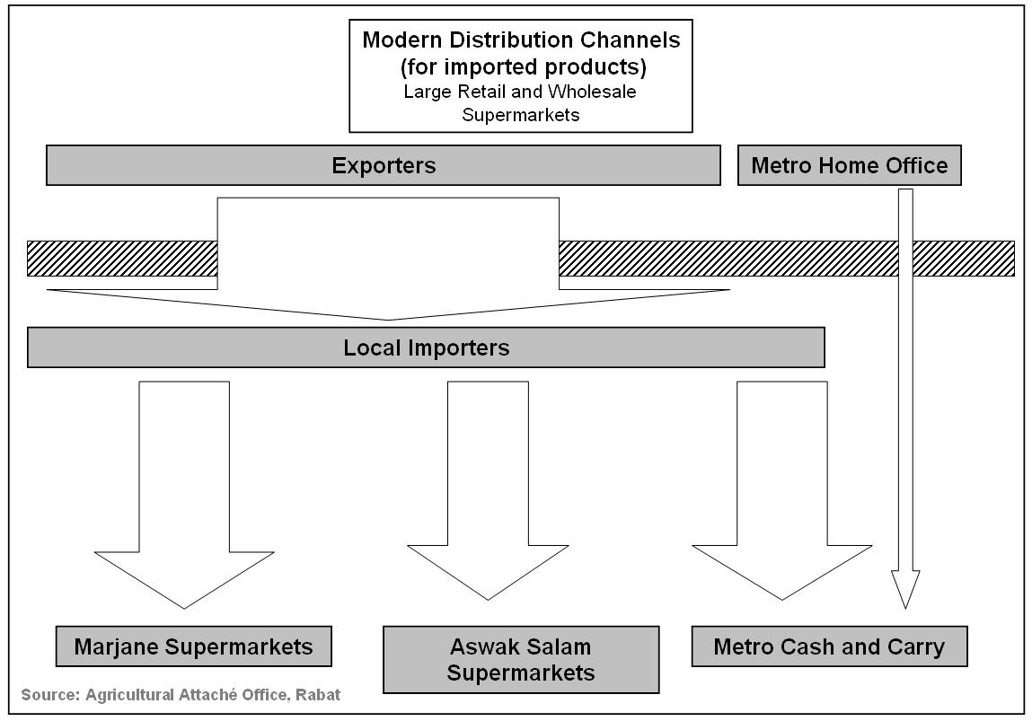

Local importers still supply a large share of imported food products to large supermarket chains in Morocco in spite of some imports being carried out directly by the wholesale cash and carry chain (METRO) through their home office in Europe. Purchases (from local producers and from importers) by these large supermarkets chains are typically handled by their headquarters in Casablanca. Since Marjane Chain and ACIMA convenience stores (see below) belong to the same company and carry many products in common, food procurement (except produce and meat) is handled by the Central office in Casablanca.

In August 2007, the French Auchan withdrew from Marjane and ACIMA chains. Auchan procured 49 percent of these chains on January 2001 and started selling many products under the Auchan label. Currently Marjane and ACIMA are owned entirely by the largest Moroccan consortium (ONA) and it is likely that the chains will continue to grow as plans are to open outlets in cities of more than 300,000 people. Whether Marjane and ACIMA will continue to be 100 percent Moroccan in the future remains to be seen.

Supermarkets in this category are aggressive in promoting their products. They publish monthly brochures and occasional flyers where the importers promote their products. Also, these supermarkets, especially Marjane, advertise regularly on the radio for available sales and discounts to attract customers. The Marjane chain has been very aggressive in promotion over the past few years, as they have been organizing heavy radio advertising campaigns that claim cheaper prices, quality products and services after sale for the non-food products. They have also been promoting the winner “FAIZ” card that provides interest-free delayed payments to consumers.

Company Profiles

Retailer  Name | Ownership | Estim.  Sales  ($Mil.) | Total Nb of  Outlets  (opened over past 2 years) | Locations  Nb of stores | Purchasing Agent type
Marjane  70,000 ft² | 100 % Moroccan (ONA Consortium) since August 2007 | 50-100  18 million customers per year | 17 (4) | Casablanca-4,  Rabat-2,  Marrakech-2, Meknes-1,  Agadir-1,  Tanger-1,  Fes-1,  Mohamedia-1,  Safi-1, Kenitra-1  Tetouan-1,  Oujda-1. | Buys from limited number of local importers / distributors.  (Same buying platform as for small convenience stores chain, ACIMA).
METRO (formerly Makro) wholesale Cash and Carry | Dutch (METRO) | 50-100 | 6 (0) | Casablanca-2,  Rabat-1,  Fes-1,  Agadir-1  Marrakech-1 | Buys from local importers / distributors.  Occasionally imports directly through headquarter in Europe and/or under own private labels.
Aswak Assalam  (Recently partner of Casino Supermarkets)  50,000 ft² | 100% Moroccan. Over 15 registers.  No alcoholic beverages or pork sold. | 30-50 | 7 (2) | Rabat-1, Marrakech-2, Kenitra-1,  Temara-1,  Agadir-1,  Tanger-1. | Buys from local importers / distributors.  Plans to open 2 new supermarkets each year
Source: Agricultural Affairs Office

The retail independent store Marjane first opened in Morocco in the early 1990's and were launched by Morocco’s largest consortium of private companies, ONA (Omnium Nord African). These supermarkets are very modern and are comparable to ones in the U.S. They are usually located is relatively remote areas and thus are visited by higher-income consumers who are also the major buyers of imported food products. Marjane employs about 5,144 people and serves over 18 million customers at its 17 stores each year. Competing on the same segment with Marjane chain is Aswak Assalam supermarket chain. These are smaller supermarkets but comparable to Marjane stores in their concept as they also carry food and non-food and are considerably larger than other supermarkets in Morocco. Aswak Assalam does not carry alcoholic beverages or pork products in order to be perceived by the public as more tradition-preserving genuine Moroccan supermarkets.

The wholesale cash and carry independent, METRO (formerly Makro), also started in the early 1990's, and today has 6 stores. It is a subsidiary of the German METRO chain. A membership card is required to purchase from these stores that are usually dedicated to large size and bulk sales. Although METRO targets primarily retailers and HRIs, today many individual consumers manage to have an access card and are buying on a regular basis from these stores, which have been offering relatively small bulk packaging. However, over the past two years, there is a clear tendency for METRO to offer larger bulk sizes in an effort to concentrate on the wholesale segment. METRO occasionally imports food products directly through its headquarter in Europe and sometimes use their own brands.

Some of these large supermarkets also market some of their products (including imported food) under their own label (for example METRO uses Aro, Metro, and Norm labels, and Marjane supermarket uses “Most economic”). Also, the entry fee to the supermarket for a single new product may be prohibitive.

A2. Small Retail Supermarkets, Convenience Stores, Large Grocery Stores

Entry Strategy

Typically, supermarkets in this category don’t get involved in direct imports because of the small volume involved. The supermarkets belonging to the largest chains (ACIMA and Hyper) buy through their purchasing boards. Thus, importers will still play a major role to introduce new products to these convenience outlets because:
- Many have long experience in this market and have agents that work on a regular basis with these supermarkets and are in a better position to negotiate space and promotional events.
- They have their own distribution fleet that can deliver relatively small volumes.
- They carry out promotional activities regularly in these stores.
- These supermarkets work often with a relatively small number of suppliers that carry known brands that sell well.

Market Structure

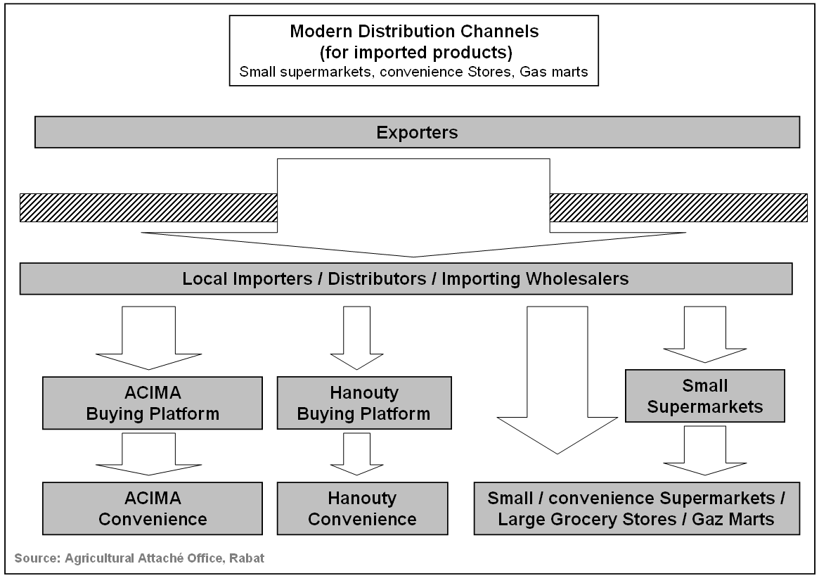

U.S. exporters will find it very difficult to sell directly to these supermarkets because of the small volume involved. Supermarkets, or their buying board for the existing chains, buy imported goods directly from importers. For the largest convenience store chain (ACIMA), food purchases are combined with those of Marjane (see large supermarket chains section). On the other hand, some importers devote full time sale agent(s) to deal with specific supermarkets. Eventually, the importer’s trucks and utility cars deliver the imported goods to the supermarkets.

In addition, the small self-service stores may also purchase from local wholesalers if the quantities involved are very small. Both importers and wholesalers provide financing to supermarkets. Typically the importer’s agents deliver the imported products to the supermarkets in small vans (panel trucks) or trucks.

Company Profiles

Retailer  Name | Ownership | Estim.  Sales  ($Mil.) | Nb of  Outlets  (Estimated) | Locations | Purchasing  Agent type
Small Supermarket  Independent (ACIMA)  (6 registers, typically > 20000 ft²) | 100 % local since August 2007.  Same Owner as Marjane Supermarkets | 1-5 | 25 | Casablanca-11,  Rabat-3, Marrakech-2, Fes-1, Safi, 1, Khouribga-1,  Beni Mellal-1,  El Jadida-1, Temara-1, etc. | Buying Board Buys from  Importers. Also through combined imports with Marjane Chain.
Small Supermarket (Hyper Chain)  (> 3 registers, >25000 ft²) | Local – private  Hyper S.A. | 1-5 | 16 | Casablanca-6,  Rabat-5,  El Jadida 1, Kenitra 1, Settat 1, Meknes 1, Mohamedia 1. | Buys from  Importers, and wholesalers.  Centralized Distribution Platform.
Small Supermarket  (> 3 registers, >25000 ft²) | Local – private | 1-5 | 15 | Casablanca-14,  Rabat-6,  Agadir-3, etc. | Buys from  Importers, and wholesalers.
Large grocery stores  (Self-service,  > 1 register, < 2000 ft²) | Local - private | 0.2 - 1 | 180 | Casablanca-68,  Marrakech-13,  Rabat-12, El Agadir 8, etc. | Buys from  Importers and Wholesalers
Hanouty Small Convenience Stores Chain - Franchisee  (1 register, 220-1300 ft2 )  First shops in 2006 | 95 percent of shops are Franchisee. Franchiser is a Moroccan company | na | 130 | Concentrated in Casablanca and Rabat. Plans to cover other regions as well. | Through a centralized purchase platform (4PML)
Source: Importers, Agricultural Affairs Office, Rabat

The first 3 groups (small supermarkets) are much smaller than Marjane but have a minimum of 20,000 ft2 and 3 to 6 registers. These stores offer a wide variety of products including non-food items. The largest stores in this category sale also house appliances. Typically these supermarkets include butcher shops, sell frozen products and alcoholic beverages, and have relatively limited parking space. They are located in, or within walking distance to, medium to high-income neighborhoods. These supermarkets are appropriate outlets for imported products since they are frequented by medium-high income consumers and could be used to carry out in store promotion activities.

ACIMA convenience supermarket chain opened 25 supermarkets over the past 6 years. Thanks to the strong financial capability of the owning companies, it is expected to open 5 new supermarkets every year. In fact, ACIMA and the largest supermarket chain in Morocco (MARJANE) belong to the largest consortium in Morocco (ONA). These large convenience stores are meant to attract urban consumers from the traditional mom & pop shops and open-air market where they would typically go. ACIMA as a convenience store offers a much larger percentage of food products including fresh fruits and vegetables. It is estimated that ACIMA supermarkets carry over 5,000 items.

The Label Vie independent supermarkets has today some 16 supermarket and carry some 2000 food items (40 % of the total number of products carried). Currently, they continue to buy mostly through importers but do get involved directly in imports of the private label (Leader Price) products and of some specialty products (some alcoholic beverages).

In 2006, one of the largest financial groups in Morocco launched a new chain of small convenience stores called HANOUTY (literally my shop). The franchiser provides credit for working capital, a uniform design and management for all Hanouty shops. The franchisees provide the location, are in charge of management, and must fulfill preset specifications and rules of conduct. The franchiser set up a new buying platform (called 4PML) in charge of contracting local suppliers and importers and dispatching the products. While 4PML does not get involved in imports it is the decision maker as to what products are being offered for sale in Hanouty shops. Hanouty franchiser also provides in store promotion (LCD screens, banners, etc.). Today Hanouty chain comprises some 130 shops located mostly in the Casablanca and Rabat area and are currently heavily advertized to attract more franchisees.
Hanouty chains also aims to replicate “credit to neighborhood customers” as it has been historically and commonly provided by most small stores in Morocco. Hanouty stores plan to make available to neighborhood customers a Hanouty credit card. The success of this financing to final customers will greatly depend on the flexibility and cost of the credit.

The very small supermarkets (self service) would be similar to small grocery stores in the U.S. They usually are privately owned and sell a much smaller number of items and brands and a smaller percentage of imported products. They have been opening throughout Morocco, including in the small cities.

Gas Marts

This category includes mostly gas-marts of 500 to 3,300 ft2 with one electronic register and carrying mostly convenience food.

The first store of this category opened in early 1990's. More and more gas distributors are including this service in their best-located (near exit of the major cities) gas stations. This segment is likely to continue to develop in the future. These stores are usually more expensive and carry a large number of imported convenience items, especially snack food, non-alcoholic drinks, and confectionary.

Retailer Name | Estim. # Of Outlets | Location | Purchasing  Agent
Afriquia Mini-Brahim (Managed by Maroshop) | 20 | Casablanca, Marrakech,  Agadir, Meknes, Settat, and highways | Buys from Importers  And distributors
Mobile Gas Stations  On the Run / Mobile Mart | 3 | Casablanca, Rabat, Marrakech | Buys from Importers  And distributors
Shell Gas Stations | 8 | Casablanca and highways | Buys from Importers  And distributors
SOMEPI Gas Stations | 10 | Highway | Buys from Importers  And distributors
Source: Agricultural Affairs Office

C. Traditional Markets - "Mom & Pop" Small Independent Grocery Stores

Entry Strategy

To reach these small mom & pop stores, imported products will have to go through importers and very likely wholesalers. The quantities involved are too small and imported food products are sold only in larger shops or in shops that are located in medium to high-income neighborhoods.

Market Structure

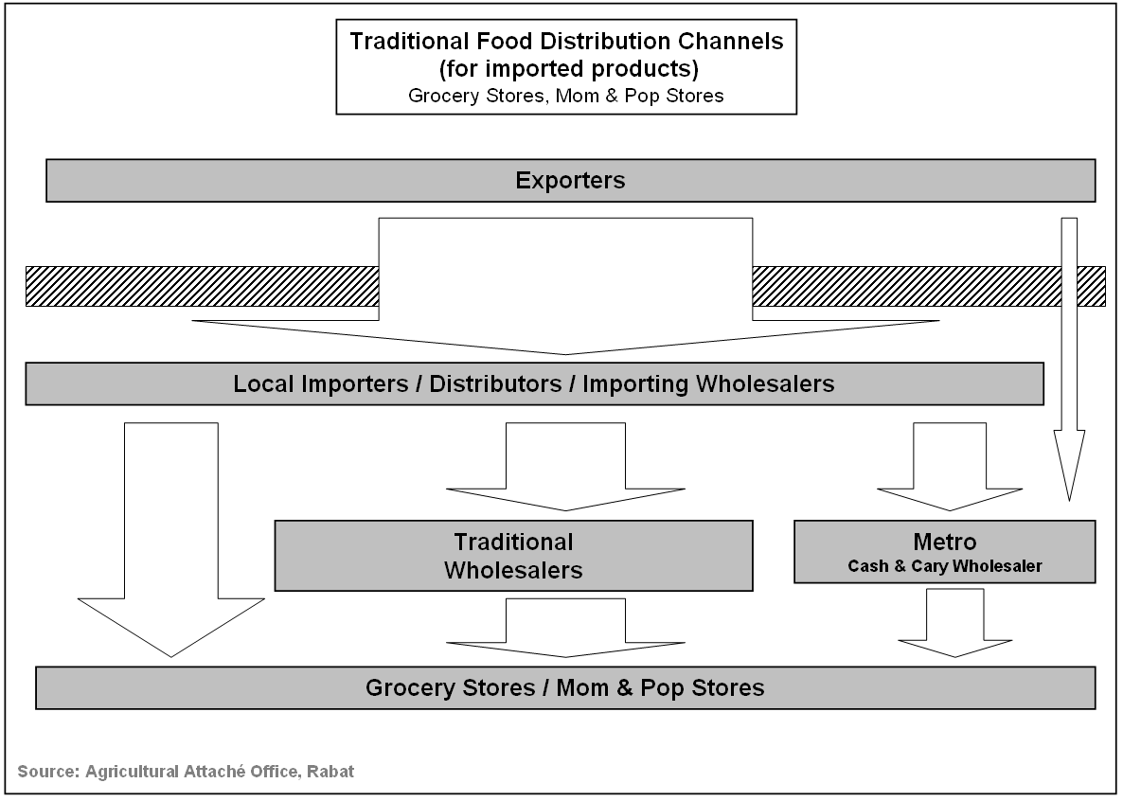

Company Profiles

This category includes an estimated 45,000 grocery stores that are not in the above categories. Their size varies from less than 226 ft2 (estimated 40,000 stores) to 1,000 ft2 (500 stores). These shops have limited financial resources and are typically managed by one person. The consumer cannot help himself in this store because the goods are behind a counter. Therefore, the shop owner plays a major role in introducing new brands to the consumer.

These shops are literally packed with a wide range of convenience and relatively low price food and non-food items. Depending on the location and size, some of these stores may have some imported products. Many of these stores in the cities have a refrigerator and a very small number have ice cream freezers. Convenience, proximity and credit to the final consumer are their strongest assets.

SECTION III. COMPETITION

Morocco has signed a free trade agreement (FTA) with the United States that entered into force in January 2006. The agreement provides U.S. exporters with new opportunities of exporting high value and consumer-oriented products in the medium and long term. With an average duty on consumer-oriented products of about 50 percent and the phase out of duties under the FTA is scheduled over 10 years, the cuts in duties and U.S. competiveness should become more significant as time passes.

In the past two years, Moroccan imports of high value products from the U.S. have grown due to a weaker dollar compared to the Euro and more competitive U.S. prices. The most significant increase came from dairy products used as ingredients by the food industry (butter, skim milk powder, dairy ingredients, whey, and cheeses) or to be resized and re-packaged locally for retail sale (butter). Also, thanks to the FTA, the newly introduced U.S. apples contributed significantly to increase of U.S. share of high value products in this market.

However, Moroccan imports of U.S. supermarket oriented products directly from the United States are rather marginal as noticed when visiting Moroccan supermarkets or retail shops. The main reason for this small share is the geographical distance and the absence of direct shipping lines between Morocco and the U.S. In practice, the long shipping time (up to 45 days because transit by Europe is necessary) excludes all short shelf-life products from being exported to Morocco. Also, since Moroccan importers bring most of their products in rather small quantities, it is easier to import products from Europe.

Moroccan consumers (and importers) are more familiar European (France and Spain) products and lifestyle. Middle and high income classes in Morocco would tend to watch more regularly French and Spanish TV channels in the Northern part of the country. European exporters regularly visit Morocco and offer their products to importers and distributors. Most of the key Moroccan importers also regularly visit food trade shows such as SIAL (Paris), ANUGA (Germany), ALIMENTARIA (Spain) and Dubai Food Shows where they meet with European and Asian producers and exporters.

Locally produced goods continue to account for the largest share of food products sold in local retail outlets. Imported consumer-oriented food products, because of their generally high price (high duties), are mostly sols in supermarkets and grocery stores located in higher income neighborhoods. It is estimated that only about 10-15 percent of the population repeatedly buy imported products.

The local industry produces a relatively limited number of products that in many cases can hardly keep up with the high quality and diversity of imported products put on the supermarket shelves every day.

Product Category  Total Imports from all origins  (Million of Dollars) | Major  Supply  Sources | Strengths of Key Supply Countries | Advantages  and Disadvantages  of Local Suppliers
Dairy $170 million  - Butter $71million  - Milk Powder $54  - Cheese $10million  - Whey $3.4 | 1. EU 58%  2. New Zealand  US – 10% | Price competitive.  Importers more Exposed to other suppliers. Some major suppliers have their representative/agent in Morocco.  U.S. products have been extensively used in 2007/2008 and develop good quality reputation. The weak dollar and U.S. competitive prices boosted imports from the U.S. in 2007 | Very seasonal production. Morocco is a net importer for butter and skimmed milk powder for production of milk derivatives (yoghurts).  Virtually no cheese production (except for spread cheese) in spite of the high local demand.
Processed Fruit $16.9  - Orange Juice $2.21  - Pears Juice $1.87  - Coconut $1.47  - Process Peaches $1.44  - Other Juices $1.43  - Jam/Jelly $1.39 | EU 77 %  Dubai 7%  South America 12 % | Price competitiveness.  Dubai has a Free Trade Agreement with Morocco (duty free juices coming in). | With the exception of citrus juice, there is no significant production of other juices.  Extensive smuggling activity trough the two Spanish enclaves in the North of Morocco.
Meat & Poultry : 34.9  - Beef Carcass( Military) $26.1  - Ground Beef (50-100g) $3.4  - Processed Canned $2.2  - Turkey $1.5  - Canned Pork $0.5  - Canned Beef $0.5 | Carcasses From Argentina / Australia  Ground Beef mostly from Argentina / Australia. | Price competitive. (Argentina).  Currently Beef carcasses are imported only for the Military.  Lack of knowledge of US meat supply. | Virtually undeveloped meat processing industry in Morocco.

Product Category  Total Imports from all origins  (Million of Dollars) | Major  Supply  Sources | Strengths of Key Supply Countries | Advantages  and Disadvantages  of Local Suppliers
Beverages $48.1  - Whisky $13.8  - Wine $11.1  - Vodka $7.4  - Soft Drinks, Carbonated $4.2  - Others $3.9  - Beer $1.9  - gin $1.8  - Mineral Water/Sparkling $1.1  - Flavored Water $0.9  - Rum $0.7  - Vermouth $ 0.3 | EU Share: 93%  US Share: 1% | Well established brands.  Competitors are represented/ have agents in Morocco.  Most hard liquors come in duty free under the US-Morocco FTA. | Virtually no local production.  Morocco population is 99% Muslims. Consumption is tolerated.
Dried Fruits and Nuts $ 8.6  - Dried Raisins $3.4  - Almonds, Shelled $2.8  - Other Dried Fruits $1.0  - Cashews $0.4  - Pistachios $ 0.4 | Stiff competition from Iran, China | Cashew and Pistachios are duty free under the Morocco-US FTA. | Extensive smuggling activity trough the two Spanish enclaves in the North of Morocco.
Processed Vegetables $23.7  - Canned $6.5  - Onion & Similar, Fresh $4.5  - Preserved $ 4.4  - Canned Corn $2.0  - Processed Tomatoes $ 3.3  - Frozen Vegetables $0.9 |  | Major European brands are represented locally by local importers.  Price competitiveness for Canned Corn from Thailand. | Most of the consumption is canned mushroom, sweet corn, asparagus, palm, and pulses. Except for the traditional canned peas, and tomato paste, other products are basically not produced by local manufacturers.
Seafood $55.2  - Frozen $12.6  - Smoked Brine Salted $9.5  - Frozen Shrimp $8.9  - Canned $8.7  - Refrig. Shrimp $ 5.0  - Canned tuna $4.1  - Fresh/Chilled $3.3 | Major competitors European countries, Argentina, China | Most seafood can come into Morocco duty free under the FTA.  Great potential for US products. | Moroccans are mostly used to purchasing fresh fish (not frozen). Traditional Distribution channels not suited for frozen fish.  Moroccan consumer is familiar with few fish species.
Fresh Fruit $58.3  - Dates $43  - Banana $7  - Apples $4 | EU has a duty free Quota for apples. Also  Competition from Chili, China | US has a tariff rate quota under the FTA open from February to May  Exports consists mostly of Red Delicious Apples  Expected to grow. | No significant production for Red Delicious. No regular quality.
SECTION IV. BEST PRODUCTS PROSPECTS

A. Products present in the market that have good sales potential:
- Canned Fruit and Vegetables
- Health and diet products (not organic)
- Confectionary
- Dried Fruits and Nuts (Almonds, Pistachios, Dried Prunes and Raisins, walnuts)
- Pop Corn
- Non Salted Butter / dairy products
- Breakfast Cereals / Biscuits, crackers / Flour Mixes
- Pulses (lentils / Chickpeas / Green beans/ white beans)
- Sauces including hot, Asian, BBQ, Salad dressings
- Snack Foods, including diet snacks
- Pet Food
- Wine

B. Products Not Present in Significant Quantities but Which Have Good Sales Potential:
- Pistachios / Pecan Seeds Preferential Access under FTA
- Garlic Preferential Access under FTA
- Mushrooms Preferential Access under FTA
- Soy Sauce Preferential Access under FTA
- Spaghetti Preferential Access under FTA
- Poultry Meat Tariff Rate Quota under FTA
- Seafood Preferential Access under FTA

C. Products Not Present because they Face Significant Barriers
- Meat Customs duties
- Cheese Customs duties
- Rice Customs duties

Category A: Products Present in the Market That Have Good Sales Potential

Product  Category | 2007  Market  Size  1000 MT | 2007  Imports  ($mil.) | 5-Yr.  Avg.  Annual  Import  Growth | Import  Tariff  Rate | Key Constraints Over Market Development | Market Attractiveness for USA
Dairy | 53 | $170 | 12 % | Butter 0% (temporarily)  Whey17.5%(0% from US)  Milk Powder 60%-102%  Cheese 10, 25, 49% | Price Competitiveness  Lack of contact with US suppliers. | Large volumes involved.  U.S. consistent quality
Processed  Fruit  &  Vegetables | 32 | $41.0 | 22% | Average of 49 % | Price Competitiveness.  Small quantities involved.  Lack of contact with US suppliers. | Increasing with the modernization of distribution channels. New products introduced each year.
Meat  &  Poultry : | 11 | $34.9 | 60 % | TRQ under the US- FTA.  275 % Beef  17.5 % Hamburger Patties  124 % for poultry  0 % Carcasses for Military | Price Competitiveness.  No Health Certificate Developed yet for export from US | TRQ for beef and poultry under the US-FTA.
Beverages | 20 | $48.1 | 19 % | Wine 50 %  Hard Liquors 10%  Exempted if from U.S. | Price Competitiveness  Lack of contact with US suppliers. | Most hard liquors are exempted from duties under the US-FTA.
Dried  Fruits  & Nuts | 8 | $ 8.6 | 14 % | 32.5 % to 50% | Price Competitiveness  Lack of contact with US suppliers. | Good reputation for US products.  Large volumes involved.
Seafood | 40 | $55.2 | 31 % | 0% from US for most Chapter 3 | Price Competitiveness.  Lack of contact with US suppliers. | Most Seafood are exempted from duties under the US-FTA

Product  Category | 2007  Market  Size  1000 MT | 2007  Imports  ($mil.) | 5-Yr.  Avg.  Annual  Import  Growth | Import  Tariff  Rate | Key Constraints Over Market Development | Market Attractiveness for USA
Fresh  Fruit | 75  Apples 6  Banana 17  Dates 50 | $58.3 | 49% | TRQ for US Apples  Out of TRQ duty phased out over 10 years starting Jan. 06.  There is also a TRQ for EU Apples | Price Competitiveness. | TRQ for apples under the US-FTA. US apples have a good reputation and exports likely to grow. Increased preference under the US-FTA each year
Prepared  Food | 72 | $142.0 | 20 % | 49 % on average  Phased out over a 10/12 year period for US products starting Jan. 06. | Price Competitiveness.  Small quantities involved.  Duty free Access  For other countries (Dubai).  Lack of contact with US suppliers. | US products have good reputation.  Increasing preference under the US- FTA.
Note: TRQ = Tariff Rate Quota, US-FTA = U.S. Morocco Free Trade Agreement

SECTION V. POST CONTACT AND FURTHER INFORMATION

Dr. Hassan F. Ahmed, Agricultural Attaché Email: Hassan.Ahmed@usda.gov

Mr. Aziz Abdelali, Agricultural Specialist Email: Aziz.Abdelali@usda.gov

Phone: (212-3) 776-2265 (Ext. 2022, 2024) Fax: (212-3) 776-5493

Reports that might be useful to U.S. exports of consumer-oriented food products to Morocco (can be found at website: http://www.fas.usda.gov):

Report | Log Number | Date Issued
Moroccan Food Standards & Regulations | MO8011 | July 2008
HRI, Food Service Sector | MO5003 | January 2005
Exporter’s Guide | MO8017 | September 2008
FAIRS, Export Certificates | MO8016 | September 2008

