Hsinchu Xinpu Hakka Yimin Festival
One Day Tour

☆ Departure Time: 8:30~18:00
☆ Duration: 10 hours
☆ Minimum Booking Tour Size: 15 Passengers
☆ NT$1,500(Adult)
☆ Included in the tour fee:
-All transportation listed on the itinerary
-Tour Guide/Driver’s Fee, Tour guide tips
-All entrance tickets listed on the itinerary
-Insurance: NT$5,000,000 travel industry liability insurance NT$200,000 accident medical insurance
☆ Not included in the tour fee:
-Extra activities that are not listed on the itinerary
-Personal expenditures including shopping expenses, snacks etc…

Itinerary
*The schedule based on road conditions and other circumstances at the time of the tour.
08:00-08:30 | Departure  (Meeting place: Taipei Main Station, East Gate 3)
08:30-09:30 | Head to Xinpu Township, Hsinchu
09:30-11:00 | Hsinchu Xinpu Hakka Yimin Festival  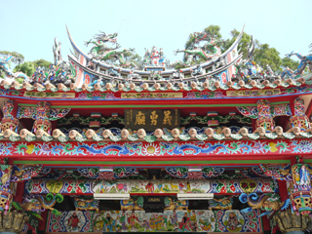  The Yimin Festival held at the Baojhong Temple in rural Xinpu Township during the seventh month of every lunar year is not just an important Hakka religious event in Hsinchu and Taoyuan Counties, it also attracts hundreds of thousands of travelers.
11:00-13:30 | Head to Baguali restaurant (lunch time)
13:30-15:00 | 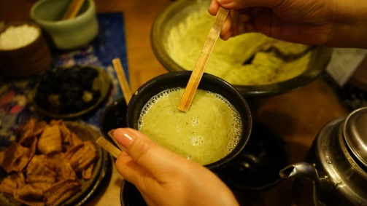  Visit Baguali Tribal Village  There is a series of eight mountain peaks counting from this place; therefore, the Japanese called it Hakaliki during the colonial period, meaning eight mountains. In the postwar era, Hakaliki was translated by sound into Baguali. The Baguali Cultural Area offers authentic Siaisyat songs and dance, as well as restaurants, guesthouses, and Saisiyat crafts. This is the place to experience the authentic aboriginal culture.
15:00-15:30 | Head to Nanzhuang old street
15:30-17:00 | Visit Nanzhuang old street  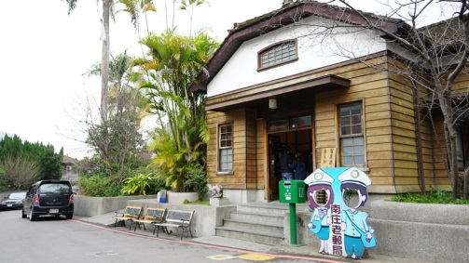  Towards the end of Nanzhuang Old Street, stands the old postal office of Nanzhuang in Japanese style that was first established during the period of Japanese colonization, and renovated recently. The old Nanzhuang Postal Office has been noted as one of the ten most treasured historical architectures of Miaoli. The nostalgia environment and ambience make the old Nanzhuang Postal Office a popular photo shooting spot.
17:00-18:00 | Return to Taipei

Payment:
Credit card (Only International Credit Cards of Visa, Master and JCB Card are accepted)
The form is below. For any inquiries regarding the payment process, please contact Lion Travel Service directly
Contact：Lucian Hsu
● TEL：+886-2-8793-9353
● FAX： +886-2-6607-1190
● E-MAIL：lucianhsu@liontravel.com
● Address：No.151, Shitan Rd., Neihu Dist., Taipei City 114, Taiwan (R.O.C.)

Wire Transfer。ATM Transfer
US Dollar Account
Pay to: LION TRAVEL SERVICE CO. LTD
Bank: MEGA INT ' L COMMERCIAL BANK HEAD OFFICE
NO. 100 CHI-LIN ROAD, TAIPEI, TAIWAN.
TEL: 886 2-25633156
SWIFT CODE: ICBCTWTP 007
Account Number: 00753003552

After you finished your payment, please contact us ASAP, and fax or mail the remittance receipt.
Please follow the account that listed in the contract and check with our branch sales before wiring in order to protect your rights and interests. Thanks!

Note
☆ We reserve the right to make changed to the schedule according to the road conditions and other circumstances at the time of the tour.
☆ Please be on time for the scheduled departure and all other meeting times throughout the tour. Should you be late and miss the tour departure your tour fee will not be refunded.
☆ Adult: 12 years and up/ Child: 2 to 12 years/ Infant: 2 years and under
☆ The price for infants includes accident and travel insurance.
☆ Please refrain from taking pets or any items that may be viewed as hazardous with you.
☆ We reserve the right to make adjustments to the schedule based upon conditions of the day,
traffic et….
☆ We reserve the right to change the date or cancel the tour due to circumstances out of our control, typhoons, etc...
☆ In paying the full tour fee you have agreed that should you choose to cancel your reservation or change the date of your tour, you will be subject to a cancellation fee.
☆ Online registration does not guarantee that the tour will be run for sure, your representative will contact you with a final confirmation whether the tour will run or not.

Application Form
Last Name（Family Name）
First Name（Given Name）
Date of Birth (dd/mm/yy)
Passport No.
Hotel／Room No.
Cell phone No.
Email Address
Muslim □ Vegetarian □ No Beef □ Special Request：
Tour |  | sign up
Hsinchu Hakka Yimin Festival One Day Tour

Visa、Master 、Jcb Credit Card Cardholder Authorization Form
I hereby agree to pay the bill below to Lion Travel Service CO.,LTD with by Credit card by issuing this letter of authorization.
Merchant No. | Lion Travel Service CO.,LTD | Merchant Name | 15838383800
Credit Card Holder Name  (First name/ Surname) |  | ID/Passport No.
English Name  (Same as Passport) |  | Phone No. (Home)
Birth Date | DD / MMM/ /YYYY | Cell Phone No.
Purchase Date | DD / MMM/ /YYYY | Issued Bank
Credit Card No. | ─ ─ ─
Expiry Date | MMM/ /YYYY | 3 digit Security No.
Amount | NTD
Signature | (same as on the Credit Card)
Billing Address

Company Name (Full Name)：
Company Address：

GUI number ：

