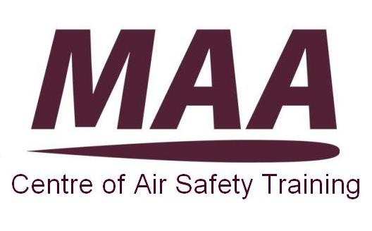
JOINING INSTRUCTIONS

OCCURRENCE INVESTIGATOR (OI) COURSE

Aim

- The overall aim and objective of this course is to enable delegates to carry out an effective occurrence safety investigation, by conducting effective information gathering via interview, data gathering, and photographic methods and presenting recommendations to reduce the likelihood of reoccurrence, in order to contribute to increased safety, quality and operational efficiency levels.
Course Content
- Delegates will gain maximum benefit from the OI course through engagement, debate and sharing of experiences with other delegates.
Pre-course Preparation

- JPA Administration. All delegates should complete the JPA form at Annex A and send it to their parent unit’s admin office before attending the course. This is essential to enable correct processing of mandatory ‘Move and Track’ action, and to ensure that JPA records accurately reflect pay and allowance entitlements.

- Prerequisites. Delegates need to have an understanding of the basic principles of Human Factors and Error Management before attending the course. Understanding can be gained from Human Factors e-learning available on the Defence Learning Portal (Code - Hum-FAC-N) and by accessing local awareness training at your unit/ organisation delivered by Human Factors Qualified Facilitators or Instructors trained via the Defence Aviation Error Management Systems (DAEMS Project).

Course Administration

- Venue. The EEM course will be held at the MAA Centre of Air Safety Training located in Eisenhower Building (BLD No 68) on the Defence Academy campus at Shrivenham.

- Directions. Directions and map can be found at Annex B and at the link below:
www.defac.ac.uk/contact-us/finding-the-defence-academy

7. Travel.

a. Train. The nearest main line railway station is Swindon.

b. Bus and Taxi. The Stagecoach number 66 bus service from Swindon to the Defence Academy is infrequent and we recommend onward travel by taxi (approx £20).Cost will vary depending on the provider used. The following taxi firms are cleared to enter the campus:

Brian’s Hire 0845 2603230; brihire@aol.com
H&F Chauffeur Ltd 07980 292595
Delegates arriving by taxi at the Main Gate should note that Defence Academy accommodation is some distance away and they may wish to have their taxi wait at the Main Gate, whilst they clear security, to take them the full distance.
c. Hire Cars. The pick up and drop off point for hire cars is at The Defence Academy, Main Visitor Reception. Unfortunately, hire cars cannot be collected from within the Defence Academy.

c.1 Delegates are reminded of the regulations on the use of MOD vehicles:

Maximum Daily Duty Period: 13 hours (on driving days) - Duty time is a combination of driving time, other work (i.e. meetings, lectures, medical appointments, AT, Sporting activities) and breaks.
If after the last day of the course you cannot arrive at your destination within the maximum daily duty period please contact CoAST who will arrange for an additional nights stay at Shrivenham.

Maximum Daily Driving Time: 9 Hours. Maximum Continuous Driving Period: 4.5 Hours (It is recommended not to drive continuously for more than 2 hours) with a Minimum Break from driving of 45 minutes.

Delegates arriving or departing in private vehicles are encourage to
abide by the above regulations.

d. Aeroplane. For delegates travelling by Air, Bristol Airport is the closest airport.

8. Identity card. Delegates are required to bring Service identity cards.

9. Car parking. Car parking spaces at Defence Academy are limited; vehicles must be parked in the allocated car park, indicated on issued car passes. Double parking and parking in non-designated areas affects traffic flow and blocks emergency routes. Security personnel regularly check the car parking areas, and will impose sanctions on those who fail to park their vehicles in the allocated areas.

10. Accommodation. The course is residential and if requested on your application form accommodation will be booked by MAA admin staff. Keys will not be available until 14:00 on the day of arrival. It is suggested you collect your room key at the end of day one unless you have arranged accommodation for the evening prior to the course.

11. Meals. The Defence Academy is PAYD. During office hours (Mon – Thurs 0830-1630 and Fri 0800-1530) you are able to buy meal vouchers from the Mess Accounts office in Churchill Lecture Theatre or pay cash in the Dining Room for what you eat. Meals will be served in Kitchener Hall Mess for the Officers and Mackay House for the Sgts/ WOs The price structure is as follows:

Meal | Core Price | Enhancement | Enhanced Core Meal Price
Breakfast | £1.31 | £0.36 | £1.67
Lunch | £1.55 | £0.68 | £2.23
Dinner | £1.96 | £1.08 | £3.04
Total | £4.82 | £2.12 | £6.94

Meal times. Meal times are as follows:

  - Officers (Kitchener Hall)

 | Breakfast | Lunch | High Tea | Dinner
Monday to Friday | 0730-0845 | 1230-1345 | 1645-1745 | 1900-2000
 | Breakfast | Brunch |  | Dinner
Saturday/Sunday | 0830-0930 | 0930-1330 |  | 1830-1930

  - SNCOs and WOs (Mackay House)

 | Breakfast | Lunch | Bar Snacks | Dinner
Monday-Friday | 0730-0830 | 1230-1330 | 1230-1315 | 1800-1900
Saturday & Sunday | 1000-1230 (Brunch) |  |  | 1730-1830

12. Dress. The dress code for the course and mess is smart casual. The minimum dress standards in public rooms of the Mess are at Annex C.

13. Course assembly. Course assembly will be at 08:30 and the lecture facilities are located in Eisenhower Building. There is limited car parking in this area of Shrivenham, therefore 15 minutes should be allowed to walk to Eisenhower Building. If travelling to Shrivenham on the first morning of the course, delegates should aim to be booked in on site by 08:10. This will allow sufficient time to travel to Eisenhower Building.

14. Computer use. There is computer access for those with DII accounts. Delegates who wish to access DII should speak to the Course Facilitation Staff.

15. Stationery. Delegate need to bring their own pens and paper if there wish to make notes as this will not be provided on the course.

16. Mess bill. Individual accommodation charges will be paid when collecting keys. Payment may be made by cash, cheque or Debit/Credit card. Please note that due to the length of the course, all payments for meals and the bar will be cash only.

Annexes:

A. JPA Move and Track Form.
B. Directions to Defence Academy at Shrivenham.
C. Mess Dress Codes.
Annex A to
DAEMS JIs

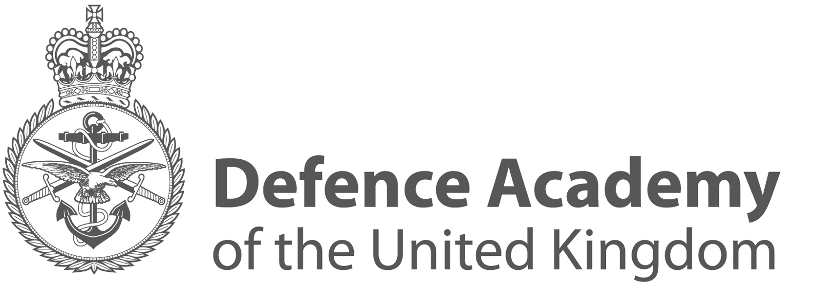

TO BE COMPLETED BY MILITARY PERSONNEL ONLY

Military students are to complete the attached JPA proforma and forward it to their parent unit admin office prior to attending the course. Failure to adhere to this instruction will mean that mandatory ‘Move & Track’ action will not be processed and may result in pay and allowances being adversely affected; as a consequence, your JPA record may not accurately reflect your entitlements; responsibility for accurate recording of such information ultimately rests with the individual and is subject to audit action.

JPA MOVE AND TRACK

In accordance with the Course Joining Instructions issued by the Defence Academy, students have been instructed to complete this proforma and forward it to their parent unit’s admin office for the appropriate Move & Track to be taken.

For Student completion and onward dispatch to their parent unit admin office

Number……………………………… Rank…………………… Name………………………..

Name of Course: ..……………………………………………………………………………………….

Date of Arrival:…………………………………………………………………………………………….

Date of Departure:………………………………………………………………………………………..

Single Accommodation occupied during the course: *Yes/No

For Parent Unit Admin Office

Please ensure that the necessary Move & Track action is taken for the above Service Person.

The Defence Academy is a PAYD site and has been granted exemption from administering Move and Track for those personnel attending courses here which are 14 days or less duration because of the
extremely high level of student activity at the site. There is no requirement for the daily food charge to be levied against the student’s salary but please ensure the PAYD marker is activated on JPA for the period of this training course. Grade 2 accommodation charges may also need to be applied unless a waiver in accordance with JSP 754 Chap 9, Sect 1 applies.

If there are any queries regarding this matter please contact the JSAU SO2 PS on 96161 8802 or Office Manager on 96161 8849.

* Delete where applicable.

Annex B to
DAEMS JIs

Annex C to
DAEMS JIs

MESS DRESS CODES

Officers Mess
 | Before 0830 | 0830-1730 | 1730 onwards  (Green (2) | By exception  (Red (2)
Public Rooms (1)  Weekdays | Open neck shirt/polo shirt (not rugby shirt)  and clean, long trousers (no jeans)  Uniform working dress | Tailored shirt and tie with smart, long trousers (no jeans).  Uniform working dress | Open neck shirt/polo shirt (not rugby shirt) and clean, long trousers (no jeans).  Uniform (only if on Duty) | Jacket and tie.  ‘Planters Rig’ (long sleeved shirt and tie) can be worn in the summer.  No Uniform (unless cleared by the PMC).
Public Rooms (1)  Weekends (Public Holidays and Stand Downs) | Open neck shirt/polo shirt (not rugby shirt) and clean, long trousers, including jeans.  Uniform (only if on Duty). | Open neck shirt/polo shirt (not rugby shirt) and clean, long trousers, including jeans.  Uniform (only if on Duty).
High Tea | N/A | Clean sports kit may only be worn after sports when taking high tea. | N/A | N/A
National dress | As appropriate to the time of day may be worn.
Outside dress | Outside dress (e.g. coats, umbrellas etc) are not to be taken into the dining rooms. All members are to use the appropriate cloakrooms in their respective messes.

MESS DRESS CODES

Warrant Officer and Sergeants Mess
(Taken from the Mess Rules, dated Jul 2010)

- It is the duty of each Mess Member to ensure that he/she is properly dressed in accordance with these Mess Rules and to ensure that all private guests or guests of the Mess are aware of and conform to the standards set out. When wearing uniform jackets are not to be unbuttoned and the following is to be complied with:

- Shorts are not to be worn in the Mess unless it is for a specific luncheon.

  - Members may wear uniform, suits or other plain clothes in the Mess providing they are of a sober design. The minimum standard of dress in the mess is collared polo shirt, clean jeans and shoes.

  - Casual dress may be worn unless otherwise directed by the Presiding Member.

  - Smart casual clothing is to be worn at Family lunches except where directed by the Presiding Member.

  - Coveralls, mixed dress, sports clothing, canvas or carpet slippers are not permitted in the Dining Room or bar.

- Military Dress is not to be worn in the bar after 1900 hrs unless specifically authorised by the Presiding Member.

- The Minimum standard for mess meeting is working dress or shirt, tie and jacket.

Jeans may be worn within the Mess unless the function dictates otherwise.

