Attachment 3

GENERAL INFORMATION
14th JASIC Asia Government / Industry Meeting

Hanoi, Vietnam
November 25 – 27, 2009

JAPAN AUTOMOBILE STANDARDS INTERNATIONALIZATION CENTER
AND
VIETNAM REGISTER

Hanoi

Hanoi is not only the capital of Socialist Republic of Vietnam; it is the political and cultural center of the country. Hanoi is a city begat by mythology and inspired by legends. It has been a survivor of countless violent struggles and political intrigues, sustained on patriotism, ideology and the willful independence of its people. This is a city that has experienced an eventful millennium.

Hanoi still preserves many ancient architectural works including One Pillar Pagoda (built in 1042), the Temple of Literature (built in 1070), or the Old Quarter and over 600 pagodas. Around Hanoi, there are still many traditional handicrafts village. Feature with a delta region and many lakes located in the city, Hanoi gives you special natural charm.

October 2010 will officially mark 1000 years of the establishment of the city.

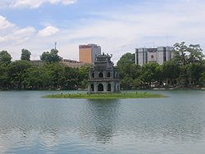 | 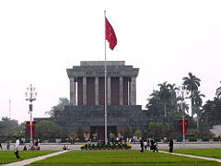 | 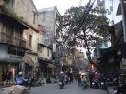
Hoan Kiem Lake | Ho Chi Minh Mausoleum | Hanoi old quarter

Geography of Hanoi
The city is located on the right bank of the Red River. Hanoi is located at 21°2′N 105°51′ECoordinates: 21°2′N 105°51′E, 1760 km (1094 miles) north of Ho Chi Minh City, formerly called Saigon. On May 29, 2008, it was decided that Ha Tay province, Vinh Phuc's Me Linh district and 4 communes of Luong Son district, Hoa Binh is merged into the metropolitan area of Hanoi from August 1 2008. Hanoi's total area increased to 334,470 hectares divided into 29 subdivisions.
Language
Normally Hanoi people use northern dialect. And they use Vietnamese as official language. However, they also use English at tourist attraction and places
Electricity
220 volts a/c is the common standard.
Time
The time zone is GMT + 7 hours.
The day time in November is between 7.00 Am to 18.00 PM.
Climate
Hanoi experiences the typical climate of northern Vietnam, where summers are hot and humid, and winters are relatively cool and dry. The summer months from May to September receive the majority of rainfall in the year (1,682 mm rainfall/ year). The winter months from November to March are relatively dry, although spring then often brings light rains. The minimum winter temperature in Hanoi can dip as low as 6–7°C (43°F) not including the wind chill, while summer can get as hot as 38–40°C (100-104°F). The average temperature in November is about 24⁰C.
Bank and Vietnamese currency
Banks are usually open on Monday to Friday, from 08:30AM to 4:00PM. Money Changers are available at most major shopping centers, the airport and major banks. Hotels and Shopping Centers normally accept major credit card, such as Visa Card, American Express, Master Card, Diners Club and etc..

Vietnamese currency is Dong. Approximately, US$ 1.00 is equal to 18,000 Dong as of July 2009. Exchange services are available for cash and travelers cheques in Banks, Hotels, and Foreign Exchange Places. Bank Notes are issued in the following denominations:

Vietnamese Dong 500,000; Vietnamese Dong 200,000; Vietnamese Dong 100,000; Vietnamese Dong 50,000; Vietnamese Dong 20,000; Vietnamese Dong 10,000; Vietnamese Dong 5,000; Vietnamese Dong 2,000; Vietnamese Dong 1,000; Vietnamese Dong 500.
Coins are Vietnamese Dong 5,000; Vietnamese Dong 2,000; Vietnamese Dong 1,000; Vietnamese Dong 200.

Shopping
With its rapid growth and extremely high population density, several modern shopping centers have been built in Hanoi.
- Trang Tien Plaza, Hoan Kiem District
- Vincom City Towers, Ba Trieu Street, Hai Ba Trung District
- Ruby Plaza, 44 Le Ngoc Han Street, Hai Ba Trung District
- Parkson Department Store, Tay Son Street, Viet Tower, Dong Da District
- Luxury Mall, 01 Dao Duy Anh Street, Dong Da District (upscale shopping center specialized in high-end Italian brands)
- Big C Thang Long Supercenter, Cau Giay District
- The Garden Mall, Me Tri - My Dinh, Tu Liem District
- Vincom Shopping Galleries, Vincom Park Place, Hai Ba Trung District (grand opening in August 2009)
- Ciputra Mall, Ciputra urban area, Tay Ho District (currently under constrction)
- Yen So Shopping Mall, Hoang Mai District (currently under construction)

Transportation
Hanoi is served by Noi Bai International Airport, located in the Soc Son District, approximately 40 km (25 miles) north of Hanoi. Noi Bai is the only international airport for the northern regions of Vietnam.
Taxis are plentiful and usually have trip meters, although it is also common to agree on the trip price before taking a taxi from airport to the city centre. Tourists also sometimes tour the city on cyclos especially in the Old Quarter.
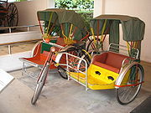 | 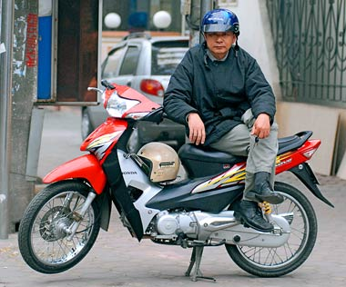
Cyclo | Hug vehicle
The main means of transport within the city are motorbikes, buses, taxis, and bicycles. Motorbikes remain the most common way to move around the city.Public buses run on many routes and fare can be purchased on the bus. For short trips, "xe ôm" (literally, "hug vehicle") motorcycle taxis are available where the passenger sits at the rear of a motorbike.
VISA information
Non-Immigrant VISAS are required for international travelers (citizens of other countries), coming to Vietnam temporarily.

International travelers come to Vietnam for a wide variety of reasons. The type of visa needed is defined by immigration law, and is related to the purpose of your travel. The Consular Officer at your embassy or consulate will decide what kind of visa you need and when to apply. Advance planning can smooth your visa application process.

If you need VISA to Vietnam, please log in the Website of the Foreign Affairs of Vietnam at:
www.mofa.gov.vn/en
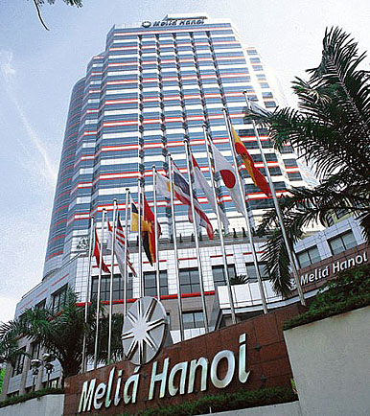
Hotel Accommodation
The meeting will be held at MELIA HANOI HOTEL in November 25 – 27. We suggest you to book your room at the Hotel by sending a Hotel Reservation Form direct to the Hotels as the address below:
Nguyen Manh Cuong (Mr.)
Melia Hanoi Hotel
44b Ly Thuong Kiet Street, Hoan Kiem, Ha Noi, Vietnam

Fax: 84-4-39348 688; Tel: 84-4-39343 343 ext 7409

Email: smc@meliahanoi.com.vn

cc: gse@meliahanoi.com.vn

Website: www.meliahanoi.com

Others
Please don’t hesitate to contact the following person if you have any questions.

[CONTACT PERSON]

VR : Mr. Nguyen Huu Phan
Director
International Cooperation Department
Vietnam Register
Address: 18 Pham Hung Rd., My Dinh, Tu Liem, Hanoi, Vietnam
Phone: +84 (4) 3768 4716 ext. 221 Fax: +84 (4) 3768 4727
e-mail: phannh@vr.org.vn Mobile: 0915344946

JASIC : Mr. Keiji Fukuda (Mr.)
Chief of Technical Section
Japan Automobile Standards Internationalization Center (JASIC)
Address: 3F, Shoei-Rokubancho Bldg.,6, Rokubancho, Chiyoda-ku,
Tokyo 102-0085, JAPAN
Phone: +81-(0)3-5216-7241 Fax:+81-(0)3-5216-7244
e-mail: fukuda@jasic.org

