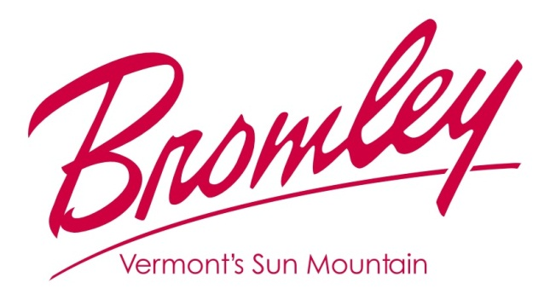

2019 INNKEEPERS RACE SERIES | Team Application

Name of Team: ______________________________________________ Mailing Address: _____________________________________________

Team Leader: ________________________________________________ _____________________________________________
 | Team Member’s Name | M/F | Ski/  Snowboard | Email | Date Of Birth | Shirt  Size | *Bromley Pass-holder?*
1
2
3
4
5

By December 19, 2018 - $575 After December 19, 2018 - $615
*Bromley Season Passholders – discount $30 for each 2018/19 passholder. Bromley Full, Super Value or Midweek Passholders will not receive a printed Innkeepers Season Pass, unless specifically requested from the Ticket Office.

Circle One: Visa Master Card American Express Discover

CC Number: ________________________________________ Expiration Date: ___________ CCV#: ________

Card Holder Name (as shown on card): ___________________________________________________________

By signing below, I agree to the terms above and authorize the charges to my credit card.

Signature: ________________________________________________________ Date : ________________________

Please remit to: The Ticket Office, Bromley Mountain, PO Box 1130, Manchester Center, VT 05255

