CURRICULUM VITAE
FURQAN AHEMAD 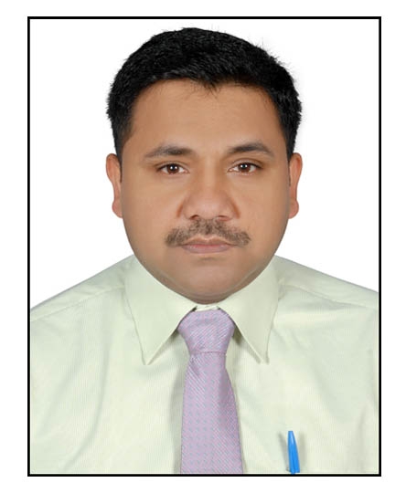
Manama (Bahrain)
Contact No- 009734164789
Email: furqan.ahemad76@gmail.com
ahemadf@yahoo.co.in
Skype id: - furqan.ahemad

Career Objective
- To grow with an organization which will provide me the ample opportunities for the self-development along with an organization with a desire to learn more and I am confident of achieving the top level in any area I am to be an asset for the Organization.
Education Qualification
- B.Com in 1999 from Mahatma Jyotibaphule Ruhelkhand University, Bareilly.
ADDITIONAL SKILLS
- Extensive knowledge of billing methods and procedure.
- Possess excellent knowledge of Microsoft word, spreadsheet and the internet.
- Good manners in professional telephone conversation
- Sound of mathematical background. Expert in typing and keyboard.
- Good organizational and multitasking skills.
- Excellent verbal and written communication skills in English.
- Able to stand and walk for extended periods of time.
KEY ACCOPLISHMENTS
- Eye for detail with good monitoring and supervisory.
- Fulfilled the company’s define customer experience by maintaining a friendly and customer focused approach.
- Expert in processing all type of payment methods such credit card checks and cash.
- Promote the organization’s program such as warranty sales, score card and private label credit card alike.
- Provided timely and welcoming customer service increased revenue.

Work Experience
- Presently working as a HEAD CASHIER with Bahrain Public Transport Company (Group of National Express) from 6th Feb-2015 to till date.
- Worked as HEAD CASHIER with MANAMA TOWER HOTEL (Four star properties) a unit of Imperial Suites Management Co. Manama Kingdom of Bahrain since 18th August 2012 to 16/01/2015.
- Worked as Store Keeper with Digi Smile store of in Ghaziabad from 25/01/2011 to 12/08/2012.
- Worked as Outlet Cashier in MANAMA TOWER HOTEL (four star properties) a unit of Imperial Suites Management Co. Manama in Kingdom of Bahrain, since 31/03/2009 to 15/01/2011.
- Worked as a CASHIER in HOTEL PALACE HEIGHTS in D-26/28, Connaught Place, New Delhi-110001, since 15/03/2007 to 25/03/2009.

Main Responsibilities as a Store Keeper
- Maintained store facilities to ensure smooth functioning made arrangements and placed orders for new stock and supplies wherever necessary.
- Responsible for upkeep of various appropriate records of materials received.
- Maintain the budget of all the expenditures incurred and presented same to store managers.
- Reported to store manager on a regular basis regarding the need/demand of item so that the future orders could be place accordingly.
- Developing and establishing new storage systems for improving the accuracy of ware house operation.

Main Responsibilities as a Cashier.
- Exchange worldwide currency.
- Greet customers as they arrive and direct them to merchandise they need.
- Assist customers with buying decision when required & maintain petty cash.
- Operate cash register and adding machine in order to manage cash for sold item.
- Balance all transaction at the end of the day for the cash reconciliation.
- Balance accounts receivable checks & Recorded received transaction

OTHER ACHIEVEMENT
- Improved the accounting system through creative ideas and overhauling the previous haphazard cash management system.
- Attaint employee of year award following customer’s feedback of providing excellent service.
- Proficient in the assisting accounts personal with locating and reconciling.
- Maintain monthly half yearly and yearly stock, sales, purchased report.
Personal Strength
- Sales ability costumer dealing
- Relationship building skills
- Analytical Skills and Flexible
Passport Detail
Passport No L 3416925
Validity 16/02/2014 to 15/02/2024
Personal Detail
  - Father’s Name Mr. Yunus Khan
  - Date of Birth 22-August-1976
  - Marital Status Married
  - Nationality Indian
Permanent Address
Village– Avid Nagar @ Dhundhli. Post office- Bishanpura
District- Bijnor. Police Station- Seoraha Uttar Pradesh (India), Pin code 246727.
Declaration
I hereby declare that all the information given is true and complete to best my knowledge.

Date ----
Place: - Manama (Bahrain) (FURQAN AHEMAD)

