2012 National English Contest for
College Students
(Level C – Preliminary)
(总分：150分 时间：120分钟)
Part I listening Comprehension (30 marks)
Section A (5 marks)
In this section, you will hear five short conversations. Each conversation will be read only once .After each conversation, there will be a twenty-second pause. During the pause, read the question and the three choices marked A, B and C, and decide which is the best answer .Then mark the corresponding letter on the answer sheet with a single line through the centre.
- What does the man say we can do to deal with oil crisis?
A. To make full use of oil. B. To use as little oil as possible
C. To find alternative energy.
2. Where does this conversation most probably take place?
A. In an insurance company. B. In a bank.
C. In a supermarket.
3. According to the man, who is going to take over the position they are talking about?
A. Janice. B. Someone else.
C. Meryl.
4. What does the woman say about the man’s report for the meeting?
A. He has to get it ready before tomorrow noon.
B. He has done well enough.
C. He has enough time to prepare it.
5. How many people will be on the earth by the year 2020 according to the professor?
A. Some 5.8 billion. B. Nearly 7 billion.
C. Over 8.5 billion.
Section B (10 marks)
In this section, you will hear two long conversations. Each conversation will be read only once. At the end of each conversation, there will be a one-minute pause. During the pause, read the questions and the three choices marked A, Band C, and decide which is the best answer. Then mark the corresponding letter on the answer sheet with a single line through the centre
Conversation One
6. What’s the main job of Simon’s organization?
A. They send out radio signals to communicate with other planets.
B. They look for life and intelligence on other planets.
C. They study stars that have planets orbiting around them.
7. Why does the organization search for radio signals from space?
A. Their presence may prove the existence of aliens.
B. They may help scientists find out how the universe started.
C. They convey messages about life on the earth.
8. Does Simon believe those stories about aliens visiting our planet?
A. No, he doesn’t believe them at all.
B. Yes, he does believe those stories because of his study.
C. Yes, he believes them although he has no evidence.
9. Which of the following factor is considered to be important in forming life according to the passage?
A. Gravity. B. Minerals. C. Water.
10. When did the “big bang” occur?
A. No one knows. B. 12 billion years ago. C. 20 billion year ago.
Conversation Two
11. Why did Bob make the news last month?
A. Because he criticized traditional jobs
B. Because he earned a lot of money.
C. Because he tried new strategies in finding a job.
12. In which way do the bestsellers like “The Brand Called You” and “The Personal Branding Phenomenon” help people?
A. They advise people to promote themselves as brands.
B. They teach people how to be a perfect partner.
C. They give people tips for job interview.
13. When did Bob come up with the idea of using the internet to find a job?
A. Ten years ago when he was a college student.
B. When he began to do research between jobs.
C. After he launched the campaign “Give Bob a Job”.
14. What was the purpose of Bob’s making the video?
A. To fulfill his ambition as a director.
B. To sell his products like Teddy bears and T-shirts.
C. To advertise his skills and talents.
15. How can the internet help Bob in his job search exactly?
A. By helping him make friends.
B. By passing on the video he made.
C. By providing job information for him.
Section C (5 marks)
In this section, you will hear five short news items. After each item, which will be read only once, there will be a pause. During the pause, read the question and the three choices marked A, B and C, and decide which is the best answer. Then mark the corresponding letter on the answer sheet with a single line through the centre.
16. How many troops are going to withdraw from Afghanistan by the end of next year?
A. 43,000. B. 10,000. C. 33,000.
17. What is the finding of the study?
A. Low-calorie foods may lead to more weight.
B. High-calorie foods may lead to more weight.
C. High-calorie foods may lead to less weight.
18. What do the conflicting reports show about radiation?
A. The radiation level given by Tokyo Electric is much smaller than that given by other tests.
B. The radiation level given by other tests is smaller than that given by Tokyo Electric.
C. The radiation level is close to 10,000 times the normal level.
19. Why are Caribbean Service and Europe Today shut down by BBC?
A. Because of their outdated services.
B. Because of cuts in government funding.
C. Because of lack of target audience.
20. What’s the cause of demonstrations in cities and towns across Syria?
A. They are calling for more freedom.
B. Workers demand higher pay.
C. Some thirty people were killed by the police.
Section D (10 marks)
In this section, you will hear a short passage. There are 10 missing words or phrases. Fill in the blanks with the exact words or phrases you hear. The passage will be read twice. Remember to write the answers on the answer sheet.
Recovery from jetlag can take as long as a day for every time zone crossed. So if you’re flying east-west for your holiday or on business, it is likely to mean a few days of feeling tired or even unwell.
Jetlag is the (21)__________ of the body’s natural cycle and some factors make it worse. The artificial atmosphere inside a plane can affect the body in a number of ways and add to the effects of jetlag.
Exercising before flights helps to offset the effects on the body of reduced (22) _________, and aerobic exercise afterwards helps to reoxygenate it. Drink plenty of water. Children may need more. Drinking carrot juice before flying overcomes oxygen deficiency.
Eat light, frequent meals. Heavy meals (23) __________ the blood circulation, which can lead to dizziness and fainting. For two weeks before you fly, eat plenty of food containing vitamins A and E; they will build up your (24) __________ and help to keep you fit. Sleep as much as you can before the flight and on it. On board, wear earplugs and eye pads because darkness (25) __________ secretion of the hormones that enhance sleep.
Avoid alcohol, which restricts the brain’s oxygen intake. Like tea and coffee, alcohol increases the dehydration effect of flying. If you need to drink to relax, (26) __________ that the cabin environment intensifies the effect of alcohol.
Wear loose, comfortable, warm clothes and limber up during flight. Sitting down for several hours slows down the (27) _________, leading to local stiffness, cramps and dizziness. Re-adjust to local time as soon as you can. Bright light helps the body stay alert, so if you are going somewhere sunny, stay outside.
Do not smoke before or during the flight since smoking (28) ___________ the blood oxygen level. If you need to calm your nerves, try aromatherapy oils which have a sedative effect. (29) _________ your doctor before flying if you are on medication. The effects of some drugs are strengthened at high altitudes and some may produce (30) _________.
Part II Vocabulary and Structure (15 marks)
There are 15 incomplete sentences in this section. For each blank there are four choices marked A, B, C and D. Choose the one that best completes the sentence. Then mark the corresponding letter on the answer sheet with a single line through the centre.
31. What we all work for is to free ________ time for the things we really want to do.
A. off B. up C. aside D. in
32. You _________ his words seriously. He was talking nonsense.
A.won’t.take B. may not take C. mustn’t have taken D. needn’t have taken
33. Never hesitate to _________ the first opportunity that comes along.
A. seize B. draw C. who; that D. obtain
34. His mother ________ hated city life longed to return to the village in _______she grew up.
A. that; where B. who; which C. who; that D. who; where
35. All things _______, I think I’d better take your advice.
A. considering B. to be considered C. considered D. have been considered
36. Twelve European countries ________ over to the Euro on January 1st, 2002.
A. transformed B. switched C. reversed D. altered
37. She isn’t anything ________ unpleasant as people say she is.
A. as like B. like C. as D. like as
38. Stop complaining. You really ________ my nerves.
A. get down B. get along C. get off D. get on
39. There wasn’t _______ truth in what he said.
A. a grain of B. a ray of C. a point of D. a drop of
40. ________ for my savings, I wouldn’t be able to survive these miserable days.
A. Was it not B.Were it not C.Had it been not D. Hadn’t it been
41. There was a power cut this morning. ________, I couldn’t do anything with my computer.
A. Supposedly B. Presumably C. Consequently D. Essentially
42. Alarm clocks needlessly wake ______ households. I want to design something targeted at the individual sleeper.
A. whole B. total C. full D. high
43. _______ both parties agree on these issues will a contract be signed soon.
A. If only B. Unless C. Should D. Only if
44.—I’ve run out of cash. Could you lend me a few pounds this evening?
—_____ I’ll just have to find time to get to the bank and make a withdrawal.
A.I can lend you some now.
B. I’m not sure I’ve got any either.
C. Sorry, I haven’t got a penny in my account.
D. My credit card must be left home.
45. —We’re all going to the New Skyline Restaurant for our end-of-year get-together. Can we count you in?
—Oh, thanks, Sara, but _____
A. I didn’t find you then. B. I’ve been to the restaurant once.
C. I’ll pass this time. D. I’ll meet you there at 5:00.
Part III Cloze (10 marks)
Read the following passage and fill in each blank with one word. Choose the correct word in one of the following three ways: according to the context, by using the correct form of the given word, or by using the given letters of the word. Remember to write the answers on the answer sheet.
Did you know that for every 20,000 novels written, only one gets published? So the (46) ____ (likely) that I’ll ever fulfill my ambition of becoming a professional mystery writer doesn’t seem very high. But the prospect of turning my lifelong passion into my livelihood and achieving fame and (47) for ______ at the same time is just too exciting for me to be put off by dull statistics.
So what does it (48) t_______ to become a writer? Reading is important—all writers need to research their genre thoroughly to familiarize themselves (49) _______ its codes and conventions. My bookshelves at home are stacked with the novels of all the great mystery writers, which I’ve read and in many cases, re-read, despite (50) _______ (know) all the time “who’d done it”.
Of course, being a writer requires imagination. You have to develop your own personal style rather than simply copy the work of “the greats”. I’ve turned out (51) d________ of short crime stories for my university student magazine—some have been published, some not, but I’ve always aimed to produce original and imaginative material.
Last but not (52) ________, successful writers possess enormous self-discipline. I’ve often sacrificed my social life in order to devote the necessary time and effort to producing a good quality story. And more than once that has meant (53) _______ the midnight oil.
We’ve got a novel inside us. Getting it out in anywhere near publishable form is no (54) ______ task, but with imagination and determination, and the help of an expert on “master class”, who could possibly fail to (55) re_______ their ambition?
Part IV Reading Comprehension (40 marks)
Read the following passages. Each passage is followed by several questions. Respond to the questions using information from the passage. Remember to write the answers on the answer sheet.
Section A (10 marks)
Questions 56—60 are based on the following passage.
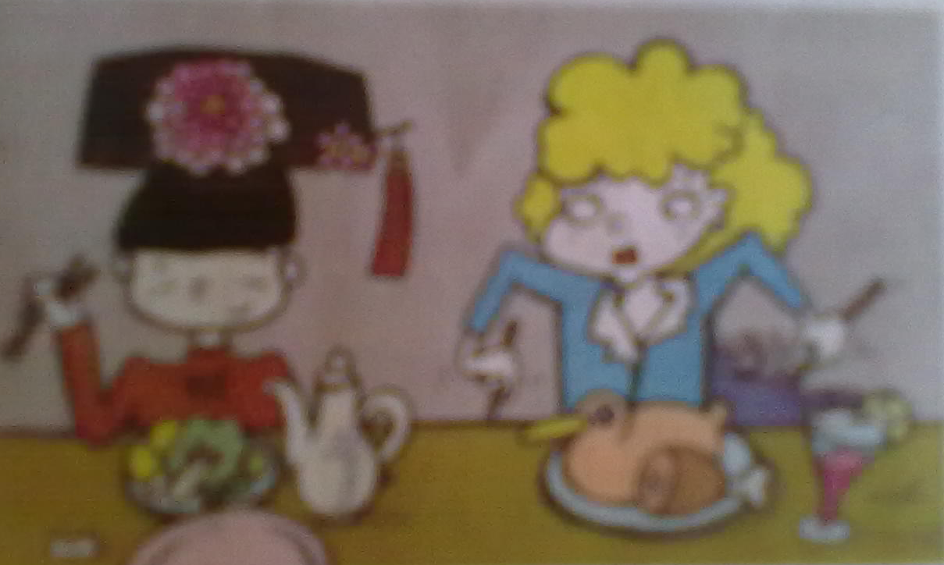
The term culture shock was introduced for the first time in 1958 to describe the anxiety produced when a person moves to a completely new environment. This term expresses the feeling of not knowing what to do or how to do things in a new environment. This term expresses the feeling of not knowing what to do or how to do things in a new environment. We can describe culture shock as the physical and emotional discomfort a person suffers when coming to live in a place different from the place of origin.
Often, the way that we live before is not accepted or considered as normal in the new place. Everything is different, for example, not speaking the language, not knowing how to use banking machines, not knowing how to use telephones, and so forth.
The symptoms of culture shock can appear at different times. Although a person can experience real pain from culture shock, it is also an opportunity for growing and learning new perspectives. Culture shock can help people develop a better understanding of themselves and stimulate personal creativity.
Culture shock has many stages. Each stage can be ongoing, or appear only at certain times. In the first stage, the new arrival may feel very happy about all of the new experience. This time is called the honeymoon stage. Afterward, the second stage presents itself. A person may encounter some difficulties in daily life. For example, communication difficulties may occur, such as not being understood. In this stage, there may be feelings of impatience, anger and sadness. Transition between the old methods and those of the new country is a difficult process and takes time to complete. The third stage is characterized by gaining some understanding of the new culture. A new feeling of pleasure and sense of humor may be experienced. A person may start to feel a psychological balance. The individual is more familiar with the environment and wants to belong. This starts an evaluation of the old ways versus those of the new. In the fourth stage, the person realizes that the new culture has good and bad things to offer. This stage can be one of double integration or triple integration, depending on the number of cultures that the person has to process. This integration is characterized by a more solid feeling of belonging. The person starts to define himself or herself and establish goals for living. The fifth stage is the stage that is called the reentry shock. This occurs when a person returns to the newly acquired customs are considered improper in the old culture.
Questions 56—60
Complete the summary with words from the passage, changing the form where necessary, with only one word for each blank.
Introduced in 1958, culture shock is a term used to (56) __________ physical and emotional discomfort people experience when they come to or live in a new place. Although many people suffer a lot from culture shock, it is an (57) _________ for personal improvement. The five stages of culture shock may last for a long time or show up once in a while. In the first stage, the (58) __________ stage, the new arrival might be OK with everything. Afterward, (59) ________ from old methods to the new one calls for time and energy. During the third and fourth stage, people may gain more understanding of the new culture and possess objective views. The double or triple integration is (60) __________ by a feeling of belonging. The last stage, called reentry shock, refers to the feeling people have when returning to their home country.
Section B (10 marks)
Questions 61-65 are based on the following passage.
For some people, it would be unthinkable. But Gabe Henderson is finding freedom in a recent decision; he canceled his MySpace account. The 26 years old graduate student stopped his account after realizing that a lot of his online friends were really just acquaintances. “The superficial emptiness clouded the excitement I had once felt,” Henderson wrote in an article. “It seems we have lost, to some degree, the special depth that true friendship is about.”
Journalism professor Michael Bugeja, who is a strong supporter of face-to-face communication, read Henderson’s column and saw it was a sign of hope. Though he’s not anti-technology, Bugeja often lectures students about “interpersonal intelligence” —knowing when, where, and for what purpose technology is most appropriate. He points out the students he’s seen walking across campus, holding hands with each other while talking on cell phones to someone else He’s also seen them in coffee shops, surrounded by people, but staring instead at a computer screen. “True friends,” he says, “need to learn when to stop blogging and go across campus to help a friend.”
These days, young people are more wired than ever—but they’re also getting more worried. Increasingly, they’ve had to deal with online bullies, who are posting anything from embarrassing photos to online threats. And increasingly, young people also are realizing that things they post on their profiles can come back to hurt them when applying for schools or jobs.
Social networking can be an “extremely effective” way to publicize events to large groups. It can even help build a sense of community on campus. People joined Facebook as a way to meet others. However, it has limitations. A good Internet profile could make even the most boring person seem some what interesting. People are also not always happy with text messages on the cell phones. Cell phones can be a quick way to say “have a good day”. But friends can also cancel a night out with a text message to avoid having to explain. “Our generation needs to get over this fear of confrontation and rejection.” Henderson says. “The focus needs to be on quality communication, in all ways.” Back in his life, Henderson is enjoying spending more face-to-face time with his friends and less with his computer. He says his decision to quit his social-networking Internet accounts was a good one. “I’m not sacrificing friends,” he says, “because if a picture, some basic information about their life and a Web page is all my friendship has become, then there was nothing to sacrifice to begin with.”
Questions 61—63
Decide whether the following statements are true (T) or false (F) according to the passage.
61. Although Henderson quit MySpace, most of his online friends are actually close friends.
62. According to Bugeja, young people should know when to use technology and when to stop using it.
63. Social networking helps build a sense of community but has a negative effect on young people’s life if it is used inappropriately.

Questions 64—65
Answer the following questions briefly according to the passage.
64. What does Henderson lose by using social networking websites like Myspace?
65. What do young people need to overcome in order to focus on quality communication?
Section C (10 marks)
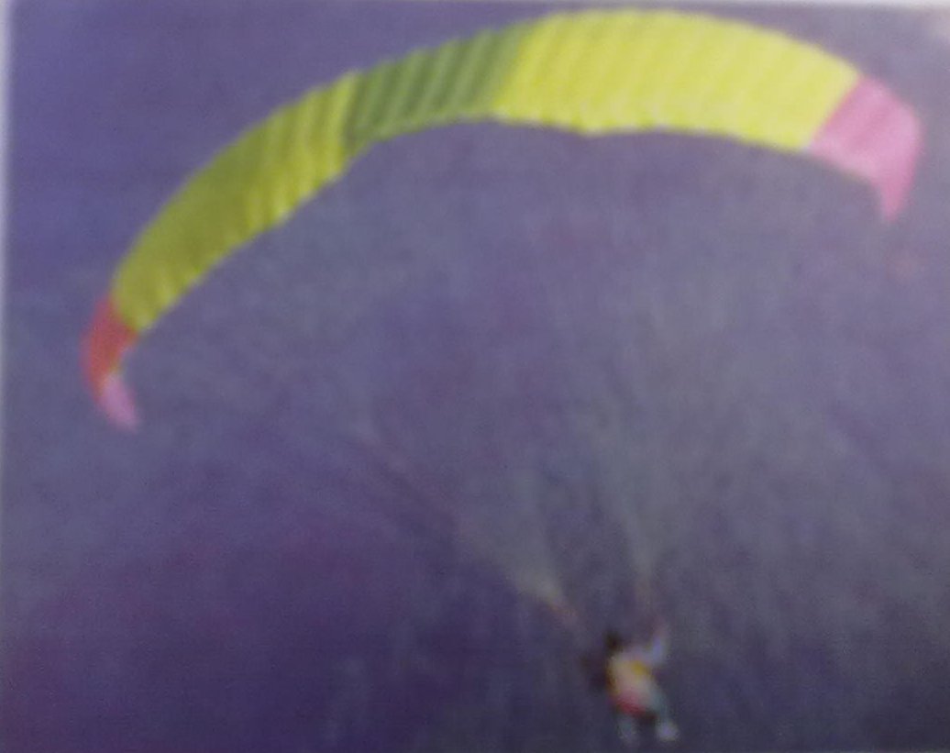
Questions 66—70 are based on the following passage.
“Five … Four … Three … Two … One … See ya! ” and Chance McGuire, twenty-five, is airborne off a 600 –foot concrete dam in Northern California. In one second he falls 15 feet, in two seconds 60 feet, and after three seconds and 130 feet, he is flying at 66 miles an hour.
McGuire is a practitioner of what he calls the king of all extreme sports. BASE—an acronym for building, antenna, span (bridge) and earth (cliffs)—jumping has one of the sporting world’s highest fatality rates: in its 18-year history, forty –six participants have been killed. Yet the sport has never been more popular, with more than a thousand jumpers in the United States, and more seeking to get into it every day. It is an activity without margin for error. If your chute malfunctions, don’t bother researching for a reserve—there isn’t time. There are no second chances.
Still, the sport may be a perfect fit with the times. Americans may have more in common with McGuire than they know or care to admit. America has embarked on a national orgy of thrill seeking and risk taking. The rise of adventure and extreme sports such as BASE jumping, snowboarding, ice climbing, skateboarding, and paragliding is merely the most vivid manifestation of this new national behavior.
The rising popularity of extreme sports speaks of an eagerness on the part of millions of Americans to participate in activities closer to the edge, where danger, skill, and fear combine to give weekend warriors and professional athletes alike a sense of pushing out personal boundaries. According to American Sports Data Inc., a consulting firm, participation in so-called extreme sports is way up. Snowboarding has grown 113 percent in five years and now boasts nearly 5.5 million participants. Mountain hiking, skateboarding, scuba diving—their growth curves reveal a nation that loves to play with danger. Contrast that with activities such as baseball, touch football, and aerobics, all of which were in steady decline throughout the 1990s.
The pursuits that are becoming more popular have one thing in common: the perception that they are somehow more challenging than a game of touch football. “Every human being with two legs and two arms is going to wonder how fast, how strong, how enduring he or she is,” says Eric Perlman, a mountaineer and film maker specializing in extreme sports. “We are designed to experience or die.”
Questions 66—68
Complete the following sentences with information given in the passage in a maximum of 4 words for each blank.
66. _______ rates doesn’t stop people from getting into BASE jumping every day.
67. The rise of extreme sports manifests the national behavior of _______ and ________.
68. The combination of fear, skill and danger gives both amateurs and professionals a sense of ______.
Questions 69—70
Choose the best answer according to the passage.
69. Which of the following activities reveals a nation that loves to play activities closer to the edge?
A. Touch football. B. Baseball. C. Scuba diving. D. Aerobics.
70. What does Eric mean by saying “We are designed to experience or die”?
A. Life with great challenges is a meaningful one.
B. Life without great experiences is very common.
C. People may die while doing extreme sports.
D. Extreme sports are essential parts of human life.
Section D (10 marks)
Questions 71—75 are based on the following passage.
Albert Einstein was one of the greatest thinkers the world has ever known. He formulated theories of relativity, successfully described the nature of the universe and came up with the most famous equation in the world. David Beckham is the footballer whose skills and precision have made him one of the most gifted sportsmen of his generation. Who is more intelligent?
How Gardner’s theory of multiple intelligences (MI) dares us to put these two men on neighboring pedestals. Instead of regarding intelligence as a single quantity measurable by pen-and-paper tests, Gardner, an education professor at Harvard University, divides human intelligence into no fewer than eight separate categories ranging from mathematical to musical competence. (74)His ideas have provoked vigorous debate about how one defines intelligence. Gardner’s point is that quantity measures only one capacity, the sort of mental agility that is valued in academic achievement, and that this single number does not do justice to human potential. So he has created his own spheres of achievement. Some categories are easily reconcilable with general perceptions about IQ. For example, “linguistic” intelligence confers a mastery of language, and is the preserve of such people as poets, writers and linguists. “Logical mathematical” intelligence marks out people who take a reasoning approach to physical things, and seek underlying principles. Einstein is the standard –bearer of this group, which also includes philosophers. These two categories are the main components of what we generally think of as “intelligence”.
“Musical” intelligence characterizes musicians, composers and conductors. “Spatial” intelligence is about being able to picture perspective, to visualize a world in one’s head with great accuracy. Chess players, artists and architects would rate highly in this category. Dancers, athletes and actors are lumped under the “bodily-kinesthetic” heading; these individual, like Beckham, are able to control their bodies and movements very carefully.
Then come two types of “personal” intelligence-intrapersonal, the ability to gauge one’s own mood, feelings and mental states, and interpersonal, being able to gauge it in others and use the information. These two categories could be interpreted as emotional intelligence. Psychiatrists are particularly adept at the former, while religious leaders and politicians are seen as people who can exploit the latter.
Charles Darwin is perhaps the perfect embodiment of the eighth intelligence –“naturalist”. This label describes people with a deep understanding of the natural world and its objects. Zoologists and botanists can count themselves among this group.
(75)These eight categories certainly reflect the fact that, in these areas, there is a spectrum of human ability ranging from the hopeless to the brilliant. But are these really intelligences, or could these competences be more accurately described as gifts or talents?
Questions 71—73
Answer the following questions briefly according to the passage.
71. What are the main components of “intelligence” we generally think of?
72. What kind of abilities does emotional intelligence involve?
73. Which intelligences are represented by Einstein and Beckham respectively?
Questions 74—75
Translate the underlined sentences in the passage into Chinese.
74. His ideas have provoked vigorous debate about how one defines intelligence.
75. These eight categories certainly reflect the fact that, in these areas, there is a spectrum of human ability ranging from the hopeless to the brilliant.

Part V Translation (10 marks)
Translate the following sentences into English, using the hints given in brackets. Remember to write the answer on the answer sheet.
76. 既然没有退路了，我们不妨试试他的方法。(might as well)
77. 公司的利润连续三个月下滑，你如何解释？(account for)
78. 在谈到如何能取得成功时，Blair强调创造机遇比等待机遇更重要。（put emphasis on）
79. 我希望我年轻的时候也有你们这么好的机会。（虚拟语气）
80. 高昂的学费并不一定能够保证良好的教育。（guarantee）

Part VI Error Correction (10 marks)
Proofread the passage as required. Each indicated line contains a maximum of one error. Correct the passage in the following way: for a right line, put the sign “√” in the corresponding blank; for a wrong word, underline the wrong word and write the correct one in the blank; for a missing word, mark the position of the missing word with the sign “∧” and write the word you believe to be missing in the blank; for an unnecessary word, cross the unnecessary word with the sign “\” and put the word with the sign “\” in the blank. Write the answers on the answer sheet.
For example:
One of my favorite writers are Charlotte Bronte. She was born in the early ___is___ nineteenth century when women had far fewer opportunities ∧ they have now. __than___ She lived in a small village in Yorkshire and she took great pleasure in walking ____√___ on the moors where __where__
Cash reward is a common form of motivation used by parents with high
expectation to encourage their children work hard at exam time. Some 81. ________
youngsters receive payments of as much as ￡100 for each A grade they
obtain at GSCE. But would such “bribes” be based on exam performance or 82. ________
should they, as many parents and teachers feel, be offered in recognition of a 83. ________
child’s effort, regardless of results? The later approach would solve the 84. ________
problems of how parents reward children with different levels of ability; 85. ________
imagine, for example, a family with one child who is academically gift and 86. ________
another who has learning difficulties. The dangers of result-relating incentives 87. ________
for the second child are clear; with little hope of obtaining the higher grades,
the withholding of promised financial rewards would only compound of the 88.________
child’s feeling of false. However, some leading educational psychologists 89. ________
believe that parents should rely in their own judgments in such matters. They 90. ________
maintain that if parents know that money will motivate their child, then they
should not be condemned for operating a system of cash payouts.
Part VII IQ Test (5 marks)
There are five IQ Test questions in this part. Write the answers on the answer sheet.
91. Which two words starting with “P” and “O” contain the most letters?
92. What is at: The beginning of eternity
The end of time and space
The beginning of every end
And the end of every place?
93.
L
O
V
E
What’s the phrase that is represented by the picture?
- Which picture should replace the question mark?
?

95. Your sock drawer contains ten pairs of white socks and ten pairs of black socks. If you’re only allowed to take one sock from the drawer at a time and you can’t see the color of the sock you’re taking until you’ve taken it, how many socks do you have to take before you’re guaranteed to have at least one matching pair?
Part VIII Writing (30 marks)
I (10 marks)
WRITERS REQUIRED
We are looking for people to write for this magazine about places of interest in their local area which would be of interest to an international readership. We would like to hear from anyone who has:
—an interest in travelling to places of interest;
—some personal experience of writing;
Send us a letter of application, explaining why you think you are suitable.
You should write no fewer than 100 words on the answer sheet. Use “Frank” instead of your real name.
II (20 marks)
China is now experiencing the largest mass migration of people, an estimated 230 million (2010), from the countryside to cities in history. They’ve brought economy boom to cities and life improvement to their own families. However, this migration leaves land in the countryside uncultivated and children of migrant workers poorly educated.
How do you think can the migration in China have a balanced development?
Write your article in about 140 words in an appropriate style on the answer sheet.

2012年全国大学生英语竞赛c类初赛赛卷答案
2012 National English Contest

for College Students (Level C - Preliminary)

Part I Listening Comprehension (30 marks)
Section A (5 marks) 1—5 CBBAC Section B (10 marks) 6—10 BAACB 11—15 CABCB Section C (5 marks) 16—20 ACABA Section D (10 marks)
21. disruption 22. airpressure 23. slow down 24.immune system 25.stimulates
26. bear in mind 27.circulation 28. decreases 29. Consult 30. side effects

Part II Vocabulary and Structure (15 marks)
31—35 BDABC 36—40 BDDAB 41—45 CADBC

Part III Cloze (10 marks)
46. likelihood 47.fortune 48. take 49. with 50. knowing
51. dozens 52. least 53. burning 54.easy/simple 55. realize

Part IV Reading Comprehension (40 marks)
Section A (10 marks)
56. describe 57. opportunity 58. honeymoon 59. transition 60. characterized

Section B (10 marks)
61. F 62. T 63. T 64. The special depth that true friendship is about.
65. They need to get over fear of confrontation and rejection.

Section C (10 marks)
- High fatality 67. thrill seeking; risk taking 68. pushing out personal boundaries 69. C 70. A
Section D (10 marks)
71. “Linguistic”intelligence and“Logical mathematical”intelligence.
72. The ability to gauge one’s own mood, feelings and mental states, and the ability to gauge it in others and use the information.
73. “Logical mathematical” intelligence and the “bodily-kinesthetic” intelligence.
74. 他的观点引发了激烈的讨论，应如何定义智力。
75. 这八个类别的智力无疑反映了这样的事实，即这些类别中都有从无能到聪慧的各种不同能力的人。

Part V Translation (10 marks)
76. Since there is no turning back, we might as well try his method.
77. How do you account for the decline in profits for three consecutive months?
78. Talking about how to achieve success, Blair puts more emphasis on creating rather than waiting for opportunities.
79. I wish I had had such good opportunities as yours when I was young.
80. High tuition doesn’t necessarily guarantee better education.

Part VI Error correction (10 marks)
- to 82. should 83.√ 84. latter 85. problem 86. gifted 87. related 88. of
89. failure 90. on

Part VII IQ Test (5 marks)
91. Post Office. 92. The letter“e”. 93. Falling in love. 94. A
- Three socks.

