BT-6 The thermal control unit specification

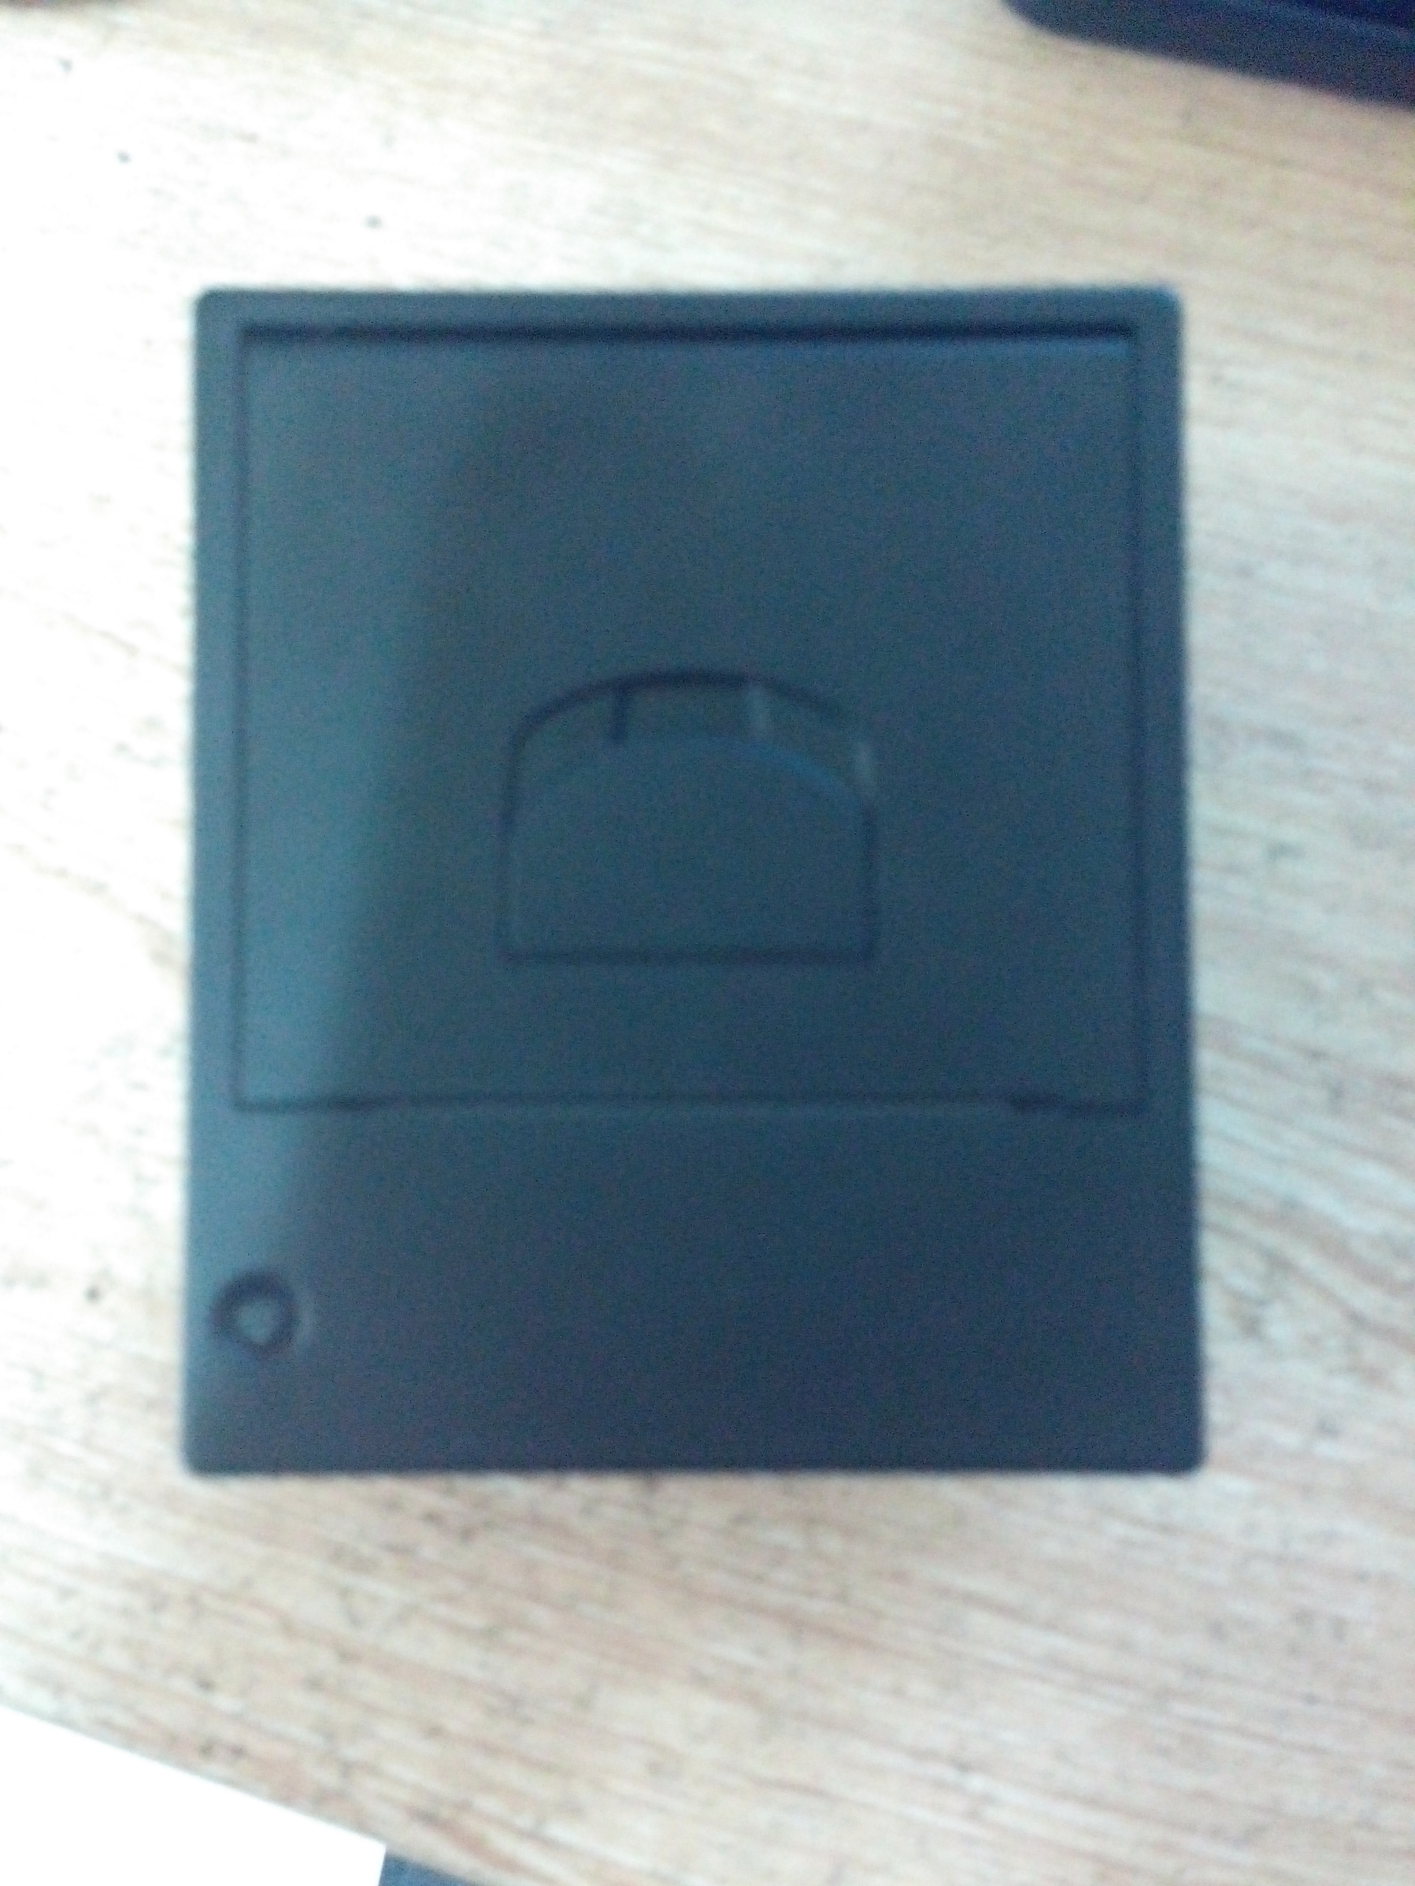

Day | versions | remark
2014年6月3日 | V1.0
Content

1、Introduction of the board 4
2． 6
Pin Definitions： 6
3、technical specifications 6
4、Instru Comment 7
4.1 Instruction list 7
4.2 Command Detail 9
①Print and paper feed commands 9
Print and paper feed 9
Enter 9
Print and paper feed n dots 9
Print and paper feed n line 10
②Print setup commands 10
Set the line spacing to n dots 10
Set the line spacing for the default value 11
Set the print position 11
Set the left margin 11
Set the character print mode 12
Set the character size 13
Set, remove the white print 13
Set, remove the underline 14
Set, remove 90 ° rotation printing 15
Set the print alignment 15
Set the Chinese character pattern 16
Cancel the Chinese character pattern 16
Choice, cancel the user-defined character set 16
Define the user custom character set 17
Cancel the user-defined character 19
③Graphics printed instructions 19
Graphics vertical modulus according to fill 19
Image level take modulus according to print 21
Define the bitmap 22
Print a download bitmap 23
Define the NV bitmap 24
Print NV bitmap 27
④TAB order 28
Horizontal Tab 28
Set the horizontal TAB location 28
⑤One-dimensional bar code printing instructions 29
Set one-dimensional bar code readable (HRI) printing position 29
Set one-dimensional bar code height 30
Set one-dimensional bar width 30
One-dimensional bar code printing 31
⑥Qr code printing instructions 35
Set the module type of QR code 35
Set the QR code error correction level er 35
Store QR code data to the QR code buffer 36
Print QR code 36
Set the graphics information for QR codes 37
⑦Status query instruction 38
Transfer state 38
Real-time transfer status 39
⑧Other instructions 41
INIT 41

1、Introduction of the board
1、To send data through a serial port to the control panel, panel driving machine for printing.
2、Press on the lower K1, the printer to print a test page.
3、The input voltage before delivery can choose 5-9 v or 12 v.
4、You can choose RS232 communication interface before they leave the factory or TTL, USB. The board size and pin definition

2．

Pin Definitions：
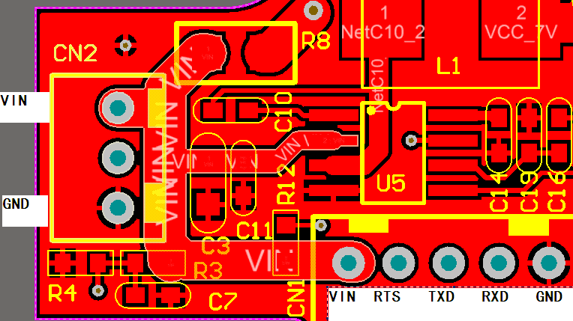

Pin | No | direction | Type | Introductions
VH | 1 | Input |  | POWER
Transmit data | 2 | output |  | TXD, printer output
Receive data | 3 | Input |  | RXD, printer input
DTR | 4 | output |  | Flow Control
GND | 5 |  |  | GND

3、technical specifications
Printing method | Line thermal printer
print paper width | 58mm
print paper width | 48mm
resolution ratio | 203DPI
Each row of points | 384 dots
print speed | 50mm/s
Can print content | GBK Chinese character, ASCII characters, a dimensional barcode, support different density point figure bitmap print and download. Extensible two-dimensional bar code.
Default Font | 9X17(ASCII),24x24(Chinese)

4、Instru Comment

4.1 Instruction list
LF | Print and paper feed | Print and paper feed commands
CR | Enter | Print and paper feed commands
ESC J | rint and paper feed n dots | Print and paper feed commands
ESC d | rint and paper feed n line | Print and paper feed commands
ESC 3 | Set the line spacing for n dots | Print setup instructions
ESC 2 | Set the line spacing for the default value | Print setup instructions
ESC $ | Set the print position | Print setup instructions
GS L nL nH | Set the left margin | Print setup instructions
ESC ! | Set the character print mode | Print setup instructions
GS ! n | Set the character size | Print setup instructions
GS B n | Set, remove the anti-white print | Print setup instructions
ESC - n | Is set, remove the underline | Print setup instructions
ESC V n | Set, remove 90 ° rotation printing | Print setup instructions
ESC a | Set the print alignment | Print setup instructions
FS & | Set the Chinese character pattern | Print setup instructions
FS . | Cancel the Chinese character pattern | Print setup instructions
ESC % n | Choice, cancel the user-defined character set | Print setup instructions
ESC & | Define the user custom character set | Print setup instructions
ESC ? n | Cancel the user-defined character | Print setup instructions
ESC * | Graphics vertical modulus data fill | Graphics printed commands
GS v 0 | Image level take modulus data print | Graphics printed commands
GS * | Define the Under the bitmap | Graphics printed commands
GS / m | Printed the under bitmap | Graphics printed commands
FS q | Define the NV bitmap | Graphics printed commands
FS p n m | Print NV bitmap | Graphics printed commands
HT | Horizontal Tab | TAB commands
ESC D | Set up horizontal TAB | TAB commands
GS H | Set one-dimensional barcode readable characters (HRI) print position | One-dimensional barcode printing commands
GS h | Set one dimensional barcode height | One-dimensional barcode printing commands
GS w | Set one-dimensional barcode width | One-dimensional barcode printing commands
GS k | one-dimensional bar code printing | One-dimensional barcode printing commands
GS ( | Print the qr code | Qr code printed commannds
GS r n | Transfer state | Status inquiry commannds
DLE EOT n | Real-time transmission state | Status inquiry commannds
ESC @ | To initialize the printer | Other commands

4.2 Command Detail

①Print and paper feed commands

Print and paper feed
Directive Title |  | Print and paper feed
Command code |  | ASCII ：LF  decimalism ：10  sexadecimal ：0A
Funtions |  | Print the contents of the buffer,then set feed one line of the paper according the  Current line spacing And adjust the print position to the next line starting position.
Parameter range |  | No
Default Values |  | No
Support model |  | All the models
Attention |  | No

Enter
Name | Enter
Codes | ASCII ：CR  decimalism ：13  sexadecimal：0D
Funtions | Print position adjustment to starting position,not change the line
Parameter range | No
Default Values | No
Support model | All the models
Attention | After return command, the new print data will bitwise "or" cover to print the original data in the cache

Print and paper feed n dots
Name | Print and paper feed n dots
Codes | ASCII ：ESC J n  decimalism ：27 74 n  sexadecimal ：1B 4A n
Funtions | Print the details in the cache and paper feed n dots
Parameter range | 0 ≤ n ≤ 255
Default Values | No
Support model | All the models
Attention | When printing the cache is empty, only feed n dots.Print position move to the starting position of the next line
example | 1b 40 30 31 32 1b 4a 10

Print and paper feed n line
Name | Print and paper feed n dots
Codes | ASCII ：ESC d n  decimalism ：27 100 n  sexadecimal ：1B 64 n
Funtions | Print the details in the cache and paper feed n dots
Parameter range | 0 ≤ n ≤ 255
Default Values | No
Support model | All the models
Attention | The command to set the print starting position is the starting dot.
example | 1b 40 30 31 32 1b 64 01

②Print setup commands

Set the line spacing to n dots
Name | Set the line spacing to n dots
Codes | ASCII ：ESC 3 n  decimalism ：27 51 n  sexadecimal ：1B 33 n
Funtions | Set the line spacing to n dots
Parameter range | 0 ≤ n ≤ 255
Default Values | n = 33
Support model | All the models
Attention | example：  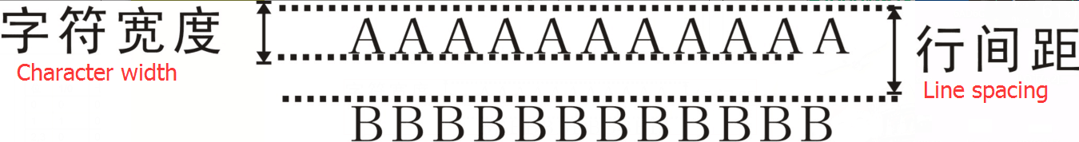  If set the line spacing is less than the height of the maximum character in a line. so the line line spacing is equal to the maximum character level  If ESC 2,ESC @,printer rest,printer power failure, The line spacing to restore to default values
example | 1b 40  1b 33 30  30 31 32 0d 0a  30 31 32 0d 0a  1b 32  30 31 32 0d 0a  30 31 32 0d 0a

Set the line spacing for the default value
Name | Set the line spacing for the default value
Codes | ASCII ：ESC 2  decimalism ：27 50  sexadecimal ：1B 32
Funtions | Set the line spacing to the default of 33 dots
Parameter range | No
Default Values | No
Support model | All the models
Attention | Line spacing indicated detailed look at the ESC 3 instructions  If set the line spacing is less than the maximum height character in a line, so the bank line spacing is equal to the maximum character level You can use the ESC 3 custom line spacing.
example | No

Set the print position
Name | Set the print position
Codes | ASCII ：ESC $ nL nH  decimalism ：27 36 nL nH  sexadecimal ：1B 24 nL nH
Funtions | Adjust the print position to print starting position (nL nH + x 256) dots
Parameter range | 0 ≤ nL ≤ 255，0 ≤ nH ≤ 255
Default Values | No
Support model | All the models
Attention | This directive applies only to the line,after change a new line print position is reset to print starting position, beyond the scope of print is moved to the next line printing
example | 1b 40 1b 24 08 00  30 31 32 0d 0a  30 31 32 0d 0a

Set the left margin
Names | Set print position
Codes | ASCII ：GS L nL nH  decimalism ：29 76 nL nH  sexadecimal ：1D 4C nL nH
Funtions | Set the left margin amount to（nL + nH × 256）dots
Parameter range | 0 ≤ nL ≤ 255，0 ≤ nH ≤ 255
Default Values | No
Support model | All the models
Attention | The command is valid only in a line of the starting position of the handle.  As bellow：  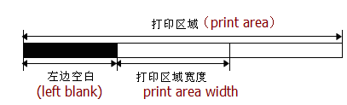  If set outside the printable area, use the maximum printing unit
example | 1b 40 1d 4c 08 00  30 31 32 0d 0a  30 31 32 0d 0a

Set the character print mode
Names | Set the character print method
Codes | ASCII ：ESC ! n  decimalism ：27 33 n  sexadecimal ：1B 21 n
Funtions | Set the character print method（Font, white, high horse, bold, times and times width, and underscore), the parameter n  Define as bellow：  post function value  0 1  0 character model normal small character  1 contra white cancel set  2 backwards place cancel set  3 simpless form cancel set  4 double high cancel set  5 double wide cancel set  6 underline cancel set  7 Undefined
Parameter range | No
Default Values | n = 0
Support model | All model
Attention | The instruction for Chinese fonts and foreign fonts are effective  When the ESC @, printer after reset, power outages, the setting of this directive
example | 1B 40 1B 21 01 30 31 32 0D 0A  1B 40 1B 21 02 30 31 32 0D 0A  1B 40 1B 21 04 30 31 32 0D 0A  1B 40 1B 21 08 30 31 32 0D 0A  1B 40 1B 21 10 30 31 32 0D 0A  1B 40 1B 21 20 30 31 32 0D 0A  1B 40 1B 21 40 30 31 32 0D 0A  1B 40 1B 21 80 30 31 32 0D 0A

Set the character size
Name | Set the character size
Code | ASCII ：GS ! n  decimalism ：29 33 n  sexadecimal ：1d 21 n
Funtions | Set the character size for 1-8 times as wide, 1-8 times double high  definitions as follows：  Use 0 to 3 set character height 4 to 7 bits set character width as shown below  Chart 1 Chart 2  Character width setting Height of character set
  sexadecimal | decimalism | width |  | sexadecimal | decimalism | width
  00 | 0 | 1(normal) |  | 00 | 0 | 1(normal)
  10 | 16 | 2(double width) |  | 01 | 1 | 2(double width)
  20 | 32 | 3 |  | 02 | 2 | 3
  30 | 48 | 4 |  | 03 | 3 | 4
  40 | 64 | 5 |  | 04 | 4 | 5
  50 | 80 | 6 |  | 05 | 5 | 6
  60 | 96 | 7 |  | 06 | 6 | 7
  70 | 112 | 8 |  | 07 | 7 | 8
range of parameters | No
default | n = 0
Support model | All model
Attention | This directive in addition to the HRI characters of Chinese fonts and foreign fonts are effective when the ESC @, reset the printer, power outages, the setting of this directive
example | 1b 40 1d 21 11  30 31 32 0d 0a  30 31 32 0d 0a

Set, remove the white print
Name | Set, remove the white print
instruction | ASCII ：GS B n  decimalism ：29 66 n  sexadecimal ：1d 42 n
Funtions | Set, remove the white print  When n the least significant bit is 0, the white mode off.  When n the least significant bit is 1, the white open mode.
Parameter range | No
Default Values | n = 0
Support model | All models
Attention | Only n lowest effective.  The command to the built-in character and user-defined character are effective.  When the white model is opened, it also effective to ESC SP set of blank. This command does not affect the bitmap, user-defined bitmap, bar code, HRI characters, and space by HT skip, ESC $.  This command does not affect the line spacing. Reverse mode takes precedence over the underline. When set against the white model, even the underline mode open are prohibited from (but not cancelled). When the ESC @, printer after reset, power outages, the setting of this directive
example | 1b 40 1d 42 01  30 31 32 0d 0a  30 31 32 0d 0a

Set, remove the underline
Name | set, remove the underline
Code | ASCII ：ESC - n  decimalism ：27 45 n  sexadecimal ：1B 2D n
Funtions | Based on the value of n, set/remove the underline mode:
  n | funtion
  0, 48 | Remove the underline mode
  1, 49 | Set the underline mode (1 dot coarse)
  2, 50 | Set the underline mode (2 dot coarse)
Parameter range | 0 ≤ n ≤ 2, 48 ≤ n ≤ 50
Default Values | n = 0
Support model | All models
Attention | Printers can give all characters underscore (including character to the right of the interval), except by HT set blank. •   Printers can give all characters underscore (including character to the right of the interval), except by HT set blank. •   When by setting the value of n to 0 or 48 to remove the underline mode, the following data is not be printed underline, and remove the underline mode before setting the underlined roughness do not change. By default the underline roughness is 1 point. •   Change the character size does not affect the current underlined roughness. • use ESC! Also can be set or remove the underline mode. Note, however, the last received command is valid.
Example | 1b 40 1b 2d 01  30 31 32 0d 0a  1b 40 1b 2d 02  30 31 32 0d 0a  1b 40 1b 2d 00  30 31 32 0d 0a

Set, remove 90 ° rotation printing
Name | Set up the, remove clockwise rotate 90 ° to print
Code | ASCII ：ESC V n  decimalism ：27 86 n  sexadecimal ：1B 56 n
Funtions | Set or remove 90 ° rotation printing.  When n equals 0 or 48, lifting 90 ° rotation printing.  When n equals 1 or 49, set up 90 ° rotation printing.
Parameter range | 0 ≤ n ≤ 1， 48 ≤ n ≤ 49
Default Values | n = 0
Support model | All models
Attention | When set up the underline mode, in the case of characters clockwise rotate 90 °, the printer is not underlined.  In clockwise rotate 90 ° mode, times and times higher command wide direction and general mode of the characters x magnification high command wide zoom in the opposite direction of the characters. When the ESC @, printer after reset, power outages, the setting of this directive
example | 1b 40 1b 56 01  30 31 32 0d 0a  30 31 32 0d 0a

Set the print alignment
Name | Set the print alignment (left, center, right)
Code | ASCII ：ESC a n  decimalism ：27 97 n  sexadecimal ：1B 61 n
Funtions | To align all the data in a line, the value of n meaning is as follows:  n MODE  0, 48 left  1, 49 center  2, 50 right
Parameter range | 0 ≤ n ≤ 2 or 48 ≤ n ≤ 50
Default Values | n = 0
Support model | All model
Attention | When the ESC @, printer after reset, power outages, the setting of this directive
example | 1B 40 1B 61 02  30 31 32 0D 0A  1B 40 1B 61 01  30 31 32 0D 0A  1B 40 1B 61 00  30 31 32 0D 0A

Set the Chinese character pattern
Names | Set the Chinese character pattern
Codes | ASCII ：FS &  decimalism ：28 38  sexadecimal ：1C 26
Funtions | Select mode
Parameter range | No
Default Values | No
Support model | All model
Attention | Choosing model of Chinese characters, the printer handle all Chinese characters code, every time two bytes.  In the first byte, and the second byte order processing code of Chinese characters.
example | 1b 40 1C 26 C8 C8 0d 0a  1C 2E C8 C8 0d 0a

Cancel the Chinese character pattern
Names | Cancel the Chinese character pattern
Codes | ASCII ：FS .  decimalism ：28 46  sexadecimal：1C 2E
Funtions | Cancel the Chinese character pattern
Parameter range | No
Default Values | No
Support model | All model
Attention | Not choosing model of Chinese characters, all characters are as ASCII code, a character at a time processing.
example | No

Choice, cancel the user-defined character set
Names | Choose or cancel the user custom character set
Codes | ASCII ：ESC % n  decimalism ：27 37 n  sexadecimal ：1B 25 n
Funtions | Choose or cancel the user custom character set  When n the least significant bit is 0, cancel the user-defined character set.  When n the least significant bit is 1, select user-defined character set.
Parameter range | 0 ≤ n ≤ 255
Default Values | 0
Support model | All model
Attention | When cancel the user-defined character set, automatically choose the internal character set.
example | No

Define the user custom character set
Names | Define the user custom character set
Codes | ASCII ：ESC & y c1 c2 [x1 d1 ... d (yx1)] ... [xk d1 ... d(y x k)]  decimalism ：27 38 y c1 c2 [x1 d1 ... d(yx1)] ...[xk d1 ... d(yxk)]  sexadecimal ：1B 26 y c1 c2 [x1 d1...d(y x1)]...[xk d1...d(yxk)]
Funtions | Define the user custom characters.  • y Bytes specifies the vertical direction.  • c1 Specifies the starting character encoding, c2 Specify the end character encoding.  • xk Specify the horizontal points.
Parameter range | x y The scope and corresponding internal fonts  If choose the 6 * 12 font, y = 2， 0 ≤ x ≤ 6  If you choose the font of 12 * 24, y= 3， 0 ≤ x ≤ 12  32 ≤ c1 ≤ c2 ≤ 126  0 ≤ d1 ... d(y*xk) ≤255
Default Values | No
Support model | All model
Attention | Can define the scope of the character encoding: from < > 20 H to < 7 > e H ASCII (95 characters).  Can define multiple continuous character encoding of the characters. When only need one character, make c1 = c2.  d is point data of the characters. Point pattern is horizontal direction from the start on the left. On the right side of the remaining points for blank. •   Define user custom character data is (y * x) bytes. •   Set to print the corresponding to 1 or not print points corresponding to 0. • The command for each font definition different user-defined character pattern. Use the ESC! Set the font.  •The user-defined character and downlink bitmap is defined at the same time. When the command is executed, the bitmap is cleared.  •In the following situations user-defined character is clear:  carry out ESC @。  carry out GS *。  carry out ESC ?。  Reset the printer or shut off the power.  Illustration:  When set the font A (1224)  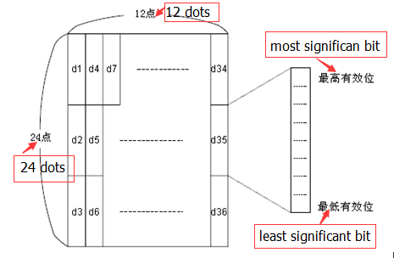  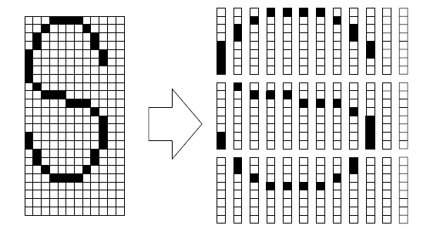  d1= <0F>H d4 = <30>H d7 = <40>H . . . .  d2 = <03>H d5 = <80>H d8 = <40>H . . . .  d3 = <00>H d6 =<00>H d9 = <20>H . . . .
example | ①y = 2  1B 40  1b 26 02 20 20 06 FF FF FF FF FF FF FF FF FF FF FF FF  1b 25 01  20 20 0D 0A  1b 3f 20  30 20 30 20 0d 0a  ②y = 3  1B 40  1b 26 03 20 20 06 FF FF FF FF FF FF FF FF FF FF FF FF FF FF FF FF FF FF FF  1b 25 01  20 20 0D 0A  1b 3f 20  30 20 30 20 0d 0a

Cancel the user-defined character
Names | Cancel the user-defined character
Codes | ASCII ：ESC ? n  decimalism ：27 63 n  sexadecimal ：1B 3F n
Funtions | Cancel code n specified by the user custom characters
Parameter range | 32 ≤ n ≤ 126
Default Values | No
Support model | All model
Attention | The command to terminate for character encoding defined style, character encoding specified by n. After the user-defined character was cancelled, to internal character pattern print accordingly.  In ESC! Choose the font, the command to remove the definition for a given coding style. If a user-defined character is not defined, the printer to ignore this command.
example | No

③Graphics printed instructions

Graphics vertical modulus according to fill
Names | Set the character print method
Codes | ASCII ：ESC * m Hl Hh [d]k  decimalism ：27 42 m Hl Hh [d]k  sexadecimal ：1B 2A m Hl Hh [d]k
Funtions | Print the longitudinal modulus image data, the parameter meaning is as follows: m For some photo format:  m mode Horizontal Scale Vertical Scale  0 8 Some single density ×2 ×3  1 8 Point double density ×1 ×3  32 24 dot single density ×2 ×1  33 24 dot double density ×1 ×1  Hl、Hh is horizontal dots（Hl＋256×Hh）  [d]k is dot figure data  k Used to indicate a figure data bytes, not to participate in the transmission
Parameter range | XX58：  m = 0、1、32、33  1 ≤ Hl + Hh × 256 ≤ 384  0 ≤ d ≤ 255  k = Hl + Hh × 256（当 m = 0、1）  k = ( Hl + Hh × 256 ) × 3（当 m = 32、33）  XX80：  m = 0、1、32、33  1 ≤ Hl + Hh × 256 ≤ 576  0 ≤ d ≤ 255  k = Hl + Hh × 256（当 m = 0、1）  k = ( Hl + Hh × 256 ) × 3（当 m = 32、33）
Default Values | No
Support model | All model
Attention | [d]k Corresponding bit is 1 the said that point to print, the corresponding bit is 0, the said that point is not to print the image horizontally part is out of print area will be ignored  Dot figure data and print effect relationship is as follows: 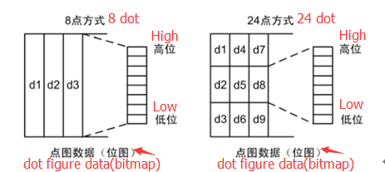  This instruction is only fill print cache, image printing should start only after receive the printed instructions, image printing finished printing the cache is cleared  If need to print the image height is bigger, can is first broken down into several height of 8 (m = 0, 1) or 24 (m = 32, 33) point image print respectively  After filling graphic data, can continue to fill the other information, so that the graphics are printed together with other information  After filling spot diagram, generally use the ESC J (n = 24) instruction for printing, also can use LF instructions for printing, but LF instructions can cause feed operation (by line spacing in the paper), makes the multi-line image discontinuity, can set the line spacing is 0, is not too much into the paper. (stylus printer will start migration, if there is offline, please send the data continuously)
example | 1B 40  1b 2a 00 0C 00 FF FF FF FF FF FF FF FF FF FF FF FF  1B 33 00  0A

Image level take modulus according to print
Name | Image level take modulus according to print
Code | ASCII ：GS v 0  decimalism ：29 118 48 m xL xH yL yH [d]k  sexadecimal ：1D 76 30 m xL xH yL yH [d]k
Funtions | Print transverse modulus image data, the parameter meaning is as follows:  m Is the bitmap method:  m mode Horizontal Scale Vertical Scale  0,48 normal × 1 × 1  1,49 double width × 2 × 1  2,50 double high × 1 × 2  3,51 bouble width double high × 2 × 2  xL、xH horizontal bytes（xL + xH × 256）  yL、yH Points for the vertical direction（yL + yH × 256）  [d]k dot figure data  k dot figure data bytes, k is used to signal, without transport
Parameter range | XX58：  0 ≤ m ≤ 3；48 ≤ m ≤ 51  1 ≤ xL + xH×256 ≤ 48  0 ≤ yL ≤255，0 ≤ yH ≤255  0 ≤ d ≤ 255  k = (Hl + Hh×256)×(yL + yH×256)  XX80：  0 ≤ m ≤ 3；48 ≤ m ≤ 51  1≤ xL + xH×256 ≤ 72  0 ≤ yL ≤ 255，0 ≤ yH ≤ 255  0 ≤ d ≤ 255  k = (Hl + Hh×256)×(yL + yH×256)
Default Values | No
Support model | All model
Attention | [d]k The corresponding bit is 1 the said that point to print, the corresponding bit is 0, the said that point if not print image level bytes out of print area, beyond the part will be ignored  This instruction execution according to the image size into the paper, from the ESC 2, ESC 3 line spacing  After the instruction execution, print coordinates are reset to the left margin position and image content is empty  The bitmap data relationship with the print effect as below：  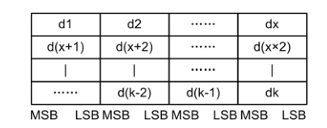  This command with a printing function, data transfer and print, don't need to use the print command
example | 1B 40  1d 76 30 00 03 00 09 00  FF FF FF FF FF FF FF FF FF FF FF FF FF FF FF FF FF FF FF FF FF FF FF FF FF FF FF

Define the bitmap
Name | definition download bitmap
Code | ASCII ：GS * x y d1...d(x×y×8)  decimalism ：29 42 x y d1 ...d(x×y×8)  sexadecimal ：1D 2A x y d1...d(x×y×8)
Funtions | x and y Specify the points to define the pass bitmap.  x Specify the level direction points to be 8*x。  y Specify vertical points for points 8*y。
Parameter range | 1 ≤ x ≤ 255  1 ≤ y ≤ 48  x*y ≤ 1536  0 ≤ d ≤ 255
Default Values | No
Support model | All model
Attention | This command is forbidden if x * y exceeds the specified range.  • D represents the bitmap data. The data (d) specifies that the print bit is 1 and the non-print bit is 0.  • In the following cases, remove the bitmap definition:  execute ESC @。  execute ESC &。  Printer reset or turn off the power.  downlink bitmap and the relationship between the print data as shown in the figure below  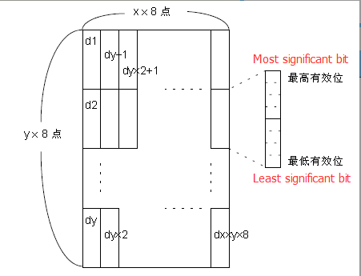
example | 1B 40  1D 2A 03 03  FF FF FF FF FF FF FF FF FF FF FF FF FF FF FF FF FF FF FF FF FF FF FF FF  FF FF FF FF FF FF FF FF FF FF FF FF FF FF FF FF FF FF FF FF FF FF FF FF  FF FF FF FF FF FF FF FF FF FF FF FF FF FF FF FF FF FF FF FF FF FF FF FF  1D 2F 00

Print a download bitmap
Name | Print a download bitmap
Code | ASCII ：GS / m  decimalism ：29 47 m  sexadecimal ：1D 2F m
Funtions | Print the bitmap in the mode specified by m
  m | Mode
  0, 48 | normal
  1, 49 | double width
  2, 50 | double height
  3, 51 | double width/ height
Parameter range | 0 ≤ m ≤ 3  48 ≤ m ≤ 51
Default Values | No
Support model | All mode
Attention | If the bitmap data is not defined, the command is ignored.  • In standard mode, this command is valid only when there is no data in the print buffer.  The print mode (bold, overlapping, underlined, character size, or anti-white print) is invalid, except for the reverse printing mode. •  if will print over the downlink bitmap print area, is beyond the data does not print.
example | No

Define the NV bitmap
Name | Define the NV bitmap
Code | ASCII ：FS q n [xL xH yL yH d1...dk]1...[xL xH yL yH d1...dk]n  decimalism ：28 113 n [xL xH yL yH d1...dk]1...[xL xH yL yH d1...dk]n  sexadecimal ：1C 71 n [xL xH yL yH d1...dk]1...[xL xH yL yH d1...dk]n
Funtions | Define the NV bitmap with a specific n value.  • n specified NV of the definition of the number of the bitmap.  • xL, xH defined level of NV bitmap specified in the direction of points (256) xL + xH * * 8.  • yL, yH to define the points at the specified vertical NV in the bitmap (yL + yH * 256) * 8.
Parameter range | 1 ≤ n ≤ 255  0 ≤ xL ≤ 255  0 ≤ xH ≤ 3  (1 ≤ (xL+xH*256) ≤ 1023)  0 ≤ yL ≤ 255）  0 ≤ yH ≤ 1  (1 ≤ (yL+yH*256) ≤ 288)  0 ≤ d ≤ 255）  k = (xL+xH*256)*(yL+yH*256)*8  The data area defined by the program = 192K bytes
Default Values | No
Support model | All mode
Attention | Frequently write command it might damage the NV memory.Therefore, it is suggested that to NV memory perform no more than 10 times a day write operations.  In the process of put an image in NV memory, printers, perform a hardware reset operation.So the user custom characters, downlink bitmap should be after complete the command definition.Printer qing  In addition to receive and print buffer, and reset to available at the time of turning on the power supply mode.(does not support hardware reset interface)  The command is cancelled all has been defined in the command NV bitmap.  Since this command during processing to complete hardware reset, cannot perform mechanical operation (including when initializing the print head cover open position with feed button into paper, etc.).  In this command during the processing, when NV memory write data to the users of the printer is busy and stop receiving data.Therefore forbidden during the execution of this command transmission data, including real-time command.  NV bitmap is a definition in the nonvolatile memory bitmap.FS are defined with the FS q p to print.  Under the standard mode, the command is valid only in the beginning of a line processing.  • the command 7 bytes < FS ∼ yH > command is valid after normal processing.  • when data volume exceeded the xL, x H, yL, yH, defined the scope of the left capacity outside the scope of printer defined in xL, xH, yL, yH defined scope.  • in the first set of bitmap, when the xL, xH, yL, any parameter in yH is beyond the definition of scope, this command is forbidden.  • in the first group of a group of bitmap, when the printer in xL, xH, yL, yH is beyond the scope definition, is to stop processing the command, and began to write NV image.At this time, there has been no defined NV bitmap banned (undefined,) but a previously defined any NV bitmap is still valid.  • d defined data. In data (d), specify a to print a one point and a 0 bit specify a print of the point.  • the command defined n NV the number of the bitmap.01 h began to rise in order number from the bitmap.So the first data set [xL xH yL yH d1... dk] is NV bitmap 01 h, the final data set [xL xH yL yH d1... dk] n is NV bitmap.Total and FS p command set NV bitmap number consistent.  • the definition of a NV bitmap data by [xL xH yL yH d1... dk].Therefore, when only one NV bitmap n = 1, printer only deals with data set [xL xH yL yH d1... dk] at a time.Printers use NV memory ([data: (256) xL + xH * * (yL + yH * 256) * 8] + [header: 4]) bytes.  • this printer defined in the area of 192 k bytes (maximum).This command can define several bitmap, but cannot be defined according to the total capacity [bitmap data + head] more than 192 k bytes of the bitmap.  • even set the ASB, printers don't transmit ASB during processing the command or execution state detection.  • once defined a NV bitmap, it cannot be implemented ESC @, reset, the power is removed.  • the command to perform only the definition of NV bitmap, does not perform print.NV bitmap print by FS p command execution.  Illustration: when xL = 64, xH = 0, yL = 96, yH = 0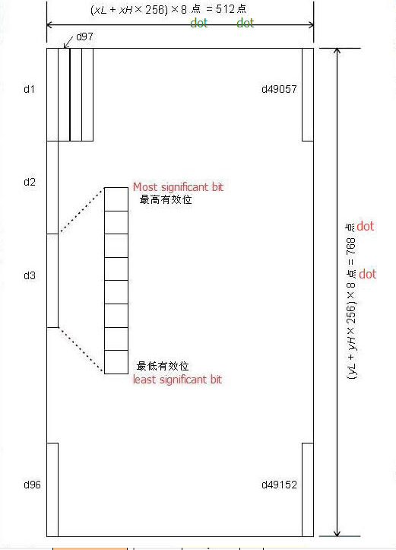
example | 1B 40  1C 71 01 03 00 03 00  FF FF FF FF FF FF FF FF FF FF FF FF FF FF FF FF FF FF FF FF FF FF FF FF  FF FF FF FF FF FF FF FF FF FF FF FF FF FF FF FF FF FF FF FF FF FF FF FF  FF FF FF FF FF FF FF FF FF FF FF FF FF FF FF FF FF FF FF FF FF FF FF FF  1C 70 01 00

Print NV bitmap
Name | Print NV bitmap
Code | ASCII ：FS p n m  decimalism ：28 112 n m  sexadecimal ：1C 70 n m
Funtions | Print the NV bitmap with the model m specified
  m | Mode
  0, 48 | Normal
  1, 49 | double width
  2, 50 | double height
  3, 51 | Double width/ height
Parameter range | 0 ≤ m ≤ 3  48 ≤ m ≤ 51  1 ≤ n ≤ 255
Default Values | No
Support model | All mode
Attention | N is the number of NV bitmap (FS q command definition).  • m specified bitmap mode.  NV bitmap is a definition in the nonvolatile memory bitmap.FS are defined with the FS q p to print  • when there is no specified NV bitmap the command is invalid.  • in standard mode, only when there is no data in the print buffer, this command is valid.  • the command is not affected by print mode (in bold print, overlapping, underline, character size, reverse printing or character 90 °), and rotated inverted except the print mode.  • if you want to print more than one line of the downlink bitmap, is beyond the data does not print.  • in common and times as wide as mode, the command into the paper n points (n NV bitmap level), under the mode of high times and four times the size (the command into the paper 2 n, n for NV bitmap height), and ESC 2 or 3 set the line spacing of ESC has nothing to do.  • bitmap after printing, this command to set the print position at the beginning of a line, and the subsequent data according to the general data processing
example | No

④TAB order

Horizontal Tab
Name | Horizontal Tab
Code | ASCII ：HT  decimalism ：9  sexadecimal ：09
Funtions | Move the printing position to the next TAB
Parameter range | No
Default Values | No
Support model | All mode
Attention | TAB position are set in the ESC D  If the TAB position is not set no horizontal TAB position (the default), the instruction will be treated as LF instructions  If the TAB position beyond the print area, coordinates will be shifted to the next line of the starting position of the (depending on the data bank is full, and print a newline)
example | No

Set the horizontal TAB location
Name
Code | ASCII ：ESC D [d]k NUL  decimalism ：27 68 [d]k 0  sexadecimal ：1B 44 [d]k 00
Funtions | Settings TAB position, the parameter meaning is as follows: d1... Dk: horizontal tabular location, at 8, NULL is the terminator
Parameter range | XX58：1 ≤ d ≤ 46（d1 <d2 < …… dk ，1 ≤ k ≤ 16）  XX80：1 ≤ d ≤ 70（d1 < d2 < …… dk ，1 ≤ k ≤ 16）
Default Values | [d]k = 0（default, there is no horizontal table location）
Support model | All mode
Attention | table position is indicated as follows：  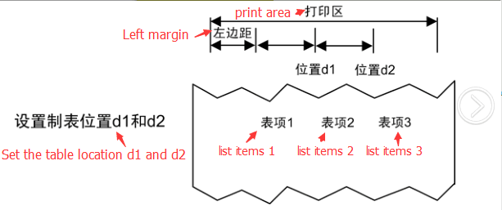  Maximum 16 TAB position setting  Using this command will cancel the previous TAB position Settings  K is used to signal, no transport  Transmission [d] k when you meet the NULL as the end  If the dk is less than or equal to dk - 1, as the end, the remaining data as a common data processing  TAB position can be made of HT switch  After the change the left margin, TAB position change at the same time  When the ESC @, printer after reset, power outages, the setting of this directive
example | No

⑤One-dimensional bar code printing instructions

Set one-dimensional bar code readable (HRI) printing position
Name | Set the bar code readable character (HRI) printing position
Code | ASCII ：GS H n  decimalism：29 72 n  sexadecimal ：1D 48 n
Funtions | Set bar code readable character (HRI) printing position, n parameter is as follows:  n print position  0，48 NOT print  1，49 top of the barcode  2，50 bottom of the barcode  3，51 Above and below the bar code
Parameter range | 0 ≤ n ≤ 3 或 48 ≤ n ≤ 51
Default Values | n = 0
Support model | All mode
Attention | When ESC @, printer reset, power failure, the Settings of this directive fail
example | No

Set one-dimensional bar code height
Names | Set one-dimensional bar code height
Codes | ASCII ：GS h n  decimalism ：29 104 n  sexadecimal ：1D 68 n
Funtions | The height of the bar code is n, and the parameter n is as follows:  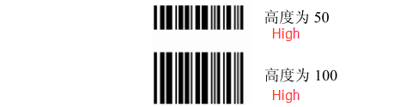
Parameter range | 1 ≤ n ≤ 255
Default Values | n = 64
Support model | All mode
Attention | When ESC @, printer reset, power failure, the Settings of this directive fail
example | No

Set one-dimensional bar width
Names | Set one-dimensional bar width
Codes | ASCII ：GS w n  decimalism ：29 119 n  sexadecimal ：1D 77 n
Funtions | Set the bar code unit to n points, and the n meaning is as follows:  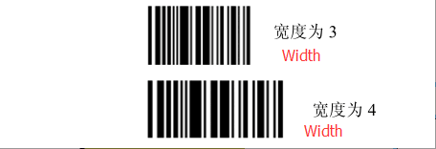
Parameter range | 1 ≤ n ≤ 6
Default Values | n = 2
Support model | All modes
Attention | When ESC @, printer reset, power failure, the Settings of this directive fail
example | No

One-dimensional bar code printing
Names
Codes | (A) ASCII ：GS k m [d]k NUL  decimalism ：29 107 m [d]k NUL  sexadecimal ：1D 6B m [d]k NUL  (B) ASCII ：GS k m n [d]k  decimalism ：29 107 m n [d]k  sexadecimal ：1D 6B m n [d]k
Funtions | Print a dimensional barcode, the parameters meaning is as follows:  M for encoding  N for encoding data length, (B) use only, the difference between the (A) and (B) the instruction is the end of the data segment with A NULL character (A), and (B) indicates the length of the data  [d] k for barcode data  K for the length of the bar code data, is used to signal and don't have to transfer  The relationship between the parameters shown in the table below:  (Instructions A)  (instruct B)
  m | code system | Barcode data (SP for space)
  m | code system | data length | k | character set | data（d）
  0 | UPC-A | Fixed | k = 11，12 | 0~9 | 48≤d≤57
  1 | UPC-E | Fixed | 6≤k≤8，  k = 11，12 | 0~9 | 48≤d≤57  [When k = 7,8,11,12，  d1 = 48 ]
  2 | JAN13  (EAN13) | Fixed | k = 12，13 | 0~9 | 48≤d≤57
  3 | JAN8  (EAN8) | Fixed | k = 7，8 | 0~9 | 48≤d≤57
  4 | CODE39 | variable | 1≤k | 0~9，A~Z  SP，$，%，*，+，-，.，/ | 48≤d≤57，  65≤d≤90，  d = 32，36，37，42，43，45，46，47
  5 | ITF  (Interleaved 2 of 5) | variable | 2≤k≤255  （even number） | 0~9 | 48≤d≤57
  6 | CODABAR  (NW-7) | variable | 1≤k | 0~9，A~D，a~d  $，+，-，.，/，: | 48≤d≤57，  65≤d≤68，  97≤d≤100，  d = 36，43，45，46，47，58  (65≤d1≤68，  65≤dk≤68，  97≤d1≤100，  97≤dk≤100)
  m | code system | Barcode data (SP for space)
  m | code system | data length | n | character | data（d）
  65 | UPC-A | Fixed | n = 11，12 | 0~9 | 48≤d≤57
  66 | UPC-E | Fixed | 6≤n≤8，  n = 11，12 | 0~9 | 48≤d≤57  [当 n = 7,8,11,12，  d1 = 48 ]
  67 | JAN13  (EAN13) | Fixed | n = 12，13 | 0~9 | 48≤d≤57
  68 | JAN8  (EAN8) | Fixed | n = 7，8 | 0~9 | 48≤d≤57
  69 | CODE39 | variable | 1≤n | 0~9，A~Z  SP，$，%，*，+，-，.，/ | 48≤d≤57，  65≤d≤90，  d = 32，36，37，42，43，45，46，47
  70 | ITF  (Interleaved 2 of 5) | variable | 2≤n≤255  （even number） | 0~9 | 48≤d≤57
  71 | CODABAR  (NW-7) | variable | 1≤n | 0~9，A~D，a~d  $，+，-，.，/，: | 48≤d≤57，  65≤d≤68，  97≤d≤100，  d = 36，43，45，46，47，58  (65≤d1≤68，  65≤dk≤68，  97≤d1≤100，  97≤dk≤100)
  72 | CODE93 | variable | 1≤n≤255 | 00H~7FH | 0≤d≤127
  73 | CODE128 | variable | 1≤n≤255 | 00H~7FH  C1H~C4H(FNC) | 0≤d≤127  d = 193，194,195,196
  74 | UCC/EAN128 | variable | 1≤n≤255 | 00H~7FH  C1H~C4H(FNC) | 0≤d≤127  d = 193，194,195,196
Parameter range | (A) 0 ≤ m ≤ 6  (B) 65 ≤ m ≤ 74
Default Values | No
Support model | All mode
Attention | If the area beyond can print bar code width, the printer does not perform the barcode printing  This instruction execution according to the need to feed, not affected by the ESC 2, 3 ESC line spacing also does not affect the line spacing Settings  This instruction is not affected by ESC!Character style Settings  After the instruction execution, print position back to the starting location  M parameter 0 ~ 6 (A) and (B) 65 ~ 71 to choose the same coding system, print effect is the same  M parameter 0 ~ 6 (A), bar code data ended with NULL  M parameters (B) 65 ~ 74, the bar code data to data length n  K is used to signal, do not need to transfer  Print UPCA (m = 0 or 65), the need to pay attention to:  Regardless of the input data length is 11 or 12, check digit automatically insert or error correction  The starting character, middle separator, terminators automatically inserted  Print UPCE (m = 1 or 66), the need to pay attention to:  When the data length is 6, the system character (NSC) 0 automatically inserted  When the data length is 7, 8, 11, and 12, the first system characters (NSC) d1 must be 0  Regardless of the input data length is 6, 7, 8, 11 or 12, check digit automatically insert or error correction  Regardless of the input data length is 6, 7, 8, 11 or 12, barcode readable characters (HRI) show only 6, for the data does not include the system character (NSC) and the check code;  To transmit data and print the data transformation relationship is as follows: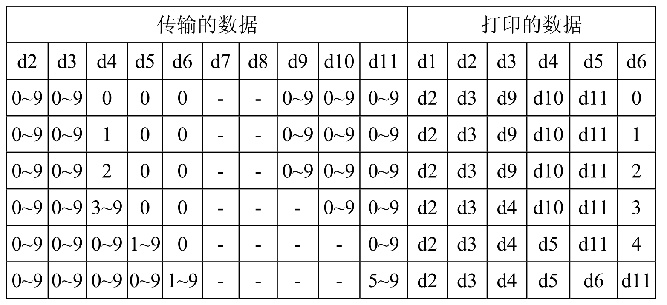  When d6 is 1 ~ 9, should guarantee the d7, d8, d9, d10 is 0, d11 is 5 ~ 9  The starting character, terminators automatically inserted  Print EAN13 (m = 2 or 67), the need to pay attention to:  Regardless of the length of the input data is 12 or 13, check digit automatically inserted or error correction  The starting character, middle separator, terminators automatically inserted  Print EAN8 (m = 3 or 68), the need to pay attention to:  Regardless of the input data length is 7 or 8, check digit automatically insert or error correction  The starting character, middle separator, terminators automatically inserted  Print CODE39 (m = 4 or 69), the need to pay attention to：  When d1 or not as the starting character/dn terminator "*", encoder automatically inserted into the "*"  When the data center meet with "*", encoder as the terminator, the rest of the data as a common data processing;  Check digit does not automatically calculate and add  Print ITF25 (m = 5 or 70), the need to pay attention to:  Starting character and terminators automatically inserted  Check digit does not automatically calculate and add  Print CODABAR (NW - 7) (m = 6 or 71), the need to pay attention to:  Starting operator and the end will not automatically inserts, requires the user to manually add, scope for "A" ~ "D" or "A" ~ "D"  Check digit does not automatically calculate and add  Print CODE93 (m = 72), the need to pay attention to:  Starting character and terminators automatically inserted  Two check code automatic calculation and insert  When set barcode readable characters (HRI) print, without any said start/end HRI characters  When set (HRI) print barcode readable characters, control characters will be replaced with a space  Print CODE128 (m = 73), the need to pay attention to:  Intelligent identification data coding system and realize the minimum length coding, without user set character set (including the starting character set) or switch character set Function character FNC1 ~ FNC4 USES C1H ~ C4H input  Check bits are automatically computed and added  When setting the barcode readable characters (HRI) print, control characters and FNC1 ~ FNC4 will use Spaces instead of print EAN128 (m = 74),Pay attention to the basic structure as follows:  connection structure is as follows:  Coding system intelligent identification data and realize the minimum length coding, without user set character set (including the starting character set) or switch character set function character FNC1 ~ FNC4 using C1H ~ C4H input user input data in AI don't need to use "(" ")" instructions, coding system automatically inserts, no side could go wrong, such as: 18 "019501234567890 *", GS 74 k 01 is the AI, the following is wrong: GS 74 18 k "(01) 9501234567890 *"  When using the connection structure, you need to insert FNC1 (C1H "Decimal = 193") as follows:  GS k 74 18 "019501234567890*" 193 "029501234567890*"  When set (HRI) print barcode readable characters, control characters will replace with a space, and FNC1 ~ FNC4 will be removed
  starting character set | FNC1 | AI | data | parity bit A |  | parity bit B | end mark
  automatic insertion |  | （d1...dk） |  |  | automatic insertion
  starting character set | FNC1 | AI | data | parity bit A | FNC1 | AI | data | parity bit A | parity bit B | end mark
  automatic insertion |  | （d1...dk） |  |  |  |  |  |  | automatic insertion
example | 1b 40 1d 48 02  1d 6b 41 0c 31 32 33 34 35 36 37 38 39 30 31 32  1d 6b 42 0c 30 32 33 34 35 36 30 30 30 30 38 39  1d 6b 43 0c 30 32 33 34 35 36 30 30 30 30 38 39  1d 6b 44 08 30 32 33 34 35 36 30 30  1d 6b 45 08 30 32 33 34 35 36 30 30  1d 6b 46 08 30 32 33 34 35 36 30 30  1d 6b 47 08 41 32 33 34 35 36 30 41  1d 6b 48 08 41 30 32 33 34 35 36 41  1d 6b 49 08 41 30 32 33 34 35 36 41

⑥Qr code printing instructions

Set the module type of QR code
Name | Set the module type of QR code
Code | ASCII ：GS ( k pL pH cn fn n  decimalism ：29 40 107 pL pH cn fn n  sexadecimal：1D 28 6b pL pH cn fn n
Funtions | Set the module type of QR code
Parameter range | pL=3, pH=0  cn=49  fn=67  0 ≤ n ≤ 16
Default Values | n=3
Support model | All mode
Attention | Set the type of the QR code graphic module to [n dot* n points].
example | No

Set the QR code error correction level er
Name | Set the QR code error correction level error
Code | ASCII ：GS ( k pL pH cn fn n  decimalism ：29 40 107 pL pH cn fn n  sexadecimal ：1D 28 6b pL pH cn fn n
Funtions | Set the QR code error correction level error
Parameter range | pL=3, pH=0  cn=49  fn=69  48 ≤ n ≤ 51
Default Values | n=48
Support model | All mode
Attention | Set the QR code error correction level error
  n | Funtions | Reference: restore probably represent (%)
  48 | Error correction level error L | 7
  49 | Error correction level error m | 15
  50 | Error correction level error q | 25
  51 | Error correction level error h | 30
example | No

Store QR code data to the QR code buffer
Name | Store QR code data to the QR code buffer
Code | ASCII ：GS ( k pL pH cn fn m d1…dk  decimalism ：29 40 107 pL pH cn fn m d1…dk  sexadecimal ：1D 28 6b pL pH cn fn m d1…dk
Funtions | Store QR code data to the QR code buffer
Parameter range | 4 ≤ (pL + pH×256 ) ≤ 7092 (0 ≤ pL ≤ 255, 0 ≤ pH ≤ 28)  cn=49  fn=80  m=48  0 ≤ d ≤ 255  k = (pL + pH×256 ) - 3
Default Values | No
Support model | All mode
Attention | Store the data of the qr code (d1... dk) to the qr code buffer. ((pL + pH (256) - 3) bytes after the m (d1... dk) as a graphic data is processed.
example | No

Print QR code
Name | Print QR code
Code | ASCII ：GS ( k pL pH cn fn m  decimalism ：29 40 107 pL pH cn fn m  sexadecimal ：1D 28 6b pL pH cn fn m
Funtions | Print QR code
Parameter range | pL=3, pH=0  cn=49  fn=81  m=48
Default Values | No
Support model | All mode
Attention | Print QR cod, The user must consider the space of the QR code (the spacing of the QR codes and the spacing of the right and left are specified in the specification).
example | 1b 40  1d 28 6b 03 00 31 43 03  1d 28 6b 03 00 31 45 30  1d 28 6b 06 00 31 50 30 41 42 43  1b 61 01  1d 28 6b 03 00 31 52 30  1d 28 6b 03 00 31 51 30

Set the graphics information for QR codes
Name | Set the graphics information for QR codes
Code | ASCII ：GS ( k pL pH cn fn m  decimalism ：29 40 107 pL pH cn fn m  sexadecimal ：1D 28 6b pL pH cn fn m
Funtions | Set the graphics information for QR code. Below is the details of the graphic information:  Width and height data send:  •The height and width of the graphic data are measured in points.  Other information data send:  • "Hexadecimal = 30H/decimal = 48" indicates that the data is not printed. "hexadecimal = 31 h/decimal = 49" said data not be printed
  Send Data | sexadecimal | decimalism | data type
  Header | 37H | 55 | 1byte
  Flag | 36H | 54 | 1byte
  Width | 30H-39H | 48-57 | 1-5byte
  Separator | 1FH | 31 | 1byte
  Height | 30H-39H | 48-57 | 1-5byte
  Separator | 1FH | 31 | 1byte
  Fixed Value | 31H | 49 | 1byte
  Separator | 1FH | 31 | 1byte
  Other Information | 30H or 31H | 48 or 49 | 1byte
  NUL | 00H | 0 | 1byte
Parameter range | pL=3, pH=0  cn=49  fn=82  m=48
Default Values | No
Support model | All mode
Attention | This command does not print QR codes. Users must consider the QR code graphic space (QR code graphics context about spacing and the spacing is specified in the specifications).
example | No

⑦Status query instruction

Transfer state
Name | Transfer state
Code | ASCII ：GS r n  decimalism ：29 114 n  sexadecimal ：1D 72 n
Funtions | Send the state specified by n, as shown below:
  n | status
  1.49 | Transfer paper sensor status
Parameter range | n = 1, 49
Default Values | No
Support model | All modes
Attention | When using a serial interface:  If set DTR/DSR control, the printer after confirm the host receiving data in place (the DSR signal for SPACE), only one byte.If the host computer not ready to receive send data (the DSR signal for MARK), printers, wait until the host is ready.  If set XON/XOFF control, printer just send a byte, and does not confirm the DSR signal state.  • when data generated in the print buffer, execute the command.So between receives the commands and transmit state, there may be a time interval, it depends on the state of the receive buffer.  • when activated automatically by GS a reply ASB, sent by GS r state and ASB state must be separate.  • state of transmission type as shown below:  Printing paper sensor state (n = 1, 49) :  •   Bit 2 and 3: the printer is in the offline state and the command is not carried out when the printer is finished. So bit 2 and 3 do not transmit a lack of paper state.
  bit | Off/on | sexadecimal | decimalism | ASB status
  0,1 | - | - | - | Nonsense.
  2,3 | off | 00 | 0 | Paper sensors: paper is sufficient.
  2,3 | on | (0C) | (12) | Paper sensor is missing paper.
  4 | off | 00 | 0 | It's not used, it's fixed to off
  5,6 | - | - | - | Undefined.
  7 | on | 00 | 0 | It's not used, it's fixed to off
example | No

Real-time transfer status
Name | Real-time transfer status
Code | ASCII ：DLE EOT n  decimalism ：16 4 n  sexadecimal ：10 04 n
Funtions | According to the following parameters, the state of the printer is sent in real time, and the parameter n is used to specify the status of the printer to be transmitted:  n = 1：Transfer printer status  n = 2：Transmission offline state  n = 3：miscommunication  n = 4：Transfer paper sensor status
Parameter range | 1 ≤ n ≤ 4
Default Values | No
Support model | All modes
Attention | • printer return immediately after receiving the command associated state  Try not to plug in, the command sequence of two or more bytes of command.  , even if the printer is ESC = (peripherals) command set to ban, the command is still valid.  Printer send current state, every state with 1 byte data representation.  Transfer, printer status is not confirmed whether the host when received.  Printer, received the command executed immediately.  • the command applies only to a serial port printer.The printer in any state received the command is executed immediately.  n=1 Printer Status  n=2: off-line state  n=3 Error status  n=4: Transfer paper status
  Bit | 0/1 | sexadecimal | decimalism | function
  0 | 0 | 00 | 0 | Fixed 0
  1 | 1 | 02 | 2 | Fixed 1
  2 | 0 | 00 | 0 | One or two suitcases open
  2 | 1 | 04 | 4 | Both the money boxes were closed
  3 | 0 | 00 | 0 | online
  3 | 1 | 08 | 8 | offline
  4 | 1 | 10 | 16 | Fixed to 1
  5，6 |  | --- | --- | undefined
  7 | 0 | 00 | 00 | Fixed to 0
  Bit | 0/1 | sexadecimal | decimalism | function
  0 | 0 | 00 | 0 | Fixed 0
  1 | 1 | 02 | 2 | Fixed 1
  2 | 0 | 00 | 0 | loam cake off
  2 | 1 | 04 | 4 | loam cake on
  3 | 0 | 00 | 0 | Not press the feeding key
  3 | 1 | 08 | 8 | Press the paper feed button
  4 | 1 | 10 | 16 | Fixed to 1
  5 | 0 | 00 | 0 | printer is not short of paper
  5 | 1 | 20 | 32 | Printer paper out
  6 | 0 | 00 | 0 | Without error
  6 | 1 | 40 | 64 | Erro
  7 | 0 | 00 | 0 | Fixed to 0
  Bit | 0/1 | sexadecimal | decimalism | function
  0 | 0 | 00 | 0 | Fixed 0
  1 | 1 | 02 | 2 | Fixed 1
  2 |  | --- | --- | undefined
  3 | 0 | 00 | 0 | Cutter has no error
  3 | 1 | 08 | 8 | Cutter error
  4 | 1 | 10 | 16 | Fixed to 1
  5 | 0 | 00 | 0 | No unrecoverable error
  5 | 1 | 20 | 32 | Have unrecoverable error
  6 | 0 | 00 | 0 | print head temperature and voltage is normal
  6 | 1 | 40 | 64 | Beyond the scope of the print head temperature or voltage
  7 | 0 | 00 | 0 | Fixed to 0
  Bit | 0/1 | sexadecimal | decimalism | function
  0 | 0 | 00 | 0 | Fixed 0
  1 | 1 | 02 | 2 | Fixed 1
  2,3 | 0 | 00 | 0 | Have paper
  2,3 | 1 | 0C | 12 | Paper out
  4 | 1 | 10 | 16 | Fixed to 1
  5,6 | 0 | 00 | 0 | Have paper
  5,6 | 1 | 60 | 96 | Paper out
  7 | 0 | 00 | 00 | Fixed to 0
example | No

⑧Other instructions

INIT
Name | INIT
Code | ASCII ：ESC @  decimalism ：27 64  sexadecimal ：1B 40
Funtions | Initialize the printer:  Clear print cache parameters to restore the default value
Parameter range | No
Default Values | No
Support model | All mode
Attention | No
example | No

