North Western Karnataka Road Transport Corporation
Civil Engineering Department Central Office HUBBALLI.
No/NWKT/EE/HBL/DB[T]/ 463/2015-16 Date 11/08/2015

TENDER NOTIFICATION NO. - 15/2015-16

(Through GOK e-procurement platform https://eproc.karnataka.gov.in)

Item rate tenders for the works mentioned below as per Karnataka Transparency in Public procurement ordinance of 2000, and Act 2000 in Two Cover System are invited from the Class-I Contractors registered in Karnataka CPWD/MES and KPWD as mentioned below. In E-procurement the contractors will have to upload all information, documents and rates etc in website only. i.e. https://eproc.karnataka.gov.in No documents will be accepted in person manually.

The intending contractors can obtain the Tender details through website https://eproc.karnataka.gov.in and upload the duly completed tenders / Relevant documents within the stipulated date and time mentioned in website only.
The Tender shall be submitted through e-Procurement Portal (https://www.eproc.karnataka.gov.in) only. Vendors/ contractors need to register in the e-Procurement portal to submit their bids online. The tender document can be viewed on e-Procurement Portal.

Note:-The Tenderers/Bidders have to confirm themselves for up-loading of all the Tender Documents.

For any “HELP” regarding uploading of Tender Documents please call on – Helpdesk: 080-22485867/22485927 of all working hrs. Between 9.00 am to 9.00 pm.
Calendar of Tendering

- Tender Reference Number : NWKT/2015-16/WORK_INDENT
- Last Date & Time for Tender Queries/ :at 11.00Hrs in the office of the
Clarifications & Pre-bid meeting Executive Engineer NWKRTC
CENTRAL OFFICE Hubballi on
Dt 04/09/2015
- Last Date & Time for uploading tender documents : 29/09/2015 up to 16:00 Hrs
- Date & Time for Opening of Technical Bid if possible : 05/10/2015 @ 16:30Hrs
- Date & Time for Opening of Financial Bid if possible : 09/10/2015 @ 12:00Hrs

Sl.  No | Name of work | Amount put to tender  (Rs. in lakhs) | ( EMD )  Earnest money deposit  In Rs. | Time limit for completion of work  (excluding monsoon period)
1 | Concreting to the parking area of Bus Station @ “Annigeri” (Tq:Navalgund) | 141=00 | 2,11,500=00 | 6 Months

Scope of work: providing rigid concrete pavement to the parking area.

The Tenderers shall pay the tender processing fee and Earnest Money deposit (EMD) through any of the following e-payment modes. The details are available at the end of this document.
- Credit Card
- Debit Card
- National Electronic Fund Transfer (NEFT)
- Over the Counter (OTC)

TWO COVER SYSTEM
The tender shall follow Two Cover System with cover-I (Technical Bid) and cover-2 (Financial Bid)

The Cover-I shall contain the information regarding
- Registration Certificate.
- Experience and past performance in execution of similar contracts
- Annual Turnover Certificate.
- Line of Credit from Banks
- Accessed available tender capacity
- Technical man power machinery / equipment

The Cover-II shall contain the quoted prices for the tender
- Financial bid of those contractors/Firms who are successful in the technical bid will be opened only.

ELIGIBILITY CRITERIA:
(The supporting documents to be uploaded along with technical bid)

Sl.No | Requirements | Documents to be up-loaded
1. | Should be valid registered Contractor in Karnataka. CPWD/MES/KPWD. | Registration Certificate
2. | - Work-done Certificate for having satisfactorily completed as a prime contractor at least one similar nature of work not less than 50% of amount put to tender in last previous five years in any of the Government / Public Sector Undertaking i.e.(2010-11, 2011-12, 2012-13,2013-14 & 2014-15 till date of submission of tender).  - Construction of building works of framed structure having following items and Qty  - M35 Concrete : 516=00 Cum  - Steel reinforcement : 24416=00 Kg  - Wet mix macadam : 720=00 Cum | Certificate of completion issued by an Officer not below the rank of Executive Engineer, in case of Govt., / Public Sectors under takings.
3. | Should have achieved in at least two financial years a minimum financial turn over (in all classes of Civil Engineering Construction works only) usually not less than two times the amount put to tender for the financial years.(2010-11, 2011-12, 2012-13,2013-14 & 2014-15) | Up load a copy of audited profit/loss statement and balance sheet duly certified by chartered accountant only.
4 | Liquid assets and availability of credit facilities of not less than 30 % of the equivalent of the amount put to tender. | Up load a copy of Credit Lines / Letters of Credit / Certificates from any nationalized Banks.(Name of the particular work should be indicated in the line of credit).
5 | Tenderer should furnish the information in respect of Technical man power, equipments and machinery available | Up load a copy of owning of the machineries, plants & technical man power details.
6 | Assessed Available Tender Capacity [AATC] | Contractor has to provide maximum value of Civil Engineering works executed in any one year during last five years .(2010-11, 2011-12, 2012-13,2013-14 & 2014-15) and value of existing commitments and on going works to be completed should be in the format only

TERMS AND CONDITIONS
1. |  | The rate shall be quoted in both words and figures clearly
2. |  | The quoted rates shall be inclusive of cost of materials, all lead and lift, and transportation up to work spot.
3 |  | The quoted rates shall be inclusive of all taxes, surcharges, service taxes, Income Tax, sales tax etc.
4 |  | The selected firm/Contractor should submit the PERT CHART/ MILE STONE to show execution plan of work.
5 |  | The firm/Contractor should submit the quality test reports by reputed/Govt colleges/Quality control labs for the materials/concrete/steel/mortar used at his own cost and submit to the Engineer-in-charge of work.
6 |  | The firm/Contractor should make their own temporary arrangement for water supply, electricity, sanitary during the execution of work. If the contractor intends to use Dept, water, 1% of cost of items consuming water shall be recovered in the bills.
7 |  | The firm/Contractor should make all safety measures and safety practices as per safety manual.
8 |  | The firm/Contractor should make all necessary barricading works for the execution of work at his own quoted cost.
9 |  | The firm/Contractor should not store the explosives/building materials as per prevailing rules.
10 |  | The firm/Contractor has to establish a site office in the NWKRTC site premises
11 |  | The firm/Contractor should adhere to the rules and regulations of the Labour Department and should have been registered with Labour Department
12 |  | The firm/Contractor should provide minimum infrastructure facilities for their deployed workers (i.e, Drinking water facility, housing facility, Sanitary and First Aid Medical facility etc.,) at the project site.
13 |  | If the firm/Contractor delays the project, milestone penalties will be levied to the maximum of 7.50 % of the contract value.
14 |  | The Contractor has to achieve minimum progress for each month as per SBD
15  16 |  | The firm/Contractor should abide by all terms and conditions mentioned in the contract framework and SBD, Schedule of contract agreement and amendments there off  The Contractor /firm has to compulsorily use Desigen mix M35/ READY MIX CONCRETE [RMC] for all the concrete as specified in the tender schedules and shall get transported through transit mixer
17 |  | The firm/Contractor will have to deploy the technical staff having minimum 5 years experience for the execution of work.
18 | The tenderer shall submit a list of litigations pending as on 31.03.2015, during last 5 Years.(01.04.10 to 31.03.15) with all relevant details i.e., Name of litigant party, nature of Litigation, facts of litigation, name of court and final outcome of the litigation if Any false information will be viewed seriously and may even lead to termination of the contract.
19 | In case, if the firms registered under the Indian Partnership Act and companies registered under Companies Act, the person signing the tender shall state the authorization authority under which he is Signing/acting on behalf of partnership firm /company and enclose the certified copy of the Partnership deed/Memorandum of Articles of Association issued by the Authorities.
20 | The tenderer shall study specifications, detailed drawings carefully and visit the work spot, Quarries, before quoting his tender rates. Any requests or claims for Escalation of rates in Quoted tender rates for any reasons will not be entertained. Quoted rates are binding on Contractor.
21. | No joint venture participation in the tender will be accepted.
22 | Conditional tenders and incomplete tenders will be rejected.
23 | The Competent Authority reserves the right to reject any or all the tenders without assigning any reasons.
24 | The contractor shall use only 43grade ordinary port land cement confirming to BIS 8112 from reputed manufacturer of cement having a production capacity not less than 1million ton or more per annum such as ACC/Ultra Tech/CCI/Coramandal etc having ISI certification mark for their product
25 | The contractor/firm shall procure MS/TMT [Thermo Mechanic Treatment] bar of Fe-415 confirming to BIS-1786-2008 of SAIL/TISCO/VIZAK confirming to ISI certification mark for their product
26 | The estimate rates are derived from the PWD SR of Dharwad/Circle along with lead charges based on PWD lead chart. The rates quoted shall be inclusive of cost of all materials. Labour charges all lead and lift transportation and finishes. Any escalation in quoted rated for any reasons will not be entertained.
27 | Any information regarding work, plan and estimate may be obtained from the office of the Executive Engineer during office hours on working days.
28 | Mobilization advance payment will not be made.
29 | All the statutory recoveries will be made in each bill as per prevailing Govt. rules and the regulations and any modification thereof.
30 | The other stipulated terms and conditions prescribed in transparency Act-2000 and SBD schedule of contract form shall be applicable.
31 | The contractor shall cast 3 sets of 3nos each of test sample of concrete cubes on each day of laying of concrete. These cubes shall be tested for 28 days compressive strength of concrete at his own cost he shall submit the test reports to the Engineer-in charge of work.
32 | The contractor/firm should submit the quality test report by reputed/Govt Collages/Quality Control labs for the materials/ concrete/steel/mortar used at his own cost and submit to the Engineer In Charge. The contractor should furnish design mix for RMC M-35 grade from the reputed Engineering College.
33 | The Tenderer /Firm shall make all arrangements to ensure safety for its employees/ laborers and to public causing any untoward incidents that may occur while execution which may cause injuries /fatal accidents. The tenderer /firm is solely responsible for these incidents. NWKRTC is not responsible for this.
34 | The NWKRTC is not responsible for any technical defects committed by the firms/contractor while downloading & uploading the tender documents.
35 | Dispute resolution shall be only through courts and not through process of Arbitration The jurisdiction of courts will be at Hubballi only.
36 | Quoting lowest rates shall not confer legitimate right for award of contract to the tenderer/firm. The decision of the Competent Authority in this regard is final and binding on all the quoted firms / contractors.
37 | All subsequent notifications, changes and amendments with regard to the bidding process will be posted on the aforesaid websites.
38 | The Contractor/Firm should not engage the child labour on the work site.
39 | The Contractor shall have no right to claim any compensation due to delay in supply of drawings/deviations the applicable tender time limit will be extended for department delay.
40 | The Proportionate progress on the work to be achieved every month as per SBD.
41 | The firm/Contractor should abide by the terms and conditions mentioned in the contract frame work and SBD Schedule of contract agreement and amendments there off
42 | If the Tenderer fails to quote his rates for any items, it will be construed as to be covered by the rates quoted in other items and shall execute that item without assigning any reasons. The rate shall be considered as Zero
43 | If any chance the above mentioned tender dates happens to be holiday or declared as a holiday due to any valid reason the dates will be postponed to next working day with specified timing.
44 | The CA shall at any time even after execution of agreement or while execution of work shall terminate the contract if the information like work done certificate, registration certificate,TOC and any other information furnished is found to be false & non authentic after verification from concerned department.
45 | The information furnished by the bidder shall be get verified from issuing department for its authenticity
46  47  48  49 | The tenderer should not sublet the contract work wholly or partially  Tender documents submitted through e-governance without the requisite as mentioned in the above qualification information will be summarily rejected.  If authority desires, physical verification will be done both for previous work done and annual Turnover details submitted by the tenderer.  Even though the tendere meet the above criteria, they are subject to be disqualified if they have  - Made misleading or false representation in the forms, statement and attachment submitted in the proof of the qualification requirement and or  - Record of proof performance such as abandoning the work, not properly completing any contract, inordinate delays in completion, litigation history or financial failures etc.

50 The contractor shall abide by the tender Conditions mentioned in the NWKRTC Schedule of contract Book.
51 In each running bill 6.00% FSD will be deducted apart from EMD. The same will be refunded after completion of
maintenance period of One year from date of completion of work.
52 Any defects observed during maintenance period, should be attended by the contractor / firm at his own cost failing which
EMD & FSD amount will be forfeited.
53  54  55  56  57  58  59  60  61  62  63  64  65  66  67  68 | In case of the death of contractor after executing the agreement / commencement of the work, His legal heir, if an eligible registered contractor and willing, can execute and complete the work at the accepted tender rates irrespective of the cost of the work.  The contractor shall go through terms and condition clearly before quoting his rates and have no right for any climes subsequently thereafter.  If the bidder quotes his rate less than the Sanctioned Estimated Rates (SER), then the difference amount shall be paid by the bidder before entering into the agreement. And it will be refunded after completion of those items without interest.  The tender / Firm shall make arrangements to ensure safety for its employees / laborers and to public causing any untoward incidents that may occur while execution which may cause injuries / fatal accident. The tenderer / Firm is solely responsible for these incidents. NWKRTC is not responsible for this.  The employer may terminate the contract if the other party causes fundamental breech of contract.  Statutory recoveries as and when imposed by the central and state Government such as Taxes and cess shall be recovered in the bills payable to the Contractor.  The rate and prices quoted by the Tenderer will not be subjected to any price adjustment during the performance of the Contract. The quoted price submitted by the tenderer will be the same for the entire work period of contract.  The contractor should adhere to the rules and regulations of the labour department and should have been registered with labour department, contractor is solely responsible for any violation noticed by the labour department.  The contractor / Firm awarded with the work shall undertake all necessary precautionary measures and make all necessary arrangements to ensure safety for its employees/ laboures and to public. The contractor / Firm awarded with the work is solely responsible for any such un toward incidents that might occur during work execution that may cause injuries/ fatal accidents. The contractor / Firm awarded with the work is solely responsible for any incidents. NWKRTC, the prime Employer will not be responsible for any such untoward and accidental incidents.  The contractor bidder shall study specification detailed drawings carefully and visit the work spot, quarries and shall ascertain himself with regard to availability of construction materials and labours and cost of all materials and labour before quoting his tender rates. Any requests or climes for Escalation for rates in quoted tender rates for any reasons will not be entertained. Quoted rates are binding on contractor.  Tender bid is to be submitted in the GOK e-Procurement portal www.eproc.karnataka.gov.in system only.  Tenderers who have not registered in GOK e-Procurement portal should be registered through website www.eproc.karnataka.gov.in  Tender should obtain tender documents through e-Procurement website www.eproc.karnataka.gov.in additional conditions and information’s also can be obtained through the above mentioned website.  Bidders contactors should not submit the bid on the website it self 9 for help e-Procurement / e-Payment, please contact helpdesk No.80255201216 and 802501227 from Monday to Saturday during 9.00am to 9.00pm.  Tender documents may be downloaded from Govt of Karnataka e-Procurement website  www.eproc.karnataka.gov.in  Tenderer shall not be under a declaration of ineligibility for corrupt and fraudulent practices issued by the Government of Karnataka.

69 Any modification of the tender documents which may become necessary as a result of queries will be made by the employer
exclusively through the issue of an Addendum pursuant to tender clause.
70 The contractor has to deploy one experienced technically qualified, B.E (Civil) graduate with experience in execution of
similar nature of works for supervision and execution of work.
71 The Contractor has to make arrangements for obtaining power sanction from HESCOM.

Tender Transaction fee and Earnest Money Deposit.

The supplier/contractor can pay the Earnest Money Deposit (EMD) in the e-Procurement portal using any of the following payment modes:

- Credit Card
- Direct Debit
- National Electronic Fund Transfer (NEFT)
- Over the Counter (OTC)

- CREDIT CARD PAYMENT METHOD:

To pay the registration fee through your credit card, click on the “Credit Card (Online Payment)” option. If you choose to pay the fees later click on “Close” button. Click Pay after verifying details on the screen that appears.
Click on “Pay” button to proceed with payment process. Click “Back” if you wish to
Choose a different payment method. Click on “OK” button on the payment method
Confirmation window that is displayed. You will choose your card type (VISA, master Card).
You enter your credit card details.

Card Details completely filled.

The screen will look like it is shown above when you have completely filled the card details.Click on “PAY NOW” button to effect the payment. Your card details are verified by the payment gateway service and you will receive confirmation of payment debited to your card account if the card is valid. If the card is not valid you will receive alert about it and system will wait for you to correct any errors in the card details provided by you. A successful transaction message is displayed.

- DIRECT DEBIT METHOD:

Click on “Direct Debit Using Internet Banking (Online Payment) option to pay from your bank account through Internet Banking facility.
Click on “Pay” to proceed or “Back” to change the payment method on the Payment details screen.
Click on “OK” on the confirmation window to effect the payment. Click on “Cancel” and then on “Back” to change the payment method.
You will information on your screen about successful completion of payment process.

- OTC PAYMENT PROCEDURE:
If a contractor/supplier chooses to make payment of EMD/tender processing fees Over The Counter (OTC) in any of the designated Axis Bank branches listed in the e-Procurement web-site (www.eproc.karnataka.gov.in), the contractor/supplier will need to log into e-Procurement system, access the tender for which bid is being created and then select the OTC option under the payment section and print the Challan shown in that section. The printed challan will have the unique bid reference number and the amount to be remitted. Along with the challan, contractor can choose to make the payment either in the form of cash or in the form of Demand Draft. Cheque payments will not be accepted. The contractor is requested to specifically inform the bank officer to input the unique bid reference number printed in the challan in the banking software. Upon successful receipt of the payment, the bank will provide a 16-digit reference number acknowledging the receipt of payment. This 16-digit reference number has to be inputted by contractor in the payment section of its bid as payment confirmation before the bid is submitted (i.e.) as a pre-requisite for bid submission.
4. NEFT (National Electronic Fund Transfer) PAYMENT PROCEDURE:
If a contractor/supplier chooses to make payment of EMD/tender processing fees using Reserve Bank of India's (RBI) National Electronic Fund Transfer (NEFT) system, the contractor/supplier will need to log into e-procurement system, access the tender for which bid is being created and then select the neft option under the payment section and print the challan shown in that section. the printed challan will have the unique bid reference number, account details of Government of Karnataka and the amount to be remitted. The contractor has to submit the printed challan to its bank-branch (NEFT-enabled) and request for an account-to-account transfer, wherein the money will get transferred from the contractors' bank account to GoK's bank account. The contractor should ensure that NEFT transfer instructions are executed and the funds are wired to the Government of Karnataka's principal account before the last date for bid submission and preferably 24 hours before the last date for bid submission. If the contractor's bank transfers/wires the money after the last date for bid submission, the contractor's bid will be liable for rejection. Upon executing the transfer, the contractor's bank will provide a reference number generated by NEFT software as confirmation of transfer, which has to be inputted by contractor in the payment section of its bid as payment confirmation before the bid is submitted (i.e.) as a pre-requisite for bid submission. Also, the account number from which the funds were transferred has to be inputted in the e-Procurement system as part of its bid.
The supplier/contractor’s bid will be evaluated only on confirmation of receipt of the payment (EMD) in the Government of Karnataka central pooling a/c held at Axis Bank.
For details on e-Payment services refer to e-procurement portal for more details on the process.
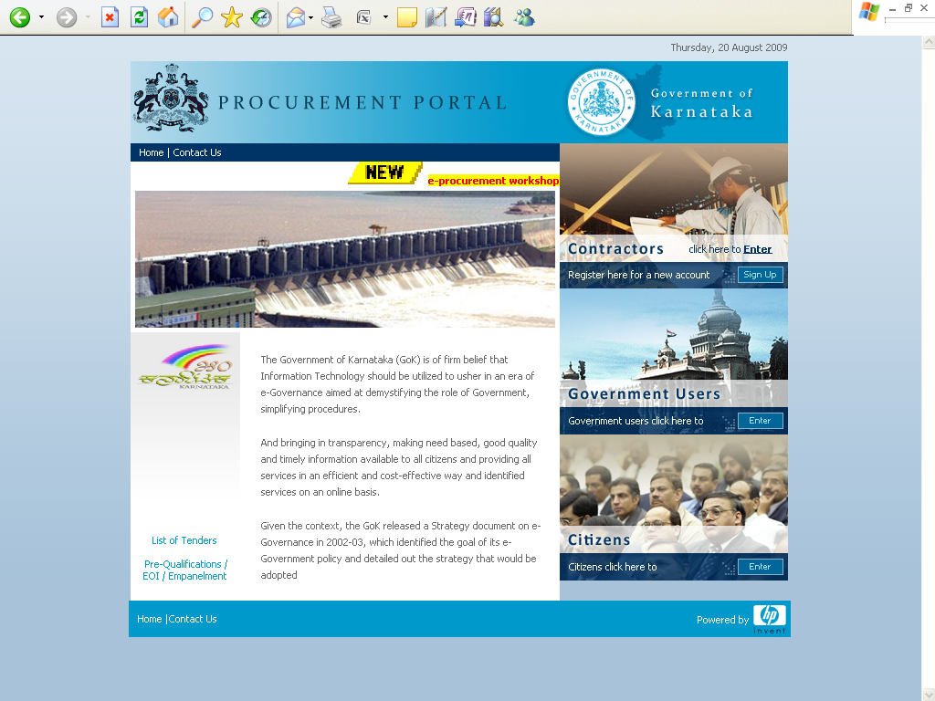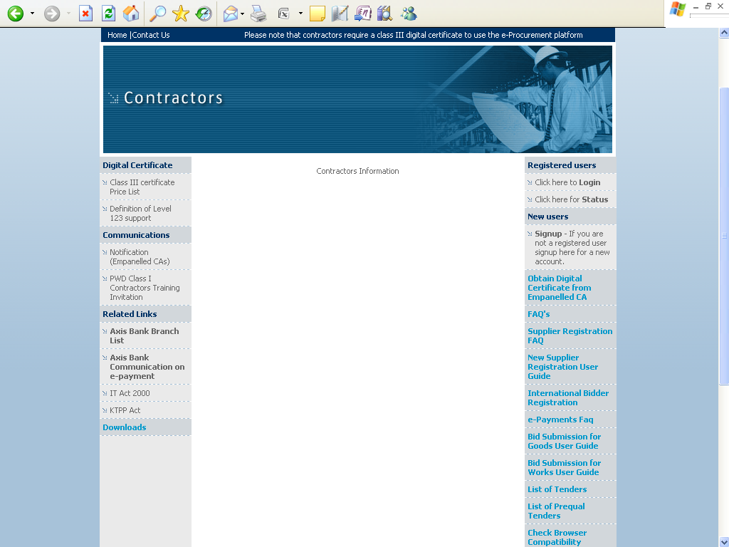

Note: In e-Procurement Portal Contractor has the option of withdrawing the Bid by digitally signing to withdraw/can cell bid before the bid submission time /Date.

e-mail: hphelpdesk.blr@rteservices.com
SUPPORTS timings : (9.00 am to 9.00 pm)
Help desk : 080-2451475
or
e-mail: hphelpdesk.blr@rteservices.com

Executive Engineer
NWKRTC, CE.Dept,
Central Office Hubballi
Copy submitted to:-

- To the Deputy Secretary, State tender Bulletin Officer, Home and Transport Department, Government of Karnataka, MS buildings Bangalore for kind information and with a request to publish this tender in the State tender bulletin.

- The Deputy Commissioner and Dist, tender Bulletin Officer Government of Karnataka, Dharwad for kind information and with a request to publish the same in the District tender bulletin.

- The P.S to Chairman, KSRTC, BMTC & N.W.K.R.T.C, N.E.K.R.T.C Central Offices.
- M/s building Bangalore, for kind information and with a request to bring to the notice of the Hon’ble Chairman.
- The P.S to the Vice Chairman and Managing Director, KSRTC, Central Offices, Bangalore and Managing Director NWKRTC, NEKRTC, BMTC Central Offices, Bangalore, Hubballi, Gulbarga for information and to bring to the kind Notice of Managing Director.
- Chief Civil Engineer/ Chief Mechanical Engineer/ Chief Law Officer/ C.A.O &FA/ Chief Security & Vigilance officer/ Chief Labour Welfare Officer/ Systems Manager/ Manager/ (HRD)/ Chief Statistical & Planning Officer NWKRTC, Central Offices, Hubballi for kind information.

Copy Fwcs to:-
- The Sr. Divisional Controller/ Divisional Controller, Belgaum, Chikkodi, Bagalkot, Haveri, Bijapur, NK/Dharwad/Gadag NWKRTC for kind information.
- The Executive Engineer, Mysore, Gulbarga, BMTC, KSRTC, NEKRTC, NWKRTC, for information.
- The Executive Engineer, P.W.D/ Zilla Panchayath Dharwad, Belgaum, Gadag, Karwar, Haveri, Dharwad, Chikkodi, Bagalkot District for kind information, with request to display the notification on the officer notice board.

Copy to:-
- The Asst. Executive Engineer, NWKRTC, CE sub divisions,
Chikkodi/Bagalkot/Hubballi/Haveri/Sirsi/Gadag/Belagum,Dharwad for information, with request
to display the notification on the officer notice board.
- Copy to the Accounts Supdt/ Cashier (Accts) NWKRTC C.E Division, Hubballi for necessary action.

Executive Engineer
NWKRTC CE Dept,
Central Office Hubballi.

