THE CHURCH OF THE
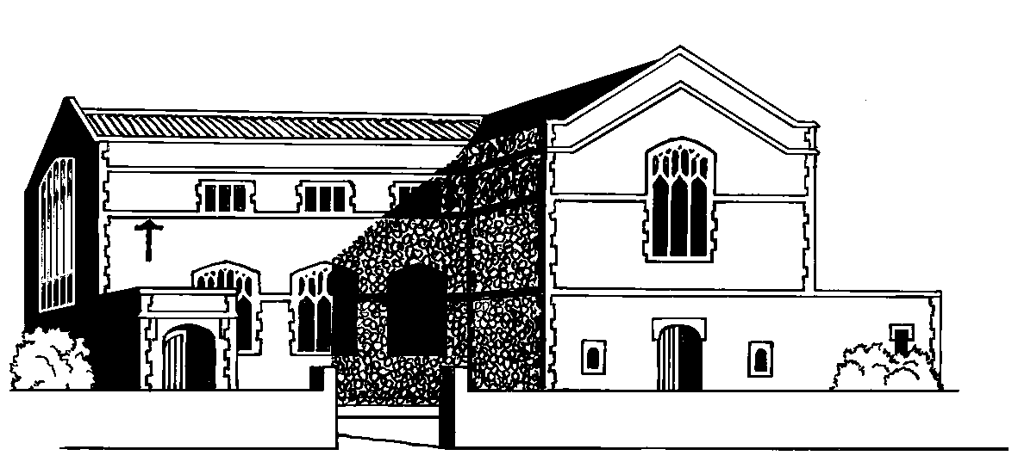

SACRED HEART OF JESUS

& SAINT JOSEPH, WARE, sg12 7ej

e.mail: ware@rcdow.org.uk Parish Priest: Fr. John Gray
website: www.sacredheartware.com Parish Deacon: Rev. Adrian Cullen
telephone: 01920 462140 Pastoral Assistant: Mary Hallett
Parish Secretary: Tracy Moloney



25th September 2016

26th Sunday in Ordinary Time

TIMES OF SERVICES & GROUP MEETINGS THIS WEEK

MONDAY  26th | 11.00 a.m.  8.00 p.m. | MASS at Carmel  Prayer Group at Leaside Hall
TUESDAY  27th | 11.00 a.m. | MASS at Carmel
WEDNESDAY  28th | 10.00 a.m.  Evening from 6.00 p.m. | MASS with Morning Prayer  Tables, Chairs & Crockery to go back into New Parish Centre – All welcome to help - PLEASE
THURSDAY  29th  Sts Michael, Gabriel & Raphael | 10.00 a.m.  6.30 p.m. - 7.30 p.m.  7.30 p.m. | MASS with Morning Prayer  First Holy Communion Introductory Meeting for children (please bring books)  Fund Raising Group Meeting
FRIDAY  30th  St Jerome | 10.30 a.m.  11.00 a.m.  12.30 p.m. | Exposition & Benediction of the Blessed Sacrament, including The Chaplet of Divine Mercy  MASS  Fr. John at Funeral at Stanstead St Margaret’s
SATURDAY  1st October  St Thérèse of the Child Jesus | 11.00 a.m. - 11.30 a.m.  12.00 noon  5:30 p.m-6.00 p.m.  6.30 p.m. | Confessions  Golden Jubilee Mass of Thanksgiving  Confessions  FIRST MASS OF SUNDAY
SUNDAY  2nd  27th Sunday in Ordinary Time | 8.30 a.m.  10.30 a.m.  3.00 p.m. | MASS  MASS  Fusion Concert in Church – All welcome – pay on the door or by ticket( see inside for more details)

Mass Book Page 143
Response to today’s Psalm
“My soul, give praise to the Lord.”

READINGS NEXT WEEK
Habakkuk 1:1, 2-3, 2:2-4, Psalm 94: 1-2, 6-9 response v 7-8,
2 Timothy 1:6-8, 13-14, Gospel Luke 17: 5-10
MONEY COUNTING TEAM NO 2 THIS WEEK

CHURCH CLEANING

This week Sharon Selfe & Ita Bevan, thank you.

CONGRATULATIONS

We offer our congratulations to Emma Faulkner and Bill Davies who were received into Full Communion in the Roman Catholic Church, Confirmed and made their First Holy Communion at the 6.30 p.m. Mass on 24th September. May they both continue to grow in the love of God.
_________________________________________________________________
interesting point. You can position the text box anywhere in the document. Use the Drawing Tools tab to change the formatting of the pull quote text box.]
CONCERT FOR THE PARISH CENTRE

There will be a concert in the Church on Sunday 2nd October
at 3.00 p.m. performed by Fusion Voices in Harmony. They are a local group who sing popular songs from the 1920’s to the present day. Come and listen to the music and enjoy tea and cakes in our new parish centre. Tickets are £6.00p for adults & £4.00p for children & concessions. Either purchase tickets after Masses this weekend or pay on the day at the door. All funds raised will go towards our parish centre. Donations of cakes would be very welcome - also volunteers are needed to serve refreshments, if you are able to help with this please speak to Mary Hallett. If you would like more information about the concert then please speak to Lynne Warrilow in the choir.
_________________________________________________________________

APF HALF YEARLY COLLECTION

Boxes for emptying should be handed in at the Presbytery please. Once the boxes have been counted they will be available for collection from the back of the Church, together with a receipt and magazine.

WALSINGHAM

The Bishops of England & Wales have approved a one-off appeal to help in the developments at the National Shrine of Our Lady at Walsingham. This is a long term project; there is much to be done. If you would like to contribute there are envelopes at the back of the Church, please take one and pop back through presbytery door.
_________________________________________________________________

Arnold & Katie Worton-Geer’s Sponsored 5km Bear Grylls Race

Arnie & Katie will be undertaking a 5km run with 20+ obstacles and 2+ Bear Grylls’ Survival Challenges. As they make their way through the Survival Zones they will encounter scenarios found in some of the world’s toughest terrains and surroundings, where they will truly experience what survival is like in the Jungle, Desert, Mountains, and Arctic.

They will be taking part on Saturday 8th October 2016 to raise funds towards the cost of our new Parish Centre. Sponsorship forms are now available at the back of the Church for anyone who would like to sponsor them.
_________________________________________________________________

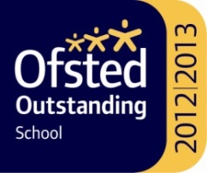
ST MARY’S CATHOLIC SCHOOL

2016 ranked one of the top 100 non-selective State Schools in England

is holding its Open Evening for prospective parents and pupils next Wednesday 28th September, 2016. The evening starts at 6.00 p.m. and ends at 8.30 p.m. The Headteacher, Mr. Celano, will be giving presentations at 6.30 p.m. and 7.30 p.m. in the Hall. All parents with children currently in Year 6 are very welcome.
_________________________________________________________________

THE GIVING MACHINE

We recently received a credit for £17.55p from ‘The Giving Machine’ in respect of commission because parishioners bought goods ‘on line’. Thank you to all who do this & put our parish as your nominated charity. If you are shopping online, did you know you can raise money for our Church at no extra cost to yourself by accessing your favourite retailer’s websites via The Giving Machine website http://www.thegivingmachine.co.uk Please be reassured, you do not need to put any credit card details into the Giving Machine website, these are only entered in the normal way on the retailer’s site for the purpose of making your actual purchase.
_____________________________________________________________

Sponsored Bike ‘n Hike

Please may we have the sponsorship money promised for the
Bike ‘n Hike as soon as possible. It can be put through the presbytery door in an envelope marked with your name and Bike ‘n Hike. Thank you _________________________________________________________________

HOW DO I BECOME A CATHOLIC?

If you would like to know more about the Catholic faith then you may be interested in joining the RCIA (Rite of Christian Initiation for Adults).

If any of the following applies to you will be very welcome:

1. Adults who wish to be baptised
2. Adults who are already baptised in another Christian denomination and who now wish to become members of the Roman Catholic Church
3. Adults who were baptised in the Catholic Church, and who might not yet have either been confirmed or made their First Holy Communion
4. Any adult who wishes to learn about the Catholic Faith
5. Any Catholic who wants to find out more or deepen their Catholic Faith

If you would like to come along or are interested in knowing more please speak to Fr. John, Deacon Adrian or Mary Hallett.
_________________________________________________________________

LW:LW Presents “Ware’s Got Talent”

Finals show at 7.00 p.m. 8th October 2016 at Chauncy School Hall.
LoveWare:LiveWare are delighted to announce the return of this free community talent show, welcoming acts of all ages and varieties. Free entry, free interval refreshments, lots of fun and masses of local talent!
Auditions will be held on 1st October 2016. Entrants must have a Ware connection (e.g. work/school/family). For full details of the audition requirements and to enter please visit http://www.lovewareliveware.org/
_________________________________________________________________

ROTA’S

If you are currently on any of our rota’s for Church cleaning, Eucharistic Minister, Readers, etc, etc, we would be grateful if you will provide the office with an email address in order for your copy to be emailed to you. If you are not on email then please contact the office so that alternative arrangements can be made to ensure you receive your copy. Thank you.
_________________________________________________________________

NEWSLETTER ITEMS NEED TO BE AT THE PRESBYTERY IN WRITING OR E-MAIL BY
9.00 AM THURSDAY WITH YOUR NAME & PHONE NO. —NEW PARISHIONERS Please take a parish membership form from the porch. The completed forms should be posted through the presbytery letterbox, thank you.

