Windows Printer Driver
User Guide
for NCR Retail Printers

B005-0000-1609
Issue E
The product described in this book is a licensed product of NCR Corporation.
NCR is a registered trademark of NCR Corporation.
It is the policy of NCR Corporation (NCR) to improve products as new technology, components, software, and firmware become available. NCR, therefore, reserves the right to change specifications without prior notice.
All features, functions, and operations described herein may not be marketed by NCR in all parts of the world. In some instances, photographs are of equipment prototypes. Therefore, before using this document, consult with your NCR representative or NCR office for information that is applicable and current.
To maintain the quality of our publications, we need your comments on the accuracy, clarity, organization, and value of this book.
Address correspondence to:
Manager, Information Products
NCR Corporation
2651 Satellite Blvd.
Duluth, GA 30096
Copyright © 2004
By NCR Corporation
Dayton, Ohio U.S.A.
All Rights Reserved

Preface
Audience
This guide is targeted to users who want to understand how NCR printer driver works in order to maximize the capabilities of the printer and print text/graphics documents successfully.
This guide is also geared toward software developers who need to create custom application to perform special printer functionalities using native printer command sequences such as barcode printing, bit-image download, bit-image printing, printer status notification, etc.
Notice: This document is NCR proprietary information and is not to be disclosed or reproduced without consent.
References
NCR 7197 Thermal Receipt Printer Owner’s Manual (B005-000-1409)
NCR 7167 Two Station-POS Printer Owner’s Manual (B005-000-1406)
NCR K590 Self Service Printer Owner’s Guide (B005-0000-1346)
NCR 7198 Thermal Receipt Printer Owner’s Guide (B005-0000-1736)
NCR 7698 Thermal Receipt Printer Owner’s Guide (B005-0000-1713)
NCR F306 FastLane Thermal Printer Owner’s Guide
NCR 7152 Self Service Printer Owner’s Manual (B005-0000-1739)
NCR 7346-F309 2ST FastLane Printer Owner’s Manual

Table of Contents
Introduction 1
Printer driver Architecture 1
Printing Mechanism in Windows 1
Printer Driver Components 3
Minidriver 4
Language Monitor 5
NCR POS Application Programming Interface 6
Installation 8
Windows 2000/XP Install Program 8
Installation Instructions 8
Windows 2000/XP Install Program (Continued) 13
Command Line Installation Instructions 13
Windows 2000/XP Driver Install Wizard 16
Installation Instructions 16
Post Installation Instructions 17
Windows 98/ME Driver Install Wizard (Driver Version 3.0 only) 18
Installation Instructions 18
Post Installation Instructions 18
Windows NT Driver Install Wizard (Driver Version 3.0 only) 19
Installation Instructions 19
Post Installation Instructions 20
SETTINGS 22
Resolution 22
Paper Sizes 23
Paper Sources 24
Paper Orientation 26
Two sided thermal Printing 27
Two Sided Thermal(2ST) Printing Modes 27
Print on both Sides 29
Knife Cut Feature 31
Changing Default Settings 33
Windows 2000/XP 33
Windows 98/ME (Version 3.0) 33
Windows NT (version 3.0) 33
Programming (NCR Language Monitor & NCRPOSAPI) 34
Commands 34
NCRPOSAPI.dll. 34
How To Use NCRPOSAPI.dll 39
Interfaces 43
NCRPOS API Exported Functions 43
DLL-Related Functions 46
Job Control Functions 48

Revision Record
Issue | Date | Remarks
A | Nov 2004 | First issue
B | Jun 2007 | Driver 4.0 release; NCRPOSAPI 4.2 release; Windows standalone install documentation
C | Jan 2008 | Addition of Knife Cut Feature
D | Feb 2008 | Addition of F307, F309, 7198 Receipt, 7198 Slip printer models.
E | May 2008 | Two Sided thermal printing feature

Introduction
This manual discusses the windows printer driver technology in order to successfully print on the following NCR Retail raster printers:
- NCR 7167 Receipt Printer
- NCR 7167 Slip Printer
- NCR 7197 Receipt Printer
- NCR K590 Self-Service Printer
- NCR F306 Self-Service Printer
- NCR 7168 Receipt 2ST Printer
- NCR 7168 Slip Printer
- NCR 7198 Receipt 2ST Printer
- NCR 7198 Slip Printer
- NCR F307 Self-Service Printer
- NCR F309 Self-Service Printer

Printer driver Architecture

Printing Mechanism in Windows
If an application uses a printer in Windows, it starts a complex interaction with the GDI16 / GDI32 library module, the printer device driver library module (which has a .DRV/.dll extension) and the Windows print spooler.
The following figure explains how the printing mechanism is being implemented in Windows platform.
Figure 1. Printing Mechanism in Windows
When the application wants printing to begin using a printer, it first obtains a handle to the printer device context using CreateDC or PrintDlg. This causes the printer device driver library module to be loaded into memory and to initialize itself. The program then calls the StartDoc function, which signals the beginning of a new document. The StartDoc function is handled by the GDI module. The GDI module calls the Control function in the printer device driver, telling the device driver to prepare for printing.
The call to StartDoc begins the process of printing a document; the process ends when the program calls EndDoc. These two calls act as bookends for the normal GDI functions that display text or graphics to the document pages. Each page is itself delimited by a call to StartPage to begin a page and EndPage to end the page. For example, if a program wants to draw an ellipse on the page, it first calls StartDoc to begin the print job, then StartPage to signal a new page. It then calls Ellipse, just as it does when drawing an ellipse on the screen. When the application program is finished, the program then calls EndPage.

Printer Driver Components
A Windows Raster printer driver consists of the following components:
- The printer graphics driver DLL implements the DDI to the degree necessary to support printer rendering features and capabilities that cannot be adequately handled by the graphics engine.
- The printer interface driver DLL creates an interface that allows users to set the physical properties of the printer and the logical properties of the document. This interface is also responsible for interacting with the Common Property Sheet User Interface to provide device- and document-specific property sheet page(s) in response to an application request.
- An optional print processor that helps the spooler process to despool print jobs.
- An optional language monitor to enable spooler to communicate with the bi-directional printer
- An optional port monitor that sends printer-ready data to hardware port drivers.
To help vendors provide printing solutions to customers, Microsoft provides a standard printer driver for non-Postscript printers called Universal Printer Driver (Unidrv). Instead of creating full-blown drivers, printer vendors only need to provide minidrivers to support new printers.
In Windows 95/98/Me, system-supplied UNIDRV.DLL is the printer graphics and interface driver DLL.
In Windows NT 4.0, system-supplied RASDD.DLL and RASDDUI.DLL are the printer graphics driver DLL and printer interface DLL respectively.
In Windows 2000/XP, system-supplied UNIDRV.DLL and UNIDRVUI.DLL are the printer graphics driver DLL and printer interface DLL respectively.

Minidriver
A printer minidriver is data file that provides device-driver support for a particular class of printers. A printer minidriver contains a collection of data structures referred to as the printer's data table. A data table contains data such as the printer's resolution, color capabilities, metrics for device fonts, and the strings that correspond to various printer commands. It also specifies printer model-specific aspects of how primitive bitmap and text operations are to be performed.
NCR provides minidrivers to allow Unidrv to support NCR POS printers.

Language Monitor
NCR printer drivers also include a language monitor based on ESC/P POS language to provide a full-duplex communication channel between the print spooler and the NCR printers.
This Language Monitor will be able to handle the following errors/status in the printer:
- Printer is busy at the RS-232C Interface
- Receipt paper door or Slip Cassette door is open
- Paper Feed button is pressed
- Printing stopped due to paper condition
- Slip motor jam (Only for 7167 Slip)
- Knife error occurred
- Thermal print head temperature and power supply voltage are out of range
- Paper low (if paper low sensor enabled)
- Receipt Paper exhausted
- Unrecoverable error
- Slip paper exhausted (Only for 7167 Slip)
- Presenter Mechanism Error (Only for K590)
- Paper jam status (Only for K590)
- Printer door status (Only for K590)
- Black Mark Detection Failure (Only for K590)
- Printer Head Failure (Only for K590)
- Slip Leading Edge Sensor Error (Only for 7167 Slip)
- Slip Trailing Edge Sensor Error (Only for 7167 Slip)
- Presenter Paper Dectecter Paper Status (Only for K590)
- Printer Reset Status (Only for K590)

NCR POS Application Programming Interface
Aside from printing normal text/graphics documents, NCR printers are capable of reporting printer status and performing special printer functionalities using native printer command sequences such as barcode printing, Bitimage download and printing, etc. To take advantage of these functionalities, NCR provides NCRPOS API dll which application developers can exploit. This DLL will be part of the NCR POS printer driver installation package. It is copied during installation to the System directory of the OS.
NCR POS API DLL exports the following functions:
- NCRPOS_WritePrinter()
- NCRPOS_ReadPrinter()
- NCRPOS_PrinterStatus()
The application developers will load this DLL using LoadLibrary function call during run-time. After the DLL is loaded into the virtual memory address of the calling process, the application will call GetProcAddress function to get the addresses of the above mentioned exported. The application will then call these exported DLL functions using the function pointers returned by GetProcAddress.
Figure 2. Architecture of Interfacing the DLL with an application module
When using the NCRPOSAPI.DLL/NCRAPI.DLL from the application (provided with the package) for querying printer status, the user may get a time-out message. In such cases, the user is requested to wait for some time before querying the printer status again.

Installation
Before installing the NCR drivers, close all applications and TSR (Terminate and Stay Resident) programs that load at startup (in Windows or DOS) such as virus checkers, fax utilities, etc., and all other applications that may be open. Also close all shell utilities such as: Microsoft Office Manager, Norton Desktop, etc.

Windows 2000/XP Install Program

Installation Instructions
- From the Start bar, select Run then type in or browse to the NCR POS Printer Driver. msi/exe file.
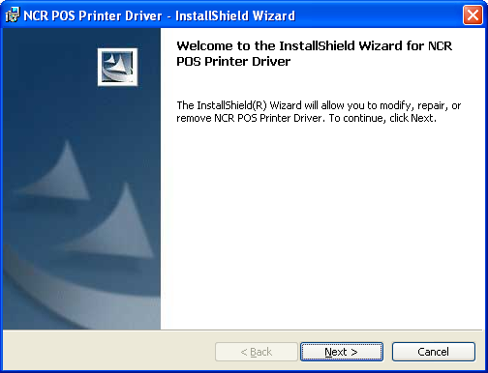
- Click Next then select the printer(s) to be installed.
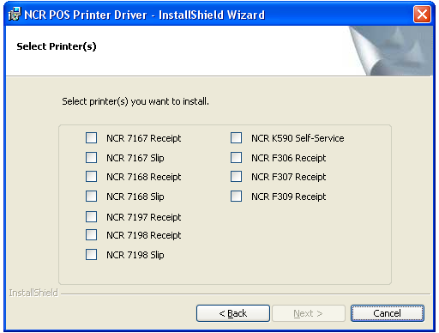
- Click Next, then select the printer port. NCR Printers only support serial connections or USB connections through a serial emulation driver.
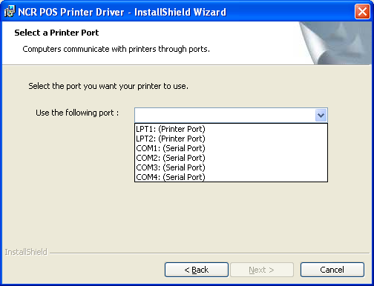
- To begin the file copy of the install, click on Continue Anyway.
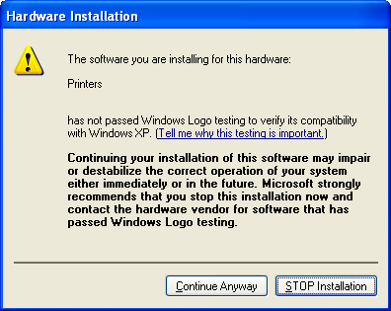
- Once all files have been copied or updated, click Finish to complete the install.
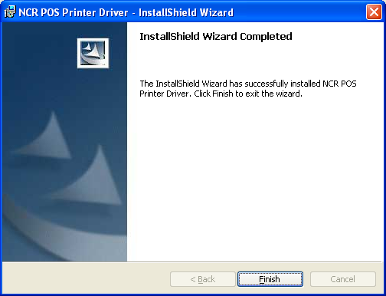
- To view the printer(s) added, click START, Printers and Faxes. Within Printers and Faxes click refresh to update the view of all printers installed.
4.1 Windows Install Script (NCR POS PRINTER DRIVER.MSI or .EXE) Installation Instructions:
Execute the Windows Install Script .MSI or .EXE file. If a NCR Windows printer driver is currently installed, this install script shall first uninstall the current driver before installing the new driver.

Windows 2000/XP Install Program (Continued)

Command Line Installation Instructions
- Run from Start bar, select Run or Command Prompt window.
Click Start, Run then type in or browse to the NCR POS Printer Driver. msi/exe file.
Printing preferences shall be lost because current driver must be un-installed before installing the new driver.
Command lines should have NO SPACES within or between parameters except for file names that have spaces.
All properties are case sensitive (must be in uppercase).
- Printer Model Properties Options:
INSTALL_K590 = "T" or "t"
"T" or "t" : Installs the NCR K590 Self-Service.
Example:
Msiexec /I "c:\NCR POS Priner Driver.msi" INSTALL_K590="T" PRINTER_PORT="COM1:" /qb

INSTALL_F306="T" or "t"
"T" or "t" : Installs the NCR F306 Receipt

INSTALL_7197="T" or "t"
"T" or "t" : Installs the NCR 7197 Receipt

INSTALL_7167R="T" or "t"
"T" or "t" : Installs the NCR 7167 Receipt

INSTALL_7167S="T" or "t"
"T" or "t" : Installs the NCR 7167 Slip

INSTALL_7168R="T" or "t"
"T" or "t" : Installs the NCR 7168 Receipt

INSTALL_7168S="T" or "t"
"T" or "t" : Installs the NCR 7168 Slip

INSTALL_7198R="T" or "t"
"T" or "t" : Installs the NCR 7198 Receipt

INSTALL_7198S="T" or "t"
"T" or "t" : Installs the NCR 7198 Slip

INSTALL_F307="T" or "t"
"T" or "t" : Installs the NCR F307 Receipt

INSTALL_F309="T" or "t"
"T" or "t" : Installs the NCR F309 Receipt

- Printer Port Property Options:
PRINTER_PORT="LPT1:"
Example:
Msiexec /I "c:\NCR POS Printer Driver.msi" INSTALL_K590="T" PRINTER_PORT="COM1:" /qb
"LPT1:" : Installs the LPT1 or the Parallel Port 1
"LPT2:" : Installs the LPT2 or the Parallel Port 2
"COM1:" : Installs the COM1 or the Serial Port 1
"COM2:" : Installs the COM2 or the Serial Port 2
"COM3:" : Installs the COM3 or the Serial Port 3
"COM4:" : Installs the COM4 or the Serial Port 4

Syntax:
Msiexec /I [.msi package] [printer model property] [printer port property]

Msiexec /I "c:\NCR POS Priner Driver.msi" INSTALL_7168R = "T" PRINTER_PORT = "COM2:" /qb

Windows 2000/XP Driver Install Wizard

Installation Instructions
- From the Start bar, select Settings then Printers.
- From the Printers window, double click the Add Printer icon.
- In the "Add Printer Wizard" dialog box, press Next.
- To install a local printer, click the check box for a "Local printer" and within that "Automatically detect and install my Plug and Play printer" box should be unchecked and then press Next.
- Select the Printer Port and press Next. Note: This driver supports only COM ports. Ensure that when you select a port for this driver, it should be physically present in the host system.
- For a new model of printer, press Have Disk.
- Enter, or use the browser, the path of directory of this package.
- The Oemsetup.inf file should appear, then press Open.
- Press OK for the directory you have chosen.
- Select the model of your printer, then press Next.
- If you have installed the NCR driver for this printer before, select either Keep or Replace the existing driver, then press Next.
- Enter the name of your printer (usually the name which comes in the field should be kept), then press Next.
- Indicate whether the printer will be shared, then press Next.
- Indicate whether to print a test page at this moment, and then press Finish to complete the installation.

Post Installation Instructions
- Please ensure that system Baud Rate of the COM port is same as that of the printer. The Baud Rate supported by the driver for the printers are as follows:
NCR K590 Self-Service : 9600, 19200, 38400, 57600, 115200
NCR 7197 Receipt : 9600, 19200, 38400, 57600, 115200
NCR 7167 Receipt : 9600, 19200, 38400, 57600, 115200
NCR 7167 Slip : 9600, 19200, 38400, 57600, 115200
In addition these NCR printers are shipped with DSR/DTR "Flow Control" handshaking enabled. By default to match this handshaking, ensure that the "Flow control" in COM port settings is set to "Hardware". If you have modified the printer's default setting, then set the handshaking to the setting you have chosen.
Right click on the printer object and go to "Properties". In the Ports tab of Properties page press the Configure Port button and set "Bits per second", "Data bits", "Parity", "Stop bits" and "Flow Control".
- In the Ports tab of Properties page, "Enable bidirectional support" box should be checked and "Enable printer pooling" box should be unchecked.
- In the Advanced tab of Properties page, "Spool print documents so program finishes printing faster" should be enabled and within that "Start printing immediately" should be checked. "Print spooled documents first" and "Enable advanced printing features" should be checked. "Hold mismatched document" and "Keep printed documents" should be unchecked.

Windows 98/ME Driver Install Wizard (Driver Version 3.0 only)

Installation Instructions
- From the Start bar, select Settings then Printers.
- From the Printers window, double click the Add Printer icon.
- Select the Local Printer option from this dialog and then press Next.
- Press Have Disk to browse the path of directory of this package. The OEMSETUP.INF file should appear, and then press open.
- Select the model of your printer, then press Next.
- Select the Printer Port and press Next. Note: This driver supports only COM ports. Ensure that when you select a port for this driver, it should be physically present in the host system.
- Click on Configure Port button. Select "Bits per second" (Baud Rate), "Flow control" as supported by the printer and then press OK.
- If you have installed the NCR driver for this printer before, select either Keep or Replace the existing driver, then press Next.
- Enter the name of your printer (usually the name which comes in the field should be kept), then press Next.
- Indicate whether to print a test page at this moment, and then press Finish to complete the installation.

Post Installation Instructions
- Please ensure that system Baud Rate of the COM port is same as that of the printer. The Baud Rate supported by the driver for the printers are as follows:
NCR K590 Self-Service : 9600, 19200, 38400, 57600, 115200
NCR 7197 Receipt : 9600, 19200, 38400, 57600, 115200
NCR 7167 Receipt : 9600, 19200, 38400, 57600, 115200
NCR 7167 Slip : 9600, 19200, 38400, 57600, 115200
In addition these NCR printers are shipped with DSR/DTR "Flow Control" handshaking enabled. By default to match this handshaking, ensure that the "Flow control" in COM port settings is set to "Hardware". If you have modified the printer's default setting, then set the handshaking to the setting you have chosen.
Right click on the printer object and go to "Properties". In the Ports tab of Properties page press the Configure Port button and set "Bits per second", "Data bits", "Parity", "Stop bits" and "Flow Control".
- In the General Tab of Properties page, the "Separator page" should be "(none)". This option is used to identify a document among others in the printer. "Comment" should be blank.
- In the Spool Setting dialog within Details tab, "Spool print jobs so program finishes printing faster", "Start printing after first page is spooled" and "Enable bi-directional support for this printer" should be checked. Default spool data format is "EMF".

Windows NT Driver Install Wizard (Driver Version 3.0 only)

Installation Instructions
- From the Start bar, select Settings then Printers.
- From the Printers window, double click the Add Printer icon.
- Select "My Computer" then press Next.
- Click the check box for a port the printer will be using.
- Click on Configure Port button. Select the Port, click on settings. Select Baud Rate, Flow control as supported by the printer.
- Select the Local Printer option from this dialog and then press Next.
- Press Have Disk to browse the path of directory of this package. The OEMSETUP.INF file should appear, and then press open.
- Select the model of your printer, then press Next.
- If you have installed the NCR driver for this printer before, select either Keep or Replace the existing driver, then press Next.
- Enter the name of your printer (usually the name which comes in the field should be kept), then press Next.
- Indicate whether the printer will be shared, then press Next.
- Indicate whether to print a test page at this moment, and then press Finish to complete the installation.

Post Installation Instructions
- Please ensure that system Baud Rate of the COM port is same as that of the printer. The Baud Rate supported by the driver for the printers are as follows:
NCR K590 Self-Service : 9600, 19200, 38400, 57600, 115200
NCR 7197 Receipt : 9600, 19200, 38400, 57600, 115200
NCR 7167 Receipt : 9600, 19200, 38400, 57600, 115200
NCR 7167 Slip : 9600, 19200, 38400, 57600, 115200
In addition these NCR printers are shipped with DSR/DTR "Flow Control" handshaking enabled. By default to match this handshaking, ensure that the "Flow control" in COM port settings is set to "Hardware". If you have modified the printer's default setting, then set the handshaking to the setting you have chosen.
Right click on the printer object and go to "Properties". In the Ports tab of Properties page press the Configure Port button and set "Bits per second", "Data bits", "Parity", "Stop bits" and "Flow Control".
- In the General Tab of Properties page, the "Separator page" should be empty. This option is used to identify a document among others in the printer.
- In the Ports tab of Properties page, "Enable bidirectional support" box should be checked and "Enable printer pooling" box should be
- In the scheduling tab of Properties page, "spool print documents so program finishes printing faster" should be enabled. "Hold mismatched document", "Print spooled document first" and "Keep documents after they have printed" should be disabled.
For USB connection the printer is only supported through a Virtual COM port using the I/O Networks Virtual COM to USB drivers. See the USB section of the Owner's Guide for the specific printer you are using. These Owner's Guides are listed in the references section.

SETTINGS

Resolution
This printer driver supports various print resolutions.
The following table describes the printer wise breakup of supported resolutions:
Printer | Supported Resolution | Displayed Resolution
NCR K590 Self-Service  NCR F306 Self-Service  NCR F307 Self-Service  NCR F309 Self-Service | 203 dpi x 68 dpi  203 dpi x 203 dpi  203 dpi x 203 dpi  203 dpi x 203 dpi | 203 x 68 dots per inch  203 x 203 dots per inch  203 x 203 dots per inch  203 x 203 dots per inch
NCR 7197 Receipt | 203 dpi x 68 dpi  203 dpi x 203 dpi | 203 x 68 dots per inch  203 x 203 dots per inch
NCR 7167 Receipt  NCR 7168 Receipt  NCR 7198 Receipt | 203 dpi x 68 dpi  203 dpi x 203 dpi | 203 x 68 dots per inch  203 x 203 dots per inch
NCR 7167 Slip  NCR 7168 Slip  NCR 7198 Slip | 70 dpi x 72 dpi  140 dpi x 72 dpi | 70 x 72 dots per inch  140 x 72 dots per inch
For K590, 7167, 7197 and 7198 Receipt printers, the default resolution is set to 203 x 203 dpi.
For 7167 and 7198 Slip printer, the default resolution is set to 140 x 72 dpi.

Paper Sizes
This printer driver supports various paper sizes. The following table describes the printer wise breakup of supported paper sizes:
Printer | Supported Paper Sizes
NCR K590 Self-Service | 80 mm x 111 mm Black Mark
NCR K590 Self-Service | 80 mm x 127 mm Black Mark
NCR K590 Self-Service | 80 mm x 140 mm Black Mark
NCR K590 Self-Service | 80 mm x 152 mm Black Mark
NCR K590 Self-Service | 80 mm x 75 mm TO 80 mm x 600 mm
NCR K590 Self-Service | 82.5 mm x 111 mm Black Mark
NCR K590 Self-Service | 82.5 mm x 127 mm Black Mark
NCR K590 Self-Service | 82.5 mm x 140 mm Black Mark
NCR K590 Self-Service | 82.5 mm x 152 mm Black Mark
NCR K590 Self-Service | 82.5 mm x 75 mm TO 82.5 mm x 600 mm
NCR K590 Self-Service | 114 mm x 111 mm Black Mark
NCR K590 Self-Service | 114 mm x 127 mm Black Mark
NCR K590 Self-Service | 114 mm x 140 mm Black Mark
NCR K590 Self-Service | 114 mm x 152 mm Black Mark
NCR K590 Self-Service | 114 mm x 75 mm TO 114 mm x 600 mm
NCR 7197 Receipt | 80 mm
NCR 7197 Receipt | 58 mm
NCR 7167 Receipt  NCR 7168 Receipt  NCR 7198 Receipt | 80 mm
NCR 7167 Receipt  NCR 7168 Receipt  NCR 7198 Receipt | 58 mm
NCR F307 Self-Service  NCR F309 Self-Service | 80 mm
NCR F307 Self-Service  NCR F309 Self-Service | 58 mm
NCR F306 Self-Service | 80 mm
NCR 7167 Slip  NCR 7168 Slip  NCR 7198 Slip | 82.2 mm
For 7167, 7197 and 7198 Receipt printers, the default paper size is 80mm.
For K509 Self-Service printer, the default paper size is 80mm x 75mm TO 80mm x 600mm.

Paper Sources
This driver provides the following paper source for POS Printer.
Printer | Supported Paper Source
NCR K590 Self-Service | Receipt
NCR 7197 Receipt | Receipt
NCR 7167 Receipt | Receipt
NCR 7167 Slip | Slip
NCR 7168 Receipt | Receipt
NCR 7168 Slip | Slip
NCR F306 Self-Service | Receipt
NCR F307 Self-Service | Receipt
NCR F309 Self-Service | Receipt
NCR 7198 Receipt | Receipt
NCR 7198 Slip | Slip

Paper Orientation
This printer driver supports the following paper orientation
- Portrait
- Landscape
The default paper orientation is set to Portrait.
The 7168 printer supports two sided printing as an option shown below.
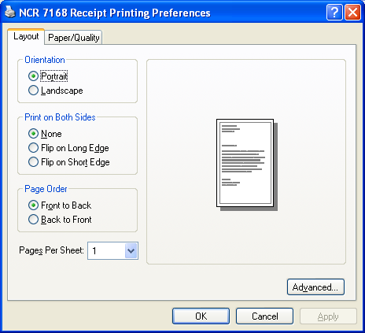
Clicking on the Advanced button would show the window below for the 7168 printer. The Two-Sided Thermal printing modes are shown in a dropdown list.

Two sided thermal Printing
The printer driver supports the printing on both sides of a sheet of paper for 7168, 7198 and F309 Printer.

Two Sided Thermal(2ST) Printing Modes:
The printer driver supports five types of modes for printing on two sided thermal paper.
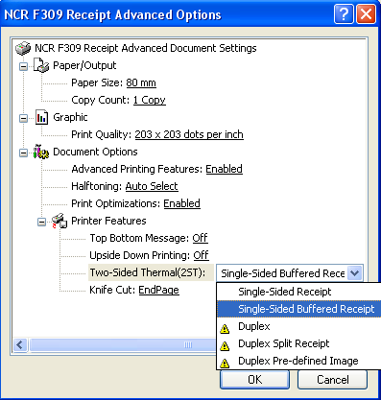
Single-sided Receipt:
In this mode printer prints the data on front side of paper, as soon as it receives the data from application. This is the usual printing mode just like other printers.
Single-sided Buffered Receipt:
In this mode printer buffers the data until a paper cut command and then it prints the data at once on front side of the paper.
Duplex
In this mode the printer receives the data until paper cut command and then it prints the data on both sides of paper, where data on odd page number is printed on front side of paper and data on even page number is printed on back side of the paper.
Duplex Split Receipt
In this mode the printer receives single sided data until a paper cut command is received. The print data is then automatically divided into two parts where the first part is printed on the front side and the second part is printed on back of the receipt when knife cut command is send to the printer.
Duplex Pre-defined Image
This option will allow the automatic printing of predefined data on back of the receipt. The pre-defined data is preloaded into the printer and when the receipt is printed the predefined data is automatically printed on the back of the receipt.
Print on both Sides :

In order to select one sided or two sided printing, on the Layout tab, under Print on Both Sides, click one of the following options:
• None to print just on front side of paper.
• Flip on Long Edge to print on both sides of the paper with pages that are bound on the left edge.
• Flip on Short Edge to print on both sides of the paper with pages that are bound on the top edge
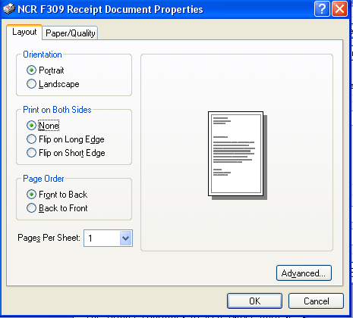
In order to select any single sided options of thermal printing mode like Single-sided Receipt or Single-sided Buffered Receipt, the Print on Both Sides option must be selected as None in the window above.

In order to select any two sided options of thermal printing modes like Duplex/ Duplex Split Receipt/Duplex Pre-defined Image, the Print on Both Sides options other than None must be selected in the window above.
Note:
While printing the document with two sided thermal option as Duplex, the top margin on back side of paper is the default margin of physical printer device for back side printing and it is not adjustable.

Knife Cut Feature

This printer driver supports knife cut feature. With the knife cut feature, printer becomes capable of cutting the page after printing. The cutting of page takes place as per the selected options shown below.

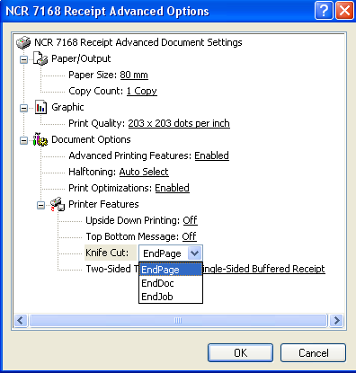
End page option cuts the paper upon reaching the end of every page of the document.
EndDoc option cuts the paper upon reaching the end of the document.
EndJob option cuts the paper upon reaching the end of the job.
The default Knife Cut option is set to End Page.
Note: The K-590 printer configured with EndDoc or EndJob knife cut option, supports maximum document limit of 610 mm.

Changing Default Settings
To view and modify the default settings of your printer, perform the following steps:

Windows 2000/XP
- Select an installed printer from Printers folder.
- Right click on the printer icon and select ‘Printing Preferences’.
- Select Layout tab to change paper orientation.
- Select Paper/Quality tab to change paper source.
- Press the Advanced button to change resolution and paper size settings.

Windows 98/ME (Version 3.0)
- Select an installed printer from Printers folder.
- Right click on the printer icon and select ‘Properties’.
- Select Paper tab to change paper size, orientation and paper source settings.
- Select Graphics tab to change resolution setting.

Windows NT (version 3.0)
- Select the installed printer from Printers folder.
- Right click on the printer icon and select ‘Document Defaults’.
- Select Advanced tab to change paper size, orientation and resolution settings.

Programming (NCR Language Monitor & NCRPOSAPI)

Commands
The different features and functions provided by the printer are controlled by sending commands from the host computer to the printer. The printer commands are made up of one or more bytes of data starting with a command control code followed by its supporting parameters. For in-depth information regarding the available commands supported by your printer, see references.
To be able to send commands to and read status from the printer, use the functions exported by

NCRPOSAPI.dll.
Application Information & Error Notification
Language monitor generates an event to notify about the error message to user mode applications. This mechanism is explained below.
Language monitor registers a message called “NCRRSD_WIN32_GDI_ERROR” using RegisterWindowMessage( ) API. RegisterWindowMessage API generates a system wide unique message identifier for “NCRRSD_WIN32_GDI_ERROR” and guarantees that it does not conflict with any existing or future messages. An application that wants to receive this message has to call RegisterWindowMessage(“NCRRSD_WIN32_GDI_ERROR”) from with in the application. Once an application calls RegisterWindowMessage() API, it can handle this message in it’s message handling routine.
Language monitor declares 32-bit error macros for NCR printer statuses to uniquely identify each printer status using this 32-bit macro. A list of these macros along with NCR printer statuses is shown in table below.
Sr. No. | NCR printer status | 32-bit error code used by Language Monitor
Sr. No. | NCR printer status | Macro | 32-bit value
1. | RS232C interface busy | PTRSTAT_RS232_EMPTY | 0x00002000
2. | Cover or Door open | PTRSTAT_COVER_OPEN | 0x00000001
3. | Paper feed button is pressed | PTRSTAT_PAPERFEED_PRESSED | 0x00000020
4. | Slip motor fault | PTRSTAT_MOTOR_FAULT | 0x00000200
5. | Knife error | PTRSTAT_KNIFE_FAULT | 0x00000400
6. | General fault | PTRSTAT_FAULT | 0x00000800
7. | Unrecoverable error | PTRSTAT_FAILURE | 0x00001000
8. | Printhead temp. or Voltage out of range | PTRSTAT_AUTORECOVER_FAULT | 0x00000100
9. | Receipt low | PTRSTAT_REC_NEAREND | 0x00000004
10. | Receipt empty | PTRSTAT_REC_EMTPY | 0x00000002
11. | Paper condition error | PTRSTAT_PAPER_CONDITION | 0x00000080
12. | Slip leading edge sensor no paper | PTRSTAT_SLP_LEAD_NO_PAPER | 0x00000008
13. | Slip trailing edge sensor no paper | PTRSTAT_SLP_TRAIL_NO_PAPER | 0x00000010
14. | Slip empty | PTRSTAT_SLP_EMPTY | 0x00000040
15. | Presenter mechanism error | PTRSTAT_PRESENTER_ERR | 0x00010000
16. | Presenter paper jam | PTRSTAT_PAPER_JAM | 0x00020000
17. | Presenter door open | PTRSTAT_CDS_OPEN | 0x00040000
18. | Black mark detection failed | PTRSTAT_BMD_FAILURE | 0x00080000
19. | Printhead damaged | PTRSTAT_HEAD_FAILURE | 0x00100000
20. | Presenter Paper Detector Paper status | PTRSTAT_PRSNT_PDP_STATUS | 0x00200000
21. | Printer Reset status | PTRSTAT_PRINTER_RESET | 0x00400000
22. | Time Out | PTRSTAT_TIMEOUT | 0x00800000
Below is a standard Win32 application code showing how to obtain NCR error message. An action of popping up a MessageBox is shown in this code. Such an action is not the recommended way of handling errors. It is only shown for demonstration purposes. It is recommended that the application prompt the user to take the appropriate action to recover from the error, and then attempt to continue printing, or reprint depending on the situation.
/* main.c
*/

#include <windows.h>

/* define error constants */

#define PTRSTAT_COVER_OPEN 0x00000001 // Cover or door open.
#define PTRSTAT_REC_EMPTY 0x00000002 // Receipt out.
#define PTRSTAT_PAPERFEED_PRESSED 0x00000020 // paper feed button pressed

/* other error constants */

const char g_szClassName[] = "myWindowClass";

UINT NCRMsgID = 0;

/* The Window Procedure */
LRESULT CALLBACK WndProc(HWND hwnd, UINT msg, WPARAM wParam, LPARAM lParam)
{
if (msg == NCRMsgID)
{
if (wParam & PTRSTAT_COVER_OPEN)
MessageBox(hwnd, "Cover Open", "Error", MB_OK);

if (wParam & PTRSTAT_REC_EMPTY)
MessageBox(hwnd, "Out of Paper", "Error", MB_OK);

if (wParam & PTRSTAT_PAPERFEED_PRESSED)
MessageBox(hwnd, "Paper feed button is pressed.", "Error", MB_OK);

/* process other errors here */
}

switch(msg)
{
case WM_CLOSE:
DestroyWindow(hwnd);
break;
case WM_DESTROY:
PostQuitMessage(0);
break;
default:
return DefWindowProc(hwnd, msg, wParam, lParam);
}
return 0;
}

int WINAPI WinMain(HINSTANCE hInstance, HINSTANCE hPrevInstance, LPSTR lpCmdLine, int nCmdShow)
{
WNDCLASSEX wc;
HWND hwnd;
MSG Msg;

/* Registering the Window Class */
wc.cbSize = sizeof(WNDCLASSEX);
wc.style = 0;
wc.lpfnWndProc = WndProc;
wc.cbClsExtra = 0;
wc.cbWndExtra = 0;
wc.hInstance = hInstance;
wc.hIcon = LoadIcon(NULL, IDI_APPLICATION);
wc.hCursor = LoadCursor(NULL, IDC_ARROW);
wc.hbrBackground = (HBRUSH)(COLOR_WINDOW+1);
wc.lpszMenuName = NULL;
wc.lpszClassName = g_szClassName;
wc.hIconSm = LoadIcon(NULL, IDI_APPLICATION);

if(!RegisterClassEx(&wc))
{
MessageBox(NULL, "Window Registration Failed!", "Error!", MB_ICONEXCLAMATION | MB_OK);
return 0;
}

// Creating the Window
Hwnd = CreateWindowEx(WS_EX_CLIENTEDGE, g_szClassName,
"Test Application", WS_OVERLAPPEDWINDOW,
CW_USEDEFAULT, CW_USEDEFAULT, 240, 120,
NULL, NULL, hInstance, NULL);

if(hwnd == NULL)
{
MessageBox(NULL, "Window Creation Failed!", "Error!", MB_ICONEXCLAMATION | MB_OK);
return 0;
}

ShowWindow(hwnd, nCmdShow);
UpdateWindow(hwnd);

/* register so we can be notified about NCR error messages */
NCRMsgID = RegisterWindowMessage("NCRRSD_WIN32_GDI_ERROR");

/* The Message Loop */
while(GetMessage(&Msg, NULL, 0, 0) > 0)
{
TranslateMessage(&Msg);
DispatchMessage(&Msg);
}

return Msg.wParam;
}

How To Use NCRPOSAPI.dll
The pseudo-code to access the NCRPOS API DLL’s exported functions from an application using run-time dynamic linking is given below:
Library_handle = LoadLibrary ( DLL_Path \ DLL_name) // The LoadLibrary function maps the
// specified executable module into the
// address space of the calling process
If ( Library_handle == NULL )
{
Message( Failed to obtain DLL handle)
Exit
}

Function_handle = GetProcAddress( Function_name ) // The GetProcAddress function
// retrieves the address of an
// exported function from the
// specified dynamic-link library
// (DLL)
NCRMessage = 0
If ( Function_handle == NULL)
Message ( GetProcAddress Failed )
else
Function_handle ( Printer_name, NCRMessage) // Call the function using the
// function pointer and providing pointer
// to message value to be returned.
.
.
.
.
FreeLibrary(Library_handle) // Loaded dll will be freed from the
// process address space

Below is a sample code to demonstrate how to communicate with a printer using NCRPOSAPI.dll. The code specifically sets up a print bar code command sequences and writes it to the printer.
/* main.c
*/

#include windows.h

int WINAPI WinMain(HINSTANCE hInstance, HINSTANCE hPrevInstance, LPSTR lpCmdLine, int nCmdShow)
{
HINSTANCE hLibrary;
FARPROC hFunction = NULL;
char PrinterName[] = "NCR 7167 Receipt"; /* or NCR K590 Self-Service or /
/NCR 7197 Receipt or NCR 7167 Slip */
HANDLE hPrinter;
DOC_INFO_1 pDocInfo;
DWORD pcWritten;
char pBarCode[16];

/***** Loads the NCRPOSAPI.DLL****/

hLibrary =LoadLibrary("NCRPOSAPI.DLL");
if(hLibrary == NULL)
{
MessageBox(NULL,"NCRAPI.DLL cannot be loaded","Error",MB_ICONERROR);
return 1;
}

/***** Retrieves the NCRPOS_WritePrinter() function handle ****/

hFunction = GetProcAddress(hLibrary,"NCRPOS_WritePrinter");
if(hFunction == NULL)
{
MessageBox(NULL,"NCRPOS_WritePrinter function failed","Error",MB_ICONERROR);
return 1;
}

/***** Retrieves the Printer handle ****/

if(!OpenPrinter(PrinterName,&hPrinter, NULL))
{
MessageBox(NULL,"Error Opening Printer","Error",MB_ICONERROR);
return 1;
}

pDocInfo.pDocName ="Bar Code";
pDocInfo.pDatatype = NULL;
pDocInfo.pOutputFile = NULL;

StartDocPrinter(hPrinter, 1, (LPBYTE)&pDocInfo);
StartPagePrinter(hPrinter);

/***** Setup UPC-A bar code command ****/

pBarCode[0] = 0x1D;
pBarCode[1] = 0x6B;
pBarCode[2] = 0x00; /* UPC-A bar code type */

/***** numeric data ****/
pBarCode[3] = '0';
pBarCode[4] = '1';
pBarCode[5] = '2';
pBarCode[6] = '3';
pBarCode[7] = '4';
pBarCode[8] = '5';
pBarCode[9] = '6';
pBarCode[10] = '7';
pBarCode[11] = '8';
pBarCode[12] = '9';
pBarCode[13] = '0';

pBarCode[14] = '5'; /* check digit */
pBarCode[15] = 0; /* end of command */

/******** NCRPOS_WriterPrinter() function call **********/
if(!hFunction( hPrinter, pBarCode, 16, &pcWritten))
{
MessageBox(NULL,"Error in Writing to the Printer","Error",MB_ICONERROR);
return 1;
}
else
MessageBox(NULL,"Command successfully Written to the Printer","Success",MB_OK);

EndPagePrinter(hPrinter);
EndDocPrinter(hPrinter);
ClosePrinter(hPrinter);
FreeLibrary(hLibrary);

return 0;
}

Interfaces

NCRPOS API Exported Functions

BOOL NCRPOS_WritePrinter(HANDLE hPrinter, LPVOID pBuf, DWORD cbBuf, LPDWORD pcWritten )
Notifies the print spooler that data should be written to the specified printer.
Parameters:
hPrinter - [in] Handle to the printer. Use the OpenPrinter function to retrieve a printer handle.

pBuf - [in] Pointer to an array of bytes that contains the data that should be written to the printer.

cbBuf - [in] Specifies the size, in bytes, of the array.

pcWritten - [out] Pointer to a value that receives the number of bytes of data that were written to the printer.

Returns:
If the function succeeds the return value is nonzero.
If the function fails, the return value is zero.

BOOL NCRPOS_ReadPrinter(HANDLE hPrinter, LPVOID pBuf, DWORD cbBuf, LPDWORD pNoBytesRead )
Retrieves data from the specified printer.
Parameters:
hPrinter - [in] Handle to the printer for which to retrieve data. Use the OpenPrinter function to retrieve a printer handle.

pBuf - [in] Pointer to a buffer that receives the printer data.

cbBuf - [in] Specifies the size, in bytes, of the buffer to which pBuf points.

pNoBytesRead - [out] Pointer to a value that receives the number of bytes of data copied into the array to which pBuf points.

Returns:
If the function succeeds the return value is nonzero.
If the function fails, the return value is zero.

BOOL CALLBACK NCRPOS_PrinterStatus(LPSTR PrinterName, LPDWORD NCRPOSMsg)
Retrieves 32-bit printer status message identifier posted by the Language Monitor Module of the specified Printer Driver.
Parameters:

PrinterName - [in] Pointer to a null-terminated string that specifies the printer object name.
NCRPOSMsg- [out] Return value is 32-bit unique message identifier. See the table below for possible values.

Returns:
If the function succeeds the return value is True.
If the function fails, the return value is False.

Sr. No. | NCR printer status | 32-bit error code used by Language Monitor
Sr. No. | NCR printer status | Macro | 32-bit value
1. | RS232C interface busy | PTRSTAT_RS232_EMPTY | 0x00002000
2. | Cover or Door open | PTRSTAT_COVER_OPEN | 0x00000001
3. | Paper feed button is pressed | PTRSTAT_PAPERFEED_PRESSED | 0x00000020
4. | Slip motor fault | PTRSTAT_MOTOR_FAULT | 0x00000200
5. | Knife error | PTRSTAT_KNIFE_FAULT | 0x00000400
6. | General fault | PTRSTAT_FAULT | 0x00000800
7. | Unrecoverable error | PTRSTAT_FAILURE | 0x00001000
8. | Printhead temp. or Voltage out of range | PTRSTAT_AUTORECOVER_FAULT | 0x00000100
9. | Receipt low | PTRSTAT_REC_NEAREND | 0x00000004
10. | Receipt empty | PTRSTAT_REC_EMTPY | 0x00000002
11. | Paper condition error | PTRSTAT_PAPER_CONDITION | 0x00000080
12. | Slip leading edge sensor no paper | PTRSTAT_SLP_LEAD_NO_PAPER | 0x00000008
13. | Slip trailing edge sensor no paper | PTRSTAT_SLP_TRAIL_NO_PAPER | 0x00000010
14. | Slip empty | PTRSTAT_SLP_EMPTY | 0x00000040
15. | Presenter mechanism error | PTRSTAT_PRESENTER_ERR | 0x00010000
16. | Presenter paper jam | PTRSTAT_PAPER_JAM | 0x00020000
17. | Presenter door open | PTRSTAT_CDS_OPEN | 0x00040000
18. | Black mark detection failed | PTRSTAT_BMD_FAILURE | 0x00080000
19. | Printhead damaged | PTRSTAT_HEAD_FAILURE | 0x00100000
20. | Presenter Paper Detector Paper status | PTRSTAT_PRSNT_PDP_STATUS | 0x00200000
21. | Printer Reset status | PTRSTAT_PRINTER_RESET | 0x00400000
22. | Time Out | PTRSTAT_TIMEOUT | 0x00800000

DLL-Related Functions

HMODULE LoadLibrary(LPCTSTR lpFileName)
Maps the specified executable module into the address space of the calling process.

Parameter:
lpFileName - [in] Pointer to a null-terminated string that names the executable module (either a .dll or .exe file). The name specified is the file name of the module and is not related to the name stored in the library module itself, as specified by the LIBRARY keyword in the module-definition (.def) file.

If the string specifies a path but the file does not exist in the specified directory, the function fails. When specifying a path, be sure to use backslashes (\), not forward slashes (/).

If the string does not specify a path, the function uses a standard search strategy to find the file.

Returns:
If the function succeeds, the return value is a handle to the module.
If the function fails, the return value is NULL. To get extended error information, call GetLastError.

FARPROC GetProcAddress(HMODULE hModule, LPCSTR lpProcName )
Retrieves the address of an exported function or variable from the specified dynamic-link library (DLL).
Parameters:
hModule - [in] Handle to the DLL module that contains the function or variable. The LoadLibrary function returns this handle.

lpProcName - [in] Pointer to a null-terminated string containing the function or variable name, or the function's ordinal value. If this parameter is an ordinal value, it must be in the low-order word; the high-order word must be zero.

Returns:
If the function succeeds, the return value is the address of the exported function or variable.
If the function fails, the return value is NULL. To get extended error information, call GetLastError.

BOOL FreeLibrary(HMODULE hModule )
Decrements the reference count of the loaded dynamic-link library (DLL). When the reference count reaches zero, the module is unmapped from the address space of the calling process and the handle is no longer valid.

Parameters:
hModule - [in, out] Handle to the loaded DLL module. The LoadLibrary function returns this handle.

Returns:
If the function succeeds the return value is nonzero.
If the function fails, the return value is zero. To get extended error information, call GetLastError.

Job Control Functions
BOOL OpenPrinter( LPTSTR pPrinterName, LPHANDLE phPrinter, LPPRINTER_DEFAULTS pDefault)
Retrieves a handle to the specified printer or print server.

Parameters:
pPrinterName - [in] Pointer to a null-terminated string that specifies the name of the printer or print server.

phPrinter - [out] Pointer to a variable that receives a handle to the open printer or print server object.

pDefault - [in] Pointer to a PRINTER_DEFAULTS structure. This value can be NULL.
Windows 2000/XP: Use the DesiredAccess member of the PRINTER_DEFAULTS structure to specify the access rights that you need to the printer. The access rights can be one of the following. (If pDefault is NULL, then the access rights are PRINTER_ACCESS_USE.)
Desired Access value | Meaning
PRINTER_ACCESS_ADMINISTER | To perform administrative tasks, such as those provided by SetPrinter.
PRINTER_ACCESS_USE | To perform basic printing operations.
PRINTER_ALL_ACCESS | To perform all administrative tasks and basic printing operations except for SYNCHRONIZE (see Standard Access Rights.

Returns:
If the function succeeds the return value is nonzero.
If the function fails, the return value is zero.

DWORD StartDocPrinter( HANDLE hPrinter, DWORD Level, LPBYTE pDocInfo)
Notifies the print spooler that a document is to be spooled for printing.

Parameters:
hPrinter - [in] Handle to the printer.

Level - [in] Specifies the version of the structure to which pDocInfo points.

pDocInfo - [in] Pointer to a structure that describes the document to print.

Returns:
If the function succeeds, the return value identifies the print job.
If the function fails, the return value is zero.

BOOL StartPagePrinter( HANDLE hPrinter )
Notifies the spooler that a page is about to be printed on the specified printer.

Parameters:
hPrinter - [in] Handle to the printer.

Returns:
If the function succeeds , the return value is nonzero.
If the function fails, the return value is zero.

BOOL EndPagePrinter( HANDLE hPrinter )
Notifies the print spooler that the application is at the end of a page in a print job.

Parameters:
hPrinter - [in] Handle to the printer for which the page will be concluded.

Returns:
If the function succeeds , the return value is nonzero.
If the function fails, the return value is zero.
BOOL EndDocPrinter( HANDLE hPrinter )
Ends a print job for the specified printer.

Parameters:
hPrinter - [in] Handle to a printer for which the print job should be ended.

Returns:
If the function succeeds , the return value is nonzero.
If the function fails, the return value is zero.

BOOL ClosePrinter( HANDLE hPrinter )
Closes the specified printer object.

Parameters:
hPrinter - [in] Handle to the printer object to be closed.

Returns:
If the function succeeds , the return value is nonzero.
If the function fails, the return value is zero.

