BRITISH DRESSAGE SW REGION
Is your New Year’s Resolution to ride a test like Charlotte and Valegro?
Come along and join our clinic
At Hollow Farm, Elmore, Glos. GL2 3SG

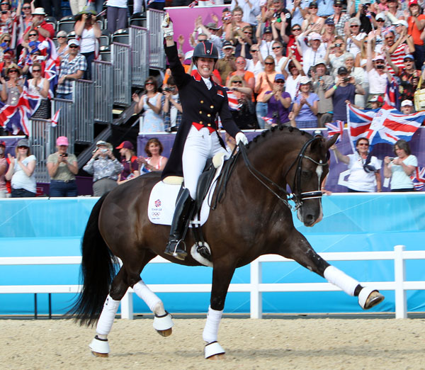
Open to any BD, Pony Club and BYRDS Members who would like to give dressage a go or who are already competing.
16th and / or 17th March 2013 | £40 private lesson  £20 shared lesson  Included in the cost will be proficiency training.  If you are not a BD member please add £5 supplement to the individual prices  Any rider wishing to train on both days an overnight stable can be provided if required, at £20.  This will count as an official BYRDS training day for members.
TO BOOK A PLACE PLEASE CONTACT:
Helen James – Mobile 07970374754
Helen@hollowfarm.co.uk
For details of the venue visit www.hollowfarm.co.uk

All bookings must be accompanied by a Booking form and payment in full. In the event of cheques please make them payable to British Dressage.
If you have any questions or require any further advice regarding this clinic or BYRDS activities in the SW Region please contact:
Amanda Heath - Regional Development Officer
Email: Amanda.heath@britishdressage.co.uk
Or
Your SW BYRDS Representative: Helen Griffiths on 07850 801254
To reserve a place please phone, text or email Mandy to provisionally reserve your place. All reservations must be followed up immediately by payment either via post (cheque) or credit card over the phone. Places are allocated on a first come first served basis.
Please reserve me Place (s)
Date (s) | Please list event name here
What level are you riding at / competing at?

British Dressage Membership Number
Please note all events are open to Non Members but an additional £5 is payable on the advertised rate
Location of Event / preferences i.e. times etc (we will accommodate if possible and apologise if not)

£ enclosed – cheques payable to British Dressage  Or phone 07894232355 to make a card payment but this form still needs to be emailed or posted. | £
SAE Enclosed | Yes / No
Name of attendee (s) | Contact Details for times etc
Email:
Phone: | Mobile:
Please complete this form and return it to your County Co Ordinator as above or alternatively to
Mandy Heath, Regional Development Officer
British Dressage, Rosudgeon, Brockhampton, Swindon Village, Cheltenham, Glos. GL51 9RS
Phone: 07894232355 Email: amanda.heath@britishdressage.co.uk

If you are under 18 years of age, this form must be signed by a parent or guardian, if you are attending training other than BYRDS Specified training, signing this form indicates that you accept that the training may not always be taken by a person who holds a Child Awareness Certificate. Refunds will only be made 7 days prior to the event, after that payment in full is required. No times will be allocated until payment in full is received by the organizer.

_____________________________________________ Date: __________________

