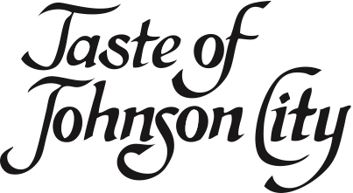

Enjoy a variety of food and beverage at the
35th Annual Taste of Johnson City,
Monday, September 18th, 6:30-8:30pm,
Johnson City Country Club.

A limited number of tickets are available.
Tickets go on sale to the public August 21st.

Must be 21 or older to attend.

*********************************************************************************

Please send __ tickets at $50 each (sales tax included). Please note tickets will not be reserved without advance payment. The Chamber cannot guarantee ticket availability after August 21st.

My check made payable to The Chamber of Commerce in the amount of $_____________ is enclosed.

Please charge my credit card in the amount of $____________
Acct # ____________________________________ Exp Date __________ V Code ________

Name: _______
Company: ________
Address/State/Zip: _________
Phone: ____ Fax: ______

Return to: The Chamber of Commerce, P.O. Box 180, Johnson City, TN, 37605
Or Fax to: (423) 461-8047

