
Cafe Show China 2013

Visitor’s Manual

August 9 (Fri) - 11 (Sun), 2013
China International Exhibition Center
No. 6 East Beisanhuan Road, Chaoyang District, Beijing
www.cafeshow.com.cn

Contact Us
Ms. Claudia Liu /Ms. Lydia Sun / Mr. Yumin Zhang
CIEC Exhibition Co., Ltd., CIEC Group
Tel: +8610 8460 032 / 0341 / 0318
Fax: +8610 8460 0325
Email: liuchen@ciec.com.cn / sunying@ciec.com.cn/zhangyumin@ciec.com.cn
Website: www.cafeshow.com.cn

Timetable

Exhibition Period | Date | Time
Opening Ceremony | August 9 (Fri) | 9:30
Opening Hours | August 9 (Fri) - 10 (Sat)  August 11 (Sun) | 9:00 – 17:00  9:00 – 15:00

Note:
- Visitor Registration & Badge Taking: Booking Office, Front Gate, CIEC
- On event day, visitors can fill in the registration form on site and show your business card to collect your badge at Booking Office.
- On-line pre-registered visitors can collect your badge at the Booking Office at the Front Gate

Visa Invitation Letter
FORM
4A
CIEC Exhibition Co., Ltd.
Contact: Ms. Claudia Liu
Tel.: +8610 8460 0322
Fax: +8610 8460 0325 / 0346
Email: liuchen@ciec.com.cn

- Please state clearly the place where your visa will be issued.
- Expenses incurred for visa application will be fully borne by the applicant.

- I need the original copy of the visa invitation letter. (The applicant will be charged for the express expense.)

Full Name (underline Surname): Sex:
Nationality: ate of Birth (d-m-y):
Passport No.: Date of Expiry (d-m-y):
Place of Issue:
Duration of Stay: Days; From (d-m-y), till (d-m-y)
Company Name: Hall & Booth No.:
Address (where we can send the invitation to):
m
Tel.: (Country code required) Fax:
E-mail:

Bank Account Information:
A/C Name: CIEC Exhibition Company, Ltd.
Bank：Industrial and Commercial Bank of China
Beijing Municipal Branch, Wangjing Sub-Branch, Xibahezhongli Banking Office
A/C：020 0253009024503367
Swift Code: ICBKCNBJBJM

如以人民币支付，付款方式为：
收款单位：北京华港展览有限公司
开户银行：工行北京分行国展支行（行号：966）
账号：0200253009024503367

FORM
4B
Hotel Reservation
Please return to
CIEC Exhibition Co., Ltd.
Contact: Ms. Zhang Yan
Tel: +86-10-8460 0817
Fax: +86-10-8460 0325 / 8460 0346
E-mail: zhangy@ciec.com.cn

Hotel | Star | Official  Price | Discount PRICE  for Exhibitors | Distance | Notes
Jing Gang Wan  Hotel | ★★ | 368RMB | Single: 190RMB  Twin: 230RMB  Three: 290RMB | 2.8km  (Free Shuttle) | Breakfast Included
Shi Hua Hotel | ★★★ | 680RMB  780RMB  880RMB | Single: 338 RMB  Twin: 438 RMB  Three: 500 RMB | 500m
The Great Hotel | ★★★ | 598RMB | Twin: 338RMB | 500m
Radisson SAS Hotel | ★★★★ | 1250RMB + 15% | Single: 700RMB  Twin: 800 RMB | 100m | Breakfast Included  Credit Card No. & Date of Expiry  Required
Jiabao Hotel | Express Hotel | RMB 388  RMB 298  RMB 538  RMB 638  RMB 688 | Twin: 288 RMB  Single: 258 RMB  Three: 438 RMB  Suite: 578 RMB  VIP: 488 RMB | 100m | Breakfast Included
IBIS (Sanyuanqiao) |  |  | Standard Room:  228-329 RMB | 2km

公司名称Company Name:
联系人姓名Contact Person: 联系电話Tel.:
传真Fax: 手机Mobile:
电子邮箱 E-mail: 展台号 Hall & Booth No.:
客人姓名及身份证号码 Guest Name and passport No.:

入住日期Check-in Date: 退房日期Check-out Date:
间数Quantity: 备注Note:
到达航班 Arrival Flight No. & time: 离境航班Departure Flight No. & time:

首选酒店名称 1st Choice Hotel Name | 次选酒店名称 2nd Choice Hotel Name

- 若首选酒店房间已订满，我们将安排您入住次选酒店。
If your first choice hotel is fully occupied, we will shift your accommodation to your second choice hotel.
- 请务必写清您的联系方式，以备我们与您联络。
Please make sure your contact information is filled correctly, so we would be able to keep in touch with you.

Map of CIEC

No. 6 East Beisanhuan Road, Chaoyang District, Beijing
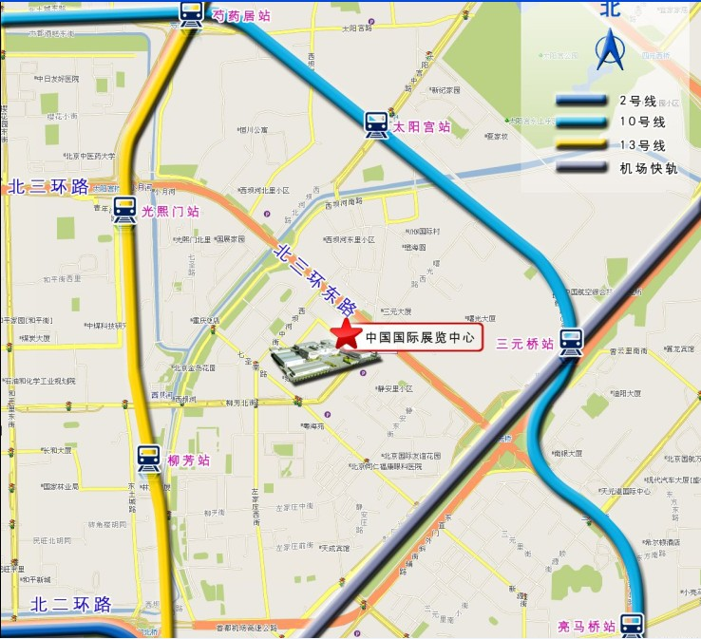

Airport to CIEC: 20km
- By Airport Bus: take Bus Line 4 [Airport to Gongzhufen], get off at China International Exhibition Center, cross overbridge
- By Airport Express (subway): take Airport Express, get off at Sanyuanqiao Station, take Bus No. 300, 302 or walk to the venue

Subway station near CIEC
1) Subway Dongzhimen Station (Line 2, Line 13, Airport Express): 3.2 km to CIEC. Bus No.18, 515, 966 are available to CIEC.
2) Subway Liufang Station (Line 13): 0.8 km to CIEC. About RMB 10 Yuan by taxi.
3) Subway Sanyuanqiao Station (Line 10, Airport Express) : 2.2 km to CIEC. Bus No.300, 302 are available to CIEC.

Bus stop near CIEC
Bus No.8, 18, 104, 300, 302, 367, 379, 419, 515, 731, 966,985, about 300m away from the stop to CIEC

Hall Layout

