CHAPTER 2

2. NEW TRANSPORT MEDIA TECHNOLOGIES
(OPTICAL FIBRES, RADIO, SATELLITE)
2.1 OPTICAL FIBRES
2.1.1 Transmission properties
A typical optical fibre is made up of a central cylindrical part, the core, in which the light is normally travelling, surrounded by an optical cladding used to guide the light into the core, i.e. to maintain as much as possible the optical power inside the core. These two parts, the core and the cladding, are normally made of ultra pure doped silica. For mechanical protection, these two parts are covered by a concentric primary coating made of a plastic material, which is very important for insuring a stable and reliable behaviour. The primary coating is also, in general, marked, i.e. by a colour code for fibre identification.
Definitions of these parameters as well as other parameters listed below and the way to measure them can be found on the following publications:
ITU-T Recommendation G.650: Definitions and test methods for the relevant parameters of single-mode fibres.
ITU-T Recommendation G.651: Characteristics of a 50/125 µm multimode graded index optical fibre cable.
IEC Publication 61931: Fibre optic terminology.
IEC Publication 60793-1: Optical fibres - Part 1: Generic specification.
IEC Publication 60794-1: Optical cables - Part 1: Generic specification.
For single-mode fibres, which are the only ones used for telecommunication applications (multimode fibres are used only for Local Area Networks and short distance applications), the main transmission characteristics are the attenuation, the chromatic dispersion, the cut-off wavelength and the polarization mode dispersion.
Numerical values related to these parameters which can be found in International Standards or Recommendations are the result of a consensus between the different members at the time of preparation of the Standard. Therefore and considering also the evolution of the technology, it is possible for some parameters to find different values for the best products available on the market.
Several fibre parameters, in particular transmission parameters, can be affected by the cabling and/or installation. For designing a transmission system, it is essential to consider only fibre parameters of installed cables and therefore, the values given hereafter shall be understood as applicable to cabled fibres.

2.1.1.1 Attenuation
Attenuation is defined as:
1 - A decrease of electromagnetic power between two points.
2 - The quantitative expression of power decrease which may be expressed by the ratio of the values at two points of a quantity related to power in a well defined manner.
Attenuation is certainly one of the most important parameter for an optical fibre as it is the most common limitation of the maximum distance for an optical link. It is normally given as an attenuation coefficient, i.e. attenuation per unit length, and is normally measured around specific wavelengths, 1310 and 1550 nm for standard single-mode fibres. During the last ten to fifteen years, the value of the attenuation coefficient has been continuously reducing due to the evolution of the technology and is now very close of the theoretical minimum value.
Maximum attenuation coefficient values specified for cabled fibres are presently 0.5 dB/km (1310 nm) and 0.4 dB/km (1550 nm). Values of 0.38 to 0.40 dB/km at 1310 nm and around 0.25 dB/km at 1550nm can be found on the market.

2.1.1.2 Chromatic Dispersion
Chromatic dispersion is:
The spreading of a light pulse per unit source spectrum width in an optical fibre caused by different group velocities of the different wavelengths composing the source spectrum.
NOTE: The chromatic dispersion may be due to the following contributions: material dispersion, waveguide dispersion, profile dispersion.
It may also limit the maximum distance for an optical link especially for high bit rates which are now used more and more. For the basic single-mode fibres, minimum attenuation is obtained in the 1550nm window, and minimum chromatic dispersion happens in the 1310nm window. The try to solve this problem, new types of fibres combining minimum attenuation and reduced chromatic dispersion have been proposed and are discussed in the following chapter.
Specified value for G.652/B1.1 fibres is presently: S₀max (ps/nm².km) ≤ 0.093.

2.1.1.3 Cut-off Wavelength
Cut-off wavelength is defined as:
The wavelength at which the ratio between the total power, including launching higher order modes, and the fundamental mode power has decreased to less than a specified value, the modes being substantially uniformly excited.
NOTE: This specified value is presently chosen to be 0.1 dB.
NOTE: The cut-off wavelength depends upon the measurement conditions and in particular on the sample length, its curvature and cabling.
NOTE: The cut-off wavelength is generally different from the theoretical cut-off wavelength that can be computed from the refractive index profile of the fibre. The theoretical cut-off wavelength is a less useful parameter for determining fibre performances in a telecommunication network.
This parameter is the one that insures the single mode behaviour of the fibre. It can be understood from the note 2 that cut-off wavelength is affected by the cabling process and possibly by installation conditions. Therefore, it is necessary to know deployment conditions of a fibre to evaluate its cut-off wavelength, which must be smaller than the operating wavelength of the system. Indication on the way to choose cut-off wavelength is given in IEC 60793-2 by the following note:
In general, there is no unique relationship between the fibre cut-off wavelength λ and that of cabled fibre λ. The necessary value of ëc for any particular system application depends upon the fibre, cable and system design (including system operating bit-rate and operating wavelength), together with the expected length and curvatures of repair cables. However, a general relationship may be determined between λ and λ for particular fibre cable designs. The required value for λ is still under study and will be indicated in the product specification on optical cables (IEC 60794-2).

For some applications, some users have preferred to set limits for λ below the envisaged operating wavelength; typical values within the range 1100-1280 nm have been adopted in such cases. For other applications, some users have chosen to permit λ to be as high as 1350 nm, relying on the effects of cable making and installation to yield values below the operating wavelength range.

2.1.1.4 Polarisation Mode Dispersion
Polarization Mode Dispersion (PMD) is:
The distortion of the transmitted signal attributable to the different velocities of the polarization components of the same mode and their dependence on wavelength.
NOTE: In straight, unstressed circularly symmetric fibres the polarization dispersion is negligible.
PMD has been recognized recently as a potential limitation for very high bit rate long haul links. The statistical nature of PMD creates some difficulty for an accurate prediction of its impact on the global link. The consequences of PMD are particularly important for long distance applications as it may impair the performance of a long length and high bit rate fibre optic system(e.g. 10 Gbit/s transport over 100 km). When designing this type of system, it is therefore recommended to use very low PMD fibres to avoid any risk of impairing the global link performance.
Recommended PMD value for cabled fibres is presently ≤ 0.5 ps.km^{-1/2}. Values ≤ 0.2 ps.km^{-1/2} or lower can be found on the market.

2.1.2 Fibre types
For long distance telecommunication applications, only single-mode fibres are used, as they exhibit the lowest attenuation and the highest transmission capability. However, there are different types of single-mode fibres, corresponding to different applications, which are described in the following ITU Recommendations :
G 652 Characteristics of a single-mode optical fibre cable
G 653 Characteristics of a dispersion-shifted single-mode optical fibre cable
G 654 Characteristics of a 1550 nm wavelength loss - minimized single-mode optical fibre cable
G 655 Characteristics of a non-zero dispersion shifted single-mode optical fibre
IEC specifies the fibres according to the following categories:
B1.1 Dispersion unshifted for operation at 1310 nm
B1.2 Loss minimized for operation at 1550 nm
B2 Dispersion shifted for operation at 1550 nm
B3 Dispersion flattened for operation at 1310 nm and 1550 nm
B4 Non zero dispersion for operation at 1550 nm
Characteristics of these different categories of fibres are specified in IEC publication
60793-2: Optical fibres - Part 2 : Product specifications.
The most common product, in terms of the installed base since the beginning of the single-mode technology, is fibre category B1.1, corresponding to Recommendation G 652. It is presently this fibre which represents the major part of the market due to its capability of providing, at the most attractive cost, good performance adaptable to most of the telecommunication applications.
For B1.1 single-mode fibres, minimum attenuation is obtained in the 1550nm window, and minimum chromatic dispersion happens in the 1310nm window. It is therefore not possible to achieve at the same time an optimum behaviour from the point of view of both loss and dispersion. Dispersion shifted fibres (DSF, category B2 according to Recommendation G.653) have been developed to answer the need for simultaneous optimisation, but due to their higher cost linked to a more sophisticated structure, they remain limited to those applications really requiring this extra capability, e.g. for submarine links.
Loss minimized fibres (category B1.2 corresponding to Recommendation G.654) have been used for some very long links where the attenuation limitation was predominant.
More recently, it has been recognized that for Wavelength Division Multiplexing (WDM) applications, an important parameter is the stability of chromatic dispersion for the different wavelengths used. It is for this reason that a new category of fibre (category B4, corresponding to Recommendation G.655) called non-zero dispersion fibre (NZDSF) has been generated. Compared to a DSF, a NZDSF exhibits a higher value of chromatic dispersion at 1550 nm, but the slope of the curve chromatic dispersion vs. frequency is reduced in the operating window, in order to facilitate WDM operation.
Standardization of this new category of fibres has been initiated both in the ITU and in the IEC, prompted by decisions of installation in some countries, and some standards values have been agreed upon and published. However, these values provide only a very broad definition
and are not sufficient to define precisely a standard product. Several different products, corresponding to different interpretations of the category, can be accommodated within the existing standard and it has not been possible until now to define an agreed set of values leading to a real standard uniform category.
According to IEC Publication 60794-2, which is the most recent publication defining characteristics of fibres, all single-mode fibres have in common several basic parameters such as:
cladding diameter : 125 ± 2 μm
primary coating diameter : 245 ± 10 μm (uncoloured)
250 ± 15 μm (coloured)
A cladding diameter value of 125 ± 1 μm can be found presently, which provides advantages for splicing purposes.
However, some other parameters differ from one category to another. For example, mode field diameter is:
8,6 to 9,5 μm at 1310 nm for B1.1
7,8 to 8,5 μm at 1550 nm for B2
6 μm at 1310 nm and 7 μm at 1550 nm for B3
under consideration for B1.2 and B4.
Transmission parameters such as attenuation coefficient and dispersion characteristics are obviously different for the different categories. B1, B2 and B3 categories are more or less completely defined as B4 remains under consideration for most of its parameters.

2.1.3 Optical fibre implementation
Optical fibres are normally not used alone but are incorporated in a cable. The purpose of the cable is to protect fibres against mechanical and environmental aggression, but sometimes the cabling and installation processes may impair fibre characteristics if not done properly. Furthermore a single length may not be sufficient and several lengths may need to be spliced together, which requires further consideration of both fibre and cable parameters.
The ITU-T has already published a series of Recommendations on the subject. The most recent of these are :

[L.12] (07/92) - Optical fibre joints
[L.13] (07/92) - Sheath joints and organizers of optical fibre cables in the outside plant
[L.14] (07/92) - Measurement method to determine the tensile performance of optical fibre cables under load
[L.15] (03/93) - Optical local distribution networks - Factors to be considered for their construction
[L.17] (06/95) - Implementation of connecting customers into the public switched telephone network (PSTN) via optical fibres
[L.17 App.1] (02/97) - Implementation of connecting customers into the public switched telephone networks (PSTN) via optical fibres, Appendix 1: Examples of possible applications
[L.20] (10/96) - Creation of a fire security code for telecommunication facilities
[L.22] (10/96) - Fire protection
[L.23] (10/96) - Fire extinction - Classification and location of fire extinguishing installations and equipment on premises
[L.25] (10/96) - Optical fibre cable network maintenance
[L.26] (10/96) - Optical fibre cables for aerial application
[L.27] (10/96) - Method for estimating the concentration of hydrogen in optical fibre cables
[L.28] (10/96) - External additional protection for marinized terrestrial cables
[L.29] (10/96) - As-laid report and maintenance/repair log for marinized terrestrial cable installation
[L.30] (10/96) - Markers on marinized terrestrial cables
[L.34] (10/98) - Installation of Optical Fibre Ground Wire (OPGW) cable
[L.35] (10/98) - Installation of optical fibre cables in the access network

2.1.3.1 Fibre protection
The first level of protection is provided by the primary coating.
The selection of the primary coating is of paramount importance for insuring the reliability of the fibre. A good primary coating should protect the fibre against mechanical stress, abrasion, etc., as well as environmental and chemical effects such as humidity for instance. It should not create micro-bending (that can happen if it is not applied concentric to the silica material), should make fibre handling easy and should be easily removable (for splicing purposes).
Furthermore, the primary coating in general also provides identification means through a colour code. It should be adapted to this function and the coloured fibber should keep the same characteristics as an uncoloured one. Compatibility between primary coating and the colours used should be demonstrated after production and also for the operating lifetime of the fibre. Stability of colour identification is also needed, as well as compatibility with all the constitutive materials of the cable.
All these requirements show the high level of technology required for the development and implementation of a good primary coating.
In practice, it is not possible to continuously maintain fibres free of stress during their operating lifetime. Some level of stress can be applied, either continuously or for a short time period. It is therefore necessary to consider this situation and to evaluate the consequences on the fibres.
One obvious consequence, when stress is applied to the fibre exceeding some level which is function of cable structure, is a degradation of transmission characteristics, in particular the attenuation coefficient. This issue is therefore quite easy to understand by submitting the cable to appropriate tests.
Another consequence, which cannot be detected immediately but is also very important, is a reduction of expected fibre lifetime, if the fibre is submitted to a stress exceeding some value as described hereafter. This point requires more attention as the result is not directly measurable.
The ability of a fibre to survive mechanical constraints is given by the knowledge of the stress corrosion susceptibility parameters. Definitions and measurement methods for static and dynamic parameters (n_{s} and n_{d} respectively), which are both used in practice, are given in IEC Publication 60793-1-3. The lifetime of a fibre under operational conditions is linked to its value of n_{s} and n_{d}: the bigger n_{s} and n_{d} are, the longer is the expected fibre lifetime for given conditions.
The purpose of the cable is to reduce the level of stress transfer to the fibre itself, due to environment during the operational life of the system, but the above rule related to the n values is always valid: it means that, for a given external stress, if different cable structures transfer differently stress to fibre, the less it transfers, the better it is. But, for a given level of stress on fibre, any increase on the n value will increase the fibre lifetime.
Values of n_{s} ≥ 20 and n_{d} ≥ 25, shown presently by many products can insure, under normal conditions and based on commonly accepted theoretical calculations, a satisfactory minimum lifetime. Higher values will provide a longer expected lifetime.
The second level of protection is provided by the cable itself. Parameters for optical cables and the way to measure them are given in IEC Publication 60794-1 Optical fibre cables – Part 1: Generic specification.
In particular, the lifetime aspect, as mentioned above, is linked to the absence of micro-bending on the fibre which can be characterized by a thermal cycling test (see IEC Publication 60794-1-2).
The evaluation of the cable behaviour for stress parameters such as tension, crush, impact, bending, torsion, needs also to be done, according to operational requirements. The same reference as above (IEC Publication 60794-1-2) applies.

2.1.3.2 Installation procedures
It is important to keep unaltered, by using convenient installation procedures, the characteristics of optical fibre cables.
Useful information can be found in the informative Annex C of IEC Publication 60794-1-1. The introduction of this document summarizes its main points as follows:
Optical fibre cables are designed so that normal installation practices and equipment can be used wherever possible. They do, however, generally have a strain limit rather lower than metallic conductor cables and in some circumstances, special care and arrangements may be needed to ensure successful installation.
It is important to pay particular attention to the cable manufacturer's recommendations and stated physical limitations, and not exceed the given cable tensile load rating for a particular cable. Damage caused by overloading during installation may not be immediately apparent but can lead to failure later in its service life.

2.1.3.3 Splicing
For the purpose of optical cable splicing, two types of characteristics need to be considered : those related to the fibre and those related to the cable structure.
Concerning the fibre, splicing losses increase with higher tolerances. A reduction of tolerances on cladding diameter to ± 1 μm as mentioned above will reduce splice loss.
A similar result can be achieved by reducing the tolerance on mode field diameter, 2w₀: the specified value is ± 1 μm and it is possible to achieve values of ± 0.5 μm or lower.
Fibre handling for splicing is characterized by fibre curl (see IEC Publication 60793-1-3). The radius of fibre curl, r, has to be as great as possible and there is a general consensus that a minimum of 2 meters is required. Greater values can be found on the market.
The cable structure is also of interest, considering parameters such as modularity, possibility of easy access to fibres (sheath or tube removal), identification of fibres in the cable structure (colour code, stability of colour over time).
In conclusion, it is clear that optical fibre implementation is governed by a large number of parameters. Some parameters of general interest have been reviewed but it is also important to know precisely the conditions applicable for the operation of the network, during its installation and over its operational lifetime, in order to select the most relevant conditions for the protection of fibres.

2.1.4 Protection of Optical Networks
2.1.4.1 Introduction
Survivability is arguably one of the most important factors in the evaluation and design of fibre optic telecommunication networks. This happens as more traffic is carried by the same fibre infrastructure and more telecommunications service customers are likely to be served by bigger central offices. The evolution of transport networks towards a two layer WDM / SDH has increased even further the emphasis on survivability.

2.1.4.2 Network Survivability
Network survivability is the ability of the network to recover traffic in the event of a failure of a network component, such as the complete loss of a transmission link or the failure of a central office. The main objective of network survivability is to guarantee a certain traffic service level agreement.
Traffic survivability enhancement is achieved by the replacement of failed or degraded transport entities. The replacement is normally initiated by the detection of a defect, performance degradation or an external management request.
The main characteristic of the protection mechanisms as standardised in ITU-T Recommendations like G.841 and G.842 is that they are able to recover traffic very quickly, for most of them, the target is to protect the traffic in less than 50 ms. Further, protection also operates autonomously from the network operation centre. Protection makes use of pre-assigned capacity between the nodes. The simplest protection architecture has one dedicated protection entity for each working entity (1+1). The most complex architecture has m protection entities shared amongst n working entities (m:n).
The following protection mechanisms were entirely defined in ITU-T recommendations:

2.1.4.2.1 SNC-P / I (Sub-network Connection Protection with Inherent monitoring)
This protection mechanism uses 1+1 architecture, which means it needs a spare sub-network connection to protect a working sub-network protection. It is single ended that is both directions of traffic are protected independently. The faults under which SNC-P / I is able to react and protect are those due to hard failures, occurring as equipment failure, optical interface failures and link failures. Radio link short period interruptions initiating Tributary Unit – Alarm Indication Signal (TU AIS) or Tributary Unit – Loss of Power (TU LOP) will also cause SNCP-I to protect. SNC-P / I may be implemented on a VC per VC basis allowing a given transmission facility to transport unprotected traffic and protected traffic.

2.1.4.2.2 SNC-P / N (Sub-network Connection Protection with Non
intrusive Monitoring)
This protection mechanism differs from the previous one, only in the fault conditions under which it is able to protect. SNC-P / N protects against the usual hard failures as described for SNC-P / I but it also protects against failures such as human related activities, operating system mismanagement or mis-provisioning. These types of failures could be originated by a wrong matrix connection or opening of connections. Further, SNC-P / N also protects against soft failures due to degradation of optical interfaces or to errors occurring in a radio link exceeding the predetermined threshold value for maximum acceptable BER.

2.1.4.2.3 MS Linear Trail Protection
This is a bulk traffic protection mechanism able to protect against fibre cuts, optical interface failures, as well as against performance degradation of optical interfaces and fibre. MS Linear trail protection supports many types of architectures, which may be 1+1 or 1:N. The bandwidth made available for protection may be used to transport low priority traffic when all the working spans are faultless. MS Linear Trail Protection can be also used to protect spans in linear or chained type of networks.

2.1.4.2.4 MS-SPRING (Multiplex Section Shared Protected Ring)
MS-SPRING is also a bulk traffic protection mechanism able to protect against fibre cuts, optical interface failures, as well as against performance degradation of optical interfaces and fibre. However, MS-SPRING is a protection mechanism that needs a network ring physical topology to work. One of the major advantages of MS-SPRING with respect to other protection mechanisms, is its ability to reuse bandwidth capacity which makes it the most efficient protection mechanism available under conditions of uniformly distributed traffic.
MS-SPRINGs in general are considered to be appropriate in areas of the network where the traffic is uniformly distributed.
There is also a variation of the MS-SPRING implementation in G.841 to optimise it for long distance applications, like submarine networks or backbone networks in large countries, where the distance between nodes can be many thousands of kilometres long. During network failures and while maintenance is taking place, the path under protection can be much longer than in normal operation as ring switches take place adjacent to the network failure. This translates into longer voice transit delay which can constitute an impairment to the conversation fluidity over a long distance PSTN network. To limit this degradation of voice quality, the MS-SPRING functionality has been enhanced to what is called MS-SPINGs for long distance applications and it is described in Annex A of ITU-T G.841

2.1.4.2.5 Restoration
Restoration makes use of any capacity available between nodes to recover traffic against network failures. In general the algorithms used for restoration will involve re-routing. When restoration is used some percentage of the transport network capacity will be reserved for re-routing working traffic. As yet, restoration has not been standardised, the several products currently available in the market respond to a number of specific customer specifications.
Restoration is the most efficient traffic availability enhancement technique if the network physical topology is reasonably well meshed. For example, when the network nodes are reachable through at least three or even better more disjoint physical routes, the amount of spare bandwidth devoted to spare capacity of around 33% or less per span would be enough to restore against single span failures. This is in comparison with the 50% of spare capacity required by the ring protection mechanisms explained above.
The centralised operating system has all the knowledge about traffic distribution, spare capacity, and traffic profiling in function of their priority to be recovered. Depending on the nature of the failure, the restoration mechanism can administer the use of working traffic and other low priority traffic while restoring the higher priority traffic. This feature is called traffic pre-emption. Restoration response is slower than protection due to its high versatility in recovering traffic and its bandwidth efficiency. Centralised automatic restoration mechanisms are able to recover traffic in a time range between 5 to 10 secs without incurring unavailability on traffic for the affected circuits.

2.1.4.3 Selection criteria to chose restoration or protection
To implement cost effective network architectures, ring protection mechanisms and mesh restoration mechanisms should be used together. It is important to understand that these are not possible alternatives for implementation of reliable networks, but they complement each other very well due to their differences and thus should be used together. The criteria for choosing one or other needs to take into account the distribution of fibre and stations in the field. Physical node connectivity is defined as the average number of diversely routed links that arrive to a node (central office). This varies significantly depending on the demographic conditions. In general densely populated areas are served by a well connected or “meshed” network infrastructure. Less densely populated areas tend to have less fibre, with network topologies made up of long chains or large rings. Finally for very low population density, radio and very little fibre constitutes a cost effective way to provide telecommunication services.
In the cases where the connectivity of the nodes in the network is high enough, for instance higher than 3, the use of meshed restoration can be more appropriate as it is possible to exploit all its virtues. These include its minimum utilisation of spare bandwidth in the network, flexibility of growth and pre-emption.
Most countries have both densely populated areas with a correspondingly well-meshed network to support it, and areas more sparsely populated correspondingly with less fibre connectivity.
Hence, it is possible to state that meshed protection and ring protection can be efficiently used complementing each other to construct reliable high capacity network architectures.
The figure below illustrates this concept which follows the above mentioned criteria of demographic distribution and telecommunication infrastructure required to serve the population.
Figure 2.1.1 – Typical Fibre and Node distribution

2.1.4.4 Conclusions
A number of economical considerations exist for planning and implementing reliable transport network architectures. High availability transport networks have the merit to support cost effectively a complete range of services and their associated quality. Reliable networks incur in much lower operational expenses on maintenance. As maintenance actions can be deferred and lumped, hence there is much more possibility to plan them better.
Furthermore, the only way to take advantage, safely, of the evolution of the high capacity TDM and WDM systems is to plan for a self-healing network architecture.
Mesh restoration and ring protection mechanisms help construct reliable networks. Studies indicate that ring protection mechanisms are the perfect solution for a poorly interconnected network infrastructure found in medium populated areas.
Restoration with its flexibility and economy of spare bandwidth resources is the best solution to be used with a well inter-connected network infrastructure, which is usually found in densely populated areas. As most countries have areas with high, medium and low density population, a combination of mesh restoration, ring and linear protection respectively constitute the right solution to build reliable transport network architectures for the next century.
      - ITU-T References
For more details in planning optical networks and their protection, the following ITU-T Recommendations are important:
[G.872]; Architecture of optical transport networks
[G.709]; Network Node Interface for the Optical Transport
[G.691]; Optical interfaces for multichannel systems
[G.959.1]; Optical transport networks physical layer interfaces
[G.871]; Framework of optical transport network
[G.798]; Functional characteristics of optical networking equipment
[G.874]; Planned; Management of optical network elements
[G.875]; Planned; Information model for optical network equipment

    - Abbreviations
BER Bit Error Rate
DSF Dispersion Fibre
MS Multiplex Section
MS-SPRING Multiplex Section – Shared Protected Ring
NZDSF Non-Zero Dispersion Fibre
PMD Polarization Mode Dispertion
PSTN Public Switched Telephone Network
SDH Synchronous Digital Hierarchy
SNC-P/I Sub-network Connection Protection with Inherent monitoring
SNC-P/N Sub-network Connection Protection with Non-intrusive monitoring
TU AIS Tributary Unit – Alarm Indication Signal
TU LOS Tributary Unit – Loss of Power
WDM Wavelength Division Multiplexing

2.2 DIGITAL RADIO-RELAY SYSTEMS

2.2.1 General
Digital radio-relay systems (DRRS) are used in many applications ranging from transporting telephone and TV signals to carrying a wide variety of modern data signals. Distances bridged may range from less than a kilometre to a continent or beyond. Similarly, the capacity of a digital radio system may be as little as a single DS1 signal (1.54 Mbit/s) or as large as 1,000 Mbit/s. Only a small range of the electromagnetic spectrum is suitable for radio-relay applications and within this range only a limited number of bands are available. The bands are further subdivided into channels that can carry either low capacity or high capacity digital signals.
The growth of digital networks was dictated for more than thirty years by the conversion of voice telephone traffic from analogue to digital. Not until recently has pure data traffic been an important factor. Data traffic is now increasingly generated by voice band modems, ISDN terminals, video conferencing and high quality television terminals and other data sources.
The advantages of digital radio-relay systems include:
– Low costs: Radio is cost-effective in comparison with other alternative systems like copper and fibre optic cable. The installation of cable and the cable itself can be very expensive and in urban areas it may be difficult to acquire the necessary rights-of-way.
– Rapid deployment: Radio equipment can be easily moved to new sites to meet rapidly evolving network requirements. Infrastructure requirements are small.
– Ease of maintenance: Maintenance is limited to the infrequent radio stations along the radio path in contrast to cable system where the entire path is exposed to potential cable breaks.
- Spectrum
The ITU conducts periodic international conferences, the World Radiocommunication Conferences or WRCs, where the electromagnetic spectrum is allocated to various users. Regional Radiocommunication Conferences (RRCs) are also held to develop agreements covering the use of the RF spectrum at the regional level. The results are published in the Radio Regulations as the ITU Table of Frequency Allocations, which cover the spectrum from 9 kHz to 400 GHz. In addition to the fixed terrestrial and fixed-satellite services of concern here the spectrum is allocated to many other users like mobile (land, aeronautical, maritime), broadcast, (sound, TV) meteorological, space (operation, research, inter-satellites Earth exploration) radio astronomy, amateur and radio-determination (radar). The Radio Regulations (RR) allocate the spectrum in only the broadest possible terms. Most of the countries use the RR as the basis for their own national frequency tables in which they provide additional details, segregated into government and non-government usage.
The ITU-R Recommendations may not always reflect the latest channel arrangements used in individual countries. New channel initiatives often start in a particular country and are recognized only some time later in an ITU-R Recommendation. If a manufacturer plans to supply radio equipment into a foreign market it is therefore necessary to become familiar with that country's particular developments. A country may also allow a non-standard channel arrangement or open up a government frequency band to non-government use.
- In relation with ITU-R Recommendations (F-series), we can take into account the general frequency band arrangements for radio-relay systems:
- 1.4, 2, 4, 5, L6, U6, 7, 8, 10, 11, 12, 13, 14 and 15 GHz
- 18, 23, 27, 31, 38 and 55 GHz
Digital radio systems operating below 15 GHz are essential in providing junction and backbone links in the long haul and regional networks. They are also used in remote areas or over difficult terrain and are thus complementary to other transmission systems like optical fibre. Congestion in the bands below 15 GHz makes it often impossible to increase the number of links in an area. That is why the bands above 15 GHz become more and more important. In many countries equipment operating above 15 GHz is being deployed in large numbers for short-range access networks (SDH spurs, LAN, temporary links, and cable protection) and for mobile network infrastructure (e. g. GSM, AMPS, DCS 1800).

- Digital channel capacity
The bit rates carried by digital radio-relay systems are the rates standardized in ITU-T Recommendations G.702, G.703 and G.704 for the plesiochronous digital hierarchies and in ITU-T Recommendations G.707, G.708 and G.709 for the synchronous digital hierarchies (SDH or SONET). According to the ITU Recommendations, and depending on the channel bandwidth and the modulation (4 QAM, 16 QAM , 256 QAM, 512 QAM), the capacity of digital radio-relay systems in bit rates fb includes multiples of DS1 (1.544 Mbit/s) and DS3 (44.736 Mbit/s), E1 (2.048 Mbit/s) and E3 (34.368 Mbit/s), STS1 or Sub-STM1 (51.84 Mbit/s) and STM-1 (155.52 Mbit/s). These are the bit rates delivered to and from the digital radio. Inside the digital radio system the bit rate fbr is often about 6% higher (fbr = 1.06 fb) because of the addition of forward error correction (FEC) and the addition of extra overhead bits for internal radio maintenance and to achieve the radio-internal multiplexing of several standard bit streams.

2.2.2 New Digital Microwave (Point-to Point) Radio Technologies
In the remaining part of this section, some of the fields where new technology has appeared over the last few years will be treated in some detail. These technologies are incorporated in new Digital Microwave Radio (DMR) SDH (Synchronous Data Hierarchy) equipment, and will ensure a smooth transition from the currently prevailing Plesiochronous Data Hierarchy (PDH) architecture.
- FEC (Forward Error Correction) and Coded Modulation Techniques
In the original and conventional DRRS design, the FEC coding and modulation functions are done independently. Several types of error correction techniques are in use, such as block coding and convolutional coding.
In an FEC block coding scheme, the input data stream to be encoded is divided into k information symbols together with redundant parity or check symbols to produce a coded work of n symbols which are then modulated and transmitted. An independent block code encoder operating in this way is producing a (n,k) or rate k/n block code. At the receiver, the demodulated bitstream is first decoded to extract the information bits, which are corrected, if necessary, by the parity or control bits.
In an FEC convolutional coding scheme, parity or control bits are calculated over a span of bits to form a continuous bit stream. Convolutional coding is also described in terms of n and k. Here, n is the number of coded bits that are used to make a certain bit sequence, and k is the span of bits that makes the sequence. k is called the constraint length. Convolutional coding is usually designed for specific decoders, such as Viterbi decoding, sequential decoding or syndrome decoding.
In coded modulation, the FEC coding and modulation functions are combined by inserting redundant bits in multi-state numbers of the transmitted signal constellation. The most popular coded modulation techniques traditionally used for terrestrial digital microwave radio systems are (1) Block Coded Modulation (BCM), (2) Trellis Coded Modulation (TCM), and (3) Multi-level Coded Modulation (MLCM). Of these techniques, the MLCM technology has seen the most rapid advancement in recent years.
BCM modulation schemes achieve a lower coding gain than TCM schemes. Coding gain (in dB) may be defined as maintaining the same BER on a radio link even if the C/N is reduced. Thus, if a certain modulation scheme has a coding gain of, for example, 3 dB, the C/N can be reduced by 3 dB for the same BER. BCM schemes, however, are simpler than TCM schemes to implement, and may be used in parallel demodulation configurations.
TCM modulation schemes use convolutional coding techniques which require a smaller bandwidth for a given transmission rate and BER probability. The demodulator used for a TCM scheme is often implemented with Viterbi algorithms in a Maximum Likelihood Sequence Estimation (MLSE) circuit. The complexity of TCM schemes can be quite high, but they may have a high degree of flexibility. The characteristics of TCM schemes are such that their coding gain on a non-linear channel is greater than on a linear channel. This advantage of TCM will reduce residual BER for high complexity modulation schemes.
In MLCM each modulation level is considered to be a separate communications channel, and different FEC coding schemes may be applied to different levels. Furthermore, one MLCM scheme is not restricted to one coding scheme. For example, some levels may use block codes while other levels may employ convolutional coding. This means flexibility in selecting coding rates since they can be selected separately for individual levels.
Fig 2.2.1. shows the basic techniques for TCM and MLCM schemes. In the MLCM case, the incoming serial bitstream is speed converted and changed from serial to parallel mode. Encoder 1 will, for example, apply FEC bits to the Least Significant Bit (LSB) at a rate R=3/4 (i.e. a total of four bits are transmitted for every three information bits), and Encoder 2 may apply FEC bits to the second LSB at a rate of R=11/12 (12 transmitted bits for every 11 information bits). After this encoding process, the encoder outputs are parallel-to-serial converted and combined with the remaining bit levels in a mapping circuit before being sent to the 128QAM modulator. Because of the lowering of the operational speed of the coding and decoding processes, a more reliable and robust circuit design is realized.

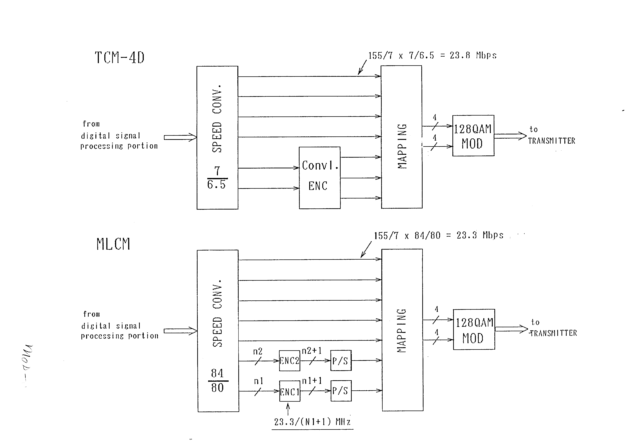

Figure 2.2.1 - Basic Concepts of TCM and MLCM Techniques

In the example of Fig 2.2.1 the total MLCM coding redundancy is only about 5% (80/84). This has the advantage that an additional 2 Mbit/s channel can be transmitted (so-called Wayside channel). This advantage is absent in TCM, where for example in 4-dimensional TCM the coding redundancy is 8% and therefore cannot sustain a Wayside channel.
- Cross Polarization Interference Canceller (XPIC) Techniques
The frequency bands used in digital microwave radio systems (as well as in other radio communications systems) are limited resources, and therefore should be utilized in the most effective way possible. Increasing the level of modulation as described in the previous section is one way to increase the capacity of a given system. Another way to increase the use of a given frequency band is to use it twice in the same system by transmitting RF carriers with different polarizations.
Co-channel dual polarization equipment has been in operation in commercial satellite systems for many years, but only more recently has it been introduced into terrestrial microwave systems. The reason for this is that satellite systems are rarely operated below antenna elevation angles of 5 degrees and propagation fading is not a critical issue. Terrestrial microwave systems, however, are inherently susceptible to severe fading because they are transmitting parallel to the surface of the earth, and cross-polarization discrimination (XPD), i.e. interference of signals between the two polarizations, is highly affected by multipath fading RF carriers.
Fig 2.2.2 shows the expected XPD vs. fading depths. The data shown in this figure are for an antenna designed for high cross-polarization discrimination. As shown, under non-fading conditions an XPDo (XPD in normal condition) of 35 dB may be expected.

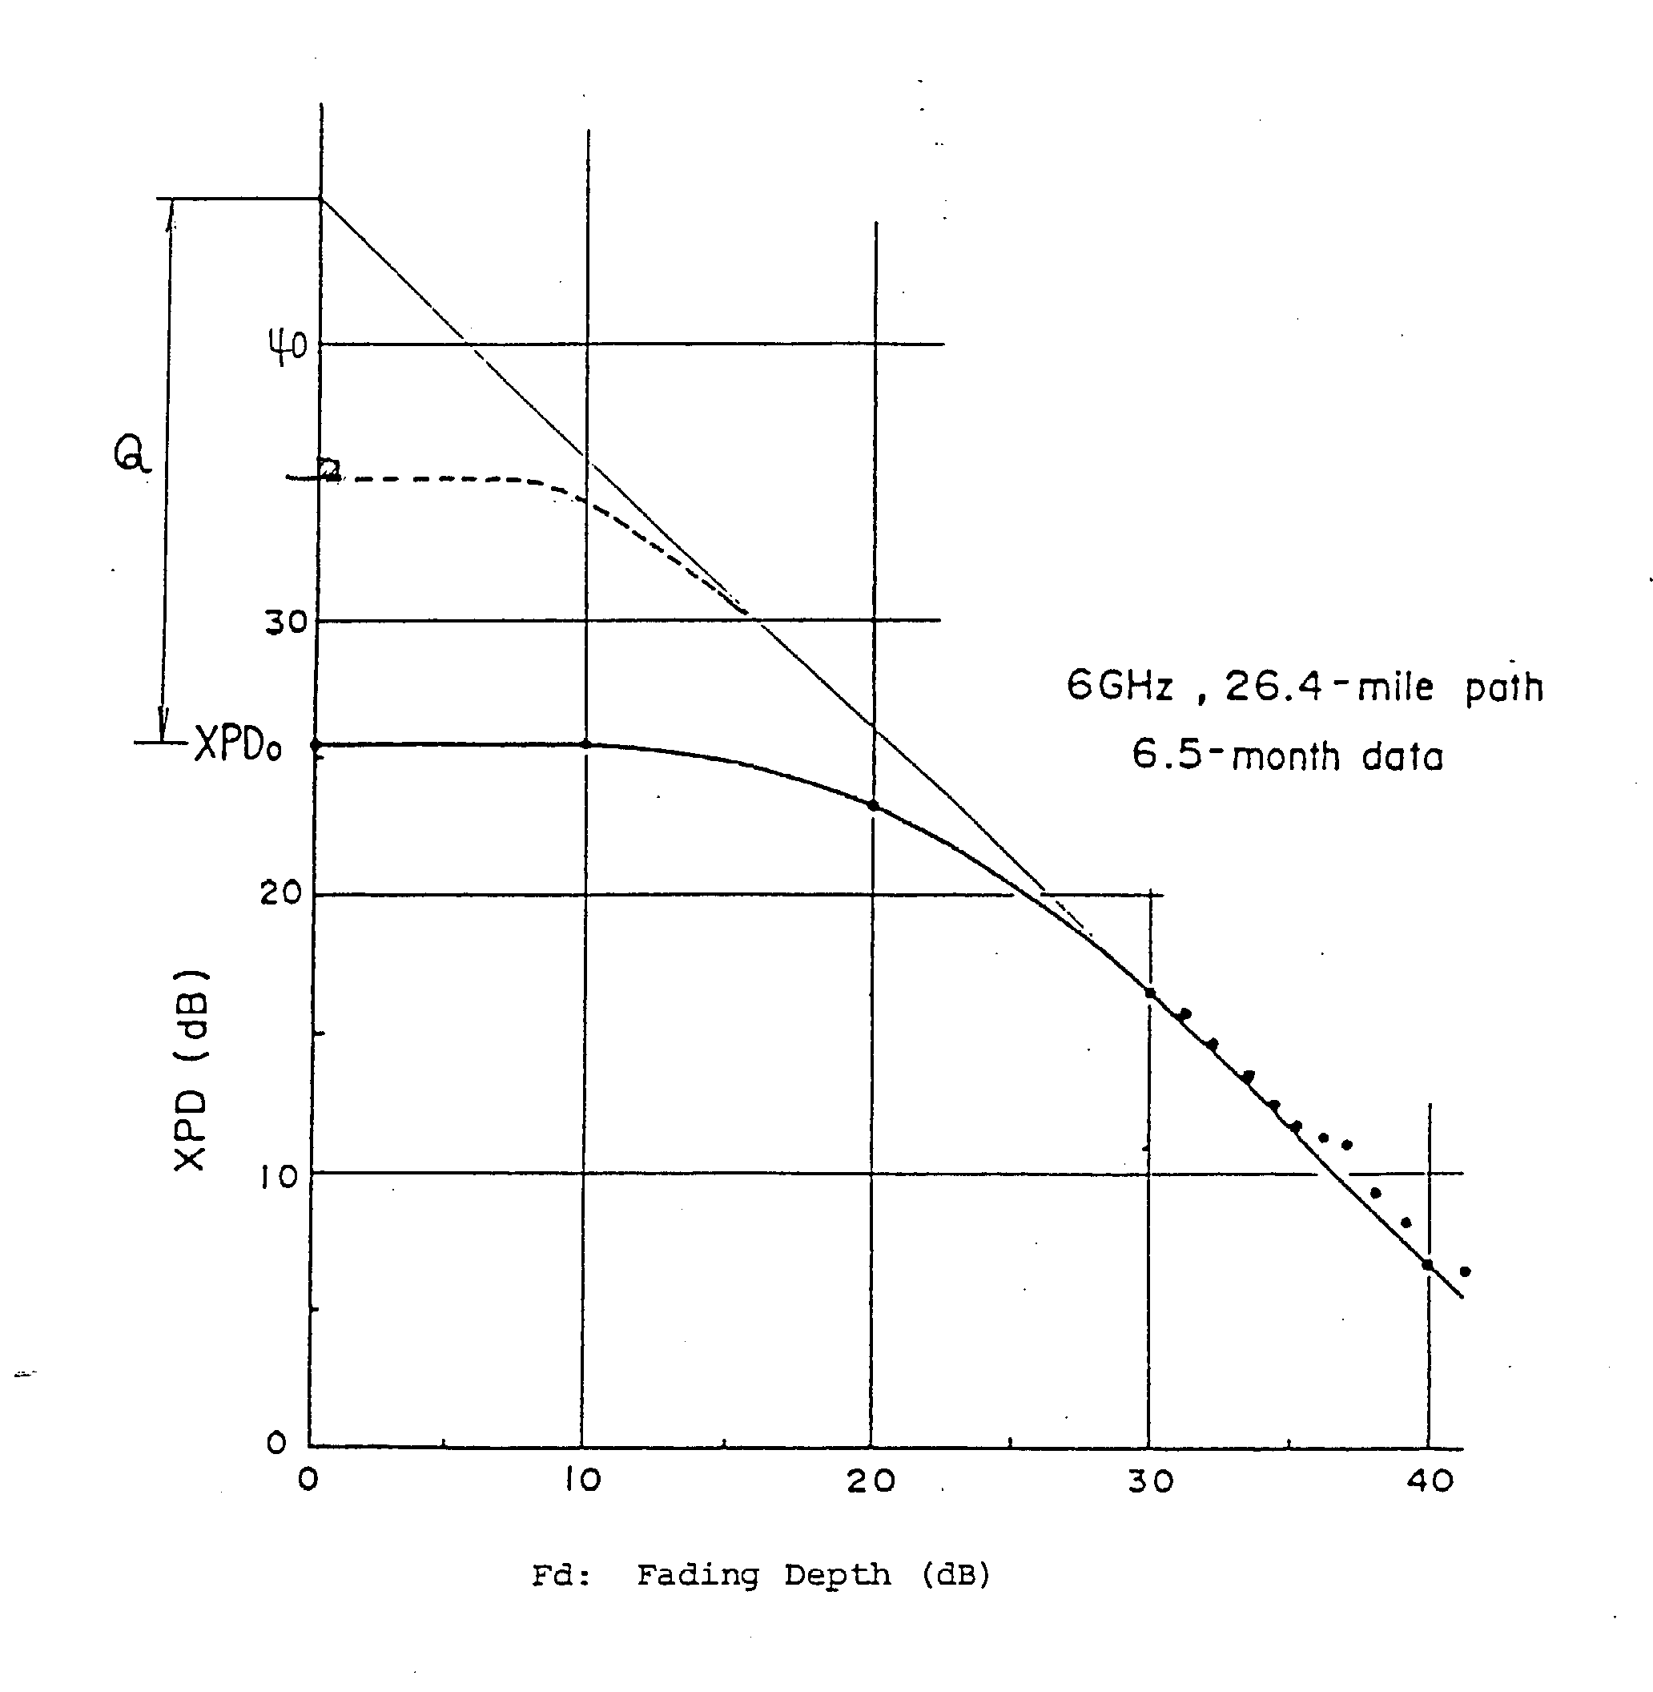
Figure 2.2.2 - Expected Cross-Polarization vs. Fading Depth

In order to maintain the XPD between the two polarizations even under fading conditions, equipment developers have turned their attention to designing antennas with increased XPD characteristics about the antenna boresight and cross-polarization interference cancellers (XPIC) utilizing transversal equalizing technology. Since terrestrial systems often transmit several RF carriers simultaneously, adjacent channel interference should be addressed at the same time by proper filter designs with sharp cut-off characteristics. A 256QAM system, for example, will improve the band efficiency from approximately 7 bits/Hz to 14 bits/Hz.
The XPIC circuit takes samples of the interfering signals and applies them to the desired signals for cancellation of the interference. The cancellation may be done at either RF, IF or at the baseband level. The complexity of the XPIC circuitry increases with multilevel coded modulation schemes, and systems that employ 256QAM and 512QAM modulation states call for very sophisticated XPIC designs. The benefits to be gained, however, are very reliable communications links even in the face of severe fading.
Due to controlled imperfections in the antennas, some interference will be expected in the IF signals. The vertically polarized carrier will have interference from the horizontally polarized carrier, and vice versa. The amount of interference is dependent on the antenna XPD and the amount of fading. In the absence of fading, the interference is minimum and acceptable.
Fig 2.2.3 shows the improvement that can be expected in XPD performance by using cross polarization interference canceller circuits. This figure indicates measured results for a system employing 128QAM modulation techniques at a constant BER rate of 1 x 10⁻³ under flat fading conditions. The expected improvement is approximately 20 dB.

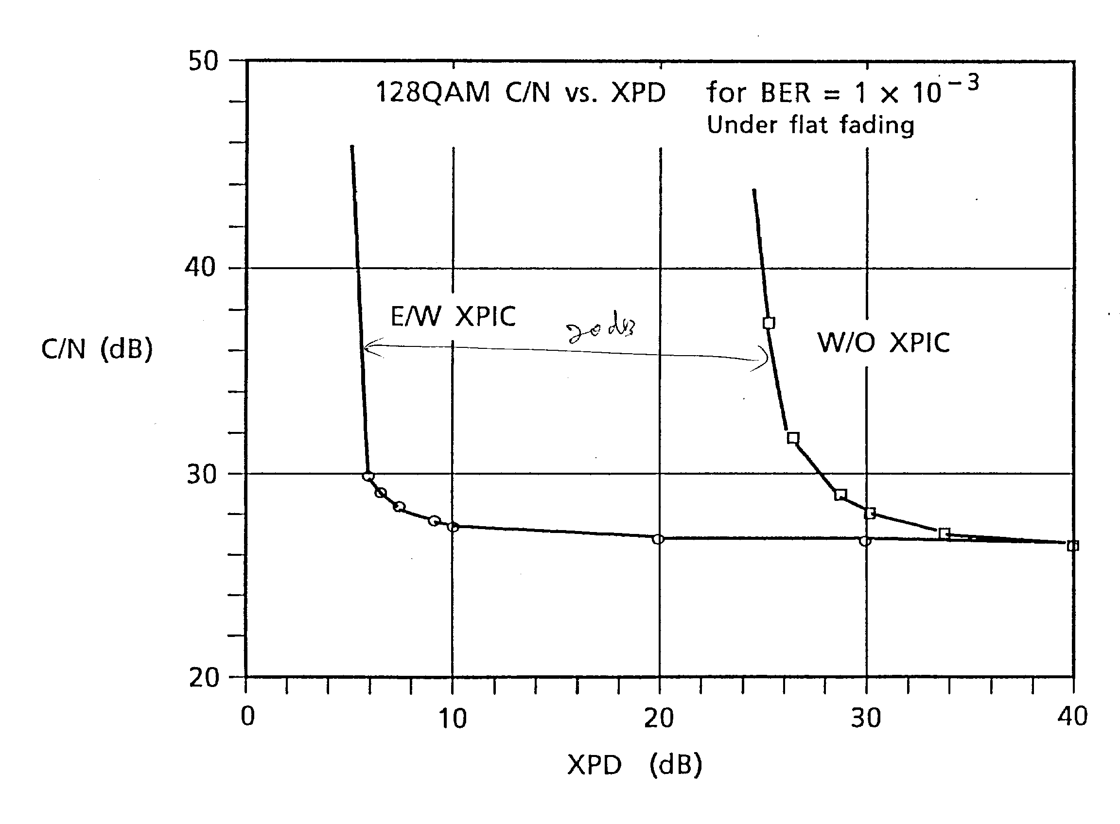
Figure 2.2.3 - Measured XPD Improvement by Using XPIC Equipment
- Automatic Transmission Power Control (ATPC)
Inclusion of automatic transmission power control (ATPC) circuitry in DMR systems will reduce interference particularly between channels on the same route and between channels transmitted from the same system site. By using ATPC, several advantages are accomplished, including: (1) reduction in angular separation between adjacent radial routes, (2) reduction in the distant interference between hops which reuse the same frequency, (3) reduction of interference between adjacent digital and analogue channels that share the same frequency band.
Further equipment related advantages by using ATPC are realized, including: (4) reduction in the DC power consumed by the RF amplifier. This reduction may be quite significant (up to 40%), (5) improvement in the residual BER performance (typical 1 x 10⁻¹³),
The dynamic range of ATPC circuits is typically between -12 dB and + 2 dB in controlled steps of 1 dB with fading tracking speed of 100 dB/sec, and the threshold level of the received signal may be preset in a range between -50 dBm and -70 dBm.
- Equalizers for Counteracting Multipath Fading
Multipath fading is of major concern on most DMR links implemented in the world. Traditionally, the adverse effects of multipath fading have been mitigated by installing redundant equipment operating in space diversity or frequency diversity configurations.
Another way to combat the effects of multipath fading is to use adaptive equalizers in time or frequency domains. Recent technological advances have improved the performance of these equalizer circuits quite significantly, which is particularly important for DMR systems that use multi level coded modulation schemes.
Adaptive equalizers may be implemented at the IF or baseband levels, and the most common circuits in use are the so-called decision feedback equalizers (DFE) and linear transversal equalizers.
Fading effects on a digital radio link are often depicted as a system "signature", which is a static indication of the susceptibility of equipment to a two ray model of the multipath channel in both minimum phase and non-minimum phase conditions. It is often used for the purpose of equipment comparison.
Due to the dynamic nature of multipath fading, dynamic tests should be performed on the equipment. This is often done by using a dynamic simulator that can simulate the time sequences of multipath fading. Such simulation tests are used for optimisation of synchronization and equalizer coefficient adapter circuits. Fig 2.2.4. shows the measured signature of a 64QAM 155 Mbit/s digital radio system with decision feed-back circuits included. The ability of equalization against minimum phase fading of the linear equalizer is the same as that against non-minimum phase fading. In contrast to that, the adaptive time domain equalizer shown in Fig 2.2.4 equalizes minimum phase fading completely and it is possible to equalize severe fading in which the reflective wave becomes bigger than the main signal.

Figure 2.2.4 - Measured Signature of 64QAM 155 Mbit/s System With DFE

2.2.3 A Modern SDH System Utilising New Technologies
Long-haul digital microwave radio systems have been recommended by the ITU-T in 1988 to adopt Synchronous Digital Hierarchy (SDH) configuration, in an effort to synchronize equipment over wider geographical areas. SDH systems are thus taking over from Plesiochronous Digital Hierarchy (PDH) systems which have been in operation for a number of years. SDH equipment should be designed and implemented with a smooth transition from PDH in mind.
SDH systems generally operate in frequency bands between 4 and 13 GHz using 64 or 128 Quadrature Amplitude Modulation (QAM) and have transmission capacity of Synchronous Transmit Module 1 (STM-1). They can be accommodated in existing RF frequency channel slots vacated by PDH systems.
A modern SDH digital microwave radio system should include features that make it easy to operate and maintain, and which make the most effective use of the available RF bandwidth. New technological advancements as outlined in this book should be included to the extent possible. Features that should be implemented include:
* Conformity with the latest international standards, specifically ITU-R, ITU-T and ETS standards.
* Protection against fading such as Frequency Diversity (FD) and/or Space Diversity (SD) switching. Furthermore, the system should be traffic capacity expandable preferably by simply adding equipment modules.
* The system gain should be high by using receivers with low noise figures. In systems utilizing FD and/or SD protection switching, the switching should not result in any drastic reduction in Bit Error Rate (BER) performance.
* Multi-Level Coding Modulation (MLCM) should be used in order to ensure improved effectiveness and performance. Coding gain should be optimized and coding redundancy should be minimized to enable insertion of additional 2.048 or 1.544 Mbit/s service channel(s) in the Radio Frame Complementary Overhead (RFCOH) field.
* Automatic Transmit Power Control (ATPC) should be considered in order to reduce interference to neighbouring systems, improvement of the residual BER performance, alleviation of fading problems, and reduction in power consumption.
* Decision Feedback Equalizers (DFE) or other suitable equalization schemes should be included in order to reduce inband dispersive amplitude and delay distortion caused by multi-path fading.
* Two different external synchronization clocks should be available for redundancy purposes. This should be in addition to an internal oscillator clock.
* The SDH system should be capable of being integrated into existing PDH baseband networks. Upgrading of the interface to STM-1 transmission should be software selectable.
* The Section Overhead (SOH) should preferably be terminated in two directions, i.e. not only for the radio section but also for the electrical or optical line section which is terminated at the radio station.
* The system should be equipped with an electrical or an optical STM-1 interface for each channel. The optical interface should be available for two or more different cable lengths: for intra-office and long haul inter-office applications.
- In addition to the STM-1 or 140 Mbit/s main traffic stream, several (Digital Service Channels (DSC), and depending on the MLCM scheme used, one or two additional 2.048 or 1.544 Mbit/s service channel(s) should be dropped and inserted at every terminal and repeater radio station. These channels should be transported in the RFCOH.

* Extensive performance monitoring and control functions should be built into the equipment. Such parameters should be in conformance with ITU-T G.784. Furthermore, a count should be kept of the number of protection switch-over operations, and an account of the failed time for individual channels. Such functions should preferably be performed from a Network Management System (NMS).
* In order to enhance the reliability of the equipment and extend the MTBF figure, extensive use of LSI Microwave Integrated Circuits (MIC) and Hybrid IC (HIC) should be implemented. Furthermore, low-power high-speed Complementary Metal Oxide Semiconductor (CMOS) LSI should be used wherever possible in order to make the equipment more compact and reduce the power consumption.
* Equipment should be installed in standard racks with room for expansion, and should be able to operate over a wide range of environmental conditions.
* The equipment should be flexible and should be reconfigurable.
* Orderwire communications should preferably be implemented with a priority orderwire and an omnibus orderwire using SOH bytes E2 and E1, respectively. The orderwire channels should provide voice communications throughout the entire SDH radio network using selective calling facilities by means of Dual Tone Multifrequency (DTMF) signalling.
* Management features should be designed in accordance with, amongst others, ITU-T Recommendations of the M.3000 series and G.784. This enables interconnection to TMN-based Network Management System (NMS) from various vendors by means of the so-called Q3 interface (see more information see Fascicle 2, Chapter 5 Network and Service Management).

2.2.4 Multiple Access Radio Systems
Despite the fact that people all over the world are crowding into metropolitan or urban areas in ever increasing numbers, the major part of the world's population is still living in rural areas and to a large extent has the same aspirations and requirements for telecommunications services as their counterparts in the big cities. Such rural population is often spread thinly over vast geographical areas.
National telecommunication organizations that have been charged with providing communications to all areas of a country have traditionally not had many options available to them, and particularly not for providing high-grade services like television and high-speed data communications. Often, the only choice has been a pair of copper wires.
With the advent of high-powered satellites in recent years, VSAT (Very Small Aperture Terminal) systems can be used for providing high-speed data and television services to rural areas. Such systems may be established quickly and rather inexpensively per terminal. However, VSAT systems are normally looked upon as low capacity facilities, and covering a vast thinly populated area with VSAT terminals may be an expensive proposition. Widespread inexpensive hand-held satellite telephone sets operating with Low or Medium Earth Orbit (LEO/MEO) satellites are still a few years away, and in any case the initial costs and running and operating costs of such devices may put them out of reach for many rural areas (see more details in subchapter 2.4 Satellite Systems of this Fascicle).
As an alternative for rural communications, multiple access subscriber radio communication systems may be considered as an attractive solution. One such system employing modern digital technology may be implemented with up to approximately 1000 subscriber lines spread over a radius of about 1000 km from one base station. That is more than 3000 square kilometres per subscriber, and in terms of economy and services provided, such a system may compete with VSAT systems and LEO/MEO hand-held satellite telephone sets.

2.2.4.1. System Architecture
A subscriber radio system consists of three major elements, namely the base station, repeater stations and terminal (subscriber) stations. A system may be implemented in a homogeneous configuration (typical of an urban system), or in a linear configuration (typical of a rural system). These systems operate in the 1.5-2.4 GHz frequency bands and typically use TDM (Time Division Multiplexing) technology with 60 time slots for 1024 subscribers in the downward direction (i.e. from the base station to the subscribers), and TDMA (Time Division Multiple Access) technology in the upward direction. Voice channels are encoded at 64 kbit/s Pulse Code Modulation (PCM). Such a system is often referred to as a Digital Radio Multiple Access Subscriber Systems (DRMASS). In newer systems the voice coding is done at 32 kbit/s Adaptive Differential PCM and the number of time slots is approximately doubled.
A subscriber radio system is constructed with cells in a honeycomb configuration, not unlike cellular radio systems for mobile users. Fig 2.2.5 shows the basic concept of subscriber radio system and Fig 2.2.6 is an example of a typical cell arrangement and frequency allocations for a 14-channel DRMASS system. The base station is typically located at the same site as a metropolitan or urban telephone exchange for easy interface of the DRMASS circuits into the national telephone network. The interface may be either digital (for example at 2 Mbit/s) or 2-wire analogue circuits. Each cell in the DRMASS system has radio transmit and receive equipment for passing calls on to the next cell or for communicating with subscribers under its jurisdiction.
The subscriber equipment in a DRMASS system includes multiline subscriber units for locations with several subscribers grouped together, and mini terminals for locations with a single or two subscribers in one location.
In technology recently developed, a cell in the DRMASS system may be included for mobile and/or fixed users. Such a cell is referred to as a Digital Cordless Telephone System (DCTS) cell and is used for communicating with cordless telephone sets or small fixed terminals at 32 kbit/s ADPCM (Adaptive Differential Pulse Code Modulation).

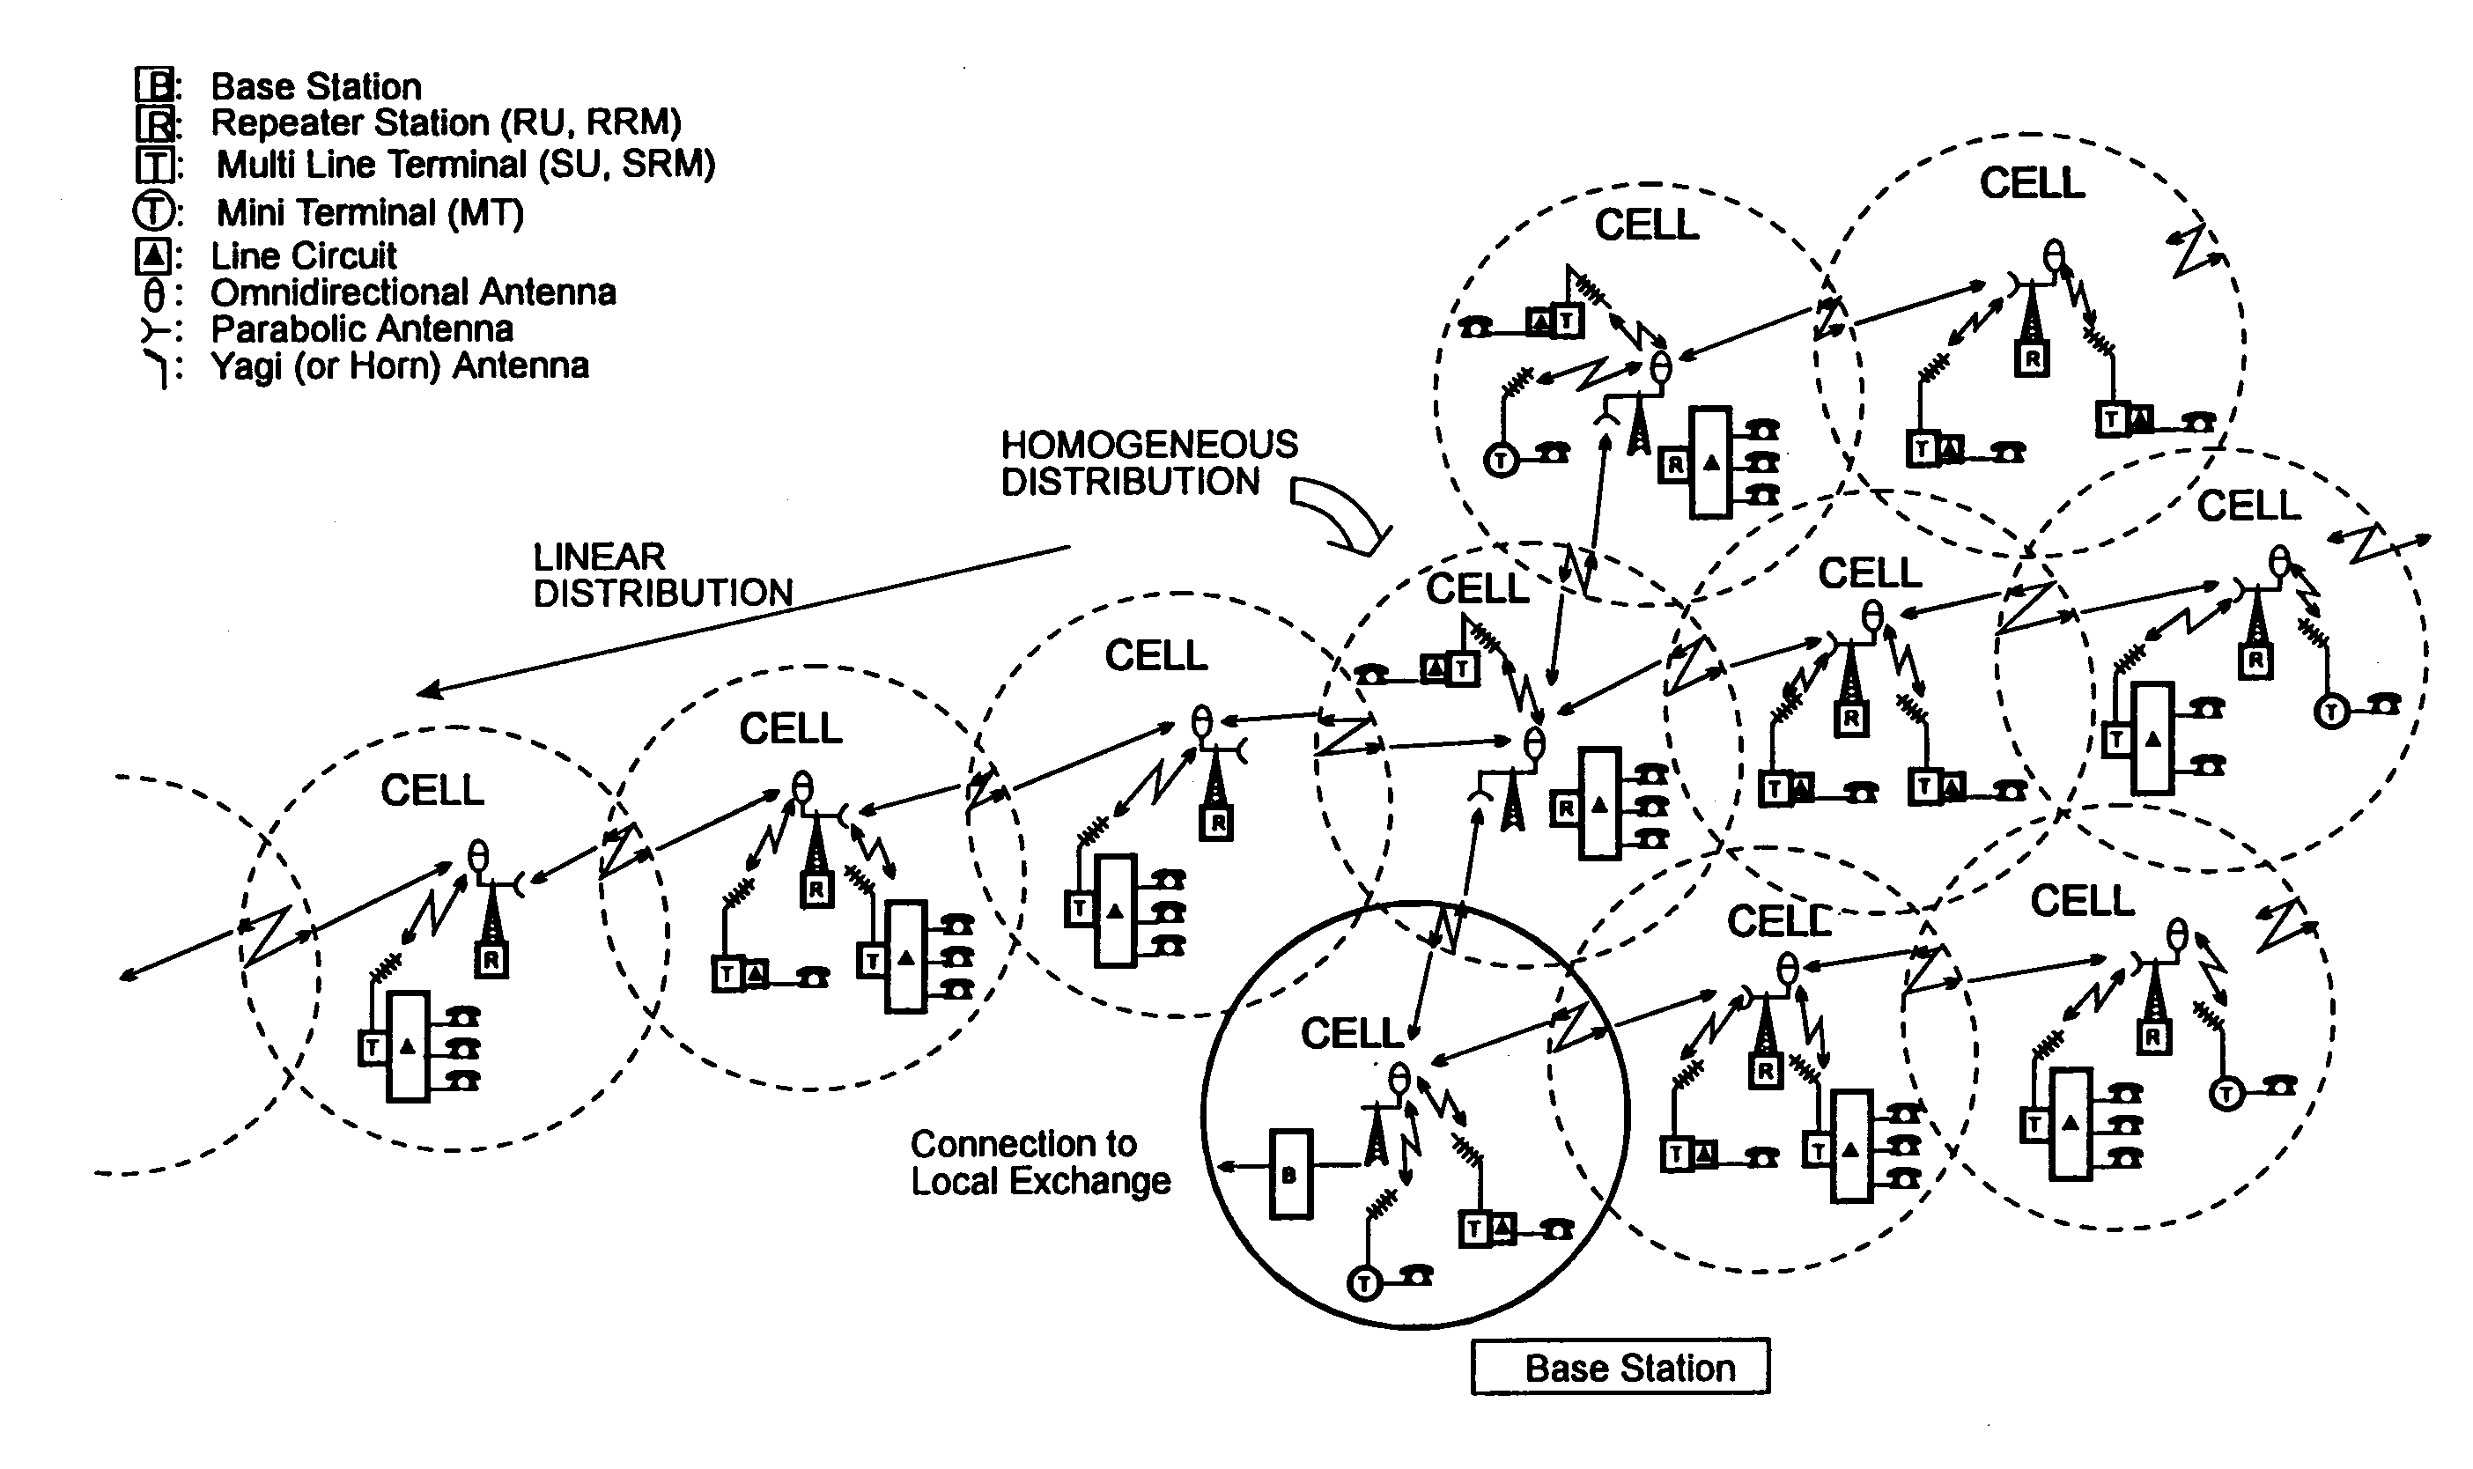
Figure 2.2.5 - Digital Radio Multiple Access Subscriber System Basic Concept

In DRMASS systems each cell repeater station can cover an area up to a radius of approximately 45 km, and a DCTS cell can communicate with fixed terminals at a radius of approximately 3 km.

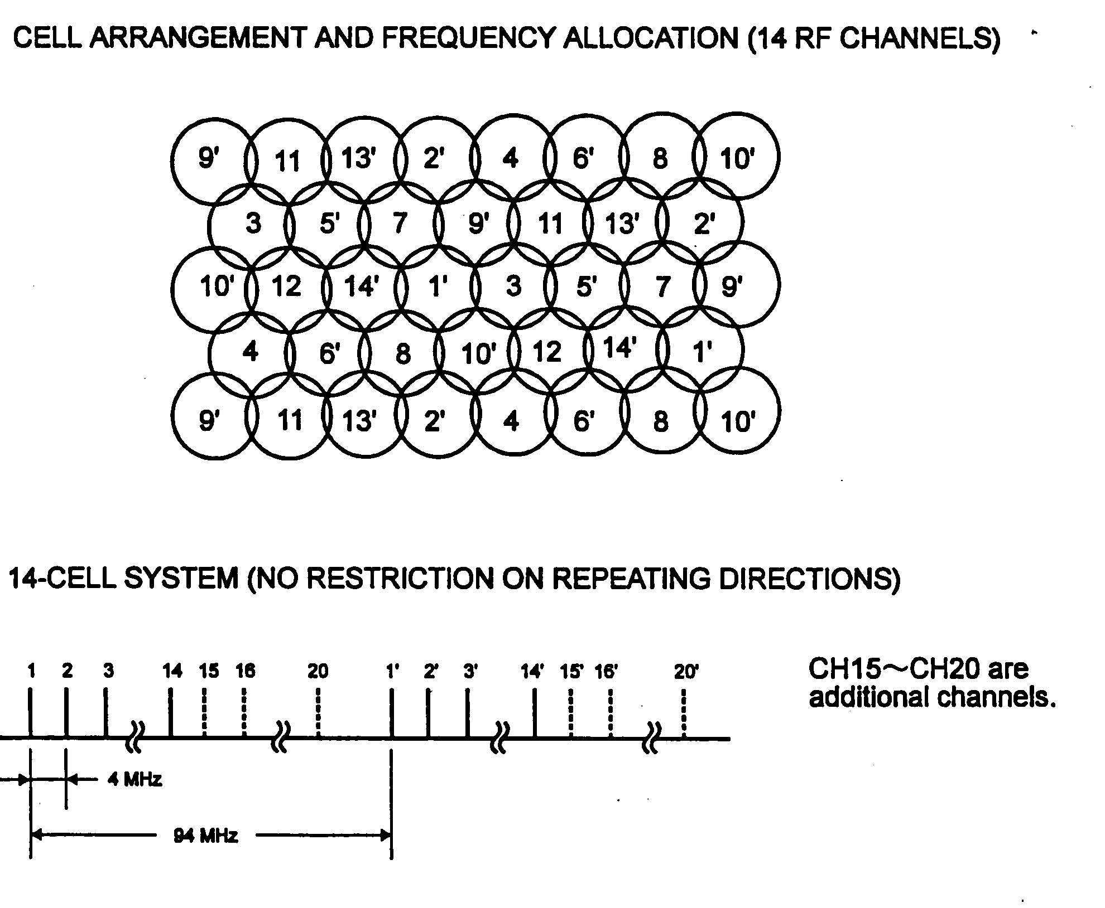
Figure 2.2.6 - Example of Cell Arrangement and Frequency Allocations for 14 Channels

A DRMASS system provides its services by concentrating a large number of subscriber lines into available time slots, and the system is normally transparent to signalling to and from the subscribers.
The telephone channels coming from the local telephone exchange are concentrated and converted to digital signals and transmitted down to the nearest repeater and onwards to other repeaters if applicable. Each repeater will communicate with its subscriber from an omni directional antenna. One time slot among the 60 slots is automatically assigned to the subscriber making a call. For the upward transmission from the subscriber via a repeater station to the base station, the subscriber is assigned a time slot and his transmission is in burst mode (TDMA) without any risk of overlapping with other subscribers. Only one pair of frequencies is used for upward and downward transmissions.
In Fig 2.2.7 the overall frame format for one frame is shown together with the various fields of information in the frame. Fig 2.2.8 shows a typical format for one subscriber time slot channel (so-called V-channel).
The radio frame consists of 60 voice channels (V CH), one control channel (C CH), one supervisory channel (SV CH), one orderwire channel (OW CH), one telegraph channel (TELEX CH), one acquisition and local maintenance channel (ACQ/LOCAL CH), and a frame synchronization pattern (F, F’). The frame period is 4 msec, and the frame pattern is allocated 7 bits in the leading section of both the C CH and the ACQ/LOCAL CH channels. The first part of the leading section is a fixed word of 5 bits and the remaining 2 bits is a variable word (ID NO.). These words are used to discriminate between the routes, and as frame identification. Identifications of every 16 frames are done by a test module. The polarity of the ACQ/LOCAL CH and the C CH is inverted in the fixed word and this polarity alternates at intervals of 2 msec.
Frame synchronization uses a one bit shift hunting method, and synchronizing protection is achieved by 3 continuous ‘yes’/4 continuous ‘no’ pulses.
Each V CH, OW CH and SV CH has 152 bits for both upward and downward signal flows and consists of the actual data (for example 64K voice) and control information. In the upward signal flow, two guard time slots are provided at the beginning and the end of the frame. The C CH has 128 bits and is used for sequencing call connections. The ACQ/LOCAL CH has 280 bits. When in the acquisition mode, it is used for delay adjustments at the initial system line-up. When in local maintenance mode it is used for delay fine adjustments. The TELEX CH also has 152 bits and may be used for low data rates (up to 19.2 kbit/s) or up to 40 telex channels. The V CH has the same structure when used for telex or data service. Modulation is normally QPSK, and therefore 2 bits of PCM data are transmitted per symbol. Hence, for a 4 ms frame, 256 bits of PCM data are transmitted (64 kbit/sec) per V CH.

Figure 2.2.7 - Frame Format in a DRMASS TDM/TDMA System

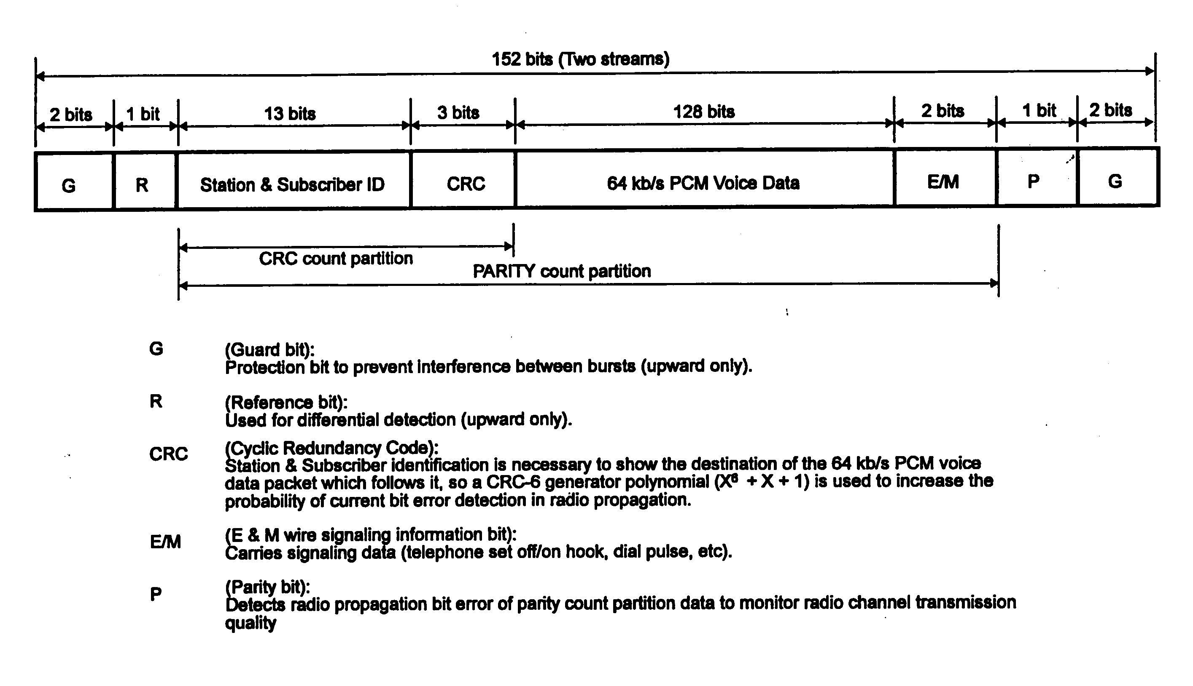
Figure 2.2.8 - Frame Format of Subscriber Time Slot

- Services Provided and Grade of Service
A modern multiple access subscriber radio system operates at a high technology level and should be able to provide at least the following services:
* Ordinary telephone service
* Coin telephone service
* Data transmission, typically up to 384 kbit/s which, with modern software, is adequate for providing PC-to-PC medium quality video conferencing
* Telex service
* Dedicated (pre-assigned) telephone and data channels
* 4-wire communications with E&M signalling
* Intra-call service. This refers to calls between subscribers using the sam
terminal station.
* Emergency priority call service. If used, non-priority calls may be dropped.
* Priority automatic call-back service. If a subscriber has this priority, his call may be placed in a queue if the system is busy. He will be called back
automatically ahead of ordinary call-backs when a channel is available.
* Ordinary automatic call-back service
* Call forwarding on busy/no response/unconditional status
* Call waiting
* Three-way calling
* Supervisory Control and Data Acquisition (SCADA) operations
* 4-wire DAMA (Demand Assigned Multiple Access) service
* ISDN (Integrated Services Digital Network) service
Since a DRMASS system utilizes the concentrator concept, the maximum number of subscribers that can be handled in a system is a function of the average traffic generated by each subscriber, the desired blocking probability, and the number of time slots.
Based on experience, the average business hour traffic call rate of a DRMASS system is typically set at 0.09 erlang/line. This is for an example design where coin telephone sets (0.3 erlang/line) is assumed to use 10% of the system capacity, business communications (0.1 erlang/line) constitute 30%, and residential subscriber lines (0.05 erlang/line) are 60% of the system capacity. The blocking probability (i.e. the ratio of busy calls to the total number of calls in a certain time period) is typically set at 0.01 or 1%. Based on these assumptions, a DRMASS system with 60 time slots will be suitable for 512 subscribers. However, by implementing intra-calling in the system, the number of subscriber lines can be doubled to 1024.
- The Base Station
Since in most cases a subscriber radio system has to be interfaced into a national switched telephone network, the most practical location of the base station is at an existing exchange that already may have a radio tower that can be used, and may have enough power generating AC/DC equipment to power the base station. However, where this is not practical, part of the base station equipment (including the RF modules) may be located anywhere, and the remaining equipment in the telephone exchange area as long as the two sites can be interfaced by a 2 Mbit/s digital connection or wireless communications links.
The major equipment elements in the base station are the following:
* One Base Station Controller Module (BSCM)
* One TDM Controller Unit (TCU) including RF transmitter, receiver and antenna.
* One or several Loop Open End Modules (LOEM)
* One or several Data Units (DU)
* A computerized supervisory and control system for operations and
maintenance purposes
If for some reason it is not practical to install all the base station equipment at the telephone exchange site, the radio tower with antenna and the TCU module may be installed in a separate location and connected to the BSCM by two 2 Mbit/s links.
The functions of the base station communications equipment are described as follows:
- Base Station Controller Module (BSCM)
This module is acting as a concentrator and provides 2-wire interface with up to 1024 subscriber line circuits. It will concentrate 1024 telephone lines and convert them into 60 time slots in two 2.048 Mbit/s TDM data streams. The concentrator contains processor units which, under stored program control, perform call sequencing and execute remote supervision of the complete system.
- Loop Open End Modules (LOEM) and Data Units (DU)
The LOEM module(s) provide(s) the interface to the local exchange by plug-in cards. Typically, two types of cards are available, namely one for 8 ordinary telephone lines and one for 4 coin telephone lines. The type and quantity required depend on the LC (Line Circuit) configuration in the subscriber and repeater stations.
The DU module contains plug-in cards for data channel interfaces with the telephone exchange. The configuration of these cards depends on the overall DRMASS system configuration and contains interfaces for data ports, telex channels, and 4-wire E&M signalling.
- TDM Controller Unit (TCU)
The TCU converts the two 2.048 Mbit/s data streams from the concentrator into two 2.496 Mbit/s radio TDM signals for the "downward" transmit path and reverses this for the "upward" receive path. Orderwire and supervisory/maintenance signals are multiplexed/demultiplexed in the TCU. Duplicated (working and standby) configuration is normally implemented for higher reliability. In addition, an unprotected version is available for low-cost applications. The TCU can be located remotely from the BSCM concentrator equipment via two 2.048 Mbit/s communications links with ITU-T G.703 interfaces.
The radio or TDM part of the TCU performs the following functions:
* It converts the two 2.048 Mbit/s data streams from the concentrator to packet data for radio communications, and multiplexes the control, supervisory and maintenance signals onto the packet data. The data is modulated and transmitted to the nearest repeater station and onwards to the next repeater station(s) and subscriber stations, as applicable.
* It receives the burst mode TDMA RF signals from the nearest repeater station, regenerates the packet data, removes the control, supervisory and maintenance information from the baseband data and converts the signals into two 2.048 Mbit/s data streams and sends them to the concentrator.
Within the TCU, a main processor controls the TCU side of the data transfer between the TCU and the BSCM for control of the radio protocol. The frame converter converts the baseband 2.048 Mbit/s PCM frame to the radio frame 2.496 Mbit/s format (upward), and from 2.496 Mbit/s to 2.048 Mbit/s (downward). It also multiplexes and demultiplexes the radio frames, and supervises radio transmission errors.
The 60 time slots are transmitted in RF carriers using QPSK modulation. Transmitter power is typically about 1 watt from a transistor amplifier, and the receiver has a noise figure of about 3 dB. It will maintain its operation with acceptable BER rates down to about - 85 dBm. Depending on the system configuration, omni directional antennas (gain = 10 dB), or up to 4-meter parabolic antennas (gain = 32-37 dB) are typically used.
- The Repeater Stations
The repeater stations serve two main purposes. Firstly, a certain repeater station will communicate with subscribers within its coverage area. Typically, a total of 256 subscribers may be located in this coverage area. Secondly, it will pass on a call to the next repeater if the call is not intended for one of its own subscribers. There is no real limitation to the number of repeaters in a system, but due to practical considerations one DRMASS system is rarely implemented with more than 23 repeaters and an overall distance of 1080 km.
Fig 2.2.9 shows a block diagram of a segment of a typical DRMASS system configuration. 2 repeater stations and 2 subscriber stations are shown (one mini-terminal with 2 telephone lines served by the base station, and one multi-line terminal which may contain up to 16 telephone lines, served by a repeater station).
The repeater station receives the "downward" signal stream transmitted from the base station (or preceding repeater station). After regenerating the signal, the repeater transmits it on a different radio frequency, not only to the subscriber units within its service area, but also to neighbouring repeaters for further repeating. The "upward" signal is transmitted towards the base station in the reverse direction.
The multiple use of repeaters allows the service area to be expanded to virtually any distance without any noticeable degradation in the signal quality because digital transmission with regeneration of signals is used.
A repeater station may be implemented as an indoor unit or an outdoor unit. The major equipment blocks are the repeater unit itself for receiving, regeneration, and retransmission of RF signals, and one or more drop-out unit. One drop-out unit will typically serve 64 subscribers in an outdoor-type repeater station. Indoor repeaters may contain up to 4 drop-out units for service to 256 subscribers.

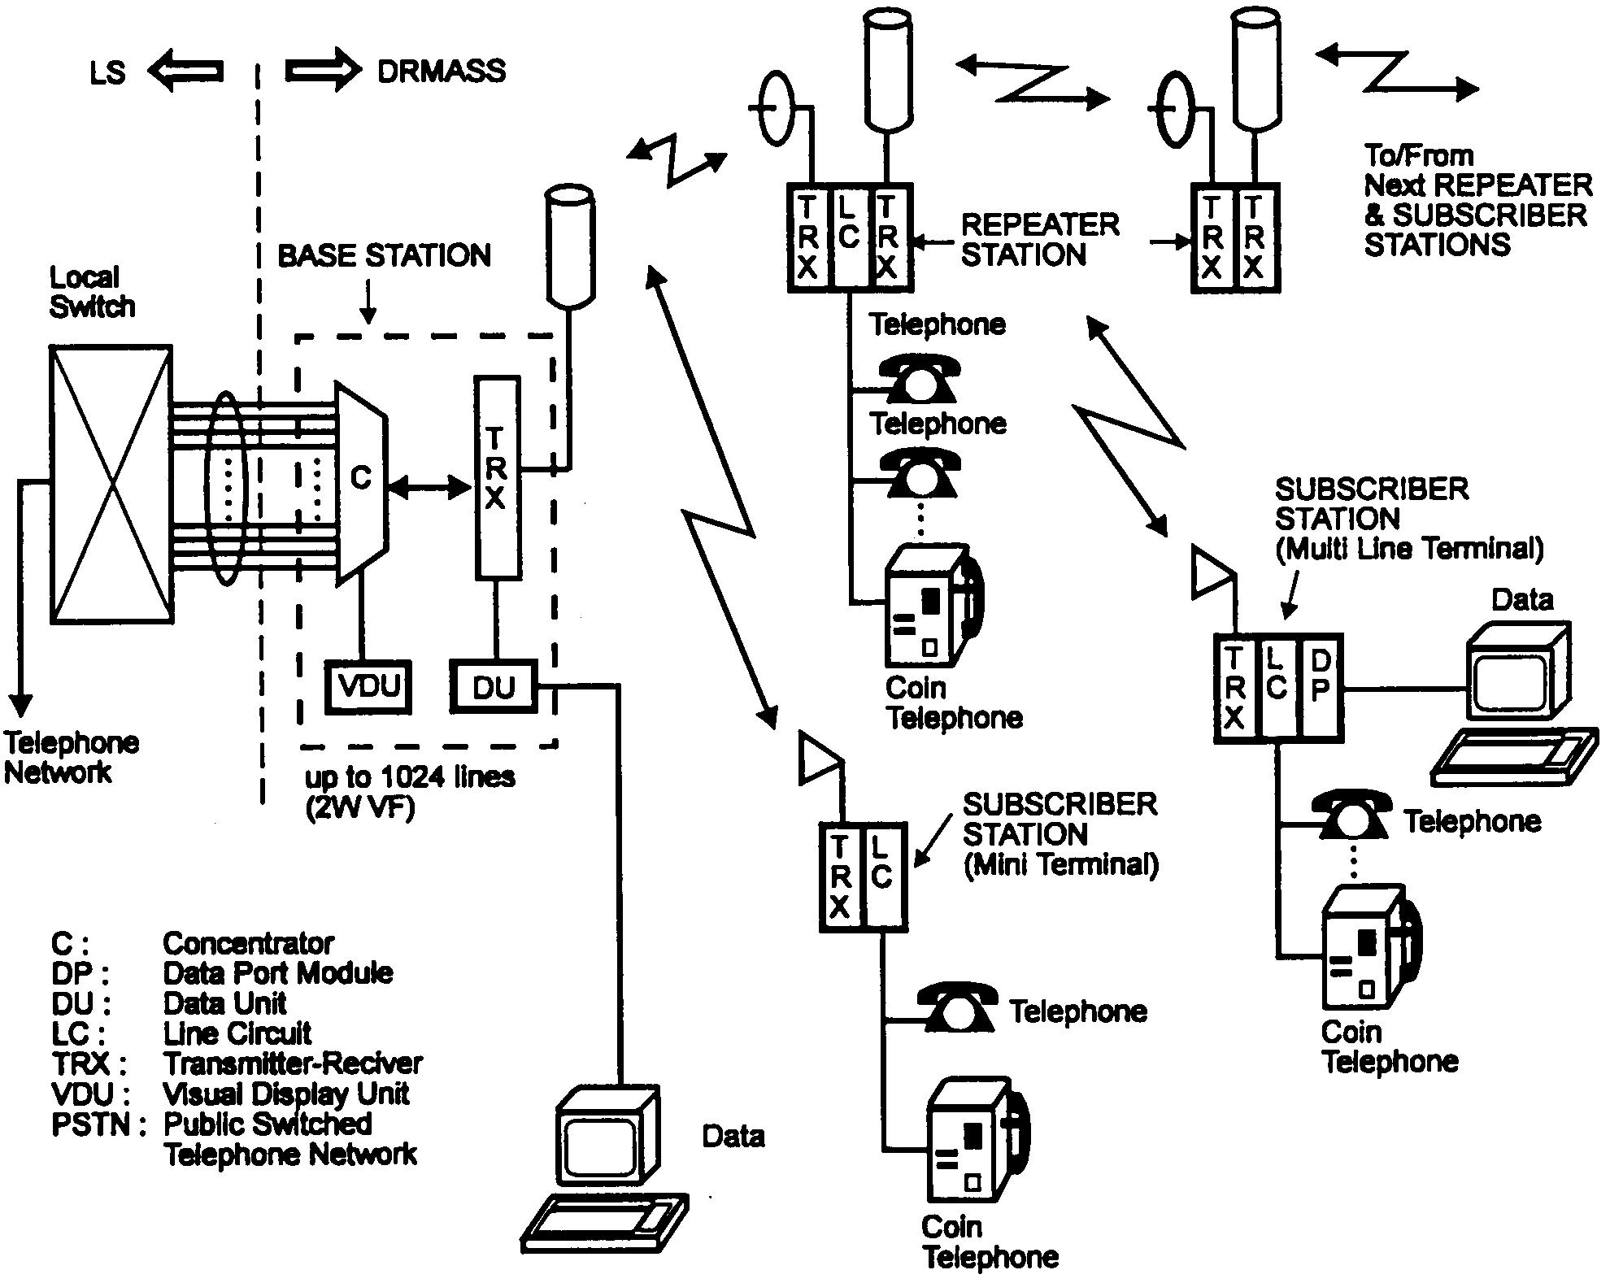
Figure 2.2.9 - Example Segment of DRMASS System Configuration

- The Subscriber Stations
A subscriber station may be a multi-line terminal or a mini-terminal. A multi-line subscriber station is composed of a SU (Subscriber Unit) and a DOU (Drop-out Unit) combination for a capacity of up to 64 subscribers for out-door type repeaters. Alternatively, a SRM (Subscriber Rack Mount) and a DORM (Drop-out Rack Mount) combination may be used to provide up to 256 subscribers capacity (indoor type repeater). The mini-terminal for indoor installation is for small subscriber capacities (typically one telephone set and one coin telephone line).
Due to the low power consumption of the subscriber units achieved by the use of LSI technology, solar-powered operation is made possible for these terminals. The terminal equipment and solar control unit including batteries can be accommodated in small cabinets suitable for installation either on a wall of an existing building or on an antenna pole in an outdoor environment.
A subscriber station performs the following functions:
* It receives the RF transmission from the base or repeater station and regenerates the 2-wire analogue telephone signal information and relays this information to the proper subscriber line.
* It detects incoming call requests from the subscriber line and converts the 2-wire analogue telephone signals to RF bursts which are transmitted to the repeater or base station.
Data port cards may be substituted for voice cards in order to provide data communications channels.
The mini-terminal is suitable for locations where only one or two subscriber lines are required. These lines may be a combination of services such as two telephone sets, two coin telephone lines, one telephone and one coin line, one telephone line and one data line, or one coin telephone line and one data line.
- Digital Cordless Telephone System (DCTS) Cell Stations
Small economical mobile or fixed telephony terminals with limited range may be integrated into a subscriber radio system. These terminals are using the most advanced digital cordless telephony technology and may be operated within a range of 3-5 km from a DCTS cell station for fixed terminals and up to about 1 km for portable handsets. Fig 2.2.10 shows a conceptual drawing of a cell station with all electronic equipment including power supply mounted on a pole.
Portable terminals will typically use a short whip antenna, and fixed installations will use a small pole-mounted Yagi antenna. The terminals use 32 kbit/s Adaptive Differential Pulse Code Modulation (ADPCM) and dynamic channel assignment is employed in the system. The DCTS cell stations also operate in the 1.9 GHz band. A maximum of 52 subscribers can access one cell station by using TDMA techniques with a traffic loading of 0.1 erlang and a 1% blocking rate. Voiceband data and fax service may be used up to a speed of 7.2 kbit/s.
- Centralized Operations and Maintenance Control
In trend with operating and maintaining modern communications systems, multiple access subscriber radio systems will have automatic centralized operations and maintenance facilities. This is in particular important for a system employed for rural communications where all equipment is operating unattended often in inhospitable environments, and where technical expertise is unavailable and long in arriving if required.

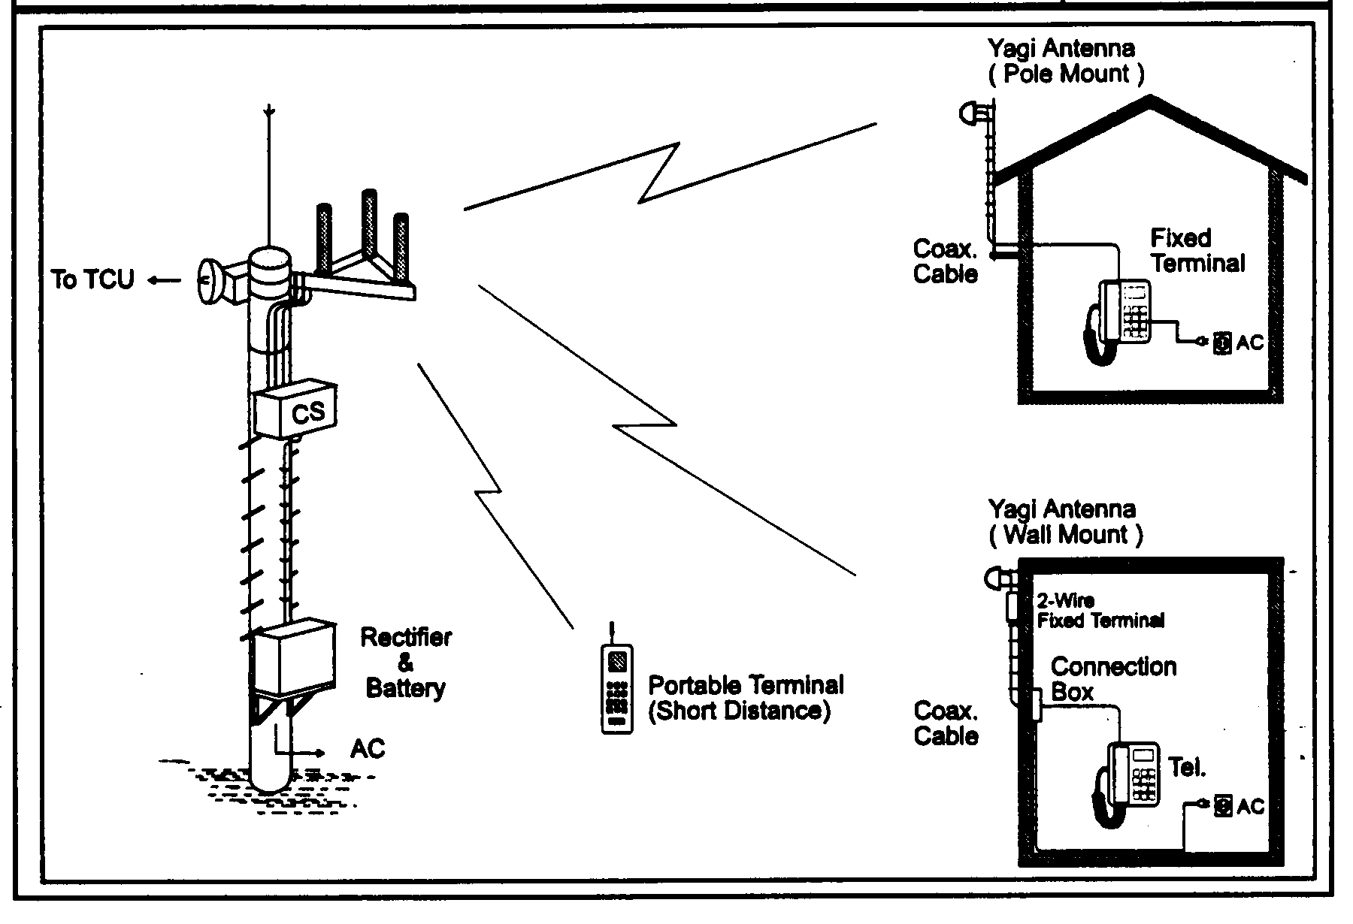
Figure 2.2.10 - DCTS Cell Station (CS)
A centralized operations and maintenance system will normally be co-located with the base station equipment and will contain facilities for overall system equipment status monitoring, maintenance and testing. Specifically, from one central position, one operator should be able to monitor and control functions within the following areas:
- Alarm status and reporting
- Subscriber line testing (insulation resistance/capacitance), and test calls to specific subscribers
- Traffic statistics reporting
- System reconfiguration
All above functions should be performed remotely and controlled from the base station. If such a system is implemented together with the multiple access subscriber radio system, it is possible to operate a 1024 subscriber system spread over a 1080 km radius from the base station with one maintenance engineer and one technician, provided the equipment is designed to modern MTBF (Mean Time Between Failures) requirements.

2.2.5 Digital Radio Networks

a) Long haul digital radio systems
Long haul, high capacity digital radio systems can be competitive with optical fibre, especially in difficult terrain, like mountains, across lakes or rivers, in urban areas with expensive or unavailable rights-of-way, or where speed of deployment is important. Also, digital long haul radio systems can re-use a vast system of towers and buildings, previously used by analogue radio systems employed in national backbone telecommunications networks. Channel capacities employed by these systems are the maximum that can be achieved with high-state QAM modulation schemes. A large number of channels may be operated on the same route by using an n + 1 switching system. Because of the long distances involved the lower frequency bands of 4 and 6 GHz have been widely used in many countries.

b) Short haul digital radio systems
Today digital radio systems find a major application in all those cases where cable laying would be difficult, costly and time consuming. Digital radio systems can be deployed very rapidly, especially if small unobtrusive antennas can be located on existing buildings or towers and distances are relatively short. Equipment operating at frequencies above 15 GHz meet these requirements very well because they are small, rugged and economical. The explosive growth of cellular networks for mobile radio has generated a large market for these millimetre wave radios. They interconnect cell sites with Mobile Switching Centres (MSC) using capacities that are relatively low, ranging from 1-DS1 to 4-DS1 or 1-E1 to 4-E1. Because of the low capacity, protection is sometimes omitted or otherwise provided by automatic hot standby switching. And since hop lengths are often short there is no need for frequency or space diversity protection against multipath fading. Rain attenuation is the predominant cause of signal outage, which can be kept within ITU requirements by the use of high system gain radios and short hops.
Where larger hop lengths are required, digital radios operating below 15 GHz have to be used. The 2 GHz band was used extensively in the United States of America for low capacity connections by power and gas companies. This band has now been allocated to various PCN uses and the existing radio services can be redeployed in the Lower 6 GHz (L6), Upper 6 GHz (U6) and 11 GHz bands which have been opened up for low capacity digital applications. These bands are not affected by rain fading and therefore provide large distance capabilities. Space and frequency diversity systems are used here as countermeasures for multipath fading with frequency diversity systems normally operated in the form of an n + 1 protection switching system. In the interest of spectrum conservation, the FCC in the United States of America demands that the number n grows to at least 3 within three years after first deployment on a route. This rules out permanent 1 + 1 frequency diversity systems. Other countries may have other rules or no such requirements.
c) Radio Local Area Networks (RLAN)
Today’s computer-based business activity largely depends on communication infrastructure provided by local area networks (LANs). LANs have to be extended in line with the increase of terminal users, and therefore designed to handle bursty traffic in order to efficiently share computer resources. However a wired LAN has many constraints in the aspects of cost, maintenance and installation in particular for networks with complicated architecture
Many types of RLAN exist including those already put into service or to be realized in the near future. Table 2.2.1 summarizes typical examples of RLANs using frequency bands above 1 GHz and having maximum data rate higher than 1 Mbit/s.
Information on wireless local loop technologies is available in Fascicle 2 Chapter 4.2.2.1.

2.2.6 ITU Publications
ITU-R Handbook on Digital Radio-Relay Systems issued in the 1996 represents a comprehensive summary of basic principles, design parameters and current practices for design and engineering of digital radio-relay systems. It is issued in all ITU languages.
Another useful ITU Handbook is Rural Telecommunications, Volume I – Radio Systems in Rural Areas, 1994.

Frequency band | Modulation  and/or access scheme | Data rate (typical) | Application | Range(1)  (typical)
403-470 MHz  806-869 MHz  946 MHz | 4-level FSK | 19.2 kbit/s | ARDIS(2) subscriber equipment | ARDIS service area
850 MHz (cellular) | FSK | 14.4 kbit/s  9.6 kbit/s  (Fax) | Personal communication via cellular phone | Cellular phone service area
902-928 MHz | Frequency hopping (FSK) | 64 kbit/s to  500 kbit/s | Point-to-point data link campus and private networks | 4 km
 | Direct sequence | 2 Mbit/s  215 kbit/s to 1.0 Mbit/s | Portable LAN  Ethernet LANs | 250 m  100 to 1 000 m
 | CDMA/TDMA spread spectrum | 1.536 Mbit/s line rate | Personal communication networks | 450 to 5 000 m2
 | Direct sequence with  1.5 MHz frequency channel selection | 60 kbit/s | Bar-code reading | 120 to 210 m
 | Direct sequence  PSK trellis code | 5.7 Mbit/s | Ethernet LAN (IEEE 802.3) | 80 m
2.4 to 2.4835 GHz  2.4 to 2.485 GHz  (transceiver to hub)  5.745 to 5.830 GHz  (hub to transceiver) | CDMA, direct sequence frequency hopping  Direct sequence 16 PSK trellis code | 1 Mbit/s (Approx.)  5.7 Mbit/s | –  Ethernet LAN (IEEE 802.3) | –  80 m
5.2 GHz | GMSK  (BT = 0.4) | 24 Mbit/s  Raw data rate | High performance RLANs  (HIPERLANS) | 50 m
17.2 GHz | Specification in progress | Specification in progress | High performance  RLANs  (HIPERLANS) | Specification in progress
18.8 GHz  19.2 GHz | TDMA-TDD  4-FSK | 15 Mbit/s | Ethernet LAN | 40 m  (maximum)
19.5 GHz | TDMA-TDD  4-FSK | 25 Mbit/s | Ethernet LAN | 40 m  (maximum)
(1) The range of operation of RLAN systems may vary greatly depending on data rate, frequency, RF power, antenna and the propagation environment.
(2) ARDIS: advanced radio data information service.
Table 2.2.1 - Examples of RLAN Characteristics

    - Abbreviations

ACQ/LOCAL CH Acquisition and Local Maintenance Channel
ADPCM Adaptive Differential Pulse Code Modulation
AMPS Advanced Mobile Phone System
ARDIS Advanced Radio Data Information Service
ATPC Automatic Transmission Power Control
BCM Block Coded Modulation
BER Bit Error Rate
BSCM Base Station Controller Module
C CH Control Channel
CDMA Code Division Multiple Access
CMOS Complementary Metal Oxide Semiconductor
CRC Cyclic Redundancy Check
DAMA Demand Assigned Multiple Access
DCS Digital Cellular System
DCTS Digital Cordless Telephone System
DFE Decision Feedback Equaliser
DMR Digital Microwave Relay
DOU Drop-out Unit
DORM Drop-out Rack Mount
DRMASS Digital Radio Multiple Access Subscriber System
DRRS Digital Radio Relay System
DTMF Dual Tone Multi-Frequency
DU Data Unit
ETS European Telecommunication Standard
FCC Federal Communications Commission
FD Frequency Diversity
HIC Hybrid Integrated Circuit
IC Integrated Circuit
IF Intermediate Frequency
ISDN Integrated Services Digital Network
ITU International Telecommunications Union
ITU-R International Telecommunications Union – Radiocommunications
LAN Local Area Network
LC Line Circuit
LEO Low Earth Orbit
LOEM Loop Open End Module
LSI Large Scale Integration
MEO Medium Earth Orbit
MIC Microwave Integrated Circuits
MLCM Multi-level Coded Modulation
MLSE Maximum Likelihood Sequence Estimation
MSC Mobile Switching Centre
MTBF Mean Time Between Failure
NMS Network Management System
OCH Orderwire Channel
PCM Pulse Code Modulation
PCN Personal Communication Network
PDH Plesiochronous Digital Hierarchy
PSK Phase Shift Keying
QAM Quadrature Amplitude Modulation
QPSK Quadrature Phase Shift Keying
RF Radio Frequency
RFCOH Radio Frame Complementary Overhead
RLAN Radio Local Area Network
RR Radio Regulations
RRC Regional Radiocommunication Conference
SCADA Supervisory Control and Data Acquisition
SD Space Diversity
SDH Synchronous Digital Hierarchy
SOH Section Overhead
SONET Synchronous Optical Network
SRM Subscriber Rack Mount
STM-1 Synchronous Transmission Module 1
SU Subscriber Unit
SV CH Supervisory Channel
TCM Trellis Coded Modulation
TCU TDM Controller Unit
TDM Time Division Multiplexing
TDMA Time Division Multiple Access
TELEX CH Telex Channel
V CH Voice Channel
VSAT Very Small Aperture Terminal
XPD Cross Polarisation Discrimination
XPDo Cross Polarisation Discrimination in normal condition
XPIC Cross Polarisation Interference Canceller

2.3 MOBILE COMMUNICATION SYSTEMS
2.3.1 Introduction
Mobile radio systems provide their users with opportunities to travel freely within the service area being able to communicate with any telephone, fax, data modem, and electronic mail subscriber anywhere in the world; to determine their own positions; to track precious cargo; to improve the management of fleets of vehicles and the distribution of goods; to improve traffic safety; and to provide vital communication links during emergencies, search and rescue operations, etc. These tieless (wireless, cordless) communications, exchanges of information, determination of position, course, and distance travelled etc. are made possible by the unique property of the radio to employ an aerial (antenna) for radiating and receiving electromagnetic waves. When the user’s radio antenna is stationary over a prolonged period of time, the term fixed radio is used; a radio transceiver capable of being carried or moved around, but stationary when in operation, is called a portable radio; a radio transceiver capable of being carried and used, by a vehicle or by a person on the move, is called mobile radio. Individual radio users may communicate directly or via one more intermediaries, which may be passive radio repeater(s), base station(s), or switch(es). When all intermediaries are located on the Earth, the terms terrestrial radio system and radio system are used; when at least one intermediary is satellite borne, the terms satellite radio system and satellite system are used. According to the location of a user, the terms land, maritime, aeronautic, space, and deep-space radio systems are used. The second unique property of all terrestrial and satellite radio systems is that they all share the same natural resource – the airwaves (frequency bands and the space).

Recent developments in microwave monolithic integrated circuit (MMIC), application specific integrated circuit (ASIC), analogue/digital signal processing (A/DSP), and battery technology, supported by computer aided design (CAD) and robotics in manufacturing allow a viable implementation of miniature radio transceivers. The continuous flux of market forces (excited by the possibilities of a myriad of new services and great profits), international and domestic standards forces (who manage the common natural resource- the airwaves), and technology forces (capable of creating viable products), acted harmoniously and created a broad choice of communications (voice and data), information, and navigation systems, which propelled an explosive growth of mobile radio services for travellers.

The terms fixed (radio) service and mobile (radio) service are defined by the IUT Radio Regulations:

Fixed service: a radiocommunication service between specified fixed points.
Mobile service: a radiocommunication service between mobile and land stations, or between mobile stations.

Indeed, these radio service definitions form the basis for the allocation of radio spectrum internationally by the ITU as well as domestically within each country. For the most part, the ITU has made joint allocations to the mobile and fixed services in various frequency bands. Traditionally, in some countries a choice has been made between the two services.

2.3.2 Spectrum
Key input parameters to the design of a wireless network are teledensity over time and subscriber usage (e.g., Erlangs per subscriber). These variables establish the traffic density (e.g., Erlangs per square kilometre) that the wireless system needs to support. The availability of spectrum, channelization of the particular radio access technology, the extent to which frequencies can be re-used, and cell-size, all influence the traffic carrying capacity of a radio-based system. Wireless access systems, from an RF planning/network viewpoint, are deployed in a similar way to cellular systems, even though the teledensity requirements may be different. Radio spectrum requirements and availability need to be examined. Figure 2.3.1 shows bands of the radio spectrum where fixed wireless access systems operate in some countries. The precise availability of radio spectrum for these applications is subject to local regulations. For example, in addition to the bands 1.4 and 2.4/2.6 GHz, the 3.5 GHz band has been endorsed by CEPT/ETSI, as is the 10.5 GHz band for use in Europe. Also, in Region 2 the 3.4 -3.7 GHz band is being considered for wireless access applications in some countries. The applications shown in Figure 2.3.1 for different frequency bands may be known by different names which are related to the traditional use of these bands. However, the common underlying aspect is wireless access, which may take many flavours depending on the signal transfer capabilities offered (e.g., voice, data, image, video), mix of service (e.g., purely fixed, mixed fixed/mobile, nomadic), and range (e.g., use of repeaters).

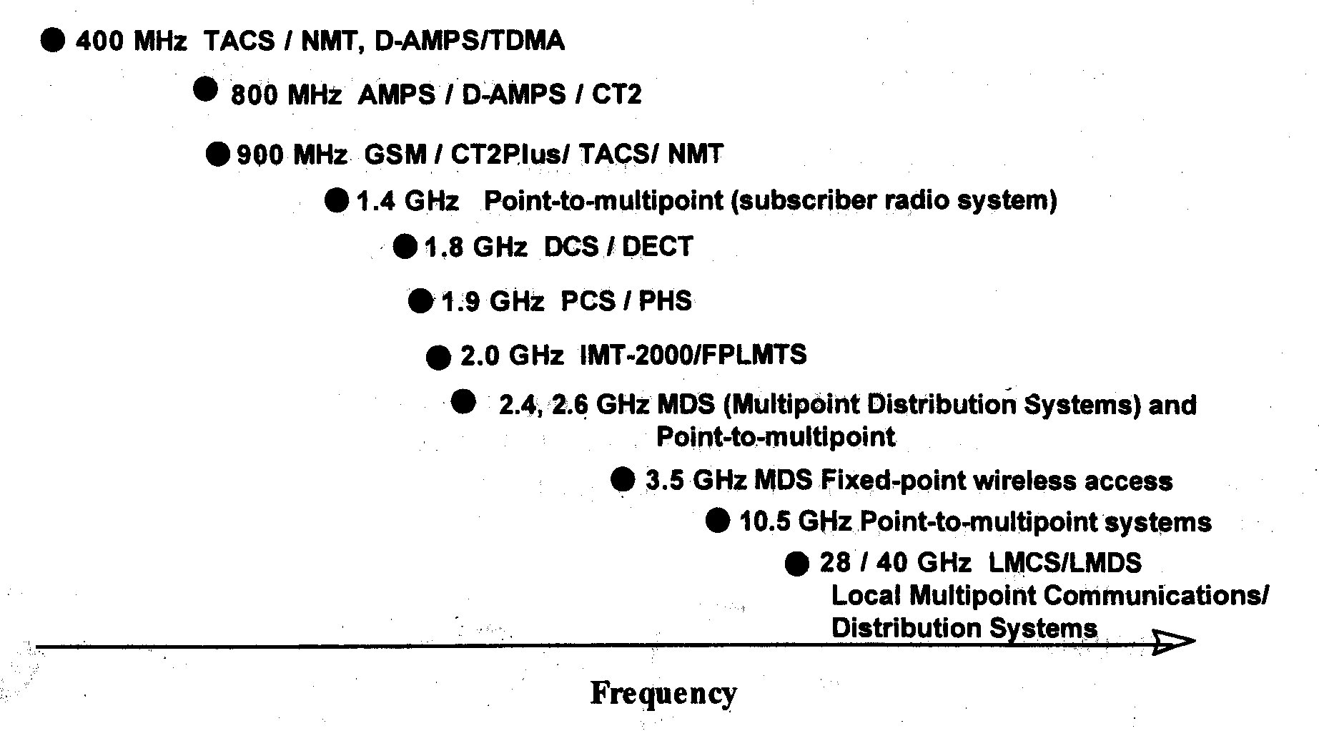

Figure 2.3.1 - Examples of bands of radio spectrum for wireless access

The choice of technology needs to be related to capacity and cost requirements as it is shown in Figure 2.3.2.

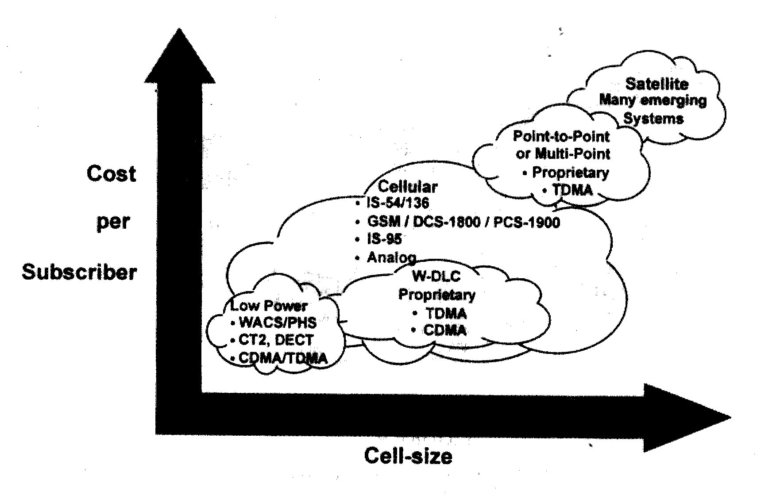

Figure 2.3.2 - Mapping technology onto appropriate requirements

2.3.3 Terrestrial Systems
In a terrestrial mobile radio network, a repeater was usually located at the highest point in the vicinity, offering maximum service area coverage. As the number of users increased, the available frequency spectrum became unable to handle the increased traffic, and a need for frequency reuse arose. The service area was split into many small sub-areas called cells, and the term cellular radio was born. Frequency reuse offers an increased system capacity, whereas the smaller cell size can offer an increased service quality but at the expense of increased complexity of the user's terminal and network infrastructure. The tradeoffs between real estate availability (base stations) and cost, the price of equipment (base and mobile), network complexity, and implementation dynamics dictate the shape and the size of a cellular network.

2.3.3.1 Analogue Cellular Technologies
Analogue cellular modulation is based on the principle of Frequency Modulation (FM). The speech to be transmitted is used to modulate the carrier causing it to be varied in amplitude and frequency. Most analogue cellular systems use Frequency Modulation (FM) for speech and Frequency Shift Keying (FSK) for data. In analogue cellular systems, a traffic channel is usually modulated on one radio frequency.
Table 2.3.1 gives some of the operating analogue cellular radio systems: the North American AMPS, the Japanese land MCS-L1 and MCS-L2, the Nordic NMT-900, the German C450, and the United Kingdom’s TACS.

PARAMETER | AMPS | MCS-L1  MCS-L2 | NMT | C450 | TACS
TX freq. MHZ  Base  Mobile | 869-894  824-849 | 870-885  925-940 | 935-960  890-915 | 461-466  451-456 | 935-960  890-915
Multiple Access | FDMA | FDMA | FDMA | FDMA | FDMA
Dulpex Method | FDD | FDD | FDD | FDD | FDD
Channel bw, kHz | 30.0 | 25.0  12.5 | 12.5 | 20.0  10.0 | 25.0
Traffic Channela  per RF Channel  Total Traffic Channels | 1  832 | 1  600  1200 | 1  1999 | 1  222  444 | 1  1000
Voice | Analog | Analog | Analog | Analog | Analog
Sylabic comp. | 2:1 | 2:1 | 2:1 | 2:1 | 2:1
Speech rate kb/s | - | - | - | - | -
Modulation | PM | PM | PM | PM | PM
Peak dev. KHz | + 12 | + 5 | +5 | + 4 | +9.5
Ch. Rate kb/s | - | - | - | - | -
Control | Digital | Digital | Digital | Digital | Digital
Modulation | FSK | FSK | FFSK | FSK | FSK
BB waveform | Manch. | Manch. | Manch. | Manch. | Manch.
Peak dev., kHz | + 8 | + 4.5 | +3.5 | + 2.5 | +6.4
Ch. Rate, kb/s | 10.0 | 0.3 | 1.2 | 5.3 | 8.0
Channel coding | BCH | BCH | B 1 | BCH | BCH
Base –Mobile | (40.28) | (43.31) | Burst | (15.7) | (40.28)
Mobile-Base | (48.36) | a.(43.31)  p.(11.07) | Burst | (15.7) | (48.36)

Table 2.3.1 - Comparison of Radio Systems

AMPS –Advanced mobile phone system
The AMPS air interface is currently specified by the American National Standards Institute, Electronic Industries Association (EIA), and Telecommunications Industry Association (TIA). The current version is EIA/TIA-553.
- Nordic mobile telephone (NMT)
Standard Nordic systems (NMT) are designed to operate within the 400-470 MHz band. NMT was developed in the late 1970's, and was operational before cellular systems were implemented. This system operates in a manner similar to a cellular system and is used by Iceland, Sweden, Finland, Switzerland and Holland. A modified version is also used by Denmark.
- Total access communication system (TACS)
Total Access Communication System (TACS) is a 15 MHz frequency spectrum used in Europe, some parts of Asia, the Middle East and Africa.

Channel spacing 25 kHz
Duplex spacing 45 MHz
Frequency range for channels:
Base receive/mobile transmit 890.0125- 904.9875 MHz
Base transmit/mobile receive 935.0125 -949.9875MHz
Total number of voice channels 558
Signalling channels 42

- Expanded total access communication system (E-TACS)
E-TACS adds an additional 16 MHz of spectrum to the existing TACS system and is considered an extension of TACS No additional signalling channels are provided; however, 640 voice channels are allocated -320 for Band A and 320 for Band B. Transmit and receive frequencies are separated by 45 MHz.

Channel spacing 25kHz
Duplex spacing 45 MHz
Frequency range for channels:
Base receive/mobile transmit 872.0125- 887.9875 MHz
Base transmit/mobile receive 917.0125- 932.4975 MHz
Total number of new voice channels 640
Total number of voice channels 1198
(TACS and E-TACS combined)
- Japanese Total Access Communication System (J-TACS) and Narrow-Band Total Access Communication System (N-TACS)
Japanese Total Access Communication System (J-TACS) and Narrow-Band Total Access Communication System (N-TACS) are single band frequency spectra currently used by Japan. The overall band occupies 10 MHz of spectrum. This allows 800 total channels. Channels are not separated into separate bands (A or B) in these systems. The original specification, J-TACS, uses only the even numbered channels. Only when the narrow specification N- TACS was implemented, did the odd channels come into use.

Channel spacing 25 kHz
Duplex spacing 55 MHz
Frequency range for voice and signalling channels:
Base receive/mobile transmit 915.025- 924.475 MHz
Base transmit/mobile receive 860.025- 869.975 MHz
Voice channels: N-TACS 752 J-TACS 376
Signalling channels: N-TACS 48 J-TACS 24

J-TACS/ N-TACS cell sites receive on the higher frequencies of the allocated spectrum transmit on the lower frequencies spectrum. Conversely, AMPS and TACS cell sites transmit on the higher frequencies and receive on the lower frequencies. As a result, J-TACS/ N-TACS subscriber units cannot be used in TACS or AMPS systems. The same is also true of the subscriber units of the TACS and AMPS systems – they cannot be used in the J-TACS/ N-TACS systems.

- Universal total access communication system (U-TACS)
Universal Total Access Communication System (U-TACS) is used in Europe, some parts of Asia, the Middle East, China and Africa. U-TACS has a 15 MHz frequency spectrum using 25 kHz channel spacing, providing up to 920 channels. The U- TACS frequency spectrum and channel allocation is the same as the combined TACS/E-TACS with the exception of the lower 8 MHz of the spectra. With 8 MHz less spectrum, U-TACS has 320 fewer channels.

2.3.3.2 Second Generation Systems
Designed during the 1980s, all of the so-called second generation mobile communication systems are digital. For voice calls, digitally encoded speech is transmitted on the radio interface using one of the many available digital modulation schemes. To offset the processing complexity required for these digital systems, two advantages are 1) the possibility of using spectrally efficient radio transmission schemes (e.g., time division multiple access [TDMA] or code division multiple access [CDMA]) in comparison to the analogue frequency division multiple access (FDMA) schemes previously employed; and 2) the ability to implement of a wide variety of (integrated) speech and data services and security features (e.g., encryption).
Typical cellular, cordless, and PMR network architectures are represented in Fig.2.3.3.These are reference models which may not always fully apply to all systems described hereafter.

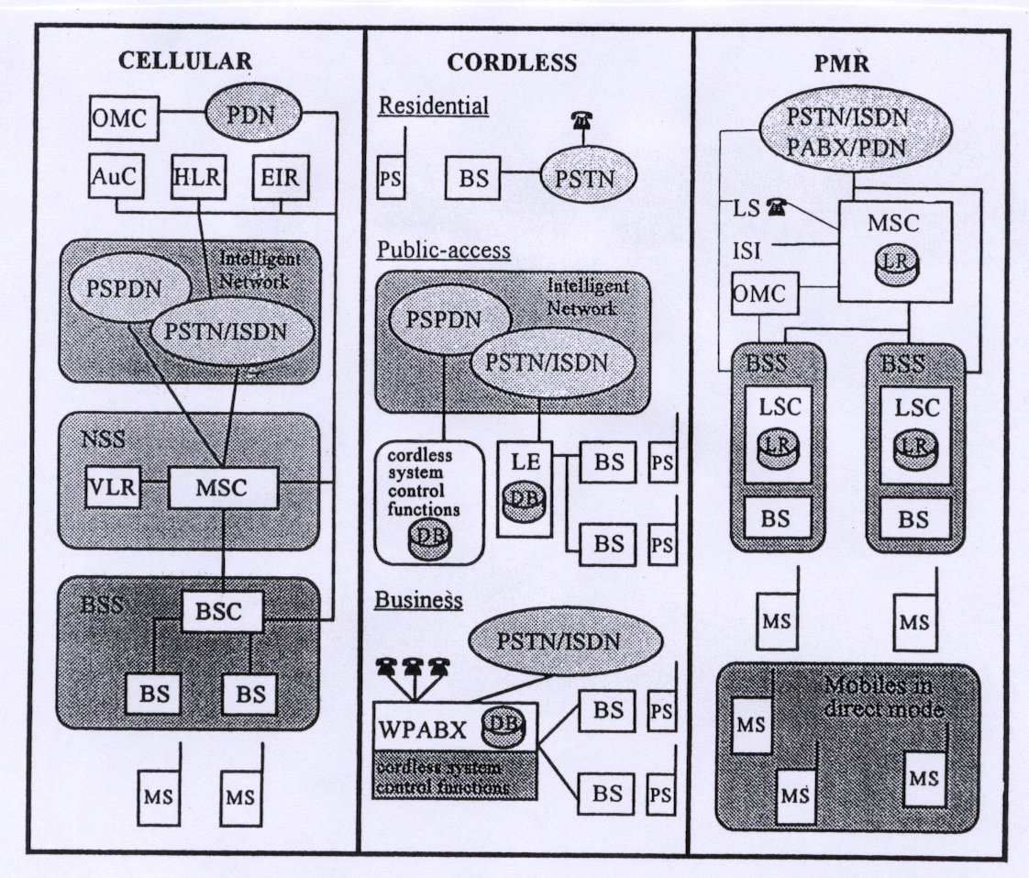

Figure 2.3.3 - Network reference models.
In cellular systems, the base station subsystem (BSS) comprises a base station controller (BSC) and radio transceivers (BS or BTS) which provide radio communication with MS in the covered area. The network subsystem (NSS) includes dedicated mobile switching equipment (MSC) linking all system elements through leased lines to PSTN, ISDN, and Packet Switched Public Data Network (PSPDN). The home and visitor location registers (HLR/VLR) are databases containing mobile subscriber data and used for subscriber registration and mobility management. Copies of the subscribers' secret keys are stored in the authentication centre (AuC) and the mobile equipment serial numbers are stored in the equipment identity register (EIR). ITU-T Signalling System No.7 (SS#7) and related application protocols are often used in the mobile network. All system elements are operated, controlled, and maintained by the operation and maintenance centre (OMC).
The cordless network architecture depends on application. For residential use, the portable station (PS) behaves like a regular telephone and has direct access to the PSTN through the private BS. In a public-access system, BSs are connected to a local exchange (LE) containing a local database (DB) used for subscriber registration and mobility management in the covered area. The LEs are connected to the PSTN /ISDN (for the purpose of traffic routing) and to centralized elements of the cordless system through the PSPDN (for signalling exchange). These centralized elements perform control functions (user identification, charging, network management) and may contain a centralized database that stores location updates of the cordless subscribers and, therefore, enables routing of incoming calls. For business applications, the same private automatic branch exchange (PABX) may be used for both wire and wireless access. The wireless PABX (WPABX) interconnects the BSs of the private network. Cordless subscribers can therefore access other private wired subscribers or the PSTN/ISDN. The WPABX generally incorporates the subscriber DB and control functions of the cordless system.
The architecture of a PMR network is somewhat similar to that of cellular networks, but the BSS is generally consists of a single piece of equipment incorporating the BS and the local station controller (LSC). Since the LSC contains a copy of the subscribers location register (LR), local calls (which represent a significant part of the traffic) can be established and routed locally in the BSS, thus achieving a short call set-up time and maintaining local operation, even in fallback mode, if the BSS-MSC link is interrupted. Inter-site calls are routed through the MSC and access to other networks (PSTN/ISDN /PDN), or devices (PABX) may be provided either at MSC or BSS level. Line stations (LS) may be connected directly to BSS or MSC, or through an intervening network (e.g., ISDN). Interworking of different PMR networks of the same standard is provided through the intersystem interface (ISSI). Mobiles may also use direct simplex communications (direct mode), either autonomously or while keeping contact with the network (dual watch).
The major second generation systems are described in Table 2.3.2.

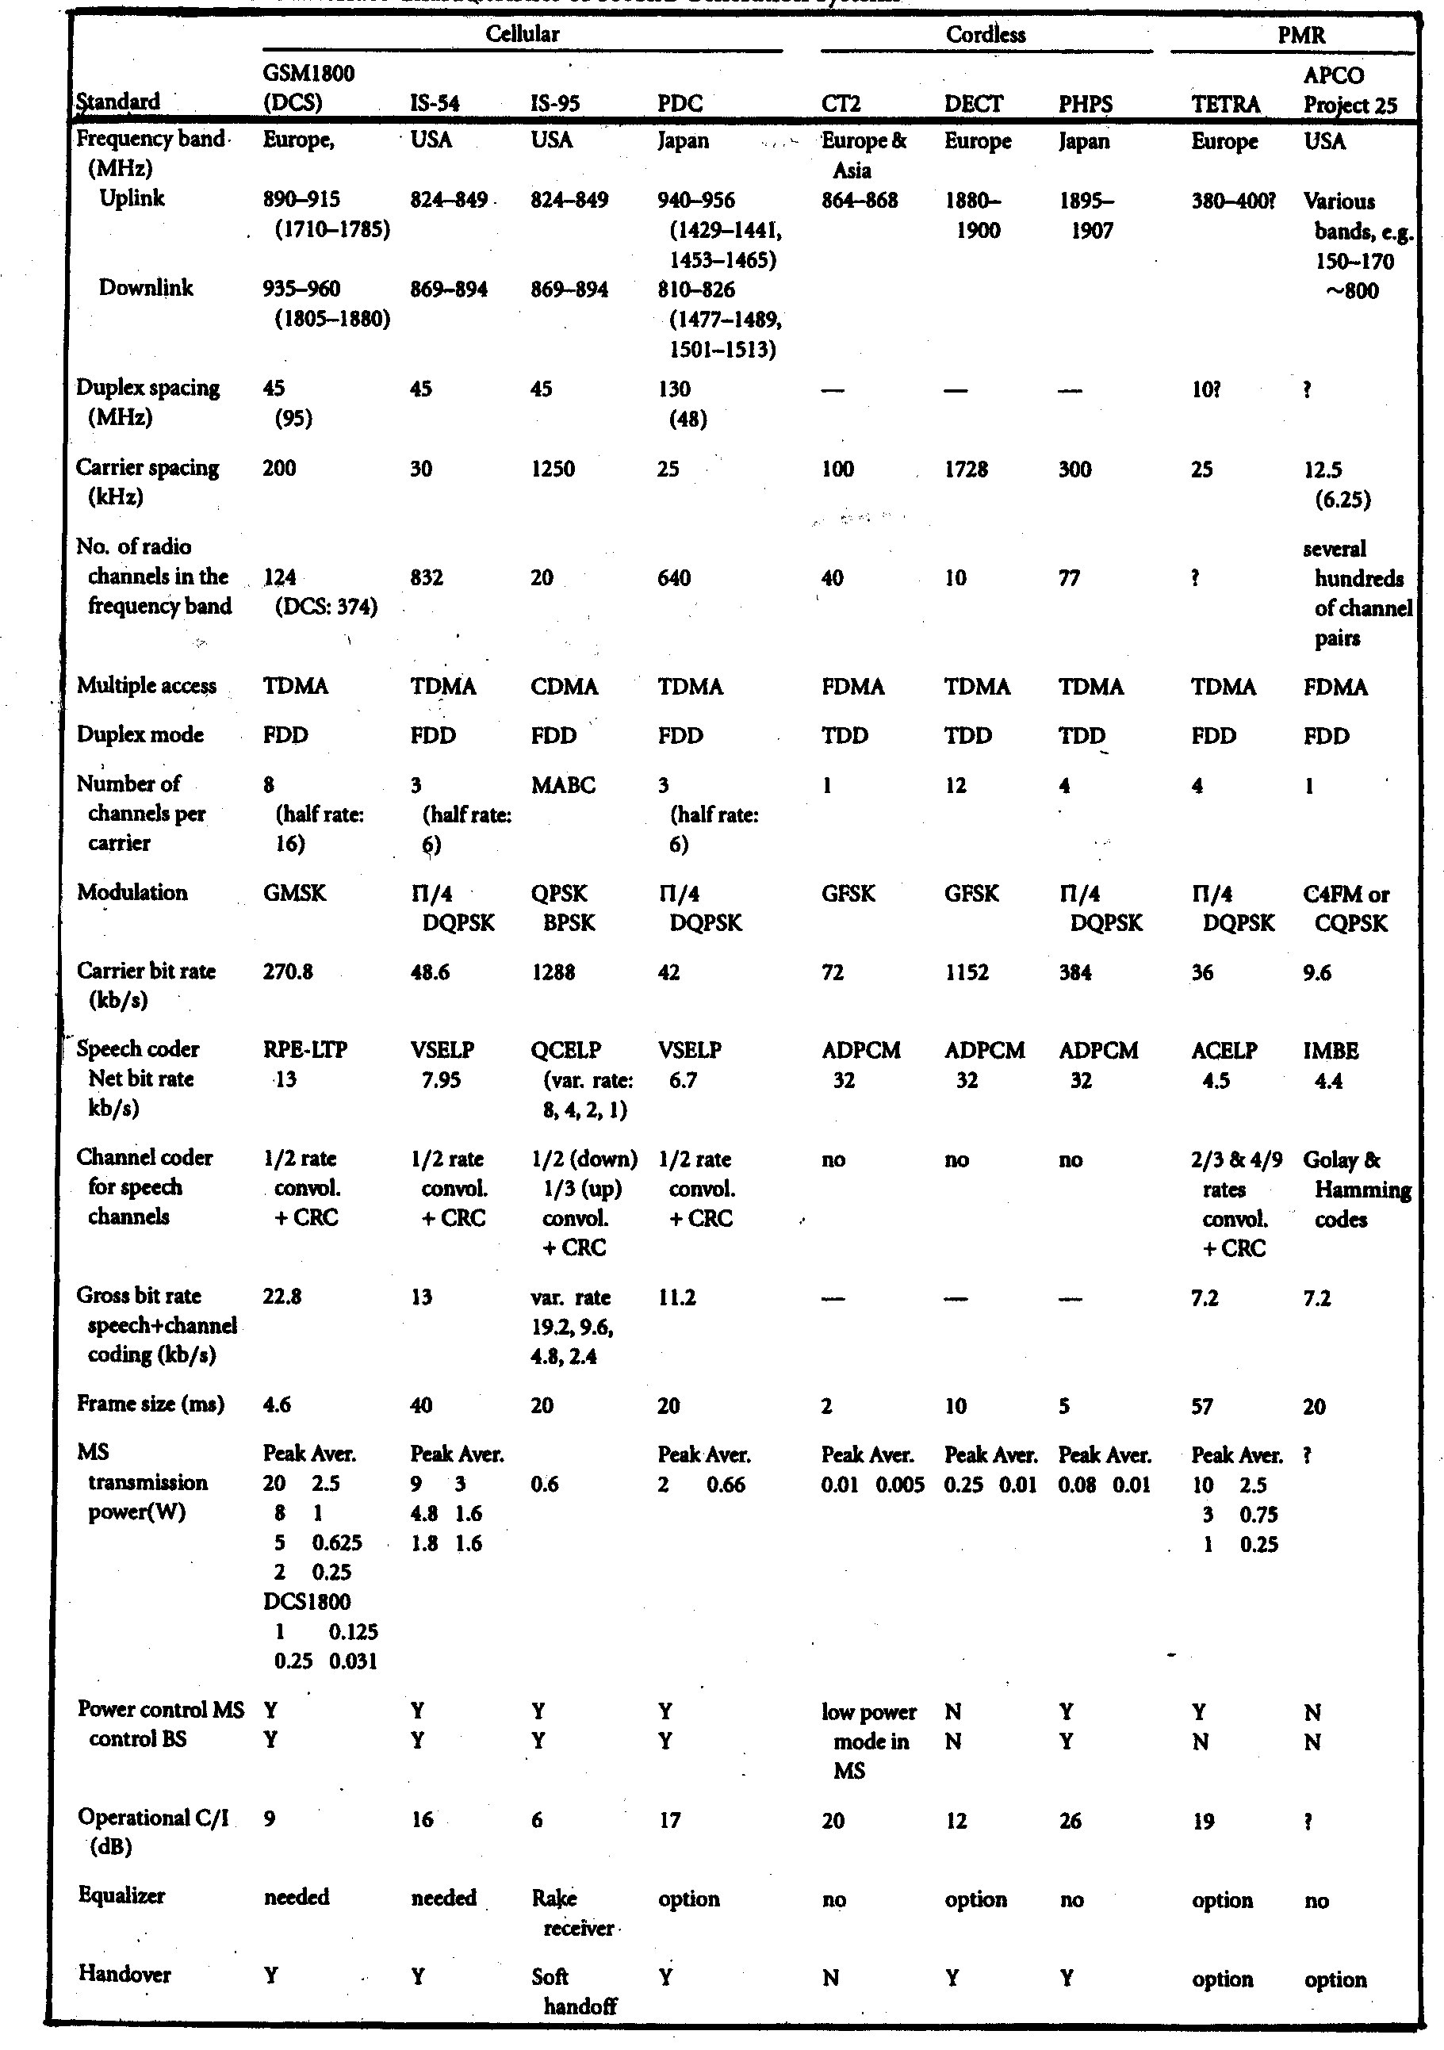

Table 2.3.2 - Air Interface Characteristics of Second Generations Systems

2.3.3.2.1 Digital Cellular Mobile Networks

2.3.3.2.1.1 Global System for Mobile Communications/Digital Cellular System 1800 (GSM/DCS1800)
The GSM standard was specified by the European Telecommunications Standards Institute (ETSI) for pan-European digital cellular mobile radio services. It was designed to answer the need for a common mobile communications standard throughout Europe, where a variety of incompatible analogue cellular systems like the Nordic Mobile Telephone (NMT) and the Total Access Communications Systems (TACS) existed. The allocation of a dedicated pan-European frequency band around 900 MHz and the signature of a Memorandum of Understanding (MoU) between countries, which committed to launch nation-wide GSM networks with internetworking capabilities, were the other important steps leading to an European network.
Phase 1 of the GSM standard was completed by ETSI in 1990 and is the basis of currently implemented networks. It provides a variety of speech and data services. These services, progressively being offered to the users, include telephony, emergency calls, conference calls, fax transmission, short messages, and data transmission at various rates up to 9600 bit/s. Supplementary services like call forwarding, call barring, and connected line identification are also defined.
The GSM network architecture closely follows the general principles introduced in the preceding section. All interfaces between network elements have been standardized, including MSC-BSC (A) and BSC-BTS (Abis) interfaces. Interfaces to AuC/HLR/EIR and to PSTN /ISDN use SS#7 with the mobile application part (MAP) protocol for non-circuit related signalling. This architecture, with a clear breakdown between the different equipment and different functional parts (e.g. radio resource management in the BSC), facilitates evolution.
The subscriber identity module (SIM) is the key to personal mobility, whereby a user can use any GSM terminal equipment just by inserting his SIM card. This smart card contains all subscriber data and is also used for basic security functions, such as subscriber identity authentication and key generation for traffic encryption on the air interface. This prevents fraudulent use of the system and ensures call privacy.

The GSM air interface is characterized by an eighth-order TDMA scheme with frequency division duplex (FDD). The available frequency band in Europe is 2 x 25 MHz, with a radio channel spacing of 200 kHz. Data is modulated at 270 kbit/s using Gaussian minimum shift keying (GMSK) modulation and transmitted in bursts of 577 μ.s. Each TDMA frame consists of eight time slots corresponding to eight separate physical channels. Each of these physical channels supports a combination of logical channels that are used in turn to carry signalling or traffic data. Slow frequency hopping is used to combat adverse propagation conditions, and most infrastructure implementations also include BTS receiver antenna diversity. The relatively low carrier to interference ratio (C/I) operational value (9 dB) is achieved through powerful channel coding, interleaving, and equalization techniques. Speech transmission is based on a linear prediction coder called regular pulse excited-long term prediction (RPE-LTP), which yields a net bit rate of 13 kbit/s and a gross bit rate of 22.8 kbit/s after channel coding. The air interface protocol follows a classical layered structure and includes a number
of advanced features that are specific to mobile radio applications, such as mobile assisted handover (MAHO), power control (in both up and down links), and discontinuous transmission (DTX) based on voice activity detection (VAD).
GSM standardization in ETSI is still an ongoing process, and a number of additional services and features (such as multiparty calls, half-rate coder, and general packet data service) will be available in phase 2. Standardization of a GSM adaptation tailored to railway application has also recently started. This will include specific features such as group calls or support of high-speed mobiles.
One important GSM extension is the digital cellular system-1800 (DCS1800) standard designed for personal communication networks ([PCN], optimized for urban and suburban use) and for which various licences have already been granted in Europe. The main differences with GSM are the frequency band (around 1800 MHz), national roaming capabilities, and a reduced transmission power (hence a reduced cell size). It is also a candidate standard for the U.S. Personal Communication Services (PCS) in the 1900-MHz band.
Originally focused on the European market, the GSM/DCS1800 standard has now achieved worldwide recognition and deployment. More than 65 countries have already adopted the GSM standard, and at least 40 GSM/DCS1800 networks are currently in service around the world. These figures are constantly growing. (See Fascicle 2 - Chapter 3 for more details)

2.3.3.2.1.2 Interim Standard (IS-54)
The main driving force for the definition of a second generation digital standard in North America was the rapidly growing demand for cellular services during the 1980s. This would have easily exceeded the capacity of the analogue networks based on the advanced mobile phone system (AMPS). Accordingly, the new digital standard was specified by the Telecommunications Industry Association (TIA) upon request of the Cellular Telecommunications Industry Association (CTIA), with the major objective being to provide a significant increase in system capacity while maintaining upward compatibility with widespread AMPS. The Federal Communications Commission (FCC), however, decided to open the existing cellular band (2 x 25 MHz in the 800-MHz range) to any suitable technology.

The IS-54 standard was finally selected from several proposals and published in January 1991. Both dual mode (AMPS/IS-54) mobile stations and base stations are specified, thus enabling the design of equipment capable of analogue or digital operation. Other related standards have also been defined: IS-55 and IS-56 were defined for the performance specifications and measurement methods for mobile stations and base stations, respectively. Concerning network aspects, several standards have been developed by TIA since 1988 independently from the air interface design and are, hence, applicable to analogue AMPS as well as IS-54 and other systems.

Though less ISDN oriented than GSM, the IS-54 standard also supports several services, e.g., telephone service, short message service, and data services with a maximum transmission rate of 9.6 kbit/s. Supplementary services include call forwarding, three-party call, and call barring. Security features include a personal identification number (PIN), subscriber authentication upon connection to the system, and voice as well as subscriber data encryption.

The IS-54 air interface uses TDMA/FDD technology with three channels per 30-kHz AMPS carrier. The modulation bit rate is 48.6 kbit/s. π/4 shifted differential quadrature phase shift keying (DQPSK) modulation is employed. For each (full rate) channel, the gross bit rate is 13 kbit/s, and speech is encoded at 7.95 kbit/s using a vector sum excited linear prediction (VSELP) algorithm.

Advanced radio-link control based on power control and DTX improves spectrum efficiency. The air interface protocol, compatible with the AMPS protocol, includes an optional extended mode to allow for the addition of new system features and operational capabilities.

The traffic capacity achievable with IS-54 is expected to be three to four times that of existing AMPS systems. This capacity will be doubled with the introduction of a half-rate codec, currently under standardization. Using the original frequency band of the AMPS system, digital channels compliant to the IS-54 standard are now progressively replacing analogue channels, thereby alleviating the shortage of spectrum while enabling a smooth transition from analogue to digital. Network and terminal equipment are already available from several manufacturers and commercial service is being offered in the largest U.S. cities.

Based on the IS-54 standard, Hughes has developed a new technology called E-TDMA, with operational networks in the U.S. and recently adopted for several regional networks in Russia and China. It is claimed to achieve a significantly higher capacity, taking advantage of advanced features such as half-rate coding, digital speech interpolation (DSI) and channel pools.

2.3.3.2.1.3 Interim Standard IS-95
Introduction
Code division multiple access (CDMA) provides a spectrally efficient, digital solution for the second generation of cellular, wireless telephony, and personal communications systems (PCS) services. The CDMA air interface is near optimum in its use of the subscriber station transmitter power, enabling the widespread commercial use of low-cost, lightweight, hand-held portable units that have improved battery life. The technology is also near optimum in its link budgets, minimizing the number of base stations required for an excellent grade of service coverage. As customer penetration in a given service area increases, the system is called upon to deliver more capacity. CDMA has demonstrated a capacity increase over advanced mobile phone service (AMPS) of at least a factor of ten, which means that up to ten times fewer base stations will be required when customer demand for service increases. The use of soft handoff nearly eliminates the annoyance of dropped calls, fading, and poor voice quality.

CDMA, in this context, means not just generic code division multiple access, but the specific implementation of it described in the air interface standard: TIA/ EIA/ IS-95-A: Mobile Station- Base Station Compatibility Standard for Dual-Mode Wideband Spread Spectrum Cellular System. Compliance with the requirements in this standard assures subscribers and service providers that equipment of all types will interoperate satisfactorily.

IS-95-A originated with a system design developed by QUALCOMM, beginning in April 1989. The early requirements were defined by the cellular carriers with input from manufacturers and carriers and by public testing. After the initial proposal and presentation of a draft air interface, a standards committee composed of system operators, subscriber equipment vendors, infrastructure equipment vendors, and test equipment vendors reviewed, revised, and formalized the air interface. The formal adoption of what is now the IS-95-A air interface took place in December 1993.

The CDMA System

The multiple access scheme exploits isolation provided by the antenna system, geometric spacing, power gating of transmissions by voice activity, power control, an efficient modem, and a signal design that uses powerful error correction coding.

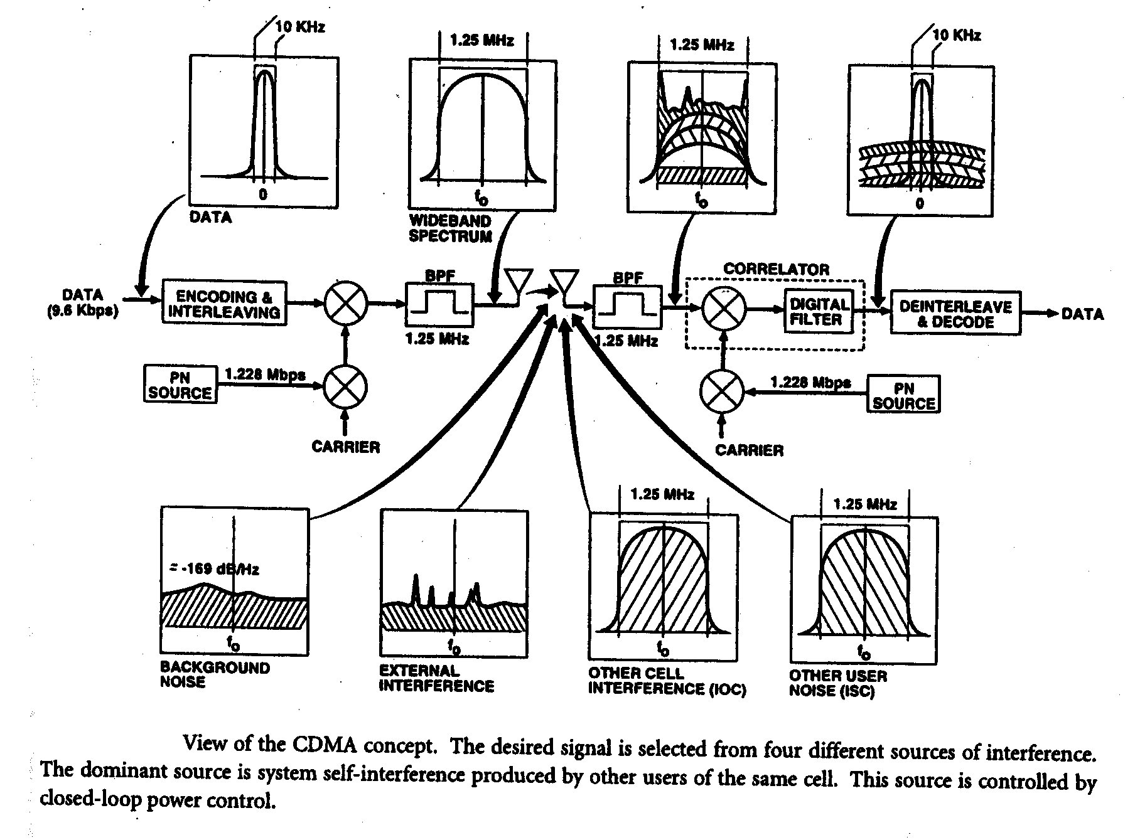Figure 2.3.4 - View of CDMA concept

A combination of open-loop and closed-loop power control (through measurements of the received power at the mobile station and the base station) commands the mobile station to make power adjustments in order to maintain only the power level required for adequate performance. This minimizes interference to other users, helps to overcome fading, and conserves battery power in the mobile station.
The CDMA digital cellular waveform design uses a pseudo-random noise (PN) spread spectrum carrier. The chip rate of the PN spreading sequence was chosen so that the resulting bandwidth is about 1.25 MHz after filtering, or approximately one-tenth of the total bandwidth allocated to one cellular service carrier.

The USA Federal Communications Commission (FCC) has allocated a total of 25 MHz for mobile station to cell site and 25 MHz for cell site to mobile station, for the provision of cellular services. The FCC has divided this allocation equally between two service providers, the A and the B carriers, in each service area. Because of the time sequence of the FCC's actions in allocating the cellular spectrum, the 12.5 MHz allocated to each carrier for each direction of the link is further subdivided into two sub-bands. For the B carriers, the sub-bands are 10 MHz and 2.5 MHz each. For the A carriers, the sub-bands are 11 MHz and 1.5 MHz each. A signal bandwidth of less than 1.5 MHz fits into any of the sub-bands, whereas a bandwidth of less than 2.5 MHz fits into all but one sub-band.

A set of ten 1.25-MHz-bandwidth CDMA channels can be used by each operator if the entire allocation is converted to CDMA. Initially, only one or a small number of 1.25 MHz channels needs to be removed from the present PM analogue service to provide digital service. This facilitates the deployment by introducing a gradual reduction in analogue capacity. Each 1.25 MHz CDMA segment can provide about twice the capacity of the entire 12.5 MHz allocation using the present FM system. Some frequency guard band is necessary if there are adjacent high-power cellular (or other) frequencies in use, and the maximum capacity of the CDMA cell is required. Capacity can be sacrificed for decreased guard band if desired. Adjacent CDMA channels need not employ a guard band.

Overview of the IS-95 CDMA Standard
The common air interface standard, IS-95-A, prescribes, in detail, the behaviour of dual-mode CDMA/AMPS subscriber stations, and, to a lesser extent, the base stations. Use of compliant subscriber stations assures base station manufacturers of predictable behaviour on which to base system designs. An IS-95-A compliant subscriber station can obtain service by communicating with either an AMPS (analogue PM) base station or with a CDMA base station. System selection depends on the availability of either system in the geographic area of the station, as well as its programmed preference. Minimum performance requirements for dual-mode base stations, IS-97, and subscriber stations, IS-98, supplement the basic air interface.
IS-95-A emphasizes subscriber station requirements because the subscriber side reflects all call processing features, and because the specification is simpler in the context of a single user. In contrast to the detailed subscriber station requirements, base station requirements are incomplete. Generally the standard prescribes only those base station requirements that are important for the design of subscriber stations, leaving unspecified behaviour to the discretion of the vendors. Base stations are fielded in much smaller quantities, but at much greater cost per unit. Market considerations therefore encourage good designs.
The standard specifies that mobile stations operating with analogue base stations meet the analogue compatibility provisions for mobile stations as specified in EIA/ITA/IS-54-B, Bual-Mode Mobile Station-Base Station Compatibility Specification, January 1992. The incorporation of the analogue portions of EIA/ITA/IS-54-B instead of EIA/ITA-553 (Mobile Station-Land Station Compatibility Specification, September 1989) accommodates all the changes to analogue operation imposed by the EIA/ITA/IS -54-B dual-mode standard.

2.3.3.2.1.4 Personal Digital Cellular (PDC)

As in North America and in Europe, the design of the PDC standard in Japan was motivated in the late 1980s by the saturation of analogue cellular networks and by the need for new and enhanced services. After a study phase initiated by the Japanese Ministry of Posts and Telecommunications in April 1989, the PDC air interface standard was issued in April 1991 by the Research and Development Centre for Radio Systems (RCR) under the name STD27 [RCR-STD27, 1991]. It was complemented by network interface specifications providing the basis for a unified digital cellular system in Japan and enabling connectivity with fixed ISDN.

RCR STD27 is a common air interface specification. Though there are some similarities with the American IS-54 standard in terms of technical features, no compatibility with existing analogue systems was required here. The new digital systems in Japan benefit from a specific spectrum allocation, initially in the 800-MHz band and later in the 1.5-GHz band.

The carrier spacing is 25 kHz and the multiple access scheme is a TDMA/FDD of order 3 with the current full-rate codec and of order 6 with the future half-rate codec. The carrier bit rate is 42 kbit/s. π/4 DQPSK modulation is used. The full-rate speech codec employs a VSELP algorithm with a gross bit rate of 11.2 kbit/s and a net bit rate of 6.7 kbit/s, with forward error correction based on a convolutional code (rate ½) and a cyclic redundancy check (CRC). A specific channel assignment procedure (flexible channel reuse from one BS to another) enables an increase of the system capacity. The standard also specifies power control and MAHO type handover procedures.

PDC systems will provide numerous services, including speech transmission, data transmission (G3-facsimile, modem, videotex), and short message service. Supplementary services such as calling line identification, call forwarding, or three-party call are also foreseen. The air interface protocol is ISDN oriented with a layered structure following the open systems interconnection (OSI) principles, including a link access protocol called LAP DM at layer 2 and a layer 3 divided into radio transmission management (RT), mobility management (MM), and call control (CC, based on ITU-T I.451). Security features include authentication and encryption.

Interfaces between network elements of a PDC system have been defined by cellular operators in Japan, except the A interface (BSS-MSC) which is left open for implementation. The network architecture follows the reference model of ITU-T SS#7, if used between network elements and on the interface to other networks. The application protocols are an enhanced version of ISDN user part (ISUP) for circuit related signalling and MAP, developed as an application service element on TCAP, for non-circuit related signalling.

Commercial service with a PDC network was initiated by NTT in 1993 for the 800-MHz band and in 1994 for the 1.5-GHz band. Two other operators have launched digital cellular services in the 500 MHz band in 1994, and the Japanese government has recently decided to allow two new operators to offer digital service in the 1.5 GHz band. Enhancements of the PDC standard are also foreseen (such as the half-rate codec, packet data, etc.).
2.3.3.3 Cordless Telephony (CT)
The first generation of the UK’s cordless telephones (coded CT1) was developed as the answer to the large quantities of imported, technically superior, yet unlicensed mobile radio equipment. The simplicity and cost effectiveness of CT1 analogue radio and base station products using eight RF channels and FDMA scheme stem from their applications limited to incoming calls from a limited number of mobile users to the isolated telepoints. As the number of users grew, so did the co-channel interference levels, while the quality of the service deteriorated. Anticipating this situation, the second generation digital cordless telecommunications radio equipment and common air interface standards (CT2/CAI), incompatible with the CTl equipment, have been developed. CT2 schemes employ digital voice but the same FDMA principles as the CTl schemes. Network and frequency re-use issues necessary to accommodate anticipated residential, business, and telepoint traffic growth have not been addressed adequately. Recognizing these limitations and anticipating the market requirements, different FDMA, TDMA, CDMA, and hybrid schemes aimed at cellular mobile and digital cordless telecommunications (DCT) services have been developed. The technical characteristics of some schemes are given in Table 2.3.3:

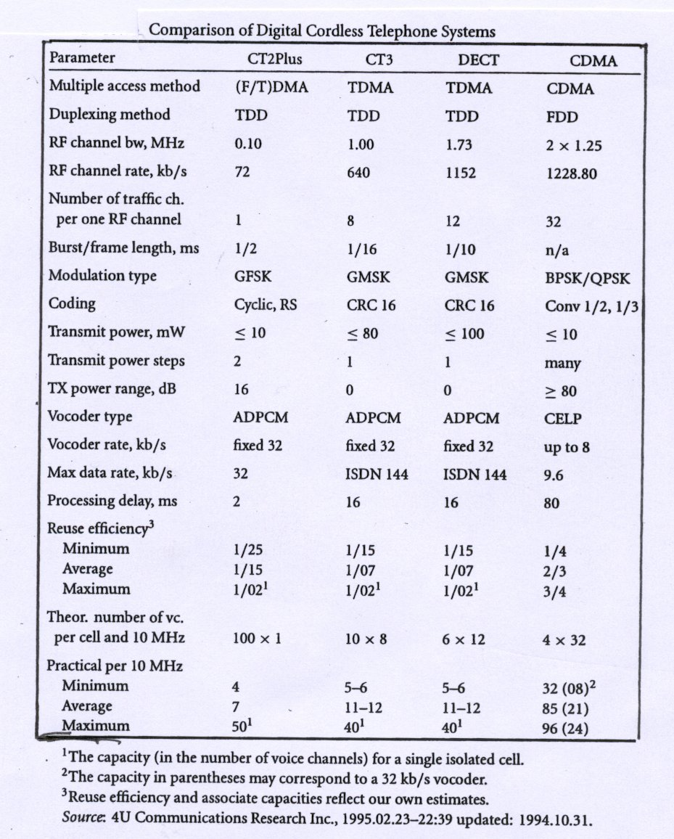

Table 2.3.3 – Comparison of Digital Cordless Telephone Systems
The complete description of these systems is given in the Chapter 4 of Fascicle 2.

2.3.3.4 Private Mobile Radiocommunications (PMR)
The world of PMR is manifold as there are so many different user groups with very different operational requirements. PMR is used by large organisations devoted to public safety, such as police, customs, fire brigades, rescue and ambulances etc. who need hierarchically structured networks with local, regional or even nation-wide coverage. There are also non-emergency authorities like government departments, public health, environment protection, PTTs and the like with similar networks. However, PMR is also used by medium and small user groups with very differing requirements for a wide range of applications.
PMR employs a variety of different technologies and covers a wide field of applications from local communication of small user groups up to networks with nation-wide coverage.

Definitions
To understand why PMR is versatile and unique it is necessary to understand the underlying operational and economical requirements and the resulting properties in detail. Firstly a short definition of PMR should be given:
PMR offers two-way radiocommunications carrying speech, data or a mix of both in non-public networks tailored to the specific operational requirements of professional mobile user groups for efficient and flexible communication within their area of daily operation.
Until around 1980 PMR systems were mostly systems employing a single base station or repeater, the modulation was analogue FM or PM, and the modes of operation were simplex, half or full duplex. Up to 80 mobile stations were served per radio channel and the coverage could reach up to 30 km. PMR meant mainly PTT controlled voice transmission, with a relatively limited amount of proprietary data services.
More recently paging and data facilities, digital switches and trunking, as well as PSTN and ISND connections were added. Sophisticated digital modulation including non-constant envelope schemes have been introduced and digital signal processing permits the use of transmission techniques giving more channels and less interference. Moreover, integrated data services like X.25, X.400 etc. are now used to a larger extent and closed user groups (CUG) with dynamic reconfiguration are now possible.
The use of a common channel is widespread and a decisive factor in the spectral efficiency of PMR. In many applications channel access must be available almost immediately, e. g. in less than 200 ms. It is important to note that PMR traffic is very different from cellular services, the talk time amounts to seconds instead of minutes with a much higher call frequency, hence the channel access time must be in a reasonable relation to the talk time. The coverage must be reliable and well suited to the users’ needs including the requirements for coverage in areas with bad propagation conditions. Since PMR comprises a variety of radiocommunication systems tailored to the different needs of various user groups several main applications can be distinguished.
Self-provided large PMR systems consist of networks having typically more than 300 mobiles in densely populated areas. Utilities, public urban transport, railways, power suppliers and large industrial sites are the main user groups. Specific requirements including limited access to PSTN and ISDN characterise the needs of such groups.
Small PMR networks have less than 50 mobiles. Taxis, vehicle recovery services and business users are typical customers of such systems. The migration to GSM makes the future growth of this segment uncertain.
Service-provided PMR systems are often called Public Access Mobile Radio (PAMR) or CBS (Community Base Stations). They are trunked systems run by an operator and have been in operation since the mid eighties. The technical and licensing conditions vary from country to country. Where PSTN or ISDN access is possible, these systems could be regarded as a public service competing with GSM. There are many PMR and PAMR networks with regional limited coverage, however, there are also networks operating nationwide for police and other emergency bodies.

Spectrum Allocation

PMR originally was allocated in the band 40 to 80 MHz as a national matter. Hence there was no harmonisation resulting in currently three different channel separations and many other differences. Later the PMR allocations were extended considerably.

Equipment

a) Analogue equipment

Conventional single channel PMR systems suffer traffic congestion and inefficient use of spectrum. Trunked systems use channels for control as well as traffic. The advantages are more efficient use of the spectrum and hence more traffic per channel.
In order to save frequencies and thus be able to satisfy more users in the allocated PMR bands, the transition to 12.5 kHz channel separation instead of the 20 or 25 kHz was made during the seventies and the eighties in most European countries, and in most of the PMR bands. However in reality the overall gain in spectrum efficiency is about 1.1 instead of 2.0 if fading and shadowing are taken into account.

Currently the trunked PMR systems MPT 1327 and MPT 1343 employing analogue speech transmission and signalling at 1200 bit/s dominate in the PAMR sector and several different variations are available. Trunked PMR generally is dominated by proprietary protocols. Conventional PMR users are also moving towards trunked system solutions because of the better frequency utilisation.

b) Digital equipment

The first attempt to create a complete digital PMR (DPMR) system standard was made by ETSI with DSRR for 25 kHz channels in the 900 MHz employing GMSK and the GSM speech coder. TETRA (Trains European Trunk Radio System) is the second DPMR system standard, called now EP TETRA, for DPMR equipment supporting all kinds of digital transmission, e.g. data and digitised voice. The results of the standardisation work on TETRA are in the ETSI standards series ETS 300 392 to 396.

- i) TETRA is a TDMA system with four times slots per carrier operating on 25 kHz channels for 385 – 470 MHz, 870 – 921 MHz. The gross bit rate is 38 kbit/s offering usable bit rates up to 28.8 kbit/s with time slot aggregation. Single time slot traffic channels provide a gross bit rate of 9 kbit/s and an unprotected user bit rate of 7.2 kbit/s.
- ii) Additionally two de facto PMR standards have been developed based on proprietary specifications, namely MPT 1327 and 1343 (initiated by the UK DTI and providing digital calling and data transmission at 1.2 kbit/s combined with analogue voice) and MOBITEX (which was developed originally only for data at 1.2 kbit/s, while MOBITEX II or MOBITEX 8k offers a gross bit rate of 8.0 kbit/s on 25 kHz channels in the 400 and 900 MHz bands).

- iii) Additionally, several proprietary fully digital PMR systems have been launched during the last few years. The most important of the proprietary DPMR systems in the market place are listed below:

- APCO 25 is a fully digital FDMA system developed for the USA, for the 150, 400 and 800 MHz bands, and based on 12.5 kHz channel separation and C4FM modulation. A future migration to 6.25 kHz channels and a linear modulation scheme (CQPSK) is envisaged.
- ASTRO is a FDMA system developed by Motorola for DPMR applications in the 2 m band and for the three channel separations 12.5, 20 and 25 kHz using QPSK-C modulation and providing a gross bit rate of 9.6 kbit/s.
- EDACS is the Enhanced Digital Access Communications System developed by Ericsson with 12.5 kHz and 25 kHz channel separation in the 160, 450, 800 and 900 MHz bands. The system uses GFSK modulation and is upgradeable channel by channel from analogue FDMA also providing TDMA. The TDMA version was launched in 1995 and has become fully digital. EDACS is a multi-site system and offers a gross bit rate of 9.6 kbit/s and large area coverage.
- GeoNet is a FHMA system provided by Geotek. It is based on Frequency Hopping Multiple Access and 800 and 900 MHz band implementations are available. It is claimed that such a network with 50% data traffic exhibits a capacity increase by up to 30 times compared with trunked analogue PMR. (This is possible due to the much higher transmission rate compared to systems like MPT 1327).
- MIRS is the Motorola Integrated Radio Service which was introduced by Motorola in 1991 in the US. In 1995 MIRS was renamed iDEN (Integrated Dispatch Enhanced network). It is a 6TDMA linear modulation system employing m16QAM (m=4) modulation and providing a gross bit rate of 64 bit/s, and thus a six fold capacity increase compared with traditional PMR systems is claimed, being increased further by appropriate geographic frequency reuse to 18 times. This system has been developed for the 800, 900 and 1,500 MHz bands.
- TETRAPOL was developed by Matra and has been available since 1992. It is based on FDMA and available for the 80 MHz band and the 400 MHz range with a channel separation of 12.5 kHz. A channel separation of 10 kHz is also feasible on demand. The gross bit rate is 8.0 kbit/s based on GMSK modulation. Many of its current applications are devoted to public safety.

Modern digital PMR systems are structured according to the ISO/OSI layer model in a systematic and transparent order and offer a variety of specialised services. The Basic Services comprise Tele Services and Bearer Services while the Supplementary Services consist of PMR Type Supplementary Service and Telephone Type Supplementary Services.

Teleservices offer different encrypted or non-encrypted types of calls, mainly individual calls (point to point), group calls (point to multipoint), acknowledged group calls and broadcast calls, while the bearer services comprise circuit mode unprotected or protected data and packet mode connection oriented or connectionless data, usually available with different network transmission speeds, e. g. for TETRA 2.4 to 9.6 kbit/s in case of protected data and 7.2 to 28.8 kbit/s for unprotected data in circuit mode.

There are also a variety of PMR type supplementary services available. The most interesting ones are access priority, pre-emptive priority, priority call, call authorised by dispatcher, include call, transfer of group control, late entry, ambience listening, discreet listening, area selection, short number addressing, talking party identification and dynamic group number assignment.

Lastly a comprehensive list of telephone type supplementary services is provided, e. g. list search call, call forwarding, call barring, call report, call waiting, call hold, calling party identity presentation, calling party identity restriction, call completion, advice of charge and call retention.

This variety of offered services indicates the complexity of modern digital PMR systems. It also shows that such systems do not only offer all the usual PMR features but also some additional advanced services and a wide range of telephone services.

2.3.3.5 Third Generation Mobile Systems - IMT-2000

IMT-2000 third generation mobile systems will deliver voice, graphics, video and other broadband information direct to the user, regardless of location, network or terminal. These fully personal communication services will provide terminal and service mobility on fixed and mobile networks, taking advantage off the convergence of existing and future fixed and mobile networks and the potential synergies that can be derived from such convergence. The key benefits that IMT-2000 promises include improvements in quality and security, incorporating broadband and networked multimedia services, flexibility in service creation and ubiquitous service portability.
Networked multimedia may be defined to include services such as pay- TV; video- and audio-on-demand; interactive entertainment; educational and information services; and communication services such as video-telephony and fast, large file-transfer.
For more information on IMT-2000 see Fascicle 2 – Chapter 3, and the Final Acts of the World Radiocommunications Conference 2000.

2.3.3.6 The Use of Satellite Systems

The employ one or more satellites to serve as base station(s) and/or repeater(s) in a mobile radio network. The position of satellites relative to the service area is of crucial importance for the coverage, service quality, price, and complexity of the overall network. When a satellite encompasses the Earth in 24-h periods, the term geosynchronous orbit has been used. An orbit that is inclined with the respect to the equatorial plane is called an inclined orbit; an orbit with a 90° inclination is called a polar orbit. A circular geosynchronous 24-h orbit over the equatorial plane (0° inclination) is known as geostationary orbit, since from any point at the surface of the Earth the satellite appears to be stationary; this orbit is particularly suitable for the land mobile services at low latitudes and for maritime and aeronautical services at latitudes of <80°. Systems that use geostationary satellites include INMARSAT, MSAT, and AUSSAT. An elliptical geosynchronous orbit with the inclination angle of 63.4° is known as tundra orbit. An elliptical 12-h orbit with the inclination angle of 63.4° is known as Molniya orbit. Both tundra and Molniya orbits have been selected for the coverage of the northern latitudes and the area around the North Pole; for users at those latitudes, the satellites appear to wander around the zenith for a prolonged period of time. The coverage of a particular region (regional coverage) and the whole globe (global coverage) can be provided by different constellations of satellites including those in inclined and polar orbits. For example, inclined circular orbit constellations have been proposed for GPS (18-24 satellites, 55-63° inclination), Globalstar (48 satellites, 47° inclination), all systems will provide global coverage. ORBCOM system employs Pegasus launchable low-orbit satellites to provide uninterrupted coverage of the Earth below ± 60° latitudes and an intermittent but frequent coverage over the polar regions.
Satellite antenna systems can have one (single-beam global system) or more beams (multibeam spot system). The multibeam satellite systems similar to the terrestrial cellular system, employs antenna directivity to achieve better frequency reuse, at the expense of system complexity.
For more details, see Subchapter 2.4 of Fascicle 1 and the Final Acts of the World Radiocommunications Conference 2000.

    - Abbreviations
ADPCM Adaptive Differential Pulse Code Modulation
AMPS Advanced Mobile Phone System
ANSI American National Standards Institute
ASIC Application Specific Integrated Circuit
AuC Authentication Centre
BSC Base Station Controller
BSS Base Station Sub-system
CAD Computer Aided Design
CBS Community Base Station
CC Call Control
CDMA Code Division Multiple Access
CELP Code Excited Linear Prediction
CRC Cyclic Redundancy Check
CT Cordless Telephony
CTIA Cellular Telecommunications Industry Association
CUG Closed User Group
DAMA Demand Assigned Multiple Access
DB Database
DCS Digital Cellular System
DCT Digital Cordless Telecommunications
DPMR Digital Private Mobile Radio
DQPSK Differential Quadrature Phase Shift Keying
DSI Digital Speech Interpolation
DSP Digital Signal Processing
DTX Discontinuous Transmission
EIR Equipment Identity Register
ETACS Expanded Total Access Communication System
ETSI European Telecommunications Standards Institute
FCC Federal Communications Commission
FDD Frequency Division Duplex
FDMA Frequency Division Multiple Access
FHMA Frequency Hopping Multiple Access
FSK Frequency Shift Keying
FM Frequency Modulation
GSM Group System Mobile
HLR Home Location Register
IMT International Mobile Telecommunications
ISDN Integrated Services Digital Network
ISUP ISDN User Part
JTACS Japanese Total Access Communication System
LAP Link Access Protocol
LE Local Exchange
LR Location Register
LSC Local Station Controller
MAHO Mobile Assisted Handover
MAP Mobile Application Part
MIRS Motorola Integrated Radio Service
MMIC Microwave Monolithic Integrated Circuit
MoU Memorandum of Understanding
MPEG Moving Picture Expert Group (ISO)
MSC Mobile Switching Centre
NMS Network Management System
NMT Nordic Mobile Telephone
NSS Network Sub-system
NTACS Narrow-band Total Access Communication System
OSI Open Systems Interconnection
PAMR Public Access Mobile Radio
PCS Personal Communication System
PDC Personal Digital Cellular
OMC Operation and Maintenance Centre
PABX Private Automatic Branch Exchange
PM Phase Modulation
PMR Private Mobile Radio
PS Portable Station
PSTN Public Switched Telephone Network
PSK Phase Shift Keying
PSPDN Packet Switched Public Data Network
QPSK Quadrature Phase Shift Keying
QAM Quadrature Amplitude Modulation
RDR Research and Development Centre for Radio Systems
RPE-LTP Regular Pulse Excited – Long Tern Prediction
RT Radio Transmission
SS7 Signalling System No. 7
TACS Total Access Communication System
TCAP Transaction Capability Application Part
TDD Time Division Duplex
TDMA Time Division Multiple Access
TETRA Trans-European Trunk Radio System
TIA Telecommunications Industry Association
VAD Voice Activity Detector
VLR Visitor Location Register
VSELP Vector Sum Excited Linear Prediction
WPABX Wireless Private Automatic Branch Exchange

2.4 SATELLITE SYSTEMS
Global communications coverage by satellites has been available for many years using large earth stations. This is now being extended to smaller and smaller mobile terminals.
The three most suitable categories of satellite orbits for communications purposes are:
• Geostationary Orbit (GSO)
• Non-Geostationary Orbit (Non-GSO)
1) Medium Earth Orbit (MEO)
- Low Earth Orbit (LEO)

LEO
Sky/Galavision
Latinoamerica
GEO
Spaceway Cyperstar/Skybridge Astrolink
Final Analysis
Multimedia
Broad-band
(Ku-, Ka-, V-, O- Band)

Direct to
homeTV
(Ku-Bd)

Mobile
(Leo/Meo)
(L-,S-Bd)

Mobile Serv.
(Geo)
(L-,S-Bd.)

Fixed Satellite
Services

(C-,K-Bd)

Teledisc
Leo

Global
Direct TV, PrimeStar Echostar, BSkyB
Global
Galaxy/Latinoamericano
Worldspace
Digital Audio System
Astra/SES (Europe)/Analogue
Astra/Digital
Regional/Global
Constellation Ellipso, ICO Globalstar
Global Mobile

ACeS
AMSC (USA) TMI. Inc. (Canada)
Thuraya
Regional
Inmarsat
Inmarsat Privatized
Global
Global
Lockheed Martin Intersputnik
Private Global System
Intersputnik/Regional FSS
(Intergovernmental)

Hotbirds
>DTH
Entelsat/Regional GEOsystems
Strategic Alliances & Mergers e.g. Loral Spacenet/Orion/Satmex/Eurostar
Domestic (National) System -> Regionalisation/Privatisation

Panamasat/Hughes Galaxy Global Private System Direct TV
Global FSS/DTH System
New Skies/ Commercial
NewIntelsat Global
System
Intelsat/Global GEO System

1970-80's 89- 94 96 98 99 2002

Figure 2.4.1 - Development of Satellite Systems

Satellite Orbits
- If the GSO is used, the entire world except for the polar regions can be covered by only 3 satellites in equatorial orbits. The altitude of these satellites must be approximately 35,800 km above the surface of the earth. The satellites will appear to an observer on earth as being stationary.
- If a MEO constellation is used, the altitude has to be selected between the inner and outer Van Allen Radiation belts, typically around 10,355 km above the surface of the earth. The orbit period in this case will be 6 hours. The world can be covered by 10-12 satellites in 2-3 planes e.g. 5 satellites in each of 2 planes or 4 satellites in each of 3 planes.
- If a LEO constellation is used, the satellite altitude is much lower, typically between 700 to 2000 km. The orbit period will be somewhere between 100 and 120 minutes. Due to the lower altitude, the view of the world from the satellite is rather small and the number of planes to cover the entire globe will have to be increased to 6-8, and the number of satellites must be 6 per plane.

Typical representations of satellite system technology development as well as future trends are shown in Figure 2.4.1.

In the sections below the technology of GSO and non-GSO satellite systems are explained.

2.4.1 GSO Satellites
The beginning of satellite communications was dominated by the GSO satellite concept. The Syncom-2 satellite launch on July 19, 1963 was the first geosynchronous satellite (33 degrees orbit inclination), whereas Syncom-3, launched on August 19, 1964 was the first geostationary satellite.

The main advantages of GSO satellites are the following:
• Three operational satellites are sufficient to provide full-coverage of the earth, excluding the polar caps.
• GSO satellites are fixed in the sky, so it is not necessary to provide large earth station antennas with fast moving auto-tracking systems, as would be the case with LEO satellites.
• The earth station antenna is required to work with only one GSO satellite for a continuous connection, whereas with LEO satellites it is either necessary to use an earth station antenna able to jump quickly from the setting satellite to a rising one, or to use two antennas for each earth station.
• The onboard antenna of the GSO satellite may be very directive. A LEO satellite, due to its moderate altitude and quick movement with respect to earth, is forced to use a small-gain antenna or fast moving tracking systems if the onboard antenna gain is increased.
GSO satellites have some disadvantages with respect to LEO satellites:
• The propagation delay is much larger and may cause an echo with about 500-ms time deference;
• The free space attenuation is much larger. The distance between a point on the earth and the satellite will vary between a minimum of 35,786 km for the equatorial point aligned with the satellite and the centre of the earth, and a maximum of 41,756 km for the points located on the cone projected from the satellite and tangent to the earth surface. The free space attenuation for a GSO satellite link varies therefore for the various frequency ranges;
• They do not cover the polar caps;
• They may not provide coverage of big cities for land-mobile communications, due to the shadows created by tall buildings.

2.4.1.1 Fixed GSO Satellite Systems
Non-mobile satellite systems will continue to depend on satellites in GSO orbits, but as the lower microwave bands (e.g. C-Band) allocated to such systems increasingly become more crowded, fixed satellite systems will be expected to move up to higher frequency bands (e.g. Ku-band). Therefore, attention has centred on developing equipment for new and higher microwave bands or increasing the capacity of existing frequency bands. Two typical and different communications systems which use advanced digital concepts are:

- Demand Assignment Multiple Access (DAMA); and
- Time Division Multiple Access (TDMA) system.

In the DAMA concept, a pool of satellite transponder channels is assigned to a number of users. DAMA provides instant, dial-up connectivity between a larger community of users and is an attractive option for any user looking for cost-effective digital technology combined with the lowest equipment investment. Operating costs are also low since DAMA circuits are charged according to the amount of satellite resources actually used, on a per-minute basis.
TDMA is a digital service for public switched networks which require high connectivity on medium density traffic routes. DAMA is an attractive option for users who want the highest quality INTELSAT service because of higher stability, greater equipment flexibility and better digital bit error ratio (BER) than any other INTELSAT service. The quality and availability of this service is consistent with current fibre optic technology.

The search for more capacity in a given bandwidth is shown in the following examples:

* Antenna technology
More capacity is made available by designing antennas for higher microwave bands, and by reusing frequency bands with different polarizations and spatial beam separations. This technology is equally applicable to satellite and earth station designs.

* Low noise and high power amplifier technology
As satellite transponders become more powerful and earth stations more sensitive, the number of communications channels that can be squeezed into a given bandwidth increases.

* High precision frequency oscillators and converters
Digital communications systems are highly dependent on the stability and purity of oscillators and clock sources derived from the oscillators. For example, in high-capacity TDMA (Time Division Multiple Access) systems as used in satellite systems, the arrival time at the satellite transponder of transmitted bursts from numerous participating earth stations is controlled to within microseconds despite physical movements of the satellite, Doppler shifts and other propagation abnormalities. If this strict control was not possible, more guard-time between bursts would have to be allocated with an ensuing loss of channel carrying capacity.

* Modem technology
An important development in modem technology is to reduce its C/N (Carrier-to-Noise) threshold for a certain Bit Error Rate (BER). If the modem is operating at a low C/N ratio, it will need less power from the satellite, which means that the power can be used for additional satellite channels. Advancements in modem technology are also closely related to FEC (Forward Error Correction) technology.

* Use of Digital Signal Processing
FEC technology is just one example of technology which can be implemented using digital signal processing.
Other advancements in this field are the use of digital signal processing for the compressing and decompressing of signals to ever lower transmission rates. This technology is applied to any type of analogue signals such as voice-band channels or TV signals, and since lower transmission rates mean smaller transponder bandwidth the number of channels in a given bandwidth may be increased.
An additional example of digital signal processing used in fixed satellite systems is in Digital Circuit Multiplication Equipment (DCME) introduced in this section. By using this technology, the number of telephone or data channels carried by a satellite RF channel may be increased by a typical factor of 5.

2.4.1.2 Digital Circuit Multiplexing Equipment
One of the major advantages of converting communications systems from analogue to digital technology is that it opens up a wide range of possibilities in signal processing. Three processing concepts which, when taken individually, have already made important improvements in digital communications, have had a significant impact on digital system designs when they are combined. These three processing concepts are (1) Low Rate Encoding (LRE) and compression/decompression techniques, (2) Digital Speech Interpolation (DSI), and (3) Forward Error Correction (FEC) techniques. The equipment which exploits the first two processes when combined is known as Digital Circuit Multiplication Equipment (DCME).

FEC is incorporated in the RF digital carriers transmitted over the satellite link.

The two main technologies combined in the DCME equipment, as mentioned above, are LRE and DSI. LRE refers to the reduction in the number of bits required to transmit a given piece of information. The standard 64 kbit/s PCM channel is produced by sampling an analogue input channel 8000 times per second and converting each sample to an 8-bit PCM code. However, by using a variety of techniques, it is possible to significantly reduce the number of transmitted bits for each sample. The reduction is dependent on the required grade of service and whether speech, voice-data or signalling will be transmitted. A reduction from 64kbit/s down to 8kbit/s is possible, and the ITU-T is developing a speech coder operating at 4kbit/s.

DSI uses dynamic assignment techniques, i.e. a time slot (satellite channel)is assigned to a particular international communication channel on demand, but the same time slot is not used for the duration of the telephone call. This technique is made possible by the fact that during a telephone conversation, the speech is not continuous and so the channel is not required all the time and therefore the time slot can be allocated to a different channel. The DSI circuits concentrate a number of terrestrial input channels (generally known as trunk channels) into a smaller number of time slots (referred to as bearer channels or satellite channels). In the opposite transmission direction, the concentrated bearer channels are expanded into a larger number of trunk channels. The maximum number of satellite channels (time slots) is 61 (81 under overload condition).

TSI (Time Slot Interchange) in the DCME equipment is used as a static assignment technique, i.e. terrestrial channels are manually assigned to international channels until a manual reassignment is required. The terrestrial input lines to the DCME equipment are coming in 2 Mbit/s (typically up to 10) carriers, which may contain many empty time slots. Therefore, the potential number of terrestrial channels (typically 310) is higher than the 216 international channels that can be handled by the DSI circuits. The static assignment process (TSI process) is the manual procedure of picking out 216 international channels from the maximum 310 terrestrial channels. Hence, by static assignment techniques (TSI), 216 international channels are picked out from among 310 terrestrial channels, and by dynamic assignment techniques (DSI), the 216 international channels are compressed into 61 (or 81) satellite channels.

A certain trunk channel is connected to a certain bearer channel only for the time duration (including an appropriate hang-over time period) that the trunk channel is active, i.e. while it is carrying a burst of speech or transmitting voice-band data or signalling. Taking account of the interval between speech bursts during a normal telephone conversation, the trunk channel will be active only for about 30-40 % of the time. For a large number of trunk channels, therefore, the number of bearer (satellite) channels can be reduced significantly (by a factor of 2.5-3.0) by assigning the satellite bearers "on demand". Pre-assignment of channels should, however, be possible in the equipment.

Frequent trunk/bearer assignment information must be transmitted between the corresponding earth stations in order to make sure that the transmitting trunk channel is connected to the correct receiving trunk channel at the remote side for the duration of the telephone conversation, or voice-band data transmission. The information is exchanged in a special Assignment Channel (AC).

On the terrestrial interface side, each DCME module is connected to an International Switching Centre (ISC) with up to ten 2 Mbit/s communications links (total of 310 voice or data channels (64 kbit/s) plus 20 synchronization and signalling channels). On the satellite interface side, each DCME module is connected to an Intermediate Data Rate (IDR) modem operating at 2.048 Mbit/s information data rate.
DCME equipment may be used in other than satellite communications systems (for example submarine cables). If used for satellite applications, the operational modes are the following:

* Single Destination (SD) mode
* Multi-Clique (MC) mode
* Multi-Destination (MD) mode
* Mixed SD/MD mode

The SD mode, as the name implies, is the simplest mode and is also the most economical for large users. The minimum requirement as far as DCME/IDR equipment is concerned, is one redundant set of DCME modules, and one redundant set of IDR modems. In addition, the required earth station equipment is up-converters and down-converters, low-noise amplifiers, power amplifiers and antenna. IDR/DCME equipment may be implemented in a new earth station design or incorporated into an existing station. In the latter case, station facilities such as terrestrial microwave link, power plant, and air conditioning may already be available.

In Multi-clique operation, the satellite bearer channels on the transmit side are divided into one or two separate blocks, or "cliques", each clique associated with a different destination. Since two destinations are served, the earth station will need two IDR demodulators. The two demodulators will provide the wanted as well as the unwanted channels at its output. In order to avoid sending the unwanted channels to the ISC and thereby reducing the capacity of the terrestrial link, only the wanted channels are picked out and sent to the ISC by a Digital Cross-connect or Digital Branch equipment. By placing the DCME equipment at the ISC rather than the earth station, the reduction in the number of required satellite channels is also extended to the terrestrial link.

Multi-destination operation may be used for up to 4 destinations per DCME set and is economical for small users with multi-destination requirements. All satellite bearer channels are subject to DSI processing regardless of the channel destination. Fig 2.4.2. shows a system configuration with 4 destinations. In this example, one IDR modulator and 4 demodulators are required for one DCME equipment set. The DCME may be located at either the earth station or at the ISC.

DCME in use on a satellite link should ensure provision for ISDN (Integrated Services Digital Network) bearer services. This means that the DCME must be transparent to circuit mode unrestricted 64 kbit/s terrestrial channels used with different access protocols. Likewise, the 64 kbit/s channel must be able to transmit 3.1 kHz voice-band data from modems. Furthermore, the DCME must handle alternate transmission of voice and data during the same call.

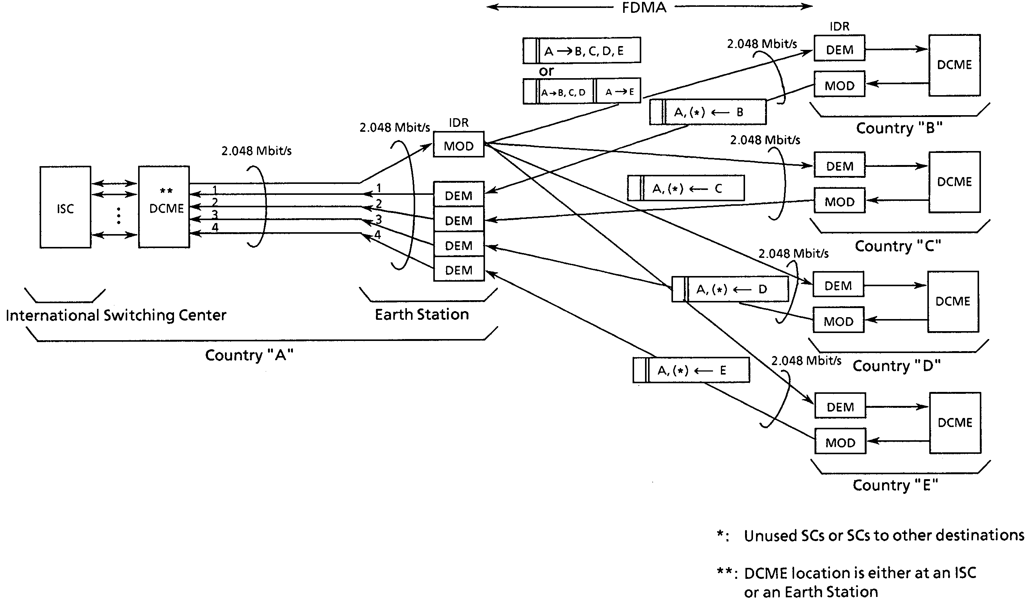

Figure 2.4.2 - Basic Concept of DCME/IDR Multi-destination Operation

2.4.1.3 High-capacity International Satellite Telephony and Data Systems

The difference between satellite communications systems used for international links and for domestic or regional communications is primarily one of capacity. International earth stations are usually designed as high-capacity installations capable of handling from several hundreds to perhaps thousands of voice and data channels plus multiple TV channels. Domestic or regional systems, on the other hand are usually implemented for low to medium capacity perhaps from a few dozens to several hundreds channels, and a single TV channel.
Whether an earth station is designed for high capacity international links or for low capacity domestic or regional communications, the technology used in the earth station equipment is basically the same. The difference is in sizing the equipment to the application on hand plus employing equipment that will increase the number of channels on high capacity links.
This section contains information on the various equipment subsystems that are included in a typical earth station. The differences that characterize the large-capacity earth station from its low-capacity counterpart are the following:

* The physical size of the antenna is larger in order to increase the antenna gain and therefore the station's capacity. A typical antenna size is a diameter of 16-18 meters. The figure-of-quality of the station is indicated in its G/T figure, which is the receive antenna gain divided by the system thermal noise temperature in Kelvin. For example, a 16-meter antenna operating at 4 GHz may have a receive gain of 3.16 x 10⁻⁵ (55 dB) and a noise temperature at its operating elevation angle of 100K. This noise temperature has two major components, namely the Low Noise Amplifier (LNA) temperature (for example 50K), and the antenna noise temperature (50K). This would give the station a G/T of 35 dB/K which is typical of an international earth station. The antenna feed and tracking equipment is identical to the ones described in the next section of this Handbook.

* The High Power Amplifiers (HPA) need a higher rated output power. Since large international stations often will be transmitting 2 or more RF carriers through the same HPA, intermodulation considerations may dictate a rather large HPA power back-off and the HPA must be sized accordingly.

* The modulator(s) and demodulator(s) must be able to handle high capacity information data streams of typically 2.048, 6.312, 8.448, 32.064, 34.368 and 44.736 Mbit/s. Even higher information rates such as 139.264 Mbit/s in the Plesiochronous Digital Hierarchy (PDH) and 155.52 Mbit/s in the Synchronous Digital Hierarchy (SDH) may find roles in satellite communications systems.

- High-capacity earth stations are often implemented with Digital Circuit Multiplication Equipment (DCME) which takes advantage of channel Low Rate Encoding (LRE) and Digital Speech Interpolation (DSI) technologies in order to increase the number of voice channels or voice-band data channels in a given satellite transponder bandwidth by a factor of up to 5.0.

High Capacity Modems

Modulator and demodulator (modem) technology has made great advancements during the last few years. Development has focused on reducing the physical size of the equipment and integrating numerous functions into Large Scale Integration (LSI) circuits. Such functions include Forward Error Correction (FEC) technology that makes it possible to operate the demodulator at ever decreasing Carrier-to-Noise (C/N) or Energy-per-bit-to-noise density (Eb/No) ratios for a certain Bit Error Rate (BER).

Modern high-capacity modems for earth stations are now available in a variety of configurations such as physically separate modulators and demodulators, combined modems, fixed transmission rate modems, variable rate modems, rack-mounted or plug-in card modems.
In the combined modem configuration, one modem in each shelf is stand-by for the remaining 8 on-line modems with automatic and manual switch-over control equipment built into the shelf. Likewise, IF combiners, dividers and a patch-panel are included in the shelf. In terms of channel capacity, then, one 210-cm rack may hold up to 32 on-line modems with a total maximum capacity of 3840 voice and/or data 64 kbit/s channels with 64 synchronization and signalling channels. In terms of capacity measured in bits per second, the total capacity of the rack is approximately 270 Mbit/s.

Whether the modem is implemented as a separate unit or combined, it is capable of operating with FEC rates of 1/2, 3/4 and 7/8 and may be implemented with concatenated Reed-Solomon coding technology. User interfaces are RS-422/449 or V.35 (48-8448 kbit/s) or ITU-T Rec. G.703 (1544-8448 kbit/s). For FEC rate 1/2 the demodulator will typically produce a BER of 1 x 10⁻⁶ or better at an Eb/No of 6.1 dB. The corresponding Eb/No figures for FEC R3/4 and FEC R7/8 are 7.6 dB and 8.7 dB, respectively.

The modulator is using 4-phase PSK (Phase Shift Keying) and the demodulator coherent 4-phase PSK technologies. IF frequencies are either 70 or 140 MHz, and the modem is capable of tuning in 2.5, 22.5 or 25 kHz steps across the IF passband. Frequency stability is typically +/- 1 x 10⁻⁶ per year. Furthermore, the modulator provides synchronization and ESC (Engineering Service Channel) signals for its corresponding demodulators, and drop and insert multiplexed signals are available in data rates between 64 and 1920 kbit/s. To keep demodulators in synchronization with modulators, Plesiochronous/Doppler buffers may be included. The power consumption of a fully equipped shelf (9 modem units) is approximately 0.8 KVA.

Extensive local and remote monitoring and control facilities of high-capacity modems are essential for their proper operation. Table 2.4.1 and 2.4.2 show typical items, which may be monitored and controlled in modern modem designs.

Table 2.4.1 - High-capacity Modulator Monitoring and Control Items

Table 2.4.2 - High-capacity Demodulator Monitoring and Control Items

2.4.1.4 Low to Medium-capacity Regional and Domestic Satellite (DOMSAT) Systems

With the liberalization of telecommunications policies that has swept the world in recent years and with the prospects of even more liberalization to come, new satellite systems are being implemented around the world by organizations that previously, under monopolistic policies, would have been prevented from setting up their own systems. These systems, which normally have higher traffic capacity than VSAT (Very Small Aperture Terminal) systems can provide, are generally implemented within the borders of a certain country (Domsats) but may also cover a region of countries.

With the proliferation of new satellite systems and migration to higher frequency bands, there is a requirement for a more flexibility in earth station system design, and for the development of affordable yet ultra-reliable earth station subsystems since many stations will be operated unattended. Power consumption is also a significant aspect of new equipment design, because more and more earth stations will be using alternate primary power sources, such as solar power plants.

The broad categories of equipment that comprise a modern digital earth station are the following: (1) Antenna system with feed and tracking equipment (if applicable), (2) Low-noise devices, (3) High-power devices, (4) Frequency up- and down-converters, (5) Modems (treated in the previous section of this book), (6) Centralized monitoring and control systems.

Flexibility in antenna technology can now be achieved by an antenna design that operates simultaneously in the C-band and the Ku bands, i.e. 6/4 and 14/11 GHz bands. This is important because many modern satellites will be equipped with both FSS frequency band transponders. Furthermore, the flexibility is advantageous to TV uplink and cable restoration earth stations that occasionally have a need for accessing different satellites operating with either C- or Ku-band satellites, or both at the same time.

Development of low-noise devices as the front-end of the earth station is focused on lowering the noise temperature, reducing the physical size, extending the Mean Time Between Failures (MTBF), and making the devices maintenance-free and capable of operating without cooling. MTBF figures of 500,000 hours for modern LNA (Low Noise Amplifiers) are not uncommon.

High-power amplifiers have developed from klystrons and travelling wave devices to FET transistor amplifiers under the generic term Solid State Power Amplifiers (SSPA). With this development, the physical size of the amplifiers has shrunk significantly, and the reliability has been extended enormously, primarily due to simpler power supply designs.

Frequency converters are essential components in an earth station for converting between common IF frequency bands and the assigned RF frequencies in the satellite transponder. With the change of communications technology from analogue to digital, the performance of the converters has taken on new significance with respect to phase noise, linearity, spurious output signals and reliability. Modern frequency converters make extensive use of advanced technologies such as monolithic FET RF amplifiers, monolithic bipolar IF amplifiers, and thin-film and thick-film Microwave Hybrid Integrated Circuits (MHIC).

Modulators and demodulator designs are important in digital earth stations because they, to a large extent, determine the overall quality of a satellite link, and they have the capability to lower the amount of RF power needed from the satellite, and maintain the communications link at a high quality level. This is accomplished by sophisticated Forward Error Correction (FEC) schemes that, in effect, lower the threshold of the demodulator to very small values.
Finally, centralized monitoring and control of one or several earth stations or a complete Domsat or regional system is important because the equipment is frequently unattended, not only in the main (central) earth station but very often also at remote stations under the control of the central station. A modern monitoring and control subsystem is computerized equipment (typically one or more PCs operating in a Local Area Network) from where a single operator can monitor and control all equipment in the main and remote earth stations. The software used for this purpose closely follows the development of modern-type windows software architectures with user-friendly man-machine interface.

Combined C/Ku-band Antenna Structures

To cater for different earth station system designs and different frequency bands, combined C- and Ku-band parabolic antenna technology with simultaneous dual-band, dual-polarization transmission and reception feeds is now available in antenna diameter sizes from 7.6 meters to 16 meters. Traditionally, dual circular polarization has been used at the 4/6 GHz C-bands, and linear dual polarization at the 11-12/14 GHz Ku-bands. With the increasing demands on the frequency bands, it is anticipated that linear and circular polarizations will also be used in the C- and Ku-bands, respectively. Likewise, it is anticipated that feed technology with switching between circular and linear polarizations will play a role in satellite systems.

Combined C/Ku-band Feed

The combined C/Ku-band feed is where most new antenna technological development has been invested. Fig 2.4.3 shows the basic concept of a combined dual-band/dual polarization parabolic antenna design. The feed is one integrated mechanical structure approximately 3 meters in length and containing only passive microwave devices.
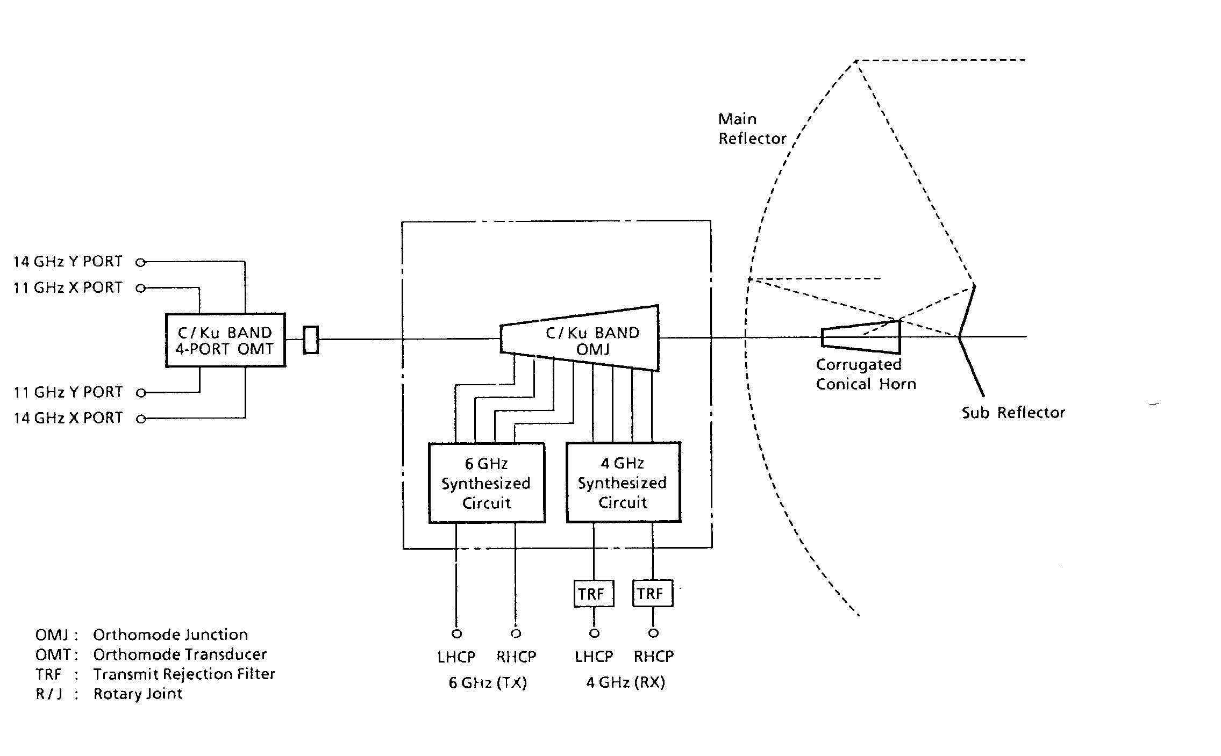
Figure 2.4.3 - Combined C/Ku-band Dual Frequency/Dual Polarization Antenna Feed

Table 2.4.3 gives the C- and Ku-band overall antenna transmit and receive gain figures in dB, and the thermal noise temperature in degrees Kelvin (K).

Satellite Tracking

Depending on the antenna diameter size of a given earth station and the movements of the applicable spacecraft, automatic/ manual satellite tracking may or may not be required, and the degree of sophistication in the tracking equipment may also vary from user to user.
At one end of the scale, small earth station terminals with antenna diameters of perhaps up to 5-6 meters and operating with highly geostationary satellites need no tracking equipment because their antenna beamwidth is so broad that the satellite never moves outside the beam. Or as a minimum tracking requirement, infrequent manual hand-crank or motorized antenna reorientations may be performed.

Table 2.4.3 - Combined band Overall Antenna Gain and Thermal Noise Temperature

At the other end of the scale, large earth station installation of the Intelsat Standard-A class with antenna diameters of 16 meters or more, need automatic tracking equipment no matter what satellite will be used. This is due to the very narrow beamwidth of such stations. For example, a 16-meter Ku-band antenna will have a half-power beamwidth in the order of 0.12 degrees at 11.2 GHz. Simple manual and automatic tracking capability is a minimum requirement for such stations if they operate with stable geostationary satellites, but the degree of sophisticated technology in tracking equipment increases rapidly if a given earth station is to be operated with less stable or non-geostationary satellites; if the station is required to switch rapidly between two or more satellites; if it is located in a geographical area that often suffers signal attenuation and/or scintillations; or even if it is to be operated with satellites in orbits which are stable but inclined to the geostationary orbit.

Satellite tracking technology has evolved from analogue monopulse concepts based on early radar technology, to modern digital computer controlled step-tracking technology which is less expensive and technologically superior in the number of functions that can be implemented. Such functions are normally performed by a microprocessor-controlled Antenna Control Unit (ACU).

As a minimum, the ACU may be implemented for manual motorized tracking only, in which case a beacon down converter and a beacon receiver is not required unless a beacon signal level indication is desired. If automatic tracking is implemented, the ACU will judge the beacon DC level at regular time intervals. If and when the signal level drops to a predetermined level, the ACU will initiate step-movements of the antenna structure in azimuth and elevation until the signal level has been optimized. Such antenna movements are controlled from a Motor Control Unit which will apply power to antenna AC or DC drive motors. When the signal level is optimized, the ACU then will shut down the tracking equipment and wait for a predetermined time duration or until the signal level again is dropping.

Typically, one or more of the following tracking modes, depending on the applicable tracking requirements, may be implemented in a modern earth station:
* Manual Mode. From the front panel of the ACU, the earth station operator will manually move the antenna in azimuth and elevation to the desired antenna orientation.
* Automatic Mode. The tracking system is operating completely automatic and will follow any movement of the satellite.
* Preset Mode. The earth station operator will input from the front panel of the ACU a satellite position in azimuth and elevation. At the push of a button or at a predetermined time, the ACU will move the antenna to the preset position.
* Program Mode. In this mode, the earth station operator will input 11 ephemeral data parameters provided by the satellite operator. The ACU uses these data to calculate and point the antenna to the satellite position at regular intervals.
* Memory Mode. If this tracking mode is selected, auto-tracking must have been done for a minimum of the past 26 hours. The ACU will use this data to track the satellite from then on. This is done on the assumption that no, or very minor, orbit variations will occur from one day to the next.
* Intelligent Self-Learning Program Tracking Mode. This mode (which could appropriately be called an active tracking mode) is a further development from the memory tracking mode (passive). In this intelligent mode, the ACU will analyse the tracking data for the previous 24 hours and based on the result will predict the satellite position from then on. This mode is more accurate than any other mode including automatic tracking. Furthermore, it reduces wear and tear on the antenna mechanical components because the equipment is not activated as often. It may be operated without a beacon signal, and is particularly useful for earth station sites that suffer frequent scintillation problems.

The sophistication of the ACU and tracking system as a whole may be appreciated when it is considered that it has no way of knowing whether a DC signal drop is because (1) the satellite is moving out of the antenna main beam, (2) the earth station antenna main beam is being reoriented, for example due to strong winds, (3) the beacon signal is suffering propagation abnormalities in amplitude and phase (particularly applicable to the 14/11 GHz systems), (4) the beacon signal is absent or faulty. The ACU must accommodate and solve all of these problems.

Low Noise Amplifiers/Converters

Successful satellite communications links rely on a tiny low noise Gallium Arsenide (GaAs) Field Effect Transistor (FET) installed at the front-end of an amplifier chain mounted in the antenna structure in close proximity to the feed. The amplifier chain is referred to as the Low Noise Amplifier (LNA). In some cases the received signals from the satellite are frequency down-converted in the same physical unit, in which case the front-end amplifier is referred to as a Low Noise Converter (LNC).

Low noise amplifier technology for satellite communications has evolved from narrow-band diode amplifiers physically cooled by liquid nitrogen or helium, to modern broad-band GaAs FET devices that require no cooling at all. At the same time, the physical size of the LNA has shrunk so that the amplifier practically is being built into the waveguide, in some designs.

At the Ku-band, earth stations may be implemented with either Ku-band LNAs of LNCs. If LNAs are selected, one amplifier unit is typically of the same physical dimensions as a C-band LNA. Such an LNA unit may have a noise temperature in the range of 80K through 180K and an overall gain of 55 dB. Depending on the application, the bandwidth of the LNA may be extremely wide, for example to cover all FSS frequency bands (10.95-12.75 GHz).

If the Ku-band earth station is implemented with a Low Noise Converter (LNC) as its front-end amplifier, the incoming 11-12 GHz signals from the satellite are down-converted in the LNC to a fixed IF band usually located around 1.0-1.5 GHz. Noise temperatures and gain are typically in the same order as the LNAs, i.e. 80K through 180K and gain of 55 dB depending on the application.

High Power Amplifiers (HPAs)

For earth stations that require FSS frequency band transmit power in the kilowatts, the High Power Amplifier (HPA) mainstay is the Travelling Wave Tube (TWT) or Klystron amplifiers. The design to choose for a particular application is dictated by technical characteristics, investment and operating costs.
With the advance of solid state technology, HPAs are increasingly being implemented in earth stations with Field Effect Transistor (FET) amplifiers which are slowly migrating from the lower microwave frequency bands to the Ku and higher bands with increasing power outputs. These amplifiers are generally assigned the generic name SSPAs (Solid State Power Amplifiers), and their significance is due to good technical performance, low power consumption and high reliability. For the same reasons, they are also increasingly being used as power amplifiers in modern satellite transponders.

A current state-of-the-art High Power Amplifier implemented in a new earth station should include the following features:
* High reliability and MTBF (Mean Time Between Failures)
* High gain and high gain stability
* Low intermodulation distortion
* Low power consumption
* Low AM/PM conversion
* Low residual AM and phase noise
* Low input surge current
* Low spurious output signals
* Simple operation and maintenance procedures
* Adequate fault and status indicators
* Adequate protection and alarm circuitry with logic sequencing to prevent mis-operation
* Auto-recycling for automatic restart after power outages or other reasons
* Compact and integrated packaging
* Ability to be integrated into a redundant transmit chain with automatic switch-over between on-line and stand-by HPAs.
* Ability to be monitored and controlled remotely

Depending on which satellite is to be used and at what frequency band, , the proper choice of HPA for a particular earth station can be made. Table 2.4.4. shows typical HPA output power capabilities at the frequency bands allocated to satellite communications and for the 3 main types of amplifier devices.

Table 2.4.4 - HPA Output Power for Various Frequency Bands

Frequency Converters

With the transformation of satellite communications from analogue to digital technology, the earth station's frequency converters have taken on increased importance.
Frequency converters include up-converters and down-converters for conversion between the RF bands and an IF band. The purpose of the up-converter is to place one or several RF carriers within the frequency passband of the satellite transponder assigned in the transmit direction. Similarly, the purpose of the down-converter is to receive one or several RF carriers within the frequency passband of a transponder assigned for the receive direction. As such, the up-converters and down-converters are normally tuned to the transponder's centre frequency. The IF is fixed at either 70 or 140 MHz. If operation with a standard 36 MHz satellite transponder is anticipated, an IF of 70 MHz will suffice. If it is desired to operate with wider frequency band transponders, like 72 MHz, an IF of 140 MHz is more appropriate.

Modern up-converters and down-converters should include the following features:
* High reliability and MTBF (Mean Time Between Failures)
* High gain stability
* High linearity
* Low intermodulation distortion
* Flat IF/RF amplitude/frequency response
* Adequate IF/RF group delay response
* Low power consumption
* Low phase noise
* Low thermal noise
* Low spurious output signals
* Simple operation and maintenance procedures
* Adequate fault and status indicators
* Ability to be monitored and controlled remotely
* Compact and integrated packaging
* Ability to be integrated into a redundant transmit or receive chain with automatic switch-over between on-line and stand-by units.

Furthermore, the down-converter should be able to incorporate Automatic Gain Control (AGC) and Automatic Frequency Control (AFC) if not included in the basic design. Figure 2.3.3. shows a typical 12 GHz triple-conversion down-converter.

High reliability and MTBF figures can be assured by using thin-film and thick-film Microwave Hybrid Integrated Circuits (MHIC) as well as monolithic circuits such as GaAs FET and bipolar transistor amplifiers. For ease and flexibility of operation, a synthesized local oscillator should be used rather than a fixed pre-assigned local oscillator. Furthermore, a triple conversion design is advantageous for reducing the frequency steps in which the up-converter or down-converter can be tuned across its designed passband.

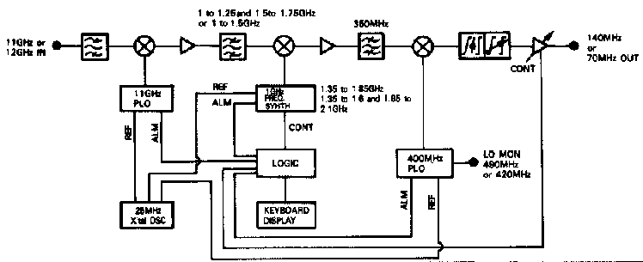

Figure 2.4.4 - Block Diagram of Ku-band Triple Conversion Down-converter

Modulators and Demodulators

Digital modulators and demodulators for domestic and regional satellite systems do not differ much in technology from their counterparts used in high-capacity systems as described in another section of this Handbook. The difference is rather in the amount of traffic they can carry.

A small-capacity domestic satellite system may be implemented with only a few pre-assigned digital voice channels, which may operate with an information rate of only 16 kbit/s. A higher capacity system may be designed for several hundred voice and data channels. Since it is not likely that all channels will be active at the same time and are not required between same geographical locations every time they are used, each channel may not be allocated permanent frequency space in the satellite transponder. Rather, the satellite channels will be assigned on demand, i.e. the satellite system will have a centralized Demand Assignment Multiple Access (DAMA) sub-system which will assign the channels as they are required. This will save satellite transponder bandwidth, and therefore operating costs for the operator of the satellite system.

Television programme distribution is a vital part of many domestic satellite systems, and with the currently available powerful satellite transponders, programmes can be provided to small roof-top TV receivers. Analogue TV transmission has been used since the beginning of satellite communications and is still being implemented in new earth station installations primarily due to the large amount of analogue TV receivers in operation in most countries. However, analogue TV will slowly be supplanted with digital TV which, when used with modern compression techniques such as MPEG-2, makes more efficient use of satellite bandwidth and power. Modulators and demodulators for digital TV will have data rates according to the image and sound quality desired. For example, an data rate of 64 kbit/s might be acceptable for a private PC-to-PC video conference, whereas a system that has to deliver studio-quality image and sound material would have to operate at a data rate of 2 Mbit/s or higher.

Centralized Monitor and Control System

In line with modern developments in operating and maintaining complex communications systems, sophisticated earth station Monitoring and Control (M&C) systems are often implemented such that one or more earth stations may be operated and maintained from a central location. This may or may not be at the location of the earth station(s). Such systems are also referred to as Computerized Station Management Systems (CSMS). M&C functions may be further extended to include monitoring and control of remote earth stations, which are under the control of one central earth station in a domestic or regional satellite system.

A modern CSMS system for monitoring and controlling an earth station (or complex of several earth stations) should include the following features:
* It should be tailor-made to the application on hand. The complexity of a modern earth station is such that a standard M&C system may not function very well.
* It should be comprehensive and cover the operation and maintenance of all equipment subsystems, whether the equipment is produced by one manufacturer, or includes equipment from several vendors. It should also be able to monitor auxiliary equipment such as fire and smoke detectors, and intruder detectors,
* It should have a high degree of flexibility. If the earth station is being reconfigured due to expansion or replacement of equipment, the CSMS should be able to be reconfigured as well, by earth station maintenance personnel, and without reprogramming of the CSMS software. A training function would also be a very useful feature.
* It should have extensive logging functions so that the performance of the earth station(s) can be analysed off-line.
* It should be easy to learn to operate. This means that it should use standard hardware to the extent possible, and it should use a standard computer user-friendly operating system which is in line with modern software developments.

2.4.1.5 VSAT Systems

A satellite VSAT (Very Small Aperture Terminal) system is an attractive solution for voice and data communications needs when the requirement is to have limited capacity from each location, but where the number of locations may run into the thousands. The flexibility of VSAT systems is such that it may be implemented very rapidly for a few sites and then gradually expanded as traffic grows or economic conditions allow. Therefore, this type of communications media is ideally suited for rural communications, when each small community may have requirements for only a few voice and data channels, but where there may be hundreds or perhaps even thousands of such communities scattered across the country.

The VSAT solution is also attractive when, in addition to voice and data communications, there is a need for one-way TV and radio broadcasting for educational or other purposes. In such cases, the remote VSAT terminals will serve not only as transmit and receive stations for voice and data, but also as TV and radio broadcast receive-only stations.
Furthermore, the digital data channels in modern VSAT terminals may be configured on-demand to serve specific purposes. This opens up a whole new spectrum of applications of which teleconferencing in general and telemedicine in particular are perhaps some of the most important. For example, a semi-skilled medical team with a video camera and medical equipment suitable for data communications, might visit VSAT communities on a regular basis. During the visit, two-way satellite video and voice channels will be made available for consultations between patients and skilled medical staff at central locations in the country.

The flexibility of VSAT systems extends to accommodate various types of traffic requirements. For example, some organizations (private or public) may have requirements for (1) voice communications and continuous data communications channels with various transmission rates, among many locations; whereas other organizations may have a need for (2) rapid and frequent interactive data communication, and occasional batch data transmission at fixed transmission rates between one central computer and many remote locations; or, (3) other organizations may have immediate requirements for both types of communications. Under traffic requirements, the routing of the traffic should also be examined. The VSAT system should be able to handle (4) star traffic in which all or most traffic flows between one central hub station and the remote VSAT terminals, and/or (5) mesh traffic, in which all or most traffic is evenly distributed among the VSAT terminals and the hub station. Also, (6) broadcast mode should be supported, in which the hub or control station is able to transmit to all or a predetermined group of VSAT terminals simultaneously. Finally, (7) it should be possible to implement digital or analogue television signal transmission by using the same RF equipment at the hub station and at the VSAT terminals, as used for the voice and data channels.

A well designed VSAT system should be able to implement all communications functions as outlined above.. It should be able to handle various transmission rates between its users. Furthermore, the VSAT system should be able to use the available satellite channel (transponder or fraction of a transponder) in an economical way with respect to power, bandwidth and time. Finally, the VSAT system must be well managed, monitored and controlled.

Satellite transponder power is conserved by implementing the VSAT system with efficient Forward Error Correction (FEC) coding schemes which will allow the system's demodulators to operate at a very low Carrier-to-Noise (C/N) ratio and therefore need reduced transponder power. Furthermore, if the system is implemented for voice communications, the voice coding should be done at the lowest rate commensurate with the desired voice quality.

Since it is preferred that the VSAT system can accommodate various transmission rates for data as well as voice channels between its users, the satellite transponder bandwidth should be assigned on demand. This Bandwidth-on-Demand (BOD) concept should be extended to transmission rates between any modulator and demodulator in the system.

The satellite transponder's time should be used as efficiently as possible. This may be accomplished by implementing the VSAT system to be operated under DAMA (Demand Assignment Multiple Access) control, whereby satellite circuits (voice or data) are assigned only on demand (i.e. when needed).

For the VSAT system to function reliably, smoothly and with the minimum number of skilled personnel, it should have a built-in central Network Management System (NMS) from where the system can be managed, monitored and controlled.

VSAT systems may be implemented in the satellite communications allocated C-band as well as Ku-bands. Significant technological advancement has gone into the development of the hardware and software used in VSAT systems. Systems may be implemented as new stand-alone projects, or they be integrated into already existing earth station equipment, thus saving capital and implementation time.

A detailed description of one particular implementation of a VSAT System is given in Annex A.

2.4.1.6 Transportable DSNG TV Earth Station Transmission System

To meet the growing demand for on-the-spot TV coverage, equipment with video and sound compression techniques according to MPEG-2 (more specifically ISO/IEC 13818-2) standards is now available in a very compact form. To keep the dimensions and weight down to manageable levels and to take advantage of modern day high powered satellites, the equipment operates in the Ku-bands allocated to satellite communications.

The equipment can be broadly categorized into the Outdoor Unit (ODU), and the Indoor Unit (IDU).

The Outdoor Unit

The ODU contains the antenna which, depending on the available satellite capability, may be a 75 or 120 cm diameter design typically operating in the 14.0-14.5 GHz transmit band, and the 12.25-12.75 GHz receive band. The station's front-end low noise transistor amplifier/converter subsystem has a nominal noise temperature of 120K, and the station will have a G/T of approximately 15.25 dB/K at 40 degrees elevation, and using the 75 cm antenna.
The transmit equipment includes a high power TWT amplifier/converter which, depending on the satellite capability, has a nominal output power of 50 or 100 watts. The maximum transmitted power from the station (saturated EIRP) will be approximately 54 dBW by using the 75 cm antenna and the 50-watt amplifier.

Satellite tracking is done manually, and the station is able to move freely 360 degrees in azimuth, and between 25 and 55 degrees in elevation. It will operate in wind up to 20 meters/second, and the weight of the ODU is approximately 50 kg.

The Indoor Unit

The IDU equipment is also housed in a weatherproof container of weight 60 kg and dimensions 52.2W X 49.4H X 50.2D centimetres. It is powered by 115 or 200 VAC and consumes approximately 1 kVA (including the ODU equipment). It accepts standard composite NTSC or PAL video and audio signals of levels 1 Vp-p and 0 dBm, respectively. These signals are compressed to one of four video coding rates, selectable by the operator of the equipment.

The video coding rate selected is primarily dependent on the available satellite power and bandwidth. Table 2.4.5 shows a table of the parameters used by the 4 different transmission modes. What is shown as the "Normal" mode, corresponds roughly to the video and sound quality of a typical household receiver. In this mode, the video coding rate is 7 Mbit/s and the transmission rate over the satellite is 11.3 Mbit/s. By using a convolutional Forward Error Correction (FEC) rate of 3/4, the required satellite transponder bandwidth is 8 MHz. Thus, 3 additional and similar TV carriers can be accommodated in a standard 36 MHz transponder, provided it has enough power. The demodulator will produce an output data stream with a BER (Bit Error Rate) of 1 x 10⁻⁸ or better at a received Carrier-to-Noise ratio (C/N) of 6.8 dB.

In transmission systems where the power from the satellite transponder is severely limited, the operator can select the "Threshold Mode", in which case the video coding rate is reduced and the transmission rate is increased compared with the "Normal" mode. The increase is due to the use of FEC rate 1/2, and the demodulator is able to operate at a C/N of only 3.6 dB for the same BER as for the "Normal" mode.

If enough satellite transponder power and bandwidth is available, the operator may select the "Medium" or "High Quality" modes of transmission which use the transmission parameters as indicated in the table. The "Medium Quality" mode is roughly equivalent to the image quality produced by today's full transponder analogue FM TV transmissions. The "High Quality" mode will produce images and sounds which, although not comparable to High Definition TV (HDTV), will satisfy most users.

Audio is provided at a bit rate of 384 kbit/s, either as 2 monaural channels or as 1 stereo channel. Orderwire communications are included with four 32 kbit/s voice channels and one 64 kbit/s data channel.

Table 2.4.5 - Transportable DSNG Earth Station Main Transmission Parameters

Mobile Transportable Earth Station

The equipment as described above may be modified and installed in a road vehicle. It may for example be a jeep-type vehicle, approximately 5 meters long and 1.8 meters wide. In this case, the antenna can be mounted on the roof of the vehicle, and the IDU is installed in the rear of the car. The antenna typically has a diameter of 1.2 meters. The HPC is typically a 100-watt TWT, and the LNC has a typical noise temperature of 80K. The IDU equipment is essentially identical to the IDU used in the portable earth station.

2.4.2 Technology for Mobile GSO Satellite Systems

From the beginning of commercial satellite communications (1965), the benefits of using satellites in geostationary orbits have outweighed the disadvantages. One of these disadvantages is the enormous free space propagation loss between the earth station and the satellite. Because of this disadvantage, earth stations have traditionally tended to be rather large installations, and only in recent years has the satellite communications technology matured to the point where it is now practical to use hand-carried portable terminals with geostationary satellites.

Inmarsat, the international organization with 79 member countries charged with providing maritime satellite communications, has led the way in providing land and air mobile communications. The equipment standards set up by the Inmarsat organization for accessing their satellites largely reflect the progression of technology and the physical size of the terminals. The ultimate goal, which will be realized with geostationary as well as non-geostationary satellites, is a handheld global communications terminal that fits into a pocket.

The Inmarsat-A terminal is still the most widespread communications terminal for mobile communications. It uses analogue technology and can support high-quality direct dial telephone, telex, facsimile and data services (9.6 and 64 kbit/s). Portable versions of this standard equipment fit into one or two suitcases and use folding antennas.

The Inmarsat-B terminal is the successor to the A-terminal and provides similar services. It uses digital technology and is therefore smaller, lighter and cheaper to buy, and has reduced user charges. Data services are provided up to 64 kbit/s.

The Inmarsat-C terminal is a small (a few kg) two-way data terminal and is the only terminal with an omni-directional antenna. It may be used in fixed, mobile, transportable, maritime and aeronautical versions. It supports store-and-forward message, text and data reporting communications at a rate of 600 bit/s.

The Inmarsat-M system also uses digital technology and provides direct-dial telephone, facsimile or 2.4 kbit/s data services. The physical size of Standard-M terminals has already progressed from the size of a small suitcase (11 kg) to the size of a notebook computer (about 2.6 kg). Further details on equipment used in the Inmarsat-M system are provided in Annex B.

2.4.3 Non-GSO Satellite Systems
Non-GSO systems require many satellites in order to provide uninterrupted service, with new satellites continually appearing over the horizon to take the place of those that are sliding out of sight on their way around the planet. The orbits of the various satellites in the constellation are designed to provide full global coverage. The non-GSO systems may occupy low earth orbits or medium to intermediate earth orbits.

Satellite constellations are tailored to provide specific regional or global coverage. Globalstar is an example of applying spacecraft constellation geometry and astro-dynamics to achieve a full-earth service area.

Since non-GSO satellites are closer to the earth than GSO satellites, they can achieve their function with smaller antennas and lower power per communications cell. The non-GSO satellites also enjoy less delay as signals from the earth travel and back to the ground have a shorter propagation delay.

A number of complex issues arise however e.g. the limited duration of visibility to a tracking, telemetry and command earth station. Ground resources, including spacecraft control and telemetry support, must be scheduled for contact times as these moving satellites come into view of an earth station antenna.

The advancement of technology in all fields used by satellite communications has resulted in increasingly more powerful and sensitive satellites, and shrinking physical size of earth stations. It was perhaps inevitable that the “earth station“ eventually would be reduced to the size of a hand-held telephone set. This is still not possible by using satellites in geostationary orbits due to the very large propagation path length resulting in signal attenuation loss and delay.
In order to overcome the disadvantages of the geostationary orbit satellites, communications systems may be implemented by using low earth orbit (LEO) or medium earth orbit (MEO) constellations. Technology at the end of the 20th century has matured to the point where such systems may be implemented with small hand-held earth stations. In fact, hand-sets will be designed for both terrestrial and satellite use with automatic switch-over between the two systems.

Orbit Constellations

If a LEO orbit constellation is used, the satellite altitude is selected much lower, typically between 700 and 2000 km. The orbit period in this case will be somewhere between 100 and 120 minutes.
Due to the lower altitude, the view of the world from the satellite is rather small and the number of planes to cover the entire globe will have to be increased to 6-8, and the number of satellites must be 6-12. The number of orbiting satellites, therefore becomes rather large.

Space Segments

The satellites may be implemented as simple repeater amplifiers with frequency conversion or they may have on-board signal processing capabilities.
The design life of the satellites obviously has an impact on the operating costs of any system implementation. The LEO orbiting satellites must be replaced more often than the MEO orbiting spacecraft, and the span of lifetime, therefore, may be in the order of 5-15 years.
In order to produce adequate power on the ground, satellites will be implemented with a large number of spot beams. This calls for rather complicated synchronization and "Handing-off" procedures by the controlling gateway stations, since a telephone subscriber while on conversation may find himself illuminated by 2 or more sweeping satellite beams.
Frequency Plans
Communications links between gateway stations and a satellite will use frequencies in the C or Ku bands. Furthermore, Ka bands are also used around 30 GHz for the up-links, and 20 GHz for the down-links.

As some of the frequency bands used are shared with GSO systems, there is a need for a balance between protecting the existing GSO services, and allowing new non-GSO systems to operate without undue constraint. Further agreements were reached at the World Radiocommunication Conference 2000 in Istanbul including some limits on earth stations of GSO networks, and power limits for non-GSO systems which define the rules of sharing the Ku band (10-18 GHz)

User Terminals
There will be a variety of user terminals employed in the LEO/MEO satellite systems. The bulk of user terminals will be small hand-held telephone sets that in many cases will be compatible with terrestrial cellular standards. The initial users will probably be international travellers who will be able to get a dial tone from anywhere in the world. Other subscribers such as users in remote areas where there is currently non-existent or very poor telecommunications infrastructure will follow.
Other terminals such as fixed terminals in village telephone booths, aircraft, ship or private residences will be used as well. Furthermore, multi-line units with several users sharing a single terminal will be developed. In most cases user terminals will be capable of interactive voice and voiceband data communications, such as facsimile, PC communications, and in some cases video conferencing.

Non-interactive communications in the form of world-covering one-way pagers that will be able to alert users and display alpha-numeric messages will also be available.

2.4.3.1 System Description
In the Annexes to Chapter 2.4 a number of LEO/MEO satellite communications systems are presented in some detail. Other systems are under preparation, and the inclusion of the above systems should not be seen as an endorsement, but rather as an attempt to illustrate representative system configurations. The description and details presented for each system is not exhaustive. Thus, the inclusion of certain equipment and functions for one system does not necessarily mean that the same equipment and functions are not included in the other systems, even if not described.

2.4.4 Global Mobile Personal Communications by Satellite (GMPCS)

The term Global Mobile Personal Communications by Satellite (GMPCS) refers to all communications systems that provide services directly to end users from a constellation of satellites. GMPCS represents the next stage in the development of wireless telephony, integrating the long-distance capabilities of satellites with the mobility of cellular phones. It accomplishes this by incorporating within portable user terminals all transmitting and receiving functions traditionally fulfilled by fixed earth station gateways and replacing terrestrial wireless networks with satellites. GMPCS uses geostationary and non-geostationary, regional and global, fixed and mobile satellite systems to interconnect individual user terminals. GMPCS systems are thus capable of transmitting any type of telephone transmission, i.e. voice, data, fax, or paging, to a destination anywhere in the world.

GMPCS thus embraces many of the systems and services addressed in this Chapter.

Further information is available in the ITU GMPCS Reference Book, December 1999.

    - Global Satellite Positioning Systems

Global Satellite Positioning Systems use satellites to provide highly accurate positioning data for a wide range of applications such as navigation on land, in the air, at sea and in space, national security, and new consumer oriented position determination applications.

The World Radiocommunications Conference 2000 provided additional allocations for radio-navigation satellite services. The additional spectrum makes it possible for the two current systems, Russia’s Global Navigation Satellite System (GLONASS) and the USA Global Positioning System (GPS) to develop into more accurate second generation systems, while providing room for Europe’s new system, Galileo.

2.4.6 ITU-R Publications

The ITU-R prepared following Handbook and Supplements dealing with Satellite communication:
- Satellite Communications (Fixed-Satellite Services), 2nd edition 1988
- Supplement No.1 to Handbook on Satellite Communications: Fixed-Satellite Service, 1995
- Supplement No.2 to Handbook on Satellite Communications: Computer Programs for Satellite Communications
- Supplement No.3 to Handbook on Satellite Communications, VSAT Systems and Earth Stations, 1995
- Radiowave Propagation Information for Predictions for Earth-to-Space Path Communications. 1996.

2.4.7 Abbreviations
AC Assignment Channel (or) Alternating Current
ACU Antenna Control Unit
AFC Automatic Frequency Control
AGC Automatic Gain Control
AM Amplitude Modulation
AOR Atlantic Ocean Region
BER Bit Error Rate
C/N Carrier-to-Noise
CSMS Computerised Station Management System
DAMA Demand Assigned Multiple Access
DC Direct Current
DCME Digital Circuit Multiplication Equipment
DOMSAT Domestic Satellite
DSI Digital Speech Interpolation
DTMF Dual Tone Multi-Frequency
ESC Engineering Service Channel
FEC Forward Error Correction
FET Field Effect Transistor
FM Frequency Modulation
GaAs Gallium Arsenide
GSO Geostationary Orbit
HDTV High Definition Television
HIC Hybrid Integrated Circuits
HPA High Power Amplifier
IDR Intermediate Data Rate
IDU Indoor Unit
IF Intermediate Frequency
IOR Indian Ocean Region
ISC International Switching Centre
ISDN Integrated Services Digital Network
LCD Liquid Crystal Display
LEO Low Earth Orbit
LES Land Earth Station
LNA Low Noise Amplifier
LNC Low Noise Converter
LRE Low Rate Encoding
LSI Large Scale Integration
MC Multi-Clique
M&C Monitoring and Control
MD Multi-Destination
MEO Medium Earth Orbit
MHIC Microwave Hybrid Integrated Circuit
MIC Microwave Integrated Circuit
MPEG Moving Picture Expert Group (ISO)
MTBF Mean Time Between Failure
NMS Network Management System
ODU Outdoor Unit
PC Personal Computer
PCM Pulse Code Modulation
PDH Plesiochronous Data Hierarchy
PIN Personal Identification Number
POR Pacific Ocean Region
PM Phase Modulation
PSK Phase Shift Keying
QPSK Quadrature Phase Shift Keying
SD Single Diversity (or) Space Diversity
SDH Synchronous Data Hierarchy
SIM Subscriber Identity Module
SSPA Solid State Power Amplifier
TDM Time Division Multiplexing
TDMA Time Division Multiple Access
TSI Time Slot Interchange
TV Television
TWT Travelling Wave Tube
VSAT Very Small Aperture Terminal

ANNEX 2A –VSAT SYSTEM

The following is a detailed description of one particular implementation of a VSAT System.

The Hub or Control Station

The Hub VSAT equipment may be constructed as a new earth station or it may be integrated into existing earth station equipment at the GCE level. For example, the existing equipment at the earth station may include a 13-meter antenna, Low Noise Amplifiers (LNA), High Power Amplifiers (HPA), Up-converters and Down-converters, Multiplexers (MUX), RF combiners, RF dividers, and 140 Mbit/s digital radio link to the International Transmission Maintenance Centre (ITMC).

The equipment to be added to the Hub station for VSAT operations is the following subsystems:

* Up-converters and down-converters for the applicable C- or Ku frequency bands.
* Voice and data channel modems. These may be plug-in cards for continuous voice and data communications with various data transmission rates. For example, the voice modems are typically able to operate at 16 and 32 kbit/s information coding rates, and the data modems at various rates between 9.6 - 2048 kbit/s. Each individual modem can be set to the desired transmission rate (Bandwidth-on-Demand function). It should be noted that the duration of a continuous type of communications channel in contrast to an interactive type of communications does not necessarily mean a permanently assigned communications channel. It may be assigned for the duration of a telephone call, forever, or for any length of predetermined time desired.
* The DAMA subsystem, in which the satellite transponder circuits are assigned on demand for voice or data communications either between the Hub and VSAT stations (star configuration), or between individual VSAT terminals (mesh configuration). The DAMA subsystem is communicating with remote VSAT terminals on a continuous TDM (Time Division Multiplex) Common Signalling Channel (CSC) (outbound or transmit communications), and by Time Division Multiple Access (TDMA) bursts from the VSAT terminals (inbound or receive communications). Modern DAMA equipment can control thousands of VSAT terminals.
* The AA/TDMA (Adaptive Assignment/Time Division Multiple Access) subsystem in which rapid and frequent interactive communications is implemented with the remote VSAT terminals. The modes of communications with the remote VSAT terminals are the same as for DAMA operations, i.e. TDM outbound and TDMA inbound.
* Data Voice Multiplex (DVM) equipment, in which the VSAT communications channels are interfaced to the existing digital MUX equipment. This interface is done at 2048 kbit/s to the existing MUX, but at various data rates to the VSAT Hub equipment.
* The Network Management System (NMS), from where the entire VSAT network can be managed, monitored and controlled. The NMS consists of a powerful workstation computer with applicable software for VSAT System Monitoring and Control, VSAT User Monitoring and Control, and for Billing management.

Voice Channels at the Hub Station

The voice channels may be configured from the NMS for either 16 or 32 kbit/s information rate. Furthermore, this information rate may be reduced to 8 kbit/s in the future without any hardware change. Implementation to 8 kbit/s is done simply by downloading information from the NMS to the hub station equipment and individual VSAT terminals. The 16 or 32 kbit/s voice channels at the hub station are input and output to/from the BOD voice channel modems as analogue channels.

At the ITMC, similar DVM equipment as at the Hub station is implemented for the analogue/digital conversion between the analogue telephone channels from the telephone exchange and the existing digital radio MUX equipment. The interface here is also at 2 Mbit/s. In the voice operations mode, one unit of DVM equipment is typically capable of handling a maximum of 30 voice channels.

Data Channels at Hub Station

The BOD data channels may also be configured from the NMS for data channel rates between 9.6 and 2048 kbit/s. Since the interface at the hub station to the existing digital radio link MUX equipment is done at 2 Mbit/s, rate conversion is required. This rate conversion is done in the Data Voice MUX equipment mentioned in the previous paragraphs.

The DVM equipment has 5 plug-in cards. For voice operation, each card can handle 6 voice channels for a total of 30 voice channels. For data channel operations, depending on the data rate, each card can handle 2-4 channels per card. The DVM can operate with a mixture of voice and data channels, but in no case can the aggregate bit rate from all input channels exceed 2048 kbit/s, which is the output data rate.

Interactive AA/TDMA Data Channels at the Hub Station

The interactive, frequent bursts of information to be transmitted to remote VSAT terminals are coming from a host front-end computer which is located at the premises of the user or owner of the VSAT system. The TDM data channel used for the outbound communications is typically operating at 64 or 128 kbit/s, and the return burst of information from the VSAT terminals are typically coming at 64 kbit/s. Since the host computer is not at the earth station (or even at the ITMC), multiplex equipment must also be included at the earth station and the ITMC to handle the interactive AA/TDMA channel.

VSAT Terminals

Depending on the required frequency bands and transmission capacity of the remote VSAT stations, antenna sizes of 1.2, 1.8, 2.4 and 3.7 meters are typically used. The Low Noise Converters (LNC) at C-band may have a 60K noise temperature, and 140K at Ku-band. High Power Converters (HPC) at C-band may use Solid State Power Amplifiers (SSPA) of 3, 10 or 20 watts rated output power, and similar devices for the Ku band may be rated at 1, 2 or 6.6 watts. The size of the antenna, and the LNC and SSPA ratings for a certain terminal, are not only dependent on the number of transmitted carriers, but also on whether the carriers are directed to the Hub station only (star configuration) or to other VSAT terminals (mesh configuration). If most of the carriers are transmitted to the Hub station, the size of the VSAT station can be minimized, or alternately, the number of carriers can be increased. This will also directly influence the power consumption and the cost of the VSAT terminal.

VSAT terminals, particularly if they are used for rural communications, are often implemented with solar power plants. Table 2.4.5 shows the C-band transmit capability and power consumption of various terminals operating with an Intelsat-7 type satellite.

ANT | ODE | No. of channels | Prime power consumption
1.8M | 5W | 5 | 337W
1.8M | 20W | 5 | 500W
2.4M | 5W | 5 | 337W
2.4M | 20W | 10 | 700W
3.7M | 5W | 5 | 337W
3.7M | 20W | 10 | 700W
Table 1 - Transportable DSNG Earth Station Main Transmission Parameters

The VSAT terminals may be implemented initially with only the antenna, the ODE and the Main Indoor Unit. The IDU is a container that may be placed on a tabletop and has no particular installation requirements. It contains up to 5 plug-in voice/data modems, of which one is used as the Common Signalling Channel (CSC) for communications with the Hub station. The Main IDU may be expanded with a total of 2 sub-IDUs for a total of 15 plug-in modems (including the CSC modem).

The Main IDU also may be expanded with the AA/TDMA Indoor Unit for interactive communications with the Hub station. The major components in this IDU are the Satellite Channel Interface (SCI) unit (modem, frequency synthesizer), a Baseband Processor (BBP) interface unit, an Operations Panel (OPP), and a power module.

Although the VSAT terminals are generally considered to be low-capacity earth stations, the capacity for each terminal is limited not so much by the equipment, as by the transmitted power, or alternately by the receive sensitivity of the satellite transponder. If the 15 channels in one VSAT terminal are implemented with data modems and each set to 2048 kbit/s, the number of 64 kbit/s channels that theoretically can be transmitted is 450 channels. If these 64 kbit/s channels were to be used with Low Rate Encoding (LRE) equipment, which is currently available with acceptable quality at 16 kbit/s, one VSAT terminal would theoretically be able to transmit 1800 channels.
Analogue or Digital TV Distribution from the Hub Station
Analogue or digital television may be transmitted from the Hub station by using the same RF equipment as the VSAT channels at the Hub station and at the remote VSAT terminals. However, if analogue TV is used, the VSAT antenna size may have to be increased. As an
attractive alternative, digital TV services can be included economically because the antenna sizes as outlined in this example may be used for the VSAT terminals with no modifications being required to the terminals. A TV receiver is connected directly to the IDU at 1 GHz IF level.

Network Management System (NMS)
The VSAT network is controlled technically as well as managerially from the Hub earth station, although the NMS functions can be performed remotely from some other location (for example the ITMC).
The main functions performed by the NMS can be broadly categorized as follows:

(1) Network Status Monitoring
(2) Network Configuration Management
(3) Network Control
(4) Network Reliability (switchover functions)
(5) Alarm Management
(6) Statistics Management
(7) Logging Management

Power Generating Equipment

The VSAT terminal equipment is very compact and requires no special shelter. The ODE unit is installed directly on the antenna structure, and the IDU cases may be located at any convenient place up to 80 meters from the antenna. This distance may be extended if low resistance cables are used.

The IDU will operate normally up to a temperature of 40C, and it is therefore not necessary to provide air conditioning except in extreme cases. If the prime power source is unreliable or not available, the VSAT terminals can be operated by solar generating power plants. Typical power consumption of the VSAT equipment was shown in a previous Table. Alternately, a small mobile diesel generator may be used.

ANNEX 2B - THE INMARSAT SYSTEM

The Inmarsat A, B, C and M standards are used for equipment in maritime or land-based services. Additional equipment standards for aeronautical services are the following:
- Aero-C for store-and-forward text and data messages to be sent and received by aircraft anywhere in the world.
- Aero-L for low-gain real-time data-only communications service for flight-deck and airline operations purposes.
- Aero-H for high-gain service providing multiple-channel flight-deck voice and passenger telephony.

Additional Inmarsat standards in preparation are Inmarsat-D, which is a pager system, and Aero-I which is a mobile voice and data service using smaller, lighter and less expensive avionics equipment and antennas designed for short- and medium-haul aircraft.

Calls originated from any of the standard equipment in the Inmarsat system must be routed through a Land Earth Station (LES), sometimes called coast earth stations or aeronautical ground earth stations. Numerous LESs are located worldwide in the Atlantic Ocean Region (AOR), Indian Ocean Region (IOR) and Pacific Ocean Region (POR).

It should be noted that the Inmarsat system is not designed to provide direct service from one mobile terminal to another. Rather, it is intended for a mobile terminal to communicate via a LES with subscribers connected to a public switched telephone or data network. Hence, if a communications link is set up between two mobile terminals, it will suffer a satellite double hop propagation delay which is unsatisfactory for telephone connections, but may be of little significance for data communications links.

If the purpose of rural communications is to establish voice and/or data links with urban centres that are already well connected to an LES, the Inmarsat-M system may currently be the fastest and least expensive way to integrate rural communities into an existing public communications network for purposes of trade, telemedicine, personal relationships and a host of other communications needs. If, however, the purpose is primarily for intercommunications between locations within or between rural communities, other communications architectures may be more appropriate.

A Portable Terminal for the Inmarsat-M System

The Inmarsat-3 series of satellites will eventually comprise 5 spacecraft covering all ocean areas. The transponders on the Inmarsat-3 satellites when used with spot beams are powerful enough to allow small notebook-size terminals to operate with an LES station and thus be connected to the international public telecommunications network.

The terminal uses the standard Inmarsat transmit frequency band of 1626.5 to 1660.5 and receive band of 1525.0 to 1559.0 MHz. Voice channels are available and encoded at 4.8 kbit/s by using advanced multiband excitation techniques. Facsimile may be transmitted and received using the G3 standard at 2.4 kbit/s, and asynchronous data transmission is available up to 2.4 kbit/s.

A built-in rechargeable lithium ion battery is used to power the equipment. When fully charged it will power the terminal for 4.5 hours in receive mode and for about 1.2 hours in transmit mode. It may be recharged from a 90-260 VAC or 12 VDC source.

Operating the terminal is fairly simple. The planar antenna, is pointed towards the satellite location for the ocean area where the terminal is located. By depressing the Menu button on the handset, the built-in LCD display on the handset will display the signal strength of signals coming from the satellite. By reorienting the antenna, the terminal may be set to receive maximum signal strength. If the direction to the satellite is unknown, a compass will aid the user in the initial orientation. An icon display will indicate that the terminal is locked on to a satellite.

The Base Unit of the Portable Terminal

The base unit of the portable terminal consists of the transmit and receive electronics, the antenna, the rechargeable battery and the cradle for the handset. The handset cradle may be detached and connected to the base unit by a cable up to 4.5 meters long so that the user of the terminal may be at his workplace while the base unit and antenna may be placed near a window. Furthermore, the antenna may also be detached and placed up to 10 meters from the base unit.

The handset cradle also serves as a connection point for a fax machine, an external telephone or a personal computer.

The base unit also contains a so-called SIM (Subscriber Identity Module) card reader. The SIM card is a "smart" card (about the size of a credit card) with an embedded electronic chip which provides enhanced security and many value added features such as: (1) personalized electronic phone book which can be easily edited and used for speed dialling and other services, (2) PIN (Personal Identification Number) code for restricting the use of the terminal, (3) personal ID providing a single number regardless of the location of the terminal, (4) security key and secret authentication algorithm for fraud protection, (5) language preference for LCD screen messages, (6) call barring capabilities for restricted dialling, and (7) short text messages for two-way communications.

SIM cards gives the user convenience and mobility. When a SIM card is used, the terminal senses the number and automatically bills call charges to a predetermined account.

The Handset of the Portable Terminal

Except for the insertion of the SIM card, the operation of the Inmarsat-M terminal is performed from the handset. Despite its small size, numerous functions are built in to this intelligent handset. The main functions are listed next:

* Storing Telephone Numbers
Users can store names and numbers in the handset and access them as an electronic directory. Numbers stored on the SIM card can also be accessed.
* Battery Status Indication
A four-stage icon on the LCD indicates the battery status. An alarm and LCD messages alert the user to low battery condition before the end of talk time.
* Call-in-Absence Indication
Un-answered calls are indicated by an LCD icon. The last 10 calls are displayed with caller ID and times and dates if the calls were made via ISDN.
* Credit Card Calling
Users can make credit card calls by keying in a two-digit prefix and the credit card number.
* Call Duration Display
Call duration is displayed at the end of every call. The handset also displays the duration of the previous call.
* Signal Strength Indicator (visual and aural)
Signal strength levels are displayed on the LCD. If the Menu button is pressed, the current signal strength is shown. Users can also set the terminal to emit beeping tones to indicate the signal strength.
* Barred Calls
The user can set the terminal to prevent calls to specified numbers or countries.
* Other Functions
Power save mode, backlight, redialling, user's numbers/ocean region display, phone lock, speed dialling, mute.

ANNEX 2C - THE GLOBALSTAR SYSTEM

General

The following information is extracted from material provided by courtesy of Globalstar L.P.:

The Globalstar system consists of a Space Segment, a User Segment, a Ground segment, and a Terrestrial Network as shown in Fig. 1. The Globalstar system provides communications from any point on the earth surface to any other point on the earth surface, exclusive of the polar regions. The satellite orbits are optimized to provide highest link availability in the area between 70 degrees south latitude and 70 degrees north latitude. Service is feasible in higher latitudes with decreased link availability.

User Terminals can be served by a satellite 10 to 15 minutes out of each orbit. A smooth transfer process between beams within a satellite and between satellites provides unbroken communications for the users. The orbital planes are inclined at 52 degrees. Coverage is maximized in the temperate areas with at least two satellites in view, providing path diversity over most of the area. There is some small sacrifice in multiple satellite coverage at the equator and at latitudes above 60 degrees.

The Gateways to the terrestrial network are illuminated by an earth coverage beam. The Gateway connects the User Terminal to the terrestrial network via an earth terminal. The terrestrial network is not a part of Globalstar.

Globalstar can locate the position of a User Terminal and provide the location as a service. Accuracy of the position location service is a function of several variables including (a) Number of Satellites in View, (b) Position Accuracy of the Satellites, (c) Geometry of the User Terminals, Satellites and Gateways, (d) The length of time that the User Terminal is connected to the Gateway.

The Gateway will also support more precise User Terminal position location as a service. With clear line of sight to at least two satellites, separated by at least 22 degrees as seen by the User Terminal, the Gateway will be able to compute the User Terminal's position to within 300 meters with 95% probability in less than 10 seconds.

Figure 1 - Overview of the GLOBALSTAR LEO System

Space segment and orbit constellation
The Globalstar space segment consists of 48 satellites in 1410 km Low Earth Orbits. The low orbits permit low power handsets similar to cellular phones. These satellites are distributed in 8 orbital planes with 6 equally spaced satellites per orbital plane. Satellites complete an orbit every 114 minutes. User Terminals in a particular location on the surface of the earth are illuminated by a 16 beam satellite antenna as it passes over the earth.
The Globalstar satellite is a simple low cost satellite designed to minimize both satellite costs and launch costs. A User Terminal transmits to the satellite by L-Band. The signal enters the satellite through the L-Band low noise amplifier. It is amplified and then converted into a C-Band signal after which it is further amplified. This is radiated to the Gateway. The Gateway receives the signal and block downconverts to an intermediate frequency. A sample of the intermediate frequency is provided to the TCU for processing. The communications traffic is presented to the CDMA equipment for demodulation.
In the transmit direction, the Gateway combines the uplink CDMA signals with the signal from the command transmitter and radiates it at C-Band up to the satellite. The satellite then down converts the signal and radiates an S-Band downlink signal to the User Terminals. Table 1 shows typical link budgets for all frequencies used by the Globalstar system.
Telemetry and commanding shares the C-Band with the communications feeder links. The T&C connects to the normal C-Band communications antenna for on-orbit operations. There is also a T&C antenna on the anti-earth face of the satellite. This antenna functions when the satellite is not oriented correctly or when there are problems. The anti-earth antenna is to insure that telemetry can be obtained and commands entered under all recoverable contingencies. Note that the anti-earth antenna bypasses the Low Noise Amplifier. This means that the transmitted power from the commanding earth terminal will have to be higher than the normal power required for commanding. This can be accommodated because there is no communications traffic when the satellite is not oriented correctly.
The satellite is steered in yaw to keep the solar panels oriented toward the sun to extract the maximum energy. This increases the communications capacity of the Globalstar System. There are some minor penalties that cause a slightly slower acquisition time and may cause more hand offs than would be otherwise required.

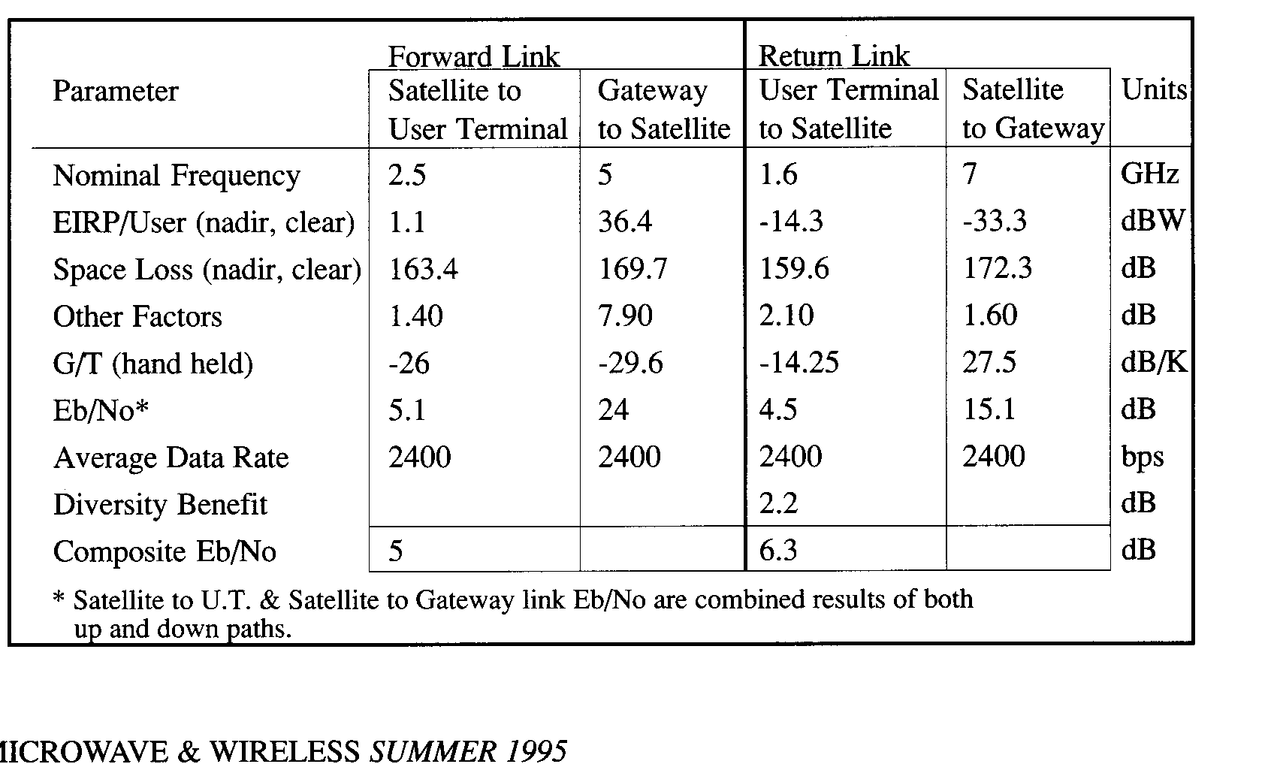
Table 1 - Typical Link Budgets for All Frequency Bands

Frequency plan

The frequency plan adopted by Globalstar is illustrated in Fig 2.
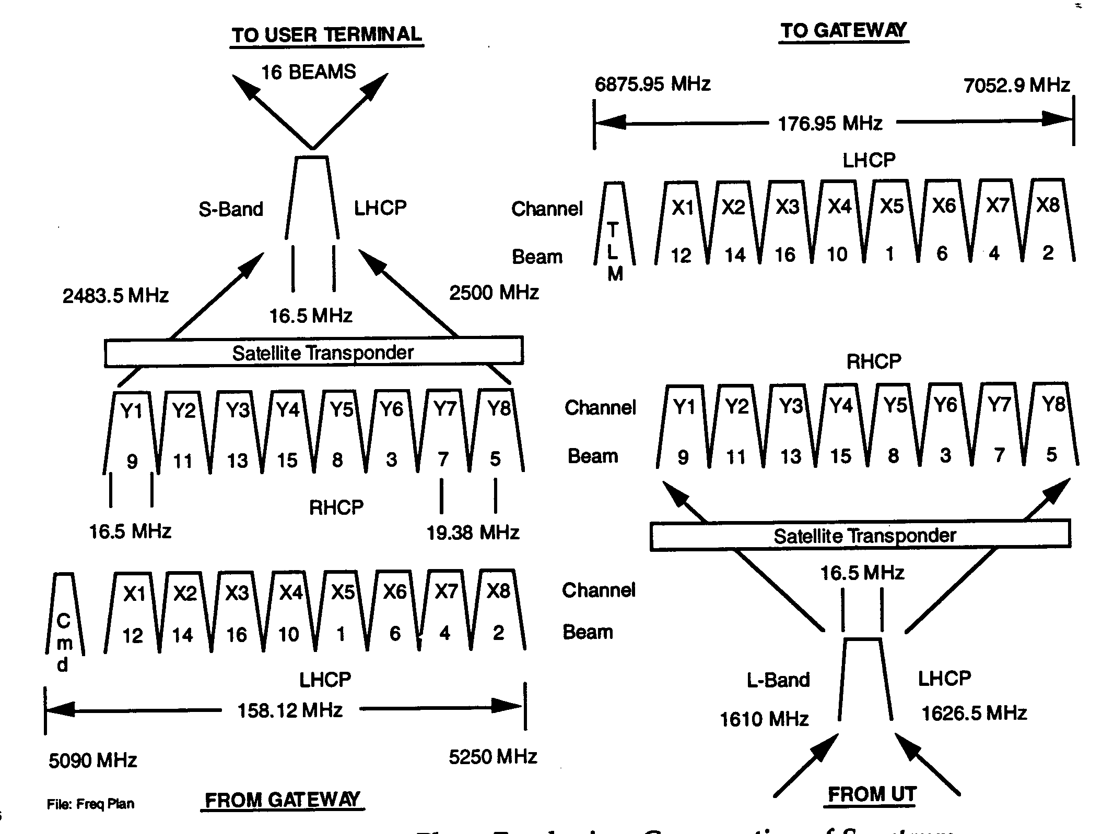

Legend: LHCP = Left-hand Circular Polarization, RHCP = Right-hand Circular Polarization, UT = User Terminal

Figure 2 - Globalstar Frequency Plan

Ground segment

Gateways

The Gateway interconnects the Globalstar satellite based wireless network and the PLMN, such as AMPS and GSM, or directly into the local telephone office (PSTN). As such, it is a termination point for network transmission and network signaling. The Gateway can be connected to existing PSTN using standard El/T1 trunk supporting a variety of signaling protocols. To GSM networks, the Gateway appears as a GSM Base Station Subsystem. To those mobile switches in the EIA/TIA environment, it appears as another mobile switch supporting the IS-41 Intersystem Operation Standard. In all cases, inter-operability between Globalstar and telephone/cellular companies is assured and the subscriber maintains a convenient single point for billing.
The Gateway is designed in a modular manner to provide flexibility in order to grow in step with market demand. The Globalstar Gateway can be shared by multiple service providers who can share investment in start-up common equipment. This design provides security from other service providers sharing the gateway and expansion is planned as revenues rise.
Each gateway will contain up to four tracking antennas and radio frequency front ends that track the satellites orbiting in their view. Gateways are expected to cost from $2 million to $5 million, depending upon the number of subscribers being serviced by the gateway and assuming that the gateway will be located at the site of an existing cellular or other appropriate telecommunications switch. Each nation with at least one gateway within it borders will have complete control over system access by users within its territory. A single gateway is expected to be able to provide fixed coverage over an area larger than Saudi Arabia and mobile coverage over an area almost as large as Western Europe. Thus, full global land-based coverage of virtually all inhabited areas of the globe could theoretically be achieved with as few as 100 gateways. Globalstar believes, however, that as many as 210 gateways may be required to minimize land-based long-distance charges and to respect national boundaries.
Although Globalstar has commissioned the design of the gateways to be used with the Globalstar system, ownership and operation of the gateways will be the responsibility of service providers in each country or region in which Globalstar operations are authorized.
Satellite Control
Globalstar’s SOCCs will track and control the satellite constellation using command and telemetry units located in various gateways around the world and telemetry stations in two locations in the United States. The SOCCs will control satellite orbit positioning, maneuvers and station keeping, and will monitor satellite health and status in all subsystems.
Furthermore, Globalstar has entered into a contract with Qualcomm Inc., providing for the design, development, manufacture, installation, testing and maintenance of two ground operations control centres (GOCCs). The GOCCs, which will be in continuous operation 24 hours a day, will be responsible for planning and controlling satellite utilization by gateway terminals and coordinating information received from the SOCCs. In addition to these planning functions, the GOCCs will be responsible for monitoring system performance, collecting information for billings to service providers and ensuring that the gateways do not exceed allocated system capacity. The GOCCs will be responsible for dynamically allocating system capacity among nearby regions to optimally service changing patterns of demand.
User Terminal
- Dual-mode User Terminal

The Globalstar/GSM Dual-mode User Terminal offers a global roaming solution for GSM cellular phone users. Globalstar enhances wireless service options by providing worldwide GSM cellular-like services in areas outside traditional cellular coverage. Inside the GSM service area, a Globalstar subscriber can continue to use the GSM services. Outside the GSM service area subscriber may roam to other GSM cellular networks or switch to the Globalstar network. Even in areas not served by cellular companies, subscribers are ensured of reliable, cost effective, world class mobile communication by Globalstar. The Globalstar constellation of Low Earth Orbit satellites will provide digitally crisp voice, data, and facsimile services. In all cases, inter-operability between Globalstar and GSM is assured and subscribers maintain a convenient single point for billing. For the mobile subscribers, a vehicle mount car kit is available. The Globalstar handheld unit can be mounted in a cradle that provides power to extend battery life and allows for handsfree operation for convenience and driving safety.

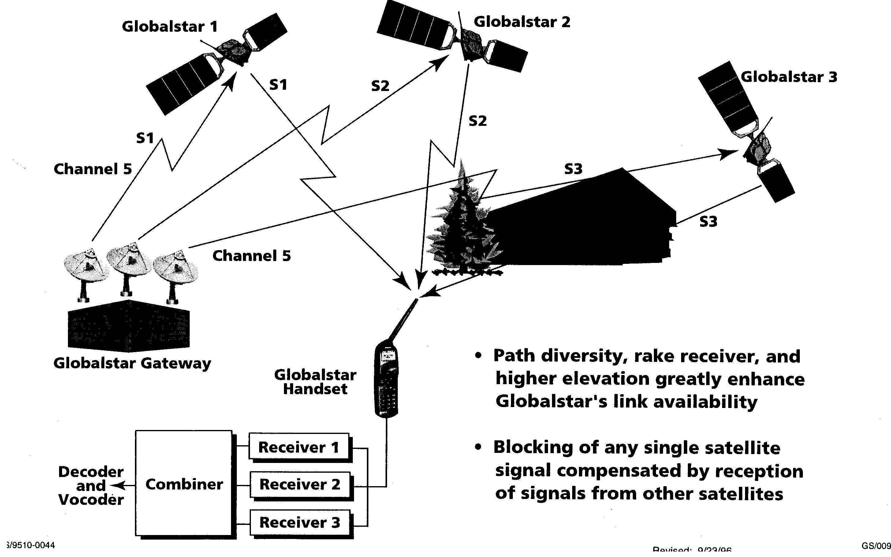

Figure 3 - Path Diversity of the Globalstar System

- Tri-mode User Terminal
The Globalstar/IS-95/AMPS Tri-Mode User Terminal offers a global roaming solution for AMPS/IS-95 cellular phone users. Globalstar enhances wireless service options by providing worldwide digital cellular-like services in areas outside traditional cellular coverage. Inside the cellular AMPS or IS-95 Code Division Multiple Access (CDMA) digital coverage area, the Globalstar subscriber could continue to use the land based services. Even in the areas not served by cellular services, the subscriber is insured access to reliable, cost effective, world class mobile communication available from Globalstar. The Globalstar system of low Earth orbit satellites will continue to provide digitally crisp voice, data, and facsimile services using hand-held, vehicle mounted or fixed products. In all cases, inter-operability between Globalstar and cellular companies is assured and the subscriber maintains a convenient single point for billing.
For mobile subscribers, a vehicle mounted car kit is available. The Globalstar handheld unit can be mounted in a cradle that provides power to extend battery life and a handsfree operation for convenience and driving safety.

Fixed Single Line

Globalstar’s family of fixed products meet the immediate communication demands for voice, facsimile and computer transmissions, and provides the flexibility, capacity and quality needed for future growth in demand. Wireless access offers an innovative solution for quick and efficient installation of a communications link for “hard to reach” subscribers without the cost and time necessary to interconnect using traditional wire. Globalstar delivers a worldwide contiguous wireless solution for delivering the “last mile” of connectivity with the telephone network.

Globalstar has designed their fixed station products to allow local content and subscriber flexibility. A Globalstar antenna, Radio Unit and optional digital telephone is provided by Globalstar. This digital phone includes a display for call progress indicators, icons for voice mail and memory for those frequently call numbers. The subscriber equipment can be locally provided by the in-country service provider. The antenna is mounted at a convenient outdoor location with a clear view of the sky and connected to the subscriber equipment. Globalstar provides cost effective interconnection to the telephone office for the unserved “hard to reach” population in developed and under developed urban and rural areas.

Multiline Unit
Globalstar delivers a worldwide contiguous wireless solution for delivering the “last mile” of connectivity with the telephone network. Our family of fixed products give local operators the flexibility, capacity and quality needed for future growth. Wireless access offers an innovative solution for quick and efficient installation of a communications link for “hard to reach” subscribers without the cost and time necessary to interconnect using traditional wire.
The Globalstar Multiline unit emulates a standard trunk circuit for interconnection with switching concentrators such as a PABX. Subscribers can be connected to the PABX using traditional wire, wireless or fiber and communicate with each other within the PABX. Globalstar is accessed when communication is required outside the switching system. The PABX subscriber will dial the outside line access number and Globalstar will connect the calling party to the public telephone office or other remote switching centre.

ANNEX 2D - THE ICO SYSTEM

The following information is based on information provided by ICO:

General

The ICO system is the first of 2 major Medium Earth Orbit (MEO), or Intermediate Circular Orbit (ICO), orbit constellations to go into operation. It is scheduled to be operational worldwide by the year 1999. The following information is extracted from material provided by courtesy of ICO Global Communications.

ICO is a satellite-based mobile communications system designed primarily to provide services to pocket phones. The system will offer digital voice, data, facsimile, and a suite of messaging services anywhere in the intended environments world-wide. Fig 1 is a diagram of the overall ICO system configuration.

The system design integrates mobile satellite communications capability with the public land mobile networks (PLMNs) and employs, among others, handheld mobile telephones (‘handhelds') which offer services similar to normal cellular phones, in outdoor environments. It will route calls from PLMNs and public switched telephone networks (PSTNs) through ground stations (called Satellite Access Nodes or "SANs") which will select a satellite through which the call will be connected. Calls from a mobile terminal will be routed via the satellite constellation to the appropriate fixed or mobile networks or to another mobile satellite terminal. Handsets will be produced by major manufacturers of telecommunications equipment, benefiting from terrestrial cellular/PCS technology. Single-mode satellite-only versions will be available, but most are expected to be capable of dual-mode operation with both satellite and terrestrial cellular/PCS systems. Dual-mode handsets will be able to select either satellite or terrestrial modes of operation automatically or under user control, subject to the availability of the satellite and terrestrial systems and the user's preferred service arrangements. A feature of the ICO system will be a suite of higher-penetration messaging functions capable of delivering an alert or short message.

Extensive measurements of the radio wave propagation typical of that expected to be experienced by handheld users operating to satellites, including the effects of shadowing and unwanted reflections, were made in a range of representative rural, suburban, and urban environments. The results were combined with the moving geometry of the satellite constellation to assess the service availability, expressed as the probability of a handheld user being able to initiate or receive a call at any given time.

An average service availability of more than 90 per cent can be provided in rural and suburban outdoor environments by providing a link power margin of about 7dB and using path diversity. In these same environments, without path diversity, a link margin of about 16 dB would be needed to achieve comparable availability. These results confirm the benefits of path diversity as a system design philosophy in terms of limiting the transmitted power and receiver sensitivity needed by individual satellites in the constellation, and thus reducing their complexity.

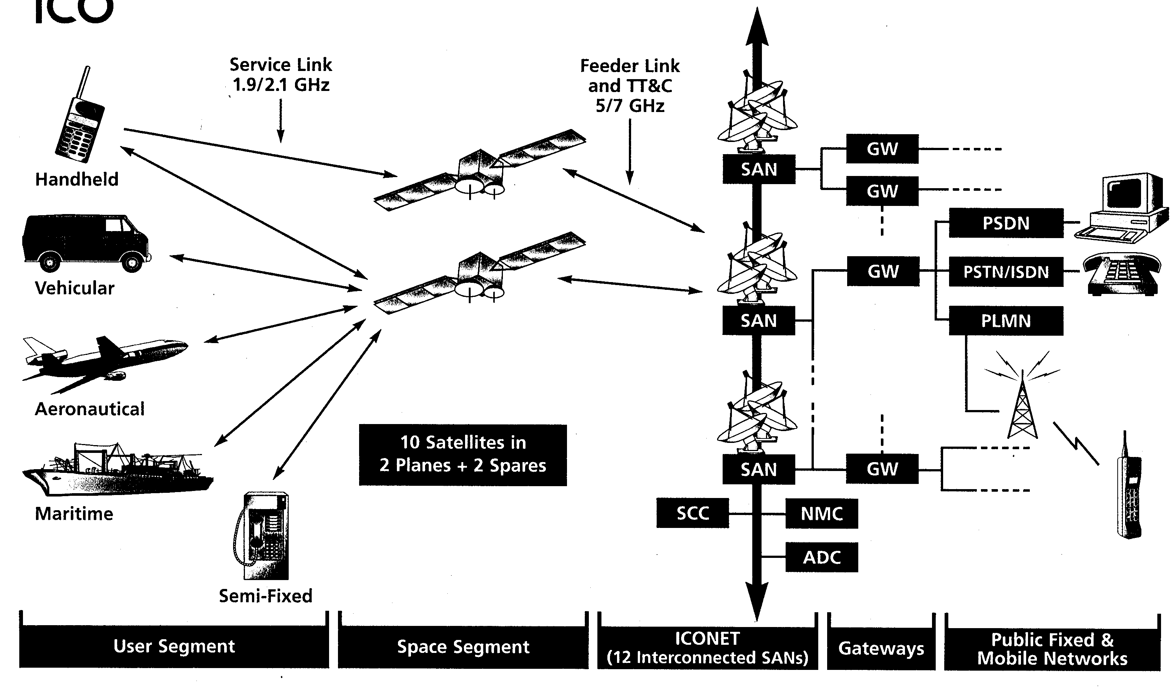
Figure 1 - Overview of ICO System Configuration

SPACE SEGMENT AND ORBIT CONSTELLATION

A constellation of 10 satellites in medium earth orbit (MEO), 10,355 km above the earth's surface will be arranged in two planes of five satellites each, with one spare satellite in each plane (i.e. 12 in orbit). Each orbital plane is inclined 45 degrees to the equator. 12 Satellite Access Nodes are located globally. Hughes Space & Communications International, Inc., will build the satellites under a contract signed in July 1995.

The configuration has been designed to provide coverage of the entire surface of the earth at all times and to maximise the path diversity of the system. Path diversity is the availability to a user of more than one satellite at the same time, and provides an alternative path for transmission in case one satellite is obstructed, increasing the likelihood of uninterrupted calls.

Satellite Constellation

The orbital pattern is also designed for significant coverage overlap, ensuring that usually two but sometimes three and up to four satellites will be in view of a user and a SAN at any time. Each satellite will cover approximately 30 per cent of the earth's surface at a given time. The satellite orbits have been selected to provide coverage of the entire globe on a continuous basis, while allowing high elevation angles to users, averaging 40-50 degrees. Fig 2 shows the ICO orbit constellation.

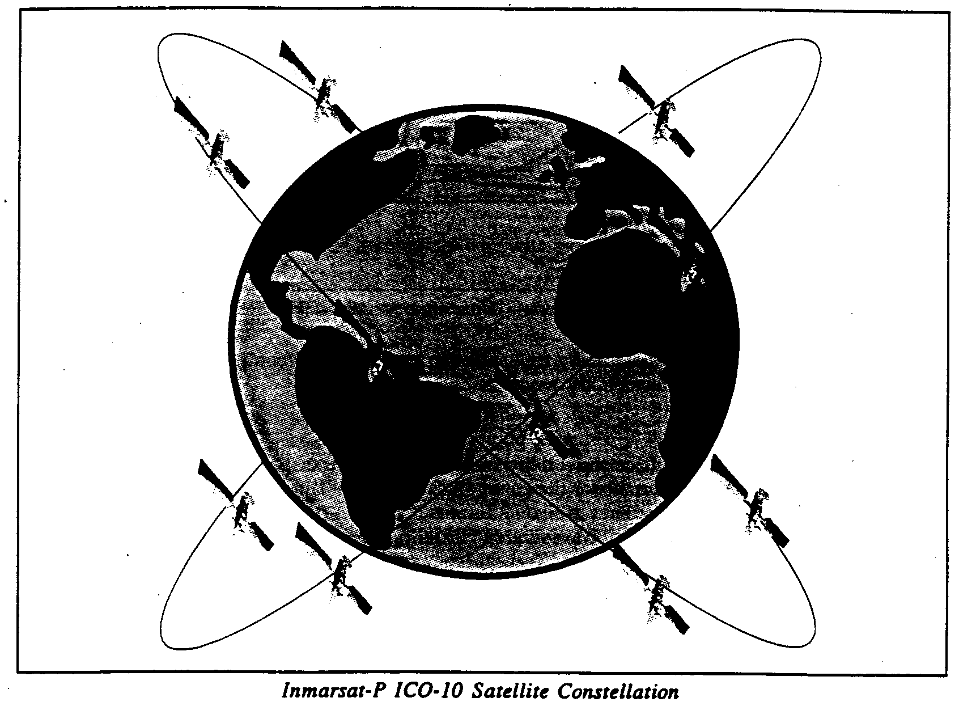

Figure 2 - ICO Orbit Constellation

Satellite Design

The satellites use the proven and popular HS601 geostationary satellite bus production line, with attitude and control systems modified to suit the special requirements of the MEO orbit. The communications payload is of transparent design, allowing flexibility to transmission format, using a high degree of digital technology for functions such as channelisation and beam generation that have traditionally been performed by analogue technology. The digital technology provides a very flexible satellite configuration (for example, flexible allocation of capacity across the full 30 MHz available in the 2 GHz service link bands), while having significant advantages over analogue technology in terms of production and manufacture for the comparatively large production run as compared with more conventional geostationary satellite orders.

Links between individual users and satellites will be established via service antennas mounted on each of the satellites. To provide robust radio links with handheld units, the satellites use antennas with an aperture in excess of two metres. The use of multiple service link beams on each satellite also allows frequency re-use and increases the efficient use of spectrum allocation.
The SANs are the primary interface with the satellite for coordinating and routing traffic. The SANs implement call routing to ensure the best quality of service to system users. In this regard, each SAN tracks the satellites within its line of sight and routes communications traffic to the optimal satellite.

Each satellite is designed to support at least 4,500 telephone channels distributed among approximately 750 carrier waves by using time division multiple access (TDMA) technology to integrate the multiple channels into each carrier wave. TDMA technology was selected after careful consideration of other technologies, including CDMA. Internal and industry studies for the ICO system have judged TDMA to have larger traffic-handling capacity and less demanding technical requirements than CDMA, and to be less subject to call failure as a result of interference. The design capacity of the individual satellites is such that this constellation will support at least 2,400 million voice minutes per year, assuming typical traffic distribution patterns with traffic "hot-spots". In addition, excess capacity will be available outside traffic "hot-spots" for further traffic opportunities. The life span of ICO satellites is expected to be approximately twelve years.

Satellite Technology

Service link and number of beams: The system performance will be well in excess of that required to provide the desired level of service. The 163 transmit and receive service link beams will provide links with a power margin in excess of 8 dB; the average link margin will approach 10 dB rising to 10-11 dB for a user at sub-satellite point.

Feeder link antennas: Feeder link antennas support the link between the satellites and the SANs. At any time, each satellite will usually be in direct contact with between two and four SANs. Before a satellite falls outside the line of sight of one SAN, it will establish contact with another SAN. This SAN will then track the satellite whilst it is in its line of sight and it will direct calls to this satellite or any other satellite within its sight depending on which one offers the best signal quality.

Satellite mass and power estimates: The total satellite launch mass, for a 'direct injection' into the circular orbit, is about 2600 kg allowing multiple launch vehicle capability. Direct injection allows some simplification to the HS601 as no apogee motor is to achieve final orbit. The solar arrays will use the latest Gallium Arsenide cells to provide end of life powers in excess of 8,700 W.

Selection of Orbital Configuration
Prior to selecting the MEO orbital configuration, Inmarsat, the largest shareholder and sponsor of ICO, conducted an extensive analysis and review of a broad range of the then available technical options. These studies focused on service properties, cost, technical risks and market potential. The research was conducted by Inmarsat with Inmarsat Signatory participation, and through a number of commissioned studies by main aerospace and telecommunications industry contractors.

The Inmarsat studies considered the relative merits of the generally known technically feasible options of providing a communication service to handheld satellite phones from:
(i) Low earth orbit (LEO - up to 2,000 km altitude)
(ii) Medium earth orbit (MEO - 8,000 to 20,000 km) or
- Geostationary orbit (GEO)

To cover the earth fully, LEO requires around 40-70 satellites, MEO needs 6-20 satellites, and GEO needs 3-6 satellites.

Inmarsat concluded that the MEO configuration could offer best overall service quality for the desired market. This is because of the orbital properties, which confer, with a reasonable number of satellites, the following benefits:
(i) High average elevation angle from user to satellites, minimising probability of blockage
(ii) High probability of a user being in the field of view of more than one satellite hence offering good satellite path diversity
(iii) Slow-moving satellites (about 1 degree per minute across the sky as perceived by the user)

The technology studies of the LEO, MEO, and GEO satellite constellations concluded that MEO represents a reasonable implementation and schedule compromise. The large number of LEO satellites which would be needed, taken with their relatively short lifetimes in their expected radiation environment, present logistical and manufacturing problems in maintaining the constellation.

Constellation Service Performance Features

There are trade-offs related to each of the orbital configurations with respect to service characteristics, costs, complexities and risks. Connectivity and propagation delay are most likely to be noticed by users.

Connectivity: All orbital configurations normally require a user to have a line of sight to a satellite to initiate and retain a connection. Obstructions such as buildings and mountains between a user and a satellite may prevent the establishment of a link or may sever an existing link, and both natural and urban canyons may present difficulties.

MEO or LEO systems typically allow for overlapping coverage of the earth from multiple satellites, which increases the likelihood of at least one satellite being within view of the user in order to establish a link. As the satellites in these systems move relative to the earth, they also leave the user's or the SAN's line of sight, moving either beyond the horizon or possibly behind an obstruction. To maintain a link, MEO and LEO systems must incorporate a system of "hand-offs".

MEO satellites move across the user's field of view more slowly than LEO satellites because they orbit at a higher altitude, which reduces the frequency of hand-offs required.

Propagation delay: This is the time delay, proportional to the sum of the distances between the satellite and the user and between the satellite and the SAN, resulting from the distance the radio signal travels. GEO systems have the highest propagation delay, while LEO systems encounter the least. A propagation delay of less than 200 milliseconds is characteristic of MEO and is well within acceptable limits.

FREQUENCY PLAN

Service link spectrum requirements for connection between user terminals and satellites:
The choice of bands for the provision of service links for MSS systems include 1.6/1.5 GHz, 1.6/2.4 GHz and around 2 GHz. ICO has chosen to operate in the 2 GHz bands, between 1985 - 2015 MHz and 2170 - 2200 MHz.

For the planned traffic distributions and volume, the service link spectrum requirement will be around 10 MHz in each of the uplink and downlink directions. The ICO satellites will retain the flexibility to maximise the use of the spectrum available in each direction in the 1985 - 2015 MHz and 2170 - 2200 MHz bands.

Feeder link spectrum requirements for connection between satellites and SAN): For feeder link operation, ICO has chosen to operate in the bands 5150 - 5250 MHz and 6975 - 7075 MHz. These bands form part of a pair of new allocations made by WRC-95 for feeder links to non-geostationary satellites providing MSS.

GROUND SEGMENT

The satellites will be linked to a ground network (the ICONET) which will interconnect twelve SANs optimally located throughout the world. SANs comprise earth stations with multiple antennas for communicating with satellites, and associated switching equipment and databases. The ICONET and SANs will implement the selection of call routings to ensure the highest possible quality and availability of service to system users. Fig 3 shows a block diagram of the ICONET.

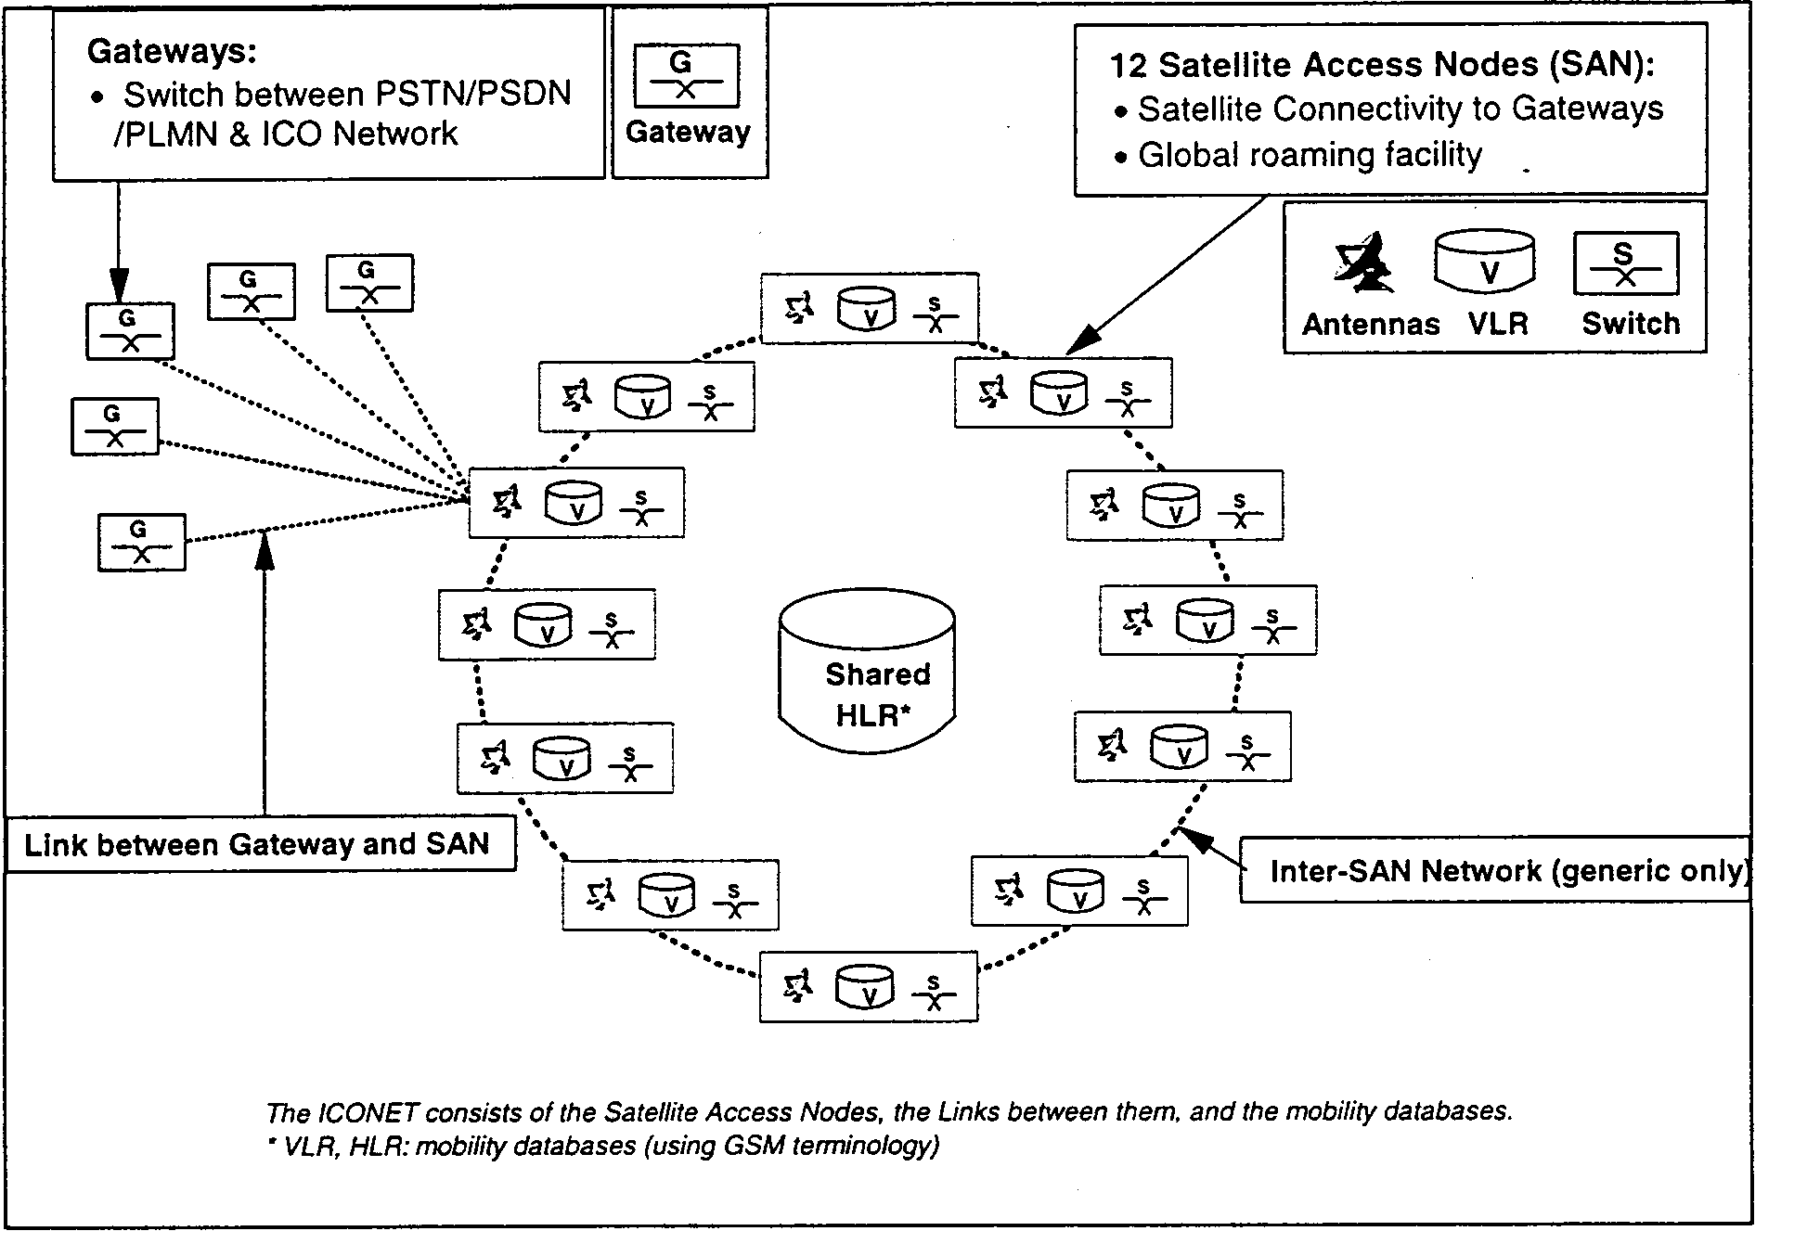
Figure 3. - The ICONET

Gateways will be located throughout the world and will connect into the ICONET to serve as the interface with the PSTN and PLMNs. They will be owned by third party operators who will be authorised to access the ICO system.

ICONET and Satellite Access Nodes

SANs will be the primary interface between the satellites and the Gateways. They will also house the equipment which will route the satellite signals for distribution to the appropriate Gateways. A SAN will comprise three main elements:
(i) Five antennas, with associated equipment to communicate with the satellites
(ii) A switch to route traffic within the ICONET and to Gateways; and
(iii) Databases to support mobility management.

Each SAN will contain a database to hold details of user terminals currently registered to that SAN (in GSM terminology, this is a Visitor Location Register or VLR). At least one SAN will also contain a database for holding some information on users (Home Location Register or HLR), though this function may be distributed among more than one SAN or in the PLMN.

Each SAN will track the satellites within its sight, direct communications traffic to the optimal satellite for the most robust link, and subsequently, as appropriate, will execute hand-offs from the satellite with the less robust link to the optimal satellite then in the line of sight of the SAN so as to maintain uninterrupted communication.

ICO will procure twelve SANs, strategically located around the world (approximately two per continent) and will own these facilities and commission their design and procurement, but the installation and operation of the SANs will be contracted out. The network of SANs will be interconnected by a terrestrial backbone network called the ICONET, which will allow calls to be routed through the ground segment of the network to the SAN best able to service the call. The ICONET will be managed by the Network Control Centre.

Gateways

Gateways are switches which will serve as the link between the SANs and the public terrestrial networks. Each Gateway will be connected to the ICONET, which will allow flexibility in traffic allocation and back-up traffic routing. The switch may be either a self-contained, dedicated unit or may be implemented as an additional function on an existing switch.

Gateways will be owned and operated by third parties. There is no pre-defined technical limit to the number of Gateways which can be incorporated into the system, and their location will be determined by market proximity and access to existing PSTN, PSDN, or PLMN switches.

User Mobility Management

In order to provide global roaming, the ICONET will include a system for management of global user mobility based upon the existing digital cellular standard, GSM.

HLRs in co-ordination with VLRs will verify user information and status, and locate the user anywhere in the world. Any handset which is turned on will send a signal via satellite and SAN to the user's HLR which will verify the user's status and allow access to the system. The system will communicate this clearance to that SAN and register it in its VLR. The HLRs second function is to communicate the VLR location of any user to the SAN through which an incoming call is originated. This will enable the call to be directed to the SAN closest to the intended call recipient. The call will then be completed via satellite link.

Cellular Network Integration

A critical feature of ICO will be its integration into PLMNs existing at that time. In most instances the satellite network will be viewed as a complementary service to PLMN subscribers who wish to have the capability of making and receiving calls in areas not serviced by their PLMNs.
The ICO network architecture will allow two broad groupings of users to be made, with corresponding service distinctions: local or regional users and users who operate worldwide.

ICO Global Communications is studying several alternative approaches to integration, including the system requirements for global numbering and the logistics of locating users and call linkage within and outside the range of cellular networks. ICO will include a dual-mode handset which will access both satellite and PLMN networks from the same terminal.

Telemetry, Tracking and Control- TT&C

TT&C stations will manage the ICO satellite system by tracking the movements of the satellites and adjusting their orbits to maintain the constellation. TT&C stations will also monitor the general condition of the satellites by collecting data on the power supply, temperature, stability and other operating characteristics of the satellites and relaying that data to the stations for processing and response.

Satellite Network Control

The NCSs, acting through TT&C stations and SANs, will control the transponder linkages between the feeder and service antennas on the satellites. This process will dictate, among other things, frequency reconfiguration within feeder link beams and optimal channel allocation between high and low traffic spot beams.

USER TERMINALS

Pocket Phones

The large majority of ICO user terminals are expected to be handheld, pocket-sized telephones, capable of dual-mode (satellite and cellular or PCS) operation and very similar in size and appearance and in voice quality to today's pocket cellular/PCS phones. The price of ICO dual mode phones, on the basis of high volume production, is expected to be competitive with other comparable satellite systems at service introduction.

The ICO pocket phone is planned to have optional features including external data ports and internal buffer memory to support data communication, messaging functions, facsimile, and the use of smartcards (SIMs).

Safety

The ICO system has been designed to ensure that the pocket phone will comply with expected safety requirements in respect of radio frequency radiation. The average transmitted power typically during use will not exceed 0.25 watts. Existing cellular phones have average transmitted power typically in the range of 0.25 to 0.6 watts.

Other Derived User Terminal Types

The technology used in ICO pocket phones is expected also to be incorporated in a wide range of other user terminal types including vehicular, aeronautical, and maritime mobile terminals and semi-fixed and fixed terminals, such as rural phone booths and community telephones. For many of these terminals it will be possible to use higher-gain antennas and/or higher transmit powers than are used for the pocket phones, which will permit higher bit-rate services to be supported.

ANNEX 2E - THE SKYBRIDGE: GLOBAL MULTIMEDIA ACCESS

The following information is based on information provided by Skybridge:

Introduction
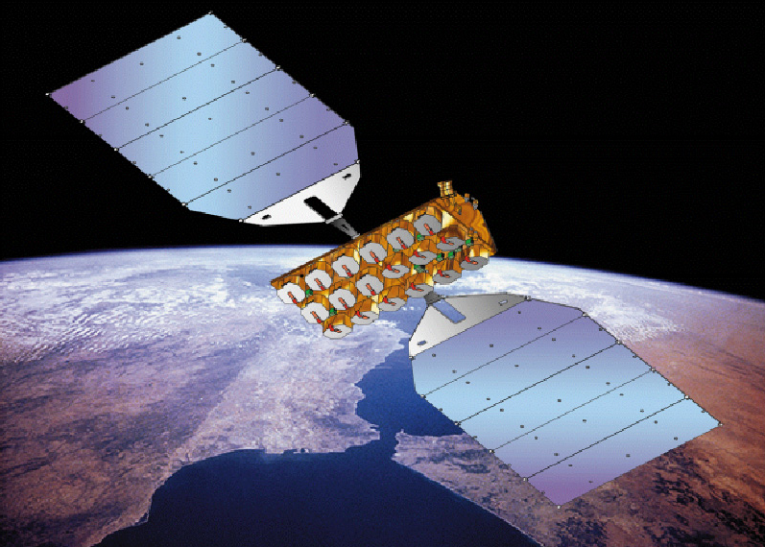
Over the past few years, businesses and individuals have rapidly embraced the Internet, realizing the benefits not only of being able to access information from all over the world at low cost, but also the potential of electronic commerce. However, the powerful interactive multimedia services that characterize the new information age require ever larger circuit capacities to transport text, images, video, sound and data. Indeed, many of these services require transmission rates tens to thousands of times larger than those needed for a simple phone call. It is estimated that by the year 2005, more than 400 million users worldwide will be using such broadband services.
To meet this demand, telecom operators have invested heavily in fiber-optic backbone networks which can transport multimedia information around the globe at the speed of light. However, the local networks that bring these services to end users have lagged far behind, creating bottlenecks which will be familiar to everyone who has waited and waited for an Internet page to download. The main reason is, of course, the high cost of replacing or upgrading the local access infrastructure, which represents more than 70% of total network investment. It is both financially and physically impossible to replace the installed local loop by high speed fiber within a few years.

Technologies such as Asymmetric Digital Subscriber Line (ADSL) and cable modems are providing attractive solutions that use the existing copper telephone networks and cable networks. However, such technologies cannot be made available technically or at a sufficiently low cost in a number of situations (e.g. in low density areas, where existing networks are of insufficient quality). Many users will thus continue to suffer from traffic jams. As a result, operators are losing the considerable revenue which they might expect to earn from offering broadband services to all their subscribers.

The question then is, how can we solve this problem in an affordable way? The answer is SkyBridge, a satellite access system which overcomes the local loop limitations by providing high speed access to the world's fiber optic backbone networks. Scheduled to start operation in 2003, SkyBridge will enable telecom operators to offer local broadband access to over 20 million users worldwide, using a constellation of 80 Low Earth Orbit (LEO) satellites. It will be the first broadband LEO satellite system, and the only one focused entirely on local access. By interconnecting the SkyBridge satellite access network with fiber optic backbones, SkyBridge will make global high speed end-to-end connectivity a reality at an affordable price. Operators will benefit from low cost, flexibility, rapid deployment and a high quality of service. As SkyBridge provides "bandwidth on demand", they can allocate capacity wherever and whenever necessary to meet users' needs. Users gain the advantage of cost-effective access to multimedia services using a small, inexpensive antenna.

Because it uses satellite technology, SkyBridge is not constrained by the terrain or the existing local infrastructure. Thus it enables people and businesses in rural and remote areas, and in developing countries, to take advantage of the information age, helping to boost the local economy.

SkyBridge System

SkyBridge uses a constellation of 80 satellites orbiting the earth at an altitude of 1469 km. Because the system operates in the Ku-band (10 to 18 GHz), it is able to provide high availability based on the use of proven satellite technology. In addition, the Ku-band is much more robust against rain attenuation than higher frequency bands, and therefore offers a high quality service even in poor weather conditions. The use of this band, which SkyBridge shares with a number of geostationary satellite systems and terrestrial microwave systems, has been unanimously approved by the World Radiocommunications Conference (WRC) of the International Telecommunications Union (ITU).

Traffic is routed from the user's antenna via the LEO satellites to a terrestrial gateway which interfaces with the terrestrial infrastructure. Switching and routing can be performed either in the gateway or by a remote switch in the operator's network.
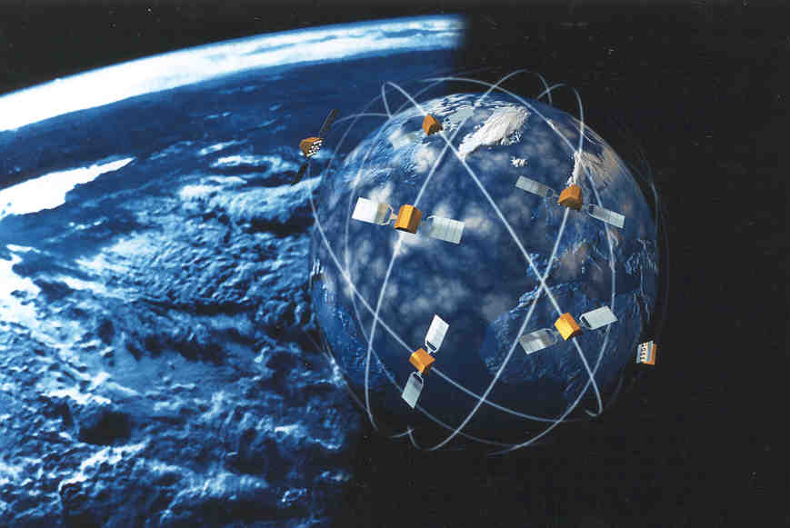Flexibility and the ability to evolve gracefully are built into SkyBridge as it operates on the simple "bent pipe" principle with no on-board switching or satellite-to-satellite communication links. Consequently, operators can manage the capacity of their networks as necessary, and develop services to meet emerging user demands. This flexibility will be crucial in maintaining a competitive market position well into the next millennium.

Architecture
The system architecture is divided into a space segment and a telecommunication segment. The space segment comprises:
- A constellation of 80 LEO satellites, plus spares.
- Two Satellite Control Centres (SCC).
- Tracking, Telemetry and Command (TT&C) ground stations.
- Two Mission Control Centres.

The satellites orbit in a so-called Walker constellation, which consists of 20 planes, equally inclined by 53º relative to the equator. There are four satellites in each plane, orbiting at an altitude of 1469 km.

A key design feature of the satellites is the use of active antennas which generate the spot beams and maintain them pointing towards the corresponding terrestrial gateways. Each spot beam illuminates a 700 km diameter cell. It can serve user terminals with an elevation angle of more than 10º.

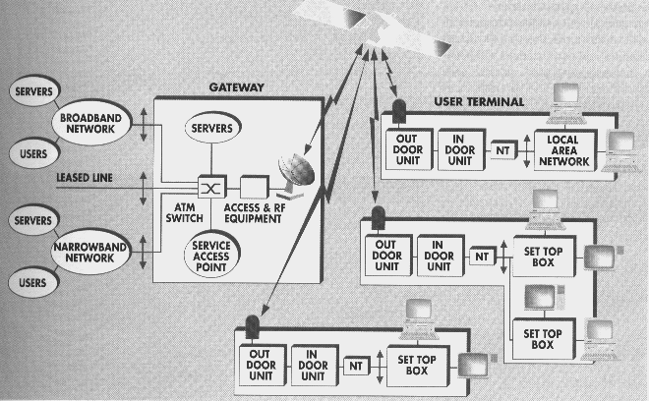

Figure 1 - Telecommunication segment of the SkyBridge system
The above figure shows the telecommunication segment. This consists of user terminals and gateways, which interface with local servers, narrow- or broadband terrestrial networks, or leased lines. User terminals comprise the antenna equipment and an interface for connection to the user's equipment, such as a multimedia PC. Up to 200 gateways are planned, ensuring global coverage. In regions with low population densities, one gateway can serve several cells.
Residential users equipped with small, 50 cm roof-mounted antennas can receive at up to 20 Mbit/s (forward link) and transmit at up to 2 Mbit/s (return link). Business terminals using 80 to 100 cm antennas can receive and transmit 3 to 5 times higher bit-rates.

SkyBridge uses standard Asynchronous Transfer Mode (ATM) and Internet Protocol / Transmission Control Protocol (IP/TCP) so that it can work seamlessly with the established and future terrestrial networks.

Handover
As a satellite moves out of sight of a terminal, the traffic it is handling with that terminal is handed over to another satellite to ensure continuity of service; the first satellite then refocuses on other terminals. Handover for a cell is managed by the corresponding gateway.
Links with the outgoing satellite are maintained long enough for the terminal and gateway antennas to point to and synchronize with the incoming satellite. Calls are switched over as soon as synchronization has been achieved.

SkyBridge Services

Because of the constraint of data acknowledgement, the performance ( throughput, window size) of IP packet transport is mainly influenced by the satellite round trip delay.
The low signal transmission delay of the SkyBridge constellation (30ms compared to 500 ms for Geostationary satellites) guarantees a good transfer efficiency for the support of Internet access services.

In addition, SkyBridge is designed to be compatible with current and emerging Internet protocol standards (e.g. Resource Reservation Protocol / Differentiated Services, Point to Point Protocol over Ethernet) which are currently being defined to support real-time quality of service over the Internet or other packet-based broadband networks.

End-user services

The SkyBridge System supports a wide range of services :

- Multimedia Applications Over the Internet: meet the increasing demand for real-time media (e.g. live video press conferences, live Internet radio), as well as emerging telephony and video conferencing on the Internet.
- Direct access to on-line services and content: SkyBridge System traffic can be routed directly to a local server that provides local services and content.
- LAN interconnection and private networking: these are provided by interconnecting individual terminals and Local Area Networks (LANs) via satellite links. In addition, the System enables operators to provide virtual LAN services by facilitating remote access to LANs (for telecommuters at home or employees in the field), and Wide Area Network (WAN).
- Connection to the Public Narrowband Network: enables any end user to use his or her own standard or digital telephone set, as well as other types of End User Terminals, such as screen phones or set-top boxes.
- Videotelephony and Video Conferencing: enable multiple users at two or more sites to communicate in real-time with bi-directional or multi-directional exchange of audio, video, and other data (including corporate applications and documents).
- Electronic Commerce: includes the marketing, ordering, delivery and payment for goods and services online. E-commerce is expected to be a major driver force behind the demand for broadband services over the Internet, intranets and extranets.
- Telecommuting: makes it possible for people to work away from traditional offices through remote LAN/WAN connections. The SkyBridge System also gives telecommuters access to remote LAN connections.
- Telelearning: supports “virtual classroom” in which instructors and students are in different locations served by SkyBridge.
- Telemedicine: involves a combination of video-on-demand, multimedia information retrieval and video conferencing.

Narrowband and Broadband transport services
SkyBridge supports narrowband services both for the provision of telephony services in suburban areas and sparsely populated areas, and for the rapid deployment of public infrastructures and private networks.

In addition SkyBridge’s transport capability supports connection to complementary broadband access systems (such as ADSL ), and the interconnection of remote groups of users to the SkyBridge Gateways.

SkyBridge end-users

The SkyBridge system serves two categories of users:
- professional users accessing remote databases and sharing interactive applications with other parties outside their business Customer Premises Network.
- residential users requiring entertainment, video communication, access to Internet Service Providers, etc.

Professional users

Professional users may require point to point or point to multipoint connectivity for applications such as teleconferencing, cooperative work, LAN-to-LAN interconnection.
Via SkyBridge, a professional user can contact another professional user connected to an external corporate network (e.g. WAN, Intranet, Virtual Private Network (VPN),) or any other user equipped with a SkyBridge terminal.

Residential users

Communications can be set up between different local SkyBridge residential users within the SkyBridge coverage area as well as between any residential user and the Service Providers connected to SkyBridge gateways.

Operators

In certain cases, network operators can also be considered as end users. In particular, SkyBridge can transmit switched or transparent E1 and T1 links.

Frequency Reuse Concept
One of the most important aspects of efficient frequency management is the concept of sharing between different telecom services and systems. Well-structured sharing techniques, enable new technologies to be deployed, which allow exciting new services to come on-line without disturbing existing services. SkyBridge is an example of this spirit of sharing. Innovative design enables SkyBridge to greatly extend access to advanced telecommunications by re-using frequencies already used by other systems, including geostationary satellite and fixed service systems.

SkyBridge is playing a pivotal role in creating the environment, that will allow this tradition of sharing and efficient frequency use to continue for Non-Geostationary Satellite Orbit Fixed Satellite Service (NGSO FSS) systems. The 1997 World Radio-communication Conference (WRC-97) took a strategic first step in approving the concept of Power Flux Density (PFD) limits. These specify the technical parameters with which a constellation of NGSO satellites must comply to ensure adequate protection to geostationary satellites and terrestrial services. WRC-97 also created a technical forum in which engineers from around the world are meeting to determine at the precise levels of protection to be afforded to Geostationary Satellite Orbit (GSO) systems and terrestrial services, while allowing the introduction of NGSO FSS services. This cooperative effort is well underway and has made substantial progress towards its goal. It will be up to WRC-2000 to finalize this regime and adopt the work done by the ITU-R working group examining this subject.

Because SkyBridge shares the Ku-band (10 to 18 GHz) with existing geostationary broadcasting satellite systems, terrestrial networks, space science projects and radiolocation services, one of the main design challenges was to ensure that it will not cause harmful interference to these or any future systems using the same band.

To achieve this, SkyBridge has optimized the various system radio parameters. First, the frequency plan has been carefully selected, including the allocation of some bands exclusively to gateway stations with no user terminals. Second, the satellite antennas have been designed to provide optimum performance. And third, the waveform has been carefully designed to minimize the required power and to ensure that the system is robust to interference from other users of the Ku-band.

Frequency Plan and Sharing Issues

Protecting Geostationary Satellite Systems

Existing geostationary satellite systems operate within a well established operating environment. Frequency sharing with geostationary satellite systems using the same Ku-band is based firstly on giving adequate protection against three potential forms of interference:
- Interference between the main beam of a SkyBridge transmitter and the main beam of a geostationary satellite receiver.
- Interference between the main beam of a SkyBridge transmitter and the sidelobe of a geostationary satellite receiver.
- Interference between the sidelobe of a SkyBridge transmitter and the sidelobe of a geostationary satellite receiver.

By exploiting the directivity of the SkyBridge and geostationary satellite earth stations, SkyBridge protects existing satellite systems against these forms of interference in a way that is transparent to end-users. All GSO earth stations point toward the GSO arc, offering the rest of the space an important antenna angular discrimination. In particular, to avoid interfering with the receivers of geostationary systems, SkyBridge satellites cease transmission to a given cell when an earth station recognizes that they are close to a GSO pointing direction.

Each gateway has a defined "non-operating zone" which includes all the satellite positions that would potentially create interference with a geostationary satellite and associated earth stations. As soon as a SkyBridge satellite enters this zone, it ceases transmission to the gateway cell corresponding to the exclusion zone; at the same time, the gateway and all the user terminals in that cell stop transmitting to the satellite. Traffic in the cell is transparently handed over to other satellites in the constellation to ensure continuity of service.

Based on an extensive analysis of the interference environment, the non-operating zone has been defined as a belt of ±10º on either side of the geostationary arc, as seen by any earth station in a gateway cell. Consequently, the non-operating zone is wider than ±10º for most points within the zone, ensuring even better protection. This limits the residual main-beam-to-side-lobe and side-lobe-to-main-beam power.

Protecting Terrestrial Services

The primary measure taken by SkyBridge to help protect the fixed terrestrial service against interference was to carefully select the frequency bands used by the small user terminals when receiving and transmitting. Only gateways operate in frequency bands that are regularly used by the fixed service. Coordination between the two systems is eased as a result of the better discrimination provided by the large gateway antennas and the limited number of earth stations to be coordinated. While this constrains the SkyBridge system, it simplifies the protection of fixed service links operating in the Ku-band.

Careful refinement of the propagating models used in coordination procedures has minimized the distance between an earth station and a fixed service link below which the two parties involved need to coordinate their operations. General agreement has been reached on these procedures.

Fixed Service reception also needs to be protected from NGSO satellite emissions through the definition of adequate PFD limits. General agreement has also been reached on these limits.

Protection of Radiolocation Service and Space Science

Existing radio regulations stipulate a maximum Equivalent Isotropic Radiated Power (EIRP) emitted by earth stations in order to protect Space Science systems which are planned to operate in the Ku band. They also specify the minimum EIRP at which earth stations must operate in order to be protected from the radiolocation service.

SkyBridge has undertaken a detailed technical analysis to determine how it will affect these services. As a result of its use of an interference robust waveform SkyBridge has proven that it can operate in the Ku-band alongside radiolocation services.

In addition, SkyBridge is proposing to limit the power transmitted by its gateways below the level defined in current radio regulations, thereby ensuring that space science applications are protected against interference from NGSO earth stations.

ANNEX 2F - THE TELEDESIC SYSTEM

The following information is based on information provided by Teledesic:

Through a broad, cooperative effort, Teledesic will bring affordable access to fiber-like telecommunications services to all parts of the world that would not be economical to serve through terrestrial means.

Today, advanced telecommunications infrastructure is limited to the developed urban areas of the world. This leaves most of the world’s population without access to even basic communications services. Even those areas with basic voice service get access through 100-year-old technology – analog, copper networks – that for the overwhelming part will never be upgraded to support digital, broadband services.

Teledesic is building a global, broadband “Internet-in-the-Sky.” Using a constellation of several hundred low-Earth-orbit satellites, Teledesic will create the world’s first network to provide affordable, worldwide, “fiber-like” access to telecommunications services such as broadband Internet access, videoconferencing, high-quality voice and other digital data needs. On Day One of service, Teledesic will enable broadband telecommunications access for businesses, schools and individuals everywhere on the planet.

Teledesic has received support from the developed and developing world alike, resulting in both international and domestic satellite service designations for the frequencies necessary to accommodate the Teledesic Network. In March 1997, the U.S. Federal Communications Commission licensed Teledesic to build, launch, and operate the Teledesic Network.

The Teledesic Network
Teledesic does not intend to market services directly to end-users. Rather, it will provide an open network for the delivery of such services by others. The Teledesic Network will enable service providers in host countries to extend their networks, both in terms of geographic scope and in the kinds of services they can offer. Ground-based gateways will enable service providers to offer seamless links to other wireline and wireless networks, such as the Internet.
The Teledesic Network will consist of 288 operational satellites, divided into 12 planes, each with 24 satellites. To make efficient use of the radio spectrum, frequencies are allocated dynamically and reused many times within each satellite footprint. Within any circular area of 100 km radius, the Teledesic Network can support over 500 megabits per second (Mbit/s) of data to and from user terminals. The Teledesic Network supports bandwidth-on-demand, allowing a user to request and release capacity as needed. This enables users to pay only for the capacity they actually use, and for the Network to support a much higher number of users.
Teledesic will operate in a portion of the high-frequency Ka-band (28.6 - 29.1 GHz uplink and 18.8 - 19.3 GHz downlink). The Teledesic Network’s low orbit eliminates the long signal delay experienced in communications through traditional geostationary satellites and enables the use of small, low-power terminals and antennas, about the size of direct broadcast satellite (DBS) dishes.

The Teledesic Network is designed to support millions of simultaneous users. Most users will have two-way connections that provide up to 64 Mbit/s on the downlink and up to 2 Mbit/s on the uplink. Broadband terminals will offer 64 Mbit/s of two-way capacity. This represents access speeds up to 2,000 times faster than today’s standard analogue modems. For example, transmitting a set of x-rays may take four hours over one of today’s standard modems. The same images can be sent over the Teledesic Network in seven seconds.
Design, production and deployment of the Teledesic Network will cost $9 billion. End-user rates will be set by service providers, but Teledesic expects rates to be comparable to those of future urban wireline services for broadband access.

Seamless Compatibility with Terrestrial Networks
Without knowing for certain all the applications and data protocols a broadband network will be called upon to accommodate in the 21st Century, it is reasonable to assume that those applications will be developed in the advanced urban areas of the developed world – where fiber-optics sets the standard. Satellite systems offer the capability to provide location-insensitive, switched, broadband access, extending the reach of networks and applications to anywhere on Earth. But to ensure seamless compatibility with those networks, a satellite system should be designed with the same essential characteristics as fiber networks – broadband channels, low error rates and low delays.

Satellite systems are of two general types: geostationary-Earth-orbit (GEO) and non-geostationary, primarily low-Earth-orbit (LEO). Geostationary satellites orbit at an altitude of 36,000 kilometers (km) above the Equator – the only orbit that allows the satellite to maintain a fixed position in relation to Earth. At this height, communications through a GEO entail a minimum round-trip transmission latency – end-to-end delay – of at least one-half second. This means that GEOs can never provide fiber-like delays.

This GEO latency is the source of the annoying delay in many intercontinental phone calls, impeding understanding and distorting the personal nuances of speech. What can be an inconvenience on voice transmissions, however, can be untenable for real-time applications such as videoconferencing as well as many standard data protocols – even for the protocols underlying the Internet.

One of the fundamental principles of the Internet is the notion of all applications moving on to a common network platform – an open network based on common standards and protocols. The idea of stand-alone, proprietary networks, or application-specific networks, is fast disappearing. All applications will move over the same networks, using the same protocols. In these packet-switched networks – where voice, video, and data are all just packets of digitized bits – it is not practical to separate out applications that can tolerate delay from those that cannot. As a result, the network should be designed for the most demanding application. The Teledesic Network is designed to provide end-to-end Quality-of-Service that enables global enterprise networking, meeting the demands of the Internet of the future.

Distributed vs. Centralized Architecture
Just as networks on the ground have evolved from centralized systems built around a single mainframe computer to distributed networks of interconnected PCs, space-based satellite networks are evolving from centralized networks relying on a single geostationary satellite to distributed networks of interconnected low-Earth-orbit satellites. In geostationary systems, any single satellite loss or failure is catastrophic to the system. To reduce this contingency to acceptable levels, reliability must be engineered far along toward the point of diminishing returns where further gains in reliability are achieved only at a very high cost.

With a distributed network, like the Teledesic Network, reliability can be built into the network rather than the individual unit, reducing the complexity and cost of the individual satellites and enabling more streamlined, automated manufacturing processes and associated design enhancements. In its distributed architecture, dynamic routing, and robust scalability, the Teledesic Network emulates the most famous distributed network, the Internet, while adding the benefits of real-time capability and location-insensitive access.

Low-Earth-Orbit Satellite Systems
The evolution from geostationary to low-Earth-orbit (LEO) satellites has resulted in a number of proposed global satellite systems, which can be grouped into three distinct types. These LEO systems can best be distinguished by reference to their terrestrial counterparts: paging, cellular, and fiber.

The Big LEOs, for example, provide premium-priced, narrowband mobile voice service, whereas Teledesic provides primarily fixed, broadband connections at costs comparable to urban wireline service. Just as cellular and fiber are generally not considered to be competitive, the only thing Teledesic really has in common with the Big LEOs is the use of low-Earth-orbit satellites.

Elevation Angle
The Teledesic Network is designed so that from anywhere on Earth, a Teledesic satellite can always be viewed nearly directly overhead. This is ensured by having an elevation angle of 40 degrees or higher at all times in all locations.

Teledesic’s 40º elevation angle enables users to place terminals on most offices, schools, and homes with an unobstructed view of the sky in all directions. A lower elevation angle dramatically increases the likelihood of obstruction by surrounding buildings, trees, or terrain, preventing service. In many areas, a low elevation angle can make any service impractical or simply impossible.

Additionally, signals at high frequencies can also be blocked by rain, especially when sent at a lower elevation angle. Teledesic’s 40º elevation angle is essential to meeting the company’s goals for high quality-of-service, with availability comparable to terrestrial networks. It also reduces the user terminal size and cost and improves the ease of coordinating the use of radio frequencies with other systems and services.

The Market for Teledesic
The convergence of computing and communications is causing all things one associates with a high standard of living – from education and health care to economic development and public services – to become dependent on an ever-increasing flow of information. In highly urbanized areas, this demand for information is being satisfied by the high-bandwidth and high-quality connections of fiber optics. Increasingly, institutions and individuals are utilizing broadband connections for Internet access, computer networking, aggregation and trunking of voice lines, and telecommuting. But step out of the cities, and these fiber-like telecommunications services become prohibitively expensive or are simply unavailable at any price.

The Teledesic Network will seamlessly extend the existing terrestrial, fiber-based infrastructure to provide advanced information services anywhere on Earth. Customers will range from the information workers unwilling to be confined in increasingly congested cities, to countries backhauling aggregated voice lines from remote cellular sites, to multinational corporations connecting branch offices throughout the world into their existing global enterprise networks. Whenever and wherever institutions and individuals want access to the fiber-like telecommunications services currently available only in the most highly developed urban areas, the Teledesic Network can provide seamless connectivity.

And, because Teledesic satellites move in relation to the Earth, Teledesic provides the same quality and capacity of service to all parts of the globe. In this sense, Teledesic’s Internet-in-the-Sky is an inherently egalitarian technology. On Day One of service, Teledesic will help transform the economics of telecommunications to enable universal access to the Internet and the information age.

ANNEX 2G – THE FINAL ANALYSIS SYSTEM

The following information is based on information provided by Final Analysis:
One of the most aggressively pursued investment, service and manufacturing opportunities in the world today resides in the newly emerging GMPCS industry. GMPCS is the acronym for global mobile personal communications by satellite – space-based telecommunication infrastructures for the next millennium.
Industry analysts and leading investors predict a booming market for new communication services delivered by global satellite constellations. These communications systems range from tens to hundreds of small satellites circling the earth and synchronized for seamless service anywhere. This is a new investment field, rapidly being filled. Only a few early investment opportunities remain as the various players rush to complete their financing, implement their systems, and begin offering customer services.
Within the GMPCS industry, there are distant differences in system technologies, costs, and target markets. Some satellite systems are designed to provide voice services, catering to business travelers using hand-held mobile phones. Other satellite systems are geared to offer sophisticated computer-to-computer data networks in the sky.
There is yet another group, Little LEO systems, capturing the imagination of investors, business entrepreneurs and markets. Because of the unique high-margin market opportunities, tested and reliable technology, and service affordability of Little Leo systems, Final Analysis Communication Services Inc. (“Final Analysis” or “FACS”) has chosen to operate in this segment of the GMPCS industry.
Final Analysis is already positioned to be the low-cost provider and one of two industry leaders. Far from being a “paper concept” company, Final Analysis has designed, built and launched two satellites; built, tested, and implemented three fully operational ground stations; built, tested and implemented a satellite control center; secured launch services for the satellite constellation; and built working prototype user terminals. Digital data applications and market development are underway in several key market segments. National and international service development at a cost of over four times the Final Analysis capital investment.
Little LEO satellite systems are focused on affordable messaging services targeted to the world’s underserved markets and on low-cost two-way messaging, asset tracking and data monitoring applications. These new services will be available in the near term with high volumes and low costs to target populations and industries in industrialized and developing countries alike. An advantage for Little LEO services is their ability to cost-effectively serve less developed and remote regions at a profitable margin.
The term, “Little LEO”, was originally conceived to distinguish these digital data systems from so-called “Big LEO” voice systems. Both will launch their satellite constellations into low-earth orbit, hence the word LEO. Little LEOs operate in the UHF/VHF band below 1 GHz where the radio communication technology has been developed, tested, and successfully used since the 1970s. Big LEO systems will require significant research and development to produce radio transceivers that can reliably operate at higher frequencies at a reasonable cost, thus representing a greater technology risk than in the Little LEO market.
Already, Final Analysis has an initial focus on a strong portfolio of high-demand and high-margin services including:
Personal Messaging and Voice Mail: The Final Analysis satellite system will provide two-way paging and variable messaging (alphanumeric keypad and display) with message sizes exceeding current paging systems. Final Analysis voice messaging (microphone and voice digitizer/decoder) is an ideal solution for people unable to read or write as the service relays the recorded speech after it has been digitized into a data transmission. Final Analysis voice messaging provides a low-cost, instantly available communications system for rural areas and small villages in the developing countries that similarly lack power and phone service. Flexible Final Analysis satellites can also send large computer and data file.
Tracking and Asset Management: Final Analysis ground terminals (equipped with GPS receivers) will provide quick, accurate, low-cost positioning information for cargo, shipping containers, rail cars, barges and trucks. Control information can be easily provided through the same equipment. Cars can have a diagnostic “check up” monitored and reported by satellite. Anti-theft devices can report on the location of a stolen vehicle anywhere in the world and disable the vehicle through a satellite command. Commercial trucks can have customs control handled through remote sensors, which can verify that the container was not opened. Anything that moves can be tracked, thus protected.
Data Monitoring and Control: Final Analysis ground terminals (equipped with microprocessors) will provide memory and operational systems to monitor consumable supplies in vending and copier machines, climate conditions at weather stations, crop conditions and feed supplies on large farms, utility usage at homes and businesses, water quality conditions from ocean buoys, point-of-sale reports from retail stores and a wide variety of inventory management data. Currently some companies, such as utilities, are trying to implement wireless systems, but these efforts still require ground-based personnel to collect the data from individual locations by driving by the site. Satellites can read many tens of thousands of sites in one pass, providing far greater efficiency and lower cost.

See more about SDH principles in Chapter 6.
See also Fascicle 2, Chapter 4.

