

Release Date:
January 22, 2018

Request for Proposals

HIV Employment Initiative (HEI) 2018

Submission Deadline:
March 5, 2018, 2:00 p.m.

TABLE OF CONTENTS

Page #
Part A: RFP Summary Information 2
I. Timelines and Proposal Submission 2
A. Questions Concerning this RFP 2
B. Notice of Intent to Bid 2
C. Proposal Submission and Due Date 2
D. Prequalification Requirement in the Grants Gateway 2
E. RFP Timetable 4
F. Agency Rights 4

II. Summary of the RFP 4
A. Purpose 4
B. Available Funds/Award Amounts 5
C. Contract Period (Multi-Year) 5
D. Eligible Applicants 6

III. Program and Contract Information 6
A. Program Background 6
B. Participant Eligibility 8
C. Coordination with Social Services Districts (districts) 8
D. Description of Services Sought 9
E. Employment Qualification 10
F. Reimbursement Structure 11
G. Documentation Requirements 12
H. Participant Reporting Requirements 13
I. Milestone Reimbursement for Previously Served Participants 13
J. Voucher Submittal and Record Keeping 14

IV. Proposal Requirements – Format and Content 14
A. Evaluation Process 15
B. Evaluation Criteria 15
C. Restriction on the Use of Funds 20
D. Method of Selection 20
E. Required Pre-Submission Uploads 20

V. Terms and Conditions Governing this RFP 22

VI. General Information for Successful Bidders 23

Part B: Instructions for Completing the Application 31

Part C: Required Forms to Upload 37

Part D: Printed Version of the Grants Gateway Application 67

Part A: RFP Summary Information

- Timelines and Proposal Submission

- Questions Concerning this RFP

Organizations may submit questions via electronic mail, fax, or by mail to the address provided below. All questions must be typed. No handwritten or telephone inquiries will be accepted. Along with your question(s), please provide your name, organization, mailing address and fax number. Questions must be submitted prior to the 5:00 p.m. deadline on February 5, 2018. Answers to all questions received by this date will be posted on the Grants Gateway website at http://grantsgateway.ny.gov, and on the OTDA website at www.otda.ny.gov no later than February 19, 2018. Prospective bidders may obtain a hardcopy of the questions and answers upon request.

New York State Office of Temporary and Disability Assistance
Employment and Income Support Programs
Attn: Melissa Alexander
40 North Pearl Street, 11th Floor
Albany, NY 12243
Fax: (518) 486-7650
Email: Melissa.Alexander@otda.ny.gov

- Notice of Intent to Bid

Organizations intending to submit a proposal in response to this RFP are asked to submit the “Notice of Intent to Bid” form by February 5, 2018, in order to help OTDA prepare for the number of proposals we may expect to receive. This form, completion and forwarding instructions are included in Attachment 1. This form is recommended, but not a requirement.

- Proposal Submission and Due Date

All proposals must be submitted via the Grants Gateway at https://grantsgateway.ny.gov, and be received no later than 2:00 p.m., March 5, 2018. Once the deadline has passed, the Grants Gateway will no longer accept applications. OTDA will conduct a thorough review of each application submitted. Eligible applicants should complete and submit answers to all questions, and submit all required forms outlined in this RFP. Failure to submit all required forms and answer all required questions may adversely affect the proposal’s competitive score, or make the proposal ineligible. OTDA is not responsible for any third party error in the submission of proposals.

All applications must meet the following requirements:

- Applications must be submitted by eligible applicants, as defined in Section II. D.; and
- All nonprofit applicants must be prequalified in the Grants Gateway, as explained in Section I. D. below.

- Prequalification Requirement in the Grants Gateway

Pursuant to the New York State Division of Budget (DOB) Bulletin H-1032, revised July 16, 2014, New York State has instituted key reform initiatives to the grant contract process which require nonprofits to register in the Grants Gateway and complete the Vendor Prequalification process in order for proposals to be considered and evaluated. Information on these initiatives can be found on the Grants Reform Website.

Below is a summary of the steps that must be completed to meet registration and prequalification requirements. The Vendor Prequalification Manual on the Grants Reform website details the requirements, and an online tutorial is available to walk users through the process. Please note, waiting until the last several days to complete your application online is risky, as you may have technical questions. Beginning the process of applying as soon as possible will produce the best results.

- Register for the Grants Gateway

- On the Grants Reform website, download a copy of the Registration Form for Administrator. A signed, notarized original form must be sent to the DOB at the address provided in the instructions. You will be provided with a username and password allowing you to access the Grants Gateway.

- If you have previously registered and do not know your username, please email grantsgateway@its.ny.gov. If you do not know your password, please click the Forgot Password link from the main log-in page and follow the prompts.

- Complete your Prequalification Application

- Log in to the Grants Gateway. If this is your first time logging in, you will be prompted to change your password at the bottom of your Profile page. Enter a new password and click .

- Click the Organization(s) link at the top of the page and complete the required fields, including selecting the State agency you have the most grants with. Applicants with no history of grants should select OTDA. This page should be completed in its entirety before you . A Document Vault link will become available near the top of the page. Click this link to access the main Document Vault page.

- Answer the questions in the Required Forms and upload Required Documents. This constitutes your Prequalification Application. Optional documents are not required unless specified in this RFP.

- Specific questions about the prequalification process should be referred to your agency representative, or to the Grants Reform Team at grantsgateway@its.ny.gov.

- Submit Your Prequalification Application

- After completing your Prequalification Application, click the Submit Document Vault link located below the Required Documents section to submit your Prequalification Application for State agency review. Once submitted, the status of the Document Vault will change to “In Review”.

- If your prequalification reviewer has any questions or request changes, you will receive an email notification from the Grants Gateway.

- Once your Prequalification Application has been approved, you will receive a Grants Gateway notification that you are now prequalified to do business with New York State.

- RFP Timetable

- RFP Release Date – January 22, 2018
- Deadline Date for Questions – February 5, 2018
- Notice of Intent to Bid – February 5, 2018
- Responses to Questions Posted – February 19, 2018
- Proposal Due Date – March 5, 2018
- Date of Notification of Award – April 24, 2018
- Contract Start Date – October 1, 2018
- Contract End Date – September 30, 2023

- Agency Rights

OTDA reserves the right to:

- Amend the specifications of this RFP, prior to application opening;
- Negotiate with applicants the requirements of this RFP regarding the scope of work to serve the best interests of the State;
- Seek clarifications and revisions of applications;
- Use applicant information obtained through site visits; management interviews; voucher submissions; State investigation of an applicant’s qualifications, experience, ability, or financial standing; and any material submitted by the applicant in response to the agency’s request for clarifying information, in the course of evaluation and/or selection under this RFP;
- Conduct contract negotiations with the next responsible applicant should negotiations be unsuccessful after a reasonable amount of time, unless otherwise agreed to by the parties;
- Award grants based on geographic location(s) or regional considerations to serve the best interests of the State, including awarding contracts to responsible entities that score fewer points than others, in order to maximize statewide coverage of geographic areas with high incidences of diagnosed HIV cases; and
- Make as many or as few awards, or refrain from making any awards under this RFP and determine that a new solicitation is necessary.

- Summary of the RFP

- Purpose

The purpose of the HEI 2018 RFP is to secure the services of eligible organizations that can assist OTDA and the AIDS Institute of the New York State Department of Health (DOH) in addressing the employment and training needs of persons living with HIV. Organizations will offer intensive job placement services to help individuals living with HIV enter or reenter the workforce, and provide necessary case management services to ensure the continued health and supportive needs of participants are not compromised once working. The jobs that program participants gain through this initiative must offer health benefits, and selected contractors must ensure that other health coverage is in place until employer-offered health benefits take effect. A job development component that identifies how job opportunities will be established to provide permanent job placement for individuals served must also be included. Program providers are encouraged to help participants attain vocational/technical skills trainings, such as Peer Worker Certification, as well as High School Equivalency (HSE) diplomas and/or higher education degrees with direct links to employment opportunities.

- Available Funds/Award Amounts

A total of $1,161,000 in State General Funds is available to support selected programs for a 12-month period beginning October 1, 2018. Funds for program periods beyond the initial 12-month period are contingent upon subsequent budget appropriations. Annual awards of up to $200,000 will be made, and we expect that at least five projects will be funded. Awards will be made based upon the distribution of statewide incidences of diagnosed HIV cases as indicated in the New York State HIV Epidemiological Profile (Attachment 14), and in consideration of the overall quality of proposals submitted and total funds requested. OTDA anticipates at least three awards will be made for projects serving New York City. Awards made in regions outside of New York City will be limited to no more than one per county. Priority points will be given to applicants proposing to serve Erie, Monroe, Westchester, Nassau and/or Suffolk Counties, which have the highest distribution of people living with diagnosed HIV (excluding NYC) based on the most recent data collected by the CUNY Institute for Implementation Science in Population Health (Attachment 14).

OTDA reserves the right to award contracts to responsible entities that score fewer points than others to satisfy the goal of assuring statewide coverage in geographic areas with high incidences of diagnosed HIV cases. Given this stipulation, a proposal with a lower score may be selected over a higher scoring proposal when the lower scoring proposal serves a geographic area with a higher incidence of diagnosed HIV cases, or when the higher scoring proposal falls subject to the one provider per county rule. Applicants serving areas outside of New York City are encouraged to submit proposals using a regional-based approach in an effort to serve participants in more than one county.

Should additional funds be made available to support this RFP, OTDA reserves the right to make awards in excess of the amount listed above. In the event the amount requested by selected organizations exceeds the amount available, OTDA will reduce the award amounts to stay within the overall funding limit. Necessary award reductions may be achieved by a proportionate decrease across all selected proposals, or by reducing the requested award amount(s) of lower scoring proposals.

Selected contractors will receive up to 75% of the award based on the submission of expenditure claims that are in accordance with the approved budget in the executed contract. The remaining 25% of the award is earned as participants achieve specific job retention milestones. The award shall not duplicate any payment provided or funding made available by OTDA, DOH or any other federal, state, or local government entity.

- Contract Period (Multi-Year)

This RFP governs contracts for the cycle starting October 1, 2018, and ending September 30, 2023. Contractors may be reimbursed for eligible 30 and/or 90-day employment milestones achieved by participants that began working on or before September 30, 2023. At the discretion of OTDA, this multi-year cycle may be shortened if determined that modifications to the program structure are necessary. Award amounts for the initial and any subsequent periods are contingent on the availability of funding, and the degree to which performance outcomes have been achieved. OTDA desires to engage the services of organizations that are successful in helping participants enter gainful employment as outlined in this RFP, and may terminate contracts or initiate contract modifications to reduce award amounts of those projects that are not making progress in fulfilling the performance component of this initiative.

- Eligible Applicants

Organizations eligible to apply for funding under this initiative are limited to nonprofit and public entities. For-profit entities are excluded from applying for funding under this initiative. Preferred applicants will be entities with experience providing employment services to persons living with HIV. Applicants are encouraged to consider collaborating with other experienced providers to establish a consortium of services that will best meet the performance component of this initiative. As experience providing employment services is critical to success in meeting milestones, we encourage applicant entities without experience providing employment services to collaborate with entities who can demonstrate a history of connecting low-income participants to in-demand employment opportunities. Applicants proposing a consortium-based approach must designate one of the applicant entities as the lead for the consortium, and must include in their application a description of the roles and responsibilities of the lead applicant and each co-applicant. Formal contracts between the lead applicant and its members must be developed to outline individual responsibilities and payment terms. The consortium members must indicate unanimous understanding and commitment to program goals for the life of the contract.

Nonprofit applicants must be registered and in good standing with the Charities Bureau of the Attorney General’s Office, and have their Vendor Responsibility Profile available and current on the NYS Office of the State Comptroller’s (OSC) VendRep System at http://www.osc.state.ny.us/vendrep/index.htm. If an applicant is unable to use the online system, a hardcopy of the Vendor Responsibility Questionnaire (Attachment 15) must be submitted to OTDA upon receiving a contract as a result of this RFP. All nonprofits are subject to the Prequalification Requirement in the Grants Gateway, as explained in Section I. D.

Selected contractors agree to provide informational materials to program participants regarding how to access various program benefits available to low-income households in New York State, including temporary assistance, tax credits and nutrition programs. Contractors also agree to display and/or distribute materials developed by OTDA related to www.myBenefits.ny.gov to program participants. OTDA will provide each selected contractor with informational materials necessary to accomplish this goal.

- Program and Contract Information

- Program Background

Treatments for HIV have advanced to the level where affected individuals are seeing their health stabilize, life expectancies increase, and are able to resume or begin employment. In an effort to respond to the employment needs of these individuals, State funds for employment programs for persons living with HIV have been included annually in the New York State budget since 1999. With this funding, and in cooperation with the AIDS Institute of the DOH, New York State OTDA contracted with six organizations to operate pilot programs that provided intensive job placement services coupled with intensive case management to ensure the continued health needs of participants were not compromised once they entered employment. The initial pilot programs operated from November 1999 to February 2003, and were among the first in the nation created solely to respond to the employment needs of low-income individuals living with HIV. Based on the experience gained through the pilot, and to incorporate certain design changes, subsequent RFPs were issued in 2002, 2007 and 2013, to continue the program through September 30, 2018.

On June 29, 2014, Governor Andrew M. Cuomo detailed a three-point plan to move us closer to the end of the AIDS epidemic in New York State. The goal is to reduce the number of new HIV infections to just 750 (from an estimated 3,000) by 2020, and achieve the first ever decrease in HIV prevalence in New York State.

The three-point plan:

- Identifies persons with HIV who remain undiagnosed and links them to health care;
- Links and retains persons diagnosed with HIV in health care to maximize virus suppression so they remain healthy and prevent further transmission; and
- Facilitates access to Pre-Exposure Prophylaxis (PrEP) for high-risk persons to keep them HIV negative.

In 2015, the Governor accepted the final Blueprint to end the HIV epidemic in New York State by 2020, from the Task Force he established on October 14, 2014. Task Force members were charged with developing recommendations to address the three-point plan. Blueprint Recommendation #30 is specifically related to the purpose of this RFP, and has as its mission the following:

Increase access to opportunities for employment and employment/vocational services. Research findings indicate a positive relationship between employment and employment services for people with HIV and access to care, treatment adherence, improved physical and behavioral health, and reductions in viral load and health risk behavior. Expanding access to certified benefits advisors equipped to address client needs is urged, including initial economic security, housing and health care program eligibility, individualized benefits enrollment and work incentives, counseling and advisement. Likewise, current HIV service providers need to develop programs to better address economic stability, vocational development, and full community inclusion of people living with HIV, including identification of employment related information, resource and service needs, encouraging employment interests, and supporting well-informed employment decision making. These efforts should include building current HIV service capacity to address identified employment needs/interests of consumers through direct service provision; developing an HIV services system implementing trauma-informed care focused on vocational self-determination; continuing/improving economic, housing and health care stability; securing living wage employment; increasing adult literacy; and completing other adult and higher education to strengthen individuals’ positions in the labor market. In addition, development of HIV employment programs is urged, including targeted services for transgender individuals (especially transgender women of color); people with HIV returning to the community from, or with a history of, incarceration; homeless youth (especially black and Hispanic/Latino MSM, and transgender women) and HIV peer workforce education, credentialing and employment.

- Participant Eligibility

Individuals eligible to participate in the program are persons living with HIV who are interested in obtaining employment with the help of the program operator. Documentation to verify HIV status must be obtained. The HEI 2018 Services Application (Attachment 12) must be completed by each program participant and certified by a program representative. In brief, to be eligible for this initiative individuals must:

- Be a resident of New York State;
- Be eligible to work in the United States;
- Have a documented HIV diagnosis; and
- Have gross family income that does not exceed the current annual and monthly standard of 200% of the federal poverty rate, as outlined below. These amounts are adjusted annually.

200% of Poverty Guidelines Chart
June 1, 2017 through May 31, 2018*
Family Size | Monthly Income | Annual Income
1  2  3  4  5  6  7  8 | $2,010  $2,707  $3,403  $4,100  $4,797  $5,493  $6,190  $6,887 | $24,120  $32,480  $40,840  $49,200  $57,560  $65,920  $74,280  $82,640
For family units with more than eight members, add $697 monthly, or $8,360 annually for each additional family member.

*Poverty Guidelines are updated annually and new standards go into effect on June 1st
each year

- Coordination with Social Services Districts (districts)

District support is not a requirement of this RFP. However, since individuals living with HIV may also receive public assistance, organizations submitting an application should discuss the program with their district(s). The district can serve as a source of program referrals, identify appropriate individuals that could benefit from the services and activities offered, and provide individuals with the supportive services needed to facilitate participation. Applicant organizations should contact their district(s) to learn what elements the program design must include to better support participation by public assistance recipients.

Applicants are also encouraged to collaborate with NYS Career Centers, ACCES- VR offices and local chambers of commerce to assist clients access comprehensive services. Information regarding local Career Centers may be accessed on the NYS Department of Labor website at https://labor.ny.gov/career-center-locator/, and ACCES-VR district office locations are available on the NYS Education Department website at http://www.acces.nysed.gov/vr/district-offices.

- Description of Services Sought

In recent years, an increasing number of persons living with HIV have seen their health stabilize to a point where they are able to resume employment. However, job attainment and sustained employment for persons living with HIV continues to be a major challenge. While many participants have the desire to work, they are often reluctant to introduce changes to their lives that may affect their health and health insurance coverage, and may also fear the loss of program benefits such as Supplemental Security Income (SSI), cash assistance and Supplemental Nutrition Assistance Program (SNAP).

Persons living with HIV are also concerned about confidentiality and often worry about disclosure in the workplace. Many such individuals have gone long periods with little or no work histories, making it difficult to obtain employment. Additionally, many of the potential program participants lack viable training and skills needed for sustainable employment, and to be able to compete in today’s competitive job market. To assist participants in overcoming these barriers, a strong case management approach is essential. Case management is a method to service delivery that strives to ensure that clients with complex needs receive timely coordinated services, and that all available and necessary resources are used to create positive program outcomes. It involves ongoing contact with the participant, which begins during the initial assessment meeting and continues throughout job placement and retention. Individuals enrolled in HEI activities should receive case management services including employability assessments, assistance with child care and transportation arrangements, financial planning and management, and connection to job skills trainings as needed to support service delivery.

Proposals submitted in response to this RFP must demonstrate an awareness of and sensitivity to the unique set of difficulties faced by persons living with HIV who strive to enter and maintain employment. In view of these barriers, the objectives of this initiative are to support programs that can:

- Enhance participant employability by providing the case management services and support needed to connect them with employment that includes medical insurance;
- Educate participants of the benefits of becoming employed, including possible health insurance and/or benefit improvements, higher self-esteem, and lower stress;
- Assist participants with enrollment into job skills training programs that provide instruction specific to a particular vocation and training in the various skills necessary to successfully perform the functions of the job, and/or provide the supports necessary to obtain a HSE diploma;
- Provide participants with continued access to an array of care and support services as part of their vocational training and job skills development pursuits, in order to maintain their health status and reduce barriers to work;
- Match participants with available job openings and/or empower participants to seek and locate employment on their own;
- Eliminate, prevent or reduce a participant’s need for public assistance and publicly funded health insurance, when applicable;
- Provide employment settings that ensure the demands of the job do not negatively affect the health of the participant;
- Assist participants in understanding and learning how to deal with issues of disclosure and confidentiality in the workplace;
- Demonstrate an awareness of the many issues facing persons living with HIV, including set-backs due to medications and medical conditions, the need for support systems, discrimination, and financial strains;
- Assist participants with navigating the impact of changes in employment on the full range of health, dental, social services and other benefits, including possible eligibility changes for housing, nutrition, and other services the individual may currently access;
- Coordinate with other case managers/service coordinators working with the participant, including those providing job skills training opportunities;
- Strive to place participants employed part-time into full-time employment of 30 hours or more to increase financial security without compromising the health of the participant;
- Provide employed program participants with the post-employment services needed to promote job retention;
- Design successful outreach strategies such as developing brochures and flyers, conducting community presentations, utilizing social media and other forms of communication, and networking to identify and recruit eligible participants to the program; and
- Consider establishing a consumer advisory board to assist with guiding program activities.

Program providers are encouraged to make available both soft skills training and vocational/technical skills training opportunities, and the cost-based portion of the HEI contract may be utilized to support such expenditures. Trainings that result in a marketable credential are preferred. Providers are encouraged to assist clients interested in earning the NYS Peer Worker Certification credential access training and employment opportunities through this pathway. More information regarding Peer Worker Certification may be found on the DOH website at: https://www.hivtrainingny.org/Home/PeerCertification.

A job development component that identifies how job opportunities will be secured to provide permanent job placement for individuals served must also be included. Applicant organizations should develop a job placement strategy that matches the skills and abilities of participants with local labor market openings. While the goal for all HEI 2018 participants is to find livable wage employment with benefits and advancement opportunities, it is understood that their move to economic independence is a process consisting of a series of steps. Applicant organizations need to understand their local labor market and be aware of employers and/or industries that hire individuals with limited employment achievements. We encourage HEI 2018 applicant organizations to engage in discussions with employers who can support this initiative, as well as local chambers of commerce. Additionally, applicants may consider establishing a business council of area employers to better support access to employment opportunities.

- Employment Qualification

To qualify for reimbursement for the job retention milestones, the employer hiring the participant must offer health insurance. If there is a waiting period before becoming eligible to enroll into an employer-offered health insurance program, the contractor must provide the necessary assistance to ensure that coverage is provided by another source (e.g. private insurance, Medicaid, Family Health Plus) during the waiting period. The New York State of Health Official Health Plan Marketplace also provides insurance options for persons with incomes above Medicaid eligibility levels. Individuals with third-party insurance who cannot meet their deductibles or co-payments, or whose policies have waiting periods, may also be eligible to enroll in the HIV Uninsured Care Programs, which includes the AIDS Drug Assistance Program (ADAP), ADAP Plus, ADAP Plus Insurance Continuation Program and the HIV Home Care Program. Participants may elect to refuse employer-offered health insurance in favor of another health plan, such as a product sold on the Marketplace, with the understanding that individuals who are applicants for or recipients of Medicaid must confer with the district before declining any offer of insurance.

For each HEI participant who completes 30 days in unsubsidized employment, providers are strongly encouraged to conduct an Employment Coaching meeting with the participant to review his or her:

- Current job and job satisfaction;
- Job progress including a discussion of attendance, interactions with co-workers, and ability to successfully complete the duties of the job;
- Barriers, health and/or support needs to maintain and advance in employment;
- Strategies and referrals for addressing barriers and/or needs; and
- Options and/or goals for future job retention/advancement.

The Employment Coaching meeting is designed to help increase retention prospects for persons living with HIV while ensuring health and support needs are not compromised. The meeting should be completed in conjunction with the participant and appropriate provider staff. After the Coaching meeting, a signed Employment Coaching Plan providing a summary of the meeting and outcomes must be maintained in the participant’s file. A sample Employment Coaching Plan is included as Attachment 13 of this RFP. The sample or an approved equivalent may be used.

- Reimbursement Structure

A combination of cost-based and performance-based reimbursement will be used to support selected programs.

- Cost-Based Reimbursement – up to 75% of the award will be reimbursed to selected providers for approved expenditures made for costs associated with the delivery of program services, including costs related to providing necessary job skills trainings and supports.

- Performance-Based Reimbursement – providers will earn at least 25% of the award as participants reach the following two milestones:

MILESTONE | VALUE | DEFINITION
30-Day Job Entry  (Full-Time) | $1,500 | This milestone is achieved when the participant has completed at least 30 calendar days in an unsubsidized job, which provides at least  30 hours of work per week and pays at least the Federal or State minimum wage for the county  in which the individual is employed, whichever  is higher.
90-Day Job Retention  (Full-Time) | $1,500 | This milestone is achieved when the participant has completed 90 calendar days in full-time unsubsidized employment that meets the  standards described above.

For some participants, a part-time job may be a necessary first step to achieving full-
time employment. Agencies will be reimbursed 50% of the full-time milestone payment for employment opportunities averaging at least 15 hours per week, but less than 30 hours per week. If the hours increase to at least 30 hours per week after a part-time job entry and/or retention milestone has been reimbursed, a second part-time job entry and/or retention milestone may be claimed once the participant has worked an average of 30 hours per week for the 30 and/or 90-day periods.

If a gap in employment occurs that is less than 45 days, the 30 or 90-day count includes all the days worked minus the gap period. If the gap in employment is longer than 45 days, the 30 or 90-day count must start over again when employment resumes.

If an individual is no longer participating in HEI 2018 activities, this milestone may only be claimed within 90 days from the date the last HEI 2018 activity was provided.

- Documentation Requirements

The table below provides the documentation requirements for participant case
files. Additional direction will be provided to selected entities on the record keeping and
claim submission requirements for both the cost-based and performance-based portions of
contracts. OTDA reserves the right to amend program reporting and documentation
requirements at any time during the contract period.

DOCUMENTATION REQUIREMENTS
Issue/Milestone |  | Documentation
Eligibility |  | HEI 2018 Application and  documentation to verify HIV diagnosis.
Participation |  | Maintain in the participant’s file:  - Release of Information form(s)  - Client Intake/Assessment form(s)  - Education/Employability Plan  - Contact Log and/or Case/Progress Notes  - Attendance (if in training)  - Resume  - Employment Coaching Plan (if employed for  at least 30 days)
HSE/Credential/Job Skills Training |  | Maintain in the participant’s file:  - A copy of the HSE, HSE quarterly report, or  HSE pass/fail report provided by SED upon  request at https://eservices.nysed.gov/ged for  the purposes of a case audit; and/or  - A copy of the certificate of completion of  a vocational or job skills training program  awarded by the governing agency.
Reimbursable Milestones | 30-Day Job Entry | Wage stubs verifying at least 30 days of employment, an Employer Verification Form, or an equivalent employer statement must be completed and maintained in the participant’s file.
Reimbursable Milestones | 90-Day Job Retention | Wage stubs verifying at least 90 days of employment, an Employer Verification Form, or an equivalent employer statement must be completed and maintained in the  participant’s file.

- Participant Reporting Requirements

Selected organizations will be required to comply with participant reporting requirements as outlined by OTDA. Information may include, but is not limited to, participant demographics, activities, employment and wage verification. OTDA reserves the right to amend participant reporting requirements at any time during the contract period.

- Milestone Reimbursement for Previously Served Participants

HEI 2018 participants may have been previously served through the HIV/AIDS Employment Initiative, which ends on September 30, 2018. Milestones for individuals who enter employment on or before September 30, 2018, and maintain employment for 30 and/or 90 days must be claimed through the HIV/AIDS Employment Initiative. In instances where participants elect to continue receiving services through HEI 2018, the HEI 2018 Application must be updated on or after the October 1, 2018 start of this procurement.
One full-time job entry and retention may be claimed per participant per calendar year. If a participant’s employment is terminated after job entry and/or retention milestone(s) have been claimed, a second job entry/retention may be claimed if all of the following criteria are met:

- The participant meets all eligibility requirements and the HEI 2018 Application has been updated within the previous 12-month period;
- The participant is still actively participating in case management services, vocational/technical training or other allowable program activities with the provider;
- The participant has been hired by a different employer; and
- It has been at least 12 months since the previous job commenced (e.g. if a job entry and/or retention milestone was claimed for employment that began on January 1, 2019, a second milestone could be claimed for employment beginning on or after January 1, 2020).

- Voucher Submittal and Record Keeping

Vouchers for claims through HEI 2018 must be submitted on at least a quarterly basis. Contractors must ensure that books, records, documents, and other evidence pertaining to milestones achieved provide the detail required by OTDA. Additionally, all records pertaining to awards made under this funding opportunity including financial audits, budgets, plans/drafts, supporting documents, statistical records, etc., must be retained for a period of at least six (6) years following the submission of the final expenditure report.

In the event any claim, audit, litigation or State/federal investigation is started before the expiration of the aforementioned record retention period, the records must be retained by the contractor until all claims or findings regarding the records are resolved. OTDA shall have access to any records relevant to the project, including books, documents, photographs, and correspondence necessary to make audit, examinations, transcripts, and excerpts. If OTDA determines that such records possess long-term historic value, they must be transferred to OTDA.

Projects will be monitored by OTDA on a regular basis throughout the term of the contract. Monitoring may include site visits as well as regular telephone contact. The goal of monitoring is to ensure that the terms of the contract are being met. In addition, monitoring enables OTDA to provide technical assistance, where necessary, in order to assist the contractor in meeting the terms of the contract. It is the responsibility of the contractor to monitor any and all subcontracts.

- Proposal Requirements – Format and Content

Proposals will consist of two parts – a technical section and a budget section. To ensure that all proposals are evaluated on the same basis, all components of the sections must be included. OTDA’s Employment and Income Support Programs will establish a Review Committee, including reviewers from DOH, to evaluate the technical and budget sections of the proposals. Applicants should not assume that the reviewers are familiar with their agency or the programs they operate.

Applicants should review the RFP for the description of the services being sought and follow the proposal preparation guidelines. Several additional steps may take place to further evaluate proposals following the review of applications. These steps may include a telephone interview with the designated contact person at the agency, a request for additional written information or documentation, and/or communication with references.
- Evaluation Process

The evaluation process will abide by the following rules:

- Applicant organizations must meet the prequalification requirements set forth on page 2 of this RFP;
- All bidders that are determined not to be responsive or responsible will be disqualified after completing an eligibility review; and
- Proposals that fail to meet the requirements of the RFP may be disqualified after completing a full review.

- Evaluation Criteria

- Technical Section (80 points)

Program Specific Questions and related uploads – Points will be allocated based on the quality with which the proposal addresses the following items. The points assigned are reflective of the importance of each item as it relates to the total narrative score.

- Priority Feature (5 points) – Applicants proposing to serve participants residing in Erie, Monroe, Westchester, Nassau and/or Suffolk Counties will receive priority points. A maximum of 5 points will be awarded. Additional points for providers proposing to serve more than one of these counties will not be awarded.

- Basis of Need (5 points) – The applicant demonstrates the need for services in the area in which they are planning to operate, and explains why existing local programs are not sufficient or available to provide the services we are seeking.

- Recruitment and Marketing Strategies (10 points) – A well-developed plan is identified to recruit eligible individuals and includes recruitment goals, outreach methods, and strategies. A screening and referral process is described, and is likely to produce a sufficient number of candidates to achieve the outcomes. The applicant uses a variety of outreach methods to identify and recruit program participants. A plan to identify and refer ineligible participants to other appropriate services is clearly described.

- Case Management (15 points) – The applicant demonstrates a case management approach to service delivery which strives to ensure that clients with complex needs receive timely and coordinated services, and that resources are used to maintain an individual’s ability to function independently in a community of his/her choice as long as practical. Barriers and limitations are discussed along with strategies to address these issues. A detailed description of the case management portion of the program is presented and includes intake and assessment procedures, service plan development and ongoing monitoring of the participants’ progress and needs. The applicant demonstrates an understanding of the medical, financial, emotional and employment needs of the participants and a plan to make referrals to outside resources such as the HIV Uninsured Care Program, as appropriate. The key functions of the case manager are defined, and include coordinating an array of services in conjunction with the needs of the participant.

- Project Strategy, Design and Training Methodology (25 points) - The goal of this initiative is to enable program completers to obtain full-time employment with health insurance coverage. This section of your HEI 2018 proposal should contain the following:

- A sound strategy for preparing participants for available employment is clearly described and includes goal-setting, overcoming barriers to employment, assessment, a job retention strategy, and job preparation activities;
- A plan to recruit employers is presented, including a method for developing ongoing relationships in order to create a potential list of worksites. Job development efforts which solicit the types of jobs suitable for persons living with HIV are described;
- The member(s) of staff responsible for assisting participants in gaining employment are identified and the responsibilities related to this task are explained. Priority will be given to entities who assign staff with specific expertise in career guidance and/or vocational rehabilitation to this contract;
A job development strategy is outlined that assures employers provide the necessary health insurance and adequate wages as well as an explanation of efforts to focus on sectors of the economy expected to experience sustained job openings or job growth. The project strategy includes efforts to ensure that job placements are consistent with the health needs of participants; and
- Linkages to additional supports that will connect participants with services to improve job performance and promote advancement (e.g. education and training providers, support groups, child care, medical aid, transportation, etc.). Preference will be provided to programs that help participants obtain job skills trainings and/or a HSE diploma.

- Organizational Experience and Past Accomplishments (20 points) – The applicant provides evidence to demonstrate their capability and relevant experience in developing and operating job preparation and placement programs for persons living with HIV. Applicant agencies must demonstrate success connecting individuals living with HIV to employment opportunities. A description of the services offered and specific outcome information must be provided. Applicants applying as members of a consortium must indicate the experience relevant to each applicant entity. Performance in meeting contract goals to date will be used in scoring this section for current OTDA contractors responding to this RFP. Applicants who are not current OTDA contractors should provide quantitative evidence of performance related to providing the services requested as part of this RFP, and include names and contact information of funders to verify performance.

2. Budget Section (20 points)

The expenditure-based budget will be examined to determine the extent to which expense projections are reasonable, necessary and allowable for delivery of services. All costs must be consistent with the scope of services described in the submitted proposal.

Reasonable costs are those that provide a program benefit generally commensurate with the amount incurred, are in proportion with other program costs for the function, and have a high priority relative to other demands. Necessary costs are those that are needed to carry out essential functions as defined by the contract, cannot be avoided without adverse impact on program operations, and do not duplicate existing efforts. Justifications must be provided for all requested items, and proposed costs must be properly explained. Administrative costs are limited to no more than 15% of the total program costs, and all administrative costs must be identified and itemized. Priority will be given to budgets that minimize administrative costs in favor of direct program costs.

The performance-based portion of the budget must be included under the Other category. Applicants must calculate the 30-day Full-Time Job Entry and 90-Day Full-Time Job Retention milestones that make up their performance components, then enter these milestones as two separate line items in the Other category. Note that the Other category may also support claims for line item expenses, such as participant support services and participant payments. These would be considered optional line items, while the employment milestones indicated above are required. Detailed information regarding how to calculate milestones and complete the performance-based section of the budget is included below and in Part B of this RFP.

Budget category definitions are as follows:

- Staff Salaries – The annual salaries of the staff that will be working on the program and their corresponding full-time equivalent (FTE) values. Describe the titles and roles of the staff listed, and indicate whether the position is considered administrative. Provide an explanation of any anticipated changes or exceptions in staffing patterns and/or annual salary costs during the contract period. Any personnel that provide both direct services and administrative duties may be split accordingly between the personnel and administrative cost categories. The explanation/justification should be very specific as to the time spent on activities in such instances. The itemized administrative total must not exceed 15% of the budget total. Funds requested in support of administrative personnel are subject to NYS EO #38, and attending NYS Social Services Law. Pursuant to this order, grant funds may not be used to support the salaries of administrative personnel that receive compensation in excess of $199,000 without an approved waiver. OTDA may adjust the compensation cap annually based on appropriate factors and with the approval of the DOB.

On January 18, 2012, Governor Andrew M. Cuomo issued Executive Order Number 38 (EO 38), “Limits on State Funded Administrative Costs and Executive Compensation”, which required that certain State agencies, including those involved in this RFP, promulgate regulations limiting State reimbursement for administrative expenses and executive compensation of service providers. Any contract awarded through this RFP will be subject to the EO 38 regulations if the awardee is a “covered provider” within the meaning of those regulations. Important Legal Notice: Based upon the April 8, 2014 decision in Agencies for Children’s Therapy Services, Inc. v. New York State Department of Health, et al. (“ACTS”), covered providers conducting business in Nassau County need not file EO 38 disclosures. For purposes of this notice, “conducting business” means having a place of business within Nassau County, providing program services or administrative services involving the use or receipt of State funds or State-authorized payments within Nassau County, or otherwise conducting business within Nassau County in relation to which executive compensation is paid. Please note that the ACTS decision is under appeal. Those affected by the ACTS decision should periodically check the EO 38 website for updates regarding any changes to this notice at http://executiveorder38.ny.gov/.

- Fringe Benefits – Briefly explain the calculation of fringe benefits associated with the staff salaries. Benefits should be budgeted in line with an organization’s standard fringe benefit policy and/or negotiated bargaining agreement and should not exceed the current NYS rate published by the OSC in the Guide to Financial Operations. Include any social security, workers’ compensation, unemployment insurance, disability insurance and other insurance programs the applicant organization provides. Contractors will be subject to rate limits that are in effect throughout the term of the contract. If budgeted fringe benefits represent an exception to standard policy, please explain the basis.

- Contractual Services – Includes costs for services rendered to the contract under a formal or written agreement, such as direct provision of services by contractual arrangement. Each type of contractual cost must be listed individually and the cost justified. This line includes individuals or organizations external to the contractor which have entered into an agreement with the contractor to provide any services outlined in or associated with the contract, and whose services are to be funded under the contract. All such agreements are to be a bona fide written contract and a copy of each must be included. If details are not known, include a brief narrative of each contractual service to be provided, indicating the organization/individual selected, anticipated outcomes and projected budget. All subcontractors receiving $50,000 or more will be required to have a prequalified document vault in the Grants Gateway and a current Vendor Responsibility Questionnaire on the OSC VendRep system. All subcontracts of $100,000 or more are subject to review and approval by New York State. Applicants submitting a proposal on behalf of a consortium must include all partner entities, and provide line item costs, including administrative costs, related to the roles and responsibilities of each partner agency under the proposed HEI 2018 contract.

- Staff Travel – Includes the travel costs associated with service delivery or attendance at approved trainings. All costs must be budgeted in line with standard agency travel policy and/or NYS OSC guidelines, and only travel costs for personnel listed under staff salaries are acceptable. Consultant or subcontractor travel expenses should be included in Contractual Services. Staff attendance at conferences and/or special events must be pre-approved by OTDA and justified in the Budget Narrative. No out-of-state travel costs are allowed unless specifically detailed and pre-approved by OTDA. All costs other than those related to day-to-day staff travel must also receive prior approval by OTDA.

- Equipment – Includes the purchase, rental and leasing of any non-consumable, tangible property having a useful life of more than one year. Three written bids in response to written specifications are required for any item costing $5,000 and over. Three telephone bids are required for items costing between $501 and $5,000. Items costing $500 or less per item are considered supplies. These bids must be attached to the application. The acquisition cost of equipment which exceeds $5,000 will be evaluated to determine if leasing is a more practical and cost effective alternative. Equipment purchases with grant dollars will be limited and substantial purchases are strongly discouraged and should be avoided.

In the Budget Narrative section, describe the equipment and how it relates to service delivery. If other than the low bidder is selected, provide a statement as to why that vendor was selected. Factors that may influence selection are free delivery and installation, special features, better warranty or maintenance agreement, etc.
- Space/Property-Rent – Include prorated necessary and reasonable real estate rental costs required for the operation of the program. A rental agreement must be included as part of an awarded contract. Space justification must be provided and include cost per square foot. Only the square feet being used by staff charged to this program at their approved FTEs may be included.

- Space/Property-Own – Include prorated necessary and reasonable real estate costs associated with owned property allocated to the program. Space justification must include cost per square foot and only the square feet being used by staff charged to this program at their approved FTEs may be included.

- Utilities – Include prorated necessary and reasonable costs associated with utilities allocated to the program, such as electricity, gas and water. Justification for utilities must be provided, and must be based on cost per square feet and/or approved FTEs, as applicable.

- Operating Expenses – List other items not included under any of the categories listed above and administrative costs up to the 15% limit. This includes general office supplies, postage, printing/photocopying, advertising, internet and telephones. Any type of expense outside of the categories listed above and any exceptional dollar amounts must be explained.

- Other – Includes participant support services, participant payments and the performance component as explained below:

- Participant Support Services Expenses – List expenses for items that you are making available to program participants including transportation allowances, clothing allowances, program supplies and costs related to providing eligible job skills trainings. Individuals requiring child care may be eligible for assistance through the district.

- Participant Payments – Include and demonstrate calculations for any wage subsidies and/or cash stipends budgeted for participants.

- Performance Component – You are required to complete this section. You must calculate the number of milestones to be included in your performance component, and enter these numbers under the Other category in your expenditure-based budget. The milestones must be indicated in two separate line items: “Full-Time 30-Day Job Entries” and “Full-Time 90-Day Job Retentions.” Below is an example of how milestones are calculated and budgeted for an applicant requesting $200,000. Performance-based expenditures must account for at least 25% of the total funds requested. An organization requesting $200,000 would therefore reserve $50,000 for milestone-based reimbursement ($200,000 * 25% = $50,000).

The RFP specifies that performance-based expenditures must be evenly divided between 30-Day Full-Time Job Entry and 90-day Full-Time Job Retention milestones, to the fullest extent possible. If performance-based funds are not evenly divisible by $1,500, applicants must round up to the nearest whole number to ensure that at least 25% of funds are reserved for this component. In this example, $25,000 would be earmarked for each milestone category ($50,000/2 = $25,000). The reimbursement rate for full-time employment milestones is set at $1,500. This provider would therefore budget for 17 30-Day Full-Time Job Entry milestones and 17 90-Day Job Retention milestones ($25,000/$1,500 = 16.6, which is then rounded up to 17 milestones per category) for their initial 12-month budget period. The applicant must write “Full-Time 30-Day Job Entry (17 @ $1,500)” and “Full-Time 90-Day Job Retention (17 @ $1,500)” as two separate line items under this category. Additional instructions will be provided in Part B of this RFP.

- Restrictions on the Use of Funds

The following are illustrative of the types of items that are not allowable direct or administrative costs:

- Advertising costs, except for recruitment of personnel or procurement of scarce items, or those specifically relating to this RFP;
- Capital expenditures for improvement or acquisition of facilities;
- Interest costs incurred by provider agencies;
- Payments to third parties and other losses not covered by insurance (indemnification);
- Bad debts, uncollected accounts or claims, and related costs;
- Fines, violations or penalties for failure to comply with federal, State or local laws;
- Costs of organized fundraising;
- Medical costs;
- Costs for attendance at conferences or meetings of professional organizations, unless attendance is necessary in connection with the project and prior approval is obtained; and
- Costs for preparation of continuation agreements and other proposal development costs.

- Method of Selection

The method of selection will be based on a point system. Awards will be based on the highest total points earned and in accordance with the guidelines set forth in Section II. B. In order to best maximize funding, OTDA reserves the right to consider lower scoring proposals to assure statewide coverage in geographic areas with high incidences of diagnosed HIV cases. Regardless of score, OTDA reserves the right to:

- Seek clarifications and revisions of applications;
- Fund or not fund an application based on availability of funds and/or other relevant information, including an agency’s financial position; and
- Award all, some or none of the funds available for HEI 2018.

- Required Pre-Submission Uploads

Following are explanations of the forms applicants are required to upload prior to submitting an HEI application. Download all forms by following the links available on the Grants Gateway Upload Screen, or you may print the forms in Part C of this RFP. Upload all forms in the places designated throughout the application. If you are unable to produce required information, you must upload an explanation in its place.

- Contractor Information Form (Attachment 2) – This form includes required applicant information and authorized signatories.

- Agency Agreement (Attachment 3) – This form must be signed by an authorized signatory and certifies agreement to the terms described herein.
- M/WBE Goal Requirements Certification of Good Faith Efforts (Attachment 4) – This form must be signed, certifying agreement to document good faith efforts to provide meaningful participation by New York State certified M/WBE subcontractors or suppliers/vendors in the performance of this contract.
- Staffing Plan (Attachment 5) – The staffing plan should be completed based on the composition of staff working on the project. Enter the numbers or count in the corresponding boxes, and add up the totals in each column. This form is for diversity research purposes only and has no bearing on M/WBE participation requirements or overall participation goals.

- M/WBE-EEO Policy Statement (Attachment 6) – This is an acknowledgement that New York State is an Equal Employment Opportunity employer, and by extension it expects all vendors, contractors, and subcontractors that hold contracts with New York State to ensure the same standard of equal opportunity in their employment practices. Applicants must sign and return the M/WBE – EEO Policy Statement with their proposals.

- M/WBE Utilization Plan (Attachment 7) – This form must be submitted with any bid, proposal, or proposed negotiated contract, or within a reasonable time thereafter, but prior to contract award. The Utilization Plan must contain a detailed description of the supplies and/or services to be provided by each certified Minority-Owned Business Enterprise (MBE) and Women-Owned Business Enterprise (WBE) under the contract. A dually certified firm cannot be counted toward both the MBE and WBE participation goals.

- M/WBE Subcontractor and Suppliers Letter of Intent to Participate (Attachment 8) – This form must be submitted with any bid, proposal, or proposed negotiated contract or within a reasonable time thereafter, but prior to contract award. The form serves as an agreement with the vendors that will provide supplies and/or services under the approved contract. Letters of Intent must be submitted for each MBE and WBE indicated on the M/WBE Utilization Plan.

- Subcontractor and Supplier Identification Form (Attachment 9) – This form for OTDA For-Profit and Nonprofit procurements (IFB/RFP/Contract Reporter $50,000 or more) was created for applicants to complete as part of the bid solicitation. The form requires applicants for each new procurement (IFB/RFP/Contract Reporter Purchases $50k or more) to list all subcontractors and the requested information for each that is in place to provide the goods and services required by that contract. This form was created to provide OTDA with a list of all subcontractors and key information, including dollar value of the subcontracts over the contract term, to assist OTDA in assessing the discretionary portion of each contract and overall compliance with NYS/OTDA M/WBE requirements.

- Terms and Conditions Governing this RFP

- The award will be made to the applicants whose proposals are determined to best meet the criteria for proposal evaluation and selection set forth in this RFP. NYS OTDA reserves the right to terminate the contract in whole or in part, or modify the contract at its discretion or due to the unavailability of funds. If additional funding becomes available, OTDA reserves the right to subsequently reconsider eligible proposals submitted in response to this RFP at that time, using the same scoring criteria and award methodology. Updated information may be requested as deemed necessary by OTDA. OTDA also reserves the right to issue a new RFP to solicit new proposals.

- This RFP does not commit OTDA to award any contracts or to pay any costs incurred in the preparation of a response to this RFP, or to procure or contract for any services. OTDA reserves the right to amend, modify, or withdraw this RFP and to reject any and all proposals submitted, and may exercise such right at any time and without notice or liability to any applicant or other parties for any expenses incurred in the preparation of a proposal.

- This RFP and any resulting contracts are subject to all applicable laws, rules, and regulations promulgated by any federal, State and municipal authority having jurisdiction over the subject matter thereof. Any contract awarded pursuant to this RFP will be subject to the Office’s processing procedures for contracts of this type, including approval as to form by the State’s Attorney General, as to award by the DOB, and by the OSC. The successful applicant will receive the complete standard contract for execution in the Grants Gateway. The applicant is encouraged to review sections of the contract that are attached before submitting an application.

- It is the policy of OTDA to encourage the employment of qualified applicants/recipients of public assistance by both public organizations and private enterprises that are under contractual agreement with OTDA for provision of goods or services. OTDA may require applicants to demonstrate how they have complied or will comply with the aforesaid policy.

- The proposal of the successful applicant will serve as the basis for the contract, the terms of which will be modified within the context of this RFP. Applicants may view a sample contract on the OTDA Procurement page. The following will be incorporated into any contracts resulting from this RFP:

- NYS Master Contract Terms and Conditions;
- Attachment A-1 (Program Specific Terms and Conditions);
- Attachment B-2 (Expenditure-Based Budget);
- Attachment C (Work Plan); and
- Attachment D (Payment and Reporting Schedule).

- Submission of a proposal will be deemed to be the consent of the applicant to any inquiry made by OTDA of third parties with regard to the applicant’s experience or other matters relevant to the proposal. OTDA reserves the right to request and consider additional information from any applicant beyond that presented in the initial proposal. The award of the contract, if any, may be made in reliance on additional information requested. Such information may include budget justification, program information, operation details, verification of past performance, personnel information, or other funding source information.

- All products, deliverable items and working papers resulting from this contract will be the sole property of OTDA, and the applicant is prohibited from releasing these documents to any persons other than the Commissioner of OTDA or his/her designee unless authorized by the Office to do so. The proposal shall be signed by an official authorized to bind the applicant and shall contain a statement to the effect that the proposal is a firm offer for a 180-day period. The proposal shall also provide the name, title, address, telephone number and area code of individuals with authority to negotiate and contractually bind the applicant, and who may be contacted during the period of proposal evaluation.

- General Information for Successful Bidders

If you are awarded a contract, you will be required to submit certain forms and comply with the
following information:

- Cost of Proposal Preparation – The OTDA will not be liable for any costs of work performed in the preparation and production of a proposal, or for any work performed prior to the formal execution of a contract. By submitting a proposal, the bidder agrees not to make any claims for, or have any right to, damages because of any misunderstanding or misrepresentation of the specifications, or because of any misinformation or lack of information. The proposals shall become property of the State of New York.

- Assurances – The applicant warrants that it has carefully reviewed the needs of the State as described in the RFP, its attachments and other communications related to the RFP, and that it has familiarized itself with the specifications and requirements of the RFP. The applicant warrants that it can provide such services as represented in their proposal. The applicant agrees that it will perform all of its obligations in the resultant contract in accordance with all applicable federal, State and local laws, regulations and policies now or hereafter in effect.

- Electronic Files or Data – If electronic files are to be exchanged as a part of this proposal or as a product of the contract, they must conform to agency policy and guidelines.

- Conflict of Interest – Applicants may be requested to provide evidence that the award of the contract from this RFP will not result in a conflict of interest with regard either to other work performed by the contractor, or to potential conflict of interest among specific contractor staff or subcontractors.

- Ownership of Materials – All materials developed with funding provided by the State and all proposals, work plans and budgets become property of New York State. All materials produced, either in whole or in part, through funding provided by New York State shall belong exclusively to OTDA and to the State of New York. OTDA may use any of the materials developed with program funds for any OTDA or other State purpose.

- Equal Employment Opportunity – By submission of its bid, the successful applicant warrants that it is an Equal Opportunity Employer, and that it does not discriminate in its employment and business practices on any of the bases provided in the New York State Human Rights Law or any applicable federal laws.

- Prompt Payment Provisions – The payment of interest on certain payments due and owed by the State may be made in accordance with the criteria established in Article XI-A of the State Finance Law.

- Contract Award – Upon receipt of necessary State approvals, an award letter will be issued by OTDA to the successful applicant advising them of a contract award. A contract defining all deliverables and the responsibilities of the contractor and OTDA will then be developed for signature by both parties and for approval and processing in accordance with State policy and practice. The contract does not become legally binding upon the State of New York until it is executed by the OSC.

- Publicity – Includes, but is not limited to, news conferences, news releases, advertising, brochures, reports, discussions and/or presentations at conferences or meetings. The inclusion of our materials, our agency name, or other such reference to New York State and/or OTDA in any document or forum is considered publicity. News releases or any other public announcements regarding this project may not be released without prior approval from OTDA.

- Freedom of Information Law and Bidder’s Proposals – The purpose of New York State’s Freedom of Information Law (FOIL), which is contained in Public Officers Law Sections 84-90, is to promote the public’s right to know the process of governmental decision making and to grant maximum public access to governmental records. Thus, a member of the public may submit a FOIL request for contracts awarded by the State, or for the proposals submitted to the State in response to Requests for Proposals. After formal contract award, the proposal of the successful applicant and the proposals of non-successful applicants are subject to disclosure under FOIL. However, pursuant to Section 87(2)(d) of FOIL, a State agency may deny access to those portions of proposals or portions of a successful applicant’s contract which “are trade secrets or submitted to an agency by a commercial enterprise or derived from information obtained from a commercial enterprise and which if disclosed would cause substantial injury to the competitive position of the subject enterprise.” Please note that information which you may claim as proprietary, copyrighted or rights reserved is not necessarily protected from disclosure under FOIL. If there is information in your proposal which you claim meets the definition set forth in Section 87(2)(d), you must so inform us in a letter accompanying your proposal.

- Americans with Disabilities Act (ADA) – The successful applicant shall comply with all
applicable requirements of the ADA, codified at Title 42 of the United States Code, section 12101 et seq. and associated regulations, including, but not limited to, those located in 28 C.F.R. Part 36. The successful applicant shall comply with all applicable requirements of the New York State Human Rights Law, codified in the Executive Law sections 290-301 and applicable regulations implemented pursuant to that law. The successful applicant shall warrant to OTDA that the successful applicant is in compliance with both the ADA and its regulations, and the New York State Human Rights Law and its regulations. Any products developed as a result of this RFP must be in a format that can be converted for use by individuals with disabilities to meet the reasonable accommodation standards established by the ADA.

- Contract Modification – The contract budget can be modified, upon mutual agreements of the parties, during any term by written amendment. Budget modifications over 10% require external approvals by both the NYS Office of the Attorney General and the OSC.

- Contract Cancellation – OTDA reserves the right to cancel the contract or any part thereof, at any time, upon 30 days written notice. If, in the judgment of OTDA, the selected contractor fails to perform the work in accordance with the contract, OTDA may terminate the contract immediately by written notice for cause. OTDA may elect to suspend contract performance or provide a cure period prior to termination.
- Responsibility Determination – Article 11 of the New York State Finance Law requires that competitive bids be awarded to responsive and responsible bidders. In order to fulfill this requirement, you must complete the Vendor Responsibility Questionnaire (Attachment 15). By signing the bid proposal, you hereby authorize OTDA to review any records in its possession concerning your organization including, but not limited to, wage records, unemployment insurance records, public works records, labor standards, and safety and health records. Based on the responses you provide, OTDA will determine whether your organization is a responsible bidder. If you are disqualified based on a determination of non-responsibility, you will be notified in writing and may appeal the determination in writing within 10 days to the Commissioner. If you fail to identify a violation and OTDA discovers the failure to disclose such violation, your contract may be terminated immediately upon written notice.

- Iran Divestment Act – By submitting a bid in response to this solicitation, or by assuming the responsibility of a contract awarded hereunder, the contractor (or any assignee) certifies that it is not on the “Entities Determined to be Non-Responsive Bidders/Offerors Pursuant to the New York State Iran Divestment Act of 2012” list (Prohibited Entities List) posted on the OGS website at: http://www.ogs.ny.gov/about/regs/docs/ListofEntities.pdf, and further certifies that it will not utilize for such contract any subcontractor that is identified on the Prohibited Entities List. Additionally, the contractor is advised that should it seek to renew or extend a contract awarded in response to the solicitation, it must provide the same certification at the time the contract is renewed or extended. During the term of the contract, should OTDA receive information that a person (as defined in State Finance Law §165-a) is in violation of the above-referenced certification, OTDA will review such information and offer the person an opportunity to respond. If the person fails to demonstrate that it has ceased its engagement in the investment activity which is in violation of the Act within 90 days after the determination of such violation, then OTDA shall take such action as may be appropriate and provided for by law, rule, or contract, including, but not limited to, seeking compliance, recovering damages, or declaring the contractor in default. OTDA reserves the right to reject any bid, request for assignment, renewal or extension for an entity that appears on the Prohibited Entities List prior to the award, assignment, renewal or extension of a contract, and to pursue a responsibility review with respect to any entity that is awarded a contract and appears on the Prohibited Entities List after contract award.

- OTDA Bid Protest Procedure – It is the policy of the OTDA to provide all applicants with an opportunity to resolve complaints or inquiries related to bid solicitations or pending contract awards administratively. The OTDA encourages all successful or unsuccessful applicants who desire a debriefing to contact Employment and Income Support Programs directly. All such matters will be accorded impartial and timely consideration. Detailed procedures are as follows:

    - Formal Written Protests – Final agency decisions or recommendations for award generally may be reconsidered only in the context of a formal written protest as described below. Any applicant or prospective applicant who believes that there are errors or omissions in the procurement process or who otherwise has been aggrieved in the drafting or issuance of this RFP, proposal evaluation, or contract award phases of the procurement, may present a formal complaint to the OTDA and request administrative relief concerning such action (“formal protest”). A formal protest must be submitted in writing to the OTDA, by ground mail (except where alternate arrangements have been made), to the Director of the OTDA Bureau of Contract Management (BCM), Christine Irvine, 40 North Pearl Street, 12th Floor, Section D, Albany, NY 12243. A formal protest must include a statement of all legal and/or factual grounds for disagreement with an OTDA specification or purchasing decision, a description of all remedies or relief requested, and copies of any and all applicable supporting documentation.

    - Deadline for Submission of Formal Protests or Omissions in the Procurement Process – The OTDA must receive formal protests concerning errors, omissions, or prejudice, including patently obvious errors in the RFP specifications or documents, at least 10 calendar days before the proposal due date.

    - Deadline for Submission of Formal Protests of Contract Award – The OTDA must receive a formal protest concerning a contract award within 10 business days of the issuance of notice of contract award.

    - Review and Final Determination of Protests – Protests will be resolved through written correspondence. However, the protestor may request a meeting to discuss a formal protest or the OTDA may initiate a meeting on its own accord, at which time the participants may present their concerns. Either the protestor or the OTDA may decline such a meeting. Where further formal resolution is required, the Director of BCM may designate an OTDA employee (“designee”) to determine and undertake the initial resolution or settlement of any protest. The designee will conduct a review of the records involved in the protest and provide a memorandum to the Director of BCM summarizing the facts as determined by the designee, an analysis of the substance of the protest, and a preliminary recommendation. The Director of BCM shall: (a) evaluate the designee’s findings and recommendations, and the evaluation team’s reports and recommendations; (b) review the materials presented by the protesting party and/or any materials required of or submitted by other Offerors; (c) if necessary, consult with the OTDA Counsel’s Office; and (d) prepare a response to the protest. A copy of the protest decision, stating the reason(s) upon which it is based and informing the protestor of the right to appeal an unfavorable decision to the OSC shall be sent to the protestor or its agent within 45 calendar days of receipt of the protest, except that upon notice to the protestor such period may be extended. The protest decision will be recorded and included in the procurement record, or otherwise forwarded to the OSC upon issuance.

    - Appeals – Upon receipt of the OTDA’s determination of a protest, a protestor has 10 business days to file an appeal of determination with the OSC, Bureau of Contracts. The appeal must be filed with Ms. Charlotte Davis, Director, Bureau of Contracts, New York State Office of the State Comptroller, 110 State Street, 11th Floor, Albany, NY 12236. The protestor’s appeal must contain an affirmation in writing that a copy of the appeal has been served on the OTDA, the successful applicant (except where the contracting agency upholds the protest and the successful applicant is the appealing party), and any other party that participated in the protest. In its appeal, the interested party shall set forth the basis on which it challenges the OTDA’s determination. The OSC Bureau of Contracts will conduct a formal review and issue its determination of the appeal in accordance with its established policy and procedures. Specifics on the Nonprofit Contract Appeal Process can be found at: http://otda.ny.gov/contracts/.

    - Reservation of Rights and Responsibilities of the OTDA – The OTDA reserves the right to waive or extend the time requirements for protest submissions, decisions, and appeals herein prescribed when, in its sole judgment, circumstances so warrant to serve the best interests of the State and the OTDA. If the OTDA determines that there are compelling circumstances, including the need to proceed immediately with the contract award in the best interest of the State, then these protest procedures may be suspended and such decision shall be documented in the procurement record. The OTDA will consider all information relevant to the protest, and may, at its discretion, suspend, modify, or cancel the protested procurement action including solicitation of bids or withdraw the recommendation of contract award prior to issuance of a formal protest decision.

    - Procurement Activity Prior to Final Protest Determination – Receipt of a formal bid protest shall not stay action on a procurement unless otherwise determined by the OTDA. If a formal protest or appeal is received by the OTDA on a recommended award prior to the underlying contract being forwarded to the OSC, notice of receipt of the protest and appeal must be included in the procurement record forwarded to the OSC.

If a final protest decision or final decision on appeal has been reached prior to transmittal to the OSC, a copy of the final decision must be included in the procurement record and forwarded with the recommendation for award. If a final protest decision is made after the transmittal of a bid package to the OSC, but prior to the OSC approval under State Finance Law §112, a copy of the final OTDA decision shall be forwarded to the OSC when issued, along with a letter either: (a) confirming the original OTDA recommendation for award and supporting the request for final §112 approval, (b) modifying the proposed award recommendation in part and supporting a request for final §112 approval as modified; or (c) withdrawing the original award recommendation.

    - Record Retention of Bid Protests – All records related to formal applicant protests and appeals shall be retained for at least one year following resolution of the protest. All other records concerning the procurement shall be retained according to the statutory requirements for records retention.

- Contractor Requirements and Procedures for Participation by New York State-Certified Minority and Women-Owned Business Enterprises (M/WBEs) and Equal Employment Opportunity (EEO) for Minority Group Members and Women and Workforce Utilization Reporting – Pursuant to New York State Executive Law Article 15-A and Parts 140-145 of Title 5 of the New York Codes, Rules and Regulations, OTDA is required to promote opportunities for the maximum feasible participation of New York State-certified M/WBEs, and the employment of minority group members and women in the performance of OTDA contracts. Executive Order Number 162 requires OTDA to monitor and submit Workforce Utilization Reports associated with Contractors performing work in New York State.

Business Participation Opportunities for M/WBEs – For purposes of this solicitation, OTDA hereby establishes an overall 30% M/WBE participation goal, and specific participation goals for both New York State-certified Minority-owned Business Enterprises (“MBE”) and New York State-certified Women-Owned Business Enterprises (“WBE”) will be assessed based on the nonprofit’s discretionary spending budget and participation opportunities therein. A contractor (“Contractor”) on any contract resulting from this procurement (“Contract”) must document its good faith efforts to provide meaningful participation by M/WBEs as subcontractors and suppliers in the performance of the Contract. To that end, by submitting a response to this RFP, the respondent agrees that OTDA may withhold payment to pursuant to any Contract awarded as a result of this RFP pending receipt of the required M/WBE documentation. The directory of M/WBEs can be viewed at: https://ny.newnycontracts.com. For guidance on how OTDA will evaluate a Contractor’s “good faith efforts”, refer to 5 NYCRR §142.8.

The respondent understands that only sums paid to the M/WBEs for the performance of a commercially useful function, as that term is defined in 5 NYCRR § 140.1, may be applied towards the achievement of the applicable M/WBE participation goal. The portion of a contract with an M/WBE serving as a broker that shall be deemed to represent the commercially useful function performed by the M/WBE shall be 25 percent of the total value of the contract.

In accordance with 5 NYCRR § 142.13, the respondent further acknowledges that if it is found to have willfully and intentionally failed to comply with the M/WBE participation goals set forth in a Contract resulting from this RFP, such finding constitutes a breach of contract and OTDA may withhold payment as liquidated damages.

Such liquidated damages shall be calculated as an amount equaling the difference between: (1) all sums identified for payments to M/WBEs had the contractor achieved the contractual M/WBE goals; and (2) all sums actually paid to M/WBEs for work performed or materials supplied under the Contract.

By submitting a bid or proposal, a respondent agrees to demonstrate its good faith efforts to achieve the applicable M/WBE participation goals by submitting evidence thereof through the New York State Contract System (“NYSCS”), which can be viewed at https://ny.newnycontracts.com, provided, however, that a respondent may arrange to provide such evidence via a non-electronic method by contacting the Contract’s program manager at OTDA.

Additionally, a respondent will be required to submit the following documents as evidence of compliance with the forgoing:

- An M/WBE Utilization Plan (Form OTDA-4971, Attachment 7) with their bid or proposal. Any modifications or changes to an accepted M/WBE Utilization Plan after the Contract award and during the term of the Contract must be reported on a revised M/WBE Utilization Plan and submitted to OTDA for review and approval.

OTDA will review the submitted M/WBE Utilization Plan and advise the respondent of
OTDA acceptance or issue a notice of deficiency within 30 days of receipt.

- If a notice of deficiency is issued, the respondent will be required to respond to the notice of deficiency within seven (7) business days of receipt by submitting to the OTDA a written remedy in response to notice of deficiency. If the written remedy that is submitted is not timely or is found by OTDA to be inadequate, OTDA shall notify the respondent and direct the respondent to submit, within five (5) business days, a request for a partial or total waiver of M/WBE participation goals. Failure to file the waiver form in a timely manner may be grounds for disqualification of the proposal.

OTDA may disqualify a respondent as being non-responsive under the following circumstances:

- If a respondent fails to submit an M/WBE Utilization Plan;
- If a respondent fails to submit a written remedy to a notice of deficiency;
- If a respondent fails to submit a request for waiver; or
- If OTDA determines that the respondent has failed to document good faith efforts.

The successful respondent will be required to attempt to utilize, in good faith, any MBE or WBE identified within its M/WBE Utilization Plan, during the performance of the Contract. Requests for a partial or total waiver of established goal requirements made subsequent to Contract Award may be made at any time during the term of the Contract to OTDA, but must be made no later than prior to the submission of a request for final payment on the Contract.

The successful respondent will be required to submit a Quarterly M/WBE Contractor Compliance & Payment Report (Attachment 10) to OTDA, by the 7th day following each end of quarter over the term of the Contract documenting the progress made toward achievement of the M/WBE goals of the Contract.

Equal Employment Opportunity (EEO) Requirements – By submission of a bid or proposal in response to this solicitation, the respondent agrees with all of the terms and conditions of Appendix A – Standard Clauses for All New York State Contracts including Clause 12 – Equal Employment Opportunities for Minorities and Women. The respondent is required to ensure that it and any subcontractors awarded a subcontract for the construction, demolition, replacement, major repair, renovation, planning or design of real property and improvements therein (the “Work”), except where the Work is for the beneficial use of the respondent, undertake or continue programs to ensure that minority group members and women are afforded equal employment opportunities without discrimination because of race, creed (religion), color, national origin, sex, age, disability or marital status. For these purposes, equal opportunity shall apply in the areas of recruitment, employment, job assignment, promotion, upgrading, demotion, transfer, layoff, termination, and rates of pay or other forms of compensation. This requirement does not apply to: (i) work, goods, or services unrelated to the contract; or (ii) employment outside New York State.

The respondent will be required to submit a Minority and Women-Owned Business Enterprise and Equal Employment Opportunity Policy Statement (Form OTDA-4970, Attachment 6) to OTDA with its bid or proposal.

If awarded a Contract, respondent shall submit form OTDA-4971 Workforce Utilization Report (Attachment 11), and shall require each of its subcontractors to submit a Workforce Utilization Report, in such a format as shall be required by OTDA on a QUARTERLY basis during the term of the Contract. The Workforce Utilization Report will include demographic information as requested in the Report and the Total Compensation for all groups of employees that perform work under each Occupation Classification and Job Title.

Further, pursuant to Article 15 of the Executive Law (the “Human Rights Law”), all other State and federal statutory and constitutional non-discrimination provisions, the Contractor and sub-contractors will not discriminate against any employee or applicant for employment because of race, creed (religion), color, sex, national origin, sexual orientation, military status, age, disability, predisposing genetic characteristic, marital status or domestic violence victim status, and shall also follow the requirements of the Human Rights Law with regard to non-discrimination on the basis of prior criminal conviction and prior arrest.

Please note: Failure to comply with the foregoing requirements may result in a finding of non-responsiveness, non-responsibility and/or a breach of the contract, leading to the withholding of funds, suspension or termination of the contract, or such other actions or enforcement proceedings as allowed by the contract.

- Participation Opportunities for New York State Certified Service-Disabled Veteran-Owned Businesses – Article 17-B of the New York State Executive Law provides for more meaningful participation in public procurement by certified Service-Disabled Veteran-Owned Businesses (“SDVOBs”), thereby further integrating such businesses into New York State’s economy. OTDA recognizes the need to promote the employment of service-disabled veterans and to ensure that certified service-disabled veteran-owned businesses have opportunities for maximum feasible participation in the performance of OTDA contracts.

In recognition of the service and sacrifices made by service-disabled veterans and in recognition of their economic activity in doing business in New York State, Bidders/Contractors are strongly encouraged and expected to consider SDVOBs in the fulfillment of the requirements of the Contract. Such participation may be as subcontractors or suppliers, as protégés, or in other partnering or supporting roles.

For purposes of this procurement, OTDA conducted a comprehensive search and determined that the Contract does not offer sufficient opportunities to set specific goals for participation by SDVOBs as subcontractors, service providers, and suppliers to the Contractor. Nevertheless, Bidder/Contractor is encouraged to make good faith efforts to promote and assist in the participation of SDVOBs on the Contract for the provision of services and materials. The directory of New York State Certified SDVOBs can be viewed at: https://ogs.ny.gov/veterans/.

Bidder/Contractor is encouraged to contact the Office of General Services’ Division of Service-Disabled Veteran’s Business Development at (518) 474-2015, or VeteransDevelopment@ogs.ny.gov to discuss methods of maximizing participation by SDVOBs on the Contract.

Part B: Instructions for Completing the Application

General Instructions

The entire HEI 2018 Application must be submitted in the Grants Gateway, which is accessible at https://grantsgateway.ny.gov. Applications, including all required documents, will not be reviewed if submitted outside of the Grants Gateway. Applicants should submit only one application per agency. Eligible entities are nonprofits subject to Prequalification Requirements, units of local government, and tribal organizations with available document vaults in the Grants Gateway.

Read and follow all instructions while completing the screens in the Grants Gateway. These instructions provide a walkthrough of the Forms Menu as they appear in the Grants Gateway order sequence. A printed version of the application appears in Section C. Refer to pages 16 through 18 of this RFP for more specific definitions of expense categories.

Here are some general guidelines for navigating the Grants Gateway:

- Log into the Grants Gateway as a Grantee, Grantee Contract Signatory, or Grantee System Administrator.
- Click the button. In the “Search by Grant Opportunity Name” box, type “HEI.” Click on the link for this RFP under the “Grant Opportunity” heading, then the  button.
- Click on the to begin. Sections from the Menu do not have to be completed in any particular order. Certain forms may be left blank if they do not apply to your application, such as budget items not requested. There will be a “” warning if you try to submit an application without completing all required forms. If this occurs, you will need to return to the sections indicated prior to submitting.
- You must click , located at the top of your screen, before moving on.
- If you do not complete the application process in one session, it will be in your “Tasks” box, labeled “application in process.” You may also click the “Applications” tab at the top of the homepage and enter “HEI” into the Grant Opportunity Name field.

Other helpful information:

- There is a Grantee Application Tutorial Video available. After logging into the Grants Gateway, click the “Training Materials” tab at the top of the screen.
- Grants Gateway Helpdesk information: (518) 474-5595, 8:00 AM to 4:00 PM, Monday-Friday, grantsgateway@its.ny.gov.
- The Grantee Quick Start Guide is available in the Pre-Submission Upload section of the application.

The following underlined headings correspond to the screens that must be completed for your HEI 2018 Application in the Grants Gateway. Each screen is listed as a link under the Forms Menu. Click a link, complete the screen as directed, save the screen often, and then go back to the Forms Menu and click another link. Continue in this manner until you have completed all the links/screens. Remember to click often. If you do not, all data entered on the screen you are working in will be lost.

Program Information

- Project Site Address Screen: Enter your organization’s name, site address, and agency specific region, then click . If additional site addresses are needed, click the button.
- Program Specific Questions Screen:
- Be sure to refer to the instructions at the top of the screen.
- The Project Title is HIV Employment Initiative 2018.
- Although most answer fields allow 4,000 characters, we encourage answers to be clear and concise.
- If you are applying as a consortium, be sure to include the roles and responsibilities of each consortium member as they relate to all questions asked.
- Questions 9 and 13 request an upload. Click and add your attachment(s).

Expenditure Budget

All costs must be reasonable, necessary and allowable for the delivery of services. Only use whole dollar amounts for funds requested. Administrative costs are limited to no more than 15% of the total program costs, and must be identified and itemized. Indirect costs are not allowable.

- Personal Services – Salary:
  - Provide a brief description of each position in the Role/Responsibility field.
  - Once a position has been entered and all required fields completed, click . Additional positions may be added by clicking the button.
  - An entry must be made for each employee that will be paid in full or in part from contract funds.

- Personal Services – Salary Narrative:
  - For each position listed in the Personal Services – Salary screen, provide a detailed description of job duties and responsibilities in relation to HEI operations.
  - This form should also be used to describe the following: exceptions in staffing patterns, annual salary costs, justification for staff funded by more than one funding source, and an explanation of the percentage of staff time allocated to HEI activities, including the percentage of time allocated to administrative versus program activities.

- Personal Services - Fringe:
  - Provide a brief explanation of the percentage and composition of your fringe benefit structure in the Justification box.
  - Once Fringe has been entered with all required fields filled out, click .

- Personal Services – Fringe Narrative:
- Use this screen to explain additional (nonstandard) fringe benefits being requested such as pension, health, life, and/or dental insurance.
- No exceptions are granted to the maximum fringe rate.

- Contractual:
  - List all contractual services provided under a formal or written agreement that will be supported with grant funds.
  - Entities applying as a member of a consortium must include all partner agencies under this section.
  - Use the Justification field to provide a brief explanation of how the costs of each service are allocated to this contract.
  - Once a contractual service has been entered and all required fields completed, click . Additional contractual services may be added by clicking the button.

- Contractual Narrative:
- Use this screen to provide detailed descriptions and justifications for each of the services listed in the Contractual section.
- For consortium-based models, indicate the roles and responsibilities of each partner agency, and the narrative details of each line item expense.

- Travel:
  - Only travel costs for personnel listed under Personal Services are acceptable.
  - In the justification field, provide a brief explanation of how travel costs are calculated and allocated to this contract.
  - After making an entry, click and then if further entries are needed.

- Travel Narrative:
  - Use this screen to provide explanations of travel-related expenses, including which staff will be traveling in connection to the project, the destination, purpose and frequency of travel.
  - Costs for attendance at conferences or meetings of professional organizations are not allowable unless attendance is necessary in connection with the project and prior approval is obtained.

- Equipment:
  - Enter each equipment item allocated to this project on a separate screen.
  - Use the Justification line to briefly describe how each equipment item will be cost-allocated to this contract.
  - Use the drop-down to indicate whether the equipment is purchased or rented.
  - After making an entry, click and then if further entries are needed.

- Equipment Narrative:
  - Use this screen to explain bids received and/or provide justifications for equipment purchase/rental costs. Note there are two separate text boxes on this form for additional information regarding equipment requests. The first text box should be used to provide documentation regarding bids received for proposed equipment purchases. If other than the low bidder is selected, provide a statement indicating why that vendor was selected. The second text box should be used to explain any out of the ordinary equipment costs.
  - Please note that equipment may not be purchased, rented or leased unless it is included in the approved contract. Substantial equipment purchases (costing more than $5,000) should be avoided and must receive prior approval.

- Space/Property (Rent):
  - Proposed space/property rental costs to be funded with HEI funds must be supported by calculations based on the cost per square foot for each FTE associated with the program.
  - Use the Justification box to provide a brief explanation of the rental costs allocated to this project.
  - Once the required fields have been filled out, click and then if further entries are needed.

- Space/Property (Rent) Narrative:
  - Use this form to provide detailed explanations of any out of the ordinary costs or anticipated changes in costs during the 12-month period.

- Space/Property (Own):
  - Proposed space/property costs to be funded with HEI funds must be supported by calculations based on the cost per square foot for each FTE associated with the program.
  - Use the Justification box to provide a brief explanation of the space/property costs allocated to this project.
  - Once the required fields have been filled out, click and then if further entries are needed.
- Space/Property (Own) Narrative:
- Use this form to provide a detailed explanation of any out of the ordinary costs or anticipated changes in costs during the 12-month period.

- Utilities:
  - Only the pro-rated portion of the entire expenditure that is related to the operation of HEI 2018 is allowed. Cost allocations must be justified in the Justification field.
  - Once the required fields have been filled out, click and then if further entries are needed.

- Utilities Narrative:
  - Use this form to provide a detailed explanation of any out of the ordinary costs or anticipated changes in costs during the 12-month period.

- Operating Expenses:
  - Briefly describe expenses not included in any of the categories above, such as general office supplies, postage, and printing/photocopying in the Justification field.
  - Once the required fields have been filled out, click and then if further entries are needed.

- Operating Expenses Narrative:
  - Use this screen to provide more detailed justifications for operating expenses included in your budget as well as explanations of any out of the ordinary costs.

- Other Expenses Detail:
  - This section includes the mandatory performance component of the HEI 2018 program, in addition to optional eligible items or services necessary to run the program which do not fall into any of the preceding lines in the budget.
  - You must enter your performance component on two separate forms following the instructions below:
    - Step 1 – Calculate your 30-Day Job Entry and 90-Day Job Retention milestones following the instructions outlined on page 18 of this RFP;
    - Step 2 – Once you know the number of 30-Day milestones to be attributed to your project, enter this number in the “Other Expenses – Type Description” field. For example, if you are proposing 17 30-Day milestones, type “Full-Time 30-Day Job Entry (17 @ $1,500)” in this field. In the Justification field, type “Performance Component.” The total grant funds for this line in this example would be $25,500. Click and then .
    - Step 3 – Repeat Step 2, but in the “Other Expenses – Type Description” field, type “Full-Time 90-Day Job Retention (17 @ $1,500).” In the Justification field, type “Performance Component.” The total grant funds for this line in this example would be $25,500. Click .
  - If you are requesting any optional eligible items in addition to the performance category, enter the item(s) in the “Other Expenses – Type/Description” field. Use the Justification field to briefly explain how are allocated to this project.
  - Click and then if further entries are needed.

- Other Narrative:
  - Use this form to provide more detailed explanations of optional items requested in the Other Expenses Detail, as well as explanations of any out of the ordinary costs.

- Expenditure Summary:
  - Make sure that the expenses requested on all previous budget forms add up to the total amount you are requesting to operate HEI 2018. This amount will appear in the “Total” cell. The entries should be in whole numbers only.

Work Plan: Grant Opportunity Defined

- Work Plan Overview Form:
- Please note that some of the information requested in this section will be duplicative from earlier in the application. You may copy/paste previous responses where appropriate.
- This section is to be completed from an annual perspective. Therefore, the Work Plan Period is October 1, 2018 through September 30, 2019.
- Although you will not be switching screens often during this section, it is recommended you often.
- This section of the application will become your work plan/program narrative, and will be included in your final contract, if selected to operate HEI 2018. You must provide detailed responses to the following:
  - Project Summary – Provide a high-level overview of your project including your location, basis of need in your area, services offered, service delivery method, wraparound services, and hours of operation. This section should be a complete description of your proposed HEI 2018 program.
  - Organizational Capacity – Describe the relevant experience of your organization and any partner organizations, including experience and capacity to administer HEI 2018 services; experience providing case management and supportive services to persons living with HIV; experience providing employment services, including job placement and retention services; and experience working with persons living with HIV. Provide outcome information wherever possible. Include the staffing, qualifications, ongoing staff development/training activities, and relevant experience of staff to support the project.

- Objectives and Tasks:
  - To start, choose an objective from the drop-down menu and click “Go.”
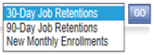
  - Next, click View/Add. Enter the performance measure name, which must match the name of the objective you chose. For instance, for the 30-Day Job Retention objective, type “30-Day Job Retentions”. Each objective then requires an integer response. In this example, enter the anticipated number of 30-day Job Retention milestones for the initial 12-month period. No upload is required.
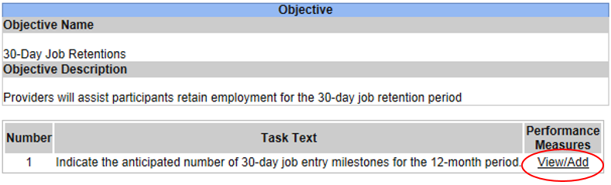
  - Click . Return to the Forms Menu and select another objective from the drop-down menu. Repeat these steps for the remaining two objectives listed (90-Day Job Retentions and New Monthly Enrollments).

Pre-Submission Uploads

Follow the instructions provided to attach required and optional pre-submission uploads. Brief explanations of each upload are included in the Grants Gateway. In addition, all required pre-submission uploads are described in Part C of this RFP.

Application Submission

When you have completed your application, click , located at the top-right of your screen. If you receive any error messages, all items must be addressed prior to submitting your application. The system will let you know when there are no outstanding items.

  - Remember that only the Grantee Signatory or System Administrator may submit the application. To do so, the appropriate person must sign into the Gateway with their credentials. This is likely someone other than the person who created the application so at this juncture, log out.
  - Once the appropriate person logs in to submit the application, click on the “Applications” tab at the top of the screen and search for “HEI” under Grant Opportunity Name.
  - Click then located under the “Application Submitted” heading.
  - Prior to submission, you will need to certify the agreement as stated. You must click “I agree” for your application to be submitted.
  - You will know your application has been submitted successfully if you hover your mouse overand it shows “There are no available status options at this time”.

Part C – Required Forms to Upload

All forms that are in bold are required forms and must be uploaded in the New York State Grants Gateway. Forms that are not in bold are either applicable in specific circumstances, optional, or for your reference.

- Notice of Intent to Bid
- Contractor Information Form
- Agency Agreement
- M/WBE Goal Requirements Certification of Good Faith Efforts
- Equal Employment Opportunity Staffing Plan
- M/WBE – EEO Policy Statement
- M/WBE Utilization Plan
- M/WBE Subcontractors and Suppliers Letter of Intent to Participate
- Subcontractor and Supplier Identification Form
- Quarterly M/WBE Compliance & Payment Report
- Workforce Employment Utilization Report
- HEI 2018 Services Application
- Employment Coaching Plan
- Number of People Living with HIV by County
- OSC Vendor Responsibility Questionnaire (completion in VendRep system is preferred)

Attachment 1
NOTICE OF INTENT TO BID

This form confirms our intent to respond to the HIV Employment Initiative (HEI) 2018 Request for Proposals issued by the New York State Office of Temporary and Disability Assistance, Employment and Income Support Programs.

Signed:
(Name/Title/Organization/Bidder Name)
(Mailing Address) (Phone # and Email Address)

Please respond by February 5, 2018 by mailing, faxing, or emailing this form to:

New York State Office of Temporary and Disability Assistance
Employment and Income Support Programs
Attn: Melissa Alexander
40 North Pearl Street, 11th Floor
Albany, New York 12243

Fax: (518) 473-7650

Email: Melissa.Alexander@otda.ny.gov

Contractor Information
Attachment 2

1. Incorporated Agency Name:

2. Street Address: City, State, Zip Code:
County(ies) Served:

3. Agency Contact: Title: Phone #: FAX #: Email Address:
Mailing Address:

Program Contact: Title: Phone #: FAX #: Email Address:
Mailing Address:

4. Federal Employer Identification #: State Registered Charitable Organization #: Municipality #: Community District(s): Federal Congressional District(s): State Senate District(s): State Assembly District(s):

5. Award Amount:
Attachment 2

Award Name: HIV Employment Initiative (HEI) 2018
Awarding Agency: New York State Office of Temporary and Disability Assistance

6. Organization Information

For statistical purposes, check yes or no for each of the following items as it relates to your organization. See the instructions for definitions. LEAVE NO BLANKS.

Non-Profit Yes No Women-Owned Yes No
Organization Business

Minority Business Yes No Municipality Yes No

Small Business Yes No

7. Non-Discrimination/Sectarian Organization Compliance Justification

a. According to your Certificate of Incorporation, are your organization’s purposes sectarian? (For example, are you a corporation organized under the religious corporation law or a corporation that has a corporate purpose to serve a particular religious group or promoting the doctrine of a particular religion in general?) | Yes | No
b. Are any of the proposed services in your project sectarian in nature?
c. Does your organization have as its goal the furthering of any sectarian purpose?
d. Are the services to be provided by sectarian staff?
e. Are services being delivered in a building owned by a sectarian organization?
If no, proceed to letter (f.). If yes, are services educational in nature?
f. Will the proposed services be provided on the basis of race, religion, color or national origin?
g. If the contract is with a sectarian organization, is the amount and comprehensiveness of the surveillance necessary to insure the contract does not foster or inhibit religion greater than the contract necessary to administer a similar contract with a non-sectarian agency?
If any of the above answers are Yes, please justify the recommendation for funding below:
LIST OF AUTHORIZED SIGNATORIES
Attachment 2

List all individuals who are authorized by the Board of Directors to sign this contract and related documents on behalf of the organization. Should any individual be added to or removed from the list, inform the Bureau in writing immediately.

Name

(Printed)
Title

Signature

Restrictions

Name

(Printed)
Title

Signature

Restrictions

Name

(Printed)
Title

Agreement
Attachment 3

It is understood and agreed to by the applicant that (1) This RFP does not commit the New York State Office of Temporary and Disability Assistance (OTDA) to award any contracts, pay the costs incurred in the preparation of a response to this RFP, or to procure or contract for any services. (2) OTDA reserves the right to amend, modify or withdraw this RFP and to reject any proposals submitted, and may exercise such right at any time and without notice and without liability to any offeror or other parties for their expenses incurred in the preparation of a proposal or otherwise. Proposals will be prepared at the sole cost and expense of the offeror. (3) OTDA reserves the right to accept or reject any or all proposals that do not completely conform to the instructions given in this RFP, including time frames for submission thereof. (4) Submission of a proposal will be deemed to be the consent of the applicant to any inquiry made by OTDA of third parties with regard to the applicant's experience or other matters deemed by OTDA relevant to the proposal, including performance under the HIV/AIDS Employment Initiative, if applicable. (5) Funds awarded for this project will be used only for the conduct of the project as approved. (6) The contract may be terminated in whole, or in part, by OTDA. Such termination shall not affect obligations incurred under the contract prior to the effective date of such termination. (7) When funds are advanced, any unexpended balance or funds unaccounted for at the end of the approved period must be returned. (8) Any significant revision of the approved project proposal must be requested in writing by the contractor prior to enactment of the change. (9) Progress reports must be submitted as required by OTDA. The final program and financial reports must be submitted within a specified time period after the project terminates. Necessary records and accounts, including financial and property controls, will be maintained and made available to OTDA for audit purposes. (10) All reports of investigations, studies, and publications made as a result of this proposal must acknowledge the support provided by OTDA. (11) All personal information concerning individuals served or studies conducted under the project are confidential and such information may not be disclosed to unauthorized persons, corporations, or agencies. (12) OTDA reserves a royalty free non-exclusive license to use and to authorize others to use all copyrighted material resulting from this project. (13) Successful applicants will be subject to the State's prompt contracting law. (14) Selected contractors agree to be bound by the Affirmative Action/Equal Opportunities anti-discrimination provisions as more fully set forth in Section VI, General Information for Successful Bidders.

OTDA reserves the right, if funds become available, to make additional awards based on the remaining proposals submitted in response to this RFP, in lieu of releasing a new RFP, if deemed to be in the best interest of the State. The same evaluation criteria shall apply as used in the original selection process.

OTDA anticipates making awards to administer projects for a five (5) year contract cycle to be funded annually for one (1) year budget periods. For those applicants selected as a result of this Request for Proposals (RFP), subsequent year's funding may be at a decreased or increased level and may be awarded on a performance basis.

The applicant certifies that to the best of his/her knowledge and belief the information in this application is true and correct, and that s/he will comply with the above agreement if the contract is received.

(Signature of official authorized to sign for applicant) (Date)

(Typed Name and Title) (Date)

Attachment 4

M/WBE GOAL REQUIREMENTS
CERTIFICATION OF GOOD FAITH EFFORTS

Contractors (to include those who submit bids/proposals in an effort to be selected for contract award as well as those successful bidders/proposers with whom OTDA enters into State contracts) must document “good faith efforts” to provide meaningful participation by New York State Certified M/WBE subcontractors or suppliers/vendors in the performance of this contract.

The undersigned hereby acknowledges that he/she took or may need to take the following actions on behalf of the Contractor to demonstrate, and upon request by OTDA, to provide written verification to document the aforesaid good faith efforts:

- The Contractor attended any pre-bid, pre-award, or other meetings scheduled by the contracting agency or the NYS Department of Economic Development or its designee to inform certified minority- or women-owned business enterprises of contracting and subcontracting opportunities available on the project, for purposes of complying with contract participation goal requirements;
- The Contractor identified economically feasible units of the project that could be contracted or subcontracted to certified minority- and women-owned business enterprises in order to increase the likelihood of participation by such enterprises on the contract;
- The Contractor undertook efforts to reasonably structure the contract scope of work for purposes of subcontracting with certified minority- and- women-owned business enterprises;
- The Contractor advertised in a timely fashion and in appropriate general circulation, trade and minority- and women-oriented publications, if any, concerning the contracting or subcontracting opportunity;
- The Contractor made written solicitations in a timely fashion to a reasonable number of certified minority- and women- owned business enterprises identified from current certified lists of such business enterprises provided or maintained by the NYS Empire State Development’s Division of Minority and Women Owned Business Development, or its designee, of the contracting or subcontracting opportunity. The directory of certified businesses can be viewed at: http://esd.ny.gov/index.html;
- The Contractor can document if any timely responses to any such advertisements and solicitations were provided by certified minority- and women-owned business enterprises;
- The Contractor followed-up initial solicitations by contacting the enterprises to determine whether the enterprises were interested in such contracting or subcontracting opportunity;
- The Contractor provided interested certified minority- and women-owned business enterprises in a timely fashion with adequate information about the plans, specifications or terms and conditions of the State contract and requirements for the contracting or subcontracting opportunity so as to prepare an informed response to a contractor solicitation;

- The Contractor submitted a completed, acceptable utilization plan in accordance with applicable requirements to meet goals for participation of certified minority-and women-owned business enterprises established in the State contract;
Attachment 4
- The Contractor used the services of community organizations, contractor groups, state and federal business assistance offices and other organizations identified by the NYS Department of Economic Development or its designee that provide assistance in the recruitment and placement of minority and women business enterprises;
- The Contractor negotiated in good faith with certified minority- and women-owned business enterprises submitting bids, proposals, or quotations and did not, without justifiable reason, reject as unsatisfactory any bids, proposals or quotations prepared by any certified minority- or women-owned business enterprise. "Good faith" negotiating means engaging in good faith discussions with certified minority- or women-owned business enterprises about the nature of the work, scheduling, requirements for special equipment, opportunities for dividing of work among the bidders, proposers, and various subcontractors and the bids of the minority or women businesses, including sharing with them any cost estimates from the request for proposal or invitation to bid documents, if available; and,
(l) The Contractor undertook efforts to make payments for any work performed by certified minority- and women-owned business enterprises in a timely fashion so as to facilitate continued performance by certified minority- and women-owned business enterprises.

_______________________________________
Signature Date

_______________________________________
Print Name

_______________________________________
Title

_______________________________________
Company

_______________________________________
Contract Number

______________________________________
Program/Solicitation Name

Attachment 5
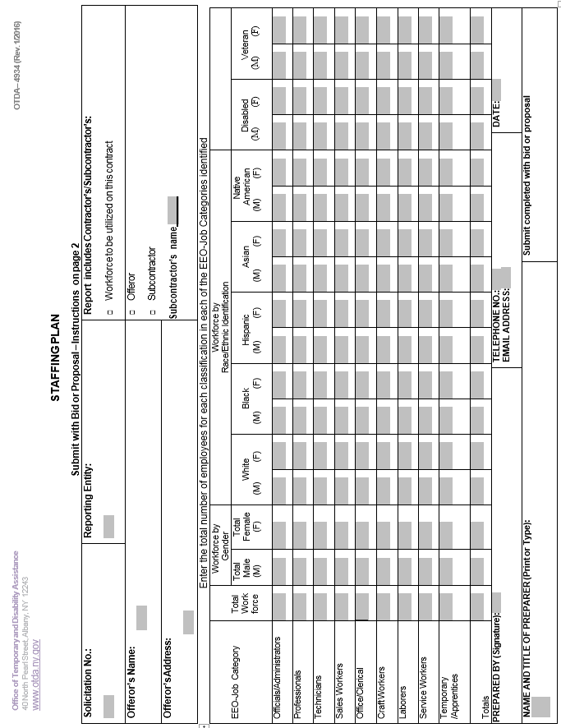

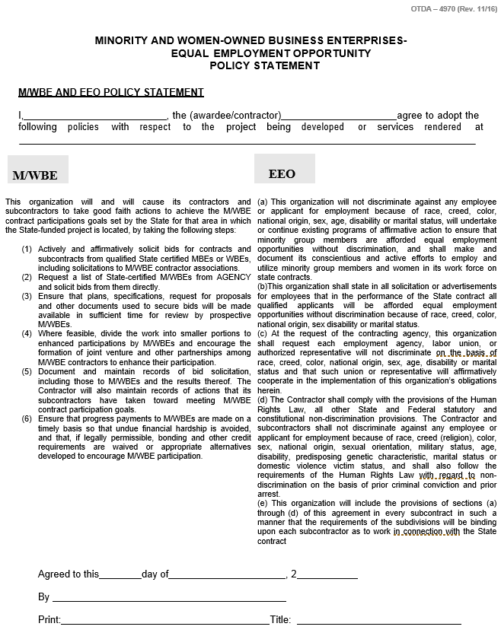
Attachment 6

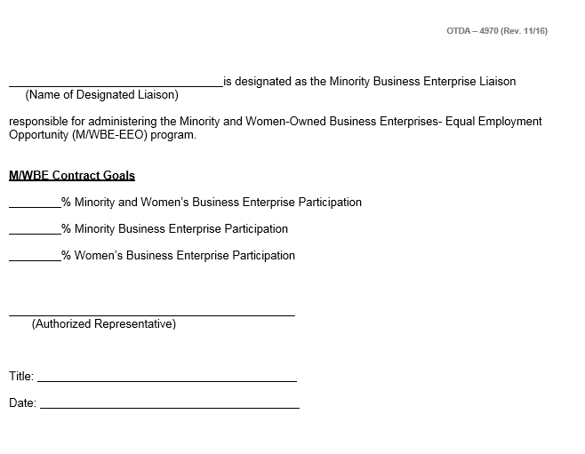
Attachment 6

Attachment 7
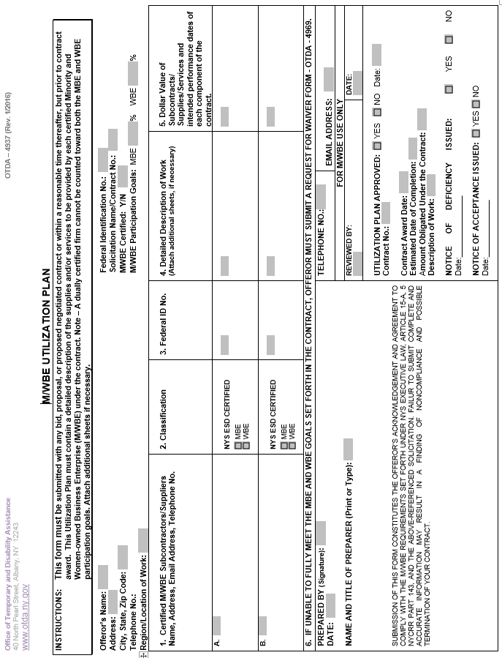
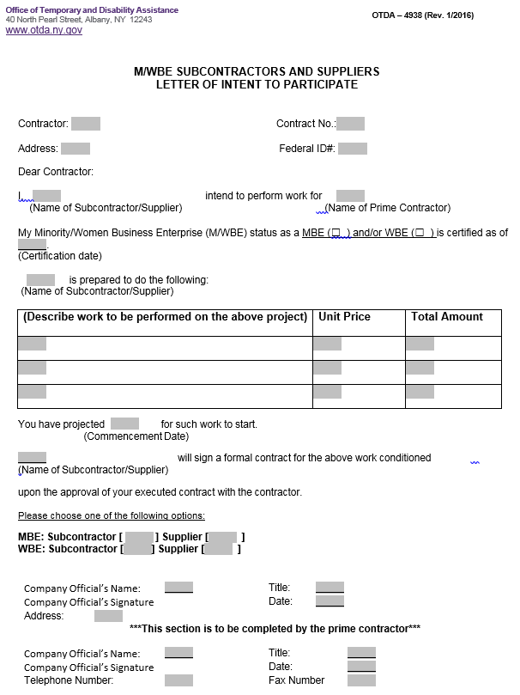
Attachment 8

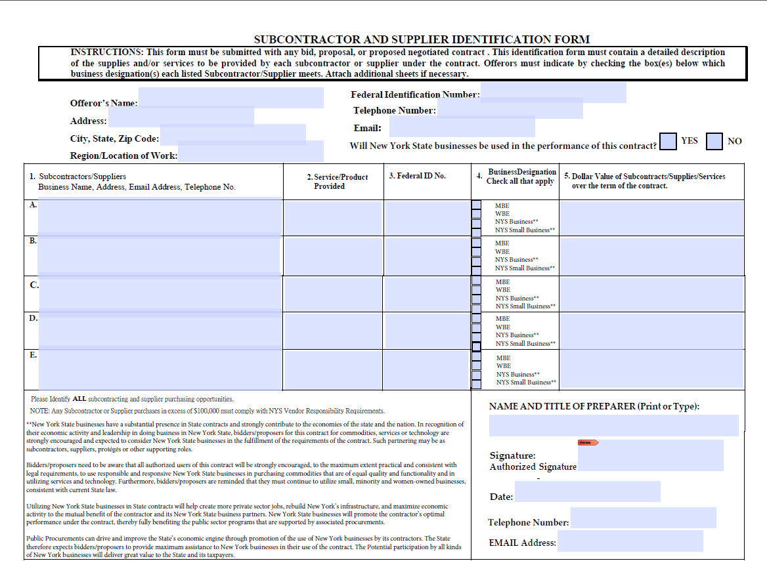
Attachment 9
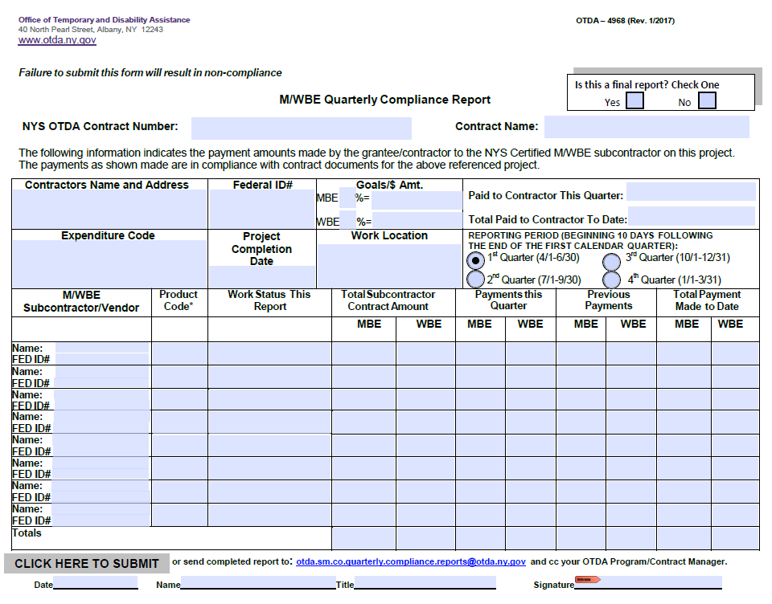
Attachment 10
Attachment 10
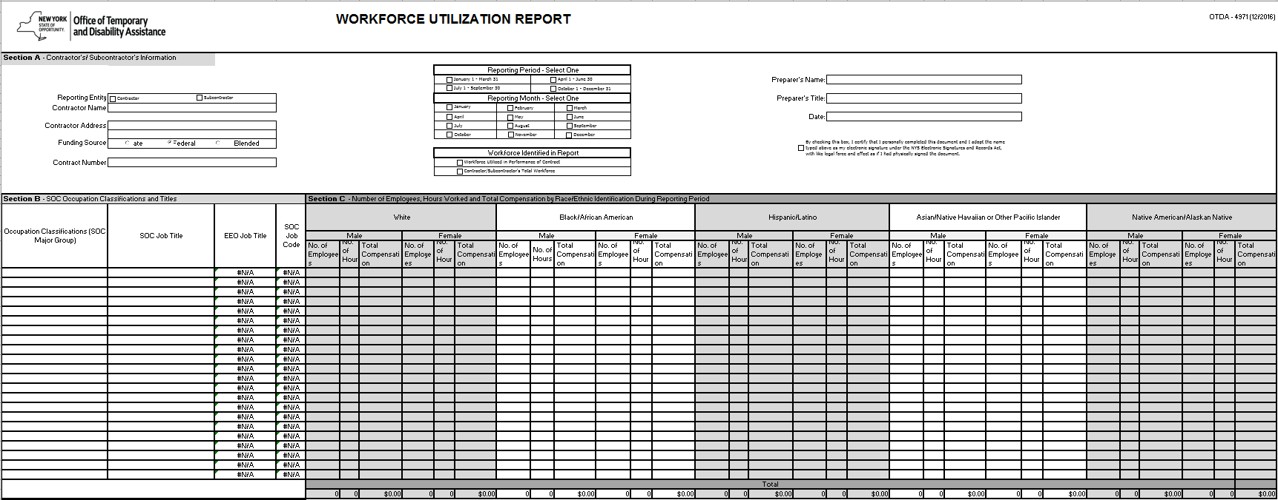
Attachment 11
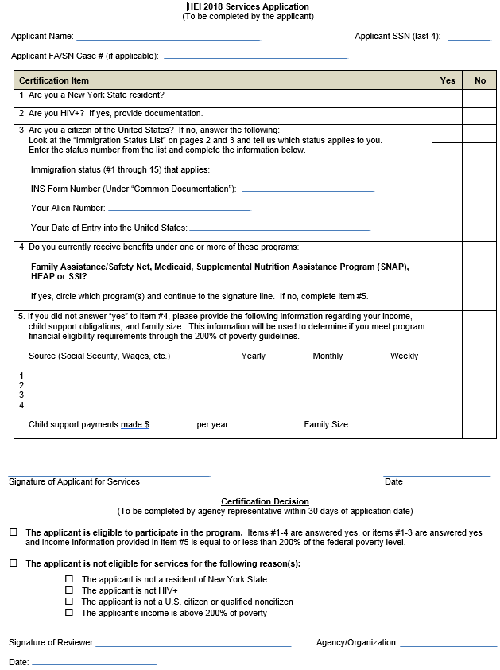
Attachment 12

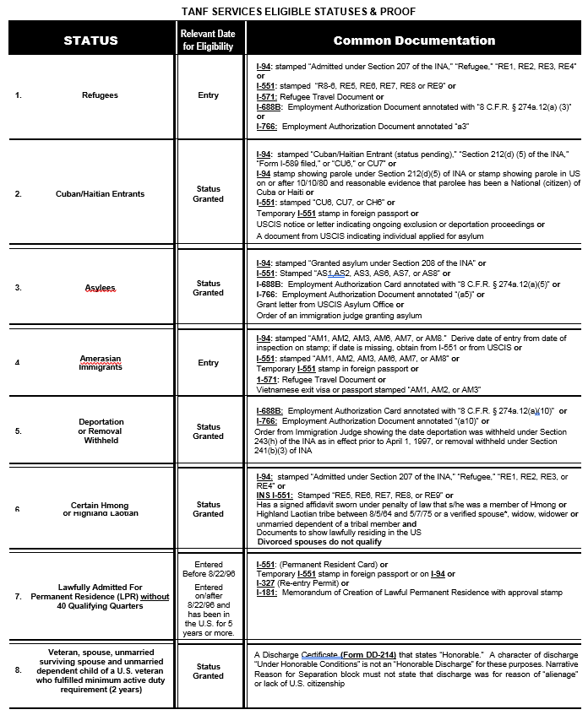

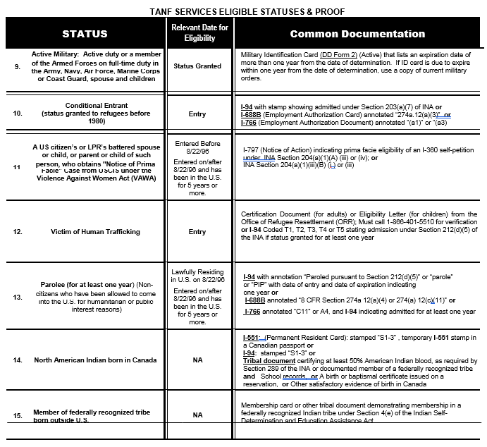

Employment Coaching Plan
Attachment 13

Participant Name:

Date:

Based on the information collected in the initial Assessment, complete the following:

  - Goals and Preferences
Describe the participant’s employment goals and any additional goals (e.g. educational, personal, family, health) and whether these goals have been achieved.

- Employment goal(s):

- What are some things you like about your job?

- Are there any job duties that are not going well?
- Are there any ways in which we could assist you with this?

- Are you getting along with your supervisor and/or coworkers?

- So far, have you missed any days of work?
- If yes, please explain. Is there any way in which we could assist you with this?

- So far, have you been on time for work each day?
- If you are having difficulty being on time, is there any way in which we can assist with this?

- Additional goal(s) and outcome(s):

  - Challenges/barriers
- Indicate the challenges and barriers the participant faces to maintaining and advancing in employment:

[ ] language barrier
[ ] literacy levels
[ ] needs additional education
[ ] needs additional training
[ ] needs necessary license
[ ] needs necessary credential
[ ] criminal history/restrictions
[ ] needs additional work experience
[ ] needs additional job skills training
[ ] health/mental health-related barrier
[ ] none
[ ] other – describe:

- Describe how barriers will be addressed per the discussion:

- What would be the most difficult thing about working more hours?

- If you cannot cover all of your expenses each month, what does not get paid or what do you cut back on? Are there any other ways in which we could assist with this?

  - Supportive Services
- Child Care Services: Is the client in need of child care services?

- Transportation Services: Is the client in need of transportation services? Indicate any transportation related supportive services that the district or your agency is providing.

- Educational Services: Is the client receiving assistance with continuing education? If yes, please describe.

- Incentives: Is the client receiving any monetary or other incentives? If yes, please describe.

- Health, Dental and Mental Health: Is the client receiving any health-related services? If yes, please describe.

- Indicate any other supportive services that your agency provides (including via referral):

[ ] work related clothing/shoes
[ ] license renewal
[ ] fingerprinting fee
[ ] books
[ ] professional licensing fee
[ ] tools
[ ] utilities
[ ] housing
[ ] legal assistance
[ ] financial literacy
[ ] nutrition assistance
[ ] acupuncture
[ ] none
[ ] other – describe:

  - Outcomes
Select all that apply.

[ ] Enrolled in/referred to employment opportunity

[ ] Received a promotion and/or increase in hours

[ ] Accepted employer-offered health insurance

[ ] Enrolled in/referred to applicable education/training activity or supportive service

[ ] Achieved an educational outcome (certificate, diploma, etc.)

[ ] Currently unable to participate in work activities or education/training

[ ] Preferences/goals cannot be accommodated or do not reflect local employment opportunities. If yes, describe.

  - Referrals and Follow-Up
List any information and referrals provided to the participant including agency referred to and any additional follow-up required.

  - Worker Notes

  - Signatures

Participant Signature:

Case Manager Signature:

Date:

HIV Epidemiology
Attachment 14

New York State Epidemiological Profile
September 2016

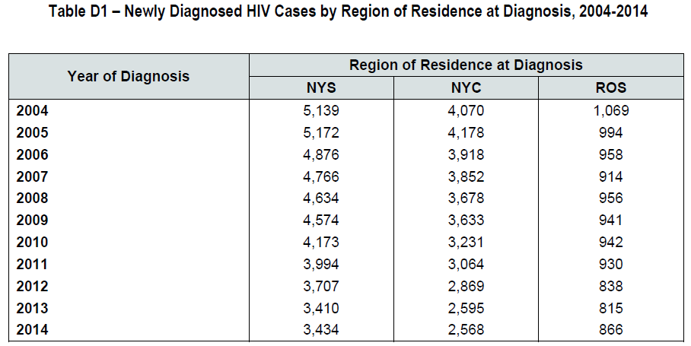
https://www.health.ny.gov/diseases/aids/general/statistics/epi/docs/epi_profile2016.pdf

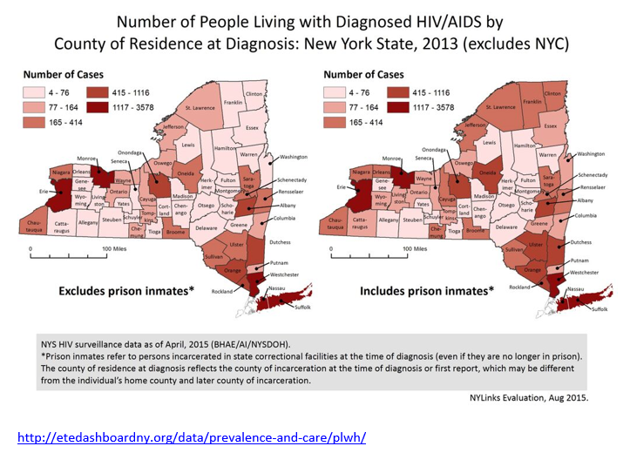

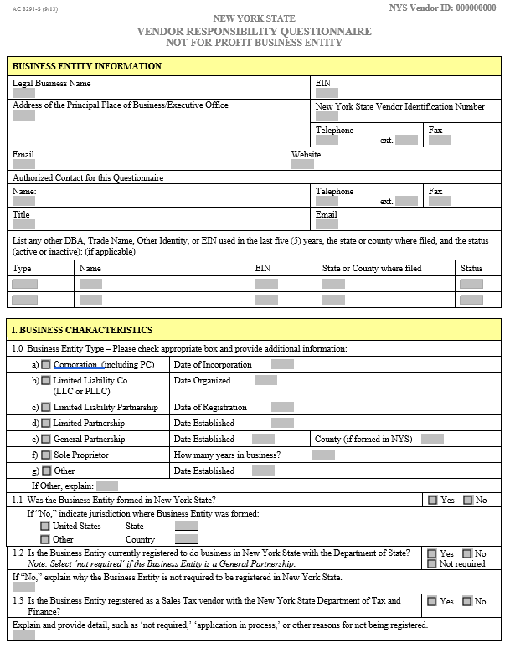
Attachment 15

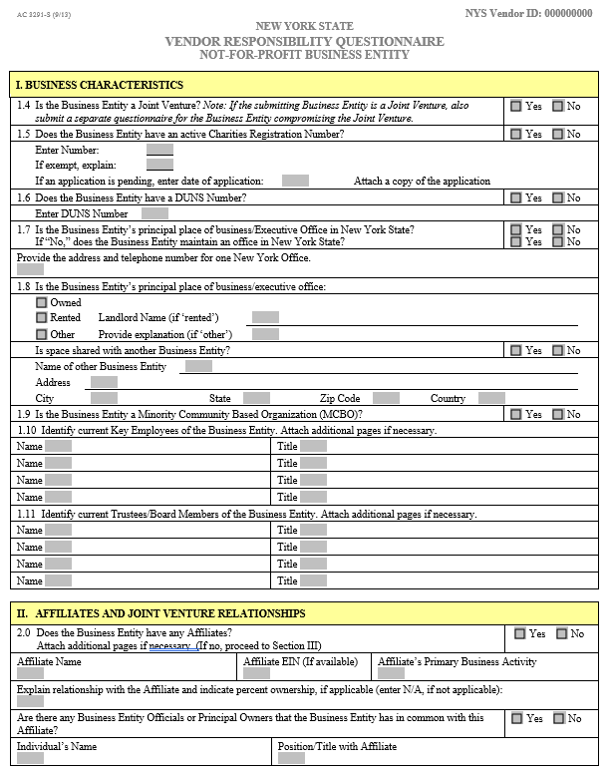
Attachment 15

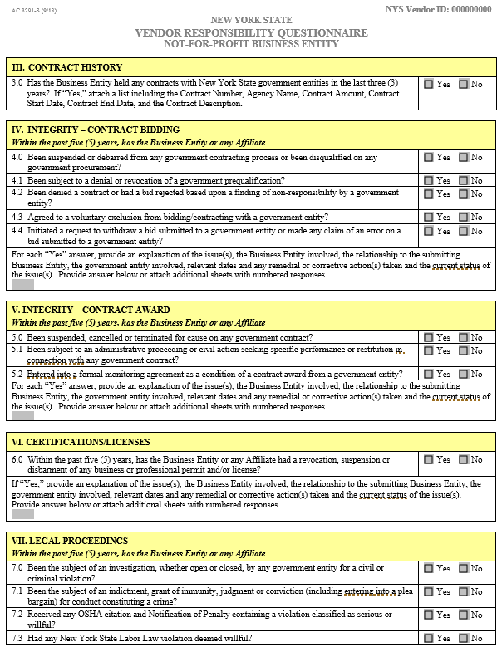
Attachment 15

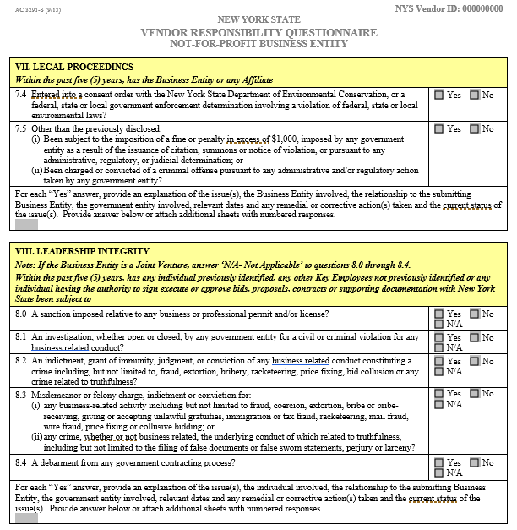
Attachment 15

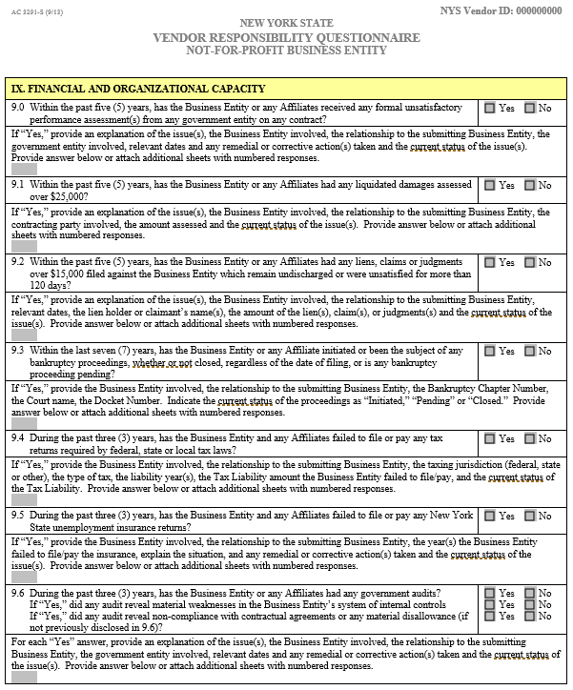
Attachment 15
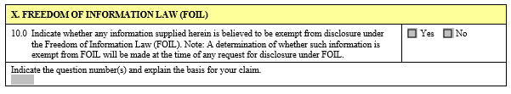
Attachment 15
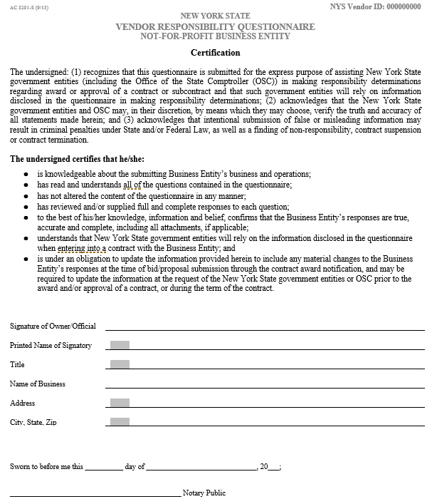

Part D – Printed Version of the Gateway Application

Please see the following pages to view the printed version of the Grants Gateway Application.

