“Nursing Assistants: Creating a Community of Caring”
A project of the Great American Caregiver Initiative
Official slogan for the 41st annual National Nursing Assistants Week June 14-21, 2018

Order Form 2018

“Nursing Assistants: Creating a Community of Caring”
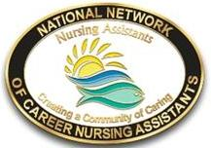
Nursing Assistants: I Choose Respect | Nursing Assistants:  Handle with Care | Nursing Assistants @ the Heart of Caring
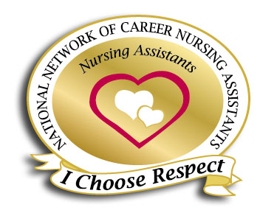 |  | 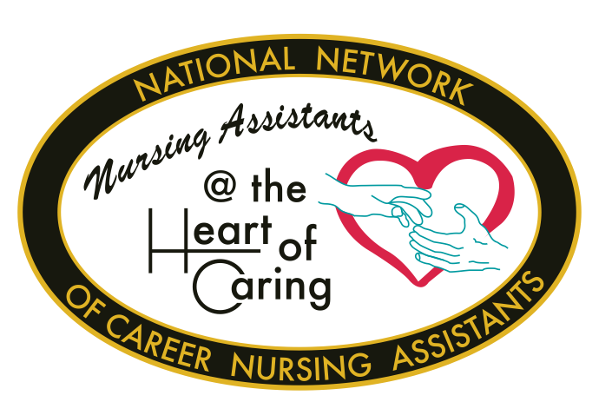

“Nursing Assistants: Creating a Community of Caring”
Lapel Pins: Official Nursing Assistants Lapel Pin (Select)

“Creating a Community of Caring” ____
“Nursing Assistants@ the Heart of Caring” ____
“Nursing Assistants: I Choose Respect” ____
“Nursing Assistants Handle with Care (Safe Lifting)” ____

1 inch logo pin in individual poly bag
Lapel Pins ___ @ $____ea $_____
$4.20 Ea/ Quantity order – see discounts below
Personalize with your facility name for a onetime fee of $75.00 ( Allow 6 weeks ) $_____
Please attach your facility info to this form. See Special shipping and handling page 2

Quantity Discounts - The following Quantity Discounts apply to Lapel Pins -1-11@ 4.20/ea;
12- 25 @ 3.79/ea; 26-49 @ 3.69; 50-99 @ 3.39/ea; 100 – 199 @ 3.39/ea; 200+ @ 2.99/ea.

Lapel Buttons (Select)

“Creating a Community of Caring ” ____
“Nursing Assistants@ the Heart of Caring” ____
“Nursing Assistants: I Choose Respect” ____
“Nursing Assistants Handle with Care (Safe Lifting)” ____

2 ¼ inch logo button with pin back - Lapel Button ___ @ $____ea $_____
$1.25/ea. $12.00/doz 10% discount 5doz or more $_____

Total page 1 $______
Order form 2018– “Nursing Assistants: Creating a Community of Caring” © Page 2

Publications by Nursing Assistant Authors
Published by the Nursing Assistant Authors Press
“Tips by Nursing Assistants for Nursing Assistants”
“Wisdom and Humor” - Tips 1 #____
“Working with the New NA” - Tips 2 #____
“Daily Dialogue” - Tips 3` #____
“TEAMWORKS “- Tips 4 #____
Ordering #_____ @ $3.99ea $______
We can add your facility name for orders of 100 or more at a low cost of $45.00 $______
Please attach your facility info to this form.

Quantity Discounts- The following Quantity Discounts apply to “Tips” booklets -1-11@ 3.99/ea; 12- 25 @ 3.59/ea; 50-99 @ 3.39/ea; 100 – 199 @ 3.19/ea; 200+ @ 2.75/ea.

2018 Planning Guide and PR Kit:
“Nursing Assistants: Creating a Community of Caring”
Change is everywhere and NAs are being called on as never before to accept new roles and new goals. Puzzle your way through projects that include:” Creating your Village,” “Start with Hello,” “ Soft Competencies for Person Centered Care,” ”Wisdom Keepers” and “Nursing Assistant Rocks campaign”. Safety Committees remain in the spot light to foster Safe Patient Handling and decrease worker and resident injury.

Have fun while sending an important message to others. Each day of NA Week focuses on a different aspect of “Community of Caring. ” Work on a committee, host an event for your facility or area, visit a legislator, convene your Committee, and Honor your “Wisdom Keepers.” The Planning Guide includes activities for each day of NAW and suggests ways to continue programs throughout the year. It also includes discussion guides, sample press release, Proclamation forms, certificate master, and talking points for legislators and planning info.

50 - 8 ½ X 11pages QTY: _____ @ $12.00 ea $__________

Request Planning Guide on line – no cost. By email only to cnajeni@aol.com

Total page 2 $______
Totals
Total Page 1 ______ Page 2_______
Subtotal $____________
Shipping and handling (see table below) $____________
Total amount $____________

Enclosed Check or MO #______ Credit Card (call for info 330-825 9342) _______

Shipping & Handling:
Flat Rates – ground shipping
Orders of $50 or less – pay $3.95
Orders of $51- $100 – pay $10.00
Orders of $101+ - pay $15.00
Additional fee for Overnight delivery

3 ways to order
1. By mail – make check payable and mail to Career Nurse Assistants Programs, Inc (NNCNA)
3577 Easton Road,
Norton, OH 44203
2. By credit card – Call to make payment by credit card –
For more info call (330) 825 9342
3. NAW On Line Store – go to <www.cna-network.org> and click Online Gift Shop-

Please print clearly.

Bill to: Amount enclosed ____________

Name________________________________________________________Dept____________________

Facility_______________________________________________________________________________

Address______________________________________________________________________________

City_____________________________________________State_____________Zip_________________

Day Phone (____) __________ext_____ FAX (____) ______________ Email _______________________

Method of payment: Check___ Credit Card___ MO____ PO____. Other_____

Ship order to (if different from billing address above):

Name________________________________________________________Dept____________________

Facility_______________________________________________________________________________

Address______________________________________________________________________________

City_____________________________________________State_____________Zip_________________

Day Phone (____) __________ext_____ FAX (____) ______________ Email _______________________

Please feel free to contact us if you have questions or if we can be of assistance. Email – canjeni@aol.com
Celebrating 41 years as a National Professional organization for Nursing Assistants and direct care workers in nursing homes, home care, and other long term care settings

Watch for more info about the 41st annual National Nursing Assistants Week June 14-21, 2018
Web site – www.cna-network.org
Facebook - Meet NAs from across the country
<https://www.facebook.com/groups/118681892980>

