GULBARGA ELECTRICITY SUPPLY COMPANY LIMITED

Phone No.08472-221830, 256950 Office of the,
Fax No.08472-255403. Superintending Engineer (Elect),
O&M Circle, GESCOM,
Kalaburagi.

No: GESCOM/SEE(O&M)/AEE(C)/2016-17/6806-10 Date:29/12/2016
TENDER NOTIFICATION:

(Through GOK e-procurement platform https://eproc.karnataka.gov.in) Item rate tender in through GOK e-procurement for the following work as per Karnataka Transparency Act in Public procurement ordinance of 2000 is invited from the Civil Contractors / Firms of appropriate Class registered in Karnataka CPWD/MES and KPWD. The intending contractors can obtain the Tender details through website https://eproc.karnataka.gov.in on or after 04-01-2017 and upload the duly completed tenders / relevant documents within the stipulated date and time mentioned in website only.

The Tender shall be submitted through e-procurement portal (https://www.eproc.karnataka.gov.in) only. Bidders/contractors need to register in the e-procurement portal to submit their bids through online. Other details can be had from the office of the undersigned on Mobile No.9448459832,
Sl.  No | Name of work | Amt put to tender (Rs. in lakhs) | Earnest money deposit (in Rs.) | Time limit for completion of work including monsoon | Class of contractor/ firm.
1 | Construction of section office building at Tadkal in Aland tq. | 20.00 | 50,000/- | 6 Months | Class- II
2 | Construction of section office building at Madan Hipparga in Aland tq. | 20.00 | 50,000/ | 6 Months | Class- II
3 | Construction of section office building at V.K.Salgar in Aland tq. | 20.00 | 50,000/ | 6 months | Class- II
4 | Construction of section office building at Kadaganchi in Aland tq. | 20.00 | 50,000/ | 6 months | Class- II
5 | Construction of section office building at Jambaga in Kalaburagi tq. | 20.00 | 50,000/ | 6 months | Class- II
6 | Construction of section office building at Mannur in Afzalpur tq. | 20.00 | 50,000/ | 6 months | Class- II
7 | Construction of section office building at Nalwar in Chittapur tq. | 20.00 | 50,000/ | 6 months | Class- II
8 | Construction of section office building at Ankalga in Jewaragi tq. | 20.00 | 50,000/ | 6 months | Class- II
9 | Construction of section office building at Kembavi in Shorapur tq. | 20.00 | 50,000/ | 6 months | Class- II
Sl.  No | Name of work | Amt put to tender (Rs. in lakhs) | Earnest money deposit (in Rs.) | Time limit for completion of work including monsoon | Class of contractor/ firm.
10 | Construction of section office building at Kodla in Sedam tq. | 20.00 | 50,000/ | 6 months | Class- II
11 | Construction of section office building at Konchavaram in Chincholi tq. tq. | 20.00 | 50,000/ | 6 months | Class- II
12 | Construction of Sub-Division office building at Jewaragi | 50.00 | 1,00,000/- | 6 months | Class-I
13 | Construction of Sub-Division office building at Yadrami in Jewaragi Tq | 50.00 | 1,00,000/ | 6 months | Class-I
14 | Construction of Sub-Division office building at Chittapur | 50.00 | 1,00,000/ | 6 months | Class-I
15 | Construction of Sub-Division office building at Gurmitkal in Yadgir Tq | 50.00 | 1,00,000/ | 6 months | Class-I
16 | Construction of Sub-Division office building at Hunasagi in Shorapuar Tq | 50.00 | 1,00,000/ | 6 months | Class-I
The tenderer shall pay the tender processing fee and Earnest Money deposit (EMD) through any of the following e-payment modes. The details are available at the end of this document.

- Credit Card
- Debit Card
- National Electronic Fund Transfer (NEFT)
- Over the Counter (OTC) (Axis Bank)

Calendar of Tendering :
- Last date & time for clarifications and queries : 28-01-2017 up to 16.00 Hours
- Date & Time of pre-bid meeting : 25-01-2017 up to 11.00 Hours.
- Last Date & Time for submission of bids : 03-02-2017 up to 16.00 Hours
- Date & time for opening of Technical Tender : 06-02-2017 up to 16.00 Hours

- Date & Time of opening of price bid : Will be intimated to technically qualified bidder.

2. Eligibility Criteria:-

Sl.No. | Requirements | Documents should be uploaded by scanning all the certificates
1 | Should be a valid appropriate class of registration in Karnataka CPWD/MES/KPWD as mentioned against each work. | Registration Certificate for the block period 2015-2020.
2 | EMD | EMD shall be paid in the form of e-payment through e-procurement on or before 03-02-2017 up to 16:00 Hrs.
3 | Should have successfully completed at least one Similar nature of work Costing not less than the 50% of amount of work put tender, from 01/04/2011 onwards for any of the Govt. / Public Sector/ Corporate undertakings. | Certificate of completion issued by an officer not below the rank of Executive Engineer, in case of Govt., / Public Sectors under takings.
4 | Should have achieved a Annual Financial Turnover of 50% of amount of work put tender pertaining to civil works for any of 2 (two) financial years from last preceding Five years i.e (2011-12,2012-13, 2013-14, 2014-15, 2015-16). | Submit a copy of audited balance sheet and profit & loss accounts statement certified by a Chartered Accountant.
5 | Sales tax Details for the current financial year. | Current year VAT Composition certificate to be attached)
6 | Income tax details | PAN No issued by Income Tax Dept.
7 | EPF details. | Submit EPF Registration certificate along with recent paid challans

CONDITIONS

- Rate shall be quoted in figures and in Indian Rupees only..
- For EMD and FSD no Bank Guarantee will be accepted.
- Quoted rates shall be inclusive of cost of all materials, all lead and lift and transportation up to work spot for all places mentioned in the notification.
- The quoted rates shall be inclusive of all taxes, surcharges, service taxes, income taxes and sales taxes and other taxes applicable time to time by GOK.
- Conditional Tenders will be rejected. The competent authority reserves right to reject all or any of the tender without assigning any reasons.
- The Department will not be responsible for any technical defects committed by the firms/agencies while down loading and up loading the documents/tender.
- Tender documents submitted through e-governance without the requisite Certificates as mentioned in the above Qualification information will be summarily rejected.
- If authority desires, physical verification will be done both for previous work done and Annual Turnover details submitted by the tenderer.
- Even though the tenderer meet the above criteria, they are subject to be disqualified if they have
  - Made misleading or false representations in the forms, statements and attachments submitted in proof of the qualification requirement: and or
  - Record of poor performance such as abandoning the works, not properly completing any contract, inordinate delays in completion, litigation history, or financial failures etc.
- The contractor shall abide by the Tender Conditions mentioned in the GESCOM Schedule of Contract Book.
- The successful bidder shall deposit 5.00% FSD in the form of bank guarantee . The same will be refunded after completion of maintenance period of One year from date of completion of work.
- Any defects observed during maintenance period, should be attended by the contractor / firm at his own cost failing which BG amount will be forfeited.
- In case of the death of a contractor after executing the agreement/ commencement of the work, his legal heir, if an eligible registered contractor and willing, can execute and complete the work at the accepted tender rates irrespective of the cost of the work.
- The contractor shall go through terms and conditions clearly before quoting his rates and have no right for any claims subsequently thereafter
- If the bidder quotes his rates less than the Sanctioned Estimated Rates (SER), then the difference amount shall be paid by the bidder before entering into the agreement. And it will be refunded after completion of those items without interest.
- The firm/Contractor should execute quantities mentioned in each sub work at different places only. The bidders shall not utilize the quantities of one sub work to another sub work.
- The employer may terminate the contract if the other party causes fundamental breech of contract.
- Statutory recoveries as and when imposed by the Central and State Government such as Taxes and Cess shall be recovered in the bills payable to the Contractor.
- The bid is to be submitted in the GOK e-procurement platform www.eproc.karnataka.gov.in system only.
- Tenderers, who have not registered in the GOK e-procurement portal should be registered through website www.eproc.karnataka.gov.in
- The tenderer should obtain tender documents through e-procurement website www.e-proc.karnataka.gov.in additional conditions and information’s also can be obtained through the above mentioned website.
- Bidders / contractors should submit the bid on the website itself (for help on e-procurement /e-payment, please contact helpdesk No. 08025501216 and 0802501227 from Monday to Saturday during 9.00 Am to 9.00 Pm
- The tender documents may be downloaded from gov. of Karnataka e-procurement website http://eproc.karnataka.gov.in.

TERMS AND CONDITIONS

1 | The selected firm /Contractor should submit the PERT CHART/MILE STONE to show execution plan of work
2 | The firm /Contractor should submit the quality test reports by reputed Govt. colleges/Quality control labs for the materials /concrete steel/mortar used at his own cost and submit to site Engineer
3 | The firm/Contractor should make their own arrangement for water supply, electricity, sanitary during the execution of work. If contractor uses departmental water 1% of amount of water consumable items shall be deducted in the Bills.
4 | The firm/Contractor should make all safety measures as per safety manual
5 | The firm/Contractor should make all necessary barricading works for the execution of work at his own cost
6 | The firm/Contractor should store the explosives/building materials as per prevailing rules
7 | The firm/Contractor has to establish a site office in the GESCOM site premises and necessary arrangements should be made for inspecting officers.
8 | The firm/Contractor should adhere to the rules and regulations of the labour department and should have been registered with Labour Department
9 | The firm/ Contractor should have minimum infrastructure facilities for the deployed workers (i.e., Drinking water facility, housing facility, sanitary and first aid medical facility etc.,) at the project site in hygienic condition
10 | If the firm/Contractor delays the project, milestones penalties will be levied to the maximum of 7.50% of the estimated cost.
11 | The proportionate progress on the work to be achieved every month as per SBD.
12 | The firm/Contractor should abide by the terms and conditions mentioned in the contract frame work and SBD Schedule of contract agreement and amendments there off
13 | If the tenderer fails to quote his rates for any items, it will be construed as to be covered by the rates quoted in other items and shall execute that item without assigning any reasons. The rate shall be considered as Zero
14 | The firm/Contractor will have to deploy the technical staff for the execution of work as per norms  .
15 | The tenderer shall submit a list of litigations pending as on 31/03/2011 and faced during last 5 years. (01/04/2011 to 31/03/2016) with all relevant details i.e., Name of litigant party, nature of Litigation, facts of litigation, name of court and final outcome of the litigation. Any false information will be viewed seriously and may even lead to termination of the contract.
16 | In case of the firms registered under the Indian Partnership Act and companies registered under Companies Act, the person signing the tender shall state the authority under which he is Signing /Acting on behalf of partnership firm/ company and enclose the certified copy of the partnership deed/Memorandum of Articles of Association issued by the Authorities.
17 | The tenderer shall see the specifications, detailed drawings carefully and visit the work spot, Quarries, before quoting his tender rates. Any requests or claims for Escalation of rates in Quoted tender rates for any reasons will not be entertained. Quoted rates are binding on Contractor.
18 | No joint venture participation in the tender will be accepted.
19 | Conditional tenders and incomplete tenders will be rejected.
20 | The tenderer shall procure and use only materials confirming to BIS specification such as Steel, Cement, Water supply materials for the work. Any one of the following brand cement shall be used: ACC, Coramandal, Birla Super and Rajashree or as per direction of Engineer in charge of work. Any of the following steel shall be used: SAIL/ TATA/VIZAK Steel or as per direction of engineer in charge.
21 | The estimate rates are derived from the KPWD SR of Gulbarga circle, along with lead charges based on PWD lead chart. The rates quoted shall be inclusive of cost of all materials. Labour charges all lead & lift transportation and finishes. Any escalation in quoted rates for nay reasons will not be entertained.
22 | Any information regarding work, plan and estimate may be obtained from the office of the Superintending Engineer Electy O&M Circle GESCOM Gulbarga during office hours on working days.
23 | No mobilization advance payable will be made.
24 | All the recoveries will be made in each bill as per prevailing Govt. rules and the regulations and any modifications there of.
25 | Royalty will be recovered as per the prevailing rates from the Mines and Geology Dept
26 | The other stipulated terms and conditions prescribed in transparency Act-2000 and SBD schedule of contract form shall be applicable
27 | The contractor shall cast 3 sets of 3 Nos each of test sample of concrete cubes of each day of concrete pavement, RCC works these cubes shall be tested for 28 days compressive strength of concrete at his own cost he shall submit the test reports to Asst. Executive Engineer(Civil)
28 | The tenderer/firms shall get the material tested in any PWD quality control lab/Govt./ Private Engineering colleges for construction materials used for the work viz.. Jelly, sand, cement and steel at his own cost and submit to the site engineer for each consignment of materials.
29 | The tenderer /firms shall make all arrangements to ensure safety for its employees/ labourers and to public causing any untoward incidents that may occur while execution which may cause injuries /fatal accidents. The tender /firms is solely responsible for these incidents.GESCOM is not responsible for this.
30 | The GESCOM will not be responsible for any failure that may occur while uploading & downloading the documents through Tendering.
31 | If any chance, the above mentioned tender dates happens to be holiday or declared as a holiday due to any valid reason the dates will be postponed to next working day with specified timings.
32 | The Competent Authority shall at any time even after execution of agreement or execution of work shall terminate the contract, if it is found the information like work done certificate, registration, TOC and any other information to be false & non authentic, after verifications from concerned department.
33 | The tenderer should not sublet the contract work
34 | Dispute resolution shall be only through courts and not through process of Arbitration The jurisdiction of courts will be at Gulbarga only.
35 | Quoting lowest rates shall not confer legitimate right for award of contract to the tenderer/firm. The decision of the Competent Authority in this regard is final and binding on all the quoted firms / contractors.
36 | All subsequent notifications, changes and amendments with regard to the bidding process will be posted on the aforesaid websites.
37 | The Contractor/Firm should not engage the child labour on the work site.
38 | The contractor shall have no right to claim any compensation due to delay in supply of drawings / deviations the applicable tender time limit will be extended for department delay.
39 | Payments shall be adjusted for deductions for retention, other recoveries in terms of the contract and taxes, at source, as applicable under the law. The Employer shall pay the Contractor the within 60 days of submission of bill.

Superintending Engineer Electy
O&M Circle, GESCOM,
GULBARGA

Tender Transaction fee and Earnest Money Deposit.

The supplier/contractor can pay the Earnest Money Deposit (EMD) in the e-Procurement portal using any of the following payment modes:

- Credit Card
- Direct Debit
- National Electronic Fund Transfer (NEFT)
- Over the Counter (OTC)

- CREDIT CARD PAYMENT METHOD:

To pay the registration fee through your credit card, click on the “Credit Card (Online Payment)” option. If you choose to pay the fees later click on “Close” button. Click Pay after verifying details on the screen that appears.
Click on “Pay” button to proceed with payment process. Click “Back” if you wish to
Choose a different payment method. Click on “OK” button on the payment method
Confirmation window that is displayed. You will choose your card type (VISA, master Card).
You enter your credit card details.

Card Details completely filled.
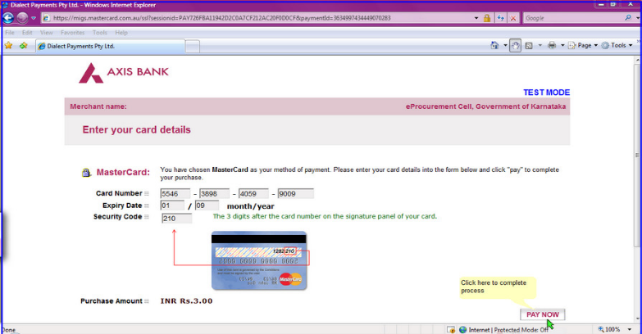

The screen will look like it is shown above when you have completely filled the card details. Click on “PAY NOW” button to effect the payment. Your card details are verified by the payment gateway service and you will receive confirmation of payment debited to your card account if the card is valid. If the card is not valid you will receive alert about it and system will wait for you to correct any errors in the card details provided by you. A successful transaction message is displayed.
- DIRECT DEBIT METHOD:

Click on “Direct Debit Using Internet Banking (Online Payment) option to pay from your bank account through Internet Banking facility.
Click on “Pay” to proceed or “Back” to change the payment method on the Payment details screen.
Click on “OK” on the confirmation window to effect the payment. Click on “Cancel” and then on “Back” to change the payment method. You will information on your screen about successful completion of payment process.

- OTC PAYMENT PROCEDURE:
If a contractor/supplier chooses to make payment of EMD/tender processing fees Over The Counter (OTC) in any of the designated Axis Bank branches listed in the e-Procurement web-site (www.eproc.karnataka.gov.in), the contractor/supplier will need to log into e-Procurement system, access the tender for which bid is being created and then select the OTC option under the payment section and print the Challan shown in that section. The printed challan will have the unique bid reference number and the amount to be remitted. Along with the challan, contractor can choose to make the payment either in the form of cash or in the form of Demand Draft. Cheque payments will not be accepted. The contractor is requested to specifically inform the bank officer to input the unique bid reference number printed in the challan in the banking software. Upon successful receipt of the payment, the bank will provide a 16-digit reference number acknowledging the receipt of payment. This 16-digit reference number has to be inputted by contractor in the payment section of its bid as payment confirmation before the bid is submitted (i.e.) as a pre-requisite for bid submission.

4. NEFT (National Electronic Fund Transfer) PAYMENT PROCEDURE:
If a contractor/supplier chooses to make payment of EMD/tender processing fees using Reserve Bank of India's (RBI) National Electronic Fund Transfer (NEFT) system, the contractor/supplier will need to log into e-procurement system, access the tender for which bid is being created and then select the neft option under the payment section and print the challan shown in that section. the printed challan will have the unique bid reference number, account details of Government of Karnataka and the amount to be remitted. The contractor has to submit the printed challan to its bank-branch (NEFT-enabled) and request for an account-to-account transfer, wherein the money will get transferred from the contractors' bank account to GoK's bank account. The contractor should ensure that NEFT transfer instructions are executed and the funds are wired to the Government of Karnataka's principal account before the last date for bid submission and preferably 24 hours before the last date for bid submission. If the contractor's bank transfers/wires the money after the last date for bid submission, the contractor's bid will be liable for rejection. Upon executing the transfer, the contractor's bank will provide a reference number generated by NEFT software as confirmation of transfer, which has to be inputted by contractor in the payment section of its bid as payment confirmation before the bid is submitted (i.e.) as a pre-requisite for bid submission. Also, the account number from which the funds were transferred has to be inputted in the e-Procurement system as part of its bid.
The supplier/contractor’s bid will be evaluated only on confirmation of receipt of the payment (EMD) in the Government of Karnataka central pooling a/c held at Axis Bank.
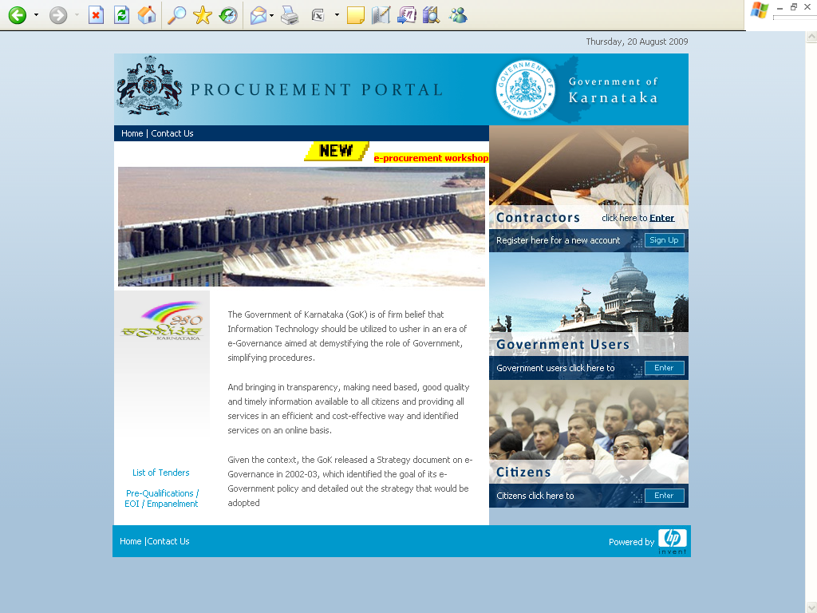
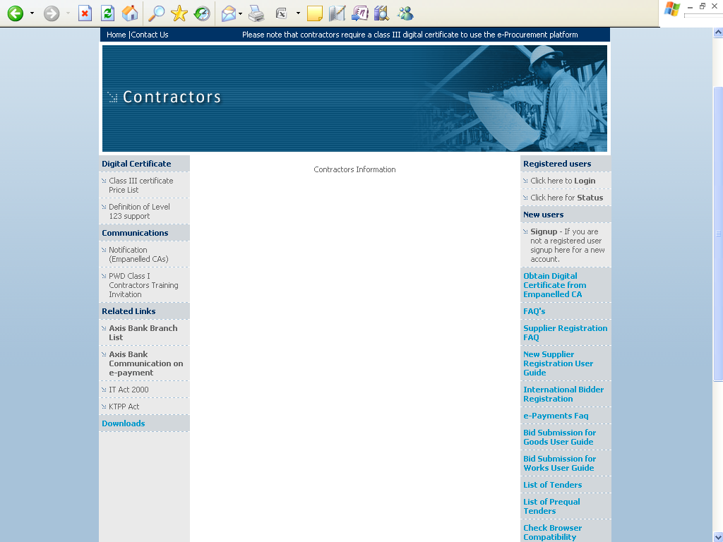
For details on e-Payment services refer to e-procurement portal for more details on the process.

Note: In e-Procurement Portal Contractor has the option of withdrawing the Bid by digitally signing to withdraw/cancel bid before the bid submission time /Date.
e-mail: hphelpdesk.blr@rteservices.com

SUPPORTS timings: (9.00 am to 9.00 pm)

Help desk: 080-22485867/22485927
or
E-mail: hphelpdesk.blr@rteservices.com

Superintending Engineer Electy
O&M Circle, GESCOM,
GULBARGA

Copy to:
- The P.S to Managing Director, GESCOM Gulbarga for information.
- The P.S to Director (T), GESCOM Gulbarga for information.
- The FA, GESCOM, Gulbarga for information.
- Chief Engineer Electy Corporate Planning, GESCOM, Gulbarga for information.
- The Executive Engineer (Ele) O&M Division, GESCOM, Gulbarga-I/II/Yadgir & Sedam information and to display on their notice board.
- Accounts officer corporate office GESCOM Gulbarga for information.

