 | BANGALORE ELECRICITY SUPPLY COMPANY LIMITED
VOLUME-I
SECTION – INB
INSTRUCTION TO BIDDERS
- INTRODUCTION

- The General Manager, Ele., Procurement, Corporate Office, IV Floor, K.R. Circle, Bangalore-560 001 on behalf of Bangalore Electricity Supply Company Limited, invite short term tender for supply of 11 kV UG cable & PIL cable heat shrinkable jointing and termination kits (indoor/outdoor), 11kv/LT AB cable mechanical connectors (straight, tee and cross) under Rate Contract for a period of two years through e-procurement portal (www. eproc. karnataka. gov.in)
1. Enquiry No. | BESCOM/BCP-1076/2017-18
2. Tender processing fee | Refer e-procurement website  www.eproc.karnataka.gov.in
3. Earnest Money Deposit | Refer EMD Clause in the tender Documents.
4. Date of availability of Bids | 25.01.2018 to 03.02.2018, 16:00 Hrs,
3. Due date for submission of Bids | 03.02.2018, 16:00 Hrs,
4. Tender System | Two Cover Tender
5. a) Date of opening of Techno commercial bid  b) Date of opening of Price Bid | a) 05.02.2018, 16:00 Hrs,  b) Will be opened in e-procurement portal after completion of techno commercial evaluation. Separate intimation regarding date of opening of price bid will not be issued.
6. Material | For supply of 11 kV UG cable & PIL cable heat shrinkable jointing and termination kits (indoor/outdoor), 11kv/LT AB cable mechanical connectors (straight, tee and cross) under Rate Contract for a period of two years

7. Schedule of requirements | Rate Contract is valid for a period of two years and purchase orders will be placed by SEE, C, O&M Circles depending upon their requirement.
8. General Terms and Conditions | Enclosed herewith
9. Technical Specifications | Enclosed herewith
10. Price Bid | The Bidder shall furnish Unit computed FORD price on the e-procurement portal in the option of ''item wise bid commercial offer'' (all inclusive) (unit price) and also furnish the break up of prices in "Edit Break up of price quoted" option. The break up of prices should contain EX works price and tax structure as applicable GST and F & I charges in e-procurement portal.

- Approximate Rate contract amount: Rs 818.84 Lakhs

- Scope :
The scope of the proposal shall completely cover the Manufacture, Testing and Supply of For supply of 11 kV UG cable & PIL cable heat shrinkable jointing and termination kits (indoor/outdoor), 11kv/LT AB cable mechanical connectors (straight, tee and cross) under Rate Contract for a period of two years conforming to BESCOM Technical Specifications. F.O.R.D at Store/Site basis, including all applicable GST, transportation and loading & unloading. The Materials are to be delivered to the destinations within BESCOM areas which will be notified at the time of issue of Purchase Orders by the Superintending Engineer (Ele), C, O&M Circles, BESCOM.

- Availability of Tender documents.
Bidders can download the tender documents from e-procurement portal from 25.01.2018 to 03.02.2018, 16:00 Hrs, (Free of cost) and techno commercial bid will be opened on 05.02.2018, 16:00 Hrs,

- Submission of tender documents
All the Tender Documents shall be submitted through e-Procurement Portal on or before Last date of bid submission i.e 03.02.2018, 16:00 Hrs,.

5.1 Opening of Technical bid:

The technical bids will be opened on 05.02.2018, 16:00 Hrs, in the e-Procurement Portal. Price Bids of techno commercially responsive firms will be opened in e-procurement portal. Separate intimation regarding date of opening of price bid will not be issued.

- QUALIFYING REQUIREMENTS OF BIDDERS

6.1 Technical Requirements:
- The Bidder should be manufacture of 11 kV, UG cable heat shrinkable cable termination kit or PIL cables jointing kits (indoor or outdoor) or 11kv AB cable mechanical connectors (straight, tee and cross) for a minimum period of 5 years. The bidder shall upload proof such as license issued by any government statutory authority.
- The bidder must have obtained Rate contract orders for at least 50 % of the Amount put to tender from any Electrical Utilities/semi government in any one of the previous four financial years (2014-15, 2015-16, 2016-17 & 2017-18 (Upto Dec-17)) as on the date of bid opening. Copies of the supporting documents shall be uploaded.
- The bidder shall upload performance certificate (in the prescribed format) for having minimum two year satisfactory operation in the preceding financial years (i.e, 2013-14, 2014-15 & 2015-16) of 11 kv UG cable heat shrinkable cable termination kit or jointing kits or PIL cables or 11 kV AB cable mechanical connectors (straight, tee and cross) issued by officer not below the rank of Executive Engineer, C, O & M Division/Cable (W&M) Division/C, O & M circles of BESCOM KPTCL/BESCOM/ESCOMS or other Electric Utilities.
- The bidder shall upload test certificates for type test conducted as per IS/IEC standards at CPRI/ERDA/any Govt NABL laboratory on heat shrinkable cable termination kit or PIL cables or jointing kits/11kv AB cable mechanical connectors (straight, tee and cross). Such type test certificate shall not be older than five years from the date of bid submission.

- The bidder should have in house laboratory equipped with suitable equipment to carry out critical routine tests on self manufactured heat shrink components and the bidder should have facility to manufacture cable breakout, rain sheds and anti tracking tubing. Self declaration for the same shall be uploaded.

- The capability of the firm will be ascertained by inspecting the Factory by the Engineers of BSCOM, if necessary before opening the price bid.

- The firm should not have been black-listed by any Central/State Government or Public Sector undertakings in India, self declaration for the same shall be uploaded.

- The firm should not have been defaulted in supplies against Purchase orders placed by any Central/State Government or Public Sector undertakings in India, self declaration for the same shall be uploaded.

- The bidder shall upload Guaranteed Technical Particulars (GTP) as per the prescribed format.
6.2 Financial Requirements:

- The Annual Financial Turnover of the bidder in any one the three preceding financial years (i.e, 2014-15, 2015-16 & 2016-17) should not be less than 50% of the amount put to tender. The bidder shall upload Audited financial statements for three preceding financial years or Turnover certificate issued by CA to this effect along with the bid. In case, audited annual accounts for the FY 2016-17 is not finalized, provisional un-audited annual accounts duly certificated by the Chartered Accountant shall be uploaded.
- The liquid assets as on 31.12.2017 or at a later date before opening of the technical bid, consisting of cash in hand + Cash at Bank+ Term Deposits + availability of credit facility (Fund based) in any Scheduled/Nationalized Bank shall not be lesser than 25% of the amount put to tender. The cash and Bank Deposit as on 31.12.2017 or at a later date before opening the Technical Bid shall be supported by certificate issued by Chartered Accountant and the availability of fund based credit facility shall be supported by a certificate issued by any Scheduled/Nationalized Bank.
- The firm should be registered under GST and the registration details shall be uploaded.

7.0 General Instructions :
7.1 The Bidder shall upload Documentary proof for the above Qualifying requirements and also upload the details in the Techno Commercial Sheets.
  - Even though the Bidders meet above qualifying criteria, as per their statements they are subject to be disqualified if they have,
    - Made misleading or false representations in statements and attachments submitted as proof of the qualification requirement and/or.
    - Record of poor performance such as poor quality of product, not properly completing the contract, inordinate delays in supply completion, or financial failures etc.,
  - In the event of the information furnished by the bidder found to be false at any stage of tendering, BESCOM at its discretion may take action against such bidders and may forfeit the bid security and disqualify the offer of such bidder and blacklist the firm.
  - In the event of the information furnished by bidder is found to be false during the execution stage, then BESCOM at its liberty to cancel the Purchase Order other than forfeiting the Security Deposit against the Purchase Order and may blacklist the firm and recover the losses and levy liquidated damages.
  - The offers shall be in General conformity with the specifications.
  - SSI Certificate shall be enclosed with the tender, if applicable.
  - Quantities noted above are provisional and subject to change as per provisions of KTPP Act.
  - The non-submission of EMD amount prescribed in e-procurement mode and balance amount of EMD in the form of Bank Guarantee is liable to be rejected.
  - Any bid submitted in response to the tender shall confirm absolutely to the tender specifications and other conditions. Any deviation whatsoever wherever mentioned will make the bid liable for rejection.
  - BESCOM reserves the right to disqualify the bid if the deviation mentioned by the bidder is not acceptable to BESCOM.
  - The Validity of the tender shall be 180 days from the date of opening of techno-commercial bid.
  - BESCOM will not be responsible for not getting internet connection while downloading the Electronic Bid sheets/documents or while uploading their offers.
  - It is mandatory to quote all the sizes of the tendered materials in the price schedule of e-procurement portal. Further, if any of the bidder who does not quote for all sizes, that bid will be rejected in e-procurement portal. Self declaration for acceptance to supply of all the materials mentioned shall be uploaded.
  - The price evaluation will be done on the basis of the total cost/Percentage quoted for all the sizes put together (unit price) and order will be placed on the total lowest quoted for all the sizes put together by the successful bidder.
  - Note : The rates for the items which are not available in the schedule: In case of restoration/execution of electrical works, for which the rates are not available, applicable common SR 2016-17 rate plus tender premium shall be considered.
- Two cover Tender :

Tender should be in two parts namely Part-I: Techno commercial Bid containing full technical particulars and commercial terms and conditions. Part-II: Price Bid containing prices.

8.1 Part-I : TECHNICAL BID:
The technical documents shall be uploaded in e-procurement portal.

8.2 INFORMATION REQUIRED WITH TECHNICAL PROPOSAL:

The following documentary evidence in respect of qualifying requirements shall be uploaded by the bidder in the form of electronic/scanned copies in the e-procurement portal by the participating bidders.

Sl. No | Qualifying Requirements |  | Documentary Evidence to be furnished by the bidder
a | Technical Requirements:  The Bidder should be manufacture of 11 kV, UG cable heat shrinkable cable termination kit or PIL cables jointing kits (indoor or outdoor) or 11kv AB cable mechanical connectors (straight, tee and cross) for a minimum period of 5 years. The bidder shall upload proof such as license issued by any government statutory authority. |  | The bidder shall upload proof such as license issued by any government statutory authority.
b | The bidder must have obtained Rate contract orders for at least 50 % of the Amount put to tender from any Electrical Utilities/semi government in any one of the previous four financial years (2014-15, 2015-16, 2016-17 & 2017-18 (Upto Dec-17)) as on the date of bid opening. Copies of the supporting documents shall be uploaded. |  | Copies of the supporting documents shall be uploaded.
c | The bidder shall upload performance certificate (in the prescribed format) for having minimum two year satisfactory operation in the preceding financial years (i.e, 2013-14, 2014-15 & 2015-16) of 11 kv UG cable heat shrinkable cable termination kit or jointing kits or PIL cables or 11 kV AB cable mechanical connectors (straight, tee and cross) issued by officer not below the rank of Executive Engineer, C, O & M Division/Cable (W&M) Division/C, O & M circles of BESCOM KPTCL/BESCOM/ESCOMS or other Electric Utilities. |  | Performance certificate for the same shall be uploaded.
d | The bidder shall upload test certificates for type test conducted as per IS/IEC standards at CPRI/ERDA/any Govt NABL laboratory on heat shrinkable cable termination kit or PIL cables or jointing kits/11kv AB cable mechanical connectors (straight, tee and cross). Such type test certificate shall not be older than five years from the date of bid submission. |  | The bidder shall upload test certificates for type test conducted as per IS/IEC standards at CPRI/ERDA/any Govt NABL laboratory on heat shrinkable cable termination kit or PIL cables or jointing kits or 11kv AB cable mechanical connectors (straight, tee and cross). Such type test certificate shall not be older than five years from the date of bid submission.
e | The bidder should have in house laboratory equipped with suitable equipment to carry out critical routine tests on self manufactured heat shrink components and the bidder should have facility to manufacture cable breakout, rain sheds and anti tracking tubing. Self declaration for the same shall be uploaded. |  | Self declaration for the same shall be uploaded.
f | The capability of the firm will be ascertained by inspecting the Factory by the Engineers of BSCOM, if necessary before opening the price bid. |  | Self declaration for the acceptance shall be uploaded.
g | The firm should not have been black-listed by any Central/State Government or Public Sector undertakings in India, self declaration for the same shall be uploaded. |  | Self declaration for the same shall be uploaded.
h | The firm should not have been defaulted in supplies against Purchase orders placed by any Central/State Government or Public Sector undertakings in India, self declaration for the same shall be uploaded. |  | Self declaration for the same shall be uploaded.
i | The bidder shall upload Guaranteed Technical Particulars (GTP) as per the prescribed format. |  | The bidder shall upload Guaranteed Technical Particulars (GTP) as per the prescribed format.
j | Financial Requirements:  The Annual Financial Turnover of the bidder in any one the three preceding financial years (i.e, 2014-15, 2015-16 & 2016-17) should not be less than 50% of the amount put to tender. The bidder shall upload Audited financial statements for three preceding financial years or Turnover certificate issued by CA to this effect along with the bid. In case, audited annual accounts for the FY 2016-17 is not finalized, provisional un-audited annual accounts duly certificated by the Chartered Accountant shall be uploaded. |  | The bidder shall upload Audited financial statements for three preceding financial years or Turnover certificate issued by CA to this effect along with the bid. In case, audited annual accounts for the FY 2016-17 is not finalized, provisional un-audited annual accounts duly certificated by the Chartered Accountant shall be uploaded.
k | The liquid assets as on 31.12.2017 or at a later date before opening of the technical bid, consisting of cash in hand + Cash at Bank+ Term Deposits + availability of credit facility (Fund based) in any Scheduled/Nationalized Bank shall not be lesser than 25% of the amount put to tender. The cash and Bank Deposit as on 31.12.2017 or at a later date before opening the Technical Bid shall be supported by certificate issued by Chartered Accountant and the availability of fund based credit facility shall be supported by a certificate issued by any Scheduled/Nationalized Bank. |  | The cash and Bank Deposit as on 31.12.2017 or at a later date before opening the Technical Bid shall be supported by certificate issued by Chartered Accountant and the availability of fund based credit facility shall be supported by a certificate issued by any Scheduled/Nationalized Bank.
l |  | The firm should be registered under GST and the registration details shall be uploaded. | GST registration details shall be uploaded.

Part II: PRICE PROPOSALS:
The prices are constant throughout the period of contract. Price variation will be not be allowed.
- COST OF BIDDING

The Bidder shall bear all costs and expenses associated with preparation and submission of its bid including post-bid discussions, technical and other presentations etc, and BESCOM will in no case be responsible or liable for those costs, regardless of the conduct or outcome of the bidding process

  - THE BIDDING DOCUMENTS

- CONTENTS OF BIDDING DOCUMENT

  - The Bidding Document is a compilation of the following Sections:
Bid Documents | Bid Documents in the following format will be available in the web site.
Bid Documents | Section-INB-Instructions to Bidders
Bid Documents | Section-GCC-General Terms and Conditions of Contract
Bid Documents | Section- Technical Specification
Bid Documents | Section- Techno-commercial sheets
Bid Documents | Section- GTP
Bid Documents | Section- Annexure

- UNDERSTANDING OF BID DOCUMENTS

A prospective Bidder is expected to examine all instructions, forms, terms and specifications in the Bid documents and fully inform himself as to all the conditions and matters which may in any way affect the scope of work or the cost thereof. Failure to furnish all information required by the Bid document or submission of a Bid not substantially responsive to the Bid document in every respect will be at the Bidder’s risk and may result in the rejection of its bid.

- CLARIFICATIONS ON BID DOCUMENTS

  - A prospective bidder requiring any clarifications regarding Bidding documents may notify the General Manager Ele., (Procurement), BESCOM in writing or by Fax or e-mail address indicated in the Bidding documents within the stipulated time. The General Manager Ele., (Procurement), BESCOM will respond to any request for clarification of the Bidding documents which he receives not later than day of the bid availability.
  - The bidder is required to carefully examine the specifications and documents and fully conformed himself as to all the conditions and matters which may in any way, affect the services to be provided and/or the cost thereof. If the bidder finds discrepancies or omissions in the specifications and documents or is in doubt as to the true meaning of any part, he shall at once make a request for an interpretation/ clarification.
  - Verbal clarification and information given by owner or his employee(s) or his representative(s) shall not in any way be binding on owner.

- AMENDMENT TO BIDDING DOCUMENT

  - At any time prior to the deadline for submission of bids, owner may, for any reason, whether at its own initiative or in response to a clarification requested by a prospective Bidder, modify the Bidding Document by amendment (s).
  - The amendment will be notified in e-mode to all prospective Bidders, who have received the Bidding Document at the address contained in the letter of request for issue of Bidding Document from the Bidders. Owner will bear no responsibility or liability arising out of non-receipt of the same in time or otherwise.
  - In order to afford prospective Bidders reasonable time in which to take the amendment into account in preparing their bids, owner may, at its discretion, extend the deadline for the submission of bids as deemed fit.
  - Such amendments, clarifications, etc, shall be binding on the Bidders and will be given due consideration by the Bidders while they submit their bids and invariably enclose such documents as a part of the bid.

C. PREPARATION OF BIDS
- LANGUAGE OF BID

  - The bid prepared by the Bidder and all correspondences and documents relating to the bid, exchanged by the Bidder and owner shall be written in the English language, provided that any printed literature furnished by the Bidder may be written in another language so long as accompanied by an English translation of its pertinent passages. Failure to comply with this may disqualify a bid. For purposes of interpretation of the bid, the English translation shall govern.
- DOCUMENTS COMPRISING THE BID

  - The Bidder shall complete the Bid Form inclusive of Price Schedules, Technical Data Requirements etc. furnished in the Bidding Documents as detailed above, indicating for the goods to be supplied, a brief description of goods, quantity and prices and upload in the e-procurement portal.
  - The Bidder shall also upload documentary evidence in the e-procurement portal to establish that the Bidder meets the Qualification Requirements.
  - SSI Certificate shall be uploaded with the Techno commercial Bid if applicable.
  - The EMD shall be uploaded/ furnished in accordance with the EMD clause of this section.
  - GST Registration certificate shall be uploaded.
- EARNEST MONEY DEPOSIT (BID GUARANTEE):
  - a) For Local Small Scale Units:
If the bidder is a Small scale units registered in the State of Karnataka, then the bidder shall pay EMD for an amount of Rs.8,19,000/- in the form of Bank Guarantee drawn in favour of General Manager, Procurement, BESCOM, Bangalore and is valid for 30 days beyond the period of validity for the bid i.e,(180+30=210) days from the date of technical bid opening.
b) For other than Local Small Scale Units:
If the bidder is not a Small scale units registered in the State of Karnataka, then the bidder shall pay EMD for an amount of Rs. 8,19,000/- in the form of Bank Guarantee drawn in favour of General Manager, Procurement, BESCOM, Bangalore and is valid for 30 days beyond the period of validity for the bid i.e,(180+30=210) days from the date of technical bid opening.
c) EMD amount indicated in (a) and (b) is exempted for Micro and Small Enterprises registered with NSIC under a single point vendor registration scheme. A relevant document shall be uploaded.
Important Note: The scanned copy of Bank Guarantee shall be uploaded along with the other documents provided in the “Upload Documents” Link and the original Bank Guarantee which has been uploaded shall be sealed and super scribed with the Bid Enquiry No. EMD Amount and Due Date of opening on the cover and must be submitted at the office of the General Manager, Procurement, 4th floor, Block-II, Corporate office, BESCOM, K.R. Circle, Bangalore on or before the last date and time of bid submission.

  - The bidder shall pay EMD for an amount of Rs. 8,19,000/- through any of the four e-Procurement modes mentioned in the e-procurement portal.

  - Earnest money deposited by unsuccessful Tenderers will be returned as soon as possible after the tender has been finalized.
  - EMD of successful bidder will be refunded after fulfilment of security deposit clause.
  - The deposit towards EMD as above shall not carry any interest.

  - Permanent EMD will not be considered.
  - EMD so deposited will be liable for forfeiture:
  - If a Bidder withdraws / modifies its bid during the period of bid validity specified by the Bidder on the Bid Form; or
  - In case of a successful Bidder, if the Bidder fails to sign the Contract; or
  - In case of a successful Bidder, if the Bidder fails to furnish the Security Deposit/Performance Guarantee.
- E-payment modes for Tender Processing Fee & Earnest Money Deposit.

The supplier/contractor should pay the Earnest Money Deposit (EMD) & Tender Fee in the e-Procurement portal using any of the following payment modes:
  - Credit Card
  - Direct Debit
  - National Electronic Fund Transfer (NEFT)
  - Over the Counter (OTC)

- CREDIT CARD PAYMENT METHOD:

To pay the registration fee through your credit card, click on the “Credit Card (Online Payment)” option. If you choose to pay the fees later click on “Close” button. Click Pay after verifying details on the screen that appears.
Click on “Pay” button to proceed with payment process. Click “Back” if you wish to Choose a different payment method. Click on “OK” button on the payment method
Confirmation window that is displayed. You will choose your card type (VISA, master Card).
You enter your credit card details.
Card Details completely filled.

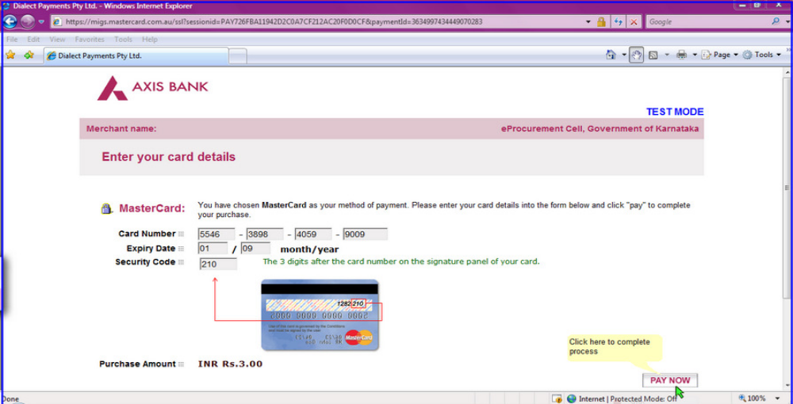

The screen will look like it is shown above when you have completely filled the card details.
Click on “PAY NOW” button to effect the payment. Your card details are verified by the payment gateway service and you will receive confirmation of payment debited to your card account if the card is valid. If the card is not valid you will receive alert about it and system will wait for you to correct any errors in the card details provided by you.
A successful transaction message is displayed.

- DIRECT DEBIT METHOD:

Click on “Direct Debit Using Internet Banking (Online Payment) option to pay from your bank account through Internet Banking facility.
Click on “Pay” to proceed or “Back” to change the payment method on the Payment details screen.
Click on “OK” on the confirmation window to effect the payment. Click on “Cancel” and then on “Back” to change the payment method.
You will information on your screen about successful completion of payment process.

- OTC PAYMENT PROCEDURE:

If a contractor/supplier chooses to make payment of EMD/tender processing fees Over The Counter (OTC) in any of the designated Axis Bank branches listed in the e-Procurement web-site (https://www.eproc.karnataka.gov.in) the contractor/supplier will need to log into e-Procurement system, access the tender for which bid is being created and then select the OTC option under the payment section and print the Challan shown in that section. The printed challan will have the unique bid reference number and the amount to be remitted. Along with the challan, contractor can choose to make the payment either in the form of cash or in the form of Demand Draft. Cheque payments will not be accepted. The contractor is requested to specifically inform the bank officer to input the unique bid reference number printed in the challan in the banking software. Upon successful receipt of the payment, the bank will provide a 16-digit reference number acknowledging the receipt of payment. This 16-digit reference number has to be inputted by contractor in the payment section of its bid as payment confirmation before the bid is submitted (i.e.) as a pre-requisite for bid submission.
- NEFT PAYMENT PROCEDURE:

If a contractor/supplier chooses to make payment of EMD/tender processing fees using Reserve Bank of India's (RBI) National Electronic Fund Transfer (NEFT) system, the contractor/supplier will need to log into e-Procurement system, access the tender for which bid is being created and then select the NEFT option under the payment section and print the Challan shown in that section. The printed challan will have the unique bid reference number, account details of Government of Karnataka and the amount to be remitted. The contractor has to submit the printed challan to its bank-branch (NEFT-enabled) and request for an account-to-account transfer, wherein the money will get transferred from the contractors' bank account to GoK's bank account. The contractor should ensure that NEFT transfer instructions are executed and the funds are wired to the Government of Karnataka's principal account before the last date for bid submission and preferably 24 hours before the last date for bid submission. If the contractor's bank transfers/wires the money after the last date for bid submission, the contractor's bid will be liable for rejection. Upon executing the transfer, the contractor's bank will provide a reference number generated by NEFT software as confirmation of transfer, which has to be inputted by contractor in the payment section of its bid as payment confirmation before the bid is submitted (i.e.) as a pre-requisite for bid submission. Also, the account number from which the funds were transferred have to be inputted in the e-Procurement system as part of its bid.
The supplier/contractor’s bid will be evaluated only on confirmation of receipt of the payment (EMD) in the Government of Karnataka central pooling a/c held at Axis Bank.
For details on e-Payment services refer to e-procurement portal for more details on the process.

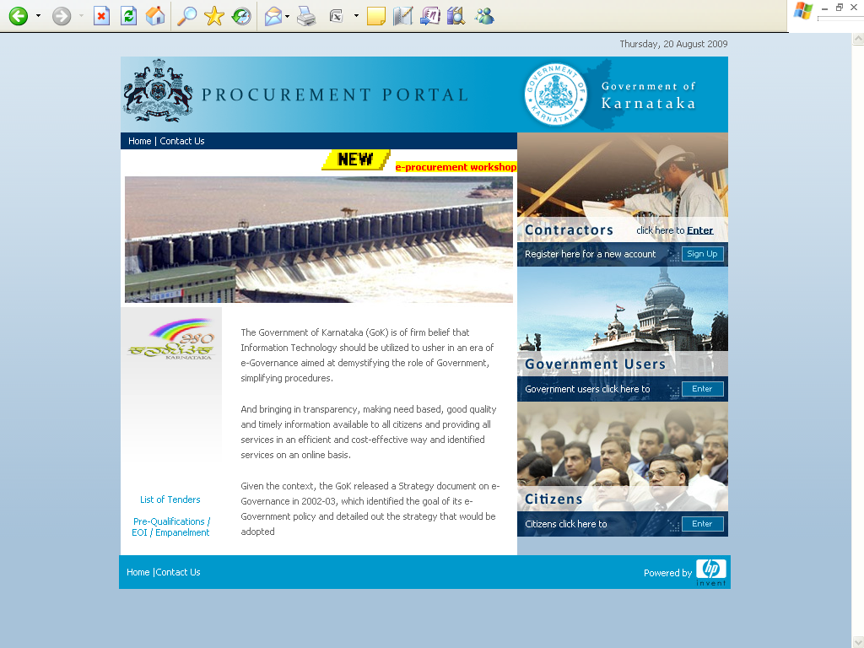

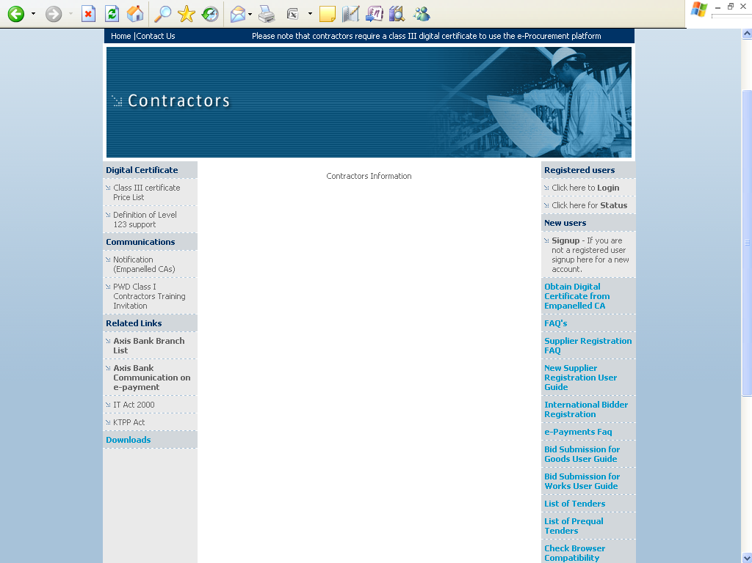

Note: In e-Procurement Portal, Contractor has the option of withdrawing the Bid by digitally signing to withdraw/cancel bid before the bid submission time /Date.

- PERIOD OF VALIDITY OF BIDS

  - Bids shall remain valid for 180 Days from the date of bid opening. A bid valid for a shorter period will be rejected as non-responsive.

  - In exceptional circumstances, owner may solicit the Bidder’s consent to an extension of the period of validity. The request and the response thereto shall be made in writing (including cable or telex). A Bidder may refuse the request without forfeiting his bid security. A Bidder granting the request will not be required or permitted to modify its bid.

- FORMATS OF COMMERCIAL OFFER:
The Commercial offers must not contradict the technical offer in any way.

- PRICES:
  - The prices are constant throughout period of the Rate Contract.
- TAXES AND DUTIES:
The bidders have to quote GST, F&I Charges and any other applicable Taxes prevailing as on date of bid opening and the same shall be clearly spelt out in the offer. The quoted/amount quoted is all inclusive.
In the event of an order.
  - GST will be paid as indicated by the bidder in the Price Bid.
  - If there is any concession/reduction in the GST by the changes in the policies of the Central/State Government regarding the same shall be availed and passed on to BESCOM.
  - If there is any enhancement in the GST due to change in policies by the Central/State Government then such enhanced taxes will be payable by BESCOM.
  - No claim for any increase towards statutory variation regarding enhancement of existing GST or introduction of a new tax or duty shall be entertained during the extended period of contract if the extension is due to the causes attributable to the successful bidder.

- COST AND CURRENCY:
  - The Bidders shall quote their offer as prescribed in the price bid in Indian Rupees only including the following:
- Cost of the equipment/material.
- Minimum of 18 Months comprehensive replacement on site warranty. This period will start from the date of supply of materials to the store/site.
- Insurance to cover equipment/material to cover up to installation of equipment/material at the BESCOM site and handing it over to the BESCOM.
- All taxes, GST (IGST, CGST and SGST) as applicable and split up details shall be furnished.
- Vendors have to make their own arrangements for obtaining road permits wherever needed.
- Entry Tax and octroi must be mentioned separately if applicable.

    - SUBMISSION OF BIDS
- FORMAT OF BID
  - The bids shall be uploaded through e-procurement portal on or before the last date and time for submission of the bid. Bids not submitted through e-procurement mode and non submission of EMD (Through the e-Mode and hard copy of the Bank Guarantee) will be treated as disqualified.
  - The bid shall contain no interlineations, erasures or overwriting except as necessary to correct errors made by the Bidder, in which case such corrections shall be initialed by the person or persons signing the bid.
  - All the documents in support of qualifying requirements shall be scanned and uploaded in the e-procurement portal. . Failure to furnish the documentary evidences/supports electronically would result in outright rejection of their offers.
- DEADLINE FOR SUBMISSION OF BIDS
  - Bids must be uploaded in the e-procurement portal on or before 03.02.2018., 16:00 Hours.

  - Owner may, at its discretion, extend this deadline for the submission of bids by amending the Bidding Document, in which case all rights and obligations of owner and Bidders previously subject to the deadline will thereafter be subject to the deadline as extended.
- MODIFICATION AND WITHDRAWAL OF BIDS
  - The Bidder may modify or withdraw its bid after the bid’s submission prior to the deadline prescribed for submission of bids.
  - No bid may be modified subsequent to the deadline for submission of bids.
  - No bid may be withdrawn in the interval between the deadline for submission of bids and the expiration of the period of bid validity specified by the Bidder on the Bid Form. Withdrawal/modification of a bid during this interval may result in the Bidder’s forfeiture of its bid security.
- LATE BIDS
e-Procurement portal automatically locks the tender after the last date and time of receipt of tenders as mentioned in the e-Procurement portal.

    - BID OPENING AND EVALUATION

- OPENING OF BIDS
  - Owner will open bids submitted through e-procurement portal on the date and time for opening of bids or in case any extension has been given thereto, on the extended bid opening date and time notified on the e-procurement portal.
  - Number of bidders participated, bidder’s names, bid withdrawal and such other details will be available on the e-procurement portal after opening.
  - The bids received/accepted/opened will be evaluated by the Owner to ascertain the techno-commercially responsiveness of the bid for the complete scope of the proposal, as covered under these specifications and documents.
  - Price bids of techno commercially responsive bidders will be opened in e-procurement portal after completion of techno commercial evaluation. Separate intimation regarding date of opening of price bid will not be issued.
- CLARIFICATION OF BIDS
  - To assist in the examination, evaluation and comparison of bids owner may, at its discretion, ask the Bidder for a clarification of its bid. The request for clarification and the response shall be in writing and no change in the price or substance of the bid shall be sought, offered or permitted.

- PRELIMINARY EXAMINATION:
  - Owner will examine the bids to determine whether they are complete, whether any computational errors have been made, whether required sureties have been furnished, whether the documents have been properly signed, and whether the bids are generally in order.
  - Owner may waive any minor informality or non-conformity or irregularity in a bid which does not constitute a material deviation, provided such waiver does not prejudice or affect the relative ranking of any Bidder.

- EVALUATION/COMPARISON OF BIDS :
  - TECHNO-COMMERCIAL EVALUATION :
The bids submitted in e-procurement platform are evaluated techno-commercially. The bids which have complied the following conditions are considered as technically qualified/responsive to open their price bids after scrutiny of documents and acceptance of other terms and conditions of the bid without any deviations.
- The pre-requisite EMD in the prescribed form is paid.
- The technical & financial qualifying requirements are fulfilled with supportive documents.
- Submission of the required annexures of the bid.
- Technical requirements as per specifications, & conforming to all terms and conditions, without any deviations.
- Acceptance for payment terms & conforming to all terms and other technical & commercial conditions etc., as specified in the terms and conditions of the Bid.
  - PRICE BIDS :
  - After opening the price bids, the price evaluation will be done on the basis of the total cost quoted for all the sizes put together obtained in the tender. Such price shall include all the costs including GST taxes, and transportation, loading & unloading if any.
  - The rate Contract will be entered with whose total quoted cost for all the sizes put together evaluated as least quoted among the Technical responsive bids in accordance with provisions of KTPP act & its amendments.. Subsequently, Purchase order will be placed by the SEE, C, O&M Circles, BESCOM depending on their requirements duly specifying the delivery schedule .

31.0 CONTACTING THE OWNER:
Bids shall be deemed to be under consideration immediately after they are opened and until such time official intimation of award/rejection is made by owner to the Bidders. While the bids are under consideration, Bidders and/or their representatives or other interested parties are advised to refrain from contacting by any means, owner and/or his employees/representatives on matters related to the bids under consideration. Owner, if necessary, will obtain clarifications on the bids by requesting for such information from any or all the Bidders, either in writing or through personal contacts as may be necessary. Bidders will not be permitted to change the substance of the bids after the bids have been opened.
32.0 NEGOTIATIONS:
It is absolutely essential for the bidders to quote the lowest price at the time of making the offer in their own interest, as BESCOM will not enter into any price negotiations, except with the lowest quoting bidder, whose offer is found to be fully technically compliant.

    - ISSUE OF RATE CONTRACT & PURCHASE ORDER

33.0 AWARD CRITERIA:
33.1 The General Manager (Ele), Procurement, BESCOM will place the Rate Contract valid for a period of Two years on the successful Bidders whose bid has been determined to be substantially responsive and has been determined as the lowest evaluated bid, provided further that the Bidder is determined to be qualified to perform the Contract satisfactorily. Owner shall be the sole judge in this regard.
34.0 RIGHT TO ACCEPT ANY BID AND TO REJECT ANY OR ALL BIDS:
Owner reserves the right to accept or reject any bid, and to annul the bidding process and reject all bids at any time prior to award of Contract, without thereby incurring any liability to the affected Bidder or Bidders or any obligation to inform the affected Bidder or Bidders of the grounds for owner’s action.

35.0 NO COMMITMENT TO ACCEPT LOWEST OR ANY TENDER:
BESCOM shall be under no obligation to accept the lowest or any other offer received in response to this tender notice and shall be entitled to reject any or all offers including those received late or incomplete offers without assigning any reason whatsoever. BESCOM will not be obliged to meet and have discussions with any bids, any or to listen to any representations.

36.0 NOTIFICATION OF AWARD
Prior to the expiration of the period of bid validity and extended validity period, if any, owner will notify the successful Bidder in writing by registered letter or fax, to be confirmed in writing by registered letter that its bid has been accepted.

37.0 EFFECT AND JURISDICTION FOR CONTRACT
The laws applicable to the contract shall be the law in force in India. The Courts of Bangalore in Karnataka State shall have exclusive jurisdiction in all matters arising under the contract.

38.0 TERMINATION FOR DEFAULT:
BESCOM may without prejudice to any other remedy for breach of Contract by 14 days written notice of default sent to the Supplier, terminate the Contract in whole or in part.
- If the Supplier fails to deliver any or all of the goods/ items within the time period(s) specified in the Contract or any extension thereof granted by BESCOM.
b) If the Supplier fails to perform any other obligation(s) under the Contract.
39.0 ISSUE OF PURCHASE ORDER:
The purchase orders will be placed by the respective SEE, C, O&M Circles, BESCOM depending on their requirement.
What ever may be the conditions of sale specified or indicated in the quotations, it is only the conditions indicated in the Rate Contract/Purchase Order and technical specifications will be binding upon BESCOM. On receipt of the Rate Contract if any successful bidder finds his inability to accept any of the terms/conditions, he shall raise the issue specifically and immediately get the matter clarified.
The supplier shall strictly adhere to the delivery Schedule indicated in the Purchase orders and any default in supplies will be viewed seriously by BESCOM and action as deemed fit will be initiated against the supplier by BESCOM.

40.0 LOCATION OF SUPPLY:
This Tender is being floated by the corporate Office of BESCOM. The materials/equipments being procured through this Tender shall be supplied by the contractor at the divisional stores/sites of the BESCOM furnished along with the Purchase Order/Dispatch Instruction. BESCOM reserves the right to make changes in the locations.
For any technical support regarding e-procurement portal please contact e-procurement help desk.
Help Desk: 080- 25501216, 25501227
Or
E-mail: hphelpdesk.blr@rteservices.com
For any queries/clarifications regarding the qualifying requirements, EMD and other conditions of the tender documents and specifications may contact the under signed at the office hours or contact through E-mail : gmproc@bescom.co.in or gmproc.work@gmail.com.
Ph : 080-22085401, Mobile : 9449868904
Fax : 080-22352485

General Manager (Ele.),
Procurement, BESCOM

