Chamundeshwari Electricity Supply Corporation Limited


Enquiry No: CESC/GM(P)/C2-4249
Dated: 05-11-2016

BID DOCUMENTS

FOR

Manufacturing, Inspection/Testing and Supply of
1.1 kV Ceramic Pin Insulators (Shell only) to CESC on Rate Contract Basis
for a period of One year

ISSUED BY
General Manager (Procurement)
CESC, Corporate office,
No.29, Vijayanagar 2nd Stage, Hinkal,
Mysore - 570 017

E-mail: gmpurc@cescmysore.org
Phone: 0821-2417109

CHAMUNDESHWARI ELECTRICITY SUPPLY CORPORATION LIMITED

TABLE OF CONTENTS

Section-I Instruction to Bidders
Section-II General Terms & Conditions of Contract
Section-III Technical Specification
Section-IV Annexure
Annexure-I Price Schedule
Annexure-II Commercial Terms and Conditions
Annexure-III Commercial Deviation
Annexure-IV Technical Deviation
Annexure-V Bid Document Submission Format
Annexure-VI Guaranteed Technical Particulars

CHAMUNDESHWARI ELECTRICITY SUPPLY CORPORATION LTD
Section-I
Instructions to Bidders
Contents
1.1 BRIEF DESCRIPTION: 1
1.2 SCOPE OF WORK: 1
1.3 TYPE OF TENDER: 2
1.4 CONTENTS OF BIDDING DOCUMENT: 2
1.5 UNDERSTANDING OF BID DOCUMENTS: 2
1.6 QUALIFYING REQUIREMENTS: 2
Technical Requirement 2
Financial Capabilities: 2
1.7 General Conditions: 3
1.8 LANGUAGE OF THE BID: 4
1.9 CLARIFICATIONS ON BID DOCUMENTS: 4
1.10 AMENDMENT TO BIDDING DOCUMENT: 4
1.11 VALIDITY OF BIDS: 5
1.12 BID PRICES: 5
1.13 PRICES: 5
1.14 TAXES AND DUTIES: 5
1.15 METHOD OF SUBMITTING THE BID: 5
1.16 TENDER PROCESSING FEE: 6
1.17 EARNEST MONEY DEPOSIT (BID GUARANTEE): 6
1.18 INCIDENTAL COST OF BIDDING: 6
1.19 E-PAYMENT MODES FOR TENDER PROCESSING FEE & E.M.D: 6
Credit Card Payment Method: 6
Direct Debit Method: 7
OTC Payment Procedure: 7
NEFT Payment Procedure: 7
1.20 CLARIFICATION REGARDING BIDS: 8
1.21 TECHNICAL EVALUATION OF BIDS: 8
1.22 OPENING OF PRICE BID: 9
1.23 EVALUATION/COMPARISON OF PRICE BIDS AND ARRIVING L1 BID: 9
1.24 NEGOTIATIONS: 9
1.25 CONTACTING THE OWNER: 9
1.26 Technical Support: 9

CHAMUNDESHWARI ELECTRICITY SUPPLY CORPORATION LTD
Section-I
Instructions to Bidders

BRIEF DESCRIPTION:
On behalf of Chamundeshwari Electricity Supply Corporation Limited, (CESC) the General Manager(Procurement), Corporate Office, #29, Vijayanagara 2nd Stage, Hinkal, Mysuru – 570017 invites tender for “Manufacturing, Inspection/Testing and Supplying of 1.1 kV Ceramic Pin Insulators (Shell only) for a period of One Year ” as per given specification.

- Enquiry Number: CESC/GM(P)/C2-4249 Date: 05-11-2016

Scope of Tender: Manufacturing, Inspection/Testing and Supplying of 1.1 kV Ceramic Pin Insulators (Shell only) for a period of One Year.
- Material, Quantity and Amount put to Tender:
- Material : 1.1 kV Ceramic Pin Insulators (Shell only)
- Quantity : 30000 No
- Amount : ` 4.50 Lakhs
- Jurisdiction : CESC Jurisdiction

- Tender Processing Fee: Refer e-procurement website www.eproc.karnataka.gov.in

- Earnest Money Deposit: 1% of amount put to tender (`12500 for SSI/MSME Firms)

- Validity of Bid: 180 days

- Type of Tender: Two Part

- Pre-Bid Meeting: 18-11-2016, 11:00 Hrs

- Last Date for submission of Bid: 24-11-2106, 16:00 Hrs..

- Techno-Commercial Bid opening: 26-11-2016, 11:00 Hrs.

- Price Bid opening: 30-11-2016, 11:00 Hrs.

- Schedule of Requirement: As per purchase order schedule

- Technical Specifications: Enclosed

- Price Bid: The bidder shall furnish computed Unit FORD price on e-procurement portal in the option “item wise bid financial offer” and also furnish the breakup of prices in "Edit Break up of price quoted" option. The breakup of prices should contain Ex-works price, taxes & duties.

SCOPE OF WORK:
The Scope of work includes the following:
- Manufacture, Testing/Inspection and Supply of material as per drawing and technical specification.
- Providing engineering drawings, data, operation/ maintenance manual if any for the owner's approval.
- Manufacturing and Testing of material as per specified standards.
- Packing, preservation and transportation of the materials to the consignee stores/ works.

TYPE OF TENDER:
Tenders invited in two part system as below:
Part-I: Techno-commercial Bid
Techno commercial bid contains technical and commercial conditions of the tender.
The bidders shall read all technical particulars and commercial conditions carefully before uploading the same in the e-procurement portal. The relevant documents in support of meeting the eligibility criteria should be furnished in the techno-commercial bid.
Part-II: Price Bid
The price bid contains the price schedule as in Annexure-I.
The bidder shall upload computed unit FORD price on e-procurement portal in the option of “item wise bid commercial offer” and also upload the breakup for the above unit ford price in the prescribed annexure-I. The breakup of prices should contain, Basic price, ED, Cess on ED, CST/VAT, Freight & Insurance and other taxes if any as in the price Annexure-I.

CONTENTS OF BIDDING DOCUMENT:
The bidding documents are as follows:
Section I - Instructions to Bidders (ITB)
Section II - General Terms and Conditions of Contract (GCC)
Section III - Technical Specification
Section IV - Annexure (I-V)

UNDERSTANDING OF BID DOCUMENTS:
The prospective bidder is expected to read all instructions, forms, terms and specifications in the bid documents and fully inform himself about all the terms and conditions. Failure to upload all information as per the bid document or submission of bid with partial information will be at the bidder’s risk and is liable for rejection.

QUALIFYING REQUIREMENTS:

Technical Requirement
- The Bidder should be a manufacturer of the tendered material and should have the registration/licence from competent authority.
Document to be uploaded: Bidder should upload manufacturing License/SSI/MSME certificate issued by competent government authority indicating the same.
- The bidder should have an experience of 3 years in manufacturer and supply of tendered materials.
Document to be uploaded: Bidder shall upload notarized copies of the Purchase Order (PO)/Supply Certificates issued from KPTCL/ESCOMs/Govt. utilities of State/Electricity boards in India or Central Government undertakings by official not below the rank of Executive Engineer.
- The bidder should have supplied at least 25% of the tendered material in any one of the preceding three financial years (2013-14, 2014-15 & 2015-16.) or in current year to the ESCOM/KPTCL/Govt. Utilities for the works of ESCOMs/Govt. utilities.
Document to be uploaded: Supply Certificates issued from KPTCL/ESCOMs/Govt. utilities of State/Electricity boards in India or Central Government undertakings by official not below the rank of Executive Engineer.
- The bidder shall upload performance certificate for at least 20% of the tendered quantity of material.
- The bidder shall have a capacity to manufacture and supply minimum of 20% of the tendered quantity in a month. Manufacturing centre will be subjected to inspection by the CESC authorities at their discretion.
Document to be uploaded: Self-Declaration in this regard.
- The type tests for unit shall be as per IS: 1445/1977.
Document to be uploaded: The type test certificates issued by any NABL Laboratory, not later than 3 years.
- The bidder should not be black listed by any ESCOM/KPTCL/Govt. Utilities for default in supply of materials.
Document to be uploaded: Self-Declaration in this regard.

Financial Capabilities:
Bidder shall be financially sound and shall submit audited financial reports for last three years preceding the date of bid submission i.e., 2013-14, 2014-15 & 2015-16.. The bidder shall meet the following financial requirement.
- The Annual Turnover of the bidder shall not be less than the 50% of amount put to tender in any one of the previous three financial years i.e., 2013-14, 2014-15 & 2015-16.
Document to be uploaded: Audited Balance Sheet of all the years mentioned above
- The Liquid Assets as on 31.03.2016 or at a later date before opening of technical bid, consisting of Cash in hand + Cash at Bank + Term Deposits + availability of credit facility in any scheduled Bank shall not be lesser than 25% of the amount put to tender. The cash & bank deposits as on 31.03.2016 or at a later date before opening of technical bid shall be supported by certificate issued by Chartered Accountant and the availability of credit facility shall be supported by a certificate issued by any scheduled Banks.
Document to be uploaded: Cash in Hand+ Cash at Bank + Term Deposits +Cash equivalent shall be supported by certificate issued by Chartered Accountants + availability of credit facility/Overdraft shall be supported by a certificate issued by any scheduled commercial banks.
Note: 1) For SSI units registered in Karnataka shall have the financial capability of 50% of the above i.e., 1.6 (h & i). The bidder should furnish documentary evidence in this regard.
2) Original copies of the documents shall be scanned & uploaded
3) Provisional Balance Sheet for can be furnished if Audit is not finalised for year 2015-16

General Conditions:
The tenders shall be offered for the full quantity only.
- The Bidder shall upload documentary evidence in support of the qualifying requirements stipulated as above.
- Even though the Bidders meet above qualifying criteria, as per their statements they are subject to be disqualified if they have made misleading or false representations in statements and attachments submitted as proof of the qualification requirement and/or.
- SSI Certificate shall be enclosed with the tender if applicable.
- Quantities noted above are provisional and subject to change as per provisions of KTPP Act.
- The tender not submitted through e-procurement mode and also non-submission of EMD is liable to be rejected.
- The offers shall be in General conformity with the specifications. Any Technical/Commercial Deviations from the specifications shall be clearly brought out in techno commercial sheet of the offer. If deviation certificate is left unfilled, it will be treated as there are no deviations and the contractor has accepted the tender conditions and specifications.
- CESC reserves the right to cancel or withdraw or modify the bid without assigning any reason for such decision. Such decision will not incur any liability whatsoever on the part of CESC consequently.
- CESC will not be responsible for not getting internet connection while downloading the Electronic Bid sheets/documents or while uploading their offers.
- The quantity indicated is provisional and can be divided among the various successful bidders, at the discretion of procuring authority.
- CESC may at their option instruct the bidder to deliver to a particular division of CESC and the supplier should comply with the condition.
- Incomplete and vague offers are liable to be rejected without any further correspondence (Refer annexure for conditions).
- Prominent customer list to which materials are supplied earlier shall be furnished along with the performance report from utilities.
- Lead time required to supply the material from the date of purchase order shall be furnished.
- The orders on successful bidders not adhering to delivery schedule is likely to be transferred to the bidders who can comply with requirements of CESC.
- Micro and Small Enterprises registered with NSIC under a single point Vendor registration scheme, will be facilitated by providing tender sets free of cost, exempting from payment of Earnest Money Deposit during purchases.

NOTE: Documents not related to the qualifying requirement should not be submitted any such documents submitted with malfide intention will be viewed seriously and action will be taken.

LANGUAGE OF THE BID:
The bids shall be prepared in English language. Bids submitted other than English language is liable for rejection. All correspondence including clarifications if any will be communicated in English language only.

CLARIFICATIONS ON BID DOCUMENTS:
- If the prospective bidder find any discrepancies or omissions in specifications, document or is in doubt as to the true meaning of any part, he shall at once make a request in writing, for an interpretation/clarification, to the owner.
- The owner will issue clarifications as he may think fit in writing/ upload in the website/ issue corrigendum in the website/ issue instructions in the website for any such requests received from the bidder seeking clarification but not later than seven (7) days prior to the last date for submission of bids as specified in the tender.
- All the clarifications will be notified to the bidders in the e-procurement website and all such clarifications shall form part of the Bidding Document and the same shall be incorporated in the bids.
- Verbal clarification and information given by owner or his employee(s) or his representative(s) shall in no way be binding on the owner.

AMENDMENT TO BIDDING DOCUMENT:
- The owner at his discretion may alter, amend or modify the bidding conditions at any time prior to the last date fixed for submission of bids. All such amendments or modifications will be notified in e-Procurement portal and the Owner will bear no responsibility or liability arising out of non-acknowledgment of the same before submitting the bid.
- In order to afford prospective Bidders reasonable time to take the amendment into account in preparing their bids owner may at his discretion extend the last date for submission of bids as deemed fit.
- Such amendments, clarifications, etc, shall be binding on the bidders and will be given due consideration by the bidders while they submit their bids and invariably enclose such documents as a part of the bid.

VALIDITY OF BIDS:
- Bids shall remain valid for 180 Days from the date of opening of techno-commercial bids.
- In exceptional circumstances, the owner may seek bidder’s consent for an extension of the bid validity period. The request and consent both shall be made in writing.

BID PRICES:
The quoted prices shall be on FIRM price basis which shall remain valid throughout the contract period. No Price Variation will be allowed.

PRICES:
Prices shall be quoted as per enclosed annexure. The Ex works price, ED, Cess on ED, F&I charges CST/VAT and any other taxes etc., shall be clearly spelt out in the offer and if no mention of the same is made then the prices quoted will be evaluated as inclusive of the above. If the prices are quoted as inclusive of the above, the breakup of ED, CST/VAT, applicable shall be furnished failing which Ex-works price will be arrived at, taking into consideration the maximum rate of ED and VAT applicable.
The prices should be clearly quoted both in figures and words. In case of divergence of rates in figures and words or in e-portal and annexure, it will be construed to consider the rates most favourable to the OWNER. If the firm becomes L-1 tenderer by virtue of such rates quoted and does not agree to supply the material at the quoted rates, the E.M.D. of such firm will be forfeited without any further correspondences.
The validity of bid shall be valid for at least 180 days from the date of opening of tenders; otherwise, the offer is liable to be rejected.
The final acceptance of the tender will rest with OWNER who does not bind himself to accept the lowest or any tender, without assigning any reason thereof. The OWNER reserves the right to increase or decrease the total quantities of items without any change in unit prices or other terms and conditions. Such increase or decrease may vary up to 25% of the total tender value.

TAXES AND DUTIES:
- The bidder shall quote all taxes and duties, statutory levies, freight & insurance as applicable in conformity with the prevailing state/ central Government orders.
- In case of any exemption from the applicability of above taxes, the bidder shall furnish documentary proof for the same. Price bid quoted without taxes will be deemed as inclusive of all taxes.
- If there is any concession/reduction in the taxes and duties due to change in policy of the Central /State Government, the same shall be availed and passed on to CESC.
- No claim for increase in any variation of statutory taxes and duties or levies or due to introduction of new tax shall be entertained during the extended period of contract attributable to the bidder.

METHOD OF SUBMITTING THE BID:
- The bids shall be submitted through e-procurement portal only on or before the last date and time for submission of bids as specified in the bid documents.
- Bids without requisite EMD as specified in the bid documents will not be able to access for submission of bids
- All the documents in support of qualifying requirements shall be scanned and uploaded in the e-Procurement portal www.eproc.karnataka.gov.in

TENDER PROCESSING FEE:
The eligible bidders who wish to participate in the tender shall have to pay the non-refundable tender processing fee as specified in the e-procurement portal www.eproc.karnataka.gov.in

EARNEST MONEY DEPOSIT (BID GUARANTEE):
- The E.M.D to be paid by the bidder as indicated in 1.1(5) through e-payment mode only.
- Earnest money deposit will be returned to the unsuccessful bidders as soon the tenders are finalised. The EMD shall not carry any interest.
- Permanent EMD holders are also necessary to furnish EMD.

INCIDENTAL COST OF BIDDING:
The bidder shall bear all costs and expenses associated with preparation and submission of its bid including post-bid discussions, technical and other presentations etc, and CESC will in no case be responsible or liable for those costs, regardless of the conduct or outcome of the bidding process.

E-PAYMENT MODES FOR TENDER PROCESSING FEE & E.M.D:
The supplier/ contractor should pay the Earnest Money Deposit (EMD) & Tender Fee in the e-Procurement portal using any of the following payment modes:
- Credit Card
- Direct Debit
- National Electronic Fund Transfer (NEFT)
- Over the Counter (OTC)

Credit Card Payment Method:
To pay the registration fee through your credit card, click on the “Credit Card (Online Payment)” option. If you choose to pay the fees later click on “Close” button. Click Pay after verifying details on the screen that appears.
Click on “Pay” button to proceed with payment process. Click “Back” if you wish to choose a different payment method. Click on “OK” button on the payment method Confirmation window that is displayed. You will choose your card type (VISA, master Card).
You enter your credit card details.
Card Details completely filled.
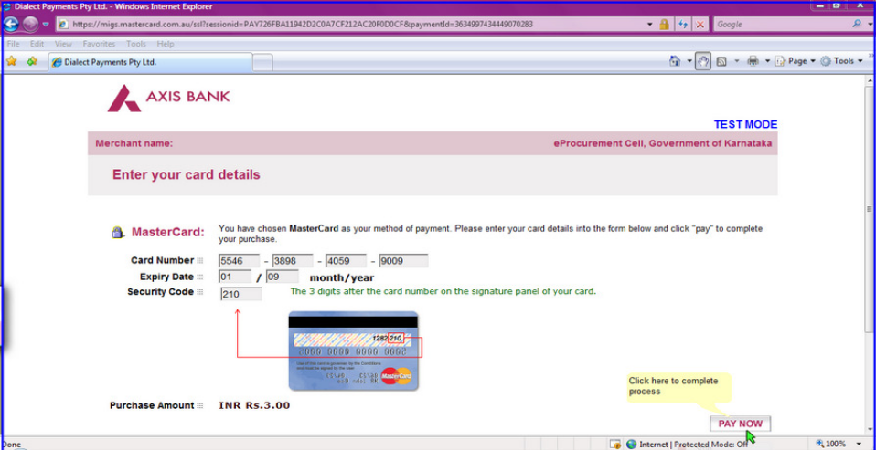
The screen will look like it is shown above when you have completely filled the card details.
Click on “PAY NOW” button to effect the payment. Your card details are verified by the payment gateway service and you will receive confirmation of payment debited to your card account if the card is valid. If the card is not valid you will receive alert about it and system will wait for you to correct any errors in the card details provided by you.
A successful transaction message is displayed.

Direct Debit Method:
Click on “Direct Debit Using Internet Banking (Online Payment) option to pay from your bank account through Internet Banking facility.
Click on “Pay” to proceed or “Back” to change the payment method on the Payment details screen.
Click on “OK” on the confirmation window to effect the payment. Click on “Cancel” and then on “Back” to change the payment method.
You will information on your screen about successful completion of payment process.

OTC Payment Procedure:
If a contractor/supplier chooses to make payment of EMD/tender processing fees Over The Counter (OTC) in any of the designated ICICI Bank branches listed in the e-Procurement web-site (https://www.eproc.karnataka.gov.in) the contractor/supplier will need to log into e-Procurement system, access the tender for which bid is being created and then select the OTC option under the payment section and print the Challan shown in that section. The printed challan will have the unique bid reference number and the amount to be remitted. Along with the challan, contractor can choose to make the payment either in the form of cash or in the form of Demand Draft. Cheque payments will not be accepted. The contractor is requested to specifically inform the bank officer to input the unique bid reference number printed in the challan in the banking software. Upon successful receipt of the payment, the bank will provide a 16-digit reference number acknowledging the receipt of payment. This 16-digit reference number has to be inputted by contractor in the payment section of its bid as payment confirmation before the bid is submitted (i.e.) as a pre-requisite for bid submission.

NEFT Payment Procedure:
If a contractor/supplier chooses to make payment of EMD/tender processing fees using Reserve Bank of India's (RBI) National Electronic Fund Transfer (NEFT) system, the contractor/supplier will need to log into e-Procurement system, access the tender for which bid is being created and then select the NEFT option under the payment section and print the Challan shown in that section. The printed challan will have the unique bid reference number, account details of Government of Karnataka and the amount to be remitted. The contractor has to submit the printed challan to its bank-branch (NEFT-enabled) and request for an account-to-account transfer, wherein the money will get transferred from the contractors' bank account to GoK's bank account. The contractor should ensure that NEFT transfer instructions are executed and the funds are wired to the Government of Karnataka's principal account before the last date for bid submission and preferably 24 hours before the last date for bid submission. If the contractor's bank transfers/wires the money after the last date for bid submission, the contractor's bid will be liable for rejection. Upon executing the transfer, the contractor's bank will provide a reference number generated by NEFT software as confirmation of transfer, which has to be inputted by contractor in the payment section of its bid as payment confirmation before the bid is submitted (i.e.) as a pre-requisite for bid submission. Also, the account number from which the funds were transferred have to be inputted in the e-Procurement system as part of its bid.
The supplier/contractor’s bid will be evaluated only on confirmation of receipt of the payment (EMD) in the Government of Karnataka central pooling a/c held at ICICI Bank.
For details on e-Payment services refer to e-procurement portal for more details.
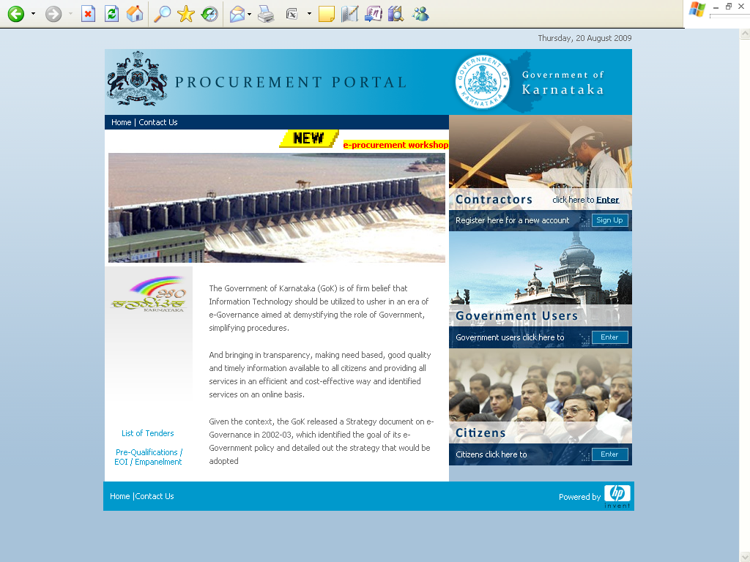

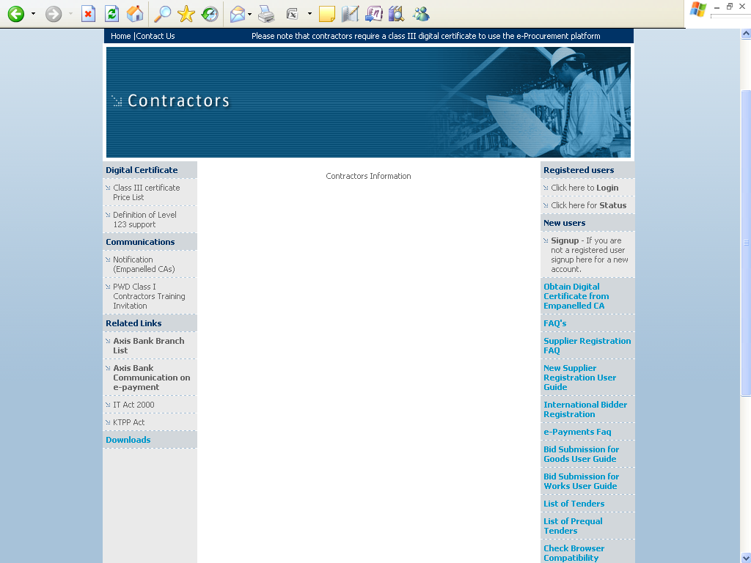
Note: In e-Procurement Portal bidder has the option of withdrawing the Bid by digitally signing to withdraw/cancel bid before the bid submission time /Date.

CLARIFICATION REGARDING BIDS:
To assist in the evaluation and comparison of bids owner may at its discretion, ask the bidder for a clarification of his bid in accordance with KTPP act. The request for clarification and the response shall be in writing but no change in the quoted price is permitted in the post tender clarifications.

TECHNICAL EVALUATION OF BIDS:
The bids submitted in e-procurement platform will be evaluated on the basis of techno-commercial information furnished by the bidder. The bids which are submitted fulfilling the qualifying requirements of the tender will be treated as technically responsive and such firm’s price bids will be opened after scrutiny of documents and verification of requisite EMD furnished by the bidder.

OPENING OF PRICE BID:
The price bids of all the technically responsive bidders will be opened. The date and time of opening of the price bid shall be intimated to all qualified bidders.

EVALUATION/COMPARISON OF PRICE BIDS AND ARRIVING L1 BID:
- The price bids of the bidders will be evaluated on amount quoted in the bid i.e., FORD price of the material inclusive of all taxes & duties, fright & insurance etc. After arrival of the unit FORD price quoted by all the bidders, the same will be compared with respect to the prevailing SR and Market rates. The lowest prices quoted by the bidder will be ranked as L-1 bidder. However, the lowest rates quoted alone may not be the criteria for selection of the successful bidder and the decision of the Owner is final.
- In a tender where the tenderers are both from the State of Karnataka as well as from outside the State of Karnataka, the Sales Tax/Vat shall be excluded for the evaluation of the price
- Goods manufactured by Micro and Small Enterprise located in the State will be given 15% price preference against the large and Medium Industries of the State and Industries of other States. Provided state MSME/SSI unit bring down their rates to L1/negotiated rates.(If & only the rates quoted by MSME/SSI is more than L1/Negotiated rates)
The volume of the award may be30% of tendered quantity or higher.
- The L1 bidder will generally qualify for supply of material.
- In case of multiple L1, the quantity to be supplied will be divided between the L1 bidders and as far as possible fair chance will be given to all such eligible bidders. The decision of CESC is final in the allocation of quantity.

NEGOTIATIONS:
The lowest rates quoted by the bidder will be compared with respect to the amount put to tender and prevailing market price. In the opinion of the owner, the lowest offered rate of the bidder is found to be on the higher side then negotiation of rates will normally be done with the L-1 bidder/s only in terms of KTPP Act.

CONTACTING THE OWNER:
Bids shall be deemed to be under consideration immediately after they are opened and until such time official intimation of award/rejection is made by owner to the bidders. While the bids are under consideration, bidders and/or their representatives or other interested parties are advised to refrain from contacting by any means, owner and/or his employees/representatives on matters related to the bids under consideration.

For any technical support regarding e-procurement portal please contact e-procurement help desk.
Supports Timings: (9.00 am to 9.00 pm)

Help Desk: 080-25501216/25501227
Or
E-mail: hphelpdesk.blr@rteservices.com

General Manager (Procurement)
CESC, Mysore.

