CD 'G' @ 21 Jan 2008 ISO TC 67/SC 7 N WG7-9
Date: 2008-01-01
ISO/CD 19905-1.9
ISO TC 67/SC 7/WG 7
Secretariat: BSI
Petroleum and natural gas industries — Site-specific assessment of mobile offshore units — Part 1: Jack-Ups
Industries du pétrole et du gaz naturel — Evaluation spécifique de site d'unités offshore mobile — Partie 1: Jack-ups
Warning
This document is not an ISO International Standard. It is distributed for review and comment. It is subject to change without notice and may not be referred to as an International Standard.
Recipients of this draft are invited to submit, with their comments, notification of any relevant patent rights of which they are aware and to provide supporting documentation.
The tracked changes show changes introduced since "ISO 19905-1 (E) CD F" dated 2006-12-29.
Date | Name | Details
2005-09-08 | WD-F-Minus | Normative & Informative post issue of N375 (including updates omitted in N375).
2005-11-01 | WD-F-Minus-Nov-01 | Updates from September panel meetings
2005-11-09 | WD-F-Minus-Nov-09 | Updates to clauses 1 thru 6 and some of A.12 by ERP meeting of November 2005
2006-02-02` | WD-F-less-minus-Jan-Feb-06: | Updates to A.6, A.7 and A.11 by ERP meeting of Jan/Feb 2006
2006-04-28 | WD-F-less-less-minus-March-06 | Updates to A.8 and A.10 by ERP meeting of March 2006
2006-07-20 | WD-F-less-less-minus-March-06 (P4)-ERP-A9-Accepted | Updates to 9 and A.9 by ERP meeting of July 2006 (Major restructuring)  (May 2006 panel inputs not received in time for inclusion)
2006-09-08 | 19905-1_(E)_WD-F-ERP-Sept06-inc-other-inputs | Added in edits from May Panel meetings.  Further Updates to 9 and A.9 by ERP meeting of September 2006
2006-12-29 | 19905-1_(E)_CD_F | Inclusion of updates from November Panel Meetings
2007-01-20 | 19905-1_(E)_CD_G-2007-01-20 | Updates to clauses 8, 9, 10, A8, A.9, A.10 from ERP meeting of 16,17 & 19 Jan 2007
2007-03-23 | 19905-1_(E)_CD_G-2007-03-20 | Updates to clauses 9, 12, 13, A.9, A.12, A.13 from ERP meeting of 20-23 Mar 2007  Includes update to definition of Class Soc & revised definition & usage for hull loadings.
2007-06-01 | 19905-1_(E)_CD_G-2007-06-01 | Updates from May Panel Meetings.
2007-06-22 | 19905-1_(E)_CD_G-2007-06-22 | Updates to clauses 12, A.12 from ERP meeting of 19,20&22 June + inclusion of NL editorial suggestions
2007-07-20 | 19905-1_(E)_CD_G-2007-07-20 | Updates to clauses 13 from ERP meeting of 20 July + misc. updares throughout inc S,C & L & tweaks to NL edits.
2007-11-13 | 19905-1_(E)_CD_G_2007-11-21 | Updates from September Panel meetings.
2008-01-13 | 19905-1_(E)_CD_G_2008-01-13 | Updates from November ERP, Sage & P4 November video-conference (latter, received 2008-01-11).
2008-01-21 | 19905-1_(E)_CD_G_2008-01-21 | Updates from January ERP meeting.
NOTE TO REVIEWERS: This document has deliberately been written to facilitate the future specific inclusion of mat-supported units.
Copyright notice
This ISO document is a working draft or committee draft and is copyright-protected by ISO. While the reproduction of working drafts or committee drafts in any form for use by participants in the ISO standards development process is permitted without prior permission from ISO, neither this document nor any extract from it may be reproduced, stored or transmitted in any form for any other purpose without prior written permission from ISO.
Requests for permission to reproduce this document for the purpose of selling it should be addressed as shown below or to ISO's member body in the country of the requester:
ISO Copyright Office
Case postale 56 • CH-1211 Geneva 20
tel. +41 22 749 01 11
fax +41 22 749 09 47
email copyright@iso.org
Web www.iso.org
Reproduction for sales purposes may be subject to royalty payments or a licensing agreement.
Violators may be prosecuted.

Contents
Foreword xiii
Introduction xv
1 Scope 1
2 Normative references 2
3 Terms and definitions 2
4 Abbreviated terms and symbols 15
4.1 Abbreviated terms 15
4.2 Symbols for Clause xx 16
4.3 Symbols for Clause yy 16
4.4 Symbols for Clause yy 16
5 Overall considerations 16
5.1 General 16
5.1.1 Competency 16
5.1.2 Planning 16
5.1.3 Assessment situations and associated criteria 16
5.1.4 Regulations 17
5.2 Assessment approach 17
5.3 Selection of limit states 19
5.4 Determination of assessment situations 19
5.4.1 General 19
5.4.2 Reaction point and foundation fixity 20
5.4.3 Extreme storm event approach angle 20
5.4.4 Weights and centre of gravity 20
5.4.5 Hull elevation 20
5.4.6 Leg length reserve 20
5.4.7 Adjacent structures 20
5.4.8 Other 20
5.5 Exposure levels 21
5.5.1 General 21
5.5.2 Life-safety categories 21
5.5.3 Consequence categories 22
5.5.4 Determination of exposure level 23
6 Data to be assembled for each site location 24
6.1 Applicability 24
6.2 Rig data 24
6.3 Site data 25
6.4 Metocean data 25
6.5 Geotechnical and geophysical data << per NL: align titles of A.6.5 & 6.5 >> 26
7 Actions 26
7.1 Applicability 26
7.2 General 26
7.3 Environmental actions 27
7.3.1 General 27
7.3.2 Hydrodynamic model 27
7.3.3 Wave and current actions 27
7.3.4 Wind actions 27
7.4 Functional actions 28
7.5 Displacement dependent effects 28
7.6 Dynamic effects 28
7.7 Earthquakes 28
7.8 Other actions 28
8 Structural modelling 29
8.1 Applicability 29
8.2 Overall considerations 29
8.2.1 General 29
8.2.2 Modelling philosophy 29
8.2.3 Levels of FE modelling 29
8.3 Modelling the leg 30
8.3.1 General 30
8.3.2 Detailed leg 30
8.3.3 Equivalent leg (stick model) 30
8.3.4 Combination detailed and equivalent leg 30
8.3.5 Stiffness adjustment 30
8.3.6 Leg inclination (add to response section) 30
8.4 Modelling the hull 30
8.4.1 General 30
8.4.2 Detailed hull model 30
8.4.3 Equivalent hull model 30
8.5 Modelling the leg/hull connection 31
8.5.1 General 31
8.5.2 Guide systems 31
8.5.3 Elevating system 31
8.5.4 Fixation system 31
8.5.5 Shock pad – floating jacking systems 31
8.5.6 Jackcase and associated bracing 31
8.6 Modelling the spudcan and foundation 31
8.6.1 Spudcan structure 31
8.6.2 Seabed reaction point 31
8.6.3 Foundation modelling 32
8.7 Mass modelling 32
8.8 Application of actions and action effects << update informative clauses to fit these changes>> 34
8.8.1 Assessment actions 34
8.8.2 Functional actions due to fixed load and variable load 34
8.8.3 Hull sagging 35
8.8.4 Environmental actions 35
8.8.5 Inertial forces 35
8.8.6 Large displacement effects 35
8.8.7 Conductor actions 35
8.8.8 Earthquake actions 35
9 Foundations 35
9.1 Applicability 35
9.2 General 35
9.3 Geotechnical analysis of independent leg foundations 36
9.3.1 Analysis methodology 36
9.3.2 Leg penetration during preloading 37
9.3.3 Yield interaction 37
9.3.4 Foundation stiffness 37
9.3.5 Vertical-horizontal foundation capacity envelopes 37
9.3.6 Acceptance checks 37
9.3.7 Skirted spudcans 38
9.4 Other considerations 39
9.4.1 Hard sloping strata 39
9.4.2 Footprint considerations 39
9.4.3 Leaning instability 39
9.4.4 Leg extraction difficulties 39
9.4.5 Liquefaction and cyclic mobility << Clause below as re-written by Young & Been and edited by the Jan 2008 ERP Did P4 intend to delete Liquefaction from this title? >> 39
9.4.6 Seabed instability 39
9.4.7 Scour 40
9.4.8 Shallow gas 40
9.4.9 Spudcan – pile interaction 40
10 Structural response 41
10.1 Applicability 41
10.2 General considerations 41
10.3 Types of analyses and associated methods 41
10.4 Common parameters 42
10.4.1 General 42
10.4.2 Natural periods and affecting factors 42
10.4.3 Damping 42
10.4.4 Foundations 43
10.4.5 Storm excitation 43
10.5 Storm analysis 43
10.5.1 General 43
10.5.2 Deterministic storm analysis 43
10.5.3 Stochastic storm analysis 44
10.5.4 Initial leg inclination 44
10.5.5 Limit state checks 44
10.6 Fatigue 45
10.7 Earthquake 45
10.8 Accidental situations 45
10.9 Alternative analysis methods 45
10.9.1 Ultimate strength analysis 45
10.9.2 Types of analysis 46
11 Long-term applications 47
11.1 Applicability 47
11.2 Assessment data 47
11.3 Special requirements 47
11.3.1 Fatigue assessment 47
11.3.2 Weight control 47
11.3.3 Corrosion protection 48
11.3.4 Marine growth 48
11.3.5 Foundations 48
11.4 Survey requirements 48
12 Structural strength 49
12.1 Applicability 49
12.1.1 General 49
12.1.2 Truss type legs 49
12.1.3 Other leg types 49
12.1.4 Fixation system and/or elevating system 49
12.1.5 Spudcan strength including connection to the leg 49
12.1.6 Overview of the assessment procedure 49
12.2 Classification of member cross-sections 50
12.2.1 Member types 50
12.2.2 Material yield strength 50
12.2.3 Classification definitions 50
12.3 Section properties 51
12.3.1 General 51
12.3.2 Plastic and compact sections 51
12.3.3 Semi-compact sections 51
12.3.4 Slender sections 51
12.3.5 Cross-section properties for assessment 51
12.4 Member moment amplification and effective lengths 51
12.5 Strength of tubular members 52
12.6 Strength of prismatic members 52
12.7 Assessment of member joints 52
13 Acceptance criteria 53
13.1 Applicability 53
13.1.1 General 53
13.1.2 Ultimate limit states (ULS) 53
13.1.3 Serviceability and accidental limit states 53
13.1.4 Fatigue limit states 54
13.2 General formulation 54
13.3 Leg strength 55
13.3.1 Partial factor approach 55
13.3.2 Working stress approach 55
13.4 Spudcan capacity 55
13.5 Holding system strength 55
13.6 Hull elevation 55
13.7 Leg length reserve 56
13.8 Overturning stability 56
13.9 Foundation Integrity 56
13.9.1 Capacity check 56
13.9.2 Displacement check 57
13.10 Temperatures 57
Annex A (informative) Recommendations and Information 58
A.1 Scope 58
A.2 Normative references 58
A.3 Terms and definitions 58
A.4 Symbols 58
A.4.1 Symbols for Clause A.1 58
A.4.2 Symbols for Clause A.2 58
A.4.3 Symbols for Clause A.3 58
A.4.4 Symbols for Clause A.4 58
A.4.5 Symbols for Clause A.5 58
A.4.6 Symbols for Clause A.6 58
A.4.7 Symbols for Clause A.7 58
A.4.8 Symbols for Clause A.8 58
A.4.9 Symbols for Clause A.9 58
A.4.10 Symbols for Clause A.10 62
A.4.11 Symbols for Clause A.11 62
A.4.12 Symbols for Clause A.12 62
A.4.13 Symbols for Clause A.13 62
A.5 Overall considerations 63
A.5.1 General 63
A.5.1.1 Planning 63
A.5.1.2 Assessment situations and criteria 63
A.5.1.3 Regulations 63
A.5.2 Assessment approach 63
A.5.3 Selection of limit states 63
A.5.4 Determination of assessment situations 63
A.5.4.1 General 63
A.5.4.2 Reaction point and foundation fixity 63
A.5.4.3 Storm approach angle 63
A.5.4.4 Weights and centre of gravity 63
A.5.4.5 Hull elevation 63
A.5.4.6 Leg length reserve 63
A.5.4.7 Adjacent structures 63
A.5.4.8 Other 64
A.5.5 Exposure levels 64
A.5.5.1 General 64
A.5.5.2 Life-safety categories 64
A.5.5.3 Consequence categories 64
A.5.5.4 Determination of exposure level 64
A.6 Data to be assembled for each site location 65
A.6.1 Scope 65
A.6.2 Rig data 65
A.6.3 Site data 65
A.6.4 Metocean data 65
A.6.4.1 General 65
A.6.4.2 Waves 65
A.6.4.2.1 Extreme wave height environment 65
A.6.4.2.2 Deterministic waves 66
A.6.4.2.3 Wave crest elevation 67
A.6.4.2.4 Wave spectrum 67
A.6.4.2.5 Effective significant wave height 67
A.6.4.2.6 Zero-upcrossing period 67
A.6.4.2.7 Short-crested stochastic waves 68
A.6.4.2.8 Non-linear wave effects 68
A.6.4.2.9 Long-term data 68
A.6.4.3 Current 69
A.6.4.4 Water depths 70
A.6.4.5 Marine growth 70
A.6.4.6 Wind 70
A.6.4.6.1 General 70
A.6.4.6.2 Wind profile 71
A.6.5 Geoscience studies 71
A.6.5.1 Geoscience data 71
A.6.5.1.1 General 71
A.6.5.1.2 Bathymetric survey 71
A.6.5.1.3 Sea floor survey 71
A.6.5.1.4 Shallow seismic survey 72
A.6.5.1.5 Geotechnical investigation 72
A.6.5.1.5.1 General 72
A.6.5.1.5.2 Soil investigation and testing 72
A.6.5.1.5.3 Geotechnical report 72
A.6.5.2 Data Integration 73
A.7 Actions 75
A.7.1 Scope 75
A.7.2 General 75
A.7.3 Environmental actions 75
A.7.3.1 General 75
A.7.3.1.1 Action combinations 75
A.7.3.1.2 Methods for the determination of actions 76
A.7.3.2 Hydrodynamic model 77
A.7.3.2.1 General 77
A.7.3.2.2 'Detailed' leg model 78
A.7.3.2.3 'Equivalent' leg model 78
A.7.3.2.4 Drag and inertia coefficients 80
A.7.3.2.5 Marine growth 82
A.7.3.2.6 Hydrodynamic models for appurtenances 83
A.7.3.3 Wave and current actions 83
A.7.3.3.1 General 83
A.7.3.3.2 Hydrodynamic actions 83
A.7.3.3.3 Wave models 85
A.7.3.3.3.1 Deterministic waves 85
A.7.3.3.3.2 Stochastic waves 85
A.7.3.3.3.3 Directionality and spreading 86
A.7.3.3.4 Current 86
A.7.3.4 Wind actions 87
A.7.3.4.1 Wind action 87
A.7.3.4.2 Shape coefficient 87
A.7.3.4.3 Wind tunnel data 88
A.7.4 Functional actions 88
A.7.5 Displacement dependent actions 88
A.7.6 Dynamic effects 88
A.7.7 Earthquake 89
A.7.8 Other actions 89
A.8 Structural modelling 90
A.8.1 Applicability 90
A.8.2 Overall considerations 90
A.8.2.1 General 90
A.8.2.2 Modelling philosophy 90
A.8.2.3 Levels of FE modelling 90
A.8.3 Modelling the leg 92
A.8.3.1 General 92
A.8.3.2 Detailed leg 92
A.8.3.3 Equivalent leg (stick model) 92
A.8.3.4 Combination detailed and equivalent leg 95
A.8.3.5 Stiffness adjustment 95
A.8.3.6 Leg inclination 95
A.8.4 Modelling the hull 95
A.8.4.1 General 95
A.8.4.2 Detailed hull model 95
A.8.4.3 Equivalent hull model 95
A.8.4.4 Hull mass model 95
A.8.5 Modelling the leg/hull connection 95
A.8.5.1 General 95
Figure A.8.5-3: Representative leg-hull connection 97
A.8.5.2 Guide Systems 103
A.8.5.3 Elevating system 104
A.8.5.3.1 Jacking (or elevating) pinions 104
A.8.5.3.2 Other 104
A.8.5.4 Fixation system 104
A.8.5.5 Shock pad – floating jacking systems 104
A.8.5.6 Jackcase and associated bracing 104
A.8.5.7 Equivalent leg/hull stiffness 104
A.8.6 Modelling the spudcan and foundation 105
A.8.6.1 Spudcan structure 105
A.8.6.2 Seabed reaction point 105
A.8.6.3 Foundation modelling 106
A.8.7 Mass modelling 106
A.8.8 Application of actions and action effects 106
A.8.8.1 Assessment actions 106
Functional actions due to f 106
A.8.8.2 ixed load and variable load 106
A.8.8.3 Hull sagging 107
A.8.8.4 Environmental actions 107
A.8.8.4.1 Wind actions 107
A.8.8.4.2 Wave/current actions 107
A.8.8.5 Inertial actions 108
A.8.8.6 Large displacement effects 108
A.8.8.7 Conductor actions 109
A.8.8.8 Earthquake actions 109
A.9 Foundations 110
A.9.1 Applicability 110
A.9.2 General 110
A.9.3 Geotechnical analysis of independent leg foundations 110
A.9.3.1 Analysis methodology 110
A.9.3.1.1 General 110
A.9.3.1.2 Approaches for response analysis 111
A.9.3.1.3 Approaches to foundation assessment 111
A.9.3.1.3.1 General 111
A.9.3.1.3.2 Simple pinned foundation 112
A.9.3.1.3.3 Linear vertical, linear horizontal and secant rotational stiffness 112
A.9.3.1.3.4 Non-linear vertical, horizontal and rotational stiffness 112
A.9.3.1.3.5 Non-linear continuum foundation model 113
A.9.3.2 Leg penetration during preloading 113
A.9.3.2.1 Introduction 113
A.9.3.2.2 Analysis method 114
A.9.3.2.2.1 General 114
A.9.3.2.2.2 Modelling the spudcan 114
A.9.3.2.2.3 Modelling the soil 115
A.9.3.2.2.4 Backflow and infill 116
A.9.3.2.3 Penetration in clays 117
A.9.3.2.4 Penetration in silica sands 119
A.9.3.2.5 Penetration in carbonate sands 120
A.9.3.2.5.1 General 120
A.9.3.2.5.2 Uncemented carbonate materials 120
A.9.3.2.5.3 Cemented carbonate materials 121
A.9.3.2.5.4 Predictive Methods 121
A.9.3.2.6 Penetration in silts 122
A.9.3.2.7 Penetration in layered soils 122
A.9.3.2.7.1 General 122
A.9.3.2.7.2 Squeezing of clay 122
A.9.3.2.7.3 Punch-through : Two clay layers 123
A.9.3.2.7.4 Punch-through : Sand overlying clay 124
A.9.3.2.7.5 Punch-through: Cemented crust over weak soil. 126
A.9.3.2.7.6 Three layered systems 126
A.9.3.3 Yield interaction 127
A.9.3.3.1 General 127
A.9.3.3.2 Ultimate vertical / horizontal / rotational capacity interaction function for spudcans in sand and clay 127
A.9.3.3.2.1 General 127
A.9.3.3.2.2 Shallow embedment 128
A.9.3.3.2.3 Deep embedment in clay 129
A.9.3.3.3 Spudcans in clay with F_{VHM} < 0.5 V_{LO} 130
A.9.3.3.4 Extension of the yield surface for additional penetration in sand 131
A.9.3.3.5 Extension of the yield surface for additional penetration in clay 131
A.9.3.4 Foundation stiffness 132
A.9.3.4.1 Vertical, horizontal and rotational stiffness 132
A.9.3.4.2 Stiffness reduction 133
A.9.3.4.2.1 Linear vertical, linear horizontal and secant rotational stiffness 133
A.9.3.4.2.2 Non-linear vertical, horizontal and rotational stiffness 134
A.9.3.4.2.3 Non-linear continuum foundation model 135
A.9.3.4.3 Selection of Shear Modulus, G, in clay 135
A.9.3.4.4 Selection of shear modulus, G, in sand 136
A.9.3.4.5 Soil-leg interaction 137
A.9.3.5 Vertical-horizontal capacity envelopes 137
A.9.3.5.1 General ultimate vertical-horizontal bearing capacity envelope 137
A.9.3.5.2 Ultimate vertical-horizontal bearing capacity envelopes for spudcans in sand 137
A.9.3.5.3 Ultimate vertical-horizontal bearing capacity envelopes for spudcans in clay 138
A.9.3.5.4 Ultimate vertical-horizontal bearing capacity envelopes for spudcans on layered soils 138
A.9.3.6 Acceptance checks 138
A.9.3.6.1 General 138
A.9.3.6.2 Level 1, Step 1a: Ultimate bearing capacity for vertical loading - Preload check 140
A.9.3.6.3 Level 1, Step 1b: Ultimate sliding capacity check of windward leg 141
A.9.3.6.4 Level 2, Step 2a: Bearing capacity/sliding check - Pinned spudcan 141
A.9.3.6.5 Level 2, Steps 2b and 2c: Spudcan with moment fixity and vertical and horizontal stiffness 142
A.9.3.6.6 Level 3, Steps 3a and 3b: Settlements resulting from exceedance of the capacity envelope 142
A.9.3.6.7 Foundation settlement not specifically addressed elsewhere 142
A.9.3.7 Skirted spudcans 143
A.9.4 Other considerations 143
A.9.4.1 Hard sloping strata 143
A.9.4.2 Footprints 143
A.9.4.3 Leaning instability 143
A.9.4.4 Leg extraction difficulties 144
A.9.4.5 Liquefaction and cyclic mobility 145
A.9.4.6 Seabed instability 145
A.9.4.7 Scour 145
A.9.4.8 Shallow gas 146
A.9.4.9 Spudcan-pile interaction 147
A.10 Structural response 148
A.10.1 Applicability 148
A.10.2 General considerations 148
A.10.3 Types of analyses and associated methods 148
A.10.4 Common parameters 150
A.10.4.1 General 150
A.10.4.2 Natural periods and affecting factors 150
A.10.4.2.1 General 150
A.10.4.2.2 Stiffness 152
A.10.4.2.3 Mass 152
A.10.4.2.4 Variability in natural period 152
A.10.4.3 Damping 152
A.10.4.3.1 General 152
A.10.4.3.2 Linear system damping 152
A.10.4.3.3 Hysteretic damping 153
A.10.4.4 Foundations 154
A.10.4.5 Storm Excitation 156
A.10.5 Storm analysis 156
A.10.5.1 General 156
A.10.5.2 Deterministic storm analysis 156
A.10.5.2.1 Dynamic amplification factors (DAF) and inertial loadsets 157
A.10.5.2.1.1 General 157
A.10.5.2.1.2 The classical SDOF analogy (DAF_{S}) 157
A.10.5.2.1.3 Inertial loadset based on random dynamic analysis (DAF_{R}) 158
A.10.5.3 Stochastic storm analysis 158
A.10.5.3.1 Random Wave Dynamic Analysis Method 159
A.10.5.3.2 Methods for Determining the MPME 160
A.10.5.4 Leg Inclination 161
A.10.5.5 Limit state checks 161
A.10.6 Fatigue 162
A.10.7 Earthquake 162
A.10.7.1 General 162
A.10.7.2 Earthquake assessment procedure 162
A.10.7.3 ELE requirements 163
A.10.7.3.1 Partial action factors 163
A.10.7.3.2 Structural and foundation modelling 163
A.10.7.4 ALE Requirements 164
A.10.7.5 Near source excitation 164
A.10.8 Accidental situations 164
A.10.9 Alternative Analysis Methods 164
A.10.9.1 Ultimate strength analysis 164
A.10.9.2 Types of analysis 164
A.11 Long-term applications 165
A.11.1 Applicability 165
A.11.2 Assessment data 165
A.11.2.1 Jack-up data 165
A.11.2.2 Metocean data 165
A.11.2.3 Geotechnical data 165
A.11.2.4 Other data 165
A.11.3 Special requirements 165
A.11.3.1 Fatigue Assessment 165
A.11.3.2 Weight control 169
A.11.3.3 Corrosion protection 169
A.11.3.4 Marine Growth 169
A.11.3.5 Foundations 169
A.11.4 Survey requirements 169
A.11.4.1 Project specific inspection plan 169
A.11.4.2 Special Survey 169
A.11.4.3 In-service inspection programme 169
A.11.4.4 Alternative In-service inspection programme surveys 170
A.12 Structural strength 171
A.12.1 Applicability 171
A.12.1.1 General 171
A.12.1.2 Truss type legs 172
A.12.1.3 Other leg types 172
A.12.1.4 Fixation system and/or elevating system 172
A.12.1.5 Spudcan strength including connection to the leg 172
A.12.1.6 Overview of the assessment procedure 172
A.12.2 Classification of member cross-sections 172
A.12.2.1 Member type 172
A.12.2.2 Material yield strength 172
A.12.2.3 Classification definitions 173
A.12.2.3.1 Tubular member classification 173
A.12.2.3.2 Prismatic member classification 173
A.12.2.3.3 Reinforced components 174
A.12.3 Section properties 178
A.12.3.1 General 178
A.12.3.2 Plastic and compact sections 178
A.12.3.2.1 Axial properties 178
A.12.3.2.2 Flexural properties 178
A.12.3.3 Semi-compact sections 179
A.12.3.4 Slender sections 179
A.12.3.4.1 General 179
A.12.3.4.2 Effective areas for compressive loading 180
A.12.3.4.3 Effective moduli for flexural loading 180
A.12.3.5 Cross section properties for assessment 182
A.12.3.5.1 Tension 182
A.12.3.5.2 Compression 183
A.12.3.5.3 Flexure 183
A.12.4 Member moment amplification and effective lengths 183
A.12.5 Strength of tubular members 185
A.12.5.1 Applicability 185
A.12.5.2 Tension, compression and bending strength of tubular members 187
A.12.5.2.1 Axial tensile strength check 187
A.12.5.2.2 Axial compressive strength check 187
A.12.5.2.3 Column buckling strength 187
A.12.5.2.4 Local buckling strength << consider moving above column buckling so Pyc is already defined >> 188
A.12.5.2.5 Bending strength check 188
A.12.5.3 Tubular member combined strength checks 189
A.12.5.3.1 Axial tension and bending strength check 189
A.12.5.3.2 Axial compression and bending strength check 189
A.12.5.3.3 Beam shear strength check 190
A.12.5.3.4 Torsional shear strength check 190
A.12.6 Strength of prismatic members 190
A.12.6.1 General 190
A.12.6.2 Prismatic members subjected to tension, compression, bending or shear 191
A.12.6.2.1 General 191
A.12.6.2.2 Axial tensile strength check 191
Axial compressive strength check 191
A.12.6.2.3 191
Column buckling 191
A.12.6.2.4 strength 191
A.12.6.2.5 Bending strength 193
A.12.6.2.5.1 General 193
A.12.6.2.5.2 Class 1 plastic and class 2 compact sections 193
A.12.6.2.5.3 Class 3 semi-compact sections << ERP JUNE 07 : PAFA needs to check this still works. Done for bending!!!!>> 194
A.12.6.2.5.4 Class 4 slender sections 195
A.12.6.2.6 Lateral torsional buckling strength check <<This clause is incomplete, but hopefully the A12.2.3.2 checks will be compromised, so we will not need to complete>> 195
A.12.6.2.7 Bending strength check 196
Prismatic member combined strength checks 197
A.12.6.3 197
A.12.6.3.1 General 197
A.12.6.3.2 Interaction equation approach 197
A.12.6.3.3 The interaction surface approach 198
A.12.6.3.4 Beam shear 199
A.12.6.3.5 Torsional shear 199
A.12.7 Assessment of member joints 200
A.13 Acceptance checks 201
Annex B (normative) Summary of partial action and resistance factors 202
Annex C (informative) Response Analysis - Additional Information and Alternative Approaches 204
Annex D (informative) Foundations - Additional Information and Alternative Approaches 215
D.1.1.1.1 D.9.3.2.3 Penetration in clays << Note to P4 -inserted as Word Tables per ISO re translation, etc. >> 216
D.1.1.1.2 222
D.1.1.1.3 222
D.1.1.1.4 D.9.3.2.4 Penetration in silica sands 222
D. 9.3.2.7.4 Punch-through : Sand overlying clay 226
Bibliography 231
1 Bibliography for Clause xx 231
2 Bibliography for Clause yy 231
3 Bibliography for Clause zz 231
4 Bibliography for Clause A.xx 231
5 Bibliography for Clause A.yy 231
6 Bibliography for Clause C 231
7 Bibliography for Clause D 231

Foreword
ISO (the International Organization for Standardization) is a worldwide federation of national standards bodies (ISO member bodies). The work of preparing International Standards is normally carried out through ISO technical committees. Each member body interested in a subject for which a technical committee has been established has the right to be represented on that committee. International organizations, governmental and non-governmental, in liaison with ISO, also take part in the work. ISO collaborates closely with the International Electrotechnical Commission (IEC) on all matters of electrotechnical standardization.
International Standards are drafted in accordance with the rules given in the ISO/IEC Directives, Part 2.
The main task of technical committees is to prepare International Standards. Draft International Standards adopted by the technical committees are circulated to the member bodies for voting. Publication as an International Standard requires approval by at least 75 % of the member bodies casting a vote.
ISO 19905-1 was prepared by Technical Committee ISO/TC 67, Materials, equipment and offshore structures for petroleum and natural gas industries, Subcommittee SC 7, Offshore structures.
ISO 19905 is one of a series of standards for offshore structures. The full series consists of the following International Standards:
- ISO 19900, Petroleum and natural gas industries — General requirements for offshore structures
- ISO 19901-1, Petroleum and natural gas industries — Specific requirements for offshore structures — Part 1: Metocean design and operating considerations
- ISO 19901-2, Petroleum and natural gas industries — Specific requirements for offshore structures — Part 2: Seismic design procedures and criteria
- ISO 19901-4, Petroleum and natural gas industries — Specific requirements for offshore structures — Part 4: Geotechnical and foundation design considerations
- ISO 19901-5, Petroleum and natural gas industries — Specific requirements for offshore structures — Part 5: Weight control during engineering and construction
- ISO 19901-7, Petroleum and natural gas industries — Specific requirements for offshore structures — Part 7: Stationkeeping systems for floating offshore structures and mobile offshore units
- ISO 19902, Petroleum and natural gas industries — Fixed steel offshore structures
- ISO 19903, Petroleum and natural gas industries — Fixed concrete offshore structures
- ISO 19904-1, Petroleum and natural gas industries — Floating offshore structures — Part 1: Monohulls, semi-submersibles and spars
The following International Standards are under preparation:
- ISO 19901-3, Petroleum and natural gas industries — Specific requirements for offshore structures — Part 3: Topsides structure
- ISO 19901-6, Petroleum and natural gas industries — Specific requirements for offshore structures — Part 6: Marine operations
- ISOº19904-2, Petroleum and natural gas industries — Floating offshore structures — Part 2: Tension leg platforms
- ISO 19905-1, Petroleum and natural gas industries — Site-specific assessment of mobile offshore units — Part 1: Jack-ups
- ISO/TR 19905-2, Petroleum and natural gas industries — Site-specific assessment of mobile offshore units — Part 2: Jack-ups commentary
- ISO 19906, Petroleum and natural gas industries — Arctic offshore structures
Introduction
<< 1st 3 paras now based on submission of FDIS 19902:2007 >>
The series of International Standards applicable to types of offshore structures ISO 19900 to ISO 19906 constitute a common basis covering those aspects that address design requirements and assessments of all offshore structures used by the petroleum and natural gas industries worldwide. Through their application, the intention is to achieve reliability levels appropriate for manned and unmanned offshore structures, whatever the type of structure and the nature or combination of the materials used.
It is important to recognize that structural integrity is an overall concept comprising models for describing actions, structural analyses, design or assessment rules, safety elements, workmanship, quality control procedures and national requirements, all of which are mutually dependent. The modification of one aspect of the design or assessment in isolation can disturb the balance of reliability inherent in the overall concept or structural system. The implications involved in modifications, therefore, need to be considered in relation to the overall reliability of the offshore structural system.
The series of International Standards applicable to types of offshore structure are intended to provide a wide latitude in the choice of structural configurations, materials and techniques without hindering innovation. Sound engineering judgement is therefore necessary in the use of these International Standards.
This Part 1 of ISO 19905 states the general principles and basic requirements for the site-specific assessment of mobile jack-ups; it is intended to be used for assessment and not for design.
Site-specific assessment is normally carried out when an existing jack-up unit is to be installed at a specific site. The assessment is not intended to provide a full evaluation of the jack-up; it assumes that aspects not addressed herein have been addressed using other practices and standards at the design stage. In some instances the original design of all or part of the structure could be in accordance with other standards in the ISO 19900 series, and in some cases other practices or standards could have been applied.
The purpose of the site assessment is to demonstrate the adequacy of the jack-up and its foundations for the assessment situations and defined limit states, taking into account the consequences of failure. The results of a site-specific assessment should be appropriately recorded and communicated to those persons required to know or act on the conclusions and recommendations. Alternative approaches to the site-specific assessment may be used provided that they have been shown to give a level of structural reliability equivalent, or superior, to that implicit in this document.
Background to and guidance on the use of this document is provided in informative Annex A, which should be read in conjunction with the main body of this document. The clause numbering in Annex A is the same as in the normative text to facilitate cross-referencing. ISO/TR 19905-2 provides additional background to some clauses.
Information on alternative approaches to aaa, bbb is presented in Annexes B - yy respectively.
<< Regional information on the application of the document to specific offshore areas is provided in informative Annex x . >>
To meet certain needs of industry for linking software to specific elements in this International Standard, a special numbering system has been permitted for figures, tables, equations and bibliographic references.

<< FOR WG7 INFORMATION, THE SOURCE INFORMATION PROVIDED BY THE PANELS FOR THIS DRAFT WAS AS FOLLOWS:
Preamble & Clauses 1 to 6:
As edited at P0 meeting of 3rd May 2007.
Clause 7: P1/2 Normative & Informative received from Olav Mo under cover of e-mail of 26th October 2007 (file named: 19905-1_(E)_CD_G-2007-07-20 P1-2 Oct 2007.doc).
Clause 8: P3 Normative & Informative received from Pau-Lin Tan under cover of e-mail of 11th October 2007 (file named: 19905-1_(E)_CD_G-2007-07-20-PLT@London.doc). Figure A.8.5.1 from file: Leg-Hull Con Comb Fig-PLT.doc received undercoverof e-mail of 23rd October 2007.
Clause 9: P4 Normative & Informative received from Patrick Wong under cover of e-mails of 13th November 2007 (file named: 19905-1_(E)_CD_G-2007-07-20 (Sep07-P4).doc and 16th January 2008 (file named: 19905-1_(E)_CD_G-2007-11-21 (P4 10-Jan-08).doc. Input also taken from: SAGE recommended changes to SNAME 5-5A RP Section 6.doc, received from Dave Lewis 28th November 2007.
Clause 10: P3 Normative & Informative received from Pau-Lin Tan under cover of e-mail of11th October 2007 (file named: 19905-1_(E)_CD_G-2007-07-20-PLT@London.doc).
Input also taken from:
1) SAGE recommended changes to SNAME 5-5A RP Section 7 Responses.doc, received from Dave Lewis 28th November 2007.doc.
2) 19905_10.7_V4_2007Sept.doc, received from Doug Stock on 4th December 2007.
Clause 11: P11 Normative & Informative received from Gregers Kudsk by hand on 14th September 2007 (file named: 19905-1_(E)_CD_G-to-PCs-2007-06-13_version afterpanel-11-meeting_sept13.doc).
Clause 12: P10 Normative & Informative received from John Stiff by hand on 13th September 2007 file named: Clauses 12-13-12A-&-13A Only - Working Copy @ City U.doc).
Clause 13: P10 Normative & Informative received from John Stiff by hand on 13th September 2007 file named: Clauses 12-13-12A-&-13A Only - Working Copy @ City U.doc)).
>>
<< CHEVRONS AS HERE INDICATE COMMENTS FROM EDITOR OR AUTHOR .>>

Petroleum and natural gas industries — Site-specific assessment of mobile offshore units — Part 1: Jack-Ups
<< Global Issues:
Edits to be made:
- Extreme Response we now use Extreme storm response, but should we use ULS in some places?? NB EXTREME is extremely over-used
- Consistency wrt resistance (sliding?), capacity (bearing/foundation), strength (steel bits)
- We agreed to use wave/current not wave-current (done MJRH Jan 2008)
- Footing to be changed to spudcan where this appropriate (done MJRH Jan 2008 - but not so simple - ERP to check).
- Site v/s location; mjrh observation: site is much more prevalent
>>

Scope
This part of International Standard 19905 specifies requirements and guidance for the site-specific assessment of independent leg jack-up units for use in the petroleum and natural gas industries. It addresses:
- manned and unmanned jack-ups;
- the installed operational phase at a specific site.
To ensure acceptable reliability the provisions of this document form an integrated approach which shall be used in its entirety for the site-specific assessment of a jack-up.
This document does not address design, transportation to and from site or installation and removal from site. However it is recommended that the assumptions used in the assessment be checked against the as-installed condition.
To ensure that the design of the jack-up is sound and the structure is adequately maintained, this Part 1 of ISO 19905 is applicable only to independent leg jack-ups that either:
  - hold valid classification society certification from an IACS member body throughout the duration of the operation at the specific site subject to assessment or
  - have been verified by an independent competent body to be structurally fit for purpose for elevated conditions and are subject to periodic inspection, both to the standards of an IACS member body.
Jack-ups that do not comply with this requirement shall be assessed according to the provisions of ISO 19902, supplemented by methodologies from this document, where applicable.
NOTE 1 Future revisions of this document may be expanded to cover mat-supported jack-ups.
NOTE 2 Well conductors are a safety-critical element for jack-up operations. However, the integrity of well conductors is not part of the site-specific assessment process for jack-ups and is therefore not addressed in this document. Annex A provides references to other publications addressing this topic.

Normative references
For dated references, subsequent amendments to, or revisions of, any of these publications do not apply. However, parties to agreements based on this part of ISO 19905 are encouraged to investigate the possibility of applying the most recent editions of the normative documents indicated below. For undated references, the latest edition of the normative document referred to applies. Members of ISO and IEC maintain registers of currently valid International Standards.

ISO 19900:200x, Petroleum and natural gas industries - General requirements for offshore structures
ISO 19901:2005, Petroleum and natural gas industries - Specific requirements for offshore structures – Part 1: Metocean design and operating conditions << add reference to this in Normative >>
ISO 19901:200x, Petroleum and natural gas industries - Specific requirements for offshore structures – Part 2: Seismic design procedures and criteria<< add reference to this in Normative >>
<< 19901-3 is not required – as agreed by SC 7 >>
ISO 19901:200x, Petroleum and natural gas industries - Specific requirements for offshore structures – Part 4: Geotechnical and foundation design criteria<< add reference to this in Normative >>
<< 19901-5, 6 are not required >>
ISO 19902:2007, Petroleum and natural gas industries – Fixed steel offshore structures
<< 19903, 19904 are not needed. We want to use dated references >>

Terms and definitions
For the purposes of this document, the terms and definitions given in ISO 19900, ISO 19901 Parts 1, 2 and 4 and the following apply.

abnormal assessment situation << NOT USED >>
assessment situation in which conditions exceed specified assessment conditions and which is used to mitigate against very remote events
NOTE Abnormal assessment situations are used to provide robustness against events with a probability of typically 10-3 to 10-4 per annum by avoiding, for example, gross overloading.

abnormal wave crest
crest of wave with probability of typically 10-3 to 10-4 per annum

accidental situation
assessment situation involving exceptional conditions of the structure or its exposure
EXAMPLES Accidental situations include impact, fire, explosion, local failure or loss of intended differential pressure (e.g. buoyancy).

action
external load applied to the structure (direct action) or an imposed deformation or acceleration (indirect action)
EXAMPLE An imposed deformation can be caused by fabrication tolerances, settlement, temperature change or moisture variation.
NOTE An earthquake typically generates imposed accelerations.
[ISO 19900:2002]

after damage assessment situation << NOT USED >>
assessment situation for which the condition of the structure reflects damage due to an accidental assessment situation and for which the environmental conditions are specially defined
NOTE Adapted from ISO 19902:2007, definition 2.14.
<< NUMBER TO BE ADDED >>
critical component
structural component, failure of which would cause failure of the whole structure, or a significant part of it
NOTE A critical component is part of the primary structure.

- << to be deleted >>

<< to be deleted >>

analysis type << NOT USED IN THIS CONTEXT >>
method including governing equations for deriving action effects
EXAMPLE Typical examples are static analysis, transient dynamic analysis, non-linear analysis
[ISO 19902:200x]

Assessment
site-specific assessment
evaluation of the stability and structural integrity of a jack-up and, where applicable, its seabed restraint or support against the actions determined in accordance with the requirements of this document
NOTE An assessment may be limited to an evaluation of the components or members of the structure which, when removed or damaged, would cause failure of the whole structure, or a significant part of it.<< THIS THOUGHT SHOULD BE ADDRESSED ELSEWHERE >>

assessment situation
set of physical conditions representing real conditions during a certain time interval for which the assessment is intended to demonstrate that the acceptance criteria of this document for relevant limit states are not exceeded
NOTE Adapted from ISO 19900:2002, definition 2.13.

assessment value << NOT USED >>
value derived from the representative value for use in the assessment verification procedure
NOTE Adapted from ISO 19900:2002, definition 2.14.

assessor
entity performing the site assessment

backflow
flow of soil from underneath the spudcan around the sides and onto the top during preloading
<< ERP Nov 2007: we need to delete back-fill throughout ; MJRH: Done Jan 2008>>
<< add number later>>
basic variable << USED ONLY IN OTHER DEFINITIONS >>
one of a specified set of variables representing physical quantities which characterize actions, environmental influences, geometrical quantities, or material properties including soil properties
[ISO 19900:2002]
- << to be deleted >>

bearing capacity
representative resistance of a foundation against combined actions

boundary conditions
actions and constraints on a (section of a) structural component (or a group of structural components) by other structural components or by the environment surrounding it
NOTE Boundary conditions may be used to generate reaction forces at locations of restraint.
[ISO 19902:2007]
- << NOT USED >>
characteristic value
value assigned to a basic variable associated with a prescribed probability of not being violated by unfavourable values during some reference period
[ISO 19900:2002]
NOTE The characteristic value is the main representative value. In some assessment situations a variable can have two characteristic values, an upper and a lower value.

chart datum
local datum used to fix water depths on a chart or tidal heights over an area
NOTE Chart datum is usually an approximation to the level of the lowest astronomical tide.
[ISO 19901-1:2005]

component
see structural component

consequence category
classification system for identifying the environmental, economic and indirect personnel safety consequences of failure a jack-up
NOTE Categories for environmental and economic consequences are (see 5.3.3):
C1 high environmental and/or economic consequence,
C2 medium environmental and/or economic consequence, and
C3 low environmental and/or economic consequence.
NOTE Adapted from ISO 19902:2007, definition 3.11.

recognized classification society (RCS)
member of the international association of classification societies (IACS), with recognized and relevant competence and experience in jack-ups, and with established rules and procedures for classification/certification of such installations used in petroleum-related activities
NOTE Adapted from ISO 19901-7:2005, definition 3.23.
- << NOT USED >>
deformation capacity
ability of a structure or structural component to deform without significant loss of resistance, or the extent to which it can do so
[ISO 19902:2007]

deterministic analysis
analysis in which the response for each loading direction is determined from a single combination of actions << NEEDS WORK >>

dynamic amplification factor
DAF
ratio of a dynamic action effect to the corresponding static action effect
[ISO 19902:200x]
NOTE For a jack-up the dynamic action effect is best simulated by means of a concentrated or distributed inertial loadset. It is usually not appropriate to factor the static environmental actions to simulate the effects of dynamic actions.

DAF_{S}
ratio of the amplitude of a dynamic action effect to the amplitude of the corresponding static action effect, each excluding their mean value

DAF_{R}
ratio of the absolute value of a dynamic action effect to the absolute value of the corresponding static action effect, each including their mean value
- << to be deleted >>

exposure level
classification system used to define the requirements for a structure based on consideration of life-safety and of environmental and economic consequences of failure
[ISO 19902:2007]
NOTE An exposure level 1 (L1) jack-up is the most critical and exposure level 3 (L3) the least.

extreme storm event
extreme combination of wind, wave and current conditions which the structure can be subjected to during its deployment at the assessed site
NOTE 1 The integrity of the structure should be unimpaired, but minor damage to non safety-critical secondary structure can be tolerated.
NOTE 2 This is the environmental event used for ULS assessment.

footprint
seabed depression which remains when a jack-up is removed from a site

foundation
soil and spudcan supporting a jack-up leg

foundation fixity
rotational restraint offered by the soil to the spudcan

foundation stability
ability of the foundation to provide sufficient support to remain stable when subjected to actions and incremental deformation
- << to be deleted >>
<< to be deleted >>

global analysis
determination of a consistent set of internal forces and moments, or stresses, in a structure that are in equilibrium with a defined set of actions on the entire structure
NOTE When a global analysis is of a transient situation (e.g. seismic), the inertial response is part of the equilibrium.

[ISO 19902:2007]

infill
material above the the backflow on top the spudcan arising from sedimentation or hole sidewall collapse
NOTE Depending upon whether infill occurs before or after preloading it can have positive or negative consequences on the foundation stiffnesses and capacities.

highest astronomical tide
HAT
level of high tide when all harmonic components causing the tides are in phase
NOTE The harmonic components are in phase approximately once every 19 years but these conditions are approached several times each year.
[ISO 19901-1:2005]
- << to be deleted >>

independent leg jack-up
jack-up unit with legs that can be raised and lowered independently

- << to be numbered >>
inertial loadset
a set of actions that approximates the effect of the inertial forces
NOTE An inertial loadset is used only in quasi-static analyses.
- << to be deleted >>

intrinsic wave frequency
wave frequency of a periodic wave in a reference frame that is stationary with respect to the wave, i.e. with no current present

jack-up
mobile offshore unit with a buoyant hull and one or more legs that can be moved up and down relative to the hull
NOTE A jack-up reaches its operational mode by lowering the leg(s) to the seabed and then raising the hull to the required elevation. The majority of jack-ups have three or more legs, each of which can be moved independently and which are supported on the seabed by spudcans.

joint probability environmental data << NOT USED IN THIS PRECISE FORM CONSISTENTLY - FIX ANOTHER DAY >>
combinations of wind, wave and current which produces the action level that would be expected to occur, on average, once in the return period

leaning instability
instability of an independent leg jack-up that can arise when the rate of increase of actions on the foundation with jack-up inclination exceeds the rate of increase of foundation resistance with depth
- << to be deleted >>
<< to be deleted >>

life-safety category
classification system for identifying the applicable level of life-safety of personnel on a jack-up:
NOTE 1 Categories for life-safety are (see 5.5.2):
S1 manned non-evacuated.
S2 manned-evacuated, and
S3 unmanned.
NOTE 2 Adapted from ISO 19902:2007, definition 3.27.

limit state
state beyond which the structure no longer fulfils the relevant assessment criteria
NOTE Adapted from ISO 19900:2002, definition 2.21.
- << to be deleted >>

load arrangement
identification of the position, magnitude and direction of a free action
[ISO 19902:2007]

load case
compatible load arrangements,deformations and imperfections considered simultaneously with permanent actions and fixed variable actions for a particular assessment or verification
NOTE Adapted from ISO 19902:2007, definition 3.29.

local analysis << NOT USED & NOT CONSISTENT WITH OUR TERMINOLOGY >>
determination of a consistent set of internal forces and moments, or stresses, in a cross-section of a structural component, or in a subset of structural components forming part of the structural system, that are in equilibrium with the boundary conditions
[ISO 19902:2007]

long-term operation
operation of a jack up on one particular site for more than the normal RCS special survey period of five years

lowest astronomical tide
LAT
level of low tide when all harmonic components causing the tides are in phase
NOTE The harmonic components are in phase approximately once every 19 years but these conditions are approached several times each year.
[ISO 19901-1:2005]
- << to be deleted >>

mat-supported jack-up
jack-up unit with the leg(s) rigidly connected by a foundation structure such that the leg(s) must be raised and lowered in unison

mean sea level
MSL
arithmetic mean of all sea levels measured at hourly intervals over a long period, ideally 19 years
NOTE Seasonal changes in mean level can be expected in some regions and over many years the mean sea level can change.
[ISO 19901-1:2005]

mean zero-upcrossing period
average period of the zero-upcrossing waves in a sea state
NOTE In practice the mean zero-crossing period is often estimated from the zeroth and second moments of the wave spectrum as defined in ISO 19901-1
NOTE Adapted from ISO 19901-1:2005 definition xx.x

member

see structural member

- << to be deleted >>

- most probable maximum extreme
MPME
value of the maximum of a variable with the highest probability of occurring over a defined period of time (e.g. X hours)
NOTE 1 The most probable maximum extreme is the value for which the probability density function of the maxima of the variable has its peak. It is also called the mode or modus of the statistical distribution.
NOTE 2 Adapted from ISO 19901-1:2005, definition 3.19.
<< add number later >>
nominal stress
stress calculated in a sectional area, including the stress raising effects of the macro-geometrical shape of the component of which the section forms a part, but disregarding the local stress raising effects from the section shape and any weldment or other fixing detail
NOTE Overall elastic behaviour is assumed when calculating nominal stresses.
[ISO 19902:2007]

nominal strength
strength calculated for a cross-sectional area, taking into account the stress raising effects of the macro-geometrical shape of the component of which the section forms a part, but disregarding the local stress raising effects from the section shape and any weldment or other fixing detail
NOTE Adapted from ISO 19902:2007, definition 3.34.

nominal value << NOT (YET) USED >>
value assigned to a basic variable determined on a non-statistical basis, typically from acquired experience or physical conditions
[ISO 19900:2002]
- << to be deleted >>

operations manual
the operating manual that defines the operational characteristics and capabilities of the jack-up in accordance with the IMO MODU code

operator
representative of the companies leasing the site
NOTE The operator will normally be the oil company acting on behalf of co-licensees.
<< to be numbered & relocated >>
jack-up owner
representative of the companies owning the jack-up
- fixed load << to be relocated >>
permanent parts of the jack-up including hull, legs and spudcans, outfit, stationary and moveable-fixed equipment
NOTE Moveable-fixed equipment normally includes the drilling package structure and associated permanently attached equipment.
- << to be relocated >>
spectral density function
energy density function
spectrum
measure of the variance associated with a time-varying variable per unit frequency band and per unit directional sector
NOTE 1 Spectrum is a shorthand expression for the full and formal name of spectral density function or energy density function.
NOTE 2 The spectral density function is the variance (the mean square) of the time-varying variable concerned in each frequency band and directional sector. Therefore the spectrum is in general written with two arguments: one for the frequency variable and one for a direction variable.
NOTE 3 Within this document the concept of a spectrum applies to waves, wind turbulence and action effects (responses) that are caused by waves or wind turbulence. For waves, the spectrum is a measure of the energy traversing a given space.
[ISO 19901-1:2005]

preloading
vertical load test on a jack-up leg with the objective of ensuring sufficient foundation capacity under assessment conditions
NOTE Whilst 3-legged jack-ups preload by taking water ballast on board, jack-ups with 4 or more legs typically achieve foundation preload by carrying the hull weight on pairs of legs in turn; this procedure is known as pre-driving and generally does not require the addition of water ballast. For the purposes of this document no distinction is made between preload and predrive.

<< to be numbered >>
preload reaction << is this needed ? >>
the vertical reaction at the base of leg, accounting for the weight and water buoyancy of the leg, required for equilibrium of the structure at the final stage of preloading
<< to be numbered >>
punch-through
rapid uncontrolled vertical leg movement due to soil failure in strong soil overlying weak soil

quasi-static analysis
static analysis of a structure subjected to actions that vary slowly in relation to the structure's fundamental natural period such that the influence of structural accelerations can be either safely neglected or is approximated by using an equivalent inertial loadset
Note Adapted from ISO 19902:2007 definition 3.38

rack phase difference
RPD
relative position of leg chords within a leg measured along the axis of the chords

redundancy
ability of a structure to find alternative load paths following failure of one or more non-critical components, thus limiting the consequences of such failures
NOTE All structures having redundancy are statically indeterminate.
[ISO 19902:2007]

regulator
authority established by a national governmental administration to oversee the activities of the offshore oil and natural gas industries within its jurisdiction, with respect to the overall safety to life and protection of the environment
NOTE 1 The term regulator can encompass more than one agency in any particular territorial waters.
NOTE 2 The regulator can appoint other agencies, such as marine classification societies, to act on its behalf, and in such cases the term regulator within this document includes such agencies.
NOTE 3 Within this document the term regulator does not include any agency responsible for approvals to extract hydrocarbons, unless such agency also has responsibility for safety and environmental protection.
[ISO 19902:2007]

representative
representative value
value assigned to a basic variable for verification of a limit state
[ISO 19900:2002]
- << to be deleted >>

- << to be deleted >>

return period
average period between occurrences of an event or of a particular value being exceeded
NOTE The offshore industry commonly uses a return period measured in years for environmental events. The return period in years is equal to the reciprocal of the annual probability of exceedance of the event.
[ISO 19901-1:2005]

scatter diagram
joint probability of two or more (metocean) parameters
NOTE A scatter diagram is especially used with wave parameters in the metocean context, see ISO 19901-1 subclause A.5.8. The wave scatter diagram is commonly understood to be the probability of the joint occurrence of the significant wave height (Hs) and a representative period (Tz or Tp).
[ISO 19901-1:2005]

scour
removal of seabed material from the foundation due to current and waves
- << to be deleted >>

sea state
condition of the sea during a period in which its statistics remain approximately constant
NOTE In a statistical sense the sea state does not change markedly within the period. The period during which this condition exists is usually assumed to be three hours, although it depends on the particular weather situation at any given time.
[ISO 19901-1:2005]

shallow gas
gas pockets or entrapped gas below impermeable layers at shallow depth
- << to be deleted >>

- << to be deleted >>

significant wave height
statistical measure of the height of waves in a sea state
NOTE The significant wave height was originally defined as the mean height of the highest one-third of the zero upcrossing waves in a sea state. In most offshore data acquisition systems the significant wave height is currently taken as 4√m₀ (where m₀ is the zeroth spectral moment, see ISO 19901-1 definition 3.31) or 4σ, where σ is the standard deviation of the time series of water surface elevation over the duration of the measurement, typically a period of approximately 30 minutes.
[ISO 19901-1:2005]

skirted spudcan
a spudcan with a peripheral skirt

slant-leg unit
jack-up with legs that can be inclined at a significant angle to the vertical
NOTE The inclination angle is typically about 5 degrees. The benefit is that the jack-up behaves more like a braced frame and less like a portal frame, with accompanying reductions in leg axial forces and moments.

sliding
horizontal movement of a spudcan
<< replace footing with spudcan everywhere. MJRH Jan 2008 done - but not so simple - ERP review needed ! >>
- << to be deleted >>

- << to be deleted >>

special survey
extensive and complete survey carried out at each nominal five year interval which closes a cycle of annual classification and mandatory surveys
NOTE Also referred to as 'renewal survey' by some IACS members.

spectral peak period
period of the maximum (peak) energy density in the spectrum
NOTE In practice there is often more than one peak in a spectrum.
[ISO 19901-1:2005]

spudcan
structure at the base of a leg supported by the soil

squeezing
lateral movement of weak soil between the spudcan base and an underlying stronger layer or of weak soil between two stronger layers
- << to be deleted >>

- << to be deleted >>

stochastic analysis
analysis in which a probabilistic approach is taken to model the random nature of the variables of interest
NOTE In general, a linear(ized) stochastic analysis can be performed in the frequency domain or in the time domain; non-linear stochastic analysis can only be performed by time domain simulations. This document does not support frequency domain stochastic analysis.

stress concentration factor
SCF
factor relating a nominal stress to the local stress at a detail
[ISO 19902:2007]

structural analysis
process or algorithm for determining action effects from a given set of actions
NOTE 1 Structural analyses are performed at three levels (global analysis of an entire structure, analysis of part of a structure e.g. a leg, local analysis of a structural member and local analysis of a structural component) using different structural models.
Note 2 Adapted from ISO 19902:2007 defintion 3.51

structural component
component
physically distinguishable part of a member cross-section of uniform yield strength
NOTE The cross-section of a non-tubular member is usually comprised of several structural components. A component consists of only one material. Where a plate component is reinforced by another piece of plating, the reinforcement may be of a different yield strength. See also further discussion in A.12.1.1.
<< P0 say the hierarchy is:
components
Member/plate beam
Part (leg/hull)
Structure = assembly of parts >>

structural member
member
physically distinguishable part of a braced structure connecting two joints
leg of a non-truss leg jack-up
NOTE See also further discussion in A.12.1.1.

sustained wind speed
time averaged wind speed with a defined averaging duration of one minute or longer
Note In ISO 19901-1:2005 definition 3.33 references a duration of “ten minutes or longer”
<< to be numbered >>
sudden hurricane
sudden cyclone
sudden typhoon
sudden tropical revolving storm which forms near the location and can affect the jack-up before demanning can be completed within the time required by the emergency evacuation plan
Note The intent is that the jack-up will be assessed to L1 for the specified sudden tropical revolving storm.

undrained shear strength
maximum shear stress at yielding or at a specified maximum strain in an undrained condition
NOTE Yielding is the condition of a material in which a large plastic strain occurs at little or no stress increase.
[ISO 19901-4:2003]
<<as instructed, MJRH has taken above from 19901-4 ; P4 are considering improved wording ; NL say we should not 'improve' the definition >>

utilization
member utilization
foundations utilization
(maximum value of the) ratio of the generalized representation of the assessment action effect to the generalized representation of the assessment resistance in compatible units
NOTE 1 The utilization is the maximum absolute value of the ratio for each limit state and assessment situation being considered.
NOTE 2 Only utilizations smaller than or equal to 1.0 satisfy the assessment criteria for a particular limit state.
NOTE 3 The assessment action effect is the response to the factored actions. The assessment resistance is the representative resistance divided by the partial resistance factor.

NOTE 4 For members and foundations subjected to combined forces, the internal force pattern and the resistance combine into an interaction equation. If the interaction equation governing the assessment check is, or can be, reduced to an inequality of the form I ≤ 1.0 the utilization is equal to I.

NOTE 5 Adapted from ISO 19902:2007, definition 3.57.

variable load
items carried by the jack-up to support its operation that are not included in the fixed load

water depth
vertical distance between the sea floor and still water level
NOTE 1 As there are several options for the still water level (see A.6.4.4) there can be several water depth values. Generally assessment water depth is determined to the extreme still water level.
NOTE 2 The water depth used for calculating wave kinematics varies between the maximum water depth of the mean high water spring tide plus a positive storm surge, and the minimum water depth of the mean low water spring tide less a negative storm surge, where applicable.
NOTE 3 Adapted from ISO 19901-1:2005, definition 3.41.

working stress
to be defined if and when required by Dave

Abbreviated terms and symbols

Abbreviated terms
ALS accidental limit state
FLS fatigue limit state
IACS International association of classification societies

SLS serviceability limit state
ULS ultimate limit state

ALE abnormal level earthquake
BOP blow-out preventer
BSTF base shear transfer function

DAF dynamic amplification factor
DAF_{S} DAF obtained excluding the mean values (typically from a single degree of freedom calculation)
DAF_{R} DAF obtained including the mean values (typically from a random wave calculation)

FE(A) finite element (analysis)

HAT highest astronomical tide
LAT lowest astronomical tide
LRFD load and resistance factor design
MHWS mean high water spring
MLWS mean low water spring

MPME most probable maximum extreme
MSL mean sea level
OCR over-consolidation ratio
PDF probability density function
PCPT piezo cone penetrometer test
PSIIP project specific in-service inspection programme
RCS recognized classification society
ROV remotely operated vehicle
RPD rack phase difference
SCF stress concentration factor
SDOF single degree of freedom
WSD working stress design

Symbols for Clause xx
<< note from November 2007 ERP: Aim to standardise on F = action, Q = capacity >>

Symbols for Clause yy

Symbols for Clause yy

Overall considerations

General

Competency
<< P0 Sept 2007: we can include competency requirements here if we decide to do so 19902 has some words wrt inspection engineers. Nov 2007: ERP does not think that adding this is helpful as the requirements would be too fuzzy to be useful. >>

Planning
Adequate planning shall be undertaken before a site-specific assessment is started. The planning shall include the determination of all assessment situations, operating and environmental conditions and assessment criteria upon which the assessment shall be based following the general requirements specified ISO 19900 as far as relevant for jack-ups.

Assessment situations and associated criteria
The assessment situations shall include both extreme events and operational modes because the critical mode of operation is not always obvious. The assessor shall use site-specific environmental, seismic and geotechnical data, as applicable, for the assessment. The assessment situations and associated criteria are jointly specified in the remainder of this document. They form one whole and shall not be separated from one another.
<< Need P10 input to ensure this addresses their intentions wrt operational modes here and in 5.1.2 >>

Regulations
Each country can have its own set of regulations concerning offshore operations. It is the responsibility of the jack-up owner and/or the operator << mjrh Jan 2008 >> to comply with relevant rules and regulations, depending upon the site and type of operations to be conducted.

Assessment approach
This subclause provides an overview of the data required, the assessment methodology, and the acceptance criteria. A flow chart is shown in Figure ‎5.2-1. Annex A (informative) provides additional information and guidance, including detailed calculation methodology. Annexes C and D (informative) provide alternative calculation methodologies. The associated Technical Report ISO 19905-2 provides background to some of the recommendations given in the Annexes. Other approaches may be applied, provided that they have been shown to give a level of structural reliability equivalent, or superior, to that implicit in this document.
The assessment of the jack-up can be carried out at various levels of complexity as expanded in a), b) and c) (in order of increasing complexity). The objective of the assessment is to show that the acceptance criteria of Clause 13 are met. If this is achieved at a certain complexity level there is no need to consider a higher complexity level. However in all cases the adequacy of the foundation shall be assessed.
- Compare site conditions with design conditions or other existing assessments determined in accordance with this document;.

Obtain jack-up data, Clause 6.1
Establish proposed Weights and C. of G.s, Clause 6.2
Obtain Environmental data, Clause 6.4
Obtain Geotechnical data, Clauses 6.5
Will “other aspects” limit suitability:
- Hydrodynamics, Clause 7.x.
- Foundations, Clause 9.4
- Condition of unit, Clause 8.7
Preventive measures available and will be adopted?
Determine hull elevation, Clause 13.6 (or as dictated by other considerations, if higher, Clause 5.4.5). Estimate leg penetrations (based on maximum preload), Section 9.3.2.
Determine responses (e.g. SDOF method), Clause 10.5/Figure x.x.
Assess structure and overturning, Clauses 12 & 13.8
If required, re-assess penetration, Clause 9.3.2 & leg length, Clauses 5.4.6 &13.7.
Choose more detailed:
-Response calculation (Clause 7/Figure 7.1.)
-Response calculation including foundation Fixity (Clause 7/Figure 7.1 & Clause 6.3/Figure 6.10)
If applicable, check horizontal deflections, Clause 13.9.2

UNIT SUITABLE
Assess foundation, Clauses 13.9.1 & 9.3.3 / Figure 9.x
Yes
UNIT UNSUITABLE
No
Yes
No
Is adequate leg length available? Clauses 5.4.6 &13.7.
No
Choose to calculate required preload and re-assess penetration and leg length?
No
Assess foundation, Clauses 13.9.1 & 9.3.3
Applicable calculations according to this Standard document exist and show acceptability? Section 5.2 a).
Establish hydrodynamic coefficients, Clause 7.3; wind loads, Clause 7.5. Prepare analysis models, Clause 8.
Yes
No
OK
OK
Not OK
UNIT UNSUITABLE
Not OK
Not OK
Not OK
Not OK
OK
OK
OK
Yes
Yes

Figure ‎5.2-1 — Overall flow chart for the assessment
<< updated but need to check the references Hold update to account for NL & US comments until rest of text is completed. >>
- Carry out appropriate calculations according to the simpler methods (e.g. pinned foundation, SDOF dynamics) given in this document. Where possible, compare results with those from existing more detailed/complex (e.g. secant or yield interaction foundation model, time-domain dynamics) calculations;
- Carry out appropriate detailed calculations according to the more complex methods (e.g. secant, yield interaction or continuum foundation model, time-domain dynamics) given in this document.
<< NL editorial comments query whether this subclause really provides the information listed in sentence 1.
Also requests that yellow in b) and c) be replaced by specific references to the method(s) that are meant, preferably by referencing the subclauses where they are given. >> << ERP July 07 additions in () may solve this as far as we can >>

Selection of limit states
ISO 19900 divides the limit states into four categories as described below. As described below, normally only the ULS needs to be assessed in a jack-up site assessment.
- Ultimate limit state (ULS).
The site-specific assessment shall include evaluation of the ULS for assessment situations including extreme combinations of environmental actions and the associated storm mode gravity actions. Seismic actions shall also be considered in cobination with the associated operational mode gravity actions; however evaluation is rarely required. The applicable partial action and resistance factors for the ULS and exposure level are summarized in Normative Annex B.
NOTE 1 In benign areas the ULS environment is sometimes within the defined SLS limits for the jack-up and the environmental conditions will not exceed the limits for changing to the elevated storm mode. In such cases the assessment should be for the ULS environment and the proposed operating mode configurations e.g. with increased variable load, cantilever extended and unequal leg loads. Individual leg reactions under the functional actions can approach the preload reaction. A small additional leg reaction due to environmental actions can then result in additional spudcan penetration..
NOTE 2 When the operations manual permits increases in the variable load with reducing environmental conditions the assessor should evaluate the ULS for a operational environments and/or lower return periods. This is of particular importance in areas where significant additional penetrations are possible.
- Serviceability limit state (SLS).
The SLS is normally covered by operational limits specified in the operations manual, and therefore do not need to be evaluated in the assessment unless the operational requirements for the site differ from those previously documented.
- Fatigue limit state (FLS).
The FLS will generally have been addressed at the design stage. Fatigue need not be evaluated unless the jack-up is to be deployed for a long-term operation (refer to Clause 11).
- Accidental limit states (ALS).
The ALS will generally have been addressed at the design stage. They do not need to be evaluated in the assessment unless there are unusual risks at the site under consideration.

Determination of assessment situations

General
A jack-up may be used in various modes at a single site (e.g. drilling / workover mode, elevated storm mode, and/or tender mode). Where more than one mode of operation is contemplated the differences in these modes (e.g., the varying hull elevations required for each) as well as the operations necessary to change from one mode to another (e.g., skidding the cantilever in for a storm) shall be considered in the assessment. The practicality of any required mode change shall be evaluated, and appropriate assumptions incorporated into the assessment calculations. Any required restrictions on the operations shall be included in the operating procedures. For each mode and limit state to be considered, the necessary assessment situations shall be determined.
Where the assessment indicates that an assessment situation does not meet the appropriate acceptance criteria, the assessment situation may be adjusted to achieve acceptability providing that any resulting deviations from the standard operating procedure of the jack-up are practically achievable, are documented and are communicated by the jack-up owner to the personnel operating the jack-up and to any other relevant stakeholders.

Reaction point and foundation fixity
The assumed reaction point at the spudcan shall be specified in the assessment. The jack-up's legs may be assumed to be pinned at the reaction point. Any divergence from this assumption shall be stated.

Extreme storm event approach angle
The critical extreme storm event approach angles relative to the jack-up are usually different for the various checks that shall be made (e.g., strength vs. overturning checks). The critical direction for each check shall be used.

Weights and centre of gravity
For each limit state being assessed, the appropriate magnitude and position of the fixed and variable loads shall be used. The tolerances on both magnitude and position shall be considered when determining the weights and centres of gravity to be used in the assessment.
Where the location of the cantilever, substructure, etc, or the hull elevation, differ between the elevated operating and storm modes, the practicality of making the changes required to achieve the storm mode shall be established.

Hull elevation
The hull elevation used in the assessment shall comply with the requirements specified in 13.6. Generally this will be the larger of that required to maintain adequate clearance with:
  - adjacent structures, such as a fixed platform;
  - the wave crest.

Leg length reserve
The assessor shall determine the necessity for a reserve of leg length above the upper guides to account for any uncertainty in prediction of penetration and to provide a contingency against settlement or scour. Recommended leg length reserve requirements are given in 13.7.

Adjacent structures
Where necessary, the interaction of the jack-up with any adjacent structures shall be considered. Aspects that may need to be considered by one or more of the stakeholders include the effects of the jack-up's spudcans on the foundation of the adjacent structure and the effects of relative motions on well casing, drilling equipment and well surface equipment (risers, connectors, flanges, etc.).

Other
The assessor should be aware that the characteristics of certain designs can have impacts on the site-specific assessment that are not specifically addressed in this document. In such cases the validity of the assessment shall be confirmed once the unit has been installed.
<< Jan 2007 ERP meeting to review this further - JJS may have some comments/thoughts >>
For example, high bending moments in the legs can be caused by lateral displacement of the spudcan or by eccentric vertical spudcan reaction due to footprints or other seabed features.
NOTE The RPD is usually a good indicator of the degree of eccentricity and the acceptability of these action effects when elevated.

Exposure levels

General
Structures can be categorized by various levels of exposure to determine criteria that are appropriate for the intended service of the structure. The levels are determined by consideration of life-safety and of environmental and economic consequences of failure.
The life-safety category addresses personnel on the jack-up and the likelihood of successful evacuation if and when an extreme storm event occurs.
The consequence category considers the potential risk to life of personnel brought in to react to any incident, the potential risk of environmental damage and the potential risk of economic losses.

Life-safety categories
The category for life-safety (S1, S2 or S3) shall be determined by the jack-up owner prior to the assessment. When either S2 or S3 is selected this shall be agreed with the operator and, where applicable, the regulator. It is recognized that matching actual situations to generic life-safety category definitions requires a degree of judgement.
- S1 Manned non-evacuated
The manned non-evacuated category refers to the situation when a jack-up (or an adjacent structure that could be affected by the failure of the jack-up) is continuously manned, and from which personnel evacuation prior to the extreme storm event is either not intended or impractical

A jack-up shall be categorized as S1 manned non-evacuated unless the particular requirements for S2 or S3 apply throughout the expected period of operations at the assessment site.
A jack-up shall always be considered S1 for the consideration of seismic events.
- S2 Manned evacuated
The manned-evacuated category refers to a jack-up that is normally manned except during a forecast extreme storm event. For categorization purposes, a manned jack-up may only be categorized as a manned evacuated jack-up if:
  - reliable forecast of a extreme storm event is technically and operationally feasible, and the weather between any such forecast and the occurrence of the extreme storm event is not likely to inhibit an evacuation; and
  - prior to a extreme storm event, evacuation is planned; and
  - sufficient time and resources exist to safely evacuate all personnel from the jack-up (and any adjacent structure that could be affected by the failure of the jack-up) with due consideration of the other demands on those resources (e.g. the evacuation of other manned platforms in the area).
- S3 Unmanned
The unmanned category refers to a jack-up that is only manned for occasional inspection, maintenance and modification visits. For categorization purposes a jack-up shall only be categorized as unmanned if:
  - << NL change OK'd and tweaked by July 2007 ERP>>visits to the jack-up are undertaken for specific planned inspection, maintenance or modification operations on the jack-up; and
  - visits are not usually expected to last more than 24 hours during seasons when severe weather can be expected to occur; and
  - the evacuation criteria for S2 manned evacuated jack-ups are met.
A jack-up in this category may also be described as not normally manned.

Consequence categories
<< These may not be needed, depending upon the final content of the matrix >>
Factors that should be considered in determining the consequence category include:
  - life-safety of personnel on, or near to, the jack-up who are brought in to react to any consequence of failure, but not personnel that are part of the normal complement of the jack-up; <<NL Draft F clarification: [this relates to other people than the jack-up’s own complement; see the adjusted text of the NOTE]>>

  - damage to the environment;
  - anticipated losses to the jack-up owner, the operator and the industry and / or other third parties as well as society in general.
NOTE This classification includes risk of loss of human life for people other than the jack-up's normal complement. The primary driver for the classification is damage to the environment or to society (e.g. the situation where a community/state/country would suffer significant losses as a consequence of the interruption of production). The classification is based on the assumption that all stakeholders agree on the economic loss category to suit their tolerance of risk.
The consequence category that applies shall be determined by the jack-up owner prior to the assessment and shall be agreed by the operator and, where applicable, the regulator and operator(s) of adjacent facilities. It is recognized that matching actual situations to generic consequence category definitions requires a degree of judgement.
- C1 High consequence category
The high consequence category refers to jack-ups where either of the following conditions apply:
  - the failure of the jack-up is determined to cause high consequences to any facility it is operating over, or adjacent to,; or. << revised by ERP July 2007 >>
NOTE Adjacent facilities, the facilities the jack-up is operating over and adjacent transport lines are unlikely to be "high consequence" unless their loss will result in significant reduction in throughput or production of hydrocarbons and they are sufficiently close that there is a high probability of impact should the jack-up collapse and drift from location. << by P0 Sept 07>>
  - as the result of structural failure due to an extreme storm or seismic event:
      - there is the potential for a significant unintended release of hydrocarbons << NL want hydrocarbons . BUT 19902 uses "either oil or sour gas" >>from the well(s) or from adjacent major hydrocarbon transport lines and / or storage facilities; and
      - the shut-in of hydrocarbon production is not planned, or not practical, prior to the occurrence of an extreme storm or seismic event that could cause such failure.
Unless one or both of these conditions apply a jack-up shall normally be categorized as C2 or C3.

- C2 Medium consequence category
The medium consequence category refers to jack-ups where production of hydrocarbons will be shut-in during the extreme storm event. The following criteria shall apply:
  - all wells that could flow on their own in the event of structural or foundation failure shall contain fully functional means of reliably closing in the well to prevent such flow, and such means shall be manufactured and tested in accordance with applicable specifications;
NOTE The possibility of flow should be considered as a result of failure in any part of the system including the riser/conductor.
  - oil storage is limited to process inventory and “surge” tanks for pipeline transfer;

  - pipelines that could be affected by failure of the jack-up shall be protected from releasing hydrocarbons, either by virtue of inventory and pressure regime, or by check valves or seabed safety valves located at sufficient distance to be unaffected by the failure;
  - the failure of the jack-up is evaluated to cause medium or low consequences to any facility it is operating over, or adjacent to.

- C3 Low consequence category
The low consequence category refers to jack-ups operating in:
  - open water sites with no existing surface or subsea infrastructure, or
  - work-over mode or production mode with low production rates and where any production will be shut-in during the extreme event.
These units may support production departing from the jack-up and low volume infield pipelines. For categorization purposes a jack-up shall only be categorized as low consequence if:
  - all wells that could flow on their own in the event of structural or foundation failure shall contain fully functional means of reliably closing in the well to prevent such flow., and such means shall be manufactured and tested in accordance with applicable specifications;
NOTE The possibility of flow should be considered as a result of failure in any part of the system including the riser/conductor.
  - oil storage is limited to process inventory;
  - pipelines that could be affected by failure of the jack-up shall be limited in their ability to release hydrocarbons, either by virtue of inventory and pressure regime, or by check valves or seabed safety valves located at sufficient distance to be unaffected by the failure;
  - the failure of the jack-up is evaluated to cause low consequences to any facility it is operating over, or adjacent to.

Determination of exposure level
The 3 categories for each of life-safety and consequence can, in principle, be combined into 9 exposure levels. However, the level to be used for categorization is the more restrictive level for either life-safety or consequence.
This results in three exposure levels as illustrated in Table 5.5-1
Table 5.5-1 — Determination of exposure level
Life-safety Category | Consequence category
Life-safety Category | C1 High consequence | C2 Medium consequence | C3 Low consequence
S1 Manned non-evacuated | L 1 | L 1 | L 1
S2 Manned evacuated | L 1 | L 2 | L 2
S3 Unmanned | L 1 | L 2 | L 3
<< Per NL column C1 changed from L2 to L1 and the s3/c2 changed from L3 to L2 ; and per Andrea S2/C3 should changed from L3 to L2>>
The exposure level applicable to a jack-up shall be determined by the jack-up owner prior to the assessment and shall be agreed by the regulator, operator or local authorities where applicable.
<< The following is a summary of what we will include later in the document - the numbers will be placed elsewhere and will be removed from here >>
L1 : 50 yr individual extremes with LF = 1.15 or 100yr j-p with LF = 1.25.
L2 :
A manned-evacuated jack-up shall be assessed for the 50 year independent extremes or 100 year joint probability data that could be reached at the site prior to evacuation being effected using regular factors (e.g. 48 hr sudden hurricane in Gulf of Mexico).
The applicable S3 condition shall also be considered for the post-evacuation case.

L3 : The unmanned, low-consequence (survivability) criteria, to be agreed between the stakeholders which would normally include the jack-up owner, operator, regulator.
Metocean data for L2 and L3 and factors for L3 applicable for the Gulf of Mexico can be found in Annex zz.
<< Sept '07 - P1-2 have done some work on the above which we ( P0 ) need to review >>

Data to be assembled for each site location

Applicability
This clause describes the data that are required to undertake an assessment.

Rig data
The jack-up data required to perform an assessment will include:
  - rig type;
  - drawings, specifications and the operations manual;
  - data pertaining to the strength, stiffness and operation of the leg-hull connection;
  - lightship and variable load and centres of gravity;
  - preloading capacity or pre-drive capability;
  - limiting spudcan capacity e.g. reactions and bearing pressure distribution(s) used in the design cases; << changes similar to NL, tweaked by ERP July 2007 >>
  - design parameters including, where applicable, RPD limits and any proposed deviations for the intended operation;
  - details of any relevant modifications.

Site data
The site data should include the site coordinates, seabed topography and water depth referenced to a clearly specified datum e.g. lowest astronomical tide (LAT) or chart datum (CD). Note that charts derived for use by comparatively shallow draft shipping are often not sufficiently accurate for siting jack-ups.

Metocean data
It is of prime importance to obtain appropriate metocean data for the site evaluation with due recognition of the quality of the data. Site specific data shall be obtained for: << NL requests references to where these are found >>
  - water depth (LAT):
  - tide and storm surge;
  - wave data
    - significant wave height and spectral peak period;
    - maximum wave height and associated period;
  - abnormal wave crest elevation
  - current velocity and profile;
  - wind speed;
Omnidirectional data may be sufficient, but in particular circumstances directional data may also be required.
Other data shall be evaluated when applicable e.g.:
  - marine growth distribution;
  - icing;
  - lowest average daily air temperatures, etc.,

The 50 year return period individual extremes or the 100 year return period joint probability metocean values should normally be used for the site-specific assessment of manned jack-ups. Partial action factors for alternative return periods are given in 5.5.4 and 8.8.1.
NOTE To give consistent reliability different action factors are used with actions determined for 50 year return period individual extremes and 100 year return period joint probability environment.
A manned-evacuated jack-up shall also be assessed for the 50 year independent extremes or 100 year joint probability conditions that could be reached while the jack-up is still manned. For example in the TRS areas consideration may be given to the use of a 50 year return period “sudden hurricane” or “sudden storm” event. An unmanned jack-up may also be assessed using these criteria.
If the jack-up deployment is to be of limited duration, applicable seasonal data may be used (for example, the assessment return period summer extreme storm event).
Directionality of wind, wave and current may be considered if accurate data are available.
General information on metocean data are given in ISO 19901-1. Details of the required metocean data for jack-up site assessment are given in A.6.4.

Geotechnical and geophysical data << per NL: align titles of A.6.5 & 6.5 >>
Site-specific geotechnical information applicable to the anticipated range of penetrations shall be obtained. The type and amount of geotechnical data required depends on the particular circumstances such as the type of jack-up and previous experience of the site, or nearby sites, for which the assessment is being performed. Such information may include shallow seismic survey (sub-bottom profiler) data, boring/coring data, piezocone penetrometer test data, side-scan sonar data, magnetometer survey data and diver's survey data.
The site shall be evaluated for the presence of geohazards as described in Table A.6.5-1.
For sites where previous operations have been performed by jack-ups of the same basic design, it may be sufficient to identify the location of, and hazards associated with, existing footprints and refer to previous site data and preloading or penetration records; however, it is recommended that the accuracy of such information should be verified.
At sites where there is any uncertainty, borings/corings and/or piezocone penetrometer tests (PCPT) data are recommended. Alternatively the site may be tied-in to such data at another site by means of shallow seismic data. If data are not available prior to the arrival of the jack-up at the site, it may be possible to take boring(s)/coring(s), etc., from the jack-up before preloading and jacking to full hull elevation. Suitable precautions should be taken to ensure the safety of the jack-up during this initial period on site and during subsequent preloading.
The site shall be evaluated for potential scour problems. These are most likely to occur at sites with a firm seabed composed of non-cohesive soils and where the penetration is low.
Certain sites prone to mudslides can involve additional risks. Such risks should be assessed by carrying out specialist studies of the area on which the jack-up is to be sited.

Actions

Applicability
This clause presents an overview of, and basic requirements for, the modelling of actions for site assessment according to this document.
Details regarding applicable methods and formulations to calculate actions are presented in A.7 which also includes presentation of hydrodynamic formulations and coefficients for detailed and equivalent modelling of hydrodynamic actions on legs.
In the present clause, and the corresponding annex, actions are presented without partial action factors. Actions shall be factored as given in 8.8 prior to the determination of the action effects.

General
The following outlines the actions to be considered in general terms:
- Environmental actions
  - Actions on legs and other structures subject to wave and current action, plus
  - Actions on hull and exposed areas (e.g. legs) subject to wind action.
- Functional actions
  - Fixed actions, plus
  - Actions from variable load
- Indirect actions resulting from responses
  - Displacement dependent effects, plus
  - Accelerations from dynamic response.
- Other Actions

Environmental actions

General
Wind, wave and current actions are typically considered to act simultaneously and from the same direction. Directionality of wind, wave and current may be applied when it can be demonstrated that such directionality persists for the site under consideration.

Hydrodynamic model
The hydrodynamic modelling of the jack-up leg may be carried out by utilizing ''detailed'' or ''equivalent'' techniques. The hydrodynamic models shall represent all structures and appurtenances subjected to wind, wave and current action. The effect of different hydrodynamic properties in different directions shall be represented as appropriate for the analysis.
Hydrodynamic (drag and inertia) coefficients shall be selected that are appropriate for the flow regime of the actual jack-up leg structure and chosen wave theory. Applicable test results may be used to select the coefficients. The effects of raw water piping, ladders and other appurtenances shall be considered in the calculation of the hydrodynamic coefficients for the legs.
The effect of marine growth on the actions shall be considered. Because jack-ups are mobile, opportunities are available to clean the leg if required. Where existing marine growth is not to be cleaned or where the operation is to last long enough for significant growth to occur the influence of growth on the leg hydrodynamic properties shall be considered. The timing of the jack-up deployment in relation to the marine growth season can also be important.

Wave and current actions
Wave and current actions on the legs and appurtenances (e.g. raw water tower) shall be computed using the Morison equation and an appropriate hydrodynamic model. A wave theory appropriate to the wave height, period and water depth shall be used for the determination of particle kinematics. Wave kinematics for the calculation of actions caused by waves shall be derived from the intrinsic wave periods (or the intrinsic wave frequency). The derived actions are directly affected by the current profile chosen and the method used to modify the profile in the presence of waves. Guidance is provided in A.6.4.3.

Wind actions
Wind actions shall be computed using wind velocity, wind profile and exposed areas. Wind velocities and wind profiles presented in A.6.4.6 may be used. These actions may be calculated using appropriate formulae and coefficients or may be derived from applicable wind tunnel tests. Generally, for site assessments, block areas may be used for the hull, superstructures and appurtenances.
Wind actions on legs can be a dominant factor for jack-ups operating at less than their maximum design water depth.

Functional actions
For functional actions it is usual to consider the jack-up with the maximum permitted variable load for structural checks and with the minimum anticipated variable load (often 50%) for the overturning calculation. If the assessment of the jack-up shows it is marginal in one of these conditions, consideration may be given to limiting the variable load to a lower or higher level (depending on the critical parameter), providing the jack-up can be successfully operated under such restrictions. The assessor shall document any restrictions on the variable load that apply to the operating limits for the site and ensure that these limits are included in the operating procedures for the site.

Displacement dependent effects
Indirect forces that are a consequence of the displacement of the structure shall be considered in the analysis. These effects are due to the first order sway (P-delta), and their enhancement due to the increased flexibility of the legs in the presence of axial actions (Euler amplification), see 8.8.6.

Dynamic effects
Indirect actions due to dynamic response of the jack-up shall be considered, and are particularly important for sea states having significant energy near the natural periods of the jack-up or multiples thereof, see 10.5.2 and 10.5.3.

Earthquakes
Actions and action effects due to earthquakes shall be considered where appropriate, see 8.8.8 and 10.7.

Other actions
Additional leg moments due to leg inclination resulting from leg-hull clearances and hull inclination shall be considered as described in 8.3.6 and 10.5.4.
Other types of action can occur in certain geographical regions, for example actions due to icing and snow. These actions shall be computed and applied in combination with other appropriate concurrent actions.

Structural modelling

Applicability
This clause presents methods for the development of an analytical model of a jack-up structure. Included in a jack-up structure are the legs, hull, leg-to-hull connection, and spudcans. The modelling of the foundation is not considered in this clause, but is presented in Clause 9.
The modelling provisions cover the generation of stiffness, self-weight, mass and application of actions.

Overall considerations

General
In general, structural modelling for the assessment of a jack-up shall achieve the following objectives for both the static and dynamic responses:
  - Realistic global response (e.g. displacement, base shear, overturning moments) for the jack-up under the applicable environmental and functional actions;
  - Suitable representation of the leg, leg/hull connection and the leg-foundation interaction, including non-linear effects as necessary; and
  - Sufficient detail to allow for assessment of the leg structure, structural/mechanical components of the jacking and/or fixation system and the foundation.

Modelling philosophy
The purpose of structural modelling is to estimate the forces and displacements in a structure when subjected to the calculated applied actions.
Distribution of global actions and estimates of forces and displacements can be obtained through use of simplified, equivalent modelling techniques.
To determine displacements and forces in the leg, leg/hull connection, leg/spudcan connection, and hull displacements, a finite element (FE) model shall be developed.
An explicit model of the conductor is rarely warranted.

Levels of FE modelling
In general, a jack up model shall include the leg, leg/hull connection and representative hull structure. FE models may contain combinations of detailed and simplified structural modelling. Four modelling techniques are summarized below.
- Fully detailed model of all legs and leg/hull connections with detailed or representative stiffness model of hull and spudcan.
- Equivalent leg (stick model) and equivalent hull. Equivalent stiffness model of all legs and spudcans, equivalent leg/hull connection springs and representative beam-element hull grillage.
- Combined equivalent/detailed leg and hull. Simplified lower legs and spudcans, detailed upper legs and leg/hull connections with detailed or representative stiffness model of hull.
- Detailed single leg (or leg section) and leg/hull connection model. This model is to be used in conjunction with the reactions at the spudcan or the forces and moments in the vicinity of lower guide obtained from model (b).

Modelling the leg

General
The leg can be modelled as a 'detailed leg', an 'equivalent leg' or a combination of the two.

Detailed leg
A ‘detailed leg' model consists of all structural members such as chords, horizontal, diagonal and internal braces of the leg structure and the spudcan (if required). Each structural component of the leg is represented by one or more appropriate finite elements. In the development of a detailed leg model, the use of beam elements is generally accepted practice. However, other finite elements can be utilized when necessary to accurately represent individual structural members.

Equivalent leg (stick model)
An 'equivalent leg' model consists of a series of collinear beam elements simulating the complete leg structure. In this model, a series of one or more beam elements represents the overall stiffness characteristics of the detailed leg.

Combination detailed and equivalent leg
In this model, the areas of interest are modelled in detail and the remainder of the leg is modelled as an equivalent leg.

Stiffness adjustment
The leg stiffness used in the overall response analysis can account for a contribution from a portion of the rack tooth material. Unless detailed calculations indicate otherwise, the assumed effective area of the rack teeth should not exceed 10% of their maximum cross sectional area. When checking the strength of the chords the chord properties should be determined discounting the rack teeth. <<< Note: a statement re. Chord properties applicable to the different inputs to acceptance checks should also be included in Clause 12 >>

Leg inclination (add to response section)
The additional leg moment due to leg inclination resulting from leg-hull clearances and hull inclination shall be considered (see 10.5.4), but need not be explicitly modelled.
The designed-in leg inclination of slant-leg jack-ups shall be modelled explicitly.

Modelling the hull

General
The hull structure shall be modelled so that the actions can be correctly transferred to the legs and the hull flexibility is represented accurately.

Detailed hull model
The detailed hull model shall include primary load carrying structures, explicitly modelled with appropriate finite elements.

Equivalent hull model
If a detailed hull model is not used, an equivalent hull model shall be constructed using a grillage of beams.

Modelling the leg/hull connection

General
The leg/hull connection controls the distribution of leg bending moments and shears carried between the guides and the jacking/fixation system. In the elevated mode, the most heavily loaded portion of the leg is normally within the vicinity of the leg to hull connection. The stress levels in this area depend on the design concept of the jack-up. The model shall provide the means to identify any possible leg to hull contact at locations other than the guides.

Guide systems
The guide structures shall be modelled to restrain the chord member. When chord to guide contact occurs in the span between chord-brace connections, significant local chord bending moments can occur. Therefore, various guide positions shall be investigated.

Elevating system
The elevating systems shall be modelled based either on the stiffness derived from detailed analysis or testing. Generally, the manufacturer specifies this information.

Fixation system
The fixation system shall be modelled to resist both vertical and horizontal forces.

Shock pad – floating jacking systems
For floating jacking systems, the shock pad stiffness shall be modelled and the shock pad shall be modelled to resist vertical compressive forces only. Generally, the manufacturer specifies the stiffness information.

Jackcase and associated bracing
The jackcase or jackhouse structures and associated bracing shall be modelled based on their actual stiffness.

8.5.7 Equivalent leg/hull stiffness
The model shall represent the overall stiffness characteristics of the leg-to-hull connection.

Modelling the spudcan and foundation

Spudcan structure
The spudcan structure shall be modelled sufficiently to accurately transfer the seabed reaction into the leg structure.
Where there is insufficient data available regarding the structural strength of the spudcans the suitability of the spudcans for the site shall be determined from applicable analysis methods.

Seabed reaction point
The selected reaction point at the spudcan shall be specified clearly in the assessment. Selection of the reaction point shall be based on the estimated penetration using geotechnical information from the site and shall consider any anticipated horizontal eccentricity.

Foundation modelling
For analyses of an independent leg jack-up unit in the elevated storm mode, the foundations may normally be assumed to behave as pinned supports, which are unable to sustain moment. Analysis and practical experience suggest that this can be a conservative approach for bending moment in the leg in way of the leg/hull connection.
In cases where the inclusion of rotational foundation fixity is justified and is included in the structural analysis, the non-linear soil-structure interaction effects shall be taken into account. The model shall include the interaction of rotational, lateral and vertical soil forces. Methods of establishing foundation fixity are given in Clause 9.
When fixity brings the structural natural period closer to the excitation frequency, the inclusion of foundation fixity can amplify the response and shall therefore be considered.
When assessing the spudcans, the leg-to-can connection and the lower parts of the leg, the spudcan reactions shall be obtained from a foundation model that properly estimates the spudcan moment.<< proposed NL ed. change was wrong. This is the ERP July 07 replacement>>
For earthquake excitation, foundation fixity tends to increase the inertia response and shall be considered. Spudcan settlement resulting from earthquake excitation shall be considered. Differential settlements can have the most serious consequences.

Mass modelling
The mass model shall reflect the mass distribution of the jack-up. The model shall include structural and non-structural mass, including entrapped fluids and added mass. The added mass shall be computed based on the displaced volume of the submerged components including marine growth acting in the direction of motion normal to the component. The mass of the variable load (e.g, consumables stored within the hull) shall be included in the mass model. Other actions due to variable load such as conductor tension and hook loads, that are not associated with masses should not be included.
The structural mass shall include:
  - legs;
  - hull structure; and
  - spudcans.
The non-structural mass shall include:
  - hull equipment and outfitting;
  - the mass of the variable load;
  - sea water supply system;
  - leg appurtenances;
  - marine growth; and
  - entrapped water in flooded members and spudcans.
Added mass shall include contributions from:
  - submerged leg chords and braces;
  - sea water caissons; and
  - spudcans.

Application of actions and action effects << update informative clauses to fit these changes>>

Assessment actions
The assessment load case, F_{d}, shall be determined using the following generalized form prior to application within the structural response analysis:
F_{d} = γ_{f,G}.G + γ_{f,Q}.Q + γ_{f,E}[E_{e} + γ_{f,D}.D_{e}]
where the actions are defined as:
G = are the actions due to the fixed load positioned to represent their vertical and horizontal distribution, see 8.8.2.
Q = are the actions due to maximum or minimum variable load, as appropriate, positioned at the most onerous centre of gravity location applicable to conditions under consideration, see 8.8.2.
E_{e} = is the environmental action due to the extreme storm event, see 8.8.4.
D_{e} = is the equivalent set of indirect actions representing dynamic effects, see 8.8.5.
the partial action factors γ are given by;
γ_{f,G} = 1.0 and is applied to the actions due to fixed load
γ_{f,Q} = 1.0 and is applied to the actions due to the variable load
γ_{f,E} = 1.15 when applied to the 50 year return period independent extreme environmental actions
= 1.25 when applied to the 100 year return period joint probability environmental actions
γ_{f,D} = 1.0 and is applied to the inertial actions due to dynamic response
NOTE Reference may be made to the Table in Annex B which contains all of the applicable factors to be used in a site-specific analysis.
The actions and action effects to be included in the analysis are outlined in 8.8.2 to 8.8.8.

Functional actions due to fixed load and variable load
The actions due to fixed load (i.e. hull, legs, outfit, stationary and movable equipment) include:
  - weight in air including appropriate solid ballast;

  - weight of permanent enclosed liquid, and
  - buoyancy.
The actions due to variable load, which comprises supplies or equipment that are expandable, readily removable,or consumable during operations, include:
  - weight of liquid and solid stores;
  - applied drilling and conductor loads; and
  - weight of readily removable equipment.
The actions due to fixed load and variable load shall be modelled to represent their correct vertical and horizontal distribution.

Hull sagging
Hull sagging resulting from distributed loading and hull flexibility can impose bending moments on the legs. It shall be verified that the amount of hull sag-induced moment transferred to the legs in the analytical model is appropriate given the operating procedures of the jack-up and site-specific conditions.

Environmental actions
Wind actions on the legs and hull shall be modelled to represent the vertical and horizontal distribution.
Wave/current actions on the leg and spudcan structures above the sea floor shall be modelled to represent their vertical and horizontal distribution.

Inertial forces
Depending on the dynamic approach adopted, (see Clause 10), inertial forces may be applied as a single point force at the hull, distributed forces on the hull or a complete set of distributed forces applied on the hull and legs.

Large displacement effects
P-delta effects occur because the jack-up is a relatively flexible structure and is subject to lateral displacement of the hull (sidesway) under environmental actions.
P-delta effects shall be included in the structural analysis.

Conductor actions
An explicit model of the conductor is rarely warranted. However, the factored tension and actions on the jack-up due to the hydrodynamic actions on the conductor shall be included in the analysis.

Earthquake actions
Earthquake actions shall include global hull actions associated with fundamental modes in addition to local actions from the legs, the spudcans and significant drilling facilities.

Foundations

Applicability
This clause addresses the geotechnical considerations, soil-structure interaction, capacity, stiffness and hazards associated with the foundations supporting independent leg jack-ups. Additional supporting information can be found in ISO 19901-4, however the provisions of this document should always take precedence in case of conflict.
NOTE Mat-supported rigs are not covered in this document.

General
Adequate geotechnical and geophysical information shall be made available to assess the spudcan penetration and foundation stability of the jack-up at the site. Applicable information from previous operations, other surveys or activities in the area may be used in the assessment of site conditions. Soil investigation shall be carried out for sites where there are no applicable data available from previous operations. See 6.5 and A.6.5 for details of the recommended geotechnical and geophysical information.
The objective of the assessment is to ensure that the foundation is adequate to carry static, cyclic, and transient forces without excessive settlement or movement. The assessment shall consider:
  - the predicted leg penetration;
  - the possibility of rapid leg penetration and/or punch through;
  - the effects of cyclic loading;
  - the consequences of excessive movement of the spudcans;
  - the positioning of spudcans on hard sloping seabed strata; and
  - the effects of local soil disturbances on the stability of the spudcans; such disturbances include but are not limited to footprints left by previous jack-up spudcans, conductor installation, scour, etc.
NOTE The foundation assessment may be performed using a working stress design (WSD) method with an overall safety factor or a partial safety factor approach, with the action factor applied before undertaking the response analysis.

Geotechnical analysis of independent leg foundations

Analysis methodology
The forces imposed on the foundation during an extreme storm event due to wave in combination with wind and current are time-varying and random in nature. The response to the horizontal, vertical and rotational forces on the spudcan and the embedded portion of the leg arising from the applied actions is non-linear and hysteretic. The non-linearity of the foundation response may have a major impact on dynamic response of the structure.
The foundation may be modelled as pinned or with foundation fixity. Foundation fixity is the rotational restraint offered by the soil supporting the spudcan and shall only be used in a model that also includes finite vertical and horizontal foundation stiffnesses. The degree of fixity is dependent on the soil type, the maximum vertical spudcan reaction during installation, the foundation stress history, the structural stiffness of the jack-up, the geometry of the spudcans, the spudcan translational and rotational displacements, and the combination of vertical and horizontal applied actions.. Foundation fixity in dynamic analysis of the structure can be included in different ways. .
The behaviour of the foundation under the action of combined forces is appropriately described by a theoretical yield surface in the vertical, horizontal and moment space. Foundation safety assessment is achieved by comparing the imposed forces with the yield surface. << ERP July 07 tweak to NL suggestion >>
The response analysis shall be carried out using one of the following foundation models which have different levels of complexity:
  - simple pinned foundation (pinned model);
  - linear vertical, linear horizontal and secant rotational stiffness where the iterative reduction of rotational stiffness ensures compliance with the yield interaction surface (secant model);
  - non-linear vertical, horizontal and rotational stiffnesses ensuring compliance with the yield interaction surface (yield interaction model);
  - non-linear continuum foundation model coupled to the structure (continuum model) which shall account for the load-penetration behaviour.

Leg penetration during preloading
The purpose of preloading is to develop adequate foundation capacity to resist the vertical and horizontal forces on the foundation due to ULS events. The jack-up should normally have sufficient capacity to apply preload in excess of the maximum vertical soil loading due to factored actions determined in the assessment. Where there is insufficient preload capacity to meet the extreme forces, a lower preload may be acceptable when justified by appropriate geotechnical considerations (e.g. level 3 of 9.3.6). << NL: replace "extreme loading" with "maximum forces" - text here is ERP compromise July 07>>
The methods for calculating ultimate vertical bearing capacity of a foundation in various types of soil are discussed in A.9.3.2. The predicted spudcan penetration is obtained from the bearing capacity versus spudcan penetration curve at the specified preload. Uncertainties regarding the geotechnical data should be properly reflected in the interpretation and reporting of analyses. The use of this data during rig move operations provides essential information on the continuity between theoretical assessment and operational reality.

Yield interaction
<< Add brief précis of the Informative (when re-written by Dean & Overy) with some Shalls >>

Foundation stiffness
<< Add brief précis of the Informative with some Shalls (Dean). Topics are: >>
Where the foundation is modelled with discrete springs the initial small strain vertical, horizontal and rotational stiffnesses shall be determined. The stiffnesses may be estimated from the elastic solutions for a rigid circular plate on an elastic half-space formulations as given in A.9.3.4.1 or determined from a continuum model. The shear modulus for clay and sand shall be determined in accordance with A.9.3.4.3 or A.9.3.4.4.
The reduction in stiffness as the spudcan reactions approach or exceed the yield surface shall be included in the analysis. There are different approaches to determining the softening of the stiffnesses. Where the reduction of stiffness is not implicitly included in the soil model, A.9.3.4.2.1 shall be used to determine the reduced rotational secant stiffness; the vertical and horizontal stiffness remain unchanged. The stiffness reduction is implicit in fully coupled yield interaction models and in non-linear continuum foundation models, as discussed in A.9.3.4.2.2 and A.9.3.4.2.3.
The effects of soil-leg interaction for deep penetrations may be included. Guidance is given in A.9.3.4.5.

Vertical-horizontal foundation capacity envelopes
The vertical-horizontal capacity envelopes shall be used for assessing the spudcan reactions when the foundation is represented with the pinned model. For the secant model, this shall be an additional check following achieving compliance with the yield interaction model. The envelopes shall be developed using the applicable subclause of A.9.3.5.

Acceptance checks
The overall foundation stability shall be assessed using Levels 1, 2 or 3, as listed below in order of increasing complexity (See Figure A.9.4-10). Any higher level check need only be performed if the lower level check fails to meet the foundation acceptance criteria given in 9.xx.yy:
Level 1 Preload and sliding check (A.9.3.6.1) with forces from a pinned spudcan analysis; steps 1a and 1b shall both be completed for a level 1 check.
Step 1a The foundation capacity check is based on the preloading capability, and
Step 1b Sliding of the windward leg is also checked (A.9.3.6.2).
Level 2 Capacity checks.
Step 2a Bearing capacity & sliding resistance << per NL >> check (A.9.3.6.3), based on resultant forces, assuming a pinned spudcan; OR
Step 2b Bearing capacity & sliding resistance check (A.9.3.6.4), including rotational, vertical and horizontal foundation stiffness with rotational stiffness reduction; OR
Step 2c Bearing capacity check (A.9.3.6.4), including rotational, vertical and horizontal foundation stiffness with reduction of vertical, horizontal and rotational stiffnesses. If the interaction yield surface is expanded due to additional penetration, << From P4, May 2007: ERP needs to address consistency between this and Informative. >> a Level 3 displacement check shall be performed.
Level 3 Displacement check (A.9.3.6.5).
Step 3a Simple check using leg-penetration curve based on the results of a level 2 check (not permitted if level 2 sliding check is failed); OR
Step 3b Numerical analysis of the complete jack-up and non-linear foundation coupled in vertical, horizontal and rotational degrees of freedom, e.g., finite element approach
Under pinned conditions, the maximum vertical force is expected to occur on the leeward leg. Likewise, the minimum vertical force is expected on the windward leg. In step 1, the preload check of the leeward leg is based on the assumption that the ultimate vertical bearing capacity is equal to the maximum spudcan force during preloading << reduction for backflow/infill ? – added –/*+by Templeton Nov 2007: >> Care shall be taken to ensure that the maximum spudcan force during preloading used for this check includes not only the structural force during preload but also any additional force from the weight of any soil backflow and also any reduction due to soil buoyancy effects (the weight of soil displaced by the spud can) or due to infilling that occurs after the maximum preload has been applied. The sliding check of the windward leg shall also be performed to ensure that the sliding resistance is adequate under minimum vertical force conditions. (See 7.2 on selection of load cases)
In step 2a, the factored bearing capacity of the leeward leg shall be checked for the combined vertical and horizontal leg reactions. A reduction in vertical bearing capacity of a spudcan occurs when it is simultaneously subjected to horizontal forces and moments. The latter are ignored in step 2a analyses as the spudcans are considered to be pinned. The sliding check of the windward leg shall be performed similarly to step 1b.
For step 2b, the forces are for a spudcan with ‘fixity’ conditions. Inclusion of foundation fixity in an assessment incorporates a check on factored bearing capacity in terms of vertical and horizontal (sliding) capacities << NL propose ed. change >>. The amount of rotational fixity is not directly involved in a checking equation, but it serves to modify the forces in both the foundation and structure.
For step 2c, the bearing and sliding checks are performed implicitly through the use of an unfactored yield function described in A.9.3.2.3. << Borrow text from SNAME? – Morandi to cross check with SNAME >>
When a level 2 assessment results in a foundation over-utilization, a level 3 assessment may be used to calculate the associated displacements. The procedure shall account for the redistribution of forces resulting from the overload and displacement of the spudcan(s). The structural, overturning and foundation utilizations shall be evaluated and the displacements derived from the analysis shall be checked. In addition

the resulting rotation of the jack-up shall neither lead to the possibility of contact with any adjacent structure nor exceed practical limitations for continued operations.
Step 3a can be accomplished by using the load-penetration curve to estimate the additional settlement. If the displacement is significant the effects on the foundation forces and the structure shall be evaluated and the procedure iterated.
Step 3b shall be performed using a structural model including non-linear soil response.

Skirted spudcans
Special considerations shall be given to the analysis of skirted spudcans including but not limited to:
- bearing capacity (which can exceed preload)
- settlement including consolidation of trapped soils
- sliding resistance
- drainage paths
- resistance to penetration and retrieval

Other considerations

Hard sloping strata
Problems associated with positioning of spudcans on a hard sloping stratum at or below the sea floor shall be carefully considered. In this respect, a hard stratum is a soil layer where only partial spudcan penetration is expected and can be either a surface or a buried feature. Where a spudcan partially penetrates into a hard sloping stratum, there is potential to generate eccentricity in the spudcan reaction.

Footprint considerations
The seabed depressions, which remain when a jack-up is removed from a site, are referred to as 'footprints'. The form of the depression depends on several factors such as the spudcan shape, the soil conditions, the spudcan penetration achieved and the method of extraction. The shape and the time period over which the depression exists may also be affected by the local sedimentary regime.
The positioning of spudcans very close to, or partially overlapping, footprints shall be carefully considered. This is because the difference in resistance between the original soil and the disturbed soil in the footprint area and/or the slope at the footprint perimeter. The resulting leg displacements and/or eccentric spudcan loading could cause damage to the jack-up. The situation may be complicated by the proximity of a fixed structure or wellhead.

Leaning instability
Leaning instability of jack-ups can occur during operations in soft clays where the rate of increase in bearing capacity with penetration is small, leading to uncontrollable leg penetration. The potential for and consequences of such instability shall be considered.

Leg extraction difficulties
Prior to emplacement of the jack-up unit consideration shall be given to potential leg extraction difficulties.

Liquefaction and cyclic mobility << Clause below as re-written by Young & Been and edited by the Jan 2008 ERP Did P4 intend to delete Liquefaction from this title? >>
Cyclic loads can cause a progressive build-up of pore pressures within the foundation soils and consequent soil strength degradation. The effects can be either local to the soils under the spudcan or over a larger area. Local foundation cyclic loading can be caused by the jack-up response to earthquakes, severe storms, rotating machinery, etc. Earthquakes can cause large scale cyclic loading and result in failure of the soil mass over a large area. Depending on the magnitude of pore pressure developed, cyclic loading can result in large vertical displacements of the spudcans which can be differential in some cases.
The assessment shall consider the effects of cyclic loading on the stability and displacements of foundations.

Seabed instability
Seabed instability can be caused by a number of mechanisms, which can be interactive or act independently. The most frequent types of instability result in large scale mass movement, in the form of mudslides or slope failures. Such phenomena are often associated with deltaic deposits, and it is recommended that expert advice be obtained when such situations are encountered.
Such failures usually manifest themselves as continued foundation settlements or large scale failure of the soil mass as described above.

Scour
When a spudcan is installed on the sea floor, its presence can cause increased local flow velocities (due to wave and current), which can result in the sea floor soils being eroded. The phenomenon of scour is observed around spudcans that are embedded in granular materials at sites with high sea floor flow velocities. If scour is recognized to potentially cause problems<< ERP re-wordings Jan 2008>>, then preventive measures shall be implemented. For further guidance see Annex A.

  - Shallow gas
Gas charged sediments can result in hazards during site investigation soil borings, reduced bearing capacity, unpredictable foundation behaviour (due to seabed depressions or gas accumulations under the spudcans) and complications with shallow drilling operations, including blowouts.
The presence of gas charged sediments can be identified by geophysical digital high-resolution shallow seismic surveys using attribute analysis techniques.
Any gas concentration should be avoided if it is located above the primary casing shoe level or the conductor pipe shoe level that are determined during the drilling programme design. This is because neither of these holes are drilled under BOP control and, therefore, there is a risk of seabed cratering around the well which could result in the undermining of the spudcans in the event of a blow out.
Of lesser risk is the potential for gas migration from depth to the surface outside the casing. Although this occurrence is uncommon the potential should be considered.

Spudcan – pile interaction
For jack-ups located in close proximity to pile-founded structures, soil displacements caused by the spudcan penetration can induce actions on the nearby piles. The magnitude of the soil displacement depends on the spudcan proximity (distance of the spudcan edge to the pile's outside surface), the spudcan diameter, penetration, and soil stratigraphy. If the proximity distance of the spudcan to the pile is greater than one spudcan diameter, then no significant lateral actions on the pile are expected in a homogeneous single-layer soil system. However, this is not necessarily also true for a layered soil system. When the proximity is less than one spudcan diameter or layered soil conditions are encountered, then the platform owner should consider the consequences of the induced actions on the pile(s).
Guidance regarding the analytical procedures available for assessing these spudcan induced actions on piles is given in Annex A.

Structural response

Applicability
The response of a jack-up unit is determined by applying actions to the structural model to determine internal forces in components and the reactions at the foundations. Responses shall be compared with resistances to determine the safety of the jack-up.
This clause presents methods for calculating the response of a jack-up including static and dynamic effects. This clause also presents a discussion of the important parameters affecting the dynamic response including mass, stiffness and damping. Actions are presented in Clause 7. Stiffness and mass modelling, as well as application of actions are addressed in Clause 8. Foundation modelling is addressed in Clause 9.

General considerations
Action effects required for the assessment of jack-ups in the ULS typically include:
  - component forces which shall be checked to determine the adequacy of individual structural components;
  - foundation reactions which shall be checked to determine foundation performance and global stability;
  - displacements for which the acceptability shall be checked.
Action effects required for the assessment of jack-ups in the FLS, when applicable for long-term operations, typically include:
  - local cyclic stresses which shall be checked to assess fatigue damage (see Clause 11)..

Types of analyses and associated methods
A jack-up shall be assessed for the in-place elevated storm mode. Additionally, in unusual circumstances, assessments for fatigue resistance, accidental situations, earthquake and abnormal environmental events can be required.
Different methods of analysis can be used for the various limit states to be considered. The methods of analysis include:
  - deterministic analysis, in which the responses of the jack-up are determined by analyzing a single combination of actions for a given worst case assessment situation;
  - stochastic analysis in which extreme values of the responses of the jack-up are determined statistically by analyzing multiple combinations of (environmental) actions for a given assessment situation. Because of the inherent non-linearity of jack-ups the preferred method of stochastic analysis is time-domain;
  - ultimate strength analysis in which the collapse strength of the jack-up structure and foundation is determined.
Regardless of whether the method is primarily manual or based on computer analysis, the analyses shall consider the parameters discussed in 10.4. Many of the provisions in this clause and the corresponding clause in Annex A are directed at computer analysis.
There are two approaches to incorporating dynamic and foundation response in the analysis: a simplified two-stage approach and a comprehensive non-linear single-stage approach, see clause 10.4.4.
<< add a table of applicability (see e.g. 19902 Table 12.4-1) >>

Common parameters

General
This subclause presents a description of important parameters that are applicable to all methods of analyses.

Natural periods and affecting factors

General
The estimation of natural periods is critical for the determination of the structural responses because jack-ups can exhibit significant dynamic effects. As a result, the dynamic responses can differ markedly from the static responses. The assessment of responses shall consider the implications of the accuracy of the estimates and of possible variations of the natural periods.
Determining the correct natural periods depends upon accurate estimates for:
  - the water depth and hull elevation;
  - leg penetration and nature of the foundation; and
  - the magnitude and location of masses associated with actions due to fixed load and variable load.

Stiffness
The overall stiffness of the jack-up shall be determined including the hull, legs, leg/hull connection, foundation and the P-delta geometric effects as defined by the modelling practices in Clause 8. A range of stiffness values should be considered if stiffness information is not well defined.

Mass
The mass model shall include contributions from structural, non-structural and added masses (see 8.7).
For all analysis types, the most likely mass distribution should be considered, e.g. the position of the cantilever, the distribution of the variable load, and the level of marine growth. A range of values or distributions should be considered if mass information is not well defined.

Variability in natural period
The variability in natural period shall be considered. There are several factors that can cause variability in natural periods. The natural periods of the jack-up are a function of the static and time-varying response due to non-linearities in the structural and foundation behaviour. Structural non-linearities can result from stiffness changes (gap impact, yielding, etc.). Foundation non-linearities can result from changes in stiffness as a function of the force level with respect to the yield surface and force reversal (hysteresis). For example, the variability in natural period should be taken into account when selecting the levels of fixity to be used in the analysis as it may affect the influence of wave reinforcement and/or cancellation effects.
NOTE The calculated natural periods can vary considerably between linear elastic and non-linear analyses.

Damping
Contributions to the system damping include foundation damping, hydrodynamic damping and structural damping. Non-linear behaviour of the foundation and the jacking system also contribute to system damping. The degree to which each of these contributions affects the system damping depends on the type of analyses and the level of system response.

Foundations
The analysis of the structure and the evaluation of the foundation can be performed essentially in two different ways:
Option 1: Two-stage approach, where the dynamic excitation of the structure is evaluated based on a simple linear analysis. The foundation and structural assessment is then performed using a quasi-static iterative analysis technique, for which the dynamic actions have already been determined.
Option 2: One stage approach, where dynamic structural analysis and assessment is performed using one model. Here a fully detailed non-linear time-domain analysis is performed taking into account the elasto-plastic behaviour of the spudcan stiffness. << Query from NL Ed. comments: Please clarify whether this is intended to be stochastic or can it also be deterministic >>
For further details refer to Annex A.

Storm excitation
Wind, current and waves all contribute to the storm excitation. The primary source of dynamic excitation is from the fluctuating nature of waves.

As waves and currents interact these two environmental factors should be considered in combination when generating time-varying hydrodynamic actions in accordance with Clauses 7 and A.7.
Various mean wave directions shall be considered. The effect of wave spreading around the mean direction may be taken into account, provided reliable information of wave spreading in the storm conditions is available.
When using joint probability data, all relevant combinations of wind, waves and current shall be considered to determine the critical combination.. << request Panel ½ to include description of critical combinations of JP to be assessed.>>
NOTE In deterministic calculations, waves with a period close to the natural period of the jack-up will give the largest dynamic amplification; consequently smaller waves could produce larger responses. Therefore, waves with peak periods closest to the natural period of the jack-up should be considered.

Storm analysis

General
For typical jack-up assessments, the time-varying nature of wave actions shall be considered as it will amplify the quasi-static responses. The extreme responses including both quasi-static and dynamic effects can be assessed by either a deterministic quasi-static analysis procedure (A.10.5.2) including an inertial loadset (A.10.5.2.1) or a more detailed dynamic stochastic (random) analysis procedure (A.10.5.3).
Actions due to fixed load and variable load and wind actions shall be combined with deterministic or stochastic wave and current actions. Inertial forces are implicitly included in a stochastic dynamic analysis but shall be explicitly added to a deterministic analysis. (also see A.7.3.1).
Increased leg bending moments due to leg inclination shall be combined with bending moments due to extreme response analysis prior to completing member strength checks. <<May also need to include discussion that leg inclination can also be in a positive as well as a negative direction ERP: Why? Provide text so we can see what this is about. >>

Deterministic storm analysis
The most common method of analysis adopted for the determination of the extreme response is the deterministic, quasi-static wave analysis. This method does not reflect the random nature of wave excitation and implicitly assumes that the extreme response are uniquely linked to the occurrence of the extreme wave. Deterministic responses are normally calculated by time stepping the extreme wave through the structure. The extreme response is determined from:
  - the actions due to fixed load and variable load and wind actions;
  - the time-dependent, but quasi-static wave and current actions;
  - inertial loadset representing dynamic effects.
The actions of the first and second group shall be determined in accordance with Clause 7.
The magnitude of the inertial actions induced by time-varying wave and current actions is generally approximated by using a dynamic amplification factor (DAF). The inertial actions are applied at the hull center gravity. Methods of calculating the DAF include:
  - a single degree-of-freedom approximation;
  - estimating the ratio of quasi-static and dynamic responses.

Stochastic storm analysis
In the stochastic method one or more random dynamic analyses are performed for a given sea state or for a range of sea states. As the stochastic wave and current excitation will vary with multiple realization of a sea state, the extreme responses per realization would also vary. The most probable maximum extreme response can be determined through either multiple analyses, or statistical analysis of one simulation.
In each analysis the actions due to fixed load and variable load and wind actions are combined with the time-varying wave and current actions. The actions shall be determined in accordance with Clause 7. The influence of dynamic effects is inherently included in the results of the stochastic dynamic analyses.

Initial leg inclination
Prior to undertaking the structural strength checks, the member forces from the analysis according to 10.5.2 or 10.5.3 shall be modified to account for the leg moment due to the initial leg inclination due to guide clearances and the permitted hull inclination. See Annex A.

Limit state checks
Limit state checks shall be performed for:
  - Strength of leg members, particularly in the vicinity of the upper and lower guides and adjacent to leg to spudcan connections.
  - Strength of holding systems and jackhouse to deck connections. Hull strength is considered to be covered by classification unless special circumstances apply.
  - Overturning stability and spudcan sliding.
  - Spudcan strength and foundation bearing capacity.
Checks shall be performed for a range of critical sea state directions to determine the maximum limit state utilizations.
See also Clauses 9, 12 and 13.

Fatigue
Although fatigue should be considered, this does not mean that a detailed assessment or analysis is required for each site-specific assessment. A fatigue analysis is normally undertaken during the design phase. For jack-up operations of relatively short duration, when compared with the inspection interval, a fatigue analysis is not required, provided that structural integrity is maintained through a RCS periodic survey or equivalent. For jack-up operations of relatively long duration, see Clause 11.

Earthquake
<< ERP Jan 2008 to P5: We need some words that avoid the need for a screening check for most cases, along the lines of:
An initial screening-level seismic assessment shall be performed for:
  - Sites where the ISO 19901-2 seismic zone is 2 or above;
  - Sites with the potential for liquefaction (ISO 19901-2 soil type f);
  - Sites with the potential for unacceptable (differential) penetration if the preload reactions are exceeded;
  - Jack-ups where the difference between the preload reaction at the seabed and the maximum still water operating reaction at the seabed is less than 25% [ or some other % from P5 ] of the total mass of the jack-up including legs,>>
In such cases the structure shall be assessed to the ultimate limit state (ULS) for strength and stiffness, when it is subjected to earthquake actions derived from the site response spectrum for a return period of 1000 years. Guidance on 1000 year seismic criteria can be found in ISO 19901-2. Under this earthquake the jack-up should sustain little or no damage.

If the jack-up does not satisfy this ULS screening assessment, the alternative assessment methods (clause 10.9) in combination with ISO 19901-2 shall be used to evaluate compliance with the earthquake performance requirements. In this case the jack-up is acceptable if the assessment demonstrates that structural failures causing loss of life and/or major environmental damage will not occur under any of the earthquake events considered, although in some cases considerable structural damage may be sustained. << Edited by ERP Jan 2008: P5's last sentence was: Structural failures causing loss of life and/or major environmental damage shall not be expected to occur under any of the earthquake events assessed, although in some cases considerable structural damage may be sustained.>>
Since it is not possible to ready the jack-up for an earthquake, it is important to consider all reasonable weight and operating conditions. A low weight will tend to lead to a shorter natural period, and hence greater amplification. A higher weight will result in a longer period, but greater lateral forces for the same transverse accelerations.
The assessment model shall consider a realistic range of spudcan-soil modelling that encompasses the uncertainties in foundation stiffness and capacities. A pinned spudcan modelling will in general produce an unconservative representation of the seismic demand on the jack-up. At sites where cohesionless soil conditions dominate, seismic induced soil liquefaction needs to be considered.

Accidental situations
Accidental situations shall be addressed as required by the jack-up owner, operator or regulator (see also 5.3).

Alternative analysis methods

Ultimate strength analysis
An ultimate strength analysis is intended to identify the collapse strength of the jack-up structure and foundation under applied actions. The uncertainties associated with foundation capacity are significantly greater than those associated with the ultimate strength of the structure. In performing ultimate strength analyses, it is therefore important to make this distinction and to evaluate both structural and foundation failure modes. Therefore, the following strategy is recommended:
- structural or foundation failure should be identified using an analysis based on mean (or best estimates) of structural steel properties and soil properties;
- where foundation failure occurs before structural failure, structural failure should be determined assuming a foundation capacity based on upper bound estimates of soil properties. This should provide an assessment of the steel structure strength.
Ultimate strength evaluation is used to estimate the most likely collapse strength of a structure with partial resistance factors set to 1,0. Due to the absence of partial resistance factors an ultimate strength evaluation shall be interpreted and used with care.

Types of analysis
Methodology for performing an ultimate strength analysis can be found in ISO 19902. The determination of actions and foundation properties shall be according to this document.

Long-term applications

Applicability
When a jack-up is to be operated on one particular site for more than the normal special survey period of five years, the assessment criteria shall be supplemented by the provisions of this clause and RCS requirements.
The specific requirements of the jack-up owner, operator and regulator related to long-term applications should be investigated.

Assessment data
In addition to the data normally required for short-term assessment, further data associated with long-term use are required. These data shall include:
  - the duration for which the jack-up will be on the site;
  - a list of modifications to the jack-up which affect the time-varying actions, structural resistance or, fatigue endurance of structural components;
  - limitations on the ability to re-level the jack-up and maintain hull elevation e.g. in connection with supported conductors;
  - deviations from the standard operating and elevated storm mode configurations given in the marine operations manual;
  - environmental data suitable for fatigue assessment, which make it possible to account for the directionality of wind, waves and current;
  - expected accumulation and vertical distribution of marine growth and relevant mitigation procedures;
  - geotechnical data required for the assessment of long-term operations; and
  - other data required for fatigue assessment (see 11.3.1).

Special requirements

Fatigue assessment
It shall be assessed and verified that the remaining fatigue life of all relevant structural components is adequate in relation to the planned period on site. . In the assessment any fatigue damage contributions from the jack-up’s prior service shall be taken into account; historical jack-up and site data shall be requested from the jack-up owner. In view of the inherent uncertainty of fatigue life assessments a margin of safety shall be applied through a ‘fatigue damage design factor’. See A.11.3.1 for further details. <<<<Investigate API RP2a sec 15 (16) on reuse of jackets for guidance WRT inspections to establish fatigue life>>> The panel reviewed and concluded that the current text and class covers this issue sufficiently

Weight control
Changes in weight during the long-term operations shall be monitored to ensure compliance with the assessment assumptions. Additionally a sufficient allowance for weight growth shall be included in the assessment.

Corrosion protection
Adequate corrosion protection shall be implemented to cover the entire duration on site. Special attention shall be given to corrosion protection in the splash zone.

Marine growth
The assessment shall include the effects of the long-term accumulation of marine growth.

Foundations
The assessment shall include consideration of the potential for and effects of:
  - long-term foundation settlement;
  - seabed subsidence, e.g. due to reservoir depletion;
  - scour; and
  - seabed mobility.

Survey requirements
Surveys are required to ensure that the integrity of the jack-up is maintained during the long-term application. As a minimum the jack-up owner shall develop a plan which includes the following surveys:
  - special survey prior to deployment on site; and
  - project specific in-service inspection programme (PSIIP) surveys.
The PSIIP required for long-term operations shall be developed based on:
  - RCS requirements;
  - the jack-up's prior operating and inspection history; and
  - the assessment results for the expected operations.
Seabed survey shall be included in the PSIIP for sites where scour and/or seabed mobility are known to occur.
Any changes to the initially planned duration, shall be agreed by the RCS, jack-jup owner, operator and regulator and include documentation of sufficient fatigue life.

Structural strength

Applicability

General
This clause provides the basis for the determination of the structural strength of truss type legs. Limited guidance is given for other leg types. The strength of the fixation system and/or the elevating system and the strength of the spudcan are normally provided by the manufacturer. The utilization checks shall be carried out according to the equations in Clause 13.

- A suitable method of carrying out the specific calculations required by this clause can be found in A.12. The resistance factors given in Annex B are specifically tied to the calculation methods presented in Annex A and should be re-calibrated if other methods are used.
NOTE RCS requirements cover the design, construction, and periodic survey of the jack-up (see Clause 1). Issues, such as material properties, fabrication tolerances, welds, and construction details, are addressed by the RCS. Similarly, other parts of the jack-up (e.g. jackhouse and hull structure) are also not addressed here.
EXAMPLE If the reactions within the fixation system are within the limits set by the manufacturer, then no additional assessment is required of the hull and jackhouse. In addition, if the spudcan vertical and rotational reactions are within the limits set by the manufacturer, it is not necessary to check the strength of the leg to spudcan connection.

Truss type legs
The requirements set out in this clause relate to chords and braces. Weld sizes, gusset plates, the strength of joints, etc. are covered by RCS requirements (see Clause 1), and should not control the overall structural integrity. Chords and braces are covered in 12.2 to 12.6.

Other leg types
Some of the checks included in this clause are applicable to either tubular or box-type legs but this clause needs to be supplemented with other documents to address stiffened sections. (e.g. API Bull 2U "Stability Design of Cylindrical Shells", API Bull 2V "Design of Flat Plate Structures", DNV-RP-C201 "Buckling Strength of Plated Structures" and DNV-RP-C202 "Buckling Strength of Shells")

Fixation system and/or elevating system
Strength of the fixation and/or the elevating system is normally supplied by the manufacturer. The data should represent the unfactored ultimate strength of the system, normally separately given in the vertical and horizontal directions.

Spudcan strength including connection to the leg
The strength of the spudcan is normally supplied by the manufacturer. The data is expected to represent the unfactored ultimate strength of the system, normally given for all applicable vertical and horizontal forces, and for moments about the horizontal axes.

Overview of the assessment procedure
The basic approach consists of the determination of:
  - classification of cross sections (12.2);
  - section properties (12.3);
  - node-to-node Euler amplification of member forces (if not included within the structural analysis) (12.4);
  - strength of lattice leg members (tubular members (12.5), and non-tubular or prismatic members (12.6)); and
  - strength of joints (12.7).

Classification of member cross-sections

Member types
The methodology used to classify member cross-sections is different for circular tubulars and all other cross sections which are called prismatics. Longitudinally reinforced tubulars and tubulars with pin-holes, cut-outs, etc. shall be considered to be prismatic.

Material yield strength
The material yield strength used in the member classification and the calculation of the capacities shall correspond to the value at 0.2% strain offset from the initial linear stress-strain behaviour. A lesser value shall be used when the material does not exhibit sufficient work-hardening.

Classification definitions
The strength of a steel cross-section is affected by its potential to suffer local buckling when subjected to compression due to either a bending moment or an axial force. By classifying cross-sections, the need to explicitly calculate local buckling stresses is avoided. Components and cross-sections are classified as plastic, compact, non-compact (or semi-compact) and slender. When a cross-section is composed of components of different classes, it shall be classified according to the highest (least favourable) class of its compression components. Slender components within a cross-section may be ignored provided that the remaining cross-section is used for all aspects of the assessment.
However, in 12.5, strength of tubular members, the presented equations account for local buckling, whether plastic or elastic. Consequently, there is no need for tubular sections to be classified to the same extent as prismatic sections other than to identify those tubulars for which plastic hinge rotation capability, i.e., class 1, is possible.

The following classification shall be applied:
Class 1 Plastic: Cross-sections with plastic hinge rotation capability. Compliance with this classification enables a plastic hinge to develop with sufficient rotation capability to allow redistribution of moments to occur within the structure. All plastic sections are inherently compact.
NOTE Compliance with this classification is only relevant when undertaking earthquake, accidental or alternative strength analyses (see 10.7, 10.8 and 10.9). In all other cases the distinction between plastic and compact is irrelevant to the assessment.
Class 2 Compact: Cross-sections with plastic moment capability. Compliance with this classification enables the full plastic moment capability of a cross-section to be developed but local buckling prevents the development of a plastic hinge with sufficient rotation capability to permit plastic assessment.
Class 3 Non-compact (or semi-compact): Cross-sections with yield moment capability. Compliance with this classification enables the yield stress to be realized at the extreme compression fibre but local buckling prevents full << EPR June 07: to discuss with PAFA >> development of the plastic moment capability.
Class 4 Slender: Cross-sections that buckle locally before yield stress can be achieved. A cross-section is classified as slender if any of the compression components of the cross-section do not comply with the limits for non-compact components.

Section properties

General
The requirements in this subclause apply to rolled and welded prismatic members which may be made up of one or more components such as can be found in a chord section of a jack-up leg.
Cross-sectional properties for prismatic members shall be determined as described in this subclause.
Cross-sectional properties of tubular members are included within the determination of their strength and addressed in 12.5.

Plastic and compact sections
For class 1 plastic and class 2 compact sections, section properties can be determined assuming fully plastic properties.
Where elastic section properties are determined for class 1 and 2 sections in place of plastic section properties, these can be based on a fully effective cross-section and shall then be treated as for class 3 sections.

Semi-compact sections
Section properties for class 3 semi-compact sections shall be based on elastic properties assuming fully effective cross-sections. When considering a cross-section comprised of components having different yield strengths, the critical stress locations shall be evaluated as these may not coincide with the minimum section modulus or the principal axes.
NOTE The critical stress locations are typically at the edges of the components and are a function of the member forces, the yield strength of the component and its position within the cross-section of the member.

Slender sections
Cross-section properties for class 4 slender sections shall be determined using elastic principles. When the stress across the entire section is tensile, the full section may be used. If any part of the section is in compression, the sectional properties shall be reduced as required based on effective sections (see A.12.xx).

Cross-section properties for assessment
The nomenclature and equations required by this subclause for use in the assessment of members are summarized in A.12.3.5.

Member moment amplification and effective lengths
Member moments shall include the effects of member deformation amplified by axial compression (Euler moment amplification - p-δ).
NOTE Traditionally, the effects of Euler amplification are included in the strength checks. However, some analyses implicitly include the effects of Euler amplification while in others it is explicitly added. The assessment needs to include the effects of both the global P-Δ and the local member moment amplification (p-δ). Large displacement effects (P-Δ) are addressed in Clause 8.
Moment amplification shall be included in the strength check when it is not included in the structural analysis. The effective length factors and moment reduction factors (C_{m}) for use in strength checks are listed in Table A.12.4-1. Alternatively, they may be determined using a rational analysis that includes joint flexibility and side-sway.
Moment amplification associated with the eccentricity between the elastic and plastic centroids shall also be included; this can occur in cross-sections which include materials of differing yield strengths.

Strength of tubular members

The strength of tubular members subjected to combined axial forces and bending shall be checked. The strength of members subjected to shear and torsional shear shall also be checked.
The requirements given in this subclause ignore the effects of hydrostatic pressure. The validity of this assumption shall be checked for all sealed tubular sections.

Strength of prismatic members
The strength of prismatic members subjected to combined axial forces and bending shall be checked. The strength of prismatic members subjected to beam shear and torsional shear shall also be checked.

Assessment of member joints
Tubular joints shall be assessed in accordance with the requirements of ISO 19902 subclause 24.9.2.2.2 (Connections). Rational analysis shall be used for non-tubular joints. The value of the internal forces (action effects) due to factored actions shall be determined in accordance with ISO 19905-1 subclause 8.8, rather than using the factors in ISO 19902 and ISO 19901-3.
NOTE The intent of the joint check is to ensure that the joint is strong enough to resist the internal forces due to applied actions. There is no requirement for the joint to be sufficiently strong to withstand the full member strength. Guidance on non-tubular joint strength can be found in other clauses of ISO 19902 and 19901-3.

Acceptance criteria

Applicability

General
This clause defines the criteria for checking the acceptability of a jack-up for operation at a specific site.
The partial action and resistance factors set out in these acceptance criteria have been developed in conjunction with the analysis methodology set out in the rest of this document and are valid only if used with this methodology. The factors do not necessarily provide adequate reliability if used with other methodologies.
NOTE This clause presently addresses the manned non-evacuated condition (L1) only and is currently based on the 50 year independent extremes as given in 6.4. Other levels will be included when they are developed << i.e GoMex L2 stuff >>.
The criteria for checking the acceptability of a jack-up are discussed in this clause, and include consideration of the following issues:
  - structural strength of legs, spudcan, and holding system (13.3, 13.4, and 13.5 respectively);
  - hull elevation (13.6);
  - leg length reserve (13.7);
  - overturning stability (13.8);
  - foundation integrity including preload, bearing capacity, sliding displacement, settlement resulting from exceedance of the capacity envelope (13.9); and
  - temperature (13.10).
<<< With ref to “Consequence Based in 1st para: jjs: present categorisation of L1 to include any other than manned evacuated needs to be re-considered. mjrh: Other return periods can be used based on 6.4. Would like it to be “consequence based exposure level criteria (life-safety PAFA).>>>

Ultimate limit states (ULS)
The assessment shall ensure that the acceptance criteria are not exceeded in any of the applicable assessment situations; see 5.1, 5.3 and 5.4.
Areas that are often critical on jack-up rigs are the legs at the lower guides, the legs between guides, the pinions and/or rack teeth, the chocks and/or chock supports (if chocks are fitted) and the leg to spudcan connection.
Where foundation fixity exists, the lower parts of the leg shall be checked assuming an upper bound fixity value. Foundation fixity shall only be included in the evaluation of the upper leg when an applicable and detailed foundation study has been made.
Compliance may be demonstrated through comparison with prior assessments according to the provisions of this document.

Serviceability and accidental limit states
Serviceability limit states and accidental limit states are discussed in 5.3.

Fatigue limit states
For jack-up operations with a duration less than the RCS special survey period a fatigue analysis is not required, provided that structural integrity is maintained through an appropriate programme of inspection. For long-term applications, fatigue shall be considered in accordance with Clause 11.
NOTE The special survey period is normally 5 years.

General formulation
The assessment shall generally follow a partial safety factor format. The partial action factors shall be applied to actions as defined in other clauses and not the action effects.
NOTE Normally both partial action and partial resistance factors are greater than unity: actions are multiplied by partial action factors and resistances are divided by partial resistance factors.
The utilization of each limit state and assessment situation check shall satisfy the following general form:
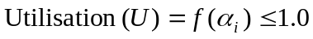 (13.2-1)
where:
U is the utilization to one significant decimal place (see also definition of utilization 3.107)
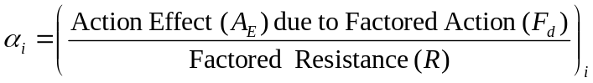 (13.2-1)
This is a generalized form of the equation, and the form appropriate for each application can differ slightly. In the linear case the function simplifies to a summation. See specific clauses for the particular form of the equation to be used.
The factored action can be generalised as
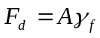` (13.2-3)
where;
A = Action due to the assessment load case
γ_{f} = The specific partial action factor for each type of action
Factored actions shall be determined in accordance with 8.8.
Action effects are determined by following the calculation methodology set out in 10 of this document. The Factored Resistance can be defined as:
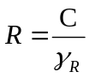 (13.2-4)
where;
C = representative capacity
γ_{R} = the resistance factor for each representative capacity
The structural and foundation resistance factors are given in normative Annex B.

Leg strength

Partial factor approach
The methodology for undertaking checks on the strength of members is described in Clause 12. In general the formulation given in 13.2 shall be used to assess the utilization of the leg structure.
Resistance factors for assessing the strength of members are given in normative Annex B.
NOTE Reference can be made to the applicable clause in the informative where the relevant factors are given along with the calculation methodology. However, to ensure that the most up to date values are used, reference should always be made to he Table in Normative Annex B which contains all the factors to be used in a site-specific analysis,

Working stress approach
<< Section to be included when completed in SNAME>>

Spudcan capacity
The forces on the top and bottom of the spudcan due to factored actions for any of the applicable assessment situations shall be checked against the factored ultimate capacity derived from the manufacturer's specification. Where limited information is available a rational approach shall be used.
<< ERP July 07: we need to devise a way of checking leg-can connection when the rest of the analysis is pinned ? use Vmax and Mlo as a start point >>
NOTE This check addresses issues such as: spudcan overburden (at maximum penetration); spudcan capacity (over the range of predicted penetration); and eccentric spudcan support (e.g. due to sloping seabed or existing spudcan footprints).

Holding system strength
The forces applied to the holding system due to factored actions shall be checked against the factored ultimate capacity derived from the manufacturer's specification. Where limited information is available a rational approach shall be used.

Hull elevation
A hull elevation resulting in at least 1.5 m clearance between the extreme wave crest and the underside of the hull shall be provided. The extreme wave crest elevation is normally determined from the extreme water level in A.6.4.4 and the wave crest in A.6.4.2.3.
In some areas of the world an abnormal wave crest height (see ISO 19901-1), can be greater than the extreme crest height plus 1.5 m. If the abnormal wave is likely to have a significant effect on the global response, the hull elevation shall be increased sufficiently to mitigate the effect. <<< (Maybe next text should be in definition of Abnormal Crest height). Per the NL comment, we need to clarify the text, but WG7 does not want to change the Abnormal to Extreme: we want to keep Extreme to be consistent with the 50 year independent values (or 100 yr JP). There is input from Panel ½ and Rupert that may be of value.>>> Where appropriate metocean databases and reliability models exist, account may be taken of the joint probability of tide, surge and crest height in determining abnormal crest elevation.
The hull elevation is also intended to account for any settlement due to the extreme or abnormal storm event.

<<<The above definition and wording was agreed to by WG 7 in Oslo November 2006 - and modified by ERP July 2007 (note deleted) to account for NL comments. Three optional wordings were considered, but the simple requirement to exceed the “abnormal” crest height was chosen.>>>
NOTE The air gap is defined in ISO 19900 as the clearance between the highest water surface that occurs during the extreme environmental conditions and the lowest exposed part not designed to withstand wave impingement. This differs from the definition historically used by the jack-up industry.

Leg length reserve
The leg length reserve above the upper guides should reflect the uncertainty in the prediction of leg penetration and account for any settlement. The leg length reserve shall be at least 1.5 m. At locations where there is uncertainty a larger reserve should be available. A larger reserve can also be required due to the strength limitations of the top bay or leg/hull interface considerations << ERP July 2007: what are the leg/hull intgerface considerations - spell out ! >>.

Overturning stability
The formulation given in 13.2 shall be used to assess safety against overturning of the jack-up. The utilization shall be calculated based on:
M_{OTM} = overturning moment due to factored actions F_{d}
R_{d OTM} = the factored stabilizing moment based on the representative stabilizing moment R_{r,OTM}
The overturning moment shall be calculated from factored actions about the overturning axis in the most critical assessment situation. For independent leg jack-ups the overturning axes shall pass through any two or more spudcan reaction points. The reaction points are given in 8.6.2 and further described in A.8.6.2.
The representative stabilizing moment R_{r,OTM} shall be calculated about the same axis for the same assessment situation as used to calculate the overturning moment and shall account for the following parameters:
  - The stabilizing moments due to the fixed action (at the displaced position resulting from the factored actions (e.g. environmental actions)).
  - The stabilizing moment due to the most onerous combination of minimum action due to variable load and centre of gravity as specified in 5.4.4.
  - The stabilizing moments due to seabed foundation fixity. Any stabilizing moments due to fixity shall be calculated in accordance with Clause 9, taking account of reduction of the moment fixity to comply with the yield surface of the foundation.
Large deflection effects shall be included when computing the overturning utilization. When the overturning moment is calculated from the foundation reactions obtained from a large deflection analysis, the reduction in stabilizing moment due to large deflection effects is implicitly included within the overturning moment. Otherwise the reduction in stabilizing moment from fixed actions and variable load caused by the displacement resulting from the factored actions shall be explicitly considered either as an increase in the overturning moment or as a reduction in the stabilizing moment.
The resistance factor on the representative stabilizing moment shall be taken as:
γ_{R,OTM} = the resistance factor on representative stabilizing moment = 1.05 << per NL >>
Note: The overturning check is a traditional benchmark. It serves no other purpose as the foundation checks govern.

Foundation Integrity

Capacity check
The formulation given in 13.2 shall be used to assess the foundation. The following utilizations shall be checked:
U_{S,vhm} = the foundation (vertical) bearing capacity utilization <<<Is this correct since the bearing check is a bearing with all the other stuff in it, as per US comment that combined bearing and sliding be checked.>>>
U_{S,hvm} = the foundation sliding resistance utilization
The spudcan reactions due to factored actions shall be checked against the factored vertical capacity and the factored horizontal resistance. The spudcan reactions and foundation capacity / resistance shall be determined in accordance with Clause 9.

NOTE The foundation checks described above encompass the traditional sliding and preload checks. <<<Jan V thinks that “traditional sliding....” is unclear.>>>

Displacement check
If the reactions on any spudcan due to factored actions exceed the factored bearing capacity and/or the factored sliding resistance discussed in 13.9.1 a further assessment may be performed in order to show that any additional settlements and/or the associated additional structural action effects are within acceptable limits and the hull can be jacked. (see A.9.3.2.2).
NOTE An allowable settlement can be estimated from the hull inclination limit, if this is specified in the operations manual.

Temperatures
The 50 year lowest mean daily average air and water temperatures shall be in compliance with the limits given in the operating manual.

- (informative)
Recommendations and Information
NOTE The clauses in this annex provide guidance on the related clause in the body of the document.
  - Scope
Although this document does not address the integrity of well conductors, the following references provide guidance on their assessment: << Expect input from Rupert Hunt providing references for Conductor assessment >
  - Normative references
No Guidance is offered.
  - Terms and definitions
No Guidance is offered.
  - Symbols
    - Symbols for Clause A.1
    - Symbols for Clause A.2
    - Symbols for Clause A.3
    - Symbols for Clause A.4
    - Symbols for Clause A.5
    - Symbols for Clause A.6
    - Symbols for Clause A.7
    - Symbols for Clause A.8
    - Symbols for Clause A.9
A = Spudcan effective bearing area based on cross-section taken at uppermost part of bearing area in contact with soil (see Figure 6.2).
A_{s} = Spudcan laterally projected embedded area.
a = Bearing capacity squeezing factor.
a_{u} = Adhesion.
B = Effective spudcan diameter at uppermost part of bearing area in contact with the soil (for rectangular footing B = width).
b = Bearing capacity squeezing factor.
c_{u} = Undrained cohesive shear strength at D + B/4 below sea floor.
c_{u1} = Undrained cohesive shear strength at spudcan tip.
c_{uo} = Undrained cohesive shear strength at maximum bearing area (D below sea floor).
c_{us} = Undrained cohesive shear strength at D/2 below sea floor.
c_{u,b} = Undrained cohesive shear strength - lower clay below spudcan.
c_{u,t} = Undrained cohesive shear strength - upper clay below spudcan.
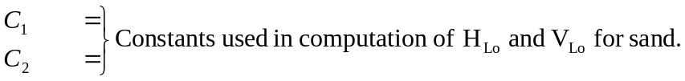
d_{c} = Bearing capacity depth factor.
= 1 + 0.2 (D/B) (max 1.5)
d_{q} = Bearing capacity depth factor.
= 1 + 2tanφ(1- sinφ)² D/B for D/B ≤ 1
= 1 + 2tanφ(1- sinφ)² arctan(D/B) for D/B > 1
d_{γ} = Bearing capacity depth factor = 1.
D = Distance from sea floor to spudcan maximum bearing area.
f₁ = Factor used in yield surface equation for embedded spudcans on clay.
f₂ = Factor used in yield surface equation for embedded spudcans on clay.
f_{r} = Reduction factor on stiffness.
F_{o}' = Effective overburden pressure due to backflow at depth of uppermost part of bearing area.
F_{H} = Horizontal foundation capacity.
F_{HM} = Horizontal foundation capacity in combination with moment.
F_{V} = Ultimate vertical foundation capacity.
F_{V,b} = Ultimate vertical bearing capacity assuming the spudcan bears on the surface of the lower (bottom) clay layer with no backflow.
F_{VH} = Vertical-horizontal foundation capacity (pinned assumption).
F_{VHM} = Vertical-horizontal-moment foundation capacity .
F_{M} = Moment capacity of foundation.
G_{v} = Vertical shear modulus .
G_{h} = horizontal shear modulus .
G_{r} = rotational shear modulus .
h = Distance from rotation point to reaction point.
h₁ = Embedment depth to the uppermost part of the spudcan, (if not fully embedded = 0).
h₂ = Spudcan tip embedment depth.
H = Distance from spudcan maximum bearing area to weak strata below.
H_{Lo} = (C₁/C₂)(V_{Lo}/4), C₁ = 0.3, C₂ = 0.625 (sand)
= Ac_{uo} +(c_{uo} + c_{u1})A_{s} (clay)
i_{c} = Inclination factor (for φ = 0).
= 1 - mF_{H}/Ac_{u}N_{c}
i_{q} = Inclination factor.
= (1 - F_{H}/F_{VH})^{m}
i_{γ} = Inclination factor.
= (1 - F_{H}/F_{VH})^{m+1}
I = Height of soil column above spudcan.
k_{a} = Active earth pressure coefficient (for c_{u} = 0) = tan²(45-φ/2)
k_{p} = Passive earth pressure coefficient = 1/k_{a}
K₁,K₂,K₃ = Stiffness factors.
K_{s} = Coefficient of punching shear.
L = Foundation length, for circular foundation L=B.
m For strip footing - inclination in direction of shorter side.
= (2 + B/L)/(1 + B/L)
m = For strip footing - inclination in direction of longer side.
= (2 + L/B)/(1 + L/B)
m For circular footing = 1.5
M_{Lo} = C₁V_{Lo}B/4, C₁ = 0.3 (sand)
= 0.1V_{Lo}B (clay)
M_{P} = moment capacity associated with further spudcan penetration under environmental actions (equal to minimum of M_{PS} and M_{PV}).
M_{PS} = moment capacity when further spudcan penetration leads to fully seated spud conditions.
M_{PV} = moment capacity under further spudcan penetration, when the actual vertical force is too low to reach fully seated conditions.
n = Iteration factor, ≥ 2.
N = Stability factor.
N_{C} = Bearing capacity factor (taken as N_{c} s_{c}= 6.0 for circular footings).
N_{q} = Bearing capacity factor = e^{πtanφ}tan²(45 + φ/2)
N_{Y} = Bearing capacity factor = 2(N_{q} + 1)tanφ
p_{o}' = Effective overburden pressure at depth, D, of maximum bearing area.
Q_{H} = Applied factored horizontal force.
Q_{M} = Applied factored moment force.
Q_{V} = Applied factored vertical force.
r_{f} = Failure ratio.
s_{c} = Bearing capacity shape factor = (1 + (N_{q}/N_{c})(B/L))
s_{q} = Bearing capacity shape factor = 1 + (B/L)tanφ
s_{Y} = Bearing capacity shape factor = 1 - 0.4(B/L)
( = 0.6 for circular footing under pure vertical action).
T = Thickness of weak clay layer underneath spudcan.
V = Volume of soil displaced by spudcan.
V_{Lo} = bearing capacity available to support the jack-up leg resulting from preloading allowing for reductions due to infill after preloading.
<< P4 owes an alternative symbol for the capacity before infill >>
α = Adhesion factor = 1.0 for soft clays, = 0.5 for stiff clays.
δ = Steel/soil friction angle - degrees, (φ-5≤δ≤φ).
δ_{v} = Vertical displacement of foundation.
δ_{h} = Horizontal displacement of foundation.
Y' = Submerged unit weight of soil.
θ = Foundation rotation - radians.
φ = Angle of internal friction for sand - degrees.
v = Poisson's ratio.
    - Symbols for Clause A.10
    - Symbols for Clause A.11
    - Symbols for Clause A.12
    - Symbols for Clause A.13
  - Overall considerations
    - General
      - Planning
No Guidance is offered.
      - Assessment situations and criteria
No Guidance is offered.
      - Regulations
No Guidance is offered.
    - Assessment approach
No Guidance is offered.
    - Selection of limit states
No Guidance is offered.
    - Determination of assessment situations
      - General
No Guidance is offered.
      - Reaction point and foundation fixity
No Guidance is offered.
      - Storm approach angle
No Guidance is offered.
      - Weights and centre of gravity
No Guidance is offered.
      - Hull elevation
No Guidance is offered.
      - Leg length reserve
No Guidance is offered.
      - Adjacent structures
No Guidance is offered.
      - Other
No Guidance is offered.
    - Exposure levels
      - General
No Guidance is offered.
      - Life-safety categories
No Guidance is offered.
      - Consequence categories
No Guidance is offered.
      - Determination of exposure level
No Guidance is offered.

  - Data to be assembled for each site location
    - Scope
No Guidance is offered.
    - Rig data
No Guidance is offered.
    - Site data
No Guidance is offered.
    - Metocean data
      - General
Experience of site assessment for manned jack-ups supports the use of the 50 year return period independent extremes. 100 year joint probability metocean data may be used as an alternative to the 50 year extremes. The action factors for these two alternatives differ.
If the jack-up life safety category is manned evacuated, it is assumed that reliable forecast of the extreme storm event is feasible, evacuation plans are established and documented, and time and resources are available to safely evacuate all personnel from the jack-up (see 5.5). Under these conditions, hindcast storm characteristics may be computed based on the threshold time horizon of storm formation relative to the jack-up site. The time horizon is defined as the time required to safely evacuate the jack-up, and the extreme storm event is derived from the population of storms that can develop and impact the jack-up site within that time horizon.
A “sudden hurricane” is defined as one which forms locally, and due to speed of formation and proximity to infrastructure at time of formation, may not allow sufficient time to evacuate manned facilities. The population of storms used to derive the sudden hurricane at a given site may therefore be defined in terms of the time horizon required to evacuate the site. For manned-evacuated jack-ups utilized in these circumstances, consideration may be given to the use of a 50-yr return period “sudden hurricane” or “sudden storm” event. An unmanned jack-up may also be assessed using these criteria.
<<Check for consistency with 5.5.4>>

Partial factors for each of these options are presented in ?5 and/or 13 << and/or Annex B >>.
Site-specific data, if available, should be used for the assessment as regional data may not take account of local variations.
Where there is sufficient evidence that any of the environmental actions at the site are directional, it may be possible to align the jack-up on the most advantageous heading.
      - Waves
        - Extreme wave height environment
The extreme wave height environment used for elevated storm conditions shall, as a minimum, be computed according to the following subclauses based on the three-hour storm duration with an intensity defined by the significant wave height, H_{srp}, for the assessment return period. The seasonally adjusted wave height may be used as appropriate for the operation.
The wave height information for a specific site may also be expressed in terms of H_{max}, the individual extreme wave height for the return period, rather than the significant wave height H_{srp}. The relationship between H_{srp} and H_{max} must be determined accounting for the effects of storms (longer than 3 hours) and for the additional probability of other return period storms <<see Commentary Section C3.5.1>>. This relationship will depend on the site-specific conditions, however H_{srp} may usually be determined from H_{max} using the generally accepted relationship for non-cyclonic areas:
H_{srp} = H_{max}/1.86 (A.6.4-1)
For cyclonic areas the recommended relationship is:
H_{srp} = H_{max}/1.75 (A.6.4-2)
Note: The wave action can be computed stochastically (through a time domain approach) or deterministically (through an individual maximum wave approach). The scaled wave heights for the two approaches are discussed in A.6.4.2.5 and A.6.4.2.2, respectively <<(see Commentary)>>.. The scaled wave heights are to be used only in conjunction with the associated kinematics modelling recommended in A.7 and the hydrodynamic coefficients given in A.7.3.
        - Deterministic waves
For deterministic/regular calculation of wave action it is appropriate to apply a kinematics reduction factor of 0.86 in order to obtain realistic action estimates for the extreme storm event<<(see Commentary)>>. This factor accounts for the need to ensure that both the deterministic/regular wave action calculation and 3 hour simulation produce statistically comparable results (i.e. both target the MPME response in the 50 year storm). In addition, the 0.86 factor may be considered to take some account of wave spreading and the conservatism of deterministic/regular wave kinematics (traditionally accomplished by adjusting the hydrodynamic properties).
<<Formulations to be included, ref. IADC/Shell study by ND>>
The reduction in kinematics may alternatively be achieved by means of a reduced wave height, H_{det}. H_{det} may be determined as a function of H_{max} from:
H_{det} = 0.86 H_{max} (A.6.4-3)
The use of a factor smaller than 0.86 may be justified on the basis of an analysis which explicitly accounting for the effects of three-dimensional spreading. However, such effects should be properly balanced by the inclusion of second-order interaction effects between spectral wave components. <<Commentary reference to IADC/ND study on wave directional spreading?>>
The wave actions should be determined using an appropriate wave kinematics model in accordance with A.7.3.3.1.
In the analysis a single value for the wave period T_{ass}, in seconds, associated with the maximum wave may be considered. The “intrinsic” period of the wave as seen by an observer moving with the current should be used in the derivation of wave kinematics required for action calculations; guidance is given in ISO 19901-1, Metocean Design and Operation Conditions, Clauses 5.2 and 8.3. Unless site-specific information indicates otherwise T_{ass} will normally be between the following limits:
3.44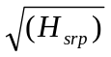 < T_{ass} < 4.42 (A.6.4-4)
where H_{srp} is the return period extreme significant wave height in meters.
        - Wave crest elevation
For calculation to determine minimum hull elevation the wave crest elevation above the extreme still water level in A.6.4.4 may be obtained from the relationship between H_{max}/H_{srp} in A.6.4.2.1 above and the appropriate deterministic wave theory in A.7.4.3.
A reasonably foreseeable extreme return period should be used for this calculation, and is recommended to be no shorter than 50 years, even if a lower return period is used for other purposes.
For some regions abnormal/extreme wave crest should be calculated based on storm statistics and according to principles as described in ISO 19901-1 Clause A.8.8. Examples for the regional application of these principles may be found in /OMAE2007-29559 by Legget & al/, or /DNV-RP-C205 Sec.3.7.3/.
NOTE A wave height reduction factor possibly used in deterministic wave analysis to represent wave spreading and the conservatism of deterministic/regular wave kinematics, see A.6.4.2.2, shall not be applied in the calculation of wave crest elevation. << MJRH June-07: THIS SHOULD NOT BE A NOTE - P1-2 edited the Note and deleted this comment Sept 07, but MJRH has retained this comment as the message should be in the main text. >>
        - Wave spectrum
Where the analysis method requires the use of spectral data, the choice of the analytical wave spectrum and associated spectral parameters should reflect the width and shape of spectra for the site and significant wave height under consideration. In cases where fetch and duration of extreme winds are sufficiently long a fully developed sea will result (this is rarely realized except, for example, in areas subject to monsoons). Such conditions may be represented by a Pierson-Moskowitz spectrum. Where fetch or duration of extreme winds is limited, or in shallow water depths, a JONSWAP spectrum may normally be applied (see Note at the end of this A.6.4.2.6).
Further discussions of wave spectra and spectral density functions for the Pierson-Moskowitz, S_{PM}(ω), and the JONSWAP, S_{JS}(ω), wave spectra are presented in ISO 19901-1 Clause A.8.6. The wave spectral density functions expressed as a function of wave frequency, i.e. S_{ηη}(f) can be found in << TR &/or 19901-1>>.
        - Effective significant wave height
For stochastic/random wave action calculations Airy wave theory is implied, see A.7.4.3. To account for wave asymmetry, which is not included in Airy wave theory, a scaling of the significant wave height should be applied to capture the largest wave actions at the maximum crest amplitude. The effective significant wave height, H_{s}, may be determined as a function of the water depth, d in meters, from:
H_{s} = [1 + 0.5e^{(-d/25)}] H_{srp} (d ≥ 25m) (A.6.4-5)
and should be used with the wave kinematics model described in A.7.4.3.
For water depths less than 25m an appropriate regular wave analysis should be considered.
        - Zero-upcrossing period
For a given significant wave height the wave period depends on the significant wave steepness which in extreme seas in deep water often lies within the range 1/20 to 1/16. This leads to an expression for zero-upcrossing period T_{z}, related to H_{srp} in meters, as follows:
3.2 < T_{z} < 3.6 (A.6.4-6)
However in shallow water the wave steepness can increase to 1/12 or more, leading to a zero-upcrossing period T_{z} as low as 2.8. This is because the wave height increases and wave length decreases for a given T_{z}.
NOTE
If a JONSWAP spectrum is applied the response analysis should consider a range of periods associated with H_{srp} based on the most probable value of T_{p} plus or minus one standard deviation. However it should be ensured that the assumptions made in deriving the spectral period parameters are consistent with the values used in the analysis. Alternatively, applicable combinations of wave height and period may be obtained from a scatter diagram determined from site-specific measurements; in this case specialist advice should be obtained on a suitable spectral form for the site. To avoid the need for analyses of several wave periods a practical alternative is to use a 2 parameter spectrum with γ = 1.0 in combination with the site-specific most probable peak period.
        - Short-crested stochastic waves
For stochastic/random wave action calculations, the short-crestedness of waves (i.e. the angular distribution of wave energy about the dominant direction) may be accounted for when site-specific information indicates that such effects are applicable. In all cases the potential for increased response due to short-crested waves should be investigated. The effect may be included by means of a directionality function F(α), as follows:
S_{ηη}(f, α) = S_{ηη}(f).F(α) (A.6.4-7)
where;
α = angle between direction of elementary wave trains and dominant direction of the short-crested waves.
S_{ηη}(f, α) = directional short-crested power density spectrum.
F(α) = directionality function.
Directionality functions can be found in ISO 19901-1 Clause A.8.7 or <<TR>>. When referring to the formulations in ISO 19901-1 Clause A.8.7 extreme analysis and fatigue analysis should be performed for swell sea and wind sea, respectively. Alternatively, directionality functions for extreme and fatigue analysis can be defined according to <<TR>>.
Note: If using the approach in ISO 19901-1 Clause A.8.7 then curve D1 with n = 8 gives good agreement with the formulation in <<TR>>. For curve D2 with s = 17 and for curve D3 with σ = 0.34 give good agreement with the formulation in <<TR>>, respectively.
Note:
The modelling of short-crested stochastic waves in the present clause shall not be combined with the wave kinematics factor used in deterministic wave analysis to represent wave spreading and the conservatism of deterministic/regular wave kinematics, see A.6.4.2.2.
        - Non-linear wave effects
Where the natural period of the jack-up is such that it may respond dynamically to waves, see A.10.4.1, the maximum dynamic response may be caused by wave heights or sea states with periods outside the ranges given in A.6.4.2.2 and A.6.4.2.6. Such conditions should also be investigated to ensure that the maximum (dynamic plus quasi-static) response is determined.
        - Long-term data
For fatigue calculations, (see 11.3.1) the long-term wave climate may be required. For the purposes of the fatigue analysis the long-term data present the probability of occurrence for each sea state (characterized by wave energy spectra and the associated physical parameters). This may be presented in the form of a significant wave height versus zero-upcrossing period scatter diagram or as a table of representative sea states.
      - Current
The extreme wind driven surface current velocity should be that associated with the assessment return period wind, seasonally adjusted if appropriate. When directional information regarding other current velocity components is available the maximum surface flow of the mean spring tidal current and the assessment return period surge current, seasonally adjusted if appropriate, should be vectorially added in the down-wind direction and combined with the wind driven surface current as indicated below. If directional data are not available the components should be assumed to be omni-directional and should be summed algebraically.
Note: A site-specific study will normally be required to define the current velocity components.
The current profile may be expressed as a series of velocities at certain stations from seabed to water surface. Unless site-specific data indicates otherwise, and in the absence of other residual currents (such as circulation, eddy currents, slope currents, internal waves, inertial currents, etc.), an appropriate method for computing current profile (see Figure ‎A.6.4-1) is:
V_{C} = V_{t} + V_{s} + (V_{w} - V_{s}) [(h+z)/h], for |z| ≤ h and V_{s} < V_{w} (A.6.4-8a)
V_{C} = V_{t} + V_{s} for |z| > h or V_{s} ≤ V_{w} (A.6.4-8b)
where;
V_{C} = current velocity as a function of z. Note that a reduction may be applicable according to A.7.4.4.
V_{t} = downwind component of mean spring tidal current.
V_{s} = downwind component of associated surge current (excluding wind driven component).
V_{w} = wind generated surface current. In the absence of other data this may conservatively be taken as 2.6% of the 1 minute sustained wind velocity at 10m.
h = reference depth for wind driven current. In the absence of other data h should be taken as 10 meters.
z = distance above still water level (SWL) under consideration (always negative).
Alternative formulations are provided in ISO 19901-1 Clause A.9.3. Comparisons of combined current and wave forces in TR.6.4.3 shows that the constant current profile is on the conservative side compared to the power law formulations presented in ISO 19901-1. << mjrh Nov 2007: P1-2's edit to last few words made poor wording worse and has been changed >>
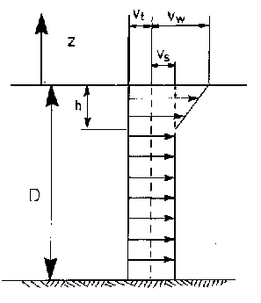
Figure ‎A.6.4-1 — Suggested current profile
In the presence of waves the current profile should be stretched/compressed such that the surface component remains constant. This may be achieved by substituting the elevation as described in A.7.3.3.3.2. Alternative methods may be suitable, however mass continuity methods are not recommended. The current profile may be changed by wave breaking. In such cases the wind induced current could be more uniform with depth.
For a fatigue analysis, current may normally be neglected.
      - Water depths
The water depth at the site should be determined and related to lowest astronomical tide (LAT). The relationship between LAT and Chart Datum is discussed in << Part 2 Commentary >>.
The mean water level (MWL) related to the seabed should be expressed as the mean level between highest astronomical tide (HAT) and lowest astronomical tide (LAT) i.e.:
MWL = (HAT + LAT)/2 (A.6.4-9)
The extreme still water level (SWL) should be expressed as a height above LAT, and should be the sum of;
Mean high water spring tide (MHWS)
+ relevant return period extreme storm surge (Use a reasonably foreseeable extreme return period (not less than 50 year value) for minimum hull elevation determination).
unless reliable data indicates that an alternative summation is appropriate.
When lower water levels are more onerous the minimum still water level (SWL) to be considered in the action calculations should be the sum of:
Mean Low Water Spring Tide (MLWS)
+ relevant return period negative storm surge.
<<Terminology commented by NL>>

      - Marine growth
Where applicable, site-specific data should be obtained. In the absence of such data, default values for thickness and distribution are given in A.7.3.5.
      - Wind
        - General
The wind velocity used for the assessment return period should be the 1 minute sustained wind, related to a reference level of 10.0m above mean sea level.
The wind velocity profile may be defined by a logarithmic function according to ISO 19901-1, or approximated by a power law see A.6.4.6.2. A comparison of wind forces shows that the below power law is slightly more conservative than the ISO 19901-1 logarithmic profile, see TR.6.4.6.1. Typically the average effect is in the range of 7 % for a 1 minute average wind speed of 10 m/sec at 10 m above sea level, and 2 % for a 1 minute average wind speed of 40 m/sec.
Different jack-up configurations (weight, centre of gravity, cantilever position, etc.) may be specified for operating and elevated storm modes. In such cases, the maximum wind velocity considered for the operating mode should not exceed that permitted for the change to the elevated storm mode.
        - Wind profile
The expression for the vertical profile of the mean wind velocity in the form of a power law is:
V_{Z} = V_{ref} (Z/Z_{ref})^{1/N} (A.6.4-10)
where;
V_{Z} = the wind velocity at elevation Z above mean water level.
V_{ref} = the 1 minute sustained wind velocity at elevation Z_{ref} (normally 10m above MWL).
N = 10 unless site-specific data indicate that an alternative value of N is appropriate.
    - Geoscience studies

      - Geoscience data
        - General
Adequate geotechnical and geophysical information shall be available to assess the site and the foundation stability. Aspects, which should be investigated, are shown in Table A.6.5-1 and are discussed in more detail in the referenced sections. The information obtained from the surveys and investigations set out in Clauses A.6.5.1.1 to A.6.5.1.5 is required for areas where there is no data available from previous operations. In areas where information is available, it may be possible to reduce the requirements set out below by use of information obtained from other surveys or activities in the area.
NOTE Experience of prior jack-up operations at the same location might be used provided the previous bearing pressures exceed those for the present operation by an adequate margin << more caveats? Footprints / large differences in spudcan shapes >>.
        - Bathymetric survey
An appropriate bathymetric survey should be supplied for an area approximately 1 kilometer square centered on the proposed position at the site. Line spacing of the survey should typically be not greater than 100 meters x 250 meters over the survey area. Interlining is to be performed within an area 200 meters x 200 meters centered on the proposed position at the site. Interlining should have spacing less than 25 meters x 50 meters. Such surveys are normally carried out using acoustic reflection systems.
        - Sea floor survey
The sea floor should be surveyed using sidescan sonar or high-resolution multibeam echosounder techniques and should be of sufficient quality to identify obstructions and sea floor features and should cover the immediate area (normally a 1 km square) of the intended site. The slant range selection should give a minimum of 100% overlap between adjacent lines. A magnetometer survey can also be required if there are buried pipelines, cables and other metallic debris located on or slightly below the sea floor.
Sufficient information to enable safe positioning and removal of the jack-up is required. Sea floor obstructions, such as pipelines and wellheads, should be indentified to sufficient depth to avoid the potential for spudcan interference during both installation on and removal from location. In some cases an ROV or diver’s inspection can be required in addition to the sea floor survey.
Sea floor and debris surveys can become out-of-date, particularly in areas of construction/drilling activity or areas with mobile sediments. Close to existing installations sea floor surveys should, subject to practical considerations, be undertaken immediately prior to the arrival of the jack-up at the site. At sites with no existing surface or subsea infrastructure the maximum period for the validity of seabed surveys should be determined taking account of local conditions.
        - Shallow seismic survey
A shallow seismic survey uses high resolution acoustic reflection techniques to:
- determine near surface soil stratigraphy.
- reveal the presence of shallow gas concentrations and other geohazards.
Due to the qualitative nature of seismic surveys, it is not possible to conduct analytical foundation appraisals based on seismic data alone. The seismic data shall be correlated with existing soil boring data in the vicinity and show similar stratigraphy.
A shallow seismic survey should be performed over an approximately 1 kilometre square area centred on the proposed position at the site. Line spacing of the survey should typically be not greater than 100 meters x 250 meters over the survey area. The survey report should include at least two vertical cross-sections passing through the proposed position at the site showing all the relevant reflectors and allied geological information. The equipment used should be capable of identifying reflectors of 0.5m and thicker to a depth equal to the greater of 30 meters or the anticipated spudcan penetration plus 1.5 times the spudcan diameter.
        - Geotechnical investigation
          - General
Site-specific geotechnical investigation and testing are recommended in areas where any of the following apply:
- nearby geotechnical data is not available;
- the shallow seismic survey cannot be interpreted with any certainty;
- significant layering of the strata is indicated; or
- the site is known to be potentially hazardous.
          - Soil investigation and testing
A geotechnical investigation should comprise a minimum of one borehole to a depth equal to 30 metres or the anticipated spudcan penetration plus 1.5 times the spudcan diameter, whichever is the greater. All the layers should be adequately investigated and the transition zones cored at a sufficient sampling rate.
The number of boreholes required should account for the lateral variability of the soil conditions, regional experience and the geophysical investigation. When a single borehole is made, the preferred location is at the center of the leg pattern at the intended position at the site.
“Undisturbed” soil sampling, in-situ testing and laboratory testing should be conducted. Recognized in-situ soil testing tools include piezocone penetrometer, vane shear, T-bar and/or pressure meter tests.
          - Geotechnical report
The geotechnical report should include borehole logs, in-situ test records (if appropriate) and documentation of all laboratory tests, together with interpreted soil design parameters. A competent geotechnical engineer should select design parameters suitable for spudcan foundation assessment. For the methods recommended in Section 9.3 and 9.4, the design parameters should include profiles of undrained shear strength and/or effective stress parameters, soil indices (plasticity, liquidity, grain size, etc.), relative density, unit weight and the over consolidation ratio (OCR).
Additional soil testing to provide shear moduli and cyclic/dynamic behaviour may be required if more comprehensive analyses are to be applied or where the soil strength may deteriorate under cyclic loading.
      - Data Integration
The results of bathymetric surveys, sea floor surveys, shallow seismic surveys, seabed samples and geotechnical investigations should be integrated to assess the soil conditions at the proposed site. Lateral variations of geotechnical parameters can be assessed from the correlation of the shallow seismic data and the geotechnical information from the borehole logs and/or in-situ tests.
<< Jan 07 ERP: Move table to first para of A6.5 at a later date AND check/update x-references >>
Table ‎A.6.5-1 — Foundation risks, methods for evaluation and prevention
RISK | METHODS FOR EVALUATION & PREVENTION | CLAUSE
Installation Problems | Bathymetric survey  Sea floor survey | A.6.5.1.1  A.6.5.2.2
Punch-through | Shallow seismic survey  Soil sampling and other geotechnical testing and analysis | A.6.5.1.3  A.6.5.1.4,  A.9.3.2.7
Settlement/Bearing failure | Shallow seismic survey  Soil sampling and other geotechnical testing and analysis  Ensure adequate jack-up preload capability | A.6.5.1.3  A.6.5.1.4  A.9.3.2.7  A.9.3.3
Sliding failure | Shallow seismic survey  Soil sampling and other geotechnical testing and analysis  Increase vertical spudcan reaction  Modify the spudcans | A.6.5.1.3  A.6.5.1.4  A.9.3.3.2
Scour | Bathymetric and sea floor survey (identify sand waves)  Surface soil samples and seabed currents  Inspect spudcan foundation regularly  Install scour protection (gravel bag/artificial seaweed) when anticipated | A.6.5.1.1  A.6.5.1.2  9.4.7
Geohazards (mudslides, mud volcanos etc) | Sea floor survey  Shallow seismic survey  Soil sampling and other geotechnical testing and analysis | A.6.5.1.2  A.6.5.1.3  A.6.5.1.4
Gas pockets/Shallow gas | Shallow seismic survey | A.6.5.1.3
Faults | Shallow seismic survey | A.6.5.1.3
Metal or other object, sunken wreck, anchors, pipelines etc. | Magnetometer and sea floor survey | A.6.5.1.2
Local holes (depressions) in seabed, reefs, pinnacle rocks, non-metallic structures or wooden wreck | Sea floor survey  Diver/ROV inspection | A.6.5.1.2
Legs stuck in mud | Soil sampling and other geotechnical testing and analysis  Consider change in spudcans  Jetting/Airlifting | A.6.5.1.4  A.6.5.1.4  A.6.5.1.4
Eccentric spudcan reactions | Bathymetric and sea floor surveys  Shallow seismic survey (buried channels or footprints)  Soil sampling and other geotechnical testing and analysis  Seabed modification | A.6.5.1.1, A.6.5.1.2  A.6.5.1.3  A.6.5.1.4  A.9.3 ????
Seabed slope | Bathymetric and Sea floor surveys  Seabed modification | A.6.5.1.1, A.6.5.1.2
Footprints of previous jack-ups | Evaluate site records  Prescribed installation procedures  Consider filling/modification of holes as necessary | A.6.5.1.1  A.6.5.1.2  9.4.1  9.4.1

  - Actions
    - Scope
This clause presents applicable formulations and methods to calculate actions for site assessment.
The wave and current actions are presented for quasi-static and dynamic analysis. Normally a quasi-static, deterministic extreme wave analysis where dynamics is represented by an inertia action set, is performed for jack-up site assessment. Calculations of actions for stochastic analysis in time domain are also presented. Such analyses are applicable for calculation of inertia action sets or for the direct calculation of the structural dynamic responses. The hydrodynamic formulations and coefficients are presented together with formulas for detailed and equivalent modelling of leg hydrodynamic actions.
Wind models, flow coefficients for different structural parts and action formulation for calculation of static wind actions are presented.
Principles for assessment of functional actions and response effects are presented.

    - General
No guidance offered.
    - Environmental actions
      - General
        - Action combinations
When undertaking an assessment using the 50 year return period individual extremes the combination of metocean components should be:
Action on legs and other structures subject to wave action due to 50 year return period individual extreme wave and current,
plus
action on hull and exposed areas (e.g., legs) as applicable due to the 50 year return period 1 minute individual extreme mean wind.
Alternatively, when undertaking an assessment using the 100 year return period joint probability environment the combination of environmental action components should be:
- Action on legs and other structures subject to wave action due to 100 year return period action level wave and associated joint probability current,
plus
action on hull and exposed areas (e.g., legs) as applicable due to the 100 year return period action level wind associated with the selected wave height and current velocity,
or, where the wind action exceeds the wave/current plus dynamic actions,
- Action on hull and exposed areas (e.g., legs) as applicable due to the 100 year return period 1 minute mean individual extreme wind,
plus
action on legs and other structures subject to wave action due to the joint probability 100 year action level wave and current combination associated with the selected wind velocity.

        - Methods for the determination of actions
The actions can be determined by one of two alternative methods, deterministic and stochastic. The dynamic actions for the deterministic method may be determined stochastically. By stochastic time domain analysis the dynamics of the jack-up and non-linearities of the action and foundation interaction may be included. Often a deterministic quasi-static analysis is used for jack-up site assessment. The action calculation procedure should follow the steps in the Table A.7.3-1 for a deterministic analysis and in Table A.7.3-2 for a stochastic analysis.

Table ‎A.7.3-1 — Action calculation procedure for deterministic analysis
TOPIC | Description | Reference clause(s)
Water depth | Define storm water depth considering LAT, tide and storm surge | A.6.4.4
Wave | Specify wave height and range of associated wave periods. | A.6.4.2.1 A.6.4.2.2
Wave theory | Determine the two dimensional wave kinematics from an appropriate wave theory for the specified wave height, storm water depth, and intrinsic wave period | A.7.3.3.3.1
 | Apply a reduction factor to the wave height to determine H_{det} | A.6.4.2.2
Current | Definecurrent velocity and profile. | A.6.4.3
 | Determine the effective local current profile by multiplying the specified current profile by a factor accounting for interference from the structure on the flow field. | A.7.3.3.4
 | Determine the current profile above mean water level in the presence of waves by stretching the current profile such that the surface component remains constant. | A.7.3.3.3.2
Hydrodynamic modelling | Establish detailed or equivalent leg models to represent structural members, appurtenances | A.7.3.2.1, A.7.3.2.2, A.7.3.2.3, A.7.3.2.6
 | Determine drag and inertia coefficients (detailed or equivalent) as functions of member shape, roughness (marine growth), size, and orientation. | A.7.3.2.4, A.7.3.2.5
 | Include marine growth thickness in case relevant for the site and planned operation | A.7.3.2.5
Wave/current action | Combine local current profile vectorially with the wave kinematics to determine locally incident fluid velocities and accelerations for calculation of wave and current actions by Morison's equation. | A.7.3.3.3.1  A.7.3.3.3.2
Wind | Define wind speed and wind profile | A.6.4.6
Wind action | Define shape coefficients and calculate the static wind action. | A.7.3.4
Dynamic effects | Represent dynamic effects by an inertia action set or a dynamic amplification factor, determined either deterministically or stochastically. | A.10.5.2, A.10.5.3
Functional actions | Define functional actions as required | A.7.4
Other actions | Define other actions as required | A.7.8
Action combinations | Apply action factors to the environmental actions and dynamic effects. | Annex B

Table ‎A.7.3-2 — Action calculation procedure for stochastic analysis
TOPIC | Description | Reference clause(s)
Water depth | Define storm water depth considering LAT, tide and storm surge | A.6.4.4
Wave | Define the return period significant wave height and corresponding spectral peak period. | A.6.4.2.4, A.6.4.2.6
 | Calculate effective significant wave height as appropriate | A.6.4.2.5
 | Specify wave spectrum, wave direction and wave spreading function. | A.6.4.2.4, A.6.4.2.7
 | Calculate wave velocities and accelerations by superposition of wave components representing the wave spectrum and wave spreading functions. | A.7.3.3.3.2
Current | Define current velocity and profile. | A.6.4.3
 | Determine the effective local current profile by multiplying the specified current profile by a factor accounting for interference from the structure on the flow field. | A.7.3.3.4
 | Determine the current profile above mean water level in the presence of waves by stretching the current profile such that the surface component remains constant. | A.7.3.3.3.2
Hydrodynamic modelling | Establish detailed or equivalent leg models to represent structural members, appurtenances | A.7.3.2.1, A.7.3.2.2, A.7.3.2.3, A.7.3.2.6
 | Determine drag and inertia coefficients (detailed or equivalent) as functions of member shape, roughness (marine growth), size, and orientation. | A.7.3.2.4, A.7.3.2.5
 | Include marine growth thickness in case relevant for the site and planned operation | A.7.3.2.5
Wave/current action | Combine local current profile vectorially with the wave kinematics to determine locally incident fluid velocities and accelerations for calculation of wave and current actions by Morison's equation. | A.7.3.3.3.1  A.7.3.3.3.2
Wind | Define wind speed and wind profile | A.6.4.6
Wind action | Define shape coefficients and calculate the static wind action. | A.7.3.4
Functional actions | Define functional actions as required | A.7.4
Other actions | Define other actions as required | A.7.8
Action combination | Apply action factors to the environmental actions and combine with functional actions | Annex B
      - Hydrodynamic model
        - General
The hydrodynamic modelling of the jack-up leg may be carried out by utilizing 'detailed' or 'equivalent' techniques. The hydrodynamic properties are then found as described in the clauses below. In all cases the following shall be considered:
The drag properties of some chords will differ for flow in the direction of the wave propagation (wave crest) and for flow back towards the source of the waves (wave trough). Often the combined drag properties of all the chords on a leg will give a total which is independent of the flow direction along a particular axis. When this is not the case it is recommended that the effect is included directly in the wave/current action model. If this is not possible it is recommended that:
- Regular wave deterministic calculations use a value appropriate to the flow direction under consideration, noting that the flow direction is that of the combined wave and current particle motion.
- An average drag property is considered for random wave analyses which are solely used to determine dynamic effects for inclusion in a final regular wave deterministic calculation which will be made on the basis of item a) above.
- The drag property in the direction of wave propagation is used for random wave analyses from which the final results are obtained directly.
Lengths of members are normally taken as the node-to-node distance (see note below) of the members in order to account for small non-structural items (e.g. anodes, jetting lines of less than 4" nominal diameter). Large non-structural items such as raw water pipes and ladders are to be included in the model. Free standing conductor pipes and raw water towers are to be considered separately from the leg hydrodynamic model.
(Note to text: For the purpose of this practice a node is defined as that point where two member axes intersect. An offset at this location may be used in calculating the equivalent C_{D}.)
The contribution of the part of the spudcan above the seabed should be investigated and only excluded from the model if it is shown to be insignificant. In water depths greater than 2.5 H_{s} or where penetrations exceed 1/2 the spudcan height, the effect of the spudcan is normally insignificant.
For leg structural members, shielding and solidification effects should not normally be applied in calculating wave actions. The current flow is however reduced due to interference from the structure on the flow field, see A.7.4.4.
NOTE The solidification effect, which increases the actions from waves due to interference from objects ”side by side” in the flow field, is normally not included in the hydrodynamic coefficients formulation for jack-ups. Jack-up rigs are usually space frame structures with few parallel elements in close proximity so that shielding and solidification effects are usually not important.
        - 'Detailed' leg model
All members are modelled with Morison coefficients accounting for member cross-section orientation relative to the flow direction. Members and/or members with appurtenances may be lumped together using the corresponding C_{D}D = ΣC_{Di}D_{i} and C_{M}A = ΣC_{Mi}πD_{i}²/4, accounting for flow direction, as defined in A.7.3.2.4.
        - 'Equivalent' leg model
The hydrodynamic model of a bay is comprised of one, 'equivalent' vertical tubular located at the geometric center of the actual leg. The corresponding (horizontal) v_{n} and _{n} << should be v dot P1-2 DELETED THIS ERP REMARK >> << JUST BECAUSE SNAME REV 2 got the terminology wrong, doesn't make it right here >>are applied together with equivalent C_{D}D = ΣC_{De}D_{e} and C_{M}A = ΣC_{Me}A_{e}, as defined in A.7.3.2.4. The model should be varied with elevation, as necessary, to account for changes in dimensions, marine growth thickness, etc.
When the hydrodynamic properties of a lattice leg are idealized by an 'equivalent' model description the model properties may be found using the method given below:
The equivalent value of the drag coefficient, C_{De}, times the equivalent diameter, D_{e}, for C_{Dei} of the bay may be chosen as:
C_{De} D_{e} = D_{e} Σ C_{Dei} (A.7.3-1)
The equivalent value of the drag coefficient for each member, C_{Dei}, is determined from:
C_{Dei} = [ sin²β_{i} + cos²β_{i} sin²α_{i} ]^{3/2} C_{Di} 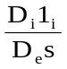 (A.7.3-2)
where;
C_{Di} = drag coefficient of an individual member (i) as defined in A.7.3.2.4
D_{i} = reference diameter of member 'i' (including marine growth as applicable) as defined in A.7.3.2.4.
D_{e} = equivalent diameter of leg, suggested as 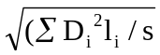
l_{i} = length of member 'i' node to node center.
s = length of one bay, or part of bay considered.
α_{i} = angle between flow direction and member axis projected onto a horizontal plane.
β_{i} = angle defining the member inclination from horizontal (see Figure ‎A.7.3-1).

Note: Σ indicates summation over all members in one leg bay
The above expression for C_{Dei} may be simplified for horizontal and vertical members as follows:

Vertical members (e.g. chords): C_{Dei} = C_{Di} (D_{i}/D_{e}) (A.7.3-3)

Horizontal members: C_{Dei} = sin³α C_{Di} (D_{i}l_{i}/D_{e}s) (A.7.3-4)

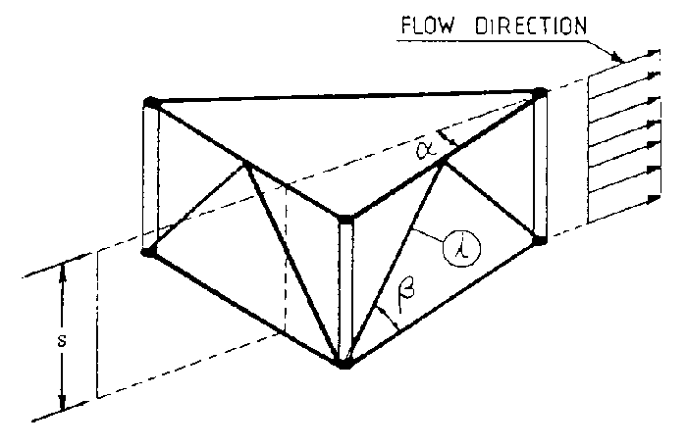
Figure ‎A.7.3-1 — Flow angles appropriate to a lattice leg
(after DNV Class Note 31.5, February 1992, [6]) <<Capture reference and reference number in biblography>

The equivalent value of the inertia coefficient, C_{Me}, and the equivalent area, A_{e}, representing the bay may be chosen as:
C_{Me} = equivalent inertia coefficient which may normally be taken as 2.0 when using A_{e}

A_{e} = equivalent area of leg per unit height = (ΣA_{i}l_{i})/s

A_{i} = equivalent area of member or gusset = πD_{i}²/4 << ERP to P1-2 Nov 2007: is the list replacing "element" complete? >>

D_{i} = reference diameter chosen as defined in A.7.3.2.4.

For a more accurate model the C_{Me} coefficient may be determined as:

C_{Me} A_{e} = A_{e} Σ C_{Mei} (A.7.3-5)

where;
C_{Mei} = [1 + (sin²β_{i} + cos²β_{i} sin²α_{i})(C_{Mi} - 1)] 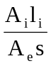 (A.7.3-6)
C_{Mi} = the inertia coefficient of an individual member, C_{Mi} is defined in A.7.3.2.4 related to
reference dimension D_{i}.

NOTE For dynamic modelling the added mass of fluid per unit height of leg may be determined as ρA_{i}(C_{mi} - 1) for a single member or ρA_{e}(C_{Me} - 1) for the equivalent model, provided that A_{e} is as defined above.
        - Drag and inertia coefficients
Hydrodynamic coefficients for leg members are given in this Clause. Tubulars, brackets, split tube and triangular chords are considered. Hydrodynamic coefficients including directional dependence are given together with a fixed reference diameter D_{i}. No other diameter should be used unless the coefficients are scaled accordingly. Unless better information is available for the computation of wave and current forces, the values of drag and inertia coefficients applicable to Morison's equation should be obtained from this Clause.
Recommended values for hydrodynamic coefficients for tubulars (<1.5m diameter) are given in Table A.7.3-3 based on the data discussed in the supporting ISO/TR 19905-2.
Table ‎A.7.3-3 — Base hydrodynamic coefficients for tubulars
Surface condition (see Note) | C_{Di} | C_{Mi}
Smooth | 0.65 | 2.0
Rough | 1.00 | 1.8

The smooth values will normally apply above MWL + 2m and the rough values below MWL + 2m, where MWL is as defined in A.6.4.4. If the jack-up has operated in deeper water and the fouled legs are not cleaned the surface should be taken as rough for wave actions above MWL + 2m.
Actions due to gussets should be determined using a drag coefficient:
C_{Di} = 2.0
applied together with the projected area of the gusset visible in the flow direction, unless model test data shows otherwise. This drag coefficient may be applied together with a reference diameter D_{i} and corresponding length l_{i} chosen such that their product equals the plane area, A = D_{i}l_{i} and D_{i} = l_{i} (see Figure ‎A.7.3-2). In the equivalent model of A.7.3.3 the gussets may be treated as an equivalent horizontal member of length l_{i} , with its axis in the plane of the gusset. C_{Mi} should be taken as 1.0 and marine growth may be ignored.

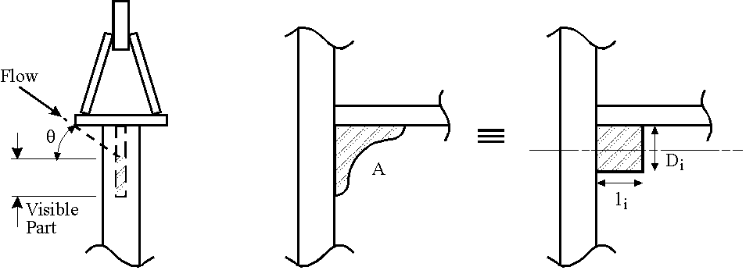
Figure ‎A.7.3-2 — Gusset plates
For non-tubular geometries (e.g. leg chords) the appropriate hydrodynamic coefficients may, in lieu of more detailed information, be taken in accordance with Figure ‎A.7.3-3 or Figure ‎A.7.3-4 and corresponding formulas, as appropriate.

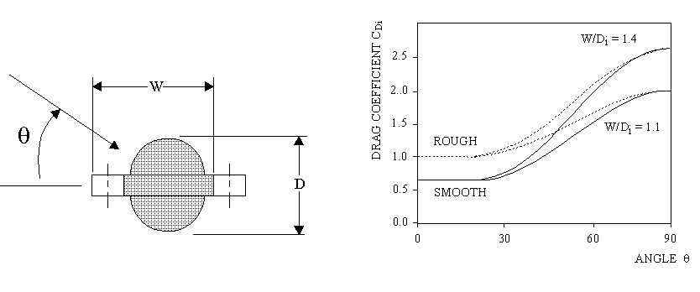
Figure ‎A.7.3-3 — Split tube chord and typical values for C_{Di}

For a split tube chord as shown in Figure ‎A.7.3-3 the drag coefficient C_{Di} related to the reference dimension D_{i} = D+2t_{m}, the diameter of the tubular including marine growth as in A.7.3.3 may be taken as:
C_{Di} = 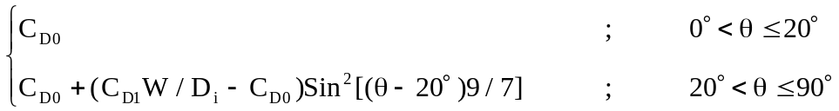 (A.7.3-7)
where;
θ = Angle in degrees, see Figure ‎A.7.3-3

C_{D0} = The drag coefficient for a tubular with appropriate roughness, see Table A.7.3-3. (C_{D0} = 1.0 below MWL+2m and C_{D0} =0.65 above MWL+2m.)

C_{D1} = The drag coefficient for flow normal to the rack (θ = 90°), related to projected diameter, W. C_{D1} is given by:
C_{D1} = 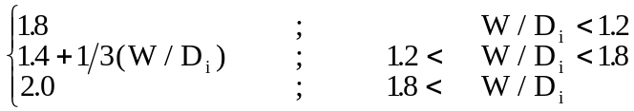 (A.7.3-8)
The inertia coefficient C_{Mi} = 2.0, related to the equivalent volume πD_{i}²/4 per unit length of member, may be applied for all heading angles and any roughness.
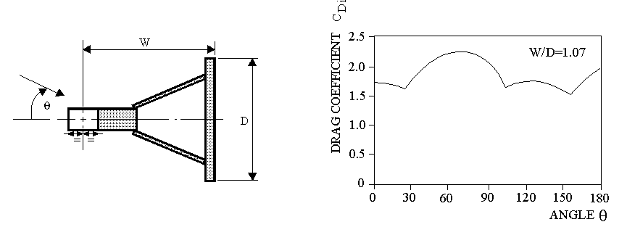
Figure ‎A.7.3-4 — Triangular chord and typical values of C_{Di}
For a triangular chord as shown in Figure ‎A.7.3-4, the drag coefficient C_{Di} related to the reference dimension D_{i} = D, the backplate width, may be taken as:
C_{Di} = C_{Dpr}(θ) D_{pr}(θ) / D_{i} (A.7.3-9)
where the drag coefficient related to the projected diameter, C_{Dpr}, is determined from:
C_{Dpr} = 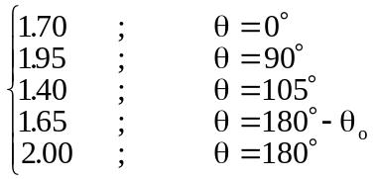 (A.7.3-10)
Linear interpolation is to be applied for intermediate headings. The projected diameter, D_{pr}(θ), may be determined from:
Dpr(θ) = 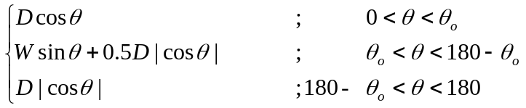 (A.7.3-11)
The angle θ_{o}, where half the rackplate is hidden, θ_{o} = tan⁻¹(D/(2W)).
The inertia coefficient C_{Mi} = 2.0 (as for a flat plate), related to the equivalent volume of πD_{i}²/4 per unit length of member, may be applied for all headings and any roughness.
Shapes, combinations of shapes or closely grouped non-structural items which do not readily fall into the above categories should be assessed from relevant literature (references to be provided) and/or appropriate interpretation of (model) tests. The model tests should consider possible roughness, Keulegan-Carpenter and Reynolds number dependence.
        - Marine growth
Where existing marine growth is not to be cleaned between sites or where the deployment is long enough for significant growth to occur, the influence of growth on the leg hydrodynamic properties should be considered. The influence of marine growth arises through increased drag coefficient due to roughness and density, increased diameter, and their variation with depth. The thickness of marine growth depends on site. Experience in one area of the world cannot necessarily be applied in another. Where possible, site-specific studies should be conducted to establish thickness and depth dependence.
If such data are not available all members below MWL + 2m should be considered to have a marine growth thickness equal to 12.5 mm (i.e. total of 25 mm across the diameter of a tubular member). Marine growth on the teeth of elevating racks and protruding guided surfaces of chords may normally be ignored.
The nominal sizes of structural members, conductors, risers, and appurtenances should be increased to account for marine growth thickness.
The marine growth thickness may be ignored if anti-fouling, cleaning or other means are applied. The surface roughness is still to be taken into account (see SNAME B5-5 Commentary to go in TR).
        - Hydrodynamic models for appurtenances
Raw water caissons on the legs and their guides shall be included in the hydrodynamic model of the structure.
NOTE The guides for raw water caissons can cause a significant increase in the leg drag, especially when they are comprised of high drag sections such as I-beams, flat bar, etc..
Depending upon the type and quantity, appurtenances can significantly increase the global wave actions. Appurtenances, such as stairways, ladders, jetting lines, and anodes, should be considered for inclusion in the hydrodynamic model of the structure.
Appurtenances are generally modelled as additional diameter or hydrodynamic coefficients contributing to the equivalent wave forces.
      - Wave and current actions
        - General
Hydrodynamic actions for deterministic or stochastic analysis may be calculated by formulas, in combination with the hydrodynamic model and appropriate wave theories as described below.
        - Hydrodynamic actions
Wave and current actions on sle nder members having cross sectional dimensions sufficiently small compared with the wave length should be calculated using Morison's equation. Morison's equation is normally applicable providing:
λ > 5D_{i} (A.7.3-12)
where;
λ = wave length and
D_{i} = reference dimension of member (e.g. tubular diameter)
Morison's equation specifies the action per unit length as the vector sum:
ΔF = ΔF_{drag} + ΔF_{inertia} = 0.5 ρ D C_{D} v_{n} ⏐v_{n}⏐+ ρ C_{M} A _{n} (A.7.3-13)
where the terms of the equation are described in the following.
To obtain the drag action, the appropriate drag coefficient (C_{D}) is to be chosen in combination with a reference diameter, including any required additions for marine growth, as described in A.7.3.
The Morison's drag action formulation is:
ΔF_{drag} = 0.5 ρ C_{D} D v_{n} ⏐v_{n}⏐ (A.7.3-14)
where;
ΔF_{drag} = drag action (per unit length) normal to the axis of the member considered in the analysis and in the direction of v_{n}.
ρ = mass density of water (normally 1025 kg/m³).
C_{D} = drag coefficient ( = C_{Di} or C_{De} from A.7.3).
v_{n} = relative fluid particle velocity resolved normal to the member axis.
D = the reference dimension in a plane normal to the fluid velocity v_{n}
( = D_{i} or D_{e} from A.7.3).
The relative fluid particle velocity, v_{n}, may be taken as:
v_{n} = u_{n} + V_{Cn} - α_{n} (A.7.3-15)
where;
u_{n} + V_{Cn} = the combined particle velocity found as the vectorial sum of the wave particle velocity and the current velocity, normal to the member axis.
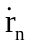 = the velocity of the considered member, normal to the member axis and in the direction of the combined particle velocity.
α = 0, if an absolute velocity is to be applied, i.e. neglecting the structural velocity.
= 1, if relative velocity is to be included. May only be used for stochastic/random wave action analyses if:
uT_{n}/D_{i} ≥ 20
where u = particle velocity = V_{C} + πH_{s}/T_{z}
T_{n} = first natural period of surge or sway motion, and
D_{i} = the reference diameter of a chord.

Note: See also A.10.4.3 for relevant damping coefficients depending on α.
To obtain the inertia force, the appropriate inertia coefficient (C_{M}) is to be taken in combination with the cross sectional area of the geometric profile, including any required additions for marine growth, as described in A.7.3. The Morison's inertia force formulation is:
ΔF_{inertia} = ρ C_{M} A _{n} (A.7.3-16)
where;
ΔF_{inertia} = inertia action (per unit length) normal to the member axis and in the direction of _{n}.
ρ = mass density of water (normally 1025 kg/m³).
C_{M} = inertia coefficient.
A = cross sectional area of member ( = A_{i} or A_{e} from A.7.3)
_{n} = fluid particle acceleration normal to member.
        - Wave models
          - Deterministic waves
For deterministic analyses an appropriate wave theory for the water depth, wave height and period should be used, based on the curves shown in ISO 19901-1 Clause A.8.44. For practical purposes, an appropriate order of Dean's Stream Function or Stokes' 5th (within its bounds of applicability) is acceptable for regular wave elevated storm analysis.
If breaking waves are indicated according to ISO 19901-1 Clause A.8.4, it is recommended that the wave period is changed to comply with the breaking limit for the specified height.
          - Stochastic waves
Time domain analysis is recommended for stochastic wave jack-up analysis. In such analysis the waves are modelled as a linear random superposition model which is fully described by the wave spectrum, (see A.6.4.2.4, A.6.4.2.5, A.6.4.2.6, and A.4.2.7). It is recommended that the random sea state is generated from the summation of at least 200 component Linear (Airy) waves of height and frequency determined to match the required wave spectrum. The phasing of the component waves should be selected at random.
The extrapolation of the wave kinematics to the free surface is most appropriately carried out by substituting the true elevation at which the kinematics are required with one which is at the same proportion of the still water depth as the true elevation is of the instantaneous water depth. This can be expressed as follows:
z' = 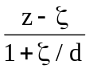 (A.7.3-17)
where;
z' = The modified coordinate to be used in particle velocity formulation
z = The elevation at which the kinematics are required (coordinate measured vertically upward from the still water surface)
ζ = The instantaneous water level (same axis system as z)
d = The still, or undisturbed water depth (positive).

This method ensures that the kinematics at the surface are always evaluated from the linear wave theory expressions as if they were at the still water level, Wheeler (1969) [4] <<be sure to capture reference and reference number for bibliography>> <<see B5-5 Figure C4.4.2 in the Commentary). >>
The statistics of the underlying random wave process are Gaussian and fully known theoretically. The empirical modification around the free surface to account for free surface effects, together with the fact that drag actions are a non-linear (squared) transformation of wave kinematics, makes the hydrodynamic action excitation always non-linear. As a result, the random excitation is non-Gaussian. The statistics of such a process are generally not known theoretically, but the extremes are generally larger than the extremes of a corresponding Gaussian random process. For a detailed investigation of the dynamic behaviour of a jack-up the non-Gaussian effects must be included. A number of procedures for doing this are presented in <<Annex C >>.
When the random displacements of the submerged parts are small and the velocities are significant with respect to the water particle velocities the damping is not well represented by the relative velocity formulation in Morison's equation, which will tend to overestimate the damping and under predict the response. A criterion for determining the applicability of the relative velocity formulation is given in A.7.3.3.2.
A summary of recommendations for the time domain modelling of random waves is given in Table A.10.5-1

-4 - Recommendation for modelling of time domain stochastic waves

          - Directionality and spreading
The effects of directionality and wave spreading may be considered in any random dynamic analysis. It is recommended that a comparison be made between the Base Shear Transfer Function (BSTF) for the chosen 2-D (long crested/unspread) analysis direction and the 3-D (short crested/spread) BSTF to determine whether the selected direction is unconservative. Optimally the direction of the 2-D sea state should be chosen to obtain a match with the 3-D BSTF for the entire wave spectrum. If this is not possible the match between the spread and unspread BSTFs should be good at the natural period.
A 3-D BSTF, H_{3D}, can be generated from a set of 2-D BSTFs, H_{2D}, by the following expression:
H_{3D}(ω) = 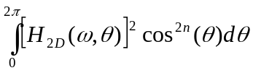 (A.7.3-18)
where:
ω = Wave excitation frequency
θ = Angle between 2-D BSTF and dominant direction of 3-D BSTF
n = Power constant of spreading function
≥ 2.0 for fatigue analysis
≥ 4.0 for extreme analysis
A simple approximation to the incorporation of wave spreading into inertial action calculations is to perform a 2-D analysis with the wave approach angle which is between the two approach angles which give the maximum and minimum forces at the cancellation and reinforcement points (see Figure ?? in Informative Annex C).
<< Review Panel Feb 06 : Add a note giving a simple explanation of the issue and possibly a simplified approach >>
        - Current
The current velocity and profile as specified in A.6.4.3 should be used. Where the current profile is defined by discrete points linear interpolation between the data points is sufficient.
The current induced drag forces are to be determined in combination with the wave actions. This is to be carried out by the vectorial addition of the wave and current induced particle velocities prior to the drag action calculations.
The current may be reduced due to interference from the structure on the flow field of the current, Taylor [5]. ] <<be sure to capture reference and reference number for bibliography>> The current may be reduced as follows (see B5-5 Commentary):
V_{C} = V_{f} [1 + C_{De}D_{e}/(4D₁)]⁻¹ (A.7.3-19)
where;
V_{C} = the current velocity to be used in the hydrodynamic model, V_{C} should be not taken as less than 0.7V_{f}.
V_{f} = the far field (undisturbed) current.
C_{De} = equivalent drag coefficient, as defined in A.7.3.3.
D_{e} = equivalent diameter, as defined in A.7.3.3.
D₁ = face width of leg, outside dimensions.
      - Wind actions
        - Wind action
The wind force for each component (divided into blocks of not more than 15m vertical extent), F_{Wi}, may be computed using the formula:
F_{Wi} = P_{i} A_{Wi} (A.7.3-20)
where;
P_{i} = the pressure at the center of the block.
A_{Wi} = the projected area of the block considered.

The pressure P_{i} should be computed using the formula:
P_{i} = 0.5 ρ V_{zi}² C_{s} (A.7.3-21)

where;

ρ = density of air (to be taken as 1.2224 kg/m³ unless an alternative value can be justified for the site).
V_{zi} = the specified wind velocity at centre of each block A.6.4.6.2.
C_{s} = shape coefficient, as given below.

NOTE The wind area of the hull and associated structures (excluding derrick and legs) may normally be taken as the profile area viewed from the direction under consideration.
        - Shape coefficient
Using a building block of elements the following shape coefficients should be used :

Type of member or  Structure | Shape coefficient  C_{s}
Hull side, (flat side). | 1.0, based on total projected area.
Deckhouses, jack-frame structure, sub-structure, draw-works house, and other above-deck blocks. | 1.1, based on the total projected area (i.e. the area enclosed by the extreme contours of the structure)
Leg sections projecting above jack-frame structure and below the hull. | C_{s} = C_{De} as determined from A.7.3.4 using tubular  C_{DI} = 0.5  A_{Wi} determined from D_{e} and section length.
Isolated tubulars (crane pedestals, etc.) | 0.5
Isolated structural shapes (angles, channels, box, I- sections). | 1.5, based on member projected area.
Derricks, crane booms, flare towers (open lattice sections only, not boxed- in sections.) | The appropriate shape coefficient for the members concerned applied to 50% of the total projected profile area of the item (25% from each of the front and back faces).
Shapes or combinations of shapes which do not readily fall into the above categories will be subject to special consideration.

        - Wind tunnel data
Wind pressures and resulting actions may be determined from wind tunnel tests on a representative model when wind actions are crucial.
    - Functional actions
Provided appropriate procedure exist and it is practical to change the mode of the jack-up unit from operating to elevated storm mode on receipt of an unfavourable weather forecast, only the elevated storm mode need be assessed. Consideration should be given to actions on the conductors if supported by the jack-up.
The following should be defined:
- Actions due to the maximum and minimum elevated weight. In the absence of other information the minimum elevated weight may normally be determined assuming 50% of the variable load permitted by the operating manual.
- Extreme limits of centre of gravity position (or reactions of the elevated weight on the legs) for the conditions in a) above.
- Substructure and derrick position, hook load, rotary load, setback and conductor tensions for the conditions in a) above.
- Weight, centre of gravity and buoyancy of the legs.
If a minimum elevated weight or a limitation of centre of gravity position is required to meet the overturning acceptance criteria (see Clause 13.x.x), then the addition of water in lieu of variable load is permitted, provided that:
- The functional actions do not exceed the operations manual limits.
- Procedures, equipment and instructions exist for performing the operation.
- The action due to the maximum variable load, including added water, is used for all appropriate assessment checks (preload, stress, etc.).
If a reduction in elevated weight or a limitation of centre of gravity position is required to meet the foundation acceptance criteria (see Clause 13.x.x), then the variable load may be limited provided that procedures, equipment and instructions exist for the timely performance of the operation.
<< Do we need the following one-line paragraphs? Can we point directly to the destination from the tables ?? >>>
    - Displacement dependent actions
No guidance offered.
    - Dynamic effects
No guidance offered.
    - Earthquake
No guidance offered.
    - Other actions
Other actions should be represented as relevant for the site.
For areas where icing may occur in the season for the planned operation the possible effect on weight and the environmental actions should be considered. Relevant data for the region should be applied. For calculating wave, current and wind actions, increases in dimension and changes in shape and surface roughness may be of significance.
  - Structural modelling
    - Applicability
This clause describes methods for the development of an analytical model of an independent leg jack-up. Techniques for modelling the legs, hull, leg/hull connection, and leg/spudcan connection are discussed. The leg/hull connection model includes the upper and lower guides, jacking pinions, fixation systems, and jackcase/associated bracing. Modelling of the foundation is limited to the structural details in this clause; geotechnical aspects are presented in A.9.
Because of the interaction of the mass and stiffness models e.g. the effect of mass modelling on hull sag, it is recommended that the analyst is familiar with the whole of this clause before commencing the modelling.
    - Overall considerations
      - General
No guidance offered
      - Modelling philosophy
The structural model should accurately reflect the complex mechanism of the jack-up so, for most jack-up configurations, this requires the use of a Finite Element (FE) computer model.
      - Levels of FE modelling
While it can be considered desirable to fully model the jack-up when assessing its structural strength this is rarely necessary for a site assessment. An overly complex model can introduce errors and unnecessarily complicate the assessment. Consequently assumptions and simplifications such as equivalent hull, equivalent leg, etc. are often made when building the model(s) used for the assessment. In view of this, various levels of modelling described in a) through d) below can be used. It should be noted that some of these methods have limitations with respect to the accuracy of assessing the structural adequacy of a jack-up. Table A 8.2-1 outlines the limitations of the various modelling techniques and should be referenced to ensure that the selected model addresses all aspects required for the assessment. When simplified models such as those described in (b) and (d) are used, it is usually appropriate to calibrate them against a more detailed model.

- Fully detailed leg model
The model consists of 'detailed legs', hull, leg/hull connections and spudcans modelled in accordance with A.8.3.2, A.8.4, A.8.5 and A.8.6, respectively. The results from this model can be used to examine all aspects of a jack-up site assessment including foundation stability requirements, overturning resistance, leg strength and the adequacy of the jacking system or fixation system.
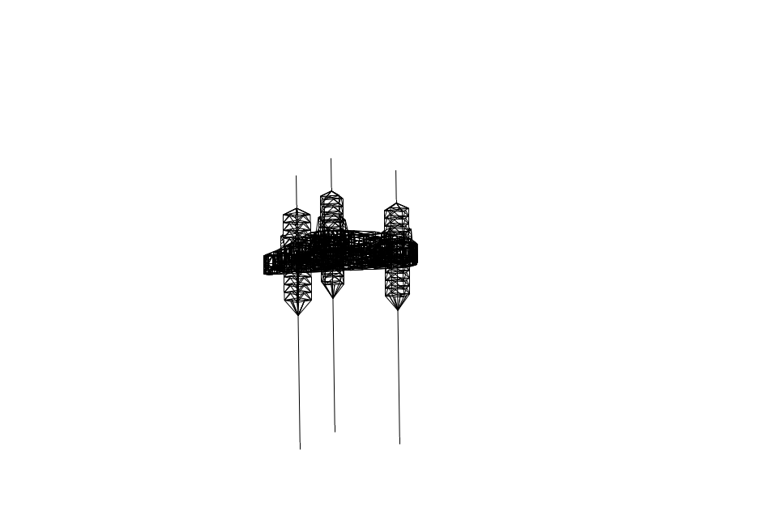
Figure A.8.2-1- Combined equivalent/detailed leg and hull model
- Equivalent leg (stick model)
The model consists of 'stick model' legs in accordance with A.8.3.3, hull structure modelled using beam elements in accordance with A.8.4.3, leg to hull connections modelled in accordance with A.8.5 and spudcans modelled as a stiff or rigid extension to the equivalent leg. The results from this model can be used to examine foundation stability requirements and overturning resistance. This model may also be used to obtain reactions at the spudcan and internal forces and moments in the leg at the vicinity of the lower guide for application to the 'detailed leg' and leg/hull model (d) which should be used to assess the strength of the leg in the area between lower and upper guides.
- Combined equivalent/detailed leg and hull model
The model consists of a combination of 'detailed leg' for the upper portion of legs and 'stick model' for the lower portion of the legs modelled in accordance with A.8.3.4. The hull, leg/hull connections and spudcans are modelled in accordance with A.8.4, A.8.5 and A.8.6 respectively. The results from this model can be used to examine foundation stability requirements, overturning resistance, leg strength in the region of the leg/hull connections and the adequacy of the jacking and/or fixation systems.
- Detailed single leg and leg/hull connection model
The model consists of a 'detailed leg' or a portion of a 'detailed leg' modelled in accordance with A.8.3.2, the leg/hull connection modelled in accordance with A.8.5 and, when required, the spudcan modelled in accordance with A.8.6. The results from this model can be used to examine the leg strength and the adequacy of the jacking and/ or fixation systems.
Table A 8.2-1 — Applicability of the suggested models
 | Applicability
Model  Type | I  Base shear and overturning moment | II  Overturning  Checks | III  Foundation  Checks | IV  Global  Leg  forces | V  Leg  Member  forces | VI  Jacking /  Fixation  System reactions | VII  Hull  Element  forces
a) Fully detailed leg | Y | Y | Y | Y | Y | Y | See note1
b) Equivalent leg (stick model) | Y | Y | Y | Y | - | - | -
c) Combined equivalent / detailed leg and hull | Y | Y | Y | Y | Y | Y | See note1
d) Detailed single leg and leg/hull connection model | - | - | - | - | Y | Y | -

Legend:
Y = Applicable
- = Not applicable
Notes:
  - Hull stresses will only be available from more complex hull models.
    - Modelling the leg
      - General
For truss legs the model(s) may be generated in accordance with the applicable following subclause(s). Single column legs may modelled with beam elements (in accordance with A.8.3.3 or by means of other appropriate finite elements with due consideration for local and global buckling.
      - Detailed leg
Modelling should account for offsets between member work points and centroids as omitting this detail can be non-conservative. If member offsets are not included in the model, analysis of the relevant joints should consider their effect. Gusset plates may be ignored in the structural leg model. However their effects may be taken into account in the calculation of member and joint strength.
      - Equivalent leg (stick model)
The leg structure can be simulated by a series of collinear beams with the equivalent cross sectional properties calculated using the formulae indicated in Figure A.8.3-1 or derived from the application of suitable 'unit' load cases to the 'Detailed Leg'. The stiffness properties of the equivalent leg shall equate to those of the ‘detailed leg’ model described above. The simplified formulae indicated below may be used to calculate stiffness properties. Where such a model is used, analysis results must be combined with a detailed leg model to determine member stresses, fixation system/pinion forces, etc.
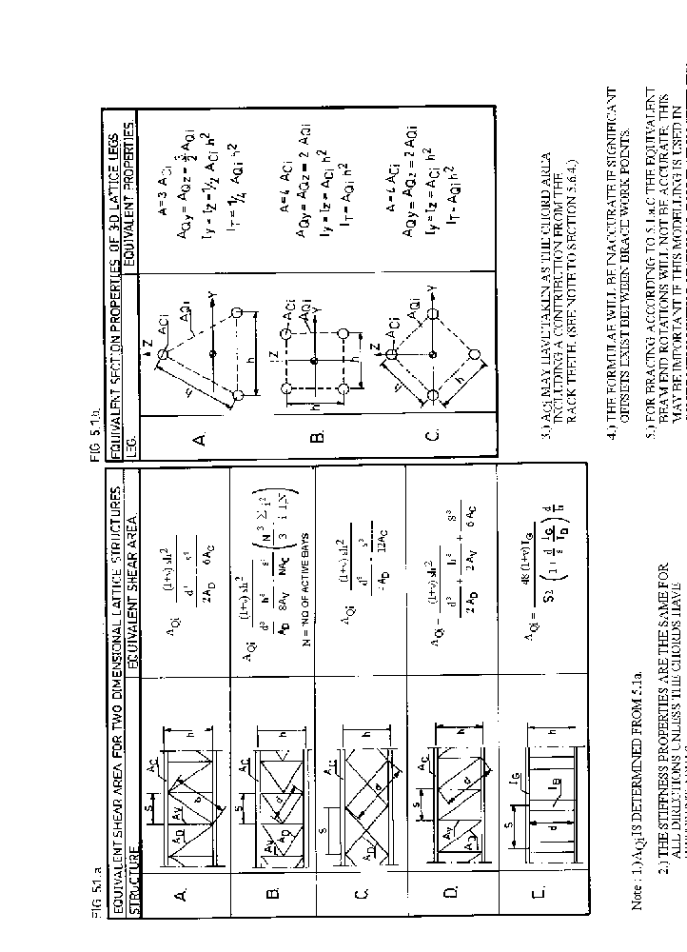
Figure A.8.3-1: Formulas for the determination of equivalent member properties;
(Reference DNV Class Note 31.5 1992 [6] (corrected))
The determination of stiffness for the equivalent leg model referred to above may be accomplished as outlined below:
Equivalent leg stiffness
- Hand calculations using the formulae presented in Figure A.8.3-1. Provided that there are no significant offsets between the brace work points these will be reasonably accurate for cases A (sideways K bracing), C (X bracing) and D (Z bracing); case B (normal K bracing) should be used with caution as the values of equivalent shear area and second moment of area are dependent on the number of bays being considered. If the leg scantlings change in different leg sections this can be accounted for by calculating the properties for each leg section and creating the equivalent leg model accordingly.
- The application of unit load cases to a detailed leg model prepared in accordance with 8.3.2 and 8.3.5 and rigidly restrained at the first point of lateral force transfer between the hull and leg. The analyst may find it more convenient to use a different reference point e,g, chock level or neutral axis of the hull. The following load cases should be considered, applied about the major and minor axes of the leg:
- Axial 'unit' load case. This is used to determine the axial area, A, of the equivalent beam according to standard theory:
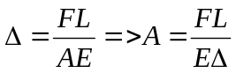
where;
Δ = axial deflection of cantilever at point of force application
F = applied axial action
L = cantilevered length (from the hull to seabed reaction point – see A.8.6.2)
E = Young's modulus
- Pure moment applied either as a moment or a couple. This is used to derive the second moment of area (I) according to standard beam theory:
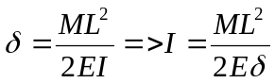 and 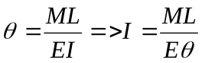
where;
δ = lateral deflection of cantilever at the point of moment application
M = applied moment
θ = slope of cantilever at point of moment application
It should be noted that the value of I resulting from the two equations can differ somewhat.
- Pure shear, P, applied at the end of the leg which may be used to derive I according to standard beam theory:
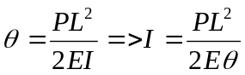
Using either this value of I, or a value obtained from the pure moment case, the effective shear area, As, can then be determined from:
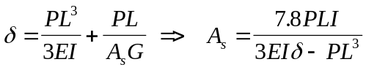
where;
G = shear modulus = E/2.6 for Poisson’s ratio of 0.3
      - Combination detailed and equivalent leg
The combined detailed and equivalent leg model shall be constructed with the areas of interest modelled in detail and the remainder of the leg modelled as an equivalent leg. To facilitate obtaining detailed stresses in the vicinity of the leg/hull connection (guides, fixation/jacking system, etc.), the detailed portion of the leg model should extend far enough above and below this region to ensure that boundary conditions at the ‘detailed leg’/‘equivalent leg’ connection do not affect stresses in the areas of interest. Care is required to ensure an appropriate interface and consistency of boundary conditions at the connections.
The plane of connection between ‘detailed leg’/‘equivalent leg’ should remain a plane and without shear distortion when the leg is bent. The connection should be composed of rigid elements that control local bending and shear distortion.
      - Stiffness adjustment
No Guidance is offered
      - Leg inclination
No guidance offered
    - Modelling the hull
      - General
Recommended methods of modelling the hull structure are given in the following subclauses:
      - Detailed hull model
The model shall be generated using plate elements in which appropriate directional modelling of the effect of the stiffeners on the plates shall be included. The elements shall be capable of carrying in-plane and, where applicable, out of plane moment and shear.
      - Equivalent hull model
The deck, bottom, side shell and major bulkheads are modelled as a grillage of beams in an equivalent hull model. The properties of the beams should be calculated based on the depth of the bulkheads, side-shell and the ’effective width’ of the deck and bottom plating. Beam elements should be positioned with their neutral axes at mid-depth of the hull. Attention should be paid to the in-plane and torsional properties due to the continuity of the deck and bottom structures. << calculate torsional property of box and divide amongst the grillage members>>
      - Hull mass model
<< ERP Jan 2007: Add forward reference to A.8.8.3 re hull sag & A.8.7 mass modelling>> ?? There is no corresponding normative clause 8.4.4.

Modelling the leg/hull connection
      - General
The leg/hull connection modelling is of extreme importance to the analysis since it controls the distribution of leg bending moments and shears carried between the upper and lower guide structures and the jacking or fixation system. It is therefore necessary that these systems are properly modelled in terms of stiffness, orientation and clearance. For the equivalent stick-leg model a simplified derivation of the equivalent leg/hull connection stiffness may be applicable.
A specific jack-up design concept can be described by a combination of the following components (see also Figure A.8.5-1):
- With or without fixation system,
- Opposed or unopposed jacking pinions (see Figure A.8.5-2),
- Fixed or floating jacking system.
LEG-HULL CONNECTION
No Fixation System
Opposed Pinions
Fixed Jacking System
Floating Jacking System
Unopposed Pinions
Fixed Jacking System
Floating Jacking System
Fixation System
Opposed Pinions
Fixed Jacking System
Floating Jacking System
Unopposed Pinions
Fixed Jacking System
Floating Jacking System
F&G
- L780 II
- JU 2000
- Alpha 350
- Super M2
- Universal M class
Hitachi
- Giant class
GustoMSC
- CJ 46
- CJ 50
Keppel FELS
- KFELS Mod V
- KFELS Mod VI
- A Class
- B Class
- N Class
LeTourneau
- Super GORILLA
- Super GORILLA XL
- Jaguar 250-C

GustoMSC
- CJ36
- CJ46
- CJ50
- CJ54
- CJ62
- CJ70

Modec
- 300c
- 400
Baker Marine
- Pacific 375
- 200 I.C.
LeTourneau
- WORKHORSE
- TARZAN

GustoMSC
- CJ 50
CFEM
- 2005
- 2600
Levingston
- 111C

LeTourneau
- 53
- 84
- 82-SD-C
- 116C
- Super 116
- Super 116E
- Super 300
- Gorilla
Baker Marine
- Freedom class
- 350
- 300
- 250
- 200
- 150
GustoMSC
- Gusto designs
Example of Units in this category

MSC CJ50 is floating but has rack-chocks; Gustos are in other categories (The latest CJ 46 and CJ 50 classed with ABS have fixed jacking systems.)…
Figure A.8.5-1- Leg/hull connection component combinations
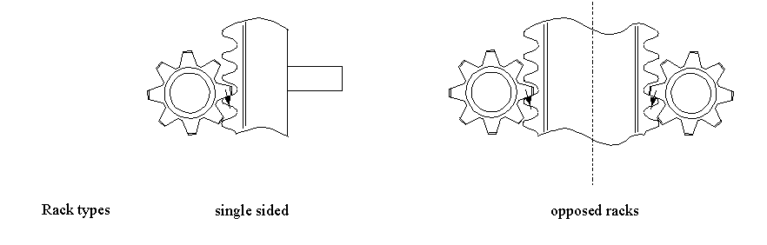
Figure A.8.5-2 : Unopposed and opposed pinion arrangements
<< List needs to be updated/corrected for modern JU’s >>
A representative leg-hull connection is shown in Figure A.8.5-3. The basic function of the leg-hull connection is to transfer forces between the leg and hull as follows:
1) horizontal shear is transferred by a set of horizontal forces in the lower guides
2) vertical force is transferred via a set of vertical forces in the support system.
3) bending moment is transferred by a combination of horizontal forces in the upper and lower guides and/or by a set of vertical forces in the support system
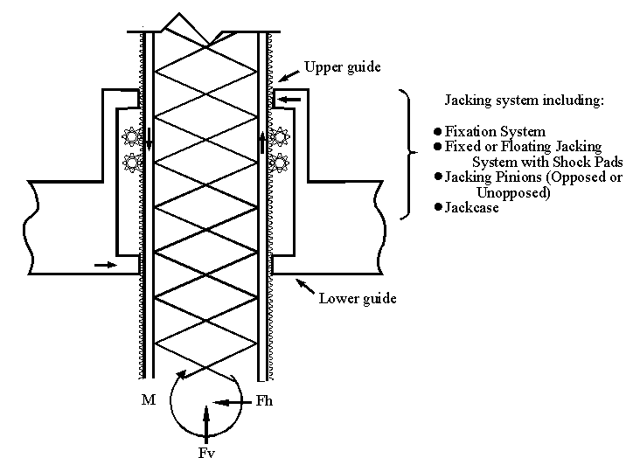

Figure A.8.5-3: Representative leg-hull connection
<< Show effect of shear increasing LG reaction and V increasing LH vertical reaction v/s RH vertical reaction (or do them as separate components) >>
For jack-ups with a fixation system, the leg bending moment will be shared by the upper and lower guides, the jacking system and the fixation systems. Normally the leg bending moment and axial force at the leg to hull connection due to the environmental actions are transferred largely by the fixation system because of its high rigidity. Depending on the specified method of operation, the stiffnesses, the initial clearances and the magnitude of the applied forces, a portion of the environmental leg loading can also be transferred by the jacking system and the guide structures. After the fixation systems are engaged, some jackups will release the pinions by disengaging the jacking system. Under this condition, the leg bending moment will only be shared by the upper and lower guides and the fixation systems. Typical shear force and bending moment diagrams for this configuration are shown in Figure A.8.5-4.
For jack-ups without a fixation system, the leg bending moment transfer will be shared by the jacking system and guide structure. For a fixed jacking system, the distribution of leg moment carried between the jacking system and guide structure mainly depends on the stiffness of the jacking pinions. Typical shear force and bending moment diagrams for this configuration are shown in Figures A.8.5-5 and A.8.5-6.
For a floating jacking system, the distribution of leg bending moment transfer between the jacking system and guide structure depends on the combined stiffness of the shock pads and pinions. Typical shear force and bending moment diagrams for this configuration are shown in Figure A.8.5-7.
The leg/hull connection should be modelled considering the effects of guide and support system clearances, wear, construction tolerances and backlash (within the gear-train and between the drive pinion and the rack).
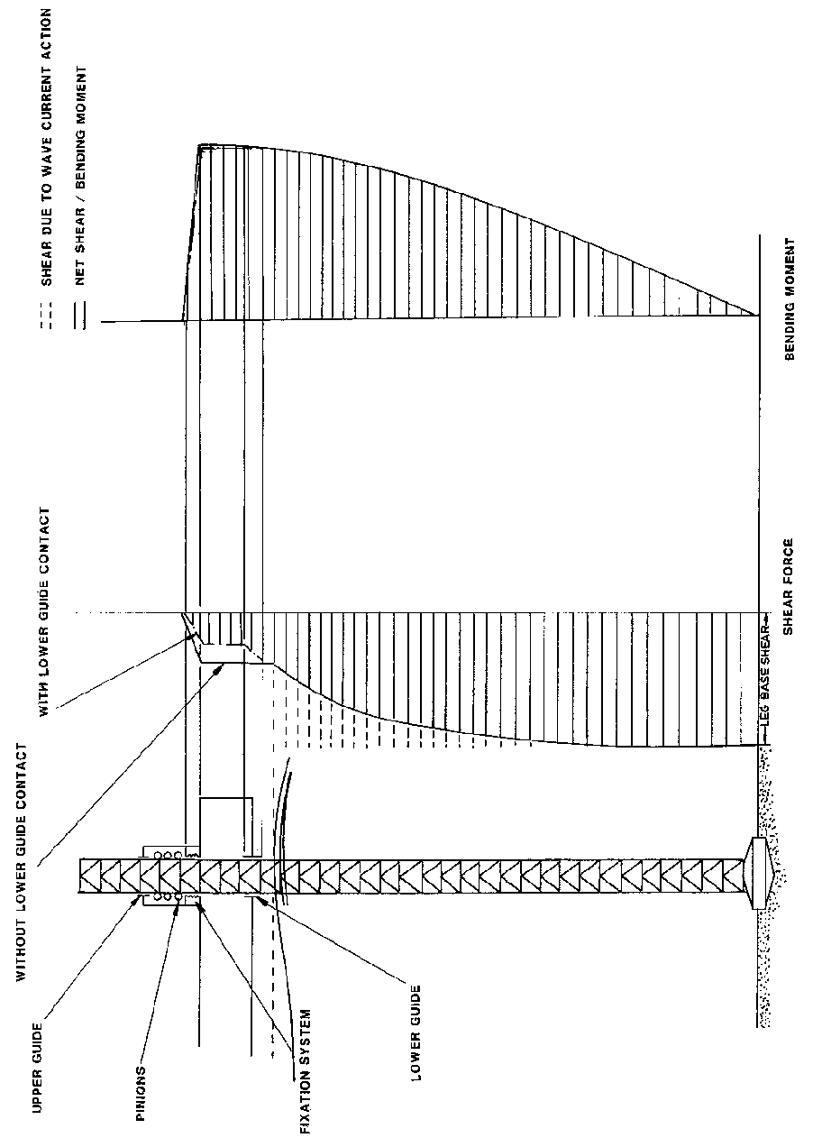
Figure A 8.5-4: Leg shear force and bending moment - jack-ups with a fixation system

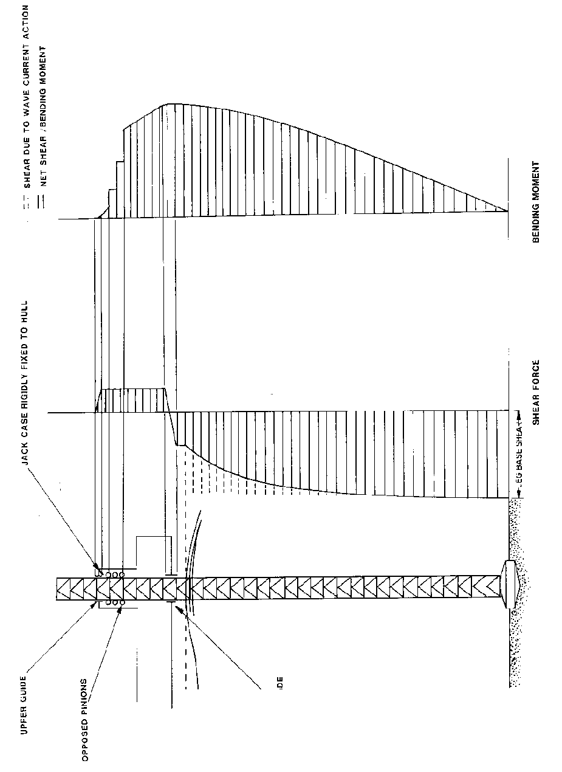

Figure A 8.5-5: Leg shear force and bending moment - jack-ups without a fixation system and having a fixed jacking system with opposed pinions

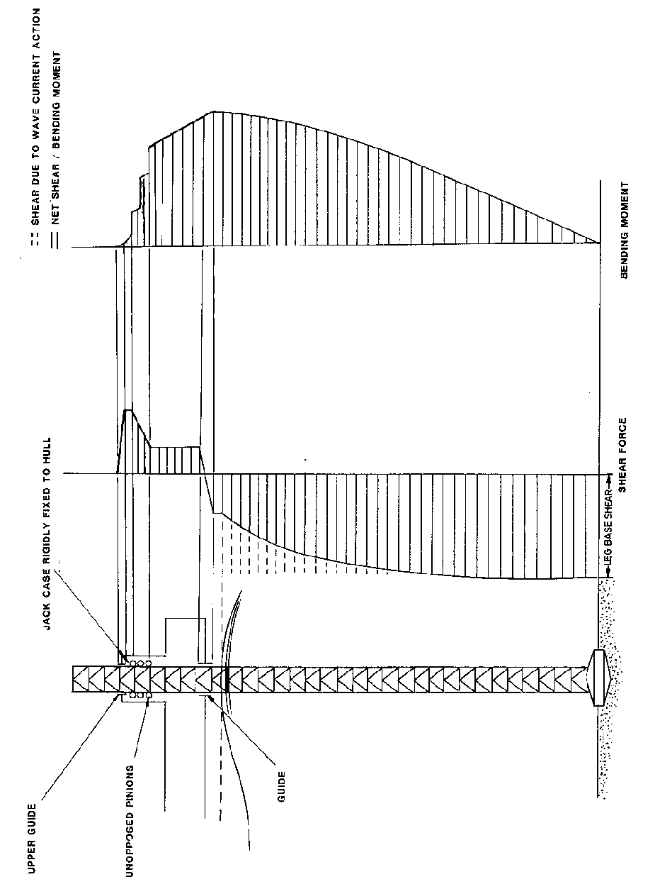
Figure A.8.5-6: Leg shear force and bending moment - jack-ups without a fixation system and having a fixed jacking system with unopposed pinions

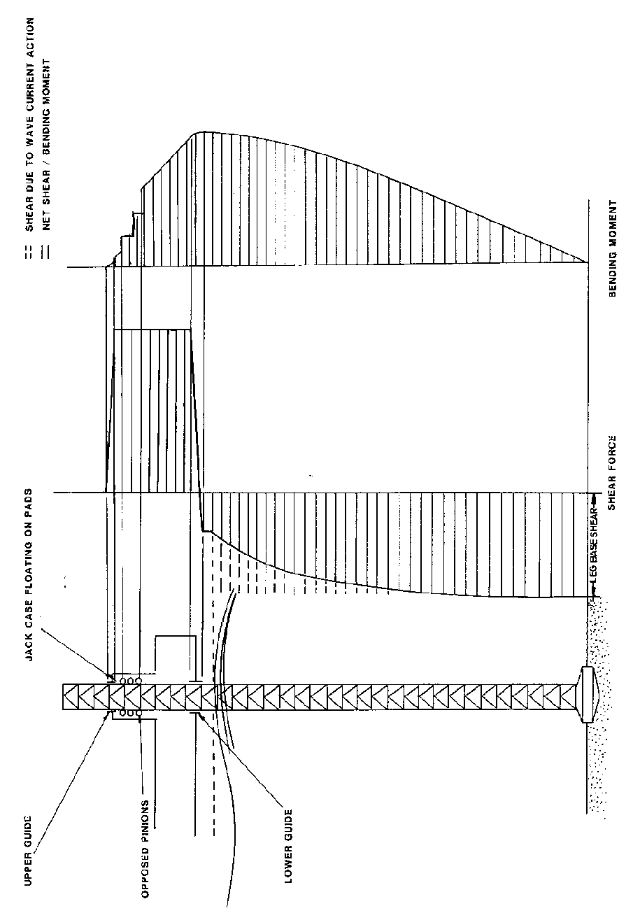

Figure A.8.5-7: Leg shear force and bending moment - jack-ups without a fixation system and having a floating jacking system

If the jacking system has unopposed pinions, local chord moments will arise due to:
- The horizontal pinion force component (due to the pressure angle of the rack/pinion).
- The vertical pinion force component acting at an offset from the chord neutral axis.

The following techniques are recommended for modelling leg/hull connections (specific data for the various parts of the structure can be available from the design data package):
      - Guide Systems
The guide structures shall be modelled to restrain the chord member horizontally only in directions in which guide contact occurs. The upper and lower guides may be considered to be relatively stiff with respect to the adjacent structure, such as jackcase, etc. The nominal lower guide position relative to the leg can be derived using the sum of leg penetration, water depth and hull elevation. It is however recommended that at least two positions are covered when assessing leg strength: one at a node and the other at midspan. This is to allow for uncertainties in the prediction of leg penetration and possible differences in penetration between the legs.
The finite lengths of the guides may be included in the modelling by means of a number of discrete restraint springs/connections to the hull. Care is required to ensure that such restraints carry reactions only in directions/senses in which they can act. Alternatively the results from analyses ignoring the guide length may be corrected, if necessary, by modification of the local bending moment diagram to allow for the proper distribution of guide reaction, see Figure A.8.5-8.
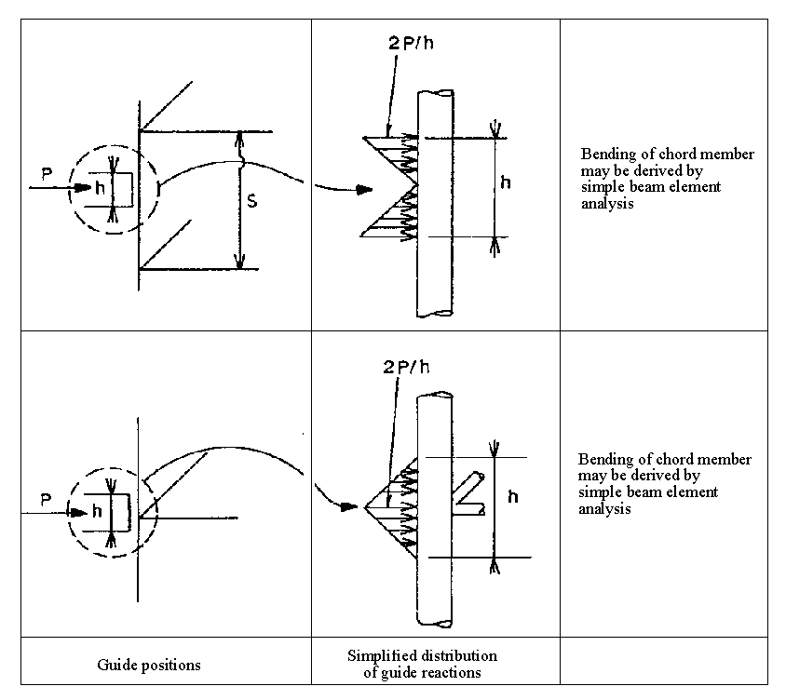
Figure A.8.5-8: Correction of point supported guide model for finite guide length

      - Elevating system
        - Jacking (or elevating) pinions
The jacking pinions shall be modelled based on the pinion stiffness specified by the manufacturer and should be modelled so that the pinions can resist vertical and the corresponding horizontal forces. A linear spring or cantilever beam can be used to simulate the jacking pinion. The force required to deflect the free end of the cantilever beam a unit distance should be equal to the jacking pinion stiffness specified by the manufacturer. The offset of the pinion/rack contact point from the chord neutral axis should be incorporated in the model.
        - Other
Elevating system designs not included above shall be modelled using stiffness values obtained from the manufacturer/designer, by appropriate system testing or by rational analysis with due consideration of member interface gap spacing and mechanical component stiffness.
      - Fixation system
The fixation system shall be modelled to resist both vertical and horizontal forces based on the stiffness of the vertical and horizontal supports and on the relative location of their associated foundations. It is important that the model can simulate the local moment capacity of the fixation system arising from its finite size and the number and location of the supports.
      - Shock pad – floating jacking systems
Floating jacking systems generally have two sets of shock pads at each jackcase, one located at the top and the other at the bottom of the jackhouse. Alternatively shock pads can be provided for each pinion or block of pinions. The jacking system is free to move up or down until it contacts the upper or lower shock pad. In the elevated condition, the jacking system is in contact with the upper shock pad and in the transit condition it is in contact with the lower shock pad. The stiffness of the shock pad should be based on the manufacturer's data and the shock pad should be modelled to resist vertical force only. It should also be noted that the shock pad stiffness characteristics are normally non-linear.
      - Jackcase and associated bracing
The jackcase and associated bracing should be modelled based on the actual stiffness since it has direct impact on the horizontal forces that the upper guide can resist.
If the hull is not modelled it is normally suitable to restrain the base of the jackcase and associated bracing, the foundations of the fixation system and the lower guide structures at their connections to the hull.
      - Equivalent leg/hull stiffness
The determination of stiffnesses for the equivalent leg/hull connection model referred to in 8.5.7 may be accomplished the following means:
- Hand calculations using the formulae presented in Figure A.8.3-1
- The application of unit load cases to a detailed leg model in combination with a detailed leg/hull connection model in accordance with 8.3.2 and 8.5. Unit load cases are applied, as described in A.8.3.3. In this instance the differences between the results from the detailed leg model alone (see A.8.3.3) and the detailed leg plus leg/hull connection model allow the effective stiffness of the connection to be determined:
  - Axial 'unit' load case. This is used to determine the vertical leg/hull connection stiffness, K_{vh} from the axial end displacements of the detailed leg model, Δ, and the axial end displacements of the combined leg and leg/hull connection model, Δ_{C}, under the action of the same 'unit' load case, F:
K_{vh} = F/(Δ_{C}-Δ)
  - Pure moment applied either as a moment or a couple. This is used to derive the rotational connection stiffness, K_{rh} from either the end slopes, θ and θ_{C}, or the end deflections, δ and δ_{C}, of the two models under the action of the same end moment, M:
K_{rh} = M/(θ_{C}-θ) or K_{rh} = ML/(δ_{C}-δ)
  - Pure shear which can be used to determine the horizontal leg/hull connection stiffness, K_{hh}, in a similar manner, accounting for the rotational stiffness already derived. Normally the horizontal leg/hull connection stiffness can be assumed infinite.
If the model contains non-linearities due to the inclusion of gap elements care should be taken to ensure that suitable levels of 'unit' load case are applied such that the derived stiffness is applicable to the analysis to be undertaken.
    - Modelling the spudcan and foundation
      - Spudcan structure
When modelling the spudcan, rigid beam elements are considered sufficient to achieve an accurate transfer of the seabed reaction into the leg chords and bracing in the area between upper and lower guides. It should be noted that, due to the sudden change in stiffness, these rigid beams can cause artificially high stresses at the leg to spudcan connections. Hence the modelling and selection of element type should be carefully considered when an accurate calculation of leg member stresses is required in this area.
For a strength analysis of the spudcan and its connections to the leg it can be appropriate to develop a separate detailed model with appropriate boundary conditions.
      - Seabed reaction point
The vertical position of the reaction point at each spudcan shall be located at a distance above the spudcan tip equivalent to:
- Half the maximum predicted penetration (when spudcan is partially penetrated), or
- Half the height of the spudcan (when the spudcan is fully penetrated)
- If detailed information exists regarding the soils and spudcan the position of the reaction point may be calculated. (Brekke et al)<<should this be referenced in the foundation section – check with Panel 4???>>
The legs of an independent leg jack-up may be assumed to be pinned at the reaction point. Any divergence from this assumption should be clearly stated together with the assumptions for any moment fixity provided to the leg's cans by the soil.
The horizontal position (eccentricity) of the reaction point used in the analysis shall be established through consideration of spudcan geometry and seabed topology under the action of preload.
Non-symmetrical geometries shall be specially considered.
Note: Situations leading to horizontal eccentricity can result from spudcan geometry, sloping seabeds, bottom obstructions, existing spudcan holes, etc.
Further discussion on seabed reaction is contained in Clause 9.
      - Foundation modelling
Methods of establishing the degree of rotational restraint, or fixity, at the spudcans are discussed further in Clauses 9 and A.9. Upper or lower bound values should be considered as appropriate for the areas of the structure under consideration.
For checking the spudcans, the leg-to-can connection and the lower parts of the leg, appropriate calculations considering soil-structure interaction shall be carried out to determine the upper bound spudcan moment. These areas may be checked assuming that a percentage of the maximum storm leg moment at the lower guide (derived assuming a pinned spudcan) is applied to the spudcan together with the associated horizontal and vertical forces. This percentage would normally be not less than 50%. For such simplified checks the spudcan-soil interaction may be modelled assuming that the soil is linear-elastic and incapable of taking tension.
For seismic modelling the intent is to use the simplest, adequate spudcan-soil models. These models should incorporate the basic maximum stiffnesses and capacities in Clause 9, which are generally suitable for seismic environments. As an example, one would not anticipate using soil stiffness degradation models in a screening analysis. More detailed spudcan-soil interaction representations may be used as necessary.
    - Mass modelling
Care should be taken when modelling the hull mass to ensure that the horizontal distribution of mass is correct as it will affect the yaw response. This is important particularly in fatigue analysis. The cantilever position should be considered when distributing the mass. The vertical and horizontal distribution of mass is important in seismic analysis.
If the mass model is also used for load distribution (e.g. when a simplified model is used to develop the dynamic response in association with non-linear foundations) then the approach taken to mass modelling should be carefully considered. See A.8.8.2 & A.8.8.3. << ERP Nov 2007 to P3: Please re-write so the intent is clear. Doug thinks this means the functional spudcan moment could be important in a non-linear spud-can model >>
    - Application of actions and action effects
      - Assessment actions

The assessment follows a partial factor format. The partial action factors are applied to actions as defined in other clauses (i.e. they are action factors, NOT action-effect factors). The jack-up response is non-linear, and hence the application of the combined factored actions will not in general develop the same result as the factored combination of individual action effects.
The actions and action effects are discussed in turn below.
Functional actions due to f
ixed load and variable load
The actions on the hull due to fixed load and variable load should be applied to the model in such a manner as to represent their correct vertical and horizontal distribution. If dynamic analyses are to be performed all weights should be represented by means of masses together with vertical gravitational acceleration. It is generally appropriate to apply these masses by means of factored element self-weight with additional correction masses applied as necessary to obtain the correct total mass and centre of gravity. Alternatively, it may be sufficient to apply point masses at the node points of the model.
NOTE 1 In benign areas the ULS environment is sometimes within the defined SLS limits for the jack-up and the environmental conditions will not exceed the limits for changing to the elevated storm mode. In such cases the assessment should be for the ULS environment and the proposed operating mode configurations e.g. with increased variable load, cantilever extended and unequal leg loads. Individual leg reactions under the functional actions can approach the preload reaction. A small additional leg reaction due to environmental actions can then result in additional spudcan penetration.
NOTE 2 When the operations manual permits increases in the variable load with reducing environmental conditions the assessor should evaluate the ULS for a operational environments and/or lower return periods. This is of particular importance in areas where significant additional penetrations are possible.

Hull sagging
When a jack-up is installed on site the legs will normally engage the seabed with the hull supported by its own buoyancy in a hogged condition. Subsequently, with the hull slightly clear of the water, preload ballast will be taken on board thus preloading the legs to achieve their final penetration. This will normally lead to an extreme hull sagging condition. Finally the preload ballast is dumped and the hull elevated to the required elevation for the site. In this condition the hull will be sagging under self-weight and variable load.
The leg shear and bending moments caused by hull sagging are very dependent on leg guide clearances, the design and operation of the jacking system, operational parameters and the modelling used in the analysis. Such moments should be considered in the site assessment analyses, and will be larger in shallow waters where the leg extension below the hull is small and consequently the leg bending stiffness is higher.
An F.E. model with distributed hull stiffness and distributed functional actions will incorporate hull sag effects if the functional actions are applied to the jack-up in its initially undeflected shape at the operating hull elevation. It should be verified that the amount of hull sag moment arising is applicable, given the operating procedures pertaining to the jack-up. It may be necessary to apply corrections to the final results for any discrepancies in the hull sag induced forces.
A simplified approach for a conservative quantitative assessment is to assume that 25 to 50 percent of the theoretical hull sagging moment at the lower guide is seen in practice. This may be accounted for in a global model by reducing the distributed hull mass by 75 to 50 percent and applying the residual mass as point masses on the hull adjacent to the connections to the legs. This procedure is not applicable when hull stresses are required. A more thorough method is to apply self equilibrating pairs of forces/moments across the spring connections between hull and legs:
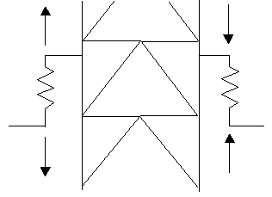
An alternative approach is to allow a relaxation of the horizontal seabed restraint by means of prescribed displacements.
      - Environmental actions
        - Wind actions
Wind loading is determined from 7.3.4. The wind actions on the legs above and below the hull should be modelled to represent the correct vertical and horizontal distribution. Actions can be applied as distributed or nodal actions. Where nodal actions are used, a sufficient number should be applied to reflect the nature of the loading, and it should be ensured that the correct total shear and overturning moment are applied on each leg.
Similarly, the wind loading on the hull and associated structure may be applied as distributed or nodal actions. The application should also ensure the correct total shear and overturning moment are applied to the hull.
        - Wave/current actions
Wave/current actions are determined from 7.3.3. The wave/current actions on the leg and spudcan structures above the sea floor should be modelled to represent their correct vertical and horizontal distribution. Where nodal actions are used, their application should ensure the correct total shear and overturning moment on each leg, and reflect the distributed nature of the loading.
      - Inertial actions
When the dynamic approach (see Clause 10) leads to the explicit determination of an inertial loadset, this should be applied to the model and should produce the incremental inertial force that is superimposed on the static storm actions to generate total base shear and overturning moment. The point(s) of application may be varied to match the base shear and best approximate the OTM while distributing the actions to avoid local stress concentrations. If a small correction to the OTM is required, this may be accomplished by applying a correcting moment as a horizontal or vertical couple in the hull (although these may cause additional stress in the hull structure).
Where the analysis result is intended for assessing the hull, the correction to the OTM may be accomplished by applying a concentrated moment at the base of the leg to avoid over-predicting the hull stresses (although this may cause inaccuracies in the foundation model for other than pinned conditions)
It is generally preferred to apply the OTM correction couple in the hull because leg and foundation forces are of primary concern for site-specific analysis and application of moment to the base of the leg will directly affect internal leg forces. If the correcting moment is larger than 10% of the dynamic OTM, then an alternative modelling approach may be necessary. <<Brad & Doug agree the number is 10-20% for deep water cases>>
      - Large displacement effects
<< ERP Jan 2007: Introduction required from P3 >> There are two displacement effects to be captured
- lateral displacement of the hull causes the functional actions to increase global OTM, and
- Euler amplification of local member forces increases member stresses.
The analyst should be cognizant of how specific software includes these effects. Global displacement effects are normally accounted as below. Euler amplification is frequently accounted for in member code checks. Some methods account for only global effects while other methods account for both.
- Large displacement methods
For large displacement methods the solution is obtained by applying the load case in increments and iteratively generating the stiffness matrix for the next load case increment from the deflected shape of the previous increment. This method accounts for both global displacement and Euler amplification effects. The member check equations should be modified to avoid duplication of the Euler effect.
- Geometric stiffness methods
Geometric stiffness methods apply a linear correction to the stiffness matrix based on the axial force present in the element. << Caution needs to be exercised to understand specifically what the user’s software includes in this method. Further investigation is required. >>
- Negative spring method
A simplified geometric stiffness approach allows incorporation of P-∆ effects in a standard linear-elastic F.E. program without recourse to iteration (refer to TR A.8 for derivation). In this approach a correction term is introduced into the global stiffness matrix prior to analysis. When the analysis is complete the hull deflections, leg axial forces and leg bending moments will include the P-∆ effects. The derivation of the method is described in TR A.8.
The correction term is: -P_{g}/L
where;
P_{g} = The sum of the leg forces due to functional actions on legs at hull. This should include the weight of the legs above the hull.
L = The distance from the spudcan reaction point to the hull vertical center of gravity.
This single (negative) value is incorporated into the global stiffness matrix by attaching a pair of orthogonal horizontal translational earthed spring elements to a node representing the hull center of gravity and entering the negative value for each of the spring constants. Some F.E. packages allow direct matrix manipulation.
The negative stiffness term at the hull will produce an additional lateral force at the hull proportional to the structural deflection. The resulting (additional) base overturning moment will be equal to P_{g} times the hull displacement.
The additional lateral force (due to the negative stiffness term) will cause an over-prediction of the base shear (in global axes). Typically this is not critical. However, the base shear at each leg can be reduced by an amount equal to the difference between the total base shear and the shear due to the applied actions (both in global axes) divided by the number of legs.
The application of negative springs to the model accounts for global displacement effects but does not include Euler effects for individual members and code checks must include appropriate terms to account for amplification of local moments.
      - Conductor actions
The conductor tension is modelled as a static force; and when applicable, the hydrodynamic action is included in the jack-up’s global analysis model. An explicit model of the conductor is rarely warranted. Hydrodynamic action from the conductor should be modelled such that the effective line of action is through the support point on the hull.
The effects of stiffness and damping in the conductor are not generally modelled in a jack-up structural assessment because they are often considered to have negligible influence on the global jack-up response.
Structural integrity assessment of an individual conductor is outside the scope of this document.
      - Earthquake actions
No guidance offered

  - Foundations
<< ERP Nov 2007:
When determining V_{Lo} from F_{v} (the capacity of the base of an open hole to the depth of the bearing area) the backflow, buoyancy due to volume of soil displaced (using submerged soil weight) and any infill at the time of preloading must be taken into account; V_{Lo} is then equal to the net vertical reaction on the leg required for equilibrium of the structure at the final stage of preloading, assuming the structural model includes effects of full steel weight and water buoyancy of legs and spudcans.
The V_{Lo} term used in the envelope must be reduced to account for infill after the preloading. Q_{V} needs to be defined such it is the net vertical reaction on the leg required for equilibrium of the structure, assuming the structural model includes effects of full steel weight and water buoyancy of legs and spudcans. >>
Note: the Q’s and F’s in the above use the existing notation; it is understood that GTH will be switching them for harmonisation with ‘common usage’ & 19902. >>
    - Applicability
No guidance offered.
    - General
<< ERP Jan 2008: The proposed P4 Jan 2008 insert with figure does not fit here, as it does not complement the Normative. It also repeats A.9.3.2.1 >>
No guidance offered.

    - Geotechnical analysis of independent leg foundations
      - Analysis methodology
        - General
This clause addresses the approaches to foundation modelling for:
  - Response analysis
  - Foundation assessment checks
The response analysis should incorporate dynamic effects using a compatible or conservative foundation model. Dynamic effects may either be applied by means of inertial actions or be directly included in the analysis. Based on the foundation model selected for the response analysis, there is a specific set of foundation assessment checks as shown in Table A.9.3-1.
The foundations of independent-leg jack-up platforms approximate large inverted cones and are commonly known as ‘spudcans’. Roughly circular in plan, spudcans typically have a shallow conical underside (in the order of 15 to 30° to the horizontal) and can even have a sharp protruding spigot. Other spudcan geometries are not uncommon (see Figure A.9.3-1). In the larger jack-ups spudcans can be in excess of 20 m in diameter, with shapes varying with manufacturer and rig. Non-circular spudcans can be approximated by means of an equivalent diameter. The bearing capacity formulae given in this section are applicable to 'circular' spudcans without consideration of skin-friction on the leg or spudcan. Due consideration should be given to the tapered geometry of most spudcans for bearing capacity assessment.
Note: Terms which are not defined in the text may be found in Clause A4.9.
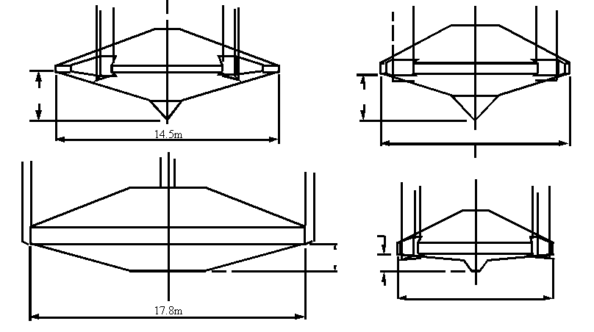
Figure ‎A.9.3-1 — Typical spudcan geometries
<< Add plan views for each of the above and add ? missing dimensions – P4 concurs >>
        - Approaches for response analysis
No guidance offered.
        - Approaches to foundation assessment
          - General
The foundation may be assessed using any of the fixity treatments in Table A.9.3-1. The overall assessment procedure of the jack-up rig is given in Fig. A.10.X-X.
Table A.9.3-1 — Approaches to foundation assessment
Fixity treatment in response analysis | Foundation assessment | Acceptance category | Reference clause
Pinned
 | Simple preload and sliding check  (subject to limitations) | Level 1; Steps 1a & b
 | Bearing and sliding checks using vertical-horizontal capacity envelope | Level 2; Step 2a
 | Displacement check  (requires that sliding meets one of the two preceding checks and input from the vertical-horizontal capacity envelope and load-penetration curve) | Level 3; Step 3a
Fixity:
Simple interaction surface (secant model)
 | Bearing and sliding checks using vertical-horizontal capacity envelope | Level 2; Step 2b
 | Displacement check  (requires that sliding meets one of the two preceding checks and input from the vertical-horizontal capacity envelope and load-penetration curve) | Level 3; Step 3a
Full interaction surface (yield interaction model)
 | Foundation checks are implicit in the non-linear model | Level 2; Step 2c; OR  Level 3; Step 3b
Continuum
 | Foundation checks are implicit in the non-linear model | Level 3; Step 3b

There are certain aspects that are not covered in the checks described above, which may require further consideration; some of the more common examples are listed below:
  - Where the "long-term" (drained) soil bearing capacity is less than the "short term" (undrained) capacity e.g. in the case for overconsolidated clays or cohesive silts with significant sand seams.
  - W-here a reduction of soil strength occurs due to cyclic loading. This can be of particular significance for silty soils and/or carbonate materials.
  - Where a potential for punch-through exists and an increase in spudcan penetration occurs e.g. due to cyclic loading,
  - Where horizontal seams of weak soil are located beneath the spudcan that can result in lateral bearing capacity/sliding instability.
If any of the above circumstances exist further analysis is required.
In the case of partial spudcan embedment, (e.g. sandy soils), additional spudcan embedment can result in a considerable increase in bearing capacity.
          - Simple pinned foundation
No guidance offered
          - Linear vertical, linear horizontal and secant rotational stiffness
This foundation fixity treatment incorporates a check on bearing capacity in terms of vertical and horizontal (sliding) capacities. The amount of rotational fixity is not directly involved in a checking equation. However, the moment, bearing and sliding interaction is implicitly checked through the use of the yield function. Bearing and sliding are checked explicitly through the checks described in A.9.3.6.
          - Non-linear vertical, horizontal and rotational stiffness
The moment, bearing and sliding interaction is implicitly checked through the use of the yield function as described in A.9.3.3. No other checks are required.
          - Non-linear continuum foundation model
This model should not be used unless one of the simpler analysis methods above has been used to provide a benchmark for the results. The soil model needs to be sufficiently non-linear to capture the strain levels potentially achievable in the response.
      - Leg penetration during preloading
        - Introduction
No guidance is offered.

        - Analysis method
          - General
The conventional procedure for the assessment of spudcan load/penetration behaviour is given in the following steps:
  - Model the spudcan.
  - Compute the vertical bearing capacity of the spudcan at various depths below seabed using closed form bearing capacity solutions and plot as a curve to a suitable depth beyond the expected penetration. This depth should normally be 1.5 times the expected penetration or to that associated with 1.5 times the preload reaction.
  - Enter the vertical bearing capacity versus spudcan penetration curve with the specified maximum vertical installation (during preloading) reaction at the spudcans and read off the predicted spudcan penetration.
          - Modelling the spudcan
For conventional foundation analyses the spudcan can often be modelled as a flat circular foundation. The equivalent diameter is determined from the area of the actual spudcan cross section in contact with the sea floor, or where the spudcan is fully embedded, from the largest cross sectional area in plan (see Figure A.9.3-2). Foundation analyses are then performed for this circular foundation at the greatest depth (D) of the maximum cross sectional area in contact with the soil.
Since the depth of spudcan penetration is normally reported and presented as the distance from the spudcan tip to the sea floor, care should be taken to use the appropriate value in the analysis and presentation of results..
Conical shapes are discussed in Annex D. Other configurations, e.g. rectangular spudcans or legs with significant skin friction, may require alternative treatment.
When a penetration analysis uses bearing capacity factors that account for the conical underside of the spudcan, at each depth the equivalent cone angle (β, Figure 9.4-4 and Appendix D) for the amount of spudcan penetrated requires evaluation. The equivalent cone shall be taken to enclose the same volume as that underside of the spudcan that is below sea floor. That is, the volume of the equivalent cone is equal to the volume of the penetrated portion of the underside of the spudcan (up to the largest cross sectional area in plane) and the planar area in soil contact is consistent (as in Figure A. 9.3-2). When a spudcan has embedded past its largest cross sectional area the equivalent conical angle stays constant. Figure XX shows for a variety of penetration conditions the definition of the equivalent bearing area and equivalent conical angle.
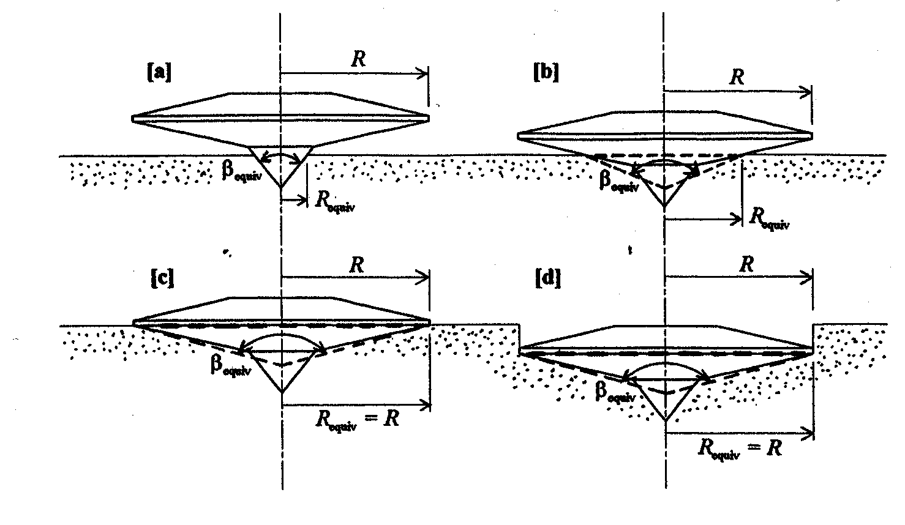
Figure ‎A.9.3-3 — Calculating an equivalent conical spudcan for various embedments (after Martin, 1994)

Modelling the soil
The appropriate soil model should be used for layered soils to account for the effects of punch through or squeezing, e.g. local failure of a weak layer between two stronger layers. It is noted that a man-made punch through condition can be created as a result of soil consolidation occurring during pauses in leg penetration whilst the spudcan is loaded to less than full preload. Such pauses can occur during installation operations or geotechnical investigation from a jack-up prior to full preloading.
The analysis methods in the following clauses address the failure mechanisms shown in Figure A.9.3-3.
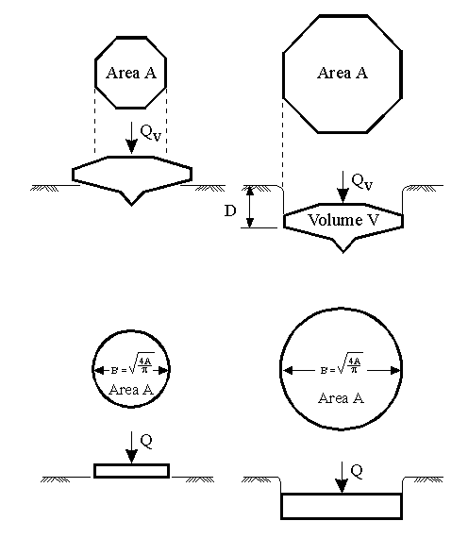
Figure ‎A.9.3-4 — Spudcan foundation model
<< Label left side 'partially embedded' right side "fully embedded". Top is real, bottom is model, Insert “D” in the lower right figure. Move to below 9.3.2.2. Change plan of original to one with notches Also add tip penetration depth – P4 concurs >>
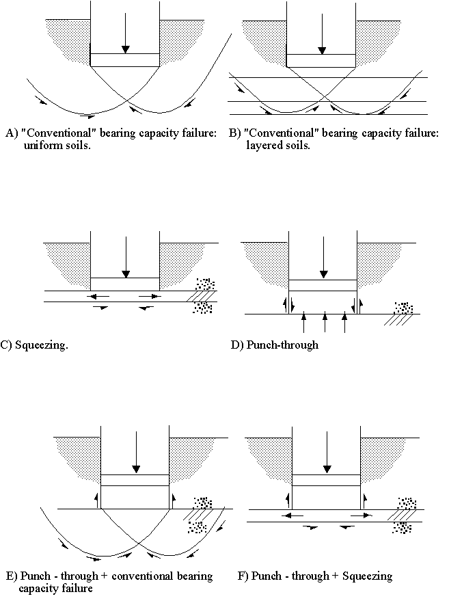
Symbol for lower sand in Fig. E should be deleted.
Figure A.9.3-4 — Spudcan bearing failure mechanisms
<< B) needs to be revised with different slopes; D) remove inner shear arrows >>
<< Leung will update all the figures in Fig. A.9.3-3 >>
          - Backflow and infill
<< ERP Nov 2007: We have sub-divided this clause so that we can have the header above. P4 to ensure that this section:
Covers all scenarios (clay, sand, layered) and distinguishes between backflow and infill; discusses the mechanisms; the effects of the timing; the effects on capacity, available vertical capacity (to support our spudcan load, ignoring soil) and moment capacity.
Soil backflow over the top of spudcan should be considered when computing bearing capacity and penetration. In very soft clays complete backflow can occur. In firm to stiff clays and granular materials, where limited spudcan penetration may be expected, the possibility of backflow diminishes.
After installation, wall collapse can occur as the surrounding soil softens; the infill increases the weight on top of the spudcan. The cavity can also infill with time due to sediment transport e.g. where there is a sand veneer over clay. Infill after preloading will result in a reduction in the available bearing capacity and should be considered.
To facilitate implementation of the above we suggest that we use V_{Lo} as the final capacity after infill, if any. Another variable should be used for the capacity generated at the completion of preloading e.g V_{P} such that:
V_{Lo} = V_{P} - (infill + any backflow due to additional penetration).
In general backflow due to additional penetration is not expected, but should be included for completeness.
The related text in the later clauses should be removed, placed here, and replaced by reference back to this clause >>
After installation, wall collapse can occur as the surrounding soil softens; the infill increases the weight on top of the spudcan. The cavity can also infill with time due to sediment transport e.g. where there is a sand veneer over clay. Infill after preloading will result in a reduction in the available bearing capacity and should be considered.

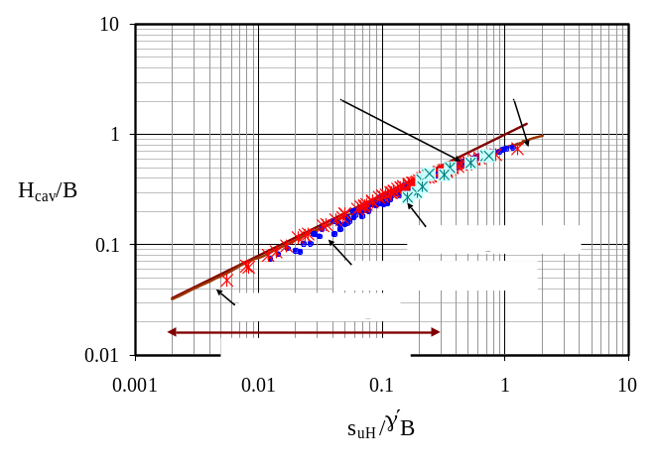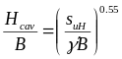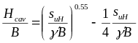
Spudcan depth
Hcav
depth
Cavity

B
sum
su0
Undrained shear strength
suH
)
Figure A.9.3-4 Estimation of limiting cavity depth, H_{cav}, due to backflow during installation.
        - Penetration in clays
The ultimate vertical bearing capacity of a foundation in clay of uniform shear strength (undrained failure in clay, φ = 0º) at a specific depth can be expressed by:
F_{V} = (c_{u}.N_{c}.s_{c}.d_{c} + p_{o}')A. << change to s_{u} everywhere >>
For the selection of the design undrained shear strength s_{u}, an evaluation should be made of the sampling method, the laboratory test type and the field experience regarding the prediction and observations of spudcan penetrations. Preference should be given to high quality push samples and laboratory strength data from unconsolidated undrained triaxial tests, miniature vane tests or torvane tests. (Randolph: To check the 19901-4 and decide on path forward, i.e., by reference only or copy and paste. [make sure in-situ tests are included and no fixed structure work scope is imposed here]. << ENSURE DATA FINALLY LISTED HERE IS CALLED UP IN A.6.5. >> - Wong to confirm action item completion by Randolph
Traditionally the value of N_{c} has been determined from solutions for strip footing on homogeneous clay, with shape and depth factors based on Skempton (1951). However, these factors are significantly affected by the gradient of shear strength with depth (Young et al, 1984; Houlsby and Martin, 2003). Field experience in the Gulf of Mexico has indicated that for typical Gulf of Mexico shear strength gradients and spudcan dimensions, spudcan penetrations in clay are well predicted by selecting s_{u} as the average over a depth of B/2 below the widest cross section in combination with the use of Skempton (1951) bearing capacity and depth factors << add reference – Young, et al., 1984 “Foundation Performance of Offshore Drilling Rigs”, Journal of Geotechnical Engineering, Vol. 110, No. 7>>..
For other areas of the world, which may have different rates of increase of strength with depth, a theoretical solution for circular conical foundations on clays of increasing strength with depth has been provided by Houlsby and Martin (2003), as presented in Annex D. The solutions give a theoretical lower bound to the soil resistance, and should therefore provide an upper bound prediction of penetration. The bearing capacity factors for rough spudcans are given in Table 9.3-1 and are valid for the following parameter ranges (see Figure A.9.3-4):
  - cone angles β between 60° and a flat plate of 180°;
  - embedment depths D between zero and 2.5 diameters;
  - values of shear strength gradient ρB/c_{um} between 0 and 5 where ρ is the rate of increase in shear strength with depth, from a value of c_{um} at the sea floor).
The tables in Annex D provide a theoretical lower bound to the bearing factor N_{c}.s_{c}.d_{c} to apply to the shear strength at the spudcan base level, c_{uo}, for the full range of the above parameters. Alternatively, Houlsby and Martin (2003) indicate that using the shear strength, c_{u}, at a depth of 0.09B below the spudcan base level together with the bearing factors given in Table 9.3-1 for a foundation on uniform strength clay will provide answers which are within ±12% of the theoretical lower bound solutions.
For clay layers with distinct strength differences methods for layered soils should be used (A.9.3.2.7).
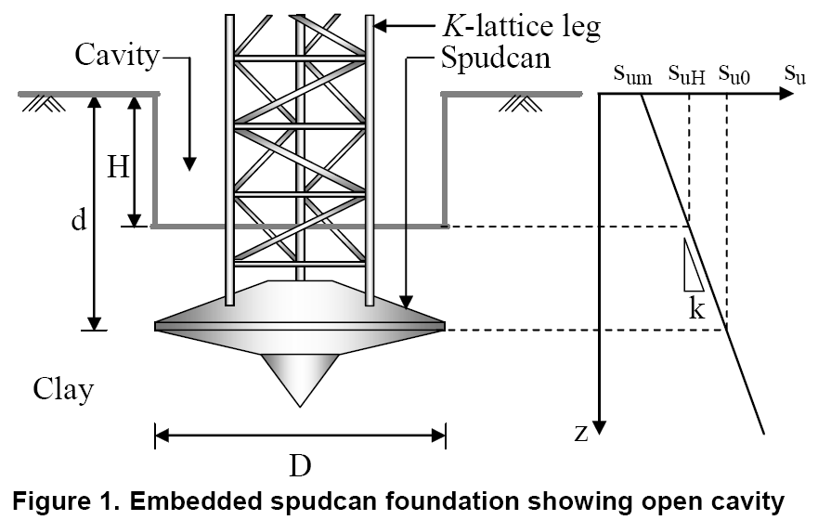

Figure A.9.3-5 : Conical spudcan with open cavity - problem definition and notation
<< ERP Jan 2008: - We need a figure here. Either the new one but we need to depict Beta and use our standard notation e.g. d to D, D to B, etc OR retain the old figure >>

Table A.9.3-2 Bearing capacity factors for rough circular plate (Houlsby & Martin, 2003)
Embedment ratio, D/B | Bearing factor, N_{c}.s_{c}.d_{c}
0 | 6.0
0.1 | 6.3
0.25 | 6.6
0.5 | 7.1
1.0 | 7.7
≥ 2.5 | 9.0

The net available vertical leg reaction when preloading is equal to the ultimate vertical bearing capacity, F_{V}, taking into account both the effect of backflow, F_{o}'A, and the effective weight of the soil replaced by the spudcan, γ'V, as follows:
V_{P} = F_{V} - F'_{o}A + γ'V
The backflow term, F’_{o}A, depends on the limiting depth of cavity, H_{cav}, that remains open above the spudcan during penetration, since F’_{o}=γ’(D-H_{cav}); when H_{cav} ≥ D (no backflow) then F'_{o} = 0 (Figure A.9.3-4). During penetration, the depth of open cavity is limited by the onset of soil backflow around the spudcan (not collapse of the cavity wall). The penetration resistance (normalised by the local shear strength, s_{u}) offered by a localised backflow mechanism becomes independent of depth for penetrations exceeding B, whereas that offered by a conventional bearing capacity failure mechanism increases with depth, even though conventionally a limiting bearing capacity factor of 9 is generally adopted (see Table 9.3-1). The transition between these two penetration mechanisms governs the onset of backflow and hence the limiting cavity depth, H_{cav}.
H_{cav} is a basic soil property which can be estimated either by comparing the resistance offered by each failure mechanism, or using the curve shown in Figure A.9.3-5, which applies to clay with uniform or increasing strength with depth [Hossain, et al. – OTC17770].
In addition to affecting the vertical reaction beneath the spudcan during preloading, the degree of backflow influences the embedment condition of the spudcan, and hence the uplift resistance (see A.9.4.4), moment restraint and the yield surface (see A.9.3.3.3). Consideration should be given to the reduction in capacity due to infill subsequent to installation (see A.9.3.2.2.4).
<< ERP Jan 2008: text from here moved to Backflow & infill clause >>

        - Penetration in silica sands
The ultimate vertical bearing capacity of a circular foundation in homogeneous frictional material (drained failure), can be expressed as:
F_{V} = γ′N_{γ}πB³/8 + p_{o}’N_{q}πB²/4 (1)
where B is the maximum spudcan diameter in contact with the soil, γ′ the effective unit weight of the soil and 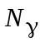 the dimensionless bearing capacity factor calculated for the axisymmetric case. For cases with an effective surcharge (p_{o}’) at the foundation level additional bearing capacity (using N_{q}) should be evaluated. Lower bound solutions for circular conical foundations have been provided by Cassidy and Houlsby (2002), as presented in Annex D. These are for the following parameter ranges:
  - cone angles between 60° and a flat plate of 180°; << Cassidy to provide tables for additional angles >>
  - non-dimensional soil-spudcan interface roughness factor, a , between 0 (smooth) and 1 (fully rough) (expressed as a = tan(δ)/tan(φ), where φ is the soil friction angle and δ the interface friction angle)
  - Angles of friction between 5° and 50°
Other values for rough circular spudcans have been provided by Martin (2004) and are discussed in the context of the bearing capacity of foundation by Randolph et al. (2004). For the rough circular plate the suggested values of Martin (2004) are given in Table A.9.3-3.
Table A.9.3-3 Bearing capacity factors for circular rough plate (Martin, 2004)
Friction angle  φ: degrees | Bearing factor, N_{γ} | Bearing factor,  N_{q}
15 | 0.93 | 5.25
20 | 2.42 | 9.61
25 | 6.07 | 18.4
30 | 15.5 | 37.2
35 | 41.9 | 80.8
40 | 124 | 193
45 | 418 | 521

Adequate consideration should be given to the selection of appropriate friction angle of the soil and displacements required to mobilise the capacity.
The maximum preload is equal to the ultimate vertical bearing capacity, F_{V}, taking into account the effective weight of the soil replaced by the spudcan, γ'V (see Annex D) i.e.:
V_{Lo} = F_{V} - F'_{o}A + γ'V

Where the predicted penetration exceeds the full embedment depth, the void above the spudcan will partially infill during penetration. The remainder of the void will infill with time due to sediment transport. The effects of the infill can result in increases in penetration during preload and reductions in the available bearing capacity after preloading, both of which should be considered.

        - Penetration in carbonate sands
          - General
Penetrations in carbonate sands are highly unpredictable and may be minimal in strongly cemented materials, or large, in uncemented materials. Cementation, crushable particles, high in-situ void ratios and compressibility are some of the characteristics of calcareous sediment that have led to the conclusion that the routine bearing capacity methods linked to the frictional soil strength are inappropriate (Poulos and Chua, 1985; Le Tirant and Nauroy, 1994; Finnie and Randolph, 1994). Extreme care should be exercised when operating in these materials.
          - Uncemented carbonate materials

Relatively large spudcan penetrations have been reported for uncemented carbonate materials despite high laboratory friction angles (Dutt, [23]). This may be attributed to either the high compressibility of these materials or low shear strengths due to high voids ratio and a collapsible structure.
The leg penetration is governed by both strength and deformation characteristics of foundation soils. The compressibility of carbonate sands is relatively higher than for silica sands. Hence, greater penetrations should be expected for carbonate sands relative to silica sands despite the similar or even higher laboratory friction angles. This is supported by both experimental (Poulos, [24]; Pan, 1999; Pan et al., 1999; Byrne and Houlsby, 2001) and theoretical (Yeung, [25]) studies on model foundations.
          - Cemented carbonate materials
Natural cementation in calcareous sediments is formed by carbonate precipitation. Model spudcan experiments on artificially cemented calcareous soils have shown that the pure vertical bearing response of circular foundations can also be described as bi-linear, with a yield point that is similar to the yield stress in 1-dimensional compression (Poulos and Chua, 1985; Houlsby et al., 1988; Sharp and van Seters, 1988; Randolph and Erbrich, 1999). The bearing resistance then increases with continuing displacements, with no clear failure point. This behaviour is consistent with local or punching shear failure. Randolph and Erbrich (1999) explain this bi-linear shape as being attributable to the very small settlement expected before the yield pressure is exceeded.
          - Predictive Methods
The predictions of spudcan penetrations in carbonate sands are likely to be performed to a lower degree of accuracy compared with those for silica sands. The conventional method is to use the plasticity based formulation for bearing capacity of shallow foundations in sand. However, friction angles to be used in the formulae should be considerably smaller than laboratory values to account (in an artificial manner) for the high soil compressibility.
Other predictive methods for circular spudcans on both cemented and uncemented calcareous sands have been published, including Islam (1999) and Islam et al. (2001), Houlsby et al. (1988), Randolph et al. (1993), Finnie and Randolph (1994) and Yamamoto et al. (2008^{a,b}). In concluding that the bearing response of shallow foundations on calcareous sands is better modelled with a compressional deformation mechanism and the punching shear pattern, Yamamoto et al. provide simple formulae for the response of shallow footings on compressible sands.
References
Byrne, B.W. and Houlsby, G.T. (2001). “Observations of footing behaviour on loose carbonate sands”, Géotechnique 51, Nº 5, pp463-466.
Dutt, R.N. and Ingram, W.B. (1988). “Bearing capacity of jack-up footings in carbonate granular sediments”, Proc. Int. Conf. on Calcareous Sediments, Perth, Vol. 1, p. 291-296.
Finnie, I.M. and Randolph, M.F. (1994). “Bearing response of shallow foundations in uncemented calcareous soil”, Proc. Int. Conf. Centrifuge ’94, Singapore, pp. 535-540.
Houlsby, G.T., Evans, K.M. and Sweeney, M. (1988). “End bearing capacity of model piles in layered carbonate soils”, Proc. Int. Conf. on Calcareous Sediments. Perth, Australia, Balkema, Vol. 1, pp. 209-214.
Islam, M.K. (1999). “Constitutive models for carbonate sand and their application to footing problems”, PhD Thesis, University of Sydney.
Islam, M.K., Carter, J.P. and Airey, D.W. (2001). “A study of surface footings on carbonate soils”, Proc. Darassulam, Brunei.
Le Tirant, P. and Nauroy, J.F. (1994). “Design guides for offshore structures: foundations in carbonate soils”, Editions Technip, Paris.
Pan, J. (1999). “The behaviour of shallow foundations on calcareous soil subjected to inclined load”. PhD Thesis, The University of Sydney.
Pan, J., Carter, J.P. and Airey, D.W. (1999). “The influence of load inclination on the bearing capacity of a circular footing”, Proc. 8th Australia New Zealand Conf. on Geomechanics, Hobart, Vol. 1, pp. 299-305.
Poulos, H.G. and Chua, K.F. (1985). “Bearing capacity of foundations on calcareous sand”, Proc. 11th Int. Conf. on Soil Mechanics and Foundation Engineering, Vol. 3, pp. 1619-1622.
Randolph, M.F. and Erbrich, C. (1999). “Design of shallow foundations for calcareous sediments”, Proc. 2nd Int. Conf. on Engineering for Calcareous Sediments, Bahrain, pp.361-378.
Randolph, M.F., Finnie, I.M. and Joer, H. (1993). “Performance of shallow and deep foundations on calcareous soil”, Proc. Symp. on Foundations of Difficult Soils, Kagoshima, Japan.
Sharp, D.E. and van Seters, A.J. (1988). “Results and evaluation of plate load test results”, Proc. Int. Conf. on Calcareous Sediments, Perth, Australia, Vol. 2. Balkema, pp. 473-483.
Yamamoto, N., Randolph, M.F. and Einav, I. (2008). Simple formulae for the response of shallow foundations on compressible sands. Int. J. for Geomechanics, ASCE (accepted August 2007).
Yamamoto, N., Randolph, M.F. and Einav, I. (2008). A numerical study of the effect of foundation size for a wide range of sands, Journal of Geotechnical and Geoenvironmental Engineering, ASCE (under review),
Yeung S.K., Carter J.P. (1989), "An Assessment of the Bearing Capacity of Calcareous and Silica Sands", International Journal for Numerical and Analytical Methods in Geomechanics, Vol. 13, pp. 19-26.
        - Penetration in silts
It is recommended that analyses for drained conditions (modelled as sand) and undrained conditions (modelled as clay) are performed to estimate the range of penetrations. Cyclic loading may significantly affect the bearing capacity of silts.
        - Penetration in layered soils
          - General
Three basically different foundation failure mechanisms are considered when making spudcan predictions in layered soils:
  - General shear.
  - Squeezing.
  - Punch-through.
The first failure mechanism occurs if soil strengths of subsequent layers do not vary significantly. Thus an average soil strength (either c_{u} or φ) can be determined below the spudcan. The spudcan penetration versus foundation capacity relationship is then generated using criteria from A.9.3.2.3 through A.9.3.2.6.
Criteria for the other two failure mechanisms (squeezing and punch-through) are given below. The latter condition is of particular significance since it concerns a potentially dangerous situation where a strong layer overlies a weak layer and hence a small additional spudcan penetration may be associated with a significant reduction in bearing capacity which results in rapid leg penetration.
Backflow shall be considered for deep penetrations in weak soils.
          - Squeezing of clay
On a soft clay subject to squeezing overlaying a significantly stronger layer (see Figure A.9.3-6), the ultimate vertical bearing capacity of a spudcan can be analyzed by methods given by Brown and Meyerhof [8] and by Vesic [8] in combination with the Skempton bearing capacity and depth factors [4].
For no backflow conditions:
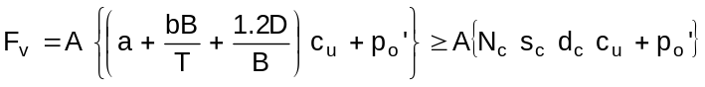
and for full backflow conditions:
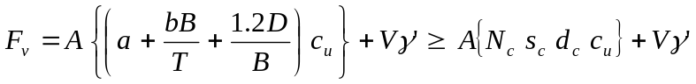
where the following squeezing factors are recommended:
a = 5.00
b = 0.33 for spudcans with B ≤ 15m and 0.25 for spudcans with B >15m.
and s_{u} refers to the undrained shear strength of the soft clay layer.

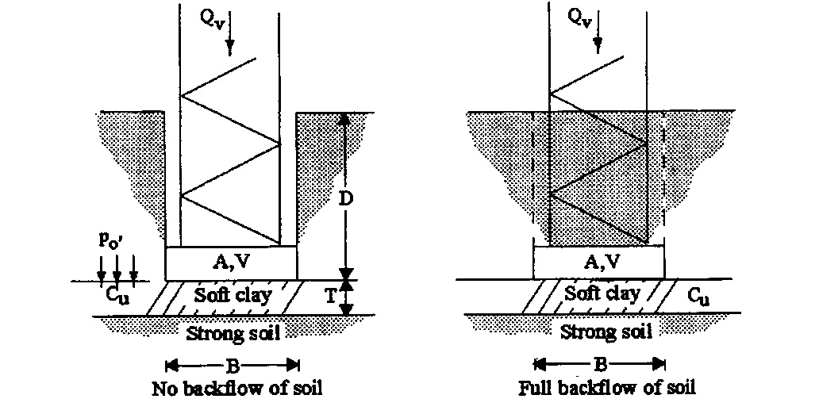
Figure A.9.3-6: Spudcan bearing capacity analysis - squeezing clay layer
It is noted that the lower bound foundation capacity is given by general failure in the clay layer (right hand side of equation), and that squeezing occurs when B ≥T/b. The upper bound capacity (for T<<B) is determined by the ultimate bearing capacity of the underlying strong soil layer.

Punch-through : Two clay layers
The ultimate vertical bearing capacity of a spudcan on the surface of a strong clay layer overlying a weak clay layer can be computed according to Brown [9] (see Figure a.9.3-7):
F_{V} = A (3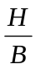s_{u},_{t} + N_{c} s_{c} s_{u},_{b}) ≤ A N_{c} s_{c} s_{u},_{t}
The equation above applies to clay layers of uniform undrained shear strengths.

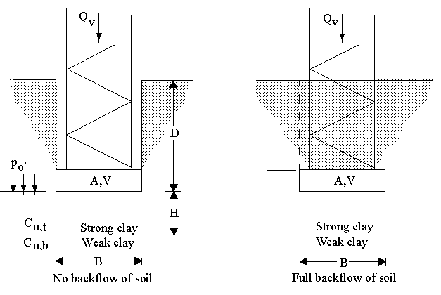
Change “strong” to “stronger” and “weak” to “weaker”
Figure A.9.3-7 — Spudcan bearing capacity analysis - two clay layers
          - Punch-through : Sand overlying clay
The ultimate vertical capacity of a spudcan on a sand layer overlying a weak clay layer can be computed using a load spread model (see Figure A.9.3-8). In this model the bearing capacity of the foundation is assumed to be equal to the bearing capacity of the foundation projected onto the lower layer for a given load spread. Typical load spread factors (n) for sand overlying clay are in the order of 3 to 5.
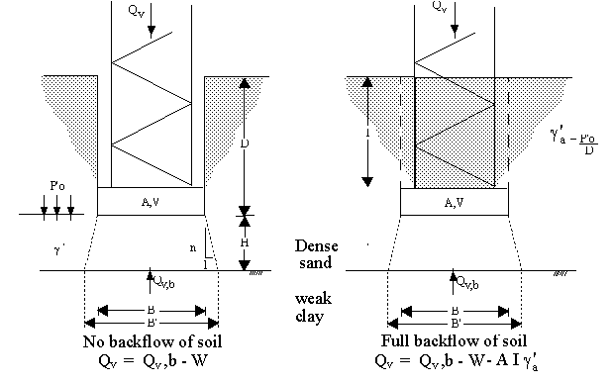
Figure ‎A.9.3-8 — Spudcan bearing capacity analysis - sand over clay
<< “Dense” to be removed from the figure. Also Remove “weak”>>
Alternatively, the bearing capacity may be calculated using the following equations derived from Hanna and Meyerhof (26) :
For no backflow:
F_{v} = Q_{u,b} - AHγ’ + 2AH(Hγ’ + 2p₀’)K_{s}tanϕ /B
For full or partial backflow:
F_{v} = Q_{u,b} - AHγ’ -AIγ’ + 2AH(Hγ’ + 2p₀’)K_{s}tanϕ/B
Where
I = depth of the top of spudcan below the seafloor,
Q_{u,b} is determined according to Section A.9.3.2.3, assuming the spudcan bears on the surface of the lower clay layer with no backflow.
The punching shear coefficient, K_{s}, depends on the strength of both the sand layer and the clay layer, which can be derived from the graphs in the reference paper.
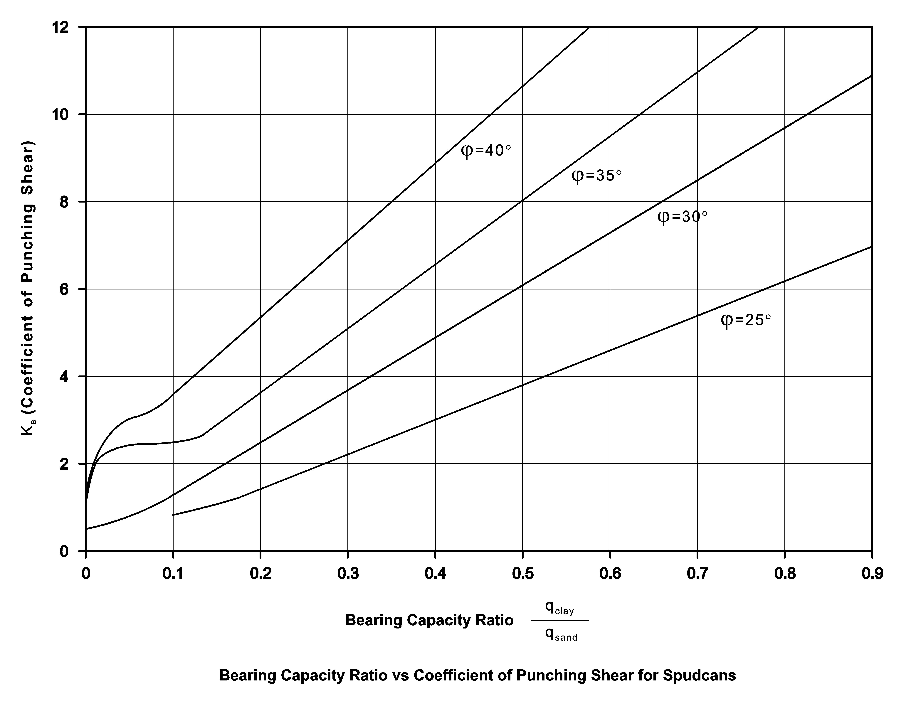
Figure ‎A.9.3-9 — Bearing capacity ratio vs coefficient of punching shear for spudcans

A new approach based on a centrifuge study has been proposed by Teh (2007). The load-penetration curve typical of the punch-through condition is represented by a simplified profile consisting of three characteristic bearing resistances, namely surface bearing resistance, q₀ (at d = 0), maximum bearing resistance, q_{max} (at d = d_{crit}), and bearing resistance in the underlying clay (for d ≥ H). A brief description of the approach is provided in Annex D.
          - Punch-through: Cemented crust over weak soil.
The occurrence of a cemented crust overlying a weak layer of clay or loose sand/silt requires careful consideration. Accurate information on the thickness of the crust and the strengths of the crust and the underlying layer is required for the analysis, which may be performed using simplified load spread models or advanced numerical / analytical models. The potential for punch-through may be significantly affected by the shape of the spudcan and its tip.
          - Three layered systems
The foundation bearing capacity for a spudcan resting in the top of a three soil layer system can be computed using the squeezing and punch-through criteria for two layer systems. Firstly the bearing capacity of a spudcan with diameter B resting on top of the lower two layers (layers 2 and 3 in Figure A.9.3-10) is computed. These two layers can then be treated as one (lower) layer in a subsequent two-layer system analysis involving the upper layer (layer 1 in Figure A.9.3-9). Analysis for the top layer may incorporate load spread effects.

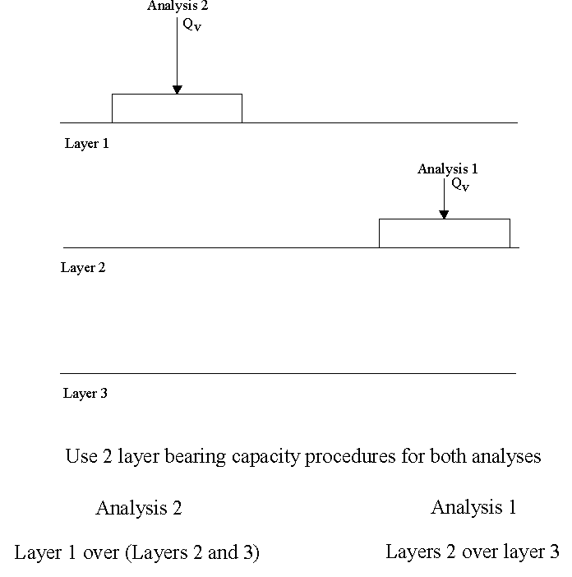
Figure ‎A.9.3-10 — Spudcan bearing capacity analysis - three layer case
<< switch the left and right sides of the diagram and footnote >>

      - Yield interaction
        - General
<< ERP suggestion to P4 - this introduction should firstly describe the actual behaviour and then move on to the way it is going to be approximated herein. Some Figures will assist. Suggest Richard Dean and Robert Overy tackle this together as they have both contributed comments to this text. >>
During preloading the soil beneath the spudcan fails plastically and the spudcan penetrates until the bearing capacity is in equilibrium with the preload reaction. When the preload is removed the soil unloads on the small strain unload-reload stiffness curve. The spudcan geometry and the soil properties at the penetrated position are then used to determine the maximum moment and horizontal capacities which, with the vertical capacity, are the principal coordinates of the yield interaction surface.
The limiting combinations of the spudcan moment, vertical and horizontal reactions are defined by the yield interaction surface.
Inside the yield surface the foundation behaviour is considered to be elastic for small strains but becomes increasing inelastic as the yield surface is approached. On the yield surface the foundation undergoes inelastic deformation with increased reaction beneath the spudcan.
Provided the jack-up's preload capacity is appropriate for a site’s environmental conditions, the majority of the foundation load-deflection behaviour during a storm should be essentially elastic and only a few, if any, extreme events cause stiffness reduction.
When the foundation is considered as pinned, the yield surface degenerates to a vertical-horizontal load space.
The following clauses are applicable to traditional spudcan designs. Information on the foundation behaviour of spudcans fitted with skirts can be found in the references listed below.
- Dean, et al. (1995), "Centrifuge Modelling of 3-Leg Jackups with Non-Skirted and Skirted Spuds on Partially Drained Sand", Proceedings Offshore Technology Conference, Houston, (OTC 7839).
- Eide, A., K. A. Tuen and M. Baerheim (1996), “The Yme Jack-up with Skirt Foundation”, Proceedings Offshore Technology Conference, Houston (OTC 8158).
- Svano and Tjelta (1993), "Skirted Spudcans - Extending Operational Depth and Improving Performance", 4th City University Jack-up Platform Conference, London.
- Cassidy, M.J., Byrne, B.W., Randolph, M.F. (2004). A comparison of the combined load behaviour of spudcan and caisson foundations on soft normally consolidated clay. Géotechnique, Vol. 54, No. 2, pp. 91-106.
- Cassidy, M.J., Randolph, M.F., Byrne, B.W. (2006). A plasticity model describing caisson behaviour in clay. Applied Ocean Research. Accepted 4 September 2006.
        - Ultimate vertical / horizontal / rotational capacity interaction function for spudcans in sand and clay
          - General
The modelling approach to the interaction of vertical, horizontal and rotational forces was developed based on a plasticity relationship <<(References C6 [48] through [52])>>. The plasticity relationship can account for moment softening at high loading levels, unloading behaviour and work-hardening effects. This model does not include sliding; where sliding is important this should be incorporated separately using the method described in A.9.3.5.
The shallow embedment yield interaction surface for sand and clay in A.9.3.3.2.2 may conservatively be used for deep embedment in clay. The more complex yield interaction surface for deep embedment in clay in A.9.3.3.2.3 reduces to the shallow embedment yield interaction surface when the depth parameter, a, is set to zero.
There is no existing data for deeply embedded spudcans in sand. The application of the yield surface calibrated to shallow penetrations will likely be conservative for the deep penetration case.
<< P4 endorses “Q” as “capacity” and “F” as “force” – WG7/ERP to do a global swap >>
          - Shallow embedment

For shallow embedment, the yield interaction can be defined by the expression below: << ERP Jan 2008 recommends that the equation, and its friends, be squared so it can be more obviously compared with the SAGE equation >>
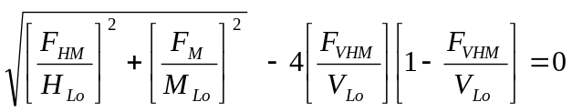

where V_{Lo} is taken to be equal to the vertical reaction beneath the spudcan achieved during preloading and H_{Lo} and M_{Lo} are as defined below.
For sand:
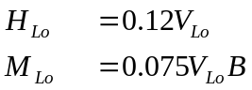
provide references for the coefficients – Cassidy/Houlsby
For clay:
H_{Lo} = c_{uo}A + (c_{uo} + c_{ul}) A_{s}
M_{Lo} = 0.1V_{Lo}B
In the above expression for the yield interaction surface, if a force combination (Q_{V},Q_{H},Q_{M}) satisfies the equality then (Q_{V},Q_{H},Q_{M}) = (F_{VHM}, F_{HM}, F_{M}). The force combination (Q_{V},Q_{H},Q_{M}) lies outside the yield surface if the left-hand side is greater than zero. Conversely, the force combination lies inside the yield surface if the left-hand side is less than zero.
The expression for the yield interaction surface above can be conservative for clay when F_{VHM} < 0.5 V_{LO}. In such cases the yield surface expansion given in A.9.3.3.3 may be used.
NOTE At zero vertical load a shallow sand foundation has no horizontal or moment capacity because it is cohesionless and conforms to the yield interaction equation in bearing. Conversely, for spudcans in cohesive clay when there is adhesion and/or suction, there can be horizontal and moment capacity in excess of the yield interaction surface given above for vertical spudcan reactions less than 50% of the preload reaction.
The expression for the yield surface can be re-written to give the maximum spudcan moment as a function of the horizontal and vertical forces. For a given vertical and horizontal force combination which lies inside the yield surface given above, the spudcan moment cannot exceed the maximum available moment capacity F_{M}:.
F_{M} = M_{Lo}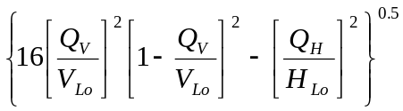
The equation above only applies when:
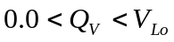
and
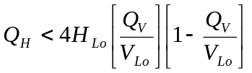
          - Deep embedment in clay
<< Jan 2008: additional text from SAGE. (note that proposed position in SNAME is wrong and we have made significant enhancements to the text) >>
In clay, a deeply embedded spudcan can achieve a greater moment capacity than a spudcan with a shallow penetration (Ref SAGE paper(s)). In addition, the shape of the yield surface changes from parabolic to be progressively more elliptical with increasing penetration (Ref. Martin & Houlsby (2001) Combined loading of spudcan foundations on clay: numerical modelling, Geotechnique, No 51 No 8 687-699 ). This effect can be accounted for by interpolating between the parabolic shape of the shallow embedment yield surface (Eq. A.9.3-y, obtained by setting a = 0 in Eq A.9.3-z) and the elliptical shape for deep embedments (D > 2.5B) using the depth parameter, a. Hence the following equation can be used for fully or partially penetrated spudcans:
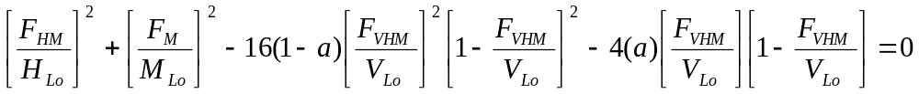
where V_{Lo} is taken to be equal to the vertical spudcan load achieved during preloading and H_{Lo} and M_{Lo} are defined as follows:
H_{Lo} = c_{uo}A + (c_{uo} + c_{ul}) A_{s}
M_{Lo} = (0.1 + 0.05a(1+b/2)) V_{Lo}B
with
a = D / 2.5B for D < 2.5B
a = 1.0 for D > 2.5B
b = ( D_{b} / D)(r_{s})
D_{b} = depth of backflow (see A.9.3.2.2.4). Infill should not be considered.
R_{s} = ratio of backflow soil strength to undisturbed soil strength
NOTE Both D (the depth of embedment) and D_{b} (the depth of backflow) are to be measured upward from the lowest elevation of the largest spud can width. As a practical matter, D_{b} should be taken as zero unless the top of the spud can is effectively covered.
The expression for the yield interaction surface above can be conservative for clay when F_{VHM} < 0.5 V_{LO}. In such cases the yield surface expansion given in A.9.3.3.3 may be used.
NOTE At zero vertical load a shallow sand foundation has no horizontal or moment capacity because it is cohesionless and conforms to the yield interaction equation in bearing. Conversely, for spudcans in cohesive clay when there is adhesion and/or suction, there can be horizontal and moment capacity in excess of the yield interaction surface given above for vertical spudcan reactions less than 50% of the preload reaction.
The expression for the yield surface can be re-written to give the maximum spudcan moment as a function of the horizontal and vertical forces. For a given vertical and horizontal force combination which lies inside the yield surface given above, the spudcan moment cannot exceed the maximum available moment capacity F_{M}:.
F_{M} = M_{Lo}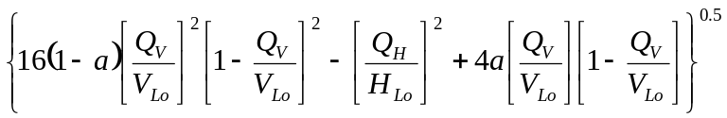
The equation above only applies when:
and
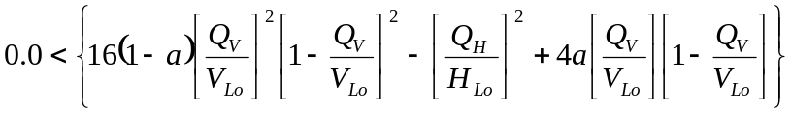
<< can anyone offer a simplified version of the above? >>
        - Spudcans in clay with F_{VHM} < 0.5 V_{LO}
As discussed in A.9.3.3.2.2, the yield surface at F_{VHM}/V_{Lo} < 0.5 (typically applicable to windward legs) can be expressed as:
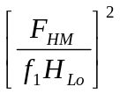 + 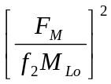 - 1.0 = 0
where;
f₁ = α + 2(1 - α)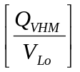
f₂ = f₁ where suction (i.e. uplift resistance) is available,
= 4 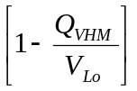where suction cannot be relied upon
α = 1.0 for soft clays
= 0.5 for stiff clays
α accounts for the degree of adhesion. The assessor may wish to consider α values within the range 0.5-1.0 depending on site-specific soil data, spudcan/soil interface roughness, etc. An α value less than 0.5 may be considered for situations such as a hard clay at the surface. In this case, the standard form of the yield surface should be considered.
<< Review and recommend a more defensible approach (instead of f1 & f2) – Houlsby/Cassidy >>
The expression above can be re-written to give the maximum spudcan moment as a function of the horizontal and vertical forces. For a given vertical and horizontal force combination which lies inside the yield surface given above, the spudcan moment cannot exceed the maximum available moment capacity F_{M}:.

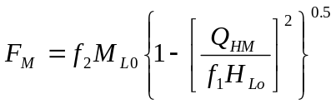
The equation above only applies when:
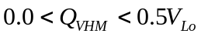
and
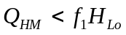

        - Extension of the yield surface for additional penetration in sand
On seabeds of silica sands, conical spudcans which are not fully seated may show increased moment capacity due to further penetration and the resulting increase in contact area. The effect can be taken into account for spudcans with Q_{V}/V_{Lo} > 0.
The moment capacity M_{p} associated with further penetration is estimated as the minimum of M_{PS} and M_{PV}, calculated as follows (Svanø [56 – Needs to be changed]):
M_{PS} = 0.075 B V_{Lo}(B_{max}/B)³
M_{PV} = 0.15 B F_{VHM}
in which B is the plan diameter of the effective contact area after preload, and B_{max} is the plan diameter of the contact area when the spudcan is fully seated. (wording can be improved: full contact, physical spudcan diameter)
The combined capacity should be checked against the modified yield interaction surface:
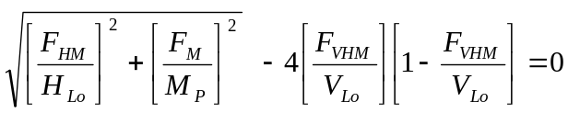
        - Extension of the yield surface for additional penetration in clay
For additional penetration of spudcans in clay, references C6 (to be changed) [49 – Needs to be changed] and [52 – Needs to be changed] provide work-hardening modifications to the yield surface equations. Updated stiffnesses are determined through plasticity principles.
49 Wong P.C. and Murff J.D. (1994), "Dynamic Analysis of Jack-up Rigs Using Advanced Foundation Models", Proceedings OMAE, Houston, paper 94-1315
52 Van Langen and Hospers (1993), "Theoretical Model for Determining Rotational Behavior of Spudcans", Proceedings Offshore Technology Conference, Houston, (OTC 7302).

Are all these referenced?
53 Noble Denton Europe & Oxford University (2005), "The Calibration of SNAME Spudcan Footing Equations with Field Data", Report No L19073/NDE/mjrh, Rev 5, dated November 2006.
54 Templeton J.S., Lewis D.R., Brekke J.N. (2003), "Spud Can Fixity in Clay, First Findings of a 2003 IADC Study", 9th City University Jack-up Platform Conference, London.
55 Andersen K.H. (2004), "Cyclic clay data for foundation design of structures subjected to wave loading", Invited lecture, International Conf. on Cyclic Behaviour of Soils and Liquefaction Phenomena, CBS04, Bochum, Germany. Proc. p. 371 – 387.
56 Svanø G. (1996), "Foundation Fixity Study for Jack-Up Unit", SINTEF report STF22 F96660, August 1996.
57 Murff, J. D., M. D. Prins, E. T. R. Dean, R. G. James, A. N. Schofield, "Jack-Up Rig Foundation Modeling", Proceedings, Offshore Technology Conference, Houston, Paper No. 6807, May 1992, pp. 35-46.
58 van Langen, H., P. C. Wong, E. T. R. Dean, “Formulation and Validation of a Theoretical Model for Jack-Up Foundation Load-Displacement Assessment”, Proceedings, 6th International Conference on the Jack-Up Platform – Design, Construction and Operation, London, 1997.
59 Wong, P. C., J. C. Chao, J. D. Murff, E. T. R. Dean, R. G. James, A. N. Schofield, Y. Tsukamoto, “Jack-Up Rig Foundation Modeling II”, Proceedings, Offshore Technology Conference, Houston, Paper No. 7303, May 1993, pp. 411-420.
<< Jan 2007 ERP did not review A.9.3.3 pending JT inputs . DONE by ERP Jan 2008 >>
      - Foundation stiffness
        - Vertical, horizontal and rotational stiffness
Vertical and horizontal stiffnesses of the foundation are based on the elastic solutions for a rigid circular plate on an elastic half-space with modification factors to account for spudcan embedment. For the effects of leg embedment see A.9.3.4.5. The elastic stiffness factors are calculated assuming full contact of the spudcan with the seabed. If the vertical reaction is insufficient to maintain full contact as the moment increases then reduced stiffnesses should be used. The stiffness factors are derived for a homogeneous, linear, isotropic soil:
Vertical stiffness, K₁ = K_{d1}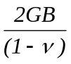
Horizontal stiffness, K₂ = K_{d2}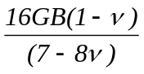
Rotational stiffness, K₃ = K_{d3}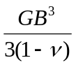 (from Winterkorn [10]) for relatively low levels of loading)
The selection of the shear modulus, G, is discussed later in this Clause. An upper or lower bound value should be selected as appropriate for the analysis being undertaken. Choice of the appropriate shear modulus should take into account the expected stress level and strain amplitude. In general, the shear modulus decreases with increasing strain amplitude.
Table A.9.3.1 provides values for the depth factors K_{d1}, K_{d2} and K_{d3}, Bell [42], to account for embedment effects on the stiffness of flat plate and conical type footings.
Table A.9.3-4 — Depth factors
 | K_{d1} |  | K_{d2} |  | K_{d3}
D/R | Open hole | With backflow | Open hole | With backflow | Open hole | With backflow
0.0 | 1.00 | 1.00 | 1.00 | 1.00 | 1.00 | 1.00
0.5 | 1.15 | 1.21 | 1.33 | 1.49 | 1.28 | 1.64
1.0 | 1.28 | 1.41 | 1.44 | 1.71 | 1.43 | 2.05
2.0 | 1.42 | 1.70 | 1.51 | 1.92 | 1.51 | 2.31
4.0 | 1.59 | 2.00 | 1.61 | 2.06 | 1.57 | 2.41

<< D/R should be replaced by appropriate symbols used in this doc. >>

For clays susceptible to cyclic degradation (OCR ≥ 4) the soil rotational stiffness, calculated from the degraded static (= cyclic ? )soil properties, may be multiplied by a factor of 1.25, Andersen [18]. << THIS IS WRONG??. The source is Rev 1 C6 P 112 - The reference and (NGI Oslo report 913012-1, Rev 1) and the SNAME commentary indicate that cyclic degradation may reduce the horizontal bearing capacity by a factor of 0.3, i.e. the horizontal bearing capacity calculated from static soil properties should be multiplied by a reduction factor = 0.7 and that the horizontal and vertical (not rotational) soil stiffnesses calculated from static soil properties may be multiplied by factors of 1.25 and 3 to 8 (respectively) as a result of cyclic effects.>>
<< ERP to P4 from a long time ago: what about OCR < 4 ?? >>
        - Stiffness reduction
          - Linear vertical, linear horizontal and secant rotational stiffness
Except for simple dynamic analyses with linearized foundations, contained within A.10.4.4 Option 1, the following should be used if the reduction of rotational stiffness is not implicitly included in the soil model.
If the force combination of (Q_{V},Q_{H},Q_{M}) lies outside the yield surface, the linear rotational stiffness at the spudcan must be reduced until the force combination lies on the yield surface. Determination of the reduced stiffness requires iterative analyses. << ERP Jan 2007: we may need further guidance from P3 or P4 to ensure that the/a correct answer is reached >> from P4 Jan 2008: << Add a sentence to say “go to higher level analysis if non-convergence”; any significant change in the rotational stiffness that impacts structure will consider another structural analysis. >>
If the force combination of (Q_{V},Q_{H},Q_{M}) lies inside the yield surface, the initial estimate of rotational stiffness should be reduced by a factor, f_{r}. The reduction factor is equal to unity when the moment and horizontal forces are zero. It is given by the following expression (Templeton, [xx]):

<< Inserted Jan 2008 by MJRH - This from Jack following request from GTH >>
f_{r} = (1 - n) r_{f} / ln[( 1 - nr_{f} ) / ( 1 - r_{f} )] .
The parameter, n, accommodates spudcan rotation resistance curves with various degrees of curvature change. In practice the value of this parameter should be set to suit the best available data (either empirical or analytical) applicable to the jack-up and site. Finite element analysis for Gulf of Mexico clay indicates the range of n = - 0.25 to - 1.0, with n = - 0.5 providing the best overall representation.
In the absence of directly applicable data, the value of n may be set to 0. In this case, the stiffness reduction expression takes a simpler form,
f_{r} = -r_{f} /ln(1 - r_{f} )
For the most conservative treatment of stiffness reduction, the value of n may be set to 1.0. In this case, the stiffness reduction expression takes its simplest from,
f_{r} = 1 - r_{f} .
The variable, r_{f}, in the stiffness reduction expression is the failure ratio defined by:
r_{f} = 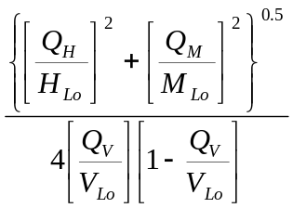 ≤ 1.0
NOTE 1 When determining the SDOF DAF using hysteretic damping in accordance with A.10.x-y << ERP Jan 2008 assumes >>, the stiffness reduction factor, f_{r}, should be based on a failure ratio, r_{f}, calculated using only the cyclic components of the loads. For the purpose of global capacity checks, the stiffness reduction factor, f_{r}, should be based on a failure ratio, r_{f}, calculated using the total loads.
<< end of text revised by SAGE >>
NOTE 2 r_{f} > 1.0 implies that the force combination (Q_{V},Q_{H},Q_{M}) lies outside the yield surface. Under such conditions, the reduced stiffness factor is not applicable, and the rotational stiffness should be reduced until the force combination lies on the yield surface.
<< start of text revised by SAGE >>
For embedded foundations in clays the failure ratio may be expressed as:
r_{f} = 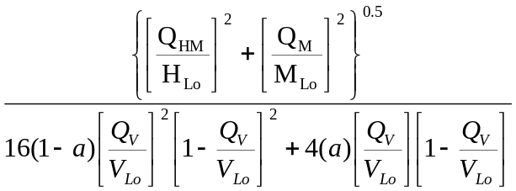
}
0.5
{
where “a” is as defined in 9.3.3.2.3 above.
<< end of text revised by SAGE >>
For fully embedded foundations in clays at vertical force ratio Q_{VHM}/V_{Lo} < 0.5, the failure ratio may be expressed as:
r_{f} = 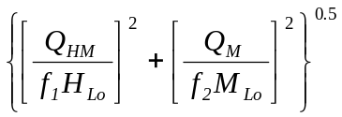
where f₁ and f₂ are as defined in A.9.3.3 above, but replacing F_{VHM} with Q_{V}.

NOTE This Step 2b Option 1 procedure does not require a reassessment or reduction in soil modulus, G, as it purely a structural tool to accommodate dynamic effects in a simple manner. If non-linear soil stiffness considerations such as strain level, soil anisotropy, etc need to be considered this should form part of a Step 3 approach (Section A.9.3.3.4) or when the yield surface is expanded due to additional penetration (section A.9.3.3.5). << From RMO - ERP Jan 2007: If this is to stay RMO needs to re-write so we can all understand the intent, particularly wrt the levels and options >>
          - Non-linear vertical, horizontal and rotational stiffness
The full interaction surface model, which includes non-linear vertical, horizontal and rotational stiffnesses, implicitly incorporates the necessary stiffness reduction as a consequence of work hardening plastic displacement and rotation.. The stiffness reduction factor should not be applied.

          - Non-linear continuum foundation model
A continuum foundation model which includes non-linear soil behaviour (e.g., elastic-plastic work hardening) implicitly incorporates the necessary stiffness reduction. The stiffness reduction factor should not be applied.
A non-linear continuum foundation model should not be used unless one of the simpler analysis methods above has been used to provide a benchmark for the results.
        - Selection of Shear Modulus, G, in clay
The value of the initial, small-strain shear modulus for clay should be based on the value of the shear strength (c_{u}) measured at the depth 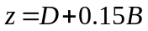 where B is the largest diameter of the spudcan in contact with the soil and D is the predicted depth below sea floor of the lowest point on the spudcan with diameter B. Where the clay is significantly layered the average strength within the range 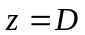 to 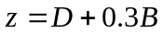 should be used. Except in areas with carbonate clays or clayey silts the shear modulus should be calculated as [ref. 53 – Needs to be changed]:
 = 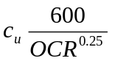 with G < C_{u}I_{rNC} and subject to the limitations given below.
Where
OCR = the overconsolidation ratio;
I_{rNC} = rigidity index for normally consolidated clays
For extreme loading conditions, and in the absence of other data, I_{rNC} shall be conservatively limited to 400 (Noble Denton, [53 – Needs to be changed]).
NOTE The recommendations of [53] are based on overconsolidated clay sites with Plasticity Indices of up to 60%. Due consideration should be given to the possibility of determining site-specific shear moduli for cohesive soils other than overconsolidated clays and/or where the Plasticity Indices exceed 60%.
I_{rNC} = 600 is supported by field data for jack-up response in the Gulf of Mexico (Templeton [54]);
It should be noted that I_{rNC} is inversely proportional to the plasticity index (Andersen [55 – Needs to be changed], figure 10.2, reproduced below). For sites with plasticity indices in excess of 60%, and not covered by field data, the analyst should account for the inverse relationship when determining G.
In some cases higher ratios of I_{rNC} may be used. The data published by Andersen ([55 – Needs to be changed], figure 10.2,) would support use of values as high as 1000 or even 2500, particularly for plasticity indices less than 20%.
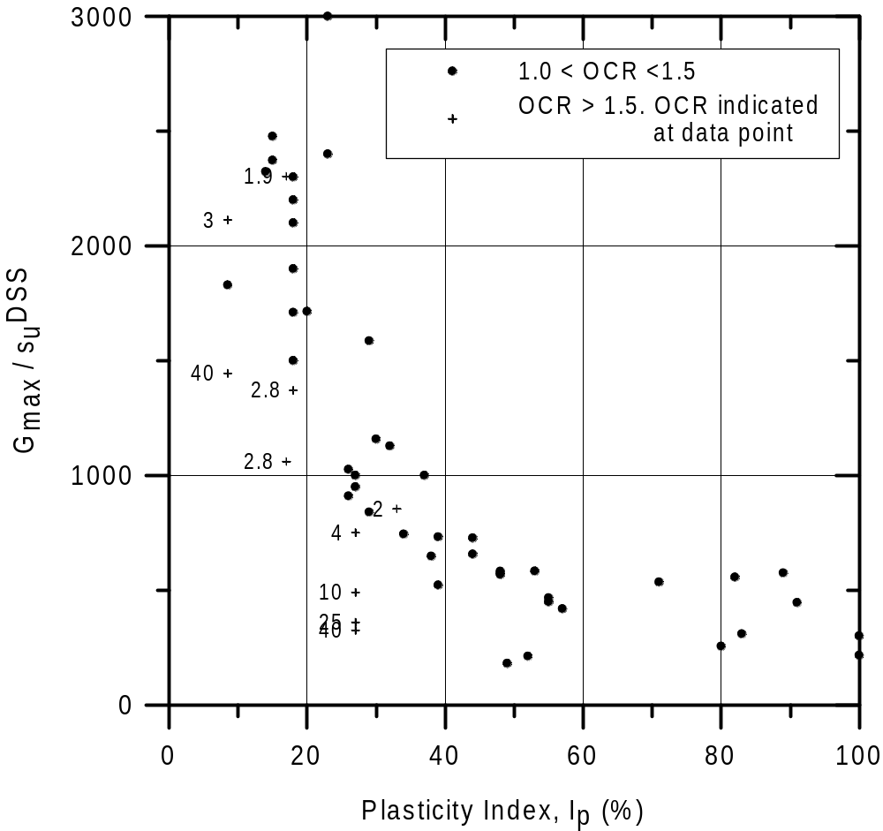
Figure A.9.3-1 Normalised initial shear modulus as a function of plasticity index, Ip, for 11 different clays. Figure 10.2 from Anderson [55 – Needs to be changed]
The recommendations given above are intended for use in both site assessments for extreme loading and applications involving small strain beneath the spudcan. In the calculation of fixity for extreme loading, the rotational stiffness based on the small strain G values will be degraded using the stiffness reduction formulae given in A.9.3.4.2 or implicit in the non-linear models used in A.9.3.4.3 and A.9.4.4. In the case of small strain applications, such as in structural fatigue analysis, the stiffness reductions do not apply and it may be appropriate to adopt upper-bound values of G. << move above figure >>
References
Cassidy, M.J., Houlsby, G.T., Hoyle, M., Marcom, M. (2002). Determining appropriate stiffness levels for spudcan foundations using jack-up case records. Proc. 21th Int. Conf. on Offshore Mechanics and Arctic Engineering (OMAE)., Oslo, Norway, OMAE2002-28085.
Cassidy, M.J., Martin, C.M., Houlsby, G.T. (2004). Development and application of force resultant models describing jack-up foundation behaviour. Marine Structures, Vol. 17 No. 3-4, pp. 165-193.
        - Selection of shear modulus, G, in sand
For sands the initial, small-strain shear modulus should be computed from:
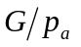= 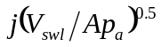
where
= 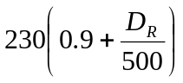 (dimensionless stiffness factor)
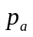 = atmospheric pressure
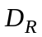 = relative density (percent)
V_{swl} = seabed vertical reaction under still water conditions.

        - Soil-leg interaction
For deep penetrations, typically experienced in soft clay conditions, the calculation of foundation fixity may be augmented with the inclusion of the lateral soil resistance on the leg members (Brekke [37]).
The lateral soil resistance may be modelled based on concepts proposed by Matlock [38] for lateral soil resistance of piles. The jack-up leg may be modelled as an equivalent pile for purposes of determining "p-y", or load-deflection curves.
The diameters of the individual members (i.e., leg chords and braces) give appropriate characteristic dimensions for determining the p-y curves. The p-y curves for each member are directionally combined to form equivalent p-y curves along the leg, accounting for soil layering and changes in leg geometry. Any face of each leg in contact with the soil may be assumed to contribute to the lateral resistance. << ? add a figure - is there one in Brekke, or adapt the figure used for equivalent CdD >>
Typically, equivalent springs at each bay elevation are used to simplify the calculations.

      - Vertical-horizontal capacity envelopes
        - General ultimate vertical-horizontal bearing capacity envelope
The general ultimate vertical-horizontal bearing capacity envelope for jack-up spudcans is a two-dimensional slice of the full vertical-horizontal-moment envelope set out in section A.9.3.3.2. If the spudcan moment capacity is zero (i.e. 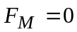), the ultimate vertical-horizontal bearing capacity envelope is:
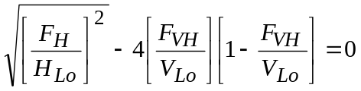

<< ERP Jan 2008: Do we need SAGE version of this equation ?? >>
where V_{Lo} is taken to be equal to the vertical spudcan load achieved during preloading (and evaluated as described in A.9.3.3.2) and H_{Lo} defined in section A.9.3.3.2.
        - Ultimate vertical-horizontal bearing capacity envelopes for spudcans in sand
The general ultimate vertical-horizontal bearing capacity envelope for jack-up spudcans in sand as described in Clause A.9.3.5.1 with H_{Lo} = 0.12 V_{Lo}.
Capacity against sliding must also be checked.

The sliding capacity envelope of a spudcan in sand is given by:
F_{H} = F_{VH}tanδ + 0.5γ' (k_{p} - k_{a}) (h₁ + h₂) A_{s}
where;
δ is the steel/soil friction angle.
for a flat plate, δ = φ - 5°, and
for a rough surfaced conically shaped spudcan, δ = φ.
        - Ultimate vertical-horizontal bearing capacity envelopes for spudcans in clay
The general equation for the horizontal and vertical bearing capacity envelopes for spudcans in clay is as described in Clause A.9.3.5.1 with H_{Lo} = c_{uo}A + (c_{uo} + c_{ul}) A_{s}.

<< ERP Jan 2008 - Will there be a revised equation giving greater capacity for deep penetrations in line with Table A.9.3-5 >>
Capacity against sliding must also be checked. The

sliding capacity in clay (
when 0 ≤ Q_{V} ≤ 0.5 F_{V}) can be conservatively assumed constant and determined by:
F_{H} = Ac_{uo} + (c_{uo} + c_{ul})A_{s}
        - Ultimate vertical-horizontal bearing capacity envelopes for spudcans on layered soils
The bearing capacity of layered soils can be determined using the principles of limiting equilibrium analysis or the finite element method. Alternatively, the formulae given in A.9.3.5.2 through A.9.3.5.3 can be used to make a conservative estimate of the ultimate F_{VH}-F_{H} relationship for layered soils by considering failure through the weakest zones in such a soil profile.
      - Acceptance checks
        - General
Figure A.9.3-1 shows the overall approach to the foundation acceptance checks.
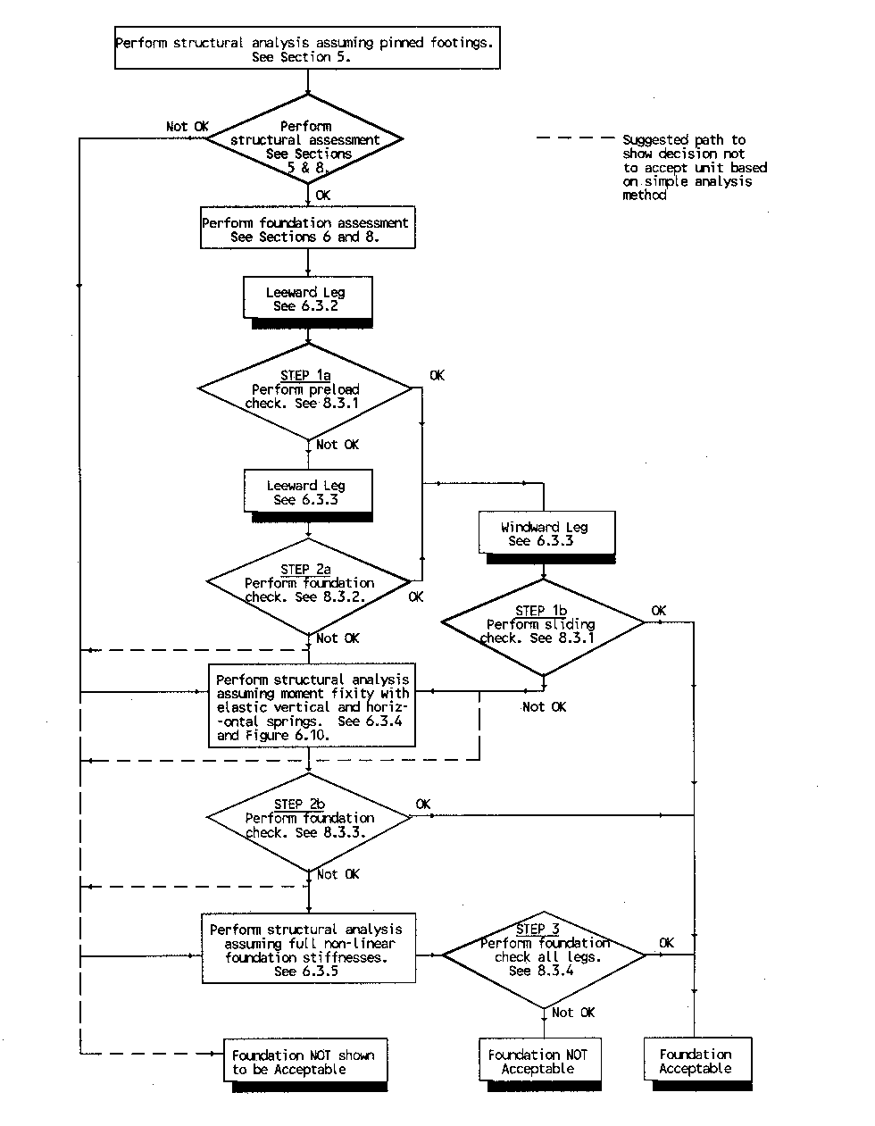
<< ERP Jan 2008: Delete the top part of this figure - under this box. Allow entry at any point from Perform foundation assessment. Update to match the process set out in the clauses below. >>
Figure A.9.3-2 Approach to foundation acceptance checks

        - Level 1, Step 1a: Ultimate bearing capacity for vertical loading - Preload check
<< Re-word this para; more to follow (e.g., acceptance criteria) – Need to ensure remainder of foundation checks (as in SNAME; captured in ISO Draft C) are included here. >>
The preload check may only be applied when the leeward leg horizontal reaction, Q_{H,}, is small (see table A.9.3-5 below). In this case the minimum preload, V_{Lo} is:
<< The capacity < V_{Lo} when backflow or infill occur after preloading >>
V_{Lo} ≥ γ_{R,P} Q_{v}
Where;
the preload resistance factor, γ_{R,P} = 1.1
Q_{v} is the vertical spudcan reaction due to the factored actions as determined from the procedures given in Clause 10
Table A.9.3-5 — Limiting Horizontal Reaction for Step 1a checks
Soil Type | Embedment | Maximum permitted horizontal reaction, Q_{H}
Dense Sand | Partial | 0.1V_{Lo}
Sand | Full | 0.03V_{Lo}
Clay | Less than 1~2 spudcan diameter | 0.1V_{Lo}
Clay | 1~2 spudcan diameter or greater | 0.5V_{Lo}
<< ERP Jan 2008: Suggest that in Clay we interpolate from 0.1V_{Lo} at 1 diameter to 0.5V_{Lo} at 2 diameters and more>>
<< ERP March 2007: P4 should review the following. The justification for 0.03 and 0.1 needs to be re-written to pass a 'logic-test'. Also note that Vaughan made some recommendations in his City Uni paper of ?2001 >>
When the leeward leg horizontal reaction, Q_{H} determined from the procedures given in Clause 10, is small, the ultimate vertical bearing capacity under extreme conditions is assumed to be the same as the maximum reaction beneath the spudcan during preloading (V_{Lo}) and the allowable reaction is V_{Lo}/γ_{R,P} i.e 0.9V_{Lo}.
In sand with a vertical reaction of 0.9V_{Lo}, the available horizontal capacity is approximately 0.03V_{Lo}. If the horizontal reaction exceeds 0.03V_{Lo} additional penetration will occur. If the spudcan is partially embedded this result in limited additional penetration. If the spudcan is fully embedded the additional penetration may be significant.
Where the spudcan is partially embedded (i.e., with maximum bearing area not mobilized) any additional penetration will result in a significant increase of bearing capacity due to the rapid increase in the bearing area. An increase in embedded area of approximately 10% will increase the horizontal capacity to 0.1V_{Lo} << This is largely because V_{Lo} has increased >>.
In sand, where a spudcan is fully embedded, the horizontal capacity at a vertical reaction of 0.9V_{Lo} is approximately 0.03V_{Lo}. Additional penetration may increase the soil resistance, but to increase the horizontal capacity to 0.1V_{Lo} the additional penetration will be in the order of 10% of the spudcan diameter and outside tolerable limits.

<< The format for the example foundation check above needs to resolved for general application >>.
        - Level 1, Step 1b: Ultimate sliding capacity check of windward leg
The horizontal capacity of the foundations of the windward leg(s) should be checked for the horizontal leg reaction Q_{H} in association with the vertical leg reaction Q_{v} determined from the procedures given in Clause 10. The most onerous case is likely to be with a single windward leg, the minimum variable load and the centre of gravity offset to leeward, however it is good practice to assess the horizontal capacity for all legs and load cases.
The foundation should satisfy the following capacity check:
Q_{H} ≤ F_{H}/γ_{R,Hfc}.
where;
F_{H} = foundation capacity to withstand horizontal forces when Q_{V} is acting
γ_{R,Hfc} = partial resistance factor for horizontal foundation capacity.
= 1.25 (effective stress - sand/drained).
= 1.56 (total stress - clay/undrained).
        - Level 2, Step 2a: Bearing capacity/sliding check - Pinned spudcan

- A reduction in vertical bearing capacity, F_{V}, of a spudcan foundation occurs when it is simultaneously subjected to horizontal force, Q_{H}, and moment, Q_{M}. The latter is ignored in Step 2a analyses as the spudcans are considered to be pinned.
The vertical/horizontal capacity envelope, F_{VH}, for sands and clays can be generated according to 9.3.5.

Alternately, the Step 2b interaction surface can be used for this check by setting the moment terms to zero.

The bearing capacity check should be made on all spudcan foundations by comparing the magnitude of only the environmental response vector, Q_{VH}, originating from the still water leg reaction, to the size of the factored yield surface along the direction of that vector (see Figure A.9.3-x). << ERP says add a figure >>
The spudcan foundations should satisfy the following capacity check:
Q_{VH} ≤ F_{VH} / γ_{R,VH}.
where;
F_{VH} = foundation capacity to withstand combined vertical and horizontal actions taken as a vector originating from the still water leg reaction in the same direction as Q_{VH}.
γ_{R,VH}. = partial resistance factor for foundation capacity.
= 1.1 - Maximum bearing area not mobilized.
= 1.15 - Penetration sufficient to mobilize maximum bearing area.
The spudcan foundations should also be assessed using the sliding check given in 9.3.6.2 since the factored sliding failure surface can lie within the factored vertical/horizontal capacity envelope.

        - Level 2, Steps 2b and 2c: Spudcan with moment fixity and vertical and horizontal stiffness

- The capacity checks to be undertaken in a Step 2b assessment are identical to those undertaken for Step 2a except that the response analysis is undertaken accounting for spudcan moment fixity.
A Step 2c analysis implicitly includes a check on compliance with the unfactored foundation yield surface, and therefore no Level 2 checks are required, however the Level 3 Step 3a displacement check is required, provided that, where applicable, the analytical model properly accounts for sliding failure

        - Level 3, Steps 3a and 3b: Settlements resulting from exceedance of the capacity envelope
Vertical settlement and/or sliding of a spudcan can occur if the reaction due to storm loading is in excess of the (F_{VH}-F_{H}) resistance envelope computed for the spudcan at the penetration achieved during installation. Such settlements can result in a gain of (F_{VH}-F_{H}) bearing capacity. However, the integrity of the foundation may decrease in the situation where a potential punch-through exists, e.g. where dense sand overlies soft clay. More thorough analyses are required for complex and/or potentially dangerous foundation conditions of the type listed in Section A.9.3.7. << We should be setting a target FOS v/s excessive additional penetration – P4 response: No, we don’t need another FOS as there existing load/resistance factors already. ERP Jan 2008: There are circumstances e.g. the one-shot Step 3b analysis where we may not have the soil resistance factor in the analysis. We have added the highlighted text to the end of 3b below … … >>
A Step 3a check can be accomplished by identifying the "virtual" preload level that would be required to expand the V-H yield surface used in Step 2 such that the factored capacity exceeds the spudcan foundation reactions. The displacement associated with this "virtual" preload is then obtained from the load-penetration curve. If the displacement is significant, the effects on the spudcan foundation reactions and the structure should be evaluated and the procedure iterated to establish whether the consequences of the displacement on the other utilization checks are acceptable.
A Step 3b analysis implicitly includes a check on the direct consequences of spudcan displacement and therefore no foundation checks are required, although care needs to be taken to ensure that the results are not sensitive to the the load-penetration assumptions i.e. that small changes in load or assumed soil strength will not lead to large increases in penetration.
When assessing the acceptability of displacements, due consideration should be given to operational limitations e.g. jacking operations to level the unit and re-establish a safe hull elevation or to depart location. The limits will be dependent upon the jack-up and the configuration at the location.

        - Foundation settlement not specifically addressed elsewhere
Settlements of the jack-up rig foundation have to be estimated and checked. If necessary, corrective actions have to be taken. The settlements due to bearing capacity failure during to preloading are not part of this Section (Refer to A.9.3.2). The settlements of installed spudcans can be assessed from a combination of:
  - elastic settlements
  - consolidation settlement
  - settlements due to cyclic loading
  - settlements due to hydraulic instability
The elastic settlements and consolidation settlements can be calculated using conventional analytical or numerical geotechnical models.
The elastic settlements occur instantaneously and can be calculated as function of the basic elastic soil properties (ν and G), the applied forces and the boundary conditions. The consolidation settlements of cohesive soils can be calculated using conventional models accounting for time effects.
Cyclic environmental actions or operational vibrations can induce further settlements. Special attention should be given to cyclic loading in silty sand or silt. Cyclic loading can also involve a soil strength reduction. This can induce settlements due to bearing failure.
Seafloor instability due to scour or piping involves a decrease of the effective bearing capacity. This can induce settlements due to local bearing failure or due local increase of loading pressures<< ERP Nov 2007 to P4 - please rewrite intelligibly >>.
The settlements should be checked regularly. If necessary level adjustments should be made or protective measures against scour development should be taken. (Clause 6.5.3)

      - Skirted spudcans
No guidance offered.
    - Other considerations
      - Hard sloping strata
A hard sloping stratum can be created by a sand wave, sand bank, scour around a platform, buried geomorphic features such as channels, footprints produced by previous jack-up unit emplacements, human-related seabed activity, or a combination of the above.
Eccentricity in the spudcan reaction can lead to emplacement and removal difficulties, particularly for slender brace/leg designs.
- This eccentric reaction can result in a significant leg bending moment in the region of the hull. Where the bending moment is reacted by the leg guides, the resulting large shear force can overstress the leg members.
- If a fixation system (rack chocks) is employed at the leg to hull interface, the bending moment present at the time when the fixation system is engaged will be locked into the leg. If the eccentricity of the spudcan reaction is subsequently exacerbated (e.g. by scouring around the spudcan), then the effective leg bending moment in the region of the hull may increase. When the fixation system is later disengaged, the moment in the leg will be redistributed in equilibrium with the present support conditions, which can overstress the leg members.
Where the jack-up unit is pre-stressed as a result of installation on such a seabed (e.g. by differential jacking on each chord of the leg), these installation stresses should be included in the overall site-specific assessment. Consideration may also be given to the potential benefit of seabed preparation prior to emplacement of the jack-up unit.
      - Footprints
Surface or buried footprints from prior jack-up operations at the proposed location can cause eccentric reactions or lateral movement of the spudcan. One preventive approach is avoidance (i.e., positioning spudcans at some minimum distance away from the footprints) while mitigations include working the legs, leg stomping, seabed remediation, etc.
Information on spudcan-footprint interaction can be found in the reference listed below:
- Stewart, D. P. and Finnie, I. M. S. (2001), “Spudcan- Footprint Interaction During Jack-up Workovers”, Proceedings, 11th International Offshore and Polar Engineering Conference, Stavanger, Vol. I, pp. 61-65.
<< P4 Convenor to check for any later reference e.g. GM/Fugro JIP. >>
      - Leaning instability
Leaning instability of jack-ups can occur during preloading operations in soft clays where the rate of increase in bearing capacity with depth is small. A lower bound estimate of the leaning stability can be obtained using the theory of Hambly [45]. However, it should be recognized that such estimates have proven to be generally conservative due to the omission of beneficial effects such as spudcan fixity and lateral soil resistance on the legs. In deep water a potentially unsafe condition (comparable to a punch-through situation) may occur. The potential for such incidents can be mitigated if appropriate installation procedures are adopted. These can, for example, include preloading the spudcans individually.

      - Leg extraction difficulties
Experience has shown that leg extraction difficulties are relevant but not limited to conditions such as:
- Deeply penetrated spudcan in soft clay or loose silt;
- Skirted or caisson-type spudcan where uplift resistance can be greater than the installation reaction;
- Sites where soil exhibits strength gain with time.
A jack-up unit pulls it legs from the seabed by lowering the hull into the water thereby generating a buoyant uplift force and inducing tensile forces in the legs. The force required to extract the leg is affected by several factors including the nature of the soils, the depth of penetration, the geometry of the spudcan and whether soil backflow has occurred above the spudcan. The force available for leg extraction is frequently less than the force applied during installation. Where significant leg penetrations are attained, it is not uncommon for pulling of the legs to take several days, or in some cases much longer.
Where leg extraction problems are predicted, this should be included in the site assessment report.
Potential mitigations include
jetting and/or excavation of the surface soils. It should, however, be noted that these can alter soil strength and the seabed topography, which could affect future emplacements of jack-up units at the same location.

References:

- Byrne, B.W. and Cassidy, M.J. (2002). Investigating the response of offshore foundations in soft clay soils. Proc. OMAE’02 21st Int. Conf. On Offshore Mechanics and Artic Engineering, Oslo, Norway, Paper No OMAE2002-28057.

- Craig, W.H. (1998). Spudcan foundations: installation with deep penetration and subsequent removal. Geotechnical Engineering, Vol 131 No 3, pp146-151.
- Craig, W.H. and Chua, K. (1990). Extraction forces for offshore foundations under undrained loading. Journal of Geotechnical Engineering, Vol 116, No 5, pp 868-884.
- Craig, W.H., Cruickshank, M. and Fisher, R. (2002). Seabed breakout forces. Proc. Int. Conf. on Physical Modelling in Geotechnics 2002, Newfoundland, Canada. Balkema. pp 283-287.
- Erbrich C.T. (2005) Australian frontiers - spudcans on the edge. Keynote lecture. Proc. Int. Symposium on Frontiers in Offshore Geotechnics. Taylor & Francis 49-74.
- Purwana O.A., Leung C.F., Chow Y.K., Foo K.S. (2005) Influence of base suction on extraction of jack-up spudcans. Géotechnique 55(10):741-753
      - Liquefaction and cyclic mobility
General guidance on the assessment of the potential for liquefaction and/or cyclic mobility is given by Kramer (1996) and Idriss and Boulanger (2004). Dean (1991) presents approximate methods for estimating settlements of submerged foundations subjected to time dependant loading.
References:
Dean, E.T.R. (1991). "Some Potential Approximate Methods for the Preliminary Estimation of Excess Pore Water Pressures and Settlement-Time Curves for Submerged Foundations subjected to Time Dependent Loading", Cambridge University Engineering Department, CUED/D-Soils/TR240.
Idriss, I.M. and Boulanger, R.W. (2004). “Semi-empirical Procedures for Evaluating Liquefaction Potential During Earthquakes”, Proceedings of the 11th International Conference on Soil Dynamics & Earthquake Engineering (ICSDEE) and the 3rd International Conference on Earthquake Geotechnical Engineering (ICEGE), Berkley, California, pp. 32-56.
Kramer, S. L. (1996). Geotechnical Earthquake Engineering, Prentice Hall, New Jersey.

      - Seabed instability
No guidance offered
      - Scour
The key ingredients for scour to occur are:
  - hydrodynamic conditions
  - flow disturbance due to presence of an obstruction
  - the potential for erosion of the sea floor material
For the hydrodynamic conditions, the combination of tidal and non-tidal current velocities (e.g. storm driven currents) are found to be key parameters, so that the effects of scour can increase rapidly during storm conditions, particularly when the two contributions are aligned.
The maximum depth of scour adjacent to the spudcan is related to the dimensions of the obstruction introduced, either the spudcan itself or the spudcan in combination with the leg structure.
Particle size has a strong influence on the erodibility, see Figure A.9.4-x. The larger particle sizes such as gravels and cobbles may be useful for scour protection measures if not part of the original sea floor soils.
Scour is more important for spudcans with limited sea floor penetration, as removal of the soil can result in:
  - a redistribution of leg forces or loss of jack-up hull trim;
  - a reduction of the bearing capacity of the foundation and seabed fixity;
  - eccentricity in the spudcan reaction;
  - an increase in an existing potential for punch-through.
There is no definitive procedure for the evaluation of scour potential, but useful reference material can be found in Sweeney et al (1988), Whitehouse (1998), and Rudolph et al. (2005). Previous operational experience can help in the management of scour, either in the development of scour protection measures or of an awareness of the critical combination of tidal and non-tidal (storm driven) currents that can induce scour. Scour protection measures include:
- Gravel dumping prior to installation provided the selected gravel gradation will not cause damage to the jack-up spudcans. Particularly for the larger materials, care must be taken to ensure that this activity does not adversely affect future jack-up emplacements.
- Use of frond mats, gravel bags, gravel or grout mattresses after installation. The requirement for this may be evaluated from scour surveillance monitoring. .
- Monitoring and adjusting for reduction in hull elevation.
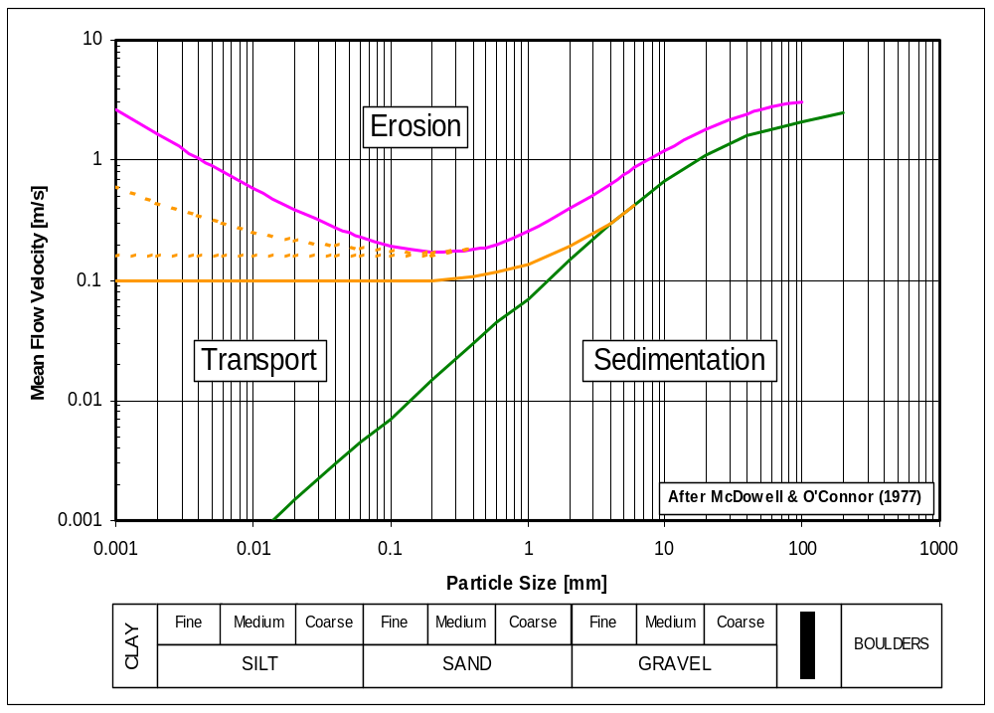
<< ERP Jan 2007: ADD TITLE >>
References
- Sweeney, M., Webb, R.M., Wilkinson, R.H. (1988): Scour around jackup rig footings, Proceedings of the 20th Offshore Technology Conference, Paper No. 5764, Houston, Texas, USA
- Whitehouse, R.J.S. (1998): Scour at marine structures, Thomas Telford Publications, London, UK
- Rudolph, D., Arnout C., Bos, K.J., Rietema, K.,. (2005): Scour around spudcans – analysis of field measurements, The Fifteenth International Offshore and Polar Engineering (ISOPE) Conference Korea, June , 2005.
      - Shallow gas
No guidance offered
      - Spudcan-pile interaction
<< Put Some text here with reference to Siciliano, et al. 1991, Stewart (Perth, 2005) & NUS (Perth, 2005) >>

- << Correct the section no. references, etc. in the figure below. >>
Action item: GTH to cross check the text against Fig. A.9.3-10 and perhaps improve the figure.

Structural response
    - Applicability
No guidance offered
    - General considerations
Two categories of action effect are to be distinguished and assessed separately. These are:
- The ULS responses typically include the internal forces in the leg members, overturning moments of the jack-up, horizontal deflections of the hull, reactions and displacements at the spudcans and forces in the holding system. The responses should be obtained using appropriate combinations of functional actions, environmental or seismic actions, and dynamic, second order and leg inclination effects with the action factors required by the acceptance criteria in Annex B. The application of actions is described in A.8.8. Clause 5.4.3 requires that the analysis be carried out for a range of environmental headings with respect to the jack-up such that the most onerous loading(s) for each item in the list above is(are) determined.
- FLS response - The cumulative effect of stress/strain cycling, which is used to estimate the fatigue lives of steel components (see 10.6). Clause 10 is specifically aimed at short-term operations where fatigue is typically not a consideration. However, fatigue response can be important for long-term applications of a jack-up unit (see Clause 11).
    - Types of analyses and associated methods
The ULS response can be determined either by a deterministic quasi-static analysis procedure including an inertial loadset (see A.10.5.2) or by a more detailed (random) dynamic analysis procedure which uses the stochastic method (see A.10.5.3). Figure A.10.3-1 shows the procedures for using these two approaches to determine the ULS response.

STOP Jack-up not suitable for this site

Y
N
Y
N
N
Y
Determine highest natural period of jack-up, T_{n}.
See Clause A10.4.2
Criteria satisfied?

Use SDOF method to determine periodic DAF from T_{n} and 0.9T_{p}.
See Clause A10.5.2.1.2
Compare with quasi-static response from same procedure with zero masses. Obtain inertial loadset so that standard quasi-static responses are amplified by same factor as random quasi-static responses
Perform random dynamic analysis See Clauses A10.5.2.1.3 & A10.5.3
Determine peak period, T_{p},
of wave spectrum for extreme
seastate and T_{ass}, the period associated with the maximum wave See Clause A6.4.2

From

Calculate Inertial load-set according to A10.5.2.1.2
set according to 7.3.6.1
Accounting for non-gaussian effects use means and standard deviations to estimate:

Selected¹ All² responses responses

estimate:
If necessary, apply results to more detailed model to obtain final results
STOP Jack-up not suitable for this site
Jack-up not suitable for this site
Go to
●

Criteria Satisfied?
Y
Nonlinear time domain simulation
Determine means and Standard deviations
Standard deviations
Apply to appropriate structural model with wave/current & wind loads in quasi-static analysis procedure.
If necessary, apply results to more detailed model to obtain final results
Analyse time series and use an appropriate method to directly predict:
Selected¹ All²
responses responses
Go to
●

Try more complex method?

N
Include Foundation Fixity?

Selected¹ All²
responses responses

Figure A.10.3-1 — Recommended approach to determine extreme responses
    - Common parameters
      - General
The ULS response may be calculated either by a quasi-static analysis procedure including an inertial loadset or by a more detailed (random) dynamic analysis procedure.
A.8 identifies the factors that affect the structural stiffness of the jack-up and A.8.x discusses the structural stiffness modelling at various levels of complexity. The hydrodynamic actions and wind actions are discussed in Clause 7.
The magnitude of the dynamic response is affected by:
- The dynamic characteristics (natural periods) of the structural system formed by the jack-up on its foundation, and
- The characteristics of the wave/current excitation. << Higher order Harmonics ? >>
The following sections discuss the factors that affect these two characteristics.
      - Natural periods and affecting factors
        - General
The natural period of the jack-up on its foundation in the fundamental (or first) mode of vibration is an important indicator of the degree of dynamic response to be expected. The first and second vibrational modes are nearly always the surge and sway modes. The natural periods of these vibrational modes are usually close together; which of the two is the higher depends on which direction is less stiff. Where the natural or wave period varies with environmental heading, care should be taken that the periods used are applicable to the environmental direction being considered in the analysis. The third vibrational mode is normally a torsional mode, the three-dimensional effects of which can be important, in particular for environmental headings where the legs and hence wave actions are not symmetric about the direction of wave propagation.
The natural period is dictated by the characteristics of the structural system, which are governed by the overall (global) structural stiffness, the mass and mass distribution and the damping.
The undamped natural period is determined from the following equation:
T_{n} = 2π 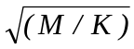
where;
T_{n} = highest (or first mode) natural period.
M = effective system mass;
K = effective system stiffness.
Due to uncertainty in parameters affecting the natural period, the calculated natural period(s) will also be uncertain. The natural period(s) used in the dynamic analysis should be selected such that a realistic but conservative value of the dynamic response is obtained for the particular application envisaged. Care should be taken to ensure that the maximum dynamic amplification is not selected as coincident with a cancellation period causing minimum environmental actions. The potential for increased response due to shortcrested waves should be considered (see Clause xxx). Figure A.10.4.2.1-1 presents the periods at which first and second cancellations and reinforcements occur in the total wave actions. It is valid for the main wave directions of 3 and 4-legged jack-ups in water depths exceeding 30m. For further details refer to Annex C.
<< Include better explanation and the methods for avoiding the problem (see 5-5A 7.3.7.3 / C.7.3.7.5 - presently in Annex C ??). >>
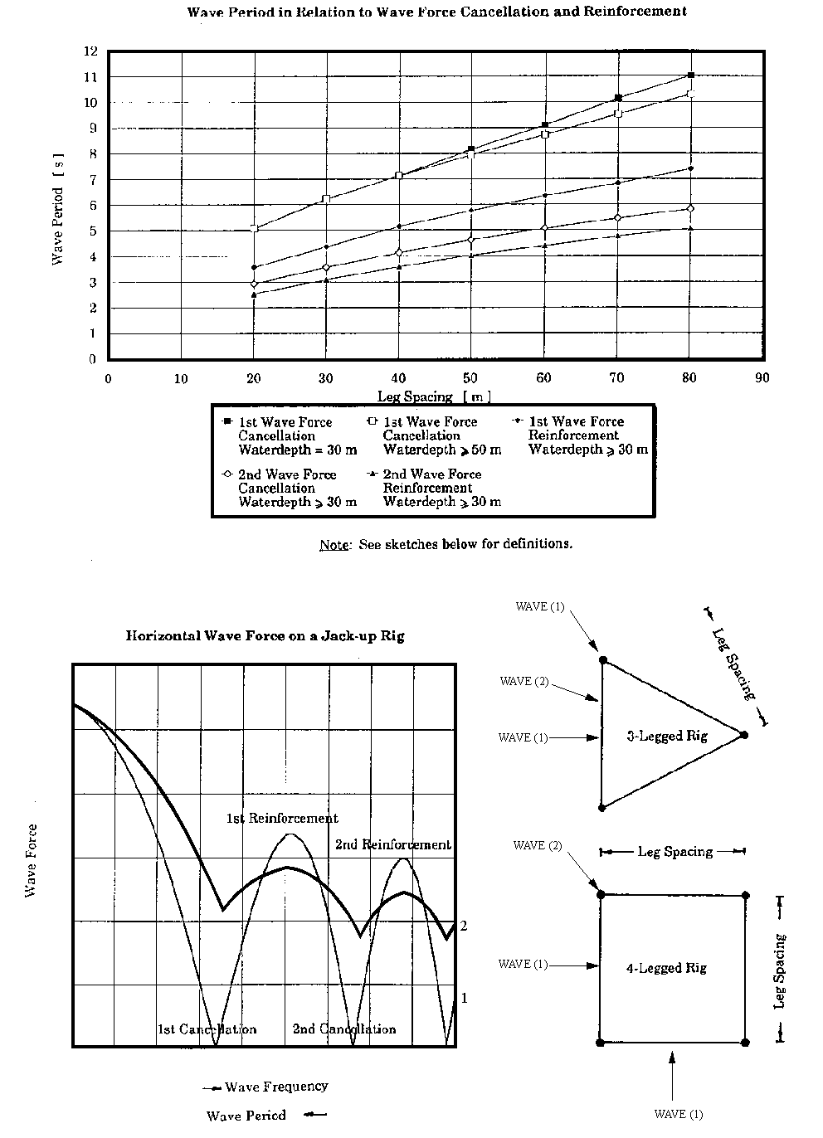
Figure A.10.4-1 — Periods for wave force cancellation and reinforcement as a function of leg spacing
        - Stiffness
The jack-up on its foundation represents a multi degree-of-freedom system. If available, a finite element structural model, containing the mass and stiffness properties, of the jack-up should be used to obtain the various natural periods and mode shapes. Structural modelling at various levels of complexity is discussed in A.8 and should consider stiffness contributions from the following:
  - bending deformation of the legs;
  - shear deformation of the legs;
  - axial deformation of the legs;
  - hull bending deformation;
  - horizontal vertical and rotational leg-hull connection stiffness;
  - horizontal, vertical and rotational foundation stiffness;
  - second order P-Δ or Euler stiffness reduction.
The model may contain a number of non-linear elements, notably the leg to hull connections and the spudcan-foundation interfaces.
If desired the system stiffness for the fundamental modes may be determined from an idealized single degree-of-freedom system as described in Annex C.

        - Mass
See 8.7 for guidance.
        - Variability in natural period
No guidance offered.
      - Damping
        - General
System damping contributors include foundation, hydrodynamic and structural damping. Non-linear behaviour of the foundation and jacking system also contribute to system damping. The degree to which each of these contributes to damping will depend on the type of analyses and the level of system response. Damping may be accounted for explicitly or implicitly:
  - Explicit damping is input to the analysis as a percentage of critical damping;
  - Implicit damping arises as a function of the analytical response and modelling e.g. fluid-structure relative velocity for hydrodynamic damping (see A.7.3.3.2) and hysteresis for foundation damping.
        - Linear system damping
Where the model relies on explicitly defined damping, then the total linear system damping should not exceed 7% without credible, applicable justification. Lower values can be appropriate for fatigue analyses and smaller sea states. Care should be taken to avoid the duplication of damping components when explicit and implicit representations are used simultaneously in the analyses. Table A.10.4-1 summarizes typical upper bound percentages of critical damping for the various damping sources that comprise the explicitly defined linear damping.
Table A.10.4-1 — Recommended explicit damping from various sources
Damping source | Global linear damping not to exceed (% of critical damping)
Structure, holding system, etc. | 2%
Foundation | 2% ⁽¹⁾
Hydrodynamic | 3% or 0%⁽²⁾

1. The small-strain soil material damping is typically small; in the absence of specific data, 2% is considered to be a reasonable estimate. At larger strains, amplitude-dependent hysteretic damping will also occur. Where a non-linear foundation model is adopted for the dynamic response analysis the hysteretic foundation damping is accounted for directly. Where a linear foundation model with stiffness reduction according to A.9.3.4.2.1 is adopted, the hysteretic damping may be added. See below.
2. In cases where the relative velocity formulation may be used (α = 1 in Equation A.7-xx) the hydrodynamic damping is accounted for directly and should not therefore be included in the global damping.
<< ERP Jan 2008: The changes to foundation damping above and below will need agreement from P4 >>
        - Hysteretic damping
When a stiffness reduction factor is being applied to reduce the spudcan rotational stiffness used for determining the DAF, an additional damping allowance may be made to account for the effects of foundation hysteretic damping.
Foundation hysteretic damping is a consequence of the hysteretic behaviour of the foundation soils. For clay soils, whenever significant foundation non-linearity is present, an additional damping component may be added to system damping to account for this phenomenon. This foundation hysteretic damping component can be included implicitly in a detailed nonlinear dynamic analysis embodying hysteretic spudcan foundation elements, or it may be calculated explicitly in the case of a simpler pseudo-static analysis, as follows:
  - The entire structure should be modelled (e.g., via a bar stool model). The model should be linear except for the inclusion of foundation non-linearities (e.g. via the use of spud can foundation elements or progressive stiffness reduction) and P-delta effects,
  - This model should be used to produce a force vs. deflection (backbone) curve for the horizontal force, F (equal to the amplitude of the extreme load cycle, including the effects of dynamic amplification), vs the horizontal deflection, x, both at the effective centre of combined storm and inertial loading,
  - 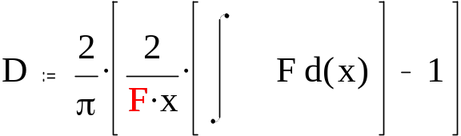The hysteretic damping, D, as a function of deflection should be developed from the F vs. x (backbone) curve according to the definition,

with the limits of integration zero to x << to be put in the equation >>, due to the magnitude of F equal to the amplitude of the extreme load cycle, including the effects of dynamic amplification, which implies multiple or iterative analysis to determine consistent values of F and D. << ERP Jan 2008: Add a Figure and perhaps more in Technical report. A more detailed procedure, or example calibration would help. >>
  - The hysteretic damping D (a fraction of critical damping) should be added to the small-strain soil material damping used in determining the SDOF DAF.
  - The hysteretic damping should be determined for each loading direction to be considered in the assessment.

      - Foundations
The analysis of the structure and the foundation evaluation can be performed essentially in two different ways:
<< ERP Jan 2008: P3 Needs to add a reference to Figure A.10.4-2. The figure needs to be revised to better follow option 1 and possibly include option 2 >>
Option 1: Two-stage approach, where the dynamic excitation of the structure is evaluated based on either a simple linear analysis or a more complex elasto-plastic analysis. The foundation and structural assessment is then performed using a quasi-static iterative analysis technique, for which the dynamic actions have already been determined. The dynamic analysis may include linearized foundation fixity. Typically the initial linearized rotational stiffness for the dynamic analysis may be taken as 80-100% the value determined from the formulation in A.9.3.4.1. This simplified approach does not capture the temporary reductions in stiffness which occur during plasticity events (generally with detrimental effects), but also does not capture the increased damping associated with these events (with beneficial effects).
Option 2: One stage approach, where dynamic structural analysis and assessment is performed using one model. Here a fully detailed non-linear time-domain analysis is performed taking into account the elasto-plastic behaviour of the foundation.
This quasi-static analysis in option 1 may be accomplished by means of either an elasto-plastic foundation model or a simplified application of the full plasticity analysis as described below. This simple approach can be used to create moments on the spudcan by inclusion of a simple linear rotational spring. The moments thus induced on the spudcan are limited to a capacity based on the yield interaction relationship between vertical force (Q_{V}), horizontal force (Q_{H}) and moment (Q_{M}) acting at the spudcan.
This simple procedure is described in the following steps:
1) Include vertical, horizontal and (initial) rotational stiffnesses (linear springs) (see A.9.3.4.1) to the analytical model and apply the factored gravity, environmental and inertial actions together with the associated and separately calculated inertial forces from a linearized dynamic analysis.
2) Calculate the yield interaction function value (see A.9.3.3) using the resulting forces at each spudcan. For extreme storm event analysis, the result will probably indicate the force combination falls outside the yield surface. In this case, reduce the rotational stiffness (arbitrarily) and repeat the analysis.
3) Continue with step 2 until the force combination at each spudcan lies essentially on the yield surface. If the moment is reduced to zero, and the force combination is still outside the yield surface, then a bearing failure (either vertical or horizontal) is indicated. << See ed. comments from NL >>
4) If a force combination initially falls within the yield surface, the rotational stiffness shall be further checked to satisfy the reduced stiffness conditions in A.9.3.4.2.
In Option 2, the effects of the foundation fixity are simultaneously considered on both the dynamic response and the seabed reactions. This approach is more complete and often requires a complex incremental and iterative calculation procedure. The following outline procedure may be adopted:
- Use a time-domain dynamic analysis to determine structural response and foundation forces at each time step.
- Compute the foundation behaviour using a non-linear elasto-plastic model, such that at each time step the plastic and elastic portions of the behaviour are captured. If desired, this model may include hysteresis. This is likely to require an iterative procedure.
- As the dynamic response will be influenced by the time history of the actions, a number of analyses should be performed for differing wave histories, and the extremes determined from a procedure described in Annex C.
The foundation stiffness may need to be further adjusted to avoid wave force cancellation. See A.10.4.2.1.
<< ERP Jan 2008: Delete the top part of this figure - under this box. >>
Figure ‎A.10.4-2 — Analysis procedure for assessment with foundation fixity
<< ERPJan 2008: The xxxxx boxes to be deleted >>
Assume elastic spudcan response
Q_{M} = K₃θ, Q_{V} = K₁δ_{v}, Q_{H} = K₂δ_{h},

Unit NOT acceptable
Perform
structural assessment with pinned case inertial loadset, See Sections 5,7 & 8.

Perform
foundation check at all spudcans (see 8.3.3)
OK
Not OK
Not OK
OK
Unit acceptable
Run iterative structural analysis using current inertial loadset and de-grade foundation stiffness until spudcan loads fall within foundation yield surface. Section 6.3.4.2

Perform dynamic analysis accounting for fixity?
Yes
Perform simplified or detailed dynamic analysis accounting for fixity?
No
Perform
foundation checks at all spudcans (see 8.3.3)
Perform
structural assessments See Sections 5,7 & 8
OK
OK
Run dynamic analysis using linearized fixity and determine wave force transfer functions.
Run non-linear elasto-plastic dynamic time-domain analysis and determine DAF from a number of differing storm simulations. Use resulting DAF to determine new inertial loadset. (Section 6.3.4.1 Option 1)
Natural Period close to cancellation point?
Select initial linearized fixity
Yes
Select revised linearized fixity &/or change hull mass.
No
Not OK
Perform
Step 3
Not OK
Not OK
OK
Try more complex method?
No
Yes
Unit NOT acceptable
Simplified
Detailed
Section 6.3.4.1 (Option 2)

      - Storm Excitation
Currents change slowly compared with the natural periods at which jack-ups oscillate and may hence be considered to be a steady phenomenon. Variations in wind velocity cover a wide range of periods, but the main wind energy is associated with periods that are considerably longer than the natural periods of jack-up oscillations. Therefore, the wind may generally be represented as a steady flow of air. The periods of waves typically lie between 3 sec and 20 sec. Since typical jack-up natural periods fall within this range, the primary source of dynamic excitation is from waves.
Sea waves are generally not regular but random in nature unless swell is predominant. This has important implications that should be considered for both the dynamic excitation and the resulting dynamic response.
<< Is this where we add input from Shell/IADC ND wave spreading study ??. Will need to link to A.6.4.2.2 and 7 or A.7.3.3.3.3 >>
    - Storm analysis
      - General
No guidance offered << ERP Jan 2007: move to here the bits of A.10.5.2 that also apply to the stochastic model >>
      - Deterministic storm analysis
The quasi-static analysis should be carried out in accordance with all relevant requirements of Clauses 5 to 10. The maximum wave action is determined by 'stepping' the maximum wave through the structure. The maximum wave is defined in 6.4 and the methodology for calculating the wave actions is described in 7.3. Load cases and combinations are discussed in 8.8.
The inertial actions are determined from a dynamic amplification factor using either a single degree of freedom.analysis (DAF_{S}) or stochastic analyses (DAF_{R}). Methods for determining the dynamic amplification factors (DAF_{S} or DAF_{R}) and subsequently the inertial loadset are given in A.10.5.2.1.
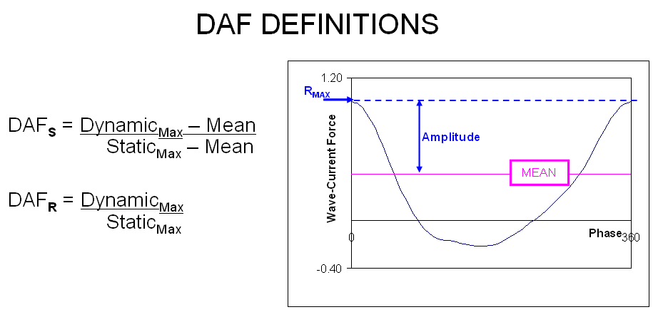
<< ADD A FIGURE RE AMPLITUDES AND DEFINE DAF_{S} and DAF_{R} etc. (mjrh sent this to RDB)>>
<< Panel 3 does not like the figure above. Equations are incorrect.>>
The spudcan-foundation interface can be modelled as described in 9.3.1.
        - Dynamic amplification factors (DAF) and inertial loadsets
          - General
When using a deterministic analysis for calculating the response, the dynamic response is represented by equivalent inertial actions as described in A.8.8.5. The inertial loadset can be derived from the simple approach described in A.10.5.2.1.2 or from the more complex methods discussed in A.10.5.2.1.3. It should be noted that dynamic amplification is the result of the inertial response which is dominated by the hull mass. Therefore amplifying the hydrodynamic actions is not a correct representation.
NOTE This difference between the height of action the wave actions and the height of the system centre of mass means that the global response (e.g base shear, overturning moment, hull deflection) and local response (e.g. member forces, holding system reactions, spudcan reactions) are not equally amplified by the inertial response.
          - The classical SDOF analogy (DAF_{S})
This representation assumes that the jack-up on its foundation can be modelled as an equivalent mass-spring-damper mechanism. The (highest) natural period of the vibrational modes can be determined as described in Section A.10.4.2. The torsional mode and corresponding three-dimensional effects cannot be included in this representation.
The single degree-of-freedom (SDOF) method is fundamentally empirical because (1) the wave/current action does not occur at the hull and (2) the loading is non-periodic (random) and non-linear.
The method described below will generally lead to a reasonable approximation of the jack-up's real behavior and has been calibrated against more rigorous methods. The following cautions are noted when using the SDOF method:
  - If the ratio of the jack-up natural period to the wave excitation period, Ω, is less than 0.5 and the current is 'relatively small' the SDOF method should give reasonably accurate results when compared to a more rigorous analysis.
  - If Ω is greater than 0.5, the relative position of the jack-up natural period within the base shear transfer function should be checked. As discussed in A.10.4.2, if the natural period falls near a wave force peak, then the SDOF method can be unconservative because it ignores forcing at other than the full wave excitation period. Note that a range of natural periods should be considered to account for a reasonable range of foundation fixity (see A.10.x.x).
  - The SDOF method can be unconservative for cases with relatively high currents. If the results of the assessment are close to the acceptance criteria further detailed analysis is recommended.
The ratio of (the amplitudes of the) dynamic to the quasi-static response as a function of frequency (ω) or period (T) of steady state, periodic and sinusoidal excitation is calculated as the classical dynamic amplification factor (DAF_{S}):
DAF_{S} = 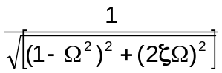
where;
Ω = 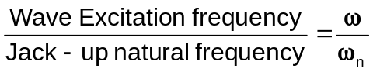
= 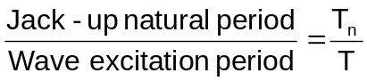
ζ = Damping ratio or fraction of critical damping
= (% Critical Damping)/100, ≤ 0.07 (see A.10.4.3).
T = 0.9T_{p}.
T_{p} = most probable peak wave period.
T_{n} = the jack-up natural period as derived in A.10.4.2.1.
The damping parameter ζ in this model represents the total of all damping contributions (structural, hydrodynamic and soil damping). For the evaluation of extreme response using the SDOF method a value not exceeding 0.07 is recommended.

<< Jan 2008. Added reference to 10.4.3 to point to revision from SAGE based on Templeton (2006)
<< Previous query from [who?]: Why? Do we want to change damping for the “calibrated” SDOF method? >>
The calculated DAF_{S} from the SDOF method is used to estimate an inertial loadset which represents the contribution of dynamics over and above the quasi-static response in accordance with Figure A.10.3-1. This inertial loadset should be determined as follows and applied at the hull center of gravity in the direction of wave propagation:
F_{in} = (DAF_{S} - 1) BS_{Amplitude}
where;
F_{in} = Magnitude of the inertial loadset for use in conjunction with the SDOF method.
BS_{Amplitude} = Single Amplitude of quasi-static Base Shear over one wave cycle.
= (BS_{(Q - S)Max} - BS_{(Q - S)Min})/2
BS_{(Q - S)Max} = Maximum quasi-static wave/current Base Shear.
BS_{(Q - S)Min} = Minimum quasi-static wave/current Base Shear.
Note: The above equation is part of a calibrated procedure and should not be altered. A more general inertial loadset procedure, using the results from random analysis, is described in A.10.5.2.1.3.
          - Inertial loadset based on random dynamic analysis (DAF_{R})

The inertial loadset can also be derived from the DAF calculated from a time domain analysis for random-wave excitation according to the recommendations of the Stochastic Storm Analysis in A.10.5.3. The DAF_{R} is to be the ratio of the MPME of the dynamic response to the MPME of the static response (MPME_{dyn}/MPME_{static}). The MPME is defined in Table A.10.5-2.
The inertial loadset should be such that it increases the responses of the deterministic quasi-static analysis by the same ratios as those determined between the random quasi-static (zero mass) analysis and the random dynamic analysis. In such cases the structural model (used for dynamic analysis) may be simplified and does not need to contain all the structural details, but will nevertheless be a multi degree-of-freedom model. See A.8.8.5 for guidance of applying an inertia loadset to the model that matches both dynamic BS and OTM.
      - Stochastic storm analysis
As an alternative to deterministic storm analysis the extreme response can also be predicted by a stochastic method of analysis where the intent is to determine the MPME of the utilizations and other responses of interest. Statistical methods are used to predict the MPME (see A.10.5.3.2).
Stochastic methods can also be used to develop DAF’s for use in the deterministic analysis.
When undertaking a fully integrated stochastic dynamic analysis that directly results in structural and foundation utilization checks, the environmental partial action factor cannot be explicitly included in the analysis. Therefore, methods for simulating the partial action factors need to be developed. One such method would be to introduce separate factors on each of the environmental parameters (i.e., wind velocity, wave height and current velocity). It is still necessary to determine the MPME of each utilization.
The waves can be modelled as a linear random superposition model that is fully described in A.7.3.3.3.3.which identifies important constraints associated with this method of random wave dynamic analysis.

        - Random Wave Dynamic Analysis Method
<< reference should be moved to the bibliography >> GET RVA’s input on this. Input on the bibliography??
Time domain simulations require that a suitable random sea state is generated, that the validity of the generated sea state is checked, and that the time-step for the solution of the equations of motion is sufficiently small. It is also necessary to ensure that the duration of the simulation(s) is sufficient for the method being used to determine the MPME. Specific recommendations are given in Tables A.7.3-4 and A.10.5-2.
<< Did P3 Sept 2007 mean to delete table content but leave table outline & header? >>
Table A.10.5-1 - Recommendations for application of random wave dynamic analysis methods
Method | Recommendations
Time  Domain | Generate random sea from at least 200 components and use divisions of generally equal energy. It is recommended that smaller energy divisions are used in the high frequency portion of the spectrum, which will generally contain the reinforcement and cancellation frequencies. Each wavelet should be taken to disperse with its own linear dispersion relationship [12]  Check validity of wave simulation:  - correct mean wave elevation  - standard deviation = (H_{s} /4) ± 1%  - -0.03 < skewness < 0.03  - 2.9 < kurtosis < 3.1  - Max crest elevation = (H_{s}/4)√{2ln(N)} -5% to +7.5%  where N is the number of cycles in the time series being qualified, N ≈ Duration / T_{z}  Integration time-step less than the smaller of:  T_{z}/20 or T /20  where;  T_{z} = the zero-upcrossing period of the wave spectrum  T_{n} = the jack-up natural period  (unless it can be shown that a larger time-step leads to no significant change in results)  Avoid transients in 'run-in' (≥100 secs).  Ensure simulation length OK for method chosen to determine the MPME response(s).  Note: The MPME is defined in Table 10.5-2

        - Methods for Determining the MPME
ERP Jan 2007 proposal:
- We need a well defined stochastic approach(s) for use in determining DAF's for the 2-step approach.
- Whilst much of this will apply to the one-step approach, this should have it's own subclause which, as a minimum, captures all the issues that need to be addressed (but probably will not provide all the answers). Issues are (at least):
- Correct probability level of extremes
- Multiple runs and statistics of their extremes to obtain the overall MPM
- How to include load factors & interaction with FSI.
Note that a lot of the text is repeated in other places >>
<< Panel 3 believes we have addressed the above comments as of Sept 10, 2007>>
When using the stochastic method to predict the extreme response from the results of a random wave dynamic analysis, it should be noted that the extreme response should be the required MPME response, which is defined in Table A.10.5-2 as the mode value or highest point on the Probability Density Function (PDF).
The stochastic waves may be modelled as a linear random superposition model which is fully described in A.7.3.3.3.2 and results in a non-Gaussian response.
Three methods for obtaining the MPME of the response are included in Table A.10.5-2.
It should be noted that the simpler modelling approaches will not lead directly to the MPME of all quantities of interest. For example, SDOF based models will provide directly only the MPME of hull displacement. Simpler multi-degree-of-freedom models will provide the MPME of total leg forces, but will not lead directly to forces in individual members of a truss-leg. Fully integrated stochastic models can be used to determine the MPME of all response parameters.
For simplified models
, the random wave dynamic analysis may be used only to determine the inertial loadset which represents the contribution of dynamics over and above the quasi-static response (see A.10.5.2.1.3).

Table A.10.5-2 - Recommendations for determining MPME (see Annex C)
Method | Recommendations
General | Define the MPME as the extreme with a 63% chance of exceedance (typically this is the mode or highest point on the probability density function (PDF)).This is approximately equivalent to the 1/1000 highest peak level in a 3-hour storm and the extreme with approximately a 63% chance of exceedance.
Time Domain | Fit Weibull distribution to distribution, for 3-hour probability level. Take results as average of MPME's from ≥ 5 simulations. Each input wave simulation to be of sufficient length for recommendations of Table A.10.5-1 to be met (usually at least 60 minutes). See Annex C.10.5.3.2-1  or  Use multiple 3-hour simulations and use Gumbel distribution on the extreme from each simulation. Sufficient simulations (usually at least 10) are required to obtain stable MPME of responses. See See Annex C.10.5.3.2-2.  or  Use Winterstein's Hermite polynomial model, with improvements by Jensen if kurtosis > 5. Simulation of sufficient duration to provide stable skewness and kurtosis of responses (normally in excess of several hours). See See Annex C.10.5.3.2-3.

      - Leg Inclination
The effects of initial leg inclination should be considered. Leg inclination can occur due to leg-hull clearances and the hull inclination permitted by the operating manual. Thus the total horizontal offset due to leg inclination, O_{T}, can be determined as:
O_{T} = O₁ + O₂
where;
O_{T} = Total horizontal offset of leg base with respect to hull.
O₁ = Offset due to leg-hull clearances.
O₂ = Offset due to maximum hull inclination permitted by the operating manual.
If detailed information is not available, O_{T} should be taken as 0.5% of the leg length below the lower guide.
The effects of leg inclination need be accounted for only in structural strength checks. This will normally be accomplished by increasing the effective moment in the leg at the lower guide by an amount equal to the offset O_{T} times the factored vertical reaction at the leg base due to fixed, variable, environmental, inertial and P-Δ actions.
      - Limit state checks
The ULS responses for assessment should be determined using appropriate combinations of actions due to fixed load and variable load, wave/current actions and wind actions as required by the acceptance criteria in Clause 13. The application of actions is described in Section 5.7. Section 5.1 requires that the analysis is carried out for a range of environmental headings with respect to the jack-up such that the most onerous force(s) for each item listed in Table A.10.5.3 is(are) determined. The checks cover:
Table A.10.5-3 — xxxx
 |  |  | Action Component
Limit State Check | Clause | Response Parameters(s)¹ |  | L ^{note 2}
 |  |  | D | min | max | E | D_{n}
Strength of members | 12 | Member force vectors³ | Y | Y⁴ | Y | Y | Y
Overturning | 13 | Overturning moment |  |  |  | Y | Y
Stability | 13 | Stabilizing moment | Y⁵ | Y⁵
Foundation capacity: | 9
- preload | 9.xx | Vertical leg reaction | Y |  | Y | Y | Y
- sliding | 9.xx | Vertical & Horizontal leg reactions | Y | Y |  | Y | Y
- bearing | 9.xx | Vertical, Horizontal  (& moment) leg reactions | Y |  | Y | Y | Y
- displacement | 9.xx | Spudcan displacements and reactions | Y |  | Y | Y | Y
Holding system | 13.y | Holding system force vectors | Y | Y⁴ | Y | Y | Y
where D, L, E and D_{n} are defined in the glossary at the end of section 7.
NOTES
1. In all instances the responses are evaluated including the effects of deformation under functional actions (hull sag) and large displacement (P-Δ) effects.
2. Placed at most onerous centre of gravity position.
3. The effects of leg offset to be added after global response analysis (see Section 5.4).
4. Consider minimum variable load if this is more onerous.
5. Must be included in response calculation so P-Δ effects are included.
    - Fatigue
For long-term applications, refer to Clause 11.
    - Earthquake
      - General
This clause complements ISO19901-2 by presenting:
- the assessment actions, combinations of actions and action effects resulting from ground motions, and
- the requirements for a jack-up subjected to earthquake actions.
The greatest structural threat to a jack-up subject to an earthquake is likely to be from the vertical excitation that result in uneven settlement of the spudcans which causes lateral instability of the jack-up.
      - Earthquake assessment procedure
ISO 19901-2 gives alternative procedures for determining earthquake actions and alternative methods for the evaluation of earthquake activity. The selection of the procedure and the method of evaluation depend on the seismic risk category (SRC). The SRC depends on the exposure level and seismic zone in which the jack-up is to be located and is given in ISO 19901-2. The effects of near-source excitation should be considered (see A.10.7.5).
The screening methodology is:
- Determine earthquake actions using either the simplified seismic action procedure or the detailed seismic action procedure, as specified in ISO 19901-2 to develop the rock response spectra. Use of the simplified procedure (maps) for the initial screening of rigs is encouraged.
- Evaluate seismic activity and the associated response spectra for the assessment of a jack-up against excitation of its base by ground motions using either ISO maps, regional maps or a site-specific seismic hazard analysis, as specified in ISO 19901-2. Since ISO map accelerations are 1000-year return period on rock, adjust the spectral shape for the 1000 year event as described in 19901-2 at the spud can depth as a function of site soil characteristics.
- Perform response spectrum analysis in accordance with A.10.7.3.
- Demonstrate the performance of the jack-up using the ULS assessment procedures provided in clause 13.
- If the rig does not pass the simplified check, proceed to a more detailed assessment in accordance with A.10.7.4 using alternative analysis methods (clause 10.9) and the 19901-2 ALE procedures.
      - ELE requirements
        - Partial action factors
The leg components and foundation should be checked for strength using the internal force (action effect) (S) resulting from the assessment action Q calculated by equation (10.7-1):
Q = 1,0 G + 1,0 Q+ 0,9 E (10.7-1)
<< ERP Jan 2008 to P5: Replace numerical load factors with gammas and provide definitions and constants >>
where E is the inertia action induced by the ELE ground-motion and determined using dynamic analysis procedures such as response spectrum analysis or time history analysis. G and Q are defined in clause 8 and should include actions that would be present during an earthquake. << Q varies >>…
Spudcan sliding should be considered for the minimum vertical reaction (uplift case) when the earthquake actions oppose the weight.
        - Structural and foundation modelling
The mass used in the dynamic analysis should consist of the mass of the structure associated with:
  - the permanent actions G,
  - the best estimate of the variable actions; in lieu of specific data, 75 % of the maximum variable load Q may be used,
  - the mass of entrapped water, and
  - the added mass.
The added mass can be estimated as the mass of the displaced water for motion transverse to the longitudinal axis of individual structural members and of appurtenances. For motions along the longitudinal axis of the structural members and appurtenances, the added mass may be neglected (except for spud cans).
The structural model should include the three-dimensional distribution of the stiffness and mass of the structure.
Asymmetry in the distribution of the stiffness and mass of the jack-up can lead to significant torsion and should be considered in the assessment. Essentially the rig model should represent the operational configuration and effects of the drill string can be ignored. Where the jack-up is supporting more than one conductor these should be considered in the model.
In computing the dynamic characteristics of the jackup, a modal damping ratio of up to 5 % of critical may be used in constructing spectra for the ELE event. Additional damping, including hydrodynamic or soil induced damping (hysteretic and radiation), shall be substantiated by special studies. Fixity or initial stiffness soil springs should be used to determine the natural periods.
Minimum soils information at the site (or correlatable via an unbroken profiling record) should consist of undisturbed and remoulded shear strength for cohesive soils, with sample characterization and cone penetrometer data for stiffer soils, to a depth of 2 diameters below the deepest spudcan penetration. Depth to bedrock or a competent soil layer may be estimated from regional considerations.
Foundation performance should be determined on the basis of studies that consider the assessment actions. The nonlinear stiffness and capacity of the foundation should be addressed in a manner compatible with clause 9. If uplift or sliding is indicated, nonlinear dynamic time history or pushover analyses may be used to evaluate cumulative displacements and the resulting structural condition.
Vertical foundation loads should not exceed the preload. If the preload is exceeded and the ULS Step 3 displacement check reveals the potential for excessive additional penetration a non-linear dynamic time history analyses with cyclic degradation should be used to evaluate cumulative displacements and the resulting structural condition, e.g. encroachment on an adjacent fixed platform.
      - ALE Requirements
For jack-ups that do not satisfy the ELE/ULS screening assessment a site specific nonlinear ALE can be used to demonstrate acceptability. This may be satisfied by a pushover analysis or time history analyses using ALE excitation.
Where substantial spudcan settlement or liquefaction is a possibility, a fully nonlinear cyclic degrading analysis, using best available soils modelling technology, is recommended.
For mat-supported rigs, base isolation by soft soil layers beneath the mat may be considered, provided the layers in question cannot initiate a rotational bearing capacity failure.
      - Near source excitation
If operating close to an active fault (typically within about 15 km), it may be necessary to consider near source ground motions. At these near-source distances, the ground motions can exhibit substantial rupture directivity effects and directionality, with characteristics often considerably in excess of normal design values, including permanent offsets, larger-amplitude ground motions at relatively longer periods (e.g., T≥ 1 sec.), and vertical motions equal to or greater than horizontal motions at shorter periods (e.g., T≤ 0.3 sec.).

Accidental situations
No guidance is offered.
<< ?? >>
    - Alternative Analysis Methods
      - Ultimate strength analysis
No guidance offered.
      - Types of analysis
Care should be taken when using ISO 19902 in modelling non-linear behaviour of chords and holding system of a jack-up structure.

  - Long-term applications
    - Applicability
No guidance offered.
    - Assessment data
      - Jack-up data
For the assessment of the jack-up a list of relevant modifications shall include information about weights, wind areas and appurtenances added or removed that affect mass, applied actions and structural integrity.
This can include:
  - Increased weight and wind area from such items as production modules, risers, flare towers, accommodation blocks, and conductors.
  - Increased wave and current actions due to risers, conductors or other structures exposed to waves.
      - Metocean data
Joint probability and/or directional metocean data may be more relevant for the long-term application. The data required for a fatigue analysis shall include long-term wave distribution and wave scatter data, refer to A.6.4.2.9.
For fatigue analysis the partial action factor may be reduced to unity when using S-N curves at -2SD.
      - Geotechnical data
Effects of seabed scour, differential settlement, consolidation settlement, reservoir subsidence and sand waves etc. may be more significant for long-term application at a site. For this reason site-specific geotechnical data shall include information necessary to evaluate these phenomena.
      - Other data
In addition to the above further data associated with long-term use may be needed such as the possible affect on geotechnical properties due to top-hole construction activities.
    - Special requirements
      - Fatigue Assessment
In order to assess existing fatigue damage, specific information relevant to prior installations is advantageous. The availability of the information will depend on the information collected and retained by the jack-up owner over the life of the jack-up. The quality of the database will affect the historical results. The historical data may have a large variability requiring the assessor to make assumptions in the historical fatigue assessment. The assessment may include detailed fatigue analysis of the historical data and/or evaluation of inspection records
The number of prior site installations with similar parameters should be assessed in the context of the proposed long-term site. Parameters identified as important in addressing the historical aspects of jack-up fatigue are as follows:
  - Site location including region (e.g. Gulf of Mexico, North Sea, Eastern Canada etc);
  - Hull Elevation;
  - Water Depth;
  - Penetration; and
  - Soil Type and Characteristics.
The assessment shall take into account the fatigue history of critical details prior to installation on the planned site and focus on details of members that are essential for the overall structural integrity of the jack up. Areas that are susceptible may include:
  - The leg members and joints in the vicinity of the upper and lower guides for the operating leg/guide locations(s);
  - The leg-to-hull holding system;
  - The leg members and joints adjacent to the waterline;
  - The leg members and joints in the lower part of the leg near the spudcan; and
  - The spudcan to leg connection.
Other special considerations in the fatigue assessment are listed below:
  - Inclusion of detailed models to arrive at local stress levels:
Areas in the structure with high stress levels may be identified using models developed for global analysis. For fatigue assessment it may be necessary to use more detailed models to identify the actual locations of high stress. The hotspot stress may be determined using fine mesh models (as defined in various codes) or by using appropriate SCF (Stress Concentration Factors) from literature.
  - Effect of foundation stiffness (seabed fixity):
The stiffness of the foundations may normally be determined only within certain bounds. As a consequence, an upper and lower bound analysis may be required. Typically the fatigue assessment of the spudcan and lower part of the leg requires the use of upper bound stiffness while the fatigue assessment for the upper leg and the leg to hull interface requires lower bound stiffness. Furthermore the assessment may take into account that foundation stiffness varies according to the reactions beneath the spudcan. The stiffness will be higher for low spudcan reactions and lower for high spudcan reactions.
  - Inclusion of geometrical non-linear effects (Refer to Clause 8.7.6)
  - Inclusion of non-linearites << in the loading?? But also structural stuff here >>:
The structural response of a jack-up is such that pure linear techniques may not be adequate. Therefore the analysis tools should include the non-linear effects of the structure e.g. at the leg-hull interface, hydrodynamic actions and dynamic response << ERP to P11 Nov 2007: This para seems to duplicate other bullets, including the next two. Is the layout of the bullets correct, or should some be at a lower level? >>
  - Inclusion of dynamic amplification (Refer to Clause 10)
  - Ensure that structures that transfer force in compression contact only are properly modelled, e,g. leg guides, jacking system and fixation system.
A robust analysis method should be used to determine the fatigue capacity. The method shall determine the response of the jack-up structure to various sea states representing the operational environment. The jack-up configuration shall be considered in the operational phase. This configuration includes the levels of variable load, hull elevation and cantilever position.
Wave spreading and directionality effects are permitted to be included.
Foundation stiffnesses are generally assumed as linear in smaller sea states. A check of non-linearity is required to validate this assumption for higher sea states.
The required margin of safety of a structural detail shall depend on its accessibility for inspection and the availability of one or more alternative load paths (redundancy) after failure of the detail investigated.
Fatigue life enhancement methods such as weld profiling or weld toe grinding may be considered.
The fatigue analysis shall determine the fatigue damage in the period before as well as during the period of the long-term application of the Jack-up
For guidance on suitable fatigue analysis methodology, S-N Curves and SCF’s it is referred to one of the integral methods outlined below:
DNV
Methods are given in Annex to DNV-OS-C104
Technical guidance on fatigue calculations, e.g. calculation methods, SN-curves, SCFs are given in DNV-RP-C203 Fatigue Design of Offshore Steel Structures.
ABS
Methods are given in the Guide for the Fatigue Assessment of offshore structures (April 2003) with the Commentary on the Guide for the Fatigue Assessment of offshore Structures (April 2003)
API RP2A
Methods are given in RP2A-LRFD-2003
UK HSE
Guidance is given in OTO 2001/015 and OTH92 390
ISO 19902
Methods are given in ISO/DIS 19902
When using the above methods the specific structural characteristics of the Jack-up as outlined under special considerations above shall be taken into account.
The required margin of safety of a structural detail shall depend on its accessibility for inspection and the availability of one or more alternative load paths (redundancy) after failure of the detail investigated. The acceptance criterion for fatigue capacity is as follows:
FDF*(SD + ED) < 1.0
Where:
SD = calculated fatigue damage during planned operations on site
ED = calculated existing fatigue damage prior to arriving at site
FDF = fatigue design factor, this is generally determined from the table below:
Fatigue Design Factor | Full access for inspection and repair | Access for inspection, no repair during operation | No access for inspection, no repair during operation
Full Redundancy/Minor Consequence | 2 | 3 | 5
No Redundancy/Major Consequence | 3 | 5 | 10

More in particular the values in the following table can be used. This table takes into account that a class approved Jack-up structure will not have single members or member connections that when damaged would cause a failure with major consequence.
Description  (all structure is considered fully redundant) |  | Fatigue Design Factor
Hull structure
Primary hull structure |  | 1
Leg to hull interface structure with access for inspection |  | 2
Leg to hull interface structure without access for inspection |  | 3
Leg structure in Air
Leg Chords |  | 2
Bracing to Chord Joints |  | 2
Bracing Joints |  | 2
Leg structure in Splash Zone
Leg Chords |  | 3
Bracing to Chord Joints |  | 3
Bracing Joints |  | 3
Leg structure Under Water
Leg Chords |  | 3
Bracing to Chord Joints |  | 3
Bracing Joints |  | 3
Leg structure under sea floor
Leg Chords |  | 5
Bracing to Chord Joints |  | 5
Bracing Joints |  | 5
Spudcan
Structure with access for inspection |  | 3
Structure without access for inspection |  | 5

      - Weight control
An installation change procedure shall be prepared to track installation changes during the long-term operation and the affect on the site assessment. This shall include wet weights were applicable. Due to the long-term application, weight changes may be significant and these should be monitored to maintain the original assessment assumption.
The weight control plan shall be sufficient to satisfy the classification societies requirements in lieu of the periodic dead weight survey.
      - Corrosion protection
No guidance offered
      - Marine Growth
Marine growth during the application period may be taken into account in the site assessment or monitored and removed.
      - Foundations
Consolidation of the soil through distribution of pore pressures over the long-term operation may result in additional settlement. This consolidation settlement should be addressed in the assessment.
Where settlement has occurred, re-levelling of the rig may have consequences which should be considered in the assessment. In some conditions where scour may occur, scour protection may be required.
    - Survey requirements
      - Project specific inspection plan
The extent and types of inspections should be decided during the project-planning phase. A special survey shall be undertaken prior to going to site and in-service inspection programme developed.
An inspection plan shall be prepared that specifies location and type of inspection. This should take into account the actual critically stressed and fatigue sensitive areas identified during the assessment. The plan shall also describe access to areas that are to be inspected.
Areas not accessible for inspection during operation shall be specially evaluated (see 11.3.1).
Areas that require special procedures for inspection such as underwater parts shall be inspected in accordance with an approved procedure giving due consideration to the most suitable and practical methods.
      - Special Survey
The jack-up shall comply with the special survey requirements of RCS rules. This survey shall be performed prior to going to site.
      - In-service inspection programme
The existing In-service Inspection Programme normally required for classification shall be modified and updated to reflect the requirements for the planned long-term application defined in 11.4.1. The modified IIP will be subject to direction and approval by the RCS.
The results of the in-service inspections should be reviewed. If appropriate, the In-service Inspection Programme should be modified to reflect this review. This information may be relevant for extending the jack-ups time on location beyond the original plan period.
      - Alternative In-service inspection programme surveys
An alternative IIP may be derived using a probabilistic approach. The safety philosophy behind the alternative IIP shall be in accordance with the RCS's safety philosophy and the structural reliability level inherent in the RCS rules shall be maintained. The developed approach shall be documented.
When using a probabilistic approach it should be recognized that uncertainties are associated with prediction of the fatigue performance and the inspection techniques applied. Key uncertainties need to be accounted for in the probabilistic analysis.
  - Structural strength
<<<Note to the CD reader/reviewer: Clause A 12 is very much a work-in-progress and suggested for review at a high level only. The Tubular checks are based on 19902, but converted to a load basis. The prismatic checks come out of SNAME T&R 5-5A. There has had to be some combining of the two in certain places which is not complete. In addition, there are some terminology/symbol changes that Panel 10 knows will have to change. The Clause has not yet been run through a proper “laugh” test to ensure that it is complete and workable. Up to Clause A12.6 the overall checking procedure is in order and complete, although still needing work. A12.6 is in an early stage of development based on the Rose Court Scroll without any significant editorial input. References such as <<<from 8.1.4.5>>> point to the relevantly number Section in SNAME. These have been maintained temporarily to ensure traceability. >>>
Clauses that critically require work in order to undertake any reasonable level of checking. There may be critical formulae missing that are NOT labeled as green, but there are known sources for these formulae/information.
Most of the comments added at City U in September 2007. Not normally critical, but must be resolved in order to have a document that will produce the right answer.
Old and outstanding issues needing resolution. Not normally critical, but must be resolved in order to have a document that will produce the right answer.
<< General issues from PAFA May 2007 input:
May v/s can - appears Paul and Andrea have different views of the "permissive may"
Paul has changed many should's to shall's even though were are in an Informative Annex >>
<< ERP Jan 2008: Need to standardise the terminology wrt:
gross / full section is effective / fully effective section / effective section
removed slender components (& wrt above)
slender section with parts of slender components ineffective
references to weight / buoyancy / stiffness area
Introduce conservative member class limits wherever possible.
>>
    - Applicability
      - General
This clause applies to steel structures only. Where necessary, the equations included in this clause have been non-dimensionalized using Young's Modulus, E, of 205000 N/mm² (or 29,070 ksi).
For the purposes of strength assessment, it is necessary to consider the structure as comprised of structural members. Typically each structural member can be represented by a single beam-column (more general) element in an appropriate analytical model of the structure. Examples of members are braces and chords in truss type legs and box or tubular legs,all of which form a piece of structure for which the properties can readily be calculated.

The cross-section of a prismatic structural member is usually comprised of several structural components. Table A.12.2-1 shows example components for typical jack-up chords comprising split-tubulars, rack plates, side plates and back plates.
A component is comprised of only one material. Therefore, where a plate component is reinforced by another piece of plating of a different yield strength (see Figure A.12.2-1) the reinforcing plate should be treated as a separate component
Tubulars shall be assessed as members.
In this clause, subscripts y and z are used to define the two axes of bending of tubular and prismatic members, however F_{y} is used to define yield strength in stress units.

Truss type legs
No Guidance Offered
      - Other leg types
No Guidance Offered
      - Fixation system and/or elevating system
No Guidance Offered
      - Spudcan strength including connection to the leg
No Guidance Offered
      - Overview of the assessment procedure
No Guidance Offered
    - Classification of member cross-sections
<< in all the following we should re-write in terms of E/Fy or sqrt (E/Fy) - using E of 205000 N/mm² >>
      - Member type
No guidance offered.
      - Material yield strength
The value of yield strength taken from a tensile test should correspond to the 0.2% offset value. Where this is greater than 90% of the ultimate tensile strength (UTS), the yield strength used in this clause should be taken as 90% of UTS. The following variables are used in this clause:
F_{y} = yield strength in stress units
= minimum of the yield strength and 90% of the UTS
F_{yi} = yield strength of the i^{th} component of a prismatic member cross-section, in stress units
= minimum of the yield strength and 90% of the UTS of the i^{th} component of the cross-section
F_{ymin} = minimum yield strength of all components in a prismatic member cross-section, in stress units
F_{yeff} = effective yield strength of a prismatic member cross-section, in stress units, determined from the plastic tensile axial capacity divided by the minimum cross-sectional area.
      - Classification definitions
        - Tubular member classification
The requirement for a tubular section for classification as a class 1 section is
D/t ≤ 0.0537 E / F_{y} (A.12.2-1)
where
D = outside diameter
t = wall thickness
F_{y} = yield strength in stress units
E = elastic modulus
<<Need to include a check for split tubes>>
NOTE Compliance with class 1 classification is only relevant when undertaking earthquake, accidental or alternative strength analyses (see 10.7, 10.8 and 10.9). In all other cases the distinction between plastic and compact is irrelevant to the assessment.

        - Prismatic member classification
When classifying prismatic components in accordance with Table A.12.2-1 to 3, a distinction is made between internal components and outstand components as follows:
- Internal components: components that are supported by other components along both longitudinal edges, i.e., the edges parallel to the direction of compression stress, and include:
  - Flange internal components: internal components parallel to the axis of bending
  - Web internal components: internal components perpendicular to the axis of bending
- Outstand Components: These components are supported by other components along one longitudinal edge and at both ends of the member under consideration, with the other longitudinal edge free.
When a cross-section is composed of components of different classes, it is classified according to the highest (least favourable) class of its compression components. Slender components within a cross-section may be ignored provided that the remaining cross-section is used for all aspects of the assessment. However, if a slender component that has been ignored is required to carry local loading e.g. horizontal pinion thrust, the effects of the global actions should be considered when that component is assessed for the local loading. The effects of the global actions can normally be included by considering the global deformations of the member in addition to the local loading. << ERP Jan 2008: Are checks for local loading required elsewhere? >>
In calculating the ratios given in Table A.12.2-1 to 3, the dimensions to be used are those given in the table. The components are generally of constant thickness; for components that taper in thickness, the average thickness over the width of the component should be adopted.
Members which satisfy the following criterion need not be checked for lateral torsional buckling. Members that do not meet the criterion need to be assessed for lateral torsional buckling. Additional guidance on LTB can be found in AISC 13th Edition and BS 5400 part 3.<<< NEED TO CHECK THAT THIS WORKS FOR MOST REASONABLE SECTIONS/LENGTHS. Clause A.12.6.2.6 Lateral torsional buckling strength check will need to be deleted if this simple check works. Paul believes need additional check for non-slender members which can be copy/pasted out of original work. This was not working very well, hence try the simple limiting approach given here.>>>
[based on Singly symmetric members (lateral torsional buckling) [Table A-F1.1(c)]
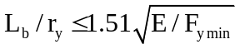 (A.12.2-2)
<< ERP June 07: we think this should use F_{yeff} or even F_{ymax} >>
<<There is agreement that use of F_{ymin} could lead to unconservative ratio. Paul says OK as long as consistent use of F_{y}. ERP to sort out the details. PAFA asks if should located under flexural checks>>
where;
L_{b} = Laterally unbraced length; length between points which are either braced against lateral displacement of the compression flange or braced against twist of the cross section.
r_{y} = Radius of gyration about the minor axis.
F_{ymin} = Minimum yield strength in the section as defined in A.12.2.2.
E = as defined in A.12.2.3.1.
        - Reinforced components
Reinforcement of member cross-sections is often of the form shown in Figure A.12.2-1.
Base plate Reinforcing plate
b₁
t₁
b₂
t₂

Figure A.12.2-1 Definitions for reinforced plate
To be considered a reinforcing plate, the plate should nominally be in contact with the base plate across its full width and continuously welded to the base plate on all edges.
The reinforcing plate shall be classified as a compression flange internal component or web internal component in accordance with Table A.12.2-1 and 3 depending on the type of in-plane loading. The value of yield stress to be used is that of the reinforcing plate. <<City U 2007: Need to check both between the welds and the combination overall.>>
The composite section shall be classified as a compression flange internal component, a web internal component or a compression flange outstand component in accordance with Tables A.12.2-1 to 3 depending on the type of in-plane loading and support conditions. The value of thickness to be used with width b₁ in the formulae in Table A.12.2-1 and A.12.2-3 shall be
t = t_{check} (A.12.2-3)
where
t_{check} = (t³_{eff} t₁)^{0.25} << Is this robust for any combination of thickness ?? Why t_{check} not t_{eff} ? Paul to check, City U 2007>>
t_{eff} = (12 I / b₁)^{1/3}
I = b₁(t₁ + t₂)³/3 - (b₁ - b₂)t₂³/3 - A(t₁ + t₂ - y₁)²
y₁ = [b₁t₁² + b₂t₂(2t₁ + t₂)]/2A
A = b₁t₁ + b₂t₂
The value of yield stress to be used in Table A.12.2-1 to 3 is the larger of the yield stress values for the reinforcing plate or the base plate.
Table A.12.2-1 - Cross-section classification - flange internal limiting components
Limiting width-to-thickness ratios for compressed internal components
t_{f}
b
b
t_{f}
b
t_{f}

Axis of
bending

Bending

Class | Type | Section in bending | Section in compression
Plastic stress distribution in component  and across section  (compression positive) |  | F_{y} | F_{y}
Plastic - Class 1 | Rolled or Welded | b/t_{f} ≤ 465/√F_{y} | b/t_{f} ≤ 650/√F_{y}
Compact - Class 2 | Rolled or Welded | b/t_{f} ≤ 530/√F_{y} | b/t_{f} ≤ 650/√F_{y}
Elastic stress distribution in component  and across section  (compression positive) |  | F_{y}  F_{y} | F_{y}
Semi-Compact - Class 3 | Rolled or Welded | b/t_{f} ≤ 650/√F_{y} | b/t_{f} ≤ 650/√F_{y}
Slender  - Class 4 | Rolled or Welded | b/t_{f} > 650/√F_{y} | b/t_{f} > 650/√F_{y}

Table A.12.2-2 - Cross-section classification - flange outstand components
Limiting width-to-thickness ratios for compression flange outstand components
t_{f}
b
t_{f}
b
b
t_{f}
Axis of
bending
b
b

Class | Type | Flange subject to compression | Flange subject to compression and bending
Class | Type | Flange subject to compression | Tip in compression | Tip in tension
Plastic stress distribution in component  (compression positive) |  | b | b  αb | b  αb
Plastic - Class 1 | Rolled  Welded | b/t_{f} ≤ 150/√F_{y}  b/t_{f} ≤ 135/√F_{y} | b/t_{f} ≤ 150/(α√F_{y})  b/t_{f} ≤ 135/(α√F_{y}) | b/t_{f} ≤ 150/(α√[αF_{y}])  b/t_{f} ≤ 135/(α√[αF_{y}])
Compact - Class 2 | Rolled  Welded | b/t_{f} ≤ 166/√F_{y}  b/t_{f} ≤ 150/√F_{y} | b/t_{f} ≤ 166/(α√F_{y})  b/t_{f} ≤ 150/(α√F_{y}) | b/t_{f} ≤ 166/(α√[αF_{y}])  b/t_{f} ≤ 150/(α√[αF_{y}])
b  Elastic stress distribution in component  (compression positive) |  |  | Maximum compression at tip | Maximum compression at connected edge
 |  |  | b  σ₁  σ₂ | b  σ₁  σ₂
Semi-Compact  - Class 3 | Rolled  Welded | b/t_{f} ≤ 250/√F_{y}  b/t_{f} ≤ 225/√F_{y} | b/t_{f} ≤ 380√(k_{σ}/F_{y})  b/t_{f} ≤ 340√(k_{σ}/F_{y})  ψ = σ₂/σ₁  k_{σ}=0.57–0.21ψ+0.07 ψ²  for 1 ≥ ψ ≥ -1 | b/t_{f} ≤ 380√(k_{σ}/F_{y})  b/t_{f} ≤ 340√(k_{σ}/F_{y})  ψ = σ₂/σ₁  k_{σ} = 0.578/(ψ + 0.34)  for 1 ≥ ψ ≥ 0  k_{σ} =1.7–5ψ + 17.1 ψ²  for 0 > ψ ≥ -1
Slender  - Class 4 | Rolled or Welded | b/t_{f} > than for Class 3 | b/t_{f} > than for Class 3 | b/t_{f} > than for Class 3
NOTE In the figures relating to stress distributions, the dimension b is illustrated only in the case of rolled sections. For welded sections, b should be assigned as shown in the diagrams at the top of the table..
Table A.12.2-3 - Cross-section classification - web internal components
Limiting width-to-thickness ratios for web internal components when subject to compression and/or bending
t_{w}
Axis of
bending
d
d
t_{w}
d
t_{w}

Class | Web subject to  Bending | Web subject to  Compression | Web subject to bending and compression
Plastic stress  distribution in  component  (compression  positive) |  |  | F_{y}  F_{y}  F_{y}  F_{y}  F_{y}  F_{y}  αd  d  d  d
Plastic - Class 1 | α = 0.5  d/t_{w} ≤ 1160/√F_{y} | α = 1.0  d/t_{w} ≤ 465/√F_{y} | when α > 0.5  d/t_{w} ≤ 2345/[(6.043α-1)√F_{y}]  when α ≤ 0.5  d/t_{w} ≤ 580/(α√F_{y})
Compact  - Class 2 | d/t_{w} ≤ 1400/√F_{y} | d/t_{w} ≤ 530/√F_{y} | when α > 0.5  d/t_{w} ≤ 2184/[(5.12α-1)√F_{y}]  when α ≤ 0.5  d/t_{w} ≤ 700/(α√F_{y})
Elastic stress  distribution in  component  (compression  positive) |  |  | f_{b}  f_{b}  f_{c}  f_{b}  ψf_{b}  d  d  d
Semi-Compact  - Class 3 | d/t_{w} ≤ 1875/√F_{y} | d/t_{w} ≤ 650/√F_{y} | when ψ > -1.0  d/t_{w} ≤  650/[(0.674+0.327ψ)√F_{y}]  when ψ ≤ -1.0  d/t_{w} ≤  937.5(1-ψ)√(-ψ)/√F_{y}
Slender  - Class 4 | d/t_{w} > than for Class 3 | d/t_{w} > than for Class 3 | d/t_{w} > than for Class 3

    - Section properties
      - General
Cross-sectional properties appropriate for the strength assessment of prismatic members of all classes shall be determined as described in A.12.3.2 to A.12.3.4, and as summarized in A.12.3.5. The properties appropriate for the stiffness assessment of prismatic members shall be based on elastic considerations.
<<Need to add a bit stating that the plastic section properties can be calculated properly, but there are some simplifications given below that may be found appropriate.PAFA suggestion City U>>
Where elastic section properties are determined for class 1 and 2 sections in place of plastic section properties, these should be treated as for class 3 sections. << THIS MAY NEED CHANGING when we fix-up Class 3 to be capable of more than outer fibre yield >>
Cross-sectional properties are normally required in respect of both major and minor axes of a prismatic section.
Cross-sectional properties for tubular members are specified in A.12.5.
NOTE In certain situations, the stiffness properties used in determining structural deflections and natural periods can differ from those used to assess member strength. For example, leg chord properties may include approximately 10% of the rack area when determining the leg stiffness for natural period calculation, however, this additional material should not be included when calculating the section properties for strength assessment.
      - Plastic and compact sections
        - Axial properties
For class 1 plastic and class 2 compact sections, section properties may be determined assuming fully plastic behaviour can occur. The properties required for a strength assessment should be determined taking into account the physical distribution of components comprising the cross-section and their yield strengths. For simplicity, the following approximations may be used to determine the relevant properties.
For axial tension and compression, the fully plastic cross-sectional area for use in a strength assessment, A_{p} may be found as:
<< Define the nominal strength = Ap Fyeff here >>
A_{p} = (Σ F_{yi} A_{i})/ F_{ymin} << It would be better to use the true area and fudged Fy PAFA: – not for consistency with requirements for other sections Classes ERP June 07: Due to the fact that we already have weight, buoyancy and stiffness areas, we don't want any more - to be reverted to adjusted Fy >> (A.12.3-1)
where
F_{yi} = yield strength of the i^{th} component comprising the structural member, as defined in A.12.2.2.
A_{i} = cross-sectional area of the i^{th} component comprising the structural member.
F_{ymin} = yield strength to be used in the calculation, as defined in A.12.2.2
NOTE 1 The centroid of the plastic section (or squash centre) of a member comprising components of differing yield strength can be offset from the centroid of the elastic section.
NOTE 2 A_{p} can be larger than the physical cross section of the member. << delete if we use F_{yeff} or go direct to M_{p} etc>>

        - Flexural properties
The second moment of area I_{f} should be determined using the fully effective cross-section.
The fully plastic section modulus Z_{p} may be found as:
Z_{p} = (Σ F_{yi} d_{i} A_{i})/ F_{ymin}<< It would be better to use the true area and fudged Fy OR BETTER STILL, go directly to Mp. PAFA: This is M_{p} (A.12.3-2)
where
d_{i} = distance between the centroid of the component under consideration and plastic neutral axis.
Note The plastic neutral axis will not necessarily coincide with the equal area axis for cross-sections composed of different yield strengths.

When using this definition of Z_{p}, the value of yield stress to be used in the calculation of plastic moment strengths shall be F_{ymin} as defined in A.12.2.2. << to be deleted if we go direct to M_{p} >>

Semi-compact sections
For class 3 semi-compact sections the section properties, A_{f}, the cross-sectional area, I_{f}, the second moment of area and S_{f}, the elastic section modulus should be based on elastic properties assuming that the full cross-section is effective.
A_{f} = Σ A_{i} (A.12.3-3)
The properties I_{f} and S_{f}, should be determined assuming that the full cross-section is effective for bending about both major and minor axes. When considering a cross-section comprised of components having different yield strengths, the section moduli used in the calculations should encompass all critical points on the cross-section.. << what are the full definitions for these variables - MJRH Jan 2008: assume resolved given re-write of first para? >>
<<Need to get the knocked down plastic moment capacity in here (the stuff out of SNAME and reviewed by Paul prior to City U 2007). But still need A_{f} (from above) as it is used in other places of the Clause. Also need a knockdown factor on the axial capacity. Paul suggestion would be to calculate an effective F_{y} at the Class 3/Class 4 transition that is backed out from the section modulus that results in the first compressive component yield due to bending of the section about the resultant bending axis. This is then used for the class 3/class 4 transition F_{y} for axial. There is then a linear interpolation back up to the full plastic at the class 2/class 3 transition. Could this be unconservative for a section that has high axial and very low bending in the opposite direction? Is F_{ymin} the way to go? Also, most J-U section should be at the upper end of Class 3, so what is used at the bottom end may not be that relevant. jjs “I think we might need a diagram!!” >>
NOTE Critical stress locations are typically those at the edges of components and are a function of the member forces, the yield strength of the component and its position within the cross-section of the member.

      - Slender sections
        - General
Cross-section properties for class 4 slender sections shall be determined using elastic principles. In tension, fully effective sections shall be assumed, i.e., A_{f} and S_{f}. In compression, the sectional properties shall be based on effective sections as described in this clause. The bases for the determination of effective cross-sections are the limiting effective width to thickness ratios specified for semi-compact sections in Table A.12.2-1 to 3.
When analysing structures that contain class 4 sections care needs to be taken in determining the force distributions. Generally it is recommended that the structural analysis is performed using full elastic section properties and the reduced section properties only used for the member capacity checks. However, care needs to be taken when use of the reduced sections would result in significantly different force distributions, in which case iterative analyses may be required.
Effective sections shall be based on actual plating thicknesses combined with plating effective widths. The effective widths of compression flange internal or outstand components shall be determined in accordance with the formulae presented in Table A.12.3-1 (a) or (b) respectively. The effective widths of web internal components subject to compression and/or bending shall be determined as shown in Table A.12.3-1 (c) for which the following definitions apply:
ψ = compression to bending stress ratio
σ₁ = compressive stress if σ₂ tensile or larger compressive stress if σ₂ compressive, compression positive
σ₂ = tensile stress if σ₂ tensile or smaller compressive stress if σ₂ compressive, tension negative
k = buckling coefficient
ρ = reduction coefficient
λ_{p} = plate slenderness parameter
λ_{plim} = limiting plate slenderness ratio
λ_{po} = plate slenderness ratio coefficient
When determining effective widths for web internal components, the stress ratio ψ used in Table A.12.3-1 may be based on compression flange internal and outstand component effective widths and web gross section properties.
The use of plating effective widths will generally lead to a shift in the neutral axis compared with that found using gross sectional properties. This shift should be taken into account when determining effective widths. The structural analysis should be performed using effective section properties. If the analysis is performed using gross section properties, the additional moment caused by the shift in the neutral axis should be found as the product of the axial force acting on the member and the shift in the neutral axis. This moment shall be treated as additional to other moments acting on the effective section unless more onerous conditions arise if it is omitted.
        - Effective areas for compressive loading

The effective area A_{eff} of a compressed component shall be found as the product of its thickness and its effective width. The total effective area:
A_{e} = Σ A_{eff} (A.12.3-4)

        - Effective moduli for flexural loading
For web or flange internal components subject to combinations of flexural and compression loading, effective widths shall be determined from Table A.12.3-1 (c). For web or flange outstand components subject to combinations of flexural and compression loading, effective widths shall be determined from Table A.12.3-1 (b).

The effective second moment of area I_{e} shall be found by calculating the properties of the section based on fully effective areas for components subject to tension, effective areas as defined in A.12.3.4.2 for components subject to compression, and effective areas as defined immediately above for components subject to combinations of compression and flexure.
Application of this procedure to determine effective second moments of area when applied to cross-sections with slender components, especially when the section is not symmetric with respect to a particular axis, will lead to two values of I_{e} about such an axis, depending upon the sign of the bending moment. The smaller value of I_{e} shall be used throughout the analysis.
When considering a cross-section comprised of components having different yield strengths, the section moduli S_{e} used in the calculations should encompass all critical points on the cross-section.
NOTE Critical stress locations are typically those at the edges of components and are a function of the member forces, the yield strength of the component and its position within the cross-section of the member.
Table A.12.3-1 Section properties - Effective widths for Slender Sections

(a) Compression flange internal components
t_{f}
325 t_{f} /√F_{y}
325 t_{f} /√F_{y}

t_{f}
325 t_{f} /√F_{y}

t_{f}

t_{f}
t_{f}
t_{f} 225/√F_{y}

t_{f} 225/√F_{y}
t_{f}
Axis of
bending
t_{f} 340√(k_{σ}/F_{y})
t_{f} 340√(k_{σ}/F_{y})
t_{f} 225/√F_{y}

(b) Outstand components under compression and/or bending
See Figure Table A.12.32-2 for definition of k_{σ} << IS THIS RIGHT FIG NO ? >>

σ₁
σ₂
d
d_{e1}
d_{e2}
1 ≥ ψ ≥ 0
d_{eff} = ρ d
d_{e1} = 2d_{eff}/(5 - ψ)
d_{e2} = d_{eff} - d_{e1}
σ₁
σ₂
d
d_{e1}
d_{e2}
ψ ≤ 0
d_{eff} = ρ d_{c} = ρ d/(1 - ψ)
d_{e1} = 0.4 d_{eff}
d_{e2} = 0.6 d_{eff}
d_{c}
d_{t}
t_{w}
Axis of
bending
d
d
t_{w}
d
t_{w}
ψ = σ₂/σ₁
ρ = 1if λ_{p} ≤ λ_{plim}
= (λ_{p} - λ_{po})/ λ_{p}² if λ_{p} > λ_{plim}
λ_{p} = (d/t_{w}) √(F_{y}/k)/435.4
λ_{plim} = 0.747 (1.09 - 0.09 ψ)
λ_{po} = λ_{plim} - λ_{plim}²
k = 8.2/(1.05 + ψ) if 1 ≥ ψ > 0
= 7.81 - 6.29 ψ + 9.78 ψ²if 0 ≥ ψ > -1
= 5.98 (1 - ψ)² if -1 ≥ ψ > -2

(c) Web internal components under bending and/or compression
Ineffective area - to be ignored when calculating effective section properties

      - Cross section properties for assessment
        - Tension
In tension, the cross-sectional area to be used in assessment shall be A_{t} where
A_{t} = A_{p} for class 1 plastic or class 2 compact sections (see equation A.12.3-1)
= A_{f} for class 3 semi-compact as defined in equation A.12.3-3.
= A_{f} as defined in equation A.12.3-3 for class 4 slender sections in tension across the whole of the cross-section (including bending); otherwise use A_{e} for class 4 sections as defined by equation A.12.3-4.
Where the cross-section contains cut-outs, pin-holes, etc., A_{t} should be determined at the location of the minimum cross-section.

        - Compression
In compression, the cross-sectional area to be used in assessment shall be A_{c} where
A_{c} = A_{p} for class 1 plastic or class 2 compact sections (see equation A.12.3-1)
= A_{f} for class 3 semi-compact sections as defined in equation A.12.3-3
= A_{e} for class 4 slender sections as defined in equation A.12.3-4..
        - Flexure
In flexure, the second moment of area with respect to major (y) and minor (z) axis bending to be used in assessment should be determined from:
I_{y}, I_{z} = I_{f} for class 1 plastic and class 2 compact sections as defined in A.12.3.2.2
= I_{f} for class 3 semi-compact sections as defined in A.12.3.3
= I_{e} for class 4 slender sections as described in A.12.3.4.3 accounting for both the chosen axis and the direction of bending
<< WE DON'T USE THESE ????
The section moduli for the two bending axes should be determined from:
S_{y}, S_{z} = Z_{p} for Class 1 Plastic or Class 2 Compact sections (see equation A.12.3-2)
= S_{f} for Class 3 Semi-compact sections as defined in A.12.3.3 for each critical stress location
= S_{e} for Class 4 Slender sections as defined in A.12.3.4.3 for each critical stress location, accounting for both the chosen axis and the direction of bending.
>>>
The radius of gyration to be used for lateral-torsional buckling considerations r_{z} should be determined from
r_{z} = (I_{z}/A_{c})^{0.5} for sections in classes 1 to 3 (A.12.3-5)
= (I_{e}/A_{e})^{0.5} for sections in class 4
    - Member moment amplification and effective lengths
There are two contributors to moment amplification, member Euler amplification (p-δ) and the eccentricity between the elastic and plastic centroids. The plastic centroid or 'centre of squash' is defined as the location at which the axial force produces no moment on the fully plastic section. For chords without material or geometric symmetry (e.g. triangular or tubular with offset rack) the centre of squash is offset from the elastic centroid when the section includes materials of differing yield strengths. Before a section is checked it is necessary to correct the moments by the axial force times the offset distance between the elastic centroid (used in the structural analysis) and the 'centre of squash' as given in Eq. A.12.4-1.a.

The non-amplified and amplified moments, M_{ue} and M_{ua} respectively should be calculated for each axis of bending from:
M_{ue} = M_{u} + eP_{u} (A.12.4-1)
M_{ua} = B M_{ue} (A.12.4-2

where;
M_{u} = the moment in a member determined in an analysis which includes global P-Δ/hull-sway effects.
P_{u} = the axial force, P_{uc} or P_{ut} as applicable, in the member determined in an analysis which includes global P-Δ/hull-sway effects.
e = the eccentricity between the elastic and plastic neutral axes taken orthogonal to the axis of bending under consideration, taking due account of sign. The term P_{u}e may be omitted from equation A.12.4-1.a when the eccentricity is included in the member modelling.
Note: e = 0 for tubular members, other cross-sections with geometric and material symmetry or when an elastic strength check is used for the assessment of a member.

B = member moment amplification factor

B = 1.0 (i) for members in tension or
(ii) for members in compression where the individual member forces are determined from a second order analysis i.e. the equilibrium conditions are formulated on the elastically deformed structure so that local p-δ effects are already included in M_{u}.
B = 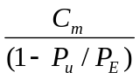 for members in compression where the local member forces are determined from a first-order linear elastic analysis i.e. the equilibrium conditions are formulated on the undeformed structure and therefore M_{u} does not include the local member p-δ effects

where:
P_{E} = (π²A_{c}E)/(KL/r)² and is to be calculated for the plane of bending. A_{c} is defined in A.12.3.5.2 and r is the radius of gyration for the plane of flexural buckling.
<<Define L in both y and z>>
K and C_{m} are given in Table A.12.4-1
NOTE For truss legs, global P-Δ effects need to be included in the determination of the member forces.

When the analysis of a jack-up with single-column tubular or box section legs has been undertaken accounting for the member moment amplification effects of global P-Δ/hull-sway, B may be taken as 1.0 as local p-δ and global P-Δ are the same. For these jack-ups, local strength due to guide reactions should be assessed in conjunction with the member forces.

Table A.12.4-1 - Effective length and moment reduction factors
Structural member | K | C_{m}⁽¹⁾
Tubular or Box complete legs  Chords with lateral loading  Chords without lateral loading  Braces  Primary diagonals and horizontals  K-braces⁽³⁾  X-brace⁽³⁾  Longer segment length  Full length⁽⁴⁾  Secondary horizontals | 2⁽²⁾  1.0  1.0  0.7  0.7  0.8  0.7  0.7 | (a)  (c)  (b)  (b) or (c)  (c)  (c)  (c)  (c)
1. The value of C_{m} can be determined from rational analysis. In lieu of such analysis, the following values may be used:
(a) For members whose ends are restrained against sidesway C_{m} = 0.85
For members whose ends are unrestrained against sidesway C_{m} = 1.0
(b) for members with no transverse loading, ignoring self-weight:
C_{m} = 0.6 - 0.4 M₁ / M₂
where M₁/M₂ is the ratio of the smaller to the larger non-amplified end moments of the segment of the member in the plane of bending under consideration. M₁/M₂ is positive for the segment subject to reverse curvature and negative when subject to single curvature.
M₁ = M_{u} + eP_{uc} at end 1; similarly for M₂
(c) for members with transverse loading, ignoring self-weight:
C_{m} = 1.0 - 0.4 P_{u} / P_{E} << PAFA: [latest AISC recommendation] >>

P_{E} = P_{Ey} or P_{Ez} as appropriate for the axis of bending under consideration.
2. Alternatively use effective length alignment chart <<to be taken from 19902 A.13.5>>.
3. For either in-plane or out-of-plane effective lengths, at least one pair of members framing into a K- or X-joint must be in tension if the joint is not braced out-of-plane.
4. For X-braces, when all members are in compression and the joint is not braced out-of-plane, use charts <<to be taken from 19902 A.13.5>>
<< We need at least the sym X-brace figure and the alignment chart from 19902 >>
    - Strength of tubular members
      - Applicability
The strength of unstiffened tubular members that satisfy the following condition should be assessed in accordance with this clause.
Any tubular with D/t < 0.244 E /F_{y} (A.12.5-1)
<< ERP Jan 2008: Why do we have the above?
Any tubular with D/t < 0.293 E /F_{y} << D/t=120 from 19902 assuming their limiting Fy of500 MPa
Any tubular with D/t < 0.437 E /F_{y} << is what is in SNAME >> >>

Tubulars that do not satisfy these conditions should be assessed using alternative methods that result in levels of reliability comparable to those implicit in this document. << ERP Jan 2008: Can we provide useful references >>
Where a tubular includes cross-sections with cut-outs, pin-holes, etc., it shall be treated as a prismatic member. unless equipped with doubler plates that at least replace all the lost area all around the hole in which case tubular formulations may be used. The major concern is that formulations in this clause, based on the D/t limit above, are unconservative for tubulars with reductions in their cross-section. << ERP June 07: to be further considered as this could be too onerous if the missing material is replaced with stiffening May need to do literature search on tubes with holes to find effect on allowable d/t ratios.>>
The requirements are considered applicable for steels with yield strength of up to 700 N/mm². The yield strength used in this clause should be as specified in A.12.2.2.
NOTE The requirements for tubular members are based on ISO 19902 Clause 13. However, for use in this document, the ISO 19902 formulations have been converted to a force base rather than a stress base.

The provisions given in this clause ignore the effect of hydrostatic pressure. The condition under which hydrostatic pressure may be ignored for a specific member is given by:
(D/t)_{m} = 0.00123 d² - 0.417 d + 74.5 (A.12.5-2)
<< ERP Jan 2008 : 1) numbers in table do not quite match the equation - which is right?
2) The formula gives D/t that increase when d > 170
Need PAFA input >>
where
d = depth below the water surface, accounting for any leg penetration, applicable to the tubular in question
(D/t)_{m} = maximum D/t ratio possible given d.
For convenience, some typical (D/t)_{m} values are listed in Table A.12.5-1.
Table A.12.5-1 Maximum D/t ratios for given depth
Water depth d  (m) | Maximum tubular  D/t
39.3 | 60.0
50 | 56.9 56.7
75 | 49.7 50.1
100 | 45.2 45.1
125 | 41.9 41.6
150 | 39.5 39.6

If (D/t) exceeds the limiting value (D/t)_{m} for the depth of the tubular, refer to ISO 19902, which are based on stress rather than strength.
      - Tension, compression and bending strength of tubular members

        - Axial tensile strength check
Tubular members subjected to axial tensile forces, P_{ut}, shall be assessed to satisfy:

P_{ut} ≤ A F_{y}/γ_{t} (A.12.5-3)
where

F_{y} = specified minimum yield stress
A = total cross-sectional area
γ_{t} = partial resistance factor for axial tension, 1.05

        - Axial compressive strength check
Tubular members subjected to axial compressive forces, P_{uc}, shall be assessed to satisfy:

P_{uc} ≤ P_{a}/γ_{c} (12.5-4)
where

P_{a} = representative compressive strength determined in A.12.5.2.3
γ_{c} = partial resistance factor for axial compressive strength, 1.15

        - Column buckling strength
The representative axial compressive strength of tubular members, P_{a}, should be determined from:
P_{a} = [1.0 - 0.278λ²] P_{yc} for λ ≤ 1.34 (A.12.5-5a)
= 0.9 P_{yc}/λ² for λ > 1.34 (A.12.5-5b)
λ = [P_{yc}/P_{E}]^{0.5} (A.12.5-6)
where
P_{yc} = representative local buckling strength (see A.12.5.2.4)

λ = column slenderness parameter
P_{E} = smaller of the Euler buckling strengths about the y or z direction
= π² E I/ (KL)²
E = as defined in A.12.1.1
K = effective length factor in y or z direction, see A.12.4
L = unbraced length in y or z direction measured between centrelines
I = Second moment of area of the tubular.
        - Local buckling strength << consider moving above column buckling so Pyc is already defined >>
The representative local buckling strength, P_{yc}, should be determined from:
P_{yc} = A F_{y} for A F_{y} / P_{xe} ≤ 0.170 (A.12.5-7a)
= [1.047 – 0.274 A F_{y}/P_{xe}] A F_{y} for 0.170 < A F_{y} / P_{xe} (A.12.5-7b)

<< ERP Jan 2008: Eqn c) deleted - D/t limit was >> 120 and not used in this way in 19902 or RP2A. >>
where
F_{y} = specified minimum yield stress
A = total cross-sectional area as defined in A.12.5.2
P_{xe} = representative elastic local buckling strength
= 2 C_{x} E A (t / D)
C_{x} = critical elastic buckling coefficient
The theoretical value of C_{x} for an ideal tubular is 0.6. However, a reduced value of C_{x} = 0.3 is recommended for use in Equation 12.5-8 to account for the effect of initial geometric imperfections. A reduced value of C_{x} = 0.3 is also implicit in the limits for P_{c}/P_{xe} given in Equations 12.5-7. << ERP June 07: Is 0.3 too harsh for jack-up tubular dimensions?? Paul says “no” @ City U 2007>>
        - Bending strength check
Tubular members subjected to bending moments, M_{b}, shall be assessed to satisfy:
M_{u} ≤ M_{b}/γ_{b} (A.12.5-8)
Where
M_{u} = M_{uy} or M_{uz} the bending moment about member y- and z-axes respectively due to factored actions
M_{b} = representative bending moment strength,

determined from:
M_{b} = M_{p} for (F_{y} D)/(E t) ≤ 0.0517 (A.12.5-9a)
= [1.13 – 2.58 (F_{y} D)/(E t)] M_{p} for 0.0517 < (F_{y} D)/(E t) ≤ 0.1034 (A.12.5-9b)
= [0.94 – 0.76 (F_{y} D)/(E t)] M_{p} for 0.1034 < (F_{y} D)/(E t) ≤ 120 (F_{y} / E) (A.12.5-9c)

M_{p} = plastic moment strength
= F_{y}

(1/6) [D³ – (D - 2t)³]
γ_{b} = partial resistance factor for bending, 1.05
<< ERP Jan 2008 : Correction from 2.85 to 2.58 eliminates the discontinuities identified by ND >>
      - Tubular member combined strength checks
        - Axial tension and bending strength check
Tubular members subjected to combined axial tension and bending forces should satisfy the following condition at all cross sections along their length:
γ_{t} P_{ut} / (A F_{y}) + γ_{b} (M_{uy}² + M_{uz}²)^{0.5} / M_{b} ≤ 1.0 (A.12.5-10)
where
P_{ut} = axial tensile force due to factored actions
A = total cross-sectional area
F_{y} = specified minimum yield stress

M_{uy}, M_{uz}= bending moments about member y- and z-axes respectively due to factored actions
M_{b} = representative moment strength, as defined in equations A.12.5-9
γ_{t} = partial resistance factor for axial tension, 1.05
γ_{b} = partial resistance factor for bending, 1.05
        - Axial compression and bending strength check
Tubular members subjected to combined axial compression and bending forces should satisfy the following conditions at all cross sections along their length:
beam-column check:
(γ_{c}P_{uc}/P_{a}) + (γ_{b}/M_{b}) (M_{uay}² +M_{uaz)}²)^{0.5} ≤ 1.0 (A.12.5-11)
and local strength check:
(γ_{c} P_{uc}/P_{yc}) + (γ_{b} /M_{b}) (M_{uy}² + M_{uz}²)^{0.5} ≤ 1.0 (A.12.5-12)
where
P_{uc} = axial compressive force due to factored actions
P_{yc} = the representative local buckling strength in A.12.5.2.4,
P_{a} = as defined in A.12.5.2.3

M_{uy} = non-amplified bending moment about member y-axis due to factored actions from A.12.4
M_{uz} = non-amplified bending moment about member z-axis due to factored actions from A.12.4

M_{uay} = amplified bending moment about member y-axis due to factored actions from A.12.4
M_{uaz} = amplified bending moment about member z-axis due to factored actions from A.12.4

M_{b} = representative bending strength, as defined in equations A.12.5-9
γ_{b} = partial resistance factor for bending, 1.05
γ_{c} = partial resistance factor for axial compressive strength, 1.15
        - Beam shear strength check
Tubular members subjected to beam shear forces should satisfy the following:
V ≤ P_{v}/γ_{v} (A.12.5-13)
where
V = beam shear due to factored actions
P_{v} = representative shear strength
= A F_{y}/(2√3)
A = total cross-sectional area
γ_{v} = partial resistance factor for beam shear strength, 1.05
        - Torsional shear strength check
Tubular members subjected to torsional shear forces should satisfy the following:
T ≤ T_{v}/γ_{v} (A.12.5-14)
where
T = torsional moment due to factored actions
T_{v} = representative torsional strength
= 2 I_{p} F_{y}/(D √3)
I_{p} = polar moment of inertia
= (π / 32) [D⁴ – (D - 2t)⁴]

    - Strength of prismatic members

      - General
The structural strength provisions for rolled and welded prismatic members were developed from the AISC 'Load and Resistance Factor Design (LRFD) Specification for Structural Steel Buildings' [14]. The AISC LRFD specification was interpreted and, in some cases, modified for use in the assessment of mobile jack-up structures. Interpretation of the specification was necessary to enable a straight-forward method to be presented for the assessment of beam-columns with components of varying yield strength and/or with cross sections having only a single axis of symmetry. Development of the specification was necessary to provide:
- A method to deal with member cross-sections comprising components constructed of steels with different yield strengths.
- A method for the assessment of beam-columns under biaxial bending to overcome a conservatism which has been identified in the standard AISC LRFD interaction equations.
T
he yield strength used in this subclause should be as specified in A.12.2.2.
The resistance factors used in the 13th Editions of the AISC LRFD specification have been adopted. << add comments about LRFD and 13th being the same (we hope) >>
<< ERP Jan 2008: P10 should consider whether we need to address hydrostatic loading on closed prismatics >>
<<< Maybe insert version of Figure 8.1 here???>>>

In the following sub-sections, y and z are used to define the major and minor axes of a prismatic member.
      - Prismatic members subjected to tension, compression, bending or shear
        - General
Prismatic members subjected to axial tension, axial compression, bending or shear should satisfy the applicable strength and stability requirements specified in A.12.6.

        - Axial tensile strength check
Prismatic members subjected to axial tensile forces, P_{ut}, shall be assessed to satisfy:

P_{ut} ≤ F_{ymin}A_{t}/γ_{t} (A.12.6-1)

where;
A_{t} = area of section from A.12.3.5.1
F_{ymin} = minimum yield stress of the cross section as defined in A.12.2.2.
γ_{t} = partial resistance factor for axial tension, 1.05

Axial compressive strength check

Prismatic members subjected to axial compressive forces, P_{uc}, not subject to flexural buckling should be assessed to satisfy: <<JJS May 2007: Either need an L/r limit for this part, or get a smooth transition between 12.6.2.3 and 12.6.2.4. To be resolved by ERP later. See also discussion in A.12.3.3>>:
P_{uc} ≤ F_{ymin}A_{c}/γ_{c} (A.12.6-2)
where;
A_{c} = area of section from A.12.3.5.2
F_{ymin} = minimum yield stress of the cross section as defined in A.12.2.2.
γ_{c} = partial resistance factor for axial compressive strength, 1.15 with the 1P curve/high strength steels and 1.10 with the 2P curve/lower strength steels - see A.12.6.2.4.
        - Column buckling

        - strength
The representative compression strength of all member classifications subject to flexural buckling should be determined from the following equations:
<< ? use Ac from 12.3.5.1earlier >><< 13th edition presents ?same eqns in revised format >>
P_{n} = A_{c}F_{cr} [AISC Eq. E2.1] (A.12.6-3)
The following may be used for all grades of steel <<DRL will check! Also consider updating the formulae below to 13th Ed >>
F_{cr} = (0.658^{λc2}) F_{ymin} For λ_{c} ≤ 1.5 [AISC Eq. E2.2] (A.12.6-4a)
F_{cr} = 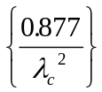 F_{ymin} For λ_{c} > 1.5 [AISC Eq. E2.3] (A.12.6-4b)
The following may only be used for high strength steels (F_{y}>450 ??):
F_{cr} = (0.7625^{λc3.22}) F_{ymin} for λ_{c} ≤ 1.2 (A.12.6-5a)
= (0.8608/λ_{c}^{1.854}) F_{ymin} for λ_{c} > 1.2 (A.12.6-5b)
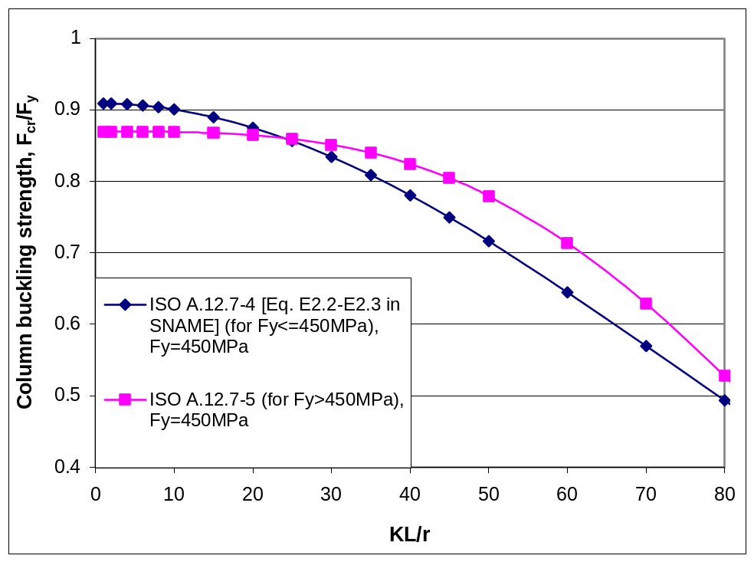
<< ERP Jan 2008: Include Pink and Dark blue curves on Fig 5-4 of ND Cl 12 report - this will bring out the fact that there is a discontinuity: Action: MJRH>>
Figure A.12.6-1 — Comparison of Equations A.12.6-4 [SNAME E2.2/E2,3 ] and A.12.6-5 INCLUDING the effect of the applicable partial resistance factors from A.12.6.3.2
<< Maybe capture some of the following text as an explanation to start this sub-clause: The requirements in Ref. A.5 are supposedly based on an approximation to the SSRC Curve 2P. In fact, the Ref. A.5 column curve, although a reasonable approximation to Curve 2P for λ < 1.5 and λ > 1.8, actually lies closer to SSRC Curve 1P for λ = 1.3 than it does to Curve 2P. Notwithstanding, Curve 2P and thus the Ref. A.5 curve relate primarily to traditional building construction steels typically with yield stresses up to 345 N/mm² together with their corresponding column tolerances of length/1000. However, because of the high strength steel used in the construction of chords in particular, up to 700 N/mm², and possibly tighter column tolerances at around length/1500, it is likely that a higher SSRC Column Curve is appropriate for the assessment of chord members. The relevance of yield stress is that the effects of welding and rolling residual stresses reduce as the yield stress of the material increases.
SSRC Column Curve 1P was investigated as a possible candidate curve. A good approximation to this, within 0.8% of the SSRC expression from λ =0.0 to 2.0, is as shown above.
Preliminary attempts have been made to see if it is possible to relatively simply allocate typical chord sections to this 1P curve or to the Ref. A.5 curve. However, this process has not been successful primarily because there are no data (test or numerical) for chord or other high strength steel sections on which to base such allocation. Nevertheless, should a jack-up leg fabricator be able to demonstrate that a chord section consistently achieves the strengths consistent with those of SSRC Curve 1P, then (A.12.7-1) may be used in the assessment of such chords. >>
where;
A_{c} = area of section (excluding rack teeth of chords) from A.12.3.5.2

λ_{c} = 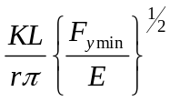 for max. KL/r from all directions [AISC Eq. E2.4] (A.12.6-6)
K = effective length factor in y or z direction, see A.12.4
L = unbraced length of member in y or z direction << This should be in 12.4 ? Also need to ensure that L does not have different meanings in different places (may be different for tubes (centre to centre, not face to face))>>:
- face to face for braces
- braced point to braced point for chords
- longer segment length of X-braces (one pair must be in tension, if not braced out of plane) See also ISO 19902 13.5.
r = radius of gyration in y or z direction, based on gross area of section.
E = Young's modulus.
F_{ymin} = minimum yield strength of the cross section as defined in A.12.2.2, unless rational analysis shows that a higher value may be used.

        - Bending strength
          - General
The classification of member cross sections in A.12.2 is used to identify the potential for local buckling. The slender section properties determined in A.12.3.4 account for the local buckling of class 4 cross sections.
The bending strength of typical closed section jack-up chord members used in truss legs will not normally be limited by lateral torsional buckling. However this can be checked using the approach presented in A.12.6.2.5.4.
          - Class 1 plastic and class 2 compact sections
The representative bending strength, M_{b}, is given by the plastic bending moment of the whole section:
M_{b} = M_{p} = Z_{p}F_{ymin} (A.12.6-7)
where
M_{b} = representative bending moment strength
Z_{p} = fully plastic section modulus determined from equation A.12.3-2
F_{ymin} = minimum yield strength of the cross section as defined in A.12.2.2

NOTE Hybrid sections built up from components of different yield strengths are addressed by the methodology described in A.12.3.2.

Class 3 semi-compact sections << ERP JUNE 07 : PAFA needs to check this still works. Done for bending!!!!>>

The representative bending strength, M_{b}, is given by:
an interpolation between the plastic bending moment and the limiting buckling moment:
M_{b} = M_{p} - (M_{p}- M_{R})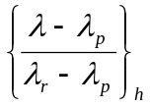 [AISC Eq. A-F1.3] (A.12.6-8)
where;
M_{p} = section plastic moment as calculated for a class 1 or 2 cross section
_{h} = subscript referring to the component which produces the smallest value of M_{n}.
λ = b/t or 2R/t as applicable for component h.
λ_{p} is determined for component h from: <<λ_{p} and λ_{r} need to be inserted from the stuff Paul supplied August 2007. The constants are the same as in Table 12.2, but all need to be non-dimentionalized. Note that the F_{r} is dropped in all cases.>>
i) For rectangular components stiffened along both edges
λ_{p} = 1.11 /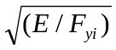<< 13th uses 1.12 >> (A.12.6-9a)
ii) For rectangular components stiffened along one edge
λ_{p} = 0.38 /<< 13th uses 0.38 >> (A.12.6-9b)
iii) For components derived from circular tubes <<Paul to check this>>
λ_{p} = 0.07 E /F_{yi} (A.12.6-9c)

λ_{r} is determined for component h from: << AISC 13th may have dropped F_{r} >>
i) For rectangular components stiffened along both edges
λ_{r} = 1.40 /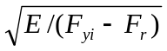 << 13th uses 1.40 & no F_{r} >> (A.12.6-10a)
F_{r} = 114 MN/m² {16.5 ksi} residual stress
ii) For rectangular components stiffened along one edge
λ_{r} = 0.62 /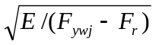 (A.12.6-10b)
<< 13th uses ??1.0?? & no F_{r} - check how AISC LRFD 1st Table B5.1 edition maps into 13th (F-5 Table B4.1)- in imperial from 1st the constant was 238 >>
F_{ywj} = web component yield stress.
F_{r} = 114 MN/m² {16.5 ksi} residual stress.
iii) For components derived from circular tubes <<Paul to check this>>
λ_{r} = 0.31 E /F_{yi} (A.12.6-10c)
M_{R} = S_{f} F_{y} < M_{p} (A.12.6-11)
S_{f} = full elastic section modulus for the plane of bending under consideration, defined in A.12.3.3
<< ERP June 07: OR SHOULD THE ABOVE USE S_{e} ??
Note to PAFA: go see: www.cnx.org/content/m10756/latest/ >>

Class 4 slender sections

The representative bending strength, M_{b}, of members including components which do not satisfy the above criteria for compact and noncompact sections or for lateral torsional buckling should be determined in accordance this section.
The representative bending strength of a member is given by the limiting flexural bending moment:
M_{b} = S_{e} F_{y} (A.12.6-12)

where;
S_{e} = reduced elastic section modulus for the plane of bending under consideration, defined in A.12.3.4.3
        - Lateral torsional buckling strength check <<This clause is incomplete, but hopefully the A12.2.3.2 checks will be compromised, so we will not need to complete>>
<<Before deleting any of this, check it is not needed for slender members>> Lateral torsional buckling should be checked for all members, regardless of the classes of section, that do not meet the length requirements of 12.2.3.2 L_{b}/r_{y}. <<Also need to check the slenderness that allows use of up to yield section modulus. Paul to supply>>
The representative lateral torsional buckling strength for members (M_{lb}) with length less than L_{r}, defined below, is given by:
M_{lt} = S_{f} F_{cr} <<This is not correct format >> (A.12.6-13)
where
L_{r} = <<See AISC Section F2.2c to get L_{r} but that is for certain sections only>>

The representative lateral torsional buckling strength for members (M_{lb}) with length greater than L_{r} is given by:
M_{lt}= S_{f} F_{cr} (A.12.6-14)
where
S_{f} = full elastic section modulus for the plane of bending under consideration, defined in A.12.3.3
F_{cr} = the lowest value of the critical buckling stress from (where appropriate):
i) Doubly symmetric members (lateral torsional buckling) << Need to ensure that this knock down presented below is correct for classes other than just class 4. Paul suspects it is, but may need care in applying to Class 1.>>
F_{cr} = 6.895 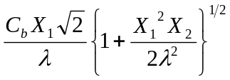<< this metric version needs to be non-dimensionalised >> [AISC Table A-F1.1(b)] (A.12.6-15)

where << all updated for axis change x=major to y=major >>;
C_{b} = 1.75 + 1.05(M₁/M₂) + 0.3(M₁/M₂)² ≤ 2.3 where M₁ is the smaller and M₂ the larger end moment in the unbraced member; M₁/M₂ is positive when the moments cause reverse curvature. ( 1/M_{LT} in PAFA)
X₁ = (π/S_{f})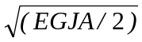
<<? Subscript for S - Check AISC &/or SNAME Rev 1 >>
X₂ = (4C_{w}/I_{z})(S_{y}/GJ)²
E = Modulus of elasticity (200,000 MN/m² {29,000 ksi}). << PAFA USES (205,000 N/mm² will be 29,070 ksi >>)
G = Shear modulus of elasticity (77,200 MN/m² {11,200 ksi}).
J = Torsion constant for section.
A = Cross-sectional area (excluding rack teeth).
I_{z} = Second moment of area of section about minor axis.
S_{y} = Elastic section modulus for major axis bending.
C_{w} = Warping constant.
λ = L_{b}/r_{z}
r_{z} = Radius of gyration about the minor axis
ii) Singly symmetric members (lateral torsional buckling) [AISC Table A-F1.1(c)]
F_{cr} = 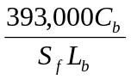 {B₁ + 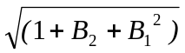} 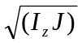 ≤ F_{y} (A.12.6-16)
<< this metric version needs to be non-dimensionalised - >>

where;
B₁ = 2.25 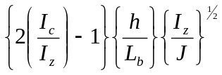
B₂ = 25 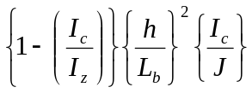
h = web depth.
I_{c} = second moment of area of compression flange about the section minor axis
C_{b} = as for doubly symmetric sections.
        - Bending strength check
Tubular members subjected to bending moments, M_{b}, shall be assessed to satisfy:
M_{u} ≤ M_{b}/γ_{b} (A.12.6-17)
where
M_{u} = M_{uy} or M_{uz} the bending moment about member y- and z-axes respectively due to factored actions
M_{b} = representative bending moment strength, determined from 12.6.2.5
γ_{b} = partial resistance factor for bending, 1.05
      - Prismatic member combined strength checks

        - General
There are two different assessment approaches to determine the utilizations of structural members:
  - Interaction equation approach, which is applicable to all member classifications.
  - The plastic interaction surface approach which is applicable to members in class 1 and 2.
Either approach can be used for members in class 1 or 2. The approaches are presented in the following clauses.

        - Interaction equation approach

Each structural member within the scope of Section 8.1.2 should satisfy the following conditions when the shear force is less than 60 percent of the shear capacity (P_{vy}, P_{vz} in A.12.6.3.4):
local strength check:

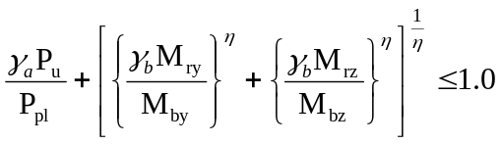 (A.12.6-18)
<< MJRH Jan 2008: In two eqn's above M_{r}'s were M_{ue}'s >>
and beam-column check:
If γ_{a}P_{u}/P_{p} > 0.2
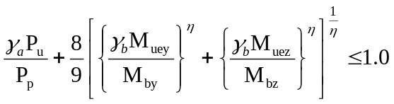 [AISC Eq. H1-1a] (A.12.6-19)
else
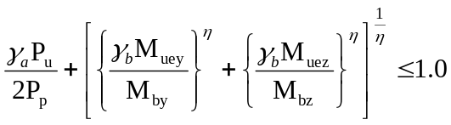 [AISC Eq. H1-1b] (A.12.6-20)
<< MJRH Jan 2008: In two eqn's above M_{ue}'s were M_{ua}'s >>
where;
P_{u} = applied axial force
P_{pl} = representative axial strength for the local strength check
= A_{t} F_{ymin} for members in tension, as defined A.12.6.2.2
= A_{c} F_{ymin} for members in compression, as defined A.12.6.2.3
P_{p} = representative axial strength for the beam column check
= A_{t} F_{ymin} for members in tension, as defined A.12.6.2.2
= P_{n} for members in compression, as defined A.12.6.2.4
M_{ry} = unamplified bending moment about member y-axis due to factored actions from A.12.4
M_{rz} = unamplified bending moment about member z-axis due to factored actions from A.12.4
M_{uey} = amplified bending moment about member y-axis due to factored actions from A.12.4
M_{uez} = amplified bending moment about member z-axis due to factored actions from A.12.4
M_{bx} = representative moment strength, as defined in A.12.6.2.5
M_{by} = representative moment strength, as defined in A.12.6.2.5
γ_{b} = partial resistance factor for bending, 1.05
γ_{a} = partial resistance factor for axial loading
= γ_{t} for axial tension = 1.1
= γ_{c} partial resistance factor for axial compressive strength, 1.15 with the 1P curve/high strength steels and 1.10 with the 2P curve/lower strength steels <<Need to insert the actual yield values>>

η = Exponent for biaxial bending, a constant dependent on the member cross section geometry, determined as follows:
i) For solid or hollow rectangular sections η = ⁵/₃
ii) For doubly symmetric open section members, η = 1.0
iii) For all geometries, a conservative value of η = 1.0 may be used.
NOTE 1 For purely circular tubular members, η = 2.0
NOTE 2 The TR presents alternative and conservative interaction equations and curves for generic families of chord cross sections << i.e. THE DYER EQUATIONS + CHORD SECTION DATA >>. The data also includes the offset distance between the elastic centroid (used in the structural analysis) and the 'center of squash', together with other geometric data for the members of each family of chord.
NOTE 3 The TR << 8.1.4.7 & C.8.1.4.7 from SNAME >> also presents an approach to determining the value of η by very tedious manual calculation. .
When the shear is greater than 60 percent of the shear capacity the moment capacity should be reduced parabolically to zero when the shear equals the shear capacity.
        - The interaction surface approach
The i

nteraction surface approach is based on Dyer [19] and was developed from the interaction approach proposed by e.g. Duan & Chen [20]. The approach is based on axial force applied at the 'centre of squash' which is defined as the location at which the axial force produces no moment on the fully plastic section.

The interaction equations are based on ultimate strength. It is therefore necessary to introduce the required resistance factors. This is achieved by defining:
P_{y} = F₁P_{n} / γ_{a} (A.12.6-21)
M_{px} = F₂M_{bx} / γ_{b} (A.12.6-22)
M_{py} = F₂M_{by} / γ_{b} (A.12.6-23)
where; F₁ = 1.0, unless alternative values are justified by analysis and when the shear force is less than 60 percent of the shear capacity (P_{vy}, P_{vz} in A.12.6.3.4).
F₂ = 1.0, unless alternative values are justified by analysis and when the shear force is less than 60 percent of the shear capacity (P_{vy}, P_{vz} in A.12.6.3.4).
The user should develop the plastic interaction surface using P_{y} M_{px} M_{py} and determine the point on the surface nearest to the member forces. A measure of the interaction ratio can then be obtained as the ratio between the vector lengths from the functional origin to the member forces and from the functional origin to the nearest point on the surface. The functional origin is the force point associated with the functional actions in the absence of environmemtal actions.
The user should note that the sign of the moment is crucially important for sections without material or geometric symmetry. The sign convention should therefore be observed with care.

Need some figures:
- Member cross-section + bulls-eye plot
- UC determination
When the shear is greater than 60 percent of the shear capacity the moment capacity should be reduced parabolically to zero when the shear equals the shear capacity.
        - Beam shear
Prismatic members subjected to beam shear forces should satisfy the following:
V_{y} ≤ P_{vy}/γ_{v} (A.12.6-24)
V_{z} ≤ P_{vz}/γ_{v} (A.12.6-25)
where
V_{y}, V_{z} = beam shear due to factored actions in the local y and z directions
P_{vy}, P_{vz} = representative shear strength in the local y and z directions
= A F_{ymin}/√3 << MJRH 21 Jan 2008: F_{y} changed to F_{ymin} >>
A = effective shear area in the direction being considered (for guidance on calculating effective shear area see BS 5950-1, or equivalent <<Paul to provide the relevant text>>)
γ_{v} = partial resistance factor for beam shear strength, 1.05
        - Torsional shear
Closed section prismatic members subjected to torsional shear forces should satisfy the following:
T ≤ T_{v}/γ_{v} (A.12.6-26)
where
T = torsional moment due to factored actions
T_{v} = representative torsional strength
= I_{p} F_{ymin}/(r √3) << MJRH 21 Jan 2008: F_{y} changed to F_{ymin} >>
I_{p} = polar moment of inertia
r = maximum distance from centroid to an extreme fibre
Open section prismatic members subjected to torsional shear forces should be checked as appropriate.
    - Assessment of member joints
No guidance offered.
  - Acceptance checks

- No guidance offered.
- (normative)
Summary of partial action and resistance factors
Symbol | Description | Factor | Ref. Clause
γ_{f,G} | Factor to be applied to the Fixed Actions G | 1.0 | 8.8.1
γ_{f,Q} | Factor to be applied to the actions due to variable load U | 1.0 | 8.8.1
γ_{f,E} | Factor to be applied to the ULS storm action E_{e} (used with 50 year independent extreme values) | 1.15 | 8.8.1
γ_{f,E} | Factor to be applied to the ULS storm action E_{e} (used with 100 year joint probability values) | 1.25 | 8.8.1
γ_{f,D} | Factor on the Dynamic Action D_{e} in combination with γ_{f,E} | 1.0 | 8.8.1
??? | Factor to be applied to the Fixed Actions G in seismic analysis | 1.0 | A.10.7
??? | Factor to be applied to the Variable load Q in seismic analysis | 1.0 | A.10.7
??? | Factor to be applied to the inertial action induced by the ELE ground motions | 0.9 | A.10.7
γ_{R,Nt} | Resistance Factor for prismatic axial tensile strength | 1.1 | A.12.6
γ_{R,Nc} | Resistance Factor for prismatic axial compressive strength | 1.1 | A.12.6
γ_{R,Nb} | Resistance Factor for prismatic bending strength | 1.1 | A.12.6
γ_{R,Tt} | Resistance Factor for tubular axial tensile strength | 1.1 | A.12.5
γ_{R,Tc} | Resistance Factor for tubular axial compressive strength | 1.15  << Per PAFA May 07 update to A.12.5.3.2 >> | A.12.5
γ_{R,Tb} | Resistance Factor for tubular bending strength | 1.1 | A.12.5
γ_{R,H} | Resistance Factor for vertical holding system between hull and leg | 1.1 | 13.5
γ_{R,OTN} | Resistance Factor for overturning | 1.05 | 13.8
γ_{R,P} | Resistance Factor for preload | 1.1 | A.9.3.6.1
γ_{R,Hfc} | Partial resistance factor for horizontal foundation capacity. | = 1.25 (effective stress - sand/drained).  = 1.56 (total stress - clay/undrained). | A.9.3.6.2
γ_{R,VH}. | Partial resistance factor for foundation capacity (see Commentary). | = 1.1 - Maximum bearing area not mobilized.  = 1.15 - Penetration sufficient to mobilize maximum bearing area. | A.9.3.6.3

NOTE Values given in this table are for normative, however reference should always be made to the specific clause for method of application. The factors are specifically tied to the calculation methodologies given in each reference clause
<<<Value for the compression resistance factor for prismatic members has been changed from 1.18 to 1.1 to be consistent with AISC 13th Edition (DRL to confirm) However, maybe the tubulars should remain at 1.18 depending on 19902, PAFA, API, Peter Marshall, and others.>>>

- (informative)
Response Analysis - Additional Information and Alternative Approaches
Wave reinforcement and cancellation effects << Needs some text and link to Normative or Informative A >>
C.10.4.2.1 Selection of Appropriate Excitation Period
A.10.4.2 requires that an appropriate selection of excitation period is made. In making the selection consideration should be given to the position of the natural period(s) in relation to the cancellation and reinforcement points in the global wave loading of the jack-up which is important for the magnitude of any dynamic wave magnification. Cancellations and reinforcements in global loading are due to spatial separation of the wave load attracting legs and may be different for different wave directions. The global loading may be characterized by the total horizontal wave loading or overturning moment; cancellation and reinforcement of points for these may appear at slightly different wave periods.
Figure A.10.4.2.1-1 presents the periods at which first and second cancellations and reinforcements occur in the total wave loading. It is valid for the main wave directions of 3 and 4 -legged jack-ups in water depths exceeding 30m.
The calculation of natural period(s) is subject to uncertainty as a result of uncertainty in the parameters affecting the natural period. In order to avoid the possibility of under-conservative dynamic amplification factors, it is important to investigate the relationship between the jack-up natural period and the cancellation and reinforcement points in the transfer functions relating wave height to base shear and overturning moment. The range of possible natural period(s) should be bracketed and compared with the relevant cancellation/reinforcement points in the global wave loading. The natural period(s) used in the dynamic analysis should be selected such that a realistic but conservative value of the dynamic response is obtained for the particular application envisaged, avoiding maximum dynamic amplification to coincide with minimum environmental loading. Figure A.10.4.2.1-1 may be used for a first evaluation of the position of the calculated natural period(s), but it is recommended that the definitive selection of natural period(s) be based on the shape of the global horizontal wave loading (base shear) and overturning moment transfer functions calculated for the actual application under consideration.
When the natural period occurs at a cancellation point in the transfer functions, the mass or stiffness should be adjusted in a logical manner to move the natural period away from the cancellation point.
If the analysis is for pinned spudcans with maximum hull mass, then the adjustment should be made by reducing the hull mass (within the normal range) and/or by introducing a degree of rotational fixity at the seabed.
If the analysis is for a case with spudcan moment fixity, then the adjustment would most logically be made by varying the degree of rotational fixity at the seabed.
To minimise cancellation effects, it is suggested that the dynamic analysis may be carried out for a single wave heading along an axis which is neither parallel nor normal to a leg line. Thus, for a 3-legged unit with equilateral leg positions and a single bow leg, suitable analysis headings would be with the environment approaching from approximately 15º or 45º off the bow. The dynamic amplification factors (DAF’s) should be determined for one, or both, of these headings, with suitably adjusted natural period. The DAF’s (or more conservative DAF’s) may then be applied to the final quasi-static analysis for all headings and hull weight cases with, when applicable, non-linear fixity iteration according to XXXXX.

C.10.4.2.2 - Idealized Single Degree of Freedom System for Natural Periods
If such a capability (a finite element structural model containing the mass and stiffness properties of the jack-up) is not available, due to the fact that the mass of the hull dominates the mass distribution, the global dynamic behavior of the jack-up may in some cases be determined from an idealized single degree-of-freedom system and thus the fundamental mode period may be estimated from the system described by:
- an equivalent mass representing the mass of the jack-up and its distribution as referred to in 10.4.2.3 the equivalent mass is equal to the mass of the hull plus a contribution from the mass of the legs, including added mass, and is located at the center of gravity of the hull.
- an equivalent spring representing the combined effect of the overall (global) structural stiffness including stiffness contributions from bending, shear deformation and axial straining of the legs, the leg to hull connections, the hull and the spudcan-foundation interface (if applicable).
The period is determined from the following equation applied to one leg:
T_{n} = 2π 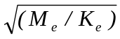
where;
T_{n} = highest (or first mode) natural period.
M_{e} = effective mass associated with one leg.
= 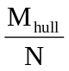 + M_{la} + 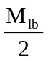
M_{hull} = full mass of hull including maximum variable load.
N = number of legs.
M_{la} = mass of leg above lower guide (in the absence of a clamping mechanism) or above the center of the clamping mechanism.
M_{lb} = mass of leg below the point described for M_{la}, including added mass for the submerged part of the leg ignoring spudcan. The added mass may be determined as A_{e}ρ(C_{Me} - 1) per unit length of one leg (for definitions of A_{e} and C_{Me} see Section 4.6.6); ρ = mass density of water.
K_{e} = effective stiffness associated with one leg (for derivation, refer to TR).
= 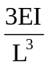 * 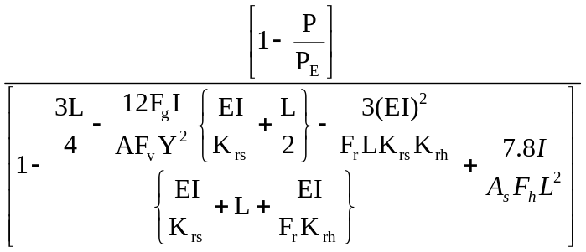
When the soil rotational stiffness K_{rs} at the spudcan-foundation interface is zero this may be re-written:
K_{e} = * 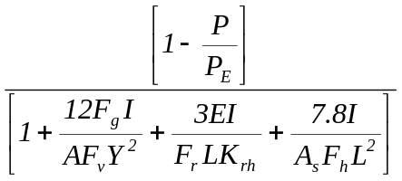
K_{rs} = rotational spring stiffness at spudcan-foundation interface.
K_{rh} = rotational stiffness representing leg to hull connection stiffness (see below).
F_{r} = factor to account for hull bending stiffness.
= 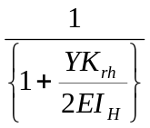
I_{H} = representative second moment of area of the hull girder joining two legs about a horizontal axis normal to the line of environmental action.
E = Young's modulus for steel.
A = axial area of one leg (equals sum of effective chord areas, including a contribution from rack teeth - see Note to Section 5.6.4).
A_{s} = effective shear area of one leg (see Figure 5.1).
I = second moment of area of the leg (see Figure 5.1), including a contribution from rack teeth (see Note to Section 5.6.4).
Y = distance between center of one leg and line joining centers of the other two legs (3 leg unit).
= distance between windward and leeward leg rows for direction under consideration (4 leg unit)
F_{g} = geometric factor.
= 1.125 (3 leg unit), 1.0 (4 leg unit)
F_{v} = factor to account for vertical soil stiffness, K_{vs}, and vertical leg-hull connection stiffness, K_{vh} (see below).
= 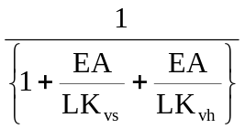
F_{h} = factor to account for horizontal soil stiffness, K_{hs}, and horizontal leg-hull connection stiffness, K_{hh} (see below).
= 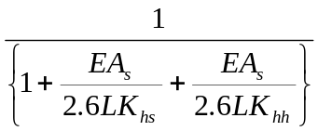
L = length of leg from the seabed reaction point (see Section 5.2.1) to the point separating M1a and M1b (see above).
P = the mean force due to vertical fixed load and variable load acting on one leg.
= 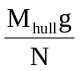
g = acceleration due to gravity.
P_{E} = Euler buckling force of one leg.
= α2EI
α = the minimum positive non-zero value of αL satisfying:
tan(αL) = 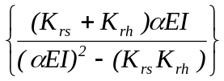
Thus:
when K_{rs} = 0 and K_{rh} = ∞, αL = π/2 and hence:
P_{E} = 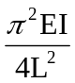
when K_{rs} = ∞ and K_{rh} = ∞, αL = π and hence
P_{E} = 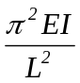
The hull to leg connection springs, K_{rh}, K_{vh} and K_{hh} represent the interaction of the leg with the guides and supporting system and account for local member flexibility and frame action. They should be computed with respect to the point separating M_{1a} and M_{1b}, as described above. The following approximations may be applied:
K_{hh} = ∞
K_{vh} = effective stiffness due to the series combination of all vertical pinion or fixation system stiffnesses, allowing for combined action with shock-pads, where fitted.
Unit with fixation system:
K_{rh} = combined rotational stiffness of fixation systems on one leg.
= F_{n}h2k_{f}
where;
F_{n} = 0.5, three chord leg; = 1.0, four chord leg
h = distance between chord centers.
k_{f} = combined vertical stiffness of all fixation system components on one chord.

Unit without fixation system:
K_{rh} = rotational stiffness allowing for pinion stiffness, leg shear deformation and guide flexibility.
= F_{n}h2k_{j} + 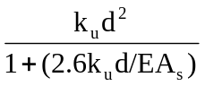
where;
h = distance between chord centers (opposed pinion chords) or pinion pitch points (single rack chords).
k_{j} = combined vertical stiffness of all jacking system components on one chord.
d = distance between upper and lower guides.
k_{u} = total lateral stiffness of upper guides with respect to lower guides.
As = effective shear area of leg.
The above equations for estimating the fundamental natural period are approximate and ignore the following effects:
- more realistic representation of possible fixity at the spudcan-foundation interface in the form of (coupled) horizontal, vertical and rotational spring stiffnesses.
- three dimensional influences of the system as compared with the two-dimensional single leg model.

Xxxxxxx

- C.10.5.3.2 Methods for determining the MPME
C.10.5.3.2.1

Fit Weibull distribution to results of a number of time-domain; simulations to determine responses at required probability level and; average the results.
This procedure requires a suitable length time domain simulation record for each quantity of interest. The input sea state record should be checked for 'Gaussianity'. Guidance is given in Tables A.7.3-4 and A.10.5-2. The procedure requires the following steps.
Step 1
The signal record is first analyzed to calculate the mean, μ_{R}, as:
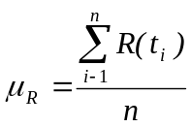
where
R(t_{i}) = time history of signal
t_{i} = time points
n = number of useable time points in simulation
(discounting the run-in)
Step 2
The individual point-in-time maxima are next extracted according to the following criteria:
A maximum occurs at t_{i} if:
R(t_{i-1}) < R(t_{i}) and R(t_{i+1}) ≤ R(t_{i})
Suppose N_{max} maxima are found in the extraction.
Step 3
From the N_{max} maxima, the mean of the signal, μ_{R}, is subtracted and the maxima R_{(max,i)} are ranked into 20 blocks having mid-points in ascending order. The blocks all have the same width and the upper bound of block 20 is taken as being 1.01 x the largest value, the lower bound of the first block being zero. A distribution of maxima observations is then found, using for each block the Gumbel plotting position in order to obtain the best possible description of the distribution for large values of R. If each block has n_{i} maxima, the cumulative probability F_{i} to be plotted against the mid point for block i is then given by:
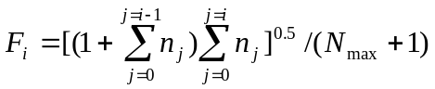
where n₀ = 0.
Step 4.a
A Weibull distribution is fitted against the cumulative distribution of the maxima as defined under Step 3 (see Steps 4.b to 4.d). The 3-parameter Weibull cumulative distribution function is defined as:
F(R;α,β,γ) = 1 - exp.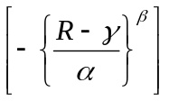
where;
F(R;α,β,γ) = probability of non-exceedance
α = scale parameter
β = slope parameter
γ = threshold parameter
and α,β,(R-γ) > 0.0
Step 4.b
Only data points R(_{max,i}), corresponding to a probability of non-exceedance greater than a threshold value of 0.2 are used to fit the Weibull distribution, i.e. only the points:
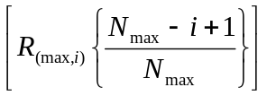 for i>0.2 x N_{max}
Notice that R(_{max,i}) are in ascending order.
Step 4.c
For each of these points, the deviations between the Weibull distribution and the values R_{(max,i)} (transformed to Weibull scales) are calculated as:
δ_{i} = ln[-ln{1-F(R_{(max,i)},α,β,γ)}] - β[ln(r_{(max,i)}-γ) - ln(α)]
Step 4.d
The parameters α,β,γ are now estimated by a non-linear least square technique, i.e.
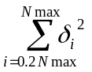 is minimized
The procedure may be based on a Levenberg-Marquardt algorithm, using the parameters of a 2-parameter Weibull distribution (found by the maximum likelihood method) as initial estimates.
Step 5
The MPM value R_{MPM} is found as the value of R for which:
F(R,α,β,γ) = 1 - 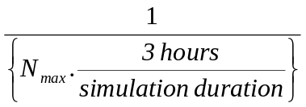
Step 6
The total extreme MPM value, R_{MPME} is found as:
R_{MPME} = μ_{R} + _{RMPM}
where μ_{R} = the mean value of R established in Step 1 R_{MPM} = the MPM value (excluding the mean) established in Step 5.
Step 7
The procedure is repeated for each required response parameter.
The basic assumption of this method is that the 3-hour extreme values follow a Gumbel distribution:
C.10.5.3.2-2 Fit Gumbel distribution to histogram of peak responses from a number of time-domain simulations to determine responses at required probability level.
The basic assumption of this method is that the 3-hour extreme values follow a Gumbel distribution:
F^{3h}(x) = exp 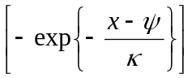
where;
F^{3h}(x) = the probability that the 3-hour maximum will not exceed value x.
ψ = location parameter
κ = scale parameter
The following steps are followed for each required response parameter:
Step 1
Extract maximum (and minimum) value for each of 10 3-hour response signal records.
Step 2
A Gumbel distribution is fitted through these 10 maxima/minima. This is done using the maximum likelihood method, yielding ψ and κ.
Step 3
The MPME is found according to:
MPME = ψ - κ ln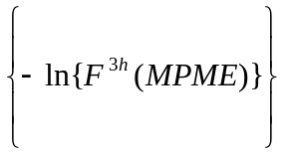
with;
F^{3h} (MPME) = 0.37
The 0.37 lower quantile is used because the extreme of recurrence of once in 3 hours will have a probability of exceedance of 0.63 (= 1 - 0.37). In this case it can be seen that:
MPME = ψ
Step 4
The procedure of Step 3 is similarly applied for minima.
C.10.5.3.2-3 Apply Winterstein's Hermite polynomial method to the results of time domain simulation(s).
For Gaussian processes, analytical results exist for the determination of the MPM values (e.g. MPM wave height = 1.86 x significant wave height). For general non-inear, non-gaussian, finite band-width processes, approximate methods are required to generate the probability density function of the process. The method proposed by Winterstein [Winterstein S.R., 'Non-Linear Vibration Models for Extremes and Fatigue', Journal of Engineering Mechanics, Vol. 114, No 10, 1988] fits a Hermite polynomial of gaussian processes to transform the non-linear, non-gaussian process into a mathematically tractable probability density function. This has been further refined by Jensen [Jensen, J.J. 'Dynamic Amplification of Offshore Steel Platform Responses due to Non-Gaussian Wave Loads', The Danish Center for Applied Mathematics and Mechanics Report No 425, May 1991, Submitted to Journal of Structural Engineering, ASCE] for processes with large kurtosis.
This procedure requires a suitable length time domain simulation record for each quantity of interest. The input sea state record should be checked for 'Gaussianity'. Guidance is given in Tables A.7.3-4 and A.10.5-2 The calculation procedure to determine the maximum of a time series, R(t), in duration T is as follows:
Step 1
Calculate the following quantities of the time series for the parameter under consideration:
μ = mean of the process
σ = standard deviation
α₃ = skewness
α₄ = kurtosis
Step 2
Hence construct a standardised response process, z = (R - μ)/σ. Using this standardised process, calculate the number of zero-upcrossings, N. In lieu of an actual cycle count from the simulated time series, N = 1000 may be assumed for a 3-hour simulation.
Step 3
Compute the following quantities from the characteristics of the response parameters identified earlier:
h₃ = 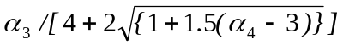
h₄ = 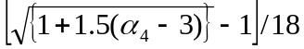
K = 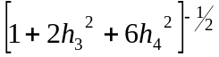
It is necessary to seek a more accurate result by determining the solution of the following equations for C₁, C₂ and C₃:
σ² = C₁² + 6C₁C₃ + 2C₂² + 15C₃²
σ³α₃ = C₂(6C₁² + 8C₂² + 72C₁C₃ + 270C₃²)
σ⁴α₄ = 60C₂⁴ + 3C₁⁴ + 10395C₃⁴ + 60C₁²C₂² + 4500C₂²C₃² + 630C₁²C₃² + 936C₁C₂²C₃ + 3780C₁C₃³ + 60C₁³C₃
using as initial guesses:
C₁ = σK(1-3h₄)
C₂ = σKh₃
C₃ = σKh₄
with σ, K, h₃ and h₄ from above. Following the solution for C₁, C₂ and C₃, the values for K, h₃ and h₄ are computed as follows:
K = (C₁ + 3C₃)/σ
h₃ = C₂/(σK)
h₄ = C₃/(σK)
Step 4
The most probable value, U, of the transformed process is computed by the following equation:
U = 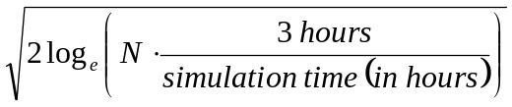
Where U is a Gaussian process of zero mean, unit variance.
Step 5
The most probable maximum, transformed back to the standardised variable, z, is then given by:
z_{MPM} = K[U + h₃(U² - 1) + h₄(U³ - 3U)]
Step 6
Finally, the MPME in the period T, for the response under consideration, can be computed from the following equation:
R_{MPME} = μ + σz_{MPM}

(informative)
Foundations - Additional Information and Alternative Approaches
        - D.9.3.2.3 Penetration in clays << Note to P4 -inserted as Word Tables per ISO re translation, etc. >>
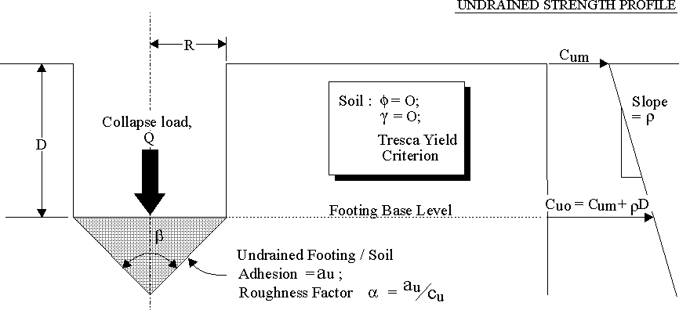

Figure D.1-1 : Conical spudcan bearing capacity - problem definition and notation
<< replace radius R with diameter B and c_{ux} with s_{ux} >>
Person responsible to review Annex D should decide whether to keep the figure above or provide a list of definitions for the symbols.

<< change 2R with B , c_{u}'s to s_{u}'s ? state equation for roughness>>
30 degrees cones |  |  |  | F_{V}/(Ac_{uo}) factors
ρ2R | D | c_{uo} | ρ2R | Roughness
c_{um} | R | c_{um} | c_{uo} | 0.0 | 0.2 | 0.4 | 0.6 | 0.8 | 1.0
0.0 | 0.0 | 1.00 | 0.00 | 4.61 | 5.51 | 6.38 | 7.22 | 8.03 | 8.78
0.0 | 0.2 | 1.00 | 0.00 | 4.80 | 5.70 | 6.56 | 7.40 | 8.20 | 8.95
0.0 | 0.5 | 1.00 | 0.00 | 5.05 | 5.94 | 6.80 | 7.63 | 8.43 | 9.18
0.0 | 1.0 | 1.00 | 0.00 | 5.41 | 6.29 | 7.14 | 7.79 | 8.76 | 9.50
0.0 | 2.0 | 1.00 | 0.00 | 5.98 | 6.85 | 7.70 | 8.51 | 9.29 | 10.03
0.0 | 5.0 | 1.00 | 0.00 | 7.12 | 7.98 | 8.81 | 9.61 | 10.38 | 11.10
1.0 | 0.0 | 1.00 | 1.00 | 7.53 | 9.02 | 10.46 | 11.84 | 13.19 | 14.46
1.0 | 0.2 | 1.10 | 0.91 | 7.45 | 8.89 | 10.27 | 11.61 | 12.90 | 14.13
1.0 | 0.5 | 1.25 | 0.80 | 7.38 | 8.73 | 10.05 | 11.32 | 12.55 | 13.72
1.0 | 1.0 | 1.50 | 0.67 | 7.28 | 8.55 | 9.78 | 10.98 | 12.14 | 13.24
1.0 | 2.0 | 2.00 | 0.50 | 7.20 | 8.38 | 9.51 | 10.61 | 11.68 | 12.68
1.0 | 5.0 | 3.50 | 0.29 | 7.34 | 8.39 | 9.39 | 10.37 | 11.30 | 12.19
2.0 | 0.0 | 1.00 | 2.00 | 10.45 | 12.51 | 14.51 | 16.44 | 18.31 | 20.10
2.0 | 0.2 | 1.20 | 1.67 | 9.65 | 11.53 | 13.33 | 15.08 | 16.79 | 18.40
2.0 | 0.5 | 1.50 | 1.33 | 8.89 | 10.58 | 12.19 | 13.76 | 15.27 | 16.72
2.0 | 1.0 | 2.00 | 1.00 | 8.20 | 9.67 | 11.09 | 12.47 | 13.80 | 15.08
2.0 | 2.0 | 3.00 | 0.67 | 7.60 | 8.87 | 10.10 | 11.30 | 12.45 | 13.54
2.0 | 5.0 | 6.00 | 0.33 | 7.37 | 8.44 | 9.48 | 10.18 | 11.44 | 12.35
3.0 | 0.0 | 1.00 | 3.00 | 13.36 | 15.98 | 18.56 | 21.03 | 23.42 | 25.71
3.0 | 0.2 | 1.30 | 2.31 | 11.51 | 13.76 | 15.92 | 18.02 | 20.05 | 22.00
3.0 | 0.5 | 1.75 | 1.71 | 9.98 | 11.89 | 13.72 | 15.49 | 17.21 | 18.85
3.0 | 1.0 | 2.50 | 1.20 | 8.74 | 10.33 | 11.87 | 13.36 | 14.80 | 16.18
3.0 | 2.0 | 4.00 | 0.75 | 7.79 | 9.11 | 10.39 | 11.64 | 12.83 | 13.98
3.0 | 5.0 | 8.50 | 0.35 | 7.40 | 8.46 | 9.51 | 10.52 | 11.49 | 12.42
4.0 | 0.0 | 1.00 | 4.00 | 16.27 | 19.46 | 22.57 | 25.62 | 28.52 | 31.32
4.0 | 0.2 | 1.40 | 2.86 | 13.10 | 15.68 | 18.14 | 20.54 | 22.86 | 25.08
4.0 | 0.5 | 2.00 | 2.00 | 10.83 | 12.87 | 14.86 | 16.79 | 18.66 | 20.44
4.0 | 1.0 | 3.00 | 1.33 | 9.11 | 10.77 | 12.38 | 13.96 | 15.47 | 16.91
4.0 | 2.0 | 5.00 | 0.80 | 7.91 | 9.26 | 10.57 | 11.84 | 13.06 | 14.23
4.0 | 5.0 | 11.00 | 0.36 | 7.40 | 8.47 | 9.52 | 10.54 | 11.52 | 12.46
5.0 | 0.0 | 1.00 | 5.00 | 19.18 | 22.94 | 26.61 | 30.20 | 33.63 | 36.92
5.0 | 0.2 | 1.50 | 3.33 | 14.48 | 17.33 | 20.06 | 22.72 | 25.29 | 27.75
5.0 | 0.5 | 2.25 | 2.22 | 11.46 | 13.64 | 15.75 | 17.80 | 19.78 | 21.68
5.0 | 1.0 | 3.50 | 1.43 | 9.37 | 11.08 | 12.77 | 14.38 | 15.94 | 17.43
5.0 | 2.0 | 6.00 | 0.83 | 7.98 | 9.35 | 10.68 | 11.97 | 13.21 | 14.40
5.0 | 5.0 | 13.50 | 0.37 | 7.40 | 8.47 | 9.53 | 10.56 | 11.55 | 12.48
60 degrees cones |  |  |  | F_{V}/(Ac_{uo}) factors
ρ2R | D | c_{uo} | ρ2R | Roughness
c_{um} | R | c_{um} | c_{uo} | 0.0 | 0.2 | 0.4 | 0.6 | 0.8 | 1.0
0.0 | 0.0 | 1.00 | 0.00 | 4.45 | 4.96 | 5.45 | 5.90 | 6.32 | 6.69
0.0 | 0.2 | 1.00 | 0.00 | 4.68 | 5.19 | 5.67 | 6.12 | 6.53 | 6.90
0.0 | 0.5 | 1.00 | 0.00 | 4.98 | 5.50 | 5.96 | 6.40 | 6.81 | 7.18
0.0 | 1.0 | 1.00 | 0.00 | 5.41 | 5.90 | 6.37 | 6.81 | 7.21 | 7.57
0.0 | 2.0 | 1.00 | 0.00 | 6.07 | 6.55 | 7.01 | 7.43 | 7.84 | 8.18
0.0 | 5.0 | 1.00 | 0.00 | 7.33 | 7.81 | 8.25 | 8.66 | 9.05 | 9.39
1.0 | 0.0 | 1.00 | 1.00 | 5.81 | 6.51 | 7.15 | 7.77 | 8.34 | 8.87
1.0 | 0.2 | 1.10 | 0.91 | 5.92 | 6.59 | 7.23 | 7.83 | 8.38 | 8.89
1.0 | 0.5 | 1.25 | 0.80 | 6.04 | 6.70 | 7.30 | 7.88 | 8.42 | 8.91
1.0 | 1.0 | 1.50 | 0.67 | 6.20 | 6.84 | 7.41 | 7.96 | 8.47 | 8.94
1.0 | 2.0 | 2.00 | 0.50 | 6.43 | 7.05 | 7.58 | 8.12 | 8.59 | 9.03
1.0 | 5.0 | 3.50 | 0.29 | 6.97 | 7.55 | 8.08 | 8.54 | 8.98 | 9.39
2.0 | 0.0 | 1.00 | 2.00 | 7.14 | 8.02 | 8.84 | 9.60 | 10.32 | 10.99
2.0 | 0.2 | 1.20 | 1.67 | 6.92 | 7.73 | 8.49 | 9.21 | 9.88 | 10.50
2.0 | 0.5 | 1.50 | 1.33 | 6.74 | 7.50 | 8.18 | 8.84 | 9.46 | 10.03
2.0 | 1.0 | 2.00 | 1.00 | 6.59 | 7.29 | 7.91 | 8.53 | 9.09 | 9.61
2.0 | 2.0 | 3.00 | 0.67 | 6.55 | 7.20 | 7.76 | 8.33 | 8.83 | 9.30
2.0 | 5.0 | 6.00 | 0.33 | 6.99 | 7.49 | 8.03 | 8.50 | 8.95 | 9.37
3.0 | 0.0 | 1.00 | 3.00 | 8.49 | 9.54 | 10.50 | 11.42 | 12.29 | 13.10
3.0 | 0.2 | 1.30 | 2.31 | 7.77 | 8.70 | 9.56 | 10.38 | 11.14 | 11.85
3.0 | 0.5 | 1.75 | 1.71 | 7.24 | 8.03 | 8.80 | 9.53 | 10.20 | 10.82
3.0 | 1.0 | 2.50 | 1.20 | 6.82 | 7.56 | 8.21 | 8.86 | 9.45 | 10.00
3.0 | 2.0 | 4.00 | 0.75 | 6.60 | 7.27 | 7.85 | 8.44 | 8.94 | 9.43
3.0 | 5.0 | 8.50 | 0.35 | 6.99 | 7.47 | 8.01 | 8.49 | 8.94 | 9.36
4.0 | 0.0 | 1.00 | 4.00 | 9.83 | 11.02 | 12.16 | 13.24 | 14.26 | 15.18
4.0 | 0.2 | 1.40 | 2.86 | 8.51 | 9.52 | 10.48 | 11.38 | 12.22 | 13.00
4.0 | 0.5 | 2.00 | 2.00 | 7.61 | 8.44 | 9.26 | 10.04 | 10.75 | 11.41
4.0 | 1.0 | 3.00 | 1.33 | 6.97 | 7.74 | 8.41 | 9.08 | 9.69 | 10.26
4.0 | 2.0 | 5.00 | 0.80 | 6.64 | 7.31 | 7.90 | 8.49 | 9.01 | 9.51
4.0 | 5.0 | 11.00 | 0.36 | 6.86 | 7.45 | 8.00 | 8.48 | 8.94 | 9.35
5.0 | 0.0 | 1.00 | 5.00 | 11.17 | 12.52 | 13.83 | 15.06 | 16.20 | 17.26
5.0 | 0.2 | 1.50 | 3.33 | 9.14 | 10.23 | 11.26 | 12.25 | 13.15 | 13.99
5.0 | 0.5 | 2.25 | 2.22 | 7.90 | 8.78 | 9.63 | 10.43 | 11.17 | 11.87
5.0 | 1.0 | 3.50 | 1.43 | 7.08 | 7.84 | 8.55 | 9.24 | 9.86 | 10.45
5.0 | 2.0 | 6.00 | 0.83 | 6.66 | 7.32 | 7.94 | 8.53 | 9.06 | 9.56
5.0 | 5.0 | 13.50 | 0.37 | 6.85 | 7.44 | 7.99 | 8.47 | 8.93 | 9.35
90 degrees cones |  |  |  | F_{V}/(Ac_{uo}) factors
ρ2R | D | c_{uo} | ρ2R | Roughness
c_{um} | R | c_{um} | c_{uo} | 0.0 | 0.2 | 0.4 | 0.6 | 0.8 | 1.0
0.0 | 0.0 | 1.00 | 0.00 | 4.64 | 5.02 | 5.36 | 5.67 | 5.95 | 6.17
0.0 | 0.2 | 1.00 | 0.00 | 4.90 | 5.28 | 5.61 | 5.91 | 6.18 | 6.41
0.0 | 0.5 | 1.00 | 0.00 | 5.22 | 5.59 | 5.93 | 6.23 | 6.49 | 6.71
0.0 | 1.0 | 1.00 | 0.00 | 5.68 | 6.03 | 6.36 | 6.66 | 6.92 | 7.14
0.0 | 2.0 | 1.00 | 0.00 | 6.37 | 6.71 | 7.05 | 7.32 | 7.58 | 7.79
0.0 | 5.0 | 1.00 | 0.00 | 7.65 | 8.03 | 8.32 | 8.60 | 8.86 | 9.05
1.0 | 0.0 | 1.00 | 1.00 | 5.57 | 6.05 | 6.47 | 6.87 | 7.22 | 7.53
1.0 | 0.2 | 1.10 | 0.91 | 5.74 | 6.21 | 6.62 | 7.00 | 7.36 | 7.65
1.0 | 0.5 | 1.25 | 0.80 | 5.94 | 6.38 | 6.79 | 7.16 | 7.50 | 7.79
1.0 | 1.0 | 1.50 | 0.67 | 6.16 | 6.61 | 6.99 | 7.36 | 7.68 | 7.97
1.0 | 2.0 | 2.00 | 0.50 | 6.50 | 6.93 | 7.30 | 7.64 | 7.95 | 8.21
1.0 | 5.0 | 3.50 | 0.29 | 7.25 | 7.57 | 7.94 | 8.25 | 8.53 | 8.78
2.0 | 0.0 | 1.00 | 2.00 | 6.46 | 7.03 | 7.54 | 8.01 | 8.45 | 8.82
2.0 | 0.2 | 1.20 | 1.67 | 6.41 | 6.94 | 7.43 | 7.88 | 8.28 | 8.65
2.0 | 0.5 | 1.50 | 1.33 | 6.41 | 6.88 | 7.35 | 7.76 | 8.14 | 8.46
2.0 | 1.0 | 2.00 | 1.00 | 6.40 | 6.88 | 7.29 | 7.69 | 8.03 | 8.35
2.0 | 2.0 | 3.00 | 0.67 | 6.54 | 6.99 | 7.37 | 7.73 | 8.06 | 8.33
2.0 | 5.0 | 6.00 | 0.33 | 7.16 | 7.49 | 7.86 | 8.18 | 8.47 | 8.72
3.0 | 0.0 | 1.00 | 3.00 | 7.36 | 8.00 | 8.59 | 9.14 | 9.65 | 10.08
3.0 | 0.2 | 1.30 | 2.31 | 6.99 | 7.57 | 8.10 | 8.60 | 9.05 | 9.45
3.0 | 0.5 | 1.75 | 1.71 | 6.70 | 7.24 | 7.73 | 8.17 | 8.59 | 8.94
3.0 | 1.0 | 2.50 | 1.20 | 6.54 | 7.04 | 7.47 | 7.88 | 8.24 | 8.57
3.0 | 2.0 | 4.00 | 0.75 | 6.56 | 7.02 | 7.41 | 7.78 | 8.11 | 8.39
3.0 | 5.0 | 8.50 | 0.35 | 7.12 | 7.46 | 7.83 | 8.15 | 8.44 | 8.46
4.0 | 0.0 | 1.00 | 4.00 | 8.22 | 8.96 | 9.64 | 10.25 | 10.82 | 11.33
4.0 | 0.2 | 1.40 | 2.86 | 7.49 | 8.11 | 8.68 | 9.22 | 9.70 | 10.14
4.0 | 0.5 | 2.00 | 2.00 | 6.94 | 7.50 | 8.01 | 8.48 | 8.92 | 9.29
4.0 | 1.0 | 3.00 | 1.33 | 6.63 | 7.15 | 7.58 | 8.01 | 8.38 | 8.72
4.0 | 2.0 | 5.00 | 0.80 | 6.57 | 7.03 | 7.43 | 7.80 | 8.14 | 8.42
4.0 | 5.0 | 11.00 | 0.36 | 7.05 | 7.44 | 7.81 | 8.13 | 8.42 | 8.67
5.0 | 0.0 | 1.00 | 5.00 | 9.11 | 9.93 | 10.66 | 11.35 | 12.00 | 12.56
5.0 | 0.2 | 1.50 | 3.33 | 7.87 | 8.55 | 9.17 | 9.74 | 10.26 | 10.75
5.0 | 0.5 | 2.25 | 2.22 | 7.12 | 7.71 | 8.24 | 8.72 | 9.17 | 9.57
5.0 | 1.0 | 3.50 | 1.43 | 6.70 | 7.22 | 7.67 | 8.09 | 8.47 | 8.82
5.0 | 2.0 | 6.00 | 0.83 | 6.57 | 7.04 | 7.44 | 7.82 | 8.16 | 8.44
5.0 | 5.0 | 13.50 | 0.37 | 7.03 | 7.42 | 7.80 | 8.12 | 8.41 | 8.66
120 degrees cones |  |  |  | F_{V}/(Ac_{uo}) factors
ρ2R | D | c_{uo} | ρ2R | Roughness
c_{um} | R | c_{um} | c_{uo} | 0.0 | 0.2 | 0.4 | 0.6 | 0.8 | 1.0
0.0 | 0.0 | 1.00 | 0.00 | 4.96 | 5.25 | 5.51 | 5.73 | 5.92 | 6.05
0.0 | 0.2 | 1.00 | 0.00 | 5.23 | 5.52 | 5.77 | 5.99 | 6.17 | 6.30
0.0 | 0.5 | 1.00 | 0.00 | 5.57 | 5.85 | 6.10 | 6.31 | 6.49 | 6.62
0.0 | 1.0 | 1.00 | 0.00 | 6.04 | 6.31 | 6.55 | 6.76 | 6.93 | 7.05
0.0 | 2.0 | 1.00 | 0.00 | 6.74 | 7.01 | 7.24 | 7.44 | 7.61 | 7.72
0.0 | 5.0 | 1.00 | 0.00 | 8.07 | 8.32 | 8.55 | 8.75 | 8.90 | 8.99
1.0 | 0.0 | 1.00 | 1.00 | 5.69 | 6.04 | 6.36 | 6.65 | 6.89 | 7.09
1.0 | 0.2 | 1.10 | 0.91 | 5.89 | 6.24 | 6.55 | 6.82 | 7.07 | 7.26
1.0 | 0.5 | 1.25 | 0.80 | 6.12 | 6.45 | 6.76 | 7.02 | 7.26 | 7.45
1.0 | 1.0 | 1.50 | 0.67 | 6.39 | 6.72 | 7.01 | 7.27 | 7.48 | 7.66
1.0 | 2.0 | 2.00 | 0.50 | 6.80 | 7.10 | 7.37 | 7.61 | 7.82 | 7.97
1.0 | 5.0 | 3.50 | 0.29 | 7.52 | 7.82 | 8.08 | 8.29 | 8.49 | 8.61
2.0 | 0.0 | 1.00 | 2.00 | 6.38 | 6.79 | 7.16 | 7.50 | 7.80 | 8.04
2.0 | 0.2 | 1.20 | 1.67 | 6.41 | 6.80 | 7.16 | 7.47 | 7.75 | 7.97
2.0 | 0.5 | 1.50 | 1.33 | 6.46 | 6.83 | 7.17 | 7.46 | 7.72 | 7.94
2.0 | 1.0 | 2.00 | 1.00 | 6.56 | 6.91 | 7.22 | 7.49 | 7.74 | 7.92
2.0 | 2.0 | 3.00 | 0.67 | 6.80 | 7.12 | 7.40 | 7.65 | 7.87 | 8.03
2.0 | 5.0 | 6.00 | 0.33 | 7.43 | 7.72 | 7.99 | 8.21 | 8.41 | 8.53
3.0 | 0.0 | 1.00 | 3.00 | 7.04 | 7.51 | 7.93 | 8.31 | 8.66 | 8.93
3.0 | 0.2 | 1.30 | 2.31 | 6.84 | 7.27 | 7.65 | 8.00 | 8.31 | 8.57
3.0 | 0.5 | 1.75 | 1.71 | 6.71 | 7.09 | 7.45 | 7.76 | 8.05 | 8.27
3.0 | 1.0 | 2.50 | 1.20 | 6.66 | 7.02 | 7.34 | 7.63 | 7.88 | 8.08
3.0 | 2.0 | 4.00 | 0.75 | 6.81 | 7.11 | 7.41 | 7.67 | 7.89 | 8.06
3.0 | 5.0 | 8.50 | 0.35 | 7.38 | 7.68 | 7.95 | 8.17 | 8.38 | 8.51
4.0 | 0.0 | 1.00 | 4.00 | 7.70 | 8.22 | 8.69 | 9.11 | 9.49 | 9.81
4.0 | 0.2 | 1.40 | 2.86 | 7.20 | 7.66 | 8.07 | 8.44 | 8.77 | 9.03
4.0 | 0.5 | 2.00 | 2.00 | 6.88 | 7.28 | 7.65 | 7.98 | 8.27 | 8.53
4.0 | 1.0 | 3.00 | 1.33 | 6.72 | 7.08 | 7.42 | 7.71 | 7.97 | 8.18
4.0 | 2.0 | 5.00 | 0.80 | 6.80 | 7.12 | 7.41 | 7.68 | 7.90 | 8.08
4.0 | 5.0 | 11.00 | 0.36 | 7.39 | 7.66 | 7.93 | 8.15 | 8.36 | 8.49
5.0 | 0.0 | 1.00 | 5.00 | 8.35 | 8.91 | 9.43 | 9.89 | 10.31 | 10.67
5.0 | 0.2 | 1.50 | 3.33 | 7.52 | 7.99 | 8.43 | 8.82 | 9.18 | 9.95
5.0 | 0.5 | 2.25 | 2.22 | 7.01 | 7.43 | 7.81 | 8.15 | 8.45 | 8.72
5.0 | 1.0 | 3.50 | 1.43 | 6.77 | 7.13 | 7.47 | 7.77 | 8.03 | 8.25
5.0 | 2.0 | 6.00 | 0.83 | 6.80 | 7.12 | 7.42 | 7.69 | 7.91 | 8.09
5.0 | 5.0 | 13.50 | 0.37 | 7.34 | 7.64 | 7.91 | 8.14 | 8.34 | 8.48
150 degrees cones |  |  |  | F_{V}/(Ac_{uo}) factors
ρ2R | D | c_{uo} | ρ2R | Roughness
c_{um} | R | c_{um} | c_{uo} | 0.0 | 0.2 | 0.4 | 0.6 | 0.8 | 1.0
0.0 | 0.0 | 1.00 | 0.00 | 5.32 | 5.55 | 5.74 | 5.89 | 6.01 | 6.05
0.0 | 0.2 | 1.00 | 0.00 | 5.60 | 5.82 | 6.00 | 6.16 | 6.26 | 6.30
0.0 | 0.5 | 1.00 | 0.00 | 5.94 | 6.16 | 6.34 | 6.49 | 6.59 | 6.61
0.0 | 1.0 | 1.00 | 0.00 | 6.41 | 6.62 | 6.80 | 6.94 | 7.03 | 7.05
0.0 | 2.0 | 1.00 | 0.00 | 7.13 | 7.32 | 7.49 | 7.62 | 7.71 | 7.72
0.0 | 5.0 | 1.00 | 0.00 | 8.46 | 8.65 | 8.81 | 8.93 | 8.99 | 8.99
1.0 | 0.0 | 1.00 | 1.00 | 5.94 | 6.22 | 6.46 | 6.67 | 6.84 | 6.97
1.0 | 0.2 | 1.10 | 0.91 | 6.16 | 6.43 | 6.67 | 6.87 | 7.04 | 7.15
1.0 | 0.5 | 1.25 | 0.80 | 6.41 | 6.67 | 6.90 | 7.09 | 7.25 | 7.36
1.0 | 1.0 | 1.50 | 0.67 | 6.71 | 6.96 | 7.18 | 7.36 | 7.51 | 7.60
1.0 | 2.0 | 2.00 | 0.50 | 7.13 | 7.36 | 7.57 | 7.73 | 7.86 | 7.95
1.0 | 5.0 | 3.50 | 0.29 | 7.91 | 8.12 | 8.31 | 8.44 | 8.56 | 8.61
2.0 | 0.0 | 1.00 | 2.00 | 6.50 | 6.82 | 7.11 | 7.35 | 7.57 | 7.73
2.0 | 0.2 | 1.20 | 1.67 | 6.59 | 6.90 | 7.16 | 7.40 | 7.59 | 7.74
2.0 | 0.5 | 1.50 | 1.33 | 6.69 | 6.98 | 7.23 | 7.45 | 7.63 | 7.76
2.0 | 1.0 | 2.00 | 1.00 | 6.84 | 7.10 | 7.34 | 7.54 | 7.70 | 7.82
2.0 | 2.0 | 3.00 | 0.67 | 7.11 | 7.35 | 7.57 | 7.74 | 7.89 | 7.99
2.0 | 5.0 | 6.00 | 0.33 | 7.81 | 8.01 | 8.21 | 8.35 | 8.47 | 8.53
3.0 | 0.0 | 1.00 | 3.00 | 7.03 | 7.40 | 7.72 | 7.98 | 8.24 | 8.43
3.0 | 0.2 | 1.30 | 2.31 | 6.94 | 7.27 | 7.56 | 7.81 | 8.03 | 8.21
3.0 | 0.5 | 1.75 | 1.71 | 6.88 | 7.18 | 7.45 | 7.68 | 7.88 | 8.03
3.0 | 1.0 | 2.50 | 1.20 | 6.91 | 7.18 | 7.43 | 7.63 | 7.81 | 7.94
3.0 | 2.0 | 4.00 | 0.75 | 7.10 | 7.35 | 7.57 | 7.75 | 7.90 | 8.00
3.0 | 5.0 | 8.50 | 0.35 | 7.76 | 7.97 | 8.16 | 8.31 | 8.43 | 8.49
4.0 | 0.0 | 1.00 | 4.00 | 7.55 | 7.94 | 8.30 | 8.58 | 8.88 | 9.10
4.0 | 0.2 | 1.40 | 2.86 | 7.23 | 7.58 | 7.89 | 8.16 | 8.40 | 8.59
4.0 | 0.5 | 2.00 | 2.00 | 7.02 | 7.34 | 7.62 | 7.86 | 8.07 | 8.23
4.0 | 1.0 | 3.00 | 1.33 | 6.95 | 7.23 | 7.49 | 7.70 | 7.88 | 8.01
4.0 | 2.0 | 5.00 | 0.80 | 7.09 | 7.34 | 7.56 | 7.75 | 7.90 | 8.00
4.0 | 5.0 | 11.00 | 0.36 | 7.72 | 7.94 | 8.13 | 8.29 | 8.41 | 8.47
5.0 | 0.0 | 1.00 | 5.00 | 8.05 | 8.48 | 8.86 | 9.19 | 9.48 | 9.74
5.0 | 0.2 | 1.50 | 3.33 | 7.46 | 7.83 | 8.16 | 8.44 | 8.69 | 8.90
5.0 | 0.5 | 2.25 | 2.22 | 7.13 | 7.45 | 7.74 | 7.99 | 8.20 | 8.37
5.0 | 1.0 | 3.50 | 1.43 | 6.99 | 7.27 | 7.53 | 7.74 | 7.93 | 8.07
5.0 | 2.0 | 6.00 | 0.83 | 7.09 | 7.34 | 7.56 | 7.75 | 7.91 | 8.01
5.0 | 5.0 | 13.50 | 0.37 | 7.70 | 7.93 | 8.12 | 8.27 | 8.40 | 8.46
180 degrees cones |  |  |  | F_{V}(Ac_{uo}) factors
ρ2R | D | c_{uo} | ρ2R | Roughness
c_{um} | R | c_{um} | c_{uo} | 0.0 | 0.2 | 0.4 | 0.6 | 0.8 | 1.0
0.0 | 0.0 | 1.00 | 0.00 | 5.69 | 5.86 | 5.97 | 6.03 | 6.05 | 6.05
0.0 | 0.2 | 1.00 | 0.00 | 5.97 | 6.13 | 6.24 | 6.29 | 6.30 | 6.30
0.0 | 0.5 | 1.00 | 0.00 | 6.31 | 6.47 | 6.57 | 6.61 | 6.61 | 6.61
0.0 | 1.0 | 1.00 | 0.00 | 6.79 | 6.93 | 7.02 | 7.05 | 7.05 | 7.05
0.0 | 2.0 | 1.00 | 0.00 | 7.49 | 7.63 | 7.70 | 7.71 | 7.71 | 7.71
0.0 | 5.0 | 1.00 | 0.00 | 8.82 | 8.94 | 8.99 | 8.99 | 8.99 | 8.99
1.0 | 0.0 | 1.00 | 1.00 | 6.25 | 6.47 | 6.65 | 6.79 | 6.90 | 6.95
1.0 | 0.2 | 1.10 | 0.91 | 6.48 | 6.69 | 6.87 | 7.00 | 7.10 | 7.14
1.0 | 0.5 | 1.25 | 0.80 | 6.74 | 6.94 | 7.11 | 7.23 | 7.32 | 7.35
1.0 | 1.0 | 1.50 | 0.67 | 7.05 | 7.24 | 7.39 | 7.51 | 7.58 | 7.60
1.0 | 2.0 | 2.00 | 0.50 | 7.47 | 7.64 | 7.79 | 7.88 | 7.93 | 7.94
1.0 | 5.0 | 3.50 | 0.29 | 8.26 | 8.32 | 8.52 | 8.60 | 8.61 | 8.61
2.0 | 0.0 | 1.00 | 2.00 | 6.73 | 6.98 | 7.20 | 7.39 | 7.53 | 7.63
2.0 | 0.2 | 1.20 | 1.67 | 6.85 | 7.08 | 7.30 | 7.46 | 7.59 | 7.68
2.0 | 0.5 | 1.50 | 1.33 | 6.98 | 7.20 | 7.39 | 7.55 | 7.66 | 7.72
2.0 | 1.0 | 2.00 | 1.00 | 7.15 | 7.36 | 7.53 | 7.67 | 7.76 | 7.80
2.0 | 2.0 | 3.00 | 0.67 | 7.45 | 7.63 | 7.78 | 7.90 | 7.96 | 7.98
2.0 | 5.0 | 6.00 | 0.33 | 8.16 | 8.27 | 8.43 | 8.50 | 8.53 | 8.53
3.0 | 0.0 | 1.00 | 3.00 | 7.16 | 7.45 | 7.69 | 7.91 | 8.08 | 8.21
3.0 | 0.2 | 1.30 | 2.31 | 7.13 | 7.40 | 7.62 | 7.81 | 7.96 | 8.07
3.0 | 0.5 | 1.75 | 1.71 | 7.15 | 7.37 | 7.58 | 7.75 | 7.88 | 7.96
3.0 | 1.0 | 2.50 | 1.20 | 7.21 | 7.42 | 7.61 | 7.75 | 7.86 | 7.91
3.0 | 2.0 | 4.00 | 0.75 | 7.43 | 7.62 | 7.78 | 7.90 | 7.97 | 7.99
3.0 | 5.0 | 8.50 | 0.35 | 8.13 | 8.23 | 8.38 | 8.46 | 8.49 | 8.49
4.0 | 0.0 | 1.00 | 4.00 | 7.56 | 7.87 | 8.15 | 8.38 | 8.58 | 8.73
4.0 | 0.2 | 1.40 | 2.86 | 7.38 | 7.64 | 7.89 | 8.09 | 8.26 | 8.39
4.0 | 0.5 | 2.00 | 2.00 | 7.26 | 7.50 | 7.71 | 7.89 | 8.03 | 8.13
4.0 | 1.0 | 3.00 | 1.33 | 7.25 | 7.46 | 7.65 | 7.80 | 7.92 | 7.98
4.0 | 2.0 | 5.00 | 0.80 | 7.44 | 7.61 | 7.77 | 7.89 | 7.97 | 8.00
4.0 | 5.0 | 11.00 | 0.36 | 8.09 | 8.19 | 8.36 | 8.44 | 8.47 | 8.47
5.0 | 0.0 | 1.00 | 5.00 | 7.94 | 8.27 | 8.57 | 8.83 | 9.05 | 9.23
5.0 | 0.2 | 1.50 | 3.33 | 7.56 | 7.85 | 8.10 | 8.32 | 8.50 | 8.64
5.0 | 0.5 | 2.25 | 2.22 | 7.34 | 7.59 | 7.81 | 8.00 | 8.15 | 8.25
5.0 | 1.0 | 3.50 | 1.43 | 7.27 | 7.49 | 7.68 | 7.84 | 7.96 | 8.02
5.0 | 2.0 | 6.00 | 0.83 | 7.43 | 7.60 | 7.77 | 7.89 | 7.97 | 8.00
5.0 | 5.0 | 13.50 | 0.37 | 8.07 | 8.18 | 8.35 | 8.43 | 8.46 | 8.46

        - D.9.3.2.4 Penetration in silica sands
Commentary: (MC to move this to Annex D with some additional write-up on conical angle)
Values of :
Various bearing capacity and shape factors are given in the literature for the analysis of bearing capacity in silica sands. Traditionally, the value of the dimensionless bearing capacity has been calculated for strip footings, and applied to circular foundations by using an empirical shape factor. However, more recently values for the axisymmetric case have been directly determined. Recent tabulated lower bound solutions have been provided by Cassidy and Houlsby (2002) for circular conical foundations of radius, R, cone angles between 30° and 180° (flat plate), a range of roughness from smooth to fully rough and angles of friction (φ) between 5° and 50°. Other values for rough circular footings have been provided by Martin (2004) and are discussed in the context of the bearing capacity of foundation by Randolph et al. (2004). For the rough circular plate the suggested values of Martin (2004) are given in Table A.9.3-2.
The factors of Cassidy and Houlsby (2002) have been derived for the problem defined in Figure D9.4.1 (friction angle, φ; radius, R; cone apex angle, β; roughness factor α, such that the interface friction angle δ is given by tanδ = αtanφ). The dimensionless bearing capacity values of Cassidy and Houlsby are detailed in Tables D9.3.2 to D9.3.7.
β
footingspudcan roughness
α
F_{V}
homogeneous soil

R

Figure D.9.3-1 – Definition of parameters for Tables D.9.3.2 to D.9.3.7
α needs to be addressed due to overlapped uses.

Table D.9.3-2 - Bearing capacity factors (N_{γ}) for a conical apex angle of 60°

β = 60°
φ (°) | α = 1 | α = 0.8 | α = 0.6 | α = 0.4 | α = 0.2 | α = 0
15 | 3.775 | 3.445 | 3.080 | 2.708 | 2.340 | 1.979
20 | 7.333 | 6.546 | 5.639 | 4.752 | 3.896 | 3.075
25 | 14.69 | 12.99 | 10.94 | 8.660 | 6.639 | 4.820
30 | 31.99 | 27.45 | 22.50 | 16.70 | 11.86 | 7.950
35 | 79.26 | 62.95 | 48.81 | 34.83 | 22.57 | 13.36
40 | 209.2 | 163.2 | 122.3 | 80.13 | 47.27 | 23.75
45 | 646.3 | 495.8 | 382.4 | 214.1 | 108.0 | 46.05
50 | 2650.0 | 1913.2 | 1414.7 | 698.1 | 295.3 | 108.8

Table D9.3-4 - Bearing capacity factors (N_{γ}) for a conical apex angle of 90°

β = 90°
φ (°) | α = 1 | α = 0.8 | α = 0.6 | α = 0.4 | α = 0.2 | α = 0
15 | 2.269 | 2.100 | 1.909 | 1.709 | 1.540 | 1.313
20 | 4.540 | 4.114 | 3.625 | 3.114 | 2.600 | 2.115
25 | 9.581 | 8.502 | 7.257 | 5.936 | 4.663 | 3.509
30 | 21.12 | 18.87 | 15.58 | 12.09 | 8.911 | 6.219
35 | 51.76 | 47.42 | 37.01 | 26.95 | 18.26 | 11.26
40 | 142.8 | 132.6 | 99.18 | 67.48 | 40.80 | 22.13
45 | 458.7 | 419.5 | 312.6 | 199.6 | 107.1 | 51.30
50 | 1923.3 | 1850.4 | 1384.0 | 751.8 | 340.1 | 115.2

Table D.9.3-5 – Bearing capacity factors (N_{γ}) for a conical apex angle of 120°
β = 120°
φ (°) | α = 1 | α = 0.8 | α = 0.6 | α = 0.4 | α = 0.2 | α = 0
15 | 1.595 | 1.510 | 1.387 | 1.248 | 1.105 | 0.963
20 | 3.373 | 3.155 | 2.810 | 2.437 | 2.055 | 1.688
25 | 7.460 | 6.987 | 6.046 | 5.008 | 3.994 | 3.064
30 | 17.58 | 16.80 | 14.30 | 11.04 | 8.232 | 5.768
35 | 44.73 | 42.99 | 35.79 | 26.74 | 18.67 | 11.88
40 | 129.4 | 124.9 | 103.3 | 73.810 | 46.44 | 25.84
45 | 446.8 | 410.0 | 359.1 | 244.2 | 138.4 | 65.00
50 | 1905.4 | 1840.3 | 1580.0 | 1089.4 | 518.4 | 180.2

Table D.9.3-6 – Bearing capacity factors (N_{γ}) for a conical apex angle of 150°
β = 150°
φ (°) | α = 1 | α = 0.8 | α = 0.6 | α = 0.4 | α = 0.2 | α = 0
15 | 1.189 | 1.140 | 1.059 | 0.951 | 0.843 | 0.728
20 | 2.725 | 2.609 | 2.386 | 2.055 | 1.752 | 1.428
25 | 6.441 | 6.126 | 5.604 | 4.632 | 3.774 | 2.890
30 | 15.93 | 15.13 | 14.02 | 11.64 | 8.632 | 6.270
35 | 42.36 | 40.42 | 36.41 | 31.34 | 21.53 | 13.79
40 | 128.1 | 120.5 | 110.5 | 94.07 | 60.86 | 34.36
45 | 477.1 | 421.6 | 387.7 | 328.2 | 201.6 | 99.10
50 | 1981.3 | 1881.9 | 1746.5 | 1584.3 | 916.6 | 347.2

Table D.9.3-7 – Bearing capacity factors (N_{γ}) for a conical apex angle of 180°
β = 180°
φ (°) | α = 1 | α = 0.8 | α = 0.6 | α = 0.4 | α = 0.2 | α = 0
15 | 0.796 | 0.787 | 0.751 | 0.691 | 0.601 | 0.553
20 | 2.160 | 2.041 | 1.990 | 1.802 | 1.477 | 1.219
25 | 5.270 | 5.375 | 5.144 | 4.371 | 3.776 | 2.865
30 | 14.13 | 13.91 | 12.98 | 11.38 | 9.891 | 6.935
35 | 42.56 | 40.93 | 36.81 | 32.69 | 26.61 | 17.88
40 | 129.4 | 121.5 | 117.0 | 103.0 | 79.44 | 50.46
45 | 505.0 | 459.4 | 427.9 | 363.5 | 279.3 | 165.1
50 | 2050.0 | 1920.0 | 2079.6 | 1656.6 | 1050.2 | 703.1

Choice of Friction Angle:(the following paras. Need to be consolidated)
Critical to the use of Equation (1) is the choice of friction angle (which should account for the curvature of the strength envelope exhibited by sands).
Consideration of the effect of the compressibility of sands and its effect on bearing capacity should also be made. Recent numerical studies by Frydman and Burd (1997) and Erickson and Drescher (2002) for strip and circular footings respectively have indicated that the dilation angle has little effect on the bearing capacity at small friction angles, but becomes significant for friction angles above 35°. This may mean that bearing capacity values derived through rigorous plasticity analysis using the assumption of associated flow (angle of friction equal to the angle of dilation) could be significantly affected by the effect of soil compressibility (i.e. due to excessive displacements the tabulated values of D9.3.1-9.3.7 are unlikely to be achievable in practice (Randolph et al., 2004)).
Therefore, reduced angles of friction φ have been recommended by various practitioners for use in bearing capacity calculations on sand (Graham and Stewart, 1971; James and Tanaka, 1984 and Kimura et al., 1985). Based on centrifuge model tests on spudcans, Murff et al. (1992) proposed a reduction of the bearing capacity factor itself.
Records of penetration of large diameter spudcans in loose sands suggest that the above procedures may underestimate penetration. Although the precise causes of the discrepancy are uncertain they may be related to partial drainage, compression of the sand or local shearing. Better predictions for loose sands may be obtained where CPT data is available by including the additional penetration derived from the procedure defined by Schmertman (1978?). Alternatively, where no CPT data are available the empirical procedure of using significantly reduced Ø’ values compared to those measured in the laboratory have to be adopted in the above analysis.
[Reduction of 5 deg. And a table from SNAME’s generic friction angle table on p.106]
Effect of penetration:
Spudcan penetrations in a thick layer of clean silica sand are usually minimal with the maximum diameter of the spudcan rarely coming into contact with the soil. It is therefore not usual to consider the effect of soil backflow and the increased capacity due to the effective surcharge. For consideration of the latter reference can be made to, among others, Randolph et al. (2004) and the ultimate vertical bearing capacity calculation adjusted to:
F_{V} = γ′N_{γ}πR³ + p′_{o}N_{q}πR²
where p′_{o} is the effective surcharge at foundation level and N_{q} the dimensionless (surcharge) bearing factor. Lower bound values of N_{q} derived by Martin (2004) for the fully rough circular case are given in Table D9.3.1.
General Comment:
Emphasis should be placed on the identification and analysis of potential punch-throughs into a clay layer (or a silt layer which may behave undrained).

References:
- Cassidy, M.J. and Houlsby, G.T. (2002). Vertical bearing capacity factors for conical footings on sand. Géotechnique, Vol. 52, No. 9, pp. 687-692
- Graham, J. and Stewart, J.B. (1984). Scale and boundary effects in foundation analysis. J. of the Soil Mechanics and Foundation Division, ASCE, Vol. 97, No. SM11, pp. 1533-1548.
- James, R.G. and Tanaka, H. (1984). An investigation of the bearing capacity of footings under eccentric and inclined loading in sand in a geotechnical centrifuge. Proc. Symp. Recent Advances in Geotechnical Centrifuge Modelling, University of California, Davis, pp. 88-115.
- Kimura, T., Kusakabe, O. And Saitoh, K. (1985). Geotechnical model tests of bearing capacity problems in centrifuge, Géotechnique, Vol. 35, No. 1, pp. 33-45.
- Martin (2003). New software for rigorous bearing capacity calculations. Proc. British Geotechnical Association Int. Conf. on Foundations, Dundee, UK, pp. 581-592.
- Martin (2004). Calculations using Martin’s ABC program (Martin, 2003) and published in Randolph et al., 2004.
- Randolph, M.F., Jamiolkowski, M.B. and Zdravkovi, L. (2004). Load carrying capacity of foundations. Proc. Skempton Memorial Conf., London, 1, 207-240.
D. 9.3.2.7.4 Punch-through : Sand overlying clay
<< P4: Please review the accuaracy of the language below; we are not sure we fully understand the method. Some edits have already been made by ERP Jan 2008 >>
Teh (2007) proposed an approach based on a simplified profile represented by three characteristic bearing resistances, namely surface bearing resistance, q₀ (at d = 0), maximum bearing resistance, q_{max} (at d = d_{crit}), and bearing resistance in the underlying clay (for d ≥ H) [see Figure 1a]. The formulations for estimating each of the characteristic bearing resistances are given in Teh, et al. (2008) .
Figure 1 shows the bearing resistance-depth profile of a spudcan with diameter D developed in a sand layer with thickness H overlying clay. The bearing resistance, q, is obtained by dividing the measured load, Q_{v}, by the spudcan widest cross-sectional area, A (=πD²/4). The penetration depth, d, is measured from the lowest elevation of the spudcan widest cross-sectional area to the original seafloor (see Figure 1b).
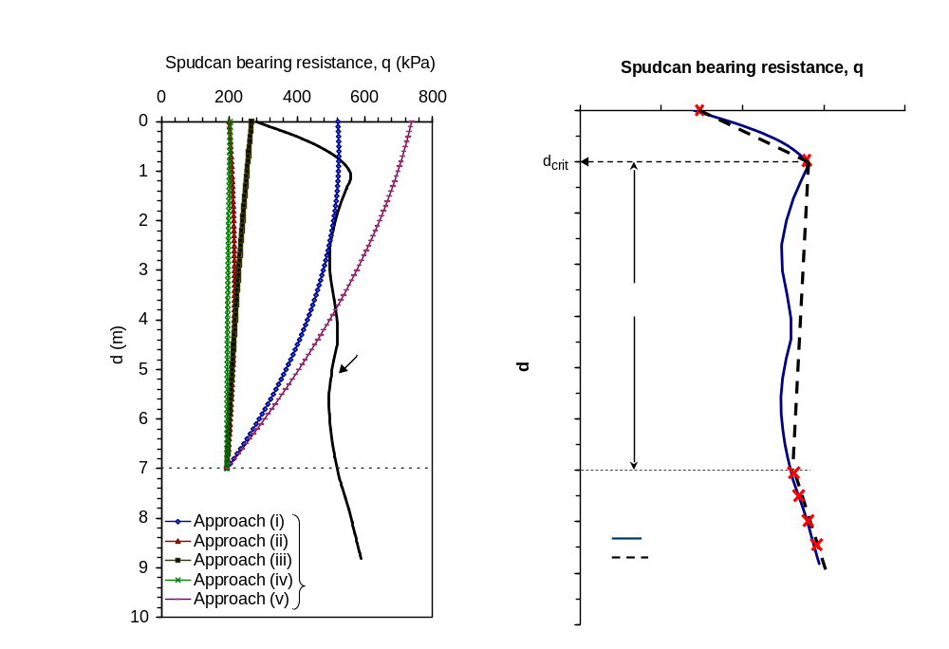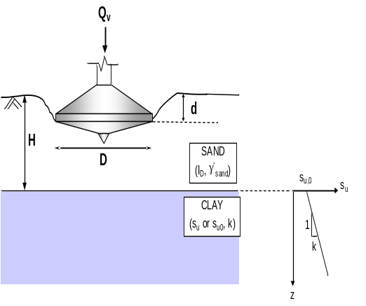
(a) (b)
Figure 1 (a) Measured and simplified spudcan bearing resistance-depth profile; and (b) Nomenclature of spudcan penetration; in sand overlying clay.
When the the lowest elevation of the widest cross-sectional area of the spudcan is at the sand surface, i.e., d = 0, the surface bearing resistance is q₀ (Figure 2). Soil movement extends into the underlying clay layer (see Figure 2a). Sand within the cylindrical wedge below the spudcan mainly moves downwards; whereas the flow of the underlying clay exhibits a Prandtl-Terzaghi failure mechanism. The failure mechanism consists of (i) shear developing along a vertical plane in the overlying sand layer; and (ii) general shear failure in the underlying clay (see Figure 2b). There is no soil back-flow.
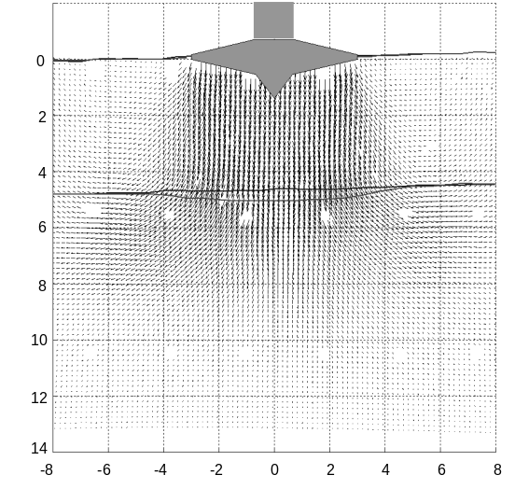
(a)

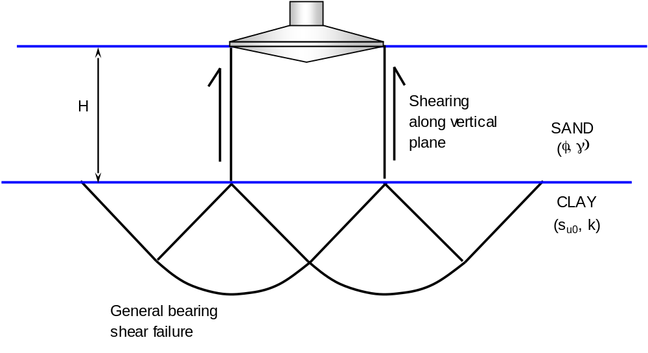
(b)
Figure 2 Spudcan bearing resistance at d = 0, q₀

When the spudcan is penetrating through the sand layer, the maximum bearing resistance, q_{max}, is reached when d = d_{rit} where d_{rit} is found to around 0.12H. Once q_{max} is exceeded, rapid penetration or punch-through will occur (Figure 1a). A truncated conical wedge of sand is separated from the surrounding sand and the underlying clay surface is acted on by sand of different inclinations (Figure 3a). The failure mechanism consists of (i) shearing along a logarithmic spiral failure plane in the upper sand; and (ii) mobilization of underlying clay bearing capacity under two different loading conditions namely vertical and inclined. Soil back-flow is minimal at this stage and hence can be ignorred. The inclusion of inclined loading into component (ii) is to avoid an overestimate of the underlying clay bearing resistance (Love et al., 1987; Burd & Fryman, 1997).

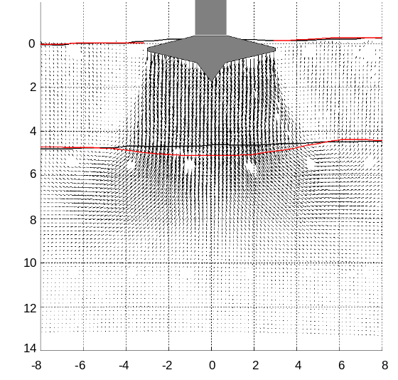
(a)

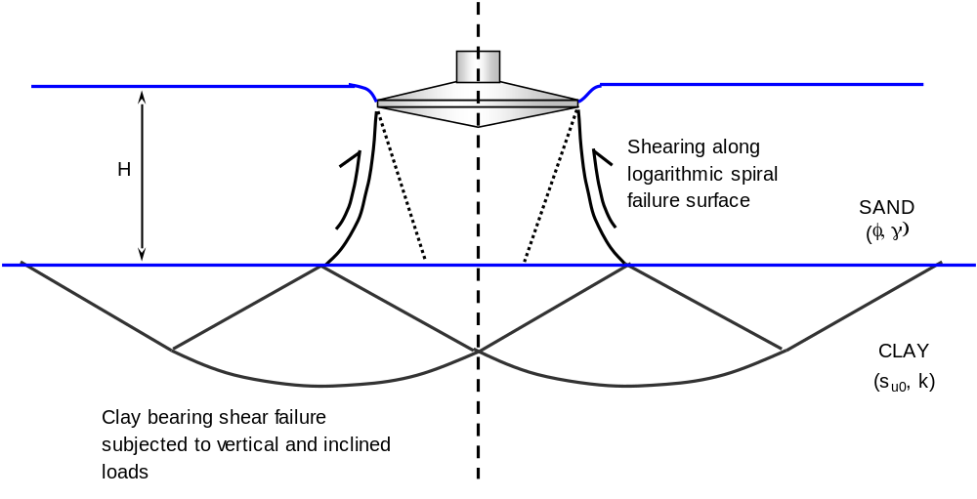
(b)
Figure 3 Spudcan bearing resistance at d = d_{crit}, q_{max}

While penetrating into the underlying clay, a sand plug with height of about H (Figure 4a) develops beneath the spudcan. The sand plug is pushed into the clay by the advancing spudcan. A similar observation was also made by Craig & Chua (1990). The assessment of q for d ≥ H should consider the presence of the sand plug by incorporating (i) additional side friction (Craig & Chua, 1990); (ii) new design depth referring to the sand plug base; (iii) new foundation base as flat and rough; and (iv) deep flow mechanism (Figure 4b).

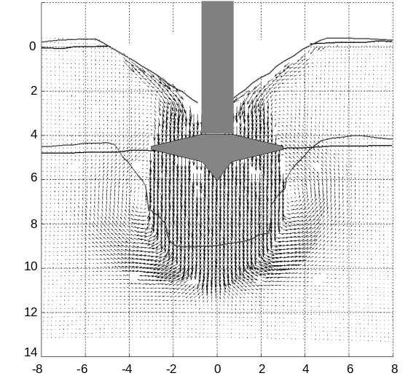
(a)

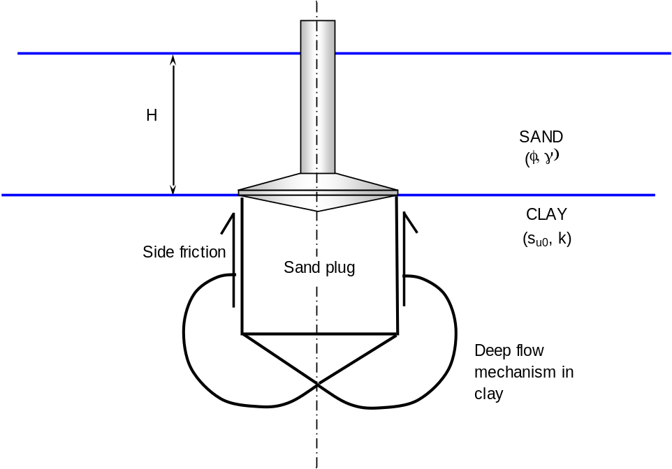
(b)
Figure 4 Spudcan bearing resistance in the underlying clay

Reference
- Burd, H.J & Frydman, S., “Bearing capacity of plane-strain footings on layered soils”, Can. Geotech. J. 34, 241-253, 1997.
- Craig, W. H. & Chua, K., “Deep penetration of spudcan foundations on sand and clay”, Géotechnique 40, No. 4, 541-556, 1990.
- Love, J. P., Burd, H. J., Milligan, W. E. & Houlsby, G. T. 1987. Analytical and model studies of reinforcement of a layer of granular fill on a soft clay subgrade. Can. Geotech. J . 24, 611-622.
- Teh, K. L., Punch-through of spudcan foundation in sand overlying clay. Ph.D thesis, National University of Singapore, Singapore, 2007.
- Teh, K. L., Cassidy, M. J., Leung, C. F., Chow, Y. K., Randolph, M. F., and Quah, C. K., “Revealing the bearaing capacity mechanisms of a penetrating spudcan through sand overlaying clay”, Géotechnique, accepted for publication, 2008.

Bibliography
<< The Bibliography has to be the last section in the whole Part of the Standard >>

Bibliography for Clause xx

Bibliography for Clause yy

Bibliography for Clause zz

Bibliography for Clause A.xx

Bibliography for Clause A.yy

Bibliography for Clause C

Bibliography for Clause D

