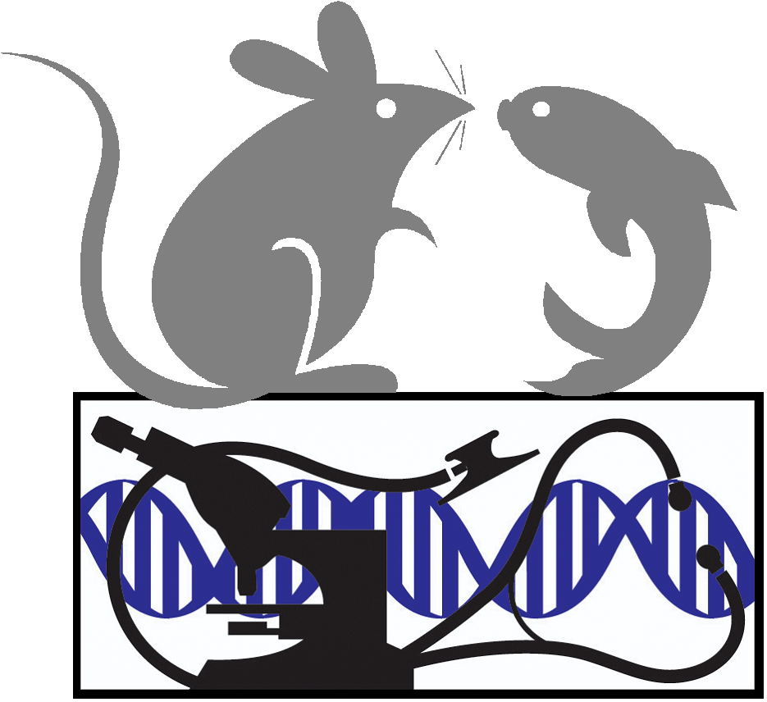

2019 Mouse Pathobiology and Phenotyping (for Translational Research)
at Johns Hopkins
July 15 - 19, 2019
Registration form for NON-JHU registrants

JHU Faculty, Staff, Students, Postdocs (with JHED ID) please use online forms at
http://www.hopkinsmedicine.org/mcp/PHENOCORE/phenocourseME680712.html
Non JHU registrants please complete this form and submit with credit card payment ($US)
by fax(443) 287-2954, or email (welza1@jhmi.edu ), or mail with
credit card payment or check payable to Johns Hopkins University to

Wendy Elza c/o Johns Hopkins University School of Medicine
733 N. Broadway, BRB 851, Baltimore, MD 21205.
Please print or type
Required information:
Last name First name MI
Institution/Affiliation:
City, State :
E-mail - for confirmation and other notification regarding this course
Credit Card PAYMENT
VISA MASTERCARD DISCOVER AMEX
EARLY Registration Fee: $600. for lectures only; $800. For Lectures + 3 hands on laboratory sessions
After June 15, 2019: $800. for lectures only; $1000. For Lectures +Labs - CALL for AVAILABILITY
Card # Exp. Date /
Name as it appears on card
Signature Today’s Date
Address (on credit card account):
CITY STATE ZIP + 4 code Country
Telephone (if we fail to reach you by email) FAX number
You will receive confirmation notice by e-mail if you provide correct e-mail address.

Please notify us if you have any special needs.
To help us plan future activities please check all that apply:
MD PhD DVM/VMD PostDoc Graduate Student
Other degrees or current position:

