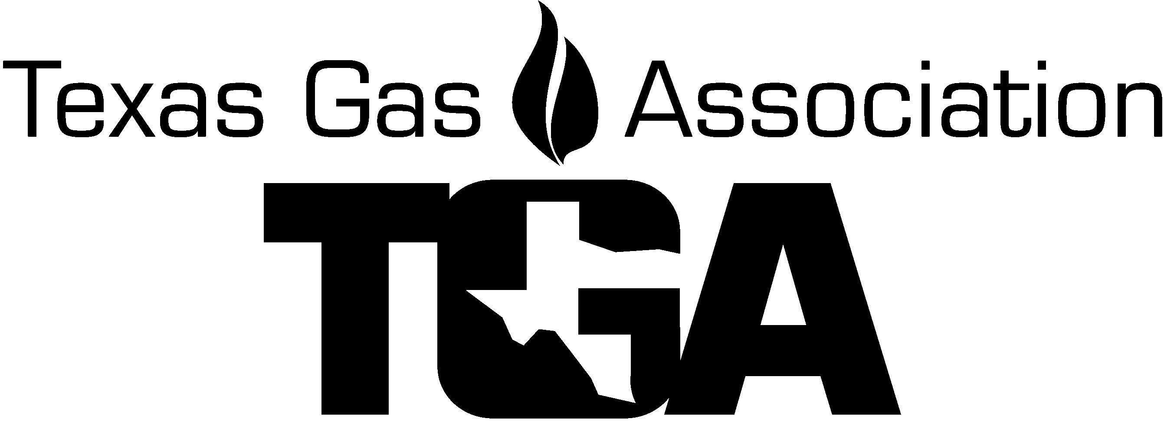
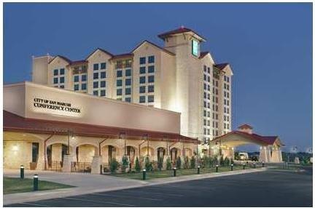


P.O. Box 440430, Houston, TX 77244-0430

Mail@texasgas.com
P:(281) 497-8427 / F: (281) 497-8426

TO: TGA Members
FROM: Randy Pryor
Annual Meeting Chairman
RE: 2019 O&M Conference / Annual Meeting Sponsorship Opportunity

The TGA Annual Meeting and Conference is scheduled for July 9-12, 2019, at the Embassy Suites in San Marcos, Texas. The Annual Meeting Committee would like to invite you to support and sponsor this event to help make it a great success.

The 2019 conference – “Natural Gas - In the Time of Disruption” -- will offer:

- Outstanding Speakers of interest to all.
- Breakout sessions that are highly educational and will have a positive bottom-line impact on the way we all do business today.
- Exhibits and presentations from manufacturers and distributors whose products and services support the natural gas industry.
- Our annual golf tournament is open to attendees and guests.
- Many fun filled attractions around San Marcos for the whole family.
- San Marcos – Shopping, tours, playing on the river & sightseeing could be a mini vacation for the family while conducting business.

In return for your participation, TGA will recognize your contribution by:
- Displaying your company’s sponsorship in prominent locations during the Annual Meeting.
- Announcing your company’s sponsorship at each event.
- Listing your company as a sponsor in the TGA Electronic O&M Conference post E-mail articles and on the TGA web site at www.texasgas.com.

Please join us in supporting this conference to ensure the best event possible by returning the completed form below to Linda Femal via mail@texasgas.com or fax at (281) 497-8426. If faxing, please notify us at 281.497.8427 at your earliest convenience.

Thank you for your consideration and support.

Sincerely,
Randy Pryor
Annual Meeting Chairman


P.O. Box 440340
Houston, TX 77244-0340
Ph: (281) 497-8427 – Fax: (281) 497-8426

Event Sponsorship Form

2019 Operations & Management Conference

Embassy Suites, San Marcos

Company___________________________Name__________________________________

We would like to support the 2019 TGA’s Operations and Management Conference by sponsoring the following events:

Tuesday Reception ($7,000) $500 [ ] $1000 [ ] $1500 [ ] Other ________ [ ]

Wednesday Luncheon ($15,000) $500 [ ] $1000 [ ] $1500 [ ] Other ________ [ ]

Thursday Luncheon ($15,000) $500 [ ] $1000 [ ] $1500 [ ] Other ________ [ ]

Thursday Reception ($7,000) $500 [ ] $1000 [ ] $1500 [ ] Other ________ [ ]

Refreshment Breaks ($7,000) $500 [ ] $1000 [ ] $1500 [ ] Other ________ [ ]

Entertainment ($3,000) $500 [ ] $1000 [ ] $1500 [ ] Other ________ [ ]

Speakers Gifts’ ($1,200) $500 [ ] $1000 [ ] $1500 [ ] Other ________ [ ]

Total Sponsorship $_________________

Payment method:

_____Check payable to TGA enclosed or:

Please charge to my: Master Card ( ) Visa ( ) AMX ( )

Credit Card # ____ _____ ____ ____ Exp. Date ______ Sec Code _____ (AMX 4 digits on front)

CC Billing Address: ___________________________ City, St, Zip _______________

Name on Card _________________________

E-mail for receipt_________________________ Name _____________ PH# __________

Please return promptly.

Mail to: Texas Gas Association Email to: mail@texasgas.com or Fax to: (281) 497-8426
P.O. Box 440340 (if faxing, please notify us at 281.497.8427)
Houston, TX 77244-0340

Thank you for choosing to support the well-being of the TGA.

Please email a high-quality logo in a jpeg to the TGA office if you choose to participate.

