Requests for Purchase – Table of Contents

Requests for Purchase 2
Online Requisitions 4
Initiate Workflow Process 29
Amount Only Purchase Requests 31
Other SPL Purchase Requests 35
LPOs - Limited Purchase Orders 37
Speedcharts 38
Item Categories 41
Non-PO Purchase Requests 43
Requisition Denial 44

Requests for Purchase
Roles Initial Approximate Resources:

Initiators
Approvers
Receivers

Overview
This section outlines the steps necessary to enter a requisition into the PeopleSoft FAST system.

Departmental Users will initiate a request for purchase by utilizing the online requisition functionality in the FAST PeopleSoft Purchasing module to initiate a request for purchase. Identification of where expenses should be charged will be entered on the requisition and will carry forward automatically through the PO to the Voucher.

Individuals will be identified in each of the units with authority to initiate requests for purchases of goods and services.

There will still be some purchases that will not require an online requisition. Payment request forms will be filled out and routed directly to Accounts Payable for payment processing for the following items:

- Subscriptions
- Memberships
- US Postmaster
- FedEx
- Travel

NOTE: The information in this guide is based on certain assumptions:
- Users have previously received training in PeopleSoft 8.4 navigation
- Control tables have been set up with needed values prior to performing the activities described below.

Occurrence
As Needed

Documents Required
Payment Request
Travel Advance Request
Travel Expense Reimbursement
Purchase Order Change Request Form

Scenarios: Roles Perfoming: Page:

Online Requisitions | Initiators | 3
Initiate Workflow Process | Initiators | 34
Amount Only Requisitions | Initiators | 36
Other SPL Purchase Requests | Initiators | 40
LPOs – Limited Purchase Orders | Initiators, Approvers | 42
Speedcharts | Initiators | 43
Item Categories | Initiators | 45
Non-PO purchase requests | Initiators | 47
Requisition Denial | Purchasing Agents | 48

Online Requisitions
Short Guide:
Step 1: Navigate to the Requisition Page
Step 2: Add Requisition Criteria
Step 3: Review and, if necessary, Override Defaults
Step 4: Enter the Requisition Header Information
Step 5: Add Items to the Requisition
Step 6: Modify Accounting Distribution (Optional)
Step 7: Save the Requisition
Step 8: Change Requisition Status to Pending
Step 9: Budget Check the Requisition
Step 10: Approve Requisition for Workflow
Step 11: Enter Requisition Comments
Step 12: Inspection Required Flag (Optional)
Step 13: Print the Requisition

Step 1 Navigate to the Requisition Page

Navigate to the Requisition page by selecting Purchasing, Requisitions, Maintain Requisitions from the menu on the left side of the page.

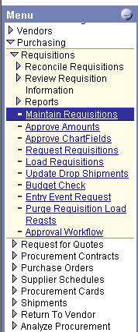
Step 2 Add Requisition Criteria

  - Click on the Add a New Value tab
  - Select the Purchasing Business Unit for this Requisition

Note: The Purchasing Business Unit represents the entity for which the purchase is being made and will default in from the User ID. The available values are as follows:
TAMPA – Tampa, Lakeland & FIPR purchases excluding Physical Plant
PPLNT – Purchases made by Tampa Physical Plant
STPTE – St Petersburg Campus purchases
SRSTA – Sarasota Campus purchases
Exception – All bookstore purchases, no matter what location will be made through the TAMPA business unit

  - Allow the Requisition ID to default to ‘NEXT’. This will flag the system to automatically assign the Requisition ID. Requisitions from the Sarasota Business Unit will begin with 006, those from St. Petersburg will begin with 007, those from Physical Plant with 009 and the Tampa requisitions will remain 000. Requisitions are 10 digits long. E.g. A Sarasota requisition will be 0060000123.
  - Click on to get to the Requisition Form page

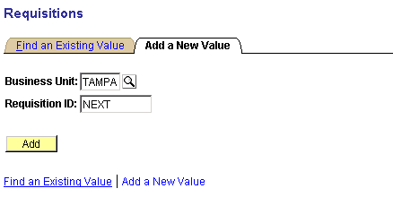

Step 3 Review and, if necessary, Override Defaults
  - Verify the Requestor name defaults in from your User ID
  - Click on the Header Defaults hyperlink to change your defaults (if necessary) and to select the Vendor.
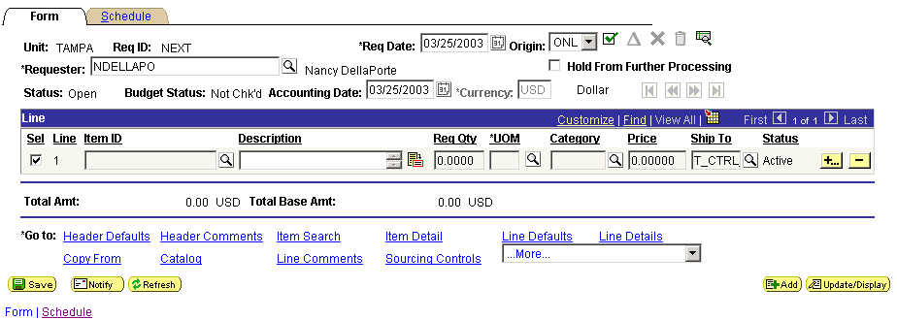
3.1 Requestor Name

3.2 Header Defaults hyperlink

  - Several values will default in based on the Requestor, all of which can be overridden by changing the values on this page
- Ship To location – identifies the shipping information for the vendor
- Internal Delivery location – identifies the building and room code (scroll the page to the right to view this field – see below)
- Chartfield string – identifies where the cost of the purchase will be charged to in the General Ledger.
- Category – identifies the Item Category. Use this default only if all or most all of the items being purchased fall under the same category. Items with a different Item Category will have to be changed on the line. (Refer to Item Categories pg. 46)
- UOM - is the Unit of Measure. Use only if all or most all items have the same unit of measure and change those lines that are different.
-

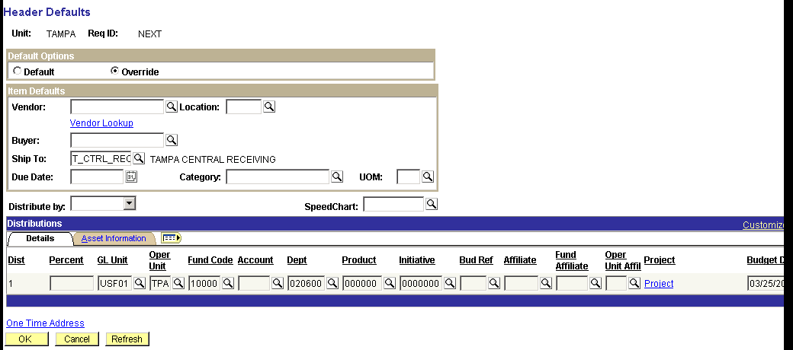
3.3 Ship To Location

Internal Delivery Location

Chartfield String
3.3 Item Category

Unit of Measure (UOM)

Scroll the page to the right to view the remaining fields
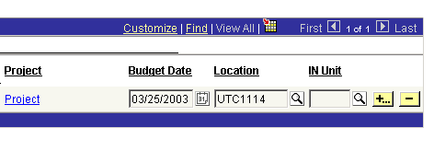

  - If you will be using multiple lines of distribution (share or split accounts in SAMAS) set them up in the Header Defaults if they apply to all or most all of your line items. This is also where you can use SpeedCharts.

  - While still in the Header Defaults hyperlink, click on the Vendor Lookup hyperlink to select the vendor.
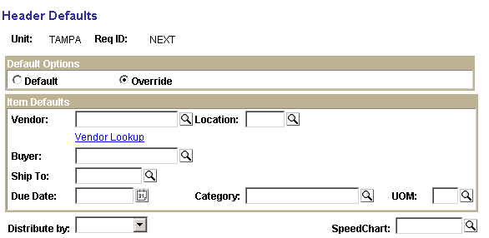

  - Enter the first several characters of the vendor name in the Name Field
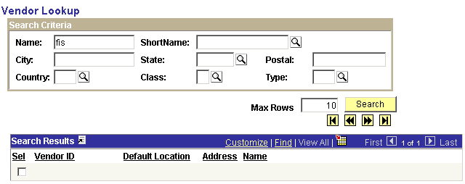

  - Click on the Search button
  - Select the vendor from the Search Results by clicking in the Sel check box next to the appropriate vendor. The Default Location will display the street address of the vendor to help make the correct choice if more than one location exists.

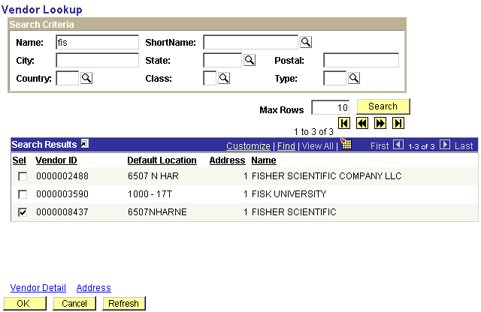
3.8 Sel checkbox

  - Click on the OK button at the bottom of the Header Defaults page to return to the requisition Forms page
  - NOTE: Click on the Address hyperlink (circled above) to check the address if you are still unsure if the correct vendor has been selected.
  - NOTE: If you cannot locate the vendor, it may need to be added to the system. New vendors can only be added to the system by Purchasing. New vendors should be identified by using the USF defined standard comment for new vendors. The Comment Type = REQ and the Comment ID = NEWV. Once the standard comment is pulled into the requisition enter the vendor information in the space provided. (See Step 11 for use of standard comments) The Purchasing department will be monitoring the requisitions for this standard comment to be sure vendors are added when needed.
  - NOTE: If you are using Defined Items, that is items that are already loaded into the system, you do not need to select a vendor. The item will have the vendor already referenced.

Step 4 Enter the Requisition Header Information
  - The Req Date will default to the current date
  - The Origin will default from your User ID
NOTE: There are two purchasing Origins.
- ONL is the default origin and should be used in most cases.
- SPL should be used when entering requisitions that require special handling by the Purchasing Department. Special handling requisitions include:
  - Amount only POs (Blankets)
  - Requests that Purchasing Agent email the Vendor copy of the PO to the department for vendor pickup
  - Requisition that need changes in standard terms and conditons or tolerances
- Remember to put in a Header Comment to explain the SPL designation
  - The Requestor will default from your User ID
  - The Status should be ‘Open’
  - The Budget Status should be ‘Not Chk’d’
  - The Accounting Date will default to the current date
NOTE: The accounting date should remain the current date except when entering pre-load. When entering pre-loads, the accounting date should be changed to July 1 of the next fiscal year. Additionally, during pre-load the budget reference date on the chartfield string will also need to be changed.
4.2 Origin
  - The Currency will default to ‘USD’ (US Dollars)
4 Requisition Headers

4.6 Accounting Date
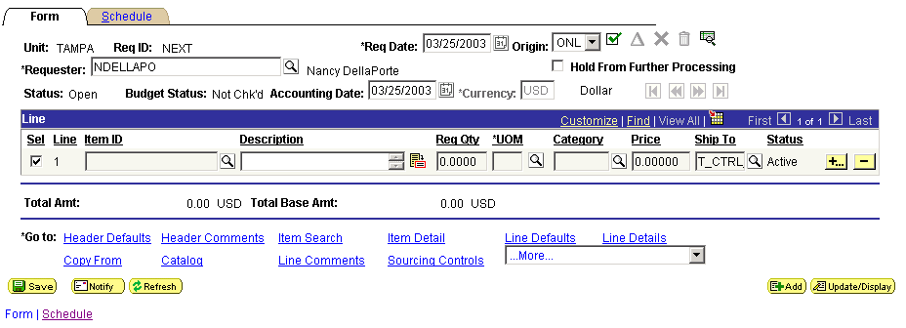
Requisition Header Info

Step 5 Add Lines/Items to the Requisition
  - In the Line section of the Form page enter a description of the purchase in the Description field. The Description can be up to 254 characters long. Additional descriptive information can be entered as Line Comments if necessary.
  - Enter the quantity to be ordered in the Req Qty field
  - Click on the icon in the UOM (Unit of Measure) field and select the appropriate value (i.e. EA, CS, etc) or type it in.
  - Click on the icon in the Category field and select the appropriate value (See NOTE: About Item Categories after Step 3.3)
  - Enter the unit price of the item to be purchased in the Price field (be sure the price specified here corresponds to the UOM in step 5.3) If the price is Zero, See Step 12.7, below
  - To enter additional items to be purchased click on the to the right of the requisition line. In the dialog box that appears, enter the number of lines to be added and click OK.
  - Trade-Ins
When purchasing equipment using a trade-in the amount should be deducted from the unit price of the item and the adjusted amount used as the unit price.
Within the description field, the requisitioner should state that the price has been adjusted by the trade-in value and reference the amout deducted.
As always, an approved Property Relief form (3008) is required prior to the purchase. The number should be referenced in the Header Comments and an copy faxed or mailed to the Purchasing Office noting the requisition number.
Make sure the correct Item Category is chosen in order to append the correct Asset Profile. (See Note About Item Categories after 3.3 and Section 6.20)
  - Note: There will be some vendor item lists uploaded into FAST PeopleSoft Purchasing allowing you to pick specific Defined Items previously purchased. You will select an Item ID rather than entering a Description and Category. This can be done by clicking on the icon next to the Item ID field. Once the item is selected, the category will be automatically populated.
  - Item IDs will display a vendor name and catalog number of the item. You can Search using “begins with” and the first few letters of the vendor name. You can use “contains” and put in part of the vendor catalog number. (Catalog numbers were defined by the vendors so there is no standard way they were entered.)
The description was also provided by the vendor. You can search on a partial description. Window’s “Find” feature can also be used to find items on the screen.
The screen below shows results from Microwarehouse using “battery” as a search criteria in the Description field. (If other vendors have the word “battery” in their descriptions, these would also be on the list.)
Requisition Line Info

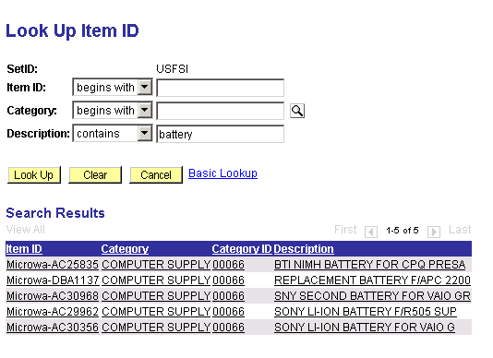
5.8 First letters of Vendor name

Catalog Number

  - Catalog – Another way to search for Defined Items is using the item Catalog. Click on the hyperlink near the bottom of the screen.

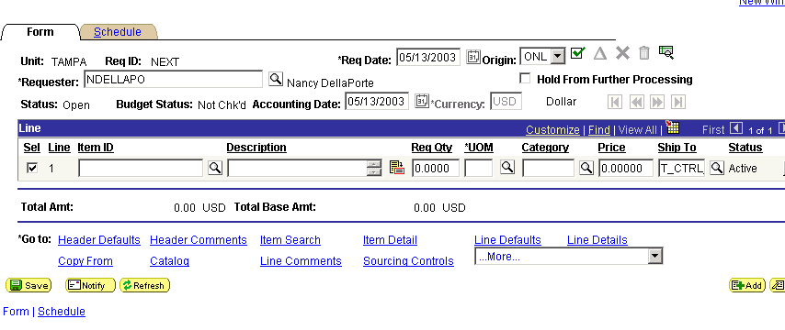
5.10 Catalog
5.11 Click on the Category link and select one of the Item Categories.
NOTE: You may need to look through more than one Category for some vendors.
Many chemicals and biologicals are categorized as Hazardous Materials instead of Chemicals or Lab Supplies.

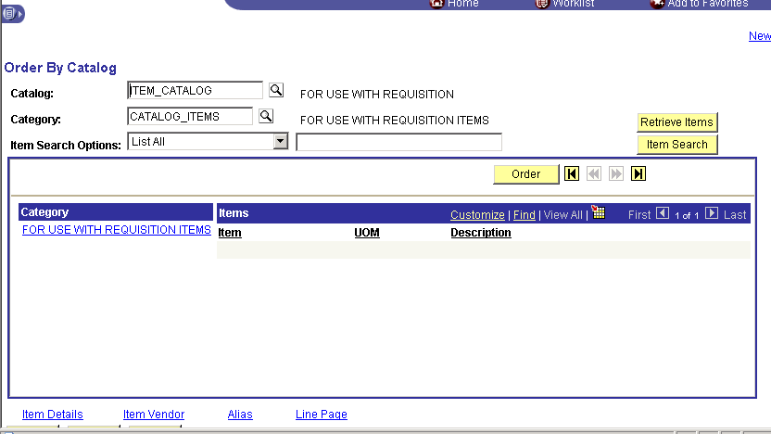
5.11 Click
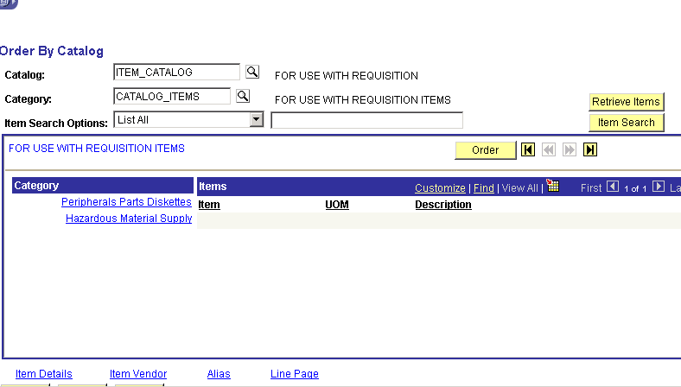
5.12 List all items or choose the “Manufacturer” as the search criteria to limit your search to a specific vendor. Click Retrieve Items.
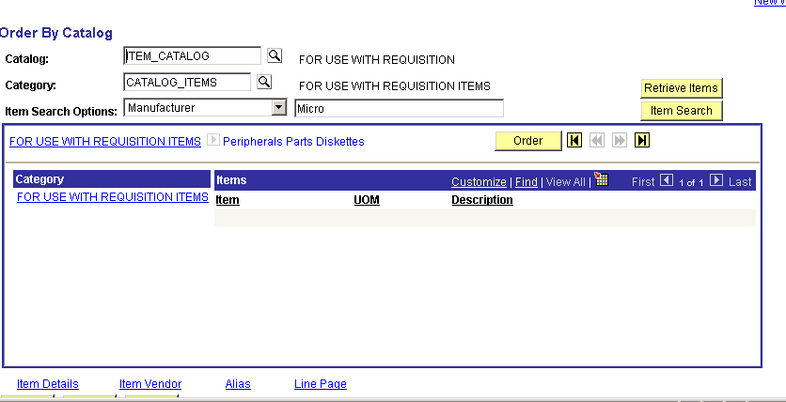
5.12 Search Criteria
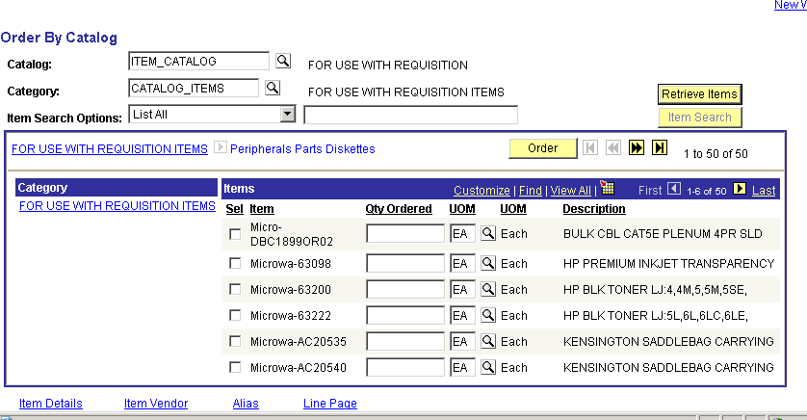
5.13 View All

Scroll
5.14 Select Items

Enter Quantities

5.13 Use the navigation bar to View All items or to scroll through the list.

5.14 Click the Sel box to the left of all items wanted, fill in the quantity and click the Order button to bring the items into the requisition.

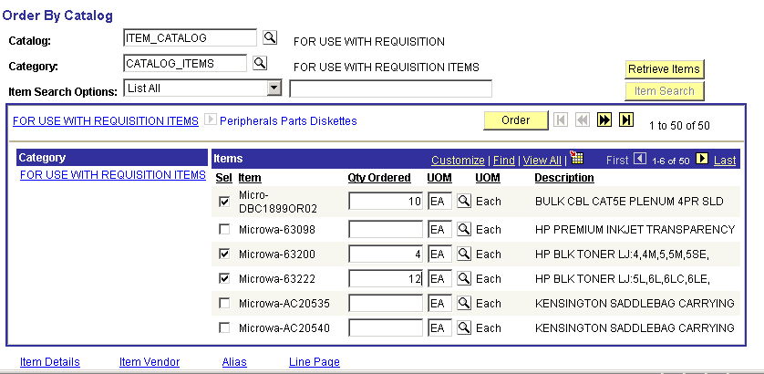
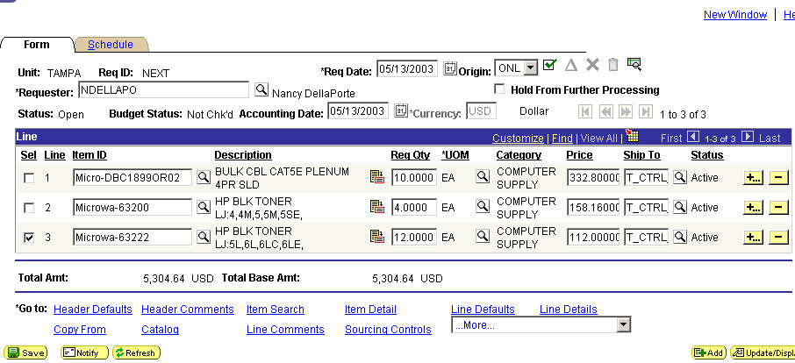

5.15 Another way to find Defined Items is the Requester Favorite Items feature. As items are ordered for a Requester, the system will keep a log of items purchased. These can be edited as needed.
This list is sortable and will list items which are ordered the most at the top of the list.
Once items are selected, quantities must be entered on the line.

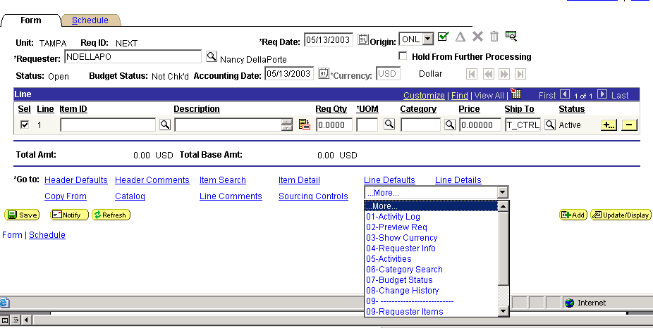

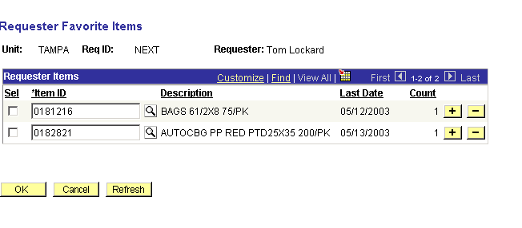
5.15 Select Items

Sort

Add or Delete Defined Items

Step 6 Modify Accounting Distribution (optional)
- Click on the Schedule tab to get to the Distribution of the requisition line item
- Click on the Distribution hyperlink
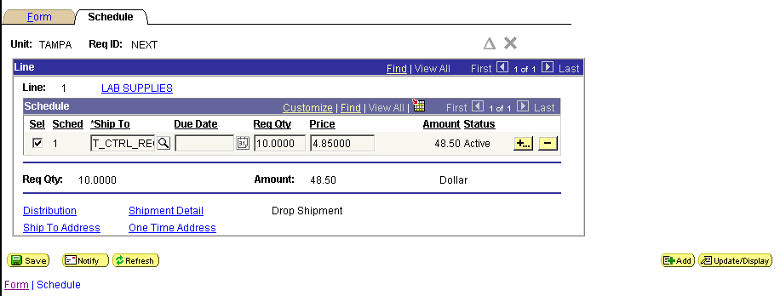
6.1 Schedule tab

6.2 Distribution hyperlink

- The chartfield string defaults from the Header Defaults. Any chartfield value can be changed on the distribution.

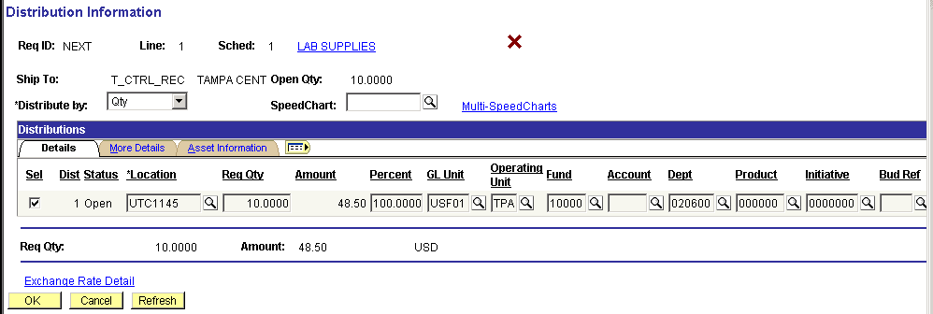
Distribution Line Info
6.4 Distribute By

- Multiple Distributions (Share/Split Accounts) for Supplies & Services
To split the cost over more than one chartfield string, select whether to Distribute By Amount or by Quantity by clicking the drop down box.
- By using the at the far right of the Distributions section, add additional distribution lines. (scroll to the right to access the + icon)
NOTE: The following are instructions for adding several lines of distribution at once. This can be used for multiple distribution on equipment
- Change either the Quantity, Amount or Percentage (based on the above choice) on the first Distribution Line to the Quantity, Amount or Percentage to be charged to that line.
- Fill out the Quantity, Amount or Percentage to be charged for all the other lines.
NOTE: Just use ONE of these fields; Amount, Quantity (it takes quantities less than I) or Percentage. The rest of the numbers on that Distribution Line will be recalculated
- Type in the chartfield values of the additional Distribution Lines added
- Distribution Lines can be deleted by using the delete key
- If you delete lines, make sure the Quantity, Amount or Percentage fields are returned to their original value
NOTE: Change all the Quantities, Amounts or Percentages on all the lines before you Refresh the screen
- Click the Refresh button
- Once you are satisfied with the distribution, click the OK button to return to the Schedule page
- Click Save
NOTE: If you change the Quanty, Amount or Percentage on a line of distribution BEFORE you add another line, the system will calculate the balance and put it on the next line. If you add one line at a time using this method, it will calculate each line as it is created.
- Multiple Distributions for Equipment
The distribution for equipment must be done by Quantity only (See 6.4 – 6.6)
Using the Percentage can be helpful here. You can adjust the percentages or quantities until you reach the right amount. The system will recalculate the other fields on the Line of Distribution
NOTE: The following are instructions for adding lines of distribution one line at a time. This can be used when creating multiple distributions for supplies and services. It is the recommended procedure for Equipment.
- Change either the Quantity or the Percentage on the Distribution Line to the Quantity or Percentage to be charged to that line. Quantity can be less than 1. Making this change now will allow the system to calculate the next line.
- Click the add sign at the right of the Distribution Line
- Fill in the chartfields with the new values
- To add another line of distribution, change the Quantity or Percentage on the new Distribution Line.
- Repeat lines 6.15 – 6.17 for additional lines of distribution
- The total distribution must equal the total amount of the line

- Option: If the purchase is for an OCO item (asset related), click on the Asset Information tab while still in the Distribution Information hyperlink to view the Asset Profile
- If the Asset Profile needs to be added or changed, Enter the AM Business Unit (USF01), select a Profile ID. Leave the Capitalize checkbox unchecked. This will ensure the cost basis for the asset is provided by the voucher from AP.
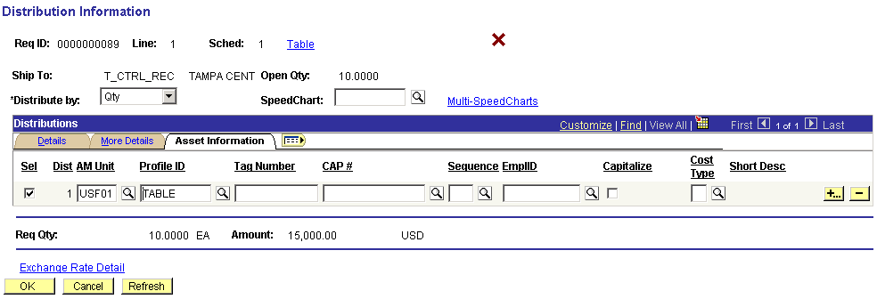
6.5 AM Unit – Profile ID – Capitalize checkbox

- Click to return to the Requisition Schedule page.
- Changing the Asset Profile should not be necessary if the correct Item Category was chosen for the equipment. (See NOTE: About Item Categories in Section 3.3)

Step 7 Save the Requisition
- From the Requisition Form page, click on to save the requisition.
- Once the save is complete, the system will assign a Requisition ID. The system checks your Requisition automatically to ensure that all required fields contain a value. In addition, edits are executed to verify that specific combinations that are not allowed by the system are not present in your Requisition chartfield distribution. If the Requisition passes the system check the requisition can be moved into workflow. If the requisition fails the system check, you will receive an error message explaining why your Requisition failed. Once the corrections have been made, you will need to save again.
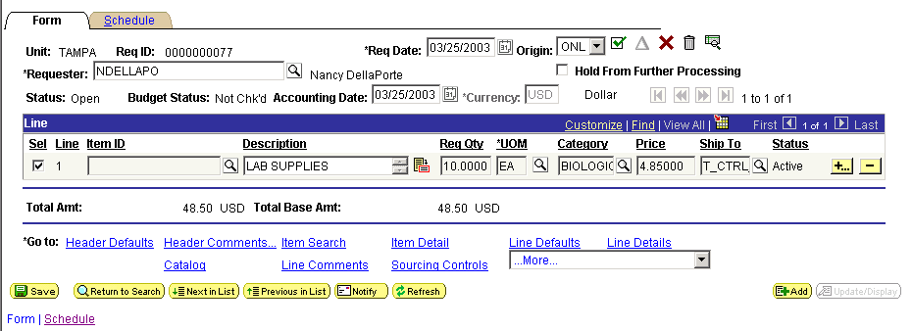
Step 8 Change Requisition Status to Pending
  - Click on the Form tab
  - Click on the icon to change the requisition status from ‘Open’ to ‘Pending’
  - Once the Status is changed, the requisition will be available for budget checking
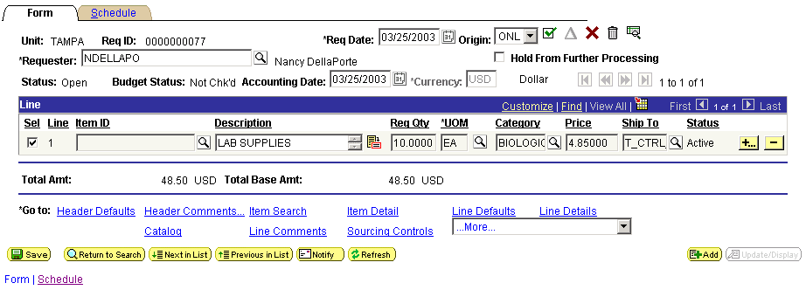

Step 9 Budget Check Requisition
  - Click on the Form tab
  - Click on the icon to budget check the requisition
  - Once the Budget Status is changed from ‘Not Chk’d’ to ‘Valid’, the requisition is ready to be entered into workflow.
This will not happen automatically.
  - If you wish to prevent the requisition from moving into workflow accidently, you can click in the “Hold From Further Processing” box below the check icon.
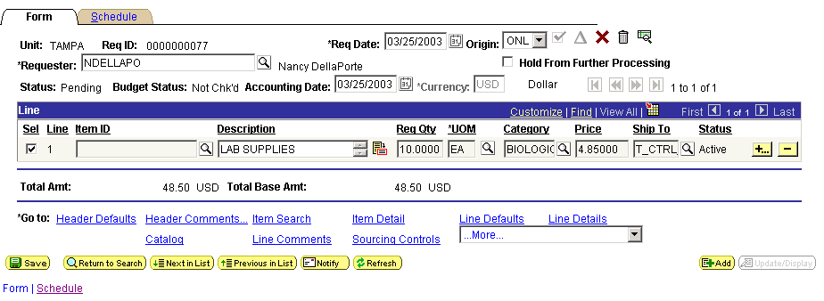
  - Click on the Add 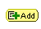 button at the lower right to enter another requisition.
9.2 Budget Check

9.3 Hold

  - Requisitions must be Approved into Workflow before they can be Approved.
Step 10 Approve requisition for workflow
    - Navigate to Approve Amounts using the Menu
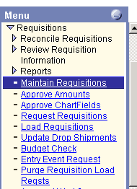
    - The requisition should appear on the Approval page if you have navigated to Approve Amounts directly from Maintain Requisitions after Budget Check is run
    - If you choose to navigate to the Amount Approval page later or from another place in the system you will have to Search for your requisitions
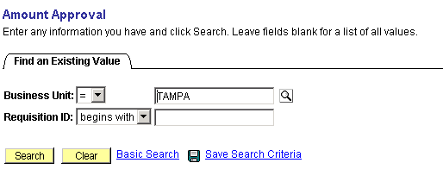
    - Enter the Business Unit, if it does not default in, and the Requisition number if you know it, and click the Search button.
If you don’t know the requisition number, the Search will bring up all requisitions that have a Valid Budget Check and are ready to be approved into workflow. Double-click on the requisition you wish to view
    - The Approval page will display the requisition selected
    - The Approval Status should read “Initial”
    - If the system has detected more than one string of Chartfields, a comment will appear. This comment is meant for the Requisition Approver and will be discussed in the Requisition Approval section of this manual.
    - The Approval Action defaults to “Approve.” The “Deny” and “Recycle” functions relate to Requisition Approval by the Authorized Signer and Purchasing and will be discussed in later sections
    - Click the Save button
    - You will receive the following message:

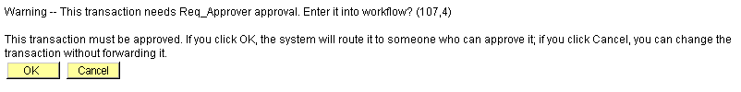

    - Click the OK button. You will be returned to the Approval page
    - The Approval Status should read “In Process”
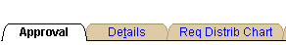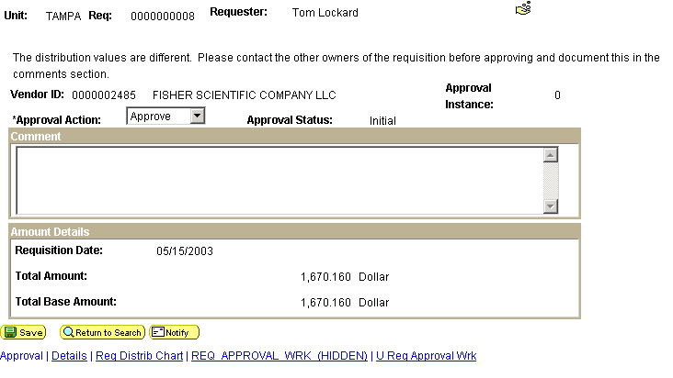
10.7 Warning for Approver

10.8 Approval Status
Step 11 Enter Requisition Comments
    - Comments may be added to a requisition at either the Header or Line level.
    - Some Standard Comments are already available in the system. These can be copied to the requisition and edited if necessary.
    - Standard Comments for requisitions such as “NEWV” for “New Vendor” and “CERT” for “Certificate of Exemption” contain “prompts” for specific information that needs to be supplied by the requisitioner.
    - Header Comments are used for things that apply to the entire requisition. They should also be used for communication between the department and Purchasing if any special instructions or information has to be exchanged.
    - Line Comments should apply only to the line item they are attached to. They can be used if the existing Description field on the requisition is not large enough.
    - From the Form page, click on either the Header Comments or Line Comments hyperlink.
    - To enter a free form comment simply key the comment into the Comments field. Comments can be up to 32,700 characters in length.
    - If the comment should be printed on the Purchase Order, check the Send to Vendor checkbox
    - If the comment should be read by the Receiver when recording the receipt of the goods or services or by Accounts Payable when entering the invoice, check the Shown at Receipt or Shown at Voucher checkboxes as appropriate
    - The Active box should be left checked or outdated statements may be used in error. The Sort Method and Sort Sequence are not used
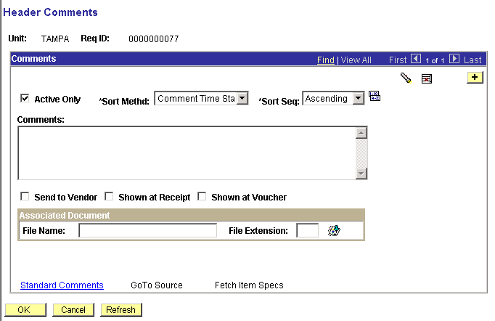

    - To enter a USF standard comment, click on the Standard Comments hyperlink
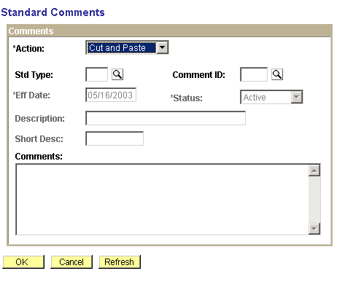
    - Use the “Cut and Paste” Action. The other actions will not allow you to edit the comment
    - Click on the next to the Std Type field to view a list of the available values and select REQ. This is the standard comment type that should be used at the requisition level by the requisitioner. Other available comments are intended for use by Purchasing
Std Type | Comment ID
REQ – Requisition Comments | CONF – Confirming Order  NEWV – New Vendor  STAT – State Contract  SOLE – Sole Source  CERT – Certificate of Exemption
    - Click on the icon next to the Comment ID field to view a list of the available values and select a value. The available values for requisitions are as follows:
    - Once the Comment ID is selected the standard comment will be populated in the Comments field
    - Click on the OK icon to return to the Comments page
    - Now the comment can be modified as necessary
    - Click on the OK icon again to return to the Form page.
    - Click on to save the requisition after each comment is entered
    - To add additional comments, click on the key and repeat steps 11.7-11.19
    - To review Comments navigate to the Comments page. The Comment displayed will be the first comment created.
    - If there is more than one Comment, the Blue Navigation Bar will indicate this
    - To see all comments on one page, click on the “View All” link
    - To scroll through the comments, use the “First,” “Last” and arrow keys between them

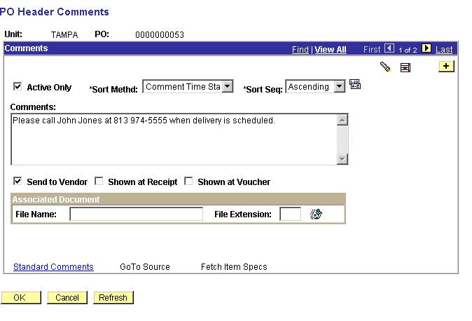
11.22 First Last Arrows

11.23 View All or One

Step 12 Inspection Required & Zero Price Indicator Flags (Optional)
    - Inspection: Although all purchases should be inspected upon receipt, some purchases will require an audit trail within the system for the inspection. The guidelines to follow when deciding if inspection should be tracked within the FAST PeopleSoft Purchasing system are as follows:
- Construction purchases
- Large equipment purchases requiring installation or inspection by a technician before authorization for payment should occur
- Purchases which require action by an individual other than the receiver before authorization for payment should occur

    - To set the Inspection Required flag, Select the line by checking the box to the left of the item to be inspected
    - Click on the Line Details hyperlink on the Requisition Form page

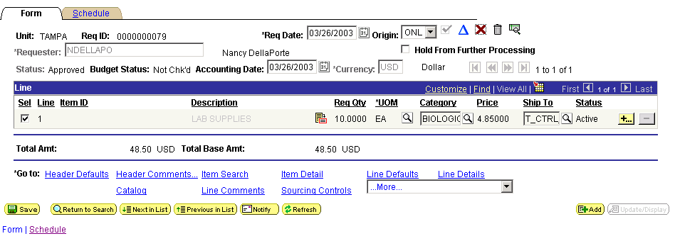
12.2 Select Line

    - Click on the Inspection Required checkbox
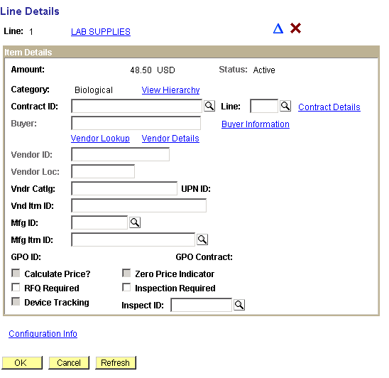
    - Click on to return to the requisition Form page
    - Click Save
    - Zero Price Indicator: Sometimes an item is free, yet it needs to be on the requisiton for the purchase order. The dollar value of the item is 0.00
    - Follow above Steps 12.2 and 12.3
    - Click on the “Zero Price Indicator” box
    - Click on to return to the requisition Form page
    - Click Save
    - The system will generate an error message to confirm that this is what you want to do
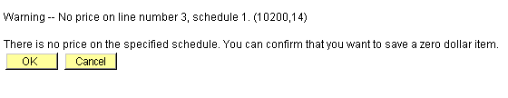
    - Click on to return to the requisition Form page
    - Click Save again

Step 13 Print the Requisition
    - Once the requisition has been saved and budget checked, select the dropdown arrow in the ‘More…’ box on the lower right of the page

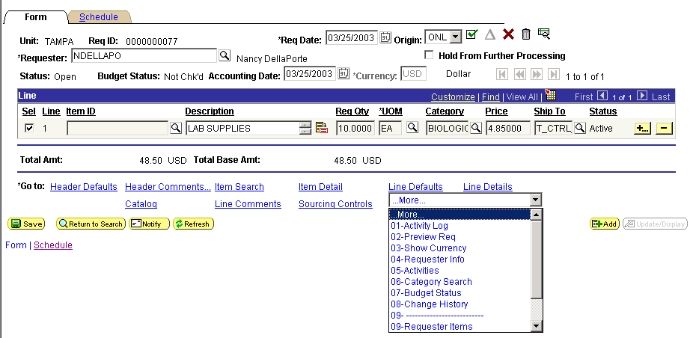

    - Select 02-Preview Req. This will open a new window and display the Report Manager page.
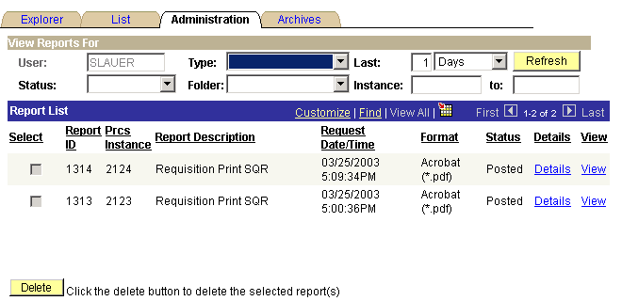

NOTE: Click on periodically to get updates to the status.

    - Once the Status is updated to Posted, click on the View hyperlink to view the requisition in Acrobat Reader. Select the hyperlink U_REQFRM_xxxx.PDF (note: xxxx represents the Process Instance used to generate the report).
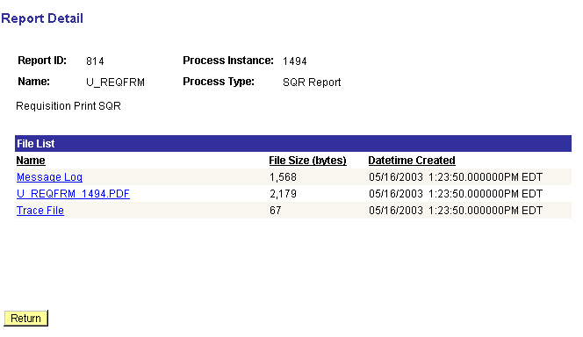
    - Acrobat Reader will open displaying the requisition
NOTE: You may be asked to log into the system again. This is a security feature. Do it and Acrobat Reader will open with the Requisiiton
    - From the Acrobat Reader, click on the print icon to print the requisition.
    - Close Acrobat Reader when finished

Initiate Workflow Process

Short Guide:
Step 1: Navigate to the Approve Amounts page
Step 2: Select Approval Status
Step 3: Save Approval

Step 1 Navigate to the Requisition Page

Navigate to the Requisition page by selecting Purchasing, Requisitions, Approve Amounts from the menu on the left side of the page.

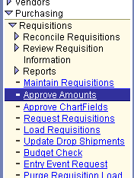
Step 2 Select Approval Action

The available Approval Action values are as follows:
Approve – Initiates the workflow process
Deny – Not applicable for Initiator
Recycle – Not applicable for Initiator
Note: the Approval Action should default to ‘Approve’.
Click on to save the approval action and initiate the workflow process
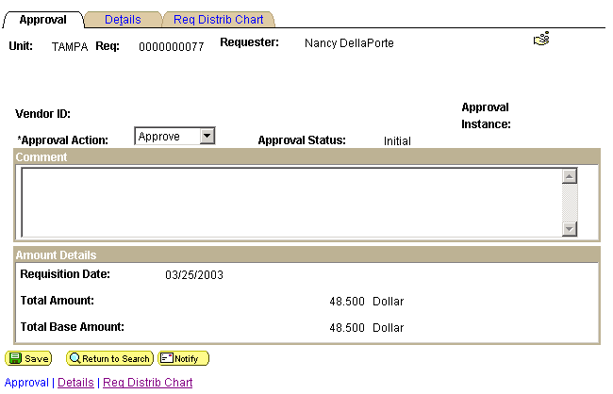
NOTE: You will receive the following message, which indicates the requisition has been initiated into the workflow process:

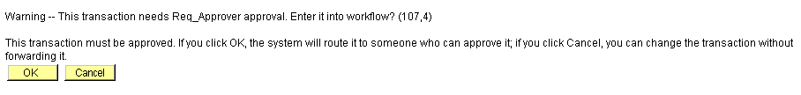

Click on to continue the process.

Amount Only Purchase Requests
Requests for Amount only purchases (blanket orders) should be kept to a minimum in order to facilitate the systematic matching of Invoices to POs and Receipts.
Accounts Payable and Purchasing will be working with the University community to evaluate those situations where amount only purchase orders may be used.

Short Guide:
Step 1: Navigate to the Requisition page
Step 2: Enter the Add Criteria
Step 3: Review and, if necessary, Override Defaults
Step 4: Enter the Requisition Header Information
Step 5: Add Lines to the Requisition
Step 6: Modify Accounting Distribution (Optional)
Step 7: Enter Requisition Comments
Step 8: Save the Requisition
Step 9: Change Requisition Status to Pending
Step 10: Budget Check the Requisition
Step 11: Approve the Requisition for Workflow
Step 12: Print the Requisition

Step 1 Navigate to the Requisition Page
See Step 1 from the Online Requisition section above

Step 2 Enter the Add Criteria
See Step 2 from the Online Requisition section above

Step 3 Review and, if necessary, Override Defaults
See Step 3 from the Online Requisition section above

Step 4 Enter the Requisition Header Information
  - The Req Date will default to the current date
  - The Origin will default from the User ID as ONL
NOTE: You MUST change this to SPL
  - The Requestor will default from the User ID
  - The Status should be ‘Open’
  - The Budget Status should be ‘Not Chk’d’
  - The Accounting Date will default to the current date
  - The Currency will default to ‘USD’

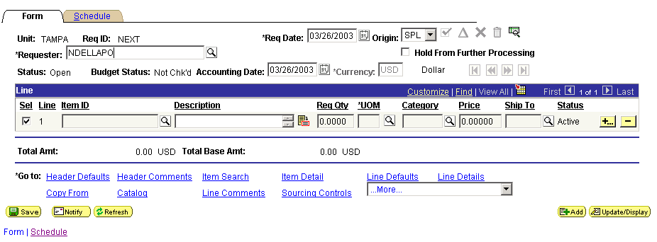

Step 5 Add Lines to the Requisition
  - In the Line section of the Form page enter a description of the purchase in the Description field
NOTE: For amount only requests the Description should include the type of item being ordered e.g. ‘Blanket order for athletic supplies,’ the effective dates (beginning or effective date of the PO and end date) and the names of those authorized to place the orders
  - Enter a quantity of 1 in the Req Qty field
NOTE: The amount only flag is not available on the Requisition, but is set on the PO.
  - Click on the magnifying glass icon in the UOM field and select the appropriate value
  - Click on the magnifying glass icon in the Category field and select the appropriate value
  - Enter the unit price of the item to be purchased in the Price field
NOTE: The unit price for amount only requests should be the total desired amount

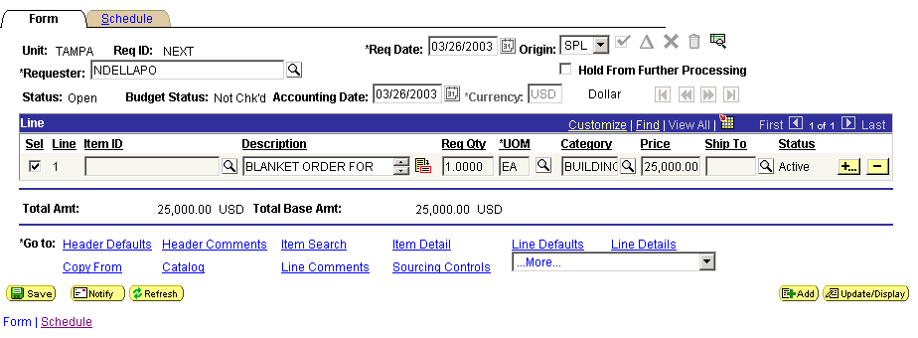
Requisition Line Info

Step 6 Modify Accounting Distribution (Optional)
See Step 6 from the Online Requisition section above

Step 7 Enter Requisition Comments
- From the Form page, click on the Header Comments hyperlink.
- In the Comments field enter text identifying this as a request for an amount only PO and also identify who granted permission for use of an amount only PO.
- Leave the Send to Vendor, Shown at Receipt and Shown at Voucher checkboxes unchecked
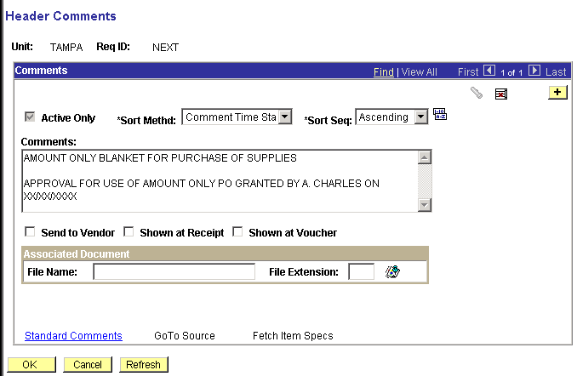

Step 8 Save the Requisition
See Step 7 from the Online Requisition section above

Step 9 Change the Requisition Status to Pending
See Step 8 from the Online Requisition section above

Step 10 Budget Check the Requisition
See Step 9 from the Online Requisition section above

Step 11 Approve the Requisition for Workflow
See Step 10 from the Online Requisition section above

Step 12 Print the Requisition
See Step 13 from the Online Requisition section above

Other SPL Purchase Requests
Purchase Order to Department
The Purchase Order print available to departments will produce a copy with the word “Unauthorized” instead of a signature. This is to prevent duplication of the order. The official Purchase Order is “dispatched” (in most cases printed) in a batch process that happens overnight.
However, if a department needs to have the official vendor copy of the order sent to them or has an urgent need for an official copy the same day, Purchasing Agents have the ability to manually process a requisition for this purpose.
Departments should contact their Purchasing Agent before using the “SPL” (Special) origin to make sure that the need is urgent and that the purchase is one that can be approved immediately.
Terms and Conditions
Requests for changes to the university’s standard terms and conditions should be kept to a minimum and only done when there is no other choice
Terms and Conditions are often set by statute or policy. Making such a change means that the department is taking the responsibility of ensuring that services and commodities meet requirements while giving up the protection the university has by law.
Minor variations can more easily be handled by using Header or Line Comments.
Contact your purchasing agent before taking any action.
Price Tolerances
Since this is the first time the university has any experience with the use of tolerances and their impact on the matching process, we expect that the tolerances will be revised as we gain more experience.
Accounts Payable and Purchasing will work together to refine these definitions and only a compelling need should drive any request of this type.

Short Guide:
Step 1: Navigate to the Requisition page
Step 2: Enter the Add Criteria
Step 3: Review and, if necessary, Override Defaults
Step 4: Enter the Requisition Header Information
Step 5: Add Lines to the Requisition
Step 6: Modify Accounting Distribution (Optional)
Step 7: Enter Requisition Comments
Step 8: Save the Requisition
Step 9: Change Requisition Status to Pending
Step 10: Budget Check the Requisition
Step 11: Approve the Requisition for Workflow
Step 12: Print the Requisition

Step 1 Navigate to the Requisition Page
See Step 1 from the Amount Only Purchase Requests section above

Step 2 Enter the Add Criteria
See Step 2 from the Amount Only Purchase Requests section above

Step 3 Review and, if necessary, Override Defaults
See Step 3 from the Amount Only Purchase Requests section above

Step 4 Enter the Requisition Header Information
See Step 4 from the Amount Only Purchase Requests section above

Step 5 Add Lines to the Requisition
See Step 5 from the Online Requisition section above
Step 6 Modify Accounting Distribution (Optional)
See Step 6 from the Amount Only Purchase Requests section above
Step 7 Enter Requisition Comments
See Step 7 from the Amount Only Purchase Requests section above
Provide the number of the approved Property Relief Form in the comment and remember to send a copy to the Purchasing Office with the requisition number noted

Step 8 Save the Requisition
See Step 8 from the Amount Only Purchase Requests section above
Step 9 Change the Requisition Status to Pending
See Step 9 from the Amount Only Purchase Requests section above

Step 10 Budget Check the Requisition
See Step 10 from the Amount Only Purchase Requests section above

Step 11 Approve the Requisition for Workflow
See Step 11 from the Amount Only Purchase Requests section above

Step 12 Print the Requisition
See Step 12 from the Amount Only Purchase Requests section above

LPOs - Limited Purchase Orders

LPOs will be automatically processed when the following conditions are met:
- The total amount of the requisition is $999.99 or less

- The item category selected is approved for an LPO purchase

Most supply and repair categories are LPO eligible.
Equipment, Services, Maintenance Agreements, personal items, decorative items and food categories are not LPO eligible.

An Item Category list is appended to this manual. Categories that are LPO eligible are marked with a “Y” in the last column marked “LPO Eligible”

- The requisition has been approved by a Requisition Manager

Requisition Managers are the equivalent of the “X” approver in PRS
Requisitions meeting these three criteria will be picked up by a batch process that will create a purchase order without further approvals.
Purchase Orders will display a buyer name of “USF BUYER”
LPOs will not print and orders are to be called in or, if necessary, faxed by the requisitioning department

An “Unauthorized” copy without a purchasing agent’s signature can be printed by the department and handled as needed

Speedcharts
Speedcharts are designed to save time by customizing the string of chartfields used in creating Requisitions.
There is a difference between SpeedCharts and SpeedTypes used in other modules. SpeedCharts enable you to group together and name an unlimited number of ChartField combinations, while SpeedTypes enable you to assign a code to a single ChartField combination.

Step 1 Navigate to Speedchart
- Set Up Financials/Supply Chain – Product Related – Procurement Options – Management - Speedchart
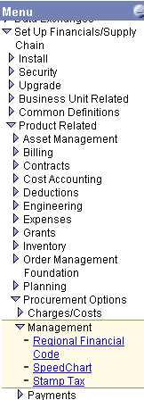
- Click on the Add a New Value tab
- Make sure the Business Unit is correct if it does not default in
- Select a name for your Speedchart and type it into the SpeedChart Key field
This can be a string of numbers or a name that uniquely identifies the SpeedChart. SpeedChart Keys can be up to 10 digits e.g.:
10000 1201 Carnegie 54
Dr. Smith XYZ Grant
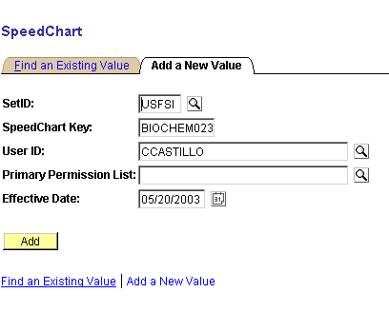
- Select your own User ID
- Click the Add button
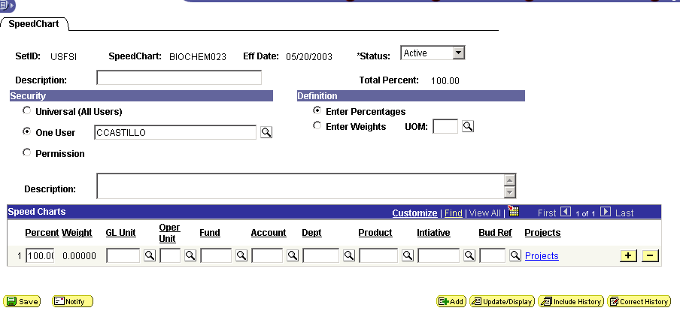
1.7 Description

1.8 Security
1.9 Definition

1.10 Description

1.10 Chartfields
- Type in a Description up to 30 characters
- The Security should default in as One User and your User ID
- The Definition should default to Enter Percentages
- Type a fuller Description (2000+ characters)
- Fill out the Chartfields with the values you want. These should be complete as possible as they will overwrite the default values on the requisition that are populated with the Requester ID.
- The GL Unit is always USF01
- The Purchasing Business Unit appears on the “Add” page only, not in the Chartfields
- Do NOT enter any Account numbers. Account numbers should default in from the Item Category selected when completing a Requisition
- The Products and Initiative fields should be filled in with zeros if they are not being used as part of the chartfield string
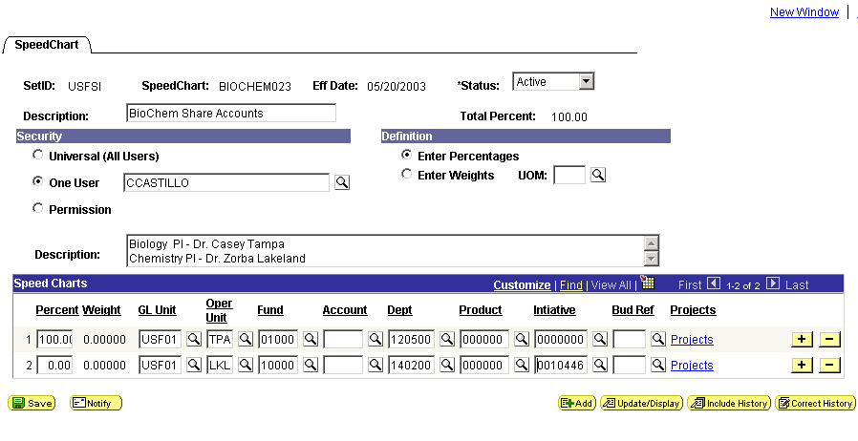
- Click on the Projects hyperlink to add Project or Grant information
- Click OK when finished to return to the SpeedChart
- To create additional lines of chartfield strings for multiple distribution (split/share accounts) click on the sign at the far right
- Complete each line of distribution following steps 1.11 – 1.17 as required
- Click on the sign to delete unwanted lines
- Click the Save button

Item Categories

GENERAL
Item Categories are the equivalent of Object Code descriptions. Except for specific equipment categories, they generally cover an area or type of purchase such as Athletic or Electronic.

This type is paired with three broad areas of expenditure; supplies, equipment and services. This results in three Item Categories:

Athletic Supply
Athletic Equipment
Athletic Service
ACCOUNT NUMBERS

Added to these are the Account numbers which occupy one of the chartfields. Account numbers correspond to SAMAS Object Code numbers. E.g.

Athlteic Supply 53500

Because we can automataically assign the correct Account using the Item Category do NOT fill out the Account chartfield on requisition Header Defaults (See Online Requistions Step 3.3) when creating requisitions or Speedtypes.
PRICE TOLERANCES

In the system, the Item Categories provide the ability to add tolerances to the price of goods and services. These tolerances allow for a difference between the price on a purchase order and the actual amount invoiced.
Tolerances are placed on both the unit price and the extended total price of each line item on a requisition and it’s subsequent purchase order.

Without tolerances, any variation of the price, even as little as one cent, will cause the system to create a “matched exception” and notify the department that the invoice cannot be paid because it was higher, or lower, than the price on the purchase order.

However, there are times when a price is firm and a department does not wish to pay any more than is stated on the order.

In order to accommodate both situations, a second Item Category was created for each type and expenditure. These Item Categories were prefixed with a “C” to represent “contract.” So, using the above example, we have:

Athletic Supply 53500
C Athletic Supply 53500

The “C” does NOT mean there is or has to be an acutal contract in existance to use this Category. You might have a verbal quote from the vendor or you might simply not want to pay any more than you indicate.

The “C” prefixed Categories are all set for a “0” (zero) tolerance for an increase in the price over that on the purchase order.

Due to the philosophy that getting a price break is always acceptable, the tolerance for a decrease in price is set to 10%. This under-price tolerance is not set higher because a vendor charging you a great deal less than expected might very well mean you did not get what you ordered or expected and it should be checked out.

Those Item Categories without a “C” are set for over and under tolerances of 10% with one or two exceptions such as Printing which only has one Item Category with 5% tolerance.

Item Category “codes” have 18 characters and a 30 character description. A variety of words, synomyns and examples were used to make it easier to search for the right category. Including the example above, the system will show:

Code Description

Athletic Supply Athletic Supply Sports Team
C Athletic Supply Contract Athletic Supply
Electronic Supply Electronic Part Supply Battery
C Electronic Suppl Contract Electronic Supply Part Battery

This enables you to search on both the Code and Description and using the “contains” search criteria is the best way to use this particular Search. You can also utilize your Windows “Find” feature to read through any long list your search criteria may return.

Equipment Purchases
Some Item Categories are set up for specific Equipment purchases in order to add an Asset Profile required for inventory reporting. These all have a choice of a 0% tolerance as well as a 10% tolerance although equipment prices should always have a firm quote from a vendor.
When purchasing equipment, use more specific words such as “microscope” rather than a general description such as “medical equipment” to see if that specific item has its own category. This will provide more accurate information to Asset Management for assessing the University’s net worth.
A list of all Item Categories is appended to this manual.

Non-po Purchase Requests

Short Guide:
Step 1: Complete Payment Request Form
Step 2: Obtain Manager Approval
Step 3: Submit Request to Accounts Payable

Step 1 Complete Payment Request Form
As noted in the Overview of this section, there are several types of purchases which do not require online requisitions, but will continue utilizing paper forms to process the requests. The purchase types and related forms are listed below:
- Subscriptions Payment Request Form
- Memberships Payment Request Form
Note: Benefit and Open-Records Statement required
- US Postmaster Payment Request Form
- Freight Payment Payment Request Form
FedEx UPS etc.
- Travel Travel Advance or Travel Expense Reimbursement
- Petty Cash Payment Request Form
Reimbursement
- Personal Payment Request Form*
Reimbursement*

Samples of these forms can be found at the end of this section.

Step 2 Obtain Manager Approval
The requestor should obtain Signature Authority approval (and any other level approval required) in the form of a signature on the form prior to sending the form to Accounts Payable.

Step 3 Submit Request to the Accounts Payable Department
Once approval has been obtained, the form should be sent to Accounts Payable with all backup documentation, where it will be entered into the PeopleSoft Payables system as a preapproved non-PO related voucher.

*NOTE: Personal Reimbursement forms and paid receipts or other proof of payment should be sent to the Purchasing Office instead of Accounts Payable. The Payment Request will be given to Accounts Payable after it has been reviewed and approved by Purchasing.

Requisition Denial

Short Guide:
Step 1: Requisition Denied
Step 2: Resolution: Changing a Budget Checked Requisition
Step 3: Resubmission
Step 4: Cancellation

Step 1 Requisition Denied
- If a requisition is denied by the department Requisition Approver or Manager or it must be returned to the department by Purchasing, the Approver/Manager or the Purchasing Agent will “Deny” the requisition, returning it to the Requester.
- Denial is processed from the Approve Amounts page. (See Requisition Approval)
- First write the reason for the denial in the Comment space provided.
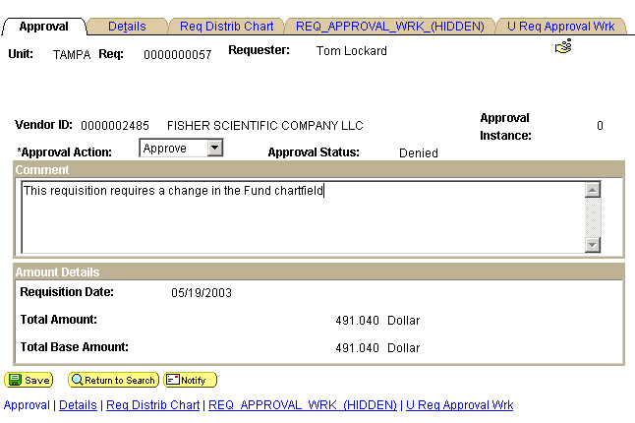
1.2 Comment
- Use the drop down Approval Action box to select Deny.
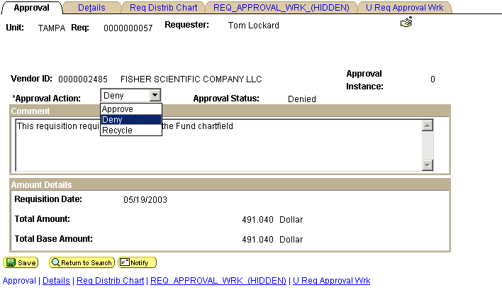
- Click Save
- The system will send a email to the Requester providing the Requisition number, vendor, amount and departrment along with the Comment.
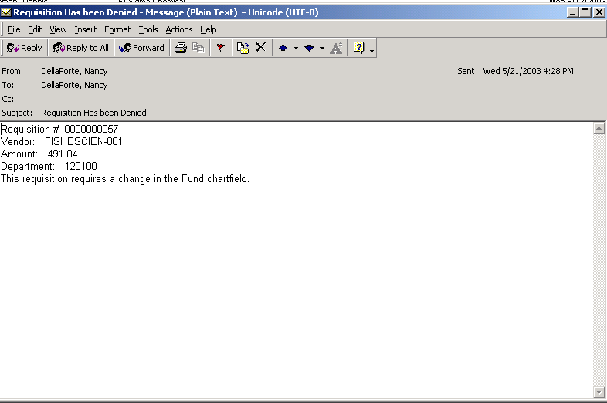
1.6 Email

Note: It will NOT look exactly like this.
Step 2 Resolution: Changing a budget-checked requisition
Header Changes
- If a change is needed to the requisition Header such as Requester, source, accounting date, or Header defaults, navigate to the requisition Form page (See Online Requisitions Step 1)
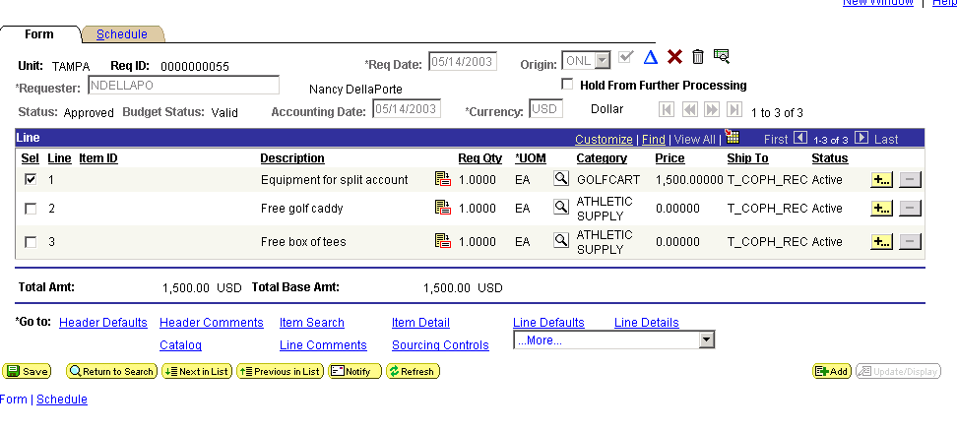
- Click on the blue change icon
Note: If the requisition budget status is Not Valid, use of the change icon is not necessary.
- Make any necessary changes.
- If Requester is changed, you will receive a message advising that the defaults will change.
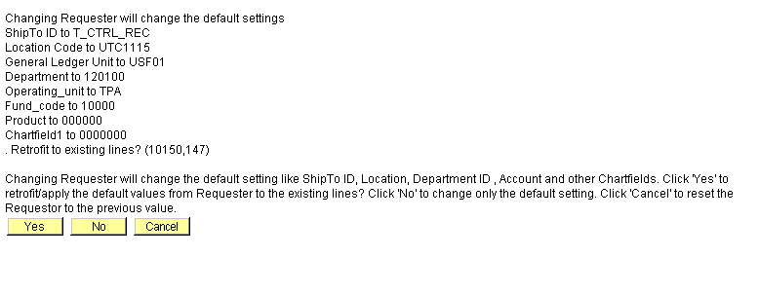
- Click Yes if the changes apply to all previous lines of the requisition.
- Click No if you are adding lines and the default settings only apply to new lines. (See Online Requisitions Step 5)
- Click Save
- If changes are made to the Header Defaults you will receive a message asking whether to retrofit the changes to existing lines or not.
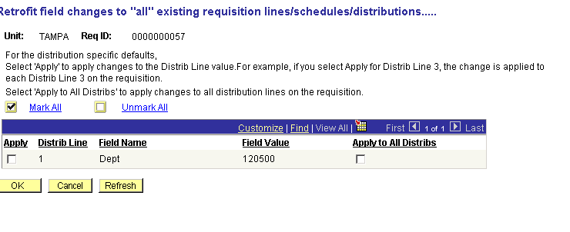
- If they do, click the Mark All hyperlink to apply to all fields
- Click OK to return to the Form page
- Click Save
- The Budget Status will read Not Valid

Line Changes
- If changes are needed to the amount, quantity or distribution, navigate to the requisition Schedule page.
- Click on the check box under Sel to the left of the line to be changed
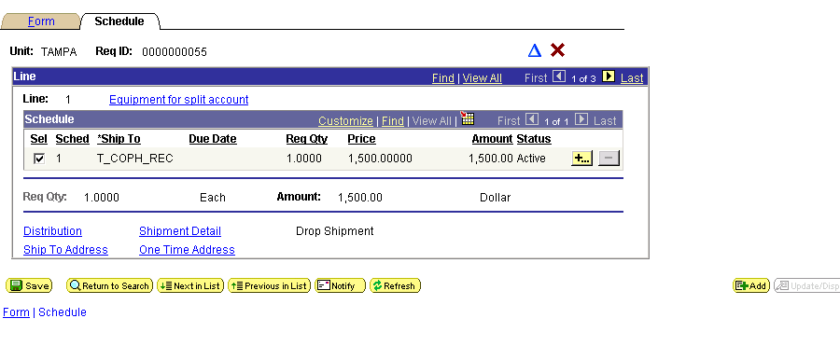
- Click on the blue change icon
Note: If the requisition budget status is Not Valid, use of the change icon is not necessary.
- Make any necessary changes.
- To change chartfield values, click on the Distribution hyperlink.
- Make any necessary changes.
- Click OK to return to the Schedule page
- Click Save.
- Changes will apply only to the line saved
Step 3 Resubmission
See Steps 9 and 10 from the Online Requisitions section above

Step 4 Review and, if necessary, Override Defaults
- Navigate to the Requisition Forms page.
- Click on the red X
- You will receive the following error message
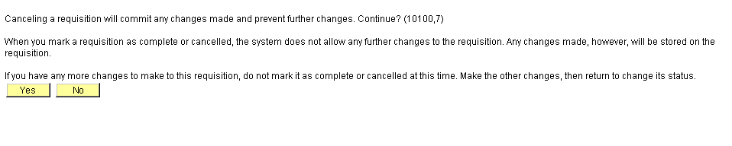
- Click Yes
- The system will return to the Requisition search page.

