

BRIEFING FOR THE INCOMING
MINISTER OF REVENUE – 2005

Contents

Commissioner’s overview 5
Introduction 6
Key points 6
Role of the Minister of Revenue 7
Matters for immediate attention 9

Briefing 11
Tax policy 12
Administration of tax and social support programmes 40

Tables
Table 1 – Tax collections and tax rates: OECD countries 20
Table 2– Major features of the operational design work programme to June 2007 41
Table 3– Growth in revenue assessed 42
Table 4 – Growth in customer base 42
Table 5 – Peak and non-peak days planned for last quarter 2004–05 44
Table 6 – Comparison of electronic services available from 2002 to 2005 45
Table 7 – Accounts accessed through our Look at Account Information service for the month 46

Figures
Figure 1 – Total tax as a percentage of GDP – 2002 22
Figure 2 – New Zealand tax to GDP ratio 22
Figure 3 – Company tax rate 2005 23
Figure 4 – Company tax as a percentage of GDP 2002 24
Figure 5 –Top marginal personal tax rate 2004 25
Figure 6 – Disposable income (one earner family, non-beneficiaries) 26
Figure 7 – Effective marginal tax rates (non-beneficiaries, single earner family) 27
Figure 8 – Historical trends in statutory corporate tax rates 30
Figure 9 – Aggregate taxable income of individuals by $1,000 bands of taxable income 33
Figure 10 – Growth in numbers of taxpayers 1998–99 to 2003–04 34
Figure 11 – Income from trusts (IR 6) 35
Figure 12 – Growth in small and medium sized enterprises 43
Figure 13 – Compliance model 48
Figure 14 – Collectable debt 2003–04 and 2004–05 51
Figure 15 – Child support debt 52

Commissioner’s overview



Introduction
The effective and efficient operation of the tax system and administration is fundamental to the functioning of the economy and maintaining the social wellbeing of New Zealanders. The main roles that Inland Revenue undertakes include:
- collecting tax, child support and student loan payments
- making payments such as tax refunds and rebates, family assistance (including the Working for Families package), child support and paid parental leave
- advising the government, together with the Treasury, on tax policy and social policy measures that interact with the tax system.

Inland Revenue’s outcomes, set out below, describe our contribution to the government’s outcomes, and to the welfare of all New Zealanders.

Primary outcome
- Improve the economic and social wellbeing of New Zealanders.

Intermediate outcomes
- Revenue is available to fund government programmes through people meeting payment obligations of their own accord.
- People receive payments they are entitled to, enabling them to participate in society.

Inland Revenue has been given responsibility for a number of government initiatives that have expanded the functions of the department. Inland Revenue is no longer just a tax collection agency; it is also a major player in the provision of the government’s social support programmes.

Key points
The New Zealand tax system is fundamentally sound. This was the conclusion of the Tax Review 2001, chaired by Rob McLeod, which reviewed the policy and administration of the tax system. The good health of the tax system is shown by strong revenue flows and high levels of public confidence in the department. There are still challenges to be addressed, and these should be an early focus for the incoming government.

This briefing paper focuses on what we see as the most critical policy and operational challenges. Inland Revenue also has many important functions and other challenges in areas such as child support and student loans, which are not discussed in detail in this briefing paper. We will be reporting to you separately on these matters.

Policy challenges
- New Zealand’s substantial company tax base is at risk because of our relatively high reliance on corporate tax as a revenue source and the relatively high foreign ownership of companies. Many other countries have lowered their company tax rates over recent years and, as they do so, it becomes harder for New Zealand to retain its corporate tax base.
- Of particular concern are Australia’s lower, 30% company tax rate and its full imputation system, both of which can act as incentives to stream profits abroad, thus eroding our company tax base. We also need to establish a response to Australia’s reduction of non-resident withholding rates on interest, dividends and royalties. This means that the future of the trans-Tasman tax relationship needs to be considered as a matter of priority.
- Problems with our personal income tax structure are also emerging, particularly in relation to the 33% and 39% personal income tax rates. There is growing evidence of tax sheltering and income splitting, raising questions of how robust our tax system is.

Operational challenges
- The department is currently implementing a full programme of initiatives, which will need to be reprioritised to accommodate any new initiatives.
- We are also considering how we can adjust our operating model to address current operating pressures, particularly if demand for our services and/or the number of people who are required to contact us continues to grow
- Any legislative changes that require significant changes to our information technology systems will require sufficient lead time to make and test the changes. The introduction of more complexity into our information technology systems, caused through integrating new products and services, means that these lead times are steadily increasing.
- We have reassessed our approach to providing electronic services. Internationally, tax administrations have led the introduction of electronic services, which highlights the importance of introducing new electronic services and expanding the use of the electronic channel. We have refocused our approach to take more of a leadership role in supporting the government’s 2010 e-government goals.

Role of the Minister of Revenue
The role of the Minister of Revenue is established by protocols between Ministers in the finance area; it is not a statutory role. On the basis of past experience, we would expect that you would need to focus on:
- management of tax policy issues—through the management of the tax policy work programme.
- overview of the administration of the department—through normal public service accountability mechanisms, such as our Statement of Intent, output plan, quarterly reports and annual report.

The legislation rests responsibility for determining taxpayer-specific affairs with the Commissioner of Inland Revenue. Responsibility for protecting the integrity of the tax system falls to both officials and any Minister having responsibility under the Tax Administration Act 1994. Section 6(1) of this Act states:
Every Minister and every officer of any government agency having responsibilities under this Act … are at all times to use their best endeavours to protect the integrity of the tax system.

The Act defines the integrity of the tax system under section 6(2) as:
Without limiting its meaning, “the integrity of the tax system” includes---
- Taxpayer perceptions of that integrity; and
- The rights of taxpayers to have their liability determined fairly, impartially, and according to law; and
- The rights of taxpayers to have their individual affairs kept confidential and treated with no greater or lesser favour than the tax affairs of other taxpayers; and
- The responsibilities of taxpayers to comply with the law; and
- The responsibilities of those administering the law to maintain the confidentiality of the affairs of taxpayers; and
- The responsibilities of those administering the law to do so fairly, impartially, and according to law.

We can assist you in undertaking these functions by providing you with policy advice, providing revenue forecasting information, and briefings on administrative issues as they arise.

We also provide you with specific assistance in a number of areas.

Reports and briefings
We will provide you with a number of regular briefings and reports—the timing and scope of these will be set to meet your requirements.
- Briefings: I suggest that we discuss the type and frequency of our briefings with you in the near future.
- Tax policy work programme updates: we will report to you periodically on the management of the tax policy work programme.
- Quarterly reports: we will provide you quarterly reports on our progress against the performance expectations set out in our Output Plan.
- Monthly status reports: we will provide you with a monthly report on management and other issues affecting the department.

Departmental staff for your office
The Policy Advice Division can provide you with suitable people to act as an interface between the department and Ministers. Over the last three years we have provided two full-time staff members in the office of the Minister of Revenue, and a part-time staff member in the office of the Associate Minister of Revenue. As well as assisting with the large volume of tax-specific queries Ministers’ offices receive, these people play a valuable coordination and advisory role for Ministers. At an early opportunity we need to discuss the Government’s requirements for the staffing of offices.

Responding to ministerial and parliamentary questions
As Minister of Revenue you can expect to receive taxpayer-specific queries and complaints. The department’s Ministerial Services unit coordinates the prompt drafting of responses for you (and other Ministers associated with the Revenue portfolio) to correspondence and parliamentary questions. In the past, Ministers have generally passed on taxpayer specific correspondence to the Commissioner’s Office to respond to directly.

Enquiries from other Members of the Parliament and constituents
There will also be occasions when you and other Members of Parliament may wish to contact us on behalf of a constituent, or advise them on the best way of contacting Inland Revenue. To assist with this process we will be sending all Members of Parliament our guide—Contacting Inland Revenue.

Tax affairs of Members of Parliament—our Special Files unit
Inland Revenue recognises that High Court judges, Members of Parliament, and its own staff face the additional responsibility of upholding the taxation law that we administer. To assist these people, we offer a centralised account management service for the taxation affairs of Members of Parliament. The Special Files Unit is located in Wellington and brings together the full range of our services for this customer group in one site. Using this service is optional for Members of Parliament and High Court judges. We will be writing to all Members of Parliament shortly to make sure they are aware of this service.

Matters for immediate attention
There are a number of tax policy and operational issues that you will need to consider in the very near future.

Tax policy
- Inland Revenue provides staff members (usually from our Policy Advice Division) to the offices of the Minister of Revenue and Associate Minister of Revenue. We will discuss the servicing of your office with you as soon as possible.
- One of the first steps for the new government is the development of a three-year revenue strategy. We and the Treasury will be reporting to you on this issue shortly.
- Another important issue is the development of a rolling 18-month tax policy work programme. Again, we will be reporting to you on this matter in the very near future.
- There are a number of key policy proposals that will need to be either reviewed or advanced. They include the KiwiSaver initiative, the carbon tax, and those outlined in the recent discussion document Taxation of investment income. We will discuss these matters with you in the context of our report on a draft 18-month tax policy work programme.
- The student loan repayment threshold for the 2006–07 income year needs to be made by Order in Council before the end of the calendar year, and the income threshold for the full-interest write-off is set as part of this process.
- The incoming government will need to consider moving the reinstatement of two tax-related bills that were before Parliament when it rose for the general election: the Taxation (Depreciation, Payment Dates Alignment, FBT and Miscellaneous Provisions) Bill, introduced in May, and the Child Support Amendment Bill, introduced in July. The tax bill introduced in May includes confirmation of tax rates for 2005–06. Constitutionally, this measure must be enacted by 31 March 2006. We will report to you separately on the reinstatement issue.
- We have a commitment to advise the Australian government before the end of the year on New Zealand’s willingness to consider reductions in withholding tax rates. Depending on the outcome of that consideration, a comprehensive re-negotiation of the double tax agreement between Australia and New Zealand may become necessary. We will be reporting to you on this issue.

Operational
- As outlined in this briefing paper, the operational work programme is fully committed to announced initiatives. We need to discuss with you whether these initiatives still reflect government’s priorities.
- We will shortly begin planning for the 2006–07 Budget cycle. It would be desirable to discuss aspects of the department’s current funding position with you at an early opportunity.

I look forward to discussing the issues raised in this briefing with you and the new Government in the near future.



David Butler
Commissioner of Inland Revenue

Dated: 16 September 2005

Briefing

Tax policy
New Zealand’s tax system, which relies for most of its revenue on a broadly based income tax and consumption tax, is fundamentally sound and well regarded internationally.

Nevertheless, a number of pressures are emerging. There is mounting evidence that our personal tax structure is fragile and that income splitting and tax sheltering are on the increase. There is also reason to believe that our company tax base is at some risk, company taxation being an important source of revenue. Of particular concern are Australia’s lower company tax rate and full imputation system, which provide incentives for profits to be streamed abroad and can erode New Zealand’s corporate tax base. How New Zealand should best respond to these emerging pressures is a difficult problem to which there are no simple solutions.

The tax policy section of this briefing explains New Zealand’s tax policy process, compares New Zealand’s taxes with those in other countries, discusses key challenges in tax policy and outlines what we believe should be key themes in future work. In examining key challenges, our focus is on income tax issues. This is not because our other main tax, GST, is unimportant – rather, it is because we believe there are fewer problems with New Zealand’s GST. It is our income tax base where most pressures are emerging, although GST fraud and avoidance schemes also pose a significant fiscal risk. These issues are raised in the administration section of this briefing paper.

Throughout this briefing paper we work within the tax policy settings that existed at the time the general election was called.

The tax policy process

Policy Advice Division
Inland Revenue’s Policy Advice Division, together with the Treasury, advises the government on all aspects of tax policy and on social policy measures that interact with the tax system. Its other roles include:
- forecasting tax revenues
- drafting tax legislation
- negotiating and maintaining New Zealand’s network of double tax agreements with other countries
- providing ministerial services.

The Policy Advice Division has a relatively small staff. It includes about 50 policy analysts, forecasters and legislative drafters who are directly responsible for the management and delivery of the tax policy work programme.

As part of its role, the Policy Advice Division manages the Generic Tax Policy Process, which covers a range of activities from initial identification of policy issues through to drafting the ensuing legislation and post-implementation review of the legislation. Our tax policy website www.taxpolicy.ird.govt.nz plays a vital part in the process.

Another important role of the Policy Advice Division is to service the Minister’s office. Over the previous government’s term Inland Revenue provided two full-time staff members to the Minister of Revenue’s Office and a part-time staff member to the Associate Minister of Revenue’s Office. We will discuss the servicing of your office with you shortly.

Policy project management
The stages of our project management are:
- Identifying issues in tax and tax-related social policy through our links and communication with Ministers; the private sector; other parts of Inland Revenue, especially operational areas and adjudication and rulings; other government departments, such as the Treasury, Ministry of Economic Development, and Ministry of Social Development; and other tax authorities and international bodies such as the OECD.
- Developing those issues into policy proposals, taking into account how they will be managed through to implementation and review. This involves early identification of potential problems and options and how these might be handled.
- Managing the consultation process on major reforms. Consultation may range from the preparation of government discussion documents setting out proposed policy to less formal discussions with business sectors likely to be affected by policy proposals.
- Managing proposed changes through the ministerial and Cabinet stages and the ensuing legislative stage, from drafting of taxation bills through to supporting their passage through Parliament.
- Post-implementation review of major reforms when potential problems are identified, to ensure that new legislation is working as intended.

No policy project is a success until it has been successfully implemented. And successful implementation of new measures depends not only on making the necessary information available to taxpayers and Inland Revenue staff alike, but also on integrating the changes into operational systems – for example, by way of form redesign and necessary changes to the computer system. That can take a great deal of time and resources for implementing major reforms such as Working for Families. See page 40 for a discussion of current operational restraints on introducing new measures.

The policy development process
Since 1994, tax policy has been developed in accordance with the Generic Tax Policy Process. The process was introduced to ensure better, more effective tax policy development through early consideration of key policy elements and trade-offs of proposals, such as their revenue impact, compliance and administrative costs, and economic and social objectives. Another key feature of the process is that it builds external consultation and feedback into the policy development process, providing opportunities for public comment at several stages.

Consultation throughout the process contributes to greater transparency of policy-making, allowing the government to set out the policy objectives of proposals and the trade-offs it has made in developing them. Therefore it helps the public to understand the rationale behind government policy proposals.

Major tax initiatives are now subject to much greater public scrutiny at key stages in their development – from broad proposal through to post-implementation review. As a result, we now have more opportunity to develop workable options for reform by drawing upon information provided to us by the private sector early in the process.

The increased opportunity for consulting on tax policy has resulted in growing numbers of individuals and organisations making submissions on proposals, whether set out in a discussion document or introduced in a taxation bill. Submissions are becoming increasingly technical and detailed, which in turn makes the process lengthier and requires greater policy and parliamentary resources.

Developing a new tax policy work programme
One of the first steps for the new government in relation to the Generic Tax Policy Process is to develop a three-year revenue strategy that is effectively linked with the government’s economic strategy. The next stage is the development of a rolling tax policy work programme that gives effect to the revenue strategy. At present, the work programme covers an 18-month period.

Developing the work programme involves scoping broad policy proposals and prioritising and sequencing the development of initiatives. We also look at budgeted resource requirements, the time needed to develop, legislate for and implement initiatives, and modes of consultation and communication to be employed throughout the process.

This stage of the Generic Tax Policy Process culminates in a joint report by the Policy Advice Division and the Treasury to the Treasury Ministers and Minister of Revenue that suggests a policy work programme. Once approved, the work programme becomes a detailed tax policy agreement between the government and the two departments.

When it is made public, as it usually is, the work programme is received with much interest by the tax and business communities, to whom it provides greater certainty and an understanding of the government’s direction in tax policy.

As time passes and the work programme is updated and new policy initiatives are added to it, there is a risk that there will be more items on the programme than can be progressed during the 18-month period. That can place a major strain on finite tax policy resources and parliamentary resources, and result in slower progress for other priorities. It is therefore important that when items are added to the work programme, existing priorities are reviewed to ensure that the government’s expectations across the work programme are met.

The management of the work programme will be a key issue for both Ministers and officials in ensuring that priorities are delivered as agreed. There is a large set of issues on the current work programme, and these will need to be either reviewed or advanced. We will be reporting to you shortly on the work programme.

The 2002-2005 tax policy work programme
Major features of the 2002-05 tax policy work programme included tax-related measures to support growth and innovation. The work programme also included measures to simplify the tax system (especially for small businesses), reduce compliance costs, protect the revenue base and promote social cohesion. Recent highlights include:
- Increasing New Zealand’s access to worldwide labour, skills and capital. Policy reforms included removing impediments to international recruitment through temporary relief of much of the offshore income of new migrants and returning New Zealanders, and changes to the tax treatment of trans-Tasman superannuation, stock lending, venture capital and foreign hybrids. Also contributing to this objective was an expansion in our network of double tax agreements with other countries.
- The coherent taxation of savings and the entities through which people invest and save. A June discussion document on the taxation of investment income proposed reforms aimed at removing anomalies between the treatment of savings held through collective investment vehicles and savings held directly by individuals. We have also made a significant contribution in the design of the government’s work-based savings package announced in Budget 2005.
- Improving the efficiency of capital allocation. Measures included changing the basis of depreciation deductions and giving companies that bring in new equity investors better access to Research and Development tax deductions.
- Tax simplification and reduction of tax compliance costs. Examples of recent changes include some of the fringe benefit tax reforms and measures designed to make tax easier for small businesses – including the introduction of tax pooling, the alignment of provisional tax and GST payment dates, and raising the depreciation low-value asset threshold. A key part of our simplification work is the progressive rewrite of the Income Tax Act, begun in the 1990s, to make the Act easier to use and understand.
- Social cohesion. Improving incentives for beneficiaries to enter paid employment and relieving child poverty were the objectives behind the Working for Families reform enacted last year. A bill before Parliament proposes further improvements to the way that child support is administered by giving liable parents who have defaulted on their payments an incentive to re-enter the system.
- The environment. The key proposed reform is the introduction of a carbon tax aimed at ensuring that New Zealand plays its part in reducing emissions of greenhouse gases. Recently enacted legislation has also improved business access to deductions for repairing environmental damage.
- Protecting the revenue base. Important recent reforms include changes relating to the tax treatment of deferred deductions, Australian unit trusts, foreign-owned banks operating in New Zealand, and corporate migration.

Setting priorities
The work programme must balance the resource requirements of the Minister of Revenue’s main tax policy initiatives against those required for initiatives introduced by other Ministers – for example, in the areas of social policy or sector assistance – which can have substantial tax implications. It must also allow room to meet private sector concerns when tax legislation is identified as causing unintended practical problems. Finally, there is an increasing demand for tax policy resources to be allocated to international tax areas such as OECD work and trans-Tasman tax matters, a reflection of the increasing extent to which New Zealand must take into account international tax trends in setting its domestic rules.

Given the many areas of government policy that have tax implications, the sheer complexity of tax issues and the limited resources available to deal with them, it is essential for Ministers to discuss and set out their tax policy priorities. Since many areas of government raise important tax policy issues, the allocation of tax policy resources is likely to affect the government’s ability to pursue non-tax policy objectives, especially in economic development and social policy. It is therefore desirable for Ministers in those areas to be clear about the implications for the tax policy work programme of policy developments in their portfolios.

Budgetary fiscal rules
The tax policy work programme can also be affected in very important ways by any budgetary fiscal rules the government decides to adopt.

In setting fiscal rules, it is essential to ensure that fiscal discipline on expenditure applies in an equal way to initiatives that would reduce tax revenue – otherwise there is an incentive for expenditure initiatives to be packaged as tax initiatives.

That being said, there are a number of ways that budgetary fiscal rules might work. One possibility is to focus solely on the size of the government deficit. In this case, other things being equal, tax reductions may be seen as bad and tax increases may be seen as good. As well as making judgements about the size of the government deficit, governments need to make decisions about whether or not they want to see taxes and government spending rise or fall over time, and these decisions should be incorporated into the budgetary fiscal rules.

Questions also arise as to how flexible fiscal rules should be in trading off revenue gains against the costs of measures, legislative or administrative, which lead to these gains. For example, a government might consider that it is worth spending $1 million to gain $100 million of revenue but not worth spending $1 million to gain $1 million of revenue. The question arises of where the appropriate trade-offs are and whether budgetary fiscal rules should be flexible enough to accommodate trade-offs of this nature. Similarly, expenditure can be incurred either to raise additional tax revenue or to avoid the loss of tax revenue in the future – so should the government be thinking in the same way about trade-offs in both instances?

The tax policy implications of any fiscal rule proposals, therefore, must be considered before such rules are adopted.

Tax concessions
Those looking to reduce impediments to the growth of priority economic sectors often seek tax reductions or concessions for certain sectors. That can add to the strain on tax policy resources and, if implemented, could undermine the broad tax bases our tax system and moderate statutory rates rely upon. Inevitably, because tax collects a proportion of any business’s profits, it is a restraint on the development of all sectors of our economy. That, however, is the inevitable cost of raising revenue to meet government expenditure commitments. Sector-specific concessions will increase the impediments faced by other sectors and, therefore, need a high level of justification. Moreover, sector-specific concessions raise boundary problems and can be open to abuse.

The legislative programme
Two tax-related bills await consideration when Parliament reconvenes: the Taxation (Depreciation, Payment Dates Alignment, FBT and Miscellaneous Provisions) Bill, which was before the Finance and Expenditure Committee when the House rose for the General Election, and the Child Support Amendment Bill, which was introduced in August and awaits its first reading. Both bills lapsed on 11 August, when the previous Parliament was dissolved, and Ministers will need to consider moving their reinstatement by Parliament.

The 2002-05 work programme also called for the introduction of a KiwiSaver bill in late November this year and a carbon tax bill in late February next year.
Taxes, distortions and the New Zealand tax system
Taxes are needed to finance government spending. At the same time, taxes distort economic behaviour, which can inhibit growth. When the tax system causes people to invest in particular assets or to structure their affairs in ways which are sensible only because of taxes, the tax system is said to be inefficient. A goal of good tax reform is to raise sufficient revenue to meet government requirements as efficiently as possible, consistent with a government’s equity objectives.

Although most taxes can distort economic behaviour, it appears to be income taxes where most pressures are emerging. Income taxes can distort behaviour, harm economic growth and produce other undesirable effects in three different ways. The possible distortions can be grouped as follows:
- those attributable to all marginal tax rates
- those attributable to differences in marginal tax rates and
- those primarily attributable to the top marginal tax rate.

It should be noted at the outset that in listing these potential distortions we are not suggesting New Zealand’s tax system is poor relative to tax systems in other countries. On the contrary, we will see that in many ways New Zealand’s tax system is relatively well designed. Being aware of the three different possible sets of distortions, however, is helpful in examining how efficient New Zealand’s tax system is likely to be.

First, high marginal tax rates can hinder individuals from working as long, as hard or in as difficult and demanding jobs as they would if marginal tax rates were lower. High marginal tax rates can also discourage individuals from saving when it would be desirable to do so if not for these tax rates, and encourage avoidance or evasion of taxes. The degree of distortion will depend on an individual’s marginal tax rate on any additional income, and different individuals will face different marginal tax rates on additional income. Thus these inefficiencies will depend on the levels of marginal tax rates facing all individuals.

Second, differences in marginal tax rates can produce another set of distortions. If marginal tax rates rise with income, the high rates faced if a risky investment pays off and the low rates faced if the investment fails may discourage risk-taking behaviour. Similarly, increasing marginal tax rates can discourage individuals from “investing in human capital” and acquiring new knowledge and skills. It is also differences in marginal tax rates that give rise to problems in taxing different forms of savings vehicles, including trusts and companies, on a consistent basis and lead to biases in the ways that individuals save. Moreover, differences in marginal rates provide scope for income splitting within a family. This leads to perceptions of unfairness.

Third, some distortions may predominantly be affected by the highest marginal tax rates. If certain forms of investment are tax advantaged relative to others, those who have the biggest incentives to invest are those on the highest tax rates. Provided these individuals have or can borrow sufficient capital, it may well be the tax rate of these individuals that determines the efficiency cost of the distortion.

By international standards, New Zealand has broad bases for both its income tax and GST, and about 90 percent of total government tax revenue comes from these taxes. Both tax bases have relatively few concessions by international standards. This allows lower tax rates and a more efficient tax system than would otherwise be possible.

The basic structure of our tax system was endorsed by the Tax Review 2001, which concluded that “. . . radical restructuring is not required. The broad architecture of the tax system is sound.” The Tax Review commissioned Professor Alan Auerbach, a leading international expert on the economics of taxation, to comment on its June 2001 Issues Paper. He prefaced his report by stating “New Zealand’s current tax system already conforms more closely to the standard objectives of taxation than do the tax systems of many other developed countries. Thus New Zealand’s tax system is not obviously in need of major overhaul.”

When comparing New Zealand’s tax system with those of other countries it is important to note that New Zealand already has a relatively well designed tax system. It should not be thought that any departure from norms in other countries is necessarily evidence of poor New Zealand policy.

OECD data on tax rates and tax collections are shown in Table 1. The year chosen in each case is the most recent year for which internationally comparable data are available.

Table 1 – Tax collections and tax rates: OECD countries
 | Total tax as a % of GDP  2002 | Corporate tax rate  2005 | Company tax as a % of GDP  2002 | Top marginal personal income tax rate  2004 | Threshold  (multiple of average production wage APW) 2004 | Top marginal tax rate minus corporate tax rate
Australia | 31.5 | 30.0 | 5.2 | 48.5 | 1.3 | 18.5
Austria | 44.0 | 25.0 | 2.3 | 42.9 | 2.8 | 17.9
Belgium | 46.4 | 34.0 | 3.5 | 59.3 | 1.2 | 25.3
Canada | 33.9 | 36.1 | 3.4 | 46.4 | 2.9 | 10.3
Czech Republic | 39.3 | 26.0 | 4.6 | 40.5 | 2.0 | 14.5
Denmark | 48.9 | 30.0 | 2.9 | 62.9 | 1.0 | 32.9
Finland | 45.9 | 26.0 | 4.3 | 56.7 | 2.0 | 30.7
France | 44.0 | 35.0 | 2.9 | 47.2 | 3.4 | 12.2
Germany | 36.0 | 38.9 | 1.0 | 60.5 | 1.6 | 21.6
Greece | 35.9 | 35.0 | 3.8 | 49.6 | 2.2 | 14.6
Hungary | 38.3 | 16.0 | 2.4 | 69.5 | 1.2 | 53.5
Iceland | 38.1 | 18.0 | 1.1 | 42.0 | 1.5 | 24.0
Ireland | 28.4 | 12.5 | 3.7 | 48.0 | 1.0 | 35.5
Italy | 42.6 | 33.0 | 3.2 | 51.6 | 3.4 | 18.6
Japan | 25.8 | 40.9 | 3.1 | 47.8 | 5.3 | 6.9
Korea | 24.4 | 27.5 | 3.1 | 39.2 | 4.0 | 11.7
Luxembourg | 41.8 | 30.4 | 8.6 | 47.8 | 1.3 | 17.4
Mexico | 18.1 | 30.0 | n/a | 28.9 | 1.9 | -1.1
Netherlands | 39.2 | 31.5 | 3.5 | 52.0 | 1.6 | 20.5
New Zealand | 34.9 | 33.0 | 4.2 | 39.0 | 1.4 | 6.0
Norway | 43.5 | 28.0 | 8.2 | 55.3 | 2.9 | 27.3
OECD unweighted | 36.3 | 29.0 | 3.4 | 47.6 | 2.9 | 18.6
OECD weighted | 31.0 | 36.0 | 2.5 | 46.6 | 5.4 | 10.6
Poland | 32.6 | 19.0 | 2.0 | 51.6 | 3.5 | 32.6
Portugal | 33.9 | 27.5 | 3.6 | 46.6 | 6.7 | 19.1
Slovak Republic | 33.1 | 19.0 | 2.7 | 21.8 | 0.5 | 2.8
Spain | 35.6 | 35.0 | 3.2 | 45.0 | 3.0 | 10.0
Sweden | 50.2 | 28.0 | 2.7 | 56.5 | 1.8 | 28.5
Switzerland | 30.3 | 24.1 | 2.7 | 47.9 | 4.0 | 23.8
Turkey | 31.1 | 30.0 | 2.2 | 40.6 | 10.6 | 10.6
United Kingdom | 35.8 | 30.0 | 2.9 | 41.0 | 1.7 | 11.0
United States | 26.4 | 39.3 | 1.8 | 42.9 | 9.4 | 3.6

These data suggest that:
- New Zealand’s tax/GDP ratio is towards the middle of the range for OECD countries
- New Zealand’s company tax rate is high relative to those of most OECD countries
- New Zealand has a relatively high level of company tax as a proportion of GDP
- New Zealand has a relatively low top statutory marginal tax rate on earned income, although this is attained at a relatively low income
- There is a relatively small difference between the company tax rate and the top personal marginal tax rate.

The absence of any tax-free threshold in New Zealand and the relatively low top personal marginal tax rates are likely to lead to relatively small differences in New Zealand’s statutory marginal tax rates. Although the top statutory marginal income tax rate in New Zealand is low, the abatement of family assistance can lead to very much higher effective marginal tax rates.

Tax as a percentage of GDP
As shown in Figure 1, New Zealand’s tax to GDP ratio of 34.9 percent in 2002 is towards the middle of the range for OECD countries. It is slightly below the unweighted average of 36.3 percent but above the GDP-weighted average of 31.0 percent. The OECD-weighted average is less than the unweighted average because the two largest economies in the OECD – the US and Japan (with 54.4 percent of GDP in total in 2002) are relatively low-tax countries.

It should be noted that comparing New Zealand’s ratio of tax/GDP with those of other OECD countries involves a comparison with relatively high-tax countries. Many non-OECD countries within our region have lower ratios. For example, ratios in Singapore and Hong Kong in 2002 were approximately 22 and 15 percent respectively.
Figure 1 – Total tax as a percentage of GDP – 2002
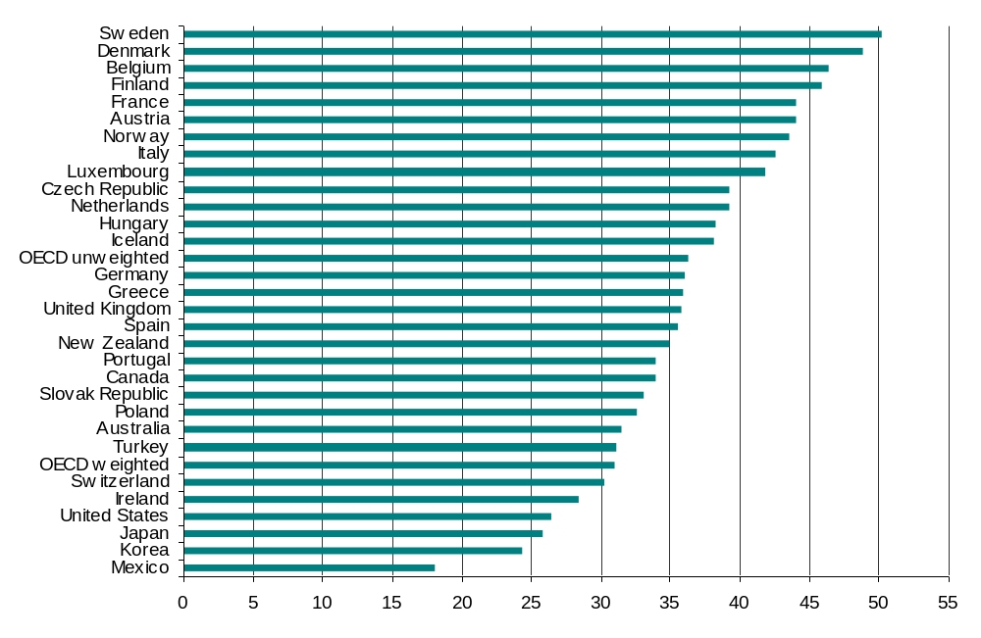

It is of interest to consider how New Zealand’s tax to GDP ratio has been changing through time. The ratio has increased slightly over recent years, but it is below the ratio in the early 1990s, as shown in Figure 2.
Figure 2 – New Zealand tax to GDP ratio
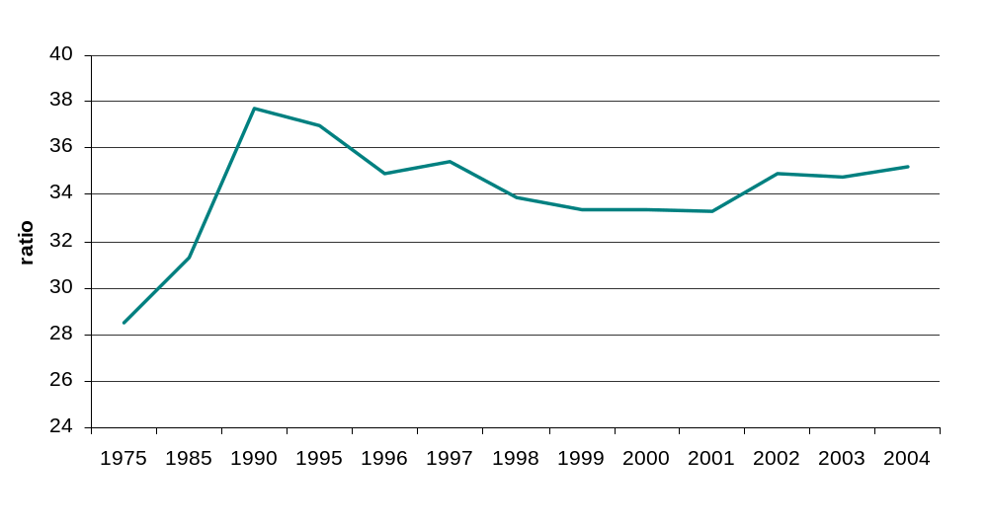

Company tax
A number of commentators have pointed out that New Zealand’s company tax rate of 33% is higher than the Australian company tax rate of 30%. Figure 3 shows company tax rates for OECD countries inclusive of both federal and state tax rates. New Zealand’s company tax rate is now in the top third of tax rates for OECD countries but lower than the weighted average of 36.0%. The weighted average is substantially affected by the largest economies (US, Japan and Germany), which have the highest corporate tax rates. There appears to be a general tendency for smaller economies to have lower statutory company tax rates than those of larger economies.
Figure 3 – Company tax rate 2005
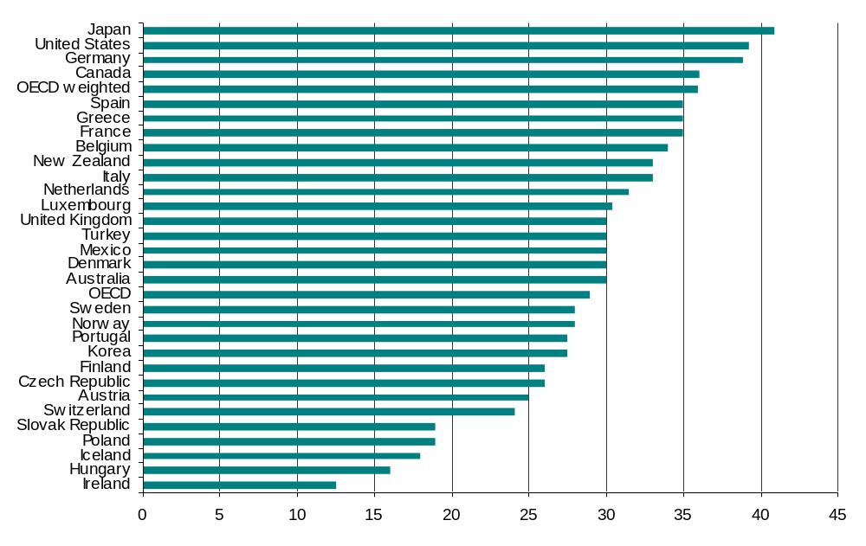
It should be noted that high statutory company tax rates do not necessarily imply a large company tax base. The countries with the highest company tax rates, Japan, US, and Germany, have respectively the fourteenth lowest, the third lowest and the lowest ratios of corporate tax collections as a proportion of GDP.

A key feature of the New Zealand tax system is the importance of the corporate tax base. In 2002, as shown in Figure 4, New Zealand had the sixth highest ratio of company tax as a proportion of GDP. In New Zealand this has risen from 4.2 percent, as reported in Figure 4, to an estimated 5.1 percent in the year to March 2005.
Figure 4 – Company tax as a percentage of GDP 2002
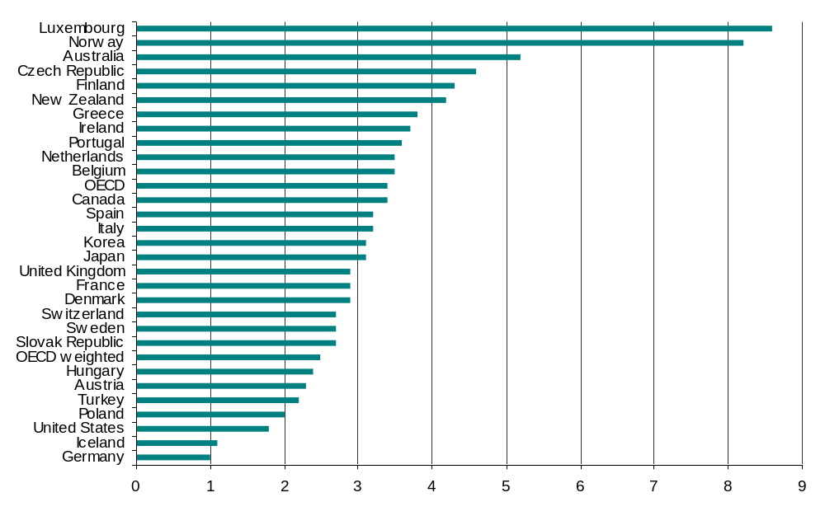
As discussed later in “Key challenges in tax policy”, international moves are placing downward pressure on New Zealand’s company tax rate, and whether we should lower this rate is an important issue for New Zealand to consider.

Personal tax rates
As shown in Figure 5, New Zealand’s top marginal personal income tax rate of 39% is low by OECD standards, with only Mexico and the Slovak Republic having lower rates, and the OECD-weighted average being 46.6%. While New Zealand has a relatively low top marginal tax rate, Table 1 indicates that it applies at a relatively low level of income (only 1.4 times the average production wage).

The data reported in Figure 5 show the top marginal tax rate on wage income, inclusive of contributions to social security. Marginal tax rates on wage income do not tell the full story, however, since more than half of OECD countries have lower taxes on capital income such as interest. New Zealand’s top marginal tax rate may look relatively less favourable if compared with the top marginal tax on different forms of capital income.

Other things being equal, New Zealand’s relatively low structure of marginal tax rates, the relatively small difference between marginal tax rates (varying between 15% on low incomes and 39% on high incomes) and its low top marginal tax rate are all likely to minimise economic inefficiencies. Even so, problems related to the 39% and 33% tax rates are emerging, as discussed later in “Key challenges in tax policy”.
Figure 5 –Top marginal personal tax rate 2004
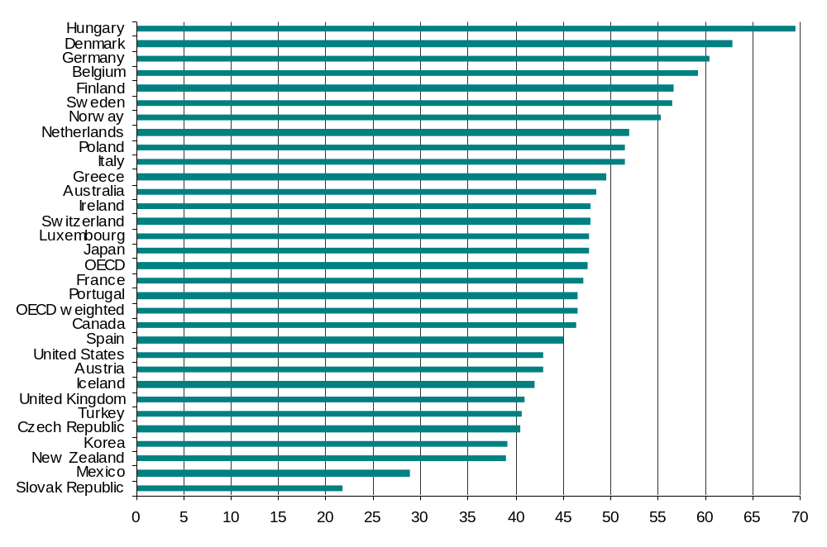

Effective marginal tax rates
Statutory marginal tax rates are not the full story. For families, effective marginal tax rates (EMTRs) can be very much higher than their statutory tax rates. The EMTR measures the fraction of an additional dollar of an individual’s income that is lost by way of tax payments and the abatement of social assistance. The high EMTRs faced by many families are of policy concern, although how best to reduce them is a thorny issue.

The Working for Families scheme was designed to make entering the workforce more attractive to families with dependent children and increase their incomes. Figure 6 shows the effects of these measures on disposable incomes after full implementation of Working for Families in 2008, under three different scenarios, all excluding the accommodation supplement. The first scenario concerns a wage and salary earner with no dependent children. The second scenario shows a single-income couple with one child aged 0-12, and scenario 3 is for a single-income couple with three children (all 12-years-old or under). In all three scenarios it is assumed that the family is not a beneficiary, so abatement of social welfare benefits is not considered.
Figure 6 – Disposable income (one earner family, non-beneficiaries)
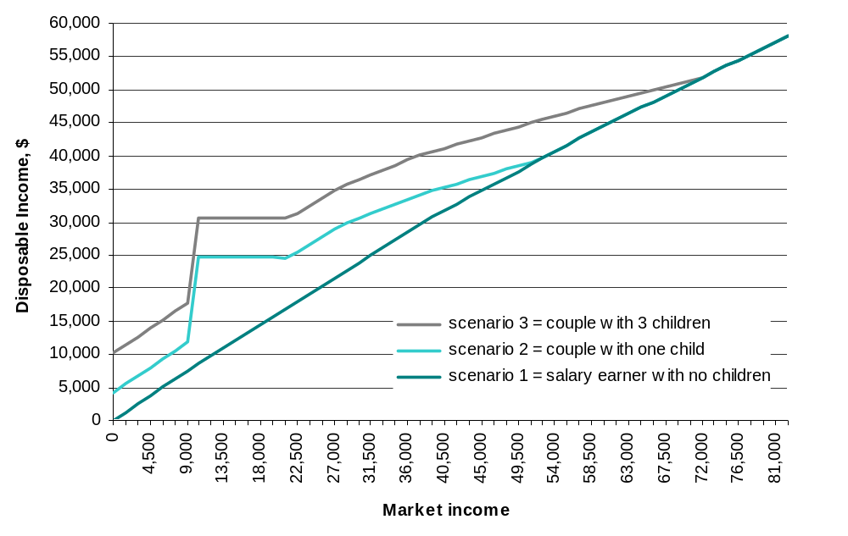
The vertical differences between the graphs reported in Figure 6 for scenarios 2 and 3 and that for scenario 1 show the assistance provided to families. While these measures assist lower-income families with children, as family assistance abates, families may capture little benefit from increasing their market incomes. For households receiving the accommodation supplement, disposable incomes will be higher than reported in Figure 6.

Figure 7 shows the EMTRs faced under the three scenarios outlined earlier.
Figure 7 – Effective marginal tax rates (non-beneficiaries, single earner family)
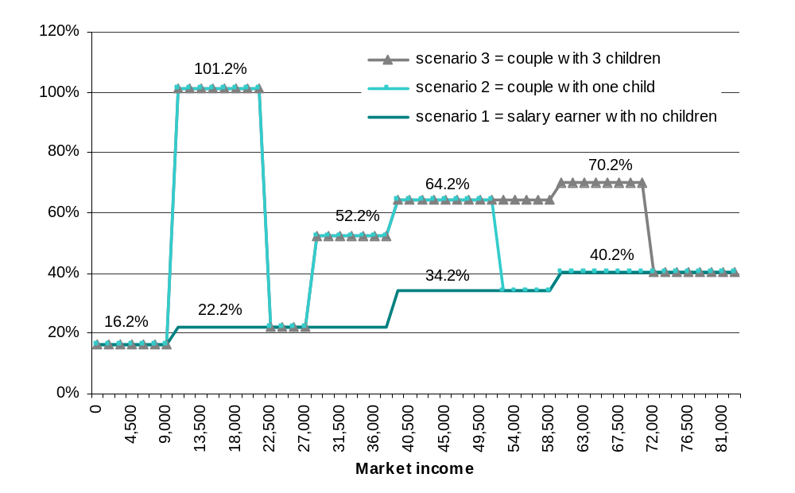
For families with dependent children, the EMTR is initially 16.2%. This rises to 101.2% once the sole income earner is working sufficient hours to be classified as a full-time employee. This is due to 79 percent abatement of the family tax credit, plus the 21% statutory rate and the ACC levy. At a salary of around $21,000 the family tax credit abates in full. EMTRs at higher incomes are affected by the abatement of family support and the in-work payment (at an abatement rate of 30 percent) and the ACC levy.

The EMTRs reported in Figure 7 do not take account of the accommodation supplement, which abates at 25 percent from an income of about $24,500. Some households face the additional 25 percent abatement for the accommodation supplement in addition to the in-work payment abatement rate of 30 percent, giving them EMTRs of 77.2 % (52.2+25) or 89.2% (64.2+25). However, there are few households that receive the accommodation supplement and have incomes above $38,000 and are therefore subject to EMTRs of 89.2%. Further, some households receive the accommodation supplement but not family support or the in-work payment.

The EMTRs reported in Figure 7 do not take account of childcare subsidies, which also abate with income. In addition, some of those required to make child support payments or repay student loans may regard such payments as a tax. If they were included as taxes, EMTRs would be higher.

High EMTRs may not be a source of substantial inefficiency if they apply over narrow bands of income and do not affect work or savings decisions for many taxpayers. Figure 7 suggests, however, that families may face high EMTRs over very broad ranges of income. Figure 7 illustrates the EMTRs faced by sole income families, but high EMTRs can also be of concern for secondary income earners in two-income families.

For households in income bands where these high EMTRs apply, additional income may not always be taxed at high EMTRs. If, for example, additional income is earned by way of fringe benefits or in superannuation funds, the income can be sheltered from abatement of family assistance. This may ameliorate work and savings disincentives but, at the same time, it will distort the way that people are remunerated and the way they save. There may also be scope for the self-employed to earn income through trusts and companies to shelter it from abatement of family assistance, which can lead to perceptions of unfairness.

This is a difficult area in which there are no easy solutions. High EMTRs are a consequence of targeting income assistance. If income assistance were not targeted, fiscal costs would increase. The only ways of reducing EMTRs are either to deliver less in the way of family assistance or to make family assistance less closely targeted.

Key challenges in tax policy
New Zealand has relatively broad tax bases for both income and expenditure and relatively low statutory tax rates. This might be thought to imply that, at least for households without children or beyond the income levels at which family assistance is typically abated, the New Zealand tax system is likely to work well and efficiently.

Nevertheless, there appear to be emerging and conflicting pressures. First, globalisation is placing downward pressure on the company tax rate, and many countries have reduced their company tax rates in recent years. New Zealand needs to decide whether it too should reduce its company tax rate. Second, there seems to be growing evidence of tax sheltering and income splitting, raising questions about the robustness of New Zealand’s tax system. This appears to be at least in part a consequence of New Zealand’s company and trustee tax rates being lower than the top marginal tax rate. By itself, any reduction in the company tax rate would add to the possibility of further tax sheltering.

Globalisation and downward pressure on company and personal tax rates
In an open economy like New Zealand’s the company tax rate has a dual function.

First, for domestic shareholders it provides a withholding tax on income derived through companies. At present, the company tax rate is 33%, and the top marginal personal tax rate is 39%. So long as the company tax rate is less than the top personal tax rate, high-income individuals who wish to accumulate savings for a period before spending them on consumption will be better off if they hold their investments in a company than if they hold their investments directly. So long as profits are accumulating they are taxed at the company tax rate rather than the higher tax rates of shareholders. This can make companies a vehicle for sheltering income from higher rates of personal tax, even though when profits are eventually distributed they will be subject to tax at the tax rates of shareholders.

Second, for foreign shareholders and for domestic tax-exempt entities, company tax acts as a final tax. As a result of New Zealand’s foreign investor tax credit (FITC) system, there is normally no additional tax when profits are distributed to foreign shareholders.

If not for international considerations, there would be a strong attraction to aligning the company tax rate and top personal rate, as was the case when New Zealand’s full imputation reform was initially introduced. This prevents companies from being used to shelter income. Income sheltering results in people in the same circumstances (one with a company and one without) paying significantly different levels of tax. Such sheltering undermines a progressive tax rate policy and creates unfairness, thereby eroding the overall integrity of the tax system.

Nevertheless, the company tax rate also needs to be set taking into account international considerations. In particular:
- Too high a rate may discourage efficient inbound equity investment.
- Higher rates than those of trading partners may create incentives for tax planning by transfer pricing and thin capitalisation to stream profits to lower-tax-rate countries.
- Too high a company tax rate may increase distortions to investment decisions and constrain economic growth.

An important phenomenon over the last 20 years has been a worldwide downward trend in company tax rates. Figure 8 shows the trend in the statutory corporate tax rates since 1985, excluding state taxes and surtaxes.
Figure 8 – Historical trends in statutory corporate tax rates
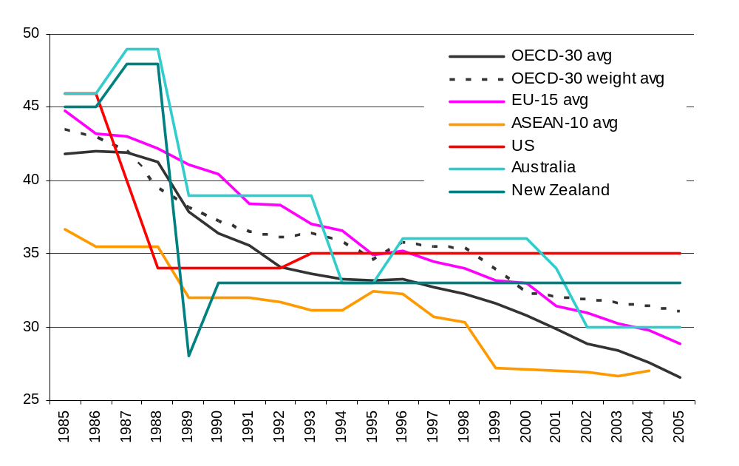
Between 1985 and 2004, the OECD average federal company tax rate fell from 43.5% to 31% on a GDP-weighted basis (or from 41.8% to 26.6% on an unweighted basis). Over the same period the Australian company tax rate fell from 46% to 30%, and the New Zealand rate fell from 45% to 33%.

At the beginning of the 1990s New Zealand’s corporate income tax rate was well below the OECD average and similar to the average of a group of ten ASEAN countries. Since then, reductions in the company tax rate in other countries mean that New Zealand’s company tax rate is no longer relatively low.

Our relatively high company tax rate, at present, may make New Zealand an unattractive place in which to establish a regional headquarters. The importance of this is difficult to measure, and other considerations – such as size of market, other taxes, labour costs and other regulatory considerations – may often be more important.

A relatively high company tax rate also exposes New Zealand to transfer pricing and thin capitalisation pressures. Tax authorities in New Zealand and other countries endeavour to constrain transfer pricing and thin capitalisation but there is strong international evidence that such measures are less than perfectly effective. A particular area of vulnerability for New Zealand is Australia’s tax system, given the importance of Australian investment into New Zealand. (Forty-six percent of foreign direct investment into New Zealand in 2003–04 came from Australia.) In 2000 Australia had a higher company tax rate than New Zealand, 36% compared with our 33%. Since then Australia has lowered its tax rate to 30%.

An additional consideration is that Australian shareholders in Australian firms gain imputation credits for Australian taxes, but not for New Zealand taxes. Even if the New Zealand and Australian company tax rate were aligned, there would be an incentive for New Zealand subsidiaries of Australian parent companies to stream profits to Australia. Stemming these incentives may require New Zealand to have a significantly lower company tax rate than Australia’s.

At present, company tax contributes more than 15 percent of total tax collections and therefore contributes significantly to the government’s overall fiscal position. The possible erosion of this tax base is a material fiscal risk. It is of interest to note that none of the five countries with greater tax collections as a percentage of GDP than New Zealand have higher company tax rates. A key concern is whether we will be able to continue to collect as much company tax as we do at present if we do not lower the rate of company tax. On the other hand, in the absence of any changes in corporate behaviour, lowering the company tax rate clearly reduces revenue.

Robustness of personal income tax system
In any tax system with varying marginal tax rates and a company or trustee tax rate below the top personal marginal tax rate there will be incentives to split and shelter income. By international standards, New Zealand has relatively little variation in statutory marginal tax rates. The range of 19.5% to 39% (or 15% to 39%, including low income earners’ rebate) is relatively narrow.

Nevertheless, a number of key methods are currently used to split or shelter income. There are a number of specific anti-avoidance rules targeted at income splitting or sheltering as well as a general anti-avoidance rule, although their effectiveness is limited.

Companies
The use of a company is often a part of an arrangement that results in lower effective tax rates for individuals. The business is undertaken by the company. The company income is taxed at 33% and when distributed is taxed again at the recipient’s marginal tax rate, with an imputation credit for the company tax paid. If the company is owned by a shareholder whose marginal tax rate is 39%, the effect is one of deferral until the income is distributed.

Trusts
The income of a trust can be taxed as trustee income at a rate of 33% and later distributed to beneficiaries on a 39% marginal tax rate, with no further tax impost. Therefore the 39% marginal tax rate can be avoided by the use of trusts. Alternatively, the income can be directed to a beneficiary (perhaps a spouse) whose income may be taxed at a rate below 33%. It seems reasonable to assume that little income passed through trusts is taxed at 39%.

The use of a trust owning a trading company has become much more common recently, in which case the 33% company tax is often effectively a final tax, even though the beneficiaries of the trust may be taxed at a rate of 39%. Other assets are also frequently placed in a trust. If the assets are income-earning (for example, as business premises can be) a 33% maximum tax rate is often achieved. Less commonly, but prevalent in some parts of rural New Zealand, trading trusts are being used for active business and achieve the same effect.

Families and associated persons
The personal income of a high marginal rate taxpayer can be split with an associated low marginal rate taxpayer to avoid tax. This might be achieved by transferring an income-producing asset to the low rate taxpayer. Business income might also be split by paying a wage to the low rate taxpayer, or by operating as a partnership and paying the low earning ‘partner’ a proportion of the profits. If such payments are not commensurate with the contribution of the low rate taxpayer the arrangement may be subject to general anti-avoidance provisions, although they will never prevent all income splitting.

SSCWT and FBT “salary sacrifices”
We have some evidence that “salary sacrifices” for employer superannuation contributions are being actively marketed. (A “salary sacrifice” is the forgoing of salary and wage income to get other benefits.) A salary sacrifice for employer superannuation contributions, which are taxed as SSCWT (specified superannuation contribution withholding tax), can result in salary income that would be taxed at 39% being taxed at a lesser rate. SSCWT involves contributions being taxed at 33% or even less.

There are also incentives for salary sacrifice for fringe benefits because of the non-abatement of family assistance against fringe benefits. As charities are not taxed on fringe benefits, there are likely to be particularly strong incentives for charities to remunerate their employees by way of fringe benefits rather than salary and wages.

Empirical evidence
Figure 9 shows aggregate income of individuals for the years 1999, 2002 and 2004. It shows three large peaks. The first is around the $9,000 to $18,000 area and relates to recipients of government transfer payments. The second and third peaks are around the marginal income tax thresholds of $38,000 and $60,000.

From 1989–90 to 1999–00 the top personal marginal tax rate was aligned with the company tax rate and trustee tax rate. From 2000–01 the top personal marginal tax rate was raised to 39%, while the company tax rate and the trustee tax rate were left unchanged. Since then there has been substantial growth in the number of taxpayers earning income around the 33% and 39% thresholds of $38,000 and $60,000, which is likely, at least in part, to be evidence of tax sheltering or income splitting.

Figure 9 – Aggregate taxable income of individuals by $1,000 bands of taxable income
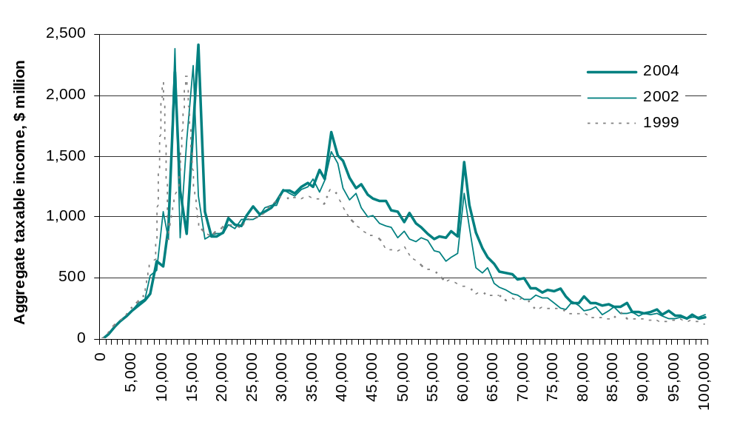

Figure 10 shows the growth in numbers of individuals with incomes in different income bands between 1998–99 and 2003–04. In the absence of tax considerations, it might reasonably have been expected that there would be negligible or negative growth in the lowest income bands and strongest growth rates in the highest income bands as income growth shifts individuals up the income spectrum. However, numbers of taxpayers with incomes below $38,000 grew by 1.0 percent, those with incomes between $38,000 and $60,000 grew by 48.4 percent, those with incomes between $60,000 and $100,000 grew by 71.8 percent, those with incomes between $100,000 and $150,000 grew by 32.1 per cent, those with incomes between $150,000 and $500,000 grew by 24.7 percent, those with incomes between $500,000 and $1 million grew by 8.2 percent and those with incomes above $1 million fell by 6.3 percent.

While there is no obvious evidence of people sheltering from the top 39% marginal tax rate in the $60,000 to $100,000 range, the slower or negative growth rates for higher income individuals is likely evidence that significant numbers of those with substantial amounts to gain through income splitting and tax sheltering are availing themselves of these opportunities.

Between 1998–99 and 2003–04 the proportion of shareholder/employees reporting salaries of exactly $60,000 (to the nearest dollar) rose from 0.45 percent to 4 percent of such individuals. The number of individuals deriving over $100,000 from shareholder salaries almost halved over the same period, to 3,600.

Figure 10 – Growth in numbers of taxpayers 1998–99 to 2003–04
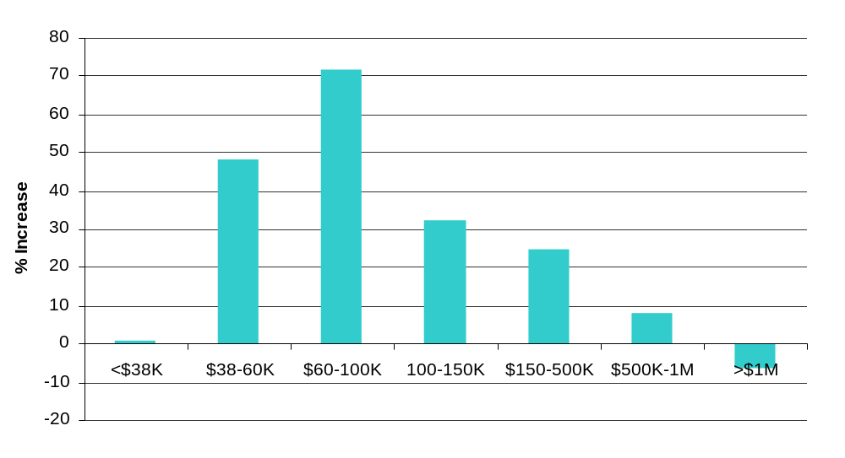

In the absence of tax considerations, there would be no a priori reason for there to be different growth rates for tax paid by companies, trusts and other persons. In the absence of any changes in behaviour, it might perhaps be expected that the increase in the top personal marginal tax rate would increase tax collections from other persons relative to trusts and companies. However, between 1998–99 and 2003–04 tax paid by trusts grew by more than 105 percent, to $480 million, while company tax grew by 71 percent, to $6,581 million, and tax paid by individual other persons rose only 16 percent, to $3,858 million.

Similarly, and in the absence of tax considerations, there would be no reason to expect different growth rates in the fraction of the income of trusts that is taxed as trustee income and the fraction taxed as beneficiary income. However, the increase in the top personal marginal tax rate to 39% means that those on the highest marginal tax rate can shelter income in trusts by having it taxed at a rate of 33% as trustee income.

Figure 11 shows trust income between 1998–99 and 2003–04, split by trustee income and beneficiary income. Over the five years from 1998–99 to 2003–04 trustee income grew by 256 percent and beneficiaries’ income by 28 percent. Practically all of this income growth is in the form of imputed dividends.

Figure 11 – Income from trusts (IR 6)
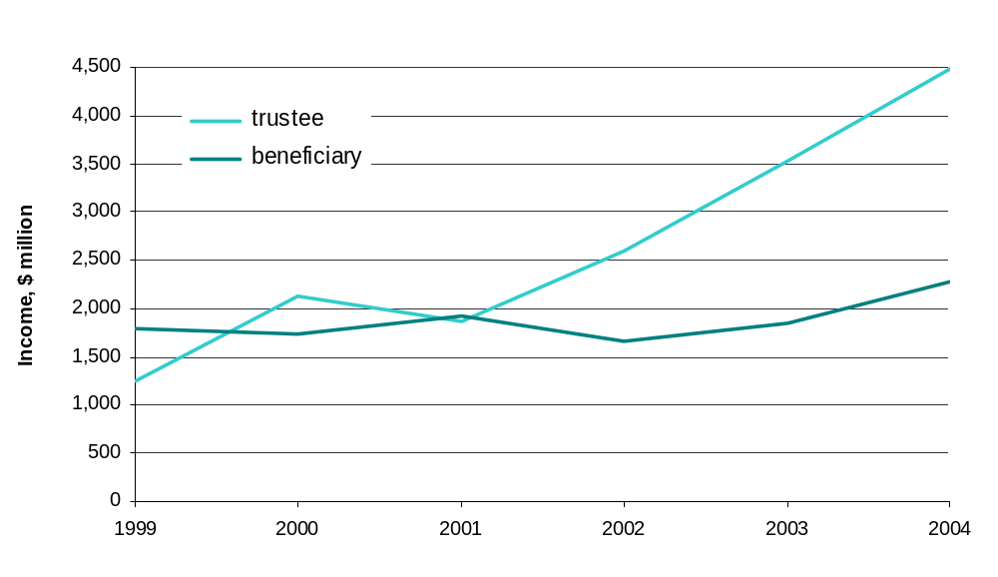
This difference in growth rates may not all be an indication of people sheltering from the top personal marginal tax rate. Part of the reason for the difference may be changes to the minor beneficiary rule in the Income Tax Act, which resulted in income distributed by a trust to a minor beneficiary being taxed as trustee income in 2002 and subsequent years.

Although there is no hard evidence yet of significant increases in salary sacrifice, there is strong anecdotal evidence that schemes using SSCWT to lower tax payments aggressively are on the rise.

The cumulative evidence suggests that, in practice, our tax system may be much less progressive than the statutory tax rates would suggest, which raises concerns about the possible corrosion of the tax system. In a self-assessment system such as New Zealand’s, it is critical for taxpayers to accept that the tax rules are broadly fair and even-handed. There is a danger that the emerging pressures we have identified may undermine the willingness of individuals to comply voluntarily. This needs to be taken into account when considering future changes. A key consideration when examining future possible tax changes is whether they increase or decrease the robustness of the tax system.

International comparisons
The income splitting and tax sheltering opportunities we have highlighted are not unique to New Zealand and, at least on the surface, there would appear to be greater problems in many other countries that have greater differences between the top and the bottom personal marginal tax rates or between the top personal tax rate and the company rate.

In particular, New Zealand’s gap between its company tax rate and top personal rate looks small when compared with Australia’s (a six percentage point gap as opposed to Australia’s 18.5 percentage point gap). However, New Zealand may be less able to sustain a major difference because of the absence of a capital gains tax. The absence of a capital gains tax allows those on the top marginal tax rate to realise profits from a company as a tax-free capital gain rather than income. This can lead to the 33% company tax rate being very similar to a final tax when profits can be accumulated for a sufficiently long time before eventual distribution. We are not advocating the introduction of a capital gains tax. The question of whether to introduce a capital gains tax was examined by the Tax Review 2001, which concluded that “the disadvantages of taxing capital gains on a realisation basis outweighed any theoretical benefits from extending the base in this way”. However, if the company tax were reduced significantly, relative to the top personal marginal rate, this issue might need to be reconsidered. For example, in Ireland a capital gains tax is considered essential to maintain the large difference between its company tax rate of 12.5%, and the top marginal personal income tax rate of 48%.

Measures to deal with income splitting and tax sheltering
Perhaps because of greater differences in tax rates, other countries have done more than New Zealand in directly targeting income splitting and tax sheltering. Measures that deal with income splitting and sheltering are likely to be more administratively complex than aligning rates. Effectively, people’s incentives to avoid tax increase the less rates are aligned, and preventing avoidance necessarily gets more difficult and necessitates more complex rules. Unless the government is willing to move to closer alignment of rates, we may need to consider some of these more complex rules.

When looking at countries with tax systems similar to New Zealand’s (Australia, Canada, the UK, the US and Ireland), the most common measures have been:
- the alignment of trust and top personal tax rates
- income attribution rules
- rules to prevent the sheltering of personal services income through a company and
- excess retention taxes on the undistributed income of a company.

The most common approach taken in these countries has been the alignment of trustee and top personal rates, thus removing the incentive to use a trust to shelter income. In Australia, the UK, Canada and the US, the trustee rate is generally aligned with the top personal rate. Ireland also largely aligns rates by imposing a penalty tax on the undistributed income of discretionary and accumulation trusts, effectively equating the trustee rate with the top personal rate.

Income attribution rules are in place in Canada and the United Kingdom. These “attribution” (Canada) or “settlement” (UK) rules are aimed at preventing income splitting with a taxpayer (including via a trust) subject to a lower tax rate. Transferred income can be attributed to income of the person making the transfer. These rules can be both complex and costly to administer, and are subject to a number of exceptions limiting their effectiveness. More recent reforms attempting to plug these gaps in Canada have added another layer of complexity yet still result in exploitable gaps. Similar rules apply specifically to trusts in the US.

Rules are in place in Australia, the UK, the US and Canada to prevent the sheltering of personal services income through a company. These rules, generally termed “personal services company” rules, have been implemented in two ways. Company income can be attributed to the owner(s) of the company, as happens in Australia, the UK and the US. Alternatively, the company can be denied deductions and any other benefits that an individual would not be entitled to, as occurs in Canada.

Although other measures implemented overseas have had mixed success, there appears to be some consensus as to the benefit of personal service company rules. While also somewhat complex, these rules appear very successful in countering the sheltering of income from personal exertion in companies. New Zealand already has rules that cover the most blatant forms of sheltering personal exertion income. However, as long as the top personal and company rate are not aligned there appears to be a case for more comprehensive reform such as that in place in Australia.

The US and Ireland both charge a penalty tax on excess retentions of income to prevent sheltering within a company. In some cases, Canada imposes a tax on investment income to promote distribution. The tax is then refunded on distribution. These rules appear to be complex, and have potential repercussions on companies’ incentives to reinvest retained earnings. Considering such measures requires some caution.

Possible directions for reform
There are a number of possible future directions for reform.

First, if there were sufficient fiscal headroom, one possibility would be to lower the top personal marginal tax rate to reduce discrepancies between the company tax rate and the top personal marginal rate. This option becomes more difficult if a substantial reduction in the company tax rate is being contemplated.

A second alternative is to increase the company and trustee tax rate to the top personal marginal tax rate. However, there are obvious problems with this direction of reform, given the increased incentives it would provide for transfer pricing and thin capitalisation. It is also likely to discourage inbound investment and hinder growth. Moreover, moves in this direction would not affect incentives for income splitting within a family, which largely depends on differences in rates of personal income tax.

A third option might involve some intermediate approach such as reducing the top personal marginal tax rate to 36%, increasing the trustee tax rate to 36% and reducing the company tax rate to 30%. This would maintain a six percentage point difference between the company tax rate and top personal rate and thereby not increase corporate tax sheltering opportunities for those on the top personal marginal rate relative to the status quo. At the same time it would remove the opportunity for trusts to be used to shelter income from the top personal marginal rate of tax.

The fourth possible direction of reform is to consider introducing some of the measures that other countries have adopted to directly confront income splitting and tax sheltering. This would, however, be likely to complicate the tax system. Even if there were to be greater tax rate alignment under one of the first three options, some move in this direction may be necessary. This is because tax sheltering schemes may be used not only to shelter income from higher rates of personal tax but also to shelter income from the very much higher effective marginal tax rates which arise when family assistance is being abated or child support is being assessed.

Key themes in future work
Base maintenance and remedial legislation will always be key features of the tax policy work programme.

In addition, a key theme over the next three years should be to consider measures to make the personal income tax system more robust. This could involve tax rate changes or strengthening anti-avoidance measures aimed at countering income splitting and tax sheltering – or a combination of the two. An important goal is to ensure that as much as possible of a person’s tax liability is independent of how he or she structures the vehicle through which income is earned.

A second key theme is to increase the robustness of our tax rules on foreign investment in New Zealand. This theme stems from the importance of company tax as a revenue source for New Zealand. There are strong international pressures on the company tax base, and any major reduction in this base is likely to place upward pressure on other tax rates. One way of increasing robustness is to lower the company tax rate; another is to step up measures that counter tax avoidance and international arbitrage by companies operating in New Zealand.

When New Zealand introduced its full imputation system, in 1989, it decided that it would not provide imputation credits to foreign investors. The aim was to tax profits earned by foreign-owned firms that are sourced within New Zealand.

At present, however, some strong pressures are tending to erode source-basis taxation when companies are wholly or partly foreign owned. These include:
- streaming of imputation credits which would normally be received by foreign residents back to New Zealand residents and
- diversion of New Zealand profits to foreign countries and then streaming them back to foreign parties without full New Zealand tax being paid, as a result of our conduit or dividend withholding payment provisions.

Australia is a very important foreign investor into New Zealand, and when Australian firms invest into New Zealand through branches or subsidiaries the Australian full imputation system provides incentives for profits to be streamed to Australia to avoid New Zealand tax.

The incoming government will also need to consider other important international issues. For example, concerns have been expressed that New Zealand’s relatively high rates of withholding tax on dividends, interest and royalties can provide an impediment to international investment. Australia has raised the issue of withholding tax in relation to our double tax agreement, to which we need to respond by the end of the year. There can be reasons to be cautious about reducing rates of withholding taxes. Withholding taxes on interest and royalties can be important in helping sustain source basis taxation, which is especially important if New Zealand wants to maintain a significant company tax base.

In our view, progressing both these international taxation concerns and measures to make the personal tax rate system more robust are key priorities for the next three years.

Administration of tax and social support programmes
Introduction
Through our people we deliver the services that the community needs to meet their obligations and receive their entitlements. We are a large employer, with 4,762 full-time equivalents in 17 cities and towns around New Zealand. Over the past three years we have worked hard to develop the skills of our people, particularly their tax technical and leadership skills. In the 2004 staff climate survey, our people showed strong support for our strategic direction and our approach.

The tax administration continues to enjoy high levels of community confidence, as shown by strong revenue flows and high levels of customer satisfaction with our services. As at 30 June 2005, 85% of customers rated our services as good or very good. We have maintained this level of confidence in the face of a continually changing environment, which includes a continued growth in the customer base. However, there are a number of challenges that we still need to address.

The key issues
We have four challenges:
- The department is currently implementing a full programme of initiatives, which would need to be reprioritised if we were required to implement any new initiatives
- The continuing growth in the customer base and community expectations is putting pressure on our ability to manage the annual workloads
- Pressures on the department’s infrastructure, particularly our information technology systems and people capability needs to address changes to policy or new business.
- Addressing compliance issues, arising from the growth in customer base and demonstrable shifts in customer behaviour in response to current policy setting.

Status of the operational work programme
Before this year’s general election, we had a full operational work programme which included the proposals announced in Budget 2005. In the medium term, this puts considerable pressure on our ability to develop and implement the operational work programme in an integrated way.

Table 2 sets out the major features of the operational work programme in terms of the development of the administrative processes required to implement announced policy initiatives. This programme needs to be revised in accordance with any changes in government policy or priorities. For example, any new initiatives would require reprioritising the current operational work programme.
Table 2– Major features of the operational design work programme to June 2007
Period | Major work and initiatives to be implemented
June 2005 to December 2005 | - Initiate project for the design and development of the proposed KiwiSaver programme  - Initiate project for the design and implementation of the proposed treatment of the collective investment vehicles  - Implementation of the extended paid parental leave for self-employed people.
December 2005 to June 2006 | - Introduction of In-work Payment (IWP)  - Initiate project for the design and development of the proposed carbon tax  - Implement discount for early payment of tax in first year for small- and medium-sized enterprises  - Develop a B2B solution to improve Companies’ Registration information  - Implement imaging technology to reduce manual processing, including an electronic document storage and retrieval (EDSR) system
June 2006 to December 2006 | - Plan for the proposed alignment of the provisional tax for GST and provisional tax for small- and medium-sized enterprises (subject to legislation)  - Design and implement initiatives for the reviewed IRD number evidential requirements  - Implement B2B solution to improve companies’ registration information
December 2006 to June 2007 | - Implement proposed carbon tax (1 April 2007)  - Implement proposed KiwiSaver programme (1 April 2007)  - Implement changes to policy for the treatment of the collective investment vehicles

Through to June 2007, the department has a very busy schedule in designing and implementing the operational and technology-based systems for planned legislative changes. The ongoing implementation of the Working for Families package of reforms (particularly the development of the In-work Payment), and the design of administrative processes and systems for the proposed KiwiSaver and the carbon tax are set out below.

Working for Families
Phase two of the implementation of the Working for Families package of reform is currently under way, with the largest component being the introduction of the In-work payment to replace the current child tax credit. The In-work payment will become operational from 1 April 2006. The ongoing work effort required to implement the Working for Families reforms is considerable, requiring:
- significant system changes needed to support the various programmes
- considerable growth in customer contacts across the department’s functions
- working closely with the Ministry of Social Development to ensure that customers receive a seamless service across both agencies.

This work will continue through to 1 April 2007, with the introduction of further increases in family support rates (as part of phase three of Working for Families package).

Paid parental leave
We are continuing to implement the changes to extend the paid parental leave scheme to cover people who are self-employed. The changes are effective from December 2005.

KiwiSaver
The proposed KiwiSaver was announced in Budget 2005 to encourage a change in the savings behaviour of individuals. As it was envisaged, Inland Revenue is to be the central administrator of KiwiSaver. The fundamentals of the design of KiwiSaver were approved by the former government. However, we (and other agencies) are conducting an ongoing process of detailed design and consultation with key stakeholders. As such, the final detailed design of the KiwiSaver scheme is yet to be established.

Carbon tax
The department has started work on the design of the proposed carbon tax (as announced in Budget 2005). The proposed carbon tax is expected to become operational on 1 April 2007.

Growth in customer base
The department is facing pressures from the continued growth in revenue assessed (Table 3) and the customer base (Table 4), which are causing workload management issues across all of our service-based functions.
Table 3– Growth in revenue assessed
Tax type | 30 June 2002  $ billion | 30 June 2003  $ billion | 30 June 2004  $ billion | 30 June 2005  $ billion
Direct taxation | $24.557 | $27.251 | $29.178 | $32.826
Indirect taxation | $6.822 | $7.720 | $8.819 | $9.220
Total taxation | $31.379 | $34.971 | $37.997 | $42.046

Table 4 – Growth in customer base
Customer type | June 2001  million | June 2004  million | % growth
Social support | 0.737 | 0.872 | 18%
Taxpayers | 5.303 | 5.769 | 9%

The growth in the customer base is the result of:
- social support programme changes that broadened eligibility for entitlements (such as Working for Families) and the increasing number of student loan borrowers. There is also significant fluidity in the base, with people moving in and out of work and changing family circumstances.
- economic activity, which is supporting the growing number of businesses. Illustrating this growth, Figure 12 shows the increase in the number of small and medium sized enterprises over the past five years. These businesses generate considerable numbers of contacts in any given year.

Figure 12 – Growth in small and medium sized enterprises
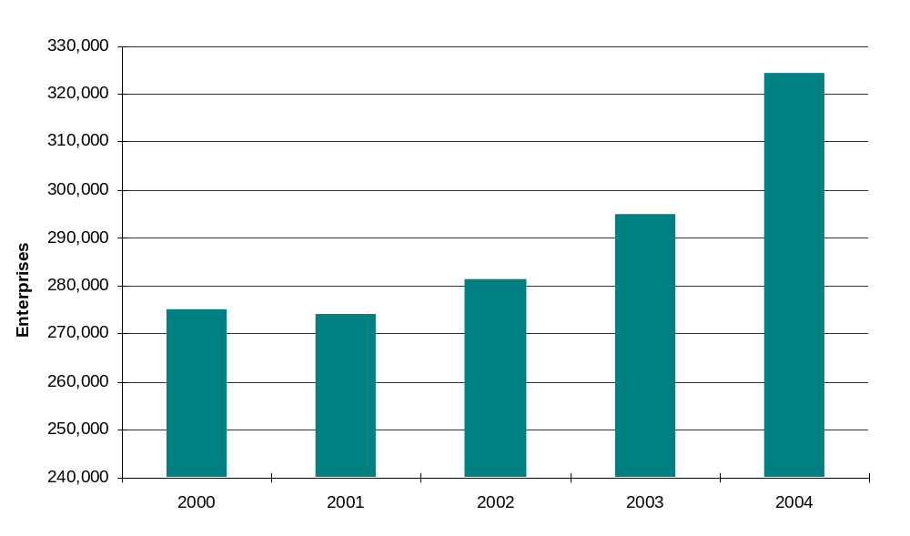
Source: Statistics New Zealand

Generally speaking, the growth in our customer base is generating an increased number of interactions that we have with our customers and this is putting considerable pressure on our ability to deliver our services. The drivers of these pressures include:
- the generation of approximately 7.7 million forms and statements per year, which create, sometimes unnecessary, customer contacts. We need to redesign some of our processes to get benefits for government and taxpayers but, in doing this, this will incur costs in information technology and implementation.
- the wide range of interactions we have with various customer groups, for example:
- the nature and complexity of the query, and the frequency of contacts
- the range of channels available for customers to contact us, including traditional and electronic delivery channels
- our ability to manage seasonal workloads, especially the peak period for telephone contacts, which is generally the last quarter of the financial year. Table 5 shows the number of peak and non-peak days planned for the last quarter of 2004–05.

Table 5 – Peak and non-peak days planned for last quarter 2004–05
 | Days planned | Days actual
Days with more than 17,500 calls accepted | 40 | 54
Days with less than 17,500 calls accepted | 36 | 22

In addressing the growth pressures, we have taken a broad-based approach by:
- managing workloads through our business-as-usual processes with the appropriate reprioritisation of resources when required (particularly around peak periods for customer contacts)
- seeking more cost-efficient options for the processing of information and the delivery of our services that make it easier for people to interact with us electronically.
- training our people, and recruiting people with the right skills and knowledge required to deliver our services.

Infrastructure
In this section, we look at three broad areas:
- our information technology systems
- developing our people capability
- accommodation issues.

Ability to make information technology system changes
The department operates a large information technology infrastructure to support the department’s various functions. The main component of our technology infrastructure is FIRST (Future Inland Revenue System Technology), which was introduced in 1992.

At that time, the department’s role was purely tax administration and FIRST was designed accordingly. Since then the department’s responsibilities have been significantly expanded to include many social policy activities including family assistance, child support, and student loans. The technology support for these activities has been integrated into FIRST, creating a more complex system than was originally designed. This complexity continues to increase as our systems are modified to incorporate policy changes, resulting in both increased cost and time to implement further changes.

Over the past 12 months there have been indications that our systems are reaching a “tipping point”, where consideration will need to be given to replace systems rather than make further changes to existing systems. This is a particular concern for the administration of the student loans system.

We also have a full development programme implementing business-as-usual changes required to maintain the integrity of business processes, as well as development work to implement already initiated policy initiatives. Therefore, making significant changes to the systems will require Inland Revenue to reprioritise its development programme to ensure that priority changes can be made in a timely manner.

Benchmarking (completed in 2003–04) against a number of international tax authorities found that we have a highly-educated, stable technology workforce, and that we efficiently use our hardware and processing power and storage. However, it also confirmed that our “time to market” for new products and services was at the high-end of industry standards.

Delivering efficient electronic products and services
We are recognised nationally as being a leading example in the delivery of online services. Our focus on designing and delivering services through electronic channels is consistent with the goals of the e-Government programme. The provision of services electronically provides people with easy and convenient access to our services and, therefore, reduces the need for people to contact us unnecessarily. Over the past three years there has been an increase in the range of services we offer electronically as shown in Table 6.

Table 6 – Comparison of electronic services available from 2002 to 2005
Service | 2002 | 2005
Authentication using a user ID with passwords and/or PIN | ✓ | ✓
Use of third party filing software and vendors | ✓ | ✓
Tax agents: client filing facilities | ✓ | ✓
Tax agents: Look at Account Information service |  | ✓
Businesses: PAYE filing | ✓ | ✓
Businesses: GST filing |  | ✓
Businesses: Income tax filing |  | ✓
Individuals: Income tax filing |  | ✓
Individuals: Look at Account Information service |  | ✓
Payment by internet banking | ✓ | ✓
Payment by credit card |  | ✓
Online correspondence |  | ✓
35 interactive online forms |  | ✓
15 online calculators |  | ✓

The key driver of this development has been our e-enablement strategy. Launched in 2002, this strategy initially focused on providing the most easily implemented services through electronic channels. This approach was intended to support the E-government strategy goal for 2004 of the internet being the dominant means of enabling ready access to government services. We are currently refreshing our 2002 e-enablement strategy to assess our current position and to realign it in accordance with the E-government goal of: “by June 2010, the operation of government will have been transformed through its use of the Internet”. Many international revenue authorities have highlighted the importance of introducing new electronic services and transforming their business through the use of the e-channel.

One of the key challenges in this area is realising efficiency gains through the introduction of these new services. The experience of other similar organisations suggests that new electronic services can increase operating costs. This is because these services are in addition to, rather than replacements for, existing services. It is not until there is significant uptake of the new services that the cost efficiencies are gained. An OECD assessment suggested that we are still relatively immature in terms of our uptake and marketing strategies. We are experiencing slow but steady increases in the level of uptake, which shows that there is more scope for us to improve our marketing of these services.

However, we are experiencing an increasing number of tax agents and individuals using our Look at Account Information service to access account information. Illustrating the extent of this growth, Table 7 shows the number of accounts accessed during three months of 2004–05.

Table 7 – Accounts accessed through our Look at Account Information service for the month
 | July 2004 | January 2005 | July 2005
Accounts accessed by tax agents | 4,677 | 83,578 | 294,783
Accounts accessed by individuals | 460 | 17,659 | 57,087

Service contracts
In addition to the delivery of electronic services, during the 2004–05 year we took important steps to establish forward-looking contracts with some of our key service providers.

During 2004–05, we signed a new seven-year mainframe services contract with EDS, which has increased our processing capacity and takes advantage of improved technology. This provides us with a more cost-efficient service. This is vital for our ability to meet the growing demand for our services and to secure our future business needs.

In April 2005, we signed a six-year telecommunications services outsourcing agreement with TelstraClear. Under this agreement, TelstraClear will provide a managed service for our telecommunications needs. The modernisation of our telecommunication network increases its business usefulness (making it flexible, cost-effective and scaleable) and provides a platform from which we can improve productivity. The advanced functionality has the potential to allow staff to respond more quickly to customer queries and reduce call waiting times. This will translate to improvements in our interactions with taxpayers and within Inland Revenue.

People capability
Our biggest asset is our people and we continue to make a large investment in their development. This is vital for the department’s ability to ensure the sustainability of the tax system, deliver our services today and to prepare for future challenges and service requirements.

Given the diverse nature of our tax and social support programme work, we need to have a wide range of skills and knowledge to help us deliver our services and achieve our outcomes. Some of the key drivers for our continued development include:
- an increasing complexity in the business environment and in the types of issues that people are asking us. This is particularly the case in the compliance improvement areas around audit and debt collection, but also in terms of the increasing complexity being faced in our customer contacts and rulings requests. This means that we need to continue to develop our people’s technical expertise.
- the addition of new functions, such as the proposed KiwiSaver and the carbon tax, also means that we need to develop a wider range of new skills that are not primarily based on taxation knowledge.

We are addressing these requirements through ongoing training (for example our technical development programmes) but often the only response is to recruit new people who have the required skills. However, we are facing pressure in our ability to recruit people with the appropriate skills, particularly given the tight labour market that is seeking the same skills across the public and private sectors.

We also face challenges in funding the level of remuneration required to attract and retain people with the skills we need. This issue is particularly relevant because:
- although there is a low turnover rate of 10.2% across the department, we are concern about particular areas (predominantly tax technical areas) where turnover is higher than average and it is harder to recruit and train people in these areas
- the level of competition in the labour market for specialist staff (for example tax professionals and information technology specialists).

Part of our approach to addressing this issue includes providing a competitive level of remuneration (commensurate with the public sector), access to appropriate training and a stimulating work environment to secure the long-term sustainability of our workforce.

Accommodation issues
We are facing pressure in our ability to accommodate our people. Key drivers of this pressure arise from recruitment of staff to address the growth in the customer base and recruitment to address new business. We are also likely to experience increases in rental expenditure as currently leases reach maturity and will need to be renegotiated.

Addressing compliance issues
We are guided in our compliance activities by the compliance model that promotes a tailored, responsive approach to taxpayers and social support customers (see Figure 13). It takes account of the external factors that influence taxpayers’ attitudes and behaviours. Our risk analysis recognises these differences in attitude and helps us develop appropriate ways of improving compliance.

Figure 13 – Compliance model

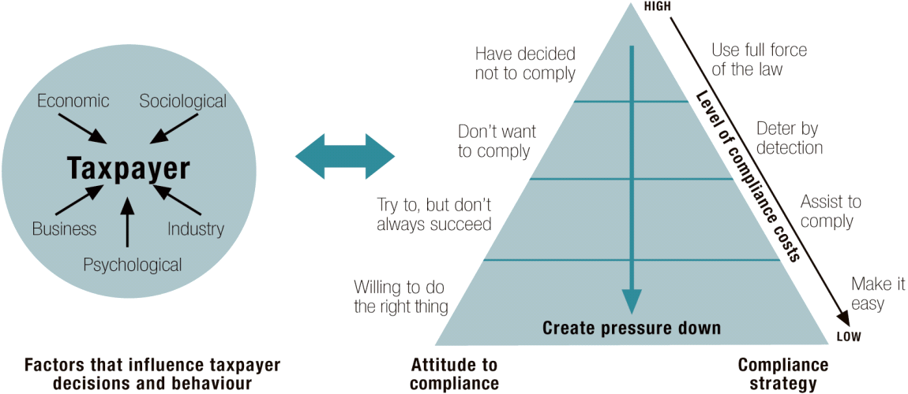

A key concept behind the model is that the majority of taxpayers comply voluntarily or aim to comply. For these taxpayers our response to a compliance concern is to make it easy for people to meet their obligations by tailoring our services to meet people’s individual needs.

At the same time suitable sanctions are needed for cases where people deliberately do not comply. Enforcing the law in such cases helps to maintain overall taxpayer confidence in the tax system and encourages ongoing compliance. However, when we are undertaking work to enforce the law our approach needs to be designed to move taxpayers to a position where they are likely to comply voluntarily in the future.

This means that we need to use an integrated mix of activities and skills to address non-compliance areas, such as:
- compliance issues that have been identified by our enforcement activities (note that some of these issues are also discussed under “Tax policy” particularly tax sheltering and income splitting)
- effects of growth in the customer base (for example increasing levels of debt).

Compliance issues identified through enforcement activity
We continue to focus our audit activity on high-risk areas such as avoidance and evasion. Recent legal challenges to major avoidance schemes were successful and these send a strong message to promoters of such schemes and to potential investors. Legislation enacted in 2003 reinforced the message by including a new penalty on promoters of certain tax schemes.

A high priority was also given to tax evasion, particularly as a follow-up to the Industry Partnership initiatives to educate and promote compliance among taxpayers who were willing to do so. In auditing small- and medium-sized enterprises, our primary areas of focus included:
- real estate property where tax issues arise from timing of claims on property purchases and undeclared profits relating to GST and income tax for speculative transactions
- tax evasion and income suppression associated with taxpayers working outside of the tax system, failing to meet employer obligations and fraud cases (for example claiming false GST credits)
- tax avoidance associated with various schemes that are intended to reduce a taxpayer’s tax liability. In many cases, these schemes are highly complex and often involve international arrangements or sophisticated structures that require lengthy audit work. Arising from this complexity, our auditors need to have highly developed technical knowledge and the skills to deal with these cases.

The Courts are also taking a serious view in the sentencing of people convicted of tax evasion and avoidance offences. During 2004–05, we took prosecution action under the Crimes Act in five cases and prosecuted 41 people under the Revenue Acts. For the 2005–06 year we have 20 pending prosecutions under the Crimes Act, 75% for evasion and 110 pending prosecutions under the Revenue Acts of which 73% are for evasion offences.

In addition, many of the concerns discussed under “Tax policy” are addressed in our audit activity, particularly:
- the use of trusts owning a trading company is becoming more common. We have evidence that taxpayers are using trading trusts to alienate personal service income to reduce the tax rate they would pay on their incomes. The policy issues surrounding income splitting, tax sheltering and discussions on tax rates are discussed in the tax policy section.
- New Zealand sourced-based income being artificially re-characterised as foreign income and taxed at the 15% withholding tax rate rather than the company tax rate of 33%. Issues around international tax are covered in the tax policy section. This highlights the fiscal risk posed by our relatively high reliance on company tax collections. Administratively, this means we need to maintain, if not enhance, our audit and litigation capability in dealing with corporate taxpayers.
- our audit activity has uncovered a number of GST fraud and avoidance schemes that revolve around input tax credit schemes to obtain tax refunds. Some of these schemes have involved identity fraud. GST schemes pose a high fiscal risk because if input credits are available with no offsetting output tax the result is a net government fiscal cost. International experience has demonstrated the high fiscal risks with GST-type taxes. The main response is likely to be audit and litigation but this may need to be backed by policy changes.
- Finally, the high effective marginal tax rates for many individual taxpayers as a result of the abatement of family assistance and related measures is likely to require increasing focus on various forms of income sheltering.

Debt management
Over recent years, the rising level of collectable debt has become a concern (Figure 14). Over the years, revenue has continued to grow significantly, while resources to collect overdue debt have remained static. At 30 June 2005, collectable debt was $1,553 million, compared to $1,296 million in 2004.

Figure 14 – Collectable debt 2003–04 and 2004–05
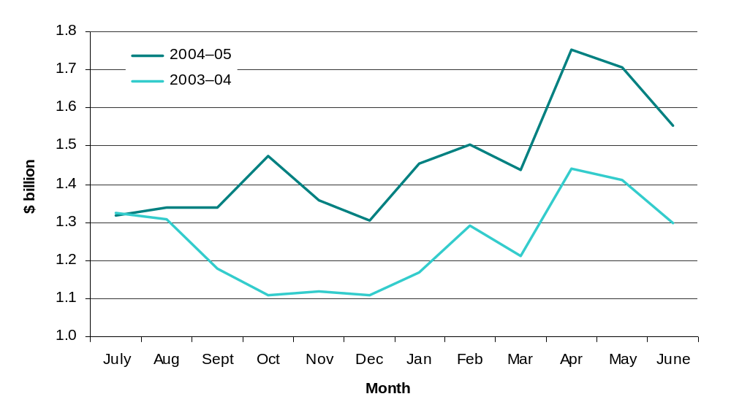

The main issues with debt include:
- the increase in the level of debt
- the older debt becomes the harder it is to collect, there is also the potential for more debt to be written off
- complex business structures used to frustrate the collection of debt, for example “phoenix” companies
- the steady increase in the level of outstanding student loan debt.

Addressing outstanding debt requires us to focus on maximising the amount of debt paid on-time and also improving taxpayer compliance behaviour. Our current debt management focus is on high-value debt, industry partnership debt (predominantly owed by small and medium sized enterprises), old debt (debt older than two years old) and debt assessed through our auditing activity. We have been making good progress in these areas and will continue this focus in the coming year.

Child support
Total child support debt has now passed $1billion. As at 30 June 2005, the level of child support debt had grown to $987 million, 16% more than in 2003–04 (see Figure 15). Of the total debt, 43% is assessment arrears and 57% is penalties.
Figure 15 – Child support debt
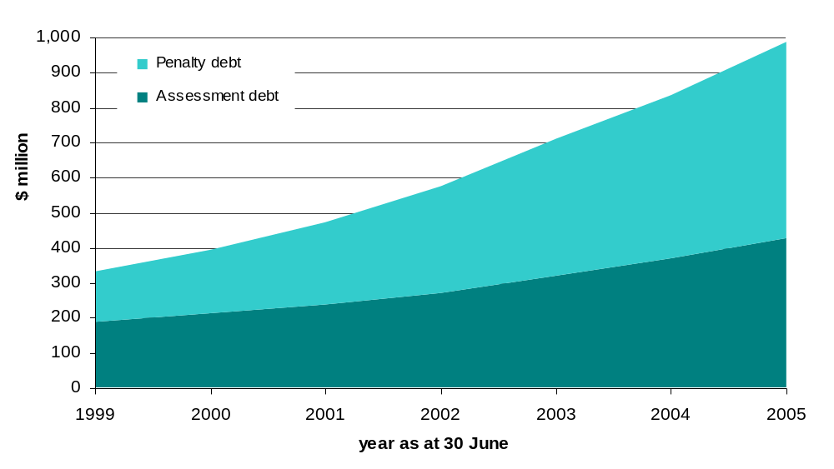
Over time we have made good progress in managing our child support responsibilities. As at 30 June 2005, we have collected 86.3% of all child support assessed since the programme began in 1992. However, the present level of debt presents a significant risk to public perception in regard to the effectiveness of the child support programme. Funding has been provided in the 2004 and 2005 budgets to address the debt issue through administrative initiatives and these are now gaining traction.

Child support legislative change
Legislative changes crucial to supplement administrative improvements were proposed in the Child Support Amendment Bill (No. 4). The Bill has lapsed and public confidence in the child support programme will continue to erode unless you reinstate the Bill. A key component of the Bill is intended to bring non-compliant parents back into the child support system by providing incentives for them to reduce their outstanding child support debt through pro-rata write-off of incremental penalties for parents who meet their current liability and keep to their arrangement to repay arrears.

Child support - international relationships
We have a close working relationship with the Australian Child Support Agency and operate a reciprocal agreement with them. In Budget 2005, we received an appropriation to pay for Australia to initiate the collection of payments from an additional 6,629 New Zealand cases where the parent has recently been identified as living in Australia. We are also considering similar agreements with other countries where there are known to be child support debtors.

As part of our international relationships, we keep a watching brief on developments in other jurisdictions, for example, the Australian Government recently commissioned a Ministerial task force to review the Australian child support programme. Recommendations in the report dated May 2005 are presently being considered by the Australian Government. Given the close nature of our relationship with Australia, we will need to consider making changes to the New Zealand system once the Australian Government have made final decisions.

Corporate risk-taking behaviour may also be discouraged at times because firms with insufficient other taxable income cannot utilise any losses immediately.
² See page 2 of the Final Report of the Tax Review 2001.
All data are from the OECD website, mostly from the OECD Tax Database.
2004 data for Japan, Greece and Poland.
This is the proportion of the average production wage at which the top marginal tax rate is first reached.
The corporate tax rate figure for Italy excludes regional taxes.
Weightings based on 2002 or 2004 GDP at current prices and exchange rates from OECD data.
Based on 2002 GDP at current prices and exchange rates from OECD data.
Companies in Australia and other countries may also be subject to taxes that do not exist in New Zealand – such as a comprehensive capital gains tax, payroll tax and stamp duties.
Excludes ACC levy of 1.2%.
Disposable incomes are market income net of tax payments and inclusive of income assistance.
This is not necessarily completely realistic as people on low wages working less than 20 hours (30 for a couple) would be financially better off on a benefit if they qualified.
Including ACC levy of 1.2%.
In theory, it is possible for households to face an EMTR of 95.2% (70.2+25) but as far as we are aware there are no such households.
This consideration led the Tax Review 2001 to suggest options for reducing the New Zealand tax rate on companies to 18% to the extent the company is owned by non-residents. These options were considered by the government but ultimately rejected on the grounds of fiscal costs and administrative impracticality.
For evidence on transfer pricing and thin-capitalisation within OECD countries see Bartlesman and Beetsma, 2003, “Why pay more? Corporate tax avoidance through transfer pricing in OECD countries”, Journal of Public Economics, 87, 2225-2252.
A recent paper by Lee and Gordon (2005) suggests a strong negative relationship between the company tax rate and economic growth (see, Lee, Y., and R.H. Gordon (2005), “Tax Structure and Economic Growth”, Journal of Public Economics, 89, 1027 – 1043.
See James Kelly and Robert Graziani – “International trends in company tax rates – Implications for Australia’s company income tax”, and the OECD Tax Database. For countries with a progressive structure of company tax rates, the top marginal tax rate is recorded. Because these data do not include state taxes and surtaxes they will tend to understate total tax rates in some other countries. The data show the standard company tax rate and ignore the fact that some countries may have preferential tax rates for certain activities.
The ten ASEAN countries are Brunei, Cambodia, Indonesia, Laos, Malaysia, Myanmar, the Philippines, Singapore, Thailand and Vietnam.
There can also be non-tax reasons, such as asset protection, for using companies.
Asset protection can also be a non-tax reason for using trusts.
Up to $100,000.
The figures for higher income individuals are less reliable because they are based on a sample of incomes, meaning the margin of error is higher for them because fewer taxpayers are involved. The year 1998–99 is used as the base year because businesses paid quite unusually high levels of dividends in 1999–00. This was likely to have been influenced by the increase in the top marginal tax rate from 33% to 39% in the following year.
Some trust returns remain outstanding for 2003–04, so the increases are likely to be a little higher once all the returns are completed.
Of course, Australia’s larger gap may also be problematic.
“All in rate” including social security and regional taxes.
KiwiSaver and the carbon tax.
This table does not include the design and implementation of the myriad of initiatives that form our business-as-usual improvement programme.
Note that the number of active entities is greater than New Zealand’s population. The reasons for this include: taxpayers remain in our system even if they are not currently resident in New Zealand (for example, the taxpayer may have an active student loan repayment obligation), and taxpayers may not have been deregistered after their deaths.
On a peak day we expect to accept more than 17,500 calls per day and on non-peak days we expect to accept less than 17,500 calls per day.
In 2004, the OECD Forum on Tax Administration Taxpayer Services sub-group surveyed the trends in revenue authorities use of new technology to deliver services.
Collectable debt includes debt for all tax types and ages. The newer debt is the easier it is to collect, however, as debt ages it becomes harder to collect. Collectable debt also includes debt that is currently under an active repayment arrangement, which accounts for 41% of collectable debt as at 30 June 2005.
A “phoenix” company is a company that has been “reborn” soon after (and in some cases before) its failure. The new company takes on the failed company’s business, often using a similar name, the same managers and directors, and the same assets, but without the previous company’s tax liabilities.
Currently there is no legislative flexibility to deal with the escalation in the level of child support penalties, which adds considerably to the level of total debt outstanding. Also, the incremental nature of the penalties can act as a disincentive to paying parents, which can result in them disengaging with the child support system.
This agreement provides for the collection of child support payments from New Zealanders living in Australia and Australians living in New Zealand.

