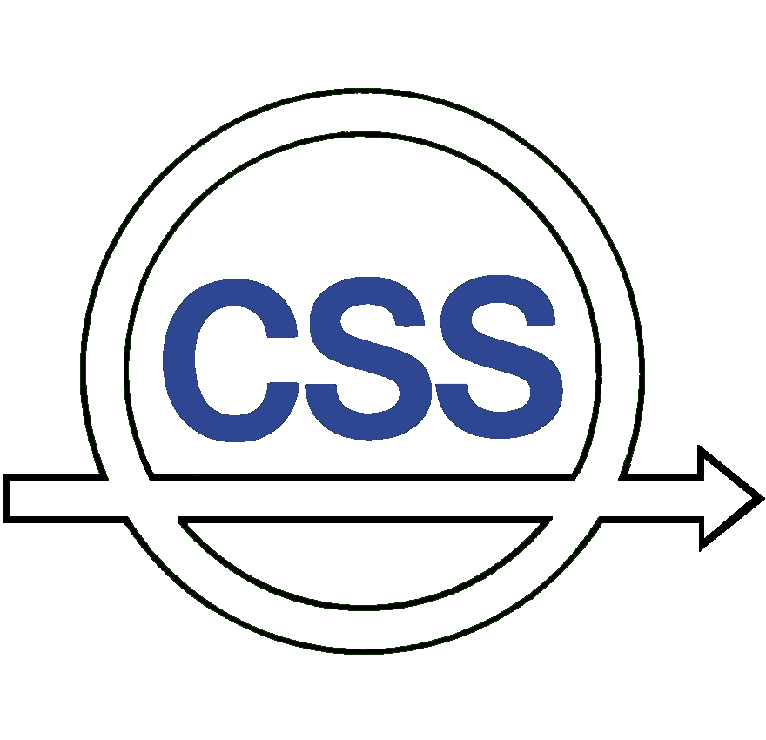


Agenda and Reports

IEEE CSS
Board of Governors Meeting

December 11, 2007

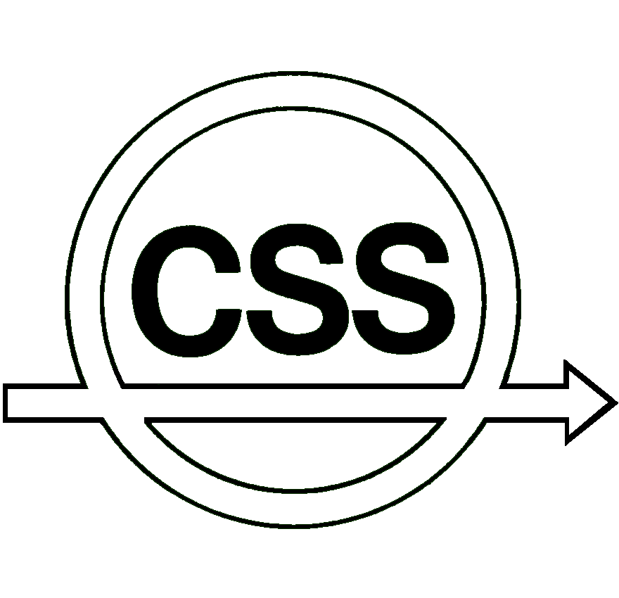
Agenda
IEEE CSS Board of Governors Meeting

December 11, 2007, 1:00 PM
Versailles
Hilton Riverside
New Orleans, Louisiana, USA

 |  | Call to Order and Approval of the Agenda |  |  |  |  |  |  | (Djaferis)
 |  | Approval of Minutes of July 10, 2007 BoGu Mtg. |  |  |  |  |  |  | (Djaferis) |  |  |  | Page 5
 |  | Action Items
 |  |  |  | Bylaw Changes
 |  |  |  | i. |  | SA Position Restructuring |  |  | (Djaferis) |  |  |  | Page 10
 |  |  |  | ii. |  | CAB Restructuring |  |  | (Djaferis) |  |  |  | Page 12
 |  |  |  | iii. |  | MAB Restructuring |  |  | (Valcher) |  |  |  | Page 13
 |  |  |  | Appointments for 2007
 |  |  |  |  | Continuing Appointments |  |  |  | (Castañón)
 |  |  |  |  | Appointed BoG Members (info only) |  |  |  | (Castañón) |  |  |  | Page 14
 |  |  |  |  | Nominating Committee |  |  |  | (Castañón) |  |  |  | Page 16
 |  |  |  |  | Standing Committees |  |  |  | (Castañón) |  |  |  | Page 18
 |  |  |  |  | Technical Committee Chairs |  |  |  | (Castañón) |  |  |  | Page 20
 |  |  |  |  | Awards Subcommittee Chairs |  |  |  | (Castañón) |  |  |  | Page 21
 |  |  |  |  | TCST AE Nominees |  |  |  | (Castañón) |  |  |  | Page 22
 |  |  |  |  | CSM AE Nominees |  |  |  | (Castañón) |  |  |  | Page 25
 |  |  |  |  | TAC AE Nominees |  |  |  | (Castañón) |  |  |  | Page 27
 |  |  |  | Finance Activities
 |  |  |  |  | 2009 Budget Parameters |  |  |  | (Abed) |  |  |  | Page 29
 |  |  |  | Conference Activities
 |  |  |  | i. |  | ISIC 2009 Program Chair |  |  | (Middleton) |  |  |  | Page 30
 |  |  |  | ii. |  | MSC 2010 General Chair and Venue |  |  | (Middleton) |  |  |  | Page 31
 |  |  |  | iii. |  | CDC-ECC 2011 Concept |  |  | (Middleton) |  |  |  | Page 32
 |  |  |  | iv. |  | CDC-ECC 2011General Chair |  |  | (Middleton) |  |  |  | Page 34
 |  |  |  | v. |  | CDC 2013 Venue and General Chairs |  |  | (Middleton) |  |  |  | Page 35
 |  | D. |  | Member Activities
 |  |  |  | i. |  | Developing Countries Conference Support |  |  | (Valcher) |  |  |  | Page 36
 |  |  |  | ii. |  | Travel support program for dev. countries |  |  | (Valcher) |  |  |  | Page 37
 |  | E. |  | Other Motions
 |  |  |  | i. |  | INFORMS Liaison |  |  | (Djaferis) |  |  |  | Page 38
 |  |  |  | ii. |  | Establishment of Task Forces |  |  | (Djaferis) |  |  |  | Page 39
 |  |  |  | iii. |  | Summary of Motions approved by email |  |  | (Djaferis) |  |  |  | Page 40
 | Activity Reports
 |  |  | Report of the President |  |  |  |  | (Djaferis) |  |  |  | Page 41
 |  |  |  |  | Standing Committees
 |  |  |  |  | a. |  | Awards | (Antsaklis) |  |  |  | Page 43
 |  |  |  |  | b. |  | Fellow Evaluation | (Cao) |  |  |  | Page 47
 |  |  |  |  | c. |  | Fellow Nominations | (Lindquist) |  |  |  | Page 47
 |  |  | ii. |  | President-Elect |  |  | (Castañón)

 |  | Report of Financial Activities Board
 |  |  | Vice President (Financial Activities) |  | (Abed) |  | Page 48
 |  |  | Standing Committees
 |  |  |  | Conference Finance | (Chong)

 |  | Report of Technical Activities Board
 |  |  | Vice President (Technical Activities) |  |  |  | (Farrell) |  | Page 51
 |  |  | Technical Committees
 |  |  | - a |  | Aerospace Control |  | (Buffington) |  | Page 51
 |  |  |  |  | Automotive Controls |  | (Rajamani) |  | Page 51
 |  |  |  |  | Behavioral Systems and Control |  | (Rapisarda) |  | Page 52
 |  |  |  |  | Bio-Systems and Control |  | (Khammash) |  | Page 53
 |  |  |  |  | Computer Aided Contr Syst Design |  | (Henrion) |  | Page 54
 |  |  |  |  | Control Education |  | (Pasik-Duncan) |  | Page 55
 |  |  |  |  | Discrete-Event Systems |  | (Leduc) |  | Page 56
 |  |  |  |  | Distributed Parameter Systems |  | (Demetriou) |  | Page 56
 |  |  |  |  | Energy Proc. & Power Syst |  | (Roy) |  | Page 57
 |  |  |  |  | Hybrid Systems |  | (Bemporad) |  | Page 57
 |  |  |  |  | Industrial Process Control |  | (Braatz) |  | Page 58
 |  |  |  |  | Intelligent Control |  | (Ge) |  | Page 59
 |  |  |  |  | Manufac Automation & Robot Control |  | (Bullo) |  | Page 60
 |  |  |  |  | Networks & Communication Systems |  | (Paschalidis) |  | Page 60
 |  |  |  |  | Nonlinear Systems and Control |  | (Teel) |  | Page 61
 |  |  |  |  | Systems Identification |  | (Ninness) |  | Page 61
 |  |  |  |  | Var Structure & Sliding Mode Control |  | (Sabanovic) |  | Page 61
 |  |  | Standing Committees
 |  |  |  |  | Standards |  | (Chang)
 |  |  | Liaison Representatives
 |  |  |  |  | IEEE Society on Social Implic of Tech |  | (Meyer) |  | Page 62
 |  |  |  |  | SIAM/SIAG Liaison |  | (Smith)
 |  |  |  |  | SICE (Instr. & Control - Japan) |  | (Ohta)
 |  |  |  |  | IEEE Nanotechnology Council |  | (Bamieh, Kosut)
 |  |  |  |  | IEEE Computational Intelligence Society |  | (Si)
 |  |  |  |  | IEEE Systems Council |  | (McClamroch) |  | Page 63
 |  |  |  |  | EUCA |  | (Camacho)
 |  |  | Representatives to External Committees
 |  |  |  | IEEE-USA Committees
 |  |  |  |  |  | Transportation Policy | (Horowitz)
 |  |  |  |  |  | Research & Development Policy | (Bielefeld)
 |  |  |  |  |  | Energy Policy | (Thomas)
 |  |  |  |  |  | Medical Technology Policy | (Martin)
 |  |  |  |  |  | Communication in Infor. Policy | (Gong)
 |  |  |  |  |  | Professional Activities Comm. | (Herget)

 |  | Report of Conference Activities Board
 |  |  | Vice President (Conference Activities) |  | (Middleton) |  | Page 64
 |  |  | Current Listing of Conferences |  | (Middleton)
 |  |  | Status Reports |  | (Middleton)
 |  |  | Final Reports |  | (Middleton)
 |  |  | Report on CSS Conferences |  | (Middleton)
 |  |  | Standing Committees
 |  |  |  | Conference Finance | (Chong)
 |  |  |  | Conference Editorial Board | (Parisini)
 |  |  |  | Conference Publication | (Misra)
 |  |  |  | Conference Administration | (Yurkovich)

 |  | Report of Publication Activities Board
 |  |  | Vice President (Publication Activities) |  | (Yamamoto) |  | Page 67
 |  |  | Editors-in-Chief
 |  |  |  | Transactions on Automatic Control | (Cassandras) |  | Page 69
 |  |  |  | Tech. Notes and Correspondence | (Tempo) |  | Page 73
 |  |  |  | Transactions on Contr Systems Tech | (Doyle) |  | Page 75
 |  |  |  | Control Systems Magazine | (Bernstein) |  | Page 77
 |  |  |  | Electronic Publications | (Misra) |  | Page 80
 |  |  | Standing Committee
 |  |  |  | Electronic Information | (Misra)
 |  |  | External Committees and Representatives
 |  |  | a | IEEE Trans. on Image Processing | (Yamamoto)
 |  |  |  | PAMI Editorial Board | (Yamamoto)

 |  | Report of Membership Activities Board
 |  |  | Vice President (Member Activities) |  | (Valcher) |  | Page 81
 |  |  | Standing Committees
 |  |  |  | Chapter Activities | (Giua) |  | Page 82
 |  |  |  | History | (Abramovitch) |  | Page 83
 |  |  |  | International Affairs | (Allgöwer) |  | Page 83
 |  |  |  | Membership and Admissions | (Lovera) |  | Page 83
 |  |  |  | Public Information | (Wang)
 |  |  |  | Student Activities | (Jabbari) |  | Page 83
 |  |  |  | Women in Control | (Zattoni) |  | Page 84
 |  |  | Subcommittee
 |  |  |  | Distinguished Lecturer | (Petersen) |  | Page 86

Report of Secretary/Administrator

 | Other Business
 |  | Old Business
 |  | New Business
 |  | Time and Location of Next BoG Meeting | (Sznaier)

 | Adjournment | (Djaferis)

Minutes of the Control Systems Society Board of Governors Meeting

July 10, 2007

New York City, NY USA

Call to Order and Approval of Agenda

T. Djaferis called the meeting of the Control Systems Society (CSS) Board of Governors (BoG) to order at 1:00 p.m. on July 10, 2007, and asked the attendees to introduce themselves. The following members of the BoG were in attendance: E. Abed, F. Allgöwer, J. Baillieul, D. Bernstein, F. Bullo, L. Bushnell, E. Camacho, D. Castanon, E. Chong, F. Chowdhury, T. Djaferis, F. Doyle, J. Farrell, S. Ge, B. Heck, K. Hoo, J. Huang, R. Middleton, E. Misawa, P. Misra, L. Pao, M. Polycarpou, M. Rotea, J. Sun, D. Tilbury, C. Tomlin, M. E. Valcher, and H. Wang.. Additionally, the following visitors attended the meeting: M. Spong and T. Samad.

Modifications and additions to the agenda were noted, and the agenda was approved by unanimous consent. Next, the minutes of the BoG meeting of December 12, 2006 held in San Diego, CA, USA were approved by unanimous consent.

Action Items

Nominations

Djaferis informed the BoG that D. Castanon will serve as the CSS President in 2008; additionally the following vice presidents will continue in their current offices for a second year: E. Abed as VP Finance, J. Farrell as VP Technical Activities, Y. Yamamoto as VP Publication Activities. Nominating committee proposed Tariq Samad as President Elect, M. Elena Valcher as VP Conference Activities and Claire Tomlin as VP Member Activities. New appointments were approved without discussion with unanimous consent.

Djaferis reminded the BoG that during the December 2006 meeting, the following slate of candidates for the BoG elections for a 3-year terms starting January 1, 2008 was approved: Marios M. Polycarpou, Thomas Parisini, Hua O. Wang, Fahmida N. Chowdhury, Yoshito Ohta, Jie Huang, Eduardo F. Camacho and Zongli Lin. Bushnell reminded the BoG that ballots were mailed June 15th and that the ballot cards or electronic ballots must be received no later than August 17th.

Appointments

Transactions on Automatic Control

Djaferis presented new appointments to the Transactions on Automatic Control Editorial Board. BoG approval for the following new members of the Editorial Board was sought: Richard Braatz (University of Illinois at Urbana-Champaign), Magnus Egerstedt (Georgia Tech), Michael C. Fu (University of Maryland, College Park), Karl H. Johansson (Royal Institute of Technology, Sweden), Hiroshi Ito (Kyushu Institute of Technology, Japan), Vikram Krishnamurthy (University of British Columbia, Canada, moving to Cornell U. in 2008), Daniel Liberzon (University of Illinois at Urbana-Champaign), Saverio Mascolo (Politecnico di Bari, Italy), Kirsten Morris (U. of Waterloo, Canada), Zhihua Qu (University of Central Florida), John Thistle (University of Waterloo, Canada), Claire Tomlin (UC Berkeley and Stanford U.), Zidong Wang (Brunel University, United Kingdom), Fen Wu (North Carolina State U.), and Tong Zhou (Tsinghua University, Beijing, China). Each candidate’s vitae was displayed. Newer members of the BoG were reminded of the experience criteria for selection of new AEs for TAC. The BoG approved the slate with unanimous consent.

Conference Editorial Board

Next, Djaferis presented the slate of new AEs for the Conference Editorial Board (CEB). He explained that typically about 20 AEs from CEB step down after each conference and to keep the load reasonable, the over all number of CEB AEs is kept around 125-130. It was moved that the following slate of new CEB AEs be approved: Francesco Basile (Università di Salerno, Italy), Francesco Borrelli (Università del Sannio, Benevento (Italy), Chengyu Cao (Virginia Tech, USA), William B. Dunbar (Univ. California Santa Cruz, USA), Giancarlo Ferrari-Trecate (Università di Pavia, Italy), Qi Gong (Univ. Texas San Antonio, USA), Maurice Heemels (Techn. University Eindhoven, Netherlands), Daniel W.C. Ho (City University Hong Kong), Hideaki Ishii (Tokyo Inst. of Technology, Japan), Chris Kellett (University of Newcastle, Australia), Sonia Martinez (University of California San Diego, USA), Kenneth Muske (Villanova University, USA), Alessandro Pisano (Università di Cagliari, Italy), Maria Prandini (Politecnico di Milano, Italy), Elisabetta Punta (National Research Council, Italy), Wei Ren (Utah State University, USA), Srinivasa Salapaka (Univ. of Illinois Urbana Champaign, USA), Rastko Selmic (Louisiana Tech. University, USA), Olaf Stursberg (Tech. University Munich, Germany), Xiaobo Tan (Michigan State University, USA), James Welsh (University of Newcastle, Australia), and Dong Yue (Nanjing Normal University, P.R. China). Several members of the BoG commended Parisini for his excellent work as the Editor of the CEB. The motion to approve the slate of new AEs passed with unanimous consent.

Financial Activities Motion and Report

2008 CSS Budget

Abed reminded the BoG that the preliminary Budget parameters for 2008 were presented and endorsed by the BoG during the December 2006 meeting. The projected surplus, based on data provided by the IEEE was approximately $466K and the net worth of the CSS was almost $5M. Djaferis briefly described the IEEE policy of requiring advance notice for new initiatives and noted that while $5M surplus shows up in the CSS account, the money really belongs to the IEEE and any major initiatives must be approved by the IEEE. With that background Abed moved that the budget for 2008 be approved.

Volunteer travel support

During the ensuing discussion several members of the BoG raised the issue of inadequate travel support for CSS volunteers to attend the BoG and related meetings during the ACC and CDC. Examples from several non-IEEE societies were cited and based on the discussion E. Chong moved that travel support for volunteers to attend the BoG and related meetings be raised from $300 for domestic and $600 for overseas travel to $500 for domestic and $900 for overseas travel. Alternative models of volunteer support such as airfare and hotel nights were proposed but it was agreed that logistically it would be difficult to implement anything but a flat rate. Rotea proposed a friendly amendment to change the support to $500 for domestic and $800 for overseas travel. Chong accepted the amendment. The revised motion passed with 15 in favor, 7 against and 4 abstentions.

The revised CSS budget for 2008 was passed with unanimous consent.

Membership Activities Motions

MAB reorganization

In order to streamline membership activities, Valcher proposed partial restructuring of the Membership Activities Board (MAB). Specifically she proposed the following amendments to the CSS Bylaws as follows:

New MAB composition:
- Awards Chair
- Chapter Activities Chair
- Distinguished Lecturers Chair (classified as a Standing Committee)
- Fellow Evaluation Chair
- Fellow Nominations Chair (possibly the task of nominating deserving members for the grade of Fellow can be taken by the VPMA) should be eliminated
- History Chair
- International Affairs Committee Chair
- MERGED: Membership & Admissions Chair and Public Information Chair replaced by a single Membership and Public Information Chair
- Student Activities Chair
- Women in Control Chair

The CSS Bylaws (Article V - Standing Committees) would need to be changed as follows, in order to take into account the proposed restructuring:

Section 8 (was Membership and Admissions Committee) will become
Section 8. Membership and Public Information Committee. This committee shall report to the Vice President for Member Activities, ad shall be responsible for (1) encouraging membership in the Society by all members of the IEEE who are interested in the Field of Interest of the Society, and by non-IEEE members as Affiliate Member, (2) recommending public relations objectives, policies, and programs for the Society, and for liaison with IEEE public relations activities. This committee shall be responsible for activities to encourage retention of existing members, and shall pass upon the qualifications of applicants for Affiliate Membership in the Society.

Section 9 (was Public Information Committee) will become
Section 9. Distinguished Lecturers Committee. This committee shall report to the Vice President for Member Activities, ad shall be responsible for running the Distinguished Lecturers Program. This program provides partial financial support to a selected number of appointed speakers which may be invited by IEEE Chapters, sections, subsections, and student groups to give a lecture. The aim of the committee is also to monitor this program and to make recommendations for changing topics and lecturers in such a way as to match the offer of subjects and lecturers to the needs of the Chapters and Active Control Groups.

Section 18 (was Fellow Nominations Committee) will be deleted and, consequently, the numbers of the following two sections (sections 19 and section 20) are decreased of a unit.

It was explained to the BoG that this is a new item for discussion. According to the CSS Bylaws, an amendment to the Bylaws cannot come into effect until the BoG has been notified of intent to modify them at least a month in advance. Further, amended Bylaws will only come into effect thirty (30) days after they have been published in the Control Systems Magazine. All such changes are subject to approval by the IEEE. In the ensuing discussion, the BoG was in agreement that some restructuring is necessary; however, several members questioned the need to eliminate the Fellow nominations committee. Djaferis deferred further discussion till the December 2007 BoG meeting in New Orleans.

Conference Activities Motions

Program Chair, 49th CDC (2010)

Middleton proposed that Fathi Ghorbel (Rice University, Houton, TX) be approved as the Technical Program Chair for the 49th CDC to be held in 2010 with M. Spong as the General Chair. Ghorbel’s CV was reviewed and his appointment was approved unanimously.

Budget, 47th CDC (2008, Cancun)

Next, Middleton presented the 47th CDC budget parameters with total projected income of $667,095; total projected outlays of $569,855; yielding a net surplus of $97,240. He informed the BoG that several past general chairs and finance chairs have already reviewed the budget. After a few minor clarifications about how various income and expense categories are defined on the IEEE budget sheet, the BoG approved the budget with unanimous consent.

Site selection, 48th CDC

He invited Baillieul (General Chair, 48th CDC) to present possible locations for the 48th CDC in China. Based on his visits, Baillieul presented Guangzhou, Shanghai, and Beijing as three possible options. Taking into account the weather in December and accessibility, the BoG approved Shanghai as the site for 48th CDC to be held in 2009.

Joint CDC and CCC in 2009

Next Baillieul moved that the 48th CDC be held jointly with the 2009 Chinese Control Conference (CCC). Several BoG members expressed concerns regarding the implementation of such an arrangement as it relates to financial, registration and other operational aspects. However, the discussion was generally supportive of the concept and Djaferis moved that BoG “endorse” it in principle. It was also suggested that a memorandum of understanding be generated to address the concerns. The BoG endorsed the concept with a majority decision.

Coordinator, Conference Operations position

Djaferis summarized for the BoG that in 1996, positions for conference publications, conference finance and conference administration were created, but the roles associated with these positions were not well defined and as a result these positions were not used effectively. In the meantime the CSS conference organization has become considerable more complex and suggested that it was necessary to provide additional support to the CSS volunteers to organize conferences without having to relearn the whole process. He noted that the conference publications and conference editorial board was in good shape; however, conference administration and finance roles needed a fresh look. Accordingly, based on recommendation of a Task Force composed of P. Antsaklis, T. Djaferis, R. Middleton, P. Misra and S. Yurkovich formed to investigate this issue, a motion was put forth to create the position of “Coordinator, Conference Operations” (CCO). The CCO will be a volunteer position and will run the “conference operations office” that will be supported by a paid staff person. This office will provide support for conference organizers in the areas of finance, banking, administration, documentation, and conference innovation. The anticipated financial impact was estimated at $50K to assist CCO through secretarial and possibly travel support to assist general chairs with their activities.

During the discussion, it was clarified that the CCO office will be a resource available to conference organizing committees – it was not to supplant roles played by general chair, finance chair, or other conference organizing committee members. The BoG approved creating the position of CCO. The appointment to CCO position will be carried out in the exact same way as the other CSS volunteer positions.

Program Chair, 2009 MSC

Carlos Canudas de Wit was proposed as the Technical Program Chair of the 2009 MSC to be held in Russia. The appointment was approved without discussion.

Site selection, 2009 MSC

Fradkov (General Chair, 2009 MSC) proposed St. Petersburg as the location for hosting 2009 MSC. Its accessibility and facilities were offered as primary reasons to consider it is preferred venue. After some discussion about what might be some local attractions for those attending the conference, the venue was approved with unanimous consent.

Technical Activities Motions

J. Farrell informed the BoG that due to other commitments, B. Ninness was stepping down as the chair of TC on System Identification and Adaptive Control. He moved that Daniel Rivera be approved to serve as the Chair of the TC on System Identification and Adaptive Control. The appointment was approved by unanimous consent.

Next he presented a recommendation from TC on Aerospace control. Specifically, the recommendation was to approve the “Best Contribution to Aerospace Control” award subject to the TC on Aerospace controls raising the required endowment funding according to IEEE specifications. It was anticipated that nominations will be due in November with Award to be given at ACC; the award would consist of $500-$1000 and travel expense and plaque according to the CSS award manual.

During the discussion, several comments were made, including non-feasibility of presenting CSS awards at the ACC; scope being in conflict with other societies/organizations; significance of award in view of the fact that this was a TC award and not a CSS award. Farrell mentioned that the TC needed the BoG’s endorsement to seek financial commitment to endow the award. A formal proposal was to be brought forth at a later date. The motion to create the award passed with 17 in favor, 5 against and 4 abstentions.

Activity Reports

Report of the President

Djaferis shared his thoughts from attending the IEEE-TAB Series meeting in Los Angeles. Following are the highlights from the meeting:

A. Strategic Thinking Session: Society presidents were given a number of topics ahead of time (listed below) and were asked to provide comments.

A discussion around these topics was carried out during one of the sessions.
- Demographic, Social and Consumer Values
- Legislative and Regulatory Issues
- Global Economic Climate
- Future of the Profession
- Scientific and Technological Advances
- How would you describe the core purpose of IEEE Technical Activities? For what reason does it exist?
- What values guide the philosophy of IEEE Technical Activities? What timeless principles reflect commonly held beliefs that are so fundamental and deeply held that they must be preserved, regardless of changing conditions in the future?
- What are the most important outcomes for IEEE Technical Activities to have accomplished for those it serves, over the next 10-15 years?
- What would success look like for IEEE Technical Activities, its members and the profession, if there were no obstacles?
- What key questions will the Technical Activities Board (TAB. need to ask and answer in order to guide the organization toward achievement of these long-range outcomes?
- What barriers to achieving success (both internal and external to TAB. will need to be addressed?
- Is there anything else you would like to add to your comments in this survey?

B. Indirect Infrastructure Funding Model: A motion was approved by the IEEE BoD on Wednesday, 14 February 2007, on the Indirect Infrastructure Funding Model. The action included the proposed changes to fund indirect infrastructure as follows: Create an Infrastructure account (IA) that will cover all indirect infrastructure expenses by funding the IA from a percentage of package product income; this percentage shall not exceed 20% of package product revenue.
- Up to 17.5% in 2008
- 18.5% in 2009
- 19.5% in 2010
- 20.0% in 2011
Create an infrastructure reserve (IR) to fund major projects similar to the current BMS project. The initial funding would be provided by the operating units with reserves as a loan to be repaid once the IR exceeds $20.0M. The IR reserve will be capped at $30.0M.

C. Dealing with Financial Algorithm Changes: The discussion continues on the development of an algorithm for the distribution of conference proceedings revenue. There will be negative impact on CSS. This was largely due to the fact that the formula used in recent years gave us a tremendous advantage.

D. European Union VAT Registration: There are issues regarding the collection of VAT in conferences held in Europe. IEEE has some scheme that they thought was legal and comprehensive but it is not. Proposals are being developed to deal with it.

He also informed the BoG that the Spring CSS Executive Committee meeting was held on May 4-6, 2007, at the Marriott Long Wharf hotel in Boston, Massachusetts.

During that time the Executive Committee was joined by the Editors and had productive discussions on various topics covering all areas of the CSS enterprise. Of particular interest was report of the Task Force on Conference Operations. The Task Force presented a report and made some recommendations regarding conference operations. A motion to approve the new position of CCO was approved earlier by the BoG. On another other topic, the Executive Committee approved to augment the staff support provided to the Secretary Administrator to more adequately cover the workload associated with that position.

The BoG thanked Djaferis for a very thorough report.

Report of the Vice President, Membership Activities

M.E. Valcher presented the Membership activities report. She summarized the current travel support program and reminded the BoG that the Conference Support Program for the Developing Countries, in its present version, was approved at the December 2004 BoG meeting for the period 2005-2007. She opined that even though the idea of helping people from the Developing Countries to attend CSS conferences has always been welcomed, both by the ExCom and by BoG members, there have always been some doubts about the effectiveness of this program, which could bring obvious advantages only to a few participants from the Developing Countries. The fallouts of this program, apart from the immediate benefit of financially supporting a few people to attend the conference, do not seem relevant. A formal motion to continue the program in either current form or with some modifications to make it more effective would be brought forth during the December BoG meeting.

Report of the Vice President, Technical Activities
J. Farrell informed the BoG that various TCs were actively soliciting members and referred them to reports distributed prior to the meeting regarding activities of individual committees. He informed the BoG that a brief tutorial on how various TC or other committee chairs will be able to maintain their own pages on the CSS website was to be presented later during the conference and urged those interested to attend it.

Report of the Vice President, Technical Activities

Middleton informed the BoG that various conferences were on track. A new initiative to hold a joint CDC-ECC in 2011 was currently being considered. More details will be brought to the BoG’s attention at a later date.

Report of the Vice President, Publication Activities

Following are the highlights from Y. Yamamoto’s report to the BoG:

- All publications are operating smoothly with relatively minor or no backlog. Some have minor increase compared to the last year, but this should be taken care of by the recently approved page budget increase.
- CSS editorial policy has been clarified for a double submission for an IEEE conference and our Transactions, and the new policy discouraging such practice is already posted http://control.bu.edu/ieee/information.html
- A major upgrade was completed to the Web-based editorial system used by TAC in the fall of 2005. This provides extended functionalities in the handling system. However, it has become clear that this system cannot be maintained and upgraded in the same way in the future. Thus, the CSS has committed to develop a new system. This is currently being designed by H. Kwakernaak and P. Misra.
- Submissions to TAC in 2006 recorded 472 regular-paper manuscripts. Slightly less than 2005, but still a very high number. This has led to a slight increase of backlog, which will be resolved by our page budget increase.
- 614 papers were submitted as Technical Notes in 2006, as compared to 635 in 2005. Among them, the corresponding author of 23% of the submitted papers is from China. Virtually no backlogs for Technical Notes in the past few years.

- TCST had set a new record in 2006 for submissions (596 manuscripts) – almost 200 increase from 2005. Submissions this year (2007) are on a similar pace.
- The average submission-first decision periods are approx. 6 months for TAC, and 3-4 months for TCST.

Bernstein (Control Systems Magazine Editor) informed the BoG that the CSM has a new “Ask the Experts” column and requested the BoG member to actively contribute to it.

Report of the Secretary-Administrator

Bushnell noted that the next BoG meeting will be held on Tuesday, December 11, 2007, at 1:00 p.m. in New Orleans, LA at the 46th CDC.

Adjournment

Djaferis thanked the members of the Board of Governors and visitors for attending the meeting. The meeting was adjourned at 5:33 PM.

Motion for Changes to Secretary Administrator Restructuring
Prepared by Theodore Djaferis, President

Motion: To replace the position of Secretary Administrator by the position of Executive Director that includes paid staff support.

CONSTITUTION - MODIFIED

Article V - Management and Officers

Section 3. The Executive Officers of the Society shall be: President, President Elect, Vice President for Technical Activities, Vice President for Financial Activities Vice President for Member Activities, Vice President for Publication Activities, Vice President for Conference Activities, the immediate Past-President and Executive Director. The Board of Governors shall annually elect the President-Elect and each of the Vice Presidents for one-year terms of office beginning January 1st of the year following their election. The President-Elect shall become President of the Society on January 1st of the second year following election to that office. The President may not serve two consecutive terms. No Vice President shall serve in one office for more than two consecutive terms.

Section 11. Prior to assumption of the Presidency, the President-Elect shall appoint, subject to the approval of the Board of Governors, the Executive Director, the editors and associate editors of Society publications, the Chairs of the Standing Committees, the Chairs of the Technical Committees, and other Society committee chairs and representatives who will serve during the President-Elect's subsequent term as President. Unless otherwise specified in the Constitution or Bylaws any appointed members of Society Committees or Boards are appointed subject to the approval of the President. The Board of Governors reserves the right to remove any appointee from office whom they deem unfit to serve.

Corresponding Bylaw Modification

Article I - Elections

Section 2. Notice to Members. On or before February 15 of each year, the Executive Director shall notify all members of the Society, through a Society publication sent to all members, that nominations for election to the Board of Governors may be made by petitions signed by 25 or more members of the Society. These petitions must be received by the Executive Director by March 15.

Section 4. Ballots. On or before April 15 the Executive Director shall mail to the appropriate IEEE office the ballot information containing all the nominees for election to the Board of Governors, including those submitted by the Nominating Committee and those properly nominated by petition, for management of the election.

Section 7. President-Elect. Prior to becoming President, the President-Elect shall submit to the incumbent Board of Governors the names of a proposed Executive Director, and proposed editors and associate editors for Society publications, and names for all the Standing Committee Chairs, all the Technical Committee Chairs, other Committee Chairs, and various Society representatives, for appointment. If a majority of the members of said Board of Governors do not object within 30 days from date of formal submission, appointments shall become final. If a majority of the members of said Board of Governors object, a new name (or names) must be submitted. The incumbent officials shall remain in office until successors are appointed and arrange to take over the offices.

Article II - Duties of Executive Officers

Section 1. Executive Director. The Executive Director shall function as the Director of the Society. The Director will supervise a staff person responsible for carrying out secretarial duties for the society, will participate in all discussions on strategic planning, and will oversee society administration. Activities include the responsibility for sending out notices according to plans delineated by the Board of Governors or laid down in the Society Bylaws, preparing the agenda for and recording the minutes of all meetings of the Board of Governors and general meetings of the Society, and making such reports of these activities as may be required by the Board of Governors or the IEEE. The Executive Director shall be responsible for ensuring that the Society operates in accordance with the Society Constitution and Bylaws, for chairing ad hoc committees formed to propose amendments to the Constitution and Bylaws, and for maintenance of the archival records of the Society.

Article III - The Board of Governors

Section 2. Meetings. No meeting of the Board of Governors shall be held for the purpose of transacting business unless each member shall have been sent notice of the time and place of such meeting 20 days prior to the date scheduled for the meeting. Provided, however, that if less than a quorum attend a duly called meeting, tentative action may be taken which shall become effective upon subsequent ratification, either at a meeting or by mail, by a sufficient number of members as to constitute a majority. Minutes of such meetings shall be mailed by the Executive Director to all Board members who shall register their disapproval of any actions taken at such meetings within 10 days after receiving said minutes, or shall be deemed to have ratified the actions.

Article V - Standing Committees

Section 4. Executive Committee. This committee shall consist of the President, the President-Elect, the Vice President for Financial Activities, the Vice President for Member Activities, the Vice President for Technical Activities, the Vice President for Conference Activities, the Vice President for Publication Activities, the immediate Past-President and the Executive Director. Between meetings of the Board of Governors, the Executive Committee shall be empowered to act for the Society except on matters which the Board has by resolution expressly reserved to itself. The Board of Governors may be majority vote at any meeting override any act or decision of the Executive Committee.

Endorsed by: Executive Committee

Financial Impact: Up to $50,000

Motion for CAB Changes
Prepared by Theodore Djaferis, President

Motion: To modify the Bylaws as indicated below, consistent with the creation of the Coordinator, Conference Operations position established during the July 2007 BOG meeting.

BYLAWS – CURRENT

Article V - Standing Committees

Section 16. Conference Administration Committee. This committee shall report to the Vice President for Conferences, and shall be responsible for registration and administration related matters for all conferences for which the Society has major financial responsibility.
Section 17. Conference Finance Committee. This Committee shall report to the Vice President for Finance, and shall be responsible for (1) finance related matters for all conferences for which the Society has major financial responsibility and (2) internal audits of the Control Systems Society sponsored conferences that are not audited by an external auditor.
Section 18. Fellow Nominations Committee. This committee shall report to the President, and shall see that the deserving members of the Society are nominated for the membership grade of Fellow of the IEEE.
Section 19. Women in Control. This committee shall report to the Vice President for Member Activities, and shall be responsible for promoting the involvement and recognition of women engineers in Society activities.
Section 20. Additional Committees. Additional committees may be formed when deemed necessary by the Board of Governors.

BYLAWS – MODIFIED

Article V - Standing Committees

Section 16. Conference Operations Committee. This committee shall report to the Vice President for Conferences, and shall provide support for finance, banking and administration related matters for all conferences for which the Society has major financial responsibility. In additional this committee will be responsible for maintaining conference related documentation and conference innovations.
Section 17. Fellow Nominations Committee. This committee shall report to the President, and shall see that the deserving members of the Society are nominated for the membership grade of Fellow of the IEEE.
Section 18. Women in Control. This committee shall report to the Vice President for Member Activities, and shall be responsible for promoting the involvement and recognition of women engineers in Society activities.
Section 19. Additional Committees. Additional committees may be formed when deemed necessary by the Board of Governors.

Endorsed by: Executive Committee

Motion for CSS MAB Structure
Prepared by M. Elena Valcher, VP Member Activities

Motion: To change the composition (starting from 2008) of the Member Activities Board

New MAB composition:
- Awards Chair
- Chapter Activities Chair
- Distinguished Lecturers Chair (classified as a Standing Committee)
- Fellow Evaluation Chair
- Fellow Nominations Chair
- History Chair
- International Affairs Committee Chair
- MERGED: Membership & Admissions Committee and Public Information Committee replaced by a single Membership and Public Information Committee
- Student Activities Chair
- Women in Control Chair
The CSS Bylaws (Article V - Standing Committees) should be changed as follows, in order to take into account the previous changes:

Section 8 (was Membership and Admissions Committee) becomes
Section 8. Membership and Public Information Committee. This committee shall report to the Vice President for Member Activities, and shall be responsible for (1) encouraging membership in the Society by all members of the IEEE who are interested in the Field of Interest of the Society, and by non-IEEE members as Affiliate Member, (2) recommending public relations objectives, policies, and programs for the Society, and for liaison with IEEE public relations activities. This committee shall be responsible for activities to encourage retention of existing members, and shall pass upon the qualifications of applicants for Affiliate Membership in the Society.

Section 9 (was Public Information Committee) becomes
Section 9. Distinguished Lecturers Committee. This committee shall report to the Vice President for Member Activities, and shall be responsible for running the Distinguished Lecturers Program. This program provides partial financial support to a selected number of appointed speakers which may be invited by IEEE Chapters, sections, subsections, and student groups to give a lecture. The aim of the committee is also to monitor this program and to make recommendations for changing topics and lecturers in such a way as to match the offer of subjects and lecturers to the needs of the Chapters and Active Control Groups.

Endorsed by: Executive Committee

Financial Impact: None

2008 Appointed BoG Members
Prepared by David Castañón, President-Elect

Gary Balas; Warren Dixon; Masayuki Fujita; João Hespanha; Dawn Tilbury; Hua Wang

Biographies for New Appointments
Gary Balas' main research interest is narrowing the gap between engineering requirements, real-time control implementation and theoretical control analysis and design techniques. He has focused on describing "real" physical systems via sets of models with the goal to develop an integrated framework for fault detection and isolation, control modeling, analysis, and synthesis, based on physically motivated assumptions, which make use of the specific characteristics of each system to be controlled. Research being pursued to achieve these goals includes: 1) development of theoretical tools for nonlinear robustness analysis, 2) theoretical extensions of nonlinear control algorithms, 3) applying these theoretical developments to real world control problems, and 4) experimentally validating results. Dr. Balas' areas of research include: extension of receding horizon control (RHC), linear, parameter-varying (LPV) control and dynamic inversion techniques to address highly nonlinear and switched systems, development and application of a robust, multivariable control theory to flexible structures, flight and high speed underwater vehicle control and process control; development of a unifying approach to aircraft health management and control to dramatically increase flight safety. Specific topics being studied are: development of a systematic nonlinear robustness analysis tools to aid validation and verification of adaptive, flight control systems; design and experimental validation of vehicle control algorithms for a high speed, supercavitating underwater vehicle; development of a new control framework for impulse vehicle control, robustness of nonlinear inversion techniques in the presence of model error and development of an indoor, uninhabited aerial vehicle to help test and validate the theory, algorithms and real-time software being developed by his group. Degrees: B.S., Civil and Electrical Engineering, University of California, Irvine, 1982. M.S., Civil a Ph.D., Aeronautics, California Institute of Technology, Pasadena, 1989. Experience: 2006 - Present; Department Head Aerospace Engineering & Mechanics, University of Minnesota; 2001 - Present; Professor Aerospace Engineering & Mechanics and Control Science & Dynamical Systems Center, University of Minnesota; 1996 - 2001; Associate Professor Aerospace Engineering & Mechanics and Control Science & Dynamical Systems Center, University of Minnesota; 1995 - Present; Co-Director Control Science and Dynamical Systems Program, University of Minnesota; 1992 - 2004; Director of Graduate Studies Control Science & Dynamical Systems Department, University of Minnesota;1990 - 1996; Assistant Professor Aerospace Engineering and Mechanics, University of Minnesota; 1990 - 1991; Visiting Research Fellow Department of Electrical Engineering, California Institute of Technology; 1984 - 1989; Research Assistant California Institute of Technology; 1987 - 1988; Teaching Assistant California Institute of Technology 1984; Staff Engineer H R Textron, Systems Group, Irvine, CA; 1982 - 1984 Research & Teaching Assistant University of California 1979-1984 Bachelor Fellowship Engineer Hughes Aircraft Company, Fullerton, CA.

Warren Dixon: Clemson University Ph.D. in Electrical Engineering (EE) - August 2000, Lyapunov-Based Control of Wheeled Mobile Robots; University of South Carolina Master of Engineering (EE) - May 1997; Clemson University Bachelors of Science (EE) - December 1994. Experience: Department of Mechanical and Aerospace Engineering – University of Florida, Gainesville, FL: Assistant Professor (May 2004 - present); Robotics and Energetic Machines Group – ORNL, Oak Ridge, TN: Eugene P. Wigner Fellow (October 2000 – October 2002) and Staff Scientist (October 2000 – May 2004). Research Interests: Nonlinear Control Methods for Mechatronic Systems; Visual Servo Control; Learning, Adaptive, and Robust Control Techniques for Uncertain Nonlinear Systems; Output and Partial-State Feedback Techniques; Fault Detection Techniques; Biomedical Engineering; Agricultural Automation. Major Awards: IEEE Robotics and Automation Society (RAS) Early Academic Career Award (2006); NSF CAREER Award (2006); U. S. Department of Energy Outstanding Mentor Award (2004); ORNL Early Career Award for Engineering Accomplishment (2001). Edited Books: W. E. Dixon, Section Editor, Complexity and Nonlinearity in Autonomous Robotics, Encyclopedia of Complexity and System Science, Springer, to appear 2008. Research Monographs: W. E. Dixon, A. Behal, and D. M. Dawson, Lyapunov-Based Control of Robotic Systems, in press; W. E. Dixon, A. Behal, D. M. Dawson, and S. Nagarkatti, Nonlinear Control of Engineering Systems: A Lyapunov-Based Approach, Birkhäuser Boston, 2003, ISBN: 0-8176-4265-X; W. E. Dixon, D. M. Dawson, E. Zergeroglu, and A. Behal, Nonlinear Control of Wheeled Mobile Robots, Vol. 262 Lecture Notes in Control and Information Sciences, Springer-Verlag London Ltd, 2000, ISBN: 1-85233-414-2. More than 130 journal and conference publications.

Masayuki Fujita received B.E., M.E. and Dr. Eng. Degreesin electrical engineering from Waseda University, Tokyo, Japan,in 1982, 1984 and 1987, respectively. From 1985 until 1992, he was with Kanazawa University, Japan, as a faculty member. He was on the faculty of Japan Advanced Institute of Science and Technology (JAIST) as an Associate Professor from 1992 to 1998, and Kanazawa University as a Professor from 1999 to 2005. He also held a visiting scientist position at Technical University of Munich, Germany, from 1994 to 1995. Since 2005, he has been a Professor of Tokyo Institute of Technology, where he is currently the Head of the Department of Control and Systems Engineering. He currently serves as Associate Editors of the IEEE Transactions on Automatic Control, the IFAC journal Automatica and the Asian Journal of Control, and starts to serve as an Editor of a new international journal: the SICE J. Control, Measurement, and System Integration. He is a member of SICE, ISCIE (Institute of System, Control, and Information Engineers in Japan) and IEEE CSS. He served as a Director of SICE from 2005 to 2006. He was also the Invited Sessions Chair of the 2004 CCA and an Associate Editor of the 44th CDC-ECC 2005, and has been involved with several international conferences as an IPC member. He received the Best Paper Prize from SICE in 1997 and from ISCIE in 2000, respectively. Hi s research interests lie in the areas of Robust Control, Visual Feedback and, more recently, of Cooperative Control. He has published over 100 technical articles in journals and international conferences.
João P. Hespanha was born in Coimbra, Portugal, in 1968. He received the Licenciatura and the M.S. degreein electrical and computer engineering from Instituto Superior T´ecnico, Lisbon, Portugal, in 1991 and 1993, respectively, and the M.S. and Ph.D. degrees in electrical engineering and applied science from Yale University, New Haven, Connecticut, in 1994 and 1998, respectively.
Dr. Hespanha currently hold a Professor position at the University of California, Santa Barbara. He is currently the Associate director for the Center for Control, Dynamical-systems, and Computation (CCDC); the Vice Chair of the Electrical and Computer Engineering department; and an Executive committee member for the Institute for Collaborative Biotechnologies (ICB). From 1999 to 2001, he was an Assistant Professor at the University of Southern California, Los Angeles; and from 2002 to 2007, he was an Associate Professor at the University of California. Dr. Hespanha is the recipient of the Yale University’s Henry Prentiss Becton Graduate Prize for exceptional achievement in research in Engineering and Applied Science, a National Science Foundation CAREER Award, the 2005 best paper award at the 2nd Int. Conf. on Intelligent Sensing and Information Processing, the 2005 Automatica Theory/Methodology best paper prize, and the 2006 George S. Axelby Outstanding Paper Award. Since 2003, he has been an Associate Editor of the IEEE Transactions on Automatic Control. In 2007 he became fellow of the IEEE. Dr. Hespanha’s interests include hybrid and switched systems; the modeling and control of communication networks; distributed control over communication networks (also known as networked control systems); stochastic modeling in biology; and the use of vision in feedback control.

Dawn M. Tilbury received the B.S. degree in Electrical Engineering, summa cum laude, from the University of Minnesota in 1989, and the M.S. and Ph.D. degrees in Electrical Engineering and Computer Sciences from the University of California, Berkeley, in 1992 and 1994, respectively. In 1995, she joined the faculty of the Mechanical Engineering Department at the University of Michigan, Ann Arbor, where she is currently Professor and Associate Chair, with a joint appointment as Professor of EECS. She won the EDUCOM Medal (jointly with Professor William Messner of Carnegie Mellon University) in 1997 for her work on the web-based Control Tutorials for Matlab. An expanded version, Control Tutorials for Matlab and Simulink, was published by Addison-Wesley in 1999. She is co-author (with Joseph Hellerstein, Yixin Diao, and Sujay Parekh) of the textbook Feedback Control of Computing Systems. She received an NSF CAREER award in 1999, and is the 2001 recipient of the Donald P. Eckman Award of the American Automatic Control Council. She was a member of the 2004-2005 class of the Defense Science Study Group (DSSG) and is a current member of DARPA's Information Science and Technology Study Group (ISAT). Her research interests include distributed control of mechanical systems with network communication, logic control of manufacturing systems, performance management and control of computing systems, and uncertainty modeling in cooperative control. She belongs to ASME, IEEE, and SWE, and is an elected member of the IEEE Control Systems Society Board of Governors.

Hua O. Wang (M'94-SM'01) received the B.S. degree from the University of Science and Technology of China (USTC) in 1987, the M.S. degree from the University of Kentucky in 1989, and the Ph.D. degree from the University of Maryland at College Park in 1993, all in Electrical Engineering. Dr. Wang's professional experience in systems and control has involved academic, government, and industry, with international collaborations. Since 2002 he has been with Boston University where he is Associate Professor of Aerospace and Mechanical Engineering. Since 2000 he has also been on the faculty with Huazhong University of Science and Technology (China) as Cheung Kong Chair Professor (2000-2005), University Professor (2006-present), and the founding Director of the Center for Nonlinear and Complex Systems. From 2000 to 2002, he served as the Program Manager (IPA) for Systems and Control with the U.S. Army Research Office (ARO) where he directed and managed a multi-million dollar extramural basic research program in systems and control. From 1996 to 2002, he was on the faculty of the Department of Electrical and Computer Engineering at Duke University, where he was the Director of the Laboratory for Intelligent and Nonlinear Control. He was on the technical staff with United Technologies Research Center (UTRC) from 1993 to 1996. Dr. Wang has served on the editorial board of the IEEE Transactions on Automatic Control, on the IEEE Control Systems Society Conference Editorial Board, on the program and organizing committees of various IEEE sponsored conferences, and as an organizer and speaker at workshops at the IEEE CDC, ACC and other conferences. He is an appointed member of the Board of Governors of the IEEE Control Systems Society for 2006 and is currently Chair of the Public Information Committee of the Member Activities Board. He is a senior member of IEEE. He serves as an Editor for the Journal of Systems Science and Complexity. He has been active in promoting international collaborations. He is a member of the International Exchange Committee and the Control Theory Committee of the Chinese Automation Society. He was the organizer and Program Chair for the 1st and 2nd International Symposiums on Intelligent and Complex Systems held in China in 2000 and 2001. He will also be serving as a Vice Program Chair of CDC'09 in China. Dr. Wang's research interests include control of nonlinear dynamics, intelligent systems and control, networked control systems, cooperative control, robotics and applications. He has co-authored 1 book and over 175 peer-reviewed papers. He is a recipient of the 1994 O. Hugo Schuck Best Paper Award of the American Automatic Control Council, the 14th IFAC World Congress Best Poster Paper Prize, the 2000 IEEE Transactions on Fuzzy Systems Outstanding Paper Award. He was conferred the title of Cheung Kong Scholar, a prestigious academic honor, by the Chinese Ministry of Education and the Li Ka Shing Foundation of Hong Kong in 1999. His other honors and awards include the 1993 and 2001 American Control Conferences Best Presentation of the Session Awards, the High Impact Performer recognition of UTRC, and the First Class People's Fellowship Award of USTC. He was awarded an NSF-STA Fellow by the US National Science Foundation (NSF) and the Science and Technology Agency (STA) of Japan in 1995 and a JSPS Fellow by the Japan Society for the Promotion of Science (JSPS) in 1996.

Nomination for Nominating Committee Members
Prepared by David Castanon, President-Elect

Nominating Committee
Chair: Baillieul, J. (06) Djaferis, T. (08)
Members: Antsaklis P. (08), Samad T. (08), Djaferis, T. (06), Baillieul, J. (06), Castañón, D. A. (07), Spong, M. (04)

(blue: continuing appointments; red: new appointments; strikeout: leaving committee)

Motion: To approve the following new Nominating Committee members for 2008:

Chair: Ted Djaferis (08)
Member: Panos Antsaklis (08)
Member: Tariq Samad (08)

Endorsed by: Executive Committee

CSS BYLAWS
Article I - Elections
Section 1. Nominating Committee. The Nominating Committee for each year shall be appointed during the preceding year by the President-Elect, with the approval of the Board of Governors. That committee shall consist of a Past President as Chair and four or more members of the Society not more than half of whom are elected members of the Board of Governors.

Biographies for New Appointments

------------------------------------------
Ted Djaferis received the B.S. degree from the University of Massachusetts Amherst in 1974, and the M.S., E.E. and Ph.D. degrees from the Massachusetts Institute of Technology in 1977, 1978 and 1979 respectively. In 1979 he joined the Electrical and Computer Engineering Department of the University of Massachusetts at Amherst where he is currently a full professor and since 2003 the Associate Dean of the College of Engineering. He is the author or co-author of more than one hundred technical publications in the area of systems and control and the author of the research monograph, Robust Control Design: A Polynomial Approach, published by Kluwer Academic Publishers in 1995. He is a co-editor of the research volume, System Theory: Modeling Analysis and Control, also published by Kluwer in 1999. He is also the author of a textbook for first-year engineering students with the title, Automatic Control: The Power of Feedback, published by PWS in 1998 (revised printing by Brooks/Cole in 1999). He is a three-time recipient of the Eta Kappa Nu Outstanding Professor Teaching Award in his Department, the recipient of a College of Engineering Outstanding Advisor Service Award in 1991 and the College Outstanding Teaching Award in 2001. He is a member of Eta Kappa Nu and Tau Beta Pi and a Fellow of the IEEE. Major service contributions to IEEECSS include: Member of the Linear Systems Committee for Reviewing Technical Notes/Correspondence Items for the IEEE Transactions on AC, 1983-84; Finance Chairman ACC 1985; Program Vice-Chair IEEE CDC 1991; Publications Chairman IEEE CDC 1995; Associate Editor Conference Editorial Board IEEE CSS 1994-96; General Chairman and Program Chairman 5th IEEE Mediterranean Control Conference 1997; Program Chairman IEEE CDC 1997; Chair Membership Retention Committee IEEE CSS 1994-98; Member, Board of Governors IEEE CSS 1996-1999, 2001-2007; Chair Conference Publications Committee IEEE CSS 1998-2001; General Chairman IEEE CDC 2001; Vice President Member Activities IEEE CSS 2002-2003; Vice President Conference Activities IEEE CSS 2004-2005; President-Elect IEEE CSS 2006; President IEEE CSS 2007.

Panos Antsaklis Panos Antsaklis is the H. Clifford and Evelyn A. Brosey Professor of Electrical Engineering and Concurrent Professor of Computer Science and Engineering at the University of Notre Dame. He served as the Director of the Center for Applied Mathematics of the University of Notre Dame from 1999 to 2005. He is a graduate of the National Technical University of Athens (NTUA), Greece,and holds MS and PhD degrees from Brown University. His research addresses problems of control and automation and examines ways to design engineering systems that will exhibit high degree of autonomy in performing useful tasks. His recent research focuses on networked embedded systems and addresses problems in the interdisciplinary research area of control, computing and communication networks, and on hybrid and discrete event dynamical systems. He has authored over 350 publications in journals and conference proceedings and several books: The graduate textbooks "Linear Systems" (McGraw-Hill 1997 and Birkhauser 2005, with A.N. Michel) and "A Linear Systems Primer" (Birkhauser 2007, with A.N. Michel); the research monographs "Supervisory Control of Discrete Event Systems Using Petri Nets" (Kluwer Academic 1998, with J. Moody) and "Supervisory Control of Concurrent Systems: A Petri Net Structural Approach" (Birkhauser 2006, with M.V. Iordache); he has also edited six books on Intelligent Autonomous Control, Hybrid Systems and on Networked Embedded Control Systems. He has been Guest Editor of special issues in IEEE Transactions of Automatic Control (April 98 & Sept 04) and the Proceedings of IEEE (July 00 & Jan 07) on Hybrid and on Networked Control Systems. He serves in the editorial boards of several journals, and he currently serves as AEAL of the IEEE Trans. Automatic Control. He has served as program chair and general chair of major systems and control conferences including the Conference on Decision and Control and he was the 1997 President of the IEEE Control Systems Society (CSS). He has been plenary and keynote speaker in a number of conferences and research workshops. He currently serves as the president of the Mediterranean Control Association. He serves in the Scientific Advisory Board for the Max-Planck-Institut fur Dynamik Komplexer Technischer Systeme, Magdeburg, Germany. He is currently member of the subcommittee on Networking and Information Technology of the President's Council of Advisors for Science and Technology (PCAST), that advises the President of the United States on Science and Technology federal policy issues regarding technology, scientific research priorities, and math and science education. He is an IEEE Fellow for his contributions to the theory of feedback stabilization and control of linear multivariable systems, a Distinguished Lecturer of the IEEE Control Systems Society, a recipient of the IEEE Distinguished Member Award of the Control Systems Society, and an IEEE Third Millennium Medal recipient. He was the 2006 recipient of the Brown Engineering Alumni Medal of Brown University, Providence, Rhode Island.

Tariq Samad is a Corporate Fellow in Honeywell Automation and Control Solutions. He has been with various R&D organizations in Honeywell for 21 years, contributing to and leading automation and control technology developments for applications in unmanned aircraft, electric power systems, the process industries, building management, automotive engines, and clean energy. His research interests relate broadly to automation, intelligence, and autonomy for complex engineering systems. Dr. Samad holds 14 patents and has authored or coauthored over 100 publications. Dr. Samad's service to IEEE CSS includes Vice President of Technical Activities (1997), Vice President of Publication Activities (2005-6), and editor-in-chief of IEEE Control Systems Magazine (1998-2003—during this time CSM's citation impact factor increased threefold and it became the top-ranked periodical in automation and control). Dr. Samad is a Fellow of the IEEE and the recipient of an IEEE Third Millennium Medal and a Distinguished Member Award from the IEEE Control Systems Society. He was the international program chair for the 2004 IEEE International Symposium on Intelligent Control and is the program chair for the 2008 American Control Conference and the general chair for the 2012 ACC. Dr. Samad received a B.S. degree in Engineering and Applied Science from Yale University and M.S. and Ph.D. degrees in Electrical and Computer Engineering from Carnegie Mellon University.

Nomination for Standing Committee Nominees
Prepared by David Castañón, President-Elect

Standing Committees
Awards Antsaklis, P. (02)
Chapter Activities Giua, A. (06)
Conference Operations Yurkovich, S. (08)
Conference Editorial Board Parisini, T. (04)
Conference Publications Misra, P. (07)
Electronic Information Misra, P. (01)
Executive Committee Djaferis, T. (07) Castañón, D. (08)
Fellow Evaluation Cao, X. (05) Krstic, M. (08)
Fellow Nominations Lindquist, A. (07)
History Abramovitch, D. (01)
International Affairs Allgöwer, F. (07)
Long Range Planning Castanon, D. (07) Samad, T.(08)
Membership & Public Information Lovera, M. (07)
Standards Chang, M. - F. (95)
Student Activities Jabbari, F. (02)
Women in Control Zattoni, E. (07)

Motion: To approve the following new and continuing Standing Committee Chairs for 2008:

D. Castañón
M. Krstic
T. Samad
S. Yurkovich

Endorsed by: Executive Committee

Short Bios

Dr. David A. Castañón is Professor of Electrical and Computer Engineering at Boston University. He received his B.S. degree in Electrical Engineering from Tulane University in 1971, and his Ph.D. degree in Applied Mathematics from the Massachusetts Institute of Technology in 1976. From 1976 to 1981, he was a research associate with the Laboratory for Information and Decision Systems at the Massachusetts Institute of Technology in Cambridge, MA. From 1982-1990, he was Senior Scientist and Chief Scientist at Alphatech, Inc. in Burlington, MA. He has been with Boston University since 1990. Prof. Castañón’s research interests include stochastic control, estimation, optimization and image understanding. He is co-director of Boston University’s Center for Information and Systems Engineering, and Associate Director of a National Science Foundation Engineering Research Center on Subsurface Censing and Imaging Systems. Prof. Castañón has served as associate editor for the Transactions on Automatic Control; Chairman for Invited Sessions for the 1996 Conference on Decision and Control in Kobe, Japan; Program Chair for the 1998 Conference on Decision and Control in Tampa, FL; member of the IEEE Control Systems Society Board of Governors, 1997-1999 and 2004-present. He served as Vice President for Financial Affairs for the IEEE Control Systems Society, 2003-2004 and serves as the 2007 President Elect and CDC07 General Chair. He is a Senior member of IEEE, and a member of SIAM and INFORMS, and serves as associate editor for the journal Computational Optimization and Applications.

Miroslav Krstic Education: PhD (1994) and MS (1992), University of California, Santa Barbara, Electrical Engineering, adv. P. Kokotovic, Dipl. Ing. (1989), University of Belgrade, Electrical Engineering, Yugoslavia. Research Areas: Control Theory. Nonlinear and adaptive control. Stabilization of partial differential equations. Extremum seeking.; Applications. Flow control (turbulence, combustion, jet engines), fusion/plasmas/magnetohydrodynamics. Flexible beams and applications to nanotechnology (atomic force microscopy, AFM). Source seeking and contaminant plume tracking in GPS-denied environments. Locomotion of cells and bacteria. Automotive engine control. Past efforts on satellites, underwater vehicles, aircraft wing rock, helicopter noise, bio/chemical reactors. Books: Nonlinear and Adaptive Control Design, Wiley, 1995; Stabilization of Nonlinear Uncertain Systems, Springer, 1998. Flow Control by Feedback, Springer, 2002; Real-Time Optimization by Extremum Seeking Control, Wiley, 2003; Control of Turbulent and Magnetoydrodynamic Channel Flows, Birkhauser, 2007. Recognitions: Russell Severance Springer Distinguished Visiting Professor, UC Berkeley, 2007; The Jacobs School Harold W. Sorenson Distinguished Scholar, 2005- ; UCSD Chancellor's Associates Award for Excellence in Research in Science and Engineering, 2005; IEEE Fellow, 2001; Presidential Early Career Award for Scientists and Engineers (PECASE), 1999; Office of Naval Research Young Investigator Award, 1998; National Science Foundation Career Award, 1996; George S. Axelby Outstanding Paper Award of IEEE Trans. on Automatic Control, 1998; O. Hugo Schuck Best Paper Award, American Automatic Control Council, 1996; Best Dissertation Award, University of California at Santa Barbara, 1995; The only recipient of the Student Best Paper Awards at both the IEEE Conf. Decision & Control and the American Control Conf. ('93 and '94, respectively); My students’ paper awards: Z. Li (winner at ’97 ACC), H. Deng (finalist at ’98 ACC and ’99 IFAC World Congress), R. Vazquez (finalist at ’05 CDC), A. Smyshlyaev (finalist at ’06 ACC); Distinguished Lecturer, IEEE Control Systems Society, 2006-; Plenary Lecture, IFAC Symp. Adaptive Systems in Control and Signal Processing, 2007; Semi-plenary Lecture, IFAC NOLCOS Symposium, 2007; Plenary Lecture, Chinese Control Conference, 2006; Southwest Mechanics Lecture Tour, Distinguished Lecturer, 2003; Outstanding Reviewer, IEEE Transactions on Automatic Control, 2006; UCSD Diversity Award, 2006. Service: Vice Chair, Dept. MAE, UCSD, 1999-2004; Vice President for Technical Activities, IEEE Control Systems Society, 2002-2004; Board of Governors Member, IEEE Control Systems Society, 2000-2004; Automatica, Editor for Adaptive and Distributed Parameter Systems, 2005-; IEEE Transactions on Automatic Control, Associate Editor, 1997-2000; Systems & Control Letters, Associate Editor, 1998-2003; International Journal of Adaptive Control and Signal Processing, Associate Editor, 1995-present; Journal of Dynamics of Continuous, Discrete, and Impulsive Systems, Associate Editor, 2000-present

Tariq Samad is a Corporate Fellow in Honeywell Automation and Control Solutions. He has been with various R&D organizations in Honeywell for 21 years, contributing to and leading automation and control technology developments for applications in unmanned aircraft, electric power systems, the process industries, building management, automotive engines, and clean energy. His research interests relate broadly to automation, intelligence, and autonomy for complex engineering systems. Dr. Samad holds 14 patents and has authored or coauthored over 100 publications. Dr. Samad's service to IEEE CSS includes Vice President of Technical Activities (1997), Vice President of Publication Activities (2005-6), and editor-in-chief of IEEE Control Systems Magazine (1998-2003—during this time CSM's citation impact factor increased threefold and it became the top-ranked periodical in automation and control). Dr. Samad is a Fellow of the IEEE and the recipient of an IEEE Third Millennium Medal and a Distinguished Member Award from the IEEE Control Systems Society. He was the international program chair for the 2004 IEEE International Symposium on Intelligent Control and is the program chair for the 2008 American Control Conference and the general chair for the 2012 ACC. Dr. Samad received a B.S. degree in Engineering and Applied Science from Yale University and M.S. and Ph.D. degrees in Electrical and Computer Engineering from Carnegie Mellon University.

Steve Yurkovich received the B.S. degree in 1978, in engineering science, from Rockhurst University in Kansas City, Missouri, and the M.S. and Ph.D. degrees in electrical engineering from the University of Notre Dame in 1981 and 1984, respectively. He held teaching and postdoctoral research positions at Notre Dame in 1984, and a Visiting Associate Professor position there in 1992. In 2001 he held a Visiting Professorship at the Université Catholique de Louvain, in Louvan-la-Neuve Belgium. He joined the Department of Electrical Engineering at The Ohio State University in 1984, where he is currently Professor. In January 2001, Professor Yurkovich was elected to the grade of IEEE Fellow. In 2000 he was awarded the IEEE Control Systems Society Distinguished Member Award, and an IEEE Third Millennium Medal. Professor Yurkovich’s research, published in more than 150 books, journal articles and conference papers, includes work in the areas of system identification and parameter set estimation for control, nonlinear and adaptive control, and fuzzy logic for control, in application areas including automotive systems, chemical process control, welding processes, and flexible mechanical structures. He is one of the founders of the Control Research Laboratory, and serves as the Education Director of the Center for Automotive Research. Prof. Yurkovich teaches a variety of undergraduate and graduate level courses in control theory, and has authored several textbooks in the area of control systems at both the undergraduate and graduate level. In addition to being General Chair for the 1996 Conference on Control Applications, Program Chair for the 1997 American Control Conference, and General Chair for the 1999 American Control Conference, he has held numerous positions within the IEEE Control Systems Society: He is past chairman of the Standing Committees on Student Activities and on Publications, is an elected member of the Board of Governors, was an Executive Officer in 1993, Vice-President for Publication Activities (1995-96), and was Vice-President for Financial Activities in 1997. In 1998 he served a one-year term as President-Elect of the IEEE CSS. In 1999, he was the IEEE CSS President. For six years (1993-1998) Professor Yurkovich served as Editor-in-Chief of IEEE Control Systems Magazine.

Motion for Technical Committee Chairs
Prepared by David Castañón, President-Elect

Technical Committees
Aerospace Controls Buffington, J. (04)
Automotive Controls Rajamani, R. (07)
Behavioral Systems and Control Rapisarda, Paolo (06)
Biosystems and Control Khammash. M. (05)
Computer Aided Control System Design Henrion, D. (05)
Control Education Pasik-Duncan, B. (02)
Control of Energy Processing and Power Systems Roy, S. (06)
Discrete Event Systems Leduc, R. (05)
Distributed Parameter Systems Demetriou, M. (03)
Hybrid Systems Bemporad, A. (02)
Industrial Process Control Braatz, R. (03)
Intelligent Control Ge, S. S. (05)
Manufacturing Automation & Robotic Control Bullo, F. (04)
Networks and Communication Systems Paschalidis, I. Ch. (06)
Nonlinear Systems and Control Teel, A. (01)
Systems ID and Adaptive Control Rivera, D. (07)
Variable Structure and Sliding Mode Control Sabanovic, A. (07)

Members on IEEE - USA Committees
Transportation Policy Horowitz, R. (07)
Research & Development Policy Bielefeld, J. (95)
Energy Policy Thomas, R. (95)
Medical Technology Policy Martin, C. (97)
Communication in Information Policy Gong, W. B. (02)
Professional Activities Committee for Engineers Herget, C. (01)

Motion: To approve reappointment of Technical Activities Chairs and Liaison Representatives for 2008

Endorsed by: Executive Committee

Motion for Chairs for Awards Subcommittees
Prepared by David Castañón, President-Elect

Awards Subcommittees
Antonio Ruberti Young Researcher Prize Willems, J. (06)
Control Systems Technology Award Banda, S. (05)
George S. Axelby Outstanding Paper Award Morse, S. (07)
TCST Outstanding Paper Award Jankovic, M. (05)
CSM Outstanding Paper Award Heck, B. (07)
CDC Best Student-Paper Award Sznaier, M. (03) TBD
MSC Best Student-Paper Award Mestha, L.K. (02)

Motion: To approve reappointment of Awards Subcommittee Chairs for 2008

Endorsed by: Executive Committee

Motion for TCST Associate Editor Nominees
Prepared by Frank Doyle, Editor-in-Chief, TCST

IEEE Transactions on Control Systems Technology
Editor-in-Chief Doyle, F. (04)

Tech Assoc Editors

Bazanella, A. (02)
Bestaoui, Y (08)
Bohn, C. (06)
Borst, S. (06)
Caccavale, C. (07)
Chowdhury, F. (07)
Christen, U. (08)
Corradini, M. L. (05)
Cuzzola, F. (08)
de Jager, B. (03)
de Mathelin, M. (04)
Dessaint, L. (08)
Devasia, S. (03)
Feliachi, A.
Fialho, I.(05)
Ghorbel, F. (98)
Giua, A. (06)
Gorinevsky, D. (01)
Guo, G. (05)
Hadjicostis, C. (08)
Hiskens, I. (07)
Hovakimyan, N. (06)
Hunt, K. (97)
Isaksson, A. (04)
Jamsa-Jounela, S.-L. (05)
Jin, Y. (01)
Kazantzis, N. (08)
Kelkar, A. (02)
Kim, S. (01)
Knospe, C. (99)
Kozlowski, K. R. (99)
Landers, R. (06)
Lee, J. (05)
Lee, C.C. (96)
Liu, S. (08)
Lovera, M. (06)
Mattei, M. (07)
Meckl, P. (06)
Mesbahi, M. (08)
Moheimani, R. (04)
Mosterman, P. (03)
Palanki, S. (03)
Perasada, S. (02)
Prattichizzo, D. (04)
Rabbath, C. (05)
Raisch, J. (06)
Rajamani, R. (04)
Rivera, D. (04)
Roepke, K (08)
Rosen, G. (01)
Saab, S. (05)
Sarangapani, J. (02)
Schlacher, K. (99)
Stewart, G. (05)
Stefanopoulou, A. (02)
Su, C.-Y. (04)
Svaricek, F. (96)
Turner, K. (05)
Vasca, F. (08)
Vemuri, A. (01)
Villani, L. (05)
Wang, C. (06)
Wang Z. (05)
Weibel, S. (03)
Young, R. (08)
Zhang, T. (06)

Motion: To approve the following nominees as Associate Editors for the Transactions on Control Systems Technology (to start January 1, 2008):

Yasmina Bestaoui
Urs Christen
Francesco Cuzzola
Louis Dessaint
Ali Feliachi
Christophoros Hadjicostis
Nikolaos Kazantzis
Sharon Liu
Mehran Mesbahi
Karsten Roepke
Francesco Vasca
Robert Young

Endorsed by: Executive Committee

Short Bios:

Yasmina BESTAOUI is currently an Associate Professor in the Department of Electrical Eng. dept., Institute of Science and Technology, University of EVRY. Other appointments include: 1997 - 1998 ‘Visiting Associate Professor’, ‘Computer Science Department’ ‘Naval Postgraduate School’, MONTEREY, California; 1993 - 1999 Mechanical engineering Department, University of NANTES; 1990 - 1993 Assistant Professor, Mechanical engineering Department, University of NANTES; 1989 - 1990 Research and Teaching Assistant, Electrical Engineering dept, University of NANTES. Education: 2000 Habilitation To Supervise Research in Robotics. University of EVRY, France ' Trajectory generation and trajectory tracking of robot manipulators and mobile robots'; 1989 Ph.D. in ‘Control and Computer Engineering’, University of NANTES, France 'Hierarchical control of a rigid robot-manipulator.' Research areas: Aerial Robotics, Motion Generation, Trajectory Generation and Trajectory Tracking of Autonomous Vehicles. Affiliations: Member of the IEEE since 1990, Member of the AIAA since 2003, Member of the AAAF and the Airship Association 1995-1997 Vice - President of the chapter 'IEEE - Robotics', France.

Urs Christen received his education at the Swiss Federal Institute of Technology (ETH), Zurich, Switzerland, Dr. sc. techn., 1996, Dipl. Masch.-Ing. ETH (Mechanical Engineering) 1991. Work experience includes: Ford Research Center Aachen (FFA), Aachen, Germany since 1998 Technical Specialist, later Technical Expert, working in the area of diesel engine control, calibration, and hybrid power-train control Washington University, St. Louis, Missouri, USA 1997, Postdoctoral research at the Department of Systems Science and Mathematics, Swiss Federal Institute of Technology, Zurich, Switzerland 1991 – 1996 Teaching and Research Assistant, CETIM, Senlis, France (Internship) Summer 1989. His interests include modeling and control of power-trains and their subsystems, linear parameter varying systems, and H∞ control. He holds 12 European and US patents.

Francesco Alessandro Cuzzola is a 2000 Ph.D. in Computer Science and Control System Engineering. Title of the thesis: “Filtering and control via LMI optimization”. A 1996: M.Sc. Degree in Electronics and Information Engineering Title of the thesis: “Methods for the reliability analysis of electronic systems and applications.” From July 2001 – Present he is with Danieli Automation S.p.A. - Executive manager - Responsible of innovation projects and responsible of level 2 software automation design for flat products/Team Leader. Awards include: 2006 Danieli Work Ethics Award and Danieli Team Ethics Award; 2004 Prize of the ANIPLA (Associazione Italiana per l’Automazione Industriale) prize for the realization of a multivaribale controller for hot strip mills for the production of steel; 2000 Prize of the Swiss foundation “Dimitris Chorafas” for the best Ph.D. thesis developed at Department of Electronics and Information Technology of Politecnico di Milano.

Louis-A. Dessaint Ph.D. Electrical engineering École Polytechnique de Montréal; 1985 M.Sc.A. Electrical engineering École Polytechnique de Montréal 1980; B.Ing. Electrical engineering École Polytechnique de Montréal 1978. Employment: 2002 – present École de technologie supérieure (ETS) Hydro-Quebec/TransEnergie Chair on Simulation and Control of Power Systems; 1992 – 2001 École de technologie supérieure Director of groupe de recherche en électronique de puissance et commande industrielle (GRÉPCI); 1986 – present École de technologie supérieure Professor titulaire at the department of electrical engineering. Awards: IEEE-Canada Ross Medal (1995); Outstanding Engineer Award, IEEE-Canada (1997); Prix d’excellence en recherche, École de technologie supérieure (1999).

Ali Feliachi: Education: Georgia Institute of Technology, Atlanta, GA Ph.D., Electrical Engineering, 1983; MS, Electrical Engineering, 1979; Ecole Nationale Polytechnique, Algiers, Algeria Diplome d’Ingenieur en Electrotechnique, June, 1976. Electric Power Systems Endowed Chair Position, LDCSEE 3/01-Present; Founder and Director, Advanced Power & Electricity Research Center (APERC) 9/01-Present; Founder and Director, Electric Power Systems Computing Lab (EPSCL) 12/96-9/01; Professor, Electrical & Computer Engineering, 5/90-Present; Associate Professor (with Tenure), Elec & Comp Eng 5/87-5/90 Associate Graduate Coordinator (EE Program) 1/88-8/94; Assistant Professor, Electrical Engineering 12/83-05/87. Awards: 2005 West Virginia U., College of Engineering & Mineral Resources, Researcher of the Year Award; 2005 West Virginia U., College of Engineering & Mineral Resources, Outstanding Researcher Award; 2004 West Virginia U., College of Engineering & Mineral Resources, Outstanding Researcher Award; 2002 T. Burke Hayes IEEE Power Eng. Society, Faculty Recognition Award (Advisor, student paper prize, students: Nedzad Atic and Amer Hasanovic); First place prize paper award, IEEE North American Power Symposium, October 2002.

Christoforos N. Hadjicostis: Education Massachusetts Institute of Technology Cambridge, MA: Doctor of Philosophy, Electrical Engineering and Computer Science, August 1999, Thesis: Coding Approaches to Fault Tolerance in Dynamic Systems; Master of Engineering, Electrical Engineering and Computer Science, February 1995, Thesis: Fault-Tolerant Computation in Semigroups and Semirings; Bachelor of Science, Mathematics, February 1999, Bachelor of Science, Computer Science and Engineering, May 1993, Bachelor of Science, Electrical Engineering, May 1993, Thesis: Static Allocation Techniques for Minimizing Cache Conflicts in Multiprocessor Caches. Employment: University of Cyprus Nicosia, Cyprus, Associate Professor August 2007–Present; Associate Professor, Department of Electrical and Computer Engineering University of Illinois at Urbana-Champaign Urbana-Champaign, IL (Associate Professor, Research Associate Professor (on leave) August 2005–Present). Fields of interest: Fault-tolerant combinational and sequential systems; error control coding; monitoring, diagnosis and control; discrete event systems; systems and control; anomaly detection and network security; algebraic systems; coding and graph theory. Awards: Best Student Paper Award finalist for the 2007 American Control Conference (with doctoral student Shreyas Sundaram, American Automatic Control Council, 2007); Willet Faculty Scholar (College of Engineering, UIUC, 2006–2009); National Science Foundation Career Award (NSF, USA, 2001); Ernst A. Guillemin Thesis Prize for exceptional Master of Engineering Thesis, the top Masters Thesis prize awarded by the Dept. of Electrical Engineering and Computer Science (Dept. of Electrical Engineering and Computer Science, MIT, 1995).

Nikolaos K. Kazantzis: Education: Aristotle University of Thessaloniki, Greece, Physics BSc (1990), First Class Honors Degree; University of Michigan, Ann Arbor, USA, Physics MSc (1992), Chemical Engineering MSE (1993) PhD (1997); University of Cambridge, United Kingdom, MP.MS/Darwin College (1998); Harvard University, USA, School of Public Health, Professional education program in probabilistic risk analysis, CRT (2003). Employment: Associate professor, Department of Chemical Engineering, Environmental Engineering Program. Also member of: Water Research Center/Bioengineering Institute, Global Clean Energy Center, Fuel Cell Center, Worcester Polytechnic Institute, Worcester, Massachusetts, USA, 07/2005 - present. Areas of interest: Analysis and control of chemical processes, energy and environmental systems; Nonlinear observer design and estimation methods; Process monitoring; Process safety; Chemical risk assessment and management; Integrated pollution prevention and control; Clean energy technologies.

Sharon Liu: Sharon Liu received the B.S.E. degree from Duke University in 1989, the M.S.E. degree from Stanford University in 1993, and the Ph.D. degree from the University of California, Santa Barbara in 1999, all in Mechanical Engineering. She has worked for General Motors since 1989. Beginning in the Powertrain Division on passenger vehicle automatic transmission product component design and development, she workedon driveline system noise and vibration analyses for a time, and is currently developing engine control algorithms. Her professional interests include the application of parameter identification for model-based control, statistical model validation, and the coordinated development of control algorithms with hardware in the industrial product design environment. Presently, at General Motors Advanced Propulsion System Control, she enjoys additional collaborative research with universities and national laboratories.

Mehran Mesbahi: Education: Ph.D. in Electrical Engineering Aug. 1996 University of Southern California, Los Angeles, CA; M.S. in Mathematics May 1995 University of Southern California, Los Angeles, CA; M.S. in Electrical Engineering Aug. 1991 University of Southern California, Los Angeles, CA; B.S. in Engineering (Summa Cum Laude) May 1989 California State University, Northridge, CA. Work Experience: Department of Aeronautics and Astronautics University of Washington, Seattle, WA Sept. 2005 – Present, Associate Professor Department of Aeronautics and Astronautics; Jet Propulsion Laboratory California Institute of Technology, Pasadena, CA Jul. 1996 – Dec. 1999, Member Technical Staff. Research Interests Distributed Space Systems, Spacecraft GN&C, Multiple Vehicle Coordination and Control, Dynamics and Control over Networks, Distributed Estimation, Sensor Networks, Optimization Theory and its Applications in Engineering, Systems and Control Theory, Applied discrete mathematics; combinatorics.

Karsten Roepke: Education: University: 1985 - 1992 Technical University Berlin (Electrical Engineering) Major subjects: Control and Measurement Engineering Diplom-Ingenieur: Oktober 1992, Dissertation: “Statistical and Model based Methods for Class Building at the Diagnosis of Universal motors”, Doktor-Ingenieur: July 1997. Employment: 1993 - 1997 Research Associate at the Institute for Electrical Measurement and Control Engineering, Technical University of Berlin, Germany; 1997 – 2000 Development Engineer at IAV GmbH, a medium-size automotive supplier in Berlin, Germany; Since 2000 Head of Department “Development Methodology.” Secondary Employiert: 1990 - 1992 Teaching Assistent at Technical University Berlin; Publications: More than 50 Publications in Conference Proceedings and Journals.

Francesco Vasca was born in 1967 in Giugliano (Napoli, Italy). In 1995 he received the Ph.D. degree in Automatic Control from the University of Napoli Federico II. Since 2000 he is Associate Professor of Automatic Control at the University of Sannio (Benevento, Italy). His research interests include: analysis and control of switched systems (averaging, complementarity, dithering, real time hardware in the loop) with applications to power electronics; automotive control for driveline and hybrid electric vehicles; simulation of manufacturing systems; formation control of multi-agent systems. Most of these topics have been inspired by collaborations with industrial and academic research centers. He is author of more than 90 scientific papers published on international journals and conferences. He is reviewer for several international journals and has been a member of technical committees for several international conferences. Since 1994 he is a member of IEEE Control System Society and IEEE Power Electronics Society. Research interests keywords: Power electronics converters, complementarity, dithering, real time hardware in the loop, automotive control, automated manual transmissions, hybrid electric vehicles, formation control of multi-agent systems.

Robert E. Young: Education: Ph.D. Chemical Engineering Univ. of California, Santa Barbara (12/88) Dissertation Topic: Adaptive Supervisory Control of a Fixed–Bed Autothermal Reactor. MS Chemical Engineering Univ. of California, Santa Barbara (12/85); BS Chemical Engineering Univ. of Texas, Austin (5/83). Employment: ExxonMobil Refining & Supply Co. Adv. Control/Plant Automation Engr. (2006 – present); Torrance, CA Senior Section Supervisor (2003 - 2006); Senior Staff Control Engineer (2001 - 2003). ExxonMobil Chemical Co. Senior Staff Control Engineer (1999 - 2001); Baytown, TX Staff Control Engineer (1993 - 1999); Senior Control Engineer (1991 - 1993). HONORS AND AWARDS: Exxon Chemical Company Polymers Presidents Award, 1997; Outstanding Teaching Asst. for Chemical Engineering, UCSB, 1984-85 and 1985-86; Graduate Students Assoc. Outstanding Teaching Asst. - Physical Sci. and Engr, UCSB, 1984-85; Houston Engineering and Scientific Society Scholarship, UT-Austin, 1982-83.

Motion for CSM Associate Editor Nominees
Prepared by Dennis Bernstein, Editor-in-Chief, CSM

Editor in Chief Dennis Bernstein

Associate Editors

Andrew Alleyne
Randy Beard
Darren Cofer
Sam Ge
Henrik Gollee
Levent Guvenc
Karlene Hoo
Pablo Iglesias
Vikram Kapilla
Carl Knospe
Alexander Leonessa
Zongli Lin
Michael Piovoso
Scott Ploen
Mike Polis
Daniel Rivera
Ricardo Sanz
Raja Sengupta
Jan Swevers
Dawn Tilbury
Panagiotis Tsiotras
Hashem Ashrafiuon
Kent Lundberg
Martin Buss
Tyrone Vincent

Penina Axelrad
Silvia Ferrari
Rafael Fierro
Kathryn Johnson
Eric Klavins
John M. Watkins

Motion: To approve the following nominees as Associate Editors for the Control Systems Magazine (to start January 1, 2008):

Endorsed by: Executive Committee

Short Bios:

Penina Axelrad. Education: Ph.D. in Aeronautics and Astronautics, 1991, Stanford University, Stanford, CA; S.M. in Aeronautical and Astronautical Engineering, 1986, Massachusetts Institute of Technology, Cambridge, MA; S.B. in Aeronautical and Astronautical Engineering, 1985, Massachusetts Institute of Technology, Cambridge, MA. Professional Experience: 2007-present Acting Chair, Department of Aerospace Engineering Sciences, University of Colorado at Boulder; 2005-Present Professor, Department of Aerospace Engineering Sciences, University of Colorado at Boulder; 1999-2005 Associate Professor, Colorado Center for Astrodynamics Research, Department of Aerospace Engineering Sciences, University of Colorado at Boulder; 1992-1999 Assistant Professor, Colorado Center for Astrodynamics Research, Department of Aerospace Engineering Sciences, University of Colorado at Boulder; 1990-1992 Member of the Technical Staff and Program Manager, GPS Systems Organization, Stanford Telecommunications Inc., Santa Clara, CA. Selected Honors and Awards: Institute of Navigation (ION) Outstanding Service Award (2005); ION Fellow (2004); ION President 2004-2005, ION Tycho Brahe Award (2003); Institute of Electrical and Electronics Engineers Senior Member (2003); American Institute of Aeronautics and Astronautics (AIAA) Associate Fellow (1999); AIAA Lawrence Sperry Award (1996). Research Interests: Global Positioning System (GPS) technology and applications for real-time satellite orbit and attitude determination, GPS-based bistatic radar; GPS multipath characterization and mitigation, satellite formation flying.

Silvia Ferrari. Education: Princeton University, Princeton, NJ, Ph.D. and M.A., Mechanical and Aerospace Engineering, November 2002 and November 1999 respectively; Embry-Riddle Aeronautical University, Daytona Beach, FL, B.S., Aerospace Engineering, summa cum laude, May 1997. Employment: Assistant Professor, Duke University, Department of Mechanical Engineering, September 2002 – present. HONORS AND AWARDS: Presidential Early Career Award for Scientists and Engineers (PECASE), 2006; International Crime Analysis Association Research Award, 2005; National Science Foundation (NSF) CAREER Award, 2005; Office of Naval Research (ONR) Young Investigator Award, 2004; NC Space Grant Consortium Research Seed Award, 2003.

Rafael Fierro. Rafael Fierro received a M.Sc. degree in control engineering from the University of Bradford, UK and a Ph.D. degree in electrical engineering from the University of Texas at Arlington in 1990 and 1997, respectively. He held a postdoctoral appointment with the General Robotics, Automation, Sensing and Perception (GRASP) Laboratory, University of Pennsylvania (1999-2001), and a faculty position with the Department of Electrical and Computer Engineering, Oklahoma State University (2001-2007). Since August 2007, Dr. Fierro is an associate professor in the Electrical & Computer Engineering Department, University of New Mexico. His research interests include distributed control of multi-vehicle systems, hybrid and embedded systems, optimization-based cooperative control, and mobile sensor/robotic networks. His work has been funded by the Army Research Office and National Science Foundation (NSF). Rafael Fierro has published numerous refereed technical papers and was the recipient of a Fulbright scholarship and a 2004 NSF CAREER Award. He directs the Multi-Agent, Robotics, Hybrid and Embedded Systems (MARHES) Laboratory. MARHES is an interdisciplinary laboratory dedicated to research and education in hybrid and embedded systems, and robotics. Also, Dr. Fierro and his group are developing “Robotic Games”. The goal of Robotic Games is to stimulate interest of children and increase their appreciation for science, math, and engineering.

Kathryn Johnson. Education: University of Colorado – Boulder, CO, Doctor of Philosophy in Electrical Engineering (August 2004) Dissertation Title: Adaptive Torque Control of Variable Speed Wind Turbines Master of Science in Electrical Engineering (May 2002); Clarkson University – Potsdam, NY; Bachelor of Science in Electrical Engineering (May 2000). RESEARCH EXPERIENCE: Clare Booth Luce Assistant Professor (Oct. 2005 – present) at the Colorado School of Mines. Postdoctoral Researcher (May 2004 – Sept. 2005) at the National Renewable Energy Laboratory.

ERIC KLAVINS. Education: San Francisco State University, Computer Science, B.S, 1996; University of Michigan, Computer Science and Engineering, M.S., 1998; University of Michigan, Computer Science and Engineering, Ph.D., 2001; California Inst. of Technology, Control and Dynamical Systems, Postdoc. 2001-03. Employment: Assistant Professor, Electrical Engineering, University of Washington, 2003 – present; Postdoctoral Research Scholar, Joint appointment in Computer Science and Control and Dynamical Systems, California Institute of Technology, 2001-2003; Research/Teaching Assistant, University of Michigan, 1997-2001; Research Assistant, San Francisco State University, 1994-1996. Research interests: Control systems, computer science, robotics, nanotechnology, systems and synthetic biology.

JOHN M. WATKINS. Education: University of Nebraska Lincoln Electrical Engineering B.S. 1989; The Ohio State University Electrical Engineering M.S. 1991; The Ohio State University Electrical Engineering Ph.D. 1995. Employment: Associate Professor August 2004 – Present, Dept. of Electrical and Computer Engineering, Wichita State University, Wichita, KS; Associate Professor August 2000 – August 2004; Assistant Professor August 1995 – August 2000, Dept. of Systems Engineering, United States Naval Academy, Annapolis, MD.

Motion for TAC Associate Editor Nominees
Prepared by Christos Cassandras, Editor-in-Chief, TAC

Editor in Chief Christos Cassandras
Editor TNC Roberto Tempo
Associate Editors

Chaouki T. Abdallah
David Angeli
Alessandro Astolfi
Carolyn Beck
Jordan M. Berg
Francesco Bullo
Sergej Celikovsky
Graziano Chesi
Jose E.R. Cury
Michael A. Demetriou
Subhrakanti Dey
Denis Dochain
Gang (Gary) Feng
Antonella Ferrara
Kenji Fujimoto
Masayuki Fujita
Stefan Haar
Anders Hansson
Didier Henrion
João P. Hespanha
Hakan Hjalmarsson
Ilya V. Kolmanovsky
Mayuresh V. Kothare
Andrew E.B. Lim
Antonio Loria
John Lygeros
Brett Ninness
George J. Pappas
Pablo Parrilo
Ioannis Ch. Paschalidis
Chun-Yi Su
I-Jeng Wang
Mingqing Xiao
Lihua Xie
Xiaolan Xie
Ji-Feng Zhang
Wei Xing Zheng

ASSOCIATE EDITORS AT LARGE

Panos J. Antsaklis
John Baillieul
Albert Benveniste
Frank M. Callier
Xi-Ren Cao
Maria Domenica Di Benedetto
Jessy W. Grizzle
Petros Ioannou
I. Lasiecka
R. Middleton
Romeo Ortega
James C. Spall
Anton A. Stoorvogel
Antonio Vicino
Edwin Yaz

Chun-Hung Chen (AE)

Motion: To approve the following nominee as Associate Editors/AEAL for the IEEE Transactions on Automatic Control (to start January 1, 2008):

Endorsed by: Executive Committee

Short Bio:
Chun-Hung Chen received the B.S. degree in Control Engineering from National Chiao-Tung University, Taiwan, in 1987, and the M.S. degree in Electrical Engineering from National Taiwan University, Taiwan, in 1989. During 1989-1991, he participated in a C3I project while performing his obligatory service in the Taiwan military. After finishing his obligatory military service, he worked with Dr. Larry Ho and obtained his Ph.D. degree in Simulation and Decision from Harvard University, Cambridge, MA, in 1994.
Dr. Chen is a Professor of Systems Engineering & Operations Research at George Mason University, Fairfax, VA. He was an Assistant Professor of Systems Engineering at the University of Pennsylvania, Philadelphia, PA, before he joins GMU. His research interests cover a wide range of areas in discrete event systems modeling and simulation, Monte Carlo simulation, optimization, network management, risk analysis, and decision making under uncertainty. Recently, he has been engaged in the development of very efficient approaches for stochastic simulation and decision problems, and in their applications to air traffic systems, semiconductor systems, supply chain management, network design, logistics, and robust design problems. Dr. Chen is the inventor of the novel simulation idea, called Optimal Computing Budget Allocation (OCBA), which can dramatically improve simulation efficiency by orders of magnitude. Sponsored by NSF, NASA, and FAA, Dr. Chen has worked on several critical issues in the analysis and management of the US air traffic network.
Dr. Chen has published more than 100 articles in leading journals and international conference proceedings. He is serving on the program committees of international conferences and on several editorial boards such as the International Journal of Simulation and Process Modeling, the Control Systems Society Conferences (including both American Control Conference and IEEE Conference on Decision and Control), and World Scientific Publishing Co. He is the Co-Editor of the 2002 Winter Simulation Conference Proceedings, and is Program Co-Chair of 2007 Informs Simulation Society Workshop.
Dr. Chen won the 1994 Harvard University Eliahu I. Jury Award for the Best Thesis in the field of Control. He received the 1992 MasPar Parallel Computer Challenge Award and the 2003 Kayamori Best Automation Paper Award from IEEE International Conference on Robotics and Automation (total 1176 papers submitted for review). Dr. Chen is an IEEE senior member and is listed in Who'sWho in America, Who'sWho in Science and Engineering, Who'sWho in Finance and Business, and Who'sWho in Education.

Motion for 2009 Budget Parameters
Prepared by Eyad Abed, Vice-President, Financial Activities

Motion: to approve the following budget parameters for 2009.

Endorsed by: CSS Executive Committee

Society membership (Including IEEE CSM)

Member/Affiliate 25
Student/other/retired 13

TAC subscription

Member/Affiliate Electronic 0
Student/other/retired Electronic 0
Member/Affiliate print & elec 40
Student/other/retired print & elec. 20

TCST subscription

Member/Affiliate Electronic 0
Student/other/retired Electronic 0
Member/Affiliate print & elec 25
Student/other/retired print & elec. 13

CSS Conference package

Member/Affiliate Electronic 0
Student/other/retired Electronic 0

Page Budgets

Year | TAC | TCST | CSM
06 | 2000 | 1100 | 736
07 | 2400 | 1210 | 736
08 | 2700 | 1210 | 752

Motion for Program Chair for 2009 ISIC
Prepared by Richard Middleton, VP Conference Activities

Motion: To approve Hua Wang as Program Chair for ISIC 2009:

Endorsed by: Executive Committee

Short Bio:

Hua O. Wang (M'94-SM'01) received the B.S. degree from the University of Science and Technology of China (USTC) in 1987, the M.S. degree from the University of Kentucky in 1989, and the Ph.D. degree from the University of Maryland at College Park in 1993, all in Electrical Engineering.

Dr. Wang's professional experience in systems and control has spanned industry, government, academe and international collaborations. Since 2002 he has been with Boston University where he is Associate Professor of Aerospace and Mechanical Engineering. From 2000 to 2002, he served as the Program Manager (IPA) for Systems and Control with the U.S. Army Research Office (ARO) where he directed and managed a multi-million dollar extramural basic research program in systems and control. From 1996 to 2002, he was on the faculty of the Department of Electrical and Computer Engineering at Duke University, where he was the Director of the Laboratory for Intelligent and Nonlinear Control. He was on the technical staff with United Technologies Research Center (UTRC) from 1993 to 1996. Since 2000 he has also been on the faculty with Huazhong University of Science and Technology (China) as Cheung Kong Chair Professor (2000-2005), University Professor (2006-present), and the founding Director of the Center for Nonlinear and Complex Systems.

Dr. Wang has served on the editorial board of the IEEE Transactions on Automatic Control, on the IEEE Control Systems Society Conference Editorial Board, on the program and organizing committees of various
IEEE sponsored conferences, and as an organizer and speaker at workshops at the IEEE CDC, ACC and other conferences. He is currently on the Program Committee of ACC’07 and is the Finance Chair for CDC’07. He will also be serving as a Vice Program Chair for CDC’09 in China. He is an appointed member of the Board of Governors of the IEEE Control Systems Society in 2006 and 2007. He has been the Chair of the Public Information Committee of the Member Activities Board of IEEE CSS since 2006. He is a senior member of IEEE. He serves as an Editor for the Journal of Systems Science and Complexity. He has been active in promoting international collaborations. He is a member of the International Exchange Committee and the Control Theory Committee of the Chinese Automation Society. He was the organizer and Program Chair for the 1st and 2nd International Symposiums on Intelligent and Complex Systems held in China in 2000 and 2001.

Dr. Wang's research interests include control of nonlinear dynamics, intelligent systems and control, networked control systems, cooperative control, robotics and applications. He has co-authored 1 book and over 185 peer-reviewed papers. He is a recipient of the 1994 O. Hugo Schuck Best Paper Award of the American Automatic Control Council, the 14th IFAC World Congress Best Poster Paper Prize, and the 2000 IEEE Transactions on Fuzzy Systems Outstanding Paper Award. He was conferred the title of Cheung Kong Scholar by the Chinese Ministry of Education and the Li Ka Shing Foundation of Hong Kong in 1999. He was awarded an NSF-STA Fellow by the US National Science Foundation (NSF) and the Science and Technology Agency (STA) of Japan in 1995 and a JSPS Fellow by the Japan Society for the Promotion of Science (JSPS) in 1996.

Motion for General Chair MSC 2010
Prepared by Richard Middleton, VP Conference Activities

Motion: To approve Masayuki Fujita as General Chair for MSC 2010, in Japan:

Endorsed by: Executive Committee

Short Bio:

Masayuki Fujita received B.E., M.E. and Dr. Eng. Degrees in electrical engineering from Waseda University, Tokyo, Japan,in 1982, 1984 and1987, respectively. From 1985 until 1992, he was with Kanazawa University, Japan, as a faculty member. He was on the faculty of Japan Advanced Institute of Science and Technology (JAIST) as an Associate Professor from 1992 to 1998, and Kanazawa University as a Professor from 1999 to 2005. He also held a visiting scientist position at Technical University of Munich, Germany, from 1994 to 1995. Since 2005, he has been a Professor of Tokyo Institute of Technology, where he is currently the Head of the Department of Control and Systems Engineering.

Masayuki Fujita currently serves as Associate Editors of the IEEE Transactions on Automatic Control, the IFAC journal Automatica and the Asian Journal of Control, and starts to serve as an Editor of a new international journal: the SICE J. Control, Measurement, and System Integration. He is a member of SICE, ISCIE (Institute of System, Control, and Information Engineers in Japan) and IEEE CSS. He served as a Director of SICE from 2005 to 2006. He was also the Invited Sessions Chair of the 2004 CCA and an Associate Editor of the 44th CDC-ECC 2005, and has been involved with several international conferences as an IPC member. He received the Best Paper Prize from SICE in 1997 and from ISCIE in 2000, respectively. Masayuki Fujita’s research interests lie in the areas of Robust Control, Visual Feedback and, more recently, of Cooperative Control. He has published over 100 technical articles in journals and international conferences.

Motion to Approve Joint CDC-ECC11 Concept
Prepared by Richard Middleton, VP Conference Activities

Motion: To approve the Joint CDC-ECC-11 Concept

Endorsed by: Executive Committee

Background material:

PROPOSED 2011 JOINT CDC–ECC MOU DRAFT 2
ISSUE | ORGANIZATION/OPERATION
Site | United States
Facilities/Hotels | Single conference hotel (preferable), or convention center with several hotels nearby. Cost reduction is important.
General Chair | Three-member committee, General Chair appointed by CSS and EUCA and two General Vice Chairs:  (i) One General Vice-Chair appointed by CSS.  (ii) One General Vice-Chair appointed by EUCA.  NOTE: Decisions are to be unanimous. Members must be approved by CSS and EUCA.
Program Chair | A Program Chair approved jointly by CSS and EUCA.
Program Committee | A balanced Program Committee (including Program Vice-Chairs) with EUCA/CSS representation. Program Committee of the joint CDC-ECC05 can be used as a model.
Other Organizing Committee Positions | A single Publication Chair, Finance Chair, Local Arrangements Chair, Workshops Chair, possibly two Publicity Chairs. Other positions chosen to facilitate the organization of the conference with “balance” being an important characteristic.
Attendance | Estimate: 1300
Finances/Budget | Expected Reg/Wrk/Exhibits/etc. $640,000  Other income expected from industry sponsors and perhaps government. All financial transactions will be done in US dollars. IEEE budget forms to be utilized. Budget approved by both CSS and EUCA and IEEE. IEEE has a mandatory audit which costs 0.6% of budget.
Income | A single registration form for the conference (discounts only for students, early registrations, and retirees). A levy of 13 Euros for both EUCA and IEEE from all paying participants. This will imply 26 Euros for paying participants including students. After discounting the levy, the surplus (or losses) will go to IEEE/CSS.
Conference Software | PaperPlaza will be used for paper submission and registration. Modifications must be made to the registration form to accommodate both organizations.
Time Frame | Early December 2011, ending prior to 12/17.
Authors Breakfast | No Authors Breakfast (not an issue for EUCA if conference at the US)
Conference Structure | Semi-plenaries, tutorials, Bode lecture
Receptions. | A combination of traditional CSS/ECC receptions (opening, closing, and banquet) and possibly others. IEEE CSS Awards ceremony to be sponsored by CSS and separate from the conference budget.
Proceedings Copyright | IEEE to hold the conference copyright. However, EUCA is given a full and liberal license to use any of the material contained in the proceedings in their usual ways and to receive income thereto.
Book Copyright | EUCA traditionally publishes book survey papers and mini-courses through a publisher such as HERMES. Copyright to go to EUCA with full and liberal license to IEEE. The special issue is distributed to all people registered as part of their registration pack.
Paper Submission & Review | Through PaperPlaza facilities for electronic submission.  Joint ECC/CSS 2005 can be used as a model. Review Board of approximately 120+ people to be appointed by Program Committee for review of all papers. Sixty+ people come from CEB to constitute the CSS contribution. Sixty+ people come from the ECC side and constitute the EUCA contribution. Program committee members can be on this review board of course. Final decisions on papers to be made by program committee in the usual fashion.
Poster Sessions and other innovations | To be decided by the Organizing and Program Committees. CSS and EUCA agree in principle with such concepts.
Paper Length | Recommendation: Traditional CDC/ECC paper length of 6 two-column pages.
International Tax Problems | In financial terms this will look like a “typical” CDC held in the US

EXPECTED INCOME
REGISTRATION FEES | Quantity | Fee | Budget
In advance | 800 | 470 | $376,000
In advance (reduced rate) | 200 | 235 | $47,000
At conference | 200 | 600 | $120,000
At conference (reduced rate) | 100 | 300 | $30,000
Total registration | 1,300 |  | $573,000
WORSHOPS | 120 | 200 | $24,000
PUBLICATION SALES |  |  | $32,500
EXHIBITS |  |  | $10,500
TOTAL |  |  | $640,000

Motion to Approve CDC-ECC11 General Chair
Prepared by Richard Middleton, VP Conference Activities

Motion: To approve Edwin Chong as General Chair of CDC-ECC11.

Endorsed by: Executive Committee

Short Bio:

Edwin K. P. Chong was born in Kuala Lumpur, Malaysia. He received the B.E.(Hons.) degree with First Class Honors from the University of Adelaide, South Australia, in 1987, graduating top of his class in the Department of Electrical and Electronic Engineering; and the M.A. and Ph.D. degrees in 1989 and 1991, respectively, both from Princeton University in the Department of Electrical Engineering, where he held an IBM Graduate Fellowship. His Ph.D. advisor at Princeton was Professor Peter Ramadge. From August 1991 to August 2001, he was on the faculty in the School of Electrical and Computer Engineering at Purdue University, West Lafayette, Indiana, where he was promoted to Professor in 2001. He is currently a Professor in the Department of Electrical and Computer Engineering and a Professor in the Department of Mathematics at Colorado State University, Fort Collins, Colorado. Professor Chong's research interests are primarily in the areas of control, optimization, and modeling, with applications to computer/communication networks and wireless systems. He received a National Science Foundation Faculty Early Career Development (CAREER) Award in 1995. Professor Chong is a Fellow of IEEE, and has served as the faculty advisor and branch counselor for the Purdue University IEEE student branch. He received the Outstanding IEEE Branch Counselor and Advisor Award in 1993, and the IEEE Section Recognition Award (IEEE Central Indiana Section) in 1994. Professor Chong was the founding chairman of the IEEE Technical Committee on Discrete Event Systems (under the IEEE Control Systems Society). He has served on the IEEE Control Systems Society Conference Editorial Board, and on program/organizing committees for several conferences, including the IEEE Conference on Decision and Control (CDC), American Control Conference (ACC), IEEE International Symposium on Intelligent Control (ISIC), IEEE Symposium on Computers and Communications (ISCC), IEEE Global Telecommunications Conference (GLOBECOM), and IEEE International Conference on Communications (ICC). He was an Associate Editor of the IEEE Transactions on Automatic Control, 1994-1997. He is currently an editor of the journal Computer Networks and of the Journal of Control Science and Engineering. Professor Chong is coauthor of a best-selling book, An Introduction to Optimization, Second Edition, Wiley-Interscience, 2001. For his contributions to research and education in electrical engineering, Professor Chong received the 1998 Frederick Emmons Terman Award from the ASEE, sponsored by HP (see information on the Terman Award and list of awardees). He was named a Purdue University Faculty Scholar in 1999.

Motion for Venue and General Co-Chairs for 2013 CDC
Prepared by Richard Middleton, VP Conference Activities

Motion: To approve Italy as the venue for the 2013 CDC and Thomas Parisini and Roberto Tempo as the General Co-Chairs:

Endorsed by: Executive Committee

Short Bios:
Thomas Parisini was born in Genoa, Italy, in 1963. He received the ``Laurea'' degree (Cum Laude and printing honours) in Electronic Engineering from the University of Genoa in 1988 and the Ph.D. degree in Electronic Engineering and Computer Science in 1993. From 1988 to 1995, he was with the Dept. of Communications, Computer and Systems Sciences (DIST), University of Genoa. In 1995, he joined the Dept. of Electrical, Electronic and Computer Engineering (DEEI), University of Trieste, as an assistant professor, and in 1998, he joined the Dept. of Electronic and Information Engineering (DEI), Politecnico di Milano, as associate professor. In 2001 he was appointed full professor and Danieli Endowed Chair of Automation Engineering at the Dept. of Electrical, Electronic and Computer Engineering (DEEI), University of Trieste. Thomas Parisini is the present Chair of the IEEE Control Systems Society Conference Editorial Board. He was the Chair of the Technical Committee on Intelligent Control and he is an appointed member of the Board of Governors of the IEEE Control Systems Society. He is a Distinguished Lecturer of the IEEE Control Systems Society. He is the co-recipient of the 2004 Outstanding Paper Award of the IEEE Trans. on Neural Networks. Thomas Parisini is currently serving as an Associate Editor of Automatica, of the Int. J. of Control, and as Subject Editor of the Int. J. of Robust and Nonlinear Control and served as Associate Editor of the IEEE Trans. on Automatic Control, of the IEEE Trans. on Neural Networks, and as Subject Editor of the Int. J. of Adaptive Control and Signal Processing. He was the Guest Editor of the IEEE Trans. on Neural Networks - Special Issue on Adaptive Learning Systems in Communication Networks and he is currently Guest Editor of the IEEE Trans. on Neural Networks - Special Issue on Neural Networks for Feedback Control. He was involved in the organization and in the technical program committees of several IEEE CSS sponsored conferences including the IEEE Conf. on Decision and Control and the IEEE Conf. on Control Applications. In particular, he is the Program Chair of the 47th IEEE Conf. on Decision and Control to be held in Cancun, MX, in 2008, he was Vice-Program Chair of the 2003 IEEE Conf. on Decision and Control, 2003, the Program Chair of the IEEE Int. Symp. on Intelligent Control, held in Mexico City, 2001 and the Program Chair of the Joint IEEE Int. Symp. on Intelligent Control and Mediterrean Control Conference held in Limassol, Cyprus, June 2005. His research interests include neural-network approximations for optimal control and filtering problems, fault diagnosis for nonlinear systems, hybrid control systems and control of distributed systems. From an application point of view, he is involved as Project Leader in several projects funded by the European Union, by the Italian Ministry for Research and by some major process control companies (ABB, Danieli, Duferco, Galileo Avionics among others).

Roberto Tempo was born in Cuorgnè, Italy, in 1956. In 1980 he graduated in Electrical Engineering at Politecnico di Torino, Italy. From 1981 to 1983 he was with the Dipartimento di Automatica e Informatica, Politecnico di Torino. In 1984 he joined the National Research Council of Italy (CNR) at the research institute IEIIT, Torino, where he is a Director of Research of Systems and Computer Engineering since 1991. He has held visiting and research positions at Kyoto University, University of Illinois at Urbana-Champaign, German Aerospace Research Organization in Oberpfaffenhofen and Columbia University in New York. Dr. Tempo's research activities are mainly focused on complex systems with uncertainty, and related applications. On these topics he has given plenary and semi-plenary lectures at various conferences and workshops, including the European Control Conference, Kos, Greece, 2007 and the Robust Control Workshop, Delft, The Netherlands, 2005. He has been an invited speaker at the NATO Lecture Series on “Robust Integrated Control System Design Methods,” Università di Bologna, Forlì, Italy, Escola Superior de Tecnologia de Setubal, Portugal and University of Southern California, Los Angeles, 2003. Dr. Tempo is author or co-author of more than 140 research papers published in international journals, books and conferences. He is also a co-author of the book “Randomized Algorithms for Analysis and Control of Uncertain Systems,” Springer-Verlag, London, 2005. He is a recipient of the “Outstanding Paper Prize Award” from the International Federation of Automatic Control (IFAC) for a paper published in Automatica. He is a Fellow of the IEEE and a Fellow of the IFAC. Dr. Tempo is currently an Editor and Deputy Editor-in-Chief of Automatica. He has served as member of the program committee of several IEEE, IEE, IFAC and EUCA (European Union of Control Associations) conferences. He has been also a member of the EUCA Council (1998-2003). Dr. Tempo has taken various responsibilities within the IEEE Control Systems Society. He has been an Associate Editor for the IEEE Transactions on Automatic Control (1998-2001), Program Vice-Chair for short papers of the 1999 IEEE Conference on Decision and Control, member of the Board of Governors (2000-2003), Vice-President for Conference Activities (2002-2003), Program Chair for the 2005 joint IEEE Conference on Decision and Control and European Control Conference. Since 2005 he is Editor for Technical Notes and Correspondence of the IEEE Transactions on Automatic Control. He received the “Distinguished Member Award” from the IEEE Control Systems Society.

Motion Developing Countries Conference Support Program 2008-2010
Prepared by M. Elena Valcher, VP Member Activities

Motion: Establish a Developing Countries Conference Support Program 2008-2010

Endorsed by: Executive Committee

Financial Impact: Up to $40,000 per year

Description:

PURPOSE: To promote IEEE CSS and research on Systems and Control in developing countries, by supporting, intellectually and financially, conferences that will take place in developing countries (For purposes of this program, a developing country is one belonging to the list given by the World Bank and available at the permanent web site http://go.worldbank.org/1TL3Y3ZIE0).

ADMINISTRATION: This program will be under the purview of the IEEE CSS Vice President for Member Activities. The evaluating committee will consist of up to 4 people, including the Vice President for Member Activities (VPMA), the Vice President for Conference Activities (VPCA) and the Chair of the CSS International Affairs Committee.

DEADLINE FOR APPLICATIONS: Proposals will be considered twice each year. The deadlines for submissions are May 1 and November 1 of each year.

AWARD NOTIFICATION DATES: Notifications of awards will be made by June 30 and December 31 each year.

ELIGIBILITY CONDITIONS: A conference for which the support is requested must be held in a country that belongs to the list of the developing countries (at the time the request is made) and must receive CSS sponsorship or technical co-sponsorship. Evaluation is based on quality and on the conference organizers’ plans for outreach and impact in developing nations.

PROGRAM DETAILS: Support provided shall not exceed $ 20,000 for any conference, nor will it exceed 50% of the budgeted conference expenditure.

Support can be sought for:
- Travel and lodging expenses for plenary speakers. In this case, the applicants should include extended biographies for the proposed speakers with the submission.
- Student/Newcomers reception, where the benefits of belonging to the CSS and to the IEEE will be briefly described, and membership forms will be made available to all attendees.
- Funds to defray costs of registration fees for students or for IEEE CSS members.
- Expenses for technical workshops associated with the conference.
- Proposals can also seek support for other conference activities not mentioned above; the applicants should describe in detail the scientific merits and benefits to conference participants and to the field.

Supported conferences must acknowledge financial support of the IEEE Control Systems Society.

Motion Travel Support for Developing Countries 2008-2010
Prepared by M. Elena Valcher, VP Member Activities

Motion: to approve
That the Travel Support program for the Developing Countries (at the MSC and CDC conferences) be continued at the funding level of not more than $25,000 p.a. for 2008-2010 subject to the changes noted below.

Endorsed by: Membership Activities Board

Financial Impact: Up to $25,000 per year

Notes: Changes to the program:
- The grant will cover the regular registration (and the society will be charged at the advanced reduced registration rate) possibly complemented by a cash grant of up to $500.
- The International Affairs Chair will handle the correspondence with the applicants, the evaluation of the applications and will provide the conference organizers with the final list of recipients.
- For each MSC and CDC conference a “Financial Support Chair” is appointed whose task is
- to administer the TSP for the respective conference, including, first of all, taking care of the cash part of the grant,
- to apply for additional funding,
- to advertise the program, and
- to report to the International Affairs Chair.
- In order to be eligible, the applicant must satisfy the following essential criteria:

1. Applicant must be working in, or a student of, an institution of one of the selected countries at the time of his/her application for funding, but not as a visitor from a country that is not on the list.
2 Applicant must have a paper accepted at the Conference and be the presenter of that paper. All authors of the paper must be working in a developing country.
3 No more than one travel grant will be allocated for one paper, or to one person in the same year.

Motion to establish an IEEECSS-INFORMS Liaison
Prepared by Theodore Djaferis, President

Motion: To establish an IEEECSS-INFORMS Liaison and name Yannis Paschalidis to this position.

Endorsed by: Executive Committee

Financial Impact: None

Position Description

It is proposed to create a formal mechanism to increase participation from INFORMS members to the IEEE CDC and make the CDC more prominent as an outlet for INFORMS related work. INFORMS is a regular Sponsor of the CDC and there has been in the past a sustained liaison effort but it has become dormant in the last few years. Despite the lack of coordination, there is a substantial contingent of IEEE CSS members that regularly attend the CDC and INFORMS conferences. Research areas with significant overlap include applied probability, optimization, stochastic control, and decision theory and these areas are well represented in the CDC program each year. With a renewed liaison effort it is expected that such cross-pollination will increase and there would be several well attended CDC sessions with INFORMS thematic interest.

To facilitate coordination it is proposed to create an IEEECSS-INFORMS Liaison position. Professor Yannis Paschalidis, of Boston University, has been proposed as the initial Liaison and has agreed to serve (if asked). The position is defined as follows:

(1) The Liaison will distribute the CDC Call for Papers and advertise the conference to INFORMS societies, including, the Optimization and the Applied Probability Society.

(2) The Liaison will encourage INFORMS members to propose CDC invited sessions with a coherent theme. These sessions will be reviewed using the standard CDC review procedure.

(3) The Liaison is appointed each year as a member of the CDC Program Committee. A three year horizon is initially suggested (2008, 2009, 2010) at which time the program will be evaluated.

(4) Once sessions get accepted, the Liaison in collaboration with the rest of the CDC Program Committee, will form a set of non-overlapping sessions (a mini-track) that have an INFORMS interest. These sessions can be presented in the program as being co-sponsored by INFORMS.

(5) The Liaison will explore a reciprocal arrangement where IEEE-CSS could sponsor a session at the Fall INFORMS Annual Meeting. This could act as a strategy to expose and attract new OR/MS practitioners to INFORMS.

Short Bio:

Yannis Paschalidis is an Associate Professor in the College of Engineering at Boston University (BU), a Co-Director of the BU Center for Information and Systems Engineering (CISE), and the Academic Director of the BU-led Sensor Network Consortium (SNC). He completed his graduate education at the Massachusetts Institute of Technology (MIT) receiving an M.S. (1993) and a Ph.D. (1996) degree, both in Electrical Engineering and Computer Science. His current research interests lie in the fields of systems and control, optimization, networking, operations research, and computational biology. His work has been recognized with an NSF CAREER award, the INFORMS George E. Nicholson second prize, participation in the Frontiers of Engineering Symposium organized by the National Academy of Engineering, and an award at the protein docking CAPRI evaluation meeting. He is an associate editor of the IEEE Transactions on Automatic Control and Operations Research Letters. He is an active member of the IEEE CSS currently serving as the Registration chair for the 2007 CDC and the chair of the Networks & Communications Technical Committee.

Motion to establish Task Forces
Prepared by Executive Committee

Motion: to approve Task Forces to develop recommendations on the following topics:

- Developing Web and Internet content in systems and control to promote our field, attract members, and project CSS as the leading organization worldwide in control science and engineering.

- Better engaging industry, especially for attracting members and volunteers from industry and for facilitating better connections between academia and industry.

Endorsed By: Executive Committee

Financial Impact: Up to $50K

Summary of Motions Approved by Email
Prepared by Theodore Djaferis, President

Motion: Appoint Mike Polis as IEEE CSM Associate Editor for Book Reviews.

This nomination was endorsed by ExCom and on September 24, 2007 we began a BOG two-week email discussion on this motion which was followed by a BOG vote with an October 15, 2007 deadline. The motion has PASSED.

Motion: Appoint Rick Middleton as IEEE TAC Associate Editor At Large as of November 1, 2007.

This motion was endorsed by ExCom and on October 11, 2007 we began a BOG two-week email discussion on this motion which was followed by a BOG vote with a November 1, 2007 deadline. The motion has PASSED.

Report of the President

FROM: Ted Djaferis
DATE: November 2007

Significant 2007 CSS Accomplishments

New Collaborations: CDC-CCC09 MOU

The IEEE Conference on Decision and Control (CDC) is the premier, annual, international conference on systems and control research and has a long tradition of technical excellence and outstanding organization. The conference has been a great forum for presenting the strongest and most recent results in systems and control research. It has also provided an environment for researchers to interact face-to-face with colleagues on technical matters and also socialize in beautiful locations around the globe. In the first twenty five years of its existence the conference had been held exclusively in the United States even though many of the authors and participants came from all over the world. The CSS leadership recognized this fact and in the early eighties decided to periodically hold the conference outside the United States. The first such venture was to Athens, Greece, in 1986 when the 25th CDC was held. This was followed in 1991 by the 30th CDC which was held in Brighton, England. The 35th CDC was held in Kobe, Japan in 1996, two years after a devastating earthquake hit that region. Right after the Australia Olympics in 2000, the 39th CDC was held in Sydney. Paradise Island in The Bahamas was the location of the 2004 CDC and in 2005 the CDC was held jointly with the European Control Conference in Seville, Spain. Taking steps to hold the CDC and other CSS-sponsored conferences more frequently in locations throughout the world strengthens the Society and enriches its international character. It can also be used as a vehicle for engaging even more researchers from all over the world in systems and control activities.

In 2009 the CDC will be held in Shanghai, China in December. Planning and organization for this event began several years ago and involves a large number of Chinese IEEECSS colleagues throughout China. Many of these colleagues have been involved in IEEECSS activities for many years but they also have been involved in the organization of local Chinese scientific events such as the Chinese Control Conference (CCC). The CCC is sponsored and organized by the Technical Committee on Control Theory (TCCT) which is part of the Chinese Association of Automation (CAA). For a number of years the CCC has been technically co-sponsored by CSS. In order to strengthen IEEECSS connections with our colleagues in China, the 2009 IEEE Conference on Decision and Control (CDC), and the 2009 Chinese Control Conference (CCC), will be held concurrently and as a single conference in Shanghai, China, in December 2009. An MOU towards this end has been developed and signed. We all look forward to a very successful conference.

New Conference: 2007 MSC

The first Multi-conference on Systems and Control (MSC) was held October 1-3 in Suntec City, Singapore. The Control Systems Society has traditionally sponsored several small to medium size technical meetings in the general area of systems and control. These were the Conference on Control Applications (CCA), the International Symposium on Intelligent Control (ISIC), and the international symposium on Computer-Aided Control Systems Design (CACSD). The CACSD was not held every year and in some years these meetings were held together at the same venue. These meetings focused on specific topics and were organized to satisfy needs expressed by researchers and practitioners. Over the years they have served the systems and control community well.

The idea of a multi-conference began to be discussed right after the turn of the century. CSS was concerned about the continued professional and financial success of these technical meetings and wanted to create a conference structure, in view of the new realities, that ensured success going forward. In recent years dramatic world events have affected the organization of technical meetings and in some cases have impacted attendance or even forced their cancellation. Holding a number of smaller meetings under the same umbrella and at the same venue allows for more efficient organization and operation. Increased attendance does lead to better hotel rates, and common registration, financial and publication operations run more efficiently. New events on specific themes and emerging technologies can be much more easily organized in a multi-conference setting, possibly in cooperation with other societies. The concept was discussed over a number of years during Executive Committee and Board of Governors meetings and a conference structure emerged through this discussion that met our needs. We hope that MSC will evolve into a premier conference in the general area of systems, control and emerging technologies.

New Award: MSC07 Local Award

The IEEECSS continues to seek out ways in which we can interact more closely with industry. One way in which this can take place is the industrial sponsorship of awards. This year members of the organizing committee of the 2007 MSC worked towards securing funding for the 2007 Industry Award for Excellence in Translational Control Research. The award was established to recognize an individual or a team of faculty researchers whose research activity arising from industry-university collaboration has produced substantive results with demonstrated impact. There was a nomination process which resulted in the award given to one individual who best demonstrated research with a high-degree of excellence and effective industry-university collaboration and with proven record of success in translating systems and control theory to practical benefits for industrial or commercial systems. The first such award was funded by the Xerox Corporation and was presented to the winner during the 2007 MSC banquet. Our hope is that this award will evolve into a new Society award.

New Position: Coordinator, Conference Operations

Journal publication and conference organization are two of the most prominent activities the Control Systems Society is involved in. Both play a vital role in accomplishing our mission of advancing the theory and practice of systems and control in engineering. All three of our technical journals are very well respected in the systems and control community and our conferences enjoy a great reputation for high quality and efficient organization. This wonderful outcome has been achieved due in large measure to the thousands of dedicated volunteers who have diligently given both time and effort to this cause over the years. Maintaining this tradition going forward is crucial for the Society and every effort should be made to ensure continued success.

CSS constantly sought ways to improve conference operations and one example of these efforts was the creation of the Conference Editorial Board (CEB) in the early nineties. CSS felt that by providing a common infrastructure for paper submission and reviews conference operations would be improved. After an evaluation the CSS leadership established three new standing committees to assist in conference operations: Conference Administration, Conference Finance and Conference Publications. This was a step in the right direction and in the case of conference publications it is significant to point out that the activity expanded and evolved. In fact, at the turn of the century PaperPlaza was introduced that greatly facilitated not only paper submission, review and final program development, but conference registration as well. The capabilities of PaperPlaza have recently been expanded and it currently provides a platform for preparing all the necessary material for proceedings publication.

A number of other needs in the areas of administration, finance, banking, documentation and new services continue to exist and in order to improve the structure and operations in these areas the Executive Committee and BOG approved the creation of the new position of Coordinator, Conference Operations. The Coordinator would work closely with conference operating committees providing a robust link between them. It will provide tighter coupling between conferences in these areas will increase efficiency and robustness and reduce duplication. It will also provide vital assistance to conference organizers in the execution of their duties. This is particularly true in the areas of finance and banking as many of our future conferences will be held outside the US and in different parts of the world. This is a volunteer position but a budget for operating expenses and travel is provided in addition to a paid staff position who will work in a supporting role.
.

Standing Committee on Awards

CSS Awards (http://www.ieeecss.org/awards/AWARDSindex.html)

FROM: Panos Antsaklis, Chair
DATE: November 9, 2007

Again this year we have an excellent group of award winners-listed below-thanks to the hard work and dedication of the award subcommittee chairs and their members.

AWARDS SUBCOMMITTEES
http://www.ieeecss.org/awards/

George S. Axelby Outstanding Paper Award
Steve Morse

Transactions on Control Systems Technology Outstanding Paper Award
Mrdjan Jankovic

Control Systems Magazine Outstanding Paper Award
Bonnie Heck

Control Systems Technology Award
Siva Banda

Antonio Ruberti Young Researcher Prize
Jan Willems

CDC Best Student-Paper Award
Mario Sznaier

CCA Best Student-Paper Award
L.K. Mestha

AWARD WINNERS 2007

Outstanding Chapter Award
Presented by Elena Valcher / Vice President, Member Activities
Japan Chapter of the IEEE CSS, Kenko Uchida, Chair

Distinguished Member Award
Presented by Elena Valcher / Vice-President, Member Activities
Dennis Bernstein, University of Michigan
Thomas Parisini, University of Trieste

CDC Best Student-Paper Award Finalists
Presented by Richard Middleton / Vice President, Conference Activities
Johan Karlsson, RIT Sweden (A. Lindquist), “Stable Rational Approximation in the Context of Interpolation and Convex Optimization,” by J. Karlsson, A. Lindquist
Stephen L. Smith, UC Santa Barbara (F. Bullo), “Target Assignment for Robotic Networks: Worst-case and Stochastic Performance in Dense Environments,” by S. L. Smith F. Bullo
Sun Yu, UIUC (P. G. Mehta), “Fundamental Performance Limitations via Entropy Estimates with Hidden Markov Models,” by S. Yu, P. G. Mehta
Emanuele Garone, U. Calabria Italy (A. Casavola), “LQG Control For Distributed Systems Over TCP-like Erasure Channels,” by E. Garone, B. Sinopoli, A. Goldsmith, A. Casavola

MSC Best Student-Paper Award Finalists
Josef Zehetner et al., “A derivative estimation toolbox based on algebraic methods – theory and practice” , Graz University of Technology, Graz, Austria. (WINNER)
Alexandros Plianos et al.,"Dynamic feedback linearization of Diesel engines with intake variable valve actuation", University of Sussex, United Kingdom.
Ghizlane Hafidi et al., "Towards nonlinear model predictive control of fed-batch cultures of E. Coli", Université Paris XI - Supélec, France.
Bin Zhang et al., "Stability and Robustness Analysis of Cyclic Pseudo-Downsampled ILC", Nanyang Technological University, Singapore.

CSM Outstanding Paper Award
Presented by Yutaka Yamamoto / Vice President, Publication Activities
James M. Bailey Emory University and Wassim M. Haddad Georgia Institute of Technology, “Drug Dosing in Clinical Pharmacology,” 25:2, pp. 35-51, April 2005

TCST Outstanding Paper Award
Presented by Yutaka Yamamoto / Vice President, Publication Activities
Andrew J. Fleming and S. O. Reza Moheimani, University of Newcastle, Australia
“Sensorless vibration suppression and scan compensation for piezoelectric tube nanopositioners,” 14:1, pp. 33-44, Jan. 2006

George S. Axelby Outstanding Paper Award
Presented by Yutaka Yamamoto / Vice President, Publication Activities
Michael Rotkowitz Australian National University, and Sanjay Lall, Stanford University
“A Characterization of Convex Problems in Decentralized Control,” 51:2, pp. 274-286, Feb. 2006

Control Systems Technology Award
Presented by Jay Farrell / Vice President, Technical Activities
Andrzej Banaszuk, United Technologies Corporation
for contributions in the areas of control of compressor instabilities, combustion instabilities, and other fluid flow instabilities in aerospace systems

Antonio Ruberti Young Researcher Prize
Presented by Theodore Djaferis, CSS President
Alessandro Astolfi, Imperial College
for contributions to the theory and applications of nonlinear control systems

Hendrik W. Bode Lecture Prize
Presented by Theodore Djaferis, CSS President / John Baillieul CSS Past President
P. S. Krishnaprasad, University of Maryland
for fundamental contributions to the theory of control of natural and synthetic physical systems

IEEE Fellows for 2007
Presented by William A. Gruver, IEEE Division X Director / Theodore Djaferis, CSS President

Evaluated by CSS
Ari Arapostathis, for contributions in nonlinear and stochastic control and applications in power systems
Richard D. Braatz, for contributions to robust control of industrial systems
Ben M. Chen, for contributions to linear systems theory, robust control theory, and industrial control applications
Jie Chen, for contributions to fundamental design limitations of feedback control
Davor Hrovat, for contributions to automotive controls
Mustafa Khammash, for contributions to robust control and its applications
Ratnesh Kumar, for contributions to discrete event system modeling, control, diagnosis, and applications
Naomi E. Leonard, for contributions to control of underwater vehicles
Zongli Lin, for contributions to linear and nonlinear control theory
Claude H. Moog, for contributions to the algebraic theory of nonlinear control systems
Li Qiu, for contributions to robust and optimal control of multirate and periodic systems
Mario A. Rotea, for contributions to robust and optimal control of multivariable systems
Toshiharu Sugie, for contributions to tracking control and its application to mechanical systems
Gang Tao, for contributions to adaptive control theory and application to aircraft control
Bo Wahlberg, for contributions to system identification using orthonormal basis functions
Lihua Xie, for contributions to robust control and filtering

Evaluated by other Societies
Henk A. P. Blom (AES), for contributions to stochastic hybrid process estimation and applications to aerospace systems. Mo-Yuen Chow (IE), for contributions to diagnostics and control in mechatronics. Alessandro De Luca (RA), for contributions to modeling and control of robotic systems. Xiaohong Guan (PE), for contributions to optimization of hydrothermal generation scheduling. Takayuki Kawahara (SSC), for contributions to low-voltage low-power random access memory circuits. Steven B. Leeb (PEL), for contributions to modeling, design, analysis, and construction of servomechanisms. Peter Magyar (IA), for contributions to digital control of electrical drive systems. Nikolaos Papanikolopoulos (RA), for contributions to distributed robotics and the creation of the miniature scout robot. David Skellern (CAS), for contributions to high speed devices and systems for wireless and wireline communications networks. Raman M. Unnikrishnan (Education), for contributions to automatic control systems and power electronic education. Jun Wang (CIS), for contributions to recurrent neural networks for optimization and engineering applications. Ning Xi (NTC), for contributions to nano-robotic manipulation and assembly

IEEE Control Systems Field Award
Presented by William A. Gruver / IEEE Division X Director
Lennart Ljung
for seminal contributions to system identification and its impact on industrial practice

Description of Control Systems Society Awards

Outstanding Chapter Award
For an outstanding Chapter of the CSS based on the level of its activities and innovations in promoting new activities and services.

CSS Distinguished Member Award
To recognize significant technical contributions and outstanding long-term service to the CSS by an individual who has been a member of the CSS for at least five years.

CDC Best Student-Paper Award
To recognize excellence in a paper presented at the IEEE Conference on Decision and Control, whose primary author is a Student Member of the IEEE.

CSM Outstanding Paper Award
For an outstanding article or column published in the IEEE Control Systems Magazine during the two calendar years preceding the year of the award, based on impact on and benefit to CSS members.

TCST Outstanding Paper Award
For an outstanding paper published in the IEEE Transactions on Control Systems Technology during the two calendar years preceding the year of the award, based on originality, relevance of the application, clarity of exposition, and demonstrated impact on control systems technology.

George S. Axelby Outstanding Paper Award
For outstanding papers published in the IEEE Transactions on Automatic Control during the two calendar years preceding the year of the award, based on originality, clarity, potential impact on the theoretical foundations of control, and practical significance in applications.

Control Systems Technology Award
To recognize outstanding contributions to control systems technology either in design and implementation, or in project management. This award may be conferred on an individual or a team.

Antonio Ruberti Young Researcher Prize
To recognize distinguished cutting-edge contributions by a young researcher to the theory or application of systems and control.

Hendrik W. Bode Lecture Prize
To recognize distinguished contributions to control systems science or engineering. The recipient gives a plenary lecture at the IEEE Conference on Decision and Control, evaluating a significant contribution to control systems science or engineering.

IEEE Awards

IEEE Fellow Award

For outstanding contributions to the electrical and electronics engineering profession

Control Systems Field Award
For outstanding contributions to control systems engineering, science or technology

Standing Committee on Fellow Evaluation

FROM: Xiren Cao, Chair
DATE: December 6, 2007

The committee consists of seven people, all of them were on last year’s committee and have served for at most two years. One of them is from industry and has played a leading role in evaluating industrial candidates. Others are from academia and we tried to balanced their research areas.

The evaluation strictly followed IEEE rules and guidance. This year there are 42 candidates. Each committee member evaluated all the candidates and ranked them according to the contributions they made. Extensive discussions were conducted before the ranking was finalized. The committee’s ranking is the average of those of the committee members. The committee’s ranking was submitted to the IEEE headquarters, which eventually selected top 13 on the list as the new fellows.

Standing Committee on Fellow Nomination

FROM: Anders Lindquist, Chair
DATE: November 26, 2007

This year I have initiated five nominations. In one case it was surprising to find out that one very deserving individual had not been a Senior Member, a pre-requisite for Fellow nomination. A Senior Member application was completed.
REPORT TO THE

IEEE CONTROL SYSTEMS SOCIETY BOARD OF GOVERNORS (BoG)
FROM THE VICE PRESIDENT, FINANCIAL ACTIVITIES
Eyad Abed

December 2007

Financial Status

The most current estimate for 2007 year-end is for a surplus of $653.5K, including all anticipated income and expenses except for investment returns.
- 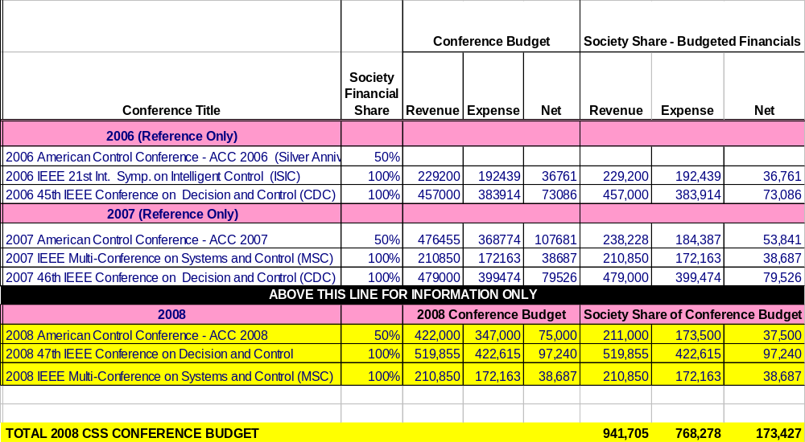 Historically the estimate provided by IEEE is low, but the estimate seems to be more realistic this year. Last year the estimate was for a surplus of $217K, while the surplus for 2006 is currently estimated at $1.378M. The actual surplus for 2007 could easily exceed $1M.

The Society’s bottom line is solid, with a net worth of over $6.5M (more below).

It would seem that we should seek to invest in new initiatives that can have a positive impact on the Society and the profession.

Conference Financial Status

CSS Net Worth, Latest figure: $6,588,000 as of June 2007

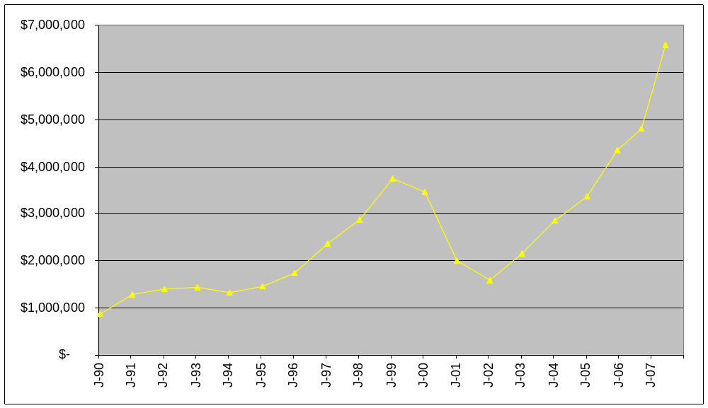

2008 Overall Budget (Final)

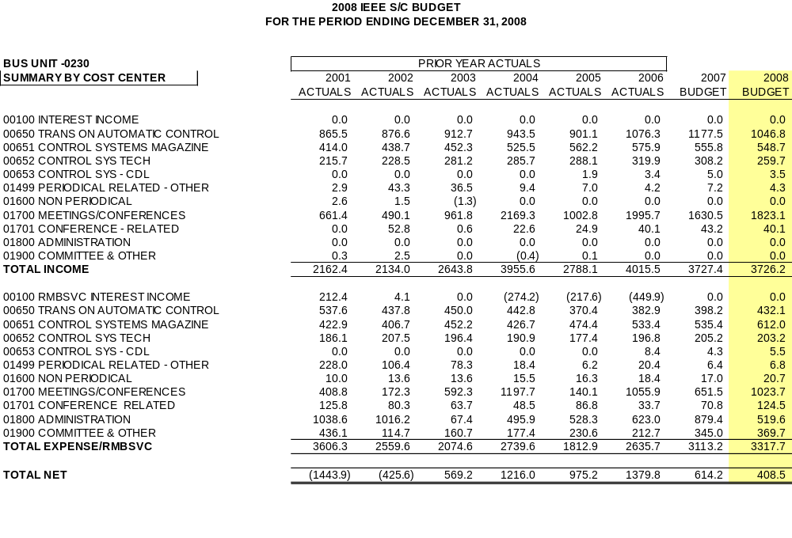

2008 Detail for Committees

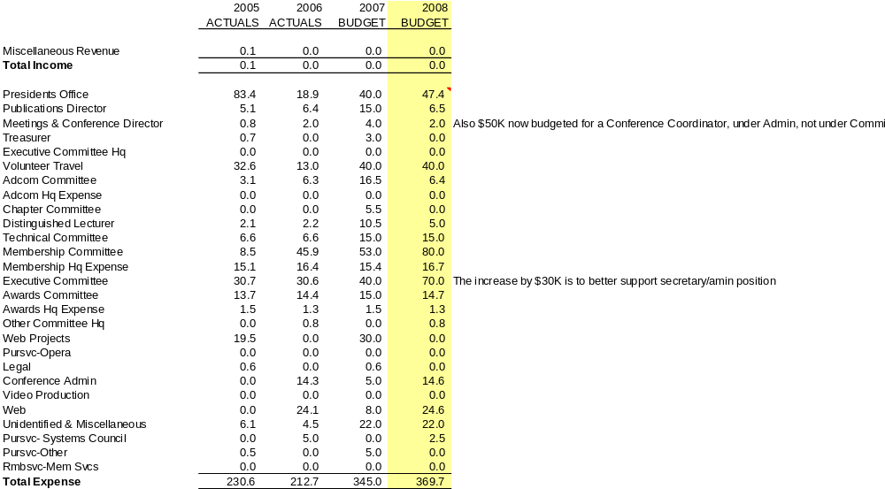

Other notes on 07 forecast & 08 budget:

-IEEE TAC budget on preceding slide to increase due to increase of page budget by 300 pages in 2008.

-$15K was allocated during 2007 for development of a new on-line paper submission system for IEEE TAC.

REPORT TO THE

IEEE CONTROL SYSTEMS SOCIETY BOARD OF GOVERNORS (BoG)
FROM THE VICE PRESIDENT, TECHNICAL ACTIVITIES
Jay Farrell

December 2007

Information Item: The name of the "IEEE CSS TC on Biosystems and Control" has been changed to the "IEEE CSS TC on Systems Biology."

Technical Committee on Aerospace Controls

TC Chair: James Buffington, chair.tcac@ieee.org

We have continued focusing our 2007 efforts in the last 6 months on defining and performing activities that are beneficial to the IEEE Aerospace Controls community at large. Significant progress in Membership, Communications, Awards & Recognition, and Conferences has been accomplished.

Membership
We are pleased to announce that we have gained one new member getting total membership up to 27 members. Currently the membership consists of 3 IEEE Fellows and 13 IEEE Senior Members, and all TC members belong to at least one TC subcommittee. Additionally, we have 2 new membership candidates in process.

Communications
Our Communications Subcommittee continues to maintain and update our website (http://www.csdy.umn.edu/ieeetcac) with current TC activities, recent accomplishments, and future plans. We have contributed to the Air Force Office of Scientific Research/Air Force Research Laboratory (AFOSR/AFRL) strategic document titled: Guidance and Control for Military Systems-Current Practice and Future Directions. This document is complete and will be released soon. Our TC is still collecting input through our Aerospace Controls Survey to collect ideas about other communications efforts, and other general TC activities, from the Aerospace Controls community. Please visit the following link to take our survey: http://www.surveymonkey.com/s.asp?u=918273919722.

Awards & Recognition
We are pleased to announce that our Awards & Recognition Subcommittee has a new chairman. Under new leadership, the Subcommittee has made significant progress in the development of a Best Contributions in Aerospace Controls Award that would annually recognize the best paper, patent, etc. in Aerospace Controls. We have gained endorsement of the award from the CSS Executive Committee and Board of Governors which gives us conditional approval to proceed with development of the award. We are currently developing the award funding strategy.

We have also begun performing our IEEE Fellow Nomination Aerospace Controls Endorsement process for the second year. We are currently identifying endorsement candidates and will begin development of endorsement letters soon. We plan to continue this successful service, so please send your Aerospace Controls Fellow nominees to our TC for endorsement consideration.

Technical Committee on Automotive Controls

TC Chair: Rajesh Rajamani, rajamani@me.umn.edu

The scope of interests of the Technical Committee on Automotive Control (TCAC) covers modeling, simulation, identification, estimation, control, optimization and diagnostics of present and future automotive systems. The Technical Committee has been in existence since 1999. TCAC presently has over 50 members, with many other researchers in the field benefiting from its activities.

Organization
TCAC has three working groups. The Powertrain controls working group is Julie Buckland (jbucklan@ford.com). The Driveline Control Working Group chair is Sharon Liu (sharon.2.liu@gm.com). The Vehicle Chassis Control Working Group is Eric Tseng (htseng@ford.com). The TCAC newsletter editor is Kevin Fischbach (kfischba@ach-llc.com) and the web editor is Xun Yu (xunyu@d.umn.edu).

Recent Activities
Recently TCAC has organized invited sessions at two conferences.

TCAC organized and submitted four invited sessions on automotive control for the 2007 American Control Conference. Three of the four sessions were. In addition, two papers in the fourth session were included as regular papers in alternate regular sessions of the conference. The titles of the three accepted sessions are:
- Modeling and Control of Advanced Automotive Propulsion Systems
- Modeling and Control of Internal Combustion Engines
- X-By-Wire Automotive Applications

TCAC organized one invited session for the 2007 Multi-Conference on Systems and Control in Singapore. The session was titled "Recent Advances in Control of Automotive Systems" (Code S33b4).

On-Going and Future Activities
The 2008 Workshop on “Open Challenges in Automotive Control” will be held in Detroit, Michigan on Friday, April 18th, 2008. This workshop is being jointly organized by the automotive control committees of IEEE, ASME and SAE. We expect it to draw a large audience from both industry and academia. Prof. Rajamani is the General Chair, Dr. Eric Tseng is the Program Chair and Dr. Sharon Liu the Local Arrangements Chair for the 2008 Workshop. Preliminary planning for the Technical Program of the workshop has been completed.

The IEEE Technical Committee on Automotive Control (TCAC) is organizing invited sessions on automotive control for the 2008 American Control Conference in Seattle, WA. As in the previous years, this is a collaborative effort with ASME DSCD's Automotive and Transportation Systems Technical Committee. Prof. Wei Zhan of Texas A&M University, Prof. Chris Manzie of the University of Melbourne, Australia, Prof. Greg Shaver of Purdue University and Prof. Beshah Ayalew of Clemson University are the invited session organizers.

A Special Issue on “Active Automotive Safety Systems” is being organized for the IEEE Control Systems Magazine (CSM). Dr. Zongxuan Sun and Dr. Shih-Ken Chen from General Motors are the two editors organizing this special issue. Each paper in the issue will be both a survey of past results and a presentation of recent important advances. The topics being covered include electronic stability control, active rollover prevention, state estimation for active safety systems, lane departure avoidance, torque distribution control and highway environment monitoring for collision prevention. Reputed authors have been contacted and have submitted extended abstracts. A proposal for the special issue has been submitted to Dr. Dennis Bernstein, the Editor-in-Chief of IEEE CSM.

Technical Committee on Behavioral Systems and Control

TC Chair: Paolo Rapisard pr3@ecs.soton.ac.uk

The 2007 budget allocation for the TC has been spent in the following ways:

The web site of the TC has been redesigned and considerably improved by the University of Southampton systems manager Mr. John Wynn.

Mr. Wynn has also set up the Behavioural Archive, a repository of the publications related to the behavioural approach. Given the large amount of publications generated in the behavioural research area, it had become increasingly difficult even for the members of the TC to keep up with the last developments. Moreover, the TC also felt that in order to promote the research activities of the group a single open source of documents accessible (including downloading) to the general public was needed. This archive is maintained on the standard server of the ISIS group of the University of Southampton, and is administered by the current Chairman of the TC, Dr. Paolo Rapisarda. Editors of the Archive are the Core Members of the TC, to which those members of the general public interested in depositing their publications must refer. In this way it will be possible to exert control on the contents of the archive, and on the respect of the copyright agreements of the journals in which the papers deposited originally appeared.

Other activities of the Core Members of the TC have been the following:
- Eva Zerz has joined the Editorial Board of Linear Algebra and Its Applications. She has also co-edited the special Issue of Linear Algebra and Its Applications in honor of Paul Fuhrmann, vol. 425, 2007.
- Maria Elena Valcher has been appointed as Vice President for the Conference Activities of the IEEE CSS for the year 2008; as Associate Editor for Systems and Control Letters; and as an Associate Editor for the Invited Sessions of the next Conference on Decision and Control (CDC 2008). She co-edited, together with Giorgio Picci, a book of scientific contributions “A tribute to Antonio Lepschy” honoring a colleague of the Italian Control area, teaching in Padova and recently passed away.
- Jan C. Willems has held a semi-plenary lecture (“Dissipative systems”) at the European Control Conference (ECC 2007); a plenary lecture (“A new look at observers”) at the Conference on Methods and Models in Automation and Robotics (MMAR) in Szczecin, Poland.
- Kiyotsugu Takaba visited the ISIS group of the University of Southampton, UK, and held a seminar (“Robust stability analysis via quadratic differential forms”) there; he visited the Institute for Mathematics and Computer Science of the University of Groningen, The Netherlands.
- Harry Trentelman visited the School of Electronics and Computer Science, University of Southampton, UK; the Department of Applied Mathematics, University of Kyoto, Japan; and the Department of Electrical Engineering, University of Nagoya, Japan. He also organized an invited session on Behavioral Systems and Control Theory at the European Control Conference.
- Shiva Shankar lectured at the Indo-French Workshop on Dynamical Systems held in the Mathematics Department of the Indian Institute of Science on "Hamiltonian Mechanics and Symplectic Structures". He visited the Institute for Mathematics and Computer Science of the University of Groningen in June.
The Core Members gave talks at several international conferences

Technical Committee on Biosystems & Control
TC Chair: Mustafa Khammash, khammash@engineering.ucsb.edu

Over the past 6 months, the Technical Committee on Biosystems and Control members have undertaken several activities:

Joint special issue on Systems Biology in the IEEE-TAC and IEEE-CAS
Our special simultaneous issue on Systems Biology to appear in the IEEE Transactions on Automatic Control and the IEEE Transactions on Circuits and Systems is on schedule to appear in January.

We have received a total of 55. Of these 19 will appear in the special issue. The quality of the submitted papers has been extraordinarily high, and that the breadth of topics covered has been impressive. The topics covered include
- Stochastic Modeling;
- Stability and Stabilization;
- Identification;
- Modeling and Control,
- Piecewise Affine Systems
- Oscillations
- Noise
- Networks
- HIV

2007 CDC Tutorial on Systems Biology and Control
A Tutorial session on Systems Biology and Control is planned for the upcoming CDC in New Orleans. The tutorial session will be chaired by M. Khammash and Pablo Iglesias and consists of 4 talks on various aspects of Systems Biology and Control. Speakers are: M. Khammash, Brian Munsky, Pablo Iglesias, Eduardo Sontag, and Domitilla Del Vecchio.

Tutorial Session on Stochastic Gene Expression in Systems Biology at the International Conference on Systems Biology
A 3 hour tutorial was given at the International Conference on Systems Biology held in Long Beach October 1-6, 2007. The tutorial was attended by close to 55 attendees including graduate students, post doctoral associates, and faculty in various areas of engineering, physics, chemistry and biology.
Tutorial Description: The tutorial reviewed a number of approaches for the analysis of stochastic fluctuation in gene expression. It explored: a) analytical and computational methods for the analysis of stochasticity in living cells; and b) examples of gene regulatory networks that suppress or exploit noise, including discussion of landmark papers that report measurements of stochasticity and its impact on biological function.

Technical Committee on Computer Aided Control System Design

TC Chair: Didier Henrion, henrion@laas.fr

Here is a summary of the activities of the TC during the second semester of 2007.

New AG webpage
The Action Group (AG) on Probabilistic and Randomized Methods in Control was started in 2005 by F. Dabbene and G. Calafiore. A webpage collecting information and news about randomized algorithms and stochastic optimization methods for the analysis and control of dynamic systems, with special focus on the computational aspects, is hosted by Politecnico di Torino, Italy. The link is: http://staff.polito.it/fabrizio.dabbene/CACSD/.

A full bibliography in BibTeX format is available for free download at the above link. The .bib file collects many references relevant to the fields of Randomized Algorithms for Control, Stochastic Optimization, Statistical Learning and Robust Control. The page was last updated in November 2007.

Software developments
The first release of the Matlab toolbox RACT -- "Randomized Algorithms Control Toolbox" will be officially released in December 2007. For details, visit the RACT webpage at http://ract.sourceforge.net/

The Toolbox was developed by A. Tremba, P. Shcherbakov, E. Gryazina, B.T. Polyak (Russian Academy of Science - RAS) and F. Dabbene, G. Calafiore, R. Tempo (National Research Counsil of Italy - CNR) under a cooperation project between RAS and CNR.

Publications
A special issue on polynomial design methods was edited by M. Hromcik and M. Sebek (AG on polynomial methods): International Journal of Robust and Nonlinear Control, Vol. 17, Issue 8, 25 May 2007, pp. 679-802.

Technical sessions at conferences
- H. Trentelman (AG on behavioral methods) organized an invited session on behavioral system theory at the European Control Conference ECC'07, Kos, Greece.
- P. Rocha (AG on behavioral methods) together with E. Rogers and K. Galkowski organized a Workshop on Multidimensional Systems, Aveiro, Portugal, June 2007.
- F. Dabbene and G. Calafiore have organized a tutorial session at ACC'07 entitled Probabilistic Methods in Control.
- P. Mosterman (AG on hybrid dynamical systems) organized a workshop on Multiparadigm Modeling: Concepts and Tools at the ACM/IEEE 10th International Conference on Model Driven Engineering Languages and Sytems (MODELS 2007).
- M. Hromcik and M. Sebek organized an invited session (polynomial design methods) during the European Control Conference, 2-5 July 2007, Kos, Greece. They are also organizing an invited session on the same topic for the IFAC World Congress, Seoul, Korea, 2008. M. Hromcik and V. Kucera are organizing an invited session on the same topic for the Mediterranean Control Conference MED 2008, Ajaccio, France, 2008.
- V. Sima and D. Kressner (AG on numerics) organize an invited session at the IEEE CACSD Symposium to be held in San Antonio, Texas, September 3-5, 2008.
- D. Peaucelle and Y. Ebihara (AG on LMIs) organize an invited session (Reducing conservatism of LMI conditions) for the IEEE CDC 2007. They also submitted an invited session proposal (LMIs and Algebraic Methods in Control) to the IFAC World Congress 2008, in cooperation with Y. Oishi, Nanzan University, Japan.
- Vardulakis and N. Karampetakis (AG on symbolic methods) organized two invited sessions (Computational and Optimization Methods and Software for Control Systems) during the European Control Conference, 2-5 July 2007, Kos, Greece.
N. Karampetakis is the invited session chair of the IEEE International Symposium on CACSD that will be held in the city of San Antonio, Texas, USA on September 3-5, 2008.

Technical Committee on Control Education

TC Chair: Bozenna Pasik-Duncan, bozenna@math.ku.edu

The TCCE held the following two major activities at ACC’07:
- Special Evening Session, on Wednesday, July 11th, 6:00 pm - 8:30 pm
Panel Session with participants of the ACC'07 Control Methods in the Finance Track as panelists and with over 100 participants representing students both: of mathematics and of engineering, academia and industry. The theme of the session was: "Merging Engineering and Mathematics in Finance. Can Mathematical Finance and Financial Engineering Programs attract students to study engineering, math and science?" Recommendations were made by participants to organize the invited sessions on Control Methods in Finance at the ACC’08. The proposal for two invited sessions was submitted for the ACC’08 as the result of this Panel Session.
2. Semiannual Meeting of the Committee on Control Education and Reception, was held on Thursday, July 12, with Virginia Warfield, the 2007 AWM L. Hay Award Recipient, University of Washington as a guest speaker . She gave a talk on: “The Joys and Hazards of Striding Confidently along an Invisible Path”. By talking about her contributions to education through her teaching, graduate student training and mentoring, and outreach and collaborations with K-16 communities, Ginger was inspirational to control community members, in particular to young members who were looking for examples of educational activities with a broader impact. The purpose of the meeting was: to find new ways to assist the 2007 President of the IEEE on her goals: “ to foster programs and activities that promote greater visibility for the IEEE and our profession, not only to employers but also to a wide range of public", Lean H. Jamieson, the President's column, in March 2007, Vol.31, No1 of the IEEE.

The following two activities are planned for the CDC’07 in New Orleans:
1. NSF High School Students & Teachers Workshop: “The Power, Beauty and Excitement of the Cross-Boundaries Nature of Control” on Tuesday, Dec. 11
The purpose of the Workshop is: to inspire interest from youth towards studies in Control Systems and to assist high school teachers in promoting the discipline of Control Systems among their students. The Workshop brings together all-star teams of some of the most eminent senior control researchers and some of the most prominent younger researchers involved in new technologies to present control systems as an exciting and intellectually stimulating field. The attractiveness and excitement of choosing a career in control engineering will also be addressed. Live interaction between the presenters and the audience is to be an important feature of the Workshop.
2. Special Evening Session: Plain Talk on Control for a Wide Range of the Public will be held on Wednesday, Dec. 12.
The purpose of the session is: to prepare a series of short presentations for a wide range of public.

Technical Committee on Discrete Event Systems

TC Chair: Ryan Leduc, leduc@mcmaster.ca

1) Our primary activity has been maintaining the website, and gathering news for our electronic newsletter. Our newsletter goes out monthly and we currently have 233 subscribers.

The website is quite automated. It has a submissions page for people to enter news items which are then loaded into an articles database. From this database, the monthly newsletter is automatically formatted and created. Also, we automatically generate the conference web page from the conference news items.

The website also contains a DES researcher info submissions form, which goes into our researchers database. From this database, we automatically generate our researchers contact info web page.

Finally, our newsletter is administered by the mailman software, which has a web interface to manage things, as well as to allow people to subscribe/unsubscribe themselves. The main time involved is gathering articles and processing them into the newsletter.

2) We are currently working with the program committee for the 2008 American Control Conference with respect to DES related papers.

4) I had taken on a Software engineering M.Eng student who developed as their masters project an online community based registry for DES related publications. The idea is to create a central, easy to use database of all papers, reports, books, and thesis that are DES
related. The registry will allow searches, and will store the bibliographical information necessary to cite the item, as well as information on acquiring a copy. Users can receive weekly e-mails announcing newly added items that fit their search criteria.

As the design is research area agnostic (you modify a config file to set it for a particular area), it should be possible to reuse the code for other research areas.

The first version of the software has been published and available for download. The DES version of the website has been launched and now has 74 registered users, and 40 publications.

Currently, the Brian Hogg Consulting Firm is working on making the install process more user friendly, and fixing several bugs that have showed up as the site has launched.

Technical Committee on Distributed Parameter Systems

TC Chair: Michael A. Demetriou, mdemetri@wpi.edu

The main activities of this committee in the last six months were:

1. TC meeting:
A meeting of the TC on Distributed Parameter Systems took place on July 26, 2007, at the CDPS 2007 Workshop on Control of Distributed Parameter Systems, Namur, Belgium.

2. Invited Sessions
--Two invited session were proposed and accepted at the 2007 IEEE Conference on Decision and Control (http://iss.bu.edu/dac/dac/cdc/index.php )
Distributed Parameter Systems I
Distributed Parameter Systems II
Both invited sessions were organized by Michael A. Demetriou
--Two invited sessions were proposed at the 2008 American Control Conference
( http://www.a2c2.org/conferences/acc2008/)
Distributed Parameter Systems I
Distributed Parameter Systems II
Both invited sessions were organized by Michael A. Demetriou and Antonios Armaou.

3. Conference organization/support
- Help with the organization of the 2007 workshop on Control of Distributed Parameter systems, held on July 23-27 at the University of Namur, Belgium
- Help planning for the 2009 workshop on Control of Distributed Parameter Systems, to be held in Southern France.

Plan for 2008 activities:
- Organize invited sessions for CDC08 and MTNS08
- Planning to organize 5 invited sessions (minisymposia) on Distributed Parameter Systems at MTNS08
- Organize a special issue on current research trends on control of distributed parameter systems.
- Invite additional members to join TC on DPS

Technical Committee on Energy Processing and Power Systems

TC Chair: Sandip Roy sroy@eecs.wsu.edu

To further the goals of the IEEECSS Technical Committee on Energy Processing and Power Systems, Dr. Bernard Lesieutre from the University of Wisconsin visited the Control Systems group at the Washington State University. Dr. Lesieutre participated in two thesis defenses in the Control Systems group (one concerned with the impact of saturation in control systems, and the other with networks of rotating machines), and also presented his studies on network- and machine-level dynamics and controls issues in the electric power systems. These interactions helped to identify foci in the Power and Energy Systems realm that can be addressed by controls engineers, which we see as a primary purpose of the committee.

Planned Activities: I expect to interact with Dr. Ian Hiskens (the previous technical committee chair) to write an article on the various directions of interest to controls engineers in the Energy Processing and Power Systems field, with a particular focus on the importance of probabilistic methods in power engineering. We also hope to put together a seminar for the Washington State University, University of Idaho, and the Schweitzer Engineering Laboratories (all located in Eastern Washington and Western Idaho), concerning control engineering needs for machines and devices for the electric power system.

Technical Committee on Hybrid Systems

TC Chair: Alberto Bemporad bemporad@dii.unisi.it

2nd HYCON PhD School on Hybrid Systems. The 2nd HYCON PhD School on Hybrid Systems was held in Siena (Italy) on 16-19 of July, 2007. The school was targeted at graduate students and researchers who wanted to learn the main concepts of hybrid systems, as well as at graduate students and postgraduate researchers already working in the field of hybrid systems. The following aspects of hybrid systems: modeling, mathematical properties, stability and stabilization, simulation, reachability analysis and verification of safety properties, observability and state estimation, networked and embedded control systems, model predictive control, identification, diagnosis, stochastic models, and the use of hybrid tools in industrial applications. The school was attended by about ninety students, from several universities and institutes around the world. The feedback from the attendees of the school was very positive, in terms of didactics and social events. The school was coordinated by Alberto Bemporad (University of Siena) and Maurice Heemels (Technical University Eindhoven).

The school was supported by the European Network of Excellence HYCON, by the University of Siena, and by the IEEE Control Systems Society. The lecture notes of all speakers are publicly available on the web site of the school at
http://www.dii.unisi.it/hybrid/school07The following poster was designed by Alberto Bemporad and distributed to the attendees:

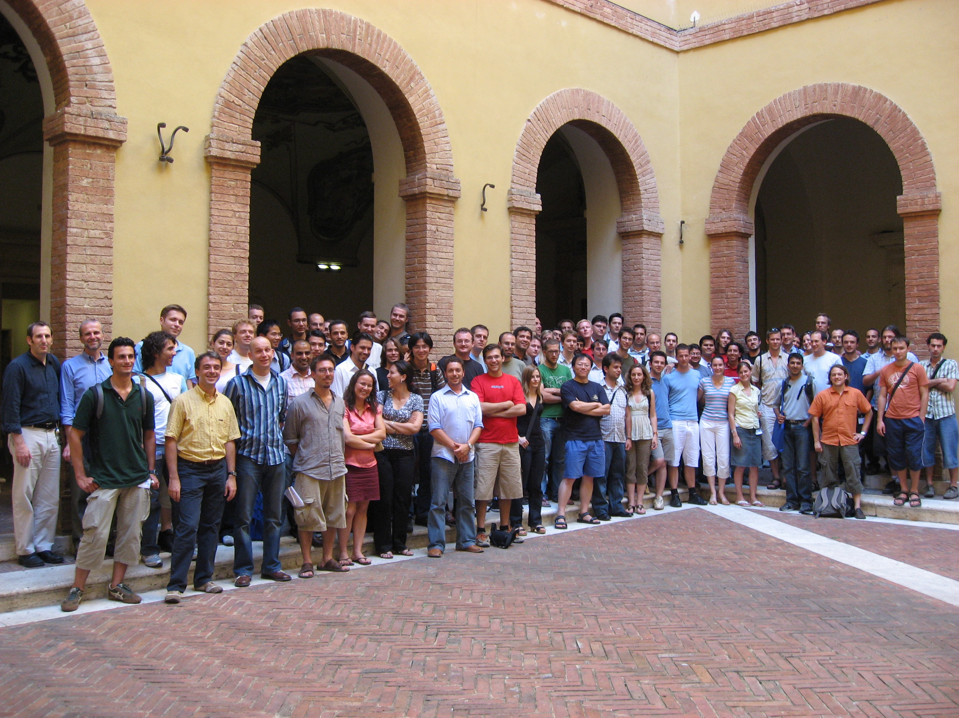
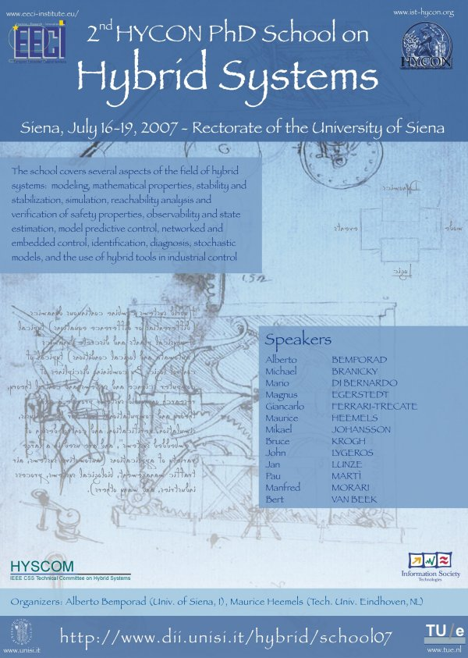

10th Conference on “Hybrid Systems: Computation and Control”. The conference was organized by A. Bemporad (Univ. of Siena), A. Bicchi (Univ. of Pisa) and G. Buttazzo (SSSUP, Pisa) and was held in Pisa, Italy, on April 3-5, 2007. 164 papers were submitted, 44 accepted for oral presentation and 39 for poster presentation. 130 registrants from sixteen different countries attended the conference. The proceedings were published by Springer Verlag, Lecture Notes in Computer Science.

HYCON Network of Excellence. The activities of HYSCOM are still strongly connected with the activities of the European Network of Excellence on Hybrid Systems HYCON “Hybrid Control: Taming Heterogeneity and Complexity of Networked Embedded Systems”, http://www.ist-hycon.org/. The most active European research groups in the field (more than 20 nodes) are actively involved in several research, dissemination, benchmarking activities of HYCON. Also US affiliates (UC Berkeley, University of Pennsylvania) participate to the activities of the network. The activities of HYCON started officially in September 2004.

HYSCOM web site. The web site located at http://www.dii.unisi.it/~hybrid/ieee has maintained and the number of subscriptions has increased steadily.

International Curriculum Option. The “International Curriculum Option of Doctoral Studies in Hybrid Control for Complex, Distributed and Heterogeneous Embedded Systems” (ICO) co-funded by the Italian Ministry of Education, University, and Research and the HYCON, is a convention of international interuniversity cooperation between several European and US universities aiming creating a joint curriculum on hybrid systems. PhD candidates are monitored by the ICO board. A PhD Thesis award was given in 2007 to Dr. M. Lazar and Dr. A. Chaillet. 24 PhD students are currently enrolled in ICO. For more informations: http://www.piaggio.ccii.unipi.it/ICO/ICO.htm.

HYCON-EECI Graduate School on Control. The school was held in Paris at the European Embedded Control Institute from 12 February 2007 to 27 April 2007 and consisted of 10 independent modules, one module per week (21 hours). The school was very well attended. For more information see http://www.ist-hycon.org/EECI-docs/EECI-Modules9.pdf

Technical Committee on Industrial Process Control

TC Chair: Richard D. Braatz, braatz@uiuc.edu

The applications areas covered by the TC IPC include microelectronic, materials, pharmaceutical, chemical, and electrochemical processes. Many emerging control applications areas such as molecular manufacturing, microchemical systems, and systems biology are addressed in this TC. Most processes of interest are highly nonlinear and spatially distributed with significant model uncertainties and constraints on actuators, states, and outputs. The main focus is on organization and programming for meetings in concert with other organizations such as AACC and IFAC. Membership is open to any member of the IEEE Control Systems Society, and CSS members interested in organizing sessions, symposia, and meetings are strongly encouraged to email your interest to braatz@uiuc.edu.
(1) Members of Steering Committee (SC)
Richard D. Braatz (Chair), Frank Allgöwer, B. Wayne Bequette, Francis J. Doyle III, Martha A. Gallivan, Martin Guay, Juergen Hahn, Michael A. Henson, Morten Hovd, Mayuresh V. Kothare, Jay H. Lee, Zoltan K. Nagy, Yahya Nazer, Babatunde A. Ogunnaike, Srinivas Palanki, Robert S. Parker, Michel Perrier, Hector D. Puyosa
(2) Main Organizational Activities
Some of the recent past and upcoming meetings organized or co-organized by members of the TC IPC are:
- IFAC Symposium on Dynamics and Control of Process Systems (DYCOPS 2007, www.dycops2007.org/, Cancun, Mexico, June 6-8, 2007): Guay, Hovd, Lee, & Ogunnaike were on the International Program Committee.
- American Control Conference (ACC, www.a2c2.org/conferences/acc2007/, NY, July 11-13, 2007): Many SC members were involved with the review process. Braatz was Vice Chair for Invited Sessions & a Director of the American Automatic Control Council. Allgöwer, Braatz, Gallivan, & Henson were on the Program Committee.
- 7th IFAC Symposium on Nonlinear Control Systems (NOLCOS, www.nolcos2007.org.za/, Pretoria, South Africa, August 22-24, 2007): Allgöwer was Co-Chair of the International Program Committee.
- Foundations of Systems Biology in Engineering (FOSBE, Stuttgart, Germany, September 9-12, 2007, www.ist.uni-stuttgart.de/fosbe/fosbe_commitee.htm): Allgöwer & Doyle were on the Organizing Team. Henson & Ogunnaike were on the International Program Committee.
- American Control Conference (ACC, www.a2c2.org/conferences/acc2008/, Seattle, June 11-13, 2008): Kothare is a Society Review Chair and Braatz is on the Program Committee. Many SC members organized sessions.
- IFAC World Congress (IFAC, www.ifac2008.org/, Seoul, Korea, July 6-11, 2008): Allgöwer & Doyle are on the International Program Committee with Allgöwer serving as a Technical Editor & Doyle as a Technical Associate Editor. Doyle & Hahn are co-organizers of the Chemical Process Control track.
- IFAC Symposium on Advanced Control of Chemical Processes (ADCHEM, Instanbul, Turkey, July 12-15, 2009): Many SC members are on the International Program Committee.
- American Control Conference (ACC, Baltimore, June 16-18, 2010): Braatz is Program Chair, Allgöwer is Vice Chair for Invited Sessions, and several SC members will serve on the Program and Organizing Committees.
Many members of the IPC (Allgöwer, Bequette, Braatz, Doyle, Henson, Hovd, Lee, Parker, Perrier) are members of IFAC TCs including the Mining, Minerals & Metals Processing TC, the Modelling & Control of Biomedical Systems TC, the Biosystems & Bioprocesses TC which Perrier serves as Vice-Chair, the Non-Linear Control Systems TC which Allgöwer chairs, and the Chemical Process Control TC which Doyle will serve as Chair in 2008.
(3) TC IPC Web Page
The TC IPC website (brahms.scs.uiuc.edu/ipc/) includes information on meetings, educational material, & journals. The next TC IPC meeting will be held during the 2007 IEEE Conference on Decision and Control in New Orleans.
(4) Summary of Editorial Activities
- Doyle is Editor-in-Chief of IEEE Transactions on Control Systems Technology where Palanki is Associate Editor.
- Braatz is Editor-at-Large of Optimal Control Applications and Methods where Lee is the Editor for a Special Issue on Batch Optimal Control that should be completed in 2008.
- Allgöwer is the Editor for Process and Computer Control of Automatica where Braatz, Guay, Henson, & Kothare are Associate Editors.
- Doyle is Reviews Editor for the Journal of Process Control where Allgöwer, Braatz, Henson, & Perrier are Associate Editors.
- Braatz was Editor of the 2007 Special Issue on Chemical Process Control for the International Journal of Robust and Nonlinear Control, to which Allgöwer & Doyle contributed papers.
Braatz & Kothare are Associate Editors of IEEE Transactions on Automatic Control.

IEEE Technical Committee on Intelligent Control

TC Chair: Shuzhi Sam Ge, elegesz@nus.edu.sg

The IEEE CSS Technical Committee on Intelligent Control (TCIC) held a meeting at the 2007 American Control Conference, New York City, USA.

Through the orchestrated efforts of TCIC, its annual conference, ISIC has 245 submission and 134 acceptance (acceptance rate: 54%) as part of in the inaugural IEEE Multi-conference on Systems and Control, 1-3 October 2007, Singapore, which received a total of 808 submissions (including invited and special sessions, in addition to the regular contributed papers), out of which 432 papers have been accepted for presentation and publication in the proceedings.

The IEEE MSC is sponsored and organized by CSS, and the inaugural conference was held on October 1-3, 2007, in Singapore. The 2007 MSC was technically co-sponsored by a number of leading technical organizations: The Chinese Association of Automation (CAA); The European Union Control Association (EUCA); The Institute of Control, Automation and Systems Engineers (ICASE), Korea; The South African Council for Automation and Computation (SACAC); and The Society of Instrument and Control Engineers, Japan (SICE).

For the first time in history we were pleased to have support from the Xerox Corporation to sponsor the 2007 Industry Award for Excellence in Translational Control Research. This gift was facilitated by LK Mestha.

Kevin L. Moore, Program Chair for ISIC 2008 is working with General Chair, Oscar R. Gonzalez, for the smooth operation of IEEE MSC at San Antonio, Texas, September 3-5, 2008. The members of TCIC are requested to give him the full support needed for the success of the 2nd MSC.

A request for web development for TCIC has been made and approved, and much development work is still underway.

IEEE Technical Committee on Manufacturing Automation & Robotic Control

TC Chair: Prof. Francesco Bullo bullo@engineering.ucsb.edu

During the period July 1 - Dec 31, 2007, the MARC TC worked on or participated in the following technical activities relevant to the Committee's focus:

1. Organization of an Invited Tutorial Session at 2007 American Control Conference on "Control and Algorithmic Methods in Distributed Robotics," New York City, July, 2007.

2. Organization of Invited Session at CDC 2007 on "Motion Coordination of Distributed Robotic Systems", New Orleans, 2007.

3. Organization of Workshop on "Cooperative multi agent systems: distributed computation, estimation and control", December 2007, Pisa, Italy.

4. Organization of Special Issue in SIAM Journal on Control and Optimization on "Control and Optimization in Cooperative Networks" (ongoing effort)

5. Editor for Proceedings volume for 3rd IFAC Workshop on Lagrangian and Hamiltonian Methods for Nonlinear Control (LHMNLC'06), Springer, 2007. (ongoing effort).

IEEE Technical Committee on Networks and Communication Systems

TC Chair: Yannis Paschalidis yannisp@bu.edu

Networks and Communications Systems have and continue to attract a lot of attention from CSS researchers. In the upcoming New Orleans CDC (2007) there are 13 sessions with topics related to the interests of this TC. Themes in these sessions include: Scheduling in Sensor Networks, Control Over Networks, Sensor Networks and Distributed Cooperative Control (Invited), Resource Allocation and Scheduling in Wireless Networks (Invited), Agents, Networks, and Autonomous Systems,

Game-Theoretic Methods in Networking and Control (Invited), Consensus Over Random Graphs, Network Analysis and Control, Networks, Control of Communication Systems, Distributed Estimation Over Sensor Networks, Computer Networks, Optimization & Control in Communication Networks.

This list of sessions gives a glimpse of the profound penetration of networks and communications related topics in CSS-driven research.

As noted in the previous report, the TC has a revamped Web site at http://ionia.bu.edu/CSS-TC/index.html. The new web site contains a description of the TC and its history and a database with control systems researchers active in networks and communication systems.

The site also includes (under Recent Activities) links to activities organized by the TC chair and TC working group chairs. Upcoming activities include two invited sessions at the New Orleans CDC on Sensor and Wireless networks (organized by Cassandras and Paschalidis and Marbach and Berry, respectively). Unfortunately, these sessions are scheduled during the same slot (WeB10, WeB16). Another significant upcoming activity is an NSF workshop on "Distributed Communication, Sensing, and Control" which will be organized in May 2008 by working group chair Sekhar Tatikonda at Yale.

IEEE Technical Committee on Nonlinear Control

TC Chair: Andy Teel teel@ece.ucsb.edu

The primary focus of the TC on Nonlinear Systems and Control in 2007 was again regional workshops that emphasize the development of graduate student researchers and post-doctoral students.

Two workshops were held during 2007. The 14th Southern California Nonlinear Control Workshop was held in June at UCLA. (http://www.ee.ucla.edu/~tabuada/SoCalNLC) Approximately forty students and faculty attended this event, consisting of twelve, thirty-minute lectures given by graduate and post-doctoral students from universities in Southern California. Sessions included “hybrid systems”, “switched systems”, “optimal control”, and “multi-agent systems”. The 3rd Northeast Control Workshop was held at the University of Pennsylvania in May. (http://www.grasp.upenn.edu/swarms/NECW2007/) This annual workshop, inspired by the workshops in Southern California and held over a day and a half period this year, included two plenary lectures by distinguished faculty and nineteen twenty-minute talks by graduate and post-doctoral students from throughout the northeast region of the United States. Topics included control over networks, coordinated motion and consensus, and biologically-inspired control. The 15th Southern California Nonlinear Control Workshop had been planned for November at USC but, due to a scheduling conflict, was pushed to January 2008. Plans are still developing for an inaugural Southeast Control Workshop, spearheaded by Warren Dixon at the University of Florida.

The technical committee will hold its annual meeting at the upcoming CDC in New Orleans. We expect the meeting to be a joint meeting with the IFAC TC on nonlinear control.

IEEE Technical Committee on System Identification and Adaptive Control

TC Chair: Daniel Rivera daniel.rivera@asu.edu

The technical committee on system identification and adaptive control currently consists of a membership of 34 individuals. Daniel Rivera of Arizona State University was approved as chair of the committee during the 2007 American Control Conference in New York, at the request of Brett Ninness, University of Newcastle, who had served as committee chair since its inception. The committee will hold a meeting on Wednesday, December 12 during the 2007 CDC in New Orleans; among the near-term goals for the committee include revisiting membership structure and responsibilities, inviting new membership, and planning invited sessions for the 2008 MSC, CDC and 2009 ACC and IFAC SYSID conferences.

IEEE Technical Committee on Structure and Sliding Mode Control

TC Chair: Asif Sabanovic asif@sabanciuniv.edu

From January 2007 the activity of TC Variable Structure and Sliding Mode Control had been concentrated on:
- Organization of the next VSS and Sliding Mode Control Workshop to be held 8-10 June 2008 in Antalya Turkey under Chairship of Prof. Okyay Kaynak, Boagazici University.
- Sponsorship of IEEE CSS, IEEE IES and International Federation of Automatic Control (IFAC) Technical Committees, 2.1 Control Design , 2.3 Non-Linear Control Design Systems. The preparations are well advanced and we hope to have one more successful meeting.
- Organization of sessions on Sliding Mode Control at the Turkish Control Conference TOK 2008, held in Istanbul on 5-7 September, 2007.
- Preparation of the proposals for Organized sessions on Sliding Mode Control at The 17th IFAC World Congress 2008, of Seoul, Korea.
- Preparation of the proposal for a Tutorial on Sliding Mode Control at The 17th IFAC World Congress 2008, of Seoul, Korea..
- Participation in organizing a Workshop on the occasion of Prof. Vadim Utking’s 70th birthday held on October 23-25, in Mexico City, Mexico.
- Initialization of the Special Issue on Sliding Mode Control of The IEEE Transaction on IE.
- The preliminary design of the TC web page. The design is not yet finalized.
- The soliciting proposals and setting the criteria for selecting new TC members. The new members are proposed and final decision will be taken in the following months.

IEEE Society on Social Implications of Technology Liaison

From: Andrew U. Meyer, Liaison Representative to IEEE Society on Social Implications of Technology

Subject: ITEMS OF POSSIBLE INTEREST

SSIT PRESIDENT AND VICE PRESIDENT:
President: 2006-7: Karl Perusich (Purdue University - perusich@sbcglobal.net) NEW: Janet Rochester (j.rochester@ieee.org)
Vice-President: 2006-7: Janet Rochester (Onancock, VA – j.rochester@ieee.org) NEW: Gerald Engel (g.engel@computer.org )

INTERNATIONAL SYMPOSIUM ON TECHNOLOGY AND SOCIETY (ISTAS): ISTAS is an annual conference of SSIT.
ISTAS 2007, with the theme “Risk, Vulnerability, Uncertainty, Technology and Society”, co-sponsored with the Risk Assessment and Policy Association (RAPA), was held on June 1-2 at the University of Nevada, Las Vegas (http://faculty.unlv.edu/dmh/ISTAS2007/).
ISTAS 2008, with the theme “Citizens, Groups, Communities and Communication Technologies” (ICT), co-sponsored with the Canadian National Research Council, will be held on June 26-28, 2008 in Fredericton, New Brunswick, Canada. Information is available at http://www.istas08.ca/.
ISTAS 2009 is in the discussion stage, possibly in Tempe, Arizona.

ISTAS 2010: Two venues are being considered, Turino, Italy and Sydney, Australia.

OTHER SSIT CO-SPONSORED MEETINGS:
EEE/ACM International Conference on Information and Communication Technologies and Development (ICTD2007) will be held on December 15-16, 2007 in Bangalore, India (http://research.microsoft.com/workshops/ictd2007).
IPCC2008, the annual conference of the IEEE Professional Communication Society, will be held July 13-16, 2008 in Montreal (http://ewh.ieee.org/soc/pcs/). IPCC2007 was held Sept. 30-Oct.3, 2007 in Seattle, WA.
Economic Strategy for Healthcare through Bio and Information Standards and Technologies, co-sponsored by the IEEE Biotechnology Council and NIST, was held on September 25, 2007 at the NIST Campus in Gaithersburg, Maryland (http://www.itl.nist.gov/Healthcare/conf/index.htm)
2007 IEEE-IIRW International Integrated Reliability Workshop was held October 15-18, 2007 at the Stanford Sierra Conference Center in Fallen Leaf Lake, California (http://www.iirw.org).
Plug-In Hybrids Accelerating Progress 2007 Symposium was held on 19 September 2007, at the Omni Shoreham Hotel in Washington, D.C. (http://www.ieeeusa.org/policy/phev/)

SSIT Online Virtual Community: An online community for SSIT members has been established to provide threads on recent articles in IEEE Technology & Society Magazine, society governance issues, current topics of interest and announcements of upcoming events. Current discussion topics include automation of the law (possible?), challenges 2020+, and other major issues of social implications of technology. (http://www.ieeecommunities.org/ssit). Community members need not be SSIT or IEEE members.

ADMINISTRATIVE MATTERS: The SSIT dues for IEEE members remain at $24 ($12 for IEEE student members). The SSIT Governing Board continues to encourage pursuing sister society relationships. SSIT collaborates with other organizations on topics of mutual interest, such as the National Institute for Engineering Ethics (http://www.niee.org

TECHNOLOGY AND SOCIETY (T&S) MAGAZINE: In December 2006, T&S received two awards of excellence by the Society for Technical Communications. SSIT continues to publish one feature article from each current issue on its web site, including an article on privacy and security as idiology (http://www.ieeessit.org/technology_and_society/free_sample_article.asp). T&S is accessible to SSIT members on IEEE-Xplore. In addition to regular issues, recent special issues include: “Security and Usability” in March 2007, “Disaster Preparedness and Recovery”, based on ISTAS’06, in September 2007 and “Engineering Ethics Education” in December 2007. Future special issues include one “Potentials and Limits of Cooperation in Fourth Generation Wireless Communications” in March 2008, “Risk, Vulnerability, Uncertainty, Technology and Society”, based on ISTAS’07 in September 2008 and “Engineering Volunteerism” in March 2009. Two additional special issues are under development.

AWARDS:

The first SSIT DISTINGUISHED SERVICE AWARD was presented in June 2007 to Prof. Joseph R. Herkert of Arizona State University in recognition of his years of dedicated service as Society President, Editor of T&S Magazine, conference organizer and presenter, speaker and mentor.

The CARL BARUS AWARD FOR OUTSTANDING SERVICE IN THE PUBLIC INTEREST is presented on occasion to an engineer who has placed him/herself at considerable risk to follow the dictates of conscience in the pursuit of his/her profession. The last Barus Award was given to Dr. Kim Harvin for her work at the Salem Nuclear Power Plant in New Jersey in promoting the safety culture of the organization.

SSIT WEBSITE: http://www.ieeessit.org/

IEEE Systems Council Liaison

CSS Liaison: Harris McClamroch nhm@umich.edu

CSS is one of the IEEE societies supporting the IEEE Systems Council. As the appointed CSS liaison to the Systems Council Ad Com, I attended one Ad Com meeting in 2006 and I have followed the plans and development of the System Council via email and some personal contacts. The first annual Systems Conferences was held in Honolulu in April, 2007, with attendance and finances slightly below what was budgeted. The first issue of the Systems Journal, edited by Mo Jamshidi, was published in Fall, 2007. There is a small but committed group of individuals who are providing leadership in growing this new IEEE council. My sense is that there is little overlap with the core CSS activities and the activities of the Systems Council are complementary to CSS.

REPORT TO THE

IEEE CONTROL SYSTEMS SOCIETY BOARD OF GOVERNORS (BoG)
FROM THE VICE PRESIDENT, CONFERENCE ACTIVITIES
RICHARD MIDDLETON
December 2007

Overview:
Our conference activities appear to be running well, and planning for future conferences is under way. Discussions for the proposed CDC/ECC in 2011 in the Eastern US have advanced to the point of a proposed Memorandum of Understanding.

CSS Sponsored Conferences
The current schedule of forthcoming CSS sponsored conferences is given below:
Conference | Location | Dates | General Chair | Program Chair
ACC 2008 | Seattle (Westin) | June 11-13 | Anu Annaswamy | Tariq Samad
MSC 2008 | San Antonio (Texas) (Hilton Palacio, del Rio) | Sept 3-5 | Oscar Gonzalez | Gary Balas  Kevin Moore  Marco Lovera
CDC 2008 | Cancun  (Fiesta Americana) | December 9-11 | Chaouki Abdallah | Thomas Parisini
ACC 2009 | St Louis, Missouri  (Adams Mark) | June 9-11 | Karlene Hoo | John Chiasson
MSC 2009 | St Petersburg | TBA | Alexander Fradkov | Carlos Canudas de Wit  Hua Wang (proposed)
CDC2009 | China | Dec 16-18 | Lei Guo  John Bailleul | Daizhan Cheng  Mark Spong
ACC2010 | Baltimore (Marriott Waterfront) | June 29-July 1 |  | Richard Braatz
MSC2010 | Japan (proposed) | TBA |  | TBA
CDC2010 | USA | TBA | Mark Spong | Fathi Ghorbel

Information Item: CDC2010 Venue

Mark Spong will make a short presentation on the conference venue.

CSS Technically Cosponsored Conferences
Technical Cosponsorship has been approved by the executive committee for the following conferences in, 2008:

Conference | Location | Dates | General Chair | Program Chair
WiOPT 2008 | Berlin, Germany | April 1-3, 2008 | Tijani Chahed, | Merouane Debbah  Giuseppe Caire
Hybrid Systems Computation & Control | St Louis, USA | April 22-24, 2008 | Magnus Egerstedt | Bud Mishra
3rd International Symposium on Advanced Control of Industrial Processes | Jasper, Canada | May 4-6, 2008 | Sirish L. Shah | H. Su
Workshop on Discrete Event Systems, 2008 | Gothenburg, Sweden | May 28-30, 2008 | Bengt Lennartson | Martin Fabian
The 3rd IEEE Conference On  Industrial Electronics & Applications | Wuxi, China | June 3-5, 2008 | Luo, Fang Lin | Man, Zhihong
VSS 2008 | Antalya, Turkey | June 8-10, 2008 | Okyay Kaynak | Vadim Utkin
MED 2008 | Ajaccio, France | June 25-27, 2008 | Dominique Sauter | Ronald Patton
Chinese Control and Decision Conference, 2008 | Yantai, China | July 2-4, 2008 | Wang, Fuli, | Wen, Changyun,
Chinese Control Conference | Kunming, China | July 16-18, 2008 | H.F. Chen | D.Z. Cheng  F.H. Xiang
The International Conference on Control, Automation, Robotics and Vision | Hanoi, Vietnam | Dec 2-5, 2008 | Soy, Yeng Chai | Wen, Changyun

Further information on individual conferences is attached in the relevant reports.

MSC 2007 Interim Report
The 1st MSC was a success with many exiting event. We have The CCA Program Chair Chun-Yi Su with Vice-Chairs Carlos Canudas de Wit, Alessandro Astolfi, Zhihua Qu and Fumitoshi Matsuno respectively, led an international program committee that handled a record number of 563 submissions. The ISIC Program Chair Sarangapani Jagannathan, with Vice-Chairs Gary Feng, Warren Dixon, Lihua Xie and Camille Alain Rabbath, led another international program committee that handled 245 submissions. In this inaugural conference we had 808 submissions, which was a new record, in spite of the fact that the CACSD was not held this year. Every effort was made to ensure the high technical quality of accepted papers and as a result only 432 were included in the technical program. This corresponded to a 54% acceptance rate which is not only a record low in recent CCA and ISIC history, but also comparable with, and in many cases lower than, the premier major conferences in systems and control.

The MSC 2007 technical program began on Monday October 1st, ended on Wednesday October 3, and included 72 sessions. Among the 72 technical sessions, there were 11 invited CCA sessions, 38 regular CCA sessions, 12 invited ISIC sessions and 11 regular ISIC sessions. The conference attendees were given the chance to participate in a wide selection of diverse sessions regarding new research findings and perspectives for future developments in control applications, intelligent control, robotics, fault diagnosis, identification, learning control, optimization, hybrid systems, nonlinear systems, adaptive control/robust control, cooperative control, sensors, among others.

In this inaugural conference, we had 609 contributed submissions and 167 invited submissions. The top 4 countries for accepted papers were: China, 74, Japan 55, USA, 53, and Singapore 48. The top 4 countries for registrations were: Japan, 64, China, 42, USA, 29, and Singapore 28. However, if we lump all the European countries together Europe is on top in both categories with 88 acceptances and 80 registrations. Both the National University of Singapore and Nanyang Technological University also contributed a strong army of around 30 student helpers during the conference.

Sam Ge,
General Chair
23 October 2007

Conference Editorial Board Activity Report

Current Status
Activity over the last reporting period:
• Regarding CDC’07, the final program preparation has been handled by Prof. Pradeep Misra with the cooperation of the CDC’07 conference publications committee and the CEB office when needed.
• Regarding ACC’08, about 1350 submissions have been received. The CEB office checked the submissions for consistency and assigned the papers to the Society Review Chairs and the appropriate Vice-Program Chairs. As for ACC’07, PaperPlaza’s flexibility has enabled the eight member societies of the AACC to start handling their individual review processes in a common editorial environment. The Program Committee meeting is scheduled to be held in December 2007 during CDC’07. Following the positive previous experience, it is planned to have a program preparation meeting with the ACC08Program Chair in Minneapolis on November 9-10, 2007.
• The CEB office has been involved also in setting up PaperPlaza for the 2008 MSC. The site is currently ready to accept submissions and will be opened in November.

Issues over the last reporting period:
There is nothing significant to report. Any PaperPlaza-related problems have been minor and quickly resolved by the PaperPlaza development team.
Thomas Parisini
26 October 2007

Report on CDC 2010
I have signed the hotel contract for the 2010 CDC, and the next step will be to work on the budget.

Mark W. Spong
16 October 2007

REPORT TO THE

IEEE CONTROL SYSTEMS SOCIETY BOARD OF GOVERNORS (BoG)
FROM THE VICE PRESIDENT, PUBLICATION ACTIVITIES
Yutaka Yamamoto
December 2007

The Publication Activities report consists mainly of reports provided by the editors-in-chief of the society publications, the IEEE Transactions on Automatic Control (TAC), the IEEE Transactions on Control Systems Technology (TCST), and IEEE Control Systems Magazine (CSM). In this introductory section I would like to highlight a few items from the publication reports. Comments from BoG on our publication activities are welcome.

Publication highlights
- All publications are operating smoothly with relatively minor or no backlog. For TAC, the backlog was increased to 10 months (from 7-8 months in the preceding year) in December 2006, but this has been taken care of by an increase of the page budget, and we hope to further decrease it in 2008.
- Our editorial policy has been clarified for a double submission for an IEEE conference and our Transactions, and the new policy is already posted on http://control.bu.edu/ieee/information.html
- As reported earlier, a major upgrade was completed to the Web-based editorial system used by TAC in the fall of 2005. This provides extended functionalities in the handling system. However, it has become clear that this system cannot be maintained and upgraded in the same way in the future. Thus, the CSS has committed to develop a new system. This is currently being designed by Pradeep Misra and Huibert Kwakernaak.
- Submissions to TAC in 2006 recorded 472 regular-paper manuscripts-slightly less than 2005, but still a very high number. It appears that in 2007, we will break a record of regular paper submissions. For accept/rejection statistics, see the pertinent report of TAC.
- 589 papers were submitted as Technical Notes in the last 12 months, as compared to 614 in the previous 12 months. Among them, the corresponding author of 22% of the submitted papers is from China. Virtually no backlogs for Technical Notes in the past few years. The rejection rate is about 60% in average.
- TCST had set a new record in 2006 for submissions (596 manuscripts) – almost 200 increase from 2005. Submissions this year (2007) are on a similar pace.
- The average submission-first decision periods are approx. 6 months for TAC, and 3-4 months for TCST.
- Each of our publications has featured and/or has in process one or more special issues:
  - TAC: Systems Biology (Papers under review); Positive Polynomials in Control (Open call for papers)
  - TCST: Control Applications in Automotive Engineering; Multivehicle Cooperative Control with Applications; Micro and Nano-Systems (all with open calls for papers);
  - CSM: Process Control (Dec. 2006); Classical Control Revisited Parts I & II (Feb. & Jun. 2007); Complex Networked Control Systems (Aug. 2007); Applications of System Identification (Oct. 2007); Modeling series: Behavior Modeling (Dec. 2007); Inertially stabilized platform technology (Apr. 2008) and others in planning stages.

CSM Website redesign
A new redesigned IEEE-CSS Website (www.ieeecss.org) has now come into effect. Under the leadership of the current chair of the CSS Electronic Information Committee, Pradeep Misra and past VP Publication Activities Tariq Samad, this web page have gone through a major revision and redesign. It should give more flexible and versatile functionalities for maintenance and updating, thereby providing more effective service to the users.

Plagiarism – A threat
There is an nontrivial increase of plagiarism investigated or under investigation. More and more cases are being discovered and reported to the society. Plagiarism can cause a serious effect not only on the lead author who may be primarily responsible but also on coauthors. While majority of papers are believed to be free of such misconducts, plagiarism can greatly harm the credibility of the accomplishment our society. Plagiarism is unethical, and it is unacceptable that such an act can give damage to our society and publications. For pertinent information, see

http://www.ieee.org/portal/cms_docs_iportals/iportals/publications/PSPB/opsmanual.pdf

particularly Section 8.2.4. We are planning to post a warning message on the CSS website, along with some guidelines.

Yutaka Yamamoto
Vice President, Publication Activities

IEEE Transactions on Automatic Control

To: VP Publications, BOG, TEB, CSS Executive Committee
From: Christos G. Cassandras, Editor-in-Chief
Date: October 30, 2007
Subject: Semi-annual Report for IEEE Transactions on Automatic Control
---------------------------------------

The second TEB meeting for 2007 will be held on December 11 in New Orleans during the CDC. The TEB will consider papers submitted since its last meeting in July 2007, as well as other unresolved papers.

• Submission Volume
The table below provides submission data over the past seven years. Note that submissions continue to substantially increase over the past four years and we are likely to break a new record in 2007.

 | 2000 | 2001 | 2002 | 2003 | 2004 | 2005 | 2006 | 2007
January | 10 | 19 | 34 | 27 | 16 | 34 | 32 | 45
February | 21 | 28 | 30 | 19 | 30 | 30 | 39 | 39
March | 28 | 23 | 25 | 36 | 38 | 42 | 40 | 45
April | 19 | 16 | 24 | 32 | 39 | 33 | 35 | 45
May | 26 | 29 | 19 | 16 | 22 | 42 | 20 | 42
June | 21 | 25 | 21 | 25 | 53 | 62 | 51 | 38
July | 14 | 24 | 14 | 57 | 37 | 43 | 39 | 40
August | 31 | 19 | 28 | 33 | 28 | 30 | 45 | 58
September | 27 | 23 | 27 | 31 | 25 | 41 | 38 | 33
October | 17 | 24 | 34 | 32 | 43 | 40 | 41 | 43
November | 19 | 20 | 32 | 26 | 43 | 42 | 48
December | 24 | 24 | 20 | 38 | 36 | 43 | 44
TOTAL | 257 | 274 | 308 | 372 | 410 | 482 | 472 | 428*

*Through October 24, 2007

• Page Budget
As the previous table shows, there has been a dramatic increase in submissions over the past few years. We have managed to sustain a low backlog with page budgets of 2000 pages in 2001, 2200 pages in 2002, 2400 pages in 2003 and 2004, 2200 pages in 2005 and 2000 pages in 2006. The page budget has once again been increased for 2007 to 2400 pages. The plan is to further increase it to 2700 pages for 2008.

• Publication Statistics
From 4/28/07 to 10/24/07, 49 papers were accepted for publication.

• Acceptance and Rejection Statistics
The following table provides data based on the interval from 4/28/07 through 10/24/07 in terms of the five categories describing how paper submissions we handle are classified:

1. Conditional Accept: Papers conditionally accepted (2P)
2. Conditional Accept TNs: Papers conditionally accepted as TNs (2N)
3. Resubmit: Papers not found publishable in their current form (3)
4. Resubmit TNs: Papers to be resubmitted only as TNs (3N)
5. Reject: Rejected papers (4, I4, or I4TN)

Conditional  Accept | Conditional  Accept TNs | Resubmit | Resubmit TNs | Reject
49 | 10 | 45 | 39 | 98

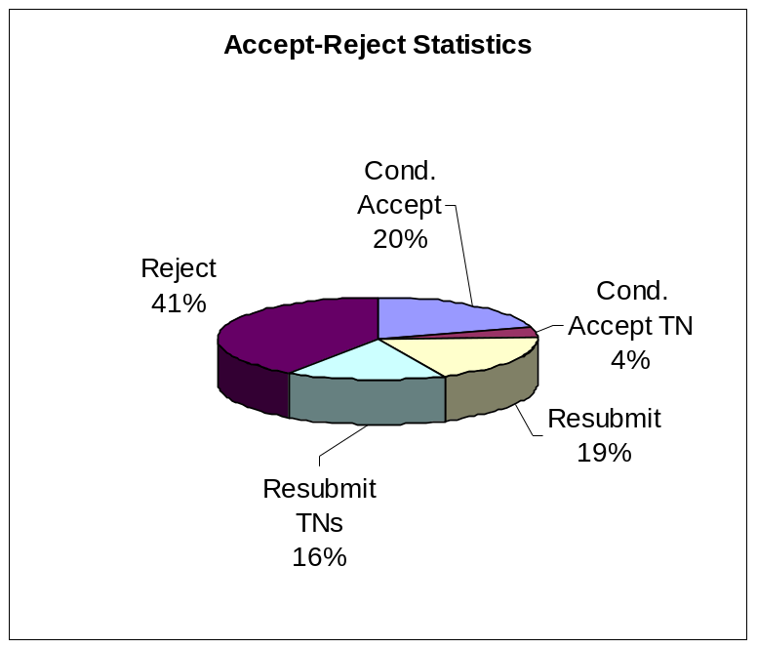

The Reject category is further broken down into:
1. Reject following review (4) – 35
2. Reject without review (I4, obviously inappropriate) – 25
3. Reject and suggest TN submission (I4TN) – 38

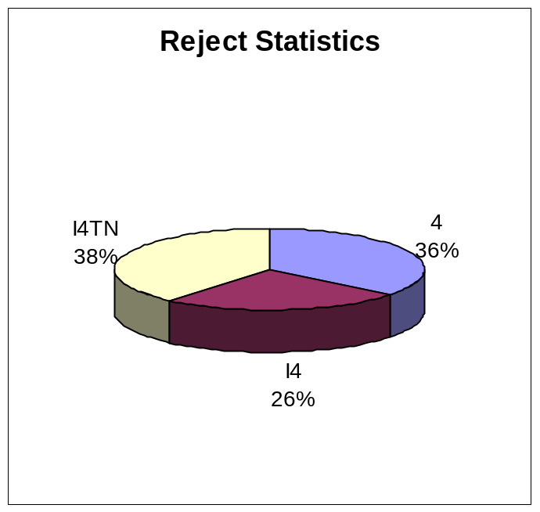

For comparison purposes, the corresponding statistics during the previous nine reporting periods were:

Conditional Accept 15% 14% 13% 18% 19% 16% 20% 19% 22%
Conditional Accept TNs 9% 12% 12% 7% 10% 6% 5% 8%` 5%
Resubmit 17% 16% 17% 18% 17% 14% 21% 16% 18%
Resubmit TNs 16% 19% 21% 18% 20% 17% 15% 15% 14%
Reject 43% 39% 37% 39% 34% 47% 39% 42% 41%

• Backlog
The backlog was 7-8 months in June 2006, and increased to10 months by December 2006. Following an increase to the 2007 page budget, it now stands at 7-8 months and we hope to further decrease it next year.

• Electronic Submission and Web-Based Reviewing System
Since March 1999, we have been accepting electronic submissions. Currently, virtually all papers are submitted this way. In the fall of 2005, a major upgrade in our web-based editorial system was carried out, adding several new editorial and reviewing functionalities. However, it was decided last December that the EIC’s office can no longer maintain and continuously upgrade our system. Thus, the CSS has committed to a new system currently being designed by Pradeep Misra and Huibert Kwakernaak. The first design review meeting for this new system took place in May 2007. A second review meeting is scheduled for November 2, 2007.

• Special Issues
A special issue on Systems Biology (Guest Editors: Mustafa Khammash, M. Vidyasagar, and Claire Tomlin) is scheduled to be published in January 2008 jointly with the IEEE Transactions on Circuits and Systems, Part-I.

A new special issue has been approved on Positive Polynomials in Control (Guest Editors: Graziano Chesi and Didier Henrion). It is tentatively scheduled for the fall of 2008.

• Reviewing Time
Starting with papers submitted in 1999, we are keeping track of the reviewing time (time between submission date and date where a publication decision is made). The average reviewing time for full papers has been consistently approximately 6 months. For papers submitted in 2006 the reviewing time histogram is shown below. The average reviewing time remains at approximately 6 months. It is noteworthy that a large number of papers are now processed within their first month from submission under the “inappropriate category”. Many of them are eventually resubmitted as Technical Notes (see also “Publication Statistics” in this report). The large number of papers in this category is a relatively new phenomenon (last two years).

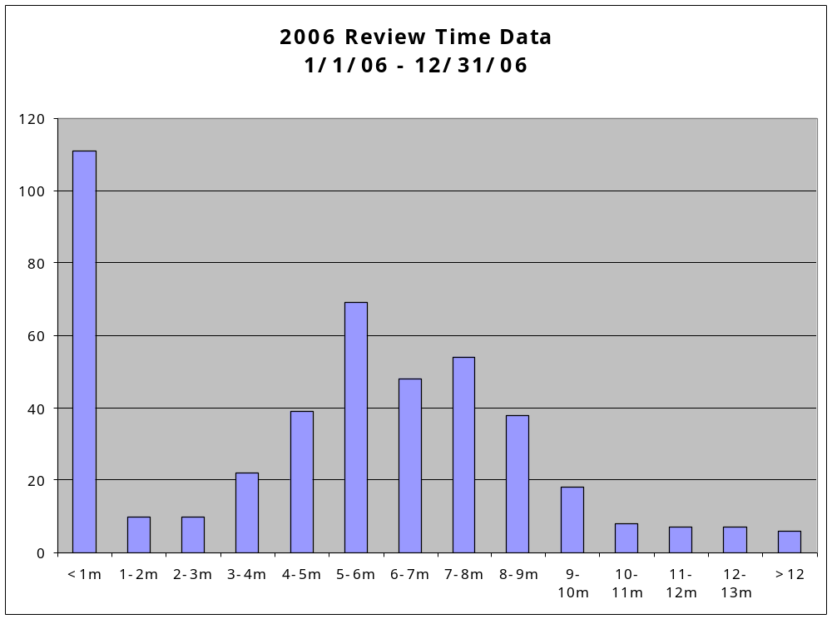

Technical Notes and Correspondence

To: Christos G. Cassandras, Editor-in-Chief
Yutaka Yamamoto, Vice President for Publications, CSS BOG, TEB

From: Roberto Tempo, Editor, Technical Notes and Correspondence
Date: October 31, 2007
Subject: Semi-annual Report for IEEE-TAC Technical Notes

- Highlights

  - The number of papers submitted in the last 12 months is 589 (compared to 614 papers in the previous 12 months).
  - The rejection rate in terms of final decisions is 60% (compared to 62% for the previous six months period).
  - The number of overdue papers is 30 (compared to 27 for the previous six months period).
  - The corresponding author of 22% of the submitted papers is from China.

- Submission History in the Period 1999 - 2007

Month of Submission | 1999 | 2000 | 2001 | 2002 | 2003 | 2004 | 2005 | 2006 | 2007
January | 29 | 42 | 57 | 39 | 42 | 39 | 50 | 54 | 59
February | 47 | 54 | 46 | 29 | 40 | 50 | 40 | 35 | 32
March | 53 | 49 | 52 | 37 | 63 | 64 | 68 | 66 | 63
April | 47 | 39 | 44 | 60 | 63 | 66 | 61 | 61 | 39
May | 38 | 43 | 43 | 38 | 38 | 57 | 48 | 65 | 54
June | 48 | 45 | 39 | 48 | 55 | 60 | 48 | 55 | 53
July | 24 | 51 | 46 | 46 | 57 | 46 | 66 | 45 | 53
August | 44 | 53 | 31 | 29 | 52 | 49 | 50 | 49 | 46
September | 53 | 30 | 35 | 44 | 51 | 66 | 46 | 28 | 35
October | 51 | 45 | 46 | 52 | 56 | 61 | 60 | 58 | 57
November | 40 | 55 | 50 | 53 | 37 | 58 | 59 | 54 | *
December | 30 | 25 | 37 | 53 | 55 | 42 | 39 | 44 | *
Total | 504 | 531 | 526 | 528 | 609 | 658 | 635 | 614 | *

Table 1. History of Submission Volume
*Not available at this time.

• Submission Distribution Among Categories
The next table gives, for the June, 2007 – October, 2007 period, the distribution of submissions according to category: new submissions and resubmissions of previous TNs that received a “3” rating.

Month of Submission | New | Resubmits of  TNs | Total
June | 47 | 6 | 53
July | 37 | 16 | 53
August | 30 | 16 | 46
September | 29 | 6 | 35
October | 47 | 10 | 57
Total | 190 | 54 | 244

Table 2. Submission Volume by Category

- Decision Statistics

Two tables are provided. Table 3 shows, for each month in the June, 2007 – October, 2007 period the number of decisions for each type regarding original submissions (decisions on revised or resubmitted versions are not tallied here nor are 1N/2N/3N decisions on manuscripts originally submitted as regular papers).

Month of Decision | Publish (1) | Revise (2) | Resubmit (3) | Reject (4) | Total
June | 0 | 8 | 7 | 19 | 34
July | 0 | 1 | 17 | 21 | 39
August | 0 | 3 | 13 | 15 | 31
September | 0 | 3 | 11 | 26 | 40
October | 0 | 4 | 18 | 16 | 38
Total | 0 | 19 | 66 | 97 | 182

Table 3. First Decisions for New TN Submissions

In Table 4, the following numbers are reported for the same period: (1) the total number of “publish” decisions and the total number of “reject” decisions (be they on an original submission or on a revised version); and (2) the “rejection ratio”: number of “reject” over the sum of number of “publish” and number of “reject” (this seems a reasonable definition of the rejection ratio, since papers are eventually published or rejected). According to this definition, the rejection ratio for the June, 2007 – October, 2007 period is about 60%.

Month of Decision | Publish | Reject | Total | Rejection Ratio
June | 13 | 23 | 36 | 64%
July | 18 | 25 | 43 | 58%
August | 13 | 17 | 30 | 57%
September | 17 | 27 | 44 | 61%
October | 11 | 18 | 29 | 62%
Total | 72 | 110 | 182 | 60%

Table 4. Final Decisions and Rejection Ratio
• Backlog
Over the past few years, there has been almost no backlog for Technical Notes. All accepted Technical Notes for which the final material has been received are regularly shipped to IEEE Publications and go immediately into production to be included in the issue that comes out two months later.

• Reviewing Time
Table 5 below gives the “Reviewing Time” (time between submission date and date at which a decision is made) paper distribution for decisions made, on the original submission as TNs, during the June, 2007 – October, 2007 time period.

Month of Decision | <1 | 1 to 2 | 2 to 3 | 3 to 4 | 4 to 5 | 5 to 6 | 6 to 7 | 7 to 8 | >8 | Total
June | 2 | 5 | 5 | 7 | 8 | 3 | 1 | 0 | 3 | 34
July | 3 | 3 | 5 | 6 | 7 | 4 | 4 | 3 | 4 | 39
August | 3 | 7 | 5 | 5 | 7 | 1 | 1 | 0 | 2 | 31
September | 7 | 0 | 6 | 8 | 5 | 5 | 1 | 3 | 5 | 40
October | 6 | 0 | 1 | 10 | 7 | 8 | 0 | 3 | 3 | 38
Total | 21 | 15 | 22 | 36 | 34 | 21 | 7 | 9 | 17 | 182

Table 5. Number of Months to Publication Decision

IEEE Transactions on Control Systems Technology

Report to the Board of Governors of the Control Systems Society
from the Editor-in-Chief of IEEE Transactions on Control Systems Technology.
Prepared by Frank Doyle – October 15, 2007

Submissions

Data for the number of submissions is given below. The electronic submission process was implemented in July 2000 and has become the dominant mode of submission.

 | 2007* | 2006 | 2005 | 2004 | 2003 | 2002 | 2001 | 2000
# submitted | 445 | 596 | 398 | 360 | 332 | 283 | 275 | 233
% electronic | 100% | 100% | 100% | 99.5% | 90% | 72% | 56% | 18%
* the number for 2007 is up to October 15, 2007.

Decision Statistics

Decision statistics are given below (current as of October 15, 2007).

 | 2007* | 2006 | 2005 | 2004 | 2003 | 2002 | 2001 | 2000
Dec. 1 | 12 | 32 | 86 | 90 | 85 | 95 | 89 | 91
Dec. 2 | 40 | 133 | 54 | 30 | 10 | 12 | 1 | 2
Dec. 3 | 63 | 180 | 114 | 98 | 106 | 76 | 96 | 79
Dec. 4 | 52 | 128 | 96 | 102 | 103 | 79 | 64 | 51
Dec. 5 | 61 | 61 | 41 | 34 | 23 | 21 | 25 | 10
Pending | 166 | 8 | 0 | 0 | 0 | 0 | 0 | 0
Withdrawn* | 51 | 54 | 7 | 3 | 5 | 1 | 3 | 6
% accept | 23% | 30% | 35% | 33% | 29% | 38% | 33% | 40%

Dec. 1 refers to accepted papers. Dec. 2 refers to conditionally accepted papers (ultimately, dec. 2 papers become either accepted or rejected papers). Dec. 3 refers to papers rejected with encouragement to resubmit (many of these papers are resubmitted and are eventually accepted). Dec. 4 refers to rejected papers. Dec. 5 refers to papers returned to the authors as unsuitable for the journal. The percentage of acceptance is defined as the number of papers accepted (dec. 1 and 2) over the total number of papers for which a decision has been reached (dec. 1 to 5).
*Includes duplicate submissions and unsubmitted papers due to over-length or format problems.

Page Budget

The number of pages printed per year is given below. Note that the journal was published 4 times per year from 1993 to 1995, and 6 times per year since 1996.

2007* | 2006 | 2005. | 2004 | 2003 | 2002 | 2001 | 2000 | 1999 | 1998 | 1997 | 1996 | 1995
1210p | 1210p | 1100p | 1000p | 998p | 950p | 880p | 1056p | 780p | 780p | 696p | 700p | 444p
* the data for 2007 is the approved page budget.

Time to Publication
Data for the average time from submission to publication is given below. The number of weeks applies to papers that were published in the given year.

 | 2007* | 2006 | 2005 | 2004 | 2003 | 2002 | 2001 | 2000 | 1999
# weeks | 71 | 86 | 87 | 96 | 85 | 89 | 100 | 126 | 119
*the data for 2007 includes the issues up to and including September 2007.

Time to Reach First Decision
Chart I: 2005-2006 papers.

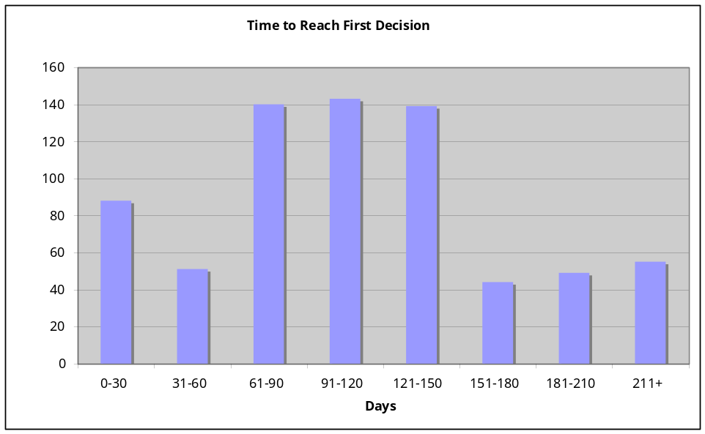

Chart II: 2007, YTD
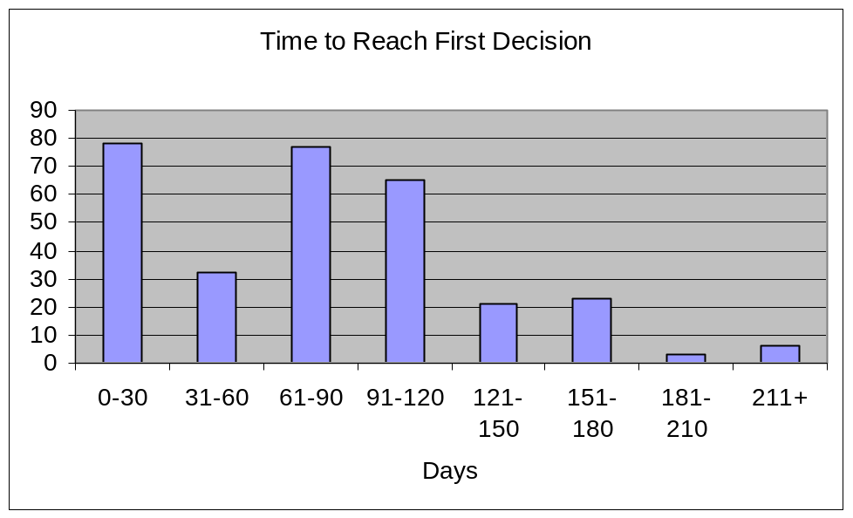
Editorial Board

The board currently counts 54 associate editors, with 43 associate editors affiliated with academia, and 11 (or 20% of the total) working in industry or in government labs. Due to term limits, approximately 12 associate editors will be retiring at the end of the year. Replacement candidates have been identified with a major objective towards maintaining or increasing the industrial participation on the board. Suggestions for associate editors from industry are always appreciated.

Control Systems Magazine

Report to the CSS Board of Governors

October 24, 2007

Dennis S. Bernstein, Editor-in-Chief

Report Coverage

This report summarizes activities relating to the IEEE CSM from May 2007 to November 2007.

Backlog

CSM has no backlog in the conventional sense since most papers remain under continual revision until the publication deadline. However, we currently have several special issues in various stages of development, so that a substantial number of feature articles are in the pipeline. Several substantive invited papers are also under development (more on this initiative below). Departmental items are developed separately for each issue with less lead time.

Completed Issues

Since the last report, 4 issues have appeared:

- August 07: Complex Networked Control Systems special issue (Guest Editors Chaouki Abdallah and Herbert Tanner)

- October 07: Applications of System Identification (Guest Editors Spilios Fassois and Daniel Rivera)

- December 07: Behavioral Modeling. The feature article is the second in the CSM modeling series. The entire issue is devoted to this single feature.

Scheduled Issues under Development

- February 08: Inertially stabilized platform technology (Mike Masten, guest editor). This is a unique issue with all industry authors.

- April 08: Contributed articles

Magazine Changes

Two new columns have been implemented.

- Ask the Experts
    - These are short articles written in a question/answer educational mode

- Member Activities
    - See below

Special Issues and Initiatives under Development

- Friction Modeling and Control (guest editor, Warren Dixon)

- Applications of Hysteresis (guest editors, Xiaobo Tan and Ram Iyer)

- Kalman Filtering, 50th anniversary (guest editors Tyrone Vincent, Jay Farrell, Alex Leonessa, Kent Lundberg). Several special issues are planned for 2009 and 2010. Abstracts have been reviewed and 20+ invitations have been issued. Papers are due at the end of 2007.

- The initiative on substantive tutorial articles on modeling issues is progressing. The first article was on bond graph models in the April 07 issue. The second article on behavioral models is scheduled for December 07. Articles have been invited on multidimensional systems, delay systems, and hybrid systems.

Editorial Board

Several new members are being nominated for the BOG meeting in December 2007.

Mike Polis has been appointed AE for Book Reviews. Scott Ploen is retiring from that position in 2008, and will be replaced by Zongli Lin. Goal is to have 2 AEs for book reviews.

Plans, Proposals, Challenges, and Action Items

In the interest of streamlining interface with CSS and ExCom I have composed a detailed list of interfaces below.

CSM/CSS Interface List

Note: All contributions to IEEE CSM are due by the 10th of the month that is the month of publication minus 4. Example: Contributions for February 2008 are due by October 10, 2007.

- Presidents Message
  - For each issue, by current CSS President.

- Call for Volunteers
  - This annual column appears in the December issue of each year, and is contributed by the incoming president. Therefore, Tariq has responsibility for the December 2008 writeup. Tariq: David wrote an extensive column that you might want to use as a starter draft.

- President-elect interview
  - In December we publish an interview and fact sheet concerning the President elect. This will be Tariq in 2007. Relevant issue is December. Due date is August 10. I can compose questions, or interviewee can make them up.

- Call for Award Nominations
  - Complete announcement of CSS awards. Awards committee chair has responsibility. Which issue to publish in??

- Call for Fellow Nominations
  - To be submitted by the fellows chair(?)
  - Once new CSS fellows are announced. CSS secretary communicates essential information to Dennis, who contacts new fellows to obtain bios for publication in People in Control column in CSM.

- BOG minutes
  - To be submitted after each of the two yearly BOG meetings at ACC and CDC by the CSS secretary.

- Annual update to 25-year member list
  - To be submitted each year by the VP for Member Activities. Aim for June issue each year. For 2008, this is Claire Tomlin. Claire has agreed to submit a column for each issue of CSM.
  - Call for senior member nominations by VP for Member Activities.

- Technical committee reports
  - To be submitted annually by VP for technical committees. For 2008 this is Jay Farrell. Target issue June 2008.

- Conference reports
  - CDC report from CDC chair—including a report on the awards session with possible additional information on the awardees. Awards chair should be involved in this process, while Secretary-Admin may continue to collect the information. The write up would ideally come from Awards Chair.
  - MSC report from MSC chair
  - All conference reports are due within 45 days of the end of the conference. Deadline is firm. Be sure to take and include lots of *good* photos with captions that identify those in the photos.

Electronic Publications

From: Pradeep Misra
To: CSS Board of Governors
Date: November 28, 2007
Subject: Semi-annual report of CSS electronic publications activities (e-letter, website)

e-letter:

e-letter continues to be a preferred means of information dissemination in the systems and control community. The current subscription stands at over 20,000 valid subscribers. Number of articles submitted every month ranges from 50 – 75, after filtering out clearly non-suitable submissions. Most popular category has been job postings for last several months followed closely by conference announcements and journal content listings.

CSS Website:

History. The original CSS website was put together using rudimentary web technology, with just sufficient scripting and database usage to ensure that various essential applications would adequately serve society needs. Approximately 18 months ago CSS decided to upgrade its website from an amateur effort to a database driven site designed by web-design professionals. The intent was that instead of have a single point of failure, namely the CSS webmaster who must maintain all web content, distributed access will provided to various committee and subcommittee chairs. This would enable them to maintain their respective subsections independently and at the same time host the content on a central CSS server so that when committee chairs change, the transfer of content is seamless.

After considerable evaluation of bids received in response to RFP, OptionMatrix from Hydrabad, India was selected as the preferred vendor to develop the engine and to port the data from the then existing site to the new database-driven site. After a promising start, the company experienced significant manpower turnover and as a result the CSS web project changed hands several times and as a result a consistent design could not be carried out. Software engineers that picked work from their predecessors introduced features that were incompatible with earlier versions and could not make scripts flexible enough for future needs.

Present. While it is far from what was envisioned, we do have a functional database driven website. All committees (chairs) do have or can request access to their web content and make modifications to pages pertaining to their committee activities. The content manager is not as robust as a distributed content manager being used by people of varying skill sets ought to be, but it can be used and indeed several Technical Committees are have successfully updated their web pages. Some backend functionality is not working as expected and we continue to work with the vendor to fix script errors as we become aware of them.

Future. Web development (especially distributed applications) is a very tricky design problem and if not done right, can be frustratingly time consuming to maintain. The present site should be able to serve the CSS function for next year or two. However, as the society needs grow, it will be necessary to revisit this issue. It is clear that this is not a function that can be adequately supported by volunteers (the design part, that is), hence a new vendor will have to be located and perhaps more weight given to how long they have been in business and more carefully evaluate their technical skill sets. It is clear that our current vendor does not have the necessary technical know how to serve our future needs.

REPORT TO THE

IEEE CONTROL SYSTEMS SOCIETY BOARD OF GOVERNORS (BoG)
FROM THE VICE PRESIDENT, MEMBER ACTIVITIES
M. ELENA VALCHER

November 14, 2007

Student Travel Support and Conference Travel Support for Developing Countries at the CDC 2006 (San Diego)

The deadline for submitting the applications through PaperPlaza was set to August 15. Decision letters were sent out on August 24, and this allowed to immediately register for free successful applicants, without dealing with refund procedures.

There were 41 applications for the Student Travel Support. All applicants were eligible, since they were IEEE CSS members (this eligibility constraint was approved at the last BoG meeting in December 2005). 8 applicants received the full registration fee (400 $), while the other 33 the student registration fee (205 $), according to their requests.
By making use of NSF funds, Faryar Jabbari has been able to provide further support to students working in the US (with priority given to IEEE CSS students, as approved at the June ’06 BoG). Also, he has taken care of obtaining rooms at reduced rate for students attending the CDC. Details have been provided in his report (below).

8 persons applied for the Conference Travel Support Program for Developing Countries. All the applicants were supported. Giving the relatively large amount of funds we could count on, we were able to offer each of these persons the Full Conference Registration (400$) plus three nights (specifically Tuesday to Thursday night) at the Conference hotel (at the conference rate, 139$ + taxes per night). This way we forecast to spend approximately 7040$.
The nations represented in the awards were:

- Poland (1)
- Russia (1)
- China (4)
- Turkey (1)
- Uruguay (1)

Initiatives for increasing Student Membership

Every year the IEEE CSS devotes about 5.000 $ (in addition to the 20.000 $ used for Student Travel support at the three main CSS sponsored conferences) to support initiatives which may increase student membership. At the last CDC-ECC’05 in Seville (Spain), and at the last CDC’06 in San Diego, free IEEE CSS membership was offered to all students who were interested in it.
This year I plan to re-iterate this initiative, aiming at increasing the number of IEEE CSS student members, by offering free IEEE CSS registration at the Students and Newcomers reception. To this end, in early October, I sent out a letter to all student who had already registered to the CDC’07 by promoting these initiative.

Also, I have chosen to give a sort of “award” to those students who are already IEEE CSS members, by offering them the free workshop fee for one of the workshops that will take place in New Orleans. Differently from what happened last year, the Announcement has been posted on the Conference web pages at the end of August and applications have been collected till the end of October. I collected 15 applications, 13 of them acceptable. The financial impact of this initiative is 845 $.

New Support Programs for the Developing Countries

The Conference Support Program for the Developing Countries, in its present version, has been approved at the December 2004 BoG meeting for the period 2005-2007, namely for three years. Even though the idea of helping people from the Developing Countries to attend CSS conferences has always been welcomed, both by the ExCom and by BoG members, there have always been some doubts about the effectiveness of this program, which could bring obvious advantages only to a few participants from the Developing Countries. The fall-outs of this program, apart from the immediate benefit of financially supporting a few people to attend the conference, do not seem very relevant (surveys were conducted in a couple of years). Even more, the number of applications is increasingly lower.
At the last BoG meeting in New York, an alternative plan was proposed. The new program aimed at supporting conferences held in Developing Countries. A draft program, whose financial impact was 30.000$ as the previous program, was conceived by Rick Middleton (VPCA), Eyad Abed (VPFA) and I. At the BoG meeting, however, there were strong requests to split the 30.000$ between two programs in favor of the Developing Countries: a new program for supporting Conferences held in the Developing Countries (20.000$) and a revised version of the old Travel Support Program, aiming at defraying the costs of registration fees, lodging and traveling for people attending the two main CSS-sponsored conferences: MSC and CDC (10.000$).
The first program have been discussed and revised at the last ExCom meeting in Boston (November 3): the budget has been increased to 40.000$. The program will be presented for approval at the next BoG meeting in December.
As far as the second program is concerned, the task of coming up with a new proposal (possibly without the IEEE membership requirement among the eligibility conditions) was assigned to Frank Allgower, the International Affairs Chair. Up to now, however, the new proposal has not been forwarded to ExCom members, and I have not received any info about that from Allgower.

Motion to change the MAB composition and, accordingly, the Society Bylaws

At the last BoG meeting, I proposed a motion for changing the MAB composition. The two changes proposed are: 1) making the Distinguished Lecturers a Standing Committee, instead of a MAB Subcommittee (actually, the only MAB Subcommittee!); 2) merge two Standing Committees (Membership and Admissions on the one hand, Public Information on the other hand) into a single one. The reason for these requests are the following ones: as far as the first change is concerned, it does not seem reasonable to give the DL Committee a lower dignity with respect to the other MAB committees. Reasons for the second requests have to be searched for in the fact that the activities of these committees seem a little vague and largely overlapping. So, it seems more reasonable to have a single committee dealing both with Membership information and with Public Information about the Society. These two motions have both been endorsed by the ExCom at the November meeting. Since they require a change in the Society Bylaws, a few days ago the modified Bylaws have been sent out to all BoG members for discussion. The term of at least 30 days in advance with respect to the official vote has been respected.

Standing Committee on Chapter Activities

(Alessandro Giua)

Activity reports
In April-May 2007 I contacted the chapter chairs to ask for a report of the activity in 2006.
Our of 65 active Chapter CSS listed in the List of Chapters:
- 12 Chapter Chairs replied and submitted a report;
- 44 Chapters did not reply but submitted during 2006 one or more Meeting Report Form (L31)
- 9 Chapter did not show any sign of activity.

Outstanding Chapter Award Recommendation
June 15: The Japanese Chapter has been selected by the IEEE CSS Membership Activities Board with an electronic vote as the Outstanding Chapter of our society for 2006. The chapter chair Dr. Kenko Uchida was informed on August 13.

New Chapters

The following new chapters were approved in 2007.

IEEE Republic of Macedonia Section CAS/CIS/CS Joint Societies Chapter. Chair: Miles Stankovski, milestk@etf.ukim.edu.mk. October 8.

IEEE Rio de Janeiro Section Instrumentation & Measurement/Control Systems Joint Societies Chapter. Chair: Gregory Kyriazis, gakyriazis@inmetro.gov.br. August 6.

IEEE Malaysia Section Control Systems Society Chapter. Chair: Mohd Nasir Taib, dr.nasir@ieee.org. July 25.

Requests from Chapters
- April 26: Juan Martín Sánchez, chair of the Spanish Joint Chapter IEEE Industry Applications & Control Systems Societies, asked financial support to organize the Seminar for Advanced Industrial Control Applications (SAICA) 2007 in November 5 & 6, 2007. The MAB supported this initiative with a grant of 1.000 $.

Other activities
- April 26: the webpage of LASS was updated

Standing Committee on History

(Daniel Abramovitch)

The one activity to report is for the 2007 ACC. We had a special history session right before the opening reception of the 2007 ACC. This session focusd on the history of the CSS' Information Dissemination Committee (IDC) which existed from 1964 until 1991 and controlled what was published in the IEEE Transactions on Automatic Control. We had several former members of the IDC to reminisce about the operations and effects of the IDC, both on the CSS at the time and on the current operation of the CSS. Unfortunately, the session was not well advertised and in an out of the way location. Thus, the number of speakers roughly equaled the number of people in the audience.

Standing Committee on International Affairs
(Frank Allgower)
The IEEE/CSS International Affairs Committee met on July 13, 2007 at the ACC venue in New York. Only five out of 34 members of this committee attended the meeting. The past chairman reported that this is a comparable attendance to the past meetings during ACCs.
The main agenda item was a discussion of the present travel support program and necessary changes for the future. The committee sees a clear need for such a program, but also acknowledges that the present one has some weaknesses. Several suggestions for improvements have been discussed, including ideas for better advertising of the program and for a change of some of the rules. It was suggested to further strengthen the ties with the distinguished lecturer program. Colleagues in developing countries should be explicitly encouraged to make use of this program. It was furthermore suggested to search for suitable distinguished lecturers from developing countries that could be suggested. It was believed that the psychological hurdle for local chapters in developing countries to approach
speakers from far away may possibly be too high and that speakers from countries with a similar structure may be a more attractive option. Furthermore it was suggested to change the committee composition and in
particular to reduce the number of members.

Standing Committee on Membership and Admissions
(Marco Lovera)

- Information leaflet on the activities of the CSS: a draft of the leaflet has been prepared.

- Attendance to the MAB meeting at the 2007 American Control Conference.

Standing Committee on Student Activities

(Faryar Jabbari)

MSC-2007

Nine (9) students were support for this conference in coordination with the VP of Member Activities. The support package included free registration as well as a free hotel accommodation, if requested, on a `double occupancy' basis. The source of funding for the entire support package was IEEE-CSS funds.

CDC-07:

Forty one (41) students were supported with CSS funds, in the form of free registration. As with the MSC, this required collaboration of the Registration Chair to minimize the paperwork burden. The total is expected to be almost $10k, assuming all grantees join the conference ($9965). Of these nine (9) were based outside of the U.S. and 32 were U.S. based students.

The Students Activities Committee also assisted with the preparation of a proposal to NSF for an additional $10k of support, toward travel, and lodging of the U.S. based students. The proposal was submitted by the General Chair of the Conference from his home institution. The final decision is due in late November, with disbursements due after the conference (January of 2008).

Finally, the conference has a slate of rooms (roughly 100) that were made available to students on a reduced cost basis. The program will be managed by the Student Activities Chair of the conference, though the IEEE-CSS committee assisted in developing a plan, including the on-line form, that should simplify the process. At the writing of this report, no further information is available about the room assignments.

Preliminary contacts were made with the General Chair and the Program Chair of CDC-08, which is anticipated have its own Students Activities Chair and rather extensive set of programs for student.

Standing Committee on Women in Control

(Elena Zattoni)
During the second half of 2007, the activities of the IEEE CSS Committee on “Women in Control” have been focused on promoting involvement of women scientists and researchers, operating in the field of control systems, in highly qualified professional, (particularly within the IEEE Control Systems Society) and academic roles and in fostering women advancement in their respective careers.

This has been performed through several means which have recently been refined and are currently maintained thanks to the help of a fair number of volunteers:
MAILING LIST: The “Women in Control” mailing list presently counts more than 200 addresses of members and affiliates. It was considered opportunity of distinguishing between members and affiliates: members are considered those people who are also IEEE CSS member, affiliates are considered those people who, for several reasons, are not IEEE CSS member but are willing to keep up-to-date on the committee activities. The mailing list is the fastest and most direct means to reach women in control members: hence, it is used for spreading open positions announcements, calls for reviewers, calls for papers and invited session proposals, calls for Senior Member upgrade, and similar.
NEWSLETTER: The “Women in Control” newsletter is sent out quarterly, before and after the main conferences (ACCs and CDCs) through the mailing list. The after-ACC issue was sent in late September, including several reports from activities performed at the ACC 2007 in New York City. The Editor of the WiC Newletter is now, effective from the September issue Dr. Jihong Wang, from the University of Birmingham, UK.
MEETINGS at the main conferences: At the ACC 2007, the Women in Control luncheon was held on Wednesday, July 11. The Women in Control Committee, in coordination with the Technical Committee on Control Education, also co-sponsored a meeting with Professor Virginia Warfield, special guest at the meeting of the Technical Committee on Control Education, and important role model to new generations of women scientists and engineers.
WEB SITE: The “Women in Control” web site was completely renewed in 2002 and is currently hosted and maintained at the Università Politecnica delle Marche, Italy. It basically serves as a window where the most recent announcements and issues are posted as well as an archive of all main past activities of the Committee.
Member expertise data-base: is a data base counting about fourty records, with information about WiC members and their areas of scientific interest. This data-base is searchable by keywords by anyone, so that it turns out to be particularly useful e.g. in recruiting qualified reviewers for conferences and journal papers.
ROOMMATE LOCATION SERVICE: was organized at the American Control Conference 2007.

As to the events organized/co-organized by WiC members for the forthcoming CDC 2007, a complete list follows:

SPECIAL SESSIONS at the 2007 CDC
New Orleans, LA
-------------------------------------------------------------------
Wed (Evening - exact time TBA) Dec. 12, 2007
Plain Talk on Control for a Wide Range of the Public
Sponsored by CSS and AACC Technical Committees on Control Education

Organizer: Bozenna Pasik-Duncan, University of Kansas
Chair: Bozenna Pasik-Duncan, University of Kansas
Co-Chair: Fahmida N. Chowdhury, University of Louisiana at Lafayette

Abstract: One of the major challenges for the controls community is to enhance its own public image and convey the essence and contribution of the field to outsiders; for this, a coordinated effort has to take place. This Special Session has as its purpose to prepare “Plain Talk about the Power, Beauty and Excitement of Control for the Non-Control Engineering Audience.” This series of talks will include a brief history of feedback control and provide a sample of short talks for a target audience of non-control engineering professionals and general public.

--------------------------------------------------------------------------
Wed 12:00 – 1:00 pm Dec. 12, 2007 Special Lunchtime Session

NSF Special Session on Research Ethics and Related Issues in Research and Education

Organizer: Fahmida N. Chowdhury, University of Louisiana, Lafayette

Chair: Karlene Hoo, Texas Tech University
Co-Chair: Bozenna Pasik-Duncan, Professor, Mathematics, University of Kansas

Abstract:

This NSF-sponsored special session will focus on ethics and related issues in research and education, NSF’s funding opportunities in these fields, and ideas for collaborative research on these issues. The session includes an invited presentation by a sociologist (stereotyping and evaluation bias) plus short talks (NSF funding programs in ethics in science and engineering, and in broadening participation in engineering) by two NSF Program Officers, and an interactive Q&A period.

Presentations:

1. Presentation on stereotyping and evaluation bias: Nilanjana Dasgupta, University of Massachusetts, Amherst; 20 min.
2. Presentation on NSF funding programs on ethics in science and engineering: Myles Boylan, Program Director, Education and Human Resources, NSF; 10 min.
3. Presentation on NSF efforts on broadening participation in engineering: Mary Juhas (Program Directror for Diversity and Outreach, OAD, Engineering, NSF); 10 min.
4. Panel discussion and Q&A: Panelists: Myles Boylan, Mary Juhas, Nilanjana Dasgupta, Karlene Hoo, Bozenna Pasik-Duncan; panel moderator: Fahmida Chowdhury; 20min.

--------------------------------------------------------------------------
Th 12:00 – 1:00 pm Dec. 13, 2007 Special Lunchtime Session

How to Present Your Work and Yourself

Organizers: Fahmida N. Chowdhury and May-Win Thein
Chair: May-Win Thein, University of New Hampshire
Co-Chair: Fahmida N. Chowdhury, University of Louisiana at Lafayette

Abstract: Presenting yourself at a job interview, and presenting your work to an audience are very important skills for professional success. In this session, Dr. James Spall of the Applied Physics Laboratory (Johns Hopkins University) will give some tips and pointers on technical presentations that will be useful for beginners and advanced researchers alike. Then, Prof. Dawn Tilbury and Dr. Jeanie Falcon will review basic job search processes for academia and industry, highlighting the differences. Prof. Tilbury was chair of the faculty search committee at the University of Michigan in 2006- 2007. Dr. Falcon is a senior engineer at National Instruments and has been involved in hiring both at NI and with their alliance member companies.

Presentations:

Jim Spall, Applied Physics Laboratory, Johns Hopkins University (20 min) Dawn Tilbury, University of Michigan (15 min) Jeanie Falcon, National Instruments (15 min) Q&A (10 min)

--------------------------------------------------------------------------
Women-in-Control Luncheon (Lunch will be Served)

Friday Dec. 14

Invited Presentation by Ms. Rosann Marosy

Steps to Becoming a Fellow

A presentation outlining the qualifications and processes on becoming an IEEE Fellow.

Rosann joined IEEE in 1999 and have managed the Fellow Program the eight years since she started. Prior to working at IEEE, she was employed by Prudential and managed their MDRT (Million Dollar Round Table) program.
--------------------------------------------------------------------------

On a final note, the discussion inside the Committee during the second half of 2007 was particularly focused on the question of promoting a wider involvement of women scientists at the highest technical levels of the IEEE CSS, with particular attention to Technical Committees and Conference and Journal Editorial Boards.

Given the high number of excellent curricula of Women in Control members, it is seen as a priority of this Committee to promote broadening of the group of women scientists and engineers involved in that kind of, highly recognized, activities.

Standing Subcommittee on Distinguished Lecturer

(Ian Petersen)

Normally lecturers are appointed for a period of three years with one third of the list updated every year. Also, in some cases the term of lecturers is extended for an extra year if that lecturer seems to be in significant demand.
The current list of lecturers is as follows:

Until December 2007
Jie Huang (China)
Bassam Bamieh (US)
Iven Mareels (Australia)
Karl Åström (Sweden)
Hebertt Sira-Ramirez (Mexico)
Marco Campi (Italy)
Kevin Passino (US)
Andrew Alleyne (US)
Thomas Parisini (Italy)
Carlos de Souza (Brasil)

Until December 2008
Carlos Canudas de Wit (France)
Miroslav Krstic (US)
Pablo Iglesias (US)

Until December 2009
João Hespanha (USA)
Stephane Lafortune (USA)
Li Qiu (Hong Kong)
Frank Allgower (Germany)

During 2007 there will be four sets of distinguished lectures. Professor Carlos DeSouza gave a Distinguished Lecture to the Singapore Chapter in May. Professor Jie Huang is to give a Distinguished Lecture to the Beijing Chapter in October. Professor Jie Huang also gave a Distinguished Lecture to the Guangzhou Chapter in September. Professor Li Qiu will give a Distinguished Lecture to the Dallas IEEE Section in December.

From the above, it can be seen that ten lecturers are due to retire at the end of this year. However, I would recommend that all of those lecturers whose term is due to expire and who have given a lecture this year, would have their terms extended for one more year. This would mean that the lecturers De Souza and Huang would have their terms extended for one more year.

I am in the process of collecting suggestions for new lecturers to be appointed until December 2010.

Next meeting of the Board of Governors: 1pm Tuesday June, 10 2008, Seattle

