LATVIA'S PAYMENT STATISTICS

In 2009, payment services were rendered by 21 banks registered in Latvia, three branches of foreign banks and the Bank of Latvia as well as the SJSC Latvijas Pasts (hereinafter, Latvijas Pasts) . Several commercial companies, mainly fuel companies, issued and serviced single-purpose retailer cards in 2009. Five electronic money (hereinafter – e-money) institutions issued and serviced e-money.

In 2009, total customer payments executed via Latvia's payment system (credit institutions (banks, incl. branches of foreign banks and e-money institutions), the Bank of Latvia and Latvijas Pasts) posted year-on-year declines of 2.3% (to 217.2 million) and 33.4% (to 244.3 billion lats) in terms of volume and value respectively (see Chart 5).

Chart 5

TOTAL CUSTOMER PAYMENTS
IN LATVIA (volume – in millions; value – in billions of lats)

- Volume
⎯ Value
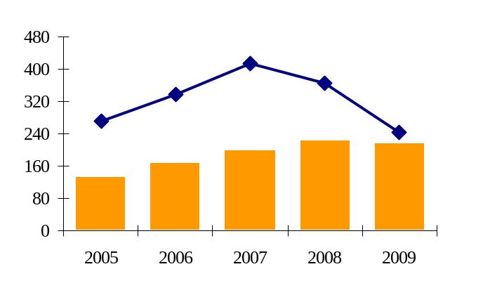

In Estonia, the total volume of payments per capita is higher than in Latvia and Lithuania. In 2008, 199 customer payments per capita were executed in Estonia, while in Latvia and Lithuania the customer payments per capita amounted to 98 and 62 respectively (see Chart 6).

Chart 6

TOTAL VOLUME OF CUSTOMER PAYMENTS PER CAPITA IN THE BALTIC STATES

- Latvia
- Estonia
- Lithuania

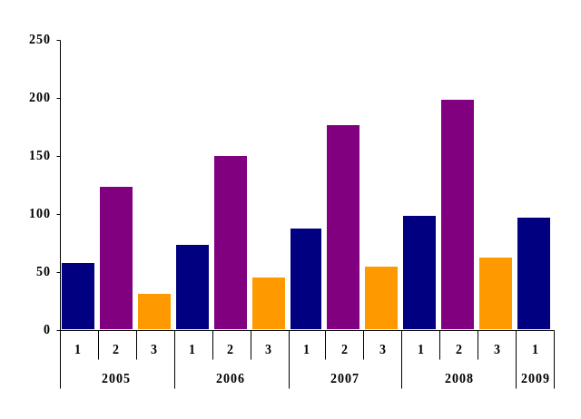

As in previous years, customer credit transfers (52.6% or 114.3 million) accounted for the majority of total customer payments effected via Latvia's payment system in 2009. Card payments continuing on an upward trend have already amounted to 45.0% of total customer payments (97.8 million payments were executed by all cards issued in Latvia), whereas direct debit and cheque payments stood at 2.0% or 4.4 million and e-money payments were 0.3% or 0.8 million. Of credit institution customer payments, card payments (51.0%) accounted for the majority, followed by credit transfers (46.3%) and other payments, such as direct debit, e-money and cheque payments.

For comparison, of total customer payments executed in the European Union, the breakdown of payments was as follows: in 2008, customer credit transfers amounted to 27.7%, card payments were 37.6%, direct debit payments stood at 25.9%, e-money payments amounted to 0.7%, cheque payments and other payment instruments – 7.4% and 0.7% respectively (see Chart 7).

Chart 7

BREAKDOWN OF THE VOLUME OF PAYMENT INSTRUMENTS

- Latvia
- European Union (total)
- Cheques
  - E-money payments
    - Direct debit
      - Card payments
        - Customer credit transfers

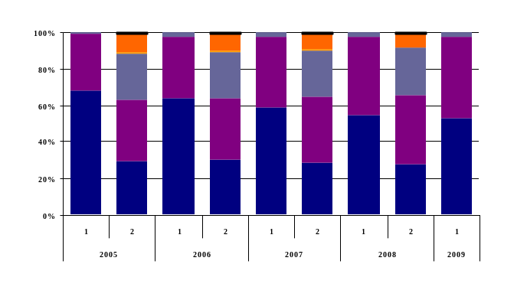

In terms of volume, card payments expanded in 2009 by 2.8% year-on-year, while customer credit transfers diminished by 6.2%, direct debit payments decreased by 0.1%, cheque payments fell by 29.8%, and e-money payments – by 8.7%.

In terms of value, credit transfers recorded a year-on-year decline of 33.4% in 2009 (to 242.7 billion lats), card payments narrowed by 20.2% (to 1.4 billion lats), direct debit payments dropped by 11.3% (to 0.2 billion lats), cheque payments contracted more than twice, and e-money – by 31.6%.

Similar to card payments, transactions at terminals were also serviced by credit institutions only (see Charts 8 and 9).

Transactions at terminals located in the country (including cash deposits and withdrawals from ATMs, payments at the POS terminals and credit transfers via ATMs) with cards issued in the country decreased by 5.6% (to 137.4 million) and 20.0% (to 4.4 billion lats) in terms of volume and value respectively.

The volume and value of transactions conducted at terminals located in the country with cards issued outside the country narrowed by 20.1% (to 3.9 million) and 26.8% (to 0.2 billion lats) respectively.

In terms of volume and value, transactions effected at terminals located outside the country with cards issued in the country increased by 4.8% (to 7.8 million) and 22.9% (to 0.6 billion lats) respectively.

Chart 8

TRANSACTIONS AT TERMINALS (volume – in thousands)

- Transactions at terminals located in the country with cards issued in the country
  - Transactions at terminals located in the country with cards issued outside the country
  - Transactions at terminals located outside the country with cards issued in the country
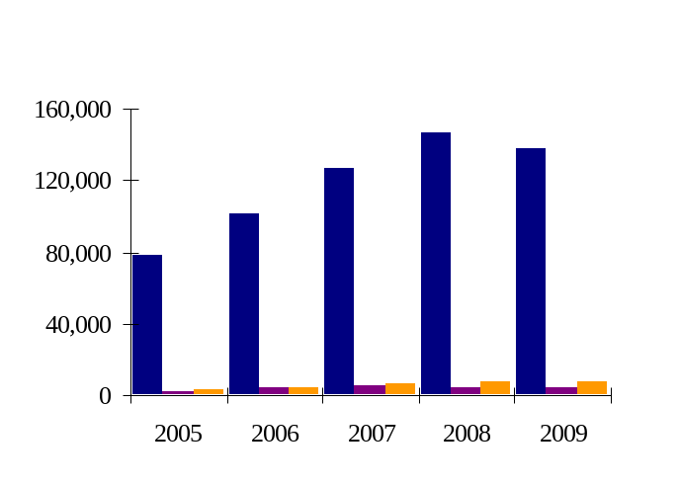

Chart 9

TRANSACTIONS AT TERMINALS (value – in millions)

- Transactions at terminals located in the country with cards issued in the country
  - Transactions at terminals located in the country with cards issued outside the country
  - Transactions at terminals located outside the country with cards issued in the country

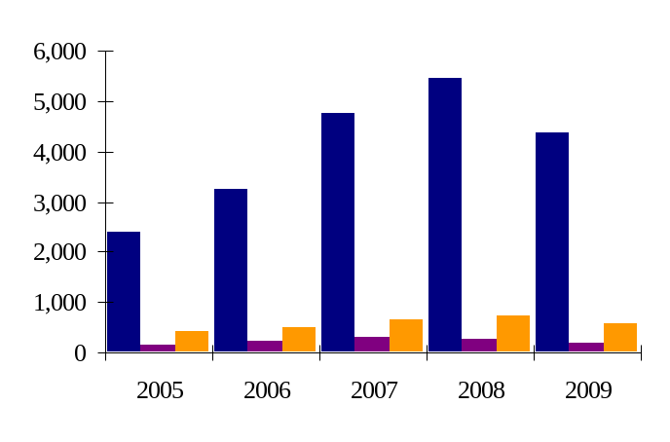

At the end of 2009, the number of customer accounts recorded a year-on-year drop of 2.7% or 135.4 thousand accounts (down to 4.9 million; see Chart 10), of which 65.8% or 3.2 million were virtual accounts. The majority of accounts (82.0%) were accessible for settling in lats. 11.9% of accounts were accessible for the euro settlement.

Chart 10

NUMBER OF CUSTOMER ACCOUNTS (in thousands)

- In lats
- In euro

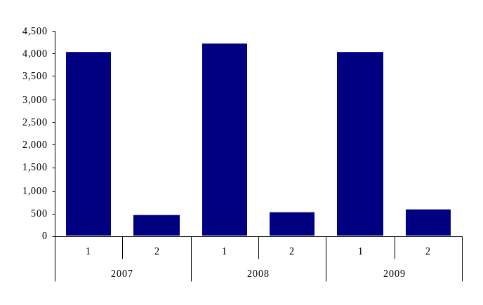

At the end of 2009, average 2.2 accounts per capita were opened in Latvia. For comparison, 2.9 accounts per capita were opened in Lithuania on average in 2008 and 1.2 accounts per capita on average in the European Union (see Chart 11).

Chart 11

NUMBER OF CUSTOMER ACCOUNTS PER CAPITA

        - Latvia
- Lithuania
  - European Union

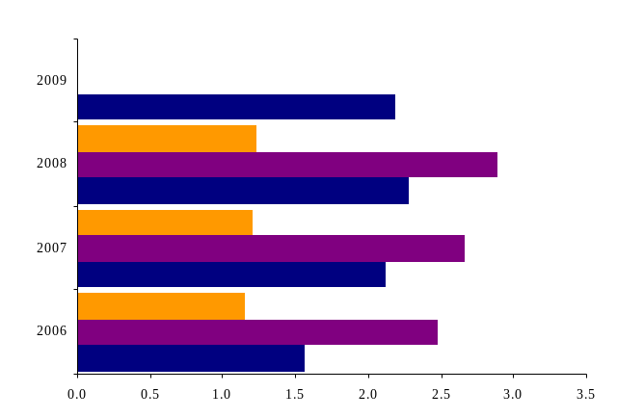

At the end of 2009, the number of cards issued recorded a year-on-year drop of 1.6% or 40.7 thousand cards (to 2.5 million cards). On average, 1.1 payment cards were issued per capita in Latvia as at the end of 2009. This compares with Estonia and Lithuania where 1.4 and 1.3 cards were issued per capita respectively on average in 2008. In the European Union, this indicator was 1.4 cards (see Chart 12).

Chart 12

NUMBER OF CARDS PER CAPITA (on average)
European Union Estonia Lithuania Latvia
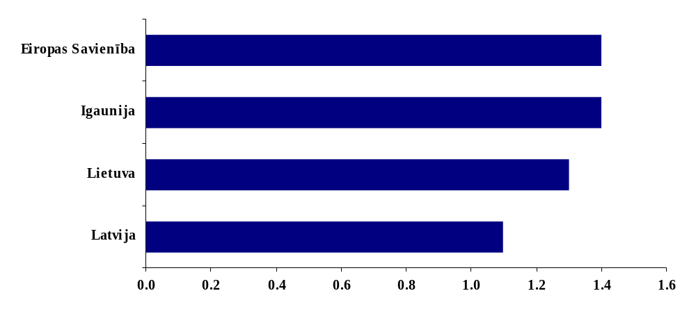
Of cards, 99.9% were cards with a cash function (the rest were virtual payment cards for effecting settlement only, providing no cash withdrawals) and almost all cards were with a payment function. Of cards with one or multiple payment functions, the majority were with a debit function (80.5% or 2.0 million). Cards with a credit function and delayed debit function amounted to 17.4% or 0.4 million and 3.7% or 0.1 million cards respectively (see Chart 13).

Chart 13

NUMBER OF CARDS (in thousands)

Total number of cards
Cards with a debit function Cards with a credit function Cards with a delayed debit function

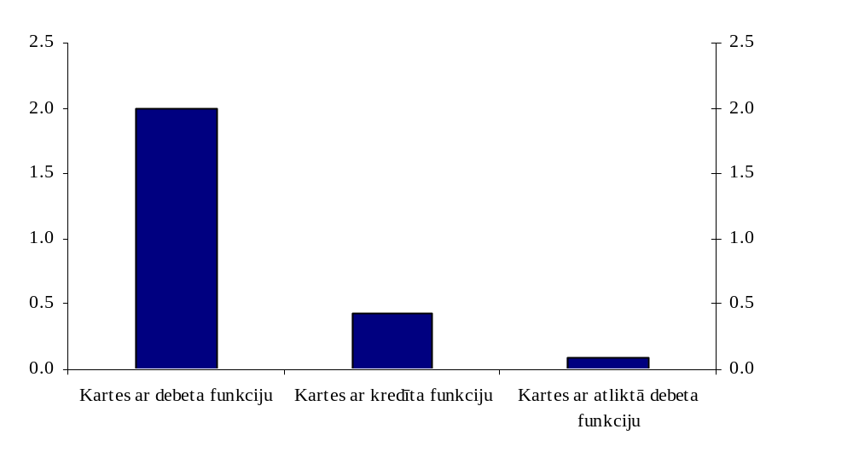
Karšu kopskaits

At the end of 2009, the number of ATMs rose by 8.1% or 103 ATMs year-on-year, reaching 1 377 (of them, 119 ATMs were with a cash deposit function). The number of POS terminals increased by 2.6% or 603, amounting to 23 836, and the number of virtual POSs for cards and e-money also continued on an upward trend, already reaching 1 374 (a 2.3 times' rise year-on-year).

