

2010 – 2011
SCRIP
Tuition Rewards Program

***PLEASE NOTE***
EVERY FAMILY MUST FILL OUT THE LAST FORM IN THIS PACKET AND RETURN IT TO SCHOOL BY FRIDAY, MAY 28, 2010!
We are beginning our second year and our SCS SCRIP Tuition Rewards Program has been tremendously successful for our families and our school! This year-long program is in place to help raise money for your family and for SCS! By purchasing grocery, retail, hotel and restaurant gift cards you earn a percentage of your total purchases that will be applied as a credit to your following-year tuition. By using SCRIP to make your everyday purchases, you earn money for SCS and for your families.
We urge you to take advantage of this pain-free way to reduce your tuition! Consistent use of the SCRIP gift cards is the key! And, your co-workers, friends, and relatives can help you buy SCRIP to receive the rewards and meet your goal.
There are some updates/changes to the program so please read through the program carefully. As always, if you have any questions please feel free to contact:
Anne Miller - 610-779-7505 annenmiller@msn.com
Kelly Wasielevski - 610-779-6309 kdw122@gmail.com

What is SCRIP?
SCRIP is a term that means “substitute money”- in other words, SCRIP is a gift certificate from participating retailers.
How does SCRIP generate revenue for you?
SCRIP participating retailers agree to sell gift certificates to our organization at a discount. Families like yours buy the certificates at full face value and redeem them for full face value. Our school receives half of the difference as revenue and your family receives the other half of the difference as a tuition reward credit.
*For Example: SCS buys a $100.00 GC for $95.00 and we split the difference

SCRIP Tuition Rewards Program

- The new SCRIP program starts on June 1, 2010 and ends on May 31, 2011.
- Every family needs to earn $100.00 in tuition rewards. We strongly urge you to earn more than the minimum amount. The total amount of SCRIP purchase will vary depending on the % offered by each vendor.**
** Please see following pages for examples.

YOU CAN SAVE HUNDREDS OF DOLLARS ON TUITION PER YEAR IF YOU USE THE SCRIP TUITION REWARDS PROGRAM FAITHFULLY!

REMEMBER – THIS IS MONEY YOU ALREADY SPEND IN YOUR BUDGET AND WITH SCRIP YOU CAN REDUCE YOUR TUITION BILL!

Types of SCRIP

There are two types of SCRIP you may purchase to meet your goal and earn your Tuition Rewards: (1) Local SCRIP and (2) Great Lakes SCRIP. Your family may purchase from one or both to meet your $100.00 tuition reward.

Local SCRIP Retailers:
- Giant Redner’s Weis/King’s Boscov’s
- Sneaker Villa Schmeck’s Villa Aldelphia Seafood
You may purchase Local SCRIP at the tables in the back of the church, at the Parish Center, or at SCS School.

Great Lakes Retailers:

There are over 600 retailers to choose from. For example:
- Barnes & Noble Best Buy Gap iTunes
- Subway Walmart Wawa Lands End
- Michael’s Pottery Barn Talbots Toy R Us
- Kohl’s Game Stop Red Robin Applebee’s
- Staples Cabela’s Home Depot Lowe’s

You may purchase Great Lakes SCRIP online at www.shopwithscrip.com

Local SCRIP
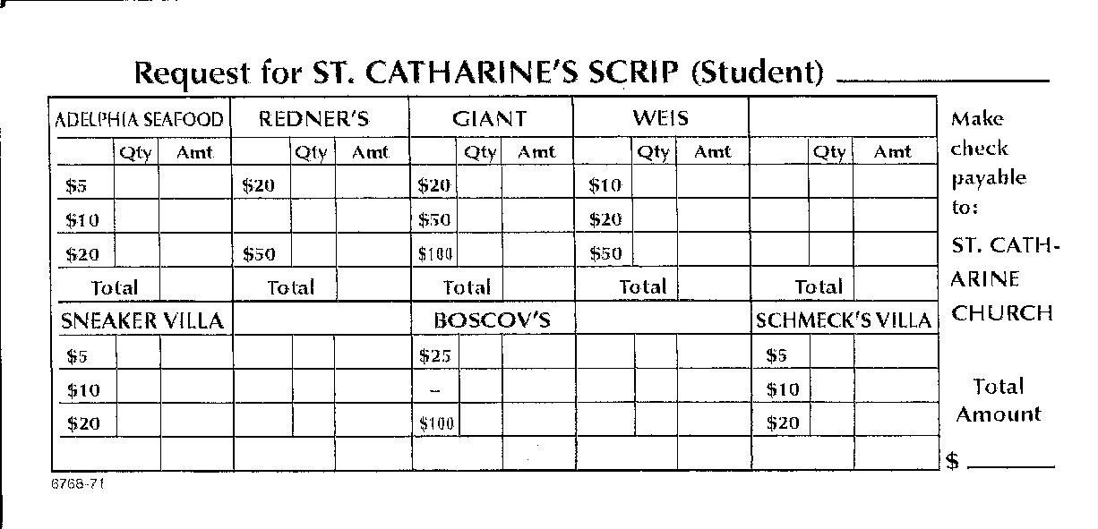
- Fill out a local SCRIP envelope/form with your youngest child’s first and last name. You will not receive credit for your purchase if your child’s name is not on the order. Please pass this information on to anyone who is purchasing SCRIP on your behalf.
- Enclose a check made payable to St. Catharine of Siena. Please be careful in filling out the form to avoid errors.
- When ordering through school, please place everything in your Family SCRIP envelope. You will receive this at the beginning of the 2010-2011 school year and it will be used back and forth for the whole year.
- You may order Local SCRIP at the tables in the back of the church, at the Parish Center or through SCS school when open.
- All orders that will be filled through SCS school must be turned in by 10:00 a.m. no later than Thursdays.
- All Local orders sent into SCS school will be sent home on Thursday.
- Local SCRIP order schedule may change due to holidays and snow days.
Local Tuition Rewards

The Local SCRIP profit is 5%. 2.5% goes to your family as a tuition credit and 2.5% goes to SCS.

See the following examples to learn how you can earn your $100.00 tuition reward.
Example #1:
Purchase $4,000.00 of Giant (2.5%) SCRIP = $100.00 tuition reward
4,000 x .025 = 100

Example # 2:
Purchase $2,000.00 of Redner’s (2.5%) and $2,000.00 of Boscov’s (2.5%) SCRIP = $100.00 tuition reward
4000 x .025 = 100

Example #3:
Purchase $500.00 Sneaker Villa, $3,000.00 of Giant, and $500.00 Boscov’s SCRIP = $100.00 tuition reward.
4000 x .025 = 100

**You may only purchase Giant and Boscov’s through Local SCRIP not through Great Lakes.
**Statements will be sent home twice a year and you may always call for your balance.
Great Lakes SCRIP (www.shopwithscrip.com)
- You may only order Great Lakes SCRIP ONLINE. We will no longer accept paper orders or notes.
- Order your Great Lakes SCRIP at www.shopwithscrip.com
- Log on to the site, enter the Enrollment Code: D1386E877L2L
- Please fill out the attached form to set up your username and password if you don’t already have one. Keep this form for your records. We will not have this information.
- Please make your check payable to St. Catharine of Siena.
- Separate checks must be made out for LOCAL and Great Lakes SCRIP.
- You may also use Prestopay to pay for your Great Lakes SCRIP purchases. This is not a credit card base system. It is a safe, reliable NACHA electronic fund transfer system. Your family enters their designate account information one time and once your account is verified, you can have your SCRIP payments electronically deducted from that account when you order. This process is done on www.shopwithscrip.com
- When sending in your payment through school, please place your check in your Family SCRIP envelope. You will receive this at the beginning of the 2010-2011 school year and it will be used back and forth for the whole year.
- Orders/payments will be due on Fridays by 10:00 a.m. in the school office.
- Orders will be sent home or ready for pick up the following Thursday.
- Great Lake orders will be processed every other week. You will receive the due dates at the beginning of the 2010-2011 school year.
- Great Lakes order schedule may change due to holidays and snow days.
Great Lakes Tuition Rewards
The Great Lakes SCRIP % profit varies from retailer to retailer. This year, SCS is sharing the profit rate with your family. ½ goes to your family as a tuition credit and ½ goes to SCS.
Example: Lands End profit rate is 18% = 9% for your family and 9% for SCS.

See the following examples to learn how you can earn your $100.00 tuition reward.
Example #1:
Purchase $1,115.00 of Lands End (9%) SCRIP = $100.00 of tuition reward.
1,115 x .09 = 100

Example #2:
Purchase $10,000.00 of Walmart (1%) SCRIP = $100.00 tuition reward.
10,000 x .01 = 100

Example #3 (Using Local/Great Lakes):
Purchase $2,000.00 Giant (2.5%), $200.00 Lands End (9%), $100.00 Applebees (4.0%), $500.00 Sneaker Villa (2.5%), and $400.00 (4.0%) Pottery Barn SCRIP = 100.50 tuition rewards.
** You may always check your balance on your Great Lakes family account, under purchases. Half of what you purchased is your tuition reward.
www.shopwithscrip.com Username and Password Set-up Process

- Log onto www.shopwithscrip.com
- Enter SCS enrollment code. D1386E877L2L
- Enter a Username and Password of your choice in the orange box on the home screen.
- Please keep this form for your records. We will not have this information.
- You are now ready to place your order.

Username: ________________________
Password: ________________________

Failure to Comply Policy

Any family that does not earn the $100.00 tuition reward will lose the tuition credit earned to date and their children’s last report cards will be held. You will also be charged the $300.00 Buy-Out, minus the amount of tuition credit earned to date.

Your family’s choice to make the commitment to give your children a Catholic education is an important one. The SCRIP program is in place to keep tuition down and to fund improvements at SCS. As always, if there is a financial hardship, please contact Sister Teresa Ballisty, IHM or Monsignor Edward Domin.

BUY-OUT Option

In order to keep tuition at the lowest possible level, all families are asked to participate in the SCRIP Tuition Rewards Program. Any family, choosing not to participate will be asked to BUY-OUT.

The BUY-OUT is $300.00 per family.

The $300.00 BUY-OUT will be added to your tuition bill and distributed to your chosen payment plan.

**WIN $500.00**

Once you meet your $100.00 tuition reward of SCRIP, your family name is automatically entered in a drawing to win an additional $500.00 tuition credit!

If you win, you may apply the $500.00 to your 2011/2012 school year tuition bill at SCS. Should an eighth grader win, the $500.00 will be forwarded to Central Catholic High School for tuition credit.

Winnings are non-transferable and are intended for those families continuing their child/children’s Catholic education at SCS or CCHS.

Summer Order Schedule and Process
- Great Lakes SCRIP will only be ordered four times over the summer vacation.
- Great Lakes orders are due ONLINE by 10:00 a.m. on the Fridays listed below.
- Checks made out to St. Catharine of Siena are due in the Parish Center by 10:00 a.m. on the same Fridays.
- You can pick up your order at the Parish Center on the Thursdays listed below after 3:00 p.m.
Note** The Parish Center is open Mondays thru Fridays 8:00 a.m. till 4:00 p.m.
- Local SCRIP orders can be filled by you, from June 03, 2010 till September 03, 2010 after Mass or at the Parish Center.

Order Dates:
- Due Friday, June 25, 2010 – pick up Thursday, July 01, 2010
- Due Friday, July 16, 2010 – pick up Thursday, July 22, 2010
- Due Friday, July 30, 2010 - pick up Thursday, August 05, 2010
- Due Friday, August 13, 2010 – pick up Thursday, August 19, 2010

ST. CATHARINE OF SIENA SCHOOL 2010/2011

Family Name: ______________________________
Family Email Address: _______________________

Please choose one of the options below.

________ YES, we are participating in the SCRIP Tuition Rewards Program. We agree to earn at least $100.00 tuition credit from June 01, 2010 thru May 31, 2011.

OR

_______ YES, we are choosing to BUYOUT at $300. The $300 BUYOUT will be added to your tuition bill and distributed to chosen payment plan.

PLEASE RETURN THIS FORM TO SCHOOL BY FRIDAY, MAY 28, 2010
SCS Tuition Rewards Program Amendments

- Participating families may only donate their earned Tuition Reward to another family of their choice by meeting the following criteria:
- If your child/children are not returning to St. Catharine of Siena School for the 2011-2012 school year.
and
- If your family has exceeded their required commitment to the SCS program. Your first $100.00 earned will be transferred to the SCS Tuition Rewards Fund. The remaining amount you earned may be transferred to a family of your choice. This must be put in writing.
Example: Tuition Reward Earned $220.00
SCS Tuition Reward Fund portion $100.00
Family of your Choice Portion $120.00

- If an eighth grader would win the $500.00 additional tuition credit drawing. The $500.00 will be forwarded to Berks Catholic High School as a tuition credit.

