
Internal Audit Directorate,
HSE Dublin Mid Leinster,
Phoenix Hall,
St Mary’s Hospital,
Phoenix Park,
Dublin 20

Tel No: 603 8900
Fax: 603 8915

Strictly Private and Confidential

Internal Report

To: Mr. Sean McGrath, National Director of HR, HSE

From: Dr. Geraldine Smith, Assistant National Director Internal Audit.

Subject: Audit of SKILL Programme Administrative Expenditure

Report Prepared by: Dr. Geraldine Smith, Assistant National Director Internal Audit

Report Approved by: Mr. Michael Flynn, National Director, Internal Audit

Date Report Issued: 8th June 2010.

Distribution List: Professor Brendan Drumm, CEO, HSE.
HSE Board Members and Board Secretary
Mr. Liam Woods, National Director of Finance, HSE.
Mr. Michael Flynn, National Director of Internal Audit, HSE.

Table of Contents

 | Page
Executive Summary | 4-13
- Audit Objectives | 4
- Key Audit Findings | 4
- Audit Recommendations | 12
- Management Comment | 12
- Audit Opinion | 12
- Acknowledgement | 13
Main Report | 14-78
- Introduction | 14
- Background | 14
- Audit Scope and Methodology | 15
- Management Comment | 16
- Audit Opinion | 16
- Overview of Project | 18
- Section I – Project Governance | 22
- Section II - Delegated Sanction | 32
- Section III – Payments to Union-A | 35
- Section IV – Foreign Travel | 52
- Section V – SKILL Project Team Expenses | 57
- Section VI - Staffing | 63
- Section VII – Pensions Contributions - Temporary Employee C | 67
- Section VIII - Equipment | 70
- Section IX - Time Schedule for Implementation of Recommendations | 71-78
Appendicies | 79-117
- List of Appendicies | 80
- Appendix I  Labour Court Recommendation 17632 | 81
- Appendix II  Analysis of Steering Group Membership 2004 to October 2009 | 85
- Appendix III  June 2005 Governance Document | 86
- Appendix IV  HSE Internal Audit correspondence to Union-A dated 30th Sept 2009 | 89
- Appendix V  Union-A correspondence to HSE Internal Audit dated 1st Oct 2009 | 92
- Appendix VI  HSE Internal Audit correspondence to Union-A dated 16th Oct 2009 | 94
- Appendix VII  Union-A correspondence to HSE Internal Audit dated 30th Oct 2009 | 99
- Appendix VIII  HSE Internal Audit correspondence to Union-A dated 6th Nov 2009 | 101
- Appendix IX  Union-A correspondence to HSE Internal Audit dated 11th Nov 2009 | 103
- Appendix X  HSE Internal Audit correspondence to Union-A dated 23rd Nov 2009 | 104
- Appendix XI  Examples of types of expenditure from DOH&C Annual Grant | 105
- Appendix XII  HSE Internal Audit correspondence to Union-A-Employee#1 dated 15th  Mar 2010 | 106
- Appendix XIII  Union-A-Employee#1 correspondence to HSE Internal Audit dated  22nd Mar 2010 | 108
- Appendix XIV  HSE Internal Audit correspondence to Union-A-Employee#1 dated 20th  April 2010 | 110
- Appendix XV  Union-A-Employee#1 correspondence to HSE Internal Audit dated  26th April 2010 | 112
- Appendix XVI  HSE Internal Audit correspondence to Union-A-Employee#1 dated  19th May 2010 | 114
- Appendix XVII  Analysis of Expenditure contained in boxes supplied by Union-A-  Employee#1 | 115
- Appendix XVIII  HSE Management Response | 117

Tables | Page
- Table 1: Skill Expenditure 1 January 2004 to 15 September 2009 | 18
- Table 2: Analysis of Administration Costs 1 Jan 2004 to 15 Sept 2009 | 19
- Table 3: Analysis of Payments to Unions | 20
- Table 4: SKILL Office Operations Expenditure 1 Jan 2004 to 15th Sept 2009 | 20
- Table 5: SKILL Programme – Steering Group Composition | 22
- Table 6: Analysis of Reimbursements of Costs to Union-A | 36
- Table 7: Overseas trips identified from travel returns and interviews | 36
- Table 8: Analysis of Taxi-Company-A Invoices | 59

Executive Summary
Audit of SKILL Programme Administrative Expenditure

Audit Objectives

- To examine Administrative Expenditure relating to the SKILL Programme 2005 – 2009.
- To ascertain that all expenditure is appropriate and conforms to HSE policy and procedures.
- To ascertain that expenditure on the SKILL programme is a proper, effective and efficient use of public money.
- To report on any material related issues which come to attention during the audit.

Key Audit Findings
The audit identified significant control and oversight deficiencies in the Administrative Expenditure of the SKILL programme and its governance structure. A summary of the findings, by category, is listed below:

Section I - Project Governance
Accountability has been defined as a relationship in which one party, the accountor, recognises an obligation to explain and justify their conduct to another, the accountee. A fundamental control element of any programme or system is the necessity to have a clear, unambiguous governance and accountability structure. In the case of the SKILL programme, the opposite was the case. There was a lack of clarity and significant confusion among parties regarding even the most basic accountability requirement – namely the reporting line for programme.

While SKILL funding is provided to the HSE through its Vote, evidence available to Internal Audit indicates that from the outset the parties involved in the negotiation and establishment of the programme sought to ensure that the funding, and consequently the Programme, was managed independently of HSE and that “to give effect to this approach the parties agreed that the Project Team through its General Manager would report to the Steering Group”.

The establishment of, and the role played by, the Steering Group is of concern. The Steering Group comprising union representatives, employer representatives and an independent consultant and chaired by an independent chairman, was established in 2004, prior to the establishment of the HSE. The authority for the establishment of the Steering Group and the approval of its membership was not evident during the audit and it is clear that the Steering Group exercised more operational authority than otherwise would be expected as some members of the Steering Group played a close role in the day to day running of the programme, and the General Manager had a reporting line to the chair and some members of the Steering Group. The performance of executive related duties by some members of the Steering Group served to blur the boundaries of accountability and oversight. The non implementation of governance and accountability lines as contained in the 2005 governance document and the lack of a robust communications and reporting line from the Steering Group to the National HR Directorate added to the lack of clarity and confusion.

Overall, this lack of transparency and clarity resulted in the creation of a silo whereby the SKILL programme with a 5 year budget of €60m and €12m pa thereafter, and although part of the HSE’s Corporate National HR Directorate, in effect did not report to that Directorate, and was not overseen by the Directorate, instead reporting to a Steering Group which did not, in reality, have a proper reporting line to the Corporate National HR Directorate.

Section II – Delegated Sanction (Funding)
A further indication that key parties considered SKILL to be separate from the HSE was the issuing by the Department of Finance to the Steering Group, and not to HSE’s Accounting Officer, of a Memorandum of Understanding setting out the terms and conditions for the 2009-2016 funding of €12m pa. This is contrary to standard public service practice whereby Accounting Officers are corresponded with directly in relation to funding allocations to their Votes. As HSE’s Accounting Officer is legally accountable for all Exchequer funding provided to the HSE through its Vote, any correspondence from the Department of Finance should have been communicated directly to the Accounting Officer and not to any other group.

Another indication that SKILL was considered by key parties to be separate from HSE is reflected in correspondence relating to the funding provided for SKILL. Exchequer funding was provided to SKILL on the basis of specific sanction (i.e. non-delegated sanction) which is usually related to a particular once-off proposal and requires any surplus funds remaining at the year end to be surrendered to the Exchequer. Documentation reviewed during the audit indicates that the SKILL Steering Group and SKILL management were of the view that any unspent allocations are available to them in future years.

These issues outlined above indicate that key parties associated with SKILL considered that SKILL was separate from the HSE and were significant factors which contributed to the operation of SKILL as a silo separate from the HSE operations and controls.

Section III - Payments to Union-A
There was a lack of governance, accountability and control in the process which between 2002 and 2009 led to the payments to a union of grants totalling €2.005m and the payments to that union in respect of reimbursement of SKILL programme costs totalling €348k (resulting in total payments to Union-A of €2.353m).

- Annual Grants
Grants totalling €2.005m were paid to Union-A between 2002 and 2009. The grants, initially €190k pa and subsequently increased to €250k pa from 2005, were negotiated and agreed bi-laterally between the DOH&C and Union-A

Deficiencies were evident at all stages of the grant process: the awarding of the grant; the communication of the award; the disbursement of, and accounting for, the grant; and the monitoring of, and accountability for, the grant.

As the Vote holder the HSE is ultimately responsible and accountable for the oversight of these grants and the audit identified that there were clear failures on the part of HSE SKILL management in this regard. However, it is important to reflect that the awarding of the grant was determined bi-laterally between the DOH&C and the Union from at least 2002 and that there is no documentation available to auditors from the DOH&C which identifies if a formal application or business case was made by the Union for the initial grant or the subsequently enhanced grant, the DOH&C decision process leading to the award of the grant, or if any grant terms and conditions were notified by the DOH&C to the Union. The DOH&C corresponded directly with the Union regarding the award of the grant. The bi-lateral agreement and the bi-lateral communication process between the DOH&C and the Union regarding the annual grant are contributory factors to the control and oversight deficiencies identified by this audit.

It is possible that the annual grant payment commenced prior to 2002. However, it is not possible to determine this due to the non-availability of the documentation in the DOH&C and/or the former Office for Health Management (OHM).

During the audit, Internal Audit contacted a senior official of Union-A seeking documentation to support the payments to Union-A. Union-A was not aware of the grants paid to it. It is the view of Union-A that it did not seek nor obtain any annual grants from the DOH&C or the HSE, nor that it paid any expenses on behalf of SKILL and subsequently neither sought nor received reimbursement. Union-A confirmed that the funds are not accounted for in its audited accounts and it did not accept that it is responsible for controlling and accounting for the receipt of public funds totalling €2.353m.

On the basis of the evidence available during the audit (i.e. invoices submitted by a Union-A official to SKILL, a Union-A named bank account, and cheques were, at Union-A’s request, made payable to the Union-A account) Union-A sought the funding relating to SKILL and is therefore responsible for controlling and accounting for it. The receipt and expenditure of these funds (i.e. annual grant and reimbursements) should be accounted for in Union-A’s Audited Annual Financial Statements, but are not.

Neither OHM nor SKILL sought audited annual financial statements from Union-A in respect of the grant in order to satisfy themselves that the funds had been properly controlled and accounted for. Failure to do so was contrary to public financial accountability procedures and financial procedure in place pre and post establishment of HSE. Tax Clearance Certificates obligations were breached by OHM and SKILL management between 2002 and 2009. From 1 January 2005 HSE (i.e. SKILL management) failed to exercise proper oversight and control regarding this grant. The requirement to account for the use of taxpayers’ funds and to ensure that such funds were paid to a tax compliant organization still remains. Therefore, audited financial statements to account for the receipt and expenditure of the public funds and retrospective tax clearance certificates must be pursued by HSE management with Union-A.

Up until 2004, the annual grant had been provided by the DOH&C via the former Midland Health Board to the OHM for payment to Union-A. In 2004 the DOH&C instructed that w.e.f 2005 the €250k annual grant to Union-A be paid from the Labour Court approved SKILL Fund. This resulted in 2.08% of the annual SKILL fund for the training of support workers being paid to the Union for its “human resource/personnel development schemes and the development of management union partnerships of best practice in health enterprises”. The audit was unable to identify the basis for the DOH&C’s decision to top-slice the support workers’ training fund for payment direct to Union-A for its own development schemes.

- Costs Reimbursement
The audit highlights a practice whereby a member of the Steering Group made payments totalling €348k on behalf of the SKILL programme, sought reimbursement from SKILL on the basis of mainly un-itemised (€243,364) and single figure invoices (€104,957), and SKILL management paid those invoices without obtaining adequate supporting back-up documentation. This practice clearly breached fundamental management control and oversight processes. SKILL management did not exercise due care, attention and oversight in determining whether the amounts invoiced represented a proper charge on the publically funded SKILL programme.

The audit identifies that invoices addressed to the SKILL Office and approved for payment by SKILL management, subsequently came into the possession of the Union’s official who paid the invoices on behalf of SKILL and then sought reimbursement from SKILL as part of an un-itemised invoice. The effect of passing invoices, which had been properly addressed to SKILL, to Union-A’s employee in order to process payments outside the SKILL books of account, resulted in proper procurement processes not being undertaken, withholding tax not being deducted on consultancy payments, tax clearance requirements not being adhered to, and could be construed as a deliberate attempt to distort the analysis, and hence transparency, of SKILL expenditure.

An invoice on un-headed paper dated 2nd December 2008 (for €6k for services provided by Union-A’s employee’s office to SKILL) was provided by Union-A’s employee to Internal Audit to substantiate a 19th November 2008 request for reimbursement of €109k. In Internal Audit’s view this is not a valid invoice as it is on un-headed paper, it appears to represents a balancing figure to make up €109k, and it was dated two weeks after the date of the original request for reimbursement. Therefore, it is Internal Audit’s opinion that the €109k has not been documented satisfactorily. Overall, Union-A’s employee has not provided adequate documentation and analysis to support Union-A’s invoices totalling €348k for reimbursement of SKILL related costs.

The effect of having two mechanisms for payment of SKILL related costs (i.e. through SKILL and Union-A) is not a sound financial practice as it could result in unauthorised and duplicate payments. From the limited documentation provided by Union-A’s employee to Internal Audit to support a reimbursement invoice of €109k, no duplicate payments were identified in the SKILL financial records. However, because supporting documentation for the remaining reimbursement requests have not been provided it is not possible to state whether any duplicate or unauthorised payments are contained within those remaining invoices.

Some further documents were provided by Union A’s employee to Internal Audit identifying transactions totalling €473k. However, the incomplete nature of the records provided to Internal Audit, the lack of corroborative information to confirm the amount and existence of the payments (i.e. bank statements), the non-confirmation of further financial transactions by Union-A’s employee, and the lack of an accountant’s report / audit opinion on the transactions mean that no assurance can be given as to the existence, valuation, validity or totality of these transactions. While some of the documents provided by Union-A’s employee referred to items of expenditure which were health sector-IR-partnership related activities, others did not (for example grants to fund services in the disability sector, payments to charities, a disability event, computer forensics contract, air-fare for Northern Ireland regeneration project, and PR material for Union-A). Based on the examples provided by Union-A’s employee and documentation available to Internal Audit, there was no clear, consistent approach to determine which categories of expenditure Union-A’s employee would fund from the annual grant and which categories he would recoup directly from SKILL.

Union-A’s employee disbursed funds without any formal application or evaluation, and in some instances in advance of any agreement with the recipients as to how or when the funds would be spent.

SKILL/OHM management did not obtain sufficient and appropriate documentary evidence to assure themselves as management responsible for the monitoring and oversight of the SKILL programme that the grant funding had been properly utilised and accounted for by Union-A, the type and total value of grant expenditure, and any balances remaining, and for satisfying themselves prior to approving the reimbursement invoices that the reimbursed costs were proper and appropriate to the SKILL programme.

In summary, it is Internal Audit’s opinion that public funds paid to Union-A totalling €2.353m have not been satisfactorily documented at the time of the audit and accounted for by Union-A or its employee.

Section IV - Foreign Travel
Documentation reviewed by Internal Audit indicated that foreign travel to the US, Australia, Hong Kong and the UK had taken place, however the financial records of SKILL did not record any travel, hotel or other expenditure in relation to such trips. Travel expenditure was processed outside the SKILL books of accounts as Union-A’s employee arranged and paid for overseas travel for public and other officials and subsequently recouped the un-vouched, unspecified costs from SKILL or funded it from the DOH&C annual grant. This practice severely undermines the transparency and accountability obligations expected and required with the expenditure of public funds, and has served to obscure the expenditure from scrutiny, and negate proper accountability, governance and transparency.

The rationale put forward during the audit for this practice (i.e to minimise the overheads and the workload on the SKILL administrative staff) cannot be deemed acceptable in light of the long established public sector obligations of transparency, accountability and control requirements for Exchequer provided public funds.

The approval for payment by the SKILL office of un-itemised invoices possibly containing travel costs and without obtaining sufficient supporting documentation is not in accordance with financial procedures which requires officials to satisfy themselves that the invoices are appropriate and correct for payment. This has also resulted in overseas travel and related costs (and all other costs included in the re-imbursements) being obscured in the SKILL financial records under the heading “Payment to Unions”.

There was non-compliance with HSE’s National Policy on Foreign Travel (2006) which requires all overseas travel of HSE employees to be arranged through the HSE’s Business Travel Unit.

The fact that a minority of Steering Group members did not provide Internal Audit with a full return of their travel details, which was subsequently provided by their Steering Group colleagues, may be attributed to the view outlined during the audit that the trips were funded by Partnership and not SKILL. However, it is Internal Audit’s view that some responses, which were made more in accordance with the letter rather than the spirit of the query, fall short of the expected standards of co-operation and transparency expected of public officials and any persons working with public bodies.

Administration Expenditure
It is clear that the processes as operated in the SKILL office resulted in a significant number of breaches of public sector requirements and HSE policies and procedures in relation to procurement, utilisation of HSE contracts, reimbursement of personal mobile telephone costs, hotel expenses, taxi usage, public sector recruitment obligations, maintenance of personnel records, superannuation commitments and data protection obligations.

- Section V - Project Team Expenses
Contrary to HSE procurement policies services were not tendered and existing HSE contracts were not utilised. The appointment of the external consultant to the SKILL programme was not tendered. Taxi expenditure was not controlled as required, and expected, by HSE and Public Sector requirements. The excessive use of taxis, trips between the office and home, trips between entertainment venues and home/office, trips outside office hours was not in accordance with Public Sector requirements and HSE policies. Utilising taxis to travel outside the greater Dublin area did not represent value for money. The payment of overnight hotel expenses incurred in relation to overnight stays, rather than payment of the standard approved rate of overnight subsistence rate, resulted in costs in excess of the approved standard subsistence rate being incurred and resulted in items being reimbursed which otherwise would not be eligible for reimbursement.

- Section VI – Staffing - Public Sector Appointments
The fundamental requirement for equity and transparency in public sector appointments was not adhered to by the SKILL office. In breach of public sector and HSE recruitment practices, relatives of the General Manager and a Steering Group member were directed to a recruitment agency and the agency then placed the two people on temporary contracts with the SKILL office. The relative of the Steering Group member was subsequently appointed to a full time temporary HSE post, and consequently placed on HSE’s payroll, without either an internal or external competition taking place and without obtaining NEMU employment control approval to fill the post. SKILL could not provide Internal Audit with any documentary evidence relating to a CV, pre-employment checks, and employment contract for this employee.

- Section VI – Staffing - Personnel Files
The inadequacy of SKILL staff personnel files is another matter of concern. The OHM/SKILL was responsible for establishing and maintaining and keeping secure personnel files for its staff on commencement of their employment. Of the 6 OHM/SKILL personnel files sought by Internal Audit, only one comprehensive personnel file, representing 16% of the files sought, could be provided by SKILL and HSE-HR. The lack of comprehensive, adequate, readily accessible personnel files governing the full tenure of these employees’ employment with OHM, SKILL and (latterly) HSE has potential implications for the HSE’s ability to fulfil its statutory obligations in the areas of employment law (which requires important employee records be maintained), and data protection legislation (which requires an employee’s personnel records to be kept secure, up to date, and in a readily retrievable manner).

- Section VII – Pensions Contributions – Temporary Employee C
In 2002 the OHM established a private pension fund for a temporary employee, who at that time would not have been eligible to join the health services occupational superannuation scheme. There is no documentation available to indicate whether DOH&C or Department of Finance approval was sought to establish the single person pension fund for the temporary employee.

Between 2002 and 2007 the OHM/SKILL paid employer contributions of €62,155 into the fund while the employee made contributions of €14,624. An extra point of salary was provided to the employee to compensate the employee for the employee’s contributions to the fund and between 2002 to 2007 this amounted to in excess of €16,858. In effect, the employer funded the full contributions to the employee’s pension fund.
In the year of the employee’s retirement, the General Manager approved an increase in the employee’s salary from point 9 of the salary scale to point 11 - the 1st Long Service Increment (LSI) thereby awarding the 1st LSI four years ahead of schedule.

Following the employee’s retirement, the former employee exercised options under HSE’s revised superannuation arrangements to have the temporary service (1 January 2002 to 2 July 2007) reckoned for HSE superannuation purposes. The General Manager confirmed the service to Superannuation Section in November 2007 and a HSE pension was awarded amounting to €3,834pa (€147 per fortnight) and a gratuity of €15,942 from which a deduction of €14,428 was made in respect of superannuation contributions and Spouses and Children’s arrears due in respect of the former employee’s temporary service, resulting in a net lump sum payable of €1,514.

In summary, the former employee was awarded, and is in receipt of, a HSE pension and gratuity in respect of temporary service with OHM and SKILL even though pension contributions, possibly in excess of €75k, had already been made by OHM and SKILL into the private pension fund.

The SKILL office is in breach of Revenue Commissioners requirements and HSE Superannuation Scheme rules by making full contributions (i.e. Employer and Employee) contributions to a temporary employee’s private pension fund and by subsequently admitting the temporary employee to the HSE’s Superannuation Scheme – in effect providing the former temporary employee with two pensions for the same period of service.

- Section VIII – Equipment
The SKILL office is in breach of HSE’s data protection obligations by allowing retired SKILL employees to retain SKILL funded assets without ensuring that official data is properly and securely erased. In addition it results in additional costs to the HSE to replace such assets.

Audit Recommendations
Internal Audit has recommended a comprehensive series of actions to be undertaken immediately by HSE senior management to address the serious deficiencies and issues identified by the audit. HSE senior management has confirmed its acceptance of the recommendations and the timescale for implementation.

Management Response
Internal Audit discussed the draft report and the audit recommendations with HSE senior management and requested that they confirm in writing their acceptance of the audit recommendations and timescales for implementation of the recommendations.

In correspondence to Internal Audit on 11th May 2010, the National Director of HR and the National Director of Finance agreed to implement the report’s recommendations.

Details of the responses are contained in the Management Comment Column in the Time Schedule for Implementation of Recommendations Section of this report.

Audit Opinion

This audit of the SKILL Programme Administrative expenditure, which is the first of a number of related SKILL Programme audits, has identified serious inadequacies in accountability, governance, control and oversight. Accordingly assurance cannot be given regarding the adequacy of the system of internal control and governance nor on certain elements of administrative expenditure incurred.

The SKILL Programme was set-up prior to the establishment of the HSE and grants were paid to a Union for several years prior to the establishment of the Programme. It is evident from the audit findings that the control inadequacies and deficiencies existed from the time the grants to the Union were agreed, through to the commencement of the programme, and these control deficiencies continued through to the time of the audit. On establishment of the HSE, the HSE as the Vote holder, became responsible and accountable for these funds and for ensuring that it established proper controls.

Fundamental elements of internal control were not in place. The audit has identified:
- The lack of a clear and transparent governance structure
- Deficient monitoring and oversight
- Performance of executive related activities by some members of the Steering Group
- Non-adherence to HSE and wider public sector policies
- A lack of transparent and proper financial accounting records
- A lack of baseline internal controls
- No available evidence at time of audit to support the awarding of grants totalling €2.005m to a Union, the lack of proper monitoring, oversight, accountability and accounting for these public funds
- Unacceptable payment processing practices
- Unorthodox processes for making foreign travel arrangements
- Significant shortcomings in the information available to Internal Audit.
- Inadequate communication processes between the Department of Finance and the Accounting Officer regarding the programme.

The audit report identifies very serious findings in respect of governance, funding, payments to Union-A, costs reimbursements to Union-A, foreign travel and the administration of the SKILL office. These are outlined in Sections I to VIII of this report.

Acknowledgement
Internal Audit wishes to formally acknowledge the co-operation and courtesy afforded to them during this audit by the staff of the SKILL office, senior HSE management and by many of the parties interviewed during the audit.

Documentation was not always readily available and a number of key personnel who would have formed the basis for this audit were not always available to the auditors during the course of the audit due to retirement and/or through ill-health. This somewhat hampered and delayed the completion of the report.

Signed: Approved:

____________________ ____________________
Geraldine Smith Michael Flynn
Assistant National Director – Internal Audit National Director – Internal Audit
8th June 2010 8th June 2010

Internal Audit Directorate,
HSE Dublin Mid Leinster,
Phoenix Hall,
St Mary’s Hospital,
Phoenix Park,
Dublin 20.

Tel No: 603 8900
Fax No: 603 8915

MAIN REPORT

Audit of SKILL Programme Administrative Expenditure

__________________________________________________________________________

Introduction
This audit was carried out at the special request of the National Director of HR. It was included in the 2009 audit plan for the HSE as approved by the HSE Audit Committee.

Background
Establishment of the SKILL Programme
SKILL (Securing Knowledge Intra Lifelong Learning) is a training and development programme aimed at 32,000 support staff employed in the Irish Health Service. It originated as part of a 2003 agreement between Health Services and Unions entitled “Recognising and Respecting the Role”. The programme is directed at a group of staff who traditionally have had limited access to education and training for their roles

The SKILL Programme was established following Labour Court Recommendation 17632 (LCR 17632) which dealt with issues relating to the parallel benchmarking agreement. LCR 17632 provided for a discrete fund of €12 million per annum to be established for training and development of support staff grades for the years late 2004 – 2008. The agreement also provided that from 2009 to 2016 a fund of €12 million (index linked) would be provided on an annual basis. The funding was initially allocated by the Department of Health and Children through the (former) Midland Health Board for transmission to the SKILL Programme. Following the establishment of the HSE on 1 January 2005, funding is now provided through the HSE vote. (See Appendix I for LCR 17632)

Education and Training
The SKILL Programme is an educational support programme for Support Staff and their Supervisors in the HSE and funded health agencies. The grades of staff for which SKILL Programmes are provided include, Health Care Assistants, Speech and Language Assistants, Family Support Workers, Therapy Assistants, Laboratory Aides, Household Staff, Catering Staff, Porters, Laundry Workers and other support grades working in the Health service.

Each prospective participant attends a Pre Learning Advice (PLA) talk on the SKILL programmes followed by an individual session with a VEC tutor. This helps identify any need for additional support in areas such as literacy, English as a second language and IT skills. The level of education provided is FETAC (Further Education and Training Awards Council) levels 3 to 6 and all programmes lead to national certification in the form of a FETAC Award.

There are a number of core modules which must be completed in conjunction with elective modules compatible with each participant’s particular grade within the health service. The core modules include; Communications, Mathematics, Care Support, Infection Prevention and Control, Legislative Procedures and Quality and Work Experience.

There are four training providers involved in the education and training provision of support grades and supervisors. SKILLVEC, which is a consortium of the VECs delivering the SKILLs modules, the HSE Centres of Nursing and Midwifery Education (CNME), the Open Training College (OTC) which deals with the modules concerning employees in the Intellectual Disability Sector, and UCD Diagnostic Imaging who provide the modules for employees in roles requiring knowledge of Theatre or Radiography Departments.

Audit Scope and Audit Methodology
This report examines the controls over administrative expenditure within the SKILL Programme from its inception in 2004 to 15th September 2009. It also examines how administrative services were procured including IT contracts; consultants used by the SKILL Programme and travel undertaken on behalf of the SKILL Programme.

An examination of the training expenditure and health agency reimbursement expenditure is outside the scope of this report and is the subject of separate audits.

The audit methodology involved an examination of the Income and Expenditure records of the SKILL Programme relating to administration costs which included payments to vendors. The audit examined the minutes of the Steering Group meeting and significant volumes of documentation relating to expenditure including invoices, approvals and income and expenditure accounting processes. The audit also focused on the governance of the programme and financial controls of the SKILL Programme to ascertain if the highest standards, which include propriety, transparency and proper, effective and efficient use of public money, were applied. Interviews were held with senior project team members and steering group members.

During the audit, the methodology was extended to include an examination of remaining available archived Office for Health Management files to identify any potential related SKILL Programme expenditure.

A number of key personnel who would have formed the basis for this audit were not always available to the auditors during the course of the audit due to retirement and/or through ill-health. This somewhat hampered and delayed the completion of the report.

Management Comment
Internal Audit discussed the draft report and the audit recommendations with HSE senior management.

In correspondence to Internal Audit on 11th May 2010, the National Director of HR and the National Director of Finance agreed to implement the report’s recommendations.

Details of the response is contained in the Management Comment column in the Time Schedule for Implementation of Recommendations Section of this report.

Audit Opinion
This audit of the SKILL Programme Administrative expenditure, which is the first of a number of related SKILL Programme audits, has identified serious inadequacies in accountability, governance, control and oversight. Accordingly assurance cannot be given regarding the adequacy of the system of internal control and governance nor on certain elements of administrative expenditure incurred.

The SKILL Programme was set-up prior to the establishment of the HSE and grants were paid to a Union for several years prior to the establishment of the Programme. It is evident from the audit findings that the control inadequacies and deficiencies existed from the time the grants to the Union were agreed, through to the commencement of the programme, and these control deficiencies continued through to the time of the audit. On establishment of the HSE, the HSE as the Vote holder, became responsible and accountable for these funds and for ensuring that it established proper controls.

Fundamental elements of internal control were not in place. The audit has identified:
- The lack of a clear and transparent governance structure
- Deficient monitoring and oversight
- Performance of executive related activities by some members of the Steering Group
- Non-adherence to HSE and wider public sector policies
- A lack of transparent and proper financial accounting records
- A lack of baseline internal controls
- No available evidence at time of audit to support the awarding of grants totalling €2.005m to a Union, the lack of proper monitoring, oversight, accountability and accounting for these public funds
- Unacceptable payment processing practices
- Unorthodox processes for making foreign travel arrangements
- Significant shortcomings in the information available to Internal Audit.
- Inadequate communication processes between the Department of Finance and the Accounting Officer regarding the programme.

The audit report identifies very serious findings in respect of governance, funding, payments to Union-A, costs reimbursements to Union-A, foreign travel and the administration of the SKILL office. These are outlined in Sections I to VIII of this report.

Overview of Expenditure

SKILL Programme Expenditure:
Internal Audit ascertained that over the period 2004 to September 2009 the SKILL Programme spent €43.550m of which €40.306m related to training provider and reimbursement agency costs and €3.244m related to administration costs.

Table 1: Skill Expenditure 1 January 2004 to 15 September 2009
Training  Providers | Health Agency Reimbursements | Administration Costs  (excl Salaries) ^{note 1} | Total Expenditure
€14,001,327 ^{note 2} | €26,305,016 | €3,243,354 | €43,549,697
Note 1 – SKILL Project team salaries for 2005 amounting to €205,964 were charged to the SKILL Project.
Note 2 – Of this €13,977,527 was paid to Irish Training Providers and €23,800 was paid to US training providers

During the audit of SKILL, Internal Audit identified that in addition to expenditure being processed through the SKILL accounting system (as operated by HSEA on behalf of SKILL Project) that the Project Team also processed administration related payments through the financial system of the former Office for Health management (OHM) (€19,673).

The main expenditure is as follows and a full table of analysis is provided in Tables 2, 3 and 4 overleaf:
- Training; this mainly involves payments to the CDVEC (SKILLVEC), Open Training College and University College Dublin and totals €14m. (Examination of this expenditure is outside the scope of this audit and is the subject of a separate audit).
- Health Sector Agency Reimbursements; which covers the cost of each health agency releasing staff to take part in the programmes amounts to €26.3m. (Examination of this expenditure is outside the scope of this audit and is the subject of a separate audit).
- Unions; payments to Unions and other associations amounted to €1.414m of which Union-A received €1.407m
- Engagement of Consultants; €429,708. This included consultancy payments to a Steering Group member. These consultancies were not tendered and withholding tax was not deducted.
- Chairman’s fees: €26,750 was paid to the Chairman of the Steering Group at a rate of €1000 per day pro rata. Withholding tax was not deducted.
- Advertising and Promotion; €241,446. This includes expenditure on student bags, DVD production and advertising. These services were not tendered by the SKILL office.
- SKILL Project Team expenses: €99,192. This includes domestic travel expenses, subsistence (including overseas subsistence but not flight or hotel costs), entertainment/dining, mobile phone and home broadband costs.
- Hotels; €100,490. This includes use of hotels for Steering Group meetings in Dublin and briefing sessions by the Project Team in various locations countrywide on the SKILL Programme.
- Conference; €45,130. A SKILL conference was held at the RDS in September 2006 for approximately 600 people. The cost includes €34,384 for hospitality. This service was not tendered by the SKILL office.
- Taxis; €12,746. Between May 2006 and September 2009 this amount was invoiced to the SKILL Programme for taxi journeys. The main provider of taxi services to the programme was Taxi-Company-A who invoiced €8,850.40. This service was not tendered by the SKILL office and neither did SKILL utilise the HSE Taxi contract.
- Office Operations; €526,445 was expended by the SKILL Programme on office operations excluding salaries and travel and subsistence.

Table 2: Analysis of Administration Costs 1 January 2004 to 15 September 2009
 | Skill Financial Records
 | €
Unions (see Table 3 below) | 1,413,736
Office Operations (see Table 4 below) | 526,444
Consultants | 429,708
Advertising | 241,446
Candidate T&S reimbursements and ad hoc study grant | 139,322
Hotels | 100,490
Conference | 45,130
Chairman’s Fees | 26,750
Taxis | 12,787
Steering Group Travel and Subsistence | 1,662
Project team: Travel, Subsistence and Expenses | 68,142
Project team: Salaries – 2005 | 205,964
Project team: Mobile Phone and Home Broadband | 18,696
Project team : Pension Fund | 13,074
 | 3,243,354

SKILL paid €1.4m to unions (see table 3 below). €0.4m of this related to reimbursement to Union-A in respect of costs incurred by Union-A in respect of the SKILL project and €1m was in relation to an annual grant of €250,000 which had been agreed directly between DOH&C and Union-A in 2002. Payments of the annual grant between 2002 and 2005 were paid to Union-A via the Office for Health Management (OHM) on the instruction of the DOH&C. (This is referred to later on in the report).

Table 3: Analysis of Payments to Unions
 | Skill Financial Records
 | €
Union-A | 1,407,361
Union-C | 2,325
Union-D | 3,840
Union-E | 250
Total | 1,413,776

The SKILL Office incurred office running costs of €526,444 (see table 4 below for analysis). None of these services was tendered by the SKILL office and neither did it utilise existing HSE contracts (except Legal Services which were sourced in relation to training provider contracts).

Catering costs consisted mainly of lunches and sandwiches generally for 6 to 20 people provided by a catering company to the SKILL Programme office. Expenditure of €1,586 was spent on the retirement dinner of one member of the SKILL Project Team.

Table 4: SKILL Office Operations Expenditure 1 January 2004 to 15 September 2009
Office Operations | Skill Financial Records
 | €
IT | 221,299
Stationery / printing | 177,669
Legal | 50,428
Recruitment | 21,376
Post | 19,678
Couriers | 16,385
Photography | 6,746
Catering | 6,530
Cash | 4,072
Gifts | 2,261
Total | 526,444

Training and Health Agency Re-imbursement
Payments of €39m were made in respect of training costs and health agency re-imbursement costs. As noted in the scope section earlier, the audit of training and health agency reimbursement expenditure is outside the scope of this audit. However, information on these costs and activity is presented here to provide an overview of the project since its inception in 2004.

A fund of €60m for the period 2004 to 2008 was provided for training for a group of 32,000 health sector employees. The Labour Court recommendation also recommended that from 2009 to 2016 that a further €96m index linked would be provided (at the rate of €12m pa indexed linked) for ongoing training for this group. (Details of funding will be outlined later in this report).

- Training:
The audit noted that the total number of support staff registered with the SKILL Programme since the programme commenced is 9,905. Of these, 5,807 have undertaken study with SKILLVEC/ OTC/ UCD with 652 graduated to date. €14m has been paid to these training providers so far through the SKILL Programme. In addition 4,096 Healthcare Assistants (HCA’s) have undertaken the modules through the Centres for Nursing and Midwifery Education. Included in this figure supplied by the SKILL Programme office are 1,560 participants who commenced in 03/04 and 04/05 which predates the SKILL Programme.

- Health Agency Reimbursements
Internal Audit noted that €26.305m was reimbursed to the various health agencies to facilitate staff release to participate in the SKILL Programme since August 2005. Of this, €25m was paid to directly to various health agencies and €1.13m was paid to the National Federation of Voluntary Bodies in respect of agencies in the Intellectual Disability sector. The reimbursement was introduced to compensate agencies for the cost of replacing employees participating in the programme. The current figure per employee is €3,500 as agreed by the Steering Group, with €1,750 paid as a first instalment and the balance on commencement of the second four modules. The agencies included in these payments include all former health boards now HSE Regional Areas and a number of voluntary health agencies funded by the HSE. (The cost to the SKILL Programme for Health Care Assistants (HCAs) attending the courses is €4,554 per participant which is made up of the backfilling contribution of €3,500 and €1,054 for National Midwifery and Planning Units (NMPDU) costs for engaging tutors presenting their modules. In all other cases the backfilling costs is €3,500).

Section I
Project Governance

Overview - Structure of Programme
The SKILL Programme is overseen by a 15 member Steering Group (Steering Group). A Project Team, headed by a General Manager, has executive responsibility for the day to day delivery of the programme.

Steering Group
The Steering Group comprises key stakeholders of unions, health employers, Department of Finance (DOF), Department of Health and Children (DOH&C), HSE and health sector voluntary bodies. An independent consultant is also a member of the Steering Group and it is chaired by an independent chairman, formerly the General Secretary of Union-A. The membership of the Steering Group has remained reasonably constant since 2004 with 8 of the original members appointed in 2004 being members in 2009 (See Appendix II “Analysis of Steering Group membership 2004 to 2009).

Table 5 SKILL Programme – Steering Group Composition
Independent Chairman
(former General Secretary Union-A) 1
Union Representatives
Union-A 2
Union-B 1
Union-C 1
Health Employers
HSE 4
Disability Federation 1
Federation of Voluntary Bodies 1
DATHS 1
Department of Health and Children 1
Department of Finance 1
Independent Consultant 1

The Chairmanship and membership of the Steering Group were in place prior to the establishment of the HSE in 2005. The chairman’s fee was set at €1,000 per day pro rata. An undated, unsigned document, believed to have been drawn up by a steering group member in 2004 entitled “Training, Education & Development for Support Staff grades” stated that a steering group comprising nine named individuals (including the independent chair) had been established. In August 2005 the Department of Finance requested the General Manager to expand the membership of the group to include representatives from the DOH&C and the DOF. The General Manager notified the DOF of the expanded Steering Group of 13 named members in September 2005.

IA Comment:
There is no evidence of any approval (including Department of Finance or Department of Health and Children approval) for (1) the establishment in 2004 of a Steering Group, and (2) the appointment of named members. Therefore the possibility exists that the Steering Group was acting ultra vires between the period 2004 and June 2005 (when a written terms of reference for the Steering Group was drawn up by the HSE Acting National HR Director#1).

There is no available evidence of approval for the rate of the Chairman’s fee.

The 2004 document identified that expressions of interest would be invited for an expert to develop the project by working with the Steering Group and the project team. The same document also stated that the appointment of a named independent consultant to the Steering Group had taken place. It was confirmed to Internal Audit that there was no procurement process for the independent consultant, no formal contract or service level agreement was drawn up and there is no evidence to indicate the determination or approval of the consultant’s daily rate. Internal Audit was informed that the independent consultant was appointed by the Steering Group before the Project Team was established.

IA Comment:
The appointment by the Steering Group of an external consultant was not in accordance with the requisite public sector procurement and contracting requirements.

Overarching Recommendations:
Due to the serious nature of the findings contained in this section and in the remainder of this report, and the preliminary findings in the draft audit reports on training and re-imbursements, Internal Audit is setting out two overarching recommendations

Overarching Recommendation no 1 – Governance and Structure: Continuance and Evaluation
1(i). The SKILL programme (as currently structured) should be restructured while an independent VFM evaluation is undertaken (see 1(ii) below) and the Steering Group stood down until a new governance structure is determined and implemented
1(ii). A full independent Value For Money evaluation of the programme’s training outcomes should be undertaken as a matter of urgency
1(iii). Future arrangements for the SKILL programme should be based on the results of the independent Value For Money evaluation
1(iv). If following the evaluation it is decided that the SKILL Programme be continued, its activities should be incorporated into HSE HR Leadership, Education and Development Department, where it should be subject to the full range of HSE’s policies and procedures.
Overarching Recommendation no 2 - Vote Accounting Obligations

Under Vote accounting rules an Accounting Officer has specific and personal duties and obligations to account for Voted Exchequer Funds and to report on their uses to the Oireachtas. An instance was noted during the audit where the Department of Finance, without informing the Accounting Officer, communicated directly with the Steering Group relating to the funding. The audit also noted that the DOHC notified a third party organisation directly that it would channel funds to it through the HSE. These communications should have issued directly to the Accounting Officer as he must have full awareness of all funds for which he is accountable. Therefore:

2(i) All correspondence from the Department of Finance concerning funding for which the HSE Accounting Officer is accountable must, in future, be communicated directly to the Accounting Officer, and not to groups or third parties. This should be raised with the Department of Finance.

2(ii) HSE should not be requested by the DOH&C or any other government department to channel funds to third parties and this practice, where it continues to operate, should cease immediately. This should be raised with the Department of Health and Children.

2(iii) HSE must obtain clarity from DOH&C regarding the specific purposes and uses for which the grants referred to in section II of this report were awarded.

Project Team
The DOH&C provided funding for the Programme through the former Midland Health Board to the Office for Health Management (OHM). The OHM was subsumed into the HSE on establishment of the HSE on 1 January 2005.

Internal Audit was informed that due to lease issues with the OHM premises, the General Manager of SKILL (formerly General Manager of OHM) sought, and was provided with, office accommodation and account processing services by the (now former) HSEA. The project team members, who were OHM staff, were, and continue to be, on the payroll of the former Midland Health Board (now HSE Dublin Mid-Leinster) and not on the payroll of the HSEA.

A Project Team, comprising five members of staff with the following structure; 1x General Manager, 2 x Assistant General Managers,1 x Senior Administrator and 1x Administrative Assistant, was established to administer the programme. The then Asst Secretary of the DOH&C approved the secondment of the General Manager from his post in the OHM to SKILL to lead the implementation of the initial phase of the initiative (2004 to 2008). The Acting National Director of HR#1 informed Internal Audit that when HSE was established in 2005 the SKILL project came under his remit and that the General Manager, who was at the grade of Assistant National Director, reported to him.

Governance
A 2004 document “Training, Education and Development for Support Staff Grades” compiled by a member of the Steering Group stated that the Steering Group was responsible for managing and overseeing the accountability of the Programme and that the General Manager reported to the Steering Group.

In June 2005 a document entitled “Skill Programme”, (hereinafter referred to as the 2005 governance document) which set out the governance and reporting arrangements for the programme, was drawn up by the then Acting National Director of HR (Acting National Director of HR#1) to whom the General Manager of SKILL reported. The Steering Group adopted the document at its meeting of 10th June 2005. The document is unsigned and undated (see Appendix III).

The 2005 governance document identified that the Steering Group is
the most important element of the governance structure and its role was to ensure the overall delivery of the objectives of the programme and that the service benefits arising from the investment are realised.
It stated that executive responsibility and accountability for the delivery of the programme rests with the HSE and it noted that the membership of the Steering Group had been determined before SKILL became part of HSE.

The role of the Steering Group, according to the 2005 governance document, included developing an overall strategic plan, agreeing objectives of the programme, guiding, overseeing and evaluating the work of the Project Team, approving the roll-out of programmes, developing an accreditation agenda, and reviewing the bi-monthly progress report. It identified that the chair is also responsible for determining the agenda and for ongoing liaison with the HSE in relation to the programme’s progress and for reporting any significant variation from plan (e.g. measureable deviation for the projected deliverables, financial projections) to the National Director HR and that the Steering Group was required to meet with the National Director of HR annually to present its year end report and its annual plan for the following year.

IA Comment:
There was little documentary evidence available to Internal Audit to indicate that ongoing liaison took place or that the annual meetings with the National Director of HR had occurred each year as required by the approved governance document.

The General Manager reported to the full Steering Group on a monthly basis and worked closely with key members of the Steering Group on a day to day basis.

The General Manager reported to the Steering Group on all aspects of the programme, for example seeking Steering Group approval for the development of the SKILL website, the design and purchase of publicity material, and the purchase of 10,000 bags costing €100,000.

A member of the Steering Group, with Steering Group approval, also exercised executive responsibilities by progressing the development of 2 promotional DVDs (budget €17.5k) and by paying directly various invoices on behalf of SKILL and seeking recoupment from HSE.

IA Comment:
Key members of the Steering Group were involved in all aspects of the Programme including its administrative aspects. The performance of executive related duties by some members of the Steering Group blurs the boundaries of accountability and oversight.

The minutes of the Steering Group indicate that it received reports from the Project Team on all aspects of the programme including financial data. The financial reports contained high level information without any corresponding analysis or commentary. Members of the Steering Group confirmed to Internal Audit that little time was afforded to discussion of financial reports. In 2008 the Steering Group raised an issue about the amount of financial information being provided to it and agreed to set up a sub committee to deal with financial matters. There is no evidence that this finance sub committee was established.
IA Comment:
High level financial data without sufficient analysis did not provide the information necessary for meaningful discussion, consideration and the exercise of oversight by the Steering Group.

Recommendations:
3. If management decide to incorporate the SKILL programme into the core activities of the HSE HR Leadership, Education and Development Unit, then full monthly financial and operational reports should be produced for review by the National Director of HR.

Reporting Relationship – General Manager
The 2005 governance document identified that, wef 1 January 2005, executive responsibility and accountability for the delivery of the programme transferred to the HSE including responsibility for implementing appropriate financial and accounting arrangements. The document states that:
- the Chair of the Steering Group ”must maintain a key relationship with the senior manager who has overall accountability for the delivery of the programme ( i.e the General Manager…)”
- the General Manager has the executive responsibility and accountability for the day to day delivery of the programme including all reporting requirements, quality assurance of training, compliance with HSE tendering requirements
- the chair of the Steering Group “may refer appropriate matters to” the Acting National Director of HR, HSEA#1 or other National Directors
- any significant variation from plan (e.g. measureable deviation for projected service deliverables, financial projection, timescales, etc.) will be reported to the National Director of Human Resources by the Chair
- the General Manager has overall responsibility for the delivery of the programme and the project will be positioned in the Change Management division of the Employer Relations Division (formerly part of the HSEA) and “as such the General Manager will have an executive reporting relationship to HSEA#1 and will have overall responsibility for the delivery of the programme objectives as set out by the working group
- the General Manager “will have a close working relationship with” a HR colleague of equivalent grade who was also a member of the Steering Group.

The contents of 2005 governance document, although approved by the Steering Group, were not fully implemented and this was confirmed in a September 2008 document to the Steering Group authored by the General Manager which stated that it had not been possible to apply the governance arrangements contained in the 2005 governance document “to the letter because of the evolving nature of the project and of the HSE” and it further stated that the 2005 governance document “was very detailed and very specific and didn’t have cognisance to the organic nature of the project”. The September 2008 document confirms the actuality of the situation namely that the Project Team was positioned in the HSEA and that apart from accommodation and access to its account system this had:
been no more than a flag of convenience. Where issues have arisen its reporting relationship has been to Director HR Corporate. […] The General Manager reports directly to the Director of HR Corporate HSE.

Correspondence dated 18th November 2008 from the Chair of the Steering Group to the Head of Workforce Planning and Professional Development (previously Acting National Director HR #2) confirms this view stating that the project:
was initially sited within […] HSEA. It has continued to be located there throughout the transitional period for that organisation but de-facto its relationship, as you know, has been with corporate HR in the HSE. (Internal Audit emphasis).

The General Manager’s reporting relationship is further stated in an April 2008 document drawn up by the DOF Steering Group representative which states that at the time of establishment of SKILL it was decided:
for a number of reasons … to have a Steering Group with broad representation from various stakeholders [and] every effort was made to ensure that it was managed independently of the mainstream revenue expenditure of the HSE. To give effect to this approach it was agreed that the Project Team through its General Manager would report to the Steering Group. (Internal Audit emphasis).

In a response tabled for the May 2008 Steering Group meeting the General Manager stated:
the governance, accountability and overall management of the project is with members of the Steering Group, while the day to day delivery of the project is within the dedicated remit of the Project Team. (Internal Audit emphasis).

Internal Audit interviewed HSEA#1. He stated that the General Manager did not report to him, that as HSEA#1 he did not have executive responsibility for the programme, that he had never seen the 2005 governance document in which he is named, and that he provided office accommodation and account processing facilities for the programme. He confirmed that the General Manager has asked him to approve his expense claims to facilitate their timely processing and that he agreed to do so. He stated this was the only instance where he had any connection with SKILL.

In an interview with Internal Audit, the General Manager stated that HSEA#1 did not have executive responsibility for SKILL and he confirmed the situation regarding the approval of his expense claims.

In interviews conducted by Internal Audit, the author of the 2005 governance document (the Acting National Director of HR#1), the General Manager of SKILL, stated that the reporting relationship was to National Directorate of HR and not to HSEA#1.

In correspondence to Internal Audit dated 5th May 2010, the subsequent Acting National Director of HR (Acting National Director of HR#2) did not agree that the SKILL project or its General Manager reported to the National Director of HR, instead stating that the reporting line was to HSEA#1 for the following reasons:
- the HSEA had negotiated the SKILL on behalf of health service employers,
- the June 2005 document states the project would be located within the change management division of the HSEA (and this was because it formed part of an on-going IR process relating to the grading of support staff),
- when established, the project office was located at the HSEA premises,
- when approved, the budget was incorporated in the HSEA allocation,
- until the end of 2005 the HSEA had direct responsibility for processing such payments directly and after that time processed them on behalf of the project office staff and that HSEA#1 approved some payments for which the Administrative/Finance Manager of the HSEA felt obliged to acquire higher level authorisation,
- audits were conducted by the C &AG from time to time as part of the HSEA audit,
- travelling expenses of the General Manager were approved by the HSEA
- the Chairman of Steering group (Nov 08) formally requested re-alignment of the Skill project from the I.R. function of the HSE (the HSEA) to the Education and Development function
- Approval issued by HSE HR Directorate for such re-alignment (Dec 08)
- PRA awards required approval by a National Director level and HSEA#1 was not authorised to approve such payments under the HSE PRA scheme

The General Manager’s application for retirement and his pay allowance were approved by Acting National Director of HR#2. Internal Audit has been informed that while the General Manager’s Performance Related Awards for 2005, 2006 and the last year of the scheme, 2007, were approved by the Acting National Director of HR#2 this approval of PRAs does not indicate a reporting a relationship to the National HR directorate as all PRAs had to be approved at a National Director level.

Various Steering Group members stated that they believed that the reporting relationship was to National Directorate of HR and not to HSEA#1. A former DoH&C representative (DOH&C representative#1) in correspondence to Internal Audit stated that he believed that the reporting relationship of the General Manager was not to HSEA#1 but to the National HR Directorate, while another former DOH&C representative (DOH&C representative #2) did not view the SKILL Project team as part of HSEA.

The chair of the Steering Group stated that the General Manager reported to HSEA#1.

Some members of the Steering Group believed that the General Manager reported to the Chair of the Steering Group and that a lot of the work of the Steering Group was done outside the main group. One Steering Group member stated that the SKILL project did not form part of HSEA operations and that the project reported more to the Steering Group than Corporate HR.

Project Team members stated to Internal Audit that they saw the reporting relationship initially to either the National Director of HR or HSEA#1 and subsequently it was to the Steering Group and that the “instructions were that the Steering Group were the governors of the programme”. One person also stated that she had only recently seen the 2005 governance document and that she never saw the reporting relationship between the General Manager and the HSEA, as set out in that document, in operation. Minutes of a September 2008 Steering Group governance review meeting reiterated that the role of the Steering Group vis-à-vis the Project Team is to hold the Project Team members to account for regular performance reporting against agreed objectives.

Further indications that the programme was positioned in HSE National HR Directorate and not the HSEA are contained in various documents: (1) in a 2007 email from the National Director of Finance which states “[…] HR has responsibility for the programme in a HSE context”, (2) in an August 2005 letter from the General Manager to the Department of Finance representative which was cc’d to the Acting National Director of HR#1 regarding the membership of the Steering Group, and (3) in a letter from the DOH&C representative #2 to the chair of the Steering Group and cc’d to the Assistant National Director National HR#1 stating “the line of accountability is from the programme to the HSE…”, (4) the 2005 governance document identifies that staffing for the Project Team will be assigned by the National Director of Human Resources and (5) a request seeking approval to fill a permanent post in the SKILL office was approved by the Acting National Director of HR#2 and submitted to HSE National Employment Monitoring Unit (NEMU). In addition, there is no indication that HSEA#1 received any SKILL documents or was involved in any SKILL Steering Group meetings.

IA Comment:
Evidence from stakeholders, as outlined by the preceeding paragraphs, suggest confusion as throughout the various documents reviewed three parties are identified as possible reporting lines for the General Manager. These are the HSEA#1, the Steering Group and the National Director of HR.

On the basis of evidence available to Internal Audit, there is a lack of clarity and confusion among various parties, in relation to the governance and reporting arrangements of the SKILL programme. Notwithstanding the fact that the reporting and accountability lines set out in the June 2005 document lacked clarity and transparency, the non implementation of the governance and accountability lines, contained in the 2005 governance document, between the Corporate National HR Directorate, the Steering Group and the General Manager has resulted in the creation of a silo whereby the SKILL programme with a 5 year budget of €60m and €12m pa thereafter, and although part of the HSE’s Corporate National HR Directorate, in effect did not report to that Directorate, and was not overseen by the Directorate, instead reporting to a Steering Group which did not, in reality, have a proper reporting line to the Corporate National HR Directorate.

This has arisen because:
- The primary governance document (the approved June 2005 governance document) was not, in reality, implemented.

- The June 2005 governance document did not set-out the reporting and accountability structure in a clear and unambiguous manner

- HSEA#1 did not accept that he had executive responsibility for the SKILL programme, that he was not the General Manager’s line manager and stated he had not seen the June 2005 document in which he is named

- Acting National Director HR#2 did not agree that the SKILL project or its General Manager reported to the National Director of HR, instead stating that the reporting line was to HSEA#1

- Some documentation indicates that the General Manager’s direct reporting line was to the National HR Directorate for example his retirement, his pay and dual responsibility allowance were approved by Corporate National HR directorate, and references throughout various documents that the SKILL programme reports to the National HR Directorate.

- There is no available evidence to indicate that the General Manager exercised this accountability to the National HR Directorate or to the HSEA for the programme’s performance on a day to day basis, nor that he was requested to do so.

- The General Manager also had a day to day reporting line to the Chair and key members of the Steering Group, who played a close role in the running of the programme.

- The Steering Group exercised more operational authority than would otherwise be expected

- An April 2008 document written by the Department of Finance’s representative on the Steering Group confirms that the General Manager’s and Project Team’s close working and reporting relationship to key members of the Steering Group had been established at the start of the programme to ensure that SKILL funding was managed independently of HSE funding. Documentation from the General Manager to the Steering Group confirms that “the governance, accountability and overall management of the project is with members of the Steering Group”.

Recommendations:
4. A clear governance structure should be drawn up and approved by the National Director of HR identifying the respective roles, responsibilities and accountabilities of the National HR Directorate, the General Manager and the Steering Group (if any) and clearly identifying the direct line reporting relationship from the General Manager to the National HR Directorate and from the Steering Group (if any) to the National HR Directorate

5. The approved governance structure should be documented, signed and dated.

Section II
Delegated Sanction

A Memorandum of Understanding between the HSE, DOH&C and DOF, agreed by the Steering Group in September 2005 stated that “discrete” training funding totalling €60m for the period 2004 to 2008 had been provided on the basis that “delegated sanction does not apply to this funding and it should be used for the express purposes for which it has been provided”, that it should be managed in accordance with government accounting practices and that any surplus at the end of each financial year should be surrendered.

Under Public Financial Procedures (section A4-10-iii) sanction may be delegated (i.e. general sanction to deal with clearly defined cases without further recourse to the Department of Finance) or specific (non-delegated sanction) (i.e. related to a particular once-off proposal and any surplus funds remaining at the year end are required to be surrendered to the Exchequer).

Between July 2005 and March 2007 two issues relating to the requirement to surrender unused Exchequer SKILL funding were raised at the Steering Group meetings. The first issue, in July 2005, indicated that Steering Group approved that funding for Health Care Assistants on the Nurse Degree programme should be provided “up-front in order to reduce the surplus funding returned to the exchequer”. The second related to whether or not unused funding had been returned to the Exchequer. The DOF Steering Group representative informed the Steering Group in July 2006 that the 2005 under spend of €9m had not been returned to the Exchequer contrary to HSE Finance Directorate assertions that it had been returned. This issue continued into July 2007 when the National Finance Directorate confirmed that “so long as the program receives annual funding as part of the HSE Vote it will be funded to that level in accordance with government and HSE policy against validated expenditures”.

IA Comment:
The issue of providing payments in advance of costs being incurred, with the objective of reducing the amount of funding to be surrendered to the Exchequer, is not in accordance with Public Financial Procedures and is contrary to the conditions attached by the Exchequer to the SKILL Funding

Having reviewed the deliberations in the minutes (regarding whether unused funds were surrendered or not) and the fact that the SKILL office continually refer to the fact that the fund is a “discrete” fund ( i.e. ring fenced for SKILL only - not HSE) it is possible that SKILL Steering Group and management are of the view that any unspent allocations are available to them in future years.

.

In May 2008 the Department of Finance representative on the Steering Group tabled a draft Memorandum of Understanding for 2009 to 2016 for discussion by the Steering Group. The memorandum was subsequently issued formally by the Department of Finance representative to the Chairman of the Steering Group in November 2008 with a request that it be brought to the attention of the Steering Group at its next meeting. The 2009-2016 Memorandum of Understanding confirmed the provision of “a discrete fund of €12m pa” for the period 2009 to 2016 subject to certain conditions. Conditions requiring compliance with government accounting rules (including non-delegated sanction and the surrender of any surplus at year end) were not set out in the new 2009 to 2016 Memorandum. The Steering Group acknowledged the work of the DOF representative in securing ongoing funding for the SKILL programme. The Department of Finance did not notify the HSE CEO in his capacity as Accounting Officer of this correspondence.

IA Comment:
As the HSE’s Accounting Officer, the CEO of HSE is accountable for all Exchequer Funding provided to the HSE through its Vote. It is standard practice in the public sector that Accounting Officers are corresponded with directly in relation to funding allocations to their Votes. Therefore, it is a matter of concern that the Department of Finance did not notify the HSE Accounting Officer of the Memorandum of Understanding (issued by DOF 18/11/2008) and instead corresponded directly with the Steering Group in relation to the provision to the HSE of €12m pa Exchequer funds for which the HSE is ultimately accountable.

The non-inclusion in the 2009 to 2016 Memorandum of Understanding of the applicable and specific government accounting obligations could result in a lack of clarity regarding Vote accounting obligations

The issuing of the formal Memorandum of Understanding from the Department of Finance, signed by the Department of Finance Steering Group representative in his official DOF capacity, for the attention of, and discussion by, the Steering Group on which the DOF representative is a key member, is not best practice in governance regarding separation of functions.

Recommendations:
6. All correspondence from the Department of Finance and the Department of Health and Children concerning funding for which the HSE Accounting Officer is accountable must be communicated directly to the Accounting Officer, and not to any other parties or groups.

7. Expenditure should not be funded in advance by SKILL in order to circumvent Public Financial Procedures.

8. It should be clarified for SKILL programme management that in accordance with Public Financial Procedures
i unspent funds are surrendered to the Exchequer at each year end and cannot be carried forward and accumulated.
Ii the extent of available Skill Funding in any year is determined by the level of funding provided in the Vote of that year.

9. A formal letter of sanction should be sought from the Department of Finance confirming that non-delegated sanction applies and setting out its associated conditions.

Section III
Payments to Union-A

Overview:
During the audit, it came to Internal Audit’s attention that an annual training and development grant of €250k was paid to Union-A on the instructions of the DOH&C. Further inquiries indicated that since at least 2002 the DOH&C had entered into an arrangement with Union-A to provide financial assistance for Union-A’s training and development schemes. Initially the DOH&C agreed to a pay a grant of €190k pa (for 2002 to 2004) and this increased to €250k from 2005 onwards. The grants paid between 2002 and 2004, totalling €705k, were in respect of Front Line Supervision Training Programme (€695k) and the Action Plan for People Management (€10k) and these were paid via the Office for Health Management (OHM) on the written instructions of the DOH&C. The grants paid to Union-A between 2005 and 2009, also on the written instruction of the DOH&C, totalled €1.3m and were in respect of Union-A’s “human resource/personnel development schemes and the development of management union partnerships of best practice in health enterprises”. The DOH&C instructed that w.e.f. 2005 the annual grant be paid from the LCR approved SKILL training fund.

While the review of OHM transactions is outside the scope of this audit, the grants paid through OHM to Union-A are referred to in this report as it is Internal Audit’s view that these are the pre-cursor to the annual grant paid to Union-A from 2005 for its “Human Resource/Personnel development schemes and the development of managerial/union partnerships programme of best practice in health enterprises”.

The majority of grant cheques were made payable to Union-A National Health and Local Authority Levy Fund. Internal Audit has not located documentation from Union-A requesting that cheques be made out to this account.

Between 2002 and 2009 grants totalling €2.005m were paid to Union-A.

In addition to annual grants referred to above, Union-A also invoiced SKILL in relation to re-imbursement of costs incurred by Union-A on behalf of SKILL. The value of the 8 un-vouched re-imbursements sought between June 2004 and December 2008 was €348k.

Table 6: Analysis of Reimbursements of Costs to Union-A
Year | Number of reimbursements | €
2004 | 2 | 2,820
2005 | 0 | 0
2006 | 2 | 24,637
2007 | 1 | 92,500
2008 | 3 | 228,364
Total | 8 | 348,321

Between 2002 and 2009 total payments of grants and cost reimbursements to Union-A amounted to €2.353m. See table 7 below for analysis.

Table 7: Union-A – Annual Grants and Re-imbursements
 |  | Annual Grant  € | Other Grants  € | Cost  Reimbursements | Total  €
 | Grant re Frontline
1 | OHM payments to Union- A  (Apr 2002 to Oct 2004) | €695,000 | €10,000 | €0 | €705,000
2 | Total (Line 1) | €695,000 | €10,000 | €0 | €705,000
 | Grant re: “Human/Resource/Personnel development schemes and the development of managerial/union partnerships of best practice”
3 | OHM payments to Union- A  (Feb 2005) | €250,000 | €0 | €0 | €250,000
4 | SKILL payments to Union-A  ( Dec 2004 to Mar 2009) | €1,050,000 | €0 | €348,321 | €1,398,321
5 | TOTAL (Line 3 + Line4) | €1,300,000 | €0 | €348,321 | €1,648,321
6 | Total Grant Payments to Union- A ( Line 2 + Line 5) | €1,995,000 | €10,000 | €348,321 | €2,353,321

Annual Grants to Union-A
In 2002 the DOH&C entered into an arrangement with Union-A for the payment of an annual grant of €190k to Union-A for the provision of Front Line Supervision Programmes (hereinafter referred to as Frontline). The DOH&C arranged that the funding would be channelled through the Office for Health Management (OHM) for payment to Union-A. The OHM was abolished in 2005 and its activities were subsumed into HSE wef 1 January 2005.

In August 2004, Union-A-Employee#1 wrote to the relevant Assistant Secretary General of the DOH&C (since retired) referring to “discussions regarding ongoing funding for the exploration through management/union partnerships of best practice initiatives in health enterprises” and requesting:
the arrangement, the funding of which has been made available … through the office for health management has been invaluable to both sides in improving and agreeing an understanding of the challenges facing a modern day Health Service. This has subsequently led to a more harmonious approach between both sides in facing into these challenges. Funds equivalent to a grant of €190,000 per year have been made available to Union-A Health Division for Human Resource/Personal Development Schemes.
Noting that the OHM was earmarked as one of the agencies to be streamlined into the HSE he stated that:
it is important that we agree the future funding arrangements of this important collaborative approach and that it is put on a firm footing going forward.

On 12th December 2004 the DOH&C’s Director of Personnel Management and Development replied increasing the funding to €250k and confirming that ongoing funding of €250k pa out of the SKILL project had:
been earmarked to maintain support for Union-A’s human resource/personnel development schemes and the development of management union partnerships of best practice in health enterprises. This funding has been provided in the Midland Health Board’s letter of determination for 2005 on the basis that it will be channelled to Union-A via the Office for Health Management as in previous years. The effect of this will be to put the current as hoc arrangement on a firm footing into the future with an enhanced funding provision.

Union-A-Employee#1 confirmed to Internal Audit that Union-A negotiated the grant directly with the DOH&C. He also confirmed that the DOH&C did not set out any terms and conditions with the grant.

HSE Internal Audit sought from the DOH&C the documentation relating to the initial application or the initial formal request from Union-A for such funding and also the terms and conditions laid down by the DOH&C to Union-A regarding the use, control and accountability for this funding. Internal Audit also sought details of any business case sought, and received by, the DOH&C from Union-A to support the increase in annual grant (from €190k pa to €250k pa) as awarded by the DOH&C to Union-A with effect from 2005.

The DOH&C informed Internal Audit that when the SKILL €60m funding was agreed, Union-A-Employee#1 wrote to the relevant Assistant Secretary in DOH&C (since retired) seeking a €190k grant for the purpose outlined earlier and the DOH&C decided to pay the annual grant from the SKILL funding. The DOH&C also confirmed that it did not explicitly set out any Terms and Conditions or the detailed purpose of grant when it notified Union-A that it had approved the annual grant however it stated that it would have expected that normal accounting arrangements would have been applied by the OHM (2002 to 2005) and the SKILL office (2005 onwards). The DOH&C informed HSE Internal Audit that it could not locate any documentation relating to any initial and subsequent applications from Union-A to the DOH&C for funding, nor could it locate any subsequent applications and any supporting business case from Union-A for the increase in funding granted by the DOH&C. The DOH&C suggested that such documentation could be in the files of the former OHM.

Internal Audit conducted a search of the archived files of the OHM for this grant request/approval documentation.

In examining the remaining OHM archived files to identify possible documentation relating to the annual grant payments, there is no evidence to substantiate if the DOH&C provided OHM with details of any formal application and business case from Union-A or any grant terms and conditions agreed with Union-A. This search identified records which show that since at least 2002 the DOH&C had agreed with Union-A to pay it a grant. This is evidenced in correspondence from the General Manager to Union-A-Employee#1 each year between 2002 and 2005 enclosing annual grant cheques and stating:
I refer to your discussions with the DOHC […] I trust this comprehends your understanding and that of the Department and brings matters to a satisfactory conclusion”.

In 2005 the grant was renamed “Union-A’s human resource/personnel development schemes and the development of management union partnerships of best practice in health enterprises”. Prior to 2005, the DOH&C provided the funding as part of Health Board/HSE base funding, however in 2005 on establishment of the HSE the DOH&C instructed that henceforth it be paid from the €60m LCR recommended SKILL training fund.

IA Comment:
It is Internal Audit’s view that it may be possible that this annual grant payment commenced prior to 2002. However due to the non-availability of the documentation in the DOH&C coupled with the inadequacy of the former OHM files and current SKILL files it is not possible to determine how many years prior to 2002 the DOH&C may have entered into this, or similar, arrangement with Union-A.

There is no evidence available to HSE Internal Audit of any DOH&C terms, conditions and the purpose of the annual grant communicated to Union-A and the OHM.

DOH&C could not provide any documentation to substantiate that a formal application and/or business case had been made by Union-A to DOH&C in respect of the original and enhanced grants.

There is no evidence available that DOH&C provided OHM with documentation relating to any application or business cases from Union-A and neither is there evidence that it informed OHM/SKILL of the obligation to establish suitable control and accountability processes for the funding.

Neither the DOH&C nor OHM/SKILL management sought audited annual financial statements from Union-A in respect of the grant in order to satisfy themselves that the funds had been properly controlled and accounted for.

There is no evidence available to indicate the basis on which the DOH&C instructed that the Union-A annual grant, heretofore funded from the DOH&C Vote, be funded from the LCR approved SKILL fund for training support workers.

Between 2002 and 2005 total of €695k was paid by the OHM on the instructions of the DOH&C to Union-A in respect of this annual grant and a further €10k was paid in respect of the Action Plan for People Management.

Between 2006 and 2009 the SKILL programme paid annual grants of €1.3m to Union-A. All cheques, except one, were made payable to Union-A National Health and Local Authority Levy Fund and were crossed “a/c payee, not negotiable”.

Eight of the ten grant cheques issued between December 2002 and March 2009 were made payable to “Union-A National Health and Local Authority Levy Fund”, however there is no documentation on file requesting that these cheque be made payable to this named payee.

There is no evidence that the Department of Finance approval for this financial support for Union-A’s training programmes was sought or obtained. The (then) Department of Finance representative on the Steering Group informed Internal Audit that the Department of Finance sanction for this annual subvention to Union-A was not required.

IA Comment
Grant-aiding trade unions’ activities would not be considered ordinarily to be part of HSE core activities.

There is no evidence that tax clearance certificates were sought from Union-A.

IA Comment:
Public sector bodies must obtain tax clearance certificates where payments of grants, subsidies and similar type payments to a recipient exceed €10,000 pa. OHM and SKILL management did not comply with this obligation each year for the years 2002 to 2009.

Re-imbursements of SKILL Costs to Union-A
Internal Audit ascertained that in addition to the DOH&C approved annual funding of €250k provided through the OHM and SKILL to Union-A, invoices were also submitted by Union-A-Employee#1 to SKILL totalling €348,321. These invoices, which were approved for payment by the General Manager SKILL, requested re-imbursement in respect of expenditure incurred by Union-A in connection with the SKILL initiative. Most invoices (€243,364) were not itemised, while the remainder (€104,957) provided a single figure for each item contained on the invoices. No back up documentation was provided with these invoices to indicate that the amount invoiced was a proper charge due to be paid by the SKILL Programme.

The chairman of the Steering Group informed Internal Audit that the Steering Group was not aware of the arrangement with Union-A.

Internal Audit sought supporting documentation for these payments from Union-A-Employee#1. However Internal Audit was informed that he was not in a position to provide these as he was on sick leave and would not be resuming duty for several months.

On 28th September 2009 Internal Audit contacted and met the General Secretary of Union-A in an effort to obtain the supporting documentation to progress the audit. During the course of the discussion Internal Audit also referred to the annual grant paid to Union-A since 2002.

The General Secretary and Head of Finance of Union-A informed Internal Audit that Union-A had never incurred, or sought reimbursement of, costs on behalf of the SKILL Programme and neither had Union-A Head Office sought or received any annual grants.

The General Secretary stated that he had been informed by Union-A-Employee#1 that the annual funding received was SKILL programme funds which were in a bank account opened on the authority of the SKILL Steering Group and under the control of the Union-A-Employee#1 as a Steering Group member and two other Steering Group members. The General Secretary stated that as these were not Union-A funds he could not assist HSE Internal Audit. The General Secretary and Head of Finance also confirmed that the funds were not included in Union-A’s audited accounts.

Internal Audit confirmed with the Chairman of the Steering Group, other Steering Group members and the former General Manager that no bank accounts had been authorised or set up by or on behalf of the Steering Group.

On 29th September Union-A’s Head of Finance confirmed to Internal Audit that records were not held in Union-A-Employee#1’s office and that Union-A-Employee#1confirmed that he had possession of the financial records and was preparing a report on the expenditure for the SKILL Steering Committee.

On 30th September, Internal Audit wrote to Union-A’s General Secretary expressing concern that Union-A had not properly controlled or accounted for Exchequer provided funds and that relevant financial records were not held on Union-A premises but instead were held by a union employee off-site. Internal Audit informed Union-A that as a recipient of exchequer funds Union-A was responsible for controlling, safeguarding and accounting for this public funding and for ensuring that it is expended for the purposes provided. Internal Audit requested that Union-A arrange to provide HSE Internal Audit with all financial records relating to the fund and relating to SKILL expenditure incurred by Union-A. (See Appendix IV).

In his reply on 1st October the General Secretary stated that from his preliminary enquiries it appeared that the funds were administered by Union-A-Employee#1 under the guidance and supervision of the DOH&C and DOF and he assumed the records were available in those departments. He confirmed that “no funds had been provided by HSE or the Department of Health directly to Union-A” and he was not in a position to provide the information sought. (See Appendix V).

Internal Audit obtained copies of the cheques paid to Union-A. The cheques which were made payable to Union-A National Health and Local Authority Levy Fund and were crossed “a/c payee not negotiable” were lodged in a branch of Bank of Ireland in Dublin. Internal Audit brought these facts to the attention of Union-A’s General Secretary who confirmed that Union-A maintains its bank accounts at this branch. He undertook to investigate the matter and revert to Internal Audit.

On 16th October, in order to assist Union-A in its investigation Internal Audit provided Union-A’s General Secretary with all documentation available to Internal Audit relating to the annual grant, Union-A invoices, and cashed cheques, and requested that Union-A provide Internal Audit with all documentation relating to these transactions and the bank account as well as the outcome of its investigation. Internal Audit stated that as a Union-A official, on behalf of Union-A, entered into an arrangement with the DOH&C for payment of an annual grant and also submitted invoices on official Union-A letterhead and from a Union-A email account stating that Union-A had incurred costs on behalf of SKILL and requesting recoupment to Union-A that accordingly Union-A was responsible for the payments, irrespective of whether the cash paid is in its accounts. As Union-A sought and received Exchequer funds it was therefore responsible for controlling, safeguarding and accounting for this public funding and for ensuring that it is expended for the purposes provided. (See Appendix VI).

In his response of 30th October 2009, the General Secretary of Union-A reiterated that Union-A did not directly seek or receive any SKILL funding and that Union-A could not be held responsible for controlling, safeguarding and accounting for such funds. He confirmed that there were no records or information available in Union-A relating to the SKILL project and he also confirmed that bank account Union-A National Health and Local Authority Levy Fund was not an authorised account of Union-A. (See Appendix VII)

In its reply dated 6th November 2009, Internal Audit did not accept the General Secretary’s contention that Union-A did not directly seek or receive Exchequer funds, nor that the bank account Union-A National Health and Local Authority Levy Fund was not an authorised Union-A account, nor that Union-A could not furnish the account information requested by Internal Audit.(See Appendix VIII).

On 11th November, the General Secretary replied stating that “nothing has changed to alter the position [as set out in the letter of 30th October] and Internal Audit’s “failure to comprehend or accept the factual situation whatever the motivation, is quite perturbing”. He confirmed that he had received correspondence from Union-A-Employee#1with “evidence verifying the fact that he has engaged the services of a Chartered Accountant […] who will be starting work to prepare draft accounts which will be submitted in due course” and that the time scale will be six to eight weeks. (See Appendix IX).

In its reply to the General Secretary Internal Audit stated that the motivation “is simply to ensure that public monies have been spent in an appropriate way and to seek the co-operation of all persons and organisations who might have had custody of that money or through whom it is routed or in whose bank accounts it may have been deposited.” The information requested on 6th November, was again requested. (See Appendix X).

The response by Union-A’s General Secretary regarding the non-receipt of any Exchequer funding were brought to the attention of HSE senior management and the Chair of the Audit Committee. The Audit Committee Chairperson contacted the Office of the Comptroller & Auditor General (OC&AG) immediately and briefed the OC&AG on this development. Throughout the audit, senior representatives of the OC&AG have attended Audit Committee meetings to discuss developments and have been fully briefed on all developments on an ongoing basis by the Audit Committee Chairperson and by Internal Audit.

In view of the issues arising during the audit, HSE HR management requested approval from DOH&C to suspend the annual grant and on 5th November the DOH&C authorised the indefinite suspension of the grant. (Note as the annual grant is paid at that start of each year the grant suspension took effect in 2010).

IA Comment
On the basis of the evidence available (i.e. invoices submitted by a Union-A official to SKILL, a Union-A named bank account, and cheques were, at Union-A’s request, made payable to the Union-A account) it is clear that Union-A sought the funding relating to SKILL and is therefore responsible for controlling and accounting for it.

The receipt and expenditure of these funds should be accounted for in Union-A’s Audited Annual Financial Statements, but are not.

It was OHM and SKILL management’s responsibility to obtain annual audited accounts in respect of the funding paid between 2002 and 2009. Failure to do so was contrary to public financial accountability procedures and financial procedure in place pre and post establishment of HSE.

On 13th October Union-A-Employee#1 provided Internal Audit with 12 invoices to support, it is assumed, a re-imbursement payment to Union-A in respect of a Union-A’s invoice (dated 19th November 2008) for €109,164. On examination of these original invoices, eight of these twelve invoices were addressed to the SKILL project at Adelaide Road and four of the eight which were in respect of consultancy payments had been stamped approved by the SKILL General Manager and Assistant General Managers. One invoice from a Management Consultant for €5k was in respect of a Union-A conference and it was not clear from some others (e.g. UK-University-A stg€6.5k, Hotel-A €12k, Company-A re purchase of bags €35k), whether the expenditure related to SKILL expenditure. One un-itemised invoice on un-headed paper for a sum of €6k, dated 2nd December 2008 (i.e. 14 days after the date of Union-A’s invoice was submitted to SKILL seeking recoupment), was from Union-A-Employee#1 for services provided by his office to SKILL.

Internal Audit queried with Union-A’s General Secretary on 16th October how invoices addressed to SKILL came to be in the possession of Union-A-Employee#1. As outlined earlier, the General Secretary stated that Union-A could not assist HSE as they had not sought or received any SKILL funding. This issue was also raised with existing Project Team members who confirmed their surprise that these invoices had come into the possession of a Steering Group member (Union-A-Employee#1) and that he had paid the invoices and subsequently claimed the cost back from SKILL.

IA Comment:
All of these service providers, except UK-University-A and Union-A-Employee#1, provided services to SKILL previously and such suppliers were, and in one case continued to be, paid through the SKILL books of account. The effect of having two mechanisms for payment could result in unauthorised and duplicate payments. From the documentation provided to support the invoice of €109k no duplicate payments for those transactions were identified in the SKILL financial records. However, because supporting documentation for the remaining reimbursement requests have not been provided it is not possible to state whether any duplicate or unauthorised payments are contained within those invoices.

The effect of passing invoices, which had been properly addressed to SKILL, to Union-A-Employee#1 in order to process payments outside SKILL books of account, resulted in withholding tax not being deducted on consultancy payments, tax clearance requirements not being adhered to, and could be construed as a deliberate attempt to distort the analysis, and hence transparency, of SKILL expenditure.

The provision of an invoice on un-headed paper dated 2nd December 2008 (for €6k for services provided by Union-A-Employee#1’s office to SKILL) which was included as part of the documentation provided by Union-A-Employee#1 to Internal Audit to substantiate the 19th November 2008 request for reimbursement of €109k, is not a valid invoice as it is on un-headed paper, it appears to represents a balancing figure to make up €109k, and it was dated two weeks after the date of the original request for reimbursement. Therefore, the €109k has not been documented satisfactorily.

Satisfactory documentation has not been provided to support all the reimbursements of costs totalling €348k.

Internal Audit Meetings with Union-A-Employee#1
Internal Audit met with Union-A-Employee#1 on 11th November 2009 and March 3rd 2010.

At the meeting on 11th November, Internal Audit requested copies of the bank account statement, details of transactions, the mandate setting up the account and details of the signatories on the account, and the balance. Union-A-Employee#1 stated that there was only one account and it had been set up over 20 years ago. As the account is not a dedicated SKILL funding account, as it contains other sources of funding, Union-A-Employee#1 would not disclose the other types of funding contained in the account and neither would he provide bank statements to HSE Internal Audit. He stated that there were two signatories, himself and another Union-A representative who is also a member on the SKILL Steering Group and that there were no signatories from HSE, DOF or DOH&C. He stated that the account has nothing to do with Union-A corporately and that it is standard practice for union branches to establish such accounts.

Regarding the annual grant he stated that the DOH&C gave him the grant and he did not receive any guidelines or terms and conditions from DOH&C for its use. He outlined examples of the types of disbursements from the grant (see Appendix XI).

IA Comment:
Internal Audit notes that some of the examples of payments provided i.e. grants to fund services in the disability sector and payments to charities, would not ordinarily be considered germane to the purpose of the grant provided by the DOH&C.

It is also noted that categories of expenditure similar to some of the examples provided (e.g. conference and promotional material, joint sponsorships with UK universities) were recouped from SKILL according to invoices submitted by Union-A-Employee#1 to SKILL.

Based on the examples provided by Union-A-Employee#1 and documentation available to Internal Audit, there was no clear, consistent approach to determine which categories of expenditure would be funded from the annual grant and which categories would be recouped directly from SKILL.

Union-A-Employee#1 stated that he had facilitated SKILL by making payments on its behalf and then recouping the funds from SKILL. He stated that he made travel arrangements on his credit card and sought recoupment from SKILL. There were trips to London, Southampton, Sheffield, Newcastle, and Manchester while the only travel to the US was the Kennedy Fellowships (1 trip) as any other trips were funded from Partnership funds. He stated that even though SKILL personnel and Steering Group members went on these trips these were not SKILL trips as they were partnership funded trips and he would not provide details of partnership funded trips. (See also Foreign Travel section below).

IA Comment:
Internal Audit subsequently contacted the Health Services National Partnership Forum (HSNPF) to confirm if long-haul overseas travel had been undertaken and funded by the HSNPF. The HSNPF confirmed that long-haul overseas trips did not take place under its auspices and nor did it fund such trips.

Union-A-Employee#1confirmed that an account of the fund had never been compiled and that he had now engaged a chartered accountant to compile an account and that this would take several weeks to do. He stated that bank account balance included a six-figure sum remaining from the DOH&C annual grant.

In January, Union-A-Employee#1 provided Internal Audit with two banker’s boxes of documents containing background information and examples of transactions undertaken. Internal Audit subsequently examined this material and identified that about 25% of the documents related to possible financial transactions. However, while this exercise identified expenditure items, in most cases there was not always confirmation that the transaction had occurred or the value of the actual transaction.

On Union-A-Employee#1’s return to duty in early March, HSE Internal Audit met with Union-A-Employee#1, the second Union-A signatory (also a member of the Steering Group) and the chartered accountant. Union-A-Employee#1 confirmed that there was 1 account only which had been set up in 1999 with two trustees, no trust deed, no reporting obligations, no regulations and no member contributions. There were two credit cards, one of which had been recently closed, and these were paid by direct debit from the current a/c. Union-A-Employee#1 confirmed that he agreed the grant directly with the DOH&C and that the DOH&C did not advise him of any Terms & Conditions or any accounting, governance or reporting obligations.

The chartered accountant confirmed that there was no indication of any other accounts or any financial instruments, there were no round sum transfers out of the account and as far as he was concerned no unexplained transactions. He confirmed there was no evidence that the cheques were made out to cash and that expenditure on the credit cards of approximately €108k was in relation to conferences, meals and accommodation. The chartered accountant provided a high level extract from Financial Summary 2004 to 2008 and 2009 and stated that due to the incomplete nature of the record keeping by Union-A-Employee#1 significant additional work would be required to provide an itemised list of expenditure. Internal Audit informed the parties that these grants are tax payers’ funds and audited accounts are the mechanism through which recipients of public funds account to tax payers for same. The chartered accountant confirmed that his financial report to the account trustees would be accompanied by a report/statement and he would discuss the matter with his clients.

Internal Audit raised 92 expenditure queries arising from the boxes of documents provided by Union-A-Employee#1 in January. Union-A-Employee#1 answered each item and agreed that where he could not provide definitive answers, that HSE Internal Audit would forward to him a list these items for confirmation and that he would provide a list of payments in excess of €10k.

Union-A-Employee#1 confirmed that he did not establish a formal application and approval process for the disbursement of these funds and that it was through word of mouth that requests were made to him for funds.

On 15th March HSE Internal Audit provided Union-A-Employee#1 with a schedule of transactions for confirmation and also requested details of payments in excess of €10k and the audited extract of accounts compiled by his auditors by 26th March. A list of the transactions verbally confirmed by Union-A-Employee#1 at the March 3rd meeting was also enclosed for his information. Supporting documentation for Union-A’s invoices for costs reimbursement was requested again and copies of the invoices were enclosed to facilitate him. (See Appendix XII).

In his response dated 22nd March Union-A-Employee#1 did not agree with the contents of HSE Internal Audit’s correspondence and that he would not be in a position to respond. (See Appendix XIII).

In its reply, Internal Audit notified Union-A-Employee#1 that as he had now adopted this position that it would now complete the audit on the basis of the limited information available to it. (See Appendix XIV).

On 26th April 2010, Union-A-Employee#1 responded, stating , inter-alia, that he had provided “all relevant documentation going back years, the preparation and supply of the accounts and additional figures up to and including 2009” and that “all relevant papers […] going back over a period of time” had been provided to HSE internal Audit. (See Appendix XV)

In its response dated 19th May 2010 Internal Audit stated that that the document entitled “Extracts from Financial Summary” provided by Union-A-Employee#1 at the meeting on 3rd March could not be deemed to represent the “ the provision of accounts” as it did not contain the standard accounting and disclosure information and certification as required by generally accepted accounting principles namely accounting policies, detailed income and expenditure account, detailed balance sheet, notes to the accounts, a trustees’ report and an independent auditor’s report. Internal Audit re-iterated that a set of audited financial statements containing the above information was still required by HSE and that in addition to the audited annual financial statements, documentation to support the reimbursement of costs totalling €348k, a list of payments in excess of €10k, and outstanding explanations regarding some payments queried with Union-A-Employee#1 at the meeting on 3rd March which he was unable to answer on that date, were still awaited. Internal Audit informed Union-A-Employee#1 that his correspondence has been passed to HSE’s National Director of HR to pursue the matter of the audited accounts and other outstanding information as outlined above. (See Appendix XVI).

Information in Bankers’ Boxes
Notwithstanding this non-confirmation of expenditure and the non-provision of the further agreed information, Internal Audit’s analysis of the documentation contained in the bankers’ boxes identified possible payments totalling €473k, documentation requesting payments but no evidence to confirm if these amounts requested (€10k) were paid, and 32 transactions for which services were / may have been received but for which there is no monetary value stated. In addition, to the accountant’s statement (referred to above) that approximately €108k of expenditure incurred on the credit cards related to conferences, meals and accommodation this indicates expenditure in excess of €591k.

Types of expenditure included in the €473k were funding 3rd level institutions to provide degree courses for Union-A members (€73k), literacy training (€10k), conference sponsorship (€12.5k) funding to health service agencies and other voluntary health and non-health related bodies (€33k), funding for a disability event (€32.5k), funding for a convenor post for an ID service provider (€50k), joint SKILL project with the UK Department of Health (€20k per Union-A-Employee#1), seed money to a Northern Ireland Union regarding a North/South project (€5k per Union-A-Employee#1), provision of laptops to Union-A members pursuing studies (€30k per Union-A-Employee#1), research in US universities (€15k confirmed by Union-A-Employee#1, other figures remain unconfirmed), development by a US university of a diversity training programme for Union-A members ($29k), retaining advisory service of US academic(s) (€10k per Union-A-Employee#1), foundation degree for UK student in UK university (€15k), meals for US delegations (amount not confirmed by Union-A-Employee#1), consultancies (€36.1k confirmed by Union-A-Employee#1, other figures remain unconfirmed), conferences (figures remains unconfirmed), effective leadership training for Union-A officials (figures remains unconfirmed), PR material for Union-A (€10k), communications training for Union-A officials (€6.7k), computer forensics consultancy for Union-A (€15k), SKILL promotional videos (€18.5k), and hosting delegations (figures remain unconfirmed by Union-A-Employee#1). Included in the conference documentation was reference to a July 2009 New York conference which identified that the then retired General Manager of SKILL presented at the conference as General Manager SKILL, along with Union-A-Employee#1. Union-A-Employee#1 informed Internal Audit that the New York conference expenditure was not SKILL related. (See Appendix XVII).

In one instance a sum of €25k was paid to an Irish third level institution in 2007 prior to any agreement as to the purpose the funding would be put to. A November 2009 letter addressed “to whom it may concern” from the head of the institution confirms that the funds are being held to fund students’ scholarships and will be utilised in 2010.

IA Comment:
Internal Audit reviewed these documents in order to identify the type of payments made and the monetary value where available.

The possible transactions identified by Internal Audit’s exercise totalling €473k and the documentation and explanations by the Union-A-Employee#1 provide some insight into the possible types and value of expenditure as well as examples of recipients.

However, it is important to state that the limitations encountered in conducting the exercise, [namely the incomplete nature of the records provided to Internal Audit by the Union-A-Employee#1, the lack of corroborative information to confirm the amount and existence of the payments (i.e. bank statements), the non-confirmation of further financial transactions by the Union-A-Employee#1, and the lack of an accountant’s report / audit opinion on the transactions] mean that no assurance can be given as to the existence, valuation, validity or totality of these transactions.

Furthermore, the sum of these transactions (€473k + €108k stated by the chartered accountant) represent 29% of the €2.003m grants paid to Union-A between 2002 and 2009.

In addition, there is no documentation available to Internal Audit to confirm if services were fully and satisfactorily provided for the value of each disbursement made.

The practice of disbursing funds in an ad hoc manner, without any formal application or evaluation, and in some instances in advance of any agreement as to how, or when, the funds would be spent, is not in compliance with standard business practice or public sector accountability and stewardship requirements.

While some of the items of expenditure are health sector-IR-partnership related activities, others are not (for example funding Intellectual Disability service projects, a disability event, computer forensics contract, air-fare for Northern Ireland regeneration project, and PR material for Union-A).

The lack of any formal notification, application and approval process for the disbursement of these funds, and the lack of proper accounting records is a matter of serious concern. The principles of transparency and equity in the disbursement of public funds and the obligations and standards of control, stewardship and accountability were not met.

Public funds totalling €2.353m have not been satisfactorily documented and accounted for by Union-A.

Conclusion
1. As noted earlier, line management (i.e. OHM and SKILL management) were responsible and accountable for obtaining annual audited financial statements in respect of the grant and for ensuring that such funds were properly expended in accordance with the grant was provided by DOH&C.

2. Key factors contributing to the lack of standards of accountability and stewardship emanated from the initiation of the grant viz:
i. The bi-lateral negotiation of the grant between the DOH&C and Union-A, and
ii. No adequate documentation, and hence clarity, regarding the purposes for which the grant was to be used (i.e. the non-notification of any terms and conditions by DOH&C to Union-A and OHM/SKILL
iii No available evidence of any business case to justify the request from Union-A or the decision to advance the funds.

3. Under Vote accounting rules an Accounting Officer has specific and personal duties and obligations to account for Voted Exchequer Funds and to report on their uses to the Oireachtas. The use of the terminology “channelled” to describe the payment of the grant to a third party on behalf of the DOH&C would not be considered appropriate terminology regarding Voted funds. The direct notification by DOH&C to a third party organisation (and not to the Accounting Officer directly) that it had arranged to channel funds ( i.e the annual grant) to it through the HSE would be considered unusual because as Accounting Officer, these communications should have issued directly to him in order that he have a full awareness of all matters relating to the funds for which he is accountable.

4. OHM and SKILL line management were also responsible for obtaining sufficient and appropriate documentary evidence to support Union-A’s invoices for reimbursement of SKILL related costs prior to authorising such invoices for payment. In accordance with financial regulations all such documentation should have been retained and available for inspection by Internal Audit and the C&AG.

5. Failure by OHM and SKILL line management to obtain the requisite documentation between 2002 and 2009 resulted in them not being able to assure themselves as management responsible for the monitoring and oversight of the SKILL programme that the funding had been utilised for the purposes provided by DOH&C, the total value of expenditure and any balances remaining.

6. In the absence of this documentation, Internal Audit sought this information directly from Union-A and subsequently from Union-A-Employee#1, and afforded both parties sufficient time to provide audited accounts and full supporting documentation for grants paid and costs reimbursed to Union-A.

7. At date of issue of this report audited accounts for grants totalling €2.005m and documentation supporting reimbursement of costs totalling €348k have not been provided by Union-A or its employee - Union-A-Employee#1.

8. Public funds totalling €2.353m have not been satisfactorily documented and accounted for by Union-A

Recommendations:
10. (i) HSE should not be required by DOH&C or any other Government Department to channel funds to third parties and this practice, where it continues to operate, should cease immediately.

(ii) Funds disbursed by the HR-HSE to any outside organisation, and accounted for through its Vote, should be the subject of a negotiated Service Level Agreement

11. (i) The National Director of HR should refer the findings relating to the DOH&C awarding of the grant to Union-A to the Secretary General of the DOH&C for his consideration.

(ii) HSE must obtain clarity from DOH&C regarding the specific purposes and uses for which the grants were awarded.

12. The practice of HSE having to grant aid trade union activities on the instruction of the DOH&C should be re-examined to ensure that such practices are consistent with State IR policy. If following such an examination it is agreed that such practice continues, it is recommended that to ensure equity and transparency that any such grant aiding of unions should be arranged through either the DOH&C or preferably through a central government Department responsible for co-ordinating the Employment/IR arena and that formal application, approval and accountability processes be implemented.

13. In the event that the DOH&C continue to require the HSE to continue to disburse grants to trade unions, then formal Service Level Agreements and governance requirements must be specified in advance of funding being made available, all grant agreements should be signed by the General Secretary or President of the union and all correspondence enclosing funds should be copied to the General Secretary. All grants should appear in the audited accounts of a union.

14. The National Director of HR should formally contact Union-A to obtain a certificate of Tax Clearance for the years 2002 to 2009 in order to verify Union-A’s tax compliance status.

15. The National Director of HR should immediately require Union-A, as the recipient of the grants, to provide audited financial statements in respect of the annual grant for the years 2002 to 2009 by 31st July 2010. The accounts should provide a detailed analysis of all expenditure and details of any balance of funds remaining.

16. The National Director of HR should immediately seek the repayment of any remaining balance of funds.

Section IV
Foreign Travel

Internal Audit’s review of documentation ( e.g. courier invoices, mobile phone bills, requests for travel imprests etc) indicated that foreign travel to the US, Australia, Hong Kong and the UK had taken place, however the financial records of SKILL did not record any travel, hotel or other expenditure in relation to such trips. There were no records of travel itineraries or details of the personnel who accompanied these trips. The minutes of the Steering Group meetings did not refer to these foreign trips.

Travel expenditure was processed outside the SKILL books of accounts. Internal Audit identified that foreign travel was organised and paid for by Union-A-Employee#1 (a Steering Group member) who then sought recoupment of these costs from SKILL. The invoices submitted by Union-A-Employee#1 to SKILL were of a general nature, did not refer to foreign travel costs, were mainly un-itemised and were not supported by any documentation.

There were no detailed records available in SKILL office which would provide information on destinations, purpose of trips, personnel who travelled, class of flights, type of accommodation and costs. To address the inadequacy and deficit in information available, Internal Audit met with key members of the Steering Group on an individual basis and subsequently wrote to all former and current members of the Steering Group and the Project Team seeking information on foreign trips and any expenses paid to them.

Although the Steering Group membership ranged from 12 to 15 members at different times, only a small group of members was aware of, and participated on, the overseas trips.

The travel returns provided to Internal Audit by the majority of Steering Group members were comprehensive and provided an invaluable aid to Internal Audit in attempting to determine the extent of foreign travel undertaken. Interviews with Steering Group members also provided a useful source of information to Internal Audit. However, the interview and travel return of one non-HSE Steering Group member were not comprehensive and did not provide details of 5 instances of the Steering Group member’s travel as provided by other Steering Group members.

Internal Audit queried if spouses had accompanied personnel on these trips. Steering Group and Project team members provided this information and confirmed that where spouses had accompanied a trip, their travel related costs had been refunded by cheque to Union-A-Employee#1. One Steering Group member informed Internal Audit that his spouse had not accompanied him on any trips, however this assertion did not concur with evidence of travel obtained by Internal Audit.

Arising from this information gathering exercise Internal Audit has identified that between 2004 and 2009 foreign trips took place to the United States, Australia, Hong Kong, UK and Belgium as set out in the following table. [It should be noted that this may not necessarily represent a full account of all overseas trips].

Table 7 - Overseas trips identified from travel returns and interviews
United States
New York 2004, 2005, 2006 (x 2), 2007( x 2), 2008, 2009 (x 2 )
Los Angles 2007
Boston 2007
Savannah, Georgia (2008)
Los Angles-Australia-Hong Kong via UK (2008)
Australia (2005)
UK
London (2005, 2006 x 2, 2007 x 2, 2008x2, 2009x3)
Birmingham (2009)
Oxford (2005 x2)
Southampton (2006, 2008)
Sheffield (2007)
Brussels (2008)

Trips to the United States were mostly study visits to health related facilities. Union-A-Employee#1 arranged the trips, including the travel and accommodation arrangements. The trips mainly comprised HSE officials (current and retired), DOH&C officials (current and retired), DOF official, Union officials and SKILL staff. Spouses accompanied some personnel.

The minutes of the Steering Group meetings do not contain any direct references to long haul foreign travel undertaken by members of the Steering Group or Project Team. The only reference to a long haul foreign trip is contained in minutes of Steering Group meeting dated 25th September 2008 which records a request from Steering Group member Union-A-Employee#1 for funding of €80,000 for a Work Placement and Best Practice Exchange Programme for 16 Health Care Assistants to Mount Sinai and Montefiore Hospitals in New York. The Steering Group approved the application and a cheque issued to Union-A National Health and Local Authority Levy Fund. In February 2009 the Steering Group Member Union-A-Employee#1 wrote to the Project Team General Manager stating that €38,200 had been spent and that as the initiative has been deferred to a more appropriate time that the balance of €41,800 should be offset against the DOH&C approved Union-A annual grant for 2009. No supporting documentation was provided to SKILL for the expenditure of €38,200. In the request presented to the Steering Group meeting on 25th September reference was made to “pre-visit research [which] has been undertaken by a high level steering committee comprising leading partnership personnel….”. In the absence of any supporting documentation it is not possible to state if the expenditure of €38,200 was used to fund the costs of the high level pre-visit research trip.

In discussions with Internal Audit, Union-A-Employee#1 stated that the trip did not go ahead subsequently and the balance of monies (€41,800) was offset against Union-A’s 2009 DOH&C annual grant.

Internal Audit met with the Chairman of the Steering Group. He stated that he was not aware of any foreign travel taking place on the SKILL programme and there had never been any discussions at, or reports to, the Steering Group Meetings about any foreign trips. He stated that he did not go on any overseas trips with SKILL. Internal Audit queried the very low level of Travel & Subsistence expenditure reported to the Steering Group, for example 2007 total Travel & Subsistence reported was €8,913. The Chairman stated this was not unusual as the only travel was around Dublin.

Internal Audit discussed the matter of foreign travel with the former General Manager. He was unable to provide specific details of trips however he outlined a number of Steering Group members who had been on a number of the foreign trips. He confirmed that the trips were not paid through SKILL; rather Union-A had paid for the trips and had recouped the costs from SKILL as part of the cost recoupments submitted by Union-A-Employee#1.

The Department of Finance representative on the Steering Group informed Internal Audit that the Steering Group was aware of the arrangement with Union-A for organising travel and recouping these costs. This, he stated, was implemented because the Steering Group wanted to keep overheads and bureaucracy to a minimum, and by using another resource to do the paperwork and to then seek recoupment from SKILL, both the overheads and the workload on the Project Team staff would be minimised.

Internal Audit is aware that the HSEA finance function refused to process subsistence advances totalling €6k for a trip to New York and the SKILL office forwarded these to Union-A-Employee#1 for payment. There is no documentation available to confirm if re-imbursement of these advances was subsequently sought, and recouped, from SKILL.

Union-A-Employee#1 informed Internal Audit that in some instances he provided his credit card number to the SKILL office for it to make the travel arrangements, but generally he made the travel arrangements. There were trips to London, Southampton, Sheffield, Newcastle, and Manchester. Union-A-Employee#1 claimed the costs of these trips as part of the recoupment invoices he submitted to SKILL, and these invoices were approved by the General Manager.

Regarding other overseas travel, Union-A-Employee#1 stated that the only travel to the US was one Kennedy Fellowships trip funded by the Kennedy Fellowship and any other trips were funded from partnership funds. He stated that even though SKILL personnel and Steering Group members went on these trips these were not SKILL trips, instead they were partnership trips and he would not provide details of partnership trips. Internal Audit confirmed with the Health Services National Partnership Forum that long-haul overseas trips did not take place under its auspices and nor did it fund such trips. It is Internal Audit’s view that the annual grant provided by DOH&C to Union-A since 2004 for the purpose Union-A’s “human resource/personnel development schemes and the development of management union partnerships of best practice in health enterprises” has been used to fund these overseas trips.

IA Comment:

The fact that a minority of Steering Group members did not provide a full return of their travel details, which was subsequently provided by their Steering Group colleagues, may be attributed to the view outlined above that the trips were funded by Partnership and not SKILL. However, it is Internal Audit’s view that some responses, which were made more in accordance with the letter rather than the spirit of the query, fall short of the expected standards of co-operation and transparency expected of public officials and any persons working with public bodies.

The practice of a third party arranging and paying for overseas travel for public and other officials and subsequently recouping the un-vouched, unspecified costs from SKILL or funding it from the DOH&C annual grant has served to obscure the expenditure from scrutiny, and negate proper accountability and governance.

The fact that the practice existed whereby a third party organisation arranged and paid for overseas travel, is a matter of concern.

The approval for payment by the SKILL office of un-itemised invoices possibly containing travel costs and without obtaining sufficient supporting documentation is not in accordance with financial procedures which requires officials to satisfy themselves that the invoices are appropriate and correct for payment. This has resulted in overseas travel and related costs (and all other costs included in the re-imbursements) being obscured under the heading “Payment to Unions” in the SKILL financial records.

The practice of funding overseas trips from the DOH&C-provided annual grant without being accountable to any party severely undermines the transparency and accountability obligations expected and required with the expenditure of public funds.

The procedures regarding travel and hospitality are dealt with in HSE’s Code of Standards and Behaviour, HSE’s National Financial Regulations and Department of Finance travel circulars:
- HSE’s Code of Standards and Behaviour (section 3 (l) and (m)) states that employees should not receive benefits of any kind, and should not accept hospitality of any kind, from a third party. Any gifts or hospitality should be of a nominal value and should be disclosed to the employee’s superior.

- However, the practice whereby overseas travel costs of public officials are paid and incurred by third parties is not referred to in the Department of Finance Travel and Subsistence Circulars and HSE National Financial Regulations (NFR-05Travel and Subsistence).

HSE National Policy on Foreign Travel (2006) requires that all overseas travel of HSE employees is arranged through the HSE Business Travel Unit. This was not complied with.

Recommendations:
Foreign Travel - General
17. All SKILL overseas travel arrangements and costs should be transparent, approved in advance and incurred in accordance with public sector travel guidelines and public financial procedures.

18. HSE National Financial Regulations (NFR-05Travel and Subsistence) should be updated to specifically prohibit the practice whereby third parties arrange and pay for HSE employees’ travel costs.

19. Staff should be reminded that all Overseas travel arrangements for HSE staff should be made through HSE Business Travel Unit in accordance with HSE policy.

20. In the event that it is agreed that a particular programme outside the HSE (for example within a government department or the EU) will meet the travel costs then an invoice from HSE itemising the travel costs incurred by HSE’s Business Travel Unit (as at 28 above) should be submitted to the relevant programme for repayment.

Foreign Travel – SKILL Specific
21. The National Director of HR should seek a full account of overseas travel expenditure, whether recouped from SKILL or funded by the DOH&C annual grant, from Union-A.

22. In relation to SKILL related travel, under no circumstances should travel for HSE officials (current and retired) be arranged and paid for by third party organisations.

Section V
SKILL Project Team Expenses

In a review of expenses incurred by the Project Team in the performance of their duties Internal Audit found that €99,192 (excluding payments routed through Union-A as referred to in an earlier section) was expended on Travel, Subsistence, Mobile Phone and Home Broadband expenses. It was confirmed to Internal Audit by members of the Steering Group that it did not focus particularly on financial management of the project and this was evidenced by the minutes of the Steering Group.

These expenses were mainly incurred by three persons on the Project Team. Travel and Subsistence allowances of €34,969 were paid to the General Manager. These include general mileage claims, subsistence claims and additional expenses charged to the programme. The additional expenses include lunches, dinners, Eircom home broadband, gifts and gratuities. The mobile phone account was paid by direct debit and is not included in the €34,969. Some conference rate foreign subsistence expenses of €3,678 are included in the figure. No invoices were available to indicate that payments to any airline, hotel or travel company to facilitate these foreign trips were made. Expenses incurred at domestic hotels of €87,965 invoiced by the hotels to the SKILL Programme are not included in this figure. This is referred to in the Hotel Expenses section below.

There are two Assistant General Managers assigned to the project. The A/General Managers incurred expenses of €32,163 between them. These include general mileage claims and subsistence allowances and conference rate subsistence for foreign travel. Additional expenses claimed include dinner receipts, lunches, gratuities (tips), parking at headquarters, taxis, computer repairs, gifts. Mobile phone and BT and Vodafone home broadband are not included in the figure. Expenses incurred at domestic hotels of €87,965 invoiced by the hotels to the SKILL Programme are not included in this figure. This is referred to in the Hotel Expenses section below.

In addition to expenses claimed, direct debit payments are also processed through the SKILL Programme for mobile phones and home broadband. A review of the Mobile Phone invoices revealed that no personal calls or texts were reimbursed to the programme by the users as required under HSE Financial Regulations. HSE contracts were not utilised for the provision of Home broadband and mobile phones. Each person sourced the home broadband providers themselves.

Hotel Expenses
Expenses incurred in relation to the SKILL Programme at domestic hotels of €87,965 were invoiced by the hotels directly to the SKILL Programme and approved by the General Manager. The expenses related to room hire, equipment hire, accommodation, parking, mini-bar, room service, newspapers, and telephone and bar charges. The cost incurred at hotels and paid by SKILL were in excess of the Department of Finance overnight subsistence rates and included items which are not eligible for recoupment such as bar, mini-bar services, room service, newspapers etc.

Taxi Service Expenditure
The SKILL Programme incurred expenditure of €12,746 on taxi services from 2006 to September 2009. Taxi use was unmonitored by either the Steering Group or Project Team and no register of use of taxi services was kept. In an interview with the General Manager he acknowledged that there was no protocol in operation in the SKILL office for taxi use and that he took a liberal view to the use of taxis by the Project Team. This is supported by Project Team staff who acknowledged that it was the culture of the office established by the General Manager. The SKILL Programme did not use the HSE taxi contract in operation at the time and opened an account with Taxi-Company-A in April 2006. In a review of invoices submitted to the SKILL programme by the Taxi-Company-A, the following was noted:
- Since April 2006 to April 2009 €8,850 was spent on taxi services by the SKILL programme with Taxi-Company-A.
- The number of journeys undertaken was 345.
- Journeys from home to the office (Adelaide Road) accounted for 8% of all journeys (28 journeys)
- Journeys to home accounted for 37% of all journeys (129 journeys). 15% of journeys were from the office to home (53 journeys).
- Journeys to and from hotels, restaurants and pubs accounted for 33% of journeys undertaken (114 journeys).
- Journeys outside of office hours (08:00 – 18:00) accounted for 24% of journeys undertaken (83 journeys). Of these, 74 taxi journeys were made between 19:00pm and 04:00am, mainly to and from hotels, restaurants and pubs.
- 19 journeys were made on Saturday nights / Sunday mornings.
- A union representative Steering Group member used the SKILL programme taxi account outside normal office hours and at weekends from hotels/ restaurants/pubs. This accounts for 10 journeys.
- Waiting time costs of €668 were incurred, representing 8% of taxi costs.

Table 8: Analysis of Taxi-Company-A Invoices
 | Amount | Total | % of all journeys
Taxi Journeys 2006 | 83
Taxi Journeys 2007 | 142
Taxi Journeys 2008 | 100
Taxi Journeys 2009 | 20
Total |  | 345 | 100
Invoiced amount 2006 | 2065
Invoiced amount 2007 | 3763
Invoiced amount 2008 | 2560
Invoiced amount to March 2009 | 462
Total |  | €8850 | 100
Journeys home 2006 | 32
Journeys home 2007 | 53
Journeys home 2008 | 33
Journeys home 2009 | 11
Total |  | 129 | 37.39
Journeys to office from Home 2006 | 8
Journeys to office from Home 2007 | 9
Journeys to office from Home 2008 | 9
Journeys to office from Home 2009 | 2
Total |  | 28 | 8.12
Journeys home from office 2006 | 9
Journeys home from office 2007 | 28
Journeys home from office 2008 | 12
Journeys home from office 2009 | 4
Total |  | 53 | 15.36
Journeys to/ from Hotels/rest/pubs 2006 | 24
Journeys to/ from Hotels/rest/pubs 2007 | 46
Journeys to/ from Hotels/rest/pubs 2008 | 36
Journeys to/ from Hotels/rest/pubs 2009 | 8
Total |  | 114 | 33.04
Cost of Waiting Times 2006 | 204
Cost of Waiting Times 2007 | 319
Cost of Waiting Times 2008 | 136
Cost of Waiting Times 2009 | 9
Total |  | 668 | 7.55
Journeys outside 08:00 - 18:00 (office hrs) 2006 | 18
Journeys outside 08:00 - 18:00 (office hrs) 2007 | 29
Journeys outside 08:00 - 18:00 (office hrs) 2008 | 27
Journeys outside 08:00 - 18:00 (office hrs) 2009 | 9
Total |  | 83 | 24.06

Additional Taxi Expenditure
Internal audit noted that additional expenditure was incurred with independent private taxi operators from North Dublin outside of the main taxi account. The following is a summary of findings:
- Additional expenditure accounted for €3,896
- One journey included taxi pick up from Dublin to Kilkenny, wait for client and return to Dublin at a cost of €432.
- One journey included a journey to Mullingar and return at a cost of €472.
- One journey involved a journey from a venue in Killliney, Dublin in December 2007 to home addresses of Project Team members (4) at a cost of €190.
- Journey from St James’ Hospital to Tullamore on 9th March and returning to Dublin City Centre via to Drumcar, Co. Louth and Dublin Airport on 10th March at a cost of €544

The General Manager confirmed to Internal Audit that he sourced the taxi driver for two of these trips while a member of the Steering Group sourced the second taxi driver for the remaining two trips. The General Manager also stated that taxi services were sometimes procured by members of the Steering Group.

Office Operations
Internal Audit found that expenditure of €532,518 was expended to September 2009 on office operations since the commencement of the SKILL Programme. It was noted in respect of this expenditure that no existing HSE contracts were used to source goods and services to the SKILL Programme:
- IT services expenditure to September 2009, including SKILL website, amounted to €246,876. No HSE contracts were used to source these goods and services. This figure includes website design and maintenance by IT-Services-Company-A of €97,048. There is no evidence of any tendering for this service. SKILL Programme also incurred the additional expenditure of €149,828 on IT Consultancy, software, software licensing, home PCs and laptops for PT members, office servers and quarterly maintenance contracts. Firms engaged for these services include, IT-Services-Company-B, IT-Services-Company-C and IT-Services-Company-D. There is no evidence of any tendering for these services or evidence that the HSE ICT Directorate was involved in the procurement of the hardware or systems in use at the SKILL Programme. There is no fixed asset register to identify any PCs, laptops, mobile phones or other office equipment in use by the SKILL Programme.

- Printing services and office supplies amounted to €137,684 of which €79,286 was expended with Printing-Company-A since March 2006. Internal Audit found no evidence that this service was tendered as required under HSE Financial Regulations regarding procurement of services.

- €20,886 was spent with Office-Supplies-Company-A, suppliers of office equipment and stationery. A HSE contract was in place with Office-Supplies-Company-B to supply the same service to the HSE.

- €37,512 was spent on a variety of services including printing, removals, daily newspapers, graphic design, office equipment and subscriptions to professional bodies.

- The SKILL Programme incurred expenditure of €116,780 for 10,000 student bags. This expenditure was not tendered as required under the normal HSE rules for procurement of goods and services.

- Courier services amounted to €16,385. There was no register or any manual recording system used to record courier use. Internal Audit noted during examination of invoices that courier services were used on at least one occasion to deliver packages from organisations with which SKILL would not have conducted official business. Internal Audit also noted that on another occasion the cost incurred for a delivery by a courier company of one parcel (5kg) from SKILL to an address in the city suburbs was €102. The equivalent cost of sending this latter package by taxi would have cost €30 - €40.

- Mobile phones in use by SKILL Project Team were not procured using the HSE mobile phone contract. Internal Audit also noted that costs incurred for any personal calls or texts by Project Team were not reimbursed to the HSE SKILL Programme.

- The SKILL Programme incurred costs of €6,529 for catering mainly provided by two companies, Catering-Company-A and Catering-Company-B. There were no details held of the reason for the expenditure with Catering-Company-B, whose invoices were mainly for sandwiches and lunches. Internal Audit noted that expenditure of €1,586 was incurred for the retirement dinner of one member of the Project Team. The invoice included food, drinks including wine and serving staff for 31 people.

IA Comment:
The culture as operated in the SKILL office resulted in a significant number of breaches of public sector requirements and HSE policies and procedures in relation to procurement, utilisation of HSE contracts, and reimbursement of personal mobile telephone costs, hotel expenses, and taxi usage

The payment of overnight hotel expenses incurred in relation to overnight stays, rather than payment of the standard approved rate of overnight subsistence rate, resulted in costs in excess of the approved standard rate being incurred and resulted in items being reimbursed which would not otherwise be eligible for reimbursement.

Taxi expenditure was not controlled as required, and expected, by HSE and Public Sector requirements. The issues identified namely the excessive use of taxis, trips between the office and home, trips between entertainment venues and home/office, trips outside office hours are not in accordance with Public Sector requirements and HSE policies. Utilising taxis to travel outside the greater Dublin area does not represent value for money.

SKILL’s lack of tendering for services, and the non-utilisation of existing HSE contracts, breaches Public Sector and HSE procurement policies.

Recommendations:
23. All HSE policies, including the National Financial Regulations and the HSE Procurement Policy, must be implemented and adhered to by the SKILLS office.

24. All services should be tendered in accordance with HSE policies, only approved subsistence rates should be paid where officers are away on business overnight, and taxi usage should be strictly in accordance with HSE Taxi usage policy.

Section VI
Staffing

Temporary Staff
The SKILL Programme incurred costs of €21,376 in the recruitment of temporary agency staff for the period May 2006 to February 2008.

During this period SKILL recruited 4 temporary staff through a recruitment agency – Recruitment-Agency-A. Internal Audit has identified that two temporary personnel sourced through the recruitment agency are related to personnel associated with the Project Team and the Steering Group. During the two month period November 2006 to December 2006 (Temporary-Employee-A) a relative of the General Manager was employed, while Temporary-Employee-B, a relative of Steering Group member Union-A-Employee#1 was engaged from February 2007. SKILL management appointed this latter person to a HSE Temporary Grade IV position with effect from 28/5/2007 without obtaining NEMU approval and without holding an open competition.

The former General Manager confirmed to Internal Audit that Temporary-Employee-A was related to him and Temporary-Employee-B is related to Steering Group member Union-A-Employee#1 and that he had directed the persons to the recruitment agency in order that the employment would be above board and that all taxes and deductions would be properly made by the recruitment agency. He stated that there was no open competition to appoint the relative of the Steering Group member Union-A-Employee#1 to a temporary HSE Grade IV position and that the relative was put on HSE payroll with effect from 28th May 2007 and is now a member of the HSE superannuation scheme.

NEMU confirmed to Internal Audit that approval was not sought for this post.

Internal Audit sought the employee’s personnel file from, in the first instance, the SKILL office and then from HSE-HR in Tullamore and Dublin. The SKILL office confirmed it did not have the file and that it should be with HR. After various communications with HR, the information provided to Internal Audit as representing the personnel file comprised copies of 3 documents: a Form HR101 (Hire/rehire form) dated 15 May 2007, a letter from the General Manger SKILL to the Assistant National Director-HR DML referring to discussion of 8th May 2007 and proposing that the employee be employed as a temporary grade IV, and a copy of emails confirming working hours. There was no file cover.

The basic documentation required to be included on a new employee’s personnel record, namely confirmation that this appointment is authorised in accordance with the HSE Employment Control Framework, employee’s CV, competition result, notification to employee of competition result, a letter of offer of employment, job specification and terms and conditions of employment, a signed employment contract indicating the type and duration of the contract, and evidence that HSE pre-employment checks had been satisfactorily been carried out were not contained in this employee’s record. Neither was there evidence of any other documentation typically generated during an employee’s tenure and reasonably expected to be contained on personnel files such as approval of increments by line managers, performance reviews, correspondence with employee re superannuation scheme etc.

IA Comment:
In correspondence with Internal Audit, HSE-HR referred to the HSE policy of moving to electronic personnel files. Internal Audit is aware that HSE policy is to scan personnel file into an electronic-file format and to dispose of paper based personnel files. In Internal Audit’s view, regardless of whether files are held in a traditional paper based medium or in an electronic medium, the basic premise remains that the standard documentation contained on personnel files should remain the same and should be readily available to management and auditors.

In the absence of a detailed personnel file, Internal Audit contacted the HSE National Employment Monitoring Unit to determine if the requisite NEMU approval had been obtained. NEMU confirmed to Internal Audit that it had no knowledge of this recruitment as the post was not processed by NEMU and therefore it would not have received NEMU approval.

IA Comment:
As part of the HSE, SKILL’s vacant posts should be filled internally (by way of expressions of interest) or from existing panels generated from internal and external competitions to ensure equity of opportunity to all to compete for publically funded posts. In addition, NEMU approval is a pre-requisite before filling any vacant posts and before placing personnel on the payroll.

In this instance a relative of a Steering Group member was appointed without either an internal or external competition and placed on the payroll without obtaining NEMU approval to fill the post contrary to HSE’s HR Employment Control Framework which has been effective since 2006 (HR circulars 001/2006 and 012/2006 refer).

In addition the appointment did not conform to the Steering Group approved 2005 Governance document which required that any replacement or increase in staffing within the programme must be done by way of internal competition within the HSE.

There is no documentary evidence relating to a CV, pre-employment checks, and employment contract for Temporary-Employee-B.

Recommendations:
25. HR should review the circumstances surrounding the appointment of Temporary-Employee-B and take action to ensure HSE is compliant with its employment control rules and public sector recruitment obligations.

26. See recommendation below regarding personnel files.

Other employees’ personnel files
It is important to state at this point that the findings set out below regarding personnel files do not represent the standard or quality of personnel files established and maintained by HR departments of the former Health Boards, which are now part of the HSE. These findings below relate only to the standard of OHM/SKILL personnel files as OHM was responsible for establishing personnel files for its staff on commencement of their employment and that these files (if established) should have been transferred to the SKILL office when the relevant staff transferred to that office. The SKILL office was then responsible for ensuring that such files were transferred to HSE-HR Tullamore.

As part of our standard process, Internal Audit sought the personnel files of the other five SKILL employees (four permanent and one temporary employee (Temporary-Employee-C).

As noted earlier, Internal Audit sought these employees’ personnel files from, in the first instance, the SKILL office. The SKILL office stated it did not have any personnel files and that these should be with HSE HR.

In only one case was a typical personnel file provided by HSE HR. This was in respect of a junior permanent employee and it contained most of the typical personnel documentation expected on an employee’s file namely application, CV, interview details, competition result, notification of result to candidate, job specification and terms and conditions, HR101 hire form, confirmation of sick leave record and correspondence regarding superannuation entitlements. There is no evidence on file of NEMU approval to fill the post although HR recruitment was informed by the General Manager that he had received NEMU approval. Internal Audit contacted NEMU who provided documentation which confirmed that the request to fill the post was approved by the then Acting National Director of HR#2 and this was submitted to NEMU where it was approved by NEMU’s Clerical/Admin Subcommittee.

Files initially provided to Internal Audit in relation to the General Manager and Temporary-Employee-C represented superannuation files initiated on notification by these employees of their intent to retire. Following further requests to HR, personnel files were provided to Internal Audit which contained the same information as the superannuation files and a few pages of correspondence regarding salaries and allowances. Typical documentation regarding these employees’ secondment to /commencement of employment with OHM/HSE, CVs, terms and conditions of employment, starting salaries, allowances, signed contracts, pre-employment checks etc was not on these files. In addition, in the case of the General Manager there is no documentation to evidence the rationale for, and approval of, an allowance entitled “generic allowance”. HR informed Internal Audit that it believes this allowance may have been agreed by the then head of the OHM with the DOH&C as part of the agreement to second the General Manager from the DOH&C to the OHM in 1997.

HR confirmed to Internal Audit that there were no personnel files for the remaining two employees and they could only provide payroll set up forms.

The SKILL office subsequently located the personnel file of Temporary-Employee-C in its offices.

IA comment:
Of the 6 OHM/SKILL personnel files sought, only one comprehensive personnel file, representing 16% of the files sought, could be provided by HSE-HR. The lack of comprehensive, readily accessible personnel files governing the full tenure of these employees’ employment with OHM, SKILL and (latterly) HSE, is a matter of concern to Internal Audit. This lack and/or inadequacy of personnel documentation has potential implications for the HSE’s ability to fulfil its statutory obligations in the areas of employment law (which requires important employee records be maintained), and data protection legislation (which requires an employee’s personnel records to be kept secure, up to date, and in a readily retrievable manner).

Recommendations:
- A full set of documentation recording these employees’ history with the organisation should be maintained and be readily accessible regardless of the storage media utilised.

- HSE-HR should ensure that up-to-date personnel files are maintained for all employees of organisations subsumed into HSE.

Section VII
Pension Contributions – Temporary-Employee-C

When staff transferred across from OHM to the SKILL project, the Steering Group agreed that staff would transfer across on their existing terms and conditions.

Temporary-Employee-C commenced employment with OHM on 1/1/02 and a condition of her employment was that because she was a temporary employee with no access at the time of her engagement to the superannuation scheme, the OHM would make annual contributions to a private pension fund. It was also agreed that the former employee would be paid an additional increment on her agreed starting salary in order to compensate her for the pension contributions she would have to pay into the pension fund.

The OHM established a single person defined contribution pension plan with an insurance company for this employee under irrevocable trusts. A financial services intermediary company arranged the pension plan and the benefits under the plan were secured by a policy issued by the insurance company. The policy was held by the employer, and its trustees were the then Director, Assistant Director and General Manager of the OHM.

IA Comment:
There is no documentary evidence available to indicate whether OHM management sought approval from the Department of Health & Children or Department of Finance to (1) establish the single person pension fund for the temporary employee with three OHM officials as trustees and (2) to make contributions into the private pension fund.

On transferring to SKILL the pension plan was continued until the employee’s retirement in June 2007.

Between 2002 and 2007 employer contributions of €62,155 were paid into the fund while the former employee made contributions of €14,624. The total paid into the fund amounted to a total of €76,780. In addition, the cost to the OHM (and latterly the HSE) between 2002 and 2007 of the extra point of scale in salary payments arising from the agreement to compensate the employee for her contributions to the fund was in excess of €16,858. In effect, the employer funded the full contributions to the employee’s pension fund.

In January 2007 the General Manager approved an increase in the temporary employee’s salary from point 9 of the salary scale to point 11 - the 1st Long Service Increment (LSI). There is no information on the files available to Internal Audit as to the reasons why the maximum point (point 10) was not applied. In addition under the terms associated with Long Service Increments, the 1st LSI should be awarded only after an employee has served 3 years on the maximum point of the scale (which in this case was point 10 of the scale). In effect the former employee was awarded the 1st LSI four years ahead of schedule.

The OHM agreed that nil commission would be charged on the pension fund, and instead a scheme administration fee would be separately invoiced by the financial service intermediary company to OHM. Between 2002 and 2005 the OHM paid fees to this company totalling €2,974. Information regarding fees for 2006 and 2007 is not contained on the file.

The employee retired in July 2007. In December 2007 she exercised her options under HSE’s revised superannuation arrangements to have her temporary service (1 January 2002 to 2 July 2007) reckoned for HSE superannuation purposes. Her service was confirmed to Superannuation Section by the SKILL General Manager in November 2007.

The former temporary employee was awarded a HSE pension of €3,834pa (€147 per fortnight) and a gratuity of €15,942 from which a deduction of €14,428 was made in respect of temporary service and Spouses and Children’s arrears, resulting in a net lump sum payable of €1,514.

IA Comment:
Internal Audit contacted HSE Superannuation section which confirmed that the payment of contributions into a private pension fund in respect of a period of temporary service and the receipt of a HSE pension in respect of the same temporary service is in breach of Superannuation Scheme rules and Revenue Commissioners’ rules.

Recommendations:
29. Management must review this (i.e. Temporary-Employee-C) matter and take action to ensure HSE is compliant with pensions’ rules as required by the Revenue Commissioners and HSE Superannuation Scheme.

30. Management should contact the former temporary employee to:
(i). Recoup from the former temporary employee the private pension contributions paid on behalf of employee (from 1 Jan 2002 to July 2007), or,
(ii). Alternatively seek repayment from the former temporary employee of the net HSE superannuation gratuity payment of €1,514 and superannuation payments to date and also rescind membership of superannuation scheme.
(iii). Ensure that whatever solution is agreed fully complies with HSE’s obligations under Revenue and Superannuation Scheme rules.

31 In general, HSE management should ensure that Department of Finance sanction is always sought and obtained regarding any proposals or contractual obligations to establish / make contributions to private pension funds.

Section VIII
Equipment

Retired SKILL Project Team staff retained computer and telephone equipment following their retirement. SKILL ceased paying rental charges.

IA Comment:
Allowing retired staff to retain SKILL funded assets without ensuring that official data is properly and securely erased is contrary to data protection obligations and results in additional costs to the HSE to replace such assets.

Recommendation:
- All SKILL funded equipment should be retrieved from former Project Team staff.

Section IX

Time Schedule for Implementation of Recommendations

 | Agreed Action | Responsible Person | Implementation  Date | Management Comment
Section I - Project Governance
1 | Due to the serious nature of the findings contained in the Project Governance section and in the remainder of this report, and the preliminary findings in the draft audit reports on training and re-imbursements, Internal Audit is setting out two overarching recommendations  Overarching Recommendation no1  SKILL Governance and Structure: continuance and evaluation  1(i) The SKILL programme (as currently structured) should be restructured while an independent VFM evaluation is undertaken (see 1(ii) below) and the Steering Group stood down until a new governance structure is determined and implemented  1(ii) A full independent Value For Money evaluation of the programme’s training outcomes should be undertaken as a matter of urgency  1(iii) Future arrangements for the SKILL programme should be based on the results of the independent Value For Money evaluation.  1(iv) If following the evaluation it is decided  that the SKILL Programme be continued,  its activities should be incorporated into  HSE HR Leadership, Education and  Development Department, where it should  be subject to the full range of HSE’s  policies and procedures. | Mr. Sean McGrath,  National Director of HR, HSE | Immediately | Agree with  overarching Recommendation no 1.
2 | Overarching Recommendation no 2  Vote Accounting Obligations  Under Vote accounting rules an Accounting Officer has specific and personal duties and obligations to account for Voted Exchequer Funds and to report on their uses to the Oireachtas. An instance was noted during the audit where the Department of Finance, without informing the Accounting Officer, communicated directly with the Steering Group relating to the funding. The audit also noted that the DOHC notified a third party organisation directly that it would channel funds to it through the HSE. These communications should have issued directly to the Accounting Officer as he must have full awareness of all funds for which he is accountable. Therefore:  2(i) All correspondence from the Department of Finance concerning funding for which the HSE Accounting Officer is accountable must, in future, be communicated directly to the Accounting Officer, and not to groups or third parties. This should be raised with the Dept of Finance.  2(ii) HSE should not be requested by the DOH&C or any other government department to channel funds to third parties and this practice, where it continues to operate, should cease immediately. This should be raised with the Dept of Health and Children.  2(iii) HSE must obtain clarity from DOH&C regarding the specific purposes and uses for which the grants referred to in section II of this report were awarded | Mr. Sean McGrath,  National Director of HR, HSE in conjunction with Mr Liam Woods, National Director of Finance | Immediately | Agree with  overarching Recommendation no 2.
3 | If management decide to incorporate the SKILL programme into the core activities of the HSE HR Leadership, Education and Development Unit, then full monthly financial and operational reports should be produced for review by the National Director of HR. | Mr. Sean McGrath,  National Director of HR, HSE | Immediately | Accept Recommendation
4 | A clear governance structure should be drawn up and approved by the National Director of HR identifying the respective roles, responsibilities and accountabilities of the National HR Directorate, the General Manager and the Steering Group (if any) and clearly identifying the direct line reporting relationship from the General Manager to the National HR Directorate and from the Steering Group (if any) to the National HR Directorate. | Mr. Sean McGrath,  National Director of HR, HSE | Immediately | Accept Recommendation.  New governance model already in place with SKILL project now reporting into Assistant National Director, HR.
5 | The approved governance structure should be documented, signed and dated. | Mr. Sean McGrath,  National Director of HR, HSE | Immediately | Accept Recommendation
Section II - Delegated Sanction
6. | All correspondence from the Department of Finance and the Department of Health and Children concerning funding for which the HSE Accounting Officer is accountable must be communicated directly to the Accounting Officer, and not to any other parties or groups | Mr. Sean McGrath,  National Director of HR, HSE in conjunction with Mr Liam Woods, National Director of Finance | Immediately | Accept Recommendation
7 | Expenditure should not be funded in advance by SKILL in order to circumvent Public Financial Procedures. | Mr. Sean McGrath,  National Director of HR, HSE | Immediately | Noted
8 | It should be clarified for SKILL programme management that in accordance with Public Financial Procedures  i unspent funds are surrendered to the Exchequer at each year end and cannot be carried forward and accumulated.  ii the extent of available Skill Funding in any year is determined by the level of funding provided in the Vote of that year. | Mr. Liam Woods, National Director of Finance, HSE. | Immediately | Accept Recommendation
9 | A formal letter of sanction should be sought from the Department of Finance confirming that non-delegated sanction applies and setting out its associated conditions. | Mr. Sean McGrath,  National Director of HR, HSE in conjunction with Mr Liam Woods, National Director of Finance | Immediately | Accept Recommendation. Please note that 2010 letter of sanction for HSE expenditure includes this provision
Section III - Payments to Union-A
10 | - HSE should not be required by DOH&C or any other government department to channel funds to third parties and this practice, where it continues to operate, should cease immediately  - Funds disbursed by the HR-HSE to any  outside organisation, and accounted for  through its Vote, should be the subject  of a negotiated Service Level  Agreement | Mr. Sean McGrath,  National Director of HR, HSE | Immediately | 1. Please note that the arrangement whereby the DoHC allocated funding to Union ‘A’ predates the establishment of the HSE.  2. Accept recommendation
11 | i The National Director of HR should refer the findings relating to the DOH&C awarding of the grant to Union-A to the Secretary General of the DOH&C for his consideration.  ii. HSE must obtain clarity from DOH&C regarding the specific purposes and uses for which the grants were awarded. This should be raised with the Dept. | Mr. Sean McGrath,  National Director of HR, HSE | Immediately | i Accept Recommendation  ii. Accept Recommendation
12 | The practice of HSE having to grant aid trade union activities on the instruction of the DOH&C should be re-examined to ensure that such practices are consistent with State IR policy. If following such an examination it is agreed that such practice continues, it is recommended that to ensure equity and transparency that any such grant aiding of unions should be arranged through either the DOH&C or preferably through a central government Department responsible for co-ordinating the Employment/IR arena and that formal application, approval and accountability processes be implemented. | Mr. Sean McGrath,  National Director of HR, HSE | Immediately | Accept Recommendation. Please note that letter, 5th Nov 2009 from Dept of Health outlined that payment of funding to Union A is to be suspended indefinitely.
13 | In the event that the DOH&C continue to require the HSE to continue to disburse grants to trade unions, then formal Service Level Agreements and governance requirements must be specified in advance of funding being made available, all grant agreements should be signed by the General Secretary or President of the union and all correspondence enclosing funds should be copied to the General Secretary. All grants should appear in the audited accounts of a union. | Mr. Sean McGrath,  National Director of HR, HSE | Immediately | Accept Recommendation
14 | The National Director of HR should formally contact Union-A to obtain a certificate of Tax Clearance for the years 2002 to 2009 in order to verify Union-A’s tax compliance status. | Mr. Sean McGrath,  National Director of HR, HSE | Immediately | Accept Recommendation
15 | The National Director of HR should immediately require Union-A, as the recipient of the grants, to provide audited financial statements in respect of the annual grant for the years 2002 to 2009 by 31st July 2010. The accounts should provide a detailed analysis of all expenditure and details of any balance of funds remaining. | Mr. Sean McGrath,  National Director of HR, HSE | Immediately | Accept Recommendation
16 | The National Director of HR should immediately seek the repayment of any remaining balance of funds. | Mr. Sean McGrath,  National Director of HR, HSE | Immediately | Accept Recommendation
Section IV Foreign Travel
Foreign-Travel General
17 | All SKILL overseas travel arrangements and costs should be transparent, approved in advance and incurred in accordance with public sector travel guidelines and public financial procedures. | Mr. Sean McGrath,  National Director of HR, HSE | Immediately | Accept Recommendation
18 | HSE National Financial regulations (NFR-05Travel and Subsistence) should be updated to specifically prohibit the practice whereby third parties arrange and pay for HSE employees’ travel costs. | Mr. Liam Woods,  National Director of HR, HSE | Immediately | Accept Recommendation
19 | Staff should be reminded that all overseas travel arrangements for HSE staff should be made through HSE Business Travel Unit in accordance with HSE policy. | Mr. Sean McGrath,  National Director of HR, HSE | Immediately | Accept Recommendation
20 | In the event that it is agreed that a particular programme outside the HSE (for example within a government department or the EU) will meet the travel costs then an invoice from HSE itemising the travel costs incurred by HSE’s Business Travel Unit (as at 28 above) should be submitted to the relevant programme for repayment. | Mr. Sean McGrath,  National Director of HR, HSE | Immediately | Agreed
Foreign Travel – SKILL Specific
21 | The National Director of HR should seek a full account of overseas travel expenditure, whether recouped from SKILL or funded by the DOH&C annual grant, from Union-A. | Mr. Sean McGrath,  National Director of HR, HSE | Immediately | Accept Recommendation
22 | In relation to SKILL related travel, under no circumstances should travel for HSE officials (current and retired) be arranged and paid for by third party organisations. | Mr. Sean McGrath,  National Director of HR, HSE | Immediately | Accept Recommendation
Section V - SKILL Project Team Expenses
23 | All HSE policies, including the National Financial Regulations and the HSE Procurement Policy, must be implemented and adhered to by the SKILLS office. | Mr. Sean McGrath,  National Director of HR, HSE | Immediately | Agreed
24 | All services should be tendered in accordance with HSE policies, only approved subsistence rates should be paid where officers are away on business overnight, and taxi usage should be strictly in accordance with HSE Taxi usage policy. | Mr. Sean McGrath,  National Director of HR, HSE | Immediately | Agreed
Section VI - Staffing
25 | HR should review the circumstances surrounding the appointment of Temporary-Employee-B and take action to ensure HSE is compliant with its employment control rules and public sector recruitment obligations. | Mr. Sean McGrath,  National Director of HR, HSE | Immediately | Accept Recommendation
26 | See recommendation below regarding personnel files. | Mr. Sean McGrath,  National Director of HR, HSE | Immediately
27 | A full set of documentation recording SKILL employees’ history with the organisation should be maintained and be readily accessible regardless of the storage media utilised. | Mr. Sean McGrath,  National Director of HR, HSE | Immediately | Accept Recommendation
28 | HSE-HR should ensure that up-to-date personnel files are maintained for all employees of organisations subsumed into HSE. | Mr. Sean McGrath,  National Director of HR, HSE | Immediately | Accept Recommendation
Section VII - Pension Contributions : Temporary-Employee-C
29 | Management must review this (i.e. Temporary-Employee-C) matter and take action to ensure HSE is compliant with pensions’ rules as required by the Revenue Commissioners and HSE Superannuation Scheme. | Mr. Sean McGrath,  National Director of HR, HSE | Immediately | Accept Recommendation. Please note that pension plan was created before the establishment of the HSE.
30 | Management should contact the former temporary employee to:  (i). Recoup from the former temporary employee the private pension contributions paid on behalf of employee (from 1 Jan 2002 to July 2007), or,  (ii). Alternatively seek repayment from the former temporary employee of the net HSE superannuation gratuity payment of €1,514 and superannuation payments to date and also rescind membership of superannuation scheme.  (iii). Ensure that whatever solution is agreed fully complies with HSE’s obligations under Revenue and Superannuation Scheme rules. | Mr. Sean McGrath,  National Director of HR, HSE | Immediately | Accept Recommendation
31 | In general, HSE management should ensure that Department of Finance sanction is always sought and obtained regarding any proposals or contractual obligations to establish / make contributions to private pension funds. | Mr. Sean McGrath,  National Director of HR, HSE | Immediately | Accept recommendation. Please note that this arrangement went on long before the HSE was established.
Section VIII - Equipment
32 | All SKILL funded equipment should be retrieved from former Project Team staff. | Mr. Sean McGrath,  National Director of HR, HSE | Immediately | Accept Recommendation

Appendices

List of Appendicies

Appendix | Page
- Appendix I  Labour Court Recommendation 17632 | 81
- Appendix II  Analysis of Steering Group Membership 2004 to October 2009 | 85
- Appendix III  June 2005 Governance Document | 86
- Appendix IV  HSE Internal Audit correspondence to Union-A dated 30th Sept 2009 | 89
- Appendix V  Union-A correspondence to HSE Internal Audit dated 1st Oct 2009 | 92
- Appendix VI  HSE Internal Audit correspondence to Union-A dated 16th Oct 2009 | 94
- Appendix VII  Union-A correspondence to HSE Internal Audit dated 30th Oct 2009 | 99
- Appendix VIII  HSE Internal Audit correspondence to Union-A dated 6th Nov 2009 | 101
- Appendix IX  Union-A correspondence to HSE Internal Audit dated 11th Nov 2009 | 103
- Appendix X  HSE Internal Audit correspondence to Union-A dated 23rd Nov 2009 | 104
- Appendix XI  Examples of types of expenditure from DOH&C Annual Grant | 105
- Appendix XII  HSE Internal Audit correspondence to Union-A-Employee#1 dated 15th  Mar 2010 | 106
- Appendix XIII  Union-A-Employee#1 correspondence to HSE Internal Audit dated  22nd Mar 2010 | 108
- Appendix XIV  HSE Internal Audit correspondence to Union-A-Employee#1 dated 20th  April 2010 | 110
- Appendix XV  Union-A-Employee#1 correspondence to HSE Internal Audit dated  26th April 2010 | 112
- Appendix XVI  HSE Internal Audit correspondence to Union-A-Employee#1 dated  19th May 2010 | 114
- Appendix XVII  Analysis of Expenditure contained in boxes supplied by Union-A-  Employee#1 | 115
- Appendix XVIII  HSE Management Response | 117

Appendix I

Labour Court Recommendation 17632

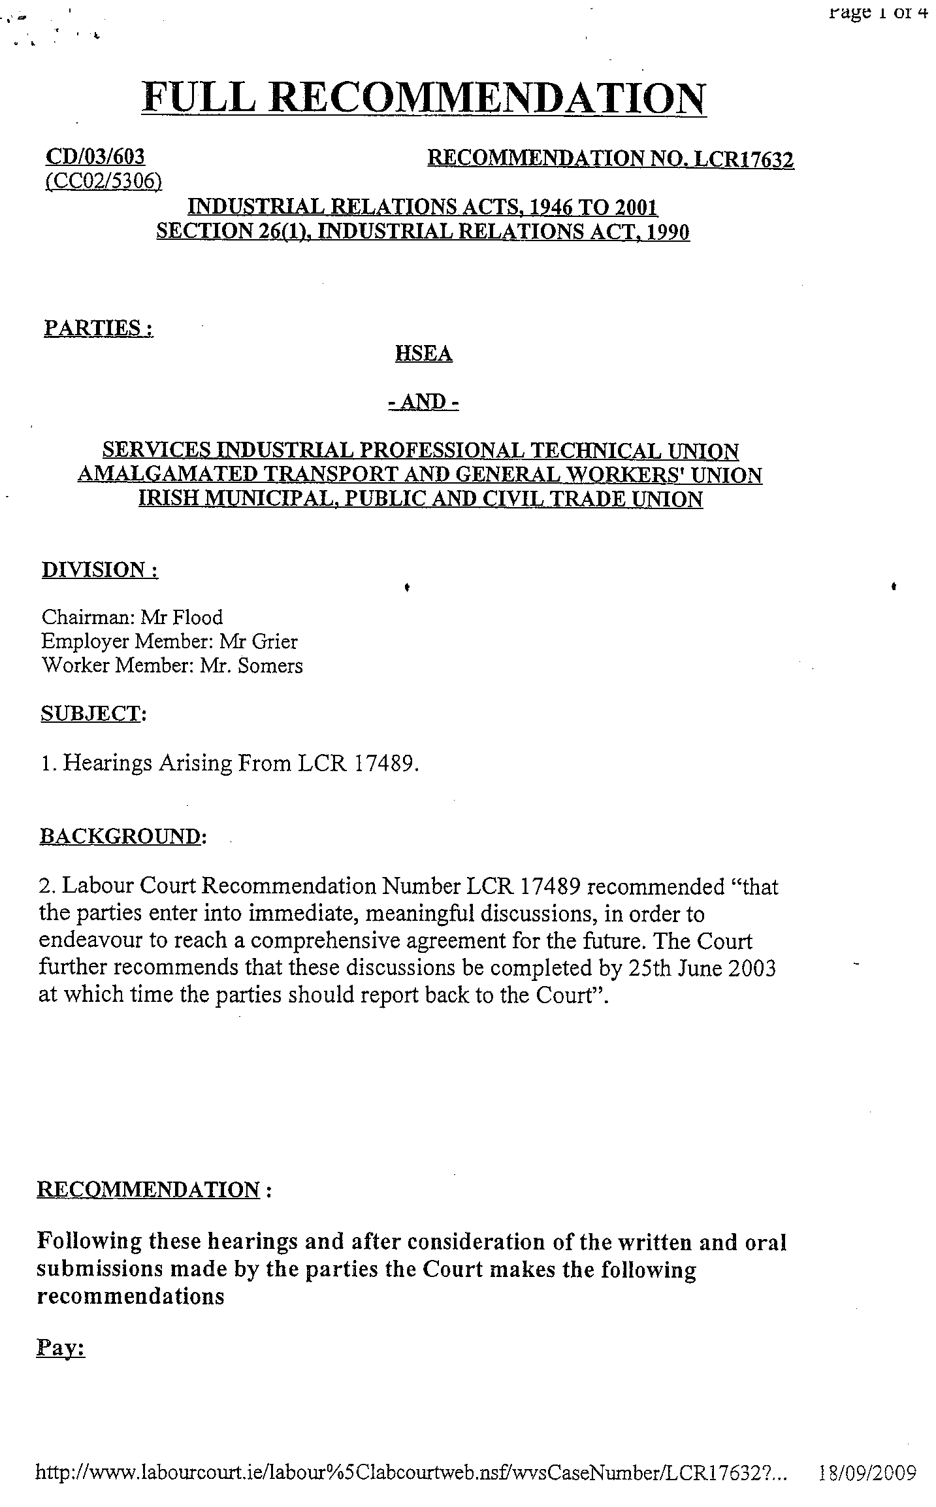

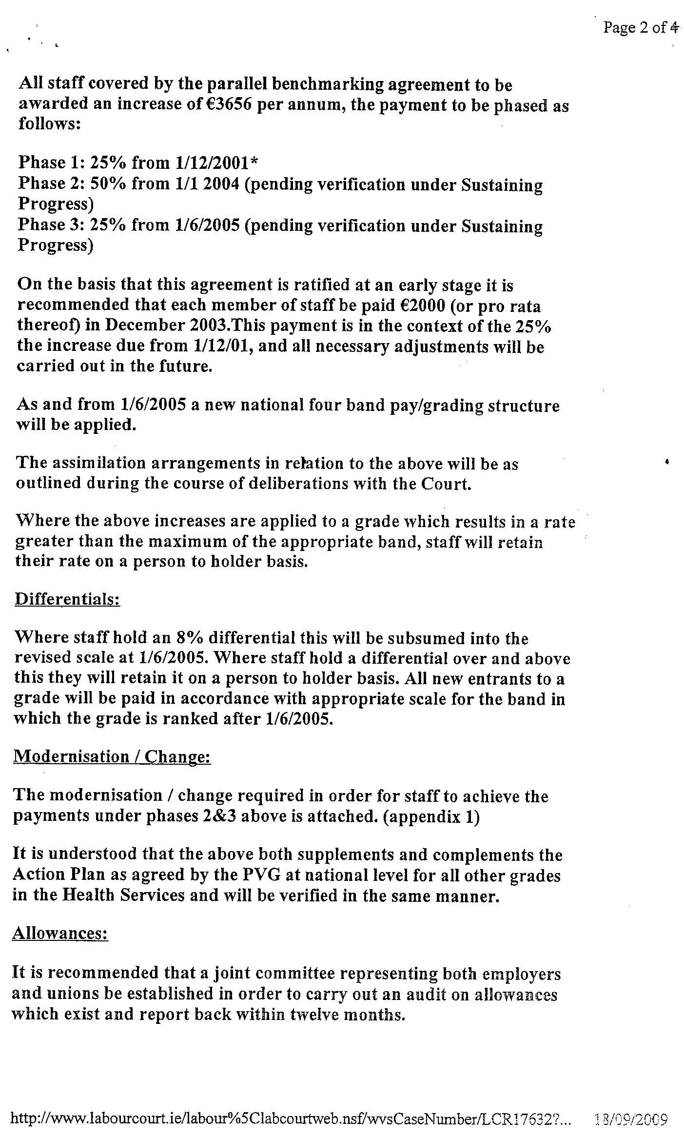

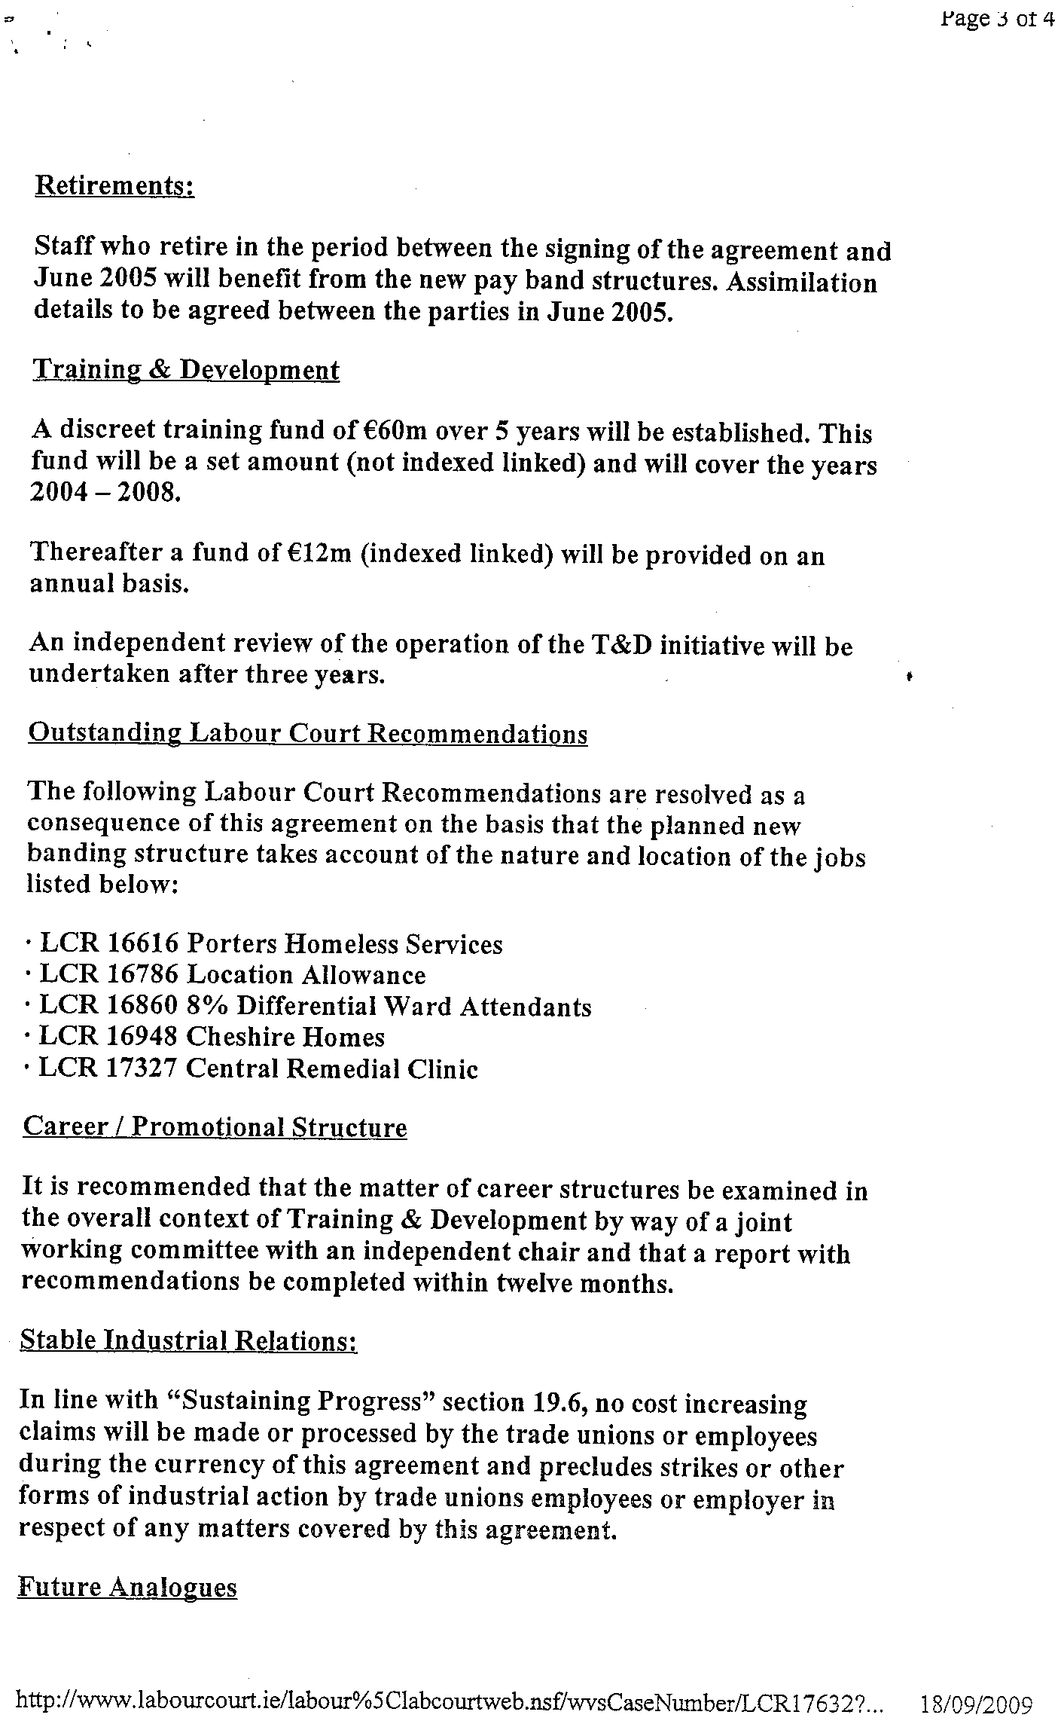

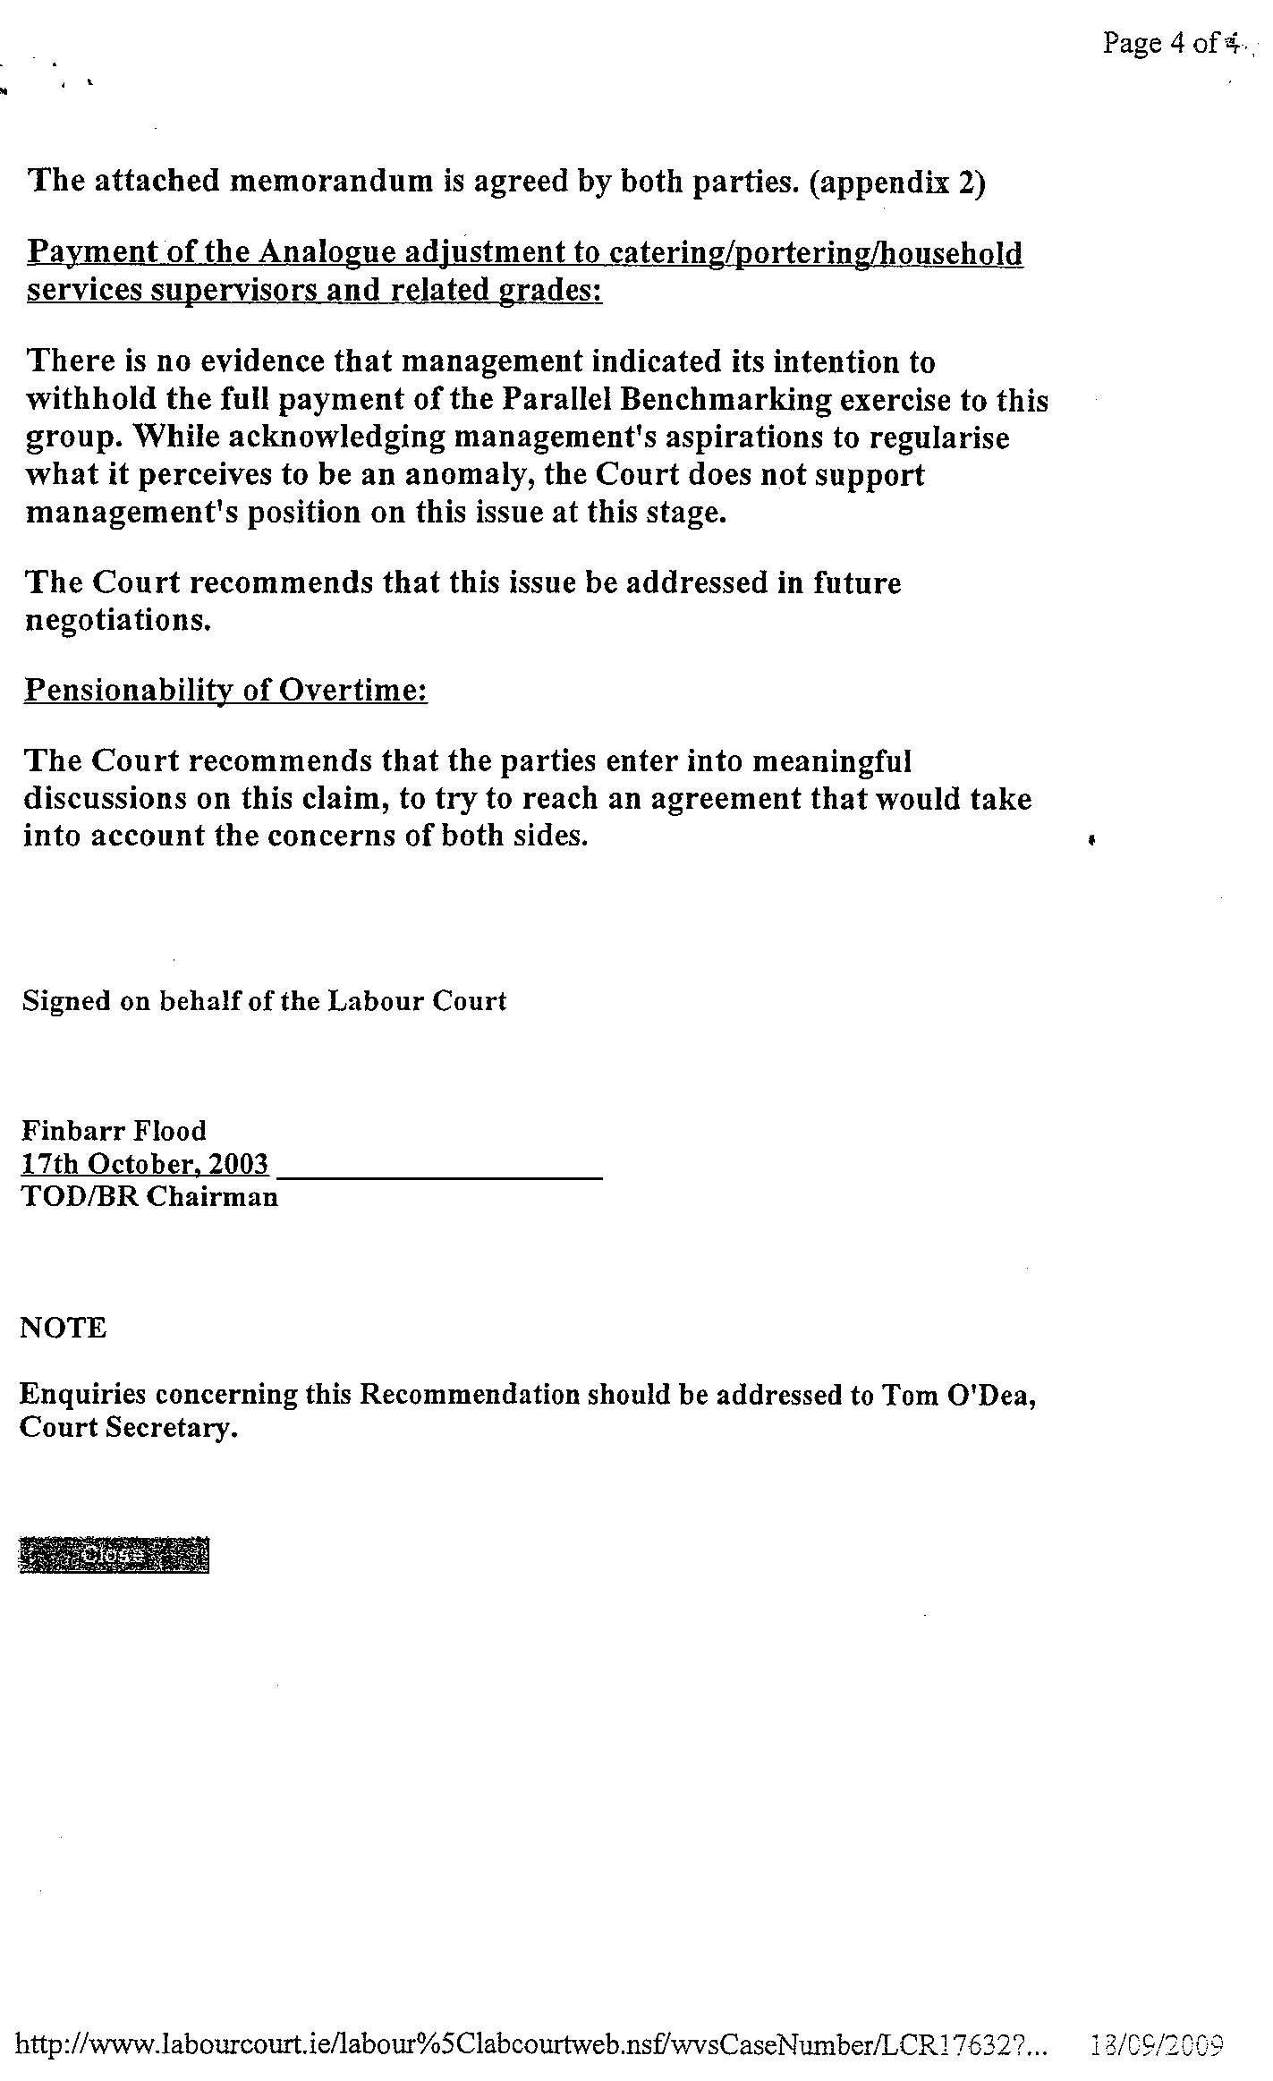

Appendix II

SKILL
Analysis of Steering Group Membership 2004 to October 2009

Steering Group Member | Representing | Membership Period
 |  | From | To
Independent Chairman | Independent Chair | 2004 | Present
Union-A-Representative#1 | Union-A | 2004 | Present
Union-A-Representative#2 | Union-A | 2004 | Present
Union-B-Representative#1 | Union-B | 2004 | Present
HSE-Representative#1 | HSE - HR | 2004 | Present
HSE-Representative#2 | HSE - HR | 2005 | 19 December 2006
ID-Sector-Representative#1 | Disability sector | 2005 | Present
External Consultant |  | 2004 | Present
Department of Finance-Representative#1 | Dept of Finance | 2005 | October 2009
HSE-Representative#3 | HSE - HR | 2004 | 15 November 2006
Department of Health & Children-Representative#1 | DOH&C | 2005 | 7 March 2006
DATHS-Representative#1 | DATHS | 2004 | 31 January 2006
Union-C-Representative#1 | Union-C | 2004 | February 2006
Union-C-Representative#2 | Union-C | 7 March 2006 | Present
DATHS-Representative#2 | DATHS | 7 March 2006 | Present
Department of Health & Children-Representative#2 | DOH&C | 8 May 2006 | 27 March 2009
Department of Health & Children-Representative#3 | DOH&C | April 2009 | Present
HSE-Representative#4 | HSE - HR | 19 December 2006 | September 2009
HSE-Representative#5 | HSE-HR | September 2009 | Present
HSE-Representative#6 | HSE - NHO | 19 December 2006 | Present
HSE-Representative#7 | HSE – PCCC | 12 February 2007 | 5 December 2007
ID-Sector-Representative#2 | Disability Sector | 22 October 2007 | Present
HSE-Representative#8 | HSE PCCC | 8 February 2008 | Present

Appendix III

June 2005 Governance Document

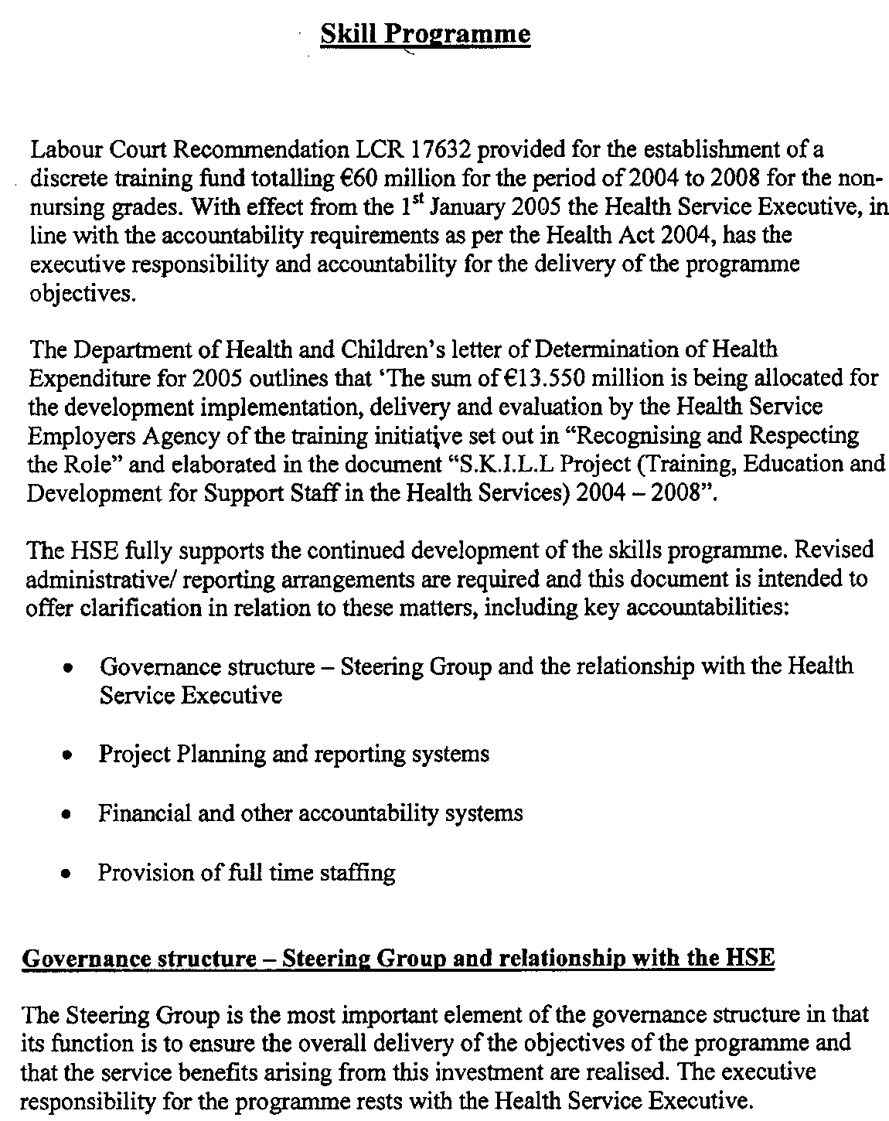
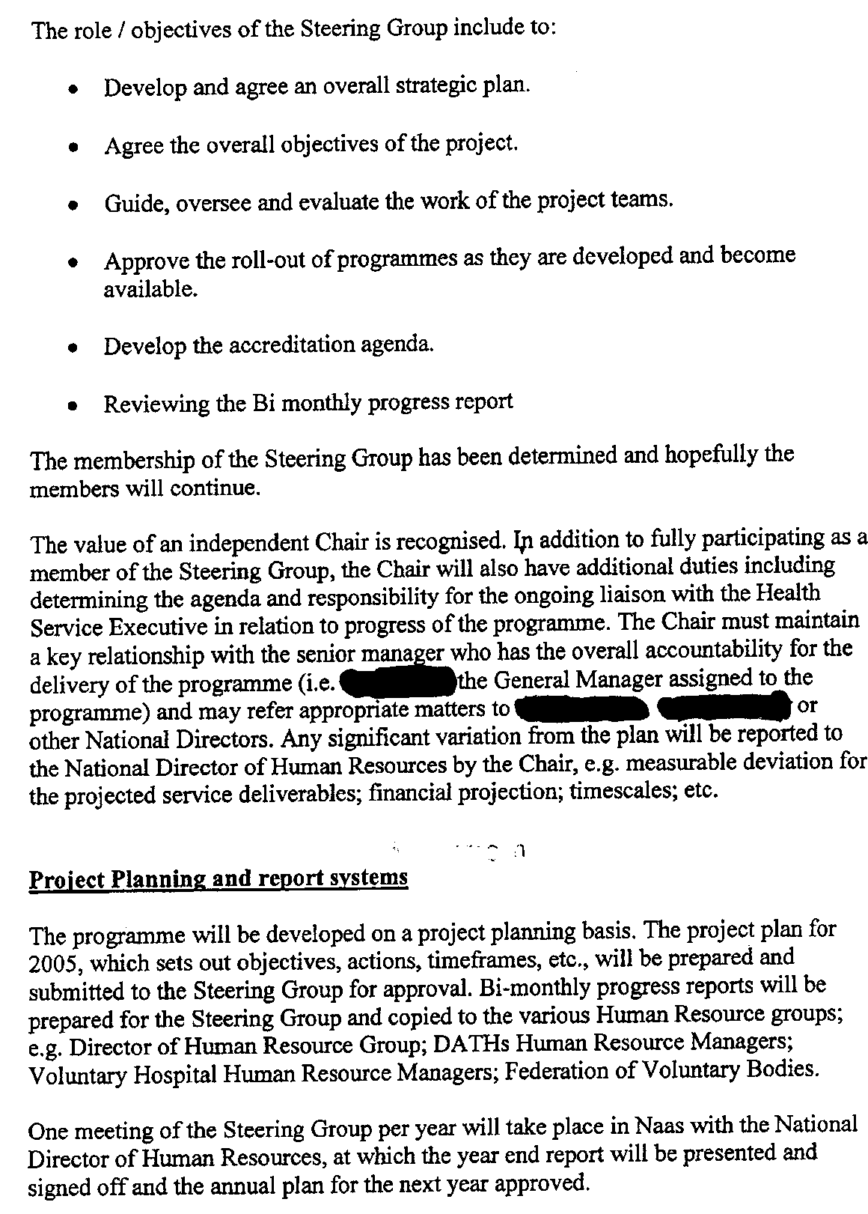

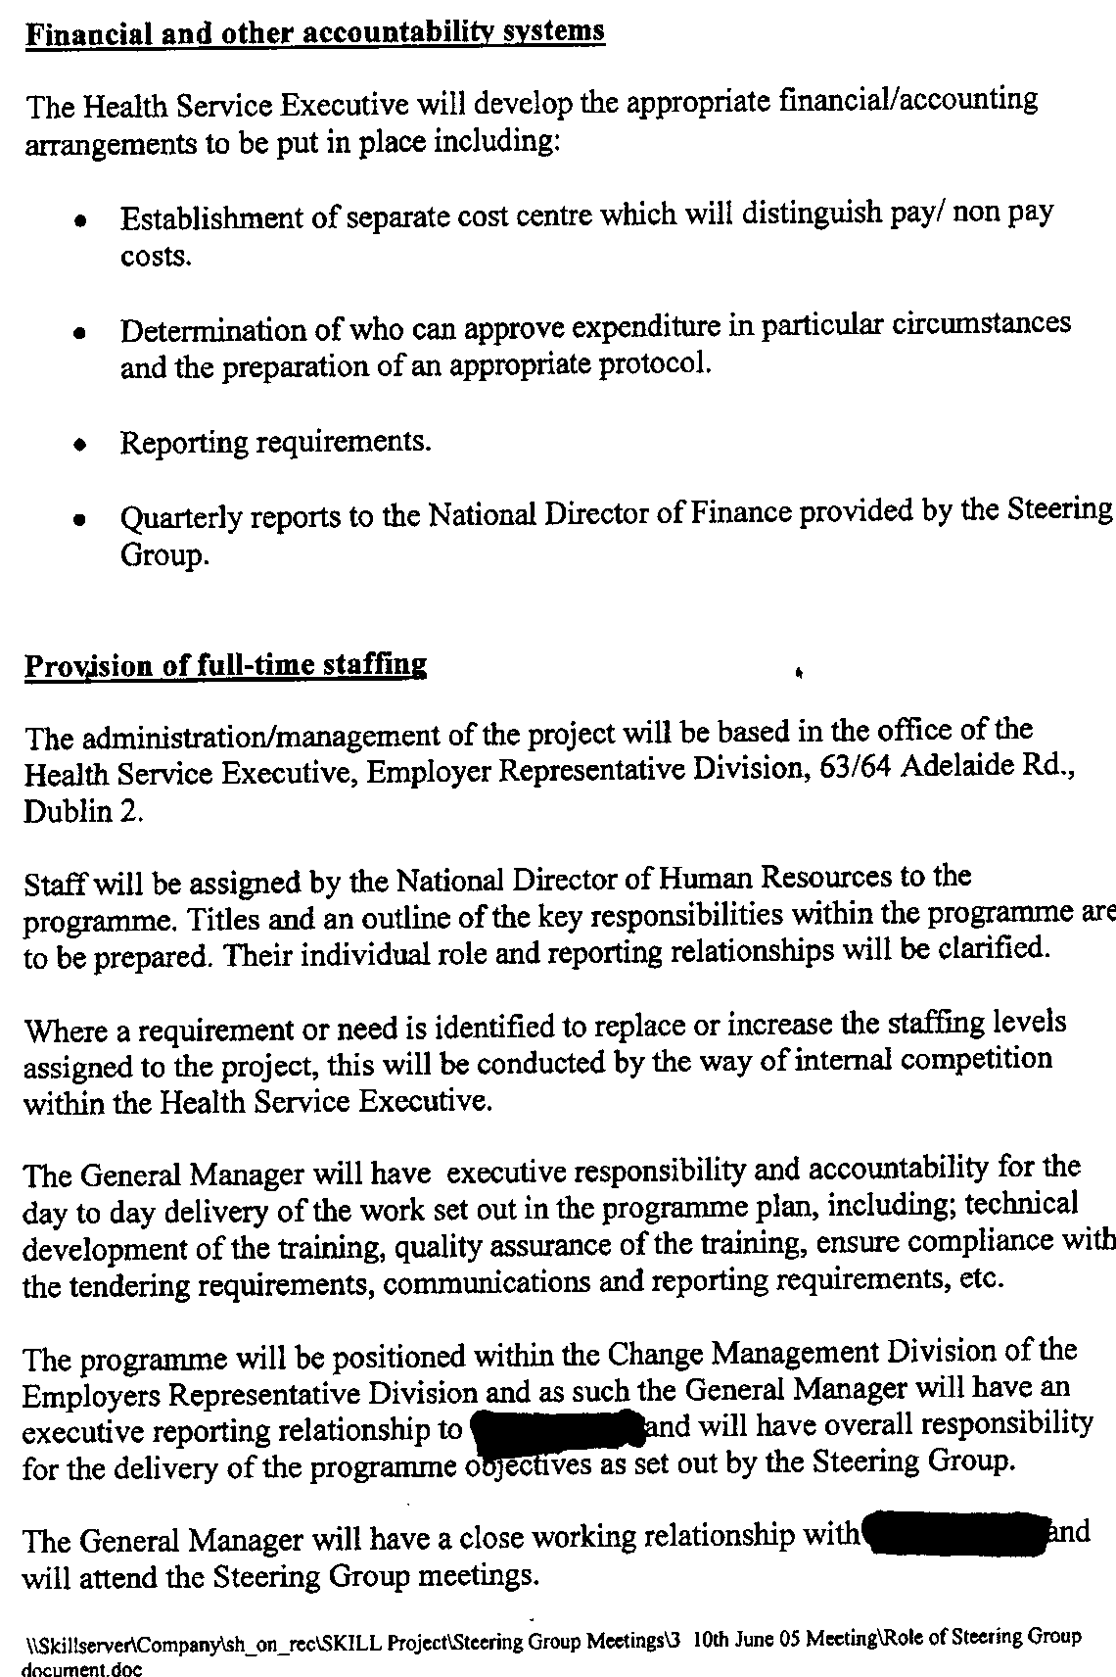

Appendix IV

HSE Internal Audit correspondence to Union-A
30th September 2009

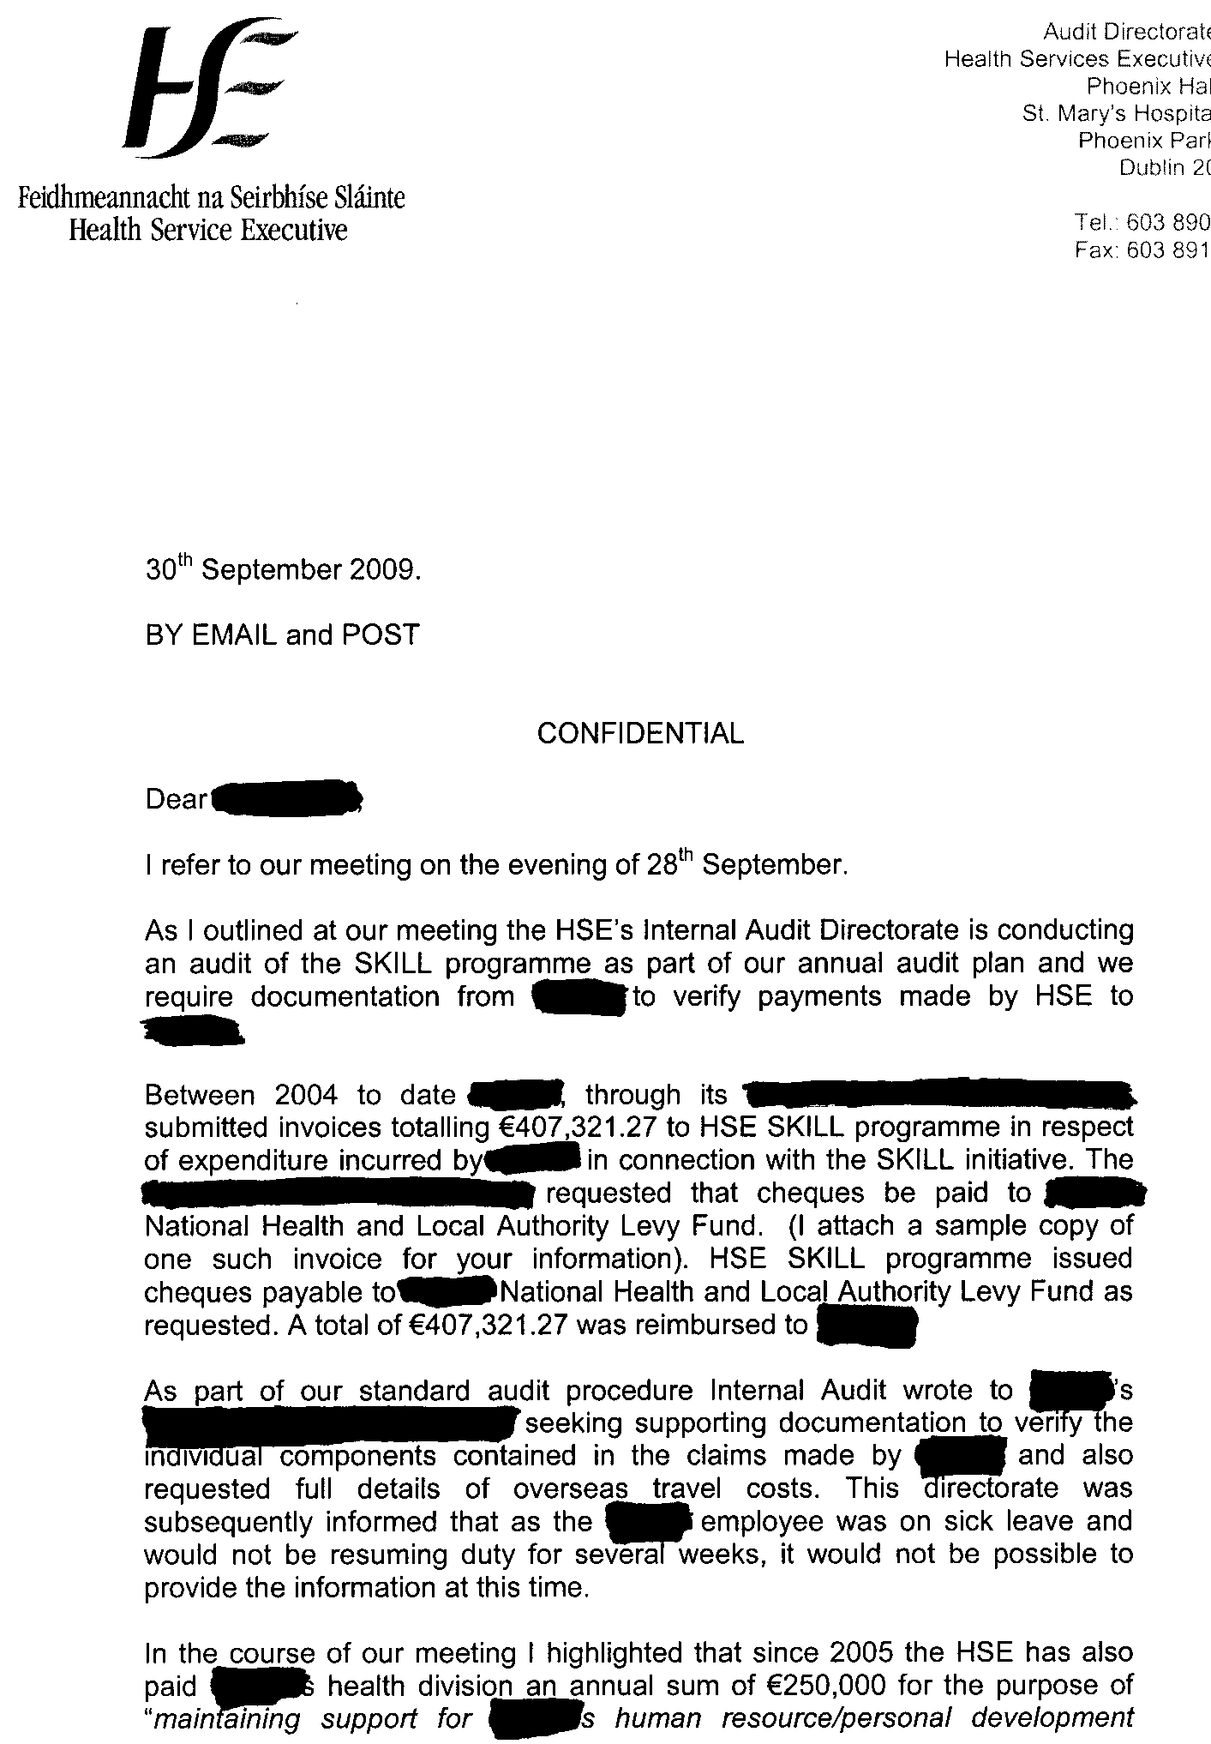

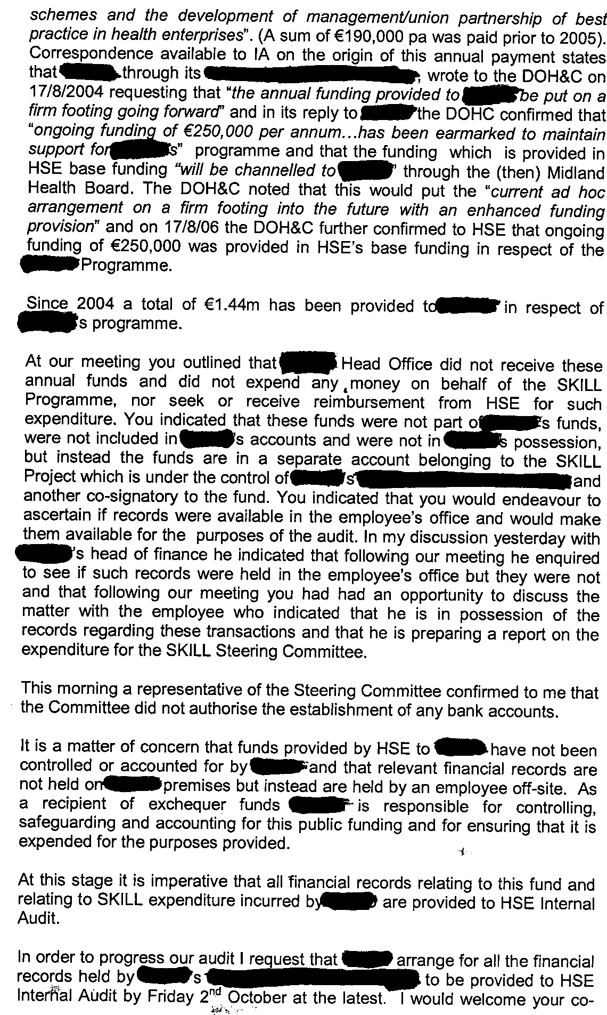

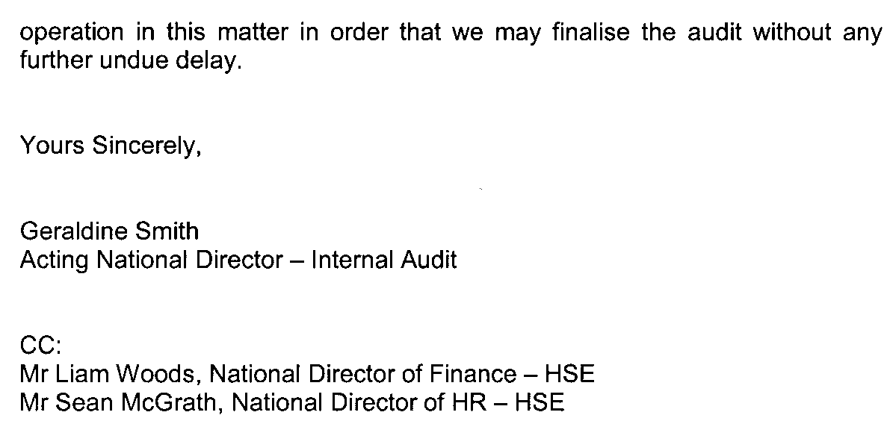
Appendix V

Union-A correspondence to HSE Internal Audit
1st October 2009

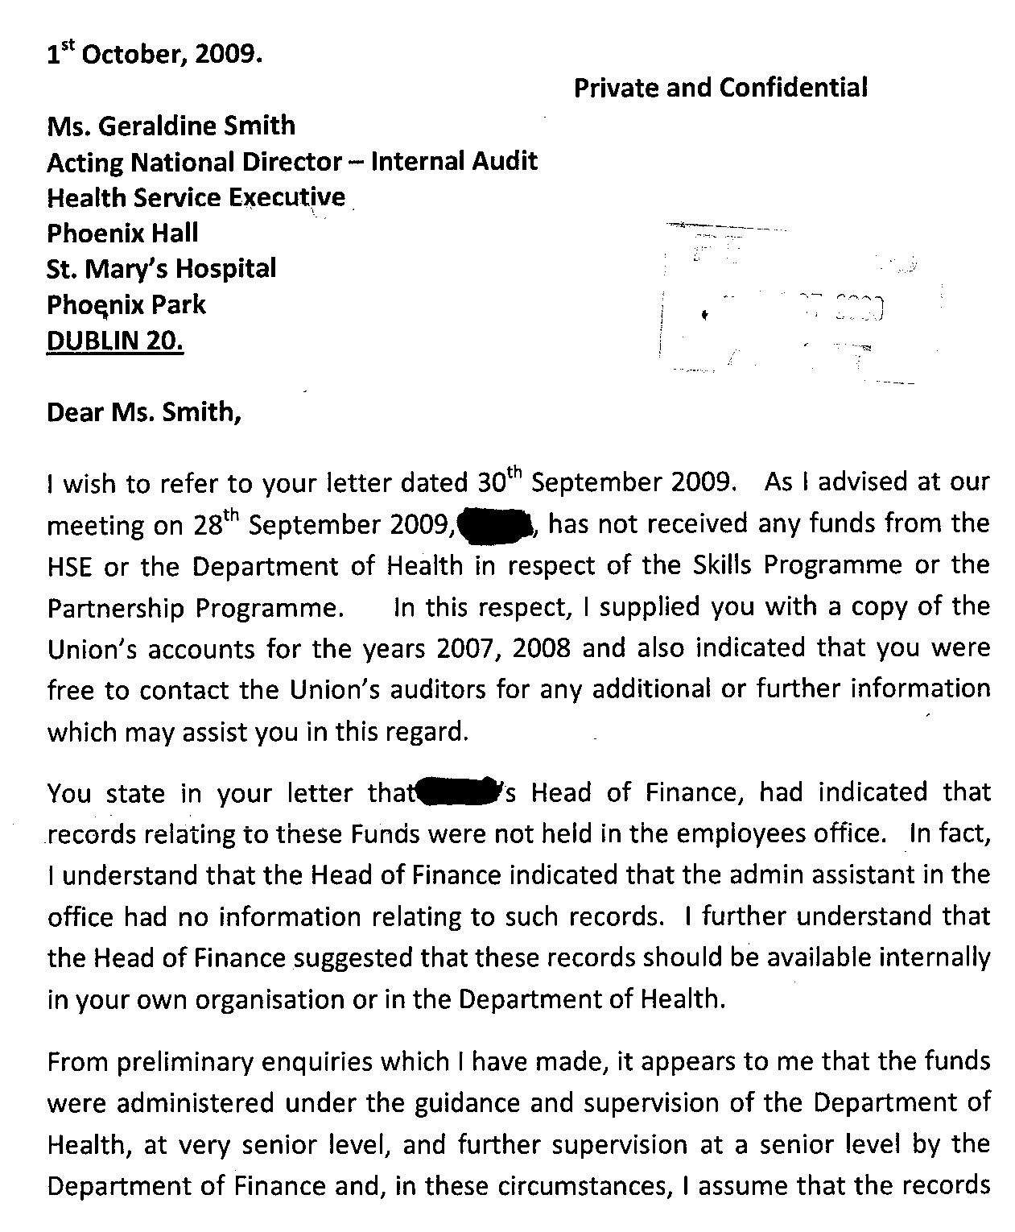
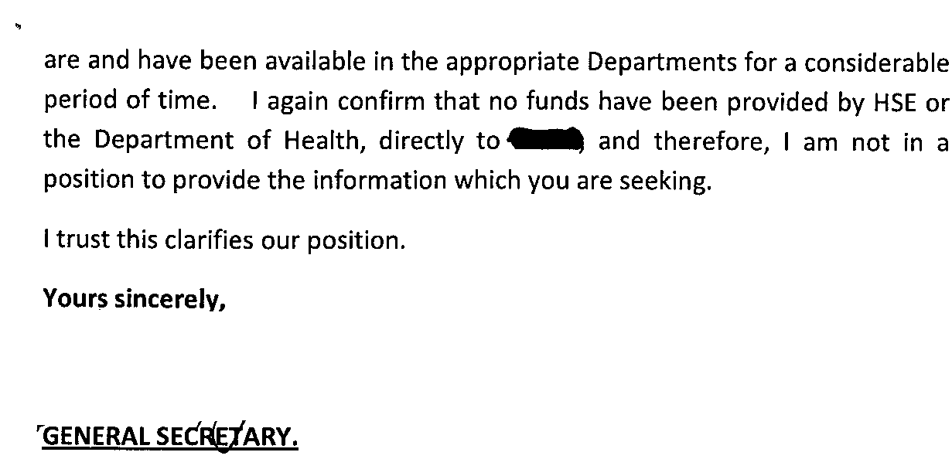
Appendix VI

HSE Internal Audit correspondence to Union-A
16th October 2009

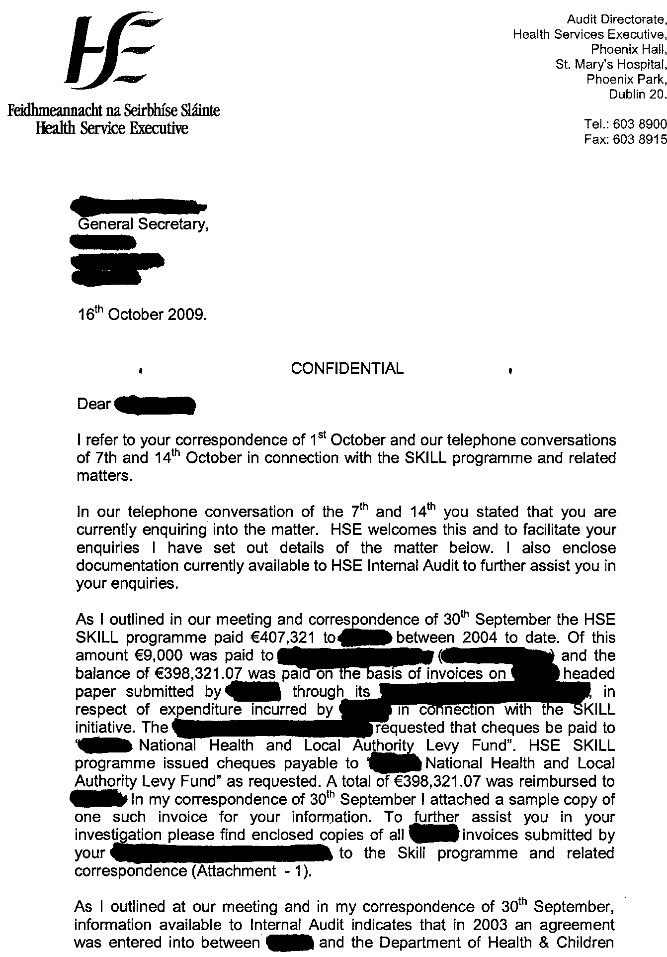
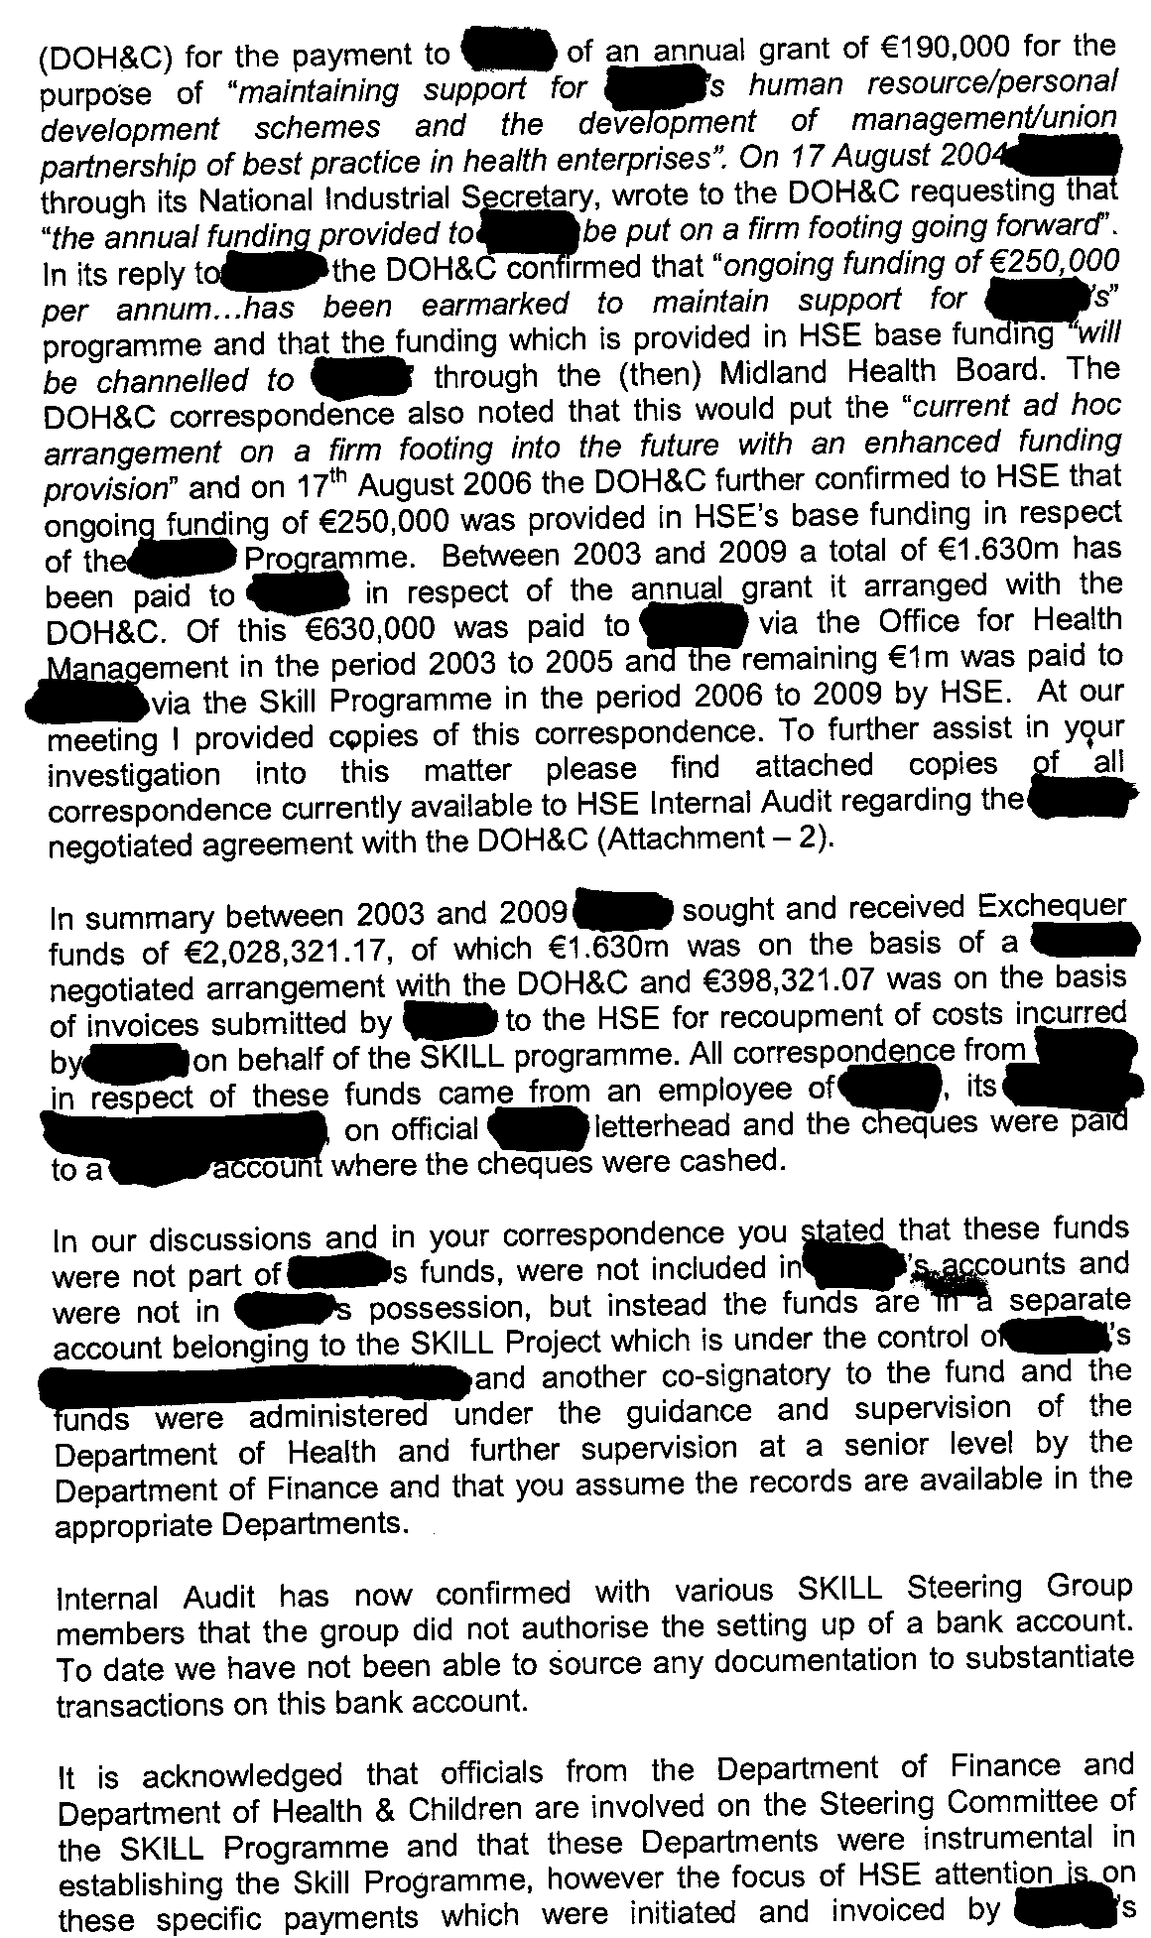


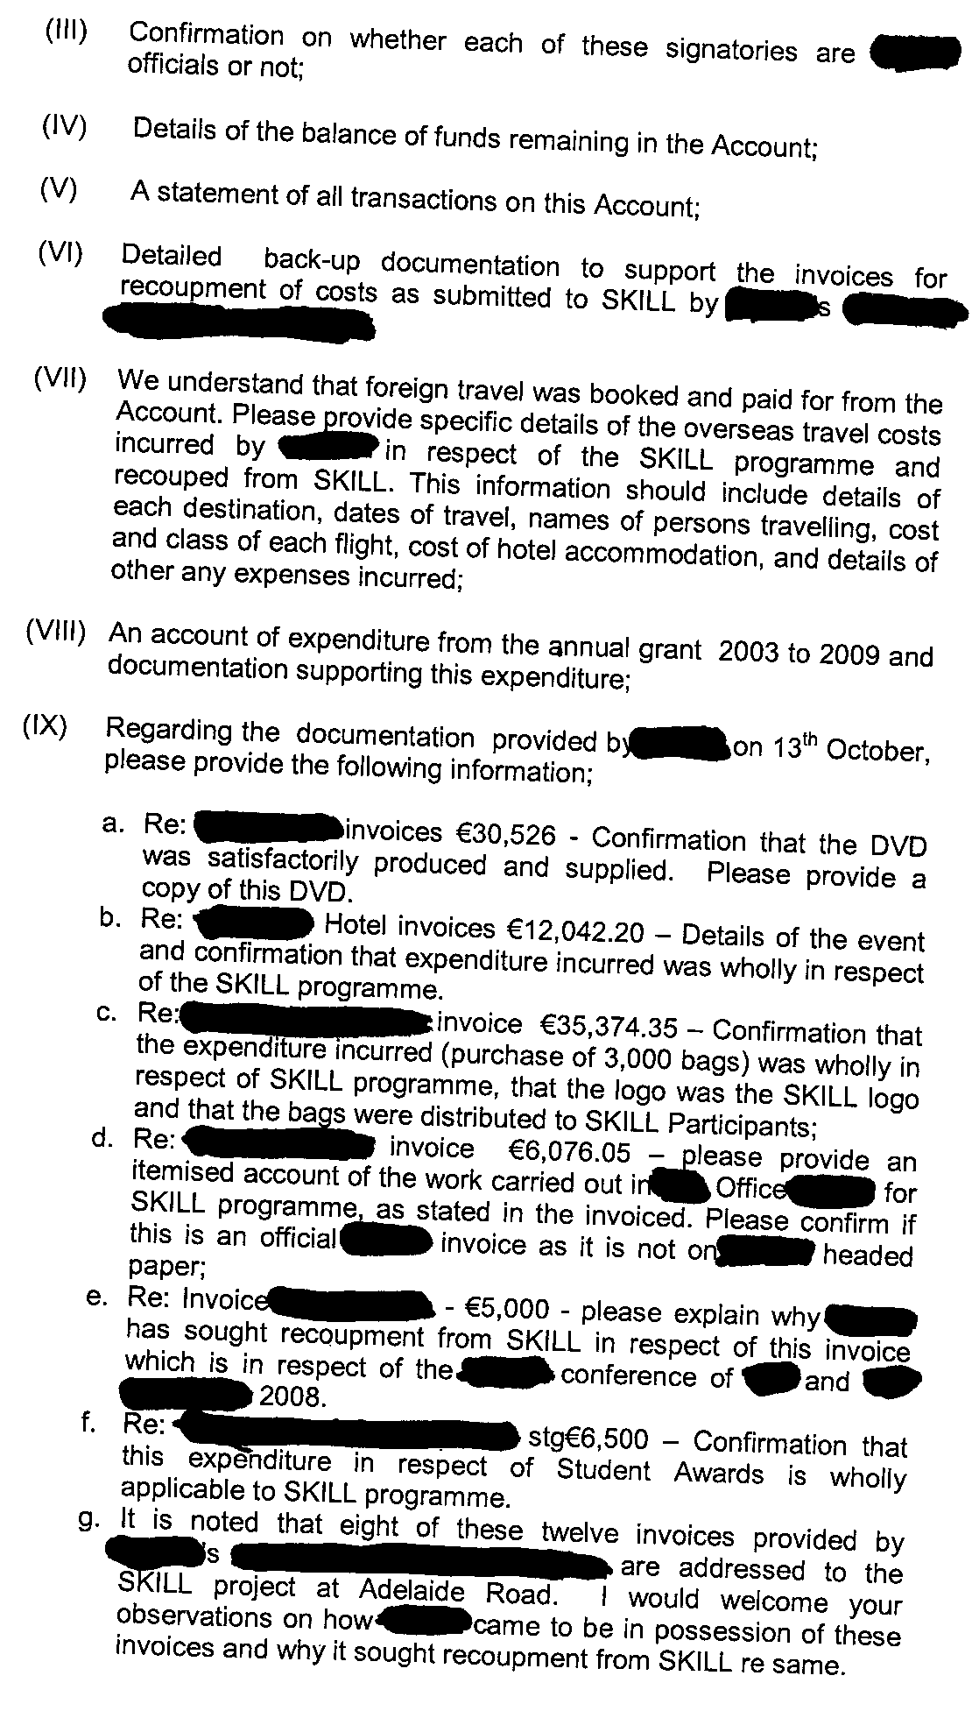
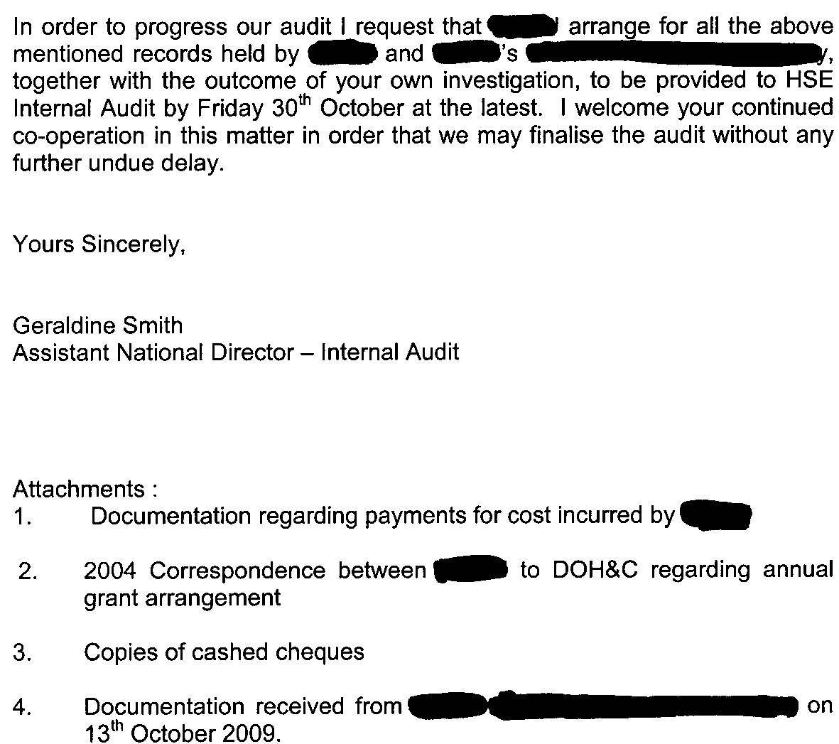
Appendix VII

Union-A correspondence to HSE Internal Audit
30th October 2009

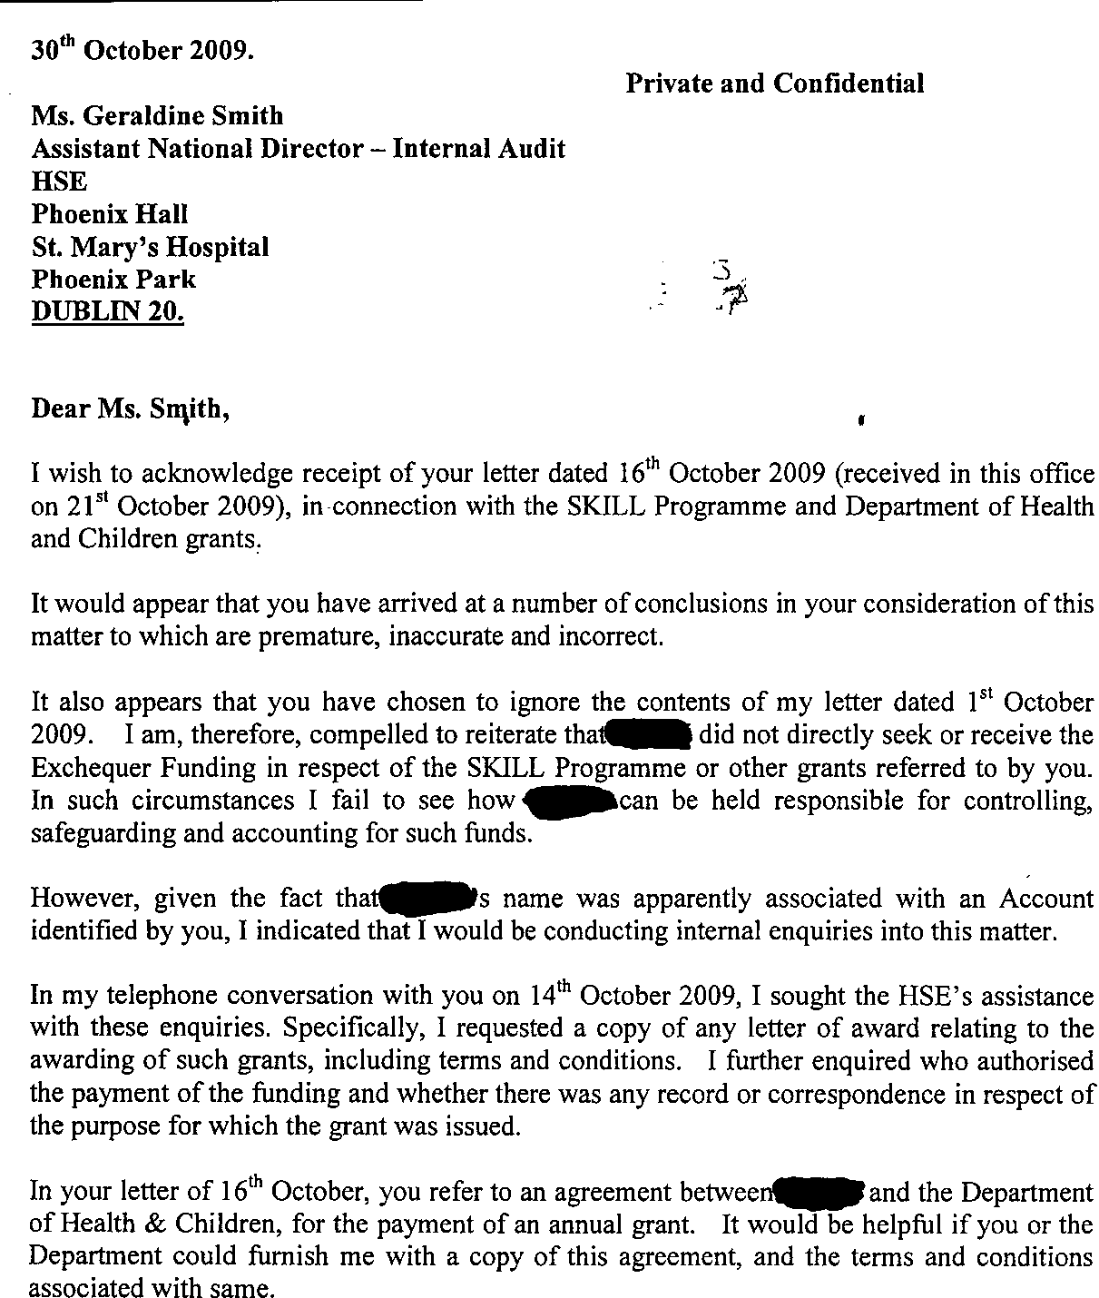
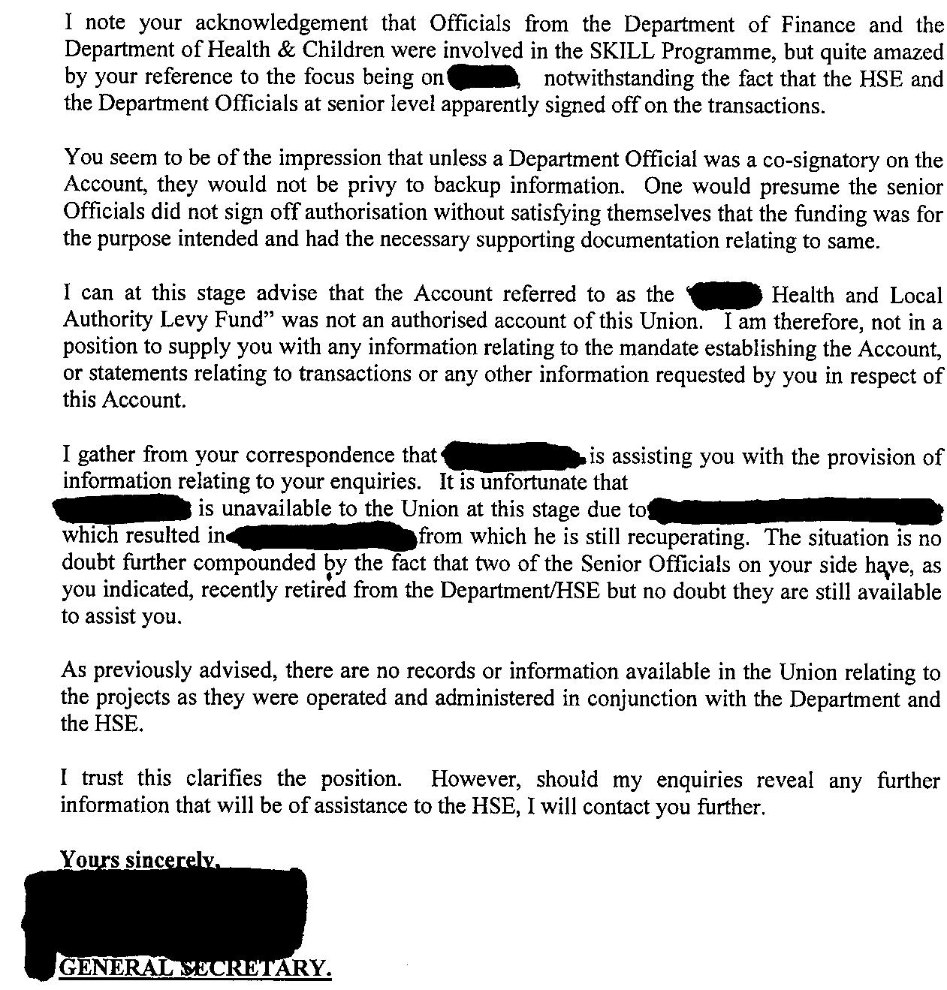
Appendix VIII

HSE Internal Audit correspondence to Union-A
6th November 2009

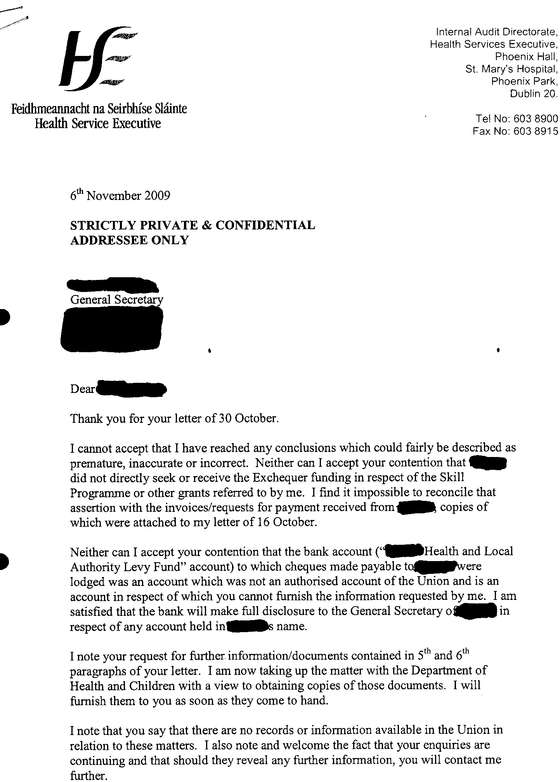
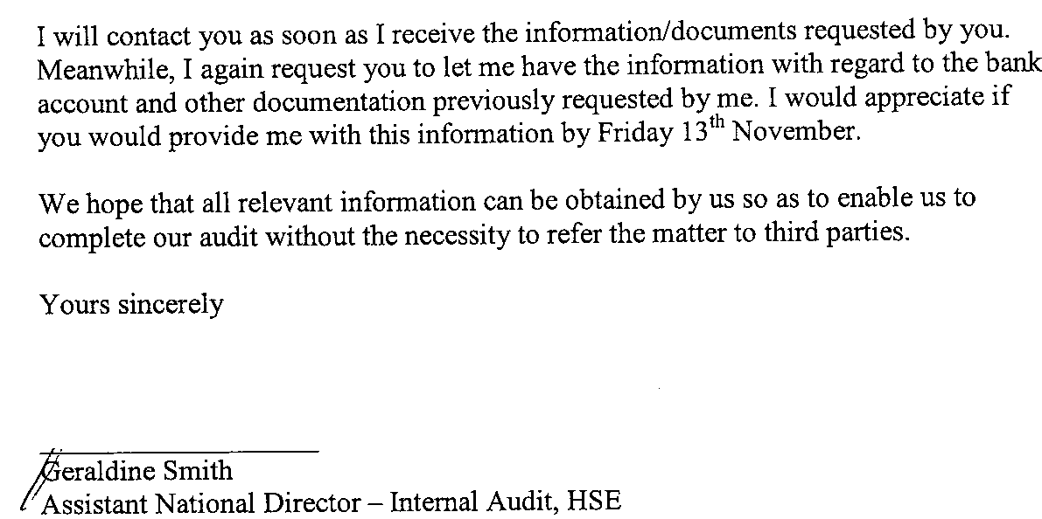
Appendix IX

Union-A correspondence to HSE Internal Audit
11th November 2009

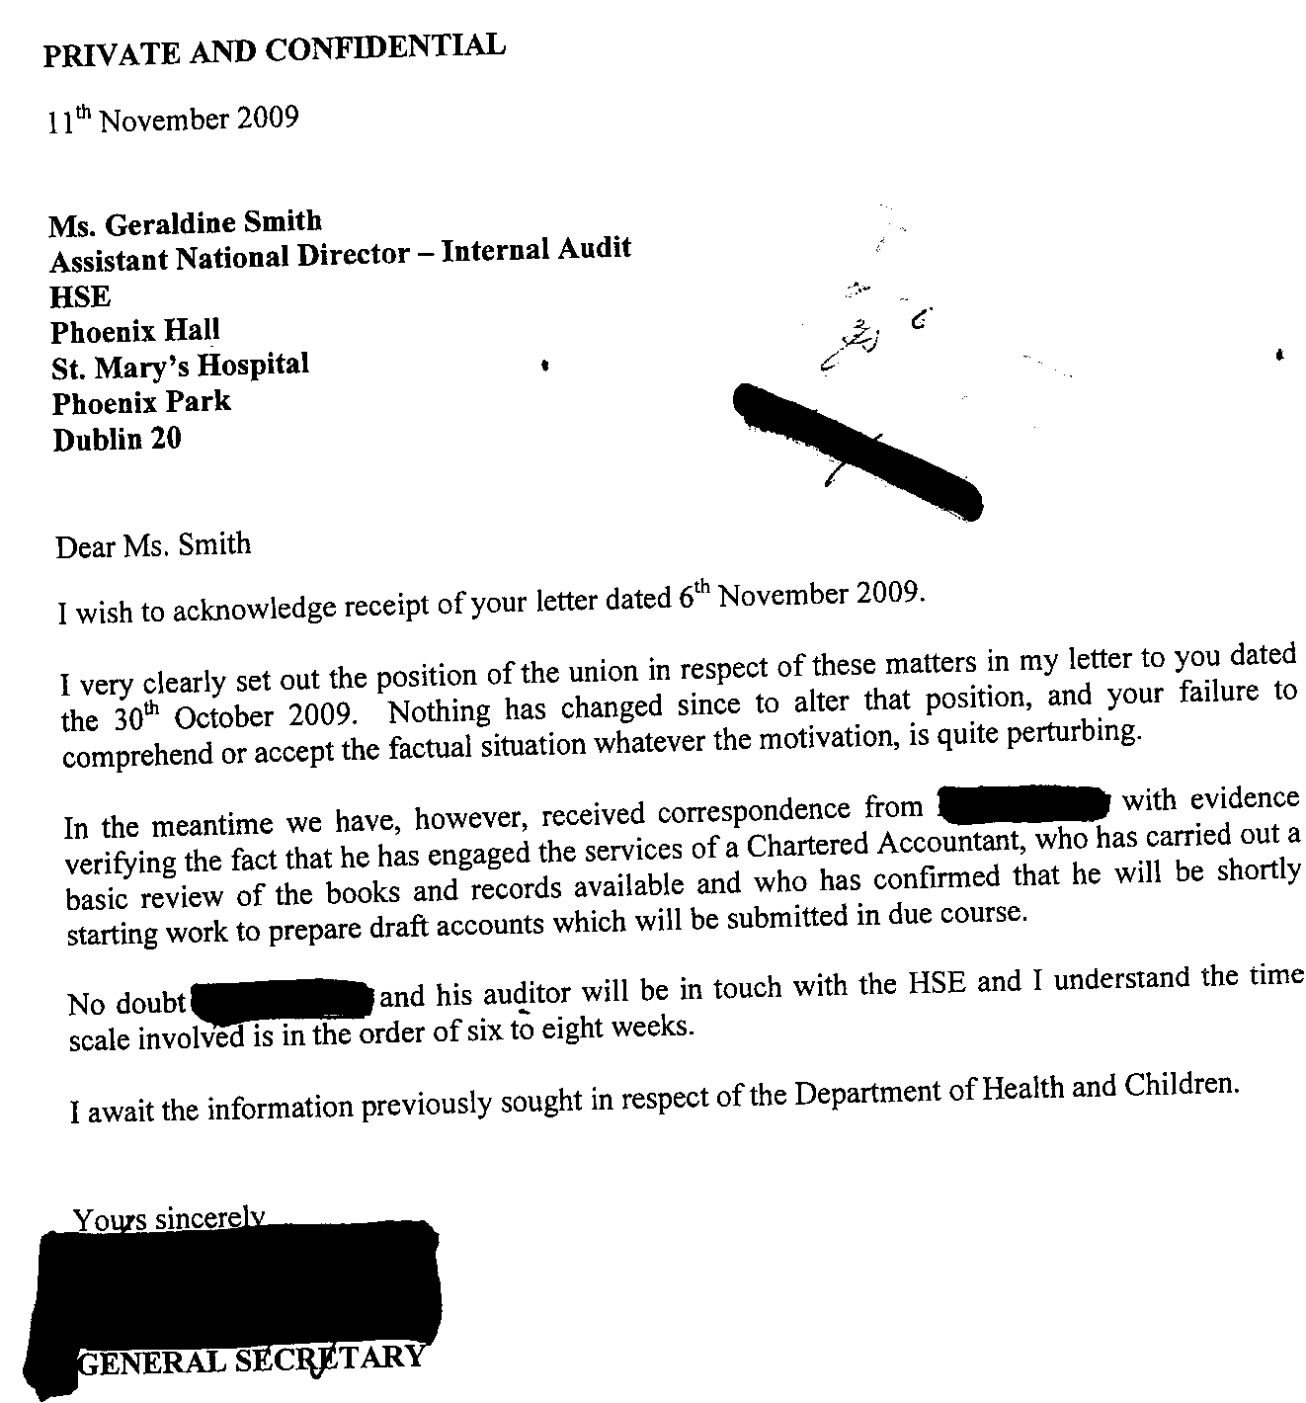
Appendix X

HSE Internal Audit correspondence to Union-A
23rd November 2009

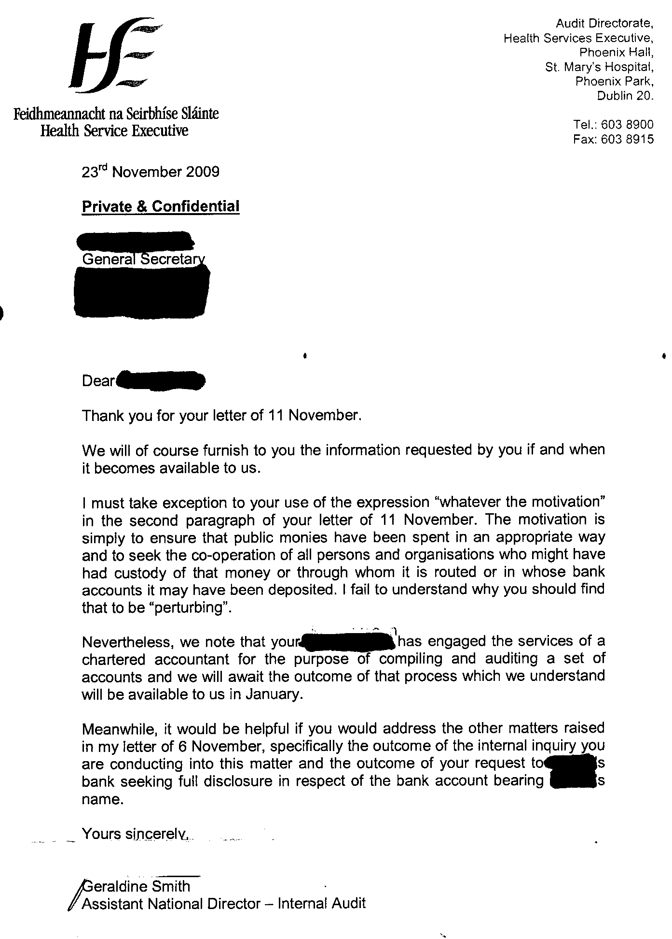
Appendix XI

Examples of types of expenditure from DOH&C Annual Grant
as outlined by Union-A-Employee#1
at 11th November 2009 meeting.

- Conferences (Hotel costs)

- Training facilitators

- Mentors and coaching

- Conference material and promotional items

- Gifts and contributions for fundraising events

- A Disability Event grant

- Charities and payments to members in distress

- Scholarships (e.g. 2 persons undertaking MSc)

- Conferences with an Irish University

- Joint Sponsorship with UK universities

- Joint sponsorship with US universities

- Sponsoring meals for delegations

- Grants provided to some HSE areas

- Grants to Intellectual Disability agencies

- Payment for syndicate meeting rooms in hotels

- Joint management / union group study visit for National Ambulance forum to Boston.

Appendix XII

HSE Internal Audit correspondence to Union-A-Employee#1
15th March 2010

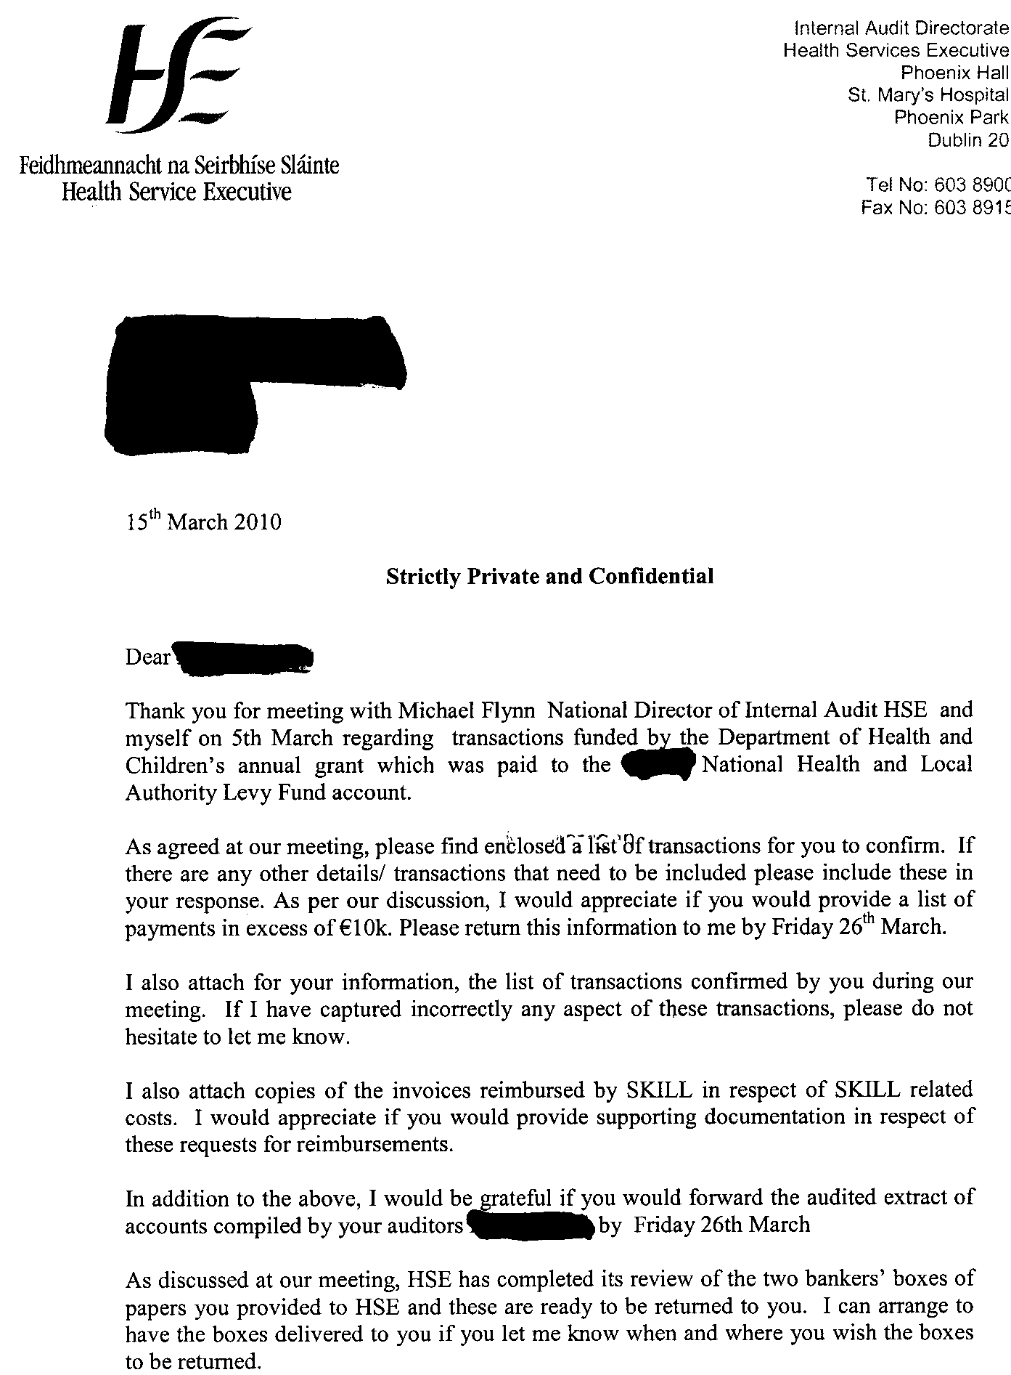

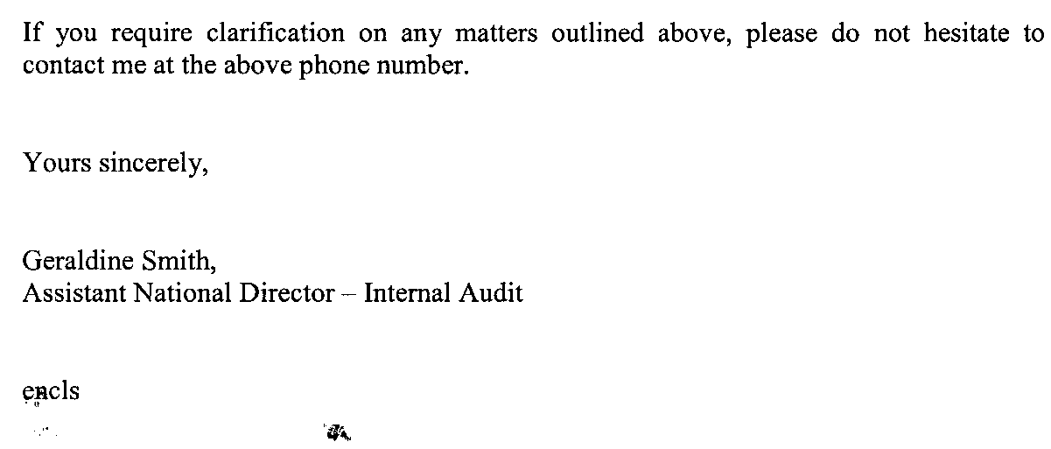

Appendix XIII

Union-A-Employee#1 correspondence to HSE Internal Audit
22nd March 2010

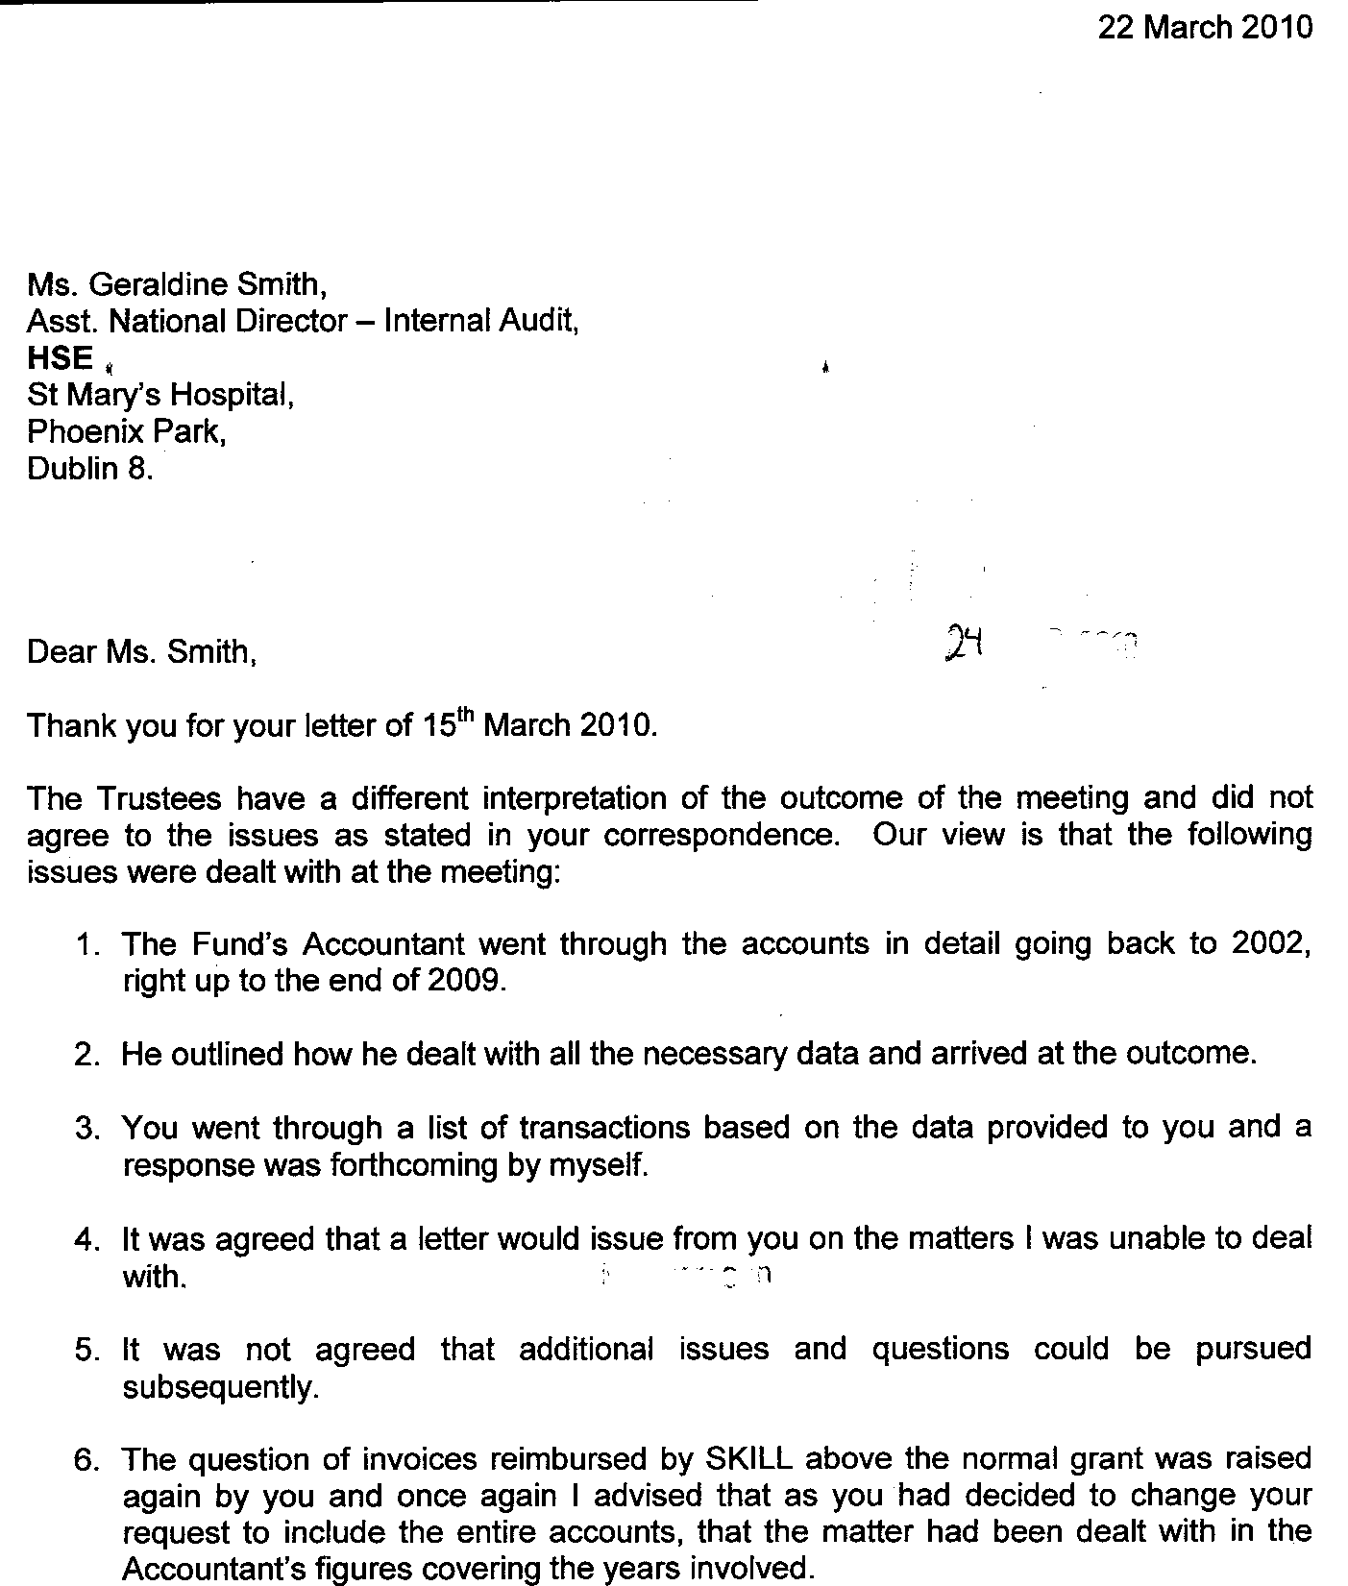
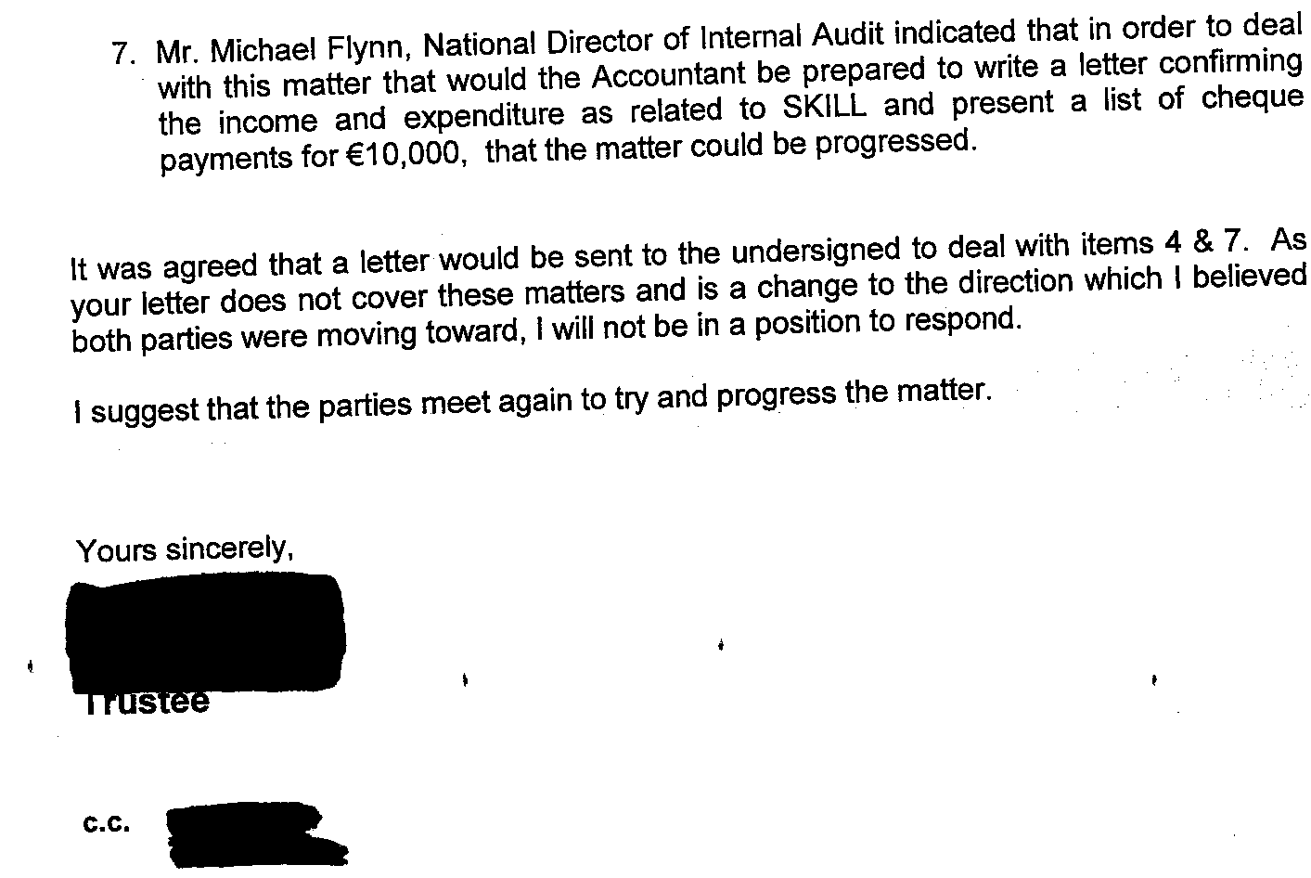
Appendix XIV

HSE Internal Audit correspondence to Union-A-Employee#1
20th April 2010

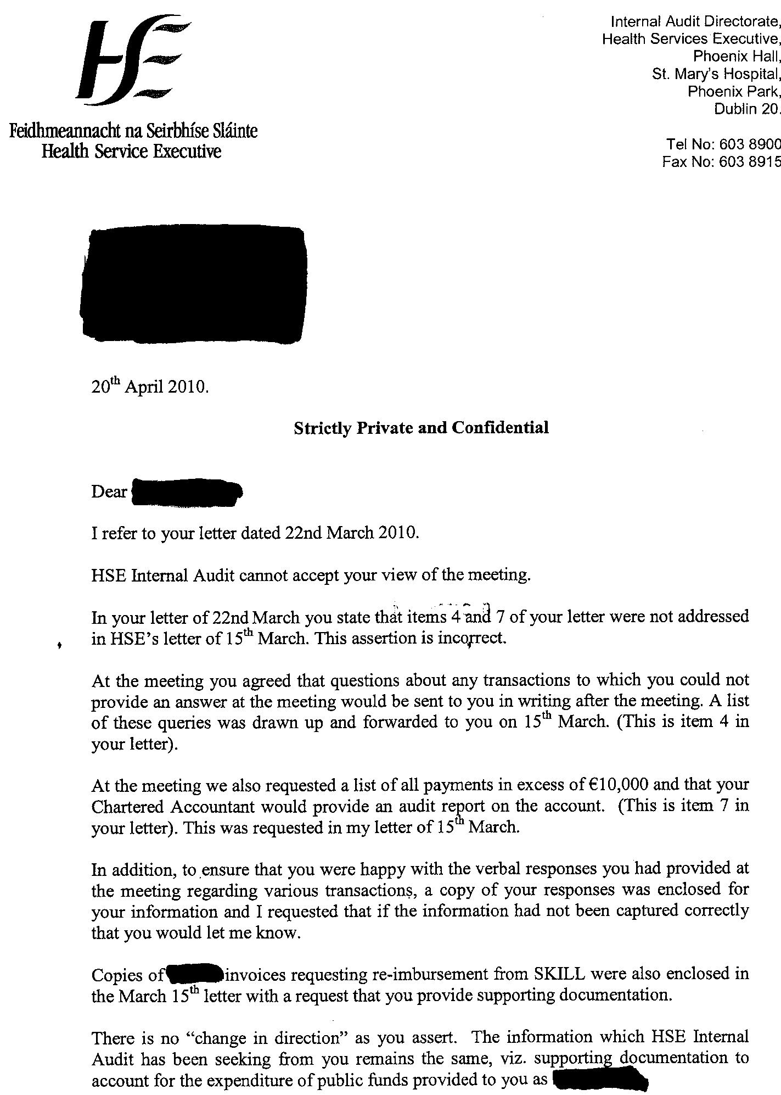
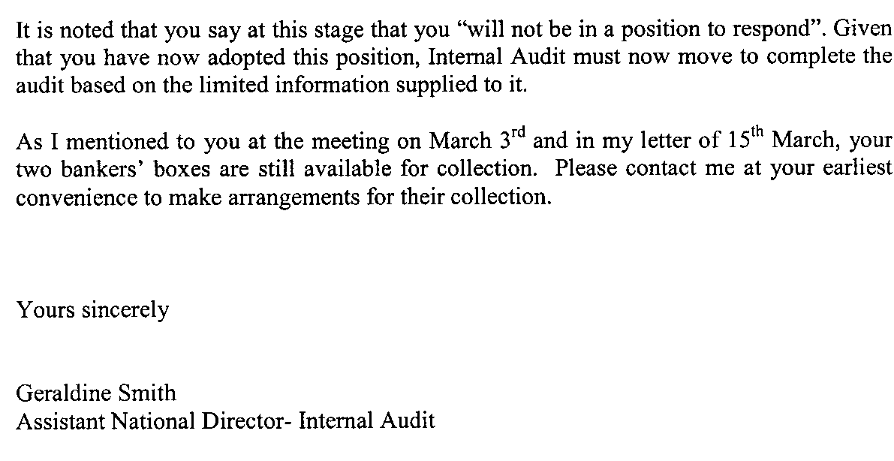
Appendix XV

Union-A-Employee#1 correspondence to HSE Internal Audit
26TH April 2010

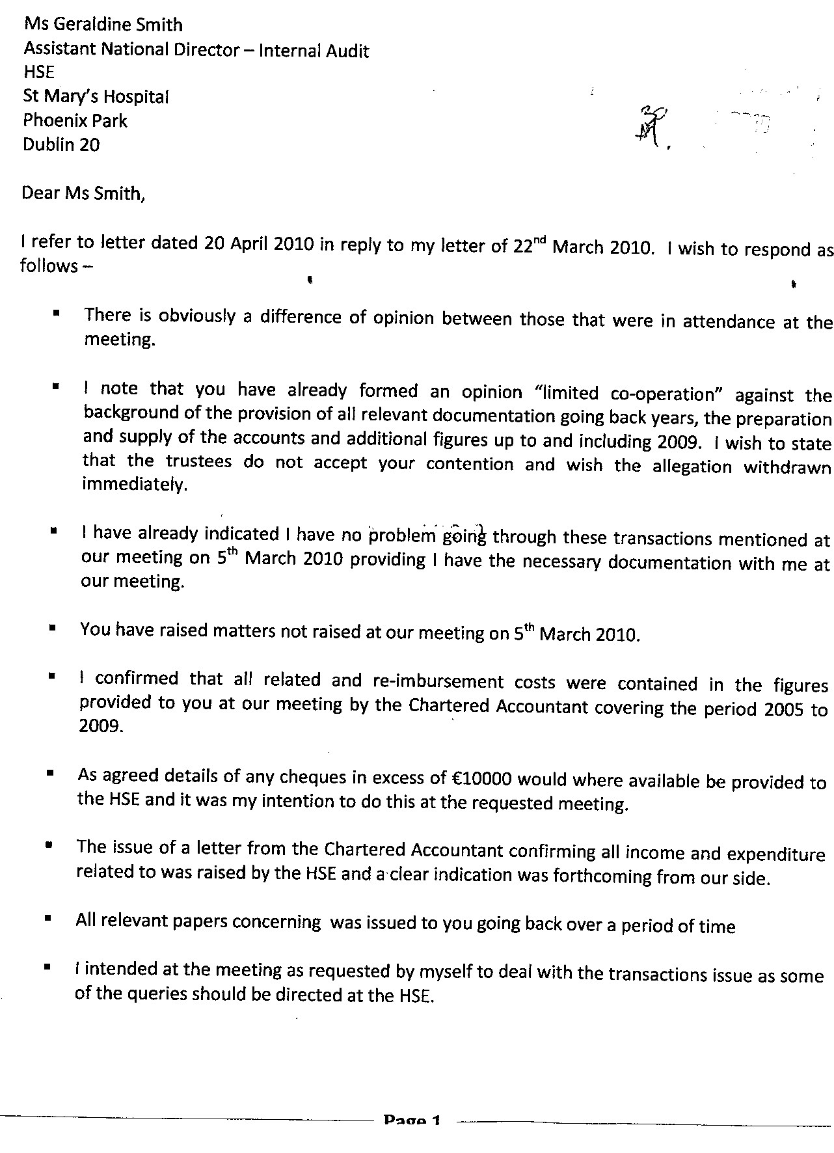

Appendix XVI

HSE Internal Audit correspondence to Union-A-Employee#1
19th May 2010

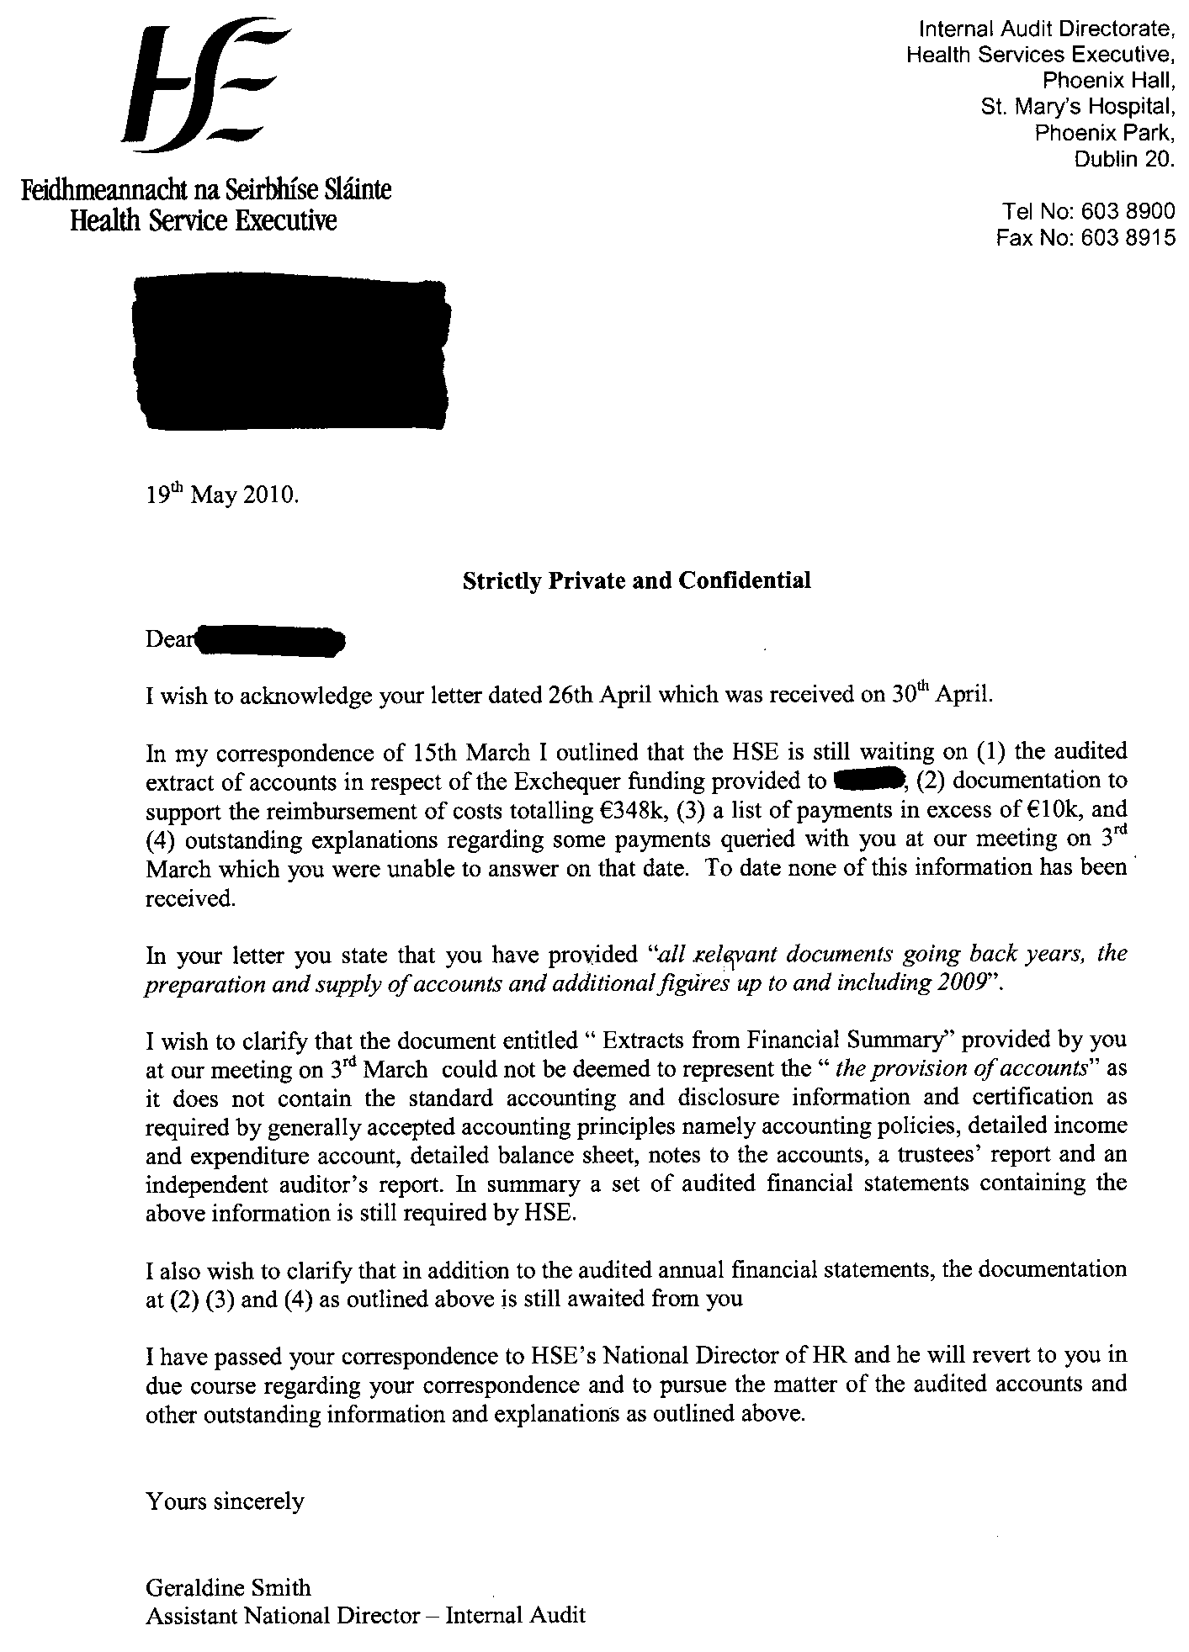

Appendix XVII

Analysis of
Expenditure contained in boxes supplied by Union-A-Employee#1

The categories of expenditure/ requests for expenditure included:

- Funding 3rd level degree courses for Union-A members € 73 k

- Literacy Training - €10k

- Requests for Grants/Funding
- ID service projects - €25k
- National advocacy group #1 - € 4k
- National advocacy group #2 - €4k
- A Disability Event €32.5k
- Intellectual Disability Service provider #1 - Cost Reduction Report €7.5k
- Intellectual Disability Service provider #1 - Convenor €50k
- Intellectual Disability Service provider #1 - Travel to Kennedy Fellowships €5k
- Voluntary Hospital #1 – ICT training courses €18k
- Institute #1 - €5k
- Historical Library - €1k
- Seed Money to Northern Ireland Union re North/South Partnership - €5k
- Laptops for Union-A members - €30k
- Union-A SKILL project with UK DOH&C - €20k

- Overseas Academic Links
- US University-A
  - Contribution to “ Advancing the Front line of Health care project” - $20k
  - Research - “How to engage Front Line Staff” - €15k
  - New York Workshop (3 x Union Attendees) - €5k per Union-A-Employeee#1
  - Consultancy fee re US academic - €10k

- US University – B
  - One–way business class airfare re Shankill/Belfast regeneration project €5k
  - Miscellaneous Hotel and travel costs (> €2k per Union-A-Employee#1)
  - Union-A Diversity training programme $29k

- US Academic’s – travel expenses (figures not available)

- UK-university-A Sponsorship of 1x Foundation degree €15k

- Consultancies
- Consultant #1 “Partnership Working and Structures in the Health services” (€17.5k per Union-A-Employee#1).
- Consultant #2 Various reports - €9.6k + several figures not available
- Consultant #3 Report on Union-A Officials’ training programme (figure not available)
- Consultant #4 Training for trade union representatives + various reports on reviews of allowances paid to support and specialist staff – (total figures not available)
- Consultant #5 Report for Union-A on care of older people €7.5k

- Conferences
- Sponsorship Irish University #1 Conference - €12.5k
- Other conferences - Maastricht, New York City global partners, Dublin conferences – figures not available
- Travel costs of visit of US speaker to Dublin – part funded but figure not available

7. Union-A related expenditure
  - Union-A Forum – Care of Older people – figure not available
  - Training for Union-A Officials
    - Union-A officials’ seminar Dundalk - figure not available
    - Union-A officials’ “Building our Union through Effective Leadership” seminars - figure not available
    - Union-A officials’ training sessions figures not available
    - Communications training for Union-A officials
      - Communications training workshops for Union-A officials - figures not available
      - Communications company – retainer - not transacted per Union-A-Employee#1
      - Leadership, Communications Team development training for Union-A officials -€6.7k
  - PR material re Union-A’s role in development of learning €10k
  - Computer Forensics retainer - Annual contract (2007 to 2009) €15k

8. Entertainment
- Meals for various delegations hosted in Dublin pub/restaurant ( figures not available)

9. SKILL specific costs
- Promotional Videos € 18.5k

10. Other items not confirmed
- Union-A and UK Skills Academy

Appendix XVII

Management Response

Internal Audit discussed the draft report and the audit recommendations with senior management.

In correspondence to Internal Audit on 11th May 2010, the National Director of HR and the National Director of Finance agreed to implement the report’s recommendations.

Details of the response is contained in the Management Comment Column in the Time Schedule for Implementation of Recommendations on pages 71 to 78 above.

The figure of €16,858 is based on pay scales at 1st January each year. It does not include arrears due to the application of new pay scales mid year (where applicable). Therefore the final value will exceed €16,858.
Salaries costs for 2006 onwards were not charged to the SKILL project.
Included in the figure of €705k is a payment of €90k. It is not clear from the documentation available to Internal Audit if this figure is part of the 2002 approved annual grant of €190k or if it is in addition to the approved grant.
Internal Audit’s examination of the archived OHM records that some SKILL related administration expenditure was processed by the SKILL project office through the former OHM financial; processing system, and not through the SKILL financial processing system.
See footnote 2.
Reference DOH&C letter dated 12th December 2004.
Attendees at the Steering Group meeting of 25 September 2009 were the Chairman, DOF representative, Union-A-Employee#1, voluntary health sector representative, the external independent consultant and HSE-Representative#7.
HSE’s Code of Standards and Behaviour is contained in “HSE Framework for the Corporate and Financial Governance of the Health Service Executive”
The figure of €16,858 is based on pay scales at 1st January each year. It does not include arrears due to the application of new pay scales mid year (where applicable). Therefore the final value will exceed €16,858.

