 | Plans, Budget & Report – 2011  Executive Director
D. 3.1.
Approach foundations and corporate donors

Planned Activities, Events, Goals, Outcomes

- Complete the “Case for Support” by assisting the Board and Fiscal Group’s Resource Development Committee using the Metropolitan Group consultant
- Identify all prospective donors which could be presented with the official “Ask for Support”
- Choose top 10-15 key donors for the current year
- For each key prospective donor Identify possible ‘pathway’ persons to co-present the “Ask for Support”
- Make appointment with key prospective donors for lunch
- With pathway person, present Case for Support and present an Ask for Support
- Accept responses and thank each for time and consideration
- Provide each Donor with promised benefits and use the donation as described in the Ask for Support
- Give constant credit to Donors – announcements, newsletters, conferences, events
- Provide recognition awards / certificates / plaques to donating organizations

Association Year 2009-10 Annual Report

Budget: Association Year 2010-11 - (Excel Data Sheet)

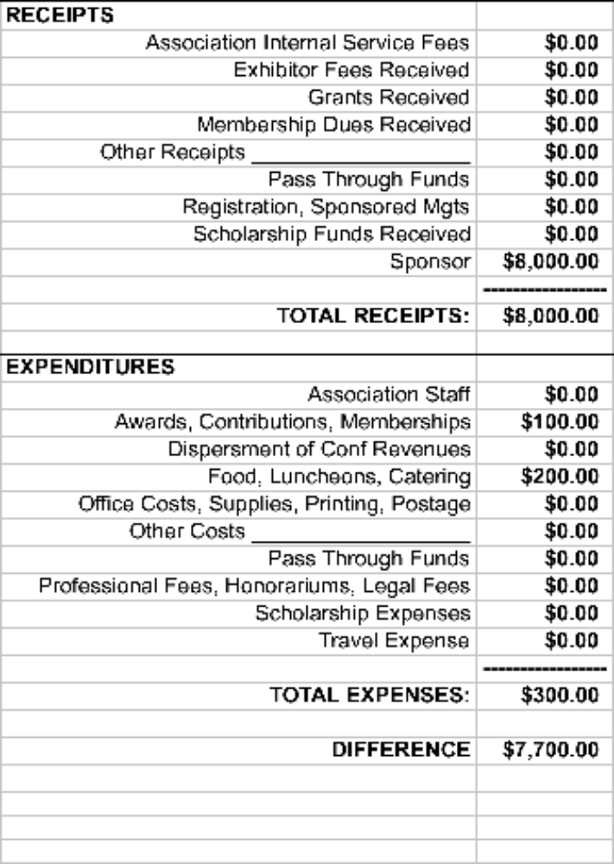

Sponsors – Annual goal for potential donors
Awards - Recognition awards for donors
Food – Lunch costs

Plans, Budget & Report – 2011
Executive Director

E. 3.1.
Develop Plan for Enhancing Advocacy Efforts

Planned Activities, Events, Goals, Outcomes

- Develop options for enhancing our advocacy efforts with Policy group
- Fully implement Convio’s MultiCenter online advocacy tools
- Provide administrative support for Convio systems
- Implement the Fundraising component of Convio’s online system, including the interface with UPHA’s Merchant Account.
- Choose 3-5 other organizations as prospective users of UPHA’s Convio advocacy tools

Association Year 2009-10 Annual Report

Budget: Association Year 2010-11 - (Excel Data Sheet)

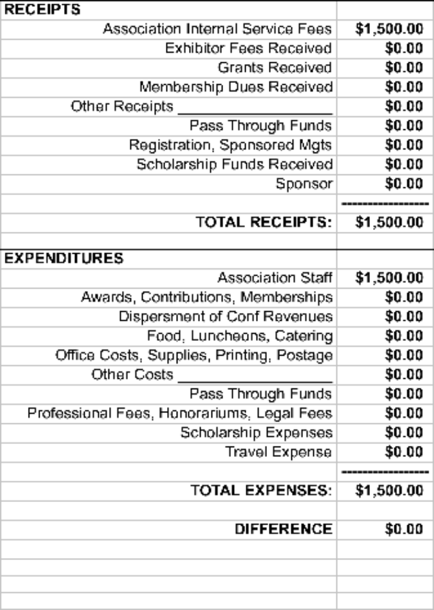

Internal Service Fund –Estimated amount needed to offset of Convio administration costs
Professional Fees – Cost of part-time interns on contract who will help set up and administer the Fundraising and ecommerce components of Convio.

Plans, Budget & Report – 2011
Executive Director

E. 6.1.
Organize Joint Leadership Council for
Utah's Public Health Organizations

E. 7.1.
Study Options for Representation on Other Boards

Planned Activities, Events, Goals, Outcomes

- As part of the Case for Support effort, identify other public health related organizations in Utah
- Identify resources and services these organizations could share with UPHA and other organizations (job boards, financial systems, tax exemptions, training events, advocacy tools, etc.)
- Develop options for coordination with other organizations, such as partnerships, alliances, affiliations, consortiums, cooperatives, joint councils, Central Resource Sharing, etc.
- Choose 2-5 organizations which are prospective Partner organizations which we will approach for discussion and consideration this year
- Identify possible pathways into each potential Partner organization
- Make contact with key possible Partner organization leadership and schedule lunch
- With pathway person, present Partner options on working together
- Accept response and thank for time and consideration
- Provide each organization which accepts proposals with promised follow up
- Develop joint statements and policies for cooperation between UPHA and other organizations
- Provide recognition awards / certificates / plaques to partnering organizations

Association Year 2009-10 Annual Report

Budget: Association Year 2010-11 - (Excel Data Sheet)

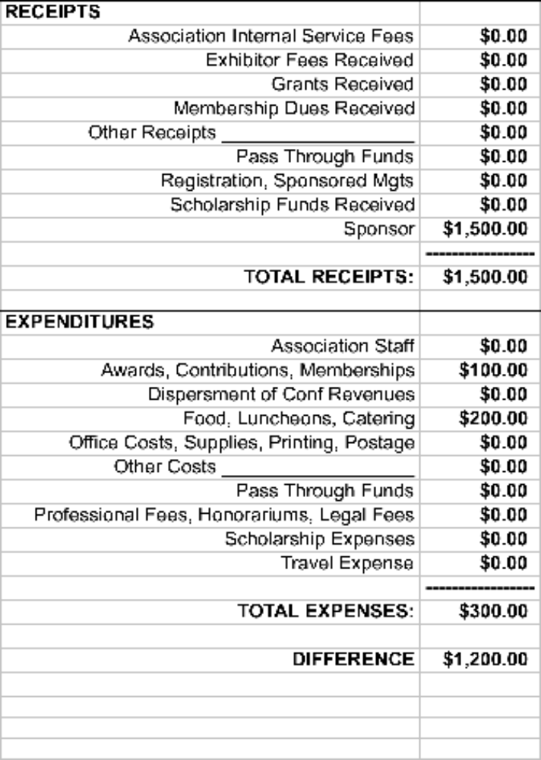

Sponsors – Estimated revenue from cooperating organizations
Awards - Recognition awards for donors
Food – Lunch costs

Plans, Budget & Report – 2011
Executive Director

Infrastructure:
Affiliate and Director Activities

Planned Activities, Events, Goals, Outcomes

The Executive Director and other Staff manage the Business Plans which includes infrastructure functions and resources of the Association, including:
  - General Association Administration – Which includes: salaries of staff, maintaining the Association’s office and related resources: physical office space and location, phone / fax, equipment, printing, AV equipment, mail management; managing Policies & Procedures, Position Descriptions, Conflict of Interest forms, physical and software inventory, intangible resource inventory (systems, copyright, etc.), legal and other professional support, requests for association support, and other administrative duties.
These services will be funded through an Administrative Indirect Rate of 10% applied against all Association revenue.
  - Provide Merchant Account Support – Which includes: payments to credit card companies, accounting for and allocating individual transactions to appropriate Association project or event, reviewing charges from credit card companies and First Data, new and enhanced financial and resource development systems such as Convio fundraising services, etc.
These services will be funded through a Transaction Fee of a $0.10 per transaction and 10% per total transaction amount processed from these services and charged back to projects and budgets which use these services.

  - Develop Systems and Maintain Information Technology – Which includes: Internet Service Provider (ISP), online databases, web resources, email addresses, technical assistance for IT resources, overall administration of Convio systems, ListServ, technical integration with Merchant Account, Administration and Human Services systems, new system design, programming, desktop publishing, etc.
These services will be funded through a rate of $30/hour charged back to projects and budgets using these services.
  - Human Resource Management System – Which includes: Association staff, interns, contracts, etc, and involves advertising positions, interviewing candidates, hiring, maintaining salary schedules, managing contracts, working with payroll vendor, assisting in performance plans and reviews, maintaining termination processes, keeping records, maintaining Job Board online, etc.
These services will be funded through a rate of $20/hour charged back to projects and budgets using these services.

Association Year 2009-10 Annual Report

Budget: Association Year 2010-11 - (Excel Data Sheet)

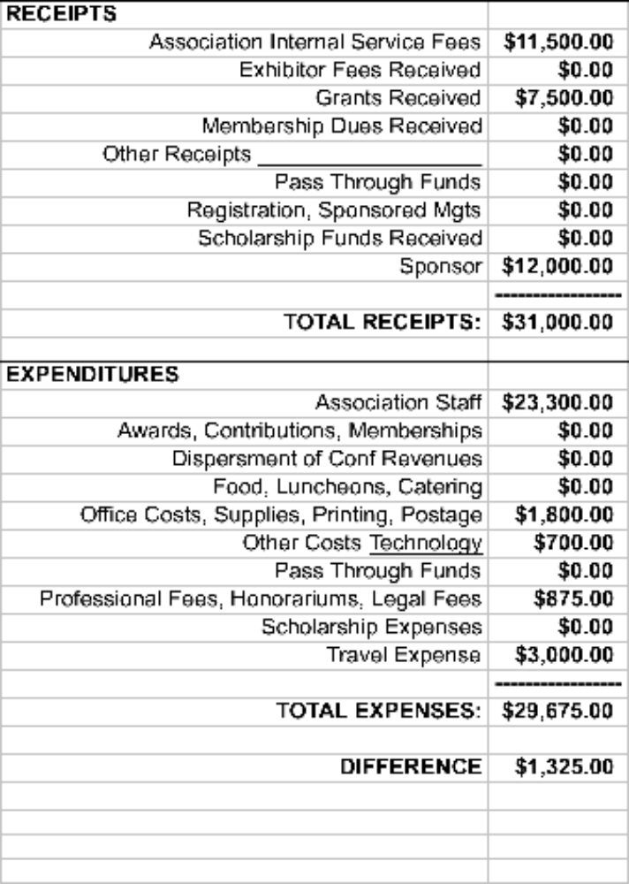

RECEIPTS:
Association Internal Service Fees –From services provided by the Executive Director – Conferences and meetings $5,000, Membership $500, Merchant and Convio $1,000, General assessment for office, etc $5,000
Grant –Affiliate Capacity Building Initiative (ACBI) Grant - APHA / Kellogg
Sponsors – Estimated revenue from cooperating organizations

EXPEDITURES:
Association Staff – (1) $20,000 - Executive Director (2) $3,000 - Other Staff (3) $300 Workers Comp, Unemployment and Liability Insurance
Office - (1) $1,400 - Rent, phone, fax, printing – UALHD; (2) First Data Merchant Account - $400
Other: Technology – (1) $300 – XMission ISP (2) $400 – Static IP and Secure Certificate
Professional – (1) $360 – PayChex payroll service (2) $15 State Business Registration (3) $500 Legal fees
Travel – Staff travel estimate

