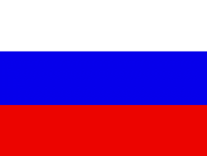


UNITED NATIONS MINISTRY OF NATURAL
INDUSTRIAL DEVELOPMENT RESOURCES
ORGANIZATION (UNIDO) AND ENVIRONMENT
MINISTRY OF HEALTH AND
SOCIAL DEVELOPMENT

AIDE-MEMOIRE

Regional EXPERT GROUP MEETING
(EGM)

on

ELIMINATION OF CFCs CONTAINED in AEROSOL mETERED DOSE INHALERS (MDI) IN THE COMMONWELATH OF INDEPENDENT STATES (cis)

4-5 OCTOBER, 2011

Moscow, Russian Federation

- Background

Asthma and chronic obstructive pulmonary disease (COPD) are the most common chronic diseases of the air passages (airways or bronchi) of the lung and are estimated to affect over 300 million people worldwide. COPD is a condition of narrowing and inflammation of the airways in conjunction with damage to the lung tissue (emphysema). COPD is caused primarily by cigarette smoking, but may result in part, from inhalation of certain occupational dusts or environmental air pollution. The prevalence of COPD in many developed countries is around 4-17 percent in the adult population aged over 40 years. Data are less certain in developing countries but it is estimated to be as high as 26 percent. An international study of asthma in childhood has shown a prevalence of asthma that varies from approximately 1 percent in some countries such as Indonesia to over 30 percent in the United Kingdom, New Zealand, and Australia.

The preferred method of drug therapy for asthma and COPD is by medications that are delivered to the airways by means of a hand held inhaler device. Meter Dose Inhaler (MDI) is a complex system designed to provide a fine mist of medicament, generally with an aerodynamic particle size less than 5 microns, for inhalation directly to the airways for the treatment of asthma and COPD. Historically the propellants used in MDIs are CFCs (CFC-12 and CFC-11, and sometimes CFC-114), and more recently HFC-134a and HFC-227ea (in the pharmaceutical sub-sector, HFC is referred to as HFA). The CFC-MDI technology was first introduced in 1956 by Riker Laboratories in the United States. Since then, the use of MDIs in the treatment of asthma and COPD has been gaining acceptance. In March 1995, the first HFA-based MDI for Salbutamol was introduced in the United Kingdom and in Europe in 1997. In 2000 the Chemical, Industrial and Pharmaceutical Laboratories (Cipla), India, launched the first CFC- free MDI inhalers, developed by a nationally-owned Article 5 party.

According to the International Pharmaceutical Aerosol Consortium (IPAC), approximately 50 per cent of the MDIs used worldwide were CFC-based. This situation is rapidly changing due to the Montreal Protocol, and it was expected that CFC-MDIs be substantially reduced in non-Article 5 Parties by the end of 2010. As of today, there is at least one non CFC-MDI (HFA) approved and marketed in more than 110 countries.

As early as the 8th Meeting (November 1996), the Parties to the Montreal Protocol began adopting decisions related to the MDIs. MOP decisions encouraged transition from the use of CFC based MDIs to non-CFC treatments for asthma and chronic obstructive pulmonary disease in order to ensure smooth and efficient transition, and protect the health and safety of patients. The MOP decision requested national authorities to expedite review of marketing/ licensing/pricing applications of non-CFC treatments of asthma and chronic obstructive pulmonary disease, in a manner that does not compromise patient health and safety.

The document (UNEP/OzL.Pro/ExCom /49/39) provided an overview of the situation and stated that MDIs are manufactured in 16 Article 5 Parties, with a total consumption of 1,875 metric tonnes of CFCs (equivalent to a production of over 75 million MDIs). About 68 per cent of this consumption (1,285 ODP tonnes) is by nationally owned manufacturing companies (equivalent to a production of some 51 million MDIs). All the MDI projects in Article 5 countries have been formulated by Implementing Agencies. UNIDO has already implemented MDI projects in Egypt, Iran and Mexico and is continuing the implementation of the MDI project in China. The last MDI project proposal has been formulated by UNIDO for the Russian Federation in September 2011 for the GEF funding. This EGM provides details on technology transfer to CFC-free MDIs in the region to all stakeholders in CISs. The representatives of the Ministries for Health of the CISs as well as representatives of pharmaceutical companies are invited to this regional EGM to get acquainted with new technologies and understand the national transition strategies in the region.

2. MDI manufacturing in CIS countries

There are no MDI producers in the CISs, except the two major MDI producers in the Russian Federation. There was MDI production in Charkov, the Ukraine, however, its production was ceased many years ago. No MDI manufacturing facilities are available in the CIS countries instead of the Russian Federation. However, there is still import of CFC based MDIs in the region. The local demand for Salbutamol in the CIS countries is covered mostly by imports from Poland, India and EU.

The two Russian enterprises supply Salbutamol to the Russian market, only one drug produced by these two local companies, which covered in 2009 83% of the total market. Salbutamol supplied by foreign companies Russia amounted to 17 %. The both companies have launched in 2009 the experimental batches of Beclamethasone, 99 doses, which could be produced in 2011 onwards. The cost of one can of Salbutamol is US$ 1.5 and this is the lowest cost worldwide. About 10% of Russian population are covered by this product. Primarily two Russian enterprises supply Salbutamol to the Russian market, the balance being supplied by imported product.

The both companies are still using CFCs for MDI production. The cost of CFCs is expected to go up, especially after 1 January 2010, CFC deadline target and as a result the cost of MDI products would be increasing. The quick conversion of MDI production facilities to the non-CFC MDl production at the both Russian companies would allow these producers to keep prices at affordable level for low-income population and thus facilitating access to vital medication for poor people in the Russian Federation. Thus, the conversion of the current CFC-based production lines is of strategic importance contributing to the protection of both, environment and population's health, in particular the millions of people suffering under respiratory diseases.

3. Import of MDIs into the Russian Federation

The Russian market was well represented by foreign pharmaceutical companies in 2010. The foreign MDI and DPIs were available on the Russian Market in the wide assortment at the unit price level:

- MDIs from 84 Rbl - 2,865 Rbl (US$ 2.80 – US$ 95.50)
- DPIs from 450 Rbl - 580 RBl (US$ 15.00 – USD$ 19.33).

It should be noticed that the portion of DPIs on the Russian market is very low and amounts only to 1%, which is 20 times lower than their portion on the EU market. In 2010 the State Register of Roszdravnadzor, Ministry of Health and Social Development registered 81 brand names of MDIs and DPIs and 28 international non-patented names of medicines for treatment of asthma. According to the Governmental statistics data of 2007-2010 on import of medical preparations 28 different medical preparations for asthma treatment (sprays, aerosols, suspensions for inhalation, etc.) including Salbutamol and Beclamethasone (the last one is not yet produced in the RF) were imported into the country. A number of companies recognised in the field of MDI manufacture, import MDIs into Russia, this includes Boehringer-Ingelheim (Germany), Chiesi Pharmaceutical (Italy) and TEVA (Ireland). The imported products include:
- Salbutamol
- Salbutamol (non-CFC)
- Beclamethasone Dipropionate
- Beclamethasone Dipropionate (non-CFC)
- Fenoterol hydrochloride.

Currently, ozone-friendly MDIs using the HFC-134a and absolute (anhydrous) ethanol, and also the HFC-227ea are manufactured by such firms as Chiesi, (Italy), Boehringer Ingelheim, Germany, Chipla, India, Orion, Finland, Teva, Ireland and others. As mentioned previously due to the higher costs of these imported products although they make up a minor share of the market by volume the percentage in terms of value is much more significant.

The table below captures the registered and market prices and market shares for both domestic and imported MDIs.
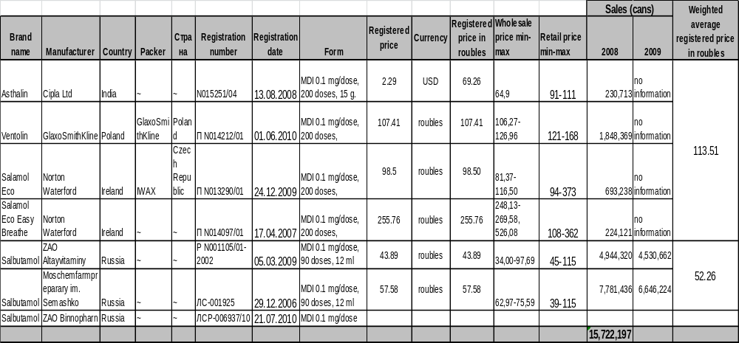

Unfortunately, there is no data available concerning MDI markets in other CIS countries. All MDIs are being imported in to the CIS countries except Russia where only the two producers fulfill the local market by 80%. However, taking into account the level of population in each country of the CIS and bearing in mind the MDI Salbutamol consumption in the RF, we can easily define the level of MDI demand as per the country. For example, the RF consumes about 10 million of locally-produced MDIs and about 2.0-3.0 million of imported ones. The Ukraine which has the level of population lower in 2.5 times than the RF, then the MDI demand could be at least 5.0 million of MDIs. Implementation of CFC conversion project in the RF allows the CISs not to import CFC-based MDIs. No considerable import of Salbutamol MDIs from the RF into other countries of the CISs. JSC Altayvitaminy is one of the MDI producers in the RF, however, its annual sales of Salbutamol to the CIS countries are very low (see Table below, in thousand pcs), in spite of the fact that the price for one unit is the cheapest among all other importers.

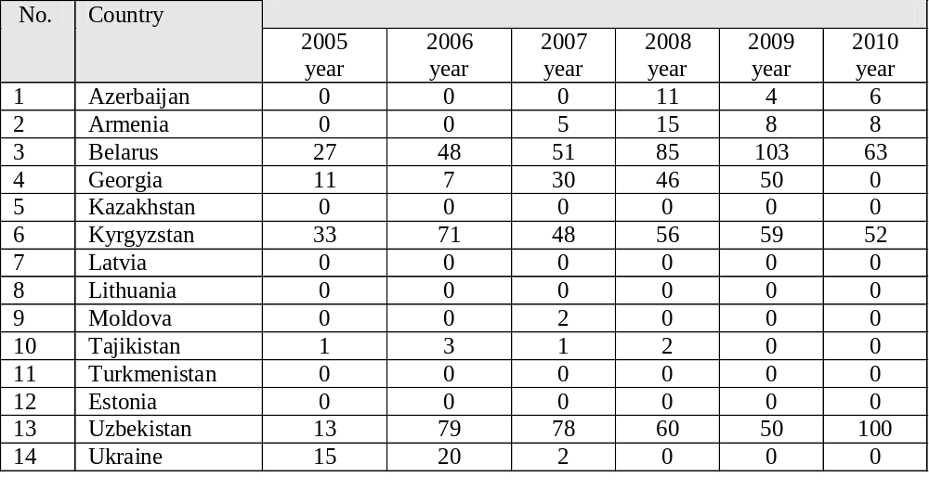

4. GEF/UNIDO Project in the Russian Federation on the total phase out of CFCs in the MDIs production

The Russian Federation has demonstrated a significant commitment to the elimination of the use of Ozone Depleting Substances (ODS) in a number of industrial sectors. With the assistance of significant grants from the Global Environmental Facility (GEF) and donor countries CFC manufacture has ceased in Russia and the use of CFC has been dramatically reduced. However the issues associated with the use of CFCs in MDIs were effectively deferred. It became evident that without some intervention in the form of financial assistance, it is most probable that the MDI projects would either continue to slip, or that the enterprises may be placed in a position where they have to consider ceasing manufacture of MDIs, as they are no longer commercially viable or the approved materials (CFCs) are no longer available.

A number of reasons for the slippage in the programme for the development of HFAs have been cited, including lack of funding from the procurement of equipment required to develop the new MDI formulations and lack of funding for the procurement of new industrial scale equipment to produce stability batches etc. Technical assistance need to be provided to convert the production of CFC metered-dose inhalers (MDIs) to ozone-friendly HFC-134a at the two local MDI producers in the RF. Due to the continuous increase in cost of CFC propellant as a result of the Montreal Protocol, which accounts for 30 – 40% of the total cost of the MDI, any further delay with this Project may have a negative impact on the costs of provision of medicine and hence Russian patients.

This Project is the GEF funding operation for complete CFC phase-out in Russia. It targets priority ODS consumption phase-out activities in the medical aerosol sector, along with the provision of a technical assistance at the government and enterprise levels. It is structured as a individual project for a total GEF grant, which amounts to US$ 2.55 million. The co-finance from the two sub-projects, i.e. JSC “Moschimpharmpreparaty” named after N.A.Semashko” and JSC “Altayvitaminy” is about US$ 10.0 million of local contribution.

This Project represents the first comprehensive international effort to consider the entire scope of work required to achieve complete CFC phase-out in the RF and minimize climate impact taking into consideration both the Montreal and Kyoto Protocols as well as National environmental policy and targets. The Project is aimed at achieving direct GHG emissions reduction through lower GWP of the new HFA propellant in comparison with GWP of CFCs used in the MDI production at the two Russian companies. This GHG emission reduction will be of approximately 1.7 MMT CO₂ equivalent in one year. Applying 10 allowable for calculation years under the CDM mechanism of the Kyoto Protocol, the GHG emission reduction will achieve the amount of 17 MMT CO₂ equivalent. As a result the CIS countries can import the HFA-based MDIs.

- Development of National Transitional Strategy in CISs.

Development of a national strategy for elimination of CFCs contained in MDIs has been recommended in decisions made during the Meeting of the Parties to the Montreal Protocol on the Substances that Deplete the Ozone Layer. These national strategies in CISs have to be prepared by Ministry of Health and Central Administration for Pharmaceutical Affairs.

The phase out of CFCs in MDIs is necessary because under Montreal Protocol the production and consumption of CFCs is now banned in the European community and throughout the whole world. However, developing countries may have a period under which the production and consumption of CFCs may continue to meet their basic domestic needs. Developing countries in principle have phased out these substances in 2010. Special use nominations are given to the countries, like Russia, China and Egypt, which are still using CFC for MDIs production till 2013.

Quantities of CFCs are still currently available in Europe for manufacture of some MDIs (not now for all drugs) and availability and use is controlled through the essential uses exemption procedures as well. This permits the continued production and use of CFCs for agreed essential uses where technical and economically feasible alternatives are not yet available. The treatment of asthma and COPD by MDIs containing CFCs was acknowledged as an essential use by the parties to the Montreal Protocol.

Suitable alternatives treatment systems, which have been internationally approved, include DPIs and MDIs with HFC (HFA) instead of CFC propellant. It has been noted that the patient perception of these systems is that they “differ” from the CFC MDI which has been replaced. Under the rules of the essential uses exemption, CFCs will no longer be authorized for products where acceptable alternatives are available.

The national strategies should include the dates of the final phase of CFCs in manufacture of MDIs or their imports into the particular CIS country. They need also to include governmental measures on transition to the new non-CFC MDIs.

Efforts should be made jointly by the Ministry of Health and Social Development (MHSD of Russia), physicians and nursing staff and all sectors linked to health. All these parties should understand that the transition is not optional and that, over the next two years, all patients currently using CFC-containing products in the CISs will have to change to CFC-free devices. They should be prepared to help patients to understand their reasons for the change and assist them during the transition.

Patients should be reassured that:
- The new inhaler is as safe and as effective as the previous ones.
- CFCs are damaging to the global environment but not damaging to the health of the individual.
- Although they will experience differences in appearance, dosage and taste, these do not imply any reduction in the effectiveness of the medicines.

Appropriate visual and written educational materials should be developed to foster this process and media should be used for their dissemination. Mass media can and must play a fundamental role in raising awareness. In RF, this is facilitated by an easy and broad access to mass media and a favorable attitude of their authorities. The relationship with educational authorities has proved to be highly positive for the development of health programmes. Primary and secondary schools are natural centres for raising awareness and disseminating information, both for children and adolescents and their families. Therefore the education plan should consider a close relationship with educational institutions.

The pharmaceutical industry in the CIS countries also plays a significant role in a successful implementation of the programme, not only by providing information through educational material and supporting scientific events intended for physicians, but also with dissemination of material for the general public. It is expected that the multi-national and domestic manufacturers, the funding from the multi–lateral fund and, to a lesser extent, the Ministry of Health and Social Development, RF will be the primary sources of funding of these initiatives. Activities will have to be scaled according to the funds available.

The Key elements of the National strategy will be as follows:

- To ensure that the health and safety of patients during the transition period will be safeguarded.
- To ensure that importers of CFC containing MDIs fully realize their obligations to withdraw such products from the CIS market, in a timely manner. The withdrawal to be conducted in a manner such as to manage the primary objectives of the national strategy.
- To ensure that any multi-national manufacturers of CFC containing MDIs in the CIS countries fully realize their obligations to withdraw such products from the CIS market, in a timely manner. The withdrawal to be conducted in a manner such as to manage the primary objectives of the national strategy.
- To encourage multi-national importers of inhalation products to CISs to support the patient awareness/ education programme, either directly or indirectly.
- To develop an educational training package to facilitate communication with patients and allow the roll out of training to a local level.
- To oversee the roll out of training initiatives to ensure that individuals in direct contact with patients receive both training and adequate supporting materials to support patient awareness.
- To generate suitable awareness enhancing media (posters, leaflets etc.) for location in environments to support patient awareness (hospitals, clinics, surgeries etc.)
- To actively promote via appropriate media (advertising, conferences, interviews etc.) awareness of the implications of the transition.
- To ensure that the nomination, approvals and licensing systems will be operated with efficiency, consistency and transparency.
- To ensure the effective de-commissioning of CFC manufacturing equipment and elimination of any residual stocks of CFCs (responsibility of the Ministry of Natural Resources and Environment, RF).

The following criteria must be met before the phase-out of a CFC MDIs in the CISs:

- Any new CFC free inhaler is at least as safe as the previous ones.
- Any new CFC free inhaler is as effective as the previous inhaler it is intended to replace.
- There should be sufficient quantities of the alternative(s) available to assure an uninterrupted supply of medication;
- Post-marketing surveillance data must confirm the safety of the alternative product(s);
- There should be sufficient types of alternatives available to meet the needs of different patient sub-groups;

6. Objectives of the EGM

- The main objective of this Regional meeting is to advise on the development of main components of a local transition strategy for non-CFC-MDIs as per each country of the CISs. The strategy will address the needs of both manufacturing and consumption countries. It would also address issues of interests and welfare of all patients in the CIS during and after the transition process.
- Explore specific activities that are proven to be technically viable and economically feasible that could be implemented in the shortest possible period of time to achieve the greatest reduction in consumption of CFCs in the CISs; through appropriate technology transfer, to phase-out the consumption of 212 ODP tones of CFC-11 and CFC- 12 (2010) used in the manufacture of MDIs in the Russian Federation;
- To manage the transition from CFC-based MDIs to CFC-free MDIs in all the countries in the CISs. The primary objective is the direct phase-out of 212 ODP tonnes of CFCs (2010) in the medical aerosol sector in the Russian Federation, and as a secondary objective to reduce future GHG emissions by approx. 2.0 MMT CO₂ t/equivalent by introducing, through technology transfer a lower GHG propellant, HFC-134a.

This regional EGM will also address the technical requirements for conversion of manufacturing facilities currently using CFCs to manufacture MDIs to one only using HFC-134a at the two Russian MDI-producing enterprises and discuss national transitional strategies in the region. Some prerequisites can be discussed to gradual transfer from HFA production of MDIs to DPIs production and their import into the CIS countries in the future. Manufacturers of the alternative(s) will be requested to confirm that they can adequately supply the Russian market and to provide information on the production capacity of their manufacturing facilities and on the measures they intend to put in place to ensure the supply of the CIS market.

UNIDO’s experience in environmental awareness, technology promotion and transfer, cleaner technology, environmental and quality management and in the phasing out of banned materials and chemicals can be efficiently leveraged and applied to the goal of eliminating the emission of ODS. The phase-out of ODS in the MDI sector in the RF has involved a number of sizeable investments. Therefore, UNIDO, Ministry of Natural Resources and Environment of the Russian Federation and Ministry of Health and Social Development of the Russian Federation have decided to provide effective assistance to the two Russian MDIs producers as well as all doctors and medical personal of clinics and hospitals.

7. Expected Results

- Develop key components of possible national transition strategies for MDIs in the CIS countries in the region.
- Ensure that a dissemination and outreach strategy is developed to inform the health professionals and patients in the region of all relevant issues before and after the transition while maintaining the interests and welfare of all patients in the region during and after the transition process;
- Explore relevant policies for governments and industries, of the countries in the region, that do not have a policy for smooth transition to non-CFC treatments and strengthen the legislative framework of the countries that already have such regulations and learn from their experiences;
- Agree on a consistent reduction timetable, for the import and production of CFC-MDIs within the region in a way that does not pose difficulties for the countries to comply with Montreal Protocol obligations. Initiate work on developing a database of MDI Grade CFC Manufacturers (and quantities to be produced till 2013) in the region;
- Use the regional, bilateral and sub-regional group discussion to gain experience of the region to assist the countries already having difficulties or at risk of non-compliance or potential noncompliance within the region;
- Develop a framework to monitor import/export and consumption of CFC-MDIs within the region following the Informal Prior Informed Consent Approach;
- A partnership with WHO and IPAC for the region could be explored by inviting these organizations. A public-private partnership with manufacturing companies could be explored.

8. Organisers
The Ministry of Natural Resources and Environment, the Ministry of Health and Social Development and UNIDO will co-host the MDI EGM, which will take place in the International Centre for Scientific and Technical Information, which is situated on Kuusinena street, 21B, Moscow (Международного центра научной и технической информации, расположенного по адресу: г. Москва, ул. Куусинена, д. 21Б.) from 4-5 October 2011.
For registration and all technical and organizational aspects of the EGM, please contact:

Mr. Alexander Lubeshkin
UNIDO/GEF Project National Coordinator
Phone: +7 985 765 45 67
E-mail: ael@adv2adv.ru

Ms. Maria Fomicheva
National Manager
Phone: +7 925 828 80 09
Email: m.fomicheva@unido.org

Mr. Arthem Kushnerev
UNIDO/GEF Project National Consultant
Phone: +7 916 619 06 96
E-mail: arthem@mail.ru

Mr. Yury Sorokin
Project Manager, UNIDO, Vienna
Phone: 43-1-26026-3624
Fax: 43-1-26026-6804
Email: y.sorokin@unido.org

Ms. Maria Volosatova
Head of the Section of Climate and Atmospheric Air of the Department of State Policy and Regulation in Hydrometeorology and Environmental Monitoring of Ministry of Natural Resources and Environment of the Russian Federation
Phone: +7 499 254 60 11
Fax: +7 499 252 67 47
Email: mpv@mnr.gov.ru

Ms. Alla Trapkova
Deputy to Head of Department
Roszdravnadzor, Ministry of Health and Social Development of the Russian Federation
Phone: +7 (495) 625 32 50

9. Participants

The meeting will be attended by health professionals from the Ministries of Health of the CIS countries, ozone officers and representatives from pharmaceutical companies from the region. Representatives of MDI importers and MDI distributors at the national level in GISs, as well as from the Implementing Agency -UNIDO, and resource persons from relevant fields are also invited. About 50 people.

10. Work programme
The provisional agenda is attached as Annex 1.

11. Format of the EGM

There will be presentations focused on the areas of interest listed above, together with ample time for discussion and questions. At the end of the second day of the EGM a roundtable discussion can be organized to focuse on four areas of interest listed above. For the roundtable, panelists will briefly present their experience and views on the above questions.

12. Language
The EGM will be conducted in Russian and English. There will be simultaneous translation facilities.

13. Travel arrangements and Financial Arrangements
Participants are requested to book hotel at their own cost and in due time. The list of hotels near to the International Centre for Scientific and Technical Information and useful information is attached. The participants have to provide air or train tickets at their own cost.
Annex 1

Regional EXPERT GROUP MEETING (EGM)
ON DEVELOPMENT OF NATIONAL STRATEGIES
FOR ELIMINATION OF CFCs CONTAINED in AEROSOL mETERED DOSE INHALERS (MDIs) IN THE COMMONWELATH OF INDEPENDENT STATES (cis)

4-5 October 2011, Moscow, Russian Federation
International Centre for Scientific and Technical Information, Kuusinena str., 21B, Moscow

Organised by
Ministry of natural Resources and environment OF THE RUSSIAN FEDERATION
MINISTRY OF HEALTH AND SOCIAL DEVELOPMENT OF THE RUSSIAN FEDERATION

on behalf of

United nations Industrial development organization (UNIDO)

with assistance from

RosZdravnadZor

EGM objectives:

Only one viable option has emerged and is being discovered to substitute Ozone Depleting Substances –CFCs in the production of MDIs in various consuming industries. This is a new propellant, HFC-134a. New MDIs products will emerge on markets in CIS Countries. All problems associated with the replacement of old type MDIs with new non-CFC based MDIs either by manufacture or by replacement of CFC-based MDIs with new ones in the markets of the CIS countries need to be carefully considered in the present EGM by all stakeholders including those representatives from the CISs, who after return home are obliged to bring to attention of all stack-holders, doctors, physicians, medical sisters and patients the particulars of new MDIs to be available on their local markets.

Objectives

- The main objective of this regional meeting is to advise on the development of main components of a local transition strategy for non CFC-MDIs as per each country of the CISs. The strategy will address the needs of both manufacturing and consumption countries. It would also address issues of interests and welfare of all patients in the CIS during and after the transition process.

- Explore specific activities that are proven to be technically viable and economically feasible that could be implemented in the shortest possible period of time to achieve the greatest reduction in consumption of CFCs in the CISs; through appropriate technology transfer, to phase-out the consumption of 212 ODP tones of CFC-11 and CFC- 12 (2010) used in the manufacture of Aerosol Metered-Dose Inhalers (MDIs) in the Russian Federation (RF);

- To manage the transition from imported CFC- based MDIs to CFC-free MDIs in all the countries in the CISs. The primary objective will be also the direct phase out of 212 ODP tonnes of CFCs (2010) in the medical aerosol sector in the Russian Federation.

This regional EGM will also address the technical requirements for conversion of manufacturing facilities currently using CFCs to manufacture MDIs to one only using HFC-134a at the two Russian enterprises and discuss national transitional strategies in the region. Some prerequisites can be discussed to gradual transfer from HFA production of pMDIs to Dry Powder Inhalers (DPI) production and their import into the CIS countries in the future. Manufacturers of the alternative(s) will be requested to confirm that they can adequately supply the Russian market and to provide information on the production capacity of their manufacturing facilities and on the measures they intend to put in place to ensure the supply of the CIS market.

UNIDO’s experience in environmental awareness, technology promotion and transfer, cleaner technology, environmental and quality management and in the phasing out of banned materials and chemicals can be efficiently leveraged and applied to the goal of eliminating the emission of ozone depleting substances.

The Venue:

UNIDO office in Moscow together with Roszdravnadzor will make necessary arrangements to conduct the EGM in Moscow on 4-5 October 2011 in the International Centre for Scientific and Technical Information, Kuusinena street, 21B, Moscow (Международного центра научной и технической информации, расположенного по адресу: г. Москва, ул. Куусинена, д. 21Б.)
Information

1. Official Languages:
Russian, English

2. Time zone:
MSD (UTC+3, summer UTC+4)

3. Useful telephone numbers:
Fire - 01
Police - 02
Medical Care - 03

4. Currency/Currency Exchange/ Credit Cards
National monetary unit of the Russian Federation is Rouble. Credit cards are accepted for payment in banks, first-rate hotels, tourist agencies and major shop. Rate of currency exchange to Roubles is inquired in a bank.
The additional information about exchange rates can found at:
http://www.cbr.ru/currency_base/monthly.aspx
Don’t exchange money in airport (poor exchange rate). It is better to use ITM.

5. Calls:
For calling to Moscow first dial code (+7495) or (+7499) and then subscriber’s number.
For long-distance calls from Moscow to another city dial code 8+tone signal+city code. For international calls dial code 8+tone signal+10+country code (from hotel rooms or from municipal pay phones) or follow directions given on phone cards.

6. Transportation:
From airport
By taxi.
By train ( aeroexpress).
http://www.aeroexpress.ru/en/
Taxi
Taxi may be ordered by phone. It is recommended to use official taxi cabs belonging to first-rate companies and having special identification symbols.
International Airport offers official taxi service. Taxi can be ordered at the operator desk in all airport terminals. For safety reasons please use only Official taxis.
For payments are accepted (airport taxi):
- Rubles;
- Credit cards of key payment systems except American Express credit cards.
Public transport
Moscow employs public conveyances network including Metro, buses, trolley buses, trams.
Metro
Tickets are sold in the metro at the cashier.
Buses, trolley buses, trams
Tickets are sold in the transport from the driver and at kiosks at the bus stops.
7. Tips:
Usual tip is 5-10% of the total order value.

8. Electric Appliances
Mains voltage in the Russian Federation is 220V/50Hz. Euro sockets are in use.

9. Hotels:
We may recommend you the following hotels in Moscow. They are located not far from the place of meeting, and also not far from the center of Moscow.
Hotels and rates for hotels in Moscow, during the period 03.10.11-06.10.11:

1) Hotel Plaza Kassado
http://www.kassado-plaza.com/
The cost of living in a standard room (with 2 single beds) with breakfast = 7030rub/day.
The cost of living in a standard room (with 2 single beds) for a single person with breakfast = 6530rub/day.

2) Hotel Art Hotel
http://www.arthotel.ru/
The cost of living in a standard room (with 2 single beds) with breakfast = 7000rub/day.
The cost of living in a standard room (with 2 single beds) for a single person with breakfast = 6100rub/day.

3) Boutique Hotel Max
http://www.hotelbutik-max.ru/
The cost of living in a standard room with breakfast = 5850rub/day.
The cost of living in a standard nomeredlya per person with breakfast = 5850rub/day.

For more information, please contact the agency directly.

Makeyeva Olesya
Manager
Merit Travel Agency
www.merit-travel.ru
alisa@merit-travel.org
tel.: + 7 495 623 99 80;.
tel./fax: + 7 495 621 56 17.
Address: 107031 KuznetskiyBridge 19, building 1, entrance 5, office 19

Or you could use the following links for hotel bookings:

http://www.hotelscombined.com/

http://www.booking.com/

UNIDO office in Moscow, Venue.

Address: UL. Kuusinena, 21B

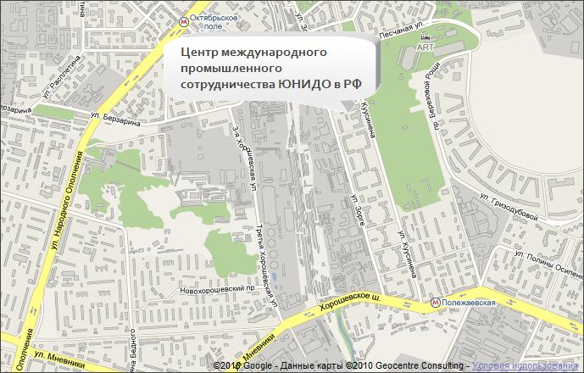
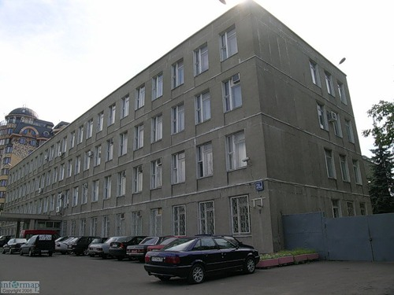

Public transport:

Metro station "Polezhaevskaya" Trolleybuses №43 or №65 and №48 bus. 3rd stop, other side off the road and go ahead approx. 150 metres.

Badge to enter the building will be at the guards’ office.

Regional EXPERT GROUP MEETING (eGM)
on
DEVELOPMENT OF NATIONAL STRATEGIES FOR ELIMINATION OF CFCs CONTAINED in AEROSOL mETERED DOSE INHALERS (MDI) IN THE COMMONWELATH OF INDEPENDENT STATES (cis)

WORK PROGRAMME

International Centre for Scientific and Technical Information, Moscow,
4-5 October 2011

Day 1
9:00 Registration

10:00 Morning session

- Opening statement, Deputy to Minister, Ministry of Health and Social Development of the Russian Federation, Moscow
- Opening statement, Mr. Yuri Sorokin, Industrial Development Officer, UNIDO

Plenary session

- Legal framework of Montreal Protocol, Mr. Vassily Tselikov, National Expert, UNIDO
- Establishment of the state system for regulation of turnover of ozone-depleting substances and products containing them within the territory of the Russian Federation, Ms. Marya Volosatova, Head of the Section of Climate and Atmospheric Air of the Department of State Policy and Regulation in Hydrometeorology and Environmental Monitoring of Ministry of Natural Resources and Environment of the Russian Federation
- Production and import of MDIs in the Russian Federation , representatives of JSC Altayvitaminy and JSC Moschimpharmpeparaty. The speaker's name to be announced later.
- State Drug Quality Control System, Drug Quality Specifications for Metered-Dose Inhalers and Their Components, Ms. Alla Trapkova, Deputy Head of the Department for the Organization of State Quality Control for Health Care Products
- National Transitional Strategy to replace CFC-based MDIs with HFA MDIs in the Common wealth of Independent States, Mr. Paul Krajnik, Industrial Development Officer, UNIDO

Coffee break

● GEF/UNIDO Project - Phase-out of CFC consumption in the Manufacture of Aerosol Metered Dose Inhalers (MDIs) in the Russian Federation, Mr. Victor Shatrauka, UNIDO Consultant
- Conversion to non-CFC production of MDIs at JSC Moschimpharmpreparaty, Mr. Oleg Sorokin, Production Manager, JSC Moschimpharmpreparaty
- Conversion to non-CFC production of MDIs at JSC Altayvitaminy, Mr. Alexey Zalesov, Expert, JSC Altavitaminy

Lunch break

Afternoon session

● Viable alternatives to conversion to non-CFC MDI, problems associated with conversion to HFA at two Russian enterprises, Mr.Victor Shatrauka, UNIDO consultant
● Physical and chemical testing methods validation in Metered Dose Inhaler production and development, Dr. Gyula Kortvelyessy, UNIDO Consultant
● Problems of ODS-containing drug turnover in the Kyrgyz Republic, Mr. Djanyl Djusupova, First Deputy Director General of the Department of Drug Provision and Medical Equipment of the Ministry of Public Health of the Kyrgyz Republic
● MDI in Kazahstan, Ms. Alieva Dinara, Chief expert of the Management of Chemical and Drug Industry of the Industrial Committee of the Ministry of Industry and Innovative Technologies of the Republic of Kazakhstan
- Specifics of registration of new MDI in the Russian Federation, Ms. Alla Sheshukova, Assistant of the Department of State Control for Drug Circulation of the Ministry of Public Health and Social Development of the Russian Federation
- Technical requirements to Good Manufacturing Practices (GMP) by manufacture of MDIs, Dr. Gyula Kortvelyessy, UNIDO Consultant
- Asthma and COPD in the Russian Federation: demand for new MDIs, Lung Association, the speaker's name to be announced later.

Day 2

9:00 Morning session

- CFC to HFA can technology: from safe containment to effective drug delivery, Mr. Richard Turner, Business Development Director, Presspart, UK
- UNIDO MDIs development projects. The V.A.R.I. &Co’s prespective over successfully completed programmes, Mr. Gabriele Marchetti, Quality Director, VARI, Italy
● Particulars of filling machines design and production, Mr. Urs Hauser, Sales Manager, Pamasol, Switzerland
- Supply of HFA pharmaceutical grade to the production enterprises, Dr. Tim Noakes, Commercial manager, Mexichem, Ltd., UK.

Coffee break

● HFA pMDI Technologies, Mr. Joy Bogaita , Technical Director, Bespak, UK
● Metering valves for HFA formulations - Factors to Consider, Mr. Chris Baron, Aptar Pharma, Associate Director, Business Development: Asthma & COPD, France
- Preparation of the Master Validity Plan, Mr. Oleg Sorokin, Production Manager, JSC Moschimpharmpreparaty

Lunch break

Afternoon session

- Dry Powder Inhalers: comparison, cost, therapeutical effect, tendency, Lung Association, the speaker's name to be announced later.
- Marketing and Business opportunities for new MDIs in Commonwealth of Independent States, Representatives of JSC Altayvitaminy. and JSC Moschimpharmpreparaty. The speaker's name to be announced later.

Round table discussions:

● Obstacles in the ODS phase-out process in the MDI sector and how to overcome them.
● Technical solutions to substitute ODS the two industrial units in the Russian Federation, i.e. JSC Altayvitaminy and JSC Moschimpharmpreparaty.
● Problems associated with replacement of old MDIs in the Russian Federation and CISs.
● National Transitional Strategies in the CIS countries

Closure of the EGM

