NOVEMBER 2013

National Bank of Rwanda

FINANCIAL STABILITY REPORT
2012 – 2013



Contents
Figures iii
Tables iv
Appendices v
Acronyms vi
Foreword 1
Macroeconomic and financial environment 3
Global economic growth 3
Global terms of trade 6
Global financial conditions 8
Developments in the East Africa region 10
Impact of global macro-financial conditions on Rwanda’s financial system 12
Domestic Macro-economic developments 13
Real GDP growth rate 13
Budget deficit to GDP ratio 13
Annual average inflation rate 14
Financial stability developments and trends 15
Structure of the Rwanda’s financial system 15
Banking system 16
Microfinance institutions 16
Insurance and pension companies 17
Financial Market 17
Cross-sector Linkages in the Rwanda’s financial sector 18
Inter-linkages among the Financial Institutions 18
Linkages with banks 19
Linkage between Financial Intermediaries and the Government 20
Financial soundness analysis 21
Performance indicators in the banking sector 21
Performance indicators in the Microfinance sector 29
Performance indicators in insurance sector 31
Performance indicators in Pension funds 35
Infrastructure development 36
Developments in payment systems 36
Financial system resilience 40
Stress testing results 40
The outlook for Rwandan financial stability 44
Appendices 45
References 55

Figures
Figure 1 Global GDP growth 3
Figure 2 Equity markets (2007=100; national currency) 8
Figure 3 Government bond yields (percent) 9
Figure 4 Net Capital flows to Emerging markets 10
Figure 5 Interest rate spreads (basis points) 10
Figure 6 Market share in the financial system 16
Figure 7 RSE transactions (in millions) 18
Figure 8 Growth of assets and liabilities (share of total growth) 22
Figure 9 Selected indicators of Capital Adequacy as at June 2013 23
Figure 10 Selected indicators of Assets Quality as at June 2013 24
Figure 11 Large exposure to gross loans as at June 2013 26
Figure 12 Selected indicators of profitability (in percent) 27
Figure 13 Liquidity position as at 30th June 2013 27
Figure 14 Exchange rate trends 28
Figure 15 Capital adequacy ratios for MFIs 29
Figure 16 Selected indicators of assets quality 30
Figure 17 ROE & ROA for MFIs 30
Figure 18 Liquidity ratio 31
Figure 19 Selected indicators of capital adequacy 32
Figure 20 Asset quality ratios for Insurance sector 33
Figure 21 Retention ratio for insurance sector 34
Figure 22 Earnings and profitability for insurance sector 34
Figure 23 Quick ratio for insurance sector 35

Tables

Table 1 Global economic growth and projections (in percent) 4
Table 2 Global inflation developments (in percent) 6
Table 3 World trade developments (annual percent change) 7
Table 4 Annual inflation in EAC Countries (in percent) 11
Table 5 Rwanda real GDP growth rate 13
Table 6 Major Balance of Payment components developments (in USD millions) 14
Table 7 Annual headline inflation (in percent change) 14
Table 8 Stage of development in domestic financial markets (Outstanding Amount in Millions of RWF) 17
Table 9 Linkages among banks 19
Table 10: Linkage between financial intermediaries and the Government 20
Table 11: The level of outstanding loans by Sector as at June 2013 25
Table 12 Pension sector performance indicators 36
Table 13: Basic payment indicators as at end June 2013 37
Table 14 Transactions settled through RIPPS as at June 2013 38
Table 15 Evolution of card based payments as at end June 2013 39

Appendices

Appendix 1 Financial soundness indicators (FSIs) in EAC countries as at 31 December 2012 (in percent) 45
Appendix 2 Financial soundness indicators (FSIs) as at 30th June 2013 47
Appendix 3 Balance sheets as at 30th June 2013 (in billions of RWF) 49
Appendix 4 Income statements as at 30th June 2013 (in billions of RWF) 52

Acronyms
ACH : Automated Clearing House  AFF : Access to Finance Forum  ASEAN : Association of Southeast Asian Nations  ATM : Automatic Teller Machine  ATS : Automated Transfer System  BCP : Basel Core Principles  BNR : National Bank of Rwanda  CAR : Capital Adequacy Ratio  CDS : Credit Default Swap  CRB : Credit Reference Bureau  CSD : Central Security Depository  CSR : Caisse Sociale du Rwanda  EAC : East African Community  EBA : European Banking Authority  ECB : European Central Bank  FSAP : Financial Sector Assessment Program  FX : Foreign Exchange  GDP : Gross Domestic Product  GFSR : Global Financial Stability Report  ICP : Insurance Core Principles  IMF : International Monetary Fund  NOP : Net Open Position  NPL : Non-Performing Loan  NSSF : National Social Security Fund | POS : Point of Sale  RAMA : La Rwandaise d’Assurance Maladie  RIPPS : Rwanda Integrated Payment Processing System  ROA : Return on Assets  ROE : Return on Equity  RSE : Rwanda Stock Exchange  RSSB : Rwanda Social Security Board  RSSP : Rural Sector Support Program  RTGS : Real Time Gross Settlement System  RWA : Risk Weighted Assets  SACCO : Savings And Credit Co-operative  SME : Small and Medium Enterprise  SMP : Security Market Program  STP : Straight-Through Processing  USA : United States of America  WEO : World Economic Outlook

Foreword

One of the mandates of the National Bank of Rwanda (BNR) is to maintain financial system stability with a view to encouraging and promoting the development of the productive resources of Rwanda. A stable financial system is one which creates a favourable environment for savers and investors, encourages efficient financial intermediation and the effective functioning of markets, and hence, promotes investment and economic growth. The financial stability analysis carried out by BNR involves continuous assessment of potential systemic risks to the Rwandan financial system and the development of policies to mitigate those risks.

This BNR’s Financial Stability Report (FSR) is the second of its annual FSR series released around October each year. The report which focuses mainly on the 2012-2013 period ending June 2013, analyses the performance and condition of the Rwandan financial system comprising of banks, insurance and pension companies, and Microfinance institutions. It also gives update on financial markets and payment systems developments. The data used for the analysis are companies’ audited financial statements as of end June 2013.

During the year July 2012 – June 2013, Rwanda has achieved high growth and macroeconomic stability despite a challenging international and regional economic environment. The banking system registered continuous growth in assets and was in a financially sound condition with a capital adequacy ratio of 23.1 percent as of June 2013, far higher than the statutory minimum of 15 percent.

In terms of growth, the microfinance industry recorded a positive performance during the last year with an increase of 28.7% of assets end June 2013 compared to end June 2012. UMURENGE SACCOs continued to play key role in the expansion of Microfinance sector’s balance sheet and financial inclusion.

Over the year 2012/2013, the insurance sector performance improved progressively. The total assets increased by 24 percent end June 2013 compared to end June 2012 and total capital increased by 43 percent for the same period. The gross premiums, net profit, and liquidity position also recorded a positive growth over the year.

The public pension sector assets continued to grow with a positive trend of 28 percent end June 2013 compared to end June 2012. Positive prospects are expected after the enactment of the new pension law that will give rise to the establishment of private pension schemes.

Overall, the Rwandan financial system continued to be sustained and resilient to different shocks due to the strong regulatory framework followed by prudential policies and regular supervision. The prudential indicators and stress testing results suggest that the Rwandan financial system is sound and stable. Nevertheless, the National Bank of Rwanda is committed to continue monitoring potential systemic risks which may rise and to foster competition, efficiency and growth of the financial system. Furthermore, the BNR will ensure that cost effective services are provided and financial inclusion promoted as an important success factor to poverty reduction.

John RWANGOMBWA
Governor

Macroeconomic and financial environment

Global financial and market conditions have improved appreciably, providing additional support to the economy. These favorable conditions reflect a combination of deeper policy commitments, renewed monetary stimulus, and continued liquidity support. However, as global economic conditions remain subdued, the improvement in financial conditions can only be sustained through further policy actions that address underlying stability risks and promote continued economic recovery. Global financial stability continued to be threatened by the prevailing Europe debt crisis, and the associated stresses in the euro area banking system. Although growth in East Africa downgraded, the European crisis and global economic conditions haves not yet created disruptions to the region’s financial system.

Global economic growth

Global growth is projected to remain subdued due to a large extent by appreciably weaker domestic demand and slower growth in several key emerging market economies, as well as by a more protracted recession in the euro area. Global GDP growth stood at an annualized rate of 3.1 percent end 2012 decelerating from 3.9 percent in 2011.
Figure 1 Global GDP growth
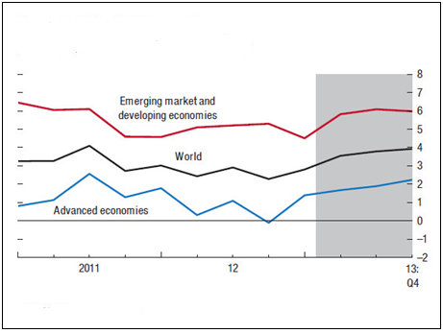
According to the IMF World Economic Outlook (WEO), global output is projected to 3.1 percent in 2013, the same as in 2012. In emerging and developing countries economic activity is forecasted to attain 5.0% in 2013 from 4.9% in 2012 while in developed economies it is expected to increase by 1.2% in 2013, the same rate as in 2012.
Source: IMF World Economic Outlook Update, July 2013
According to the IMF (WEO Updates, July 2013), weaker growth prospects and new risks raise new challenges to global growth and employment, and global rebalancing. Policymakers everywhere need to increase efforts to ensure robust growth. Potential adverse side effects should be contained with regulatory and macro-prudential policies.

Table 1 Global economic growth and projections (in percent)
 |  |  | Projections
 | 2011 | 2012 | 2013 | 2014
World Output | 3.9 | 3.1 | 3.1 | 3.8
Advanced Economies | 1.7 | 1.2 | 1.2 | 2.1
United States | 1.8 | 2.2 | 1.7 | 2.7
Euro Area | 1.5 | –0.6 | –0.6 | 0.9
Japan | –0.6 | 1.9 | 2.0 | 1.2
United Kingdom | 1.0 | 0.3 | 0.9 | 1.5
Canada | 2.5 | 1.7 | 1.7 | 2.2
Other Advanced economies | 3.3 | 1.8 | 2.3 | 3.3
Emerging and Developing Economies | 6.2 | 4.9 | 5.0 | 5.4
Central and Eastern Europe | 5.4 | 1.4 | 2.2 | 2.8
Commonwealth of Independent States | 4.8 | 3.4 | 2.8 | 3.6
Developing Asia | 7.8 | 6.5 | 6.9 | 7.0
Latin America and the Caribbean | 4.6 | 3.0 | 3.0 | 3.4
Middle East and North Africa (MENA) | 3.9 | 4.4 | 3.1 | 3.7
Sub-Saharan Africa | 5.4 | 4.9 | 5.1 | 5.9
Source: IMF, World Economic Outlook Update, July 2013

In USA, the economic recovery remained fragile in the aftermath of the global financial crisis but underlying economic conditions kept on improving. Real GDP growth is expected to slow to 1.7% in 2013 after 2.2% in 2012 dampened mainly by the fiscal contraction and a weak global environment. Economic growth rose by 1.7% in the second quarter 2013 as the federal spending cut was lower for this quarter than previously from 1.1% in the first 2013.

In the Euro Area, the economy is still constrained by continuing debt crisis together with weak domestic and external demand and weak credit markets. The economic activity is projected to contract again by 0.6% in 2013, the same level as in 2012 and should recover gradually in late 2014. In line with these projections, after an annual decline of 1.0% in the last quarter 2012, real GDP continued to contract consecutively by 1.1% and 0.9% in the first and second quarter 2013.

In Japan, following a growth of 1.9% in 2012, economic activity is projected to increase by 2.0% in 2013 supported by strong private consumption and net exports resulting from accommodative monetary policy, fiscal stimulus and structural reforms. On quarterly basis, real GDP grew by 4.1% in the first quarter 2013 and came to 2.9% in the second quarter 2013.

In emerging and developing countries, the economy continued to recover helped by developing Asian countries whose economy is expected to grow by 6.9% in 2013 from 6.5% in 2012 driven by good performance in China and India. China’s economic growth in the first and second quarter 2013 was 7.7% and 7.6% respectively, while the real GDP in India is estimated to grow by 5.1% in the second quarter 2013 from 4.8% in the first quarter 2013. According to IMF forecasts in July 2013, economic growth in 2013 is expected at 5.6% and 7.8% in India and China respectively.

In Sub-Saharan Africa, backed by improved economic policies and strong investments, economic activity remained quite dynamic and estimated at 4.9% in 2012 while projected to grow by 5.1% in 2013 helped by large scale infrastructure, development in services and industries.

Global terms of trade

Inflation

In the first half of 2013, inflationary pressures remained low in most of developed countries while volatile in emerging and developing countries. In developed countries, inflation is forecasted to slow to 1.5% in 2013 from 2.0% in 2012 whilst expected at 6.0% from 6.1% in emerging and developing economies.

Table 2 Global inflation developments (in percent)
 | 2007 | 2008 | 2009 | 2010 | 2011 | 2012 | 2013 proj.
Advanced Economies | 2.2 | 3.4 | 0.1 | 1.5 | 2.7 | 2.0 | 1.5
United States | 2.9 | 3.8 | -0.3 | 1.6 | 3.1 | 2.1 | 1.8
Euro Zone | 2.1 | 3.3 | 0.3 | 1.6 | 2.7 | 2.5 | 1.7
United Kingdom | 2.3 | 3.6 | 2.1 | 3.3 | 4.5 | 2.8 | 2.7
Japan | 0.1 | 1.4 | -1.3 | -0.7 | -0.3 | 0.0 | 0.1
Emerging & developing countries | 6.5 | 9.2 | 5.1 | 6.0 | 7.1 | 6.1 | 6.0
Source: IMF, World Economic Outlook, July 2013 and IMF,WECO April 2013

In June 2013, US inflation was at 1.8% from 1.7% in June 2012. In Euro zone, inflation reduced to 1.6% in June 2013 from 2.4% in June 2012 driven by decline in oil prices. For the first time since 14 months, Japanese inflation became positive to 0.2% in June 2013 from -0.1% in June 2012 driven by energy prices. Annual inflation for electricity reached 9.8% in June 2013. In addition, the positive inflation is attributable to the Japanese stimulus program aimed to reflate the Japanese economy after more than a decade of persistent negative inflation. In UK, price index rose by 2.9% in June 2013 from 2.4% in June 2012. By end 2013, inflation is projected at 1.8% in USA, 1.7% in Euro Area and at 2.7% in UK, globally lower compared to 2012.

In Sub-Saharan Africa, inflation slowed down in most countries as result of more stable global commodity prices, favorable weather conditions as well as tight monetary policy.

Commodity prices

With regard to price developments, oil prices are estimated to decline by 4.7% in 2013 as result of weak global demand after an increase of 1.0% in 2012 and 31.6% in 2011. Non-fuel commodity prices are projected to drop again by 1.8% after a sharp decline of 9.9% mainly due to ample supply conditions and weak demand. During the first six months of 2013 from December 2012 to June 2013, commodity prices dropped by 2.0% on the back of higher supply amid weak global demand particularly for industrial commodities. While energy prices lost by 2.0%, food and metal prices dropped by 3.0% and 12% respectively. Compared to July 2012- June 2012, all commodity price indices lost by 3.3% in July 2012-June 2013, of which energy prices fell by 3.7% and non-energy prices by 2.4%. Similarly, beverages, agricultural raw materials and metal prices declined by 13.7%, 4.7% and 10.7% respectively between the two periods.

Volume of goods and services

Consistently with slow global economic growth, the growth in world trade volume of goods and services braked to 2.5% in 2012 from 6.0% in 2011 and is expected to remain sluggish at 3.1% through 2013. Trade in goods has increased by only 2.0% after 5.2% according to WTO report in 2013.

Table 3 World trade developments (annual percent change)
 | 2007 | 2008 | 2009 | 2010 | 2011 | 2012 | 2013 proj.
Trade in goods and services
- Volume | 8.0 | 3.1 | -10.6 | 12.5 | 6.0 | 2.5 | 3.1
- Price deflator in US dollars | 7.6 | 11.3 | -10.6 | 5.8 | 11.3 | -1.7 | 1.3
Trade in volume
- Exports
Advanced Economies | 7.0 | 2.4 | -11.6 | 12.1 | 5.6 | 2.0 | 2.4
Emerging markets and developing countries | 9.8 | 4.3 | -7.9 | 13.3 | 6.4 | 3.6 | 4.3
- Imports
Advanced Economies | 5.5 | 1.0 | -12.1 | 11.5 | 4.7 | 1.1 | 1.4
Emerging markets and developing countries | 14.8 | 8.4 | -8.3 | 14.8 | 8.7 | 5.0 | 6.0
- Terms of trade
Advanced Economies | 0.4 | -1.8 | 2.5 | -1.0 | -1.6 | -0.7 | 0.2
Emerging markets and developing countries | 1.6 | 2.7 | -4.8 | 2.7 | 3.3 | 0.2 | -0.5
Trade in goods
- volume | 7.5 | 2.8 | -11.7 | 14.3 | 6.3 | 2.4 | 3.5
- Price deflators in US dollars | 7.6 | 11.4 | -11.8 | 6.6 | 12.6 | -1.9 | 1.1
Source: IMF, World Economic Outlook, April 2012 and World Economic Outlook July 2013

The global demand for imports has declined in developed economies following European economic contraction which over compensated positive prospects in United States. Exports growth remained also low in both developed and developing countries. According to IMF projections in July 2013, exports are expected to increase by 2.4% and 4.3% respectively in developed and emerging &developing countries from 2.0% and 3.6% in 2012. With regard to imports, after respective increase of 1.1% and 5.0% in 2012, they slightly rose by 1.4% and 6.0% respectively in developed and emerging& developing economies. Therefore, terms of trade are expected to deteriorate by 0.5% in emerging and developing countries while slightly improved (+0.2%) in developed countries after 3 consecutive years of deterioration.

Global financial conditions

Global financial and market conditions have improved appreciably since mid-2012, providing additional support to the economy and prompting a sharp rally in risk assets. These favorable conditions reflect a combination of deeper policy commitments, renewed monetary stimulus, and continued liquidity support. Policy rates have evolved broadly as expected, with a number of central banks in advanced and emerging market economies implementing modest rate cuts in response to the latest slowdown. According to the April 2013 Global Financial Stability Report (GFSR), near-term financial stability risks have eased.
Figure 2 Equity markets (2007=100; national currency)
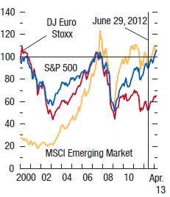
However, as global economic conditions remain subdued, the improvement in financial conditions can only be sustained through further policy actions that address underlying stability risks and promote continued economic recovery.
In advanced and emerging markets equity prices have risen by some 15 percent, and equity price volatility has fallen to pre-2008 levels (Figure 2). High-yield bond issuance is running well above pre-crisis levels in the United States, supported by record-low yields Source: IMF World Economic Outlook, April 2013
and tight bank lending conditions.
In the euro area, periphery sovereign spreads have dropped (Figure 3). For the first time in a year, selected periphery economies have successfully placed large volumes of long-term syndicated sovereign bonds. But these improvements are fragile, as suggested by the increased volatility in periphery spreads in response to political uncertainty in Italy and the events in Cyprus. Sustained, positive feedback between activity and credit still seems a distant prospect. GFSR analysis suggests that bank deleveraging is proceeding in line with the current policies baseline anticipated in October 2012, a reflection of continued concern about capital and liquidity. Euro area credit continues to contract and lending conditions to tighten, reflecting mainly conditions in the periphery economies but also the poor macroeconomic outlook for the region as a whole.
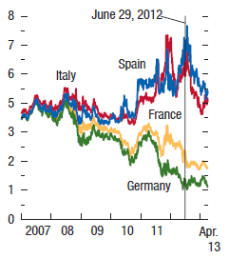
Figure 3 Government bond yields (percent)
Risk spreads on emerging market sovereigns and corporations have declined with the resumption of capital inflows (Figure 4 and 5). Bond and syndicated loan issuance has been strong. Furthermore, very low U.S. dollar and euro interest rates have prompted corporations to increase their issuance of foreign-currency-denominated debt. However, bank credit remains sluggish in many advanced economies, despite the rebound in the financial markets.
Source: IMF World Economic Outlook, April 2013

Figure 4 Net Capital flows to Emerging markets
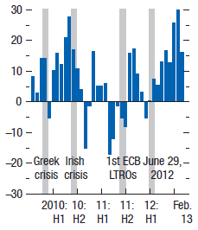
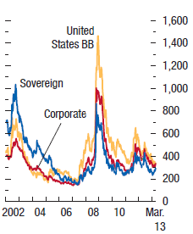
(billions of USD; monthly flows) Figure 5 Interest rate spreads (basis points)

Source: IMF World Economic Outlook, April 2013 Source: IMF World Economic Outlook, April 2013

In the United States, the rate of credit growth has been picking up gradually, and bank lending conditions have been easing slowly from very tight levels. Together with lower market risk spreads, this has noticeably eased financial conditions. This process is supported by recovering house prices, higher household net worth, and stronger bank balance sheets and profitability. However, many middle-income households continue to face high debt burdens.

Developments in the East Africa region

Economic growth

In EAC, economic activity remained resilient driven by efficient macroeconomic policies, important investment projects despite volatility in foreign inflows as a result of persistent financial crisis. Rwanda and Tanzania are expected to have the highest economic growth, 7.5% and 6.8% respectively in 2013, from 8.0% and 6.9% achieved in 2012, followed by Uganda (6.2%), Kenya (4.9%) and Burundi (4.3%).

Inflation

With regard to price developments, inflation pressures kept on declining, due to better economic performances and efficient monetary and fiscal policies. Compared to June 2012, annual inflation declined in June 2013 to 4.9% from 10.1% in Kenya, to 3.4% from 18.0% in Uganda, to 7.6% after 17.4% in Tanzania and to 11.4% against 17.3% in Burundi.

Table 4 Annual inflation in EAC Countries (in percent)
 | 2010 | 2011 | 2012 |  |  |  | 2013
 | Dec | Dec | Mar. | Jun. | Sept. | Dec. | Jan. | Feb. | Mar. | Apr. | May | Jun.
Uganda | 3.1 | 27.0 | 21.2 | 18.0 | 5.5 | 5.3 | 4.9 | 3.4 | 4.0 | 3.4 | 3.6 | 3.4
Kenya | 4.5 | 18.9 | 15.6 | 10.1 | 5.3 | 3.2 | 3.7 | 4.5 | 4.1 | 4.1 | 4.1 | 4.9
Tanzania | 5.6 | 19.8 | 19.0 | 17.4 | 13.5 | 12.1 | 10.9 | 10.4 | 9.8 | 9.4 | 8.3 | 7.6
Burundi | 4.9 | 14.9 | 24.5 | 17.3 | 14.2 | 11.8 | 7.6 | 9.4 | 5.9 | 3.0 | 8.2 | 11.4
Rwanda | 0.2 | 8.3 | 8.2 | 5.9 | 5.6 | 3.9 | 5.7 | 4.8 | 3.3 | 4.4 | 3.0 | 3.7
Source: EAC Central Banks respective websites

Performance of banks in the region

Banks in East Africa were well capitalized overall, with the average regulatory capital to risk-weighted assets ratio at around 20.4 percent as of end December 2012. For Rwanda and Tanzania, this ratio slightly decreased compared to end December 2011 while it decreased for Burundi, Kenya and Uganda. However, the Rwandan banking system has highest ratio as shown in Appendix 1. Bank asset quality in East Africa improved from year 2011 to 2012 with the ratio of non-performing loans (NPLs) to total gross loans below 10 percent for all the East African countries. Except for Rwanda, NPLs ratio rose in EAC countries between end December 2011 and December 2012, reflecting the higher lending rates in the EAC region. Burundi and Tanzania recorded the highest NPL ratio in the EAC region with 8.7 percent and 8.0 percent as of end December 2012 respectively. Banks’ profitability remained largely satisfactory in EAC countries throughout the period from December 2011 to December 2012 with an average return on equity and asset of 17.7 percent and 2.8 percent respectively.

Impact of global macro-financial conditions on Rwanda’s financial system

The global macroeconomic and financial conditions challenges experienced during the period under review did not create disruptions to the Rwanda’s financial system. Despite these challenges, the Rwandan economy continued to perform well, in line with the annual real GDP projections. In response to persistent uncertainties in international and regional environment, the Central Bank maintained a prudent monetary policy stance in order to maintain inflation expectations and revised the policy rate down to 7% in June in order to stimulate further economic financing in the second half of 2013.

As a result of prudent monetary policy, coordination of economic policies and good economic performance, the inflation rate has been maintained at low levels in the first half of 2013. Annual headline inflation fell to 3.7% in June 2013 from 5.9% and 3.9% recorded in June and December 2012 respectively.

With regard to exchange rate policy, the BNR continues to maintain a flexible exchange rate regime intervening on domestic foreign exchange market by selling foreign exchange to banks to smoothen FRW exchange rate volatility. After a depreciation of 4.5% in 2012 due to uncertainties around donors’ support, FRW has regained its stability in the first half of 2013 depreciating only by 1.8% as a result of improved external capital inflows. The National Bank of Rwanda will continue to implement a prudent monetary and exchange rate policy to ensure that the liquidity in the banking sector is within the desired level consistent with the financial needs of the economy and limiting monetary inflationary pressures.

Domestic Macro-economic developments

Real GDP growth rate

For the year 2012/2013, Rwanda’s real GDP growth was 3.7% from 9.4% realized in the previous year (2011/2012). The contribution from agriculture sector was 1.3% led by food crops (+1.3%). The industry sector grew by 4.8% driven by construction (+11.5%) and electricity & water construction (+7.2 percent), while services sector’s growth was 5.0% led mainly by wholesale and retail trade (+5.8), and banks and insurance (+10.6%).

Table 5 Rwanda real GDP growth rate
 | 2007/08 | 2008/09 | 2009/10 | 2010/11 | 2011/12 | 2012/13 (Proxy)
GDP | 8.2 | 9.7 | 4.9 | 7.4 | 9.4 | 3.7
Agriculture | 3.9 | 5.6 | 6.0 | 3.2 | 6.2 | 1.3
Industry | 10.4 | 10.4 | 1.2 | 12.8 | 12.4 | 4.8
Services | 12.2 | 12.5 | 4.8 | 9.9 | 11.5 | 5.0
Source: National Institute of Statistics of Rwanda (NISR)

Budget deficit to GDP ratio

For the fiscal year 2012/2013, trade balance stood at USD 1,195.56 million, exports value amounted to USD 707.30 million and imports amounted to USD 1,902.86 million. Compared to the fiscal year 2011/2012, exports increased in both volume and value respectively by 50.1% and 33.9% while imports also rose in both volume and value respectively by 19.8% and 6.3%. Despite these trends, trade deficit deteriorated by 13.1%. However, imports cover has improved by 27.5% from 19.0% and 32.5% after 23.6% when including cross-border trade.

Table 6 Major Balance of Payment components developments (in USD millions)

 | 2009 | 2010 | 2011 | 2012 | FY 2012/2013
A. Trade balance | -762.06 | -786.70 | -1101.58 | -1376.25 | -1195.56
B. Services (net) | -177.70 | -246.22 | -186.98 | -93.23 | -83.49
C. Income (net) | -36.79 | -42.52 | -51.80 | -73.82 | -76.30
Trade, services and income balance | -976.56 | -1075.44 | -1340.36 | -1543.29 | -1355.35
D. Current transfers net | 604.02 | 657.31 | 880.52 | 722.46 | 800.71
E. Current account | -372.54 | -418.13 | -459.84 | -820.83 | -554.64
F. Capital and Financial account balance | 433.55 | 499.36 | 682.50 | 582.47 | 780.70
G. Overall balance | 57.05 | 72.07 | 234.54 | -212.44 | 210.96
Source: BNR, Statistics Department

Annual average inflation rate

Despite some seasonal volatility, inflation in Rwanda was maintained at moderate levels since 2012. In June 2013, annual headline inflation slightly decreased to 3.7% from 5.9% recorded in June 2012. Sustained moderate inflation has been a result of prudent and efficient monetary policy, good economic performance, coordinated economic policies that mitigated the impact of exogenous shocks, easing inflationary pressures in trading partners as well as stable international oil prices.

Table 7 Annual headline inflation (in percent change)

 | 2008  Dec. | 2009  Dec. | 2010  Dec. | 2011  Dec. | 2012  Dec. | 2012  Jun. | 2013  Jun.
Headline Inflation | 22.32 | 5.69 | 0.23 | 8.34 | 3.88 | 5.92 | 3.68
1. Food and non-alcoholic beverages | 30.9 | 9.0 | -2.69 | 11.22 | 7.94 | 11.32 | 4.41
2. Alcoholic beverages and tobacco | 35.5 | 8.6 | 4.06 | 3.04 | 3.60 | 10.32 | 1.73
3. Clothing and footwear | 4.9 | 1.9 | 1.59 | 8.74 | 1.85 | 4.63 | 1.50
4. Housing, water, electricity, gas and other fuels | 21.4 | 0.9 | 1.63 | 6.81 | 1.81 | 5.53 | 0.20
5. Furnishing, household, equipment routine household maintenance | 24.4 | -0.4 | -2.37 | 4.86 | 5.58 | 4.26 | 4.27
6. Health | 12.3 | -0.8 | -1.14 | 1.90 | 1.35 | 1.44 | 0.55
7. Transport | 12.2 | 11.8 | 4.07 | 9.12 | 0.52 | 0.37 | 0.90
8. Communication | -14.3 | -3.6 | -0.44 | -6.28 | -0.03 | -7.72 | -1.94
9. Recreation and culture | 2.5 | 1.8 | 1.38 | 5.16 | -1.09 | -1.46 | 1.24
10. Education | 14.2 | 17.4 | 6.51 | 20.74 | 1.00 | 1.00 | 35.18
11. Restaurants and hotels | 25.1 | 2.0 | -0.44 | 4.46 | -0.41 | 1.98 | 3.76
12. Miscellaneous goods and services | 2.4 | 7.9 | 2.8 | 5.64 | 3.17 | 2.39 | 3.25
Source: BNR, Statistics Department
By origin, domestic inflation increased to 4.12% in June 2013 after 6.75% in June 2012 driven by food and non-alcoholic beverages while imported inflation decelerated to 1.89% in June 2013 from 2.65% in June 2012.

Financial stability developments and trends

Structure of the Rwanda’s financial system

Rwanda’s financial sector consists of Banks (9 commercial banks, 3 microfinance banks, 1 development bank and 1 cooperative bank), Microfinances institutions (11 limited companies, 63 SACCOs and 416 UMURENGE SACCOs), Non-Bank Financial Institutions [insurance companies (10 private insurers, 2 public insurers, 8 loss adjusters, 6 brokers, 155 insurance agents) and pension funds (1 public fund, 52 private funds, other funds)] and Financial Markets. As at June 2013, the Rwanda financial sector is still dominated by banking sector which hold around 66.3 percent of the total financial sector’s assets. These are followed by pensions whose market share slightly decreased to 17.2 percent of the total assets from 17.4 percent as at March 2013. Up to June 2013 (the pension sector’s total assets covers 61.7 percent of the overall total assets for non-bank financial institutions). Insurance institutions on their part, holds only a proportion of 10.7 percent of the total financial sector’s assets and microfinance institutions’ proportion of the market share in the financial sector’s assets is 5.9 percent (Figure 6). The Rwanda financial assets are hugely exposed to risks as they are not backed by strong insurance companies which can bail out the crisis during the financial distress. This can be mitigated by continued encouragement of the public to invest hugely in insurance companies, along with the ongoing financial awareness campaign, and in addition to creation of deposits protection fund.

Figure 6 Market share in the financial system
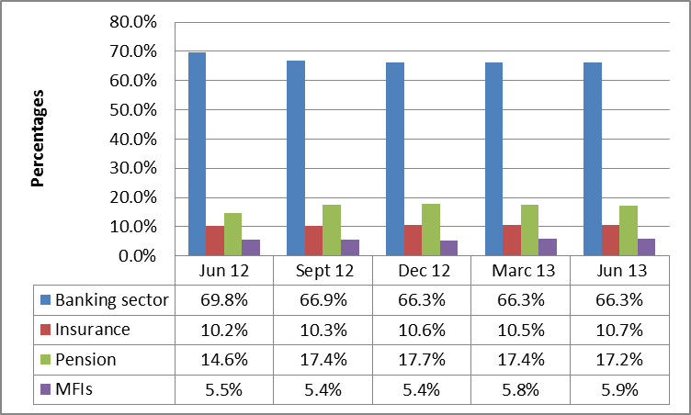
Source: Financial Stability Directorate

Banking system

As at June 2013, the Rwandan commercial banks continued to dominate the banking industry with a proportion of 80.4 percent of the total banking system’s assets while other specialized banks (Microfinance banks, development bank, and cooperative bank) account for 19.6 percent of the total banking system’s assets. In spite of that, the Rwandan banking remained concentrated with four largest banks together holding over 54 percent of the total system assets. One major bank is holding 32.0 percent of the total commercial banks’ assets while the minor bank has 3.4 percent of the total commercial bank sector’s assets.

Microfinance institutions

Microfinance sector accounts for 5.9 percent of the whole financial system’s assets as at June 2013, with a slight increase from 5.4 percent and 5.5 percent as at December 2012 and June 2012 respectively. The development in Microfinance industry during the last four quarters, 2013 was characterized by the continued growth of UMURENGE SACCOs that brought a significant improvement in the total assets of the sector. Assets of UMURENGE SACCOs grew by 33.9 percent while the growth of other Microfinance Institutions was at 24.7 percent from June 2012 to June 2013.

Insurance and pension companies

As at the end of the year ended 30th June 2013, the insurance sector accounts for 10.7 percent of the whole financial system’s assets from 10.2 percent as at June 2012. The insurance section represents a proportion of 38.3 percent of total assets for Non-Bank Financial Institutions as at June 2013.
The major part of the industry’s total assets (57 percent) is held by public insurers while 43 percent of the total insurance assets are held by Private Insurers.

As at the end June 2013, pension funds section represents 17.2 percent of the total financial system’s assets from 14.6 percent as at June 2012. It also represents a huge proportion (61.7 percent) of the total Non-Bank Financial Institutions.

Financial Market

The Rwandan financial market is mainly composed of Money markets, Securities markets and Foreign exchange markets (Table 8). The money markets dominate the Rwandan financial market with 96.5 percent (of which 60.9% is from Treasury bill for the Government) of total outstanding amount. The securities market in Rwanda is dominated by Government bonds operations.

Table 8 Stage of development in domestic financial markets (Outstanding Amount in Millions of RWF)
Period | Jun-12 | Dec-12 | Mar-13 | Jun-13
Money markets | 218,015 | 154,689 | 140,075 | 239,828
Interbank | 3,000 | - | - | 3,500
Treasury bill for Government | 91,369 | 95,256 | 122,975 | 146,128
Central bank bill | 23,246 | 6,983 | - | -
Repurchase agreements (REPO) | 100,400 | 52,450 | 17,100 | 90,200
Securities markets | 12,500 | 10,000 | 10,000 | 8,500
Government bonds | 12,500 | 10,000 | 10,000 | 8,500
Corporate bonds | - | - | - | -
Equity | - | - | - | -
Foreign exchange markets | - | - | - | -
Spot | - | - | - | -
TOTAL | 230,515 | 164,689 | 150,075 | 248,328
Source: BNR, Financial Markets Department

With regard to the stock markets, the Rwanda Stock Exchange (RSE) established in 2010 and still counts 4 listed companies at the end of June 2013. However, only two companies have been active on RSE with approximately 25 million at the end of June 2013 (Figure 7).

Figure 7 RSE transactions (in millions)
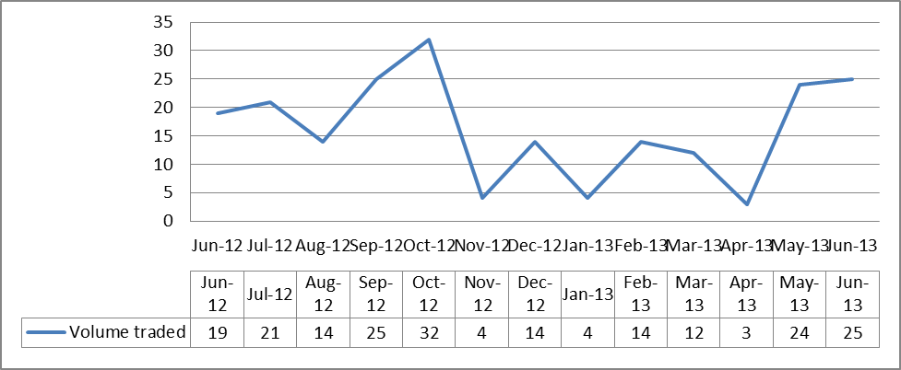
Source: BNR, Payment System Department

Cross-sector Linkages in the Rwanda’s financial sector

The following sections highlight the level of Rwanda’s financial sector interconnectedness among the financial sub-sectors, as well as with the Government of Rwanda and also describe measures which are being implemented in order to mitigate emerging risks to financial stability in Rwanda.

Inter-linkages among the Financial Institutions
The linkages between banking, pension funds and insurance companies are the most important in relation to financial stability in Rwanda. Problems arising in any of these three sectors and the infrastructure which channels financial resources can have an impact on overall financial stability and vice versa. As a result, supervisors in the three sectors must take into account the advantage in taking prompt supervisory actions to prevent or remedy problems in their respective supervised financial institutions. Furthermore, financial sector regulators and supervisors should ensure public confidence in their subsectors and in the financial sector as a whole.

Linkages with banks
The banking system linkage through placements with bank abroad increased during the second quarter 2013 when compared with the same period in 2012, from 85 billion at the end of June 2012 to 119 billion as at June 2013. The interbank lending to domestic banks increased during the period from June 2012 to June 2013 from 15.4 billion to 20.4 billion respectively. In addition to supplying liquidity to the banking system, the inter-bank linkage facilitates the operations of the payments and settlement system. As of June 2013, total interbank deposits from domestic banks increased to 20.3 billion from 16.2 billion at June 2012, and the foreign liabilities increased from 47.4 billion in June 2012 to 78.6 billion as at June 2013. The volume of placements has been expanding due to the growth of international trade financing and due to the recovery of confidence in the global economy.

Table 9 Linkages among banks
Financial system interconnectedness | Million Rwf
Financial system interconnectedness | June 2012 | Dec 2012 | June 2013
Placement with banks abroad | 85,033 | 119,111 | 119,959
Interbank placement/Lending to domestic banks | 15,455 | 17,108 | 20,481
Deposits from pension funds | 99,075 | 89,276 | 97,231
Deposits from insurance companies and MFIs | 63,667 | 66,048 | 74,737
Interbank deposits/Borrowings from domestic bank | 16,207 | 9,786 | 20,354
Foreign Liabilities | 47,455 | 50,904 | 78,691
Source: BNR, Statistic Department

The main risks arising from offshore placements are associated with foreign exchange risks and potential banking crisis in the foreign banks, especially among the international banking groups which are exposed to the sovereign debts.

The National Bank of Rwanda has a framework which monitors foreign placements and foreign exchange risks. The prudential banking regulations require banks to diversify their placements abroad according to the credit rating in order to mitigate potential risks.

Linkage between Financial Intermediaries and the Government

The on-going developments with regard to financial crisis have reminded that financial stability does not only depend on the linkages among financial intermediaries and within financial markets, but also on the interconnections with Governments. The global financial crisis experience also suggests that the governments can by themselves become a source of financial instability when they pose credit risk to public debt – as the case is with the last sovereign debt crisis in the Euro Zone. In this Section, the linkages between banks, pension funds and insurance companies on one side with the Government debt instruments on the other are highlighted. The strong interconnection between financial intermediaries and the Government as described below call for a close monitoring of developments in public debt and the debt service capacity thereof to ensure appropriate interventions are undertaken before risks precipitate into a debt crisis.

As at end June 2013, total outstanding Treasury bills amounted to 146.1 billion. Out of these, banks held 105.5 billion, pension funds held T-bills amounting to 38.6 billion, while insurance companies held no Treasury bills. On the other hand, outstanding stocks and bonds amounted to about 8.5 billion, of which banks held 7.4 billion, whereas 1.0 billion was held by pension funds.

Table 10: Linkage between financial intermediaries and the Government
Figures in millions RWF | Banks | Insurance | Pension | Others | Totals
T-bills issued | 105,529 | - | 38,650 | 1,950 | 146,129
Bonds | 7,423 | - | 1,077 | 0.100 | 8,500
Source: BNR, Financial Market Department

Consequently, banks accommodate a major portion of government debt instruments. Specifically, about 72.2 percent of outstanding T-bills (105.5 billion) and 87.3 percent of stocks and bonds (7.4 billion) were held by banks as at end June 2013. This linkage does not pose a threat to the Rwandan Financial Stability as the banks’ assets and deposits are far above the T-bills value held.

Financial soundness analysis

In this section, the stability of the Rwandan financial system is assessed by analyzing a set of selected macro-prudential indicators for the financial sector (Banks, Insurances and Microfinance institutions).

Performance indicators in the banking sector
Rwandan banks are generally well capitalized with the overall regulatory capital adequacy ratio (CAR) standing at 23.1 percent as of June 2013 and still above regulatory minimum required of 15 percent. This sound capitalization enables banks to mitigate the proportion of nonperforming loans (NPLs) which continued to increase during the year which ended June 2013 to 6.9 percent from 6.0 percent and 6.0 percent as at June 2012 and December 2012 respectively.

During the last four quarters which ended June 2013, key indicators used in measuring the banking sector development showed an increase in the proportion of asset growth compared to the growth observed in June 2012. The proportion of increase in assets continued to fluctuate as in June 2012, the increase was at 7.5 percent and down to negative 0.4 percent and then up to 3.7 percent in December and in June 2013 the increase was at 6.8 percent. Deposits increased from 6.8 percent to 8.6 percent as at June 2012 to June 2013 respectively. Outstanding loans growth rate contracted during the year ended June 2013 to 2.1 percent from 9.7 percent as at June 2012.

Furthermore, the net profit in banking sector upgraded significantly during the year ended, 2013 by 8.1 percent if compared to the same period in June 2012 to an amount of RWF 14.0 billion from RWF 12.9 billion respectively. In June 2013, Rwandan banks continued to be liquid and the funding costs were stagnant. The situation was buoyed by considerable increase in deposits to RWF 940.6 billion from RWF 827.8 billion as at June 2012; the increased level of NPLs is thought to have caused the contraction of growth in the level of loans which in turn affected negatively on the return of average assets and return on average equity. The Figure 8 below shows the growth rate of the banking sector in terms of total assets and other main items of assets and liabilities during the last year ended 2013.

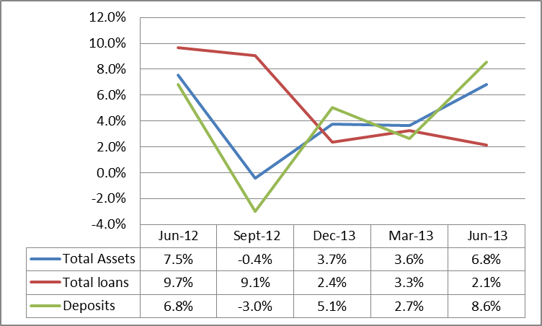
Figure 8 Growth of assets and liabilities (share of total growth)
The banking sector registered a positive proportion of growth in total assets of 6.8 percent at the end of June 2013, the same as in the Quarter 2, 2012. Further, the proportion of increase in total loans reduced from 9.7 percent in June 2012 and 2.4 percent in December 2012 to 2.1 percent in June 2013. Significant increase in the banking industry asset size from March 2013 Source: BNR, Bank Supervision Department
was buoyed mainly by increase in government securities, and due from banks in abroad which significantly increased during the last two quarters ended June 2013.

The proportion of growth of government securities strongly increased in Quarter 2, 2013 to 23.5 percent when compared to the quarter 2, 2012. Due from banks abroad proportion of growth hugely increased in June 2013 to 40.2 percent from 1.0 percent in June 2012. The proportion of increase in deposits was high in June 2013 at 8.6 percent when compared to the proportion of increase in June 2012 at 6.8 percent.

The detailed performance indicators of Rwandan banking sector are analyzed below in terms of capital position, asset quality, earnings and profitability, liquidity and sensitivity to market.

Capital position

The regulatory capital (total capital) to risk weighted assets (RWA) ratio served to assess the capital adequacy of the each individual bank and the banking sector as a whole, while the core capital (Tier 1 capital) to risk weighted assets ratio is useful for monitoring capital quality as it measures the most freely and immediately available resources to meet claims against deposit takers. A minimum Tier 1 capital to risk weighted assets ratio of 10 percent and minimum total capital to risk weighted assets ratio of 15 percent are imposed to all banks as tools to ensure that banks maintain adequate capital in relation to their risk assets thus protecting depositors’ interests and promoting financial stability.

As of end June 2013, Rwandan banks remained well capitalized. Although this ratio declined during the quarter ended June 2013, banks were adequately capitalized in terms of Tier 1 and total adequacy ratios, both ratios remaining well above the minimum prudential requirements of 10 per cent and 15 per cent respectively. The industry ratio of core capital to total risk weighted assets as of end June 2013 was 20.8 percent in terms of Tier 1 and 23.1 percent in terms of total capital.

The key challenge for the banks going forward will be to maintain strong capital positions if economic activity sectors hugely deteriorates (see stress test in later section). The strong capital position at the industry level provides a significant gauge of banks’ capacity to withstand unexpected losses arising from credit and market risks. Without prejudice to the strong capital adequacy ratio of the banking industry, the National Bank of Rwanda is continuously vigilant in prudential supervision to ensure that early problems in banks irrespective of the size are detected and prudently addressed.
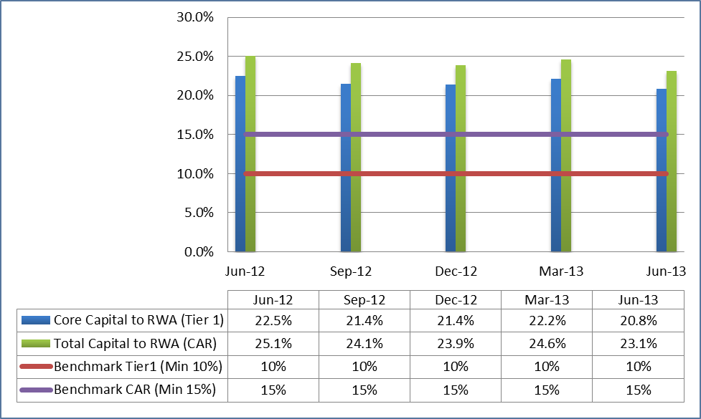
Figure 9 Selected indicators of Capital Adequacy as at June 2013
During the year under review, core capital to risk weighed assets ratio decreased to 20.8 percent from 22.5 percent as at June 2012. The total qualifying assets to risk weighed assets ratio also decreased from 25.1 percent as at June 2012 to 23.1 percent as at June 2013.

Source: BNR, Bank Supervision Department

Asset quality

The total assets of the banking system slightly turned up during the second quarter of 2013 since June 2012 when the proportion was at 7.5 percent before decrease in quarters which followed. As at June 2013, the proportion of increase was at 6.8 percent (RWF 1,292.9 billion as at March 2013 to RWF 1,381.2 billion in June 2013). Gross loans in the banking sector were around the RWF 899.8 billion at the end June 2013. On an annual basis, gross loans increased by 16.2 percent from RWF 774 billion end of June 2012. The performance assessment of the asset quality in the Rwandan banking system focuses on the level of performing and non- performing loans, credit exposure risk, and cash to total assets.

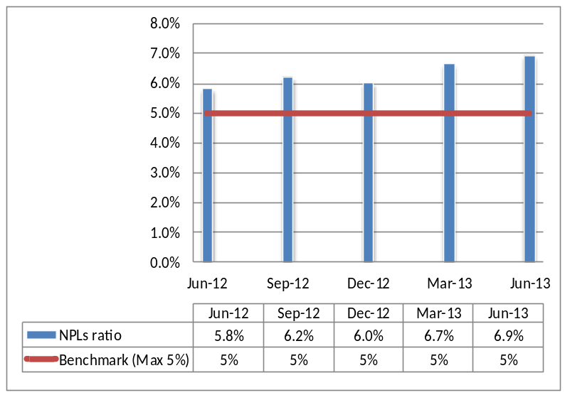
Figure 10 Selected indicators of Assets Quality as at June 2013
The level of NPLs is a crucial element when assessing the health of the banking system and financial system as a whole. Therefore, the Non-Performing Loans to total Gross Loans ratio is an important measure of the quality of the assets in banks’ loan portfolios. In times of economic slowdown, loan repayments become constrained and thus asset quality
Source: BNR, Bank Supervision Department tends to deteriorate. As per regulatory requirements, this situation would require banks to make additional provisions which in turn have an impact on banks’ capital. Normally, the reported NPLs in the banking system exhibit large variation among banks, partly reflecting different exposures to distressed sectors. During the year ended June 2013, the ratio of Non-performing loans to Gross loans in Rwandan banking sector deteriorated by increasing to 6.9 percent from 5.8 percent as at June 2013 (Figure 10). The increase of NPLs calls for a regulatory action in order to achieve the new BNR threshold of 5 percent

The loans by classes and by economic activities

Table 11: The level of outstanding loans by Sector as at June 2013
Total sector | Jun-12 | Dec-12 | Jun-13 | % age Change (Jun 12-Jun 13)
Personal loans | 146.5 | 180.2 | 161.9 | 10.5%
Agricultural, fisheries& livestock | 27.1 | 26.0 | 21.3 | -21.5%
Mining activities | 0 | 0.0 | 0.0 | 0.0%
Manufacturing activities | 37.9 | 40.0 | 46.3 | 22.3%
Water & energy activities | 6.9 | 8.8 | 8.1 | 16.7%
Mortgage industries | 206.3 | 217.0 | 202.4 | -1.9%
Trade & hotels | 218.8 | 224.1 | 247.0 | 12.9%
Transport & warehousing | 45.1 | 48.0 | 49.0 | 8.8%
OFI &Insurance | 7.7 | 7.6 | 10.0 | 30.2%
Service sector | 22.9 | 26.3 | 26.8 | 16.8%
Total sector | 719.2 | 778.0 | 772.7 | 7.4%
Source: BNR, Credit Reference Bureau

The level of outstanding loans is a crucial indicator of the quality of assets in banking sector. It indicates in which sectors banks have more risk appetite than others and thus raises the concerns of the supervisory authority as concentration risks are concerned. As at June 2013, the level of outstanding loans shows that three sectors (Commercial and Hotels, Mortgage industries and personal loans) holds a share of 79 percent of all outstanding loans. In the same case, the same sectors hold a considerable proportion of Non-Performing Loans.

Large exposure

The rationale behind the analysis of large exposure is that it helps supervisory authority to mitigate risks arising from credit concentration.

Figure 11 Large exposure to gross loans as at June 2013
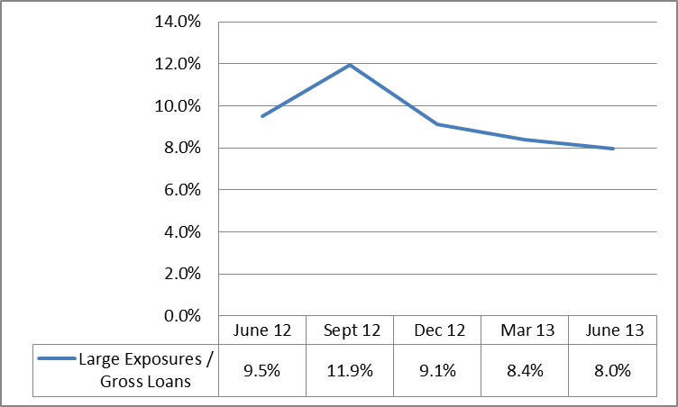
As of end June 2013, all banks continued to comply with the regulation of large exposure marking a downward shift of the rate of large exposures to gross loans (8.0 percent) when compared to June 2012 which was at 9.5 percent (Figure 11). As we go forward, a strategy to protect banks’ run by major lenders who may withdraw their Source: BNR, Bank Supervision Department
assets in Rwandan banking system need to be implemented.

Earnings and profitability

The earnings and profitability were assessed using the return on equity (ROE) and return on assets (ROA) as well as the growth of income on advances and commissions.

The profitability indicators (Figure 12) show that profitability in Rwandan banking system was fluctuating over the year but decreased during the quarter under review. The comparison shows that in June 2012, the ratio of ROA and ROE was 2.3 percent and 10.9 percent respectively. At the end of June 2013, ROA and ROE was at 2.1 percent and 9.9 percent respectively. Nevertheless, the position in profitability can be explained by the improvement in asset quality management in the overall banking sector.

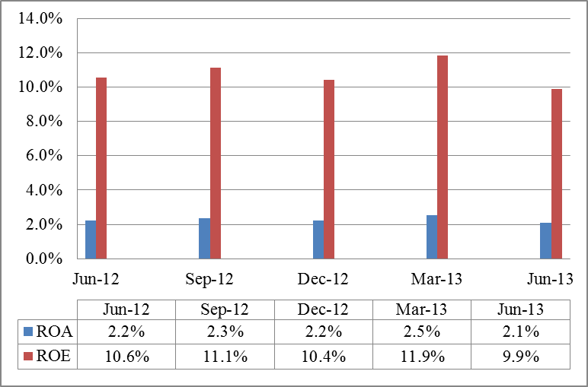
Figure 12 Selected indicators of profitability (in percent)
During the year ended June 2013, cost to deposits increased constantly up to 3.5 percent from 2.8 percent as at June 2012. Further, cost to income increased to 81.6 percent from 80.0 percent as at June 2012 and the net interest margin increased to 10 percent from 9.6 percent as at June 2012. Income on advances ameliorated due to the increased interest margin and increased loans portfolio. The steady growth in bank Source: BNR, Bank Supervision Department
lending and yield on advance followed by the increased cost to income in the banking sector as earlier mentioned was the main contributor to a steady decrease in return on average equity.

Liquidity

The level of liquidity ratio is used to assess the liquidity management in Rwandan banking system. The regulatory requirement of a minimum liquidity ratio of 20 percent is imposed to ensure that banks are all the time capable of meeting the average cash withdraws at short notice.

Figure 13 Liquidity position as at 30th June 2013
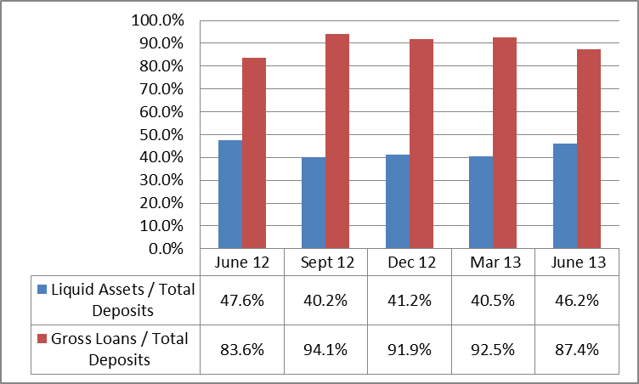
During the year ended 2013, the total deposits in Rwandan banking system increased by 13.6 percent from RWF 827 billion in June 2012 to RWF 940 billion as at the second quarter 2013. This continued increased in deposits resulted from several possible sources ranging from improved economic activities, low fluctuations in the exchanges rates to mention few. The liquidity ratio (liquid assets to deposits) which measures Source: BNR, Bank Supervision Department the banks’ ability to meet liquidity needs was 46.2
percent as of 30th June 2013 and above the minimum required of 20 percent (Figure 13). The ratio of gross loans to total deposits which measure the position of loans which are supported by deposits was also satisfactory at 87.4 percent as at June 2013 an increase from 83.6 percent as at June 2012. The interbank borrowings to total deposits ratio was also increasing during the period under review to 10.1 percent in June 2013 from 9.4 percent as at June 2012. Though, the liquidity stands at good position, the exchange rate fluctuations and the regional volatility in inflation rates, need to be closely monitored so that the Rwandan banks’ liquid assets are not hugely impaired.

Sensitivity to market

The market sensitivity was tough during the period ended 2013 as Rwandan Francs narrowly deteriorated against US$ leaving the exchange rate certain.
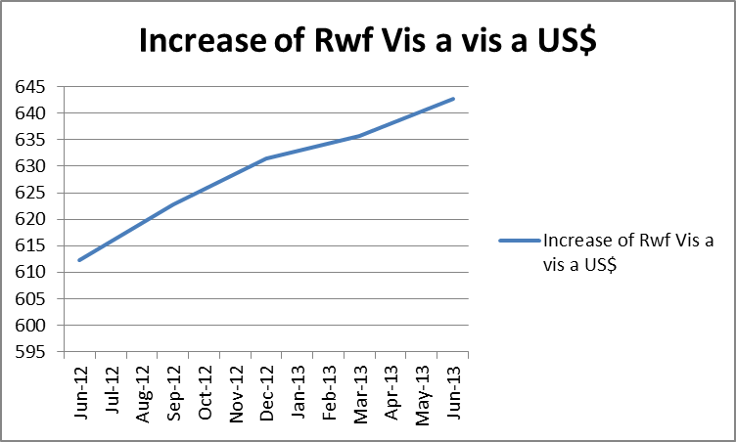
Figure 14 Exchange rate trends
The exchange rates shifted upward from 612.2 a dollar to 642.6 a dollar when June 2012 is compared with June 2013 respectively. The interest rates spread slightly decreased to 6.15 percent from 8.9 as at June 2012. However, forex exposure ratio reduced to -3.0 percent from -1.5 percent as at June 2012. Forex Loans to forex deposits decreased to 5.3 percent from 5.9 percent as at June 2012, implying a Source: BNR Website
low proportion of increase of forex loans when compared to increase of forex deposit. So far, the activities of banks in foreign currencies do not pose huge risks to Rwandan financial system as prudential limits are obeyed and capital buffers are enough to gauge risks from exchange fluctuation.

Performance indicators in the Microfinance sector

The Microfinance sector was growing and stable as at June 2013. The sector’s assets attained RWF 122 billion in June 2013 from RWF 94.8 billion in June 2012, meaning an increase of 28.7 percent. Further, the level of deposits has increased from RWF 56.6 billion in June 2012 to RWF 68.9 billion in June 2013. The gross loans registered a slight increase to RWF 63.9 billion in June 2013 from 51.4 billion in June 2012.

The selected indicators are analyzed to assess the performance of Rwandan Microfinance sector in terms of capital position, Assets quality, and Earnings and Profitability. Data here presented include UMURENGE SACCO unless otherwise stated.

Capital position

The capital adequacy ratio (equity to net assets) served to assess the capital position of Rwandan Microfinance sector as at end June 2013. A minimum regulatory capital adequacy ratio of 15 percent is required to all microfinance institutions to ensure they maintain adequate capital position.

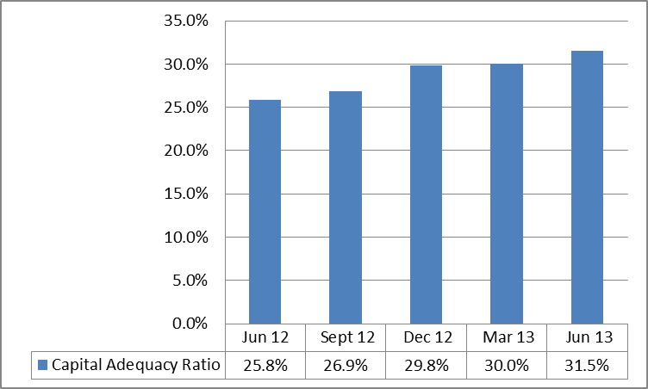
Figure 15 Capital adequacy ratios for MFIs
As of end June 2013, the Rwandan microfinance industry was well capitalized (Figure 15). The total capital (Equity) increased by 57.1 percent from RWF 24.4 billion in June 2012 to RWF 38.4 billion in June 2013. The capital adequacy ratio increased from 25.8 percent as at June 2012 to 31.5 percent as at June 2013, well above the minimum regulatory ratio of 15 percent. Source: BNR, Microfinance Supervision Department

Asset quality

The Non-Performing Loans ratio and gross loans to total assets ratio were used to assess the quality of loans in microfinance sector. Non-performing loans to gross loans indicate a slight decline of the sector’s quality of assets. The ratio increased from 8.4 percent in June 2012 to 8.9 percent as at June 2013. The gross loans to total assets ratio, an indicator of the share of loans in the sector’s assets, went on decreasing to 52.3 percent as at June 2013 from 54.2 percent in June 2012.
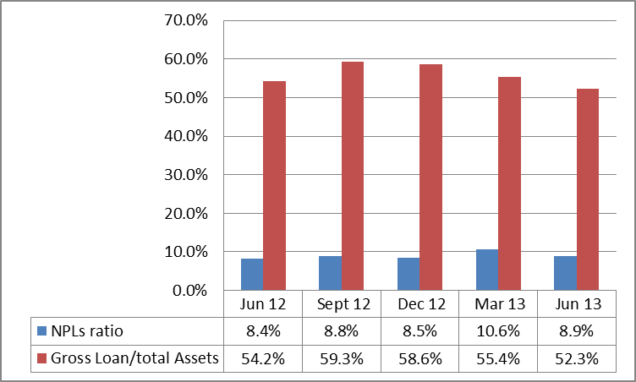
Figure 16 Selected indicators of assets quality

Earnings and Profitability

The return on equity (ROE) and return on assets (ROA) were the main indicators to assess the quality of earnings and profitability in Rwandan microfinance sector.

Source: BNR, Microfinance Supervision Department
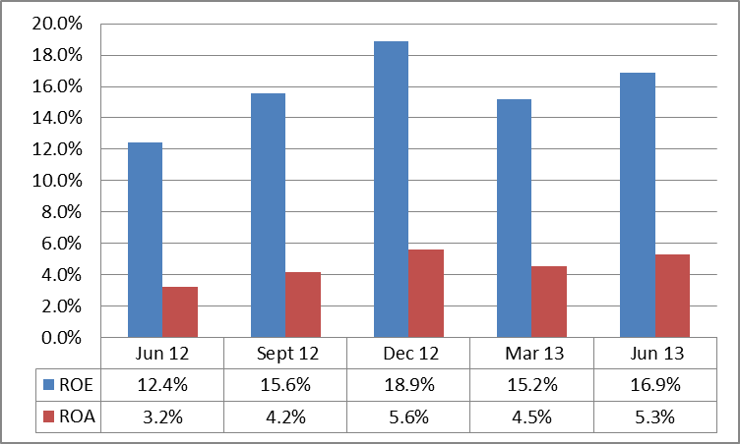
Figure 17 ROE & ROA for MFIs
The Figure 17 indicates that the profitability indicators (ROE and ROA) have slightly upgraded during the period under review. The ROE of the whole sector increased from 12.4 percent in June 2012 to 16.9 percent as at June 2013 while the ROA also increased from 3.2 percent in June 2012 to 5.3 percent as at June 2013.

Source: BNR, Microfinance Supervision Department

Liquidity

The liquidity ratio was used to assess the ability of the sector to meet current withdrawals of funds. The quick ratio is the best measure of such position though gross loans to gross deposits ratio are also important measures.
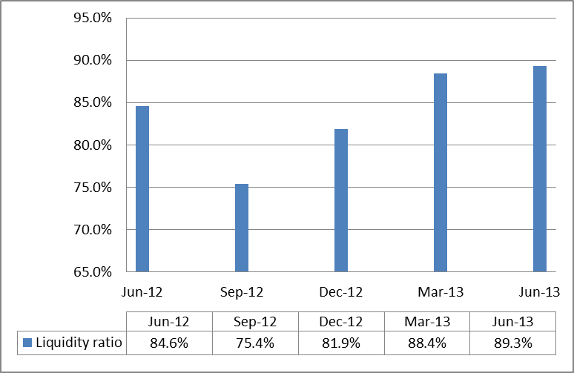
Figure 18 Liquidity ratio
The ability of the sector to meet current demand is at 89.3 percent as at June 2013 increasing from 85.0 percent as at June 2012. The gross loans to gross deposits ratio has also increased from 90.9 percent in June 2012 to 92.6 percent as at June 2013. This increase resulted much from the high proportion of increase in deposits which were followed by low proportional increase on loan portfolio. Source: BNR, Microfinance Supervision Department

It is worth to underline that the provided data are averages which can hide bad performances of MFIs considered individually. In this respect, the BNR will reinforce the supervision to be ensured especially of the adequate liquidity and loans portfolio management by MFIs considered individually.

Performance indicators in insurance sector

To assess the performance of the Rwandan insurance sector, we used the selected indicators of capitalization, assets quality, reinsurance and actuarial liabilities, earnings and profitability, and liquidity.

Capital position

The solvency coverage ratio, leverage ratio (capital to total assets) as well as capital to technical reserves was the key capital adequacy ratios used to assess the capital position of Rwandan insurance sector for financial stability purposes for the year ended June 2013.

Figure 19 Selected indicators of capital adequacy
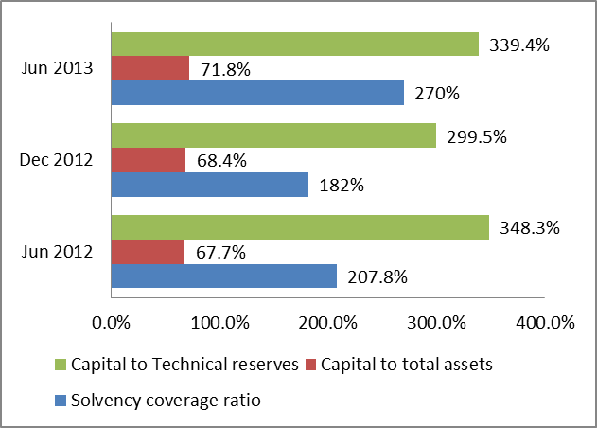
The sector focuses most of the attention to the amount of capital held by insurance companies and the level of key capital adequacy indicators. The Rwandan insurance industry, as at 30th June 2013, recorded an increase of 32.1 percent in terms of total capital and reserves to 157 billion from 119 billion in June 2012.
Source: BNR, NBFI Supervision Department As at end June 2013, the overall insurance industry was adequately capitalized (Figure 19) evidenced by the increased ratio of solvency coverage ratio and capital to total assets from 207 percent to 270 percent and from 67.7 percent to 71.8 percent as at June 2013 from June 2012 respectively. The capital to technical reserves ratio decreased to 339 percent in June 2013 from 348 percent as at June 2012.

Assets quality

The key indicators served to assess the asset quality of the Rwandan insurance industry as of end June 2013 were real estate investment to total assets ratio and equity investments to total assets ratio.
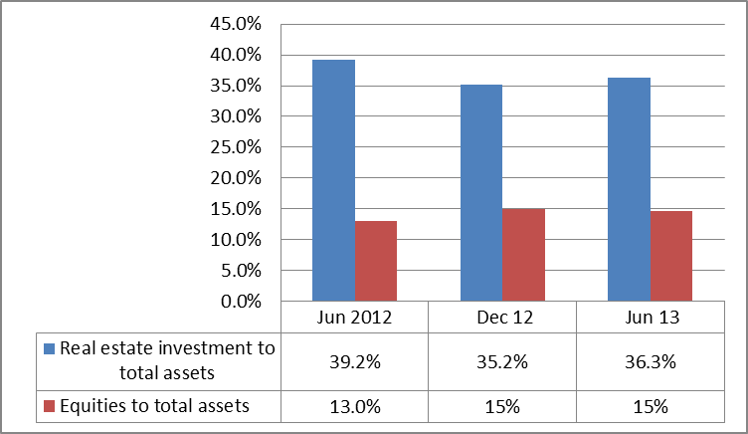
Figure 20 Asset quality ratios for Insurance sector
As at the end of June 2013, the total assets of insurance sector increased by 24.4 percent to RWF 219 billion from RWF 176.3 billion as at June 2012. However, the insurance sector continued to show satisfactory asset quality management in the period under review 2013 as all asset quality ratios did not fully comply with the regulatory required ratios. Though, the real estate Source: BNR, NBFI Supervision Department
investments to total assets slightly decreased to 36.3 percent from 39.2 percent as at June 2012 and still above the maximum required of 30 percent, the equity investments to total assets ratio also increased to 15 percent from 13 percent as at end of June 2012.

As we go forward, the prudential requirements for insurance companies are to have a reasonable investment diversification as the real estate investments and equities still dominated in total investments of insurance sector.

Reinsurance and actuarial liabilities

The retention ratio was used to assess the level of reinsurance for Rwandan insurance sector. The regulatory requirement set the retention ratio at the minimum of 60 percent and maximum of 80 percent.

Figure 21 Retention ratio for insurance sector
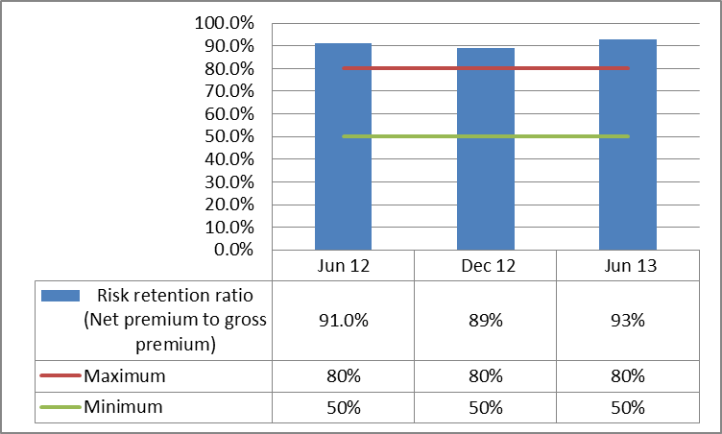
As of end June 2013, reinsurance net premiums written amounts to RWF 36.5 billion out of gross premiums of RWF 39.3 billion representing a retention ratio of 93 percent far above the maximum required of 80 percent. This ratio has increased from 91.0 percent as at June 2012 due to different proportional reduction of net premiums written and the gross premiums. It is worth to note that there is no reinsurance company operating in Rwanda and all the ceded premiums were paid to reinsurers abroad. Source: BNR, NBFI Supervision Department

Earnings and profitability
Figure 22 Earnings and profitability for insurance sector
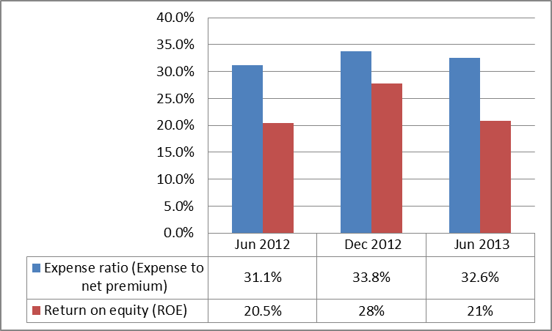
The key indicators to assess the performance of earnings and profitability in Rwandan insurance industry were investment income to net premium, investment income to investment assets and return on equity (ROE).
In period ending in June 2013, the industry recorded an increase in investment income to net premiums to 19.4 percent from 13.6 percent in June 2012. Though the loss ratio decreased from 46.3 percent to 38 percent as at December Source: BNR, NBFI Supervision Department
2012, the ratio then increased as at end June 2013 resulting from the proportion of increase in net premiums that outweigh the proportion of increase in net claims. In addition, the annualized return on equity (ROE) ratio upgraded to 21 percent from 18.9 percent in June 2012.

Liquidity

To assess the level of liquidity of Rwandan insurance sector, the quick ratio was used as key indicators.
Figure 23 Quick ratio for insurance sector
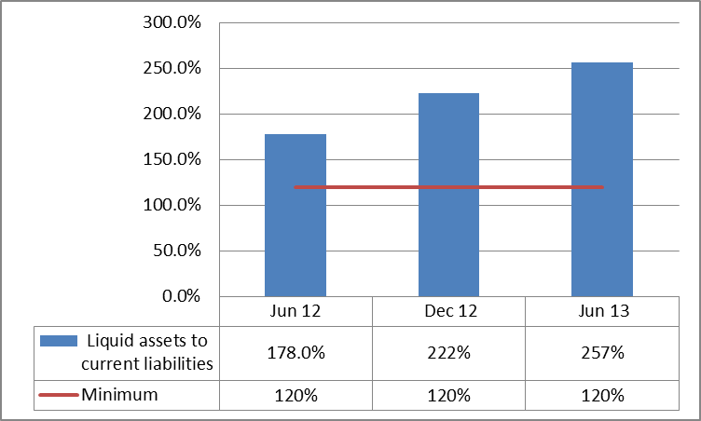
During the period ended 2013, the quick ratio upgraded to 257 percent from 178 percent as at June 2012. The Rwandan insurance industry showed a strong level of liquidity as at the end of June 2013 (Figure 23) as this ratio is well above the minimum required of 120 percent.
Source: BNR, NBFI Supervision Department
However, it has been noted that the public insurers do not have technical provisions which may form a substantial part of liabilities, thus impacting on the liquidity ratio.

Performance indicators in Pension funds
The pension sector assets increased by 27% from Rwf 301.4 billion reported for the year ended 30th June 2012 to Rwf 383.5 billion reported 30th June 2013. Comparing the two financial years, total contributions increased by 29% from Rwf 42 billion to Rwf 55 billion, total benefits paid increased by 18% from Rwf 8 billion to Rwf 9 billion and investment income increased by 70% to Rwf 17.8 billion from Rwf 10.5 billion registered end June 2012.

Table 12 Pension sector performance indicators

Financial indicators for the pension sector
 | Particulars | (Million Rwf)
 | Particulars | Jun-12 | Jun-13 | % Change
1 | Total assets | 301,4 | 383,5 | 27
2 | Total Contributions Received | 42,890 | 55,256 | 29
3 | Total benefits paid | 8,422 | 9,910 | 18
4 | Total investment income | 10,5 | 17,8 | 70
Source: BNR, Non-Bank Financial Institution Supervision Department

Infrastructure development

Developments in payment systems

After the implementation of the Rwanda Integrated Payment Processing System (RIPPS) in 2011, the period under review had been concentrated to stabilize the RIPPS and to introduce new and strengthen existing retail payment systems. All changes were spearheaded by concerted effort of the central Bank/Government and financial institutions especially commercial banks.

During the period under review, the RIPPS was stabilized and banks had put much effort to integrate core banking applications within the system. As of 30th June 2013, major banks had developed the interface between RIPPS and their core banking. The availability rate of the system had been 99% from June 2012 to end June 2013.

The development of e-payment and credit transfers has seen the dramatic reduction of cheque usage to 247.9 thousands as at June 2013 from 1.5 million as at June 2012.

Table 13: Basic payment indicators as at end June 2013
 | Jun-12 | Dec-12 | Jun 13
Volume of transactions:
Cheque | 1,519,277 | 1,351,340 | 247,974
Credit transfers | 589,048 | 895,077 | 712,134
E-payments:
Payment cards | 1,413,124 | 2,014,796 | 2,205,397
ATM number | 232 | 292 | 323
Internet banking | 2,366 | 4,493 | 7,091
Mobile banking | 113,150 | 527,300 | 604,435
Value of transactions (in Million RWF)
Cheque | 1,057,863 | 544,311 | 409,940
Credit transfers | 753,519 | 1,302,136 | 1,366,521
E-payments:
Payment cards | 49,880 | 128,974 | 66,250
Internet banking | 1,084 | 1, 708 | 3,197
Mobile banking | 3,756 | 5,215 | 7,951
Source: BNR, Payment Systems Department

To further enhance the developments in payment systems, the BNR together with the Rwanda Bankers Association, have embarked on the Cheque Truncation Project. The cheque truncation consists of cheque clearing system based on cheques image where the cheque is scanned and transmitted through the entire clearing cycle using the image instead of the physical cheque.

In this regard, new standards for the cheques were issued in November 2011 and new printers willing to provide services to banks in Rwanda are being accredited by the BNR following the accreditation guidelines that were published in May 2012. This project shall help to fast track the cheque payment process with a more secure and trusted method of processing as more security features have been added to the new cheque. Besides, the cheques will be cleared efficiently because all account structures will be harmonized facilitating the integration between RIPPS and banks’ core banking applications.

In addition, the RIPPS system is being upgraded to enable linkage to Regional Payment Systems; the East Africa Payment systems (EAPS) and the COMESA Regional Payment and settlement system (REPSS) so as to facilitate the cross border payments in the East African Community and COMESA region.

During the period under review, the BNR continued to modernize Rwandan payment systems to ensure that they are efficient and reliable. The main developments were the implementation of Rwanda Integrated Payment Processing System (RIPPS) and introduction of new payment instruments.

As of end June 2013, ATS has seen a number of messages increasing to 144, 215 and the volume of transactions were at 669,251. ATS handles gross credit transfer of real time transactions, cheques, and credit transfers.

On the Central Securities Depository (CSD) side, around 719 transactions equivalents to 774.6 billion were settled through the Central Securities Depository system. Those transactions comprise both equities and Debt instruments (REPO’s, Treasury bills and Treasury Bonds). All equities transactions are the secondary operations which take place on Rwanda Stock Exchange while on debt securities side more than 99% are new issuance by the Central Bank.
Table 14 Transactions settled through RIPPS as at June 2013

 | ATS |  |  |  |  | CSD
 | RTGS |  | ACH
 | Customers transactions | Interbank transactions | Cheques | Credit transfer (batches) | Total
Total Messages | 57,246 | 4,188 | 15,841 | 66,940 | 144,215
Volume of instructions | 57,246 | 4,188 | 84,516 | 523,301 | 669,251 | 31,643,826
Value (millions Rwf) | 761,682 | 1,535,828 | 187,066 | 289,558 | 2,774,135 | Shares traded | Turnover | Debt instruments
 |  |  |  |  |  | 655* | 15,461 | 64
Source: BNR, Payment Systems Department [(*) not in million.]

Regarding the card based payment system, banks continued to issue payment cards and RSwitch as a common platform ensured that the infrastructure is interoperable. As of end June 2013, the card based payments improved significantly in terms of number, transactions and value settled as indicated by table 13 and table 14. Moreover, the Visa National Net Settlement System (NNSS) is operational since the 1st March 2012. The Visa National Net Settlement System facilitates domestic transactions to be settled in local currency and the Central Bank is the settlement agent.

Table 15 Evolution of card based payments as at end June 2013
Items | Jun-12 | Dec-12 | Jun-13
Number of ATMs | 232 | 292 | 323
Number of Point of Sale (POS) terminals | 385 | 598 | 797
Number of debit cards | 320,565 | 408,767 | 440,875
Number of credit cards | 542 | 926 | 1,179
Number of prepaid cards | - | - | -
Total number of ATM networks | 4 | 7 | 7
Total number of POS networks | 3 | 5 | 6
Source: BNR, Payment Systems Department

The retail Payments infrastructure has also improved considerably. By end June 2013, the Number of ATMs had increased to 323 as compared to 232 by end June 2012. Points of Sale (POS) had also increased to 797 from 385 at end June 2012.

More importantly, a total of 440,875 cards were issued as at end June 2013 as compared to 320,565 in June 2012, representing an increase of 37.5% in the last twelve months.

Financial system resilience

Rwandan financial system continued to be sustained and resilient to different shocks due to the strong regulatory framework followed by prudential policies and regular supervision. Onsite and offsite inspection conducted in financial institutions as well as regularly prudential meetings and reforms contributed to the strengthening of financial stability system throughout the period under review. The financial soundness indicators discussed above suggest that the Rwandan financial sector is sound. Assessing by the capital adequacy ratios, it is reasonable to conclude that the financial sector as a whole was well capitalized and resilient to the simulated adverse shocks. There are no strong signs of fragility as trends for the indicators were within acceptable ranges.

Stress testing results

In monitoring the stability and resilience of the financial system, the National Bank of Rwanda (BNR) conducts on quarterly basis stress tests on the banks’ balance sheet against extreme shocks. The stress testing involves examining the impact of key risks, namely capital adjustment, credit, exchange rate, and the liquidity risk on individual banks and on the consolidated balance sheet of 14 banks based on June 2013 data.

Capital adjustments

The first step in the stress testing exercise was to make adjustments to bank’s reported capital, risk-weighted assets, and net assets to correct for under-provisioning in order to meet regulatory limits. The criteria for the stress tests on assets quality used two capital measures as the relevant metric:
- Regulatory capital (Total capital) divided by risk weighted assets (RWA) - CAR
- Core capital (Tier 1) to risk weighted assets (RWA).
Capital measures were also adjusted by including general provisions and combination of general and specific provisions.

Based on data reported as of end June 2013, Rwandan banking system was well capitalized and the capital adequacy ratios were above 15% before and after adjustments using regulatory capital (BNR CAR definition). Compliance with provisioning regulation has upgraded. While eight banks were under provisioned as of end June 2012, four banks were under provisioned at the end of June 2013. Therefore, there is a need of supervisory actions so that banks comply with regulation on loan classification and provisioning.

Although the application of general provisions in banking system would require seven banks to make additional provisions compared to current situation (provisions made as of end June 2013), the stress testing results show that this would not have negative effect on overall banking system capitalization. The capital adequacy ratio would not change as of end June 2013. Therefore, as required by the EAC harmonization process, the general provisions should be applied in Rwandan banking system.

Credit and concentration risks

The second step in the stress testing exercises looks on credit and concentration risks. Lending is the core of banking business. In most banking systems, credit risk is the key type of risk. The stress tests on credit and concentration risks as of June 2013 applied the following shocks: (i) the breaking point from a haircut on performing loans, (ii) a haircut on performing loans for largest banks; (iii) a haircut on performing loans for mortgage sector; (iv) a haircut on performing loans for trade and hotels sector, and (v) a 100% large borrowers default. The method used in the credit sensitivity analysis consisted of estimating the additional provisions that would be required to cover the estimated loss and charging it to capital. The provisioning shortfall was deducted from risk weighted assets and net assets as well as capital.

The stress testing by applying a haircut on overall performing loans consisted of the break point from a haircut on total performing loans i.e. test the level at which a haircut results in the first bank to become critically undercapitalized (CAR < 6%). The stress test as at end of June 2013 shows that a shock of 73% in performing loans would cause the first bank to become critically undercapitalized in Rwandan banking system. This shows improvement compared to last report (end 2011) when the probability was 24%. However, under this assumption (73% shock), the industry would be undercapitalized as a whole in term of regulatory capitalization with CAR of 13.7%.

With regards to the shock on performing loans for largest banks; this step consisted of testing the level at which an increase in NPLs results in the first bank failure (CAR<=0). The stress test as of end June 2013 shows that no bank would fail if all performing loans for four largest banks (100%) become NPLs. This shows a strong resilience and soundness of the Rwandan banking system.

When shocks for mortgages and trade and hotels sectors are introduced, the overall banking industry remains adequately capitalized. The tests consisted to the likelihood of the increase in NPLs and haircuts of PLs for mortgages and agriculture sectors. The shock on mortgage sector assumes the level at which performing loans become NPLs and the first bank will be critically undercapitalized. NPLs would increase and core capitalization would reduce. The stress testing results shows that a haircut of 100% (all performing loans for mortgage sector) would cause a decline of level of capitalization to 20.4% and three banks will become undercapitalized. However, no bank will become critically undercapitalized. This shows improvement compared to last year report (end 2011) where a haircut of 67% on good housing loans would cause the first bank failure in Rwandan banking system. The shock on trade and hotel sector assumes the level at which performing loans become NPLs and the first bank will be critically undercapitalized. NPLs would increase and core capitalization would reduce. The stress testing results shows that a haircut of 100% on good trade and hotels loans would cause regulatory capitalization level to reduce to 19.9% and the industry as a whole would still well capitalized. However, four banks would be undercapitalized.

Assuming 100% large borrowers default, tests for concentration risk found that banks will keep above their minimum regulatory capital ratios. Under this assumption, regulatory capitalization would decline to 20.8% and three banks would become undercapitalized.

Exchange rate risk

The third step of stress testing concerned exchange rate risk. With regard to the market risk, the effect of a depreciation of the Rwandan Franc to the USD which is the dominant FX exposure was calculated. As at 30th June 2013, foreign exchange risk tests measured the impact of shocks on net open position (NOP) and capital. The test measured the revaluation gains (losses) on the NOP in US dollars from simultaneous depreciation (appreciation). The results were measured against the NOP requirement. In Rwandan banking system, foreign exchange rate risk is dampened by the fact, over the period under review, that banks are required to maintain the NOP not more than ±10 percent of capital. During the period under review, banks were compliant and the FX position to capital was -3% of capital as of June 2013, which was within the regulatory limits. Stress tests found that depreciation of 4.9% in FX rate would reduce regulatory capitalization by only 0.2 percentage points. Therefore, this reduction would not affect the level of capitalization because the overall banking system would still being well capitalized.

Liquidity risk

The last step undertaken by the stress testing exercise was to assess liquidity risk. By end June 2013, liquidity risk test simulated the following shocks: (i) drop in deposit and its effect on the BNR’s definition of liquidity (i.e. liquid assets to total deposit); and (ii) the largest depositors withdraw and its effect on BNR’s definition of liquidity ratio (i.e. liquid assets to deposits). The results were measured against the 20 percent liquidity requirement for Rwandan banks. Under assumption of a drop of in deposits, 30% drop in deposits would cause the first bank in banking system to become illiquid (liquidity ratio <=0) and six banks would fall below the liquidity requirement level of 20%. The industry liquidity ratio would reduce to 22.9% from 46.2% and still above the 20% required. Overall, although the results show that the Rwandan banks are exposed to liquidity risks, the banking system were reasonably liquid as of end June 2013. With regard to the largest depositors withdraw to test the level of liquidity concentration, the 20 largest depositors withdraw and single biggest depositor withdraw were tested. With 20 largest depositors withdraw, the liquidity level would decline to 25.2% from 46.2%, three banks would be illiquid, and five banks (excluding illiquid banks) would fall below regulatory level of liquidity. In case of one biggest depositor withdraw, the liquidity level would reduce to 40.1% from 46.2% and no bank would fall below liquidity requirement of 20%. Overall, the results of largest depositors withdraw stress testing as of end June 2013 show that show that the Rwandan banking system is exposed to liquidity concentration risks. The banking system depends on few largest depositors and most of deposits are short term. This may cause high deposit rata which would cause high interest rate. Banks should implement largest depositors’ management policy and diversify sources of deposits emphasizing on long term deposits.

Ultimately, the stress testing results indicate that the resilience of Rwandan banking system continued to be sustained during the period under review. The stress tests covering standard shocks and breaking points showed that, for the period ending 30th June 2013, the Rwandan banking system was resilient to adverse changes in asset quality (credit and concentration risk), liquidity, and exchange rate. However, the level of NPLs, loan concentration (especially for mortgage loans and trade and hotels), and liquidity concentration need to be monitored carefully.

The outlook for Rwandan financial stability

The outlook for Rwandan financial stability remains positive. As of end June 2013, the financial system remained relatively stable and resilient as proven by stress testing results thanks to the strong capitalization and strengthened legal, regulatory and supervisory framework. Although there appear to be no major threats to systemic stability in the short term, risks, particularly to credit could emerge due to the high level of NPLs and credit concentration in the banking system. In addition, the global economic stability uncertainty, especially in the euro zone, and regional inflationary pressures could pose challenges to Rwandan financial stability.

Going forward, it is expected that the Rwandan financial system will face some challenges due to the unfavorable global and regional economic growth. Mindful of the potential risks to the financial stability, the BNR remains vigilant in its regular supervision of the financial system for any early warnings and committed to take proactive actions accordingly. The BNR will continue to monitor the soundness of financial institutions under its supervision regime. As the financial system is dominated by the banking system, more attention will be brought to the banks. The National Bank will continue to ensure that banks remain prudent in their operations through on-site and off-site examinations. The non-performing loans (NPLs) ratio is an important measure of the quality of the assets in banks’ loan portfolios. Therefore, the maximum of 5 percent of NPLs ratio remains the target set for the year end 2014 in Rwandan banking sector as measure of the asset quality management. The risk based supervision approach adopted by the National Bank of Rwanda and the implementation of Basel II&III are expected to contribute towards mitigation of any emerging risks to financial sector stability. Since safeguarding financial stability calls for a macro-supervision of the financial system as whole (covering banks, microfinance institutions, insurance and pension companies), the BNR ensures that is equipped with a strong legal, regulatory and supervisory framework, as well as prudent monetary policy.

Appendices
Appendix 1 Financial soundness indicators (FSIs) in EAC countries as at 31 December 2012 (in percent)
FINANCIAL SOUNDNESS INDICATORS | COUNTRY | 2011 | 2012
CAPITAL ADEQUACY
Regulatory Capital to Risk-Weighted Assets | K | 19.4 | 21.9
 | U | 17.9 | 18.8
 | T | 17.6 | 17.4
 | R | 25.0 | 23.9
 | B | 19.8 | 20.2
ASSET QUALITY
NPLs to Total Gross Loans | K | 4.4 | 4.5
 | U | 2.2 | 4.2
 | T | 6.8 | 8.0
 | R | 8.0 | 6.1
 | B | 7.7 | 8.7
EARNINGS & PROFITABILITY
Return on Assets (ROA) | K | 3.4 | 3.7
 | U | 4.0 | 3.9
 | T | 2.5 | 2.6
 | R | 2.2 | 2.2
 | B | 3.2 | 1.5
Return on Equity (ROE) | K | 30.3 | 29.7
 | U | 27.4 | 24.2
 | T | 14.5 | 13.9
 | R | 10.5 | 10.4
 | B | 23.0 | 10.1
Net interest Margin | K | 7.2 | 7.8
 | U | 11.7 | 12.8
 | T | 61.9 | 65.6
 | R | 9.7 | 9.7
 | B | n.a | 53.0
Yield on advances | K | 11.9 | 16.1
 | U | 18.9 | 19.8
 | T | n.a | n.a
 | R | 14.6 | 14.4
 | B | n.a | n.a
Cost of deposits | K | 3.4 | 6.3
 | U | 3.2 | 4.1
 | T | n.a | n.a
 | R | 2.4 | 2.6
 | B | n.a | n.a
Cost to income ratio | K | 65.2 | 69.5
 | U | 68.2 | 70.9
 | T | n.a | n.a
 | R | 80.8 | 80.9
 | B | n.a | n.a
Overheads to Total income | K | 44.6 | 37.8
 | U | 43.9 | 40.1
 | T | 66.6 | 67.9
 | R | 52.5 | 54.7
 | B | n.a | n.a
LIQUIDITY
Liquid Assets to Total deposits | K | 43.8 | 46.8
 | U | 37.6 | 42.0
 | T | 46.1 | 44.8
 | R | 45.3 | 41.2
 | B | 48.0 | 46.8
Short term gap ratio | K | n.a | n.a
 | U | (20.9) | (17.3)
 | T | n.a | n.a
 | R | 22.5 | 13.4
 | B | n.a | n.a
SENSITIVITY TO MARKET RISK
Forex Exposure to Core Capital (NOP in Foreign Exchange to Capital) | K | 3.3 | 2.6
 | U | (3.6) | (0.6)
 | T | (0.3) | (1.7)
 | R | 6.6 | (0.2)
 | B | n.a | n.a
Forex loans to forex deposits | K | 76.0 | 94.6
 | U | 67.9 | 87.0
 | T | n.a | n.a
 | R | 5.3 | 4.4
 | B | n.a | n.a
Forex assets to forex liabilities | K | 106.9 | 104.2
 | U | 100.2 | 105.0
 | T | n.a | n.a
 | R | 111.0 | 78.9
 | B | 107.8 | 104.5

Appendix 2 Financial soundness indicators (FSIs) as at 30th June 2013 (in percent unless otherwise indicated)

- Banking system

PERFORMANCE INDICATORS | Jun- 2012 | Dec- 2012 | Jun-2013
GROWTH RATES
Total Assets | 7.5% | 3.7% | 6.8%
Total loans | 9.7% | 2.4% | 2.1%
Deposits | 6.8% | 5.1% | 8.6%
Due from banks in Rwanda | -9.4% | 43.1% | 105.6%
Due from banks abroad | -33.2% | 1.0% | -23.5%
Government securities | 55.5% | -16.3% | 31.9%
MEASURES OF CAPITAL ADEQUACY/ STANDARD RATES
Core Capital / RWA (MIN 10%) | 22.5% | 21.4% | 20.8%
Total Qualifying Capital / RWA (MIN 15%) | 25.1% | 23.9% | 23.1%
Insider Loans / Core Capital (MAX 25%) | 4.6% | 3.6% | 4.1%
Large Exposures / Core Capital (MAX 20%) | 38.9% | 41.0% | 35.1%
NPLs – Provisions / Core Capital | 11.7% | 12.6% | 13.8%
MEASURES OF ASSET QUALITY
NPLs / Gross Loans (MAX 7%) | 5.8% | 6.0% | 6.9%
NPLs net of interests/Gross loans | 4.2% | 5.4% | 3.2%
Provisions / NPLs | 51.1% | 53.7% | 54.8%
Earning Assets / Total Asset | 81.4% | 79.9% | 80.8%
Fixed Assets / Core Capital | 37.4% | 38.9% | 36.8%
Large Exposures / Gross Loans | 9.5% | 9.1% | 8.0%
Gross loans/Total assets | 64.1% | 62.1% | 62.0%
Government security/Total assets | 9.3% | 5.0% | 5.9%
Cash/Total Assets | 3.2% | 3.9% | 3.4%
MEASURES OF EARNINGS (ANNUALISED)
Return on Average Assets | 2.2% | 2.2% | 2.1%
Return on Average Equity | 10.6% | 10.4% | 10%
Net Interest Margin | 9.6% | 9.7% | 10.0%
Yield on Advances | 15.4% | 14.4% | 16.4%
Cost of Deposits | 2.8% | 2.9% | 3.5%
Cost to Income | 80.0% | 81.0% | 81.6%
Overhead to Income | 55.9% | 54.7% | 51.8%
MEASURES OF LIQUIDITY
Short term Gap | 22.3% | 12.1% | 13.3%
Liquid Assets / Total Deposits (MIN 20%) | 47.2% | 41.2% | 46.2%
Interbank Borrowings / Total Deposits | 9.4% | 9.2% | 10.1%
BNR Borrowings / Total Deposits | 0.4% | 0.1% | 0.1%
Gross Loans / Total Deposits | 83.6% | 91.9% | 87.4%
MEASURES OF MARKET SENSITIVITY
Forex Exposure / Core Capital | -1.5% | -0.6% | -2.8%
Forex Loans / Forex Deposits | 5.9% | 4.4% | 5.3%
Forex Assets / Forex Liabilities | 62.0% | 78.9% | 77.7%

- Insurance sector

INDICATORS | Jun- 2012 | Dec- 2012 | Jun-2013
CAPITAL ADEQUACY
Solvency coverage ratio | 207.8% | 182% | 270%
Net premium to Capital | 25.4% | 44.5% | 23.2%
Capital to total assets | 67.7% | 68.4% | 71.8%
Capital to Technical reserves (Benchmark: MAX 100%) | 348.3% | 299.5% | 339.4%
ASSET QUALITY
(Real estate+unquoted equities+debtors) to  total assets (Benchmark: MAX 30%) | 39.2% | 35.2% | 36.3%
Loans & Receivables to (Gross premium+reinsurance  recoveries) | 53% | 22% | 39%
Equities to total assets (Benchmark: MAX 30%) | 13% | 15% | 15%
REINSURANCE AND ACTUARIAL ISSUES
Risk retention ratio  (Benchmark: MAX 80%-MIN 50%) | 91% | 89% | 93%
Net technical reserves to average of net claims paid in last three years | 279% | 241% | 321%
Net technical reserves to average of net premium received in last three years | 121% | 97% | 98%
EARNINGS AND PROFITABILITY
Loss ratio (net claims to net premium) | 46.3% | 37.7% | 44%
Expense ratio (Expense to net premium) | 31.0% | 33.1% | 32.6%
Combined ratio=loss ratio+expense ratio (Benchmark: MAX 100%-MIN 50%) | 77.3% | 71.5% | 76.6%
Revisions to technical reserves | - | - | -
Investment income to net premium | 13.6% | 28.3% | 19.8%
Investment income to investment assets | 3% | 12% | 4%
Return on equity (ROE) | 20% | 28% | 21%
LIQUIDITY
Liquid assets to current liabilities (Benchmark: MIN 120%) | 178% | 222% | 257%
- Microfinance sector

INDICATORS (In billion Rwf) | Jun- 2012 | Dec- 2012 | Jun-2013
Total Assets | 94.8 | 101.0 | 122.0
Cash & Cash equivalent | 38.5 | 31.5 | 47.6
Loan Portfolio (Net of Provisions) | 49.0 | 56.5 | 60.7
Gross Loans | 51.4 | 59.2 | 63.9
Non-Performing Loans | 4.3 | 5.1 | 5.7
Provisions | 2.4 | 2.7 | 3.2
Total Deposits | 56.6 | 54.5 | 69.0
Current Accounts | 45.3 | 40.4 | 53.3
Net Equity | 24.5 | 30.1 | 38.5
FSIs as at 30th June 2013 (in percent)
NPL (Max 5%) | 8.4 | 8.5 | 8.9
Liquidity (Min 30%) | 84.6 | 81.9 | 89.3
CAR (Min 15%) | 25.8 | 29.8 | 31.5

Appendix 3 Balance sheets as at 30th June 2013 (in billions of RWF)

- Banking system

 | 2012 |  | 2013
 | Jun- 2012 | Dec- 2012 | Jun-2013
A. ASSETS
1. Cash (domestic notes and coins) | 38.6 | 48.9 | 47.0
2. BNR with Balances | 49.3 | 57.9 | 59.3
3. Due from banks in Rwanda | 135.3 | 99.9 | 136.4
4. Due from with Banks Abroad | 65.6 | 93.7 | 100.5
5. Government Securities | 112.7 | 62.2 | 101.4
6. Investments and Other Securities | 20.6 | 18.3 | 15.7
7. (a) Loans & Overdrafts (gross) | 692.4 | 775.3 | 822.4
(b) Less: Provisions | 23.1 | 28.0 | 34.2
8. Loans & Overdrafts (Net) | 669.3 | 747.4 | 788.2
9. Fixed Assets (net) | 70.6 | 74.7 | 75.1
10. Other Assets | 45.8 | 44.7 | 57.6
11.Total Assets(net) | 1,207.8 | 1,247.7 | 1,381.2
B. LIABILITIES
12.Due to banks in Rwanda | 77.7 | 78.0 | 94.8
13. Borrowings from BNR | 3.2 | 1.0 | 0.9
Borrowings (for BRD) | 0.0 | 0.0 | 0.0
14. Deposits | 827.9 | 844.0 | 940.7
15. Due to Banks Abroad | 1.0 | 1.0 | 1.1
17. Bills Payable | 1.0 | 1.0 | 1.0
18. Other Liabilities | 47.4 | 56.2 | 54.8
19. Total Liabilities | 958.2 | 981.3 | 1,093.4
C. CAPITAL
20. Paid-up-Capital | 102.5 | 105.2 | 108.6
21. Share Premium | 33.2 | 33.0 | 33.0
22. Retained Reserves | 20.7 | 18.3 | 16.8
23.Other Reserves/Subordinated Debt | 80.2 | 82.7 | 115.4
24. Profit/loss | 13.0 | 27.3 | 14.0
25. Total Shareholders’ funds | 249.6 | 266.4 | 287.9
Total equity and liabilities | 1,207.8 | 1,247.7 | 1,381.2
D. OFF BALANCE SHEET ITEMS
26. Letters of Credit | 0.0 | 0.0 | 0.0
27. Guarantees and Performance Bonds | 273.9 | 362.1 | 464.6
28. Unused Loans/Overdrafts commitment | 70.5 | 72.3 | 87.7
29. Other off balance sheet items | 33.2 | 65.1 | 160.8
30. Total | 377.7 | 499.5 | 713.1

- Insurance sector
 | 2012 |  | 2013
 | Jun- 2012 | Dec- 2012 | Jun-2012
A. ASSETS
Cash and deposits in banks | 80.9 | 90.6 | 105.7
Loans and receivables | 17.7 | 14.9 | 15.9
Investment in securities/equities | 22.9 | 29.6 | 32.0
Investments in affiliates | 1.1 | 0.9 | 1.6
Investment in property | 28.6 | 25.3 | 32.5
Property and equipment | 20.1 | 31.2 | 26.0
Intangible assets | 0.3 | 0.6 | 0.4
Other assets | 4.8 | 4.9 | 6.0
Total assets | 176.3 | 198.0 | 219.0
B. LIABILITIES
Unearned premiums | 9.8 | 10.3 | 11.1
Unexpired risk provision | 0.1 | 0.1 | 0.1
Claims reported outstanding | 11.4 | 11.8 | 12.1
IBNR | 1.4 | 1.1 | 2.5
Other Provisions (+actuarial / Mathematical) | 11.6 | 21.8 | 20.6
Technical provisions | 34.3 | 45.2 | 46.4
Borrowings | - | - | 0.1
Due to parent/affiliates companies | 0.2 | 0.3 | 0.2
Dividend Payable | 0.0 | 0.0 | 0.0
Other liabilities | 22.6 | 17.0 | 15.2
Total liabilities | 57.0 | 62.6 | 61.8
- CAPITAL AND RESERVES
Paid up capital | 10.6 | 11.5 | 13.3
Share premium | 0.7 | 0.0 | 0.2
Retained earnings | 81.3 | 73.2 | 110.8
Other reserves | 14.6 | 13.2 | 16.8
Profit(loss) for the period | 12.2 | 37.5 | 16.4
Total capital and reserves | 119.3 | 135.4 | 157.6
D. TOTAL LIABILITIES AND EQUITY | 176.3 | 198.0 | 219.0

- Microfinance sector

 | 2012 |  |  |  | 2013
 | Jun- 2012 |  | Dec- 2012 |  | Jun-2012
Total Assets |  | 94.8 |  | 101.0 |  | 122.0
Cash in Vaults |  | 3.0 |  | 2.1 |  | 2.8
Cash in Banks |  | 33.5 |  | 29.2 |  | 42.9
Treasury Bills& Placements |  | 2.0 |  | 0.1 |  | 1.8
Loan Portfolio (Net of Provisions) |  | 49.0 |  | 56.5 |  | 60.7
Gross Loans |  | 51.4 |  | 59.2 |  | 63.9
Non-Performing Loans |  | 4.3 |  | 5.1 |  | 5.7
Provisions |  | 2.4 |  | 2.7 |  | 3.2
Other Assets |  | 7.3 |  | 11.3 |  | 13.6
B. LIABILITIES |  | 70.3 |  | 70.9 |  | 83.6
Total Deposits |  | 56.6 |  | 54.5 |  | 69.0
Current Accounts |  | 45.3 |  | 40.4 |  | 53.3
Saving Accounts |  | 7.4 |  | 9.1 |  | 11.0
Short Term Deposits |  | 3.0 |  | 4.1 |  | 3.9
Long Term Deposits |  | 0.9 |  | 0.8 |  | 0.8
Borrowings& Short Term Liabilities |  | 7.7 |  | 10.4 |  | 8.7
Other Liabilities |  | 6.1 |  | 6.0 |  | 5.9
EQUITY |  | 24.5 |  | 30.1 |  | 38.5
Earnings |  | 3.0 |  | 5.7 |  | 6.5
Retained Earnings/Accumulated Losses |  | 0.8 |  | 0.7 |  | 2.9
Net Profit/Loss of Period +/- (From January) |  | 2.3 |  | 5.0 |  | 3.6
Paid up Capital |  | 13.8 |  | 14.9 |  | 17.2
Other Equity |  | 6.9 |  | 9.5 |  | 14.8
TOTAL LIABILITIES& EQUITY |  | 94.8 |  | 101.0 |  | 122.0

Appendix 4 Income statements as at 30th June 2013 (in billions of RWF)

- Banking system
 | 2012 |  | 2013
 | Jun- 2012 | Dec- 2012 | Jun-2012
A.INCOME
31. Interest Income/ Advances | 51.0 | 110.6 | 66.8
32. Interest Income/ Government Securities | 3.5 | 8.0 | 4.3
33. Interest Income on placement | 4.4 | 7.4 | 3.3
34. Interest Income - Others | 0.0 | 0.0 | 0.0
35. Commissions | 10.1 | 22.3 | 12.0
36. Foreign Exchange Income | 9.0 | 23.4 | 14.4
37. Income – Off Balance Sheet | 0.0 | 0.0 | 0.0
38. Other Income | 12.5 | 29.5 | 11.5
39. Total Income | 90.5 | 201.1 | 112.3
B.EXPENSES
40. Interest Expense – Deposits | 11.4 | 24.0 | 15.8
41. Other Interest Expenses | 2.3 | 8.1 | 4.5
42. Provisions for Bad Debts | 8.1 | 20.8 | 13.3
43. Salaries, Wages, staff costs | 24.8 | 50.8 | 27.0
44. Premises, Depreciation, Transport | 9.2 | 19.0 | 10.8
45. Other Expenses | 16.6 | 40.2 | 20.3
46. Total Expenses | 72.4 | 162.9 | 91.7
47. Extraordinary Credits/Charges | 0.0 | 0.0 | 0.0
48. Net Profit Before Tax | 18.1 | 38.2 | 20.6
49. Corporation Tax | 5.1 | 10.9 | 6.6
50. Net Profit After Tax | 13.0 | 27.3 | 14.0

- Insurance sector
 | 2012 |  | 2013
 | Jun- 2012 | Dec- 2012 | Jun-2012
A.INCOME
Gross premium written net of cancelation | 33.3 | 67.6 | 39.4
less: premium ceded to reinsurers (& coinsurers) | (3.0) | (7.3) | (2.9)
Net premiums written | 30.3 | 60.3 | 36.5
Variations in unearned premiums | (0.2) | (1.3) | (0.7)
Net premiums earned | 30.1 | 59.0 | 35.8
B.EXPENSES
Claims incurred | (13.9) | (22.2) | (15.8)
Commissions paid to agents(brokers) | (1.1) | (2.3) | (1.3)
Management expenses | (8.3) | (17.4) | (9.7)
Other Expenses | - | (0.2) | (0.6)
Total Expenses | (23.3) | (42.2) | (27.4)
Net underwriting profit(loss) | 6.8 | 16.8 | 8.4
OTHER REVENUES
Investment income | 4.1 | 17.1 | 7.1
Other income | 2.0 | 5.0 | 1.9
Finance costs | (0.0) | (0.0) | (0.0)
Extraordinary charges/income | - | - | -
Net income from operations | 12.9 | 38.9 | 17.3
Provision for tax (income tax expenses) | (0.7) | (1.3) | (0.9)
NET INCOME AFTER TAXES | 12.2 | 37.5 | 16.5

- Microfinance sector (Including Umurenge SACCOs)

 | 2012 |  | 2013
 | Jun- 2012 | Dec- 2012 | Jun-2012
Financial Revenue | 8.3 | 18.8 | 11.0
Financial Expenses | 0.5 | 1.3 | 0.8
Net Financial Income before Provisions | 7.8 | 17.5 | 10.2
Net Provision Expenses/Gains | 1.0 | (1.6) | (1.0)
Financial Revenue (After Net Provisions) | 6.7 | 15.8 | 9.2
Operating Expenses | 6.1 | 13.6 | 7.8
Personnel Expenses | 3.0 | 7.1 | 4.3
Net Operating Income | 0.7 | 2.5 | 1.6
Net Non-Operating Income/Expense | (0.0) | 0.1 | (0.0)
Net Income (Before Taxes& Donations) | 0.7 | 2.6 | 1.6
Net Income (After Taxes & Before Donations) | 0.7 | 2.5 | 1.5
Donations | 1.6 | 2.5 | 2.1
Net Income after Taxes and after Donations | 2.3 | 5.0

References

Financial Stability Board, 2011, “Macro-prudential policy tools and frameworks”, BIS: Basel, Switzerland

International Monetary Fund (IMF), 2013, “Global Financial stability report”, Washington, DC

International Monetary Fund (IMF), 2013, “Regional Economic Outlook, Sub-Saharan Africa”, World economic and financial survey, Washington, DC

International Monetary Fund (IMF), 2013, “World economic outlook, updates”, Washington, DC

International Monetary Fund, 2006, “Financial soundness indicators, compilation guide”, Washington, DC

The World Bank and International Monetary Fund, 2005,”Financial sector assessment, a handbook”, Washington, DC

National Bank of Rwanda (BNR), 2013, Monetary Policy and Financial Stability Statement, Kigali, Rwanda

National Bank of Rwanda (BNR), 2013, Annual Report July 2012 – June 2013, Kigali, Rwanda

IMF, World Economic Outlook (WEO) Update, July 2013

