Project Water Dinner Gala
Saturday November 17, 2012

Platinum Sponsor - $10,000
Gold Sponsor - $5,000
Silver Sponsor - $3,000
Table Sponsor - $1,200
Dinner Only - $100 # of Attendees ____ Total $______

Company/Business: ________________________________
Contact Name: ___________________________________
Address: ______________________________________
Phone #: _______________________________________
E-Mail; _______________________________________
Check: ___ Credit Card: ___ MC ___ Visa___ Disc___ AE___
CC#:_____________________________ Exp:__________

Mail to: Africa 6000 International
c/o Teresa Murtland, Executive Director
2425 West 23rd Street
Erie, PA 16506
You can also make reservations by calling (814) 878-4419. We can process credit cards over the phone.

Africa 6000 International will contact all sponsors for logos and dinner booklet ad information.

***Please remember all contributions are tax-deductible!

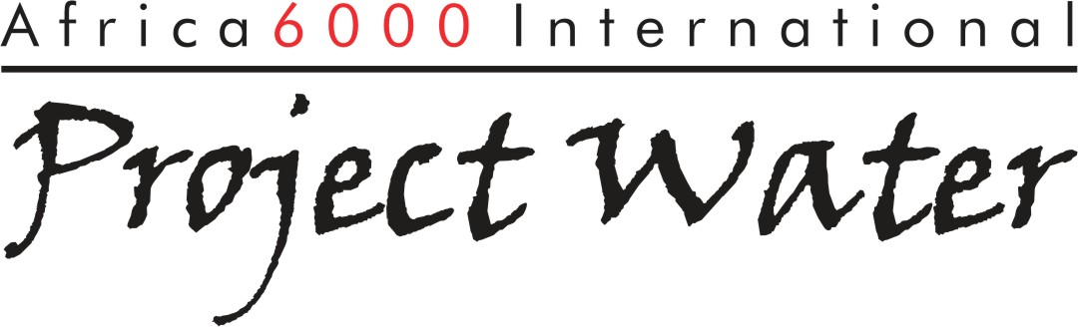
Sponsorship Opportunities: (814) 878-4419

-Platinum Sponsor: $10,000
You will receive two tables of ten in the “Exclusive” seating section; Dinner video
mention with interviews; Introduction at the dinner with opportunity to make
brief address to our guests; Your company logo on video loop during dinner; Two
full-page ads in the dinner booklet with logo on the front cover; Inclusion in all media
advertising; Entire African water well project dedicated in yours or your company’s
name.

-Gold Sponsor: $5,000
You will receive one table of ten in the “Premier” seating section; Dinner video mention;
Introduction at the dinner; Your company logo on video loop during dinner; Full page ad
in the dinner booklet with logo on the front cover.

-Silver Sponsor: $3,000
You will receive one table of ten in the “Honorary” seating section; Introduction at
dinner; Company logo on video loop during dinner; Full page ad in the dinner booklet
with logo on the back cover.

-Table Sponsor: $1,250
You will receive one table of ten at the dinner with yours or your company’s name on the
table; Dinner mention.

-Dinner Only: $100

With this sponsorship you will receive one dinner ticket. The menu entrée will include both filet & mahi mahi. (Vegetarian option is available upon request.)

