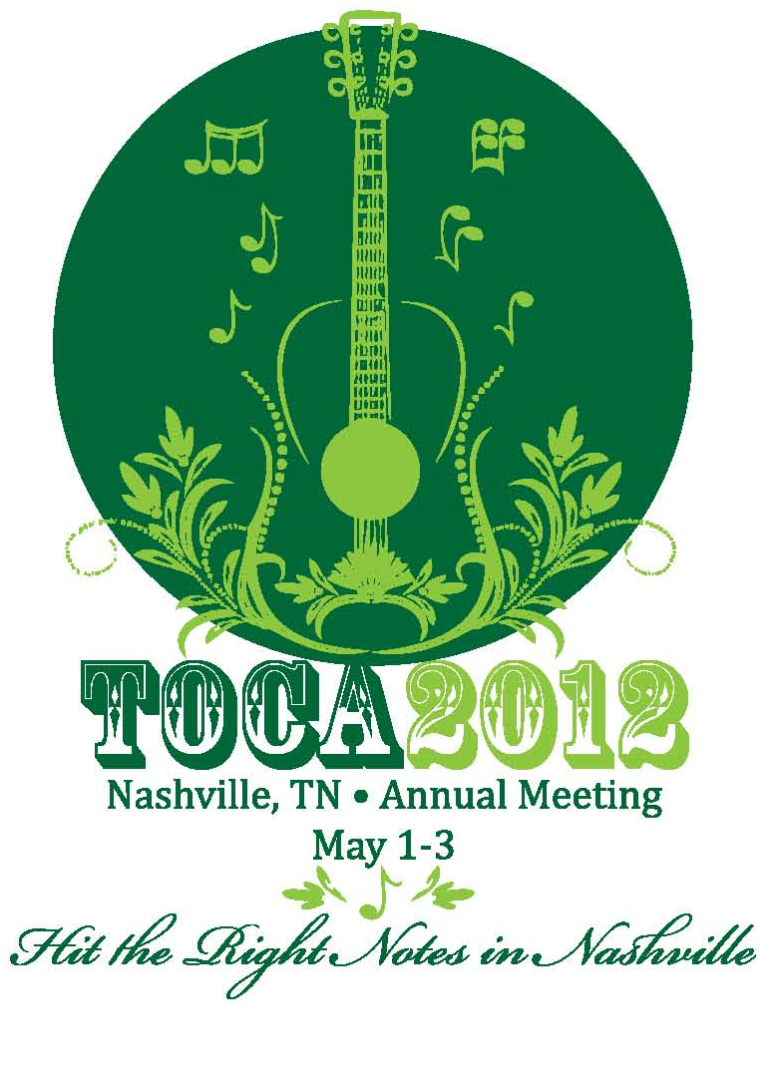


Embassy Suites Downtown

Portland, OR
May 7-9, 2013

Registration Information/Guest Information: Badge Information/Guest Information:

Name______________________________________________ First Name___________________________________
Title_______________________________________________ Full Name____________________________________
Company___________________________________________ Company ____________________________________
Address____________________________________________ City, State____________________________________
City___________________________________ State________ Guest Name _________________________________
Zip__________________ Phone____________________________________________ Fax__________________________________
Email________________________________________________________________________________________________________
Please check if you are a First Time Conference Attendee
***If you are bringing a guest, please photocopy this form and indicate GUEST on all information. Each participant must have a separate form to register.

Please indicate your t-shirt size: (TOCA members only) Small Medium Large X-Large XX-Large
____________________________________________________________________________________________________________________________

MEMBERS (Please check all functions you will attend): | GUESTS (Please check all functions you will attend):

Wednesday, May 8, 2013: (Check one activity option.)

Golf _____ Handicap (I will need to rent clubs ___RH __LH) Guest: Pacific Landscape Management Tour
(8:00 AM tee time) Golfers pay green fees at course. (Cost: $75 per person - payable to TOCA)
8:15 AM – 1:30 PM
OR

Pacific Landscape Management Tour with lunch
(Cost: $75 per person payable to TOCA)
8:15 AM – 1:30 PM

7:00 PM - 9:00 PM Welcome Reception–Embassy Suites, Portland Guest: Welcome Reception/Dinner- Embassy Suites, Portland
(Guest Cost: $85.00 per person)

Thursday, May 9, 2013:
Breakfast 8:00 AM – 9:00 AM Guest Breakfast (Guest Cost: Complimentary with Guestroom)
Lunch 12:00 PM – 1:15 PM Guest Lunch (Guest Cost: $45.00 per person)
Reception/Banquet 6:30 PM - 9:30 PM Guest Reception/Banquet (Guest Cost: $85.00 per person)

ATTIRE: Casual dress is appropriate for the entire meeting with the exception of the Thursday night reception and banquet. Comfortable walking shoes are recommended for the Wednesday tour.

***TOCA Cancellation Policy: A full refund will be issued if TOCA and/or Jean Pederson is notified within 21 working days or more prior to the starting date of the meeting (May 8, 2013).

TOCA Annual Meeting Registration Form – Page 2
Payment Method: Meeting Registration:
Annual Meeting Registration Fee: Member $350 Nonmember $500 (attending full conference)
Member Total Amount __________ (Members: Please include charge for Wednesday morning Tour in your total payment amount)
Guest Total Amount ____________ (Please include cost of tour and/or any meal functions you will attend)
I’ve enclosed a check, payable to TOCA. Amount Enclosed $___________________
Please bill my credit card (TOCA accepts only Visa, Master Card or American Express): Visa Master Card American Express

Total Amount to be billed to Credit Card $________________ (include Guest or indicate separate credit card for guest fees)

Credit Card #_________________________________________________ Expiration Date________________ Sec Code_________

Cardholder’s Name (Please Print) __________________________________________________________________________________
(If different than credit card information for hotel)
Cardholder’s Signature __________________________________________________________________________________________

Airport/Hotel Transportation:
Hotel is approximately 12 miles from the Portland International Airport (PDX). Taxi cost will be approximately $30.00.

Rental Cars Available at Airport:
Alamo | 1-800-462-5266 |  | Dollar | 1-800-800-4000 |  | Hertz | 1-800-654-3131
Avis | 1-800-331-1212 |  | Enterprise | 1-800-736-8222 |  | National | 1-800-227-7368
Budget | 1-800-527-0700 |  |  |  |  | Thrifty | 1-800-367-2277

Hotel Information:
Embassy Suites Portland Downtown  319 SW Pine Street  Portland, OR 97204 | Phone: 503-279-9000  Fax: 503-497-9051  Website: www.embassyportland.com
- TOCA has negotiated a special rate of $158.00 (single/double). The room block is available May 6 – 10, 2013. If you plan to extend your stay over the weekend, please contact Jean Pederson by April 5, 2013 so additional rooms can be requested. Hotel registrations are due by April 8, 2013
- Gratuities are not included in the above costs and will be at the individual’s discretion: TOCA will be responsible for any fees that are not paid by individual guests.

Please list the room type preference: Arrival Date_______________________ Time ______________________am/pm
(check one) Departure Date_______________________

Single (1 person, 1 King bed) Guest (Share with) Name:_____________________________________________
Double (2 person, 1 bed) Street Address _____________________________________________________
Double Double (2 persons, 2 beds) City_____________________________________ State________ Zip__________

Request Non-Smoking Room

Special Requests/Dietary Needs:__________________________________________________________________________________
Credit Card Information: (check one) Amex Mastercard Visa Discover

Account Number:________________________________________________ Expiration Date: ____________ Sec Code_________

Authorized Signature:_______________________________________________________________

Mailing Address for Credit Card if different than Registration Information:

Name____________________________________________________ Company Name___________________________________________________

Address___________________________________________________________________________________________________________________

City______________________________________________________________________________ State__________ Zip_____________________

Room reservation guarantee: In order to guarantee your room reservation, the hotel requires a valid credit card number and expiration date accompany each reservation. The first night charges will be applied 72 hours prior to arrival, unless notification of cancellation is received before the 72-hour deadline. You are responsible for payment of all room, tax and incidental charges. Any reservations made after the deadline will be based on availability at the hotel. Meeting and Hotel Reservation Deadline: April 8, 2013.
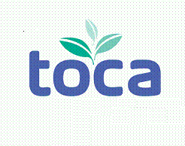
Return this form with your Registration Fee to:
Jean Pederson
8236 Irving Avenue South

Bloomington, MN 55431
Phone: 952-212-9155 Fax: 952-346-0347
E-mail: jean.pederson@live.com

TOCA Annual Meeting Registration Form – Page 3

Description of Off-Site Events

Wednesday, May 8, 2013
GOLF – STONE CREEK GOLF CLUB (Oregon City, OR)
8:00 a.m. – first tee off
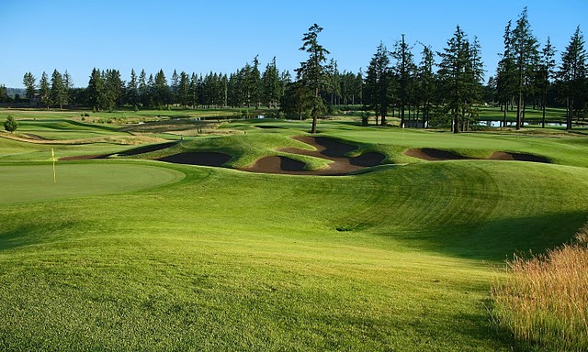
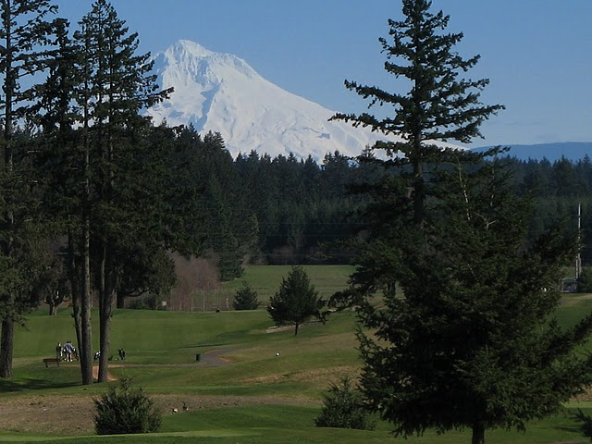
Stone Creek was designed by Peter Jacobsen and Jim Hardy and opened for public play in June of 2002. Since then Stone Creek has matured into one of the most beautiful and diverse courses in the Portland area. The course is laid out over 165 acres of rolling land with old-growth Douglas Firs, lakes, four wetlands, and forty-three bunkers. Scenically designed around the area’s natural beauty, Stone Creek also offers a spectacular view of famous Mt. Hood. The front nine was designed in a links-style while the back nine has more of a Northwest feel with tree lined fairways and elevation changes. In 2009, Stone Creek was voted by Links magazine as the eighth most “Environmentally Friendly Course” in the country.
Per person price: $65.00 plus tax payable at golf course.

www.stonecreekgolfclub.net

PACIFIC LANDSCAPE MANAGEMENT TOUR
8:15am – 1:30pm

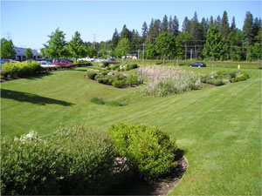
The Pacific Landscape Management facility is a sustainable demonstration project with solar power, rain gardens, green walls, bio-swales and ecological turf alternatives such as recycling, battery and propane equipment, organic fertilization, biodiesel and hybrid vehicles. Recently recognized in several industry publications, Pacific Landscape Management also hosted a PLANET summer leadership tour in 2010.
Bob Grover, president of Pacific Landscape Management, will be a featured speaker on Wednesday afternoon at the TOCA 2013 Annual Meeting.
Enjoy a relaxed light lunch at Cornelius Pass Roadhouse & Imbrie Hall McMenamins, a traditional Portland microbrewery. Alcoholic beverages are available for purchase and can be paid for separately.
Recommended Attire – Lightweight jacket or sweater, and comfortable walking shoes –may be uneven surfaces.
Per person price: $75.00 inclusive of roundtrip transportation, guided tour of the Pacific Landscape Management facility, lunch with non-alcoholic beverage, all applicable taxes and meal gratuities.

