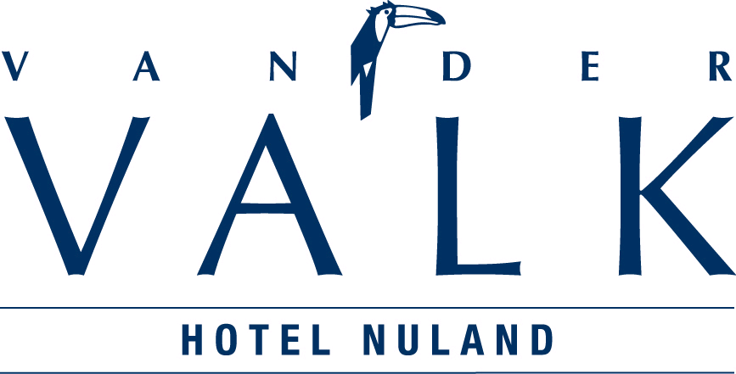

RESERVATIONFORM HOTEL NULAND
Poppen en Beren Beurs/Doll & Teddybear Fair (T383) 25 en 26 oktober 2014

General information
Name : _____________________________________________

Address : _____________________________________________

Zip code & City : _____________________________________________

Telephone number : _____________________________________________

Fax number : _____________________________________________

E-mail address : _____________________________________________

Number of persons arrival departure

1. M/F ___ _______________ O 1 O 2 _____ _____

2. M/F ___ _______________ O 1 O 2 _____ _____

Payment:
The bill needs to be settle on arrival. You can only guarantee your reservation by credit card.

Type credit card : VISA / AMEX / DINER / ………………… Expiration date : .….. / ……

Credit card number : ……………………………………………………… CVC code: ……….

Rates for 1 night
1 pers. room(ST/LX) incl. breakfast € 75,00 per stay
2 pers. room(ST/LX) incl. breakfast € 85,00 per stay

Rates for 2 nights

1 pers. room(ST/LX) incl. breakfast € 140,00 per stay
2 pers. room(ST/LX) incl. breakfast € 160,00 per stay

Rates for 3 nights
1 pers. room(ST/LX) incl. breakfast € 198,00 per stay
2 pers. room(ST/LX) incl. breakfast € 228,00 per stay
Tourist tax € 2,00 p.p.p.n.
Reservations are made on availability. Your reservation is definite when your have received a reservation number from our reception.

To Agree: Name:

Signature, Date: - - 2014
To all our reservations apply the Uniform conditions for the Hotel and Catering Industry

