

The Jewish Genealogical Society of Great Britain

21st Annual London One-Day Conference

Sponsored by

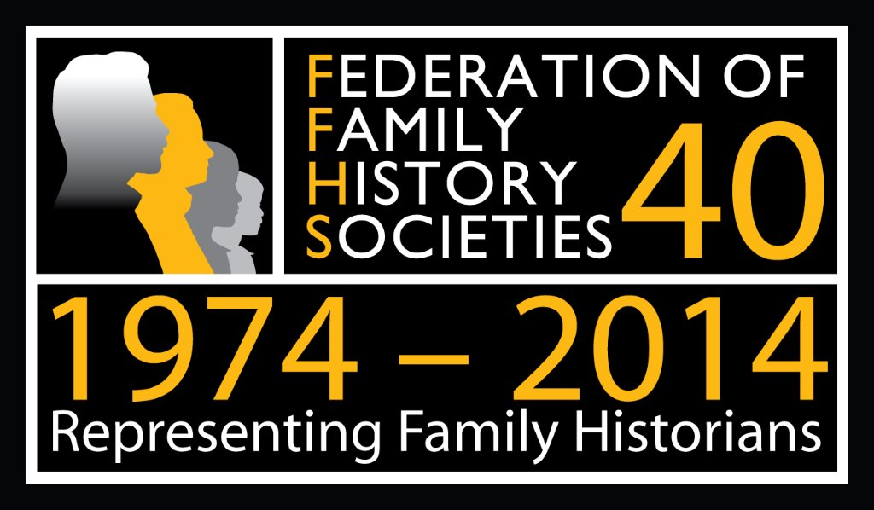

Sunday 26th October 2014
9.30 a.m. - 4.30 p.m.

At

The Jewish Museum London
Raymond Burton House,
129-131 Albert St
London NW1 7NB



Programme

9.30 a.m. – 10.00 a.m. Registration and Coffee

10.00 a.m. – 10.10 a.m. Chairman’s Welcome - Doreen Berger

10.10 a.m. – 10.50 a.m. Dr. Sharman Kadish - Director of Jewish Heritage UK: Batei Olam: For eternity? The Care and Preservation of Jewish Cemeteries and how Family Historians can help.

11.00 a.m. – 11.40 a.m. Martin D. Lee: "The singer - John Braham - Enigma, Anecdote and Reality"

11.50 a.m. – 12.30 p.m. Anna Haward: Tower Hamlets Local History Library & Archives: Jewish Sources for Family History at Tower Hamlets Local History Library & Archives

12.30 p.m. - 1.30 p.m. Lunch

1.30 p.m. – 2.20 p.m. Pamela Weisberger: President & Research Co-ordinator of Gesher Galicia: Exploring the Archives: Unique & Unusual Resources in Galician & Polish Research

2.20 p.m. - 3.00 p.m. Martin Sugarman - Archivist Jewish Military Museum (AJEX) - The March of the Judeans in 1918: when the spirit of Judah Maccabee hung over Whitechapel

3.00 p.m. – 3.30 p.m. Tea

3.30 p.m. – 4.10 p.m. Myko Clelland: from findmypast "Vu iz dos gesele?" – Using findmypast to trace those hard to find ancestors".

4.10 p.m. – 4.20 p.m. Closing address - Dr. Anthony Joseph – President Emeritus - JGSGB

4.30 p.m. Close

See following pages for Speaker Biographies and final page for Conference Registration Form

CONFERENCE PROGRAMME

9.30 a.m. to 10.00 a.m. - Registration and Coffee

10.00 a.m. to 10.10 a.m. - Chairman’s welcoming address

10.10 a.m. to 10.50 a.m.
Keynote Speaker:
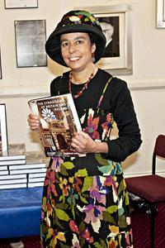

Dr. Sharman Kadish - Director of Jewish Heritage UK -
Batei Olam: For eternity? The Care and Preservation of Jewish Cemeteries and how Family Historians can help

Dr Sharman Kadish is Director of Jewish Heritage UK. She has been campaigning to protect historic synagogues and sites for over 25 years. She was born in London and educated at University College London and St Antony’s College Oxford and at the Hebrew University of Jerusalem. She has taught at the Universities of London and Manchester and is author of a number of books on Anglo-Jewish history and heritage, including Bolsheviks and British Jews (1992, winner of a Choice Outstanding Academic Book Award in 1993); A Good Jew and a Good Englishman: The Jewish Lads’ and Girls’ Brigade 1895-1995 (1995); Building Jerusalem: Jewish Architecture in Britain (ed. 1996); companion architectural guides Jewish Heritage in England (2006) and Jewish Heritage in Gibraltar (2007). Her latest book The Synagogues of Britain and Ireland: An Architectural and Social History (Yale University Press 2011) was shortlisted for the American Society of Historians of British Art Prize 2013, and a second edition of her best-selling guidebook is due to be published by English Heritage in spring 2015. Website: www.jewish-heritage-uk.org /

11.00 a.m. to 11.40 a.m.

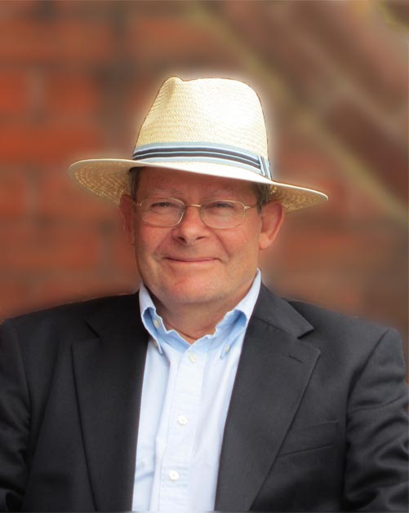

Martin D. Lee -
The singer - John Braham - Enigma, Anecdote and Reality

Martin D. Lee: My personal journey into Judaism ended with my mother’s sudden death in 1955 when I was aged 8, my father dying just 9 years later. I went on, however, to obtain degrees at Sussex and Southampton Universities and found myself undertaking a more technical than managerial career as an electronic engineer and physicist. This was triggered by my invention of a high voltage high frequency transistor switch back in 1969 to support the development of a holographic computer memory concept. Soon after, I met my future wife Sue, to whom I have been happily married ever since. We have two sons, now grown up with their own families who took somewhat different career paths in banking and the law. My wife had been a keen genealogist since 1964 and after discovering an early genealogy programme which ran on my Apple II computer back in 1981, took up tracing my own family history. A detailed hand written family tree of some of my maternal family was drawn to my attention that had been drafted by Anthony Joseph, a distant cousin, presumably when he was still in his teens for a mutual cousin. That was the first of many personal family history resources that I discovered. My Jewish family history extends from Penzance ‘through’ Lithuania to Mashhad in Persia (Iran). My Anglo-Jewish family history extending back to the late 17th century and I have uncovered a wealth of amazing family stories.

11.50 a.m. to 12.30 p.m.
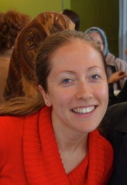

Anna Haward: Tower Hamlets Local History Library and Archives: Jewish Sources for Family History at Tower Hamlets Local History Library and Archives.

Anna is the Heritage Officer for Learning and Participation for Tower Hamlets Local History & Archives where she has worked in various guises for four years. The Library & Archives seeks to document and make available materials relating to the history of the Tower Hamlets area. Anna oversees a vibrant outreach programme in order to promote these materials. Anna is also in her second and final year of studying for a Masters in Archives and Records Management at University College London. She is passionate about advocacy for the archive sector, as she believes every individual has a right to know about and contribute to the collective memory of society, as documented in archives.

12.30 p.m. to 1.30 pm. - Lunch

1.30 p.m. to 2.20 p.m.
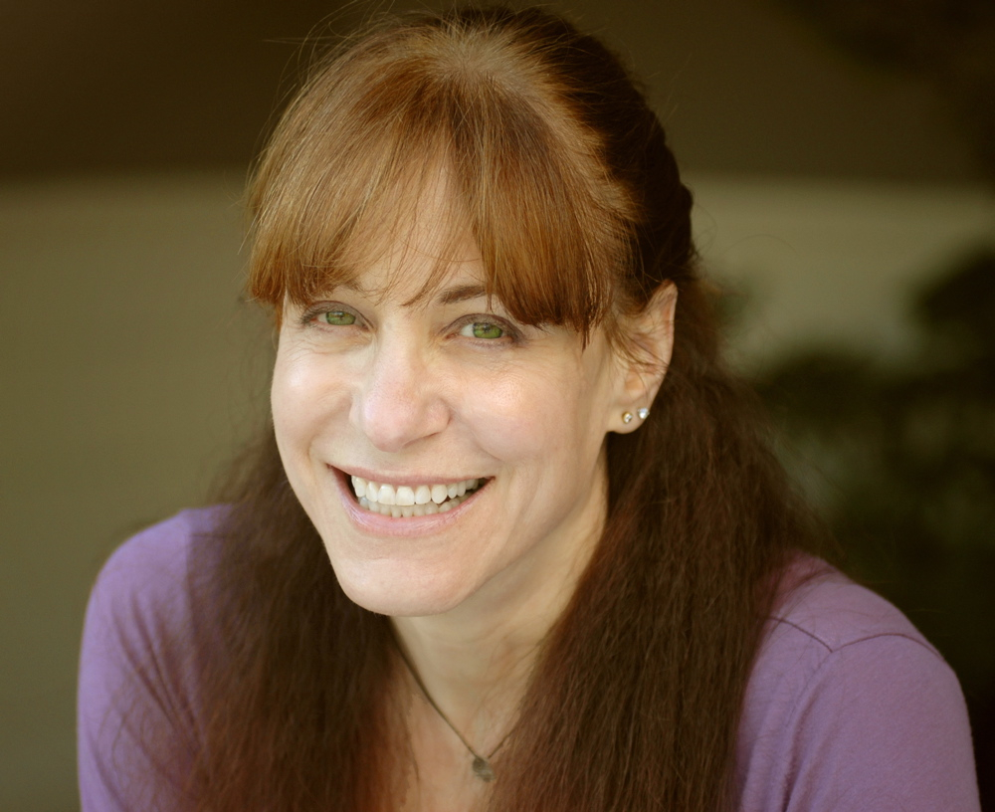

Pamela Weisberger
President and Research Co-ordinator of Gesher Galicia
‘Exploring the Archives: Unique & Unusual Resources in Galician & Polish Research’

Pamela Weisberger is the 1st V.P. and program chair for the Jewish Genealogical Society of Los Angeles, president and research coordinator for Gesher Galicia, Inc., and was co-chair of the 2010 IAJGS International Conference on Jewish Genealogy. A professional genealogist, writer, and internationally-known lecturer, she has conducted research in Polish, German Ukrainian, Hungarian and Austrian archives. She created the Galician Archival Records Project and the Gesher Galicia Cadastral (Virtual) Map Room. One of her specialties is historical newspaper research. She holds a B.A. from Washington University in St. Louis and an M.S. from Boston University.

2.20 p.m. to 3.00 p.m.

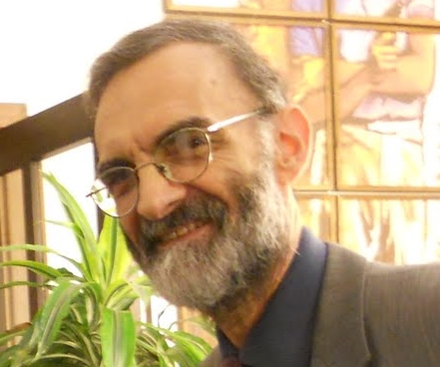

Martin Sugarman- Archivist Jewish Military
Museum (AJEX) -
The March of the Judeans in 1918: when the
spirit of Judah Maccabee hung over Whitechapel

Martin Sugarman: Born and educated in Hackney at Shacklewell Lane Primary and Upton House School, and then Bristol University (BA Hons Geography and Cert Ed. 1965-69), Martin taught for 22 years and was a Senior Teacher in Bristol and East London schools, latterly at Clapton Girls School/Technology College (formerly the John Howard Grammar).

Active in the Soviet Jewry campaign in the 1970’s, he also wrote on Holocaust history for Secondary School pupils for both the Auschwitz and Anne Frank Exhibitions in London in the 1980’s. He spent three years on Kibbutz Mizra, in Israel, as a dairy farmer, with his wife Jane (a freelance sub-editor) and children Gideon, Joel and Leah, and saw service in the Artillery, Israeli Army. He has served on his Synagogue Council, and is now Chair of the Hackney Anglo-Israel Friendship Association which is active in exchange visits between Hackney and its twin town of Haifa. His major spare time activity, however, is as Archivist of the Association of Jewish Ex-Servicemen and Women (AJEX) Military Museum in London.

Martin writes and lectures extensively on Jewish Military History and has had many articles published in the UK, USA and Israel in various historical journals, and on the internet. A book, “Fighting Back; aspects of the Jewish contribution to the British war effort 1939-45” was published in 2010 (Valentine Mitchell) and a second book “We Will Remember Them “, was published in 2011 (Valentine Mitchell, co-authored with Henry Morris). A new book on Jewish POW’s of the Japanese (‘Under the Heel of Bushido’) was published in March 2014, and Martin is also working on editing an update to the British Jewry Book of Honour of WW1, first published in 1922, based on recent researches by Harold Pollins of Oxford. A fifth book on Jews in the Fire Service in WW2 is in preparation. Martin also spends much time working with the CWGC to have unrecognised Jewish war dead commemorated and have Crosses changed to Stars of David where errors have occurred. His pre-retirement job was Examinations Officer at Westminster Kingsway College. He still lives in Hackney.

3.00 p.m. to 3.30 p.m. Tea

3.30 p.m. to 4.10 p.m.
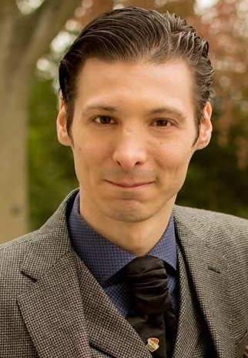
Myko Clelland from findmypast
"Vu iz dos gesele?" – Using findmypast to trace those hard to find ancestors

Myko Clelland (@dapperhistorian) has been working at findmypast for the past three years in various guises and is man with history in his veins. He’s responsible for spreading an infectious enthusiasm for genealogy through social media, promotion, advertising, PR campaigns, presentations and event presence. With a colourful ancestry covering very opposite corners of Europe and an inherited expertise for storytelling he’ll be showing conference goers how to get the best out of new findmypast and helping you get further into the past by giving a sneak peek of what’s coming in the future.

4.10 p.m. to 4.20 p.m.
Closing Address by President Emeritus
Dr Anthony Joseph

4.30 p.m. - Close

Conference Registration Form

I wish to register for the 21st Annual London One-Day Conference to be held on Sunday 26th October 2014, 9.30am - 4.30pm

The Jewish Museum, Raymond Burton House, 129-131 Albert St, London NW1 7NB (Wheelchair accessible).

Please write in BLOCK CAPITALS

Name: ………………………………………........................................................
Address: ……………………………………........................................................
........................................................................................................................
........................................................................................................................
Tel: Number: ………………………...................................
Mobile Number: ……………………..................................
E-mail: ………………………………………………………..

Please write clearly– thank you

Registration Fee per person: £35.00
Non-members £40.00
Includes Lunch & Refreshments

Name(s) of Attendee(s): ................................................................................... .................................…………………………….……….......................................

Number of Tickets: ………………….

Cheque enclosed for £ …………….. Cheques to be made payable to JGSGB

We also accept Credit and Debit cards. Please circle the card type Visa/Mastercard/Eurocard.

Name on Card: .................................................................... (Please print)
Card No: ..............................................................................
Expiry Date: .................................... 3-digit security code: ....................

All catering is kosher but not supervised.

Please tick here if you require vegetarian food

We regret we cannot provide vegan food.

Registration form and payment should be sent by post to:
Conference, JGSGB, PO Box 689, EDGWARE, HA8 4JX

