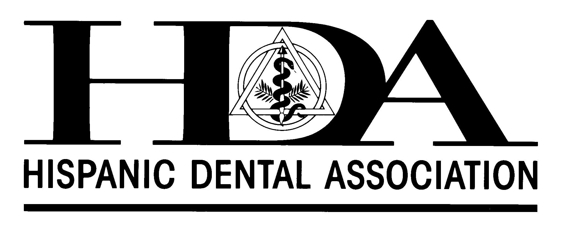
HISPANIC DENTAL ASSOCIATION
STUDENT MEMBERSHIP APPLICATION
2015 – 2016 (August 1, 2015 through July 31, 2016)

NAME (Last/First/Middle):
¨ MAILING ADDRESS:
CITY/STATE/ZIP:
CONTACT INFO: Work Phone Home Phone
Fax Email
¨ PERMANENT ADDRESS:

Please check which address is preferred for contact: ¨ Mailing ¨ Permanent

DENTAL PROGRAM INFORMATION
Name of School:
Date of Program Completion: Degree Expected:
CURRENT STATUS:
First Year Second Year Third Year Fourth Year

Post Graduate Program Type Residency Type
Does your school have a chartered HDA Student Chapter?
If YES, what is the name of your Faculty Advisor?

SURVEY INFORMATION (Optional)
- At this point, do you specialize? If yes, in what?
- Where do you think you will practice after graduation?
- What services would you like to derive from HDA membership?

- Are you willing to participate in community activities arranged by your chapter or the National HDA?
YES NO

- Are you willing to participate in a National HDA Committee (providing it does not require significant time?
YES NO

PLEASE COMPLETE AND RETURN THIS APPLICATION (by mail, fax, or email) ALONG WITH YOUR $15.00 NATIONAL STUDENT MEMBERSHIP DUES. (Your local student chapter, at its discretion, may collect additional member fees.)
Credit Card Information:
Visa [ ] Mastercard [ ] Credit Card #:
Expiration Date: Name on Card:
Security code: ________________ Billing Address:
City/State/Zip:
If mailing a check, add $10.00 processing fee. Make Check or Money Order payable to the Hispanic Dental Association. Check #: ___

