2015 endMS Summer School
Travel and Expense Policies
Funded Trainees

Before you finalize your registration, you will be asked to confirm that you have read this document and you understand these policies when planning for your attendance at Summer School. These policies apply to all Summer School participants (including those enrolled in SPRINT) who are funded by the endMS National Education and Training Program (“endMS”) to attend.

Any questions should be directed to Anik Schoenfeldt by emailing: anik.schoenfeldt@mail.mcgill.ca or by calling (514) 843-1442 / 1-877-288-2570

- Travel Awards for travel to and from endMS Summer School
These awards are intended to defray the costs of the participant’s economy airfare and/or ground transportation and will be provided on a reimbursement basis after the program, upon submission of a completed expense claim form. Participants are required to book their own air travel and ground transportation, to and from Montreal.

Any additional travel costs incurred by participants above the maximum award amount will not be reimbursed by endMS.

The maximum amount of the award depends upon the location of the participant’s institution, due to differences in flight costs from these locations:

Travel from the following regions | For those traveling from the following cities and surrounding area | Travel Awards
Western-Pacific Regional Research and Training Centre | Vancouver, BC | $ 1000
Western-Pacific Regional Research and Training Centre | Regina or Saskatoon, SK | $ 800
Alberta Regional Research and Training Centre | Edmonton, AB | $ 850
Alberta Regional Research and Training Centre | Calgary, AB | $ 850
Alberta Regional Research and Training Centre | Lethbridge, AB | $ 1050
Manitoba-Ontario Regional Research and Training Centre | Winnipeg, MB | $ 750
Manitoba-Ontario Regional Research and Training Centre | London, ON | $ 600
Manitoba-Ontario Regional Research and Training Centre | Toronto, ON | $ 500
Quebec-Ottawa Regional Research and Training Centre | Ottawa, ON | $ 200
Quebec-Ottawa Regional Research and Training Centre | Montreal, QC | $ 100
Quebec-Ottawa Regional Research and Training Centre | Quebec City, QC | $ 200
Atlantic Regional Research and Training Centre | Halifax, NS | $ 600
Atlantic Regional Research and Training Centre | St. John’s, NL | $ 800
Atlantic Regional Research and Training Centre | Fredericton, NB | $ 650
Atlantic Regional Research and Training Centre | Charlottetown, PE | $ 650

- Air Travel: Whenever possible, participants are expected to take advantage of advanced purchase excursion fares, seat sales, etc.
Prior to booking your flights, keep in mind the Summer School start/end times as well as travel time required between the airport and hotel. (Refer to the Important Registration Information document emailed along with this document)
Eligible fares:
- Air Canada Tango Plus category or equivalent (economy airfare), no matter which airline is used.
- You could save 10% on available base fares via Porter Airlines by booking online at www.flyporter.com or through your travel agent using promo code ENDMS15.
- You could save 10% on regular-fare WestJet flights by utilizing promo code YUL01 and coupon code VE2C3Q7. To book using this discount code visit www.westjet.com and both the promo code and coupon code must be entered at the time of booking. Discounts apply from May 4 to May 13th travel dates. (May 14-19 are blackout dates because of the long weekend)
- Seat selection is an allowable expense.
Not eligible:
- Costs associated with changes to air travel arrangements, including airline change fees and differences in air fare associated with the new booking, are not eligible for reimbursement.
- Other than meals (which are outlined below in item #3 – Meal Allowances), any air travel-related expenses (e.g. for onboard earphones, extra luggage) are not eligible for reimbursement.
- Fees related to booking air travel through a travel agent will not be reimbursed.
- Additional airfare for stopovers and other costs that are not related to the endMS Summer School, or do not result in cost savings to endMS are considered to be personal expenses.

Air Travel Documentation: Below is the checklist of required documents for air travel reimbursement
- Passenger Itinerary/Receipt
- Original boarding passes for all flights
- Proof of payment (itemized receipt and copy of credit card statement)
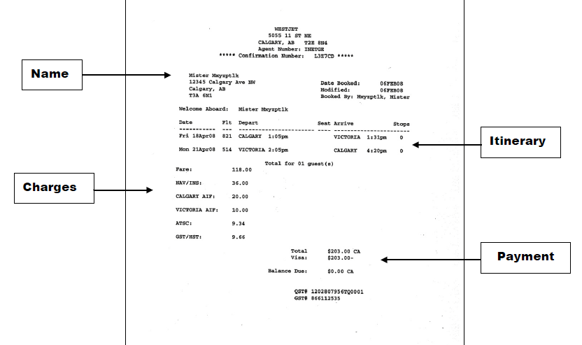
Note: While endMS will reimburse air travel booked through online travel agencies, the necessary itinerary/receipt is required. Booking confirmation without breakdown of charges and proof of payment is not acceptable for reimbursement.

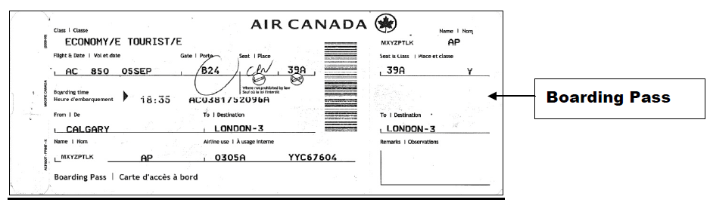

- Ground Transportation:
Taxi, Bus or Train: Taxi fares, plus reasonable gratuity, are a reimbursable expense. However, other less expensive forms of transportation should first be considered. (e.g. airport/hotel shuttle services, bus etc). Original receipts and credit card statement should be submitted with your expense claim form.
- The 747 is an airport city bus that travels between the airport and downtown Montreal, with a stop in front of the hotel. The cost is $10. There is a kiosk at the airport to purchase a ticket or payment can be made in coins directly on the bus (keep the ticket as proof of payment). For more information on this option view the website (STM)

Private Automobile Transportation: Use of a personal vehicle can be reimbursed as mileage, at a rate of 57 cents per kilometer up to a maximum claim of $250 per return trip. Mileage rate reimburses the cost of fuel and wear and tear on the personal vehicle. Additional fuel charges are not reimbursable when mileage rate is used. Include a copy of Google maps with the departure and end points as backup.

Automobile Rental: Automobile rentals, where necessary or cost-justifiable, are a reimbursable expense. Rented automobiles should be non-luxury and of standard, compact or sub-compact size. The insurance cost of rented vehicles is also a reimbursable expense. The claimant’s original automobile rental and related gas receipts are to be submitted for reimbursement.

Ground Transportation in lieu of Air Travel: Participants may claim mileage, train, bus, automobile rental instead of airfare for travelling to Montreal, up to travel award maximum.

Ground Transportation for Local Participants: Participants from the Montreal area may claim ground transportation expenses incurred when travelling to and from endMS Summer School sessions and networking events.

Parking: Airport and public parking expenses are eligible for reimbursement. Original receipts are to be submitted with the expense claim form.

- Tips for staying “on budget”:
Tip #1: You could save on airfare: see section 1.i above.
Tip #2: Share a taxi with other participants to/from airports or consider the airport city bus for travel to and from the Montreal airport (STM).
Tip #3: Don’t wait until the last minute to book your flights; fares tend to go up close to departure date

- Accommodation * All rooms must be booked through endMS *

Candlewood Suites Montreal Downtown Centre Ville
191 Rene Levesque Boulevard East
Montreal, QC H2X 3Z9
For more information on the hotel please visit their website at: Candlewood Suites

- Room booking: All rooms, including extended stays, must be booked through endMS. Please do not contact the hotel directly.
endMS will provide free accommodation at Candlewood Suites for all Summer School participants who reside outside of the Montreal region. By default, all participants will be booked to check in on May 11th and to check out on May 15th. SPRINT trainees will check in on May 10th

- Extended Stays:
Participants have the option to request additional nights, and the hotel has agreed to offer their special group rate of $129, plus taxes, to anyone wishing to extend their stay. To take advantage of this offer, you MUST specify your preferred check-in and check-out dates on the registration form, and endMS will book this for you (dependent upon room availability). Extended stays are to be paid by you directly to the hotel at your time of arrival.

- Hotel Charges:
The Hotel will require a credit card upon check-in for guests wishing to charge any incidentals to their rooms. Participants are responsible for paying the hotel directly for any and all extra charges including any extra charges associated with an extended stay.

- Meals
- Provided Meals: All are invited to disclose any dietary restrictions on their registration form.
The following meals will be provided at no charge for all participants during endMS Summer School:
- Dinner (Monday, May 11th and Tuesday, May 12th)
- Breakfast, Lunch and Breaks (Tuesday, May 12th – Friday, May 15th)
Wednesday and Thursday evenings are considered free nights. Please refer to section ii Meal Allowances for more information.

In addition, those enrolled in SPRINT will be provided with dinner on May 10th and breakfast, lunch and breaks on Monday, May 11th.

- Meal Allowances: These allowances are separate from, and in addition to, your travel award.
Meals outside of those provided during the summer school will be reimbursed up to a maximum of (including taxes and gratuities): Breakfast: $10.00 Lunch: $16.00 Dinner: $28.00

Meals en route: Participants are entitled to expense en route meals both to and from Montreal, up to a maximum of $16 each way (including taxes and gratuities). This could include meals purchased in the airport, onboard flights or otherwise en route.

Free Nights: For Wednesday and Thursday night where dinner is not provided, endMS will reimburse participants for actual out-of-pocket expenses up to $28 (including taxes and gratuities).

Alcohol is not a reimbursable expense; please deduct all expenses for alcohol (including associated taxes and gratuities) when entering the amount claimed for that receipt. TIP: Request a separate alcohol receipt, and pay for any alcoholic beverages separately.

- Documentation
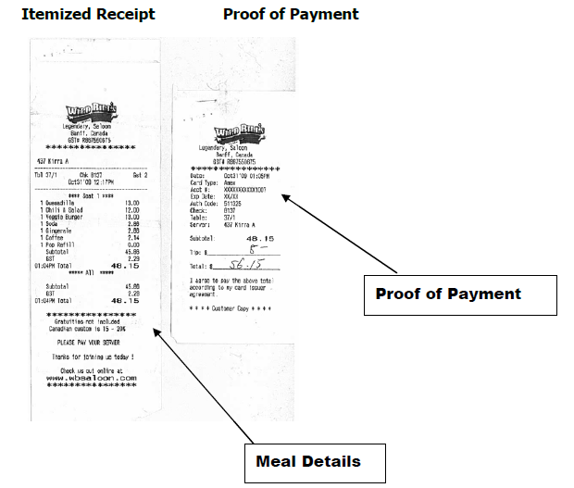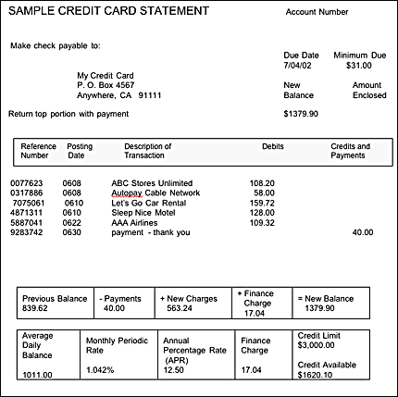

Both the itemized receipt showing actual meal and beverage details AND the proof of payment must be submitted with the expense claim form. Credit/debit card receipts are not acceptable by themselves (without the itemized receipts) as they do not provide the details of the expense. If payment is by credit card, a copy of your credit card statement with expenses highlighted must also be included. Write your name and the names of the individuals whose meals are covered by that receipt on the back of the receipt. Gratuities (if any) should be included on the proof of payment. Reminder: Alcohol is not a reimbursable expense; please ask for a separate bill for alcohol or deduct all expenses for alcohol (including associated taxes and gratuities) from your claim.

- Other
All course materials will be provided by endMS, at no cost to the participant.

- Withdrawal from the Program:
Any participant withdrawing from the program after registration may be charged a penalty for any costs that have been incurred by the endMS Network or Multiple Sclerosis Society of Canada on their behalf. In addition, the participant will not be reimbursed for any associated costs that they have already personally incurred.

- Expense Reimbursement
Anyone requesting a reimbursement must complete and return a Direct Deposit Form to the Research Institute of the McGill University Health Centre (RI-MUHC) prior to getting reimbursed. This form, which includes instructions and mailing address, will be available on the 2015 endMS Summer School webpage.

An electronic copy of the expense claim form will be available closer to the date. At the conclusion of Summer School, participants must complete, sign and return the expense claim form, including all receipts, boarding passes and a copy of your credit card statement with expenses highlighted, by June 17th to:
endMS National Education and Training Program
c/o Anik Schoenfeldt
Research Institute of the McGill University Health Centre
1025 Pine Avenue West, Room P2.028
Montreal, QC H3A 1A1

Please note: All expenses must be reimbursed to the person who incurred them. If any expenses were paid for by a relative, supervisor or other individual, they must submit a separate expense claim form for those expenses (one form per claimant). Expenses paid directly by the participant’s institution may also be reimbursed back to that institution upon submission of a separate expense claim form.

