2015 endMS Summer School
Travel and Expense Policies - Invited Presenters/Facilitators/Mentors

If you have questions about the policies and guidelines below, please contact Anik Schoenfeldt:
e-mail: anik.schoenfeldt@mail.mcgill.ca phone: 514-843-1442

Air Travel You are required to book your own air travel to and from Montreal.
Eligible Fares:
- Air Canada Tango Plus category or equivalent (economy airfare), no matter which airline is used.
- Business class travel will not be reimbursed.
- Whenever possible, please take advantage of advanced purchase excursion fares, seat sales etc.
- You could save 10% on available base fares via Porter Airlines by booking online at www.flyporter.com or through your travel agent using promo code ENDMS15.
- You could save 10% on regular-fare WestJet flights by utilizing promo code YUL01 and coupon code VE2C3Q7. To book using this discount code visit www.westjet.com and both the promo code and coupon code must be entered at the time of booking. Discounts apply from May 4 to May 13th travel dates. (May 14-19 are blackout dates because of the long weekend)
- Seat selection is an allowable expense.
Not eligible:
- Costs associated with changes to air travel arrangements, including airline change fees and differences in air fare associated with the new booking, are not eligible for reimbursement.
- Other than meals (which are outlined on page 3 – Meal Allowances), any air travel-related expenses incurred by you (e.g. for onboard earphones, extra or oversize luggage) are your responsibility and are not eligible for reimbursement.
- Fees related to booking air travel through a travel agent will not be reimbursed.
- Additional airfare for stopovers and other costs that are not related to the endMS Summer School, or do not result in cost savings to endMS are considered to be personal expenses.

Air Travel Documentation: Below is the checklist of required documents for air travel reimbursement
- Passenger Itinerary/Receipt
- Original boarding passes for all flights
- Proof of payment (receipt and credit card statement)
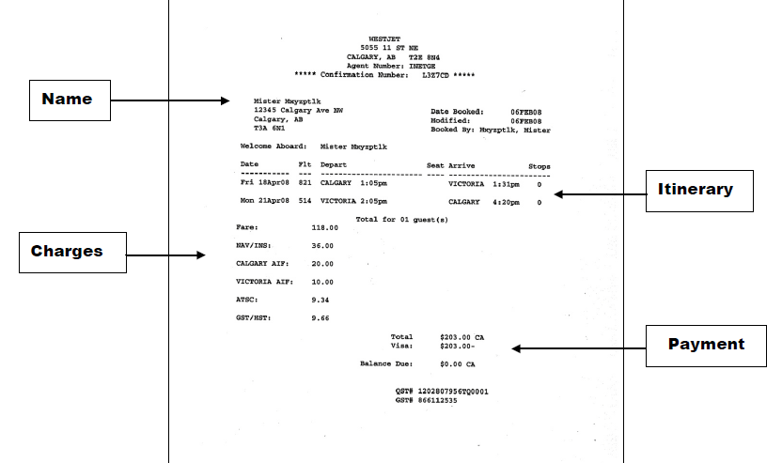
*Booking confirmation without breakdown of charges and proof of payment is not acceptable for reimbursement.
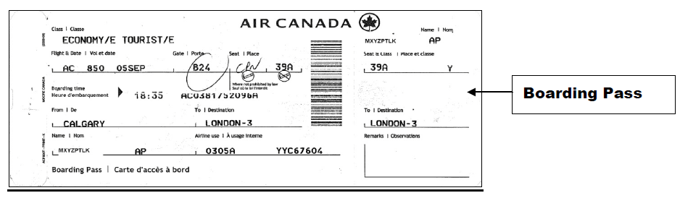

Ground Transportation
Taxi, Bus or Train: Taxi fares, plus reasonable gratuity, are a reimbursable expense. However, other less expensive forms of transportation should also be considered (e.g. airport/hotel shuttle services, bus etc). Original receipts should be submitted with your expense claim form.
- The 747 is an airport city bus that travels between the airport and downtown Montreal, with a stop in front of the hotel. The cost is $10. There is a kiosk at the airport to purchase a ticket or payment can be made in coins directly on the bus (keep the ticket as proof of payment). For more information on this option view the website (STM)

Private Automobile Transportation: Use of a personal vehicle can be reimbursed as mileage, at a rate of 57 cents per kilometer. Mileage rate reimburses the cost of fuel and wear and tear on the personal vehicle. Additional fuel charges are not reimbursable when mileage rate is used. A copy of Google maps including the departure and end points should be attached to your claim as backup.

Automobile Rental: Automobile rentals, where necessary or cost-justifiable, are a reimbursable expense. Rented automobiles should normally be non-luxury and of standard, compact or sub-compact size. The insurance cost of rented vehicles is also a reimbursable expense. The claimant’s original automobile rental and related gas receipts are to be submitted for reimbursement.

Ground Transportation in lieu of Air Travel: You may claim mileage, automobile rental or other ground transportation expenses instead of airfare for travelling to/from Montreal, up to a maximum of the equivalent economy airfare by the most direct route.

Parking: Airport and public parking expenses are eligible for reimbursement. Original receipts are to be submitted with the expense claim form.

Accommodation *All rooms must be booked through endMS. Please do not contact the hotel directly.

Candlewood Suites Montreal Downtown Centre Ville
191 Rene Levesque Boulevard East, Montreal, QC H2X 3Z9
For more information on the hotel please visit their website at: Candlewood Suites

endMS will provide free accommodation for anyone who resides outside of the Montreal region. You must specify your preferred check-in and check-out dates on your registration form.

If you choose to extend your stay (prior to May 10th or beyond May 15th) for personal travel, endMS will reimburse only the costs associated with your attendance at the 2015 endMS Summer School. Additional room nights are considered a personal expense. The hotel has agreed to offer their special group rate of $129 plus taxes to anyone wishing to extend their stay.

endMS does not object to family members travelling with you, but no expenses related to family members will be reimbursed.

Hotel Charges: The Hotel will require a credit card upon check-in for any incidentals such as long distance calls, etc. Invited presenters/mentors/facilitators are responsible for paying these extra charges. Any extra charges associated with an extended stay must be paid directly to the hotel.

Meals Everyone will be invited to disclose any dietary restrictions on their registration form.
Provided Meals: The following meals will be provided at no charge during endMS Summer School:
- Dinner (Monday, May 11th and Tuesday, May 12th)
- Breakfast, Lunch and Breaks (Tuesday, May 13th – Friday, May 16th)
The Wednesday and Thursday evening are considered free nights. Please refer to section Free Night below.

In addition, endMS SPRINT presenters/facilitators/mentors will be provided with dinner on May 10th and breakfast, lunch and breaks on Monday, May 11th.

Meal Allowances: Claims for meals not already being provided are reimbursed up to a maximum of (including taxes and gratuities): Breakfast: $10.00 Lunch: $16.00 Dinner: $28.00

Meals En Route: Participants are entitled to expense en route meals both to and from Montreal, up to a maximum of $16 each way (including taxes and gratuities). This could include meals purchased in the airport, onboard flights or otherwise en route.

Free Nights: For Wednesday and Thursday night where dinner is not provided, endMS will reimburse participants for actual out-of-pocket expenses up to $28 (including taxes and gratuities).

Alcohol is not a reimbursable expense; please deduct all expenses for alcohol (including associated taxes and gratuities) when entering the amount claimed for that receipt. TIP: You may wish to request a separate alcohol receipt, and pay for any alcoholic beverages separately.

Documentation:
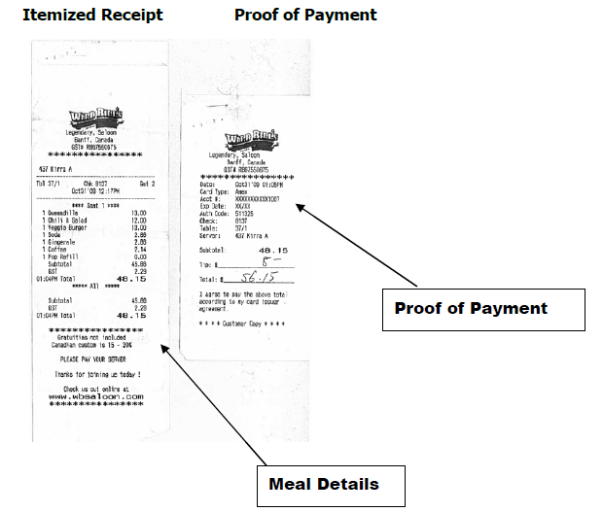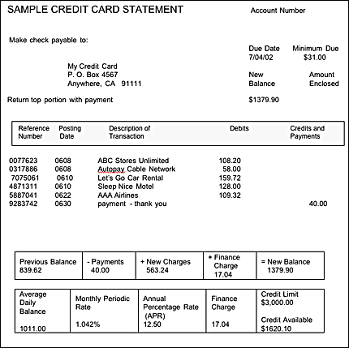

Both the itemized receipt showing actual meal amounts AND the proof of payment must be submitted with the expense claim form. Credit/debit card or cash receipts are not acceptable by themselves as they do not provide the details of the expense. A copy of your credit card statement with expenses highlighted must also be included. Please feel free to black out any personal or irrelevant information. The claimant must write the names of the individuals, whose meals are covered, on the back of the receipt. Gratuities (if any) should be included on the proof of payment.

Expense Reimbursement
Anyone requesting a reimbursement must complete and return a Research Institute Direct Deposit Form (if not already done) prior to getting reimbursed. This form, which includes complete instructions and mailing address, will be provided prior to Summer School along with an electronic copy of the expense claim form. At the conclusion of Summer School, participants must complete, sign and return the expense claim form, including original receipts, boarding passes, credit card statement with expenses highlighted, to:
endMS National Education and Training Program, c/o Anik Schoenfeldt
Research Institute of the McGill University Health Centre
1025 Pine Avenue West, Room P2.028
Montreal, QC H3A 1A1

Deadline for reimbursement submission: Wednesday, June 17, 2015.

