
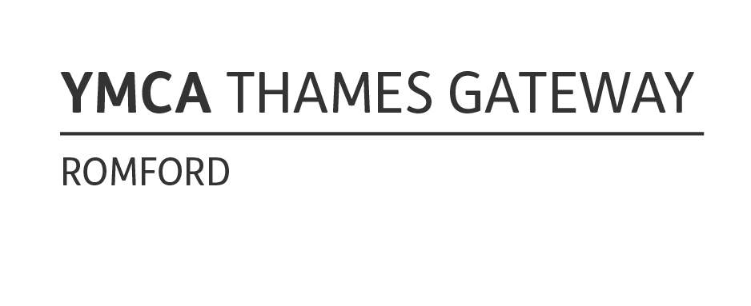

Children’s Services REGISTRATION FORM

Please complete the following information so we can register your child with the YMCA children’s services department

Type of care required (please tick relevant box)
After School Club 3pm to 6pm @ YMCATG Rush Green Road |  | After School Club 3pm to 6pm @ St Marys Hare Park School

Child’s Details
First Name | Surname
Date of Birth | Gender M / F  (please circle)
Home Address | Home telephone number
Home Address | Mobile telephone number
Postcode | Languages Spoken
Parents Email Address 1 | Religion
Parents Email Address 2 | Please provide a password for use when collecting your child
Who does the child normally live with? | School Attended

Adults authorised to collect the above Child from YMCA
Mother’s Name | Do they have parental responsibility? | N/A | Mother’s Place of work | Contact Work Telephone | Mobile
Father’s Name | Do they have parental responsibility? | N/A | Father’s Place of Work | Contact Work Telephone | Mobile
Emergency contact 1 | Do they have parental responsibility? | Relationship to Child | Home address | Contact Telephone | Mobile
Emergency contact 2 | Do they have parental responsibility? | Relationship to Child | Home address | Contact Telephone | Mobile
Emergency contact 3 | Do they have parental responsibility? | Relationship to Child | Home address | Contact Telephone | Mobile

Important
We ask that you keep us informed of any changes to the details. Periodically we may ask you to confirm your details for our records.

Medical Information and Doctors Details
Doctors Name | Doctors Address | Doctors Telephone number
Please give details of any allergies your child may have

Please give details of any medication your child is currently taking

Other information about your child which you think may be relevant – do they have a social worker, is there any health or behavioural issues we should know about?

Does your child follow any particular religion or beliefs and if so, is there anything we can do or provide to help with this?

Does your child above have any Special Education Needs? (If yes, please provide details)

Is your child on School Action, Early Years Action or Early Years Action Plus? (If yes, please provide details)

Does your child have an EHC plan (Education, Health and Care Plan)? (If yes, please provide details)

Consents |  |  | Please tick
In the event of an accident, I give my full consent for a trained member of staff to apply first aid to my child
I give permission for a member of YMCA staff to apply a plaster or bandage on my child if required
I consent to my child being photographed / videoed during the childcare activity for the purposes of general records or for the press, or for the website
In case of emergency, I give permission for the staff to seek necessary emergency medical advice or treatment. (Please note that we will contact you immediately)
I give permission for my child to leave the YMCA building with his/her group staff to attend organised trips and outing
I give permission for a member of YMCA staff to apply sun cream when my child needs it. I understand that I will supply and clearly label the sun cream.
I give permission for my child to have their face painted
I give permission for my child to use the selective mode of transport for outings and journeys planned by YMCA (this can include train, bus, underground, minibus, walking etc.). Outing risk assessments are carried out by staff prior to activities.
How did you hear about YMCA Children’s Services?

After School Club
Start date | Monday | Tuesday | Wednesday | Thursday | Friday

What payment method are you going to use?
Cash | Credit card | Work based vouchers | Monthly Direct Debit (additional form required)

Sign…………………………………………………………….Print Name…………………………………..………

Relationship to child……………………………………….. Date……………………………………..….………..

