

The Murrells Inlet Christmas Parade Committee is very excited about the 2016 Murrells Inlet Christmas Parade. The parade is hosted by Murrells Inlet 2020, a 501c3 non-profit community organization dedicated to making the Inlet a nice place to live, work and visit.
Parade Date: Sunday, December 4, 2016 at 3:00 pm -- RAIN OR SHINE
Application Deadline: Monday, November 28, 2016

Parade Route: The parade starts at Highway 17 Business from Willcox Ave (Booty’s) heads south to Wachesaw Road (Inlet Sports Lodge), then West on Wachesaw Road, towards Murrells Inlet road, where it will disband. Please note that the parade route is 1.2 miles long.
Attached is the Murrells Inlet Christmas Parade application packet. Please read the Parade Rules & Regulations very carefully. Please fill out the application completely and return it in-person or by mail, email or fax (with your entry fee) by November 28, 2016 to:
Murrells Inlet 2020
PO Box 1357
Murrells Inlet, SC 29576
Email: admin@murrellsinletsc.com
Fax: 843-357-2913

We will NOT accept any applications past the deadline and we will NOT allow any day of registrations. Please feel free to contact the Murrells Inlet 2020 office at 843-357-2007 or admin@murrellsinletsc.com.
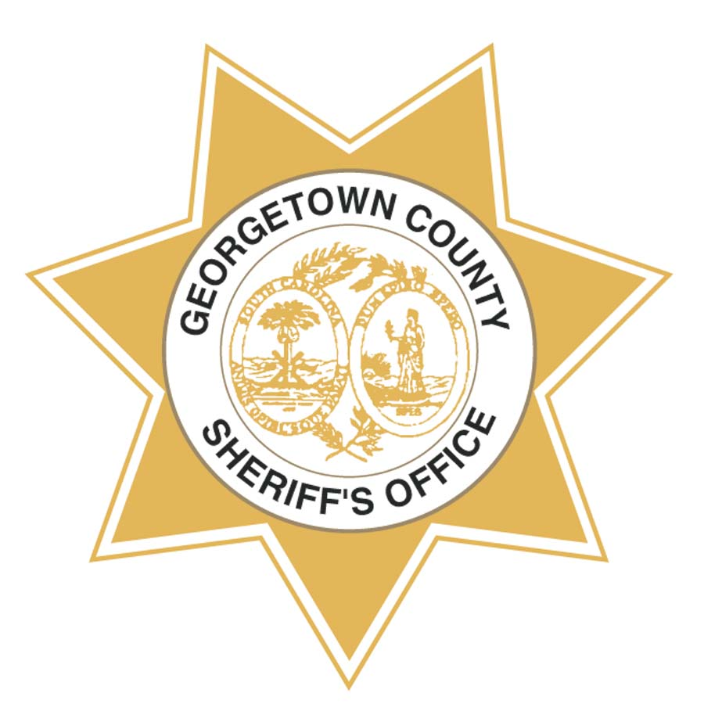
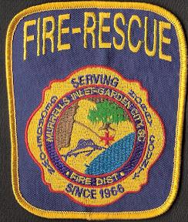
Thank you to our Parade Partners:
Georgetown County Sheriff‘s Office
Murrells Inlet/Garden City Fire & Rescue


2016 Murrells Inlet Christmas Parade Registration Form

PLEASE PRINT LEGIBLY
Group or Business Name: ___________________________________________________________________

Contact Name: ___________________________________________________________________________
Each entry must designate one person as a single point of contact who is responsible for the entire group’s conduct and the entire group’s understanding and acceptance of the Rules & Regulations. The contact person must be at least 18 years old. All correspondence will be with this person. All correspondence will be via email.
Amount Enclosed
Entry Fee: _____$15.00___
+ Donation*: ___________
Total Enclosed: __________
*Note: Your voluntary donation is appreciated. Donations are tax-deductible. You will receive a donation receipt for your records.
Phone (day): ___________________ Day of Parade Phone:__________________

Email:_____________________________________________________________

Mailing Address:_____________________________________________________

City: ___________________________________State: ______ Zip:____________
Make check payable to Murrells Inlet 2020 or Credit Cards will be accepted
Credit Card #:__________________________________ Expiration Date:_________
3-Digit Code on back: ________ Card holder‘s name:_____________________
Street Address Number:_______________ Zip:_____________ (Street address & zip associated with credit card)
Type of Entry: Please check all that apply. On the line, please indicate the size of each entry (length in feet, number of vehicles/people. This information is important for parade line-up. No more than five cars, trucks, boats, floats, motorcycles, bicycles, golf carts and/or any other vehicle per entry.
□ Marching Band _______ □ Walking Group _______ □ Car_______ □ Truck _______ □ Boat ______
□ Float/Flatbed _______ □ Motorcycle ______ □ Bicycle _______ □ Golf Cart ______ □ Small Pets_____
□ Other (Please describe)________________________________________________________________
Will you have music? □ Yes □ No
2016 Murrells Inlet Christmas Parade Participation Agreement & Liability Release
I, the undersigned, and all members of my group, have read and agree to abide by the parade rules and regulations. My group is fully responsible for our actions. In acceptance of participation in the Murrells Inlet Christmas Parade, all members of my group, our heirs and assigns, release Murrells Inlet 2020 Inc., all event workers, sponsors, officials and volunteers from any and all liability arising from illness, injury or damages that I or any member of my group may suffer or inflict on others. All members of my group hold Murrells Inlet 2020 Inc, all event workers, sponsors, officials and volunteers harmless from any and all claims, injuries or damages arising from our involvement in the parade. I also attest that our group has sufficient insurance protection for our participation in the parade. I give my permission for free use of my group’s name and picture(s) in broadcast, telecast or written accounts of the event.

Signature:_________________________________________________________Date _______________________
Please Print Name: _____________________________________________________________________________
Please submit this registration form with payment to Murrells Inlet 2020 by November 28, 2016
2016 MURRELLS INLET CHRISTMAS PARADE
RULES & REGULATIONS

- There is a $15 parade entry fee (to cover the insurance and administrative costs). We also ask you to donate one unwrapped toy for the USMC Toys for Tots drive. Fees are waived for schools, and police and fire department entries and other non-profits.
- Each parade entry is limited to five vehicles per unit (i.e., any combination of cars, trucks, boats, floats, motorcycles, bicycles, golf carts or any other vehicle).
- The 2016 Murrells Inlet Parade Committee maintains the right to control the type and number of participants in the parade. Applications are due by 4:00 pm on November 28, 2016.
- ALL ENTRIES MUST BE DECORATED IN A HOLIDAY THEME. The purpose of the parade is to provide enjoyment for the members of our community, especially for the children. MAKE IT FUN FOR THE KIDS! Decorate, Decorate, Decorate! Dress Up! Show your Christmas spirit!
- A panel of children judges, located along the parade route, will pick the best entry. An email announcing the winner will be sent to all participants after the parade.
- The official Santa Claus will ride in the fire truck at the end of the parade. Please do not dress up like Santa, so we don’t confuse the children.
- Please no throwing of candy or objects to the viewers during the parade due to liability, safety and litter concerns. You may walk beside your unit and hand out candy or other items.
- No horses or other large animals are allowed to walk in the parade. Small pets walking in the parade or sitting on trucks or floats must be leashed and under the control of a human. All animal droppings must be picked up by participants.
- Animal owners are solely responsible for the action of their animals. Owners should verify with their insurance companies to ensure their pets’ participation in parades are covered under their business or homeowner insurance policies.
- You are responsible for the safety of your participants & the safety of the spectators along the street. Take no actions that would endanger your members and/or the spectators.
- All vehicle drivers must be 18 years & older, possess a valid driver’s license & able to produce proof of insurance at parade, if asked.
- Tailgates & trailer sides must be up during the parade. Please keep all body limbs inside the vehicle
- Given the absence of curbs along the parade route, all vehicles must maintain a 5 mph speed limit and maintain a straight line down the center line.
- Please keep up the parade pace. Do not let gaps form between you & the entry in front of you.
- We ask for your cooperation, patience & your best holiday spirit during the parade line-up. Each parade entry will be assigned a lot number along Flagg Street where you will wait for the parade to start. You will not be assigned a specific parade unit number. You will receive an email 12/1/16, informing you of your line-up location and detail check-in and line-up information.
- Do NOT park any personal cars along Flagg Street or in the line-up lots.
- All participants must be loaded & ready to roll by 2:30 pm or you will not be permitted in the parade! THIS WILL BE ENFORCED.
- Your parade members can be dropped off at the Twisters Ice Cream stand at the Lazy Gator on Highway 17 Business and can walk to your line up location. You can station a member there to meet your children drop-offs. A parade volunteer will be there to help direct your drop-offs to the appropriate location. Drop-offs will not be allowed along Flagg Street.
- All entries must follow the parade route from start to finish. Please plan your walkers accordingly knowing that the route is 1.2 miles.
- No refunds issued for cancellations or no-shows. There will be a $30 service charge on all returned checks.

