DIGITALMULTIMETER
OPERATION MANUAL

I. Summary
This series product is a stable and battery-driven true RMS digital multimeter with high reliability. It adopts LCD screen with character height of 26mm; with functions including unit sign/backlight and overload protection, it is easy to use.
This series of device can be used to measure DCV, ACV, DCA, ACA, resistance, capacitance, diode, triode, continuity, temperature and frequency. As an instrument with excellent performance it adopts double integral A/D converter as its core.

II. For purchasers of this multimeter
1. Safety notice
This series of device is designed according to IEC1010 standard (safety standard issued by International Electrotechnical Committee). Please read these safety notices before using it.
1-1. Never input DC higher than 1000V or AC higher than 750V virtual voltage as measuring voltage;
1-2. The voltage lower than 36V is safe. Please confirm the earthing, connection and insulation of test leads to avoid electric shock when measuring the voltage of DC higher than 36V or AC higher than 25V;
1-3. Test leads should be away from test points when switching function or range;
1-4.Select correct function and range and beware of miss-operation. You may still be careful to ensure the safety even the device has range protection functions.
1-5.Do not input current higher than 20A when measuring current;
1-6. Introduction for safety sign.
“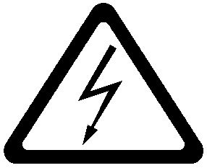“ Dangerous voltage existing; “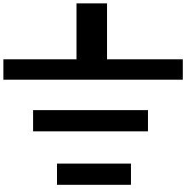” GND “” Double insulation; “” Shall refer to the user’s manual; ”” Low battery.

III. Features
1. General features
1-1. Display mode: LCD;
1-2. Max display: 1999 (3 1/2) digits automatic polarity display;
1-3. Measurement method: double integral A/D conversion;
1-4. Sampling rate: about 3 time per second;
1-5. Over-range display: the highest digit displays “OL”
1-6. Low voltage display：””;
1-7. Working environment: (0～40)℃, relative humidity: <80%;
1-8. Power supply: one 9V battery (NEDA1604/6F22 or equivalent model);
1-9.Dimension:190mm*88.5mm*27.5mm(length*width*height);
1-10. Weight: about 320g (including 9V battery);
1-11.Accessories:instruction manual, holster, color box, test leads one pair, TP01 thermocouple one piece, 9V battery one piece.
2. Technical features
2-1. Accuracy: ±(a% × reading data + digit), ensuring the accuracy environment temperature: (23±5)℃, relative humidity <75%, and the calibration warranty period lasts for one year from the date of leaving the factory.
2-2. Performance (▲ indicates the function is available for this model)
Function
DCV | ▲
ACV | ▲
DCA | ▲
ACA | ▲
Resistance Ω | ▲
Diode/ Open circuit | ▲
Triode hFE | ▲
Capacitance C | ▲
Temperature/Fahrenheit ℃/℉ | ▲
Frequency f | ▲
Auto power off | ▲
Backlight | ▲
Live wire judgement | ▲
2-3. Technical index
2-3-1. DCV
Range | Accuracy |  | Resolution
200mV |  | ±(0.5%+5) |  | 100uV
2V |  | ±(0.5%+3) |  | 1mV
20V |  |  |  | 10mV
200V |  |  |  | 100mV
1000V |  | ±(1.0%+10) |  | 1V
Input impedance: All range is10MΩ;
Over load protection: 250V DC or AC peak value for
range 200mV or 1000V DC or AC peak value for other
range.
2-3-2. ACV (True RMS)
Range |  | Accuracy |  | Resolution
2V | ±(0.8%+5) |  | 1mV
20V |  |  | 10mV
200V |  |  | 100mV
750V | ±(1.2%+10) |  | 1V
Input impedance: All range is10MΩ; Display:True RMS response
Over load protection: 250V DC or AC peak value for range 200mV; 1000V DC or AC peak value for other range .
Frequency response: sine wave, triangle wave
(40~1000)Hz ,other wave form :(40~200)Hz;
2-3-3. DCA
Range | Accuracy | Resolution
200uA | ±(1.2%+8) | 0.1uA
2mA | ±(1.2%+8) | 1uA
20mA | ±(1.2%+8) | 10uA
200mA | ±(1.2%+8) | 100uA
20A | ±(2.0%+5) | 10mA
Max measurement voltage drop: 200mV;
Max input current: 20A (no more than 10 seconds);
Overload protection: 0.2A / 250V fast-melt fuse, 20A / 250V ceramic fuse.
2-3-4. ACA (True RMS)
Range | Accuracy | Resolution
20mA | ±(1.0%+5) | 10uA
200mA | ±(2.0%+5) | 100uA
20A | ±(3.0%+10) | 10mA
Max measurement voltage drop: 200mV;
Max input current: 20A (no more than 10 seconds);
Overload protection: 0.2A / 250V fast-melt fuse,20A / 250V ceramic fuse.
Frequency response: (40~200)Hz;
Display: True RMS response.
2-3-5. Resistance (Ω)
Range | Accuracy | Resolution
200Ω | ±(0.8%+5) | 0.1Ω
2kΩ | ±(0.8%+3) | 1Ω
20kΩ | ±(0.8%+3) | 10Ω
200kΩ | ±(0.8%+3) | 100Ω
2MΩ | ±(0.8%+3) | 1kΩ
20MΩ | ±(1.0%+25) | 10kΩ
200MΩ | ±[5%+ 30] | 100kΩ
Open circuit voltage: lower than 3V;
Over load protection: 250V DC or AC peak value;
Note:
a) If in range 200Ω, please short the test leads and measure wine resistance, and then subtract the resistance from the value measured.
b) Lagged display of value is normal when measuring resistance higher than 1MΩ. Please wait until the display is stable.
2-3-6. Capacitance (C)
Range | Accuracy | Resolution
20nF | ±(3.5%+20) | 10pF
200nF | ±(3.5%+20) | 100pF
2uF | ±(3.5%+20) | 1nF
20uF | ±(5.0%+10) | 10nF
200uF | ±(5.0%+10) | 100nF
2000uF | ±(5.0%+10) | 1uF
Over load protection: 250V DC or AC peak value;
2-3-7. Frequency (f)
Range | Accuracy | Resolution
10Hz | ±(1.0%+10) | 0.001Hz
100Hz | ±(1.0%+10) | 0.01Hz
1kHz | ±(1.0%+10) | 0.1Hz
10kHz | ±(1.0%+10) | 1Hz
100kHz | ±(1.0%+10) | 10Hz
1MHz | ±(1.0%+10) | 100Hz
Input sensitivity: 1V RMS.
Overload protection: 250V DC or AC peak value(less than 15 seconds);
2-3-8.Temperature (℃)
Range | Accuracy | Resolution
(-20 ~ 1000)℃ | ±(1.0%+5) < 400℃  ±(1.5%+15) ≥ 400℃ | 1℃
(0 ~ 1832)℉ | ±(0.75%+5) < 750℉  ±(1.5%+15) ≥750℉ | 1℉
Thermocouple (plug of banana type).
Over load protection: 250V DC or AC peak value(less than 15 seconds);
2-3-9. Transistor hFE data test
Range | Display range | Test condition
hFE, NPN or PNP | 0 ~ 1000 | base electrode current is approx 10uA, and Vce is approx 3V

2-3-10. Diode and continuity test
Range | Value displayed | Test condition
 | Diode forward voltage drop (Unit: mV) | Forward DC: about 1mA, reverse voltage: about 3V.
 | Buzzer sounds continuously, resistance between two test points is less than 50Ω±20Ω. | Open circuit voltage is approx. 3V.
Over load protection: 250V DC or AC peak value;
Warning: Do not input voltage in this range.

IV. Operation method
1. Operation panel introduction
1-1. LCD: display the measured value and the unit;
1-2. Function keys
1-2-1. Power /auto-power off switch: turn on / off power and auto-power off.
1-2-2. Hold/backlight/function selecting key: turn on/off hold and backlight, when there are two functions on a gear, it can be used as selection key .
1-2-3.Max.value/min.value measurement key.
1-2-4. Continuity ,live wire alarm indicator.
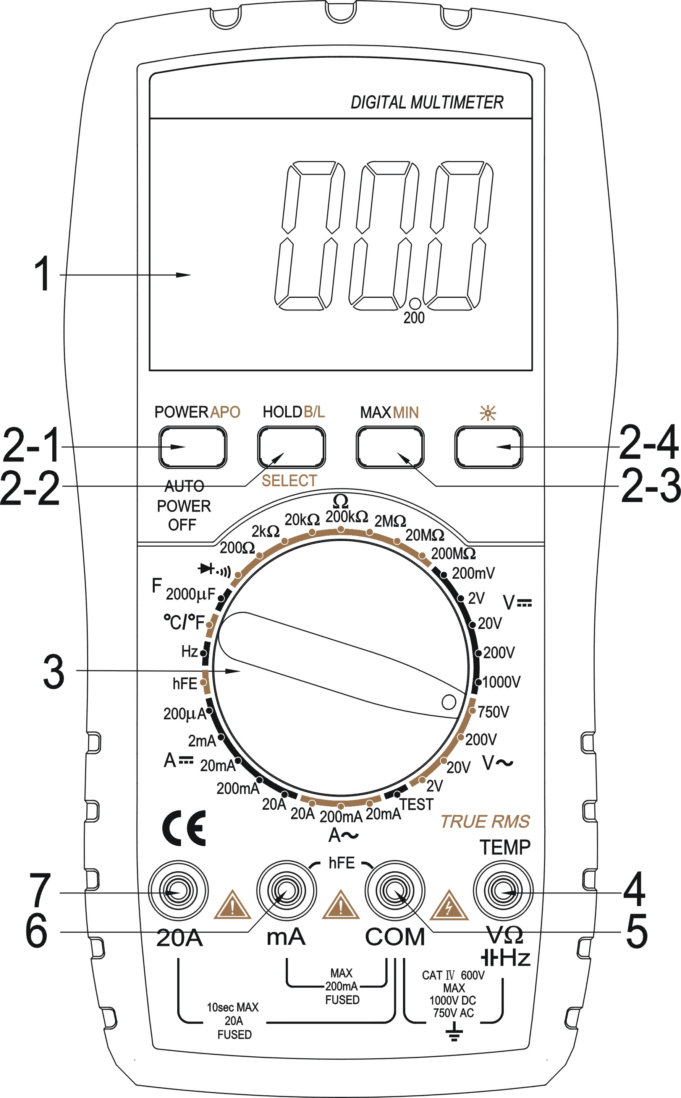
1-3. Range knob: to select measurement function and range;
1-4. “+” pole of voltage, resistance , diode, capacitance , frequency and temperature.
1-5. Triode, temperature, “—”and GND.
1-6. Triode, Jack for current less than 200mA.
1-7. Jack for current 2A/20A.
Please refer to the figure:
2. Voltage measurement
1. Insert the black test leads into the “COM” jack, and the red one into the “V/Ω/Hz” jack;
2. Turn the switch to position “DCV/ACV”. If the level of voltage to be measured is unknown then select the highest range and then decrease the range ,step by step until getting the value with the highest resolution.
3. Connecting the test leads reliably with the tested circuit, the voltage value will be displayed on LCD. While testing a DC voltage, the reading is voltage and polarity of the point connected by the red lead.
Note:
1. As showed, “OL” indicates the range is over and shall switch to a higher range.
2. The voltage to be tested shall not over DC 1000V or AC 750V. The test leads shall be away from the testing point as switching functions or ranges.
3. When measuring high voltage circuit, any parts of your body should not touch the high voltage circuit, otherwise it may hurt your body.
3. Current measurement
1. Insert the black pencil into the “COM” jack, and the red one into the “mA” or “20A/2A” jack.
2. Turn the switch to position “DC/ACmA/A”. If the level of current to be measured is unknown then select the highest range and then decrease the range step by step until getting the value with the highest resolution.
3. Connecting the leads with the tested circuit in series, the current value is displayed on LCD. While testing a DC current, the reading is the value of current and polarity of the point connected by the red lead.
Notice:
1. As showed, “OL” indicates the range is over and shall switch to a higher range.
2. The input in “mA” jack shall not over 200mA and “20A” not over 20A (less than 10 seconds of testing duration) as measuring current; the pencils shall be away from testing points as switching function or range.
4 Resistance measurement
1. Insert the black test leads into the “COM” jack, and the red one into the “V/Ω/Hz” jack;
2. Turn the range switch to resistance position, then connect the test leads at the two ends of the resistor.
Note:
1. "OL” will be displayed on LCD if the resistance is over the range, then you shall increase the range by one step;
2. When input is open circuit, it will display status of overload;
3. When measuring resistance on line, ensure that all power of circuit tested are turn down and all capacitor are discharged completely;
4. Never input voltage if in resistance measurement mode!
5. It normal for resistance higher than 1MΩ that the reading data is not stable for the first several seconds;
5 Capacitance measurement
1. Insert the black test leads into the “COM” jack, and the red one into the “V/Ω/Hz” jack;
2.Set the range knob to a proper capacitance range,connect the test leads to the capacitor under measured .
Note:
1. If capacitance exceeds the range selected, “OL” will be displayed on LCD，then you shall increase the range by one step.
2. The LCD may show some remained digits upon the starting of capacitance measurement. It’s normal and will not affect the testing result;
3. If there is serious creepage or capacitor broken down in high capacitance range, the digits showed will be random and unstable.
4. Please discharge capacitor completely to avoid device damage before measuring capacitance.
6. Temperature measurement
  - Setting function switch to °C/℉ range position.The default mode is ℃ measurement, press “HOLD/BL” key switch to ℉.Set the cold end of thermocouple sensor to the cathode in the “COM” jack, the anode (red pin) into “V/Ω/Hz” jack, put the working end (temperature measurement end) of thermocouple on the surface or inside the object to be tested. Then you can read temperature from the screen, and the data is in centigrade or fahrenheit.

Note:
1. As the input end is open, it will show environment temperature if the operation temperature is higher than 18℃ and lower than 28℃,the displayed value is for reference only if the operation temperature lower than 18℃ and higher than 28℃.
2. Do not replace temperature sensor, or the accuracy is not guaranteed;
3. Do not input voltage if in temperature mode.
7. Frequency measurement
1. Insert test leads or shielded cable into “COM” and “V/Ω/Hz“ jack;
2. Turn range switch to frequency position and connect the test leads or shield cables crossly to the signal source or load tested.
Note:
1. It can be read work if the input is higher than 10V RMS value, but the accuracy is not guaranteed;
2. In noise environment, you'd better use shield cable to measure small signal;
3. When measuring high voltage circuit, any parts of your body should not touch the high voltage circuit, otherwise it may hurt your body.
4. Never input voltage higher than 250V DC or AC peak value, otherwise it may damage your meter.
5.The frequency gear is automatic range measurement , can measure the range from 10Hz to 1MHz.
8. Transistor hFE
1. Turn the range switch to “hFE” position;
2. Insert test leads into “mA” and “com” jack. Please pay attention to the polarity, as the “com” for positive and “mA” for negative.
3. To determine the transister's type, NPN or PNP, insert the emitting, base and collector electrode into the corresponding jacks in testing accessory.
9. Diode and continuity test
1. Insert the black test leads into “COM“ jack, and the red one into the “V/Ω/Hz“ jack (Notice: the red pencil is anode);
2. Turn the range switch to position “”, connect test leads in parallel to the diode tested, with the red pencil to the anode and the black to cathode, then the reading value will be approximate forward voltage drop of the diode;
3. Connect pencils to two points of the circuit to be tested, if buzzer sounds, then the resistance between the two points is lower than (70±20)Ω.
10.Data holding
Press “HOLD/BL”, the peak value of current data will be keep displaying on LCD; press it again to cancel this function,”HOLD” disappeared..

11. Auto power off
After about (15±10)minutes meter not being used, it will be powered off automatically and enter into dormant status, and press “POWER APO” again for two times to turn on power.
12. Backlight
Press “HOLD/BL” key to turn on backlight. After 15 seconds, the backlight will be turn down automatically. Press it again to turn off the backlight .

V. Device maintenance
This series of device is a kind of precise instrument; please do not change the internal circuit by your self.
1. Pay attention to the waterproof, dustproof and breakproof of the meter;
2. Please do not store or use it in environment of high temperature, high humidity, high flammability or strong magnetic.
3. Please wipe the meter with a damp cloth and soft detergent, and abrasive and drastic solvent such as alcohol are forbidden.
4. Please take out battery to prevent meter from being eroded by battery weeping if the meter will not be used for a long time;
4-1. Be care of the status of batteries. When ““ is displayed on LCD, please replace batteries.
4-1-1. Remove the holster, screw out nut that fixing battery lid, and remove battery case;
4-1-2. Take off 9V batteries, replace with new one. It is recommended to use alkaline battery for long-time operation; even any 9V battery is adoptable.
4-1-3. Close the battery case and tighten the screws.
4-1-4. Take on holster.
4-2. Replacing fuse

Please replace fuse with another same one if necessary.

VI. Trouble shooting
If you device can not work normally, the methods below may help you to solve general problems. If these methods do not work, please contact service center or dealer.
Conditions | Way to solve
No reading on LCD | ●Turn on the power  ●Set the HOLD key to a correct mode ;  ●Replace battery
signal appears | ●Replace battery
No current or temperature input | ●Replace fuse
Big error Value | ●Replace battery

The specifications are subject to change without notice.
The content of this manual is regarded as correct, error or omits Pls. contact with factory.
We hereby will not be responsible for the accident and damage caused by improper operation.

The function stated for this User Manual cannot be the reason of special usage.

601C-088B-002D

