Questions for discussion
Episode 24
29th August 2017

High Court
- Discuss the BTN High Court story in pairs. What points were raised in the discussion?
- Briefly explain what courts do.
- If a court makes a decision that people aren’t happy with, then they can _____________
- Which is the most powerful court in the country?
  - Supreme
  - Federal
  - High
- Where in Australia is the High Court?
- What sorts of cases are heard by the High Court?
- How many people make up the High Court?
- What cases is the High Court going to hear over the next few months?
- What big decisions has the High Court made in the past?
- What did you learn watching the BTN story?

Vote in the BTN Online Poll

Teaching Finance
- Before you watch the BTN story, predict what you think it’s about.
- Discuss as a class the information raised in the Teaching Finance story.
- How has the way we use money changed over the years?
- What did a recent survey find about teenagers understanding of money?
- What is interest?
- Explain what interest rates are.
- In your own words, explain how credit cards work.
- What are the students in the BTN story learning about?
- Name three things you learnt watching the Finance Kids story.
- Do you think kids should be taught more about money? Give reasons for your answer.

Vote in the BTN Online Poll
Check out the Teaching Finance resource on the Teachers page

Spinal Cord Awareness
- Explain the BTN Spinal Cord Awareness story to another student.
- How did Tess get a spinal cord injury?
- The spinal cord is the main ________ ___________ in your spine.
- What does the spinal cord control?
- What protects your spinal cord?
- What symptoms did Tess experience?
- How did the spinal cord injury made Tess feel?
- What goals has Tess set for herself?
- What advice does Tess give to other kids?
- How did the BTN story make you feel?

Write a message about the story and post it in the comments section on the story page.

Happiness Survey 2017
- What makes you happy?
- Name something that makes you worried, angry or sad?
- What does the BTN Happiness Survey aim to find out?
- The 2015 Happiness Survey found _______of kids are nearly always happy.
- What sorts of things do kids worry about?
- How will the survey results be used to help kids?
- What do you think the words mental health mean?
- Why is taking good care of your mental health important?
- What do you find helpful if you’re feeling worried, angry or sad?
- What do you understand more clearly since watching the BTN story?

Check out the Happiness Survey resource on the Teachers page

What are Dreams?
- What was the main point of the BTN story?
- About how many hours a night do we dream?
- What did ancient Egyptians believe about dreams?
- In ancient China, dreams were thought to be…
- Dreaming mostly takes place during which stage of sleep?
- What does REM stand for?
- During REM sleep, our brain activity decreases. True or false?
- It’s thought that dreaming is an important part of how we form ____________________.
- What questions do you have about dreams?
- What did you like about this story?

Do the quiz on the BTN website

Teacher Resource
Episode 24
29th August 2017

Finance Kids


Students will investigate and calculate interest using percentages and decimals. Students will explore the difference between cash and digital money.


Maths – Year 4
Solve problems involving purchases and the calculation of change to the nearest five cents with and without digital technologies

Maths – Year 5
Create simple financial plans

Maths – Year 6
Investigate and calculate percentage discounts of 10%, 25% and 50% on sale items, with and without digital technologies Year 6

Maths – Year 7
Investigate and calculate 'best buys', with and without digital technologies Year 7

- Before you watch the BTN story, predict what you think it’s about.
- Discuss as a class the information raised in the Teaching Finance story.
- How has the way we use money changed over the years?
- What did a recent survey find about teenagers understanding of money?
- What is interest?
- Explain what interest rates are.
- In your own words, explain how credit cards work.
- What are the students in the BTN story learning about?
- Name three things you learnt watching the Finance Kids story.
- Do you think kids should be taught more about money? Give reasons for your answer.

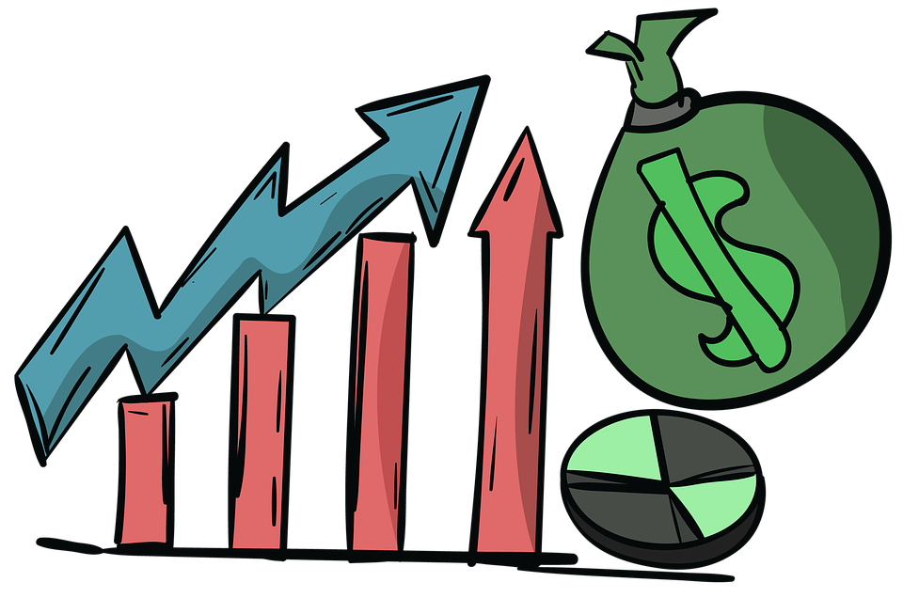

Discussion
Before watching the BTN Finance Kids story, ask students to make some predictions about what the story might be about. Students will compare and contrast their predictions with other classmates after viewing the story.

After watching the BTN Finance Kids story, hold a class discussion, using the following discussion starters. Brainstorm ideas in small groups and then students will report their group’s responses to the class.

- Think of as many words as you can that relate to finance and managing your money.
- What do you already know about credit cards, interest and loans? Describe using your own words.
- Think of 5 reasons why kids should learn more about managing their money. Share and compare your ideas with the class.
- How well do you manage your money?
- Why do you think BTN covered this topic?

Glossary
Develop a glossary of words and terms that relate to the story. Below are some words to get students started. Add words and meanings to the glossary as you come across unfamiliar words throughout your research. Consider using pictures and diagrams to illustrate meanings.

- Savings
- Bank
- Money (notes and coins)
- Budget
- Interest rate
- Credit
- Digital money
- Cash
- Loan
- Debt

What questions do you have about interest rates, credit cards and managing money? Consider visiting your local bank to ask an expert your questions.

Managing money
Introduce students to the concept of managing money, including ways to pay for things, borrowing money and budgeting. Have a class discussion to explore and investigate these concepts further, using the following questions to get the discussion started:

- What are some of the different ways you can pay for things? Give examples.
- What is the difference between cash and digital money?
- What is the difference between a credit card and a loan?
- Have you ever saved up your own money to buy something? How did you reach your savings goal?
- Have you ever had to budget for something (e.g. party or school event)? Explain.
- Have you ever borrowed money from someone?
- How did you pay the money back? What sort of agreement did you have to pay the money back? Were you able to pay the money back in time?
- Alternatively, have you ever lent money to someone else? How did they pay you back and did you have an agreement to make sure the loan was paid back in time?

Working with percentages
- In pairs, students will think about how they use maths in everyday life. Do you use ratios, percentages, sums or integers?
- As a class discuss the concept of interest and how it relates to credit and loans. What sort of maths would you need to use to calculate interest?
- Explain to students how to calculate interest on a loan using percentages and decimals. For example, calculate how much interest would need to be paid on a $500 loan with a 15% interest rate.

15% = = 0.15
0.15 x $500 = $75 interest
Classroom budget
Working in small groups, students will prepare to run a stall selling hotdogs at the school fundraising fair. Students will create a simple budget to run the stall and work out how many sausages, bread and sauce they will need to buy within their budget.

Create a table to record information about the budget. Below is an example:

Item | Individual cost | Size of item | Number of items | Total Cost
Sausages | $7.50 | 2kg (20 servings) | 10 x packages | $75.00
Bread | $2.00 | 1 loaf (20 slices) | 10 x loaves | $20.00
Sauce | $4.50 | 500mL | 4 x bottles | $18.00
 |  |  |  | $113.00

Students will address the following:
- Set a realistic budget
- How many people will want to buy a hotdog?
- Compare prices for the sausages, bread and sauce (visit more than one online shopping website, or collect more than one grocery brochure to find and compare prices).
- Select which products you will buy for your stall. Why have you chosen these products?
- What quantities of food will you need?
- What will the food cost?
- What is your total income and total expenditure?
- Do you have enough income to cover your expenses?
- Can savings be made or can more be afforded on the food?


Further challenge:
- Calculate the GST on the items you have purchased.
- How much will you charge students to buy a hotdog?
- How much will you raise from the fundraising stall?

Students will swap their budget with another group and check the following:
- Is there enough food for the number of students attending the fundraising fair?
- Do the calculations balance?
- Is it under or over budget?


BTN – Cashless Society
http://www.abc.net.au/btn/story/s4645349.htm

ABC News – Test your own financial literacy against teenagers
http://www.abc.net.au/news/2017-08-17/financial-literacy-survey-quiz-test-yourself/8815272

ABC Splash – Money and Finance
http://splash.abc.net.au/home#!/topic/495578/money-and-finance

BTN – Interest Rates
http://www.abc.net.au/btn/story/s3354552.htm

ABC Splash – How banks make money
http://splash.abc.net.au/home#!/media/29709/calculating-percentage-and-simple-interest-banking

ASIC’s Money Smart – Credit Cards
https://www.moneysmart.gov.au/borrowing-and-credit/credit-cards

Teacher Resource
Episode 24
29th August 2017

Happiness Survey
Students will develop a deeper understanding of things that affect their mental health and create a mental fitness program for their class.

Health and Physical Education – Years 3 and 4
Investigate how emotional responses vary in depth and strength

Health and Physical Education - Years 5 and 6
Examine the influence of emotional responses on behaviour and relationships
Investigate the role of preventive health in promoting and maintaining health, safety and wellbeing for individuals and their communities
Participate in physical activities designed to enhance fitness, and discuss the impact regular participation can have on health and wellbeing
Health and Physical Education – Years 7 and 8
Analyse factors that influence emotions, and develop strategies to demonstrate empathy and sensitivity

- What makes you happy?
- Name something that makes you worried, angry or sad?
- What does the BTN Happiness Survey aim to find out?
- The 2015 Happiness Survey found _______of kids are nearly always happy.
- What sorts of things do kids worry about?
- How will the survey results be used to help kids?
- What do you think the words mental health mean?
- Why is taking good care of your mental health important?
- What do you find helpful if you’re feeling worried, angry or sad?
- What do you understand more clearly since watching the BTN story?

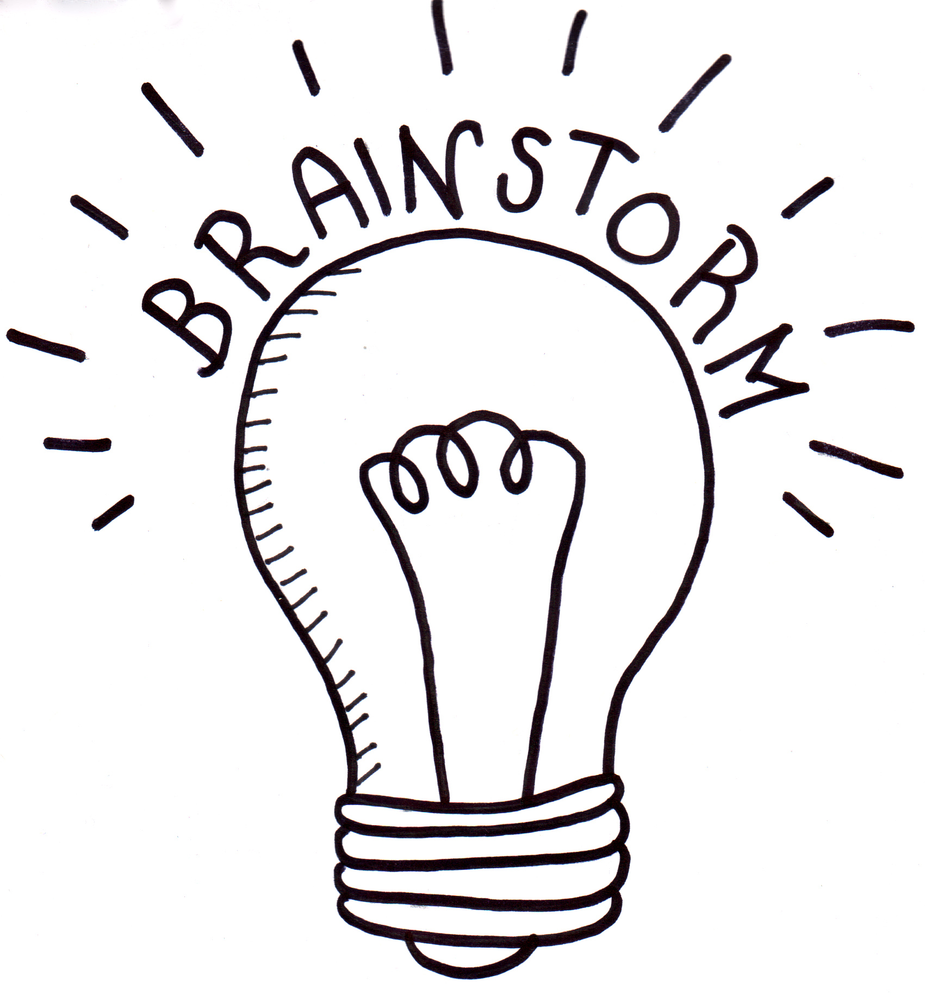
What do you think?
What do you THINK about what you saw in the BTN Happiness Survey story? What does this video make you WONDER?
- Think of three questions you have about the Happiness Survey story. Remember that good questions are open-ended (have no right or wrong answer and can’t be answered with a ‘yes’ or ‘no’).
- What did you learn from the BTN story? Leave your comment on the Happiness Survey story page.

Hold a class discussion about the information raised in the Happiness Survey story and then ask students to respond to the following questions:
- What makes you happy?
- Name something that makes you worried, angry or sad.
- What can kids do if they are feeling worried, angry or sad?

BTN Happiness Survey Results
In 2015, BTN launched the Kids' Happiness Survey to find out more about their mental health.
More than 20,000 kids responded and here are some of the results.
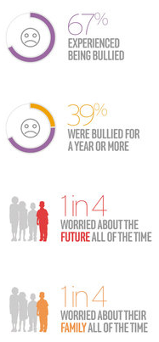
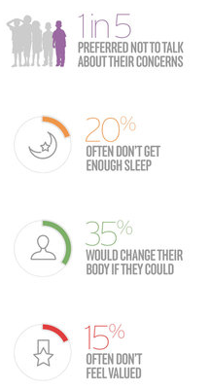

Working in small groups, discuss the results from the 2015 survey then respond to the following questions:
- What issues were raised in the group discussion?
- How would you respond to the questions/topics raised in the survey?
- What surprised you about the results of the survey?

What makes kids happy?
Survey students in your school about what makes them happy. Think about ways to record students’ responses – written, audio or video. Ask students to think of creative ways to share the results with the school community.

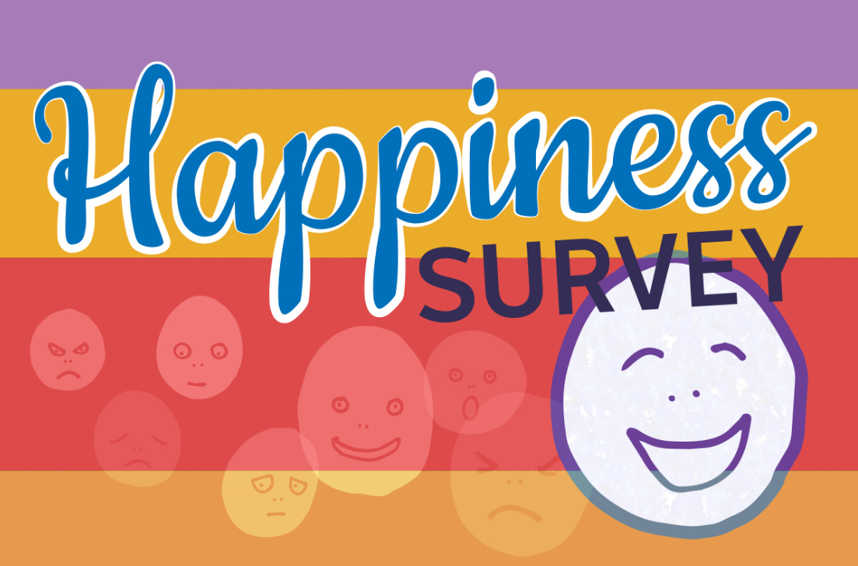

Encourage your students to take part in the BTN 2017 Happiness Survey

Identity
Getting an idea of who you are and knowing your strengths and talents can be really useful in building confidence and self-esteem.

As a class, students will begin this activity by discussing and brainstorming what makes up your personal ‘identity’. Use a mind map to record the students’ responses about identity and then find a dictionary meaning.

Who am I?
Who am I? Students will reflect on this question through discussion, writing and art. Students will brainstorm and record how they see themselves, responding to the following reflective questions. Student will then take the information they have learnt about themselves and create a collage that illustrates who they are.

- Who are you?
- What words best describe you?
- What are you really passionate about?
- What are your most important values?
- What do you think is unique and special about you?
- What are your strengths? Check out this website for tips on figuring out your strengths.
- What are your challenges?
- How are you similar/different to other people? How do you feel about your differences?
- When do you feel most like yourself?
- Why is it so important to be yourself?

Mental health
Students will think about the things that affect their mental health. Ask them to keep a journal of positive and negative things they experience, think about or hope for, over one week. After a week, students will share with a partner or the class how their journal made them feel.

- What are ways that you keep yourself healthy? Spend a few minutes writing down your ideas on post-it notes. Stick your post-it notes together on a board or wall in the classroom. As a class decide upon a definition of mental health.

- Who would you speak to or where would you go if you thought you needed help for a mental health issue? Create a mind map of all the support places/people/organisations you can think of that are available to help young people going through a tough time. Choose one of the categories and explain how someone might find support.

Home | School | In the local community | At sport/ activity clubs | Online | Other
Mental fitness guide
Design a mental fitness guide or program for students at your school. You will need to think about including information and tips about things like:
- Positive thinking
- A good sleep routine
- Regular physical activity
- Healthy eating
- Skills for managing stress
- Self-awareness
- Ways to relax
- How to build self confidence
- Ways to cope with negative emotions
- Where to find help and who can help
- What things can kids get involved in at your school to look after their mental health? For example, help with the school veggie garden, start a buddy program, start a meditation program, play a team sport or join the SRC.

Visit Reach Out for tips and techniques for ideas on how to help look after your school’s mental health.

Watch the BTN Healthy Minds story then answer the following questions:

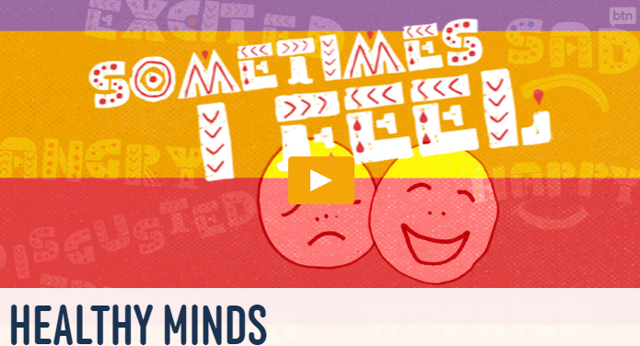
- Why do experts say it is important we have a range of different feelings?
- Why is it important not to ignore or let these feelings take over?
- What do you think the words mental health mean?
- Why is taking good care of your mental health important?
- What does Kirrilie say kids can do to help them when they are worried?
- When you are feeling sad, what can you do?

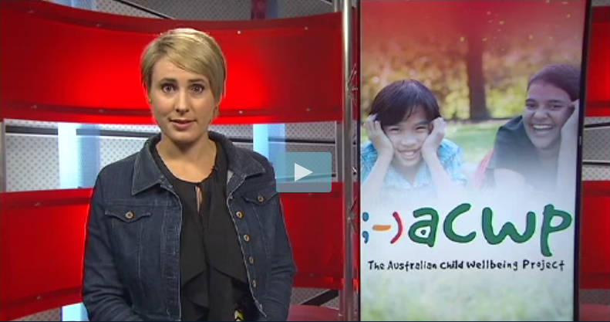
Watch the BTN Kids Wellbeing story then answer the following questions:
- What do you think it’s like being a kid in Australia?
- What percentage of kids said they feel positive about their future?
- What else did the survey find?
- The study says that kids who are bullied are twice as likely to miss ___________.
- Young people that go to school hungry are more like to have…

BTN – Healthy Minds
http://www.abc.net.au/btn/story/s4305297.htm

BTN – Resilience
http://www.abc.net.au/btn/story/s4067152.htm

BTN – Worry Workshop
http://www.abc.net.au/btn/story/s4327058.htm

Kids Helpline – Resilience
https://kidshelpline.com.au/teens/tips/resilience-a-stronger-you/

Reach Out – Mental Fitness
https://au.reachout.com/mental-fitness

Kids Helpline - Anxiety
https://kidshelpline.com.au/teens/tips/anxiety-the-facts/

BTN: Episode 24 Transcript 29/08/17

Hi, I'm Nathan Bazley, thanks for joining me for BTN!

Coming up today:

- Rookie reporter Tess tells us all about Spinal Cord Injury Awareness Week.

- We investigate why people dream.

- And the biggest news of all, we launch the BTN Happiness Survey for 2017.

Please stay with us for all that and more.

High Court
Reporter: Ruby Cornish

INTRO: But first to the news. Over the coming months, the High Court of Australia is scheduled to hear some incredibly important matters. Among them is the challenge to the same-sex postal survey and the multiple cases of the federal politicians who've found out that they're actually dual citizens. But why does this court get all those big cases? Take a look. But first, a warning to Aboriginal and Torres Strait Islander people, this story contains images of people who've died.

RUBY: Hey Nathan!

NATHAN: Hey Ruby, how's it going?

RUBY: Good. I’ve got a great idea. So, you know how I'm doing a story about the High Court this week?

NATHAN: Yup.

RUBY: Well, I want to make it space-themed. So, basically I get some kids to be aliens, and I'm like this astronaut intergalactic crime-fighter and someone on another planet has committed a terrible crime…

NATHAN: It sounds creative but it sounds ridiculous too.

RUBY: Come on, it’ll be like `Hands off you radioactive slime balls are under arrest! It'll be awesome!

NATHAN: Yeah, maybe give it another shot.

Okay, so our justice system might not have much to do with outer space but it does have everything to do the law.

Courts decide if people are guilty of a breaking a law and decide their punishment.

They sort out legal disputes between people or companies and decide how the law should be interpreted.

But sometimes a court can make a decision that people aren't happy with. If that happens, they have the right to an appeal. This can eventually mean approaching a higher-level court and asking them to review the case, in the hope of a different outcome. Much like me.

RUBY: Hey Ben!

BEN: Hi Ruby.

RUBY: So, I've got this great idea for a story. Nathan said no but I think you should hear it.

BEN: Ok, go on then.

RUBY: Okay, well I play an intergalactic astronaut crime-fighter who saves the galaxy by battling some radioactive slime balls and I basically take them out with my laser and go `hands off you radioactive slime balls, you’re under arrest and at the end the whole galaxy is saved. That’s the end. What do you think?

BEN: Yeah, no. It’s a terrible idea. Sorry.

If you've exhausted all your options in the lower courts, be it the local, district supreme, federal or family court.

There's one court, right on top, that can trump all of the others.

The big boss of the court system.

RUBY: Hi, I’d like to speak to the boss of the ABC please. Oh, hi Michelle, it’s Ruby. Listen, I've had this great idea for a story I wanted to run by you. Basically I play…

It's the High Court. It's located in our capital Canberra, and it's the most powerful court in our country. It has the final say on everything.

The High Court handles cases in a couple of different ways.

It can hear appeals from lower courts or it can hear new cases about big issues.

Often to do with interpreting the rules in Australia's oldest rulebook - the Constitution.

The High Court's made up of seven people, one chief justice and six justices.

The current Chief Justice is Susan Kiefel. She's the first woman to ever hold the position.

These seven are going to be pretty busy over the next few months, dealing with some cases you might have heard about recently. Like whether some politicians who found out they're actually dual citizens should be booted from parliament and whether the postal survey on same-sex marriage should be allowed to go ahead.

But big cases like that are all in a day's work for the High Court.

In the past, it's handed down decisions on recognising native title for Aboriginal people and ruled on where the government can process refugees.

Once decisions are made here that's it.

And that's pretty much it for me too.

RUBY: You really don't like it? Alright, bye. Well how am I meant to tell my High Court story now?

Ask A Reporter

Have you got a question about the High Court? Ask me live on Friday during Ask a Reporter!

Head to our website for all the details.

This Week in News

Hurricane Harvey hit Texas over the weekend and it's being called one of the worst natural disasters the American state has ever seen.

It ripped off roofs, snapped trees, and dumped heaps and heaps of rain on Texas especially the biggest city Houston.

Thousands of people have been rescued from cars, houses and floodwater.

It's going to get worse before it gets better, too. 1.3 metres more rain is expected throughout the week.

If you've been feeling under the weather lately you're not alone.

The number of people with the flu has hit historic highs across the country this year.

Doctors say it's not too late to get the flu shot because even though it's almost Spring, flu season could last another couple of months.

Last week millions of Americans put on solar viewing glasses to stare into the sky as the moon moved into the path of the sun and created a total solar eclipse.

It only lasted for a maximum of two and a half minutes though as the eclipse travelled from the Pacific Ocean across 14 US states to the Atlantic.

And you've probably given this a go just for laughs, but did you know that air guitaring is actually a championship sport?

The 22nd annual competition has just been held in Finland and Australia did pretty well!

Our competitor "the Jinja Ninja" came in second place.

Teaching Finance
Reporter: Jack Evans
INTRO: Next up. A survey has found that many Australian kids are confused about how credit cards and loans work. While it is still a few years until you can even get one, experts are worried that not understanding these things now, could lead to financial problems later in life. Here's more.

JACK: Need money now? Yes! Don't want to wait? Who does? Call now! Ok.

JAKE: Hello, Credit Crunch Loans. You in a dash for cash? Jake speaking.

JACK: Hi Jake

JAKE: How can I help you?

JACK: Oh, I need a loan.

JAKE: Right, I can offer you a $2000 credit loan with an interest rate of 18.25%. But we do have a special offer if you sign up in the next 20 seconds, no interest for 24 months. Of course, that interest rate will double after 24 months. But, shall we go ahead?

JACK: Um?

Credit cards, interest rates, loans, it can all sound pretty confusing. But it's really just about one thing, money. Money is a pretty important part of our lives. But over the years the way we use it has changed quite a bit. Today dollars and cents are often replaced by taps and clicks on a computer or on your phone. So, it can mean we're able to spend money faster than we can keep track of and that's got some experts worried about your generation.

Katrina Birch, Financial Basics Foundation: We live in such a cashless society now. The fact that there are so few barriers to spending, again we're opening up young people to the possibility of getting into difficult financial situations down the track.

Recently a survey found that most Aussie teens don't understand how credit cards and interest rates work. For example, 1 in 5 thought it would take a year to pay off a $2000 debt with an 18% interest rate. When in fact it could take 15 years. So, let's give you a quick crash course in both right now.
First Interest. That is the fee paid by someone who borrows money usually from a bank. The interest rate is the amount that borrower has to pay back on top of of what they borrowed. So, the higher the interest rate the more you'll have to end up paying back. Then there are credit cards. You can use them to buy stuff heaps of adults use them every day. But when you use a credit card you're actually borrowing money from the bank. So, if you don't pay back what you spend each month you'll get charged interest on top too.

Experts say it's really important for kids to start learning about things like interest rates and credit cards now. That's what these guys are doing at Mansfield State High School in Queensland.

James: I use a card at the moment. I'm earning as well with the job I've got and this is really helped with managing debt and money and what goes out and what comes in and keeping it stable.

Jayden: It's good to set me up for life and it will really help me in the future so I'll know what to do in terms of financial problems and situations.

These guys say it's a lesson that all Aussie kids should learn. So, they can take care of their cash in the future.

JAKE: So, are you interested in our offer?

JACK: I might just think about it. Or not.

Poll

So, after watching that, do you think kids should be taught more about money?

Let us know in our online poll.

And here's the results of last week's poll.

Spinal Cord Awareness
Reporter: Jack Evans

INTRO: Next week is Spinal Cord Injury Awareness Week. It easy to think that most of those types of injuries come about because of accidents. But that's not always the case.
We asked Rookie Reporter Tess to tell us more.

Hello BTN, my name's Tess and I enjoy playing with my sister and just doing normal teenager things. On the 24th of November last year. I was diagnosed with a spinal cord injury and how I got a spinal cord injury is because of an infection, MRSA. One day I was a happy healthy girl and the next I couldn’t feel my legs. The spinal cord is your main nervous system in your spine that controls all your fingers, muscles, ligaments, everything and it’s also connected to your brain. Your spinal cord is protected by your bones in your spine which are called the vertebrae.

I just thought I was getting a cold and I had really bad back pain and I just thought it was normal and I was struggling to breathe, I just had flushes, hot flushes. I couldn't walk I couldn't sit I couldn't stand. No heat packs, no nothing would help my back pain. My treatment for the infection was, I was on antibiotics through a PICC line which is like a drip in your vein. I was on that for six weeks and then I started being able to sit up while I was on my drip and learning to roll, sit, move my arms.

It was very confronting, scary. Like I didn't know what I was able to do and what I wasn't able to do. It was just very hard and scary 'cause you don't know what your future was going to hold. Whether you were gonna get worse get better. You just didn't know and finding out that you'll never be able to walk again is really, really scary and hard because that's what you've known all your life is to have your legs and be able to do everything with your legs and not just your arms.

So, I wasn't able to get on my bed by myself I wasn't able to get in a car. I wasn't able to get on a couch by myself and doing that and achieving that is a big accomplishment for me because when I was in hospital I didn't think I could achieve it. I didn't think I would be here as I am today being fully independent. I thought that I would always have to rely on someone. But being able to do this now myself within only a couple of months is a big achievement for me. It's a really big achievement and just being able to go outside, go to the shop, play with my sister. Like it’s a really, really big achievement for me and I'm so proud of myself for where I am today.

My advice to other kids is you can do anything an able person can do. Don't let anyone tell you otherwise. It might take you a little more time. You might have to do it differently. You might not walk, but you still have a lot of things to give and a lot of opportunities ahead of you. Doors open for everyone every single day.

Quiz

Now for a quiz.

How many bones are there in the spine?

3

13

33

Answer: 33

Happiness Survey 2017
Reporter: Matthew Holbrook
INTRO: The last time we ran it 20,000 kids from around Australia responded. This year we'd like to get even more. I'm talking about the BTN Kids' Happiness Survey where we ask you all about when you're at your happiest and when you're not. In a minute, I'll tell you how you can get involved in this year's survey. But first, here's a recap of what it showed us about kids back in 2015.

What makes you happy?

KID 1: What makes me happy is playing soccer with my friends.

KID 2: Being around my friends and family that I love, and they love me back. Just feeling safe and happy and having good times around them.

KID 3: Going sightseeing to museums and art galleries.

KID 4: Things that make me happy are doing things with my family, like all being together.

KID 5: What makes me really happy is when I'm at home on YouTube.

KID 6: Probably playing with my friends, messaging my friends.

That's just one of the questions kids around Australia were asked about in our last Happiness Survey. It was designed to find out the kinds of things that affect you. Not just what makes you happy, but what makes you sad, or worried. To find out how you deal with problems, and more.

It found 52 per cent of you are nearly always happy, but 1 in 5 feel worried most, or all of the time. And these are the things you worry about the most: your health, family, and your future.

67 per cent of you have been bullied. 39 per cent of those said it had gone on for a year or more. When it comes to sleep, 1 in 5 say you don't get enough! The average number of hours you guys sleep is 8. And 15 per cent of you felt that the adults in your life mostly aren't listening to you.

But listening to you is what the BTN Happiness Survey is all about. So, this time around, we're working with the University of Melbourne. They'll help analyse your answers, and make sure they're used to let important people know how you're doing, and how things can be made better.

Holding the survey again also lets us find out what's changed for Aussie kids over the past two years, and how you're feeling now. The survey is officially open on our website, and all the answers are anonymous. So, this is your chance to be involved.

You'll have until the 22nd of September to have your say, and the more young Aussies who fill it out, the better understanding we can get of the big things affecting you.

NATHAN: And as Matt said there the BTN Happiness Survey is now open! So please jump onto our website straight after the show to have your say. It'll only take about 6 minutes of your time and your responses will make a difference.

Okay, let's go to the sport now.

Sport

The AFL season has ended in spectacular fashion on weekend with the race for a spot in the finals coming down to the last five minutes of the season.

West Coast just scraped in beating minor premiers, Adelaide, by 29 points and knocking the equally placed Melbourne Demons out of the 8th spot by just half a per cent!

The bombers got over Freo to secure their place in the finals and Richmond ensured a top 4 finish defeating the Saints by 41 points.

Sydney's Buddy Franklin took out the Coleman medal for the league's leading goalkicker booting 69 for the season.

All eight teams will have a week off before the finals start.

Australia's had a great start to the Netball Quad Series!

The Diamonds beat the English Roses 54 to 50 in Brisbane.

It was a dream debut for Aussie skipper Caitlin Bassett who showed off a near perfect shooting display with 43 goals.

The Diamonds will next face South Africa on Wednesday before the series wraps up on the weekend.

And an AFP commander reckons he's broken the world record for the heaviest aircraft moved by a human!

Grant Edwards pulled this 190-tonne cargo plane FIVE METRES along a tarmac.

Grant Edwards: There's always that little bit in the back of your head that's going, 'oh God, I hope I can actually get this thing moving', so when I did it was a relief.

It still needs to be approved by record keepers, but Grant reckons he got it!

What are Dreams?
Reporter: Ruby Cornish
DUHAA: Hi BTN, my name is Duhaa and my question is: How do dreams affect us and how do they occur?

RUBY: Good morning!

CHARLOTTE: Good morning!

RUBY: What's with the hat?
CHARLOTTE: What hat?

RUBY: Huh? Oh, never mind. That’s weird.

RUBY: Oh yuck, what is that?

JACK: Hey Rubes, why are you wearing pyjamas?

RUBY: What? I'm not in. WHAT? What is going on? Oh, thank goodness, it was just a dream.

Dreams are mysterious things. On average, we dream for about two hours every night.
That's six years over the course of our life! But even with all the miracles of modern science, there's still a whole heap we don't know about how and why they happen. That hasn't stopped people speculating though.

Ancient Egyptians believed dreams were messages from the gods, sent to specially chosen people as they slept.

In Ancient China, dreams were thought to be journeys taken by souls, which could leave someone's body when they were asleep.

Even nowadays, there are books for decoding the stuff in your dreams.

RUBY: Okay, it says here that if you dream about green goo in your coffee mug, it means you have an important decision to make. It's true! What else can this thing tell me!?

But there’s no proof behind those stories. So, let's find out about the science behind our dreams.

Dreaming mostly takes place while we're in the deepest stages of sleep and our brain activity increases. It's called the "Rapid Eye Movement Phase", or REM for short. In this stage, our brain activity increases and can mimic being awake. In fact, when we dream about faces, the part of our brain involved in facial recognition lights up. And when we look around in our dreams, our brain acts like it would if we were looking around when we're awake!

Evidence suggests dreaming is also an important part of how we form memories and could improve our ability to problem-solve when we're awake.

As for where the content of our dreams comes from, well, nobody really knows!

My dream dictionary might tell me my dreams have special meanings. But while that's a cool idea, it's not really backed up by science. It's more likely that dreams are just a mish-mash of our random thoughts and feelings.

RUBY: So, we know a bit about what happens in our brains when we dream - but it's basically a mystery why we dream about the things that we do!

SOPHIA: That's interesting, but why are you in pyjamas?

RUBY: What?

Closer

And that's it for today! But remember, there is always more to see and do on our website including the Happiness Survey!

Thanks for joining me. I'll see live on Friday for Ask a Reporter and then next week for more BTN.

