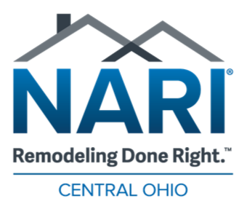

ADVERTISING PURCHASE AGREEMENT

By executing this Purchase Agreement (“Agreement”) the undersigned party (“Purchaser”) agrees to purchase from NARI of Central Ohio, the advertising services outlined below.

Purchaser agrees to pay NARI of Central Ohio the purchase price for each advertisement in accordance with the rates and terms herein. The size and type of ad, issue date and price shall be as set forth in the following table:

Issue Date | Size | Extra Charges | TOTAL PRICE | NOTES
March 2018
September 2018

PAYMENT TERMS: Payment with proof or before.

By the signature below, the Signer represents that they have thoroughly read this agreement and are the owner or authorized corporate officer for the below-named business who is authorized to both order the advertising described herein and to obligate the below-named business to pay for such advertising and if the Purchaser fails to fulfill its obligations pursuant to this Agreement, then the below named Signer shall be personally liable and hereby personally guarantees payment under this Agreement.

Company: |  |  |  | Phone: |  |  |  | Cell:
Full Address: |  |  |  |  |  |  |  | Fax:
Print Name:
Signature: |  |  |  | Email:
Date: |  |  |  | Title:
Credit Card Type: |  |  | Credit Card #: |  |  |  |  |  |  |  | Exp. Date
CVV: __________ |  |  | Auth. Signature: |  |  |  |  |  | Date to Process
Name on Card:

