Food Vendor Rules and Regulations

The following is a list of rules and regulations that you agree upon, as a vendor. We ask you to comply with these guidelines, if you chose not to, you will be asked to leave the festival site without a refund.

Space and Location

We will place your food booth within the limits of our food court area. We WILL NOT provide a tent, tables, service counters, storage units and/or any other equipment for the sale of your products. We do not guarantee sales at your booth and we reserve the right to change vendor locations without notice in accordance with changes that are made to the grounds.

The space listed on your confirmation is the only space allotted to you. If you need additional space at set-up, you must contact the Vendor Manager who will contract the additional space to you (based on availability). You will be required to pay for the space prior to the opening of the show.

Payment

All customers at Country Jam USA® must use their RFID wristband for food and beverage purchases. NO CASH SALES CAN BE ACCEPTED. Food vendors will be provided a POS terminal set up by Intellitix with said food vendors custom menu. See pages 5-7.

Sponsorship and Products

Sponsors are an important element in the continuation and growth of our events. Specific sponsorships also include exclusive product availability. Some products that are exclusive to sponsors include but are not limited to: Mardi Gras beads, beer, liquor, ice, soda and water. Approval for vending space is based upon the products listed on your application. These products are approved in accordance with our respect toward variety and sponsorship agreements. Vendors will have items approved for sale and will not be able to sell products that are in conflict or competition with sponsor products. We reserve the right to remove ANY item from the grounds that has not been listed as an item to sell.

Exclusivity

Vendors are not granted exclusivity on any products unless specified in writing by Country Jam USA®. As a vendor, you WILL NOT be allowed to use any event name, logo, entertainers name, images, dates, or make any reference to the festival or convert information directly or indirectly.

Insurance

All food vendors are required to have a minimum of $1,000,000 liability insurance on their booth. A copy of your insurance certificate specifically evidencing Country Jam USA® and coverage for the dates of July 19 – 21, 2018 is required as part of the application process. If you do not currently have insurance, you must purchase insurance and provide us with such documentation prior to the event. If you are unable to secure an insurance policy, please contact our office at 715.839.7500.

Fire Safety

Each food vendor is required to have a fire extinguisher in their booth, at all times, as required by the local Fire Department.

Electricity and LP Gas Delivery

One (2) 20-amp circuits of electricity will be provided at no charge. Electrical cords, lights and tents are NOT provided. Additional electricity may be available upon written notification of requirements and at an additional cost. If more than two 20-amp circuits of 110 volt electricity are needed, you MUST request additional power. Due to the nature of the event, additional electricity may or may not be available. The use of Halogen lights in or around your booth is prohibited. If you need LP gas delivered to your booth, please contact Ferrell Gas at 920.435.5334.

Garbage and Grease

All vendors are responsible to dispose of their garbage. Any vendor leaving garbage will be billed for its’ removal. Grease barrels are provided for food vendors at no charge. If you need grease disposal, you MUST use the barrels that are provided.

Ice

Ice storage units WILL NOT be provided. If you prepare a product on your menu using ice, you need to provide your own container for ice storage. Specific pick-up locations and price(s) will be available during setup.

UPS Shipments

UPS shipments will be delivered to the information booth each day prior to the gates opening. Please Note: ANY packages that are delivered prior to the first day of the festival (July 19, 2018) will be returned to sender! Staff WILL NOT sign for ANY of your packages or try to locate you after UPS has arrived on the grounds. COD packages WILL NOT be accepted at the grounds. To arrive at the grounds, packages must be shipped to 3443 Crescent Ave., Eau Claire, WI 54703. We ask that you use your booth name in the “Care of” field when shipping to the venue so it’s easier to identify the package when it arrives.

Carry-ins, Pets, Lawn Chairs, and Motorized Vehicles

Food/beverage and/or video/recording equipment carry-ins are NOT allowed on the event grounds by any of our fans or vendors. NO PETS are allowed in the event grounds and/or campgrounds. Vendors are given the privilege of entering the grounds early for restocking but not to place lawn chairs in the seating area. Doing so will result in removal from the festival. NO unauthorized motorized vehicles or scooters are allowed on the grounds.

Vendor Parking

Vendors who are camping are encouraged to park their vehicles at their campsite. The vendor parking passes will allow entrance into the VIP parking lot. All other vehicles (staff) will have to be parked in the general/employee parking lot for an additional charge. Carpooling is highly recommended due to limited parking space. Movement of any vehicles on the grounds is prohibited until the grounds are emptied each night. Any vendor attempting to leave the grounds before they are empty will not be allowed to re-enter and will lose any vendor fees paid.

Event Information

Set-up will begin on Wednesday, July 18, 2018. Employee access tickets and vehicle passes will be available for pick-up at the gate. Vendors arriving prior to the scheduled setup time WILL NOT be admitted and will be asked to leave. Event times are below:

Setup  Wednesday, July 18th:  8:00 a.m. – 6:00 p.m.  Thursday, July 19th:  8:00 a.m. – 10:00 a.m.  Set-Up Deadline  Thursday, July 19th – 11:00 a.m.  Restock Hours  8:00 a.m. – 10:00 a.m. Friday – Saturday  Vehicle Removal Deadline  11:00 a.m. – Daily | Daily Show Hours  Thur. July 19th: 12:00 p.m. – Approx. 12:00 am  Fri. July 20th: 12:00 p.m. – Approx. 12:00 am  Sat. July 21st: 12:00 p.m. – Approx. 12:00 am  Teardown of Exhibits  Sat. July 21st: After show – 1:00 a.m.  Sun. July 22nd: 8:00 a.m. – 12:00 p.m.  Removal Deadline  Sun. July 22nd: 12:00 p.m. (noon)

Security and Liability

Country Jam USA® provides general grounds security throughout the entire weekend of the event but is not responsible for damage to, loss, or theft of property belonging to an exhibitor, his agent, employees, business invitees, visitors, or guests. Each exhibitor shall carry its own appropriate insurance. Exhibit materials should be packed away and secured each night. Vendors agree to protect, save and hold Country Jam USA® and/or any person, organization or corporation for whom Country Jam USA® contracts with forever harmless for any and all damages or charges imposed for violations of any law or ordinance, whether occasioned by negligence of the exhibitors or those holding under the exhibitor.

All exhibitors shall at all times protect, indemnify, save and hold Country Jam USA® and/or any person, organization or corporation for whom Country Jam USA® contracts with foregoing harmless against and from any and all losses, costs (including attorneys’ fees), damage, liability, or expense arising from or out of or by reason of any accident or bodily injury of other occurrence to any person or persons, including the exhibitor, its agents, employees, and business invitees, which arises from or out of or by reason of said exhibitor’s occupancy and of the exhibition premises or a part thereof.

The decision of Country Jam USA® shall be accepted as final in any disagreement between vendors or in the decision to remove from the show without refund any exhibitor or his/her representative performing an act or practice which, in the opinion of Country Jam USA® is objectionable. All matters not covered in this agreement are subject to the decision of Country Jam USA®. If legal action must be taken, vendors will incur all legal fees.

SAFETY REQUIREMENTS FOR TEMPORARY EVENTS

1. Tent fabric and/or canopies: Shall meet the requirements for flame resistance in accordance with National Fire Protection Association Standard 701. A permanent affixed label bearing the identification and fabric or material type is required. Certification by other recognized agencies or testing facilities, such as the California State Fire Marshal or New York City may be accepted. Exception: Tents not exceeding 144 square feet, canopies open on all sides not exceeding 200 square feet and which do not contain cooking or heating appliances. Tents located on streets shall have a fire break of 12 feet from each other and adjacent buildings. Tents located in an isolated area may be within 5 feet of each other.

2. Electrical Cords: Extension cords shall be rated for at least “junior hard service per the Electric Code. An example is “SJO”. Cords shall be grounded and protected by a GFCI. Cords shall not be in contact with metal fences. Cords shall be protected from traffic and located/protected to prevent a tripping hazard.

3. Mean of Egress from tents or Canopies: No guy wire or guy rope shall cross any means of egress from any tent open to the public at a height of less than 7 feet. Tent stakes adjacent to any means of egress shall be railed off, capped, or covered so as not to present a hazard to the public.

4. Fire Extinguishers: A Class “K” fire extinguisher is required for any cooking operation involving a deep fat fryer. At least one fire extinguisher rated 2A:10BC shall be located in each tent. All extinguishers shall have a tag attached indicating that they have had a current annual inspection.

5. LP GAS Cylinders: All LP gas cylinders shall be securely fastened in place in an upright position to prevent unauthorized movement and be located NOT LESS THAN 10 feet from any tent, cooking operation or heating device. Safety relief valves shall be pointed away from tents, canopies, buildings, etc. Cylinders shall be protected from vehicle traffic.

6. Shavings, hay, straw bales: No bales, shavings or saw dust shall be located within any tent or within 10 feet thereof ON PAVED STREETS. No shavings, hay or straw bales, saw dust, etc. is allowed on unpaved surfaces such as grassy fields.



VENDOR INFORMATION –THE CASHLESS EXPERIENCE

Welcome to Cashless!

We are taking the guest experience to the next level with Intellitix’s world class, bank-certified cashless payment system. Cashless technology provides a fast, convenient, and secure method of payment for guests to make purchases at the event.

If you have any questions, please contact: Country Jam USA, 715.839.7500

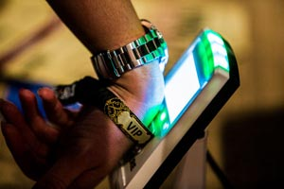 | 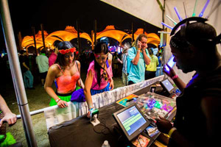 | 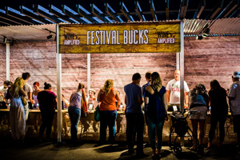

You Can Expect:



Your Festival Contact will provide you with:

- Menu Submission Form
- Equipment Allocation
- Sales Reporting Data
- Point of Contact During the Event

Intellitix will provide you with:

- POS Terminal(s) Setup: Each POS station is equipped with a POS unit and RFID Smart Reader(s)
- Installation & Configuration: Including your custom menu
- Vendor PIN Code: To unlock your POS terminal
- POS Training: There will be a mandatory onsite training

Here is a cashless introduction video to get you started (http://youtu.be/c97s7LT3-qY).

Top 5 Benefits of Cashless

- FASTER TRANSACTION TIMES
No waiting for guests to fumble with cash or wait for credit card transactions to process (which requires a reliable network connection). By drawing funds directly from a guest’s cashless account, transactions are processed immediately.

- REDUCED WAIT TIME & LINE-UPS
Faster transaction times significantly reduce queues, allowing vendor staff to focus their efforts on delivering exceptional customer service.

- INCREASED GUEST SPENDING AND SALES BY 15-30%
In combination with faster transaction times and reduced line-ups, guests spend more per head purchasing what they want, when they want it!

- FASTER VENDOR RECONCILIATION POST-EVENT
No need to count tokens at the end of the night. All transactions are recorded electronically in the cashless payment system.

- VALUABLE SALES DATA & INSIGHT
Discover real-time reporting of your sales data (unit price, amount sold, $ sales) searchable by product category, product item, festival date, and individual POS terminals. Find out what your bestselling items are to boost sales.

What Others Are Saying About Cashless

Hear first-hand from vendors, guests and event organizers on how cashless payment technology has enhanced their event experience.

The Vendor Cashless Experience
https://youtu.be/5YXzdvsOEzw

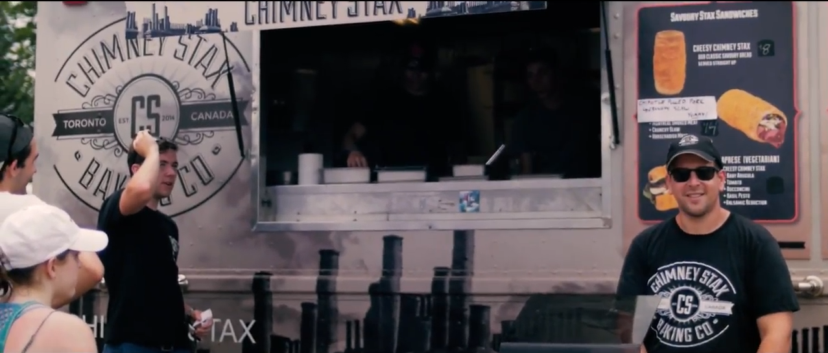

How Cashless Works

- GUEST RFID WRISTBANDS
Guests will receive their personalized RFID wristband in the mail or at the event. They will use this wristband as their ticket to enter the event grounds, as well as to make cashless purchases at your vendor station.

- TOP-UP ACCOUNTS
Guests will need to “top-up” or purchase event credit into their cashless accounts. Guests can top-up online from their desktop or smartphone, or at Top-up Stations located throughout the event.

- MAKING ONSITE PURCHASES
To make a purchase at your vendor station, guests will:
  - Tap their wristband on an RFID Smart Reader
  - Place their order with your vendor staff
  - Tap their wristband a second time to confirm the transaction

The funds are drawn from the guest’s existing cashless account balance. Guests can top-up as often as they want to re-fill their balance and keep making purchases throughout the event. All leftover funds are refunded to the guest after the event (less a refund processing fee).

The transaction is processed immediately in Intellitix’s robust cashless platform, featuring bank grade security. Intellitix’s technology uniquely runs on a closed-loop system, which means it can operate in both online and offline mode, ensuring your vendor station is operational 100% of the time.

For more information on Intellitix’s cashless payment system, please visit:
http://www.intellitix.com/services/cashless/

Welcome to the World of Cashless!

I have read and agree to these rules and regulations. I understand that failure to comply with the above rules and regulations will result in being asked to leave the festival without refund.

_____________________________________________
Sign here

_____________________________________________
Print here

_____________________________________________
Date

